WORLD METEOROLOGICAL ORGANIZATION  COMMISSION FOR BASIC SYSTEMS  OPAG on DPFS  EXPERT TEAM ON EXTENDED  AND LONG-RANGE FORECASTING  Geneva, Switzerland, 26-30 March 2012 |  | CBS-DPFS/ET-ELRF /Doc. 3.3(2)  (21.03.2012)  _______  Agenda item : 3.3  ENGLISH ONLY

Progress with the GSCU, implications for GPCs and Lead Centres

(Submitted by Vladimir Kryjov)

Summary and purpose of document

This document …

This document is intended to stimulate discussion on potential changes to procedures in verification of GPC products and the exchange and display of verification scores

Action Proposed

The meeting is invited to consider the contents.

Annexes: - Global Seasonal Climate Update. DRAFT OUTLINE MARK 0. (July 2011)
- Global Seasonal Climate Update. DRAFT OUTLINE MARK 1. (Sep. 2011)
- OPERATIONAL GUIDANCE (Sep. 2011)

Background.
Following the success of the WMO-coordinated El Niño/La Niña Updates, WMO Cg-XV (2007) recommended that the Updates be extended to include other large-scale climate indices having important regional impacts on seasonal climate. In this context, the Global Seasonal Climate Update (GSCU) has been designed through a dedicated scoping meeting of climate monitoring and prediction experts led by a WMO Task Team, and its currently nearing trial implementation phase. The objective of the GSCU is to provide the world community with an expert consensus on the state of the global climate with an outlook for the upcoming season along with information on robustness and uncertainty of the available forecast signals. The GSCU is also a means to strengthen international collaboration and information flow between GPCs, RCCs, RCOFs and NMHSs – thereby contributing to the goals of the GFCS. The GSCU is intended primarily for use by RCCs, RCOFs and NMHSs for assistance in preparation of regional and national climate Updates, however requirements of global user communities such as the Inter Agency Standing Committee (IASC) will also be considered and in this context the GSCU will contribute to application of science-based climate information in climate risk management.
WMO Scoping Meeting on GSCU. The scoping meeting in October’10 focused on the development of a practical approach. Representatives of RCCs, RCOFs, GPCs, and LCs together discussed the content of the GSCU to meet global and regional needs in assistance in risk management, adaptation policies, and decision making by global partners.
CCl Task Team on GSCU. The TT GSCU elaborated the content and an implementation plan to engage potential contributors to develop the GSCU on a trial basis in near-real-time and for limited circulation and peer review; and identify potential lead coordinators for operational production of the Global Seasonal Climate Update.

PROGRESS
According to implementation plan Richard Graham prepared a Mark 0 GSCU bulletin in July 2011 (Appendix 3.3.1, p.4). In September 2011, based on this version and comments from reviewers, Vladimir Kryjov prepared a Mark 1 GSCU bulletin (Appendix 3.3.2, p.15) and Operational Guidance (Appendix 3.3.3, p.32) for the GSCU issuance procedures in pilot phase. The GSCU pilot phase started in February 2012 (Doc. 5.3).

Implications for GPCs and Lead Centres

The prediction part of the GSCU is based on the data available at the LC LRF-MME, that is, the data provided by GPCs (Tab. 3.3.1).
According to the GDPFS, the minimum prediction range suggests four month model integration, i.e., a one month lead three month forecast. Meanwhile, existing practice of the RCOFs suggests that GSCU should be issued two month in advance of the forecast period, which requires numerical forecast be ready three month in advance, which means six month integration.
It is clear that performance of the model predictions degrade with increase of the lead time. Nevertheless, experimental seasonal forecasts with three month lead time issued and published by APEC Climate Center, show that those forecasts could be considered at least for the Tropics (D.L.Lee and H.I. Jeong. Intercomparison of 3-month and 6-month hindcast and forecast topic for summer and winter season APCC Technical Report No.1, 2011).
Issuance of such forecasts may require essential upgrade in the work of the GPCs, particularly, implementation of the coupled models and changes to the production lines.
The meeting encourage GPCs to develop the tools which allow to extend the prediction range up to six months.

Tablr 3.3.1.
The GPC real time and historical data collected by LC LRF-MME.

GPC | Beijing | CPTEC | ECMWF | EXETER | Melbourne | Montreal | Moscow | Pretoria | Seoul | Tokyo | Toulouse | Washington
Organization | BCC | CPTEC | ECMWF | Met  Office | POAMA | Bom | HMC | SAWS | KMA | JMA | Météo-  France | NCEP
Raw Data from EACH GPC
Format | Binary | GRIB1  (*.tar x2) | GRIB1 | GRIB1 | GRIB1  (*tar.gz) | GRIB1  (*.tar x8) | GRIB1  (*.zip) | GRIB1 | GRIB1 | GRIB2 | GRIB2  (*.tar) | GRIB1  (*.tar)
Transfer | FTP | FTP | FTP | FTP | Web page | FTP | FTP | FTP | FTP | Web Page | FTP | FTP
Data | Mean,  Climate | Anomaly | Anomaly | Mean | Mean,  Anomaly | Mean,  Climate | Mean | Anomaly | Mean,  Climate | Mean,  Anomaly | Mean,  Anomaly | Anomaly
Period | 3month | 6month | 6month | 5 month | 6month | 3month | 3month | 3month | 6month | 3month | 6month | 9month
Members | 8 | 15 | 41 | 41/42 | 30 | 4x10 | 10 | 6 | 20 | 51 | 41 | 40
Size(M) | 22 | 181 | 30 | 103 | 67 | 1,186 | 80 | 6 | 3,842 | 124 | 3 | 42
OUTPUT ( size(number) ) : GRIB1 (372KB : 3month)
Size(M) | 4M(10) | 20M(36) | 2M(2) | 43M(88) | 35M(64) | 20M(53) | 14M(37) | 3M(7) | 26M(46) | 26M(46) | 3M(4) | 62M(84)
HINDCAST
Period | 1983-2007 | 1979-2001 | 1981-2005 | 1996-2009 | 1980-2006 | 1969-2002 | 1979-2003 | 1982-2001 | 1979-2010 | 1979-2008 | 1979-2007 | 1981-2003
Members | 8 | 10 | X | 11/12 | 10 | 10 x 4 | 10 | X | 20 | 10 | X | 15
Size  (M) | 92 | not produced | X | 163 | 148 | 594 | 110 | X | 748 | 121 | X | 143

Appendix 3.3.1

Global Seasonal Climate Update
DRAFT OUTLINE MARK 0
January 2011

Summary
A moderate to strong La Niña event has been sustained over the previous 3-month period (October to December). Predictions indicate that La Niña conditions will most likely continue, but weaken over the next 4 months (February to May). Dynamical forecast signals for February-April temperature and precipitation broadly consistent with continuing La Niña are evident in:
- probabilities biased to below-normal temperatures over northwestern North America, the western and southern tropical east coasts of South America, southern Africa, and northeastern Asia.
- probabilities biased to above-normal rainfall over northern South America, southern Africa, and western North America and below-normal over equatorial western South America as well as parts of the southern half of the continent, equatorial East Africa, and southern parts of North America and the Caribbean.

The Indian Ocean Dipole (IOD) Index has been negative throughout October to November, with strongest amplitude in November. Dynamical model predictions indicate that the IOD will most likely become positive over the February to May period. This is consistent with forecast probabilities favouring below-normal rainfall over southwestern parts of the maritime continent of southeast Asia.

Forecast signals with relatively strong and spatially coherent signals over land are indicated below (for details, including on forecast skill, see the body of the report):
[RG: I am aware that this kind of description is not ideal for inclusion of e.g. Pacific Islands – need to address]

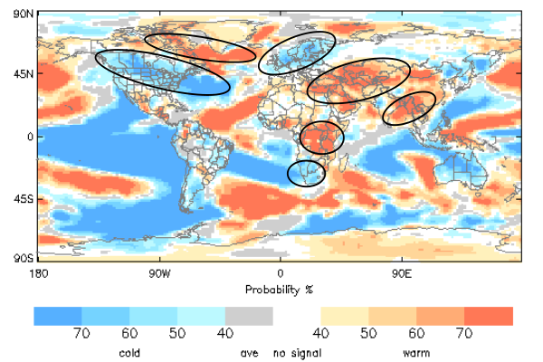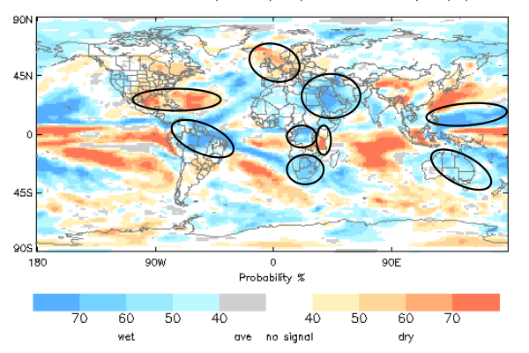

Figure 3: Left: tercile category probability forecasts for 2m temperature, February-April 2011. Blue shading: below-normal most likely; red shading: above-normal most likely; grey shading: average most likely (no probability given); white: equal chances. Left: tercile category probability forecasts for precipitation, February-April 2011. Red shades: below-normal most likely; Blue shades: above-normal most likely; grey shading: average most likely (no probability given); white: equal chances. Land regions with relatively strong and spatially coherent signals are highlighted

- Global-scale climate monitoring

  - Large-scale sea surface temperature (SST) indices

A La Niña event has been maintained throughout October-December. Monthly Niño3 and Niño3.4 SST anomalies were of order -1.6ºC, with little trend over the period.

A negative Indian Ocean Dipole (IOD) index has been maintained throughout, with largest magnitude anomalies in November.

Positive SST anomalies have been maintained over both the southern and northern tropical Atlantic, with weakly negative Tropical Atlantic SST Index [RG: there are different versions of the Atlantic Index, will need to adopt one].

Others?

Month | Niño3 | Niño3.4 | IOD | Trop. Atl. Index
October | -1.7 | -1.6 | -0.15 | TBC
November | -1.6 | -1.6 | -0.34
December | -1.7 | -1.7 | -0.12
Table 1: Large-scale SST indices: October, November, December 2010 [include units?]

  - Large-scale surface pressure indices

The Arctic Oscillation (AO) and North Atlantic Oscillation (NAO) were in negative phase throughout the period, with largest magnitude in December.

Month | AO | NAO | Others? e.g. SOI S.Hem?
October | -0.47 | -2.41
November | -0.38 | -3.34
December | -2.63 | -4.62
Table 2: Large-scale surface pressure indices: October, November, December 2010 [include units]

  - Observed temperature anomalies

Influence of large-scale climate modes
The global land-surface temperature average was xxºC, 0.95ºC above the 1971-2000 average, and the fifth warmest global OND temperature on record. Regional temperature anomalies consistent with La Niña were evident in the observed positive anomalies over the southern USA and the negative anomalies over western coastal regions of South America. Anomalies consistent with negative phase NAO were evident in the quadrapole pattern of positive anomalies over Canada and southwestern Europe/northern Africa and negative anomalies over southeastern USA and northwest Europe.

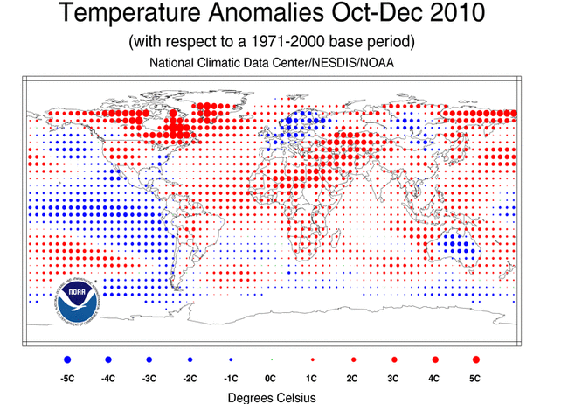

Figure 1: Observed October-December 2010 near-surface temperature anomalies relative to 1971-2000 average.

RA I: Positive temperature anomalies were observed over most of the region, peaking at 2ºC to 3ºC over central Sahel and northern Africa.
RAII: Positive anomalies were observed over most of the region, with peaks of 2ºC to 3ºC in the southwestern and northeastern parts of the region.
RAIII: Positive anomalies (mainly less than 2ºC) were observed over much of the South America. Negative anomalies, associated with La Niña, were observed over the east Pacific and the west coast of South America.
RAIV: Positive anomalies were observed over most land areas, peaking at 3-4ºC over parts of northern Canada. Negative anomalies (mainly less than 2ºC) were observed over south eastern USA, Mexico and Central America.
RAV: Negative anomalies, peaking at 2-3ºC were observed over much of non-coastal Australia. Positive anomalies (less than 2ºC) were observed over most other land regions.
RAVI: Positive anomalies were observed over parts of Greenland (4-5ºC) and over the eastern Mediterranean (2-3ºC). Negative anomalies (peaks of 3-4ºC) were observed over much of northwestern Europe.

[RG: Plots to be replaced with plots giving tercile (or percentile) categories. So text will need to change accordingly]
  - Observed precipitation anomalies

Influence of large-scale climate modes
Regional precipitation anomalies consistent with La Niña were evident in the observed positive anomalies over central and eastern Australia, southern Africa and western North America and in the negative anomalies over southern South America, Tanzania and southeastern USA. Anomalies consistent with negative phase NAO were evident in negative anomalies over northwestern Europe and southeastern USA and positive anomalies over southern Europe.

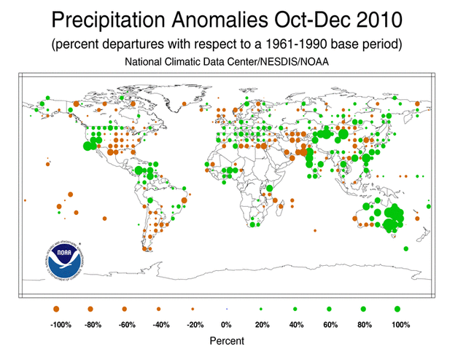
Figure 2: Observed October-December 2010 precipitation anomalies (percent) relative to 1971-2000 average.

NB: Data is sparse in many regions – significant (unobserved) anomalies may be overlooked in the following summary.
RA I: Spatial coherent regions of below-normal rainfall were observed over West Africa (up to 200% of normal) and South Africa (up to 180%). Spatially coherent regions of below-normal rainfall were observed over a region including southern Kenya, northern Tanzania (order 20% of normal) and Madagascar.
RAII: Above-normal rainfall (in excess of 200%) was observed over parts of India, northwestern China and coastal regions of the South China Sea. The main coherent region with below-normal rainfall (around 20%) was observed in eastern parts of the region from Caspian Sea to Pakistan.
RAIII: Below-normal rainfall (40-60%) was observed over much of the southern half of the South American continent. Above-normal rainfall (exceeding 200%) was observed over parts of the extreme northwest of the continent.
RAIV: Above-normal rainfall (exceeding 200%) was observed over parts of the western half of the USA, while below-normal rainfall was observed over the eastern half (less than 10% in southern areas). Above-normal rainfall (exceeding 200%) was observed in southern parts of Central America.
RAV: Above-normal rainfall was observed over much of the eastern half of the Australia continent, with values in excess of 200%, particularly over Eastern Australia.
RAVI: Below-normal rainfall (40-60%) was observed over much of northern Europe. Above-normal rainfall (reaching 180%) was observed over much of southern Europe.

[RG: Plots to be replaced with plots giving tercile (or percentile) categories. Text would need to change accordingly. NB: I have written current text in terms of % of normal rather than % anomaly]
1.5 Climate anomalies and events October-December 2010

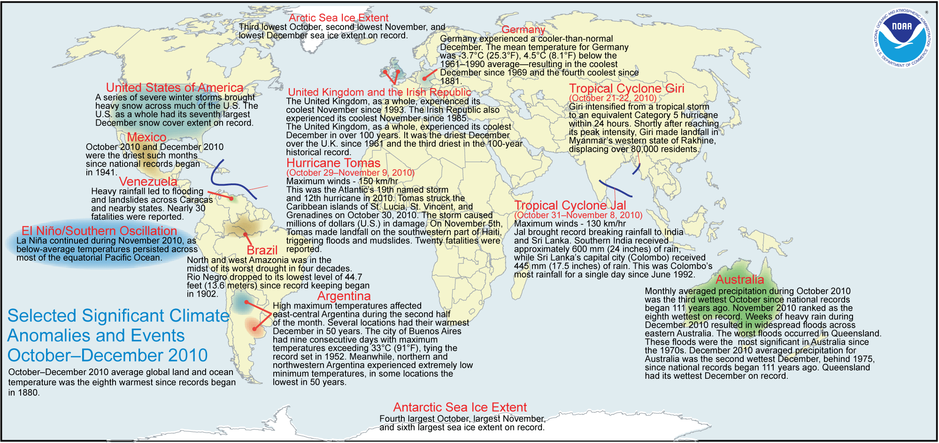

Figure. 3: Selected significant climate anomalies and events October-December 2010

- Potential evolution of the state of the climate over the next 4 months (February-May) 2011

  - Predicted large-scale sea surface temperature (SST) indices
La Niña conditions are expected to continue over the next 4 months, but with the magnitude of negative anomalies slowly decreasing (Figure 4).

Development of a positive phase Indian Ocean Dipole (IOD) is favoured (skill=?). This reflects predicted high probabilities for negative SST anomalies in the southwest Indian Ocean while neutral or above normal anomalies are favoured for the eastern part of the basin.

Development of a positive phase Tropical Atlantic Index is favoured (skill=?). This reflects predicted high probabilities for positive anomalies in the tropical north Atlantic and weaker signals for neutral or negative anomalies in the southern tropical Atlantic.
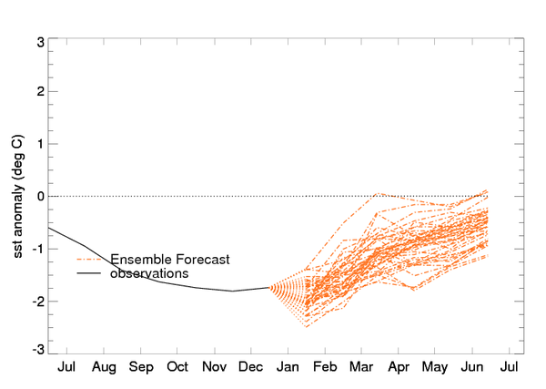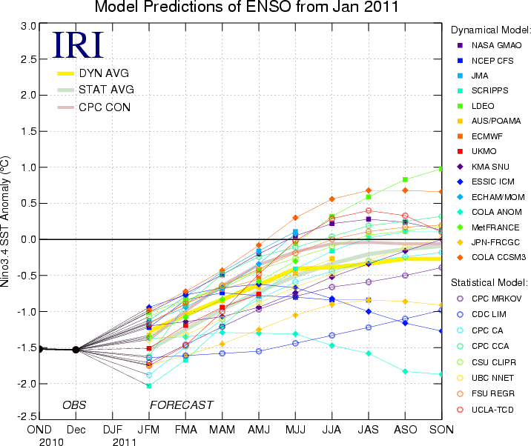
Figure 4: Multi-model forecasts for tropical Pacific SST anomaly (Niño3.4 region). Left LC-LRFMME (pending - GPC Exeter shown); right: including other dynamical systems and statistical systems (source=IRI).

Month | Niño3 | Niño3.4 | IOD | Trop. Atl. Index
February | EM+spread (skill) | EM+spread (skill) | EM+spread (skill) | EM+spread (skill)
March | “ | “ | “ | “
April | “ | “ | “ | “
May | “ | “ | “ | “
Table 3: Predicted large-scale SST indices (LC-LRFMME ensemble mean), 2011

  - Predicted large-scale surface pressure indices
[Inclusion of this section will be dependent on skill – which was demonstrated to be low at the scoping meeting].

Month | AO | NAO | Others? S. Hem?
February | EM+spread (skill) | EM+spread (skill) | EM+spread (skill)
March | “ | “ | “
April | “ | “ | “
May | “ | “ | “
Table 4: Predicted large-scale surface pressure indices, 2011

  - Predicted temperature anomalies

    - February-April 2011
Influence of predicted large-scale climate modes
Predicted regional temperature anomalies broadly consistent with continuing La Niña conditions are evident in probabilities favouring below-normal temperatures over northwestern North America, the western coast and southern equatorial east coast of South America, southern Africa, and northeastern Asia.

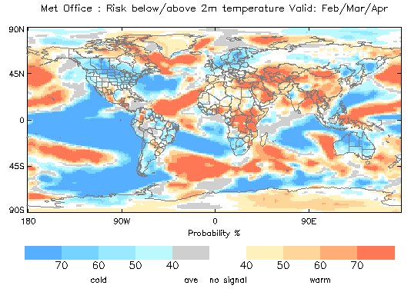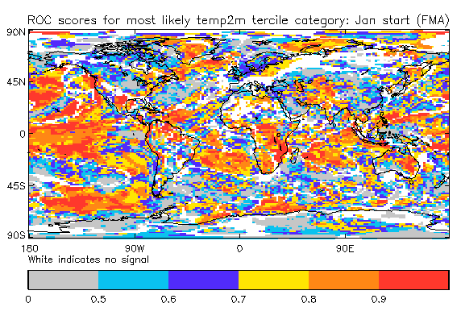
LC-LRFMME (pending) Long-term MME skill (pending)
Figure 3: Left: Tercile category probability forecasts for 2m temperature, February-April 2011. Blue shading: below-normal most likely; red shading: above-normal most likely; grey shading: average most likely (no probability given); white: equal chances. Right: ROC scores, at each point displayed for the category forecast as most likely at that location. Skill values are not plotted at points with no forecast signal. The ROC score may be interpreted as the fraction of hindcast years for which the forecast correctly discriminated the observed category, with a score of 0.5 indicating no skill (i.e. no better than guesswork).

RA I: Probabilities favour above-normal temperatures over much of equatorial Africa, and below-normal temperatures over southwestern parts of the continent (skill=good, both regions). There is no signal for much of the Sahel region (skill=low) where above-normal OND temperatures were observed (cf. Fig. 1).
RAII: In general, probabilities favour the same sign anomalies as observed in OND. Notably, above-normal anomalies are predicted with high probability in the southwest of the region and in countries border the Bay of Bengal (skill=good, both regions).
RAIII: There are relatively strong signals for below-normal anomalies over western coasts of South America (SC, OND; skill=modest) and over southern tropical regions of Atlantic coast as well as for the southern half of the continent (skill=low). Elsewhere signals are either weak or favour the average category.
RAIV: In high latitudes probabilities favour positive anomalies (SC, OND; skill=low). Below-normal anomalies are favoured over much of the rest of the continent (skill=low). Above-normal anomalies are favoured over southern North America (skill=good) and over Central America (skill=variable).
RAV: Development of below-normal anomalies is favoured over western and northern maritime southeast Asia (skill=good). Above-normal anomalies are favoured over eastern maritime Asia (skill=low). Below-normal anomalies are indicated for much of Australia (SC, OND; skill=variable). Above-normal anomalies are indicated for New Zealand (SC, OND; skill=low).
RAVI: Skill is low over most of the region. Below-normal anomalies are indicated for the northwest and above-normal anomalies for parts of the southeast (SC, OND – both regions).

    - Predicted temperature anomalies: March-May 2011
In general, predicted category probabilities for March-May 2011 are similar to those for February-April 2011, largely reflecting the 2-month overlap in target period. As expected at longer range, signals are generally (though not always) less confident. Regions where predictions for the two periods have notable differences are highlighted below.

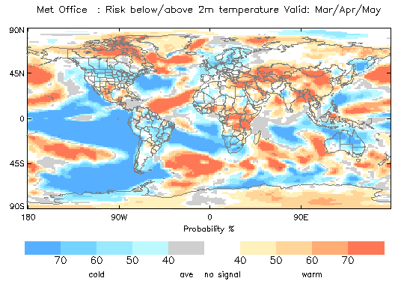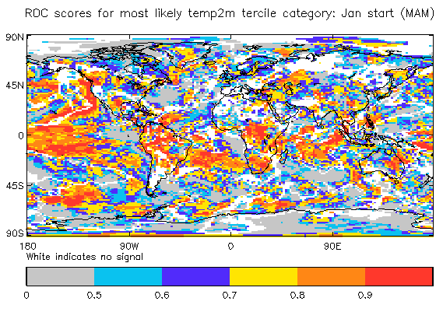
LC-LRFMME (pending) Long-term MME skill (pending)

Figure 4: As Fig. 3, but for March-April-May 2011.

RA I: Little change in overall signal.
RAII: Little change in overall signal.
RAIII: Little change in overall signal
RAIV: Above-normal anomalies in high latitudes are predicted with high confidence than for February-April, but skill is low.
RAV: Little change in overall signal.
RAVI: Little change in overall signal.

  - Predicted precipitation anomalies

    - February-April 2011
Influence of predicted large-scale climate modes
Predicted regional precipitation anomalies broadly consistent with continuing La Niña conditions are evident in probabilities biased to above-normal rainfall over northern South America, southern Africa, and western North America and below-normal over equatorial western South America as well as parts of the southern half of the continent, equatorial East Africa, and southern parts of North America and the Caribbean.

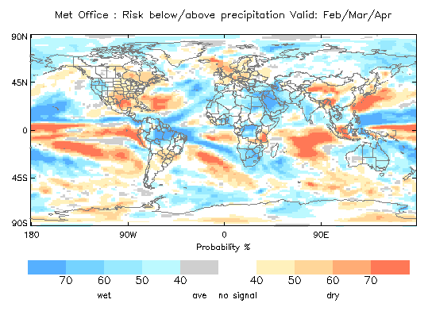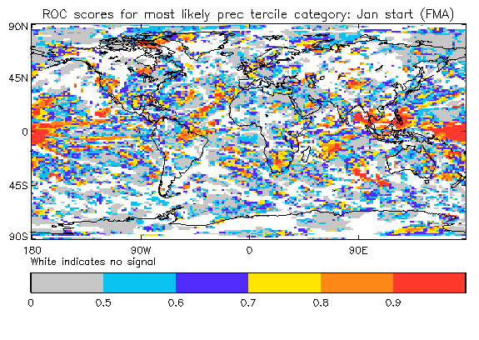
LC-LRFMME (pending) Long-term skill (pending)
Figure 5: Left: tercile category probability forecasts for precipitation, February-April 2011. Red shades: below-normal most likely; blue shades: above-normal most likely; grey: average most likely (no probability given); white: equal chances. Right: ROC scores, as Fig.3 – but for precipitation.

RA I: Probabilities favour above-normal over southern Africa (SC, OND; skill=good), and also over parts of central and western Africa and the Horn of Africa (skill=low, all regions). Below-normal anomalies are indicated over parts of equatorial East Africa (SC, OND; skill=modest).
RAII: Above-normal rainfall is indicated over western parts of the region (OC, OND; skill=low), and also over the Indian Peninsula (SC, OND; skill=low). Below-normal rainfall is indicated over parts of western China (OC, OND; skill=low).
RAIII: Above-normal rainfall is strongly indicated over much of northern South America (skill=variable) – though below-normal is favoured over western equatorial regions. Below-normal anomalies are indicated over the southern half of South America (SC, OND; skill=low).
RAIV: Probabilities favour below-normal rainfall over southwestern parts of North America (SC, OND; skill=modest). Below-normal anomalies are also favoured over much of the eastern half of North America (skill= low). Above-normal rainfall is indicated over some western regions of North America (SC, OND; skill=modest) and also over Central America and southern Caribbean (skill=modest, both regions).
RAV: Above-normal anomalies are indicated over eastern and northern Australia (SC, OND; skill= low) and strongly favoured over some eastern parts of the maritime continent (skill=good). Below-normal anomalies are favoured over parts of the southwestern maritime continent (skill=variable).
RAVI: Below normal anomalies are indicated over northwestern regions (SC, OND; skill=variable). Above-normal anomalies are indicated over some southern regions (SC, OND; skill=low).

    - Predicted precipitation anomalies: March-May 2011
In general, predicted category probabilities for March-May 2011 are similar to those for February-April 2011, largely reflecting the 2-month overlap in target period. As expected at longer range, signals are generally (though not always) less confident. Regions where predictions for the two periods have notable differences are highlighted below.

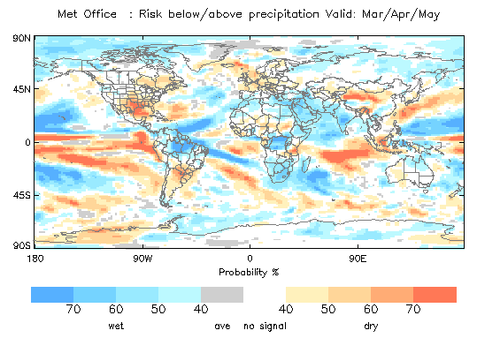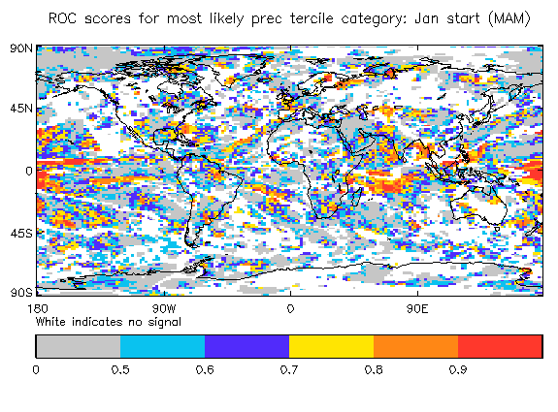
LC-LRFMME (pending) Long-term skill (pending)

Figure 6: As Fig. 5, but for March-April-May 2011.

RA I: Little change in overall signal.
RAII: Little change in overall signal.
RAIII: Some strengthening of the signal for below-normal rainfall over central eastern South America (skill=modest). Elsewhere little change.
RAIV: There is a weakening of the signal for above-normal rainfall over central western North America. Elsewhere little change.
RAV: There is a weakening of the signal for above-normal rainfall over eastern and northern Australia (skill=low) and also over the eastern and northern maritime continent (skill=variable). Elsewhere little change.
RAVI: Little change in overall signal.

- How to use the Global Seasonal Climate Update

- Seasonal outlooks for any region or nation should be obtained from the relevant Regional Climate Centre (RCC) or National Meteorological and Hydrological Service (NMHS). The GSCU is intended as guidance for RCC and NMHSs. It does not constitute an official forecast for any region or nation.
- Seasonal forecasts are probabilistic in nature. Although the text and figures used in the GSCU highlight the tercile categories with highest predicted probability, it is important to recognise that the other tercile categories may also have substantial (though lower) probability.
- The geographical areas occupied by the forecast signals should not be considered precise. Similarly, signals with small spatial extent may be unreliable.
- The skill of seasonal forecasts is substantially lower than for shorter range and skill may vary considerably with region and season. It is important to view the forecast maps together with the skill maps provided.
- In general each forecast statement in sections 1 and 2 is followed by a comment on forecast skill [RG: need definitions of good, low, variable].
- Where either of the outer-tercile categories are indicated most likely, each forecast statement is also followed by a comment indicating whether the category indicated as most likely is the same (Same Category=SC) or opposite (Opposite Category=OC) to that observed over the 3-month monitoring period. Note, however, that the monitoring period and forecast period are separated by one month.
- For reference the 6 WMO Regional Association regions are provided in the figure below.

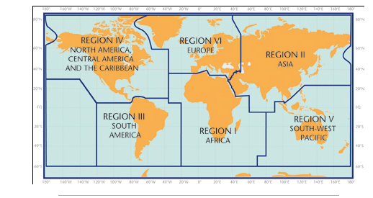
References [RG: its difficult to know where to stop with this list…]
Sources for the graphics used in the GSCU:
NOAA National Climatic Data Centre: http://www.ncdc.noaa.gov/oa/ncdc.html
The WMO Lead Centre for Long-Range Forecast Multi-Model Ensemble prediction (LC-LRFMME): http://www.wmolc.org

The WMO Lead Centre for the Standard Verification System for Long-Range Forecasts (LC-SVSLRF): http://www.bom.gov.au/wmo/lrfvs/

Other resources:
WMO portal to the Global Producing Centres (GPC) for Long-range Forecasts: http://www.wmo.int/pages/prog/wcp/wcasp/clips/producers_forecasts.html

International Research Institute for Climate and Society (IRI):
http://portal.iri.columbia.edu/portal/server.pt
WMO Portal for Regional Climate Outlook Forums (RCOFs):
http://www.wmo.int/pages/prog/wcp/wcasp/clips/outlooks/climate_forecasts.html

Acknowledgements
This Global Seasonal Climate Update has been generated using contributions from the following centres:
List…TBD
Appendix 3.3.2

DRAFT OUTLINE MARK 1

Global Seasonal Climate Update
September 2011

Summary
A moderate to strong La Niña event has been sustained over the previous 3-month period (October to December). Predictions indicate that La Niña conditions will most likely continue, but weaken over the next 4 months (February to May). Dynamical forecast signals for February-April temperature and precipitation broadly consistent with continuing La Niña are evident in:
- probabilities biased to below-normal temperatures over northwestern North America, the western and southern tropical east coasts of South America, southern Africa, and northeastern Asia.
- probabilities biased to above-normal rainfall over northern South America, southern Africa, and western North America and below-normal over equatorial western South America as well as parts of the southern half of the continent, equatorial East Africa, and southern parts of North America and the Caribbean.

The Indian Ocean Dipole (IOD) Index has been negative throughout October to November, with strongest amplitude in November. Dynamical model predictions indicate that the IOD will most likely become positive over the February to May period. This is consistent with forecast probabilities favouring below-normal rainfall over southwestern parts of the maritime continent of southeast Asia.

Forecast signals with relatively strong and spatially coherent signals over land are indicated below (for details, including on forecast skill, see the body of the report):

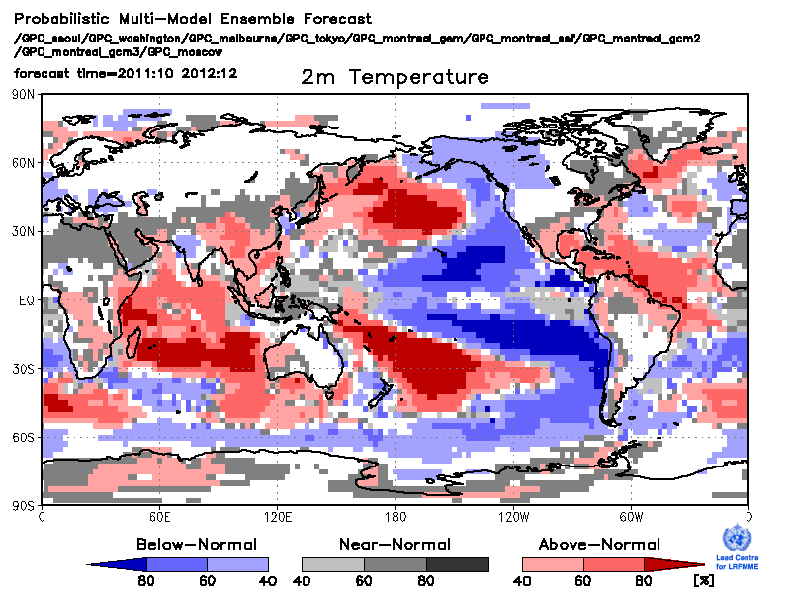 | 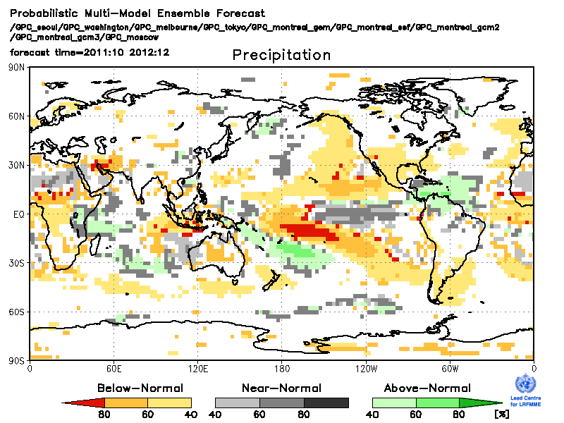

Figure 1: Left: tercile category probability forecasts for 2m temperature, October-December 2011. Blue shading: below-normal most likely; red shading: above-normal most likely; grey shading: near normal most likely; white: equal chances. Left: tercile category probability forecasts for precipitation, October-December 2011. Orange shades: below-normal most likely; green shades: above-normal most likely; grey shading: near normal most likely (no probability given); white: equal chances. Land regions with relatively strong and spatially coherent signals are highlighted

- Global-scale climate monitoring

  - Observed temperature
The global land-surface temperature average was xxºC, 0.95ºC above the 1971-2000 average, and the fifth warmest global OND temperature on record. Regional temperature anomalies consistent with La Niña were evident in the observed positive anomalies over the southern USA and the negative anomalies over western coastal regions of South America. Anomalies consistent with negative phase NAO were evident in the quadrapole pattern of positive anomalies over Canada and southwestern Europe/northern Africa and negative anomalies over southeastern USA and northwest Europe.

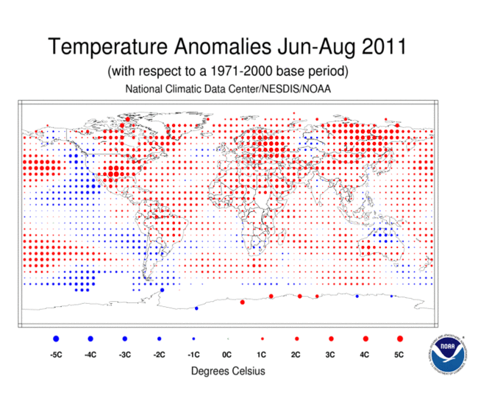 | 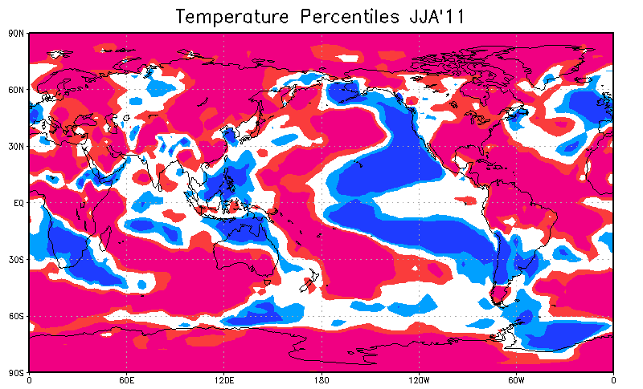
Figure 2: Observed June – August 2011 near-surface temperature anomalies relative to 1971-2000 (left panel) and near-surface temperature percentiles (from blue to red: 15%, 33%, 67%, 85%) relative to 1983-2002 (right panel).

RA I: Positive temperature anomalies were observed over most of the region, peaking at 2ºC to 3ºC over central Sahel and northern Africa.
RAII: Positive anomalies were observed over most of the region, with peaks of 2ºC to 3ºC in the southwestern and northeastern parts of the region.
RAIII: Positive anomalies (mainly less than 2ºC) were observed over much of the South America. Negative anomalies, associated with La Niña, were observed over the east Pacific and the west coast of South America.
RAIV: Positive anomalies were observed over most land areas, peaking at 3-4ºC over parts of northern Canada. Negative anomalies (mainly less than 2ºC) were observed over south eastern USA, Mexico and Central America.
RAV: Negative anomalies, peaking at 2-3ºC were observed over much of non-coastal Australia. Positive anomalies (less than 2ºC) were observed over most other land regions.
RAVI: Positive anomalies were observed over parts of Greenland (4-5ºC) and over the eastern Mediterranean (2-3ºC). Negative anomalies (peaks of 3-4ºC) were observed over much of northwestern Europe.

1.3Observed precipitation
Regional precipitation anomalies consistent with La Niña were evident in the observed positive anomalies over central and eastern Australia, southern Africa and western North America and in the negative anomalies over southern South America, Tanzania and southeastern USA. Anomalies consistent with negative phase NAO were evident in negative anomalies over northwestern Europe and southeastern USA and positive anomalies over southern Europe.

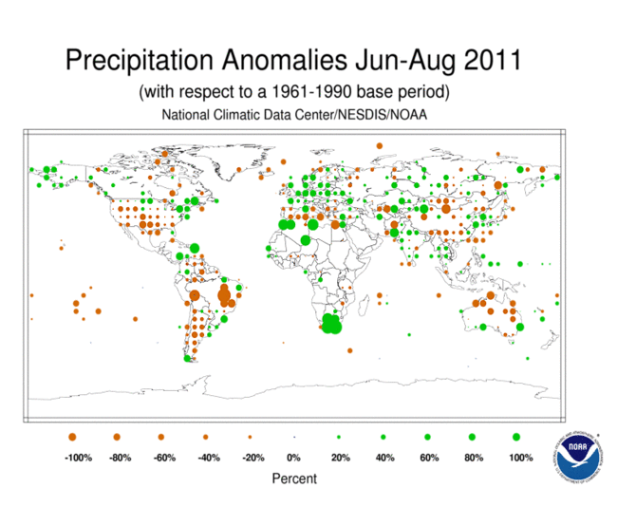 | 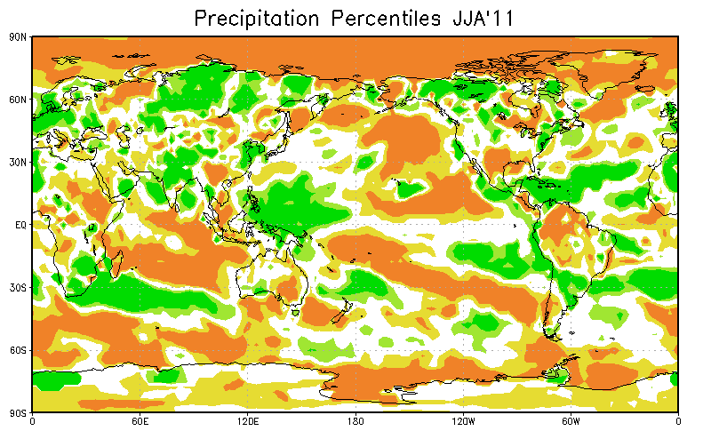
Figure 3: Observed June – August 2011 precipitation anomalies relative to 1971-2000 (left panel) and precipitation percentiles (from brown to green: 15%, 33%, 67%, 85%) relative to 1983-2002 (right panel).

RA I: Spatial coherent regions of below-normal rainfall were observed over West Africa (up to 200% of normal) and South Africa (up to 180%). Spatially coherent regions of below-normal rainfall were observed over a region including southern Kenya, northern Tanzania (order 20% of normal) and Madagascar.
RAII: Above-normal rainfall (in excess of 200%) was observed over parts of India, northwestern China and coastal regions of the South China Sea. The main coherent region with below-normal rainfall (around 20%) was observed in eastern parts of the region from Caspian Sea to Pakistan.
RAIII: Below-normal rainfall (40-60%) was observed over much of the southern half of the South American continent. Above-normal rainfall (exceeding 200%) was observed over parts of the extreme northwest of the continent.
RAIV: Above-normal rainfall (exceeding 200%) was observed over parts of the western half of the USA, while below-normal rainfall was observed over the eastern half (less than 10% in southern areas). Above-normal rainfall (exceeding 200%) was observed in southern parts of Central America.
RAV: Above-normal rainfall was observed over much of the eastern half of the Australia continent, with values in excess of 200%, particularly over Eastern Australia.
RAVI: Below-normal rainfall (40-60%) was observed over much of northern Europe. Above-normal rainfall (reaching 180%) was observed over much of southern Europe.

1.4 Climate anomalies and events, June - August 2011

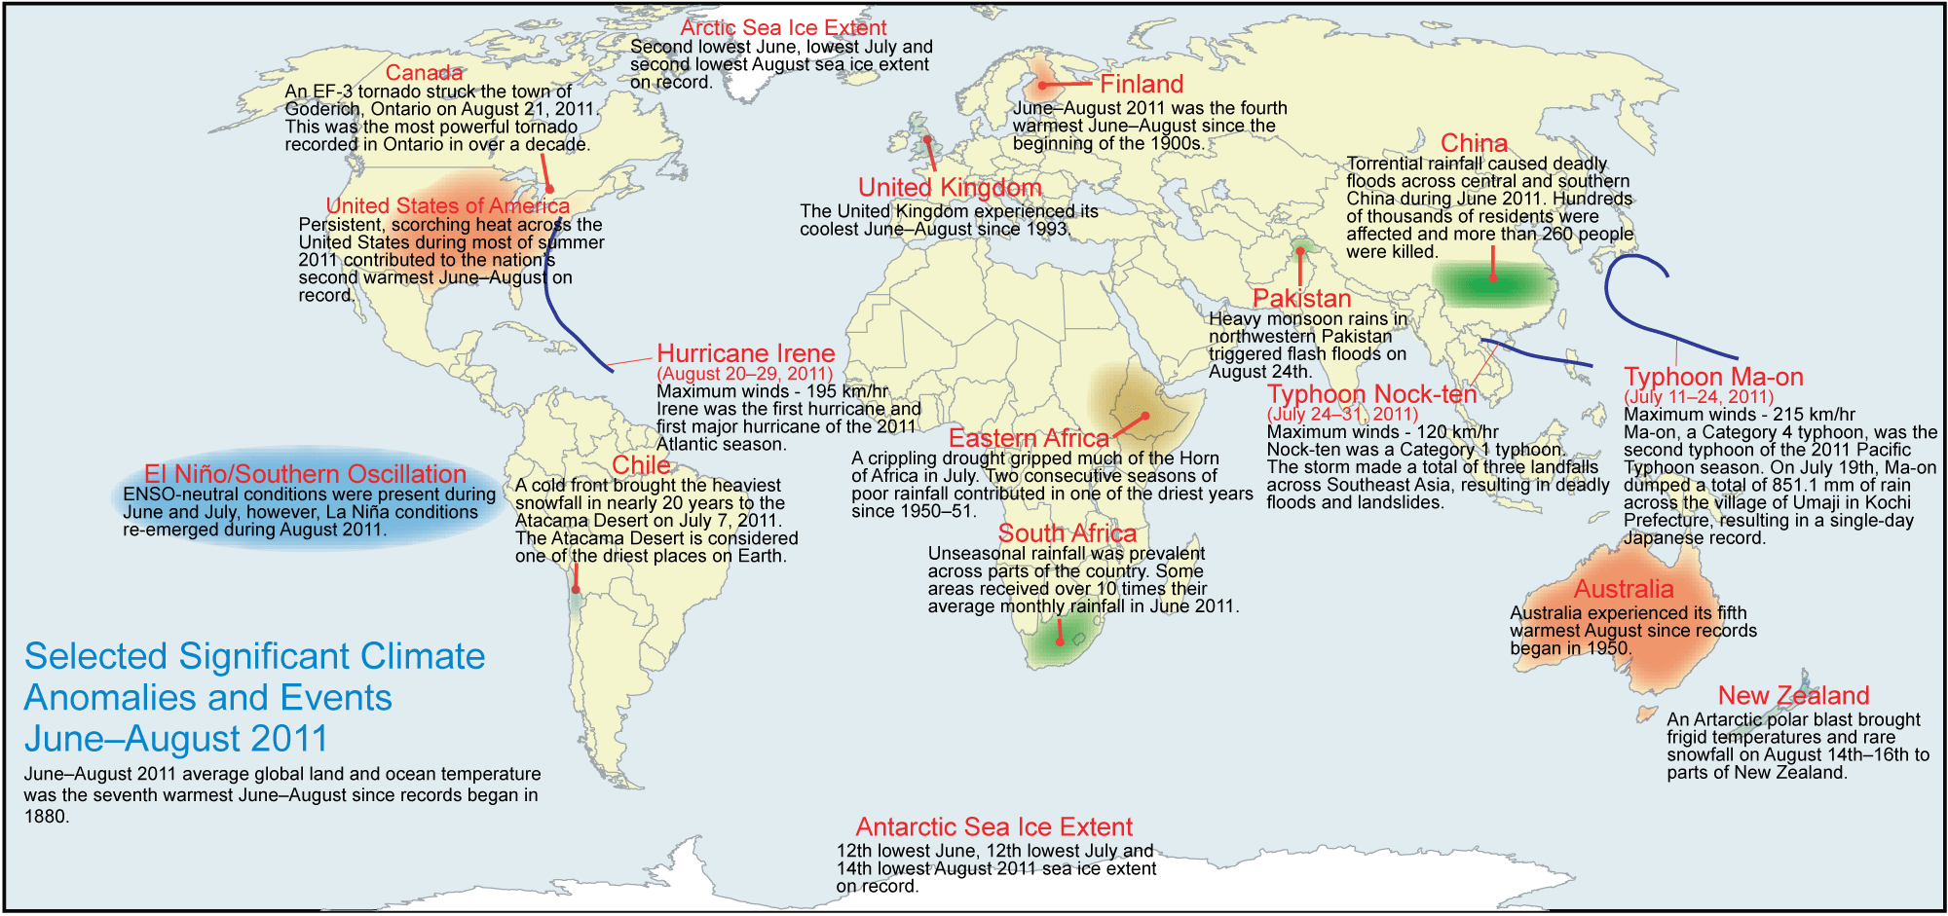

Figure. 4: Selected significant climate anomalies and events, June - August 2011

- Potential evolution of the state of the climate over the next three months (October-December) 2011

2.1. Predicted mid-troposphere circulation, October-December 2011
Necessary notification: continental scale “no signal” areas in Figs. 6 - 8 indicate essential inconsistence between the individual model forecasts which is typical for the near neutral ENSO state and associated weak forcing.
Prevailing of near normal conditions, with probabilities of anomalies of both signs being quite small.
Aleutian high is expected to be weaker than normal which tends to provide an anomalous NW advection to North America.
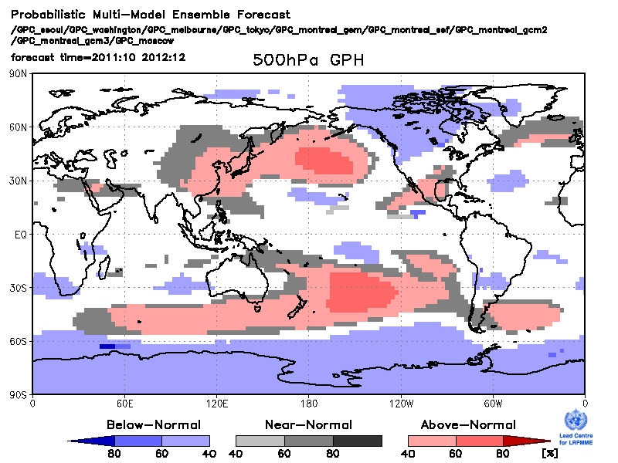 | ROC map to be done in October
Figure 6: Left: Tercile category probability forecasts for Z500, October-December 2011. Blue shading: below-normal most likely; red shading: above-normal most likely; grey shading: near normal most likely; white: equal chances. Right: ROC scores, at each point displayed for the category forecast as most likely at that location. Skill values are not plotted at points with no forecast signal. The ROC score may be interpreted as the fraction of hindcast years for which the forecast correctly discriminated the observed category, with a score of 0.5 indicating no skill (i.e. no better than guesswork).

  - Predicted temperature, October-December 2011
Prevailing of near normal conditions, with probabilities of anomalies of both signs being quite small.
ROC map to be done in October

LC-LRFMME Long-term skill
Figure 7: Left: Tercile category probability forecasts for 2m temperature, October-December 2011. Blue shading: below-normal most likely; red shading: above-normal most likely; grey shading: near normal most likely; white: equal chances. Right: ROC scores, at each point displayed for the category forecast as most likely at that location. Skill values are not plotted at points with no forecast signal. The ROC score may be interpreted as the fraction of hindcast years for which the forecast correctly discriminated the observed category, with a score of 0.5 indicating no skill (i.e. no better than guesswork).

RA I: Near normal conditions prevail over the whole Africa continent.
RAII: Prevailing of the positive anomaly over South-East Asia. No signal (inconsistent forecasts) for North Asia.
RAIII: near normal conditions prevail, with inconsistency between the forecasts being essential.
RAIV: Near normal conditions prevail with slightly increased probability of negative anomalies over the North West of the continent.
RAV: Near normal conditions prevail over the whole continent, with inconsistency between the forecasts being essential
RAVI: No signal (inconsistent forecasts) for most of Europe.

  - Predicted precipitation. October-December 2011
Prevailing of near normal conditions, with probabilities of anomalies of both signs being quite small.
ROC map to be done in October

LC-LRFMME Long-term skill
Figure 8: Left: tercile category probability forecasts for precipitation, October-December 2011. Orange shades: below-normal most likely; green shades: above-normal most likely; grey: near normal most likely; white: equal chances. Right: ROC scores, as Fig.3 – but for precipitation.

RA I: Prevailing of near normal conditions with enhances probability of anomalously dry weather in the Equatorial Africa.
RAII: No signal (inconsistent forecasts) throughout the whole continent with exception of low precipitation anomaly around the Persian Gulf.
RAIII: No signal (inconsistent forecasts) throughout the whole continent.
RAIV: Prevailing of near normal conditions.
RAV: Prevailing of near normal conditions
RAVI: No signal (inconsistent forecasts) throughout the whole continent.
- How to use the Global Seasonal Climate Update
- Seasonal outlooks for any region or nation should be obtained from the relevant Regional Climate Centre (RCC) or National Meteorological and Hydrological Service (NMHS). The GSCU is intended as guidance for RCC and NMHSs. It does not constitute an official forecast for any region or nation.
- Seasonal forecasts are probabilistic in nature. Although the text and figures used in the GSCU highlight the tercile categories with highest predicted probability, it is important to recognise that the other tercile categories may also have substantial (though lower) probability.
- The geographical areas occupied by the forecast signals should not be considered precise. Similarly, signals with small spatial extent may be unreliable.
- The skill of seasonal forecasts is substantially lower than for shorter range and skill may vary considerably with region and season. It is important to view the forecast maps together with the skill maps provided.
- In general each forecast statement in sections 1 and 2 is followed by a comment on forecast skill. We use the ROC score. We define the skill to be GOOD if ROC score is above the 90% confident level (for 20-25 years it is above appr. 0.7); VARIABLE of 0.5<ROC score<=0.7; LOW if ROC score <= 0.5.
- For reference the 6 WMO Regional Association regions are provided in the figure below.

References

Sources for the graphics used in the GSCU:
NOAA National Climatic Data Centre: http://www.ncdc.noaa.gov/oa/ncdc.html
The WMO Lead Centre for Long-Range Forecast Multi-Model Ensemble prediction (LC-LRFMME): http://www.wmolc.org
International Research Institute for Climate and Society (IRI):
http://portal.iri.columbia.edu/portal/server.pt
APEC Climate Center: www.apcc21.net
The WMO Lead Centre for the Standard Verification System for Long-Range Forecasts (LC-SVSLRF): http://www.bom.gov.au/wmo/lrfvs/

WMO resources:
WMO portal to the Global Producing Centres (GPC) for Long-range Forecasts: http://www.wmo.int/pages/prog/wcp/wcasp/clips/producers_forecasts.html
WMO Portal for Regional Climate Outlook Forums (RCOFs):
http://www.wmo.int/pages/prog/wcp/wcasp/clips/outlooks/climate_forecasts.html

Acknowledgements
This Global Seasonal Climate Update is an international effort, with contributions coming from:
- National Climate Data Center;
- Global Producing Centres: Beijing, CPTEC, ECMWF, Exeter, Melbourne, Montreal, Moscow, Pretoria, Seoul, Tokyo, Toulouse, Washington;
- WMO Lead Centre for Long-Range Forecast Multi-Model Ensemble;
- International Research Institute for Climate and Society;
- Met Office;
- Meteo France.

APPENDIX 1

Large-scale sea surface temperature (SST) indices

The ENSO state is neutral

A near neutral phase of the Indian Ocean Dipole (IOD) has been maintained since spring 2011.

Positive SST anomalies have been maintained over both North and South Tropical Atlantic.

Month | Niño3.4 | Niño 1+2 | IOD | NTA | STA
June | -0.18 | 0.85 | 0.01 | 0.79 | 0.01
July | -0.26 | 0.45 | -0.13 | 0.46 | 0.11
August | -0.64 | 0.00 | -0.06 | 0.46 | 0.15
Table 1: Large-scale SST indices: June-August 2011
(Source:
http://www.cpc.ncep.noaa.gov/data/indices/sstoi.indices; www.apcc21.net;
http://www.cpc.ncep.noaa.gov/data/indices/sstoi.atl.indices)

Large-scale circulation indices

The Arctic Oscillation (AO) and North Atlantic Oscillation (NAO) were in negative phase throughout the period, with other Northern Hemisphere Teleconnection indices significantly varying.

Month | AO | NAO | PNA | EA/WR | SCAND | POL
June | -0.858 | -0.93 | 1.80 | -0.44 | 0.01 | -1.45
July | -0.472 | -1.62 | -0.84 | -0.71 | -0.30 | 0.84
August | -1.063 | -1.85 | -2.08 | 0.30 | -3.09 | 0.07

Table 2: Large-scale circulation indices: June - August 2011
(Source: http://www.cpc.ncep.noaa.gov/products/precip/CWlink/daily_ao_index/monthly.ao.index.b50.current.ascii.table; ftp://ftp.cpc.ncep.noaa.gov/wd52dg/data/indices/tele_index.nh)

APPENDIX 2

Predicted large-scale sea surface temperature (SST) indices

Neutral to weak La Niña conditions are expected to continue over the forthcoming season.
Neutral to positive phase of Indian Ocean Dipole (IOD) is favoured.
Both North and South Tropical Atlantic indices are expected to be near normal.

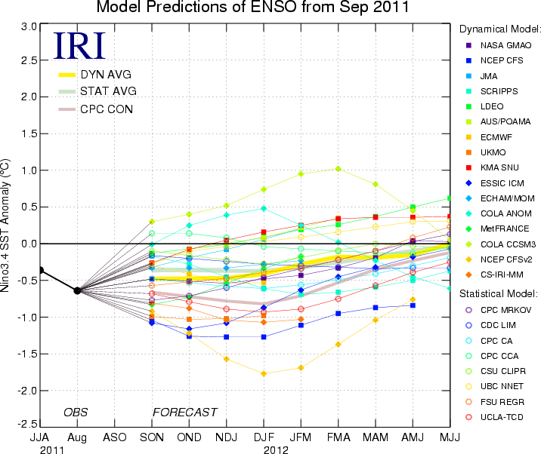Nino 3.4 | 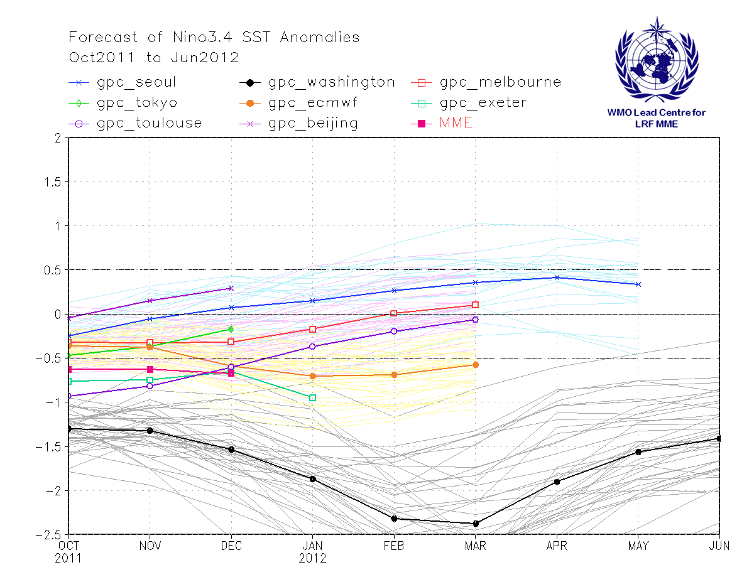Nino 3.4
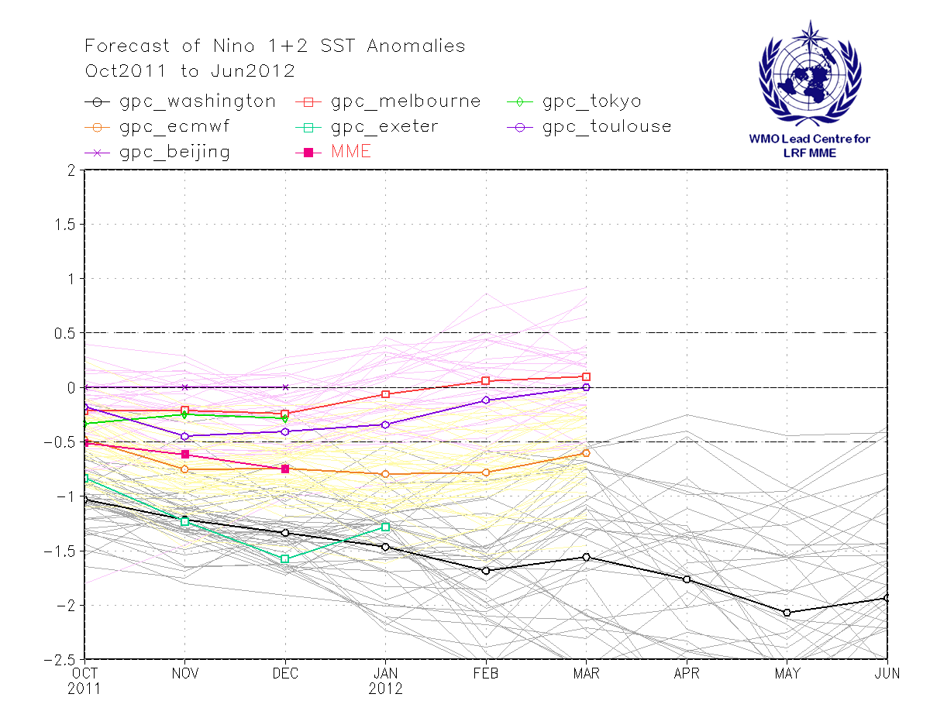Nino 1+2 | 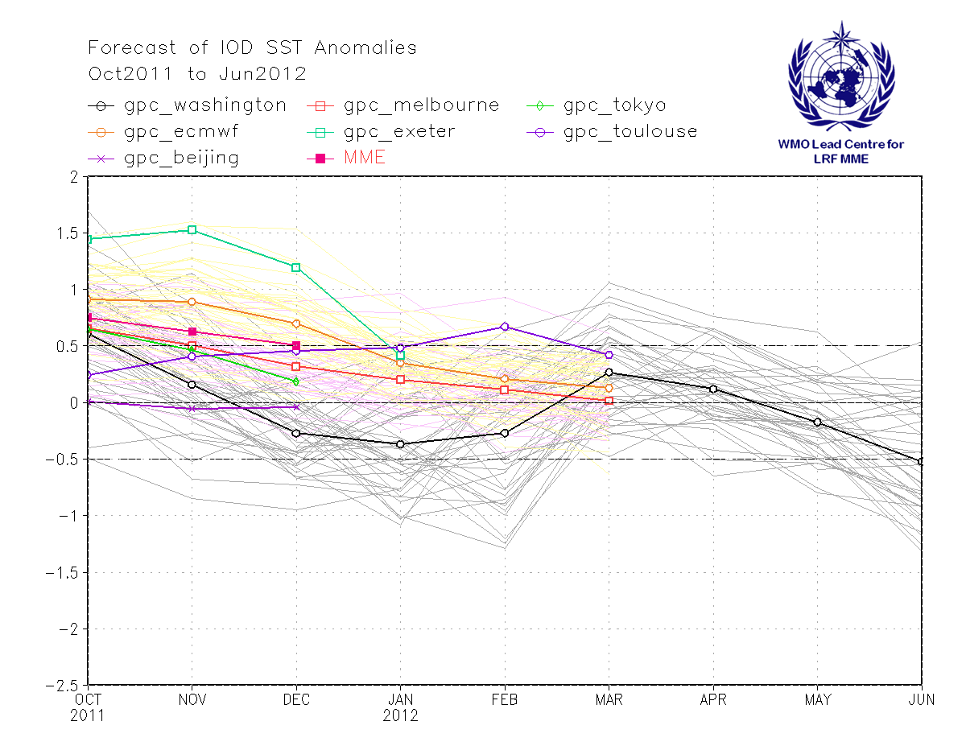IOD
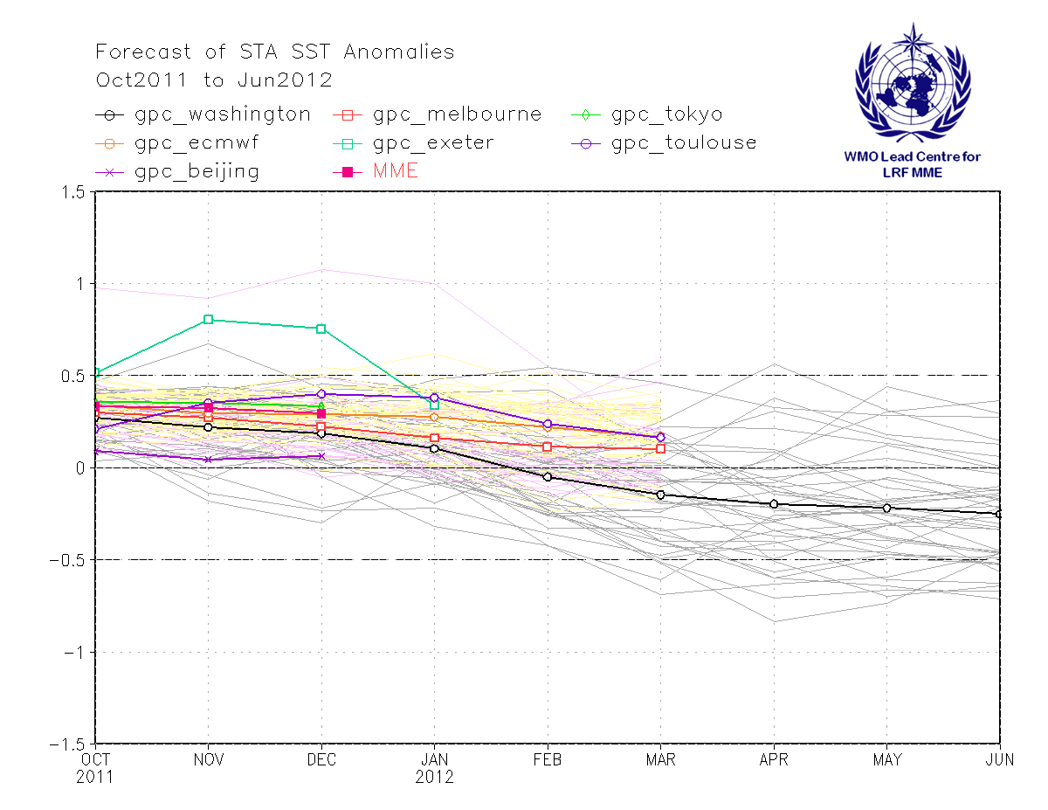NTA | 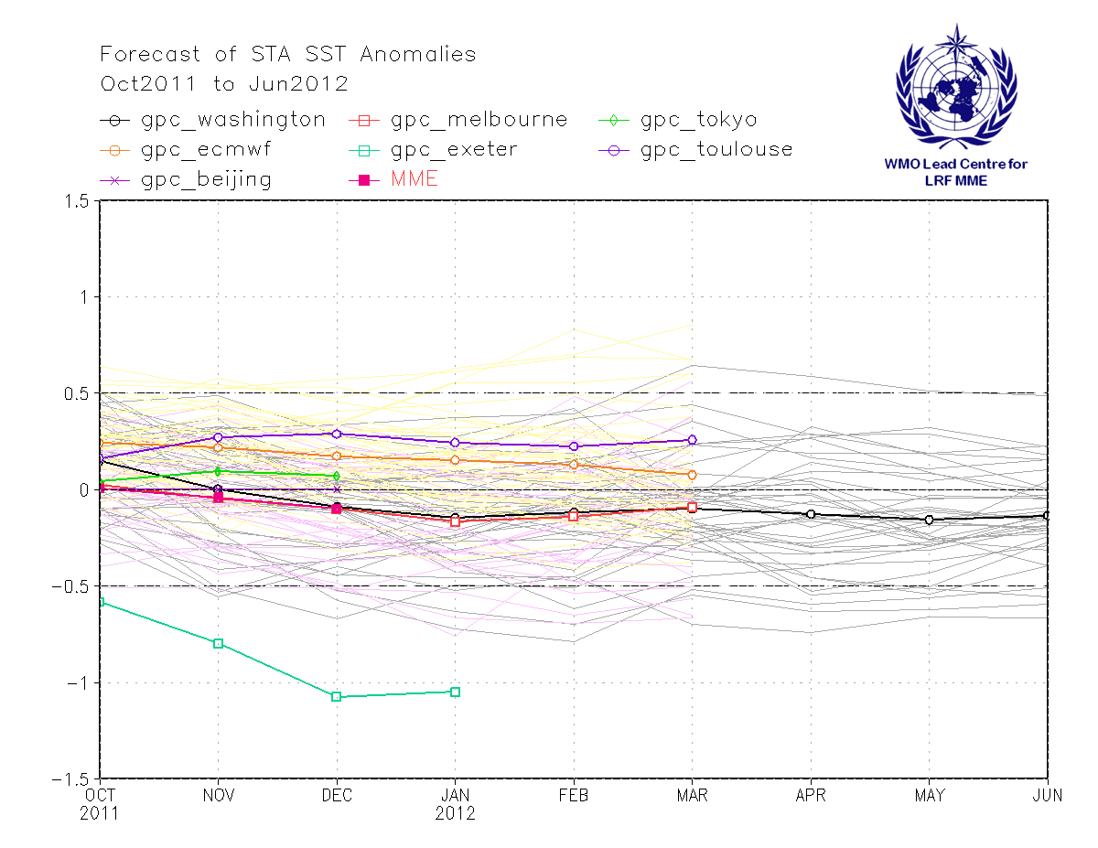STA
Figure 5: Multi-model forecasts for the oceanic indices.
Upper panel: Nino 3.4 index, left: the IRI’s analysed set of dynamical and statistical systems (http://iri.columbia.edu/climate/ENSO/currentinfo/SST_table.html); right: LC LRFMME;
middle panel: left: Nino 1+2; right: IOD from LC LRFMME;
lower panel: left NTA; right STA from LC LRFMME.
APPENDIX 3

Predicted variables with the one month lead time: October - December’11

Forecast (tercile probabilities) | Historical Skill (ROC scores)
Z500
 | ROC map to be done in October
SLP
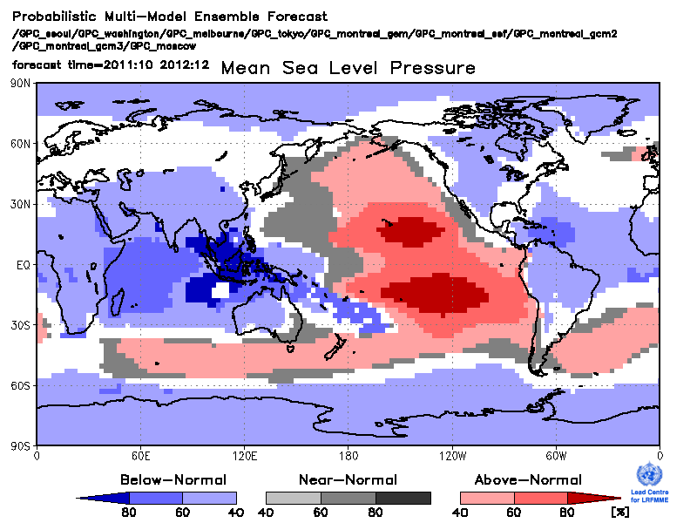 | ROC map to be done in October
T850
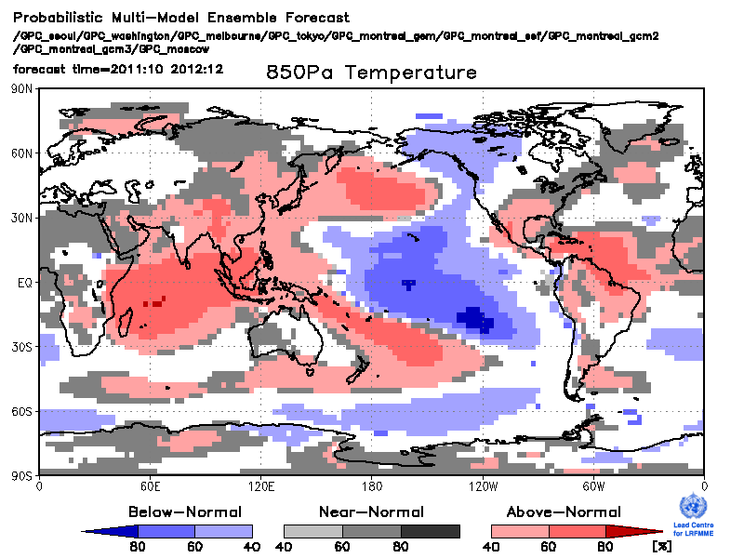 | ROC map to be done in October

T2m
 | ROC map to be done in October
Precipitation
 | ROC map to be done in October
SST
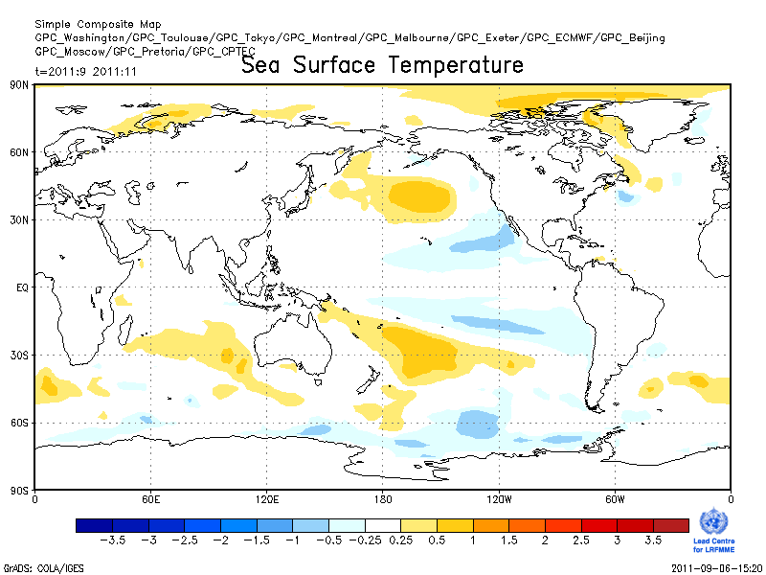 | ROC map to be done in October

APPENDIX 4 (only GPC Melbourne forecasts are available today. Real time of implermentation of this table is when most of the GPCs provide these data to construct the PMME)

Predicted variables with the two month lead time: November’11-January’12
Forecast (tercile probabilities) | Historical Skill (ROC scores)
Z500
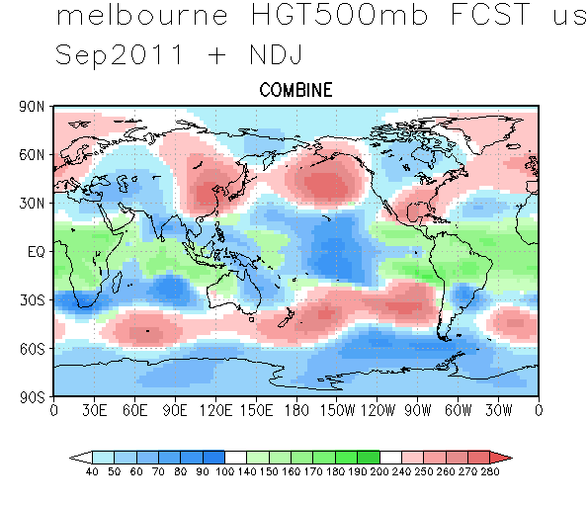 | ROC map
SLP
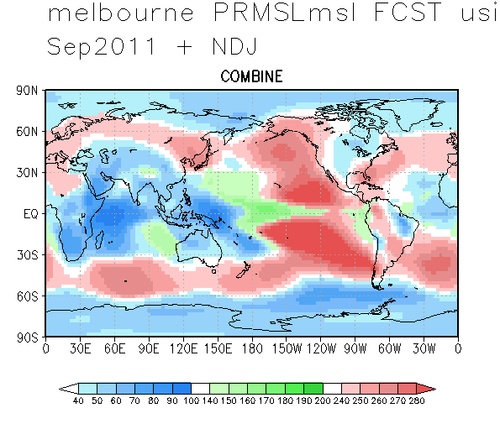 | ROC map
T850
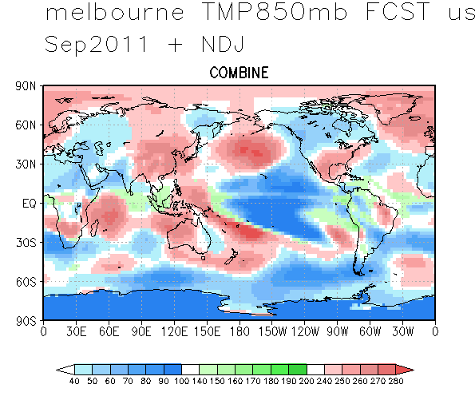 | ROC map
T2m
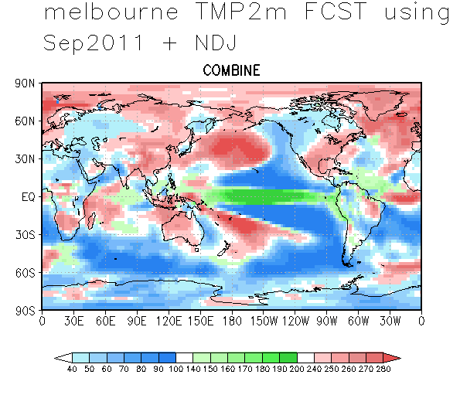 | ROC map
Precipitation
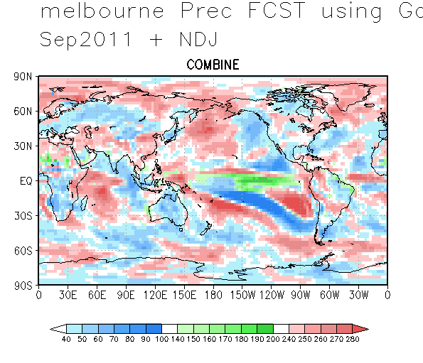 | ROC map
SST
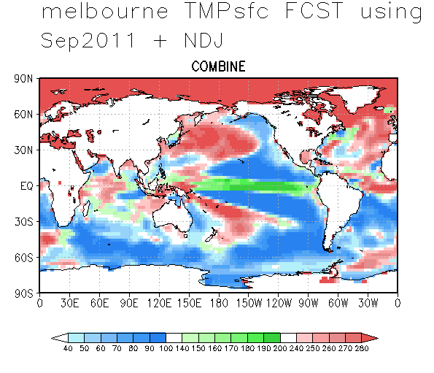 | ROC map

APPENDIX 5(to be implemented on the eve of Phase 1)

Last season (OND 2011) predicted and observed anomalies

Predicted anomalies (tercile probabilities) | Observations (percentiles)
Z500 | …< 15 < ...< 33 <....< 67 < … < 85 < …
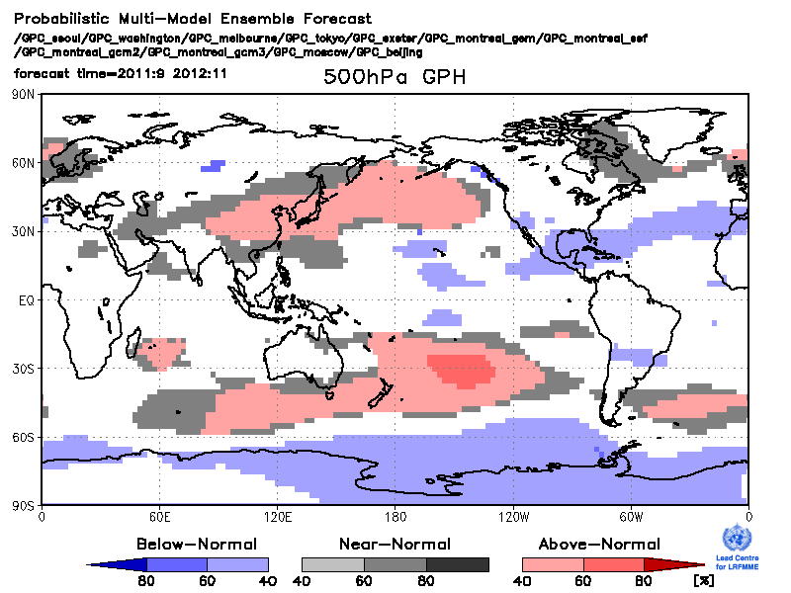
SLP
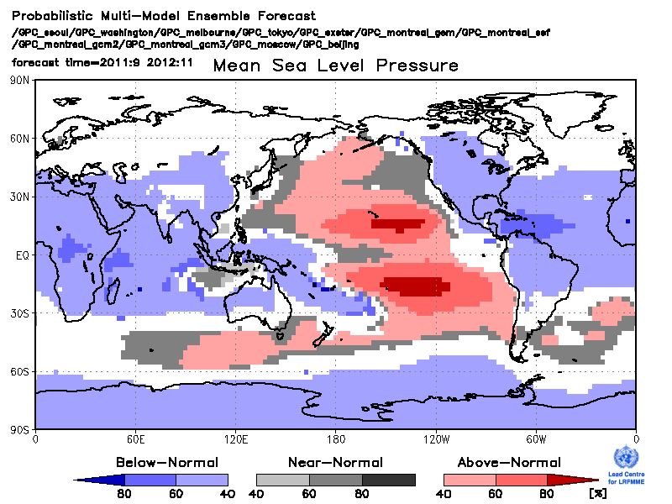
T850
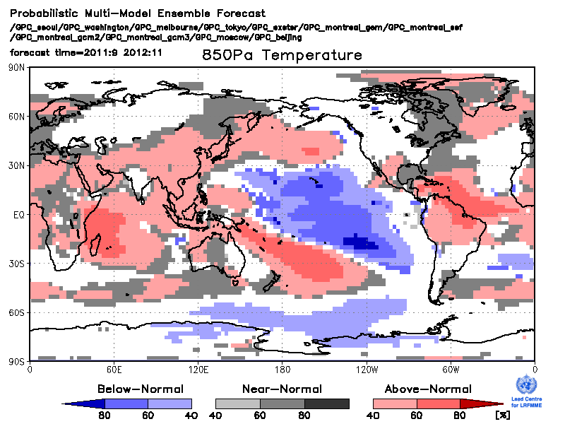
T2m
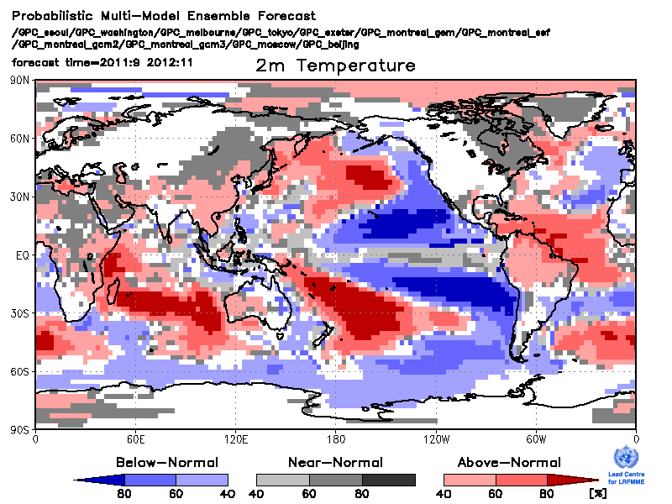
Precipitation
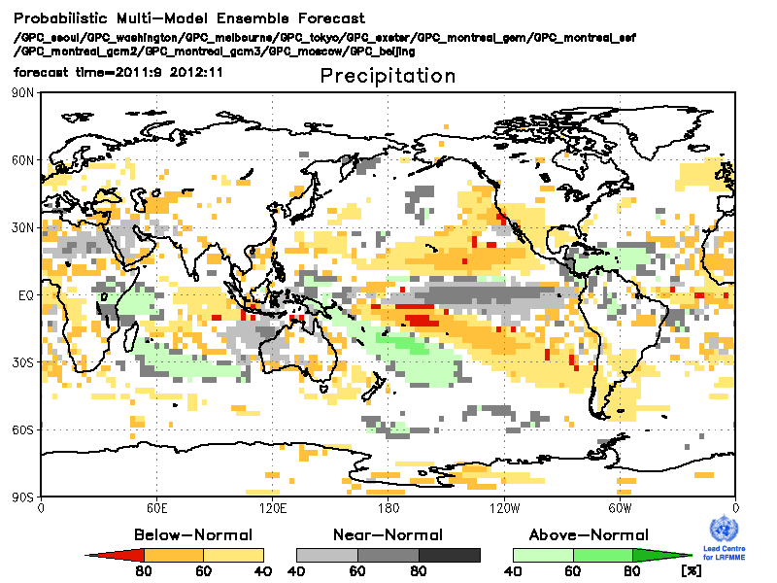
SST

Appendix 3.3.3

OPERATIONAL GUIDANCE

(version as of September 2011 with that time available software)

GENERAL INFORMATION

Basic period for Monitoring section is 1981-2010 (30 yrs) – to be implemented in the future. Now - to be decided by Ahira.

Basic period for Prediction section is the common period of the hindcasts of the GPCs’ models participating in MME: 1983-2002 (20 yrs, 8 GPCs – 11 models).

MONITORING SECTION

Monitoring covers: Large scale oceanic indices, large scale circulation indices, T2m, Precipitation, overview of extreme events.

The figures to be completely drawn at NCDC and provided for Analysis and Compilation Team by e-mail by Month 15. The text should be written by the Analysis and Compilation Team or NCDC (to be decided by them).

PREDICTION SECTION

Prediction section should be made by LC LRF-MME and provided for Analysis and Compilation Team by e-mail by Month 21.

Multimodel Ensemble Seasonal Forecast

MME Probabilistic Forecast should be produced at LC LRF-MME.

Operational procedure includes

1. Collection of the GPCs’ model outputs (usually it is 1st – 18th of the Month).

2. Estimation of probabilistic multimodel ensemble seasonal forecast (PMME) in accordance with the method described by Min et al. (WAF, 2009), with the forecast being displayed as a combined map of the prevailing tercile probabilities. The T2m and Precipitation forecast maps should be displayed in the main part of the GSCU, with all six (Z500, SLP, T850, T2m, Precipitation, SST) being shown in Appendix.

3. The two month lead time forecasts are to be estimated similarly to Point 2 (see above) on the basis of the relevant model forecasts, with all six forecast maps being shown in Appendix.

4. Estimation of the oceanic indices based on the GPCs’ couple model outputs. Each index is estimated for each model separately based on the ensemble members and ensemble mean. Indices are shown as a set of model plumes with monthly resolution in Appendix.

Verification Maps Supporting the Forecast Maps

Verification assessments of the historical forecasts are shown side by side with the corresponding forecast maps. Verification is performed in terms of Relative Operational Characteristic Scores (ROCS). ROCS is shown for the prevailing category (AN or NN or BN) for each grid-point.

The work that should be done in advance: For each variable:
1. LC LRF-MME estimates historical three PMME tercile probability maps for each season for each year of the hindcast period on the basis of the collected historical GPCs’ outputs and provides these maps (in digital form) for LC SVS;

2. LC SVS estimates three ROCS maps based on the provided historical PMMEs for tercile categories and provides them for LC LRF-MME.

In operational mode, after PMME has been estimated and the prevailing category for each gridpoint is defined, LC LRF-MME constructs the verification map based on the PMME map and three ROCS maps.

(in 2011, LC LRF-MME performs the whole verification procedure including Point 2 Estimation of three ROCS maps)

Oceanic Indices

Oceanic indices are estimated on the basis of the SST forecast fields. The indices are shown as a combination of the individual model plumes. Anomalies are estimated in respect to historical model ensemble mean.

Nino 3.4 is defined as SST anomaly averaged over the rectangle [5ºN - 5ºS, 170º - 120ºW]

Nino 1+2 is defined as SST anomaly averaged over the rectangle [0º - 10ºS, 90º - 80ºW]

Indian Ocean Dipole is defined as a difference between SST averaged over the rectangles [10ºN - 10ºS, 50º - 70ºE] and [0º - 10ºS, 90º - 110ºE]

North Tropical Atlantic index is defined as SST anomaly averaged over the rectangle [20º N - 5ºN, 60º - 30ºW]

South Tropical Atlantic index is defined as SST anomaly averaged over the rectangle [0º - 20ºS, 30ºW - 10ºE]

IRI Nino 3.4 forecast

Should be taken from the IRI site (?) or received by e-mail
http://iri.columbia.edu/climate/ENSO/currentinfo/SST_table.html

Time Table of GSCU Production Line

 | Date of the Month
Activity | 2 | 4 | 6 | 8 | 10 | 12 | 14 | 16 | 18 | 20 | 22 | 24 | 26 | 28 | 30
Monitoring section preparation
Collection of GPCs’ model forecasts
Estimation of PMME and indices
Verification maps based on hindcasts
IRI Nino 3.4 forecast
Analysis and compilation of GSCU

