WORLD METEOROLOGICAL ORGANIZATION  COMMISSION FOR BASIC SYSTEMS  OPAG on DPFS  EXPERT TEAM ON EXTENDED  AND LONG-RANGE FORECASTING  Exeter, UK, 28 June – 2 July 2010 |  | CBS-DPFS/ET-ELRF /Doc. 9  (21.VI.2010)  _______  Agenda item : 9  ENGLISH ONLY

Interannual-to-decadal Prediction

(Submitted by Richard Graham)

Summary and purpose of document

This document provides evidence that initialized decadal predictions can provide predictive information that is superior to that available from IPCC-type scenarios.

Action Proposed

The meeting is invited to consider the implications in terms of international collaboration in provision of predictive information over a range of timescales for the GFCS.

Interannual-to-decadal range prediction

Many civil and other sectors have planning timescales of order 5-10 years and it is important that the Global Framework for Climate Services develops capabilities and services for prediction on this decadal timescale - though capability at this range is currently less developed than for seasonal forecasting.

At multi-annual to decadal range, natural low-frequency variability and anthropogenically-forced changes may be of similar magnitude in many regions. Initialised climate prediction systems are therefore needed so that predicted changes are informed both by projected greenhouse gas emissions and by the predicted evolution of current observed phases of natural variability (on decadal and other timescales). Uninitialised predictions covering the decadal range (such as those available from the IPCC 4th Assessment) take account of greenhouse gas forcing – but natural variability in such projections is unconstrained by observation.

Using the Met Office decadal prediction system (DePreSys) Smith et al (2007) demonstrated that initialisation improves skill in decadal-range prediction of global-mean temperature. There is good evidence that initialisation also improves skill at regional scales, particularly at multi-annual ranges. Largest skill gains are found for temperature predictions (a case study is provided in Fig. 1), but improvements are also evident for precipitation, as may be appreciated from Fig.2 which compares correlation skill assessments for DePreSys ensemble-mean predictions of annual precipitation with corresponding uninitialised (NoAssim) predictions.

A number of centres are developing initialised seasonal-to-decadal prediction systems. Predictive information that is superior, at least for the first decade ahead, to that available from IPCC-type scenarios is therefore becoming available and it is timely to initiate international coordination in decadal prediction along similar lines to that established for seasonal prediction. To support this coordination, an extended remit for GPCs developing decadal capabilities could be defined.

We propose that CBS encourage:

- continued international collaboration in research on decadal prediction, including use of multi-models. At this early stage in scientific development, exchange of hindcasts/forecasts should be informal (such an exchange has been initiated by the Met Office Hadley Centre);
- compilation of an inventory of centres developing decadal prediction systems with a view to future operational provision;
- In 2012, after 18-months of informal data exchange and research, Met Office Hadley Centre and collaborators to inform ET-ELRF of progress and make recommendations regarding potential for WMO coordination of operational decadal prediction activities.

References :
Smith DM, Cusack S, Colman AW, Folland CK, Harris GR, Murphy JM (2007) Improved surface temperature prediction for the coming decade from a global climate model. Science 317: 796-799.

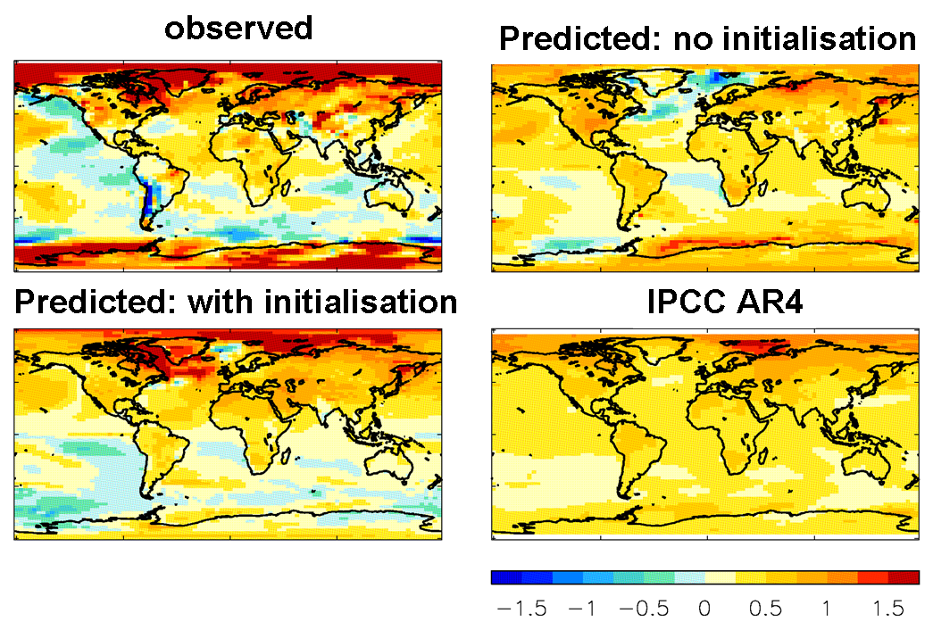
Fig. 1: Case study prediction of multi-annual temperature anomalies for the period June 2005 to Nov 2008. Top left: observed anomalies (NCEP reanalysis); bottom left: prediction from June 2005 initialisation using the Met Office decadal prediction system (DePreSys), top right: prediction from an equivalent system, but with no data assimilation, bottom right: prediction from an ensemble of uninitialized systems from the IPCC AR4. Note improved regional prediction from the initialised system.

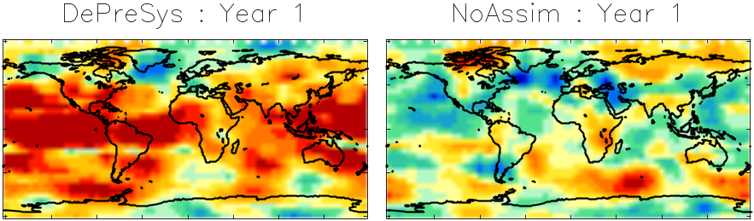
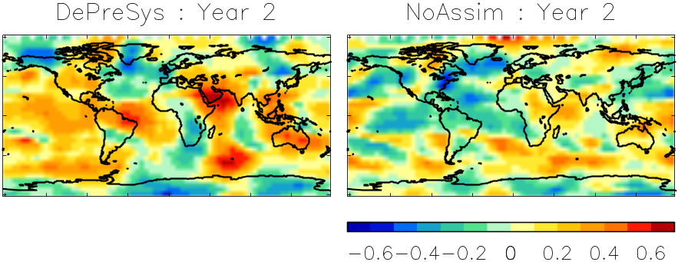
Fig. 2: Correlation between observed (GPCP) and predicted ensemble-mean annual precipitation anomalies. Each pixel shows the correlation of regional averages (over a 35°x35° latitude/longitude box) centred on that pixel and calculated over a set of hindcasts starting each November from 1979 to 2005. Left-hand column: correlations from the Met Office decadal prediction system (DePreSys). Right-hand column: correlations achieved with a corresponding system with no assimilation of the initial state (NoAssim). Both DePreSys and NoAssim predictions are the ensemble mean of a 9-member ensemble. The top and bottom rows show respectively correlations for the first and second year of the hindcasts.

