WORLD METEOROLOGICAL ORGANIZATION  COMMISSION FOR BASIC SYSTEMS  OPAG on DPFS  EXPERT TEAM ON EXTENDED  AND LONG-RANGE FORECASTING  Exeter, UK, 28 June – 2 July 2010 |  | CBS-DPFS/ET-ELRF /Doc. 5.3(1)  (22.VI.2010)  _______  Agenda item : 5.3  ENGLISH ONLY

PROVISION OF LONG-RANGE FORECASTS (LRF)

Review of the work and specific needs of the Lead Centres for
Long-Range Forecasting Multi-Model Ensemble (LC-LRFMME)

(Submitted by J.S. Chung and Arun Kumar)

Summary and purpose of document

This document provides information on the activities developed by the Lead Centre for Long-Range Forecasting Multi-Model Ensemble (LC-LRFMME).

Action Proposed

The meeting is invited to take into consideration information provided in the document when discussing new developments and specific needs, including those related to standard products and formats, and any necessary refinement in the procedures for provision and exchange of Multi-Model Ensemble LRF (e.g. content, timing, restrictions, etc.). The meeting is also invited to make recommendations, including amendments to the Manual on the GDPFS, as appropriate.

STATUS / PROGRESS REPORT FOR LC-LRFMME

5. PROVISION OF LONG-RANGE FORECASTS (LRF)

5.3 Review of the work and specific needs of the LC-LRFMME

The Korea Meteorological Administration (KMA) and NOAA/NCEP have been jointly organizing efforts to sustain and develop LC-LRFMME activities. These efforts were recognized by the WMO, and inclusion of the LC-LRFMME in the Manual on the GDPFS was recommended at the 14th Session of WMO CBS meeting held in Croatia from 25 March to 2 April 2009. The goal of the Lead Centre is to provide a conduit for sharing the model data for long-term climate predictions and to develop a well-calibrated Multi-model ensemble (MME) system for mitigating the adverse impact of unfavourable, or to maximize the benefit from favourable climate conditions.

At present, the forecast anomalies from various GPCs (for the sea surface temperature, 2-meter surface temperature, precipitation, mean sea level pressure, 850hPa temperature, and 500hpa height) are collected at the LC-LRFMME, and the forecast data are used for displaying various seasonal forecast products. The product display includes seasonal mean anomalies from individual GPCs, and also a synthesis of information in terms of consistency in the sign of anomalies from all GPCs. The region for forecast display can be chosen by a user driven interface. The access to the LC-LRFMME website is password protected, and information about how to gain access to forecast products is provided on the LC-LRFMME website (www.wmolc.org). The display of seasonal forecast products for LC-LRFMME include:

- 500hPa Geopotential height
- 850hPa Temperature
- Mean Sea Level Pressure
- Precipitation
- 2m Temperature
- Sea Surface Temperature
- Energetics
- Indices (e.g., Niño 3.4 SST index)

Some examples of the forecast products provided at the LC-LRFMME website are shown in Figs. 1-3. Forecast anomalies for a particular variable from individual GPCs can be displayed for an area selected by the user (Fig. 1). Forecast information from individual GPCs can also be synthesized into a simple multi-model average with equal weights (Fig. 2). Since hindcasts from all GPCs are not yet available, skill dependent weighting for constructing multi-model average is not yet feasible. Forecast display also includes consistency maps (Fig. 3) where a geographical distribution of number of models that agree with the sign of multi-model average anomaly is made. Consistency maps succinctly summarize the agreement in forecast anomalies across different models, and is a measure of confidence in the sign of seasonal mean anomalies. For example, if all models agree in the sign of predicted anomaly, the user can place added confidence in the forecast.

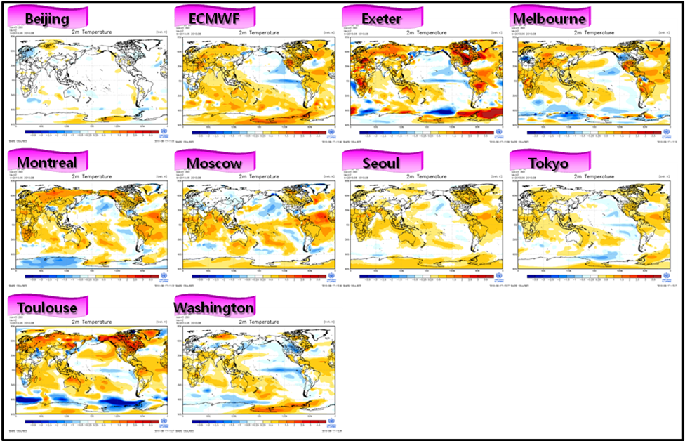

Fig. 1. An example of forecast display map available from the LC-LRFMME website. This particular example is for the 2-meter seasonal mean temperature anomaly from different GPCs. At the LC-LRFMME website the display area (and projection) can be selected by the user.

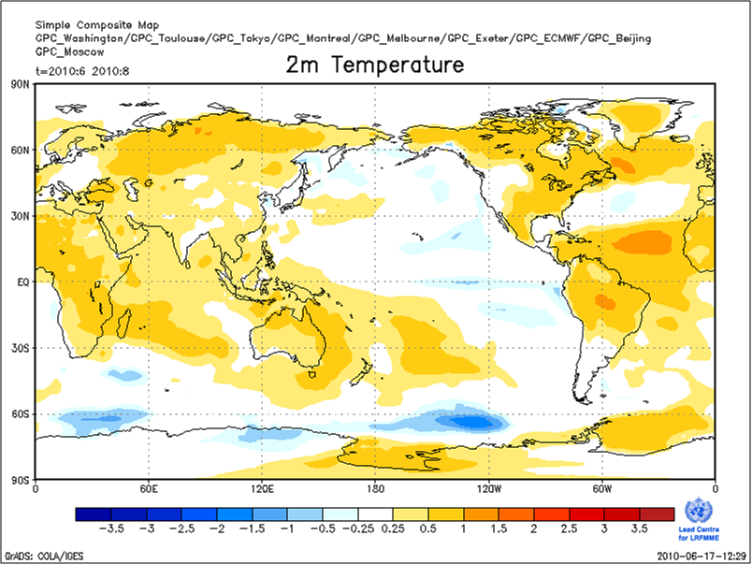

Fig. 2. An example of 2-meter seasonal mean multi-model average anomaly based on equal weights.

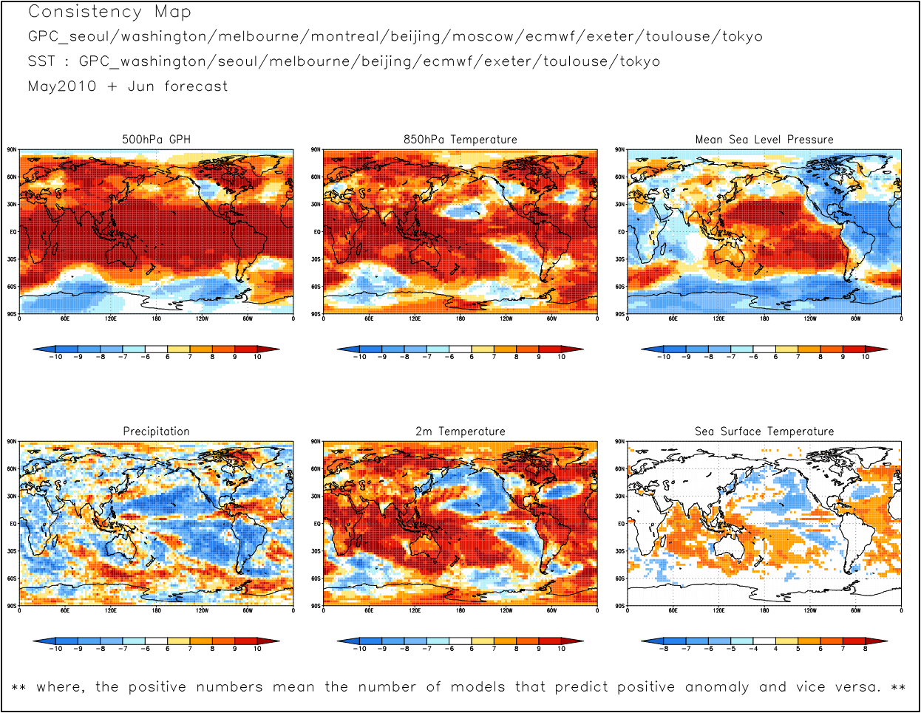

Fig. 3. An example of maps displaying the consistency among the forecasts from different GPCs. Consistency maps are based on number of models that agree with the sign of multi-model average anomaly.

LC-LRFMME products are currently used in various RCOFs (e.g., FOCRAII for Asia, SASCOF for summer forecast of South Asia, GHACOF) and RCCs.LC-LRFMME will continue to provide high-quality climate prediction products and develop more advanced climate prediction methodologies, contributing to improved prediction skills and The LC-LRFMME strives to contribute to the world-wide mitigation of disasters associated with abnormal climate and climate change. Moreover, LC-LRFMME will make an important contribution to increasing the resources available for better social-economic planning so as to be a valuable asset to the seasonal climate forecast community, and within the Global Framework of Climate Services (GSFC) developed under the purview of the WMO and other international agencies.

During the past year LC-LRFMME activities were highlighted in various forums including the World Climate Conference-3 (WCC-3), and a white paper (Stockdale et al., 2009) as part of the WCC-3. A paper highlighting the LC-LRFMME activities has been submitted for publication in Climate Research (Graham et al. 2010).

We hope to further discuss data exchange issues related to the submission of hindcasts, and tercile probabilities.

Stockdale, T. N., and Co-authors, 2009: Understanding and predicting seasonal to interannual climate variability – the producer perspective. White paper for WCC3. Available from http://www.wcc3.org/sessions.php?session_list=WS-3 .

Graham, R. J., 2010: New perspective for GPCs, their role in the GFCS and a proposed contribution to a ‘World Climate Watch.’ Climate Research, submitted.

