WORLD METEOROLOGICAL ORGANIZATION  COMMISSION FOR BASIC SYSTEMS  OPAG on DPFS  EXPERT TEAM ON EXTENDED  AND LONG-RANGE FORECASTING  Exeter, UK, 28 June – 2 July 2010 |  | CBS-DPFS/ET-ELRF /Doc. 5.1(10)  (08.VI.2010)  _______  Agenda item : 5.1  ENGLISH ONLY

REVIEW OF THE WORK, FUNCTIONS AND SPECIFIC NEEDS OF THE GLOBAL PRODUCING CENTRES (GPCs)

STATUS / PROGRESS REPORT FOR GPC MOSCOW

(Submitted by J.P. Céron and I. Charon)

Summary and purpose of document

This document describe the state of the seasonal forecast at the Toulouse GPC

Action Proposed

The meeting is invited to take into consideration information provided in the document when discussing new developments and specific needs of GPCs.

STATUS / PROGRESS REPORT FOR GPC Toulouse

1. FORECASTING SYSTEM

Please note that items 1.1 and 1.2 should be repeated for different forecasting ranges: LRF, ELF and/or any other.

1.1 Description of the forecasting system specification [please also indicate where this information is published (web address / papers)) : LC-MME, LC-SVSLRF

Meteo-France system for Global Seasonal Forecasts :

Type of system : Oceanic Atmospheric General Circulation Model (Numerical)
Description of models :
Atmosphere: Arpege Model v4 T63L91, full set of parametrisations,
Ocean : Oceanic Model OPA8.2 and Orca grid (2°) with free surface,
Coupling : Oasis coupling,
Type of forecasts :
Ensemble forecast with 41 members ; 8 different atmospheric conditions from
ECMWF analysis (24 h lag), each being associated with 5 different oceanic
conditions from Mercator analysis (random sampling) + 1 additional member using
last available atmospheric and oceanic conditions (last forecast),
Details of forecasts :
Forecasted period of 7 months,
Lead-time 1 month,(possibility of 2 3 and 4 months)
3 month forecasts (m+2 to m+4) (possibility of m+3/m+5,m+4/m+6,m+5/m+7)
Monthly update,
Date of issuance at the beginning of each month (commitment for the 8th),
Details on products :
Deterministic Production (Ensemble mean, significance test)
Probabilistic Production (Ensemble Member frequency into Tercile categories and Extreme categories (above +1 standard deviation and below -1 standard deviation)).
All products are calibrated (model climatology corrected - cf. Hindcast experience).
Global fields, Space resolution 2°5 x 2°5,
T2m, T850, Z500, Precipitation, Mean Sea Level Pressure, SST (3 month averages),
SST Indices plumes (Niño 1.2, Niño 3, Niño 3.4, Niño 4, TNA, TSA, TASI, WTIO, SETIO, DMI),
Format of products :
Standard : Gif files ,
On request : Ascii files, Grib files
Hindcasts experience :
Climatology of the forecasting suite over 1979-2007, 11 members
atmosphere : ERA40
ocean : Mercator PSY2G2
Verification dataset : T2m - ERA40 , T850 - ERA40 , Z500 - ERA40 , MSLP - ERA40 ,
SST - Reynolds , Niño Indices - Reynolds , Precipitation - Xie & Arkins,

1.2 Content of basic forecast outputs [response options in brackets; change or delete as appropriate. For non-compliant elements, please indicate intended date of compliance]

Issue frequency: | Monthly (the day of release can vary but commitment for the 8th of the current month)
Temporal resolution: | averages, accumulations or frequencies over seasons
Spatial resolution: | [2.5° x 2.5°]
Spatial coverage: | [Global]
Lead time: | Any lead time between 1 and 4 months
Output types: | [Either graphical images and/or digital data] (please indicate availability and location on the web and/or ftp)
Verification as per WMO SVSLRF | - location of verification information (web site - Not Yet / LC-LRFSVS Y);  - the verification is completed on at least 15 years hindcasts Y  - Eensemble size – 11 membres, the prediction system used in operations is identical to that used in hindcast verification

2. PRODUCTS [response options in brackets; change or delete as appropriate. For non-compliant elements, please indicate intended date of compliance]

Variable: |  | Probabilities for tercile categories of 2m temperature | Probabilities for tercile categories of precipitation | Probabilities for tercile categories of SST (coupled models only)
Spatial resolution: |  | [2.5° x 2.5°] | [2.5° x 2.5°] | [2.5° x 2.5°]
Temporal Resolution: |  | [3 months] | [3 months] | [3 months]
Coverage: |  | [Global] | [Global] | [Global]
Issue frequency: |  | [montly] | [montly] | [montly]
Lead-time | L0 | N | N | N
Lead-time | L1 | Y | Y | Y
Lead-time | L2 | Y | Y | Y
Lead-time | L3 | Y | Y | Y
Lead-time | L4 | Y | Y | Y
Lead-time | L4+ | N | N | N
Location of rendered images: |  |  | idem | idem
  ftp://ftp.meteo.fr/dclimdev_ple/wmo_ple
  Password protected
Location of digital data (if available): |  | idem | idem | idem
[For non-compliant elements, please indicate intended date of compliance]

3. VERIFICATION [response options in brackets; change or delete as appropriate. For non-compliant elements, please indicate intended date of compliance]

3.1 SVSLRF Level 1 scores

Variable: | 2m temperature | Precipitation | SST (coupled models only) | Niño region indices
Seasons: | [All 12 (as for products)] | [All 12 (as for products)] | [All 12 (as for products)] | All 12 (?)
Leads: | [All leads for which forecasts issued] | [All leads for which forecasts issued] | [All leads for which forecasts issued] | All leads (as for products)
ROC curves: | Ne/Se/T | Ne/Se/T | Ne/Se/T | Y
ROC area: | Ne/Se/T | Ne/Se/T | Ne/Se/T | Y
Reliability curve: | Ne/Se/T | Ne/Se/T | Ne/Se/T | Y
Frequency histograms (sharpness) | Ne/Se/T | Ne/Se/T | Ne/Se/T | Y
MSSS | Ne/Se/T | Ne/Se/T | Ne/Se/T | Y
Location of scores: | LC-SVSLRF web site | LC-SVSLRF web site | LC-SVSLRF web site | LC-SVSLRF web site
Scores’ availability on the LC-SVSLRF web site | All | All | All | All
[For non-compliant elements, please indicate intended date of compliance]

3.2 SVSLRF Level 2 scores

Variable: | 2m temperature | Precipitation | SST (coupled models only)
Seasons: | [All 12 (as for products)] | [All 12 (as for products)] | [All 12 (as for products)]
Leads: | [All leads for which forecasts issued] | [All leads for which forecasts issued] | [All leads for which forecasts issued]
ROC maps: | Y | Y | Y
MSSS maps: | Y | Y | Y
MSSS 1 maps: | Y | Y | Y
MSSS 2 maps: | Y | Y | Y
MSSS 3 maps: | Y | Y | Y
Location: | LC-SVSLRF web site | LC-SVSLRF web site | LC-SVSLRF web site
[For non-compliant elements, please indicate intended date of compliance]

4. DISSEMINATION

GPC products are password protected at ftp://ftp.meteo.fr/dclimdev_ple/wmo_ple

5. LRF MULTI-MODEL ENSEMBLE

participation in EUROSIP multi-model.

6. ADDITIONAL INFORMATION PROVIDED BY THE GPC

Global Climate Bulletin (monthly edition)
Zoom over Europe and Tropics
“Extreme” categories (above +1 std, below –1 std)

Atlantic Ocean box plumes and Indian Ocean box plumes (cf figures)
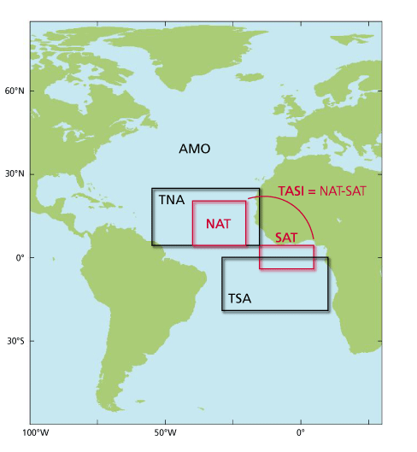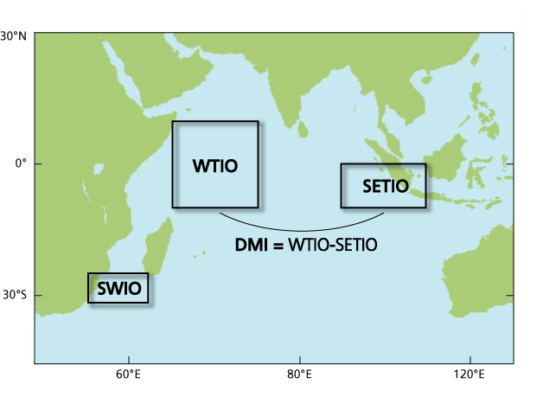

Circulation regime over the North Atlantic sector

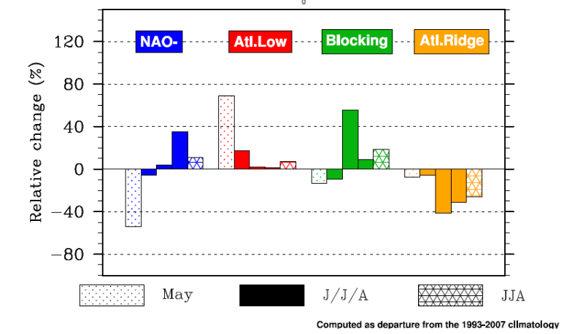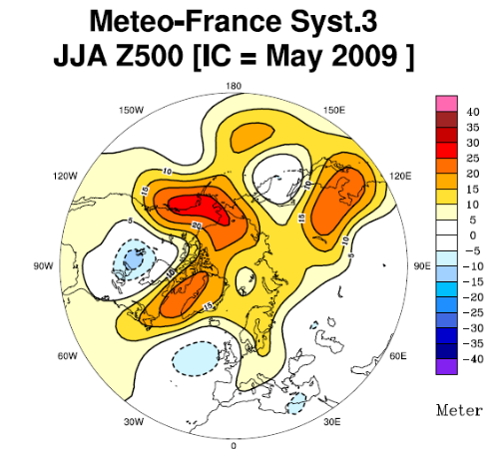

Velocity Potential and Stream Function in the high troposphere (200hPa)

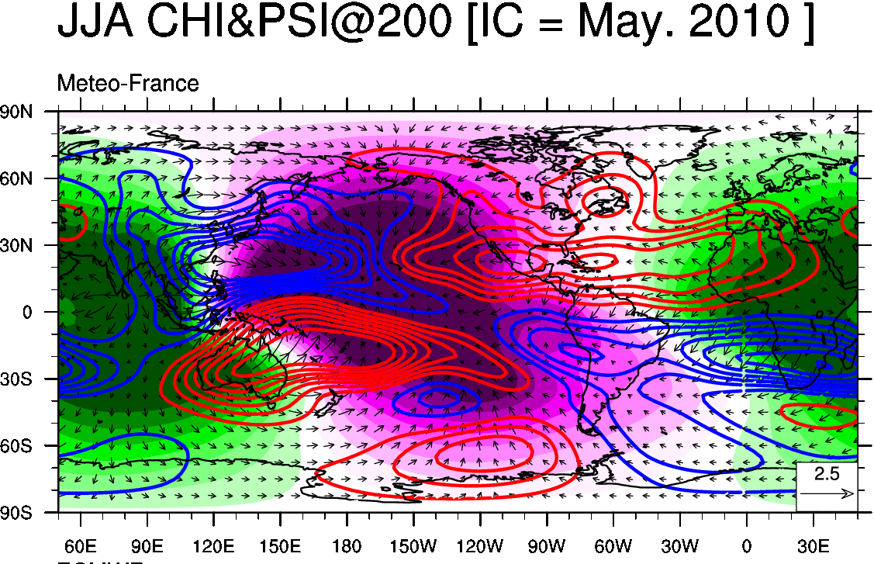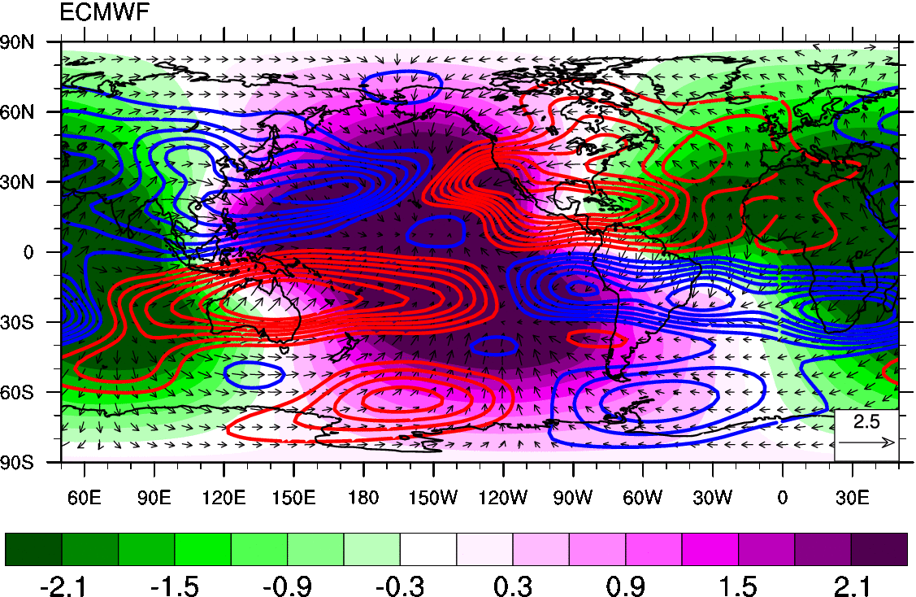

7. CAPACITY BUILDING AND TRAINING

assistance by the GPC in capacity building : interpretation and use of products, downscaling and verification techniques, development of local user applications from downscaled products.

8. SPECIFIC NEEDS

Specific needs of your GPC : Standardized Anomaly Forecasts, Large Scales indices.
Updated verification datasets

9. FUTURE DEVELOPMENTS

Development of a specific web site dedicated to Seasonal Forecasts and Global bulletin (extension to European regions in the frame of the RCC node on LRF jointly coordinated with Moscow GPC).
Change of the forecasting suite (which should be close to the one use in IPCC–AR 5 simulations – expected by mid 2012)
Development of regional and downscaled products (both RA VI and Tropics).
Verification on monthly products extracted from the seasonal forecasts

10. USERS OF THE LRF

Users of the LRF provided by Toulouse GPC :
WMO Niño update, IRI Niño synthesis, RCOFs (notably PRESAO, SEECOF, SASCOF, …), RA VI RCC, users of Global Bulletin (Magrebhian NMHS, CIIFEN, ACMAD, IRI, Spain, Belgium),

__________________

