WORLD METEOROLOGICAL ORGANIZATION  COMMISSION FOR BASIC SYSTEMS  OPAG DPFS  MEETING OF EXPERT TEAM ON EXTENDED AND LONG-RANGE FORECASTING  BEIJING, CHINA, 7-10 APRIL 2008 |  | CBS-OPAG/DPFS/ET-ELRF/Doc.7.2(2)  (03.IV.2008)  _______  ENGLISH ONLY

VERIFICATION SYSTEMS FOR ERF AND LRF
Proposed framework for verification scores
(Submitted by Simon Mason, IRI)

Summary and purpose of the document

Noting some of the conclusions and recommendations of CBS Expert Meetings, CBS Session and Workshops and on LRF, this document presents a proposed framework for defining a comprehensive suite of verification scores. The framework is designed to address the need for a set of scores that can be used to provide an initial indication of whether the model predictions contain any useful information, and is sufficiently flexible to be applicable to virtually all target variables and forecast formats.

ACTION PROPOSED

The meeting is invited to study this document and provide comments on the proposed framework. It is being considered as a recommendation for verification activities under the WMO CCl, and so any comments (positive or negative) may assist greatly in helping to coordinate verification proposals between the two Commissions.

Annex:
- Extract from: Mason, S. J., and A. P. Weigel, 2008: A Generic Forecast Verification Framework for Administrative Purposes. Monthly Weather Review, submitted.
DISCUSSION
  - There are numerous reasons for presenting verification information pertaining to ERF and LRF products, and since each verification score addresses different attributes of forecast quality, it is important to consider the precise objective of verification information when recommending specific scores. The current SVSLRF goes a long way towards addressing the needs of model developers whose interest is in identifying strengths and weaknesses of the models, but it is arguably less useful for users who need to address the question of to what extent the model prediction should be believed so as to translate the model output into an official forecast.
  - Typically, the user will have two options for using GPC products in constructing a forecast:
    - A map showing the current model prediction, together with graphical SVSLRF products illustrating the quality of the model’s hindcasts;
    - Access to model hindcasts that are then downscaled using some form of MOS.
In both cases the primary question that the SVSLRF needs to address is: Is there any useful information in the model? Perhaps more specifically, the user will want to know whether any signal in the model can be believed – if the model is predicting unusually dry conditions, can we expect unusually dry conditions to occur. In technical terms, the resolution of the forecasts is the primary characteristic of interest.
- Given this interest in the resolution of the model predictions, it is important to consider more specifically how this information might be used. In the case of the user who has access only to the graphical products (information “a” as defined above), the user may consider the ensemble mean prediction as well as a probabilistic forecast, but unless they are using only one GPC model, they will invariably not take the reliability of the model at face value; i.e., while the probability indicated for the current forecast will be used as an indication of the strength of the model signal, the user will have their own scheme for defining the probability to assign to their own forecast. The user’s probability is largely a “degree of belief”, and thus conforms to the “subjective interpretation” of probability. Since the user has to consider issues of downscaling, and the fact that different sources of information may be accessible each time a new forecast is made, this subjective approach is entirely appropriate. The point is that while the reliability of the GPC model is of course important, it is much less important than the resolution of the model: the user is primarily interested in whether the sign of the anomaly can be believed. That is the point of departure, and more sophisticated users may want to have further information about reliability. However, it is helpful to separate measures of reliability and resolution, and the resolution of the model is the first question of interest.
- In the case of the user who can get access to the model hindcasts and is intending to conduct some form of MOS correction (information ‘b” as defined above), again resolution will be the primary attribute of interest. The model is going to be recalibrated anyway, and so the reliability is effectively irrelevant. If the model has no resolution, then it has no useful information that can be exploited to construct anything but a climatological forecast (excepting of course that the spatial correction that may be considered in the MOS identifies a useful signal).
- Scores that show reliability and resolution will therefore be ambiguous: is a moderately good score a result of good resolution and poor reliability or of poor resolution and good reliability?
- Another consideration is that target variables of forecasts can be in a wide range of different formats. These formats range from binary outcomes (e.g., will a tropical cyclone hit land during the target period?), polychotomous outcomes (i.e., three or more categories; e.g., will temperature be above-normal? note that the categories are probably ordinal, but are not necessarily so), continuous (e.g., how much rainfall will there be?), circular (i.e., as used to measure wind direction or calendar dates; e.g., when will the rainy season commence?), or even as a probability distribution (e.g., to represent the observation uncertainty in a precipitation measurement). Most of the SVSLRF scores are well-designed for the binary outcomes and the continuous values (as long as the values are Gaussian), but do not address the other possibilities adequately. In addition, totally distinct sets of scores are presented for the different formats, and so there is no means of comparing the quality of an ensemble mean from one model with a probabilistic forecast for three categories from another. (Bear in mind that at the Regional Climate Outlook Forums, for example, the access to GPC products is often highly limited.)
- As indicated above, the forecasts themselves can take different formats, and these formats do not necessarily match the format of the observation. For example, it is perfectly reasonable to forecast a binary variable using more than two categories, since each of the forecast categories could represent a degree of belief. Probabilistic forecasts of binary outcomes, for example, are not restricted to probabilities of 0% and 100% only. Comparing the quality of forecasts for different formats can be complicated if a consistent set of verification scores is not used.
- Finally, it is helpful to have a score that has an intuitive scaling. Most scores are affected by the base rate, and so some form of standardization is helpful. Many verification experts seem to prefer skill scores as a means of standardizing scores. On a skill score, forecasts with no skill have a score of 0, a perfect set of forecasts has a score of 1, and bad forecasts have negative scores. Unfortunately, most of these skill scores have some undesirable properties. A primary concern is that many of them are not strictly proper (e.g., the Brier skill score). An additional problem is that in many cases the skill score does not have a lower limit of negative one. In this case one could not then compare a score of -0.5 with one of 0.5 and conclude that the negative of the forecasts with the negative score have the same quality as the forecasts with the positive score. An additional minor consideration is that most non-verification experts expect scores to exceed 50%, not 0%, if the forecasts are good.
- In summary, what is needed is a set of verification scores that have the following characteristics:
    - Measure forecast resolution;
    - Can be applied to a wide range of target variables and forecast formats;
    - Can be used to compare the quality of forecasts of the same target variable yet which may be presented in different formats;
    - Have an intuitive scaling, and are generally easy to understand.
In both cases the primary question that the SVSLRF needs to address is: Is there any useful information in the model? Perhaps more specifically, the user will want to know whether any signal in the model can be believed – if the model is predicting unusually dry conditions, can we expect unusually dry conditions to occur. In technical terms, the resolution of the forecasts is the primary characteristic of interest.
- It is proposed that the two-alternative forced choice (2AFC) test be used as a generic test for defining a set of verification scores that address all of the issues above. The 2AFC test addresses the question of whether the forecast can be used to successfully discriminate observations. In the simplest case of binary outcomes, it measures the probability with which the forecast can successfully discriminate an event from a non-event (regardless of whether the forecasts are binary, polychotomous, continuous, or probability distributions). In these cases the test is equivalent to calculating the area beneath the relative operating characteristics (ROC) curve. In the case of polychotomous outcomes, the 2AFC test measures the ability of the forecasts to successfully discriminate the observation in the higher category from the one in the lower category. The 2AFC test then becomes equivalent to a test called Somer’s delta, which is a relatively poorly known adaptation of Kendall’s correlation suitable for cases in which some of the observations are tied. If the forecasts are measured on a continuous scale, the 2AFC test measures the ability of the forecasts to successfully identify the case with the higher value. In this case the score becomes equivalent to Kendall’s correlation.
- Full details of the proposed scores are presented in the attached Annex, which has been submitted to Monthly Weather Review.
ANNEX

- Introduction

Although Jolliffe and Stephenson’s (2003) “administrative” category incorporates a wide range of possible motives for conducting a verification analysis, a common need is for a single score that can be used to summarize forecast quality. It can be added that when the purpose is to communicate to non-specialists (whether they be bureaucrats who may be making decisions about resource allocations for ongoing forecasting activities and improvements, or potential clients, or the simply curious) the score should be as simple as possible (in the sense of being easy to understand, and not in the sense of capturing only limited aspects of the scientific quality of the forecasts). Of course, it has to be accepted upfront that as soon as one decides to summarize forecast quality in any single score, information is going to be lost; forecast quality is multifaceted (Murphy 1991) and so any single number will have its limitations. Acknowledging that there can be no perfect score, the purpose in this note is to recommend a score that does have some excellent intuitive properties and compromises on questions of information loss as little as possible. The score itself (or scores themselves – since a generic framework is proposed, the precise formulation of the score depends on the nature of the forecasts and observations) is not new, but to the authors’ knowledge the framework presented in this note has not been proposed in the atmospheric science literature as suitable the purposes of administrative forecast verification.
Although not an overruling principle for proposing the score, a verification score that has an expected value of 50% for all non-skilful forecasts is highly attractive: to many non-specialists there are only two possible outcomes: the forecast was correct or incorrect, and given two choices the chances of being correct are expected to be the same as in a simple coin-toss. It would then be understood that any score above 50% would suggest that the forecasts are good, and that the closer the score gets to 100% the better they are. Similarly, a score that approaches 0% indicates that the forecasts are as bad as they can possibly get. In the past, skill scores have been proposed and defined in such a way that a score of greater than 0% indicates useful information in the forecasts. We would argue that such scores are not intuitive to non-specialists, partly because most skill scores do not have a fixed lower-bound, and thus are asymmetric, and partly because they are relative measures of forecast quality, which complicates their interpretation (a hit skill score, for example, is not easy to interpret despite the simplicity of the hit score).
A more important principle has been that of identifying a score that is sufficiently flexible to be used with forecasts and observations that cover a wide range of complexities, but without reducing the more complex cases to the simpler. Specifically, where the forecasts contain probabilistic information on a continuous target variable, and the target variable itself is measured on the same continuous scale, the score should not discretize the forecasts and observations. But at the same time, where the forecasts and observations are discretized, the score should remain meaningful.
In section 3 of this paper, the proposed framework for evaluating forecasts is presented, and the specific verification scores that are defined by the framework are introduced. The limitations of the scores are then discussed in section 4. The paper closes with some concluding remarks in section 5. First, however, a set of example data to illustrate the calculation of the scores is described.

- Example data

Forecasts for the Niño3.4 index from coupled ocean-atmosphere model of the Centre National de Recherches Météorologiques (CNRM) of Météo-France were compared with observed values. The data were generated as part of the DEMETER project (Palmer et al. 2004), and only the 40 forecasts for January 1961–2000 from model runs initialized using data for the preceding August 1960–1999 were considered. No attempt was made to calibrate the forecasts, but the mean bias is less than 0.3°C, and the model variance is about 80% that of the observed data. The ensemble-mean forecasts explain about 88% of the variance of the January Niño3.4 index for the 40-year period, indicating that the model is highly skilful.
The Finley tornado forecasts mentioned in the introduction are considered also, but only in the context of dichotomous forecasts of dichotomous observations.

- A General Framework for Evaluating Forecasts

The standard way of evaluating forecasts is to take each forecast-observation pair and to compare each in turn, asking the question of how well the forecast corresponds with its respective observation. Given n forecast-observation pairs, this question is addressed n times, and a summary measure is calculated. An alternative procedure is proposed by which a set of two forecast-observation pairs is considered, and the question then becomes whether the forecasts can be used successfully to distinguish between the observations. For example, given a day with rain and one without, can we successfully identify the wet day from the forecasts? Or can we identify the warmer of two days, again from the forecasts? Assuming that the observations are distinguishable, the probability of picking the correct year given unskillful forecasts is 50%. The aim is to compare all possible sets of two forecast-observation pairs, asking the same question each time, and calculating the proportion of times that the question is answered correctly. This proportion is known as the probability of a correct decision, and the question is known as a two-alternative forced choice (2AFC) test (Green and Swets 1989; Mason and Graham 2002). Each time the question is asked, there is a 50% chance of picking the correct observation, and so if the forecasts are skilful, the proportion of correctly picked observations will exceed 50%, and the better the forecasts are the closer the proportion will be to 100%.
In selecting the two pairs, the observations have to be different in some way, and so it may be the case that not all sets of two pairs can be assessed (for example, it is not a useful question to ask which of two days was wet if neither of them had observed rainfall). If all the observations differ from one another, a total of 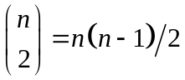 sets can be evaluated, although not all the results will be independent (if day-1 is warmer than day-2, and day-2 is warmer than day-3, then it is known that day-1 is warmer than day-3). If some of the observations cannot be distinguished then the number of sets of two forecast-observation pairs that can be meaningfully compared depends on the numbers of classes of different observations and the numbers of observations in each class, as discussed in detail later.
Technically, a 2AFC test involves asking whether the forecasts can be used to successfully discriminate between the observations (Murphy 1991), and so, in the general framework for forecast verification introduced by Murphy and Winkler (1987), the 2AFC procedure proposed in this paper involves a likelihood-base rate factorization. The precise formulation of the question in the 2AFC test depends on the nature of the forecasts and observations, and in some cases the resultant test reduces to a verification score that is already in wide use, and / or is more widely known under a different name. The following sections describe the 2AFC score under these different formulations, starting with the simplest cases of “yes” / “no” forecasts for dichotomous outcomes, and proceeding in complexity to probabilistic forecasts of outcomes measured on a continuous scale. A brief discussion of forecasts of observations for which the latter are probability distributions closes this section.

  - Dichotomous observations

The simplest situation is when there is one of only two possible outcomes; one of the possible outcomes is labeled an event, and so an event can either occur or not occur. Let 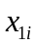 represent the ith forecast issued when an event did occur, and let there be n₁ events; let 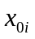 represent the ith forecast issued when an event did not occur, and let there be n₀ non-events (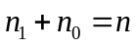). A 2AFC score for dichotomous observations can be defined as the proportion of correctly answered 2AFC tests out of all possible such tests:
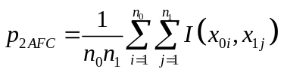, (1a)
where the scoring rule 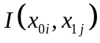 is defined as
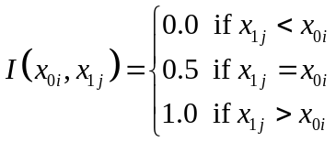. (1b)
Note that 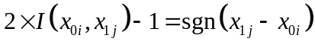. The precise calculation of Eq. (1) depends on the nature of the forecasts. Its formulation given different forecast types is detailed in the following subsections.

- Dichotomous forecasts
Dichotomous forecasts are expressed as a “yes” or a “no” for an event to occur. An example is forecasts of rainfall occurrence: rainfall either occurs or it does not occur, and the forecast indicated either that it would or would not. Such forecasts and observations are most commonly summarized in a 2×2 contingency table, and there are numerous scores that have been applied for summarizing the quality of the forecasts (Mason 2003). Finley’s tornado forecasts (Murphy 1996) are a well-known example, and the debate around the quality of these forecasts effectively illustrates some of the difficulties in communicating the quality of this type of forecast.
In a 2AFC test, the procedure would be to select one day on which a tornado occurred, and one on which a tornado did not occur, and then to decide on which day the tornado occurred based on the two corresponding forecasts. This test would be repeated for each possible pairing of a tornado with a non-tornado day. For some of the pairings, because some of the forecasts may be incorrect, it may not be possible to decide on which day a tornado occurred: sometimes both forecasts may indicate no tornado, and on other times both may indicate a tornado. For these cases a score of one-half should be recorded. Using the contingency table shown in Table 1a in which a = number of hits, b = number of false-alarms, c = number of misses, and d = number of correct rejections, the 2AFC score can be calculated as:
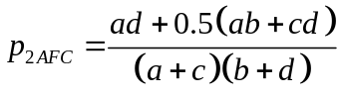. (2)
The denominator defines the total number of forecast-observation pairs to consider, and is simply the product of the number of events and non-events; the numerator is calculated as the number of correctly discriminated observations (ad) plus half the number of observations that cannot be discriminated either way. The term bc, which is obtained if the denominator is expanded, represents the number of incorrectly discriminated observations.
Eq. (2) can be shown to be a special case of Eq. (1). From Table 1, a is the number of times 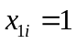, b is the number of times 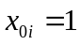, c is the number of times 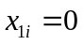, and d is the number of times 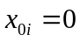, while n₁ is the number of events (a + c), and n₂ is the number of non-events (b + d). The denominator of Eq. (2) is therefore the same as in Eq. (1a), while in the numerator ad represents all the cases where 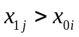, and 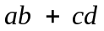 represents all the cases where 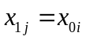.
The score defined in Eq. (2) is a version of the area beneath the relative operating characteristics (ROC) curve (Mason 2003). Since the forecasts and observations are both dichotomous, the ROC curve is defined by a single point connected to the corners. Using the trapezium rule, the area beneath the curve can be calculated as the sum of the triangular area to the left of this point, and the trapezoidal area to the right:
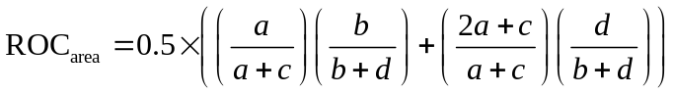. (3)
Eq. (3) reduces to Eq. (2), indicating the equivalence of the 2AFC score and the ROC area in this context. The area beneath the ROC graph (when it is calculated using the trapezium rule) can therefore be interpreted as the probability of successfully discriminating the observations (Mason and Graham 2002).
For Finley’s forecasts, the 2AFC score is approximately 76%, indicating that his forecasts successfully discriminated tornado from non-tornado days over three-quarters of the time. This score is consistent with the recognition that against a strategy of random guessing, as opposed to Gilbert’s commonly-quoted one of perpetual no-tornadoes, Finley’s forecasts are skilful (Murphy 1996, Mason 2003; Mason 2008). If Gilbert’s strategy of perpetual no-tornado forecasts can outperform Finley’s forecasts on the percent correct score, how do they fare on the 2AFC score? In this case a and b are 0, and so Eq. (2) reduces to
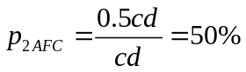, (4)
which is the same as for random guessing. At least in the context of dichotomous forecasts and observations, therefore, the 2AFC score is equitable.
Given that the 2AFC score has been presented as an attempt to address the question of how often the forecasts are correct, how does the 2AFC score of 76% relate to the percent correct score of 97% for Finley’s forecasts (Murphy 1996)? The difference is that the percent correct score is a simple count of how often the forecast matched the corresponding observation, and tells us at least as much about the base rate as it does about the quality of the forecasts. The 2AFC score, however, tells us how often the forecasts successfully distinguish a tornado day from a non-tornado day, and is independent of the base-rate.
The CNRM ensemble-mean forecasts and observed values of the Niño3.4 index were classified as, respectively, predicting and verifying “warm” events if the index exceeded 27.0°C. The resulting contingency table is shown in Table 2. From Eq. (2), the probability of correctly discriminating a “warm” event from a non-event (“cool”) is approximately 93%.

- Polychotomous forecasts
Polychotomous forecasts of dichotomous outcomes are perfectly reasonable if the forecast categories are viewed as a set of ordered warning levels, which may or may not have explicit probability thresholds assigned to them. Setting the dot subscript to represent any outcome, in terms of Eq. (1), 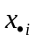 can take on one of m_{f} values, where m_{f} is the number of forecast categories. Eq. (1b) is independent of the number of possible values for and so the 2AFC score retains the same format as for the case of the dichotomous forecasts. Let n_{1k} be the number of forecasts of category k when an event occurred (i.e., the number of times 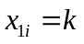), and n_{0k} the number of forecasts for the same category when an event did not occur (i.e., the number of times 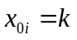). Then
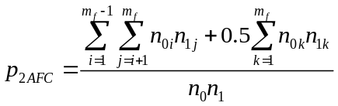. (5)
Eq. (5) is related to Eq. (1) because the first term in the numerator represents all the cases where , and the second term represents all the cases where . In the case of perpetually identical forecasts either 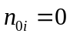 and / or 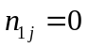, and either 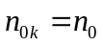 and 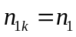, or 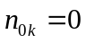 and 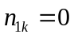. Therefore, just as Eq. (2) reduces to Eq. (4), so also Eq. (5) reduces to
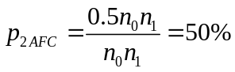, (6)
And the score is again equitable.
The equivalency of the 2AFC score and the area beneath the ROC graph in the case of dichotomous observations and forecasts was noted in section 2a.i. The same is true in the case of ordinal polychotomous forecasts, but, because the forecasts can be ranked, more than one point on the ROC graph can now be constructed. This case is identical to the way that a trapezoidal ROC area is calculated given forecasts expressed as probabilities for categories (section 2a.iv). Since the probabilities themselves are ignored when performing a ROC analysis (Mason and Graham 2002; Glahn 2004; Wilks 2006) probabilistic forecasts are reduced to forecasts of ordinal polychotomous categories. In the current context, therefore, the 2AFC score is equivalent to the standard way in which ROC is performed in forecast verification, except that the probabilities associated with each point on the curve are undefined (Mason and Graham 2002).
Retaining the definition of observed “warm” events as a Niño3.4 index of greater than 27.0°C used in the previous section, the CNRM ensemble-mean forecasts were classified as, predicting “warm” events with very high confidence if the forecast exceeded 28.0°C, high confidence if the forecast exceeded 27.0°C, low confidence if the forecast exceeded 26.0°C, and very low confidence otherwise. The resulting 2×4 contingency table is shown in Table 3. From Eq. (5), the probability of correctly discriminating a “warm” from a “cool” event is approximately 95%. This value is a slight improvement on the 93% from the 2×2 contingency table because of the greater resolution in the forecasts available in the 2×4 table, resulting in fewer ties in the forecasts. However, it should be noted that the results are somewhat sensitive to the categorization of the forecasts.

- Discrete probabilistic forecasts
The 2AFC score for discrete probabilistic forecasts is essentially the same as for the polychotomous forecasts: the probabilities define a set of ordered categories, with the number of forecast categories being equal to the number of discrete forecast probabilities. Consistent with the relationship shown in Eq. (3), the 2AFC score for discrete probabilistic forecasts is then equivalent to calculating the trapezoidal area under the ROC curve (Mason and Graham 2002). Let 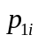 represent the ith forecast probability for an event when an event occurred, and let 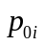 represent the ith forecast probability for an event when an event did not occur. Effectively, the forecasts and 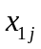 in Eq. (1) are replaced by these probabilities, giving
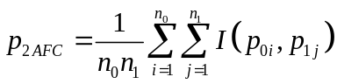, (7a)
where the scoring rule 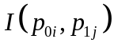 is defined as
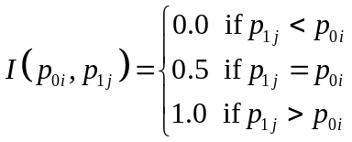. (7b)
One limitation of Eq. (7) is that the score considers only the ordering of the probabilities, ignoring the actual probability values themselves, and thus is insensitive to any monotonic transformation of the probabilities. This insensitivity is the same problem as the insensitivity of the ROC to calibration (Glahn 2004). Although 2AFC scores can be defined that explicitly consider the actual probabilities, these scores are equitable, and they cannot therefore be proper (Jolliffe and Stephenson 2008).
For the CNRM data, forecast probabilities were defined as the proportion of the ensemble members forecasting an index of greater than 27.0°C. With nine ensemble members, the number of probability bins is therefore ten. A histogram of the forecast probabilities for “warm” and “cool” events is shown in Figure 2, indicating that the “warm” and “cool” events are well-discriminated by the forecasts. The corresponding ROC curve for these forecasts is shown in Fig. 1. The area beneath the curve is about 0.98 (i.e., the 2AFC score is 98%), and is larger than for the dichotomous and polychotomous forecasts because of fewer ties. The ROC curves for the dichotomous and polychotomous forecasts are shown as grey solid and dashed lines respectively, and it is clear that the poorer resolution in these forecasts compared to the discrete probabilities is responsible for the slightly smaller area.

- Continuous forecasts
If the forecasts are continuous, the 2AFC score remains essentially the same as for the polychotomous forecasts, except that there will be as many categories as there are distinct forecast values (m_{f} = n; unless there are ties, which may occur if there is a zero-bound, for example, in which case m_{f} < n). Let the forecasts for events and non-events be pooled, and then ranked in ascending order; if the forecasts are good, the ranks for the forecasts when an event occurred should be higher than for when no event occurred. Setting r_{1j} as the rank of the forecast for the jth event, the 2AFC score is derived from the equation for the Mann-Whitney U-statistic (Conover 1999; Sheskin 2007):
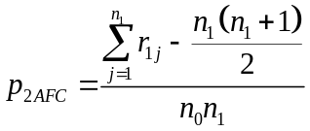. (8)
The second term in the numerator represents the sum of the ranks for the worst possible set of forecasts for the events (i.e., the forecasts for the events are all ranked first), and so the numerator as a whole calculates the number of times a rank for the forecasts for when an event occurs is greater than for forecasts for when a non-event occurs (i.e., the number of correct 2AFC tests). Eq. (8) can be shown to be a special case of Eq. (1), because:
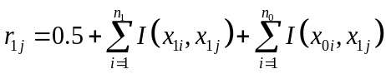, (9)
and
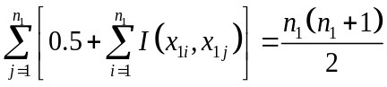. (10)
Eq. (8) is therefore equal to Eq. (5) not just when m_{f} = n, but also, because of the incorporation of forecast ties into the definition of the ranks in Eq. (9), when m_{f} < n.
To illustrate, consider the ensemble-mean CNRM forecasts for the Niño3.4 index. These forecasts are to be used to predict whether the observed value will exceed 27.0°C (defined as a “warm” event). To perform an individual 2AFC test the forecasts are ranked on the basis of the forecast temperature, and the forecast with the higher temperature, for example, is selected as the indicator of the “warm” event. To calculate the 2AFC across all “warm” – “cool” event pairings an ROC graph could be constructed with the forecast with the highest temperature being assigned as the year most likely to have experienced a “warm” event (Fig. 1). In essence the procedure is to assign an arbitrary, but monotonically increasing, probability for a “warm” event to each forecast as the forecast temperature increases, and then to perform a standard ROC as if the forecasts were probabilistic. This procedure was used by Thomson et al. (2006), and is a more effective way of evaluating the quality of continuous forecasts than reducing them to a probabilistic forecast of 0% or 100% depending upon whether the forecast exceeds 27.0°C (as in section 3a.i). The 2AFC score for the Niño3.4 forecasts is almost 99%, and is a notably higher score than for the 2×2 or 2×4 contingency tables because of the elimination of ties.

- Continuous probabilistic forecasts
If a probability distribution is provided as the forecast, i.e. a density function that is defined over a continuous scale of values, the 2AFC score can be generalized from that for the discrete probabilistic forecasts (section 3a.iii). Given forecast distributions, the probability that a value drawn from the one forecast distribution exceeds that from the other can be calculated and conditioned on the prior knowledge that the two observations can be distinguished. This conditional probability, 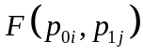, can then be used as the basis for selecting which of the two corresponding observations represents the event of interest.
If 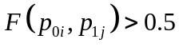 then it would seem reasonable to select (in this case correctly) the observation corresponding to forecast 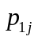 as the event, but to select (in this case incorrectly) the observation corresponding to forecast if 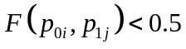. Therefore, if and in Eq. (7a) are distributions rather than discrete probabilities, Eq. (7b) can be modified to
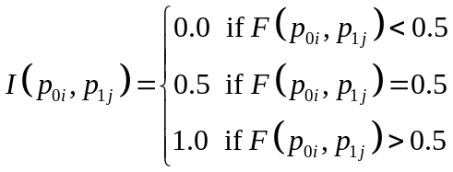. (11)
Although it would seem reasonable to use as the scoring rule in place of in Eq. (7a), the resulting score is improper. Note that the scoring rule for discrete probability forecasts, Eq. 7b, can be derived as a special case from Eq. 11. Also note that if the probability distributions for both forecasts are Gaussian, becomes equivalent to a Student’s t-test for the difference in the means of the two forecast distributions (Sheskin, 2007). The 2AFC score could therefore be interpreted as based on a series of Student’s t-tests.
As an example, the CNRM forecasts for the Niño3.4 index were converted to Gaussian forecast distributions by using the ensemble mean and standard deviation as parameters for each forecast. The 2AFC score is almost 99%, indicating excellent discrimination between “warm” and “cool” events, and is consistent with the score for the continuous forecasts (section 3a.iv). In fact, if the ensemble distributions are symmetric, then Eq. (11) becomes equivalent to Eq. (8) because will always be greater than 0.5 if the mean of is greater than the mean of , and so it is only the rankings of the ensemble means that determine the score.
This score of 99% for the continuous probabilistic forecasts is larger than that for the discrete probabilistic forecasts. This result is consistent with the observation of Doblas-Reyes et al. (2008) that forecast probabilities should be indicated with as much precision as the forecast system allows since the binning of probabilities tends to result in a degeneration of skill.

  - Polychotomous observations (nominal and ordinal)

If there are more than two possible outcomes, the 2AFC test can still be applied. Let the number of observed categories be m_{v}, and let the categories be ordinal, with category 1 representing the lowest values and category m_{v} the highest; the 2AFC score defined in Eq. (1) can then be generalized to
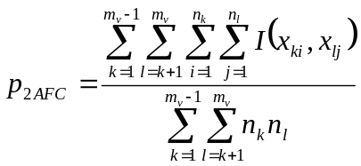, (12a)
where 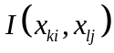 is defined in an analogous way to Eq. (1b):
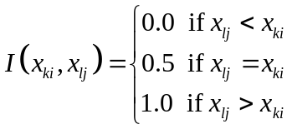. (12b)
As with Eq. (1), the objective is to calculate the proportion of correct 2AFC tests for all possible distinguishable pairs of observations. In the case of continuous forecasts, Eq. (12) is equivalent to a simple rescaling of Somer’s δ (Agresti 1984), as discussed further in section 3c.iv.
If the observed categories are not ordinal then the “<” and “>” symbols in Eq. (12b) do not make sense, and so the score has to be modified to
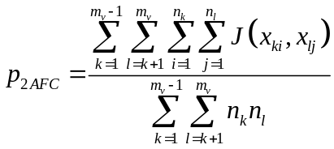, (13a)
where the scoring rule 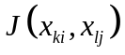 is defined as
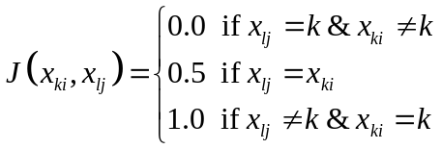. (13b)
In most cases in the atmospheric sciences the categories will be ordinal, but the nominal case is considered for completeness.

- Dichotomous forecasts
This case is not considered since some of the outcomes can never be forecast, and so the case is unrealistic.

- Polychotomous forecasts
When there are more than two-categories for the observations and the forecasts, the 2AFC score for dichotomous observations and forecasts (section 3a.i) can be generalized. Assuming that the categories are ordinal, then in a 3×3-contingency table (Table 1b) the 2AFC score becomes:
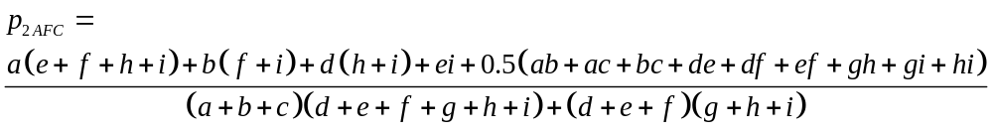. (14)
The terms in Eq. (14) are analogous to those in Eq. (2): the first terms in the numerator represent the correctly discriminated observations, while those in the final parentheses are the sets with indistinguishable forecasts that are scored as 0.5. Eq. (14) can be generalized for more than three categories:
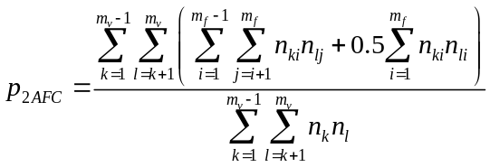, (15)
where m_{f} is the number of forecast categories. As for Eq. (5), perpetual forecasts of the same category will score 0.5.
If the observed and forecast Niño3.4 indices are classified as “hot”, “warm”, “cool”, and “cold” using thresholds of 28.0°C, 27.0°C, and 26.0°C, the resulting contingency table suggests a highly skilful set of forecasts with most of the cases near the diagonal (Table 4). However, primarily because of the large number of forecasts for “cool” conditions when “cold” were observed, the 2AFC score drops to about 90%, somewhat less than the scores recorded for the dichotomous observations. The model has a slight warm bias, which is more clearly evident in Table 4 (the model forecasts “cold” conditions 9 times whereas they are observed 15 times) than in Table 2, and is affecting the score for the model. Although the 2AFC score for continuous forecasts is insensitive to monotonic transformations of the forecasts (see further discussion in section 4) the score for polychotomous forecasts can be partially affected by biases, depending on how the categories are defined. This problem is not unique to the 2AFC score described here, and should be considered an argument against the categorization of forecasts rather than as a weakness of the score. The flexibility of the 2AFC test is therefore an advantage: the score can be applied regardless of the data format.
If the categories are nominal, then any distinguishable set of forecast-observation pairs having at least one pair drawn from the diagonal will be marked as correct (i.e., at least one of the forecasts has to be for the correct category). The numbers of observed and forecast categories need to be identical because otherwise categories are forecast that cannot be observed or vice versa. From Table 1b, the 2AFC score becomes:
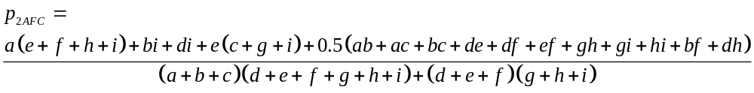. (16)
For more than three categories Eq. (16) generalizes to:
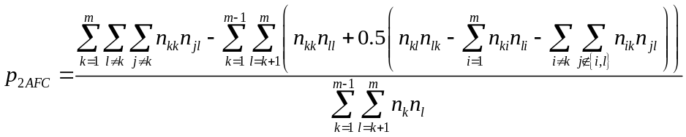. (17)
where m = m_{v} = m_{f}. If the “hot”, “warm”, “cool”, and “cold” Niño3.4 categories defined above are considered as nominal categories, the contingency table is the same as shown in Table 4, but the 2AFC score drops to about 88% because of the loss of information about the ordering of the categories. Given that the categories in this example are ordinal but are scored as if they are nominal, the difference between this score and that from Eq. (15) can be explained as follows. In cases where the forecasts are ranked correctly, but the highest ranking forecast is incorrect the forecaster is no longer able to make a selection since the requested category is not forecast; in these cases the forecaster scores 0.5 instead of 1. In cases where the forecasts are ranked incorrectly, and neither forecast indicates the requested category the forecaster is again unable to make a selection; in these cases the forecaster scores 0.5 instead of 0. In some cases, therefore, the forecaster gains, but in most cases, if the forecasts are skilful, the forecaster will lose when using the nominal version of the score, as in the CNRM example.

- Discrete probabilistic forecasts
For discrete probabilistic forecasts of polychotomous categories, the 2AFC score is a generalized version of that for the dichotomous observations (section 3a.iv). For ordinal categories, the score assesses the ability to identify the observation in the higher category, just as for the polychotomous forecasts, but makes the selection on the basis of the forecast probabilities, just as for the dichotomous observations. The score is therefore a generalization of Eq. (7), but uses the cumulative probabilities of the first k categories for the ith forecast given that category l occurred, 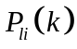. The 2AFC score is defined as
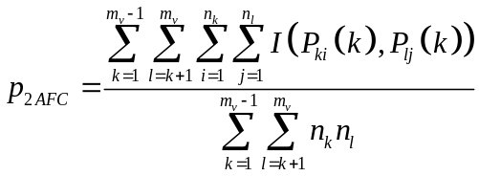, (18a)
where
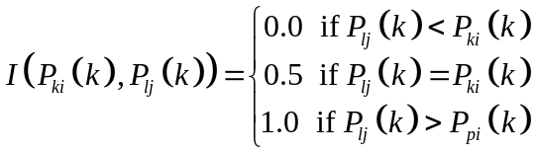 (18b)
[cf. Eq. (12)]. The numbers of observed and forecast categories need to be identical.
For the CNRM data, using the same four categories for observations and forecasts as for the polychotomous forecasts (section 3b.iii), and using the simple counting procedure for assigning forecast probabilities as was used for the dichotomous forecasts (section 3a.iv), the 2AFC score is about 90%. Although this score continues to indicate a high degree of skill in forecasting the Niño3.4 index, it remains lower than the scores for the dichotomous observations, which is attributable to the poor estimates of forecast probabilities using the counting procedure, and to the relatively poor ability to distinguish between the “cool” and “cold” conditions.
If the categories are nominal, Eq. (12) is simply applied to the probabilities, just as Eq. (7) was adapted from Eq. (1). The 2AFC score is therefore
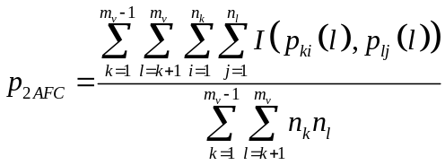, (19a)
where
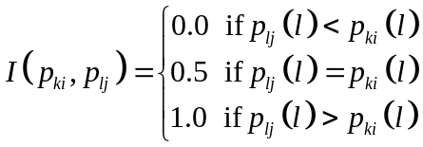. (19b)
The summation over j is across the forecasts for all the observations not in category k. In contrast to Eq. (18), Eq. (19) is based on the probability assigned to the category in question only (category l).
The score for the CNRM data is about 86%. As for the dichotomous observed categories the score for the polychotomous forecasts treated as nominal categories is less than if they are treated as ordinal. However, if the categories are considered individually, the score for being able to identify the “hot” category is about 99%, while that for the “warm” is about 93%. The scores for the “cold” and “cool” categories are notably less (about 78% and 80%, respectively); the scores for these categories are negatively affected by the previously mentioned warm bias in the model.

- Continuous forecasts
For continuous forecasts of ordinal polychotomous categories (nominal categories would not make sense), the 2AFC score is adapted in the same way as for the dichotomous categories (section 3a.iv): for n forecasts (and no ties) there are n categories. The question addressed by the 2AFC test remains identical: which is the observation with the higher value? However, since there are fewer ties in the observations now that there are more categories, a larger of number of tests can be conducted. Let the forecasts for categories k and l only be pooled, and then ranked in ascending order. Setting r_{lj} as the rank of the forecast for the jth event (where an “event” is an occurrence of category l, and the ranks are calculated using only those for forecasts for when an event l occurred), the 2AFC score is generalized from Eq. (8):
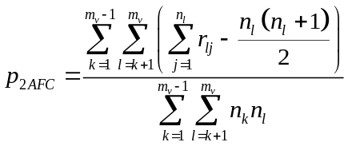. (20)
The 2AFC score for the CNRM data is about 92%, and is most negatively affected by a relatively poor ability to discriminate “cool” from “cold” conditions (73%). The only other partial scores that were imperfect were between the “warm” and “cool” categories (97%), and between “warm” and “hot” (98%), i.e., the model could not perfectly discriminate between observations in neighboring categories. However, the model’s ability to discriminate between observations in neighboring categories is better for the warmer compared to the cooler categories. A similar ability to forecast the warmest categories most successfully was noted when discussing the discrete probabilistic forecasts (section 3b.iii).

- Continuous probabilistic forecasts
For the dichotomous observed categories, the 2AFC score was based on tests for the difference between the forecast probability distribution functions for events compared to those for non-events. A similar principle applies in the case of polychotomous observed categories except that the forecast probability distributions are compared to see whether they can be used to identify the observation in the highest category. Eq. (11) is therefore generalized to
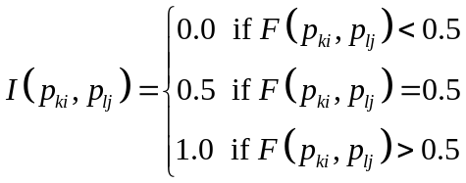, (21)
and the 2AFC score becomes
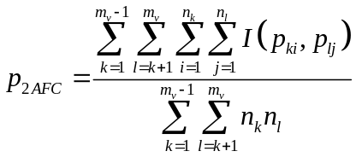. (22)
Note that again the use of 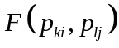 as the scoring rule in place of 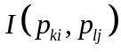 in Eq. (22) renders the score improper.
Using the same Gaussian assumption for the CNRM forecasts for the Niño3.4 index as used for the dichotomous forecasts, the 2AFC score is about 95%, which is a little worse than for the dichotomous forecasts. This reduction is primarily because of a relatively weak ability to distinguish “cold” from “cool” conditions, which has been noted a number of times in previous sections. When the observations were categorized only into warmer or colder than 27.0°C, the “cold” and “cool” categories were grouped together and so the forecasts did not have to discriminate between them. The 2AFC score for discriminating “cold” from “cool” using the Gaussian forecast distributions is only about 70%. However, the scores for discriminating all other categories exceed 98%.

  - Continuous observations

If the observations are measured on a continuous scale, the 2AFC score can be generalized in the same way as for the difference between continuous and discrete probabilistic forecasts: the n observations are treated as if they were a set of n polychotomous ordinal categories. Assuming that there are no ties in the observations, the 2AFC score defined in Eq. (1) and Eq. (12) can then be generalized to
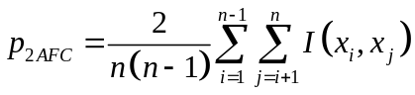, (23a)
where
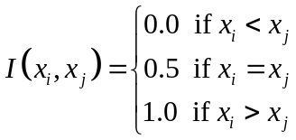. (23b)
If there are ties in the observations then the scores described in section 3b can be applied.

- Dichotomous forecasts
This case is not considered because the forecasts cannot be compared with the observations without reducing the observations to categories.

- Polychotomous forecasts
Similarly, this case is not considered because the forecasts cannot be compared with the observations without reducing the observations to categories.

- Discrete probabilistic forecasts
As for the dichotomous and polychotomous forecasts, this case is not considered because the forecasts cannot be compared with the observations without reducing the observations to categories.

- Continuous forecasts
For continuous forecasts, the 2AFC score could be calculated using Eq. (20), setting the number of categories to n. However, it is considered conceptually simpler to use Eq. (23). Note that Eq. (23) is a simple transformation of Kendall’s correlation coefficient, τ. Kendall’s τ is defined as
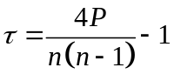, (24)
where P is the number of so-called “concordant” pairs (Sheskin 2007). A concordant pair is defined as a pair of bivariate observations, 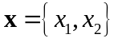 and 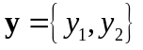, in which 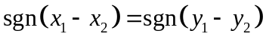, i.e., in which the ranking of the two values in x is the same as in y. Recalling from section 3a that 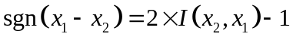, it is easy to show that
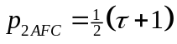. (25)
As mentioned, if there are ties in the observations the tests in section 3b can be used instead, and the rescaling indicated in Eq. (25) can be applied to Eq. (20) or Eq. (12), defining a simple rescaling of Somer’s δ (Agresti 1984). Somer’s δ is an alternative to Kendall’s τ for situations with tied observational values (Sheskin 2007). Compared to Somer’s δ, Goodman and Kruskal’s γ is a more commonly used alternative test to Kendall’s τ for situations with ties (Sheskin 2007). However, Goodman and Kruskal’s γ does not draw a distinction between tied observations and tied forecasts. This distinction is important in the 2AFC scores: tied observations cannot be discriminated and so are not considered in the score, whereas tied forecasts score 0.5 because of an inability to discriminate observations that are different.
The CNRM forecasts score 87% using Eq. (25), which is less than for the continuous forecasts scored against the polychotomous observations, and less still than against the dichotomous observations. The added precision required to correctly rank all the observed values, rather than just to discriminate successfully between categories, is responsible for the decreased score. This decrease in the score as the information content of the observations increases is not a characteristic peculiar to the scoring procedures proposed in this paper, but is evident with more traditional scoring procedures also. It should not be taken as an argument in favor of categorizing, but should rather be seen as evidence of a trade-off between precision and skill: the more precise the forecasts have to be, the greater the chance that random errors, whether because of inherent unpredictability or perhaps resulting from observational errors (Bowler 2008) will adversely affect the score.

- Continuous probabilistic forecasts
The simple extension of the polychotomous observations tests for continuous forecasts to the case of continuous observations by defining n categories can also be applied for forecasts expressed as probability distribution functions. Eq. (22) therefore becomes
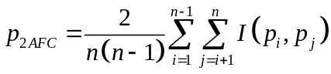, (26a)
where
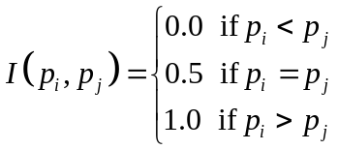. (26b)
The CNRM forecasts score 87% using Eq. (26), which is the same as for the continuous forecasts because of the symmetry assumption for the forecast probability distributions. Both these scores for the continuous observations are the lowest of all the scores reported except for the nominal polychotomous forecasts. The added precision required to forecast successfully the ranking of all the observations is responsible for the drop in the scores compared to those for the categorized observations. For the latter, the forecaster is not expected to discriminate between observations within categories.

  - Observations as probability distributions

The observations themselves can be presented as probability distribution functions (pdfs) to represent the observational errors, for example. It is possible to extend the 2AFC scores to apply to such cases. The observational pdfs would be ranked in exactly the same way as the forecast pdfs in section 3a.v, and the test would proceed as for the continuous observations (section 3c) using these ranks rather than those based on the best guesses of the observations. If the observational errors are symmetric then the ranking will be identical to that from the best guesses.

- Discussion

A number of potential criticisms that could be targeted at the 2AFC score are addressed in this section. Questions relating to the versions of the score for probabilistic forecasts (discrete and continuous) are discussed first; specifically, the question of its sensitivity to the calibration of the probabilities is considered. Then, in section 4b, some problems with the treatment of continuous observations are discussed. In section 4c the effects of spatial and temporal autocorrelation are discussed, and suggestions for addressing these issues are considered.

- Propriety and calibration

It was noted in section 3a.iii that Eq. (7) is equivalent to the calculation of the trapezoidal area beneath the ROC curve, and that in the context of discrete probabilistic forecasts the 2AFC score therefore considers only the ranking of the probabilities, and is insensitive to monotonic transformations of these probabilities. This criticism has to be taken seriously in the context of an administrative verification score because improvements in the reliability of probabilistic forecasts would not be registered. Versions of the 2AFC score that do consider the probabilities must be rejected as being effectively improper. Strictly speaking, the standard definition of propriety (see Bröcker and Smith 2007) cannot be applied to the 2AFC because the 2AFC is defined in terms of two forecast and observation pairs rather than a single pairing. Nevertheless, from idealized examples, it can be shown that the 2AFC scores for probabilistic forecasts are not optimized when the forecaster issues probabilities that are consistent with his / her best judgment.
Given the problems with lack of propriety with the probabilistic versions of the 2AFC score, the authors recommend the scores presented in the sections above that are insensitive to the calibration of the probabilities. Because the objective of the proposed score is to provide a simple metric for indicating the potential usefulness of the forecasts, the authors do not consider the failure of the scores to consider reliability a major weakness. In fact, given that the 2AFC considers only the ability to discriminate observations, this simplicity of the score may even be an advantage: it enables a party interested in using forecasts to identify which of two forecast systems, for example, is likely to be the more useful. Thus, the 2AFC score can be considered a measure of the potential usefulness of the forecasts rather than as a comprehensive measure of all aspects of forecast quality. Any serious use of forecasts should consider how the forecasts may need to be calibrated, and so the 2AFC score is able to indicate the forecasts that will prove most useful only after proper calibration. Of course, this argument is not meant to denigrate the importance of issuing well-calibrated forecasts in the first place, and so some consideration of reliability needs to be made, even within administrative contexts. The authors submit that reliability could be measured separately, as a more detailed diagnostic. In addition, equitability of the 2AFC score is considered a fundamental component of its simplicity of interpretation, and since equitability precludes propriety (Jolliffe and Stephenson 2008), the probabilistic versions of the score are necessarily ruled out.

- Continuous observations

A second criticism of the 2AFC score is that continuous observations are reduced to an ordinal scale. Pearson’s correlation coefficient is widely used for verification of forecasts of continuous variables, and does not reduce the observations to an ordinal scale. However, this score is sensitive to distributional assumptions, and so-called non-parametric alternatives are often to be preferred especially since they are almost as powerful (Sheskin 2007). Of the best-known non-parametric measures of association, Spearman’s rank-order correlation coefficient is much more widely used than Kendall’s τ, partly because of its relative computational efficiency, but also because of its close relationship to Pearson’s coefficient. However, in addition to its affinity to the 2AFC score, Kendall’s τ has additional advantages over Spearman’s coefficient: the sample correlation is an unbiased estimate of the population parameter τ; and the sampling distribution of τ closely follows the normal distribution even for small sample sizes (Lindeman et al. 1979).
Although the conversion of continuous data to ranks may well be a disadvantage, one positive implication is that the score can be used effectively on predictands that are measured on a range of different scales. It can be used for example on unbounded interval data (for most practical purposes temperature forecasts could be considered an example, although strictly temperatures do have a lower bound), ratio data (e.g., quantitative precipitation forecasts), and proportions (e.g., cloud cover). However, it is not clear that the score would make much sense on circular data (e.g., wind directions) because of the inability to rank data on this scale. Calendar dates are also measured on a circular scale, but in many cases (specifically when the dates apply to only a part of the year) a ranking of dates may be meaningful. Monsoon onset dates, for example, can be ranked from early to late onset because they do not span the whole calendar year. In such cases the 2AFC scores can be applied meaningfully as long as the forecasts display similar properties.

- Spatial and Temporal Autocorrelation

In the introduction to section 3 it was mentioned that the individual 2AFC tests that comprise the 2AFC scores are not independent. It is often mentioned that most verification scores assume that each forecast-observation pair is independent of all the other pairs (e.g., Wilks 2006). Dependency arises from spatial and / or temporal correlation, and invalidates the standard tests for statistical significance of verification scores. However, the authors recommend against calculating the statistical significance of the 2AFC scores because difficulties in their interpretation (e.g., Nicholls 2001; Jolliffe 2004; Mason 2008) are likely to introduce unnecessary confusions when the results are being communicated to non-experts. Nevertheless, some indication of the uncertainty in the 2AFC score is desirable because of potentially large sampling errors when sample sizes are small. Confidence limits are recommended instead (Jolliffe 2004; Mason 2008). For some of the versions of the 2AFC score, analytical procedures can be used to obtain confidence intervals (e.g., for the version that is equivalent to the ROC; Mason and Graham 2002), but these procedures will be invalidated given spatial and / or temporal dependency. Bootstrap procedures could be used in these instances.

- Summary

A framework for forecast verification has been described that is designed to be sufficiently general to be applicable to a wide variety of observation and forecast data types. Most verification situations in the atmospheric sciences can be addressed by the framework, except for data measured on a circular scale, examples of which include forecasts of wind directions, or some forecasts for which the predictand is a calendar date. The framework is based on the two-alternative forced choice (2AFC) test that the authors believe is sufficiently intuitive to make it a suitable procedure for calculating verification scores for administrative purposes (as defined by Jolliffe and Stephenson, 2003), including communication of forecast quality to the non-specialist. Although the actual computation of the score and some of the equations may appear fairly complex, the basic concept remains simple: given any two differing observations what is the probability that the forecaster can successfully discriminate the observations using the corresponding forecasts? For quantitative precipitation forecasts, for example, the question may be: what is the probability that the forecaster will successfully identify the wettest day? For binary outcomes, for example, the question might be: what is the probability that the forecaster will pick the day on which a tornado occurred? In all cases the score could be loosely interpreted as an attempt to answer the question: how often are the forecasts correct? However, it avoids the numerous interpretive pitfalls of the percent correct score, and various attempts to normalize this score by calculating a skill score, and retains the intuitive property of having an expected value of 50% for forecasts without skill.
Depending upon the nature of the observations and forecasts, the 2AFC score takes different formats because of an attempt to use as much of the information in the observations and forecasts as possible. The aim is to minimize the reduction of the more complex to the simple, although differences in the various formulations of the score using CNRM forecasts of the Niño3.4 index as examples have indicated some notable conditioning of skill upon the outcome.
In some cases the 2AFC score has been shown to be equivalent to, or closely related to, statistical tests known under different names. Some of these tests are already widely used in forecast verification (e.g., the trapezoidal area beneath the ROC curve); others are based on tests widely used for purposes other than forecast verification (Student’s t-test); while still others are not yet widely used in the atmospheric sciences (e.g., Somer’s δ, and Kendall’s τ).

References

Agresti, A., 1984: Analysis of Ordinal Categorical Data. Wiley, 304 pp.
Bowler, N., 2008: Accounting for the effect of observation errors on verification of MOGRPS. Meteor. Appl., 15, 199–205.
Bröcker, J., and L. A. Smith, 2007: Scoring probabilistic forecasts: the importance of being proper. Wea. Forecasting, 22, 382–388.
Conover, W. J., 1999: Practical Nonparametric Statistics. Wiley, 584 pp.
Doblas-Reyes, F. C., C. A. S. Coelho, and D. B. Stephenson, 2008: How much does simplification of probability forecasts reduce forecast quality? Meteor. Appl., 15, 155–162.
Glahn, H. R., 2004: Discussion of verification concepts in Forecast Verification: A Practitioner’s Guide in Atmospheric Science. Wea. Forecasting, 19, 769–775.
Green, D. M., and J. A. Swets, 1989: Signal Detection Theory and Psychophysics. Peninsula Publishing, 521 pp.
Jolliffe, I. T., 2004: P stands for …. Weather, 59, 77–79.
——, and D. B. Stephenson, 2003: Introduction. Forecast Verification: A Practitioner’s Guide in Atmospheric Science. I. T. Jolliffe and D. B. Stephenson, Eds., Wiley, 1–12.
——, and ——, 2008: Proper scores for probability forecasts can never be equitable. Mon. Wea. Rev., in press.
Kharin, V. V., and F. W. Zwiers, 2003: Improved seasonal probability forecasts. J. Climate, 16, 1684–1701.
Lindeman, R. H., P. F. Merando, and R. Z. Gold, 1980: Introduction to Bivariate and Multivariate Statistics. Scott Foresman & Co., 444 pp.
Livezey, R. E., and M. Timofeyeva, 2008: Insights from a skill analysis of the first decade of long-lead U. S. three-month temperature and precipitation forecasts. Bull. Amer. Meteor. Soc., in press.
Mason, I. T., 2003: Binary events. Forecast Verification: A Practitioner’s Guide in Atmospheric Science. I. T. Jolliffe and D. B. Stephenson, Eds., Wiley, 37–76.
Mason, S. J., 2008: Understanding forecast verification statistics. Meteor. Appl., 15, 31–40.
——, and N. E. Graham, 2002: Areas beneath the relative operating characteristics (ROC) and levels (ROL) curves: statistical significance and interpretation. Quart. J. Roy. Meteor. Soc., 128, 2145–2166.
Murphy, A. H., 1991: Forecast verification: its complexity and dimensionality. Mon. Wea. Rev., 119, 1590–1601.
——, 1993: What is a good forecast? An essay on the nature of goodness in weather forecasting. Wea. Forecasting, 8, 281–293.
——, 1996: The Finley affair: a signal event in the history of forecast verification. Wea. Forecasting, 11, 3–20.
——, and R. L. Winkler, 1987: A general framework for forecast verification. Mon. Wea. Rev., 115, 1330-1338.
Nicholls, N., 2001: The insignificance of significance testing. Bull. Amer. Meteor. Soc., 82, 981–986.
Palmer, T. N., A. Alessandri, U. Anderson, P. Cantelaube, M. Davey, P. Délécluse, M. Déqué, E. Díez, F. J. Doblas-Reyes, H. Feddersen, R. Graham, S. Gualdi, J. -F. Guérémy, R. Hagedorn, M. Hoshen, N. Keenlyside, M. Latif, A. Lazar, E. Maisonnave, V. Marletto, A. P. Morse, B. Orfila, P. Rogel, J. -M. Terres and M. C. Thomson, 2004: Development of a European ensemble system for seasonal to inter-annual prediction (DEMETER). Bull. Amer. Meteor. Soc., 85, 853–872.
Sheskin, D. J., 2007: Handbook of Parametric and Nonparametric Statistical Procedures,. Chapman & Hall/CRC, 1776 pp.
Thomson, M. C., F. J. Doblas-Reyes, S. J. Mason, R. Hagedorn, S. J. Connor, T. Phindela, A. P. Morse, and T. N. Palmer, 2006: Multi-model ensemble seasonal climate forecasts for malaria early warning. Nature, 439, 576-579.
Wilks, D. S., 2006: Statistical Methods in the Atmospheric Sciences, Academic Press, 648 pp.
List of Figures

Fig. 1. Relative operating characteristics curve for CNRM forecasts for the Niño3.4 index to exceed 27.0°C. The ROC curves for dichotomous (dashed), polychotomous (dash-dotted), discrete probabilistic (solid), and continuous forecasts (dotted) are shown.

Fig. 2. Relative frequencies of numbers of ensemble members forecasting the Niño3.4 index to exceed 27.0°C when the index did exceed 27.0°C (black) and when it did not (grey).
Table 1. (a) 2×2 and (b) 3×3 contingency tables.

OBSERVATIONS | FORECASTS  Yes No
Yes | a | c
No | b | d

OBSERVATIONS | FORECASTS  A N B
A | A | d | g
N | B | e | h
B | C | f | i

Table 2. Contingency table for January 1961–2000 observed values and forecasts of the Niño3.4 index above or below 27.0°C. Forecasts initialized using data for August 1960–1999 are from the coupled ocean-atmosphere model of the Centre National de Recherches Météorologiques (CNRM) of Météo-France.

OBSERVATIONS | FORECASTS  > 27.0°C < 27.0°C
> 27.0°C | 14 | 1
< 27.0°C | 2 | 23

Table 3. Contingency table for January 1961–2000 observed values of the Niño3.4 index above or below 27.0°C from the coupled ocean-atmosphere model of the Centre National de Recherches Météorologiques (CNRM) of Météo-France initialized in August 1960–1999.

OBSERVATIONS | FORECASTS  Very high high low very low
> 27.0°C | 5 | 9 | 1 | 0
< 27.0°C | 0 | 2 | 14 | 9

Table 4. Contingency table for January 1961–2000 observed values of the Niño3.4 index in the ranges <26.0°C (“cold”), 26.0°C – 27°C (“cool”), 27.0°C – 28°C (“warm”), and >28.0°C (“hot”) from the coupled ocean-atmosphere model of the Centre National de Recherches Météorologiques (CNRM) of Météo-France initialized in August 1960–1999.

OBSERVATIONS | FORECASTS  hot warm cool cold
hot | 4 | 0 | 0 | 0
warm | 1 | 9 | 1 | 0
cool | 0 | 2 | 7 | 1
cold | 0 | 0 | 7 | 8

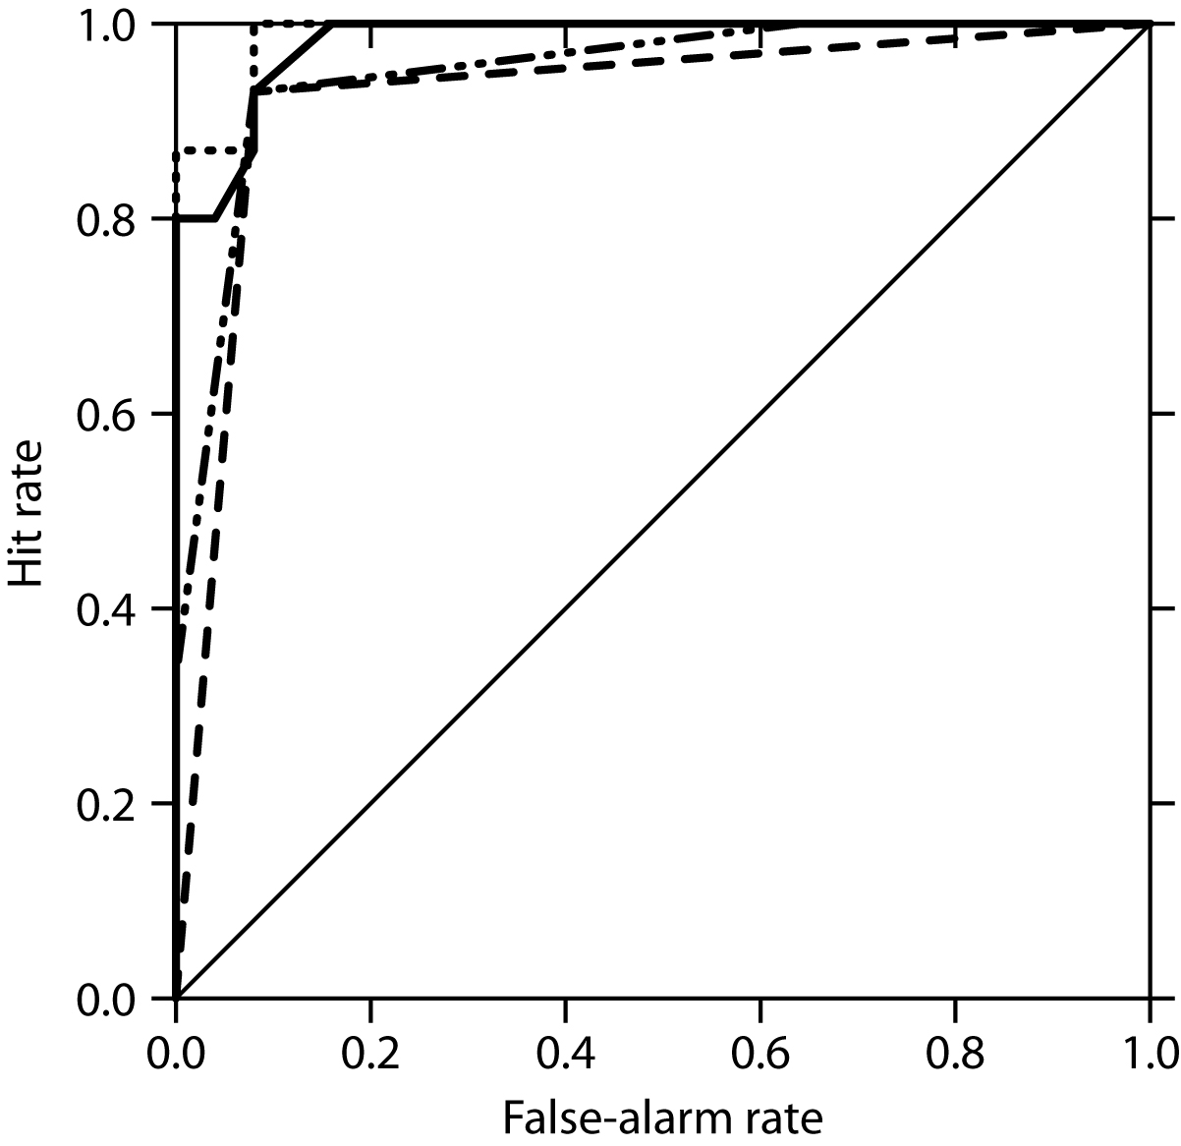

Fig. 1. Relative operating characteristics curves for CNRM forecasts for the Niño3.4 index to exceed 27.0°C. The ROC curves for dichotomous (dashed), polychotomous (dash-dotted), discrete probabilistic (solid), and continuous forecasts (dotted) are shown.
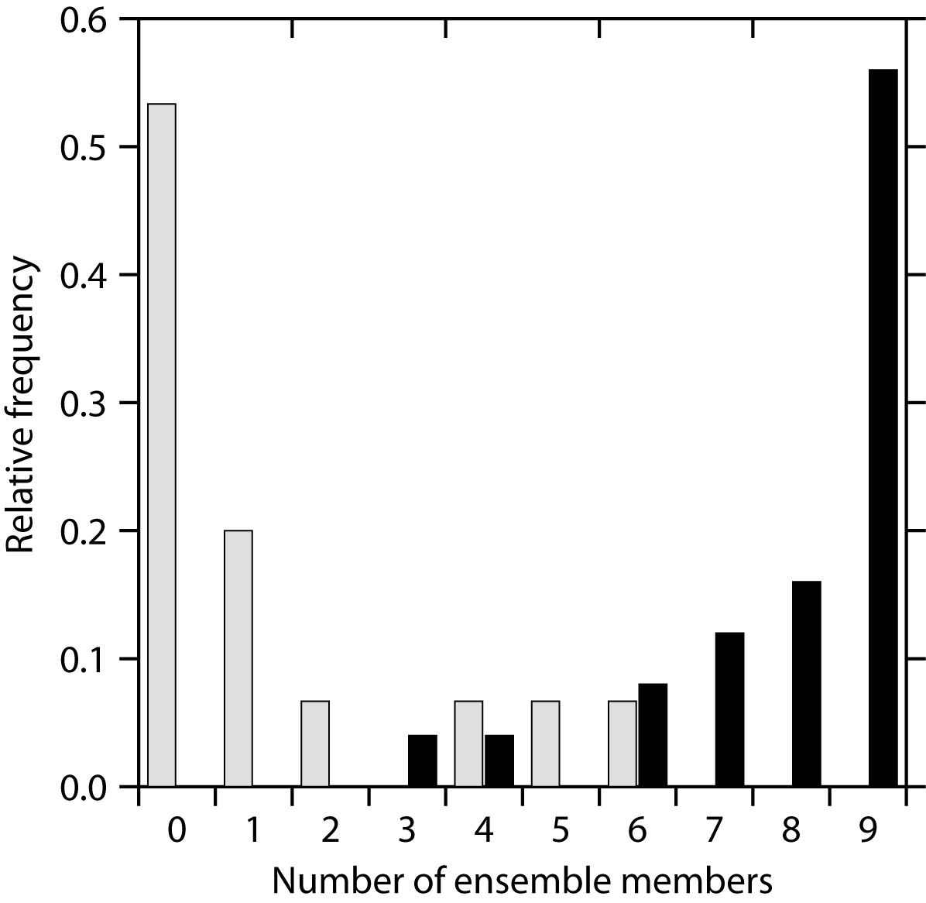

Fig. 2. Relative frequencies of numbers of ensemble members forecasting the Niño3.4 index to exceed 27.0°C when the index did exceed 27.0°C (black) and when it did not (grey).

This aspect of dependency does not invalidate the test, and should be considered distinct from the dependency that arises from spatial and temporal autocorrelation. See section 4 for further discussion.
It would seem unreasonable for the numbers of observed and forecast categories to differ if the categories were not ordinal: either at least some of the forecast categories would be incommensurable with the observational categories, or there would be forecast categories for events that never occur and so there would be no point in forecasting them. The case of nominal forecast categories and dichotomous observations is therefore not considered further.
Note that, in the case of dichotomous forecasts, a forecast of 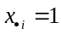 implies a forecast of an event, whereas in the case of polychotomous forecasts, a forecast of implies a forecast of category-1. In the dichotomous case the forecast categories are labelled 0 and 1 to correspond with the observed values of 0 for non-events and 1 for events. In the polychotomous case the forecast categories are numbered from 1 to m_{f}, and it is implied that the higher the forecast category, the more likely it is that an event is expected to occur.
There are more reliable methods of calculating forecast probabilities (e.g., Kharin and Zwiers 2003), but this simple method is used purely for the sake of simplifying the example.
Note that both or neither of the forecasts in a specific 2AFC test may be above or below the event threshold of 27.0°C, but that a “warm” event can still successfully be discriminated from a non-event: if forecast-1 is for 26.5°C, and forecast-2 for 26.0°C, and observation-1 is the “warm” event, the 2AFC test will be passed correctly. This calibration problem is discussed further in section 4.
The tests in this section apply whether the data are unbounded, single-bounded, or double-bounded, and so can apply to meteorological variables that can take any value, that have an absolute zero, for example, and to proportions, which have lower limits of zero, and upper limits of one. However, the tests may not be easily adaptable to data on a circular scale, such as directions or calendar dates.
One can imagine a pathologically bad model that forecasts onset dates that are randomly distributed throughout the year, making a distinction between very early and very late onsets a somewhat arbitrary distinction. In some cases, therefore, it would be difficult to make a selection in a 2AFC test even though the two forecasts may differ. Ad hoc adjustments to the score could be made to handle cases when the interpretation of the forecast itself is unclear (whether the forecast is indicating an early or a late onset), but this topic is beyond the scope of this paper.
In addition to the problems detailed in the cited references, some confusion between the p-value and the 2AFC score itself may arise because both are probabilities.

