WORLD METEOROLOGICAL ORGANIZATION  COMMISSION FOR BASIC SYSTEMS  OPAG DPFS  EXPERT MEETING ON  VERY SHORT-RANGE FORECASTING  TOULOUSE, FRANCE, 27–30 NOVEMBER 2007 |  | CBS-DPFS/EM-VSRF/Doc. 5(1)  (03.X.2007)  _______  ITEM: 5  ENGLISH ONLY

RECENT ADVANCES ON VERY-SHORT AND SHORT RANGE FORECASTING AT METEO-FRANCE

(Submitted by Jean-Marie Carrière, Météo-France, Rapporteur of the OPAG on DPFS on the application of NWP to Severe Weather Forecasting)

Summary and purpose of document

This document gives an overview of the current state and foreseen developments in the field of very-short range and short-range forecasting at Météo-France.

Action Proposed

The meeting is invited to take note of the present document.

________________

Nowcasting and very short-range forecasting at Météo-France

In recent years, Météo-France gave a high priority to a nowcasting project, which allowed progress in a number of topics.

1.1 Mesoscale observing networks

The French radar network has been refurbished, toward a Doppler and 3D capable network. It now includes 24 radars (among which 16 in C-band). 15 radars have Doppler capacity. The 3D capacity allows a revisit time period of 15 minutes for ~10 elevations, and is available on half of the radars. Further, 5 of the radars are being equipped with dual polarization capacity, which allows to estimate the hydrometeor type and to improve the rain rate estimates. The use of small, X-band radars for improving the spatial coverage is under study.

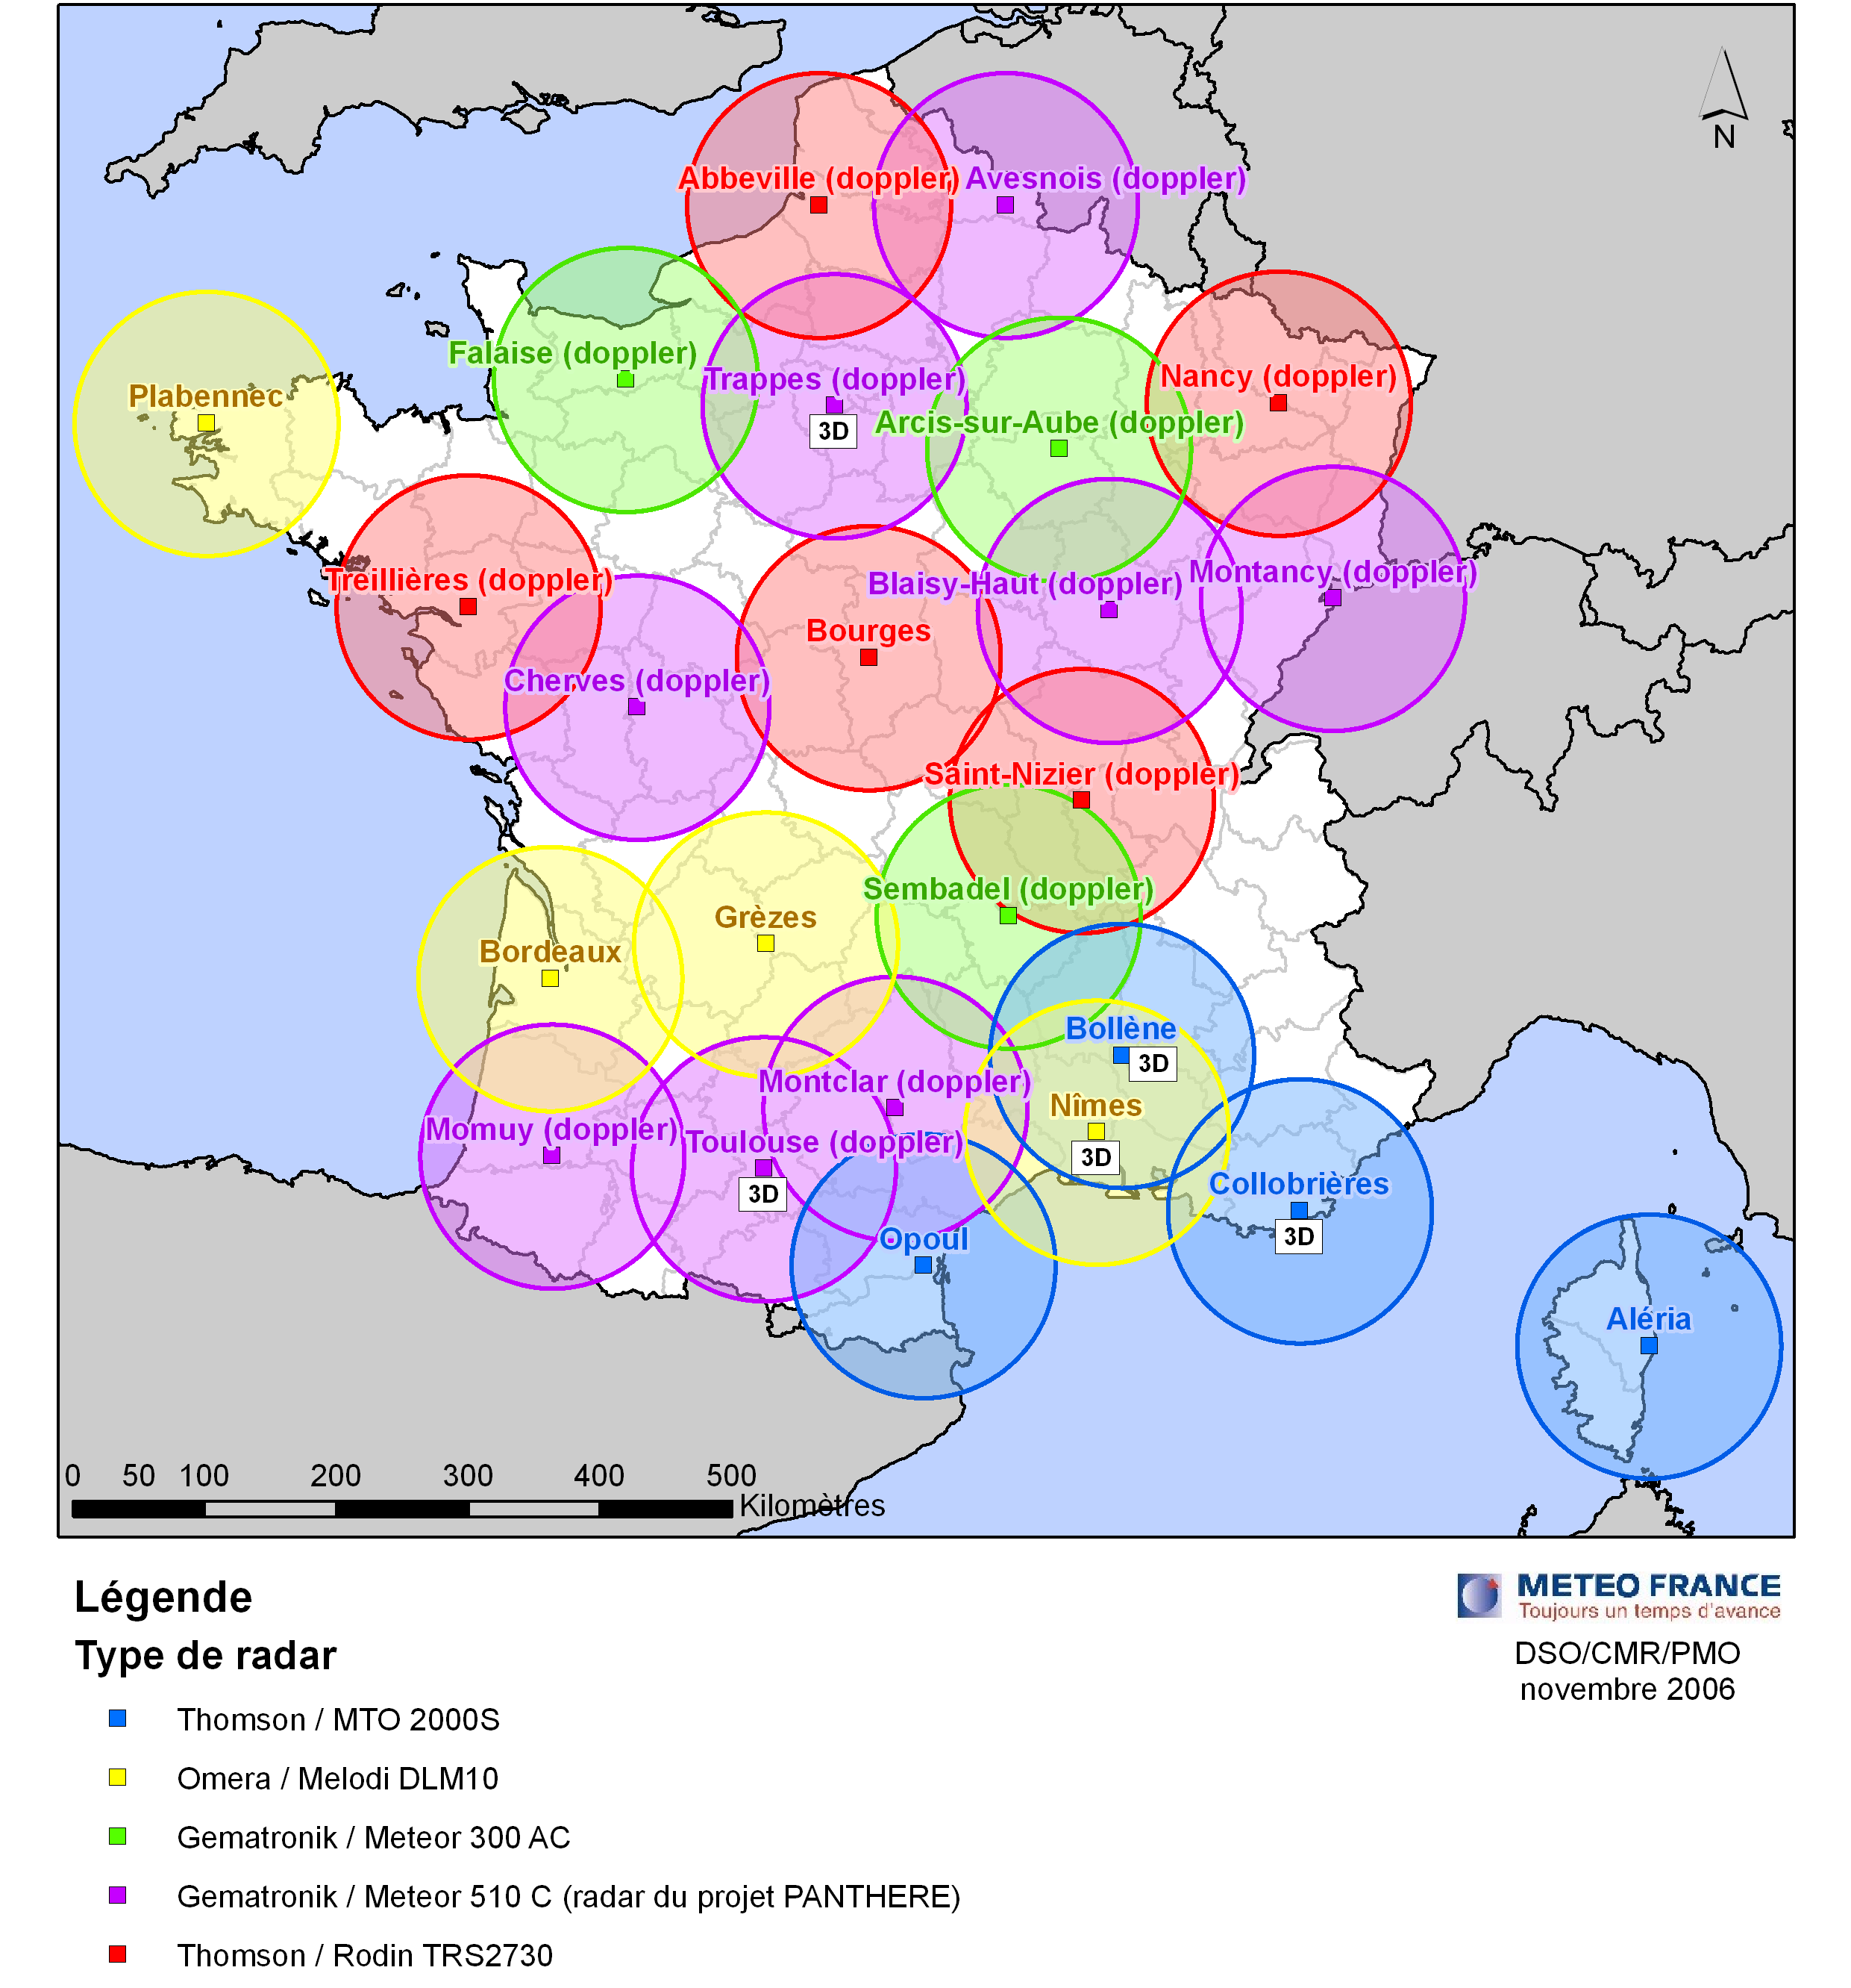
The French radar network in 2007

Regarding the ground automated observing stations, the Radome network had recently been completed. It brings observations from a proprietary network of 550 sites (so 1 per 1.000 km² on average) with at least 4 parameters (temperature, humidity, wind, rain). The basic refresh rate is one hour, but a rapid update rate of 6 minutes is available on forecaster’s demand; further, observing stations are also programmed for sending threshold crossing warnings to the forecasters. A coordination with other observing network operators is underway, and Météo-France also operates a network for the French water authority.

1.2 Advanced diagnostics based on observations

Rain estimates are derived mainly from the radar data, with a significant effort recently brought on the accuracy of this estimate; a short-cycle calibration of radar estimates by rain gauges has been put in operation in 2007; a dynamical quality indicator is also computed for each pixel of the rain estimate, based on an number of factors including the very radar providing the data, the shielding effects, the Vertical reflectivity Profile effect …. Additionally, the forecasters are provided with the VIRAP diagnostics, which show clearly any residual real-time discrepancy between gauges and radar estimates. Further the “Antilope” method, mixing rain gauge data (with kriging) in places showing only smooth gradient in the radar rain field, and radar data elsewhere, was also put in operation and should provide a sound basis for NWP rain field forecasts verification

The Centre de Météorologie Spatiale is involved in Eumetsat’s Satellite Application facility for Nowcasting, for which it develops and maintains a suite of cloud products derived from Meteosat Second Generation : cloud mask, cloud type and cloud top temperature and height. In the same context, the forecast department also develops a “Rapid Developing Thunderstorm” product, for forecasters, which identifies, tracks and characterizes convective clouds from MSG and auxiliary data

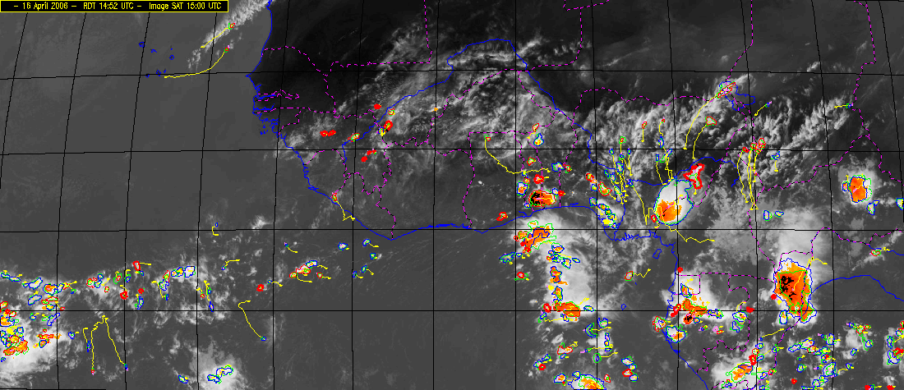

An example of the RDT product at continental scale convective clouds are contoured in red (for growing ones) or blue (for decaying ones). Their tracks show in yellow.

A mesoscale analysis system is operated with a one hour time period and with a 10km grid spacing; the analysis scheme used to be an optimal interpolation one, with the so-called DiagPack system, applied only in 2D to near-surface fields; it is now in the process of being replaced by the variational assimilation scheme used in the NWP suite, under the name of VarPack, and with a 3D capacity; this includes the assimilation of MSG clear sky radiances and will later allow to also include the Doppler winds.

A 3D wind field analysis is also under development, based on multiple Doppler winds and the so called Muscat method. It provides the 3 components of wind in rainy areas, with a 15 minutes time period ; preliminary experiments using this retrieval are much promising.

A fog occurrence diagnostic, called Caribou, has recently been put in operations, which is based on a combination of the SAF-NWC cloud type product and near-surface analysed fields from the above scheme. This allows to estimate fog occurrence likelihood in all places not covered by high or medium clouds, by deciding whether a low cloud is fog based on near-surface wind speed and humidity.

1.3 High impact weather nowcasting : flash floods, thunderstorms and fog

The french Mediterranean coast is prone to flash flood events when convection develops and maintains itself on the slopes near the sea, under south-easterly low level flow. A monitoring system called Aïga has been put in operations, which includes a simplified hydrological model and handles soil wetness information. It computes rainfall accumulation from radar data and river flows at control points, on a variety of time and space scales, and rank them with respect to return periods. The forecaster can hence be warned in a specific way about the places under threat. Civil security authorities are involved in the evaluation of this system.
For thunderstorm nowcasting , the CONO algorithm is operated since 2006. It identifies and tracks thunderstorms based on radar and lightning data, and allows to nowcast their location by extrapolating their track. It feeds the SIGOONS system, which allows the nowcaster to exert his expertise on the attributes of each thunderstorm (either present weather attributes, like wind gusts, or activity trend or motion). SIGOONS also allows the nowcaster to define more long-lived thunderstorm systems, when convection is organized enough. Operating the SIGOONS system assumes than a nowcaster is available and organizing the shifts to ensure it is a question under scrutiny.

High end fog nowcasting service is addressed at Météo-France on major airports through a specific observation setting which includes a mast and radiometers, and using a 1D model with detailed microphysics parameterization named Cobel. This system was proved to beat most existing methods for ranges up to 4 hours; it has been installed for Roissy Airport and is currently being extended to Orly and Lyon airports.

1.4 Nowcasting products for the end user

Based on the SIGOONS system, which includes both automated thunderstorm objects and forecaster’s expertise for thunderstorm systems, thunderstorm warnings specific to one user’s location and sensitivity are issued in an automated way. Trials have been organized in the past years and a product should be released to the public in 2008 for one-hour warnings, based on automated objects. Longer range warnings (up to 2 or 3 hours) will need reliable availability of nowcaster’s expertise on thunderstorm systems

Besides, a rain occurrence warning product has been recently developed, which aim is to warn for the beginning of rain event, up to one hour in advance. It is based on extrapolation of radar-based rain estimates, and warnings are delivered using mobile phone short message services. The product should be available for most part of inland France in 2008.

General overview of Météo-France’s short-range forecasting system

The Météo-France short-range forecasting system is built around a multi-scale modelling approach:

- The ARPEGE and IFS models are used at large and synoptic scales, with a 4D-Var data assimilation scheme at a resolution of the order of 20-40 km resolution over the Europe/North Atlantic area. A regional ensemble prediction system uses the ARPEGE model for the short-range.

- The ALADIN model is used at sub-synoptic scale; ALADIN-France covers Western Europe at a 10 km resolution and is initialised using a regional 3D-Var data assimilation scheme that brings extra information with respect to the driving ARPEGE model and data assimilation thanks to assimilation of ground based stations and high resolution Meteosat radiances. Other geographical domains may be used to run ALADIN.

- A third component, AROME, will be a convection-resolving model at 2.5 km horizontal resolution over mainland France and its surroundings, with its own 2.5 km 3D-Var data assimilation. AROME is in real-time experimentation since early 2006 and will be put into operations near mid 2008. The AROME data assimilation adds information over ALADIN by its use of higher-frequency observations -the target is hourly data- and Doppler winds from a new French radar network. The non-hydrostatic operational version of AROME is on the move to operations. A specific validation and training project, PARME, has been implemented in order to ensure an optimal use of AROME by the forecasters. The project includes the definition of the AROME technical production suite (e.g. timings and post-processing tools) and subjective real time evaluation by bench forecasters. PARME has revealed weaknesses in the model that could not have been identified by objective scores; these are being addressed by the scientific teams.

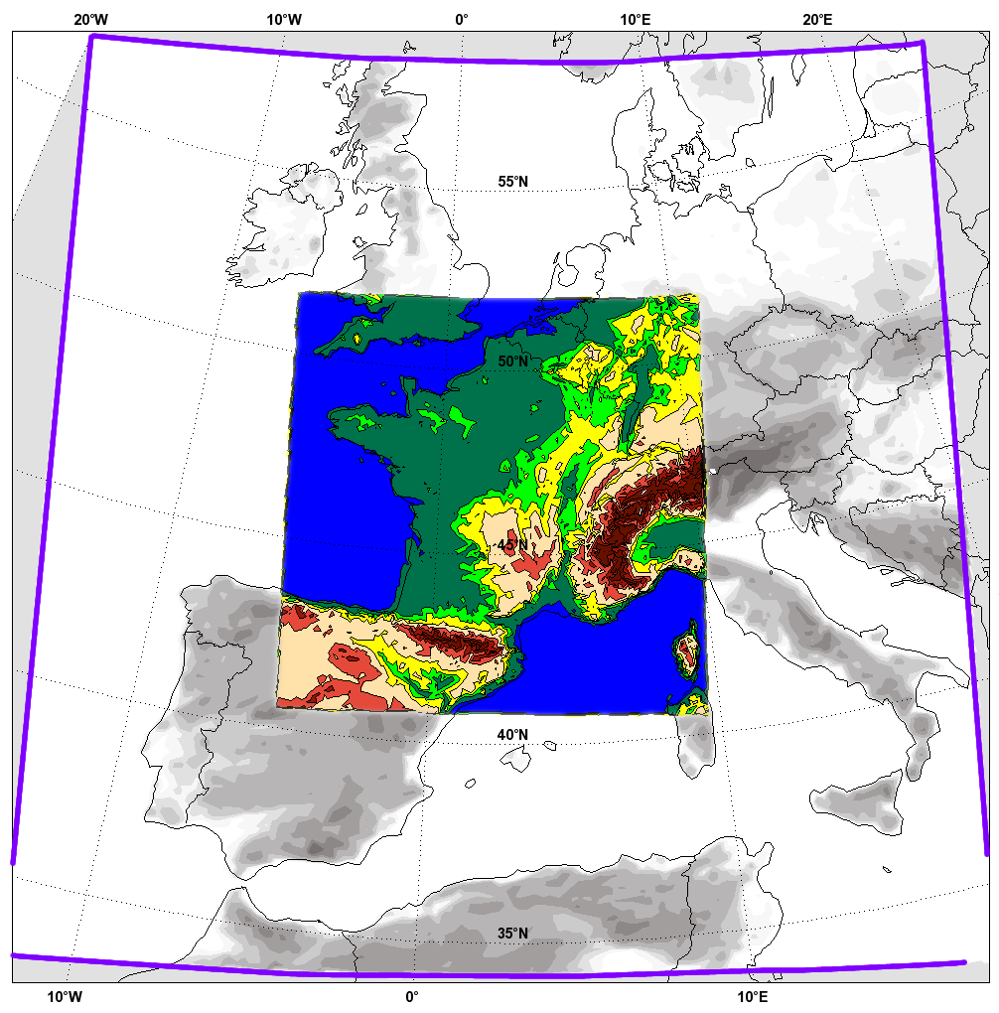
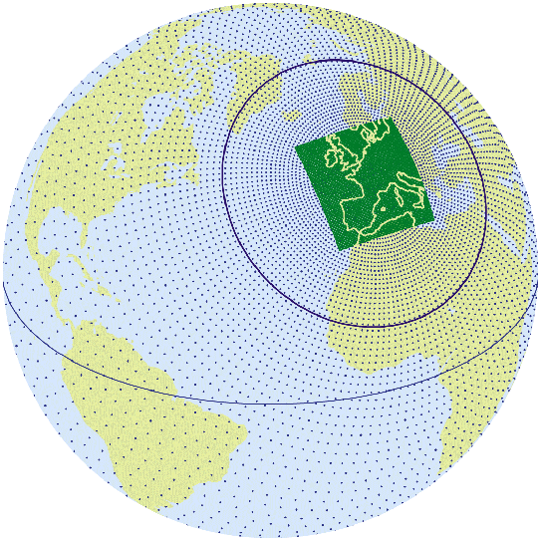
ALADIN

AROME

The global variable mesh of Arpège (left), the ALADIN-France domain and the AROME domain (right)

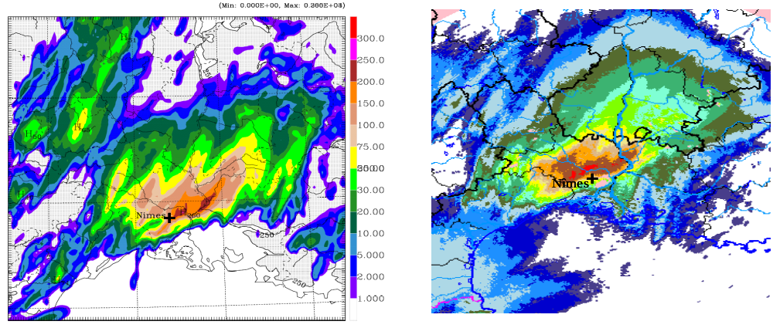
AROME prototype model. Forecast and observed precipitation for the extreme flood case of 8-9 September 2002 in South-East France

The ALADIN and AROME systems (models and data assimilation) are developed in cooperation with ECMWF, the research community and a number of countries from the ALADIN and HIRLAM consortia. The NMS from these countries help to improve the systems, and may use customised versions of the French systems. Météo-France provides real time boundary conditions to the ALADIN consortium models.

2. The short-range and regional EPS system of Météo-France

A short-range ensemble prediction system called “PEACE” (“Prévision d’Ensemble ARPEGE à Courte Echéance”, i.e. ARPEGE Short-Range Ensemble Prediction System) is running operationally at Météo-France once a day at 18 UTC since June 2004. The perturbations used in the ensemble are generated by the singular vectors technique. Nevertheless, vectors are optimized at 12h over a limited area included the Western Europe and the northern part of the Atlantic Ocean. By this way, perturbations are mainly efficient in the area of interest for the short range forecast over France. Because of heavy computational cost, the ensemble is limited to 11 members (10 perturbed + 1 control). However, it is based on the operational version of the ARPEGE model with a spectral truncation of TL358 with a stretching coefficient of 2.4 (corresponding to a grid mesh of 23 km over France and 100km over New-Zealand).

Different standard products are provided to the forecasters: stamps, mean and spread fields, probability charts for different thresholds. These products are available on SYNERGIE, the visualization tool developed at Météo-France. Other specific products such as vertical integrated singular vectors energy or low centers trajectories plumes are also available on an internal web page.
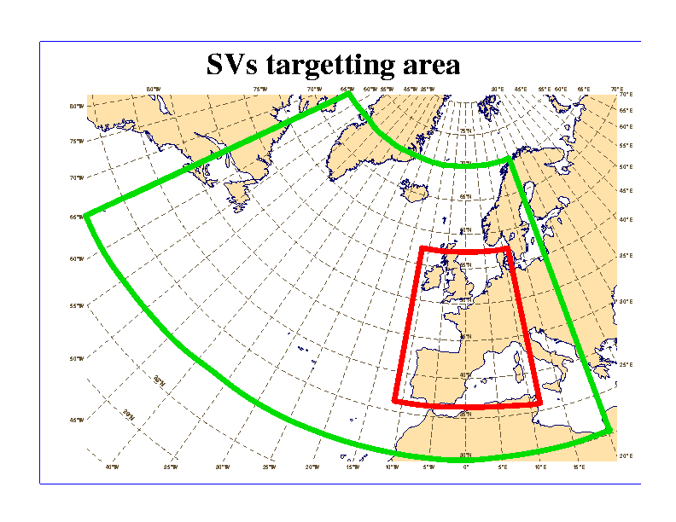
Target area for the singular vector optimization area (green) and verification area (red)

The main application is short-range probabilistic forecasts. The system gives complementary information as guidance to the forecasters especially when models disagree in perturbed situation. Some automatic applications have been also developed, like “mix” EPSgrams using PEACE for the 2 first days then ECMWF EPS for the 7 next days with a link between the 2 systems, the idea being to take advantage from the PEARP high resolution for the short range.

With the PEACE system, Météo-France will participate in the TIGGE phase I. Future plans about PEACE include and increase of the final step from 60 to 108 h, use of evolved perturbations and transformation of initial perturbations according to statistical analysis errors.

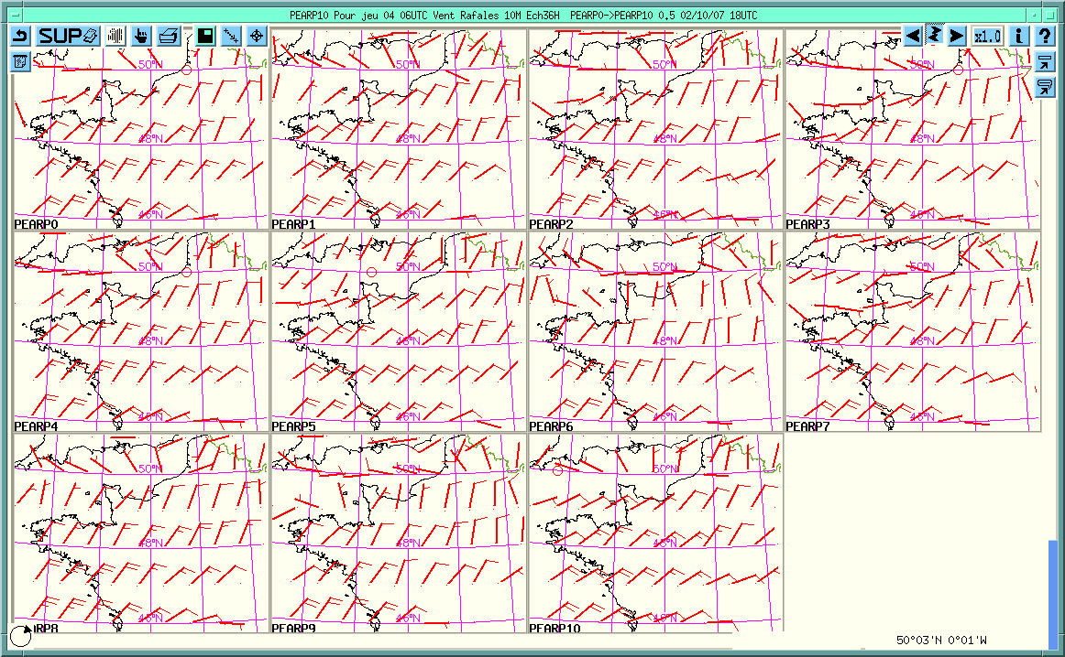

The 11 members of the PEACE EPS system: 36-hour forecast of wind gusts over France

Regional EPS are directly useful for local probabilistic forecast (e.g. EPSgrams). For that reason, it is especially important to provide unbiased and reliable forecast. In that way some post-processings are applied to ensemble distributions. A statistical adaptation is firstly used for bias correction. Then a calibration is applied to ensure a good reliability to the probabilities. In the operational configuration this calibration is realised by using rank diagrams. The Bayesian Model Averaging will be tested next year.

3. Validation and verification

Current observing networks and the state of science do not allow a completely automated validation of the short range numerical forecasts. The French models are evaluated in-house by a combination of scores e.g. with respect to hourly automated stations, daily rain gauge total rainfall, radar and satellite images (still an area of experimentation), human expertise and instrumented sites. Since the trend is towards the direct use of an increasing range of output model parameters, the validation problem is getting more and more complex and application-dependent.

The verification scores computed routinely by Météo-France in the frame of its ISO-9000 quality management system include:

- Deterministic forecasts (Arpège/ALADIN): verification against observations (radio-sounding data, ground network data,…) or against analyses for seal-level pressure, humidity, precipitation, wind speed, wind direction and geopotential height.

- Ensemble forecasts (PEARP): Brier skill score computed against climatology (gradient of sea-level pressure, wind speed, precipitation), bias and root mean square error of the median (sea-level pressure, geopotential height, temperature, wind speed). The ROC curves, rank diagrams and spread are also calculated and compared with EPS scores.

A subjective control is made by forecasters on Arpège/ALADIN and ECMWF forecasts.

As far as intercomparison of LAM is concerned, a project is under study by the EUMETNET SRNWP working group to coordinate LAM control. The project would cover the definition of the models to be compared, the verification domain, the types of observations to be used (including radars), the verification methods and the deliverables and dissemination of results. Because of the low resolution of LAM –models of 4 kmù resolution are already used operationally is some places-, the use of non-GTS observation data might be necessary and will be explored.

______________

