WORLD METEOROLOGICAL ORGANIZATION  COMMISSION FOR BASIC SYSTEMS  OPAG DPFS  EXPERT MEETING ON  VERY SHORT-RANGE FORECASTING  TOULOUSE, FRANCE  27 – 30 NOVEMBER 2007 |  | CBS-DPFS/EM-VSRF/Doc. 4(4)  (22.XI.2007)  _______  Item: 4  ENGLISH ONLY

Status of Implementation and Exchange of NWP for Very Short-range Forecasting:
RA1

(Submitted by E. Poolman)

Summary and purpose of document

This document gives an overview of the status of implementation of NWP for Very Short-range Forecasting in RA1.

Action Proposed

The meeting is invited to note the information as input to its discussions.

NUMERICAL WEATHER PREDICTION IN RA1

- NUMERICAL WEATHER PREDICTION
  - STATUS OF NWP IN RA1
    - In 2002 WMO developed the NWP-Africa strategy for African countries. The aim of the NWP-Africa strategy is to develop weather forecasting in Africa through more efficient use of Numerical Weather Prediction (NWP) systems and products. At the same time, it attempts to keep the strengths and weaknesses of operational meteorology in Africa into account. This strategy identified a four-tiered approach depending on the resources (financial and human) and needs of countries:
- Phase 1: Acquiring and using existing NWP grid point products;
- Phase 2: Acquiring and running a local NWP model without data analysis;
- Phase 3: Running a local model, without data analysis, fine tuning the system for the local region;
- Phase 4: Running a local model with local analysis of data.
    - Current progress in Africa is following this approach to a large extent. The known status of NWP systems in Africa are listed in the table in Addendum 1. In summary most countries in Africa do not have the ability to run NWP models in Africa. Only eleven of fifty-three countries have a NWP model of some kind, but not all are running them operationally. Only two (South Africa and Morocco) run complete NWP systems including data assimilation. All countries have the ability to receive or access products from NWP systems in some format, mostly images accessed by internet. A few can also receive binary output files that can be displayed in a forecaster workstation such as Synergie, Horace, Messir Vision, Ninjo or freeware such as Pcgridds or Wingrids.
    - The most important issue regarding NWP in African NMHSs is for the effect use of available NWP products relevant to their countries (Phase 1 of the NWP-Africa Strategy: Acquiring and using existing NWP grid point products). However, progress has not been satisfactory in this regard yet, mostly because of poor data communication systems, limited internet bandwidth and expensive satellite communications in many countries. Consequently too many countries still rely on old fashioned forecasting practices. The large gap between application of the rapid progress in NWP and EPS in forecasting in developed countries and the outdated forecasting practices in many developing countries are increasingly widening. This gap will increase to unacceptable levels if currently available technology and information are not made available to these forecasting offices, and effectively used in forecasting practices.
    - A number of countries are attempting to run local models of higher resolution over their countries, nested in global models. In many cases they are not very successful mainly due to communication problems when downloading large files containing boundary conditions from global centres. A more efficient process is needed, maybe using satellites channels. Various models are used ion this way, including the HRM of DWD in Germany, Ported Unified Model of the UK Met Office and the WRF model from NCEP in the US.

  - NWP in South Africa
    - The South African Weather Service (SAWS) is running an operational limited area Unified Model NWP system, including 3D-VAR, at a 12 km resolution covering Southern Africa up to the equator twice a day, called the UM SA12. A 4-km nested version of the model (UM SA4) is currently run once a day experimentally.
    - Graphical output of the UM SA12 is made available to countries of the Southern African Development Community (SADC – essentially all countries south of the equator and a number of island states) through a web interface of RSMC-Pretoria. Investigations are currently under way to overcome data communication challenges in the region by transmitting output grib files of the UM SA12 via satellite to SADC countries for more effective use in forecaster workstations.

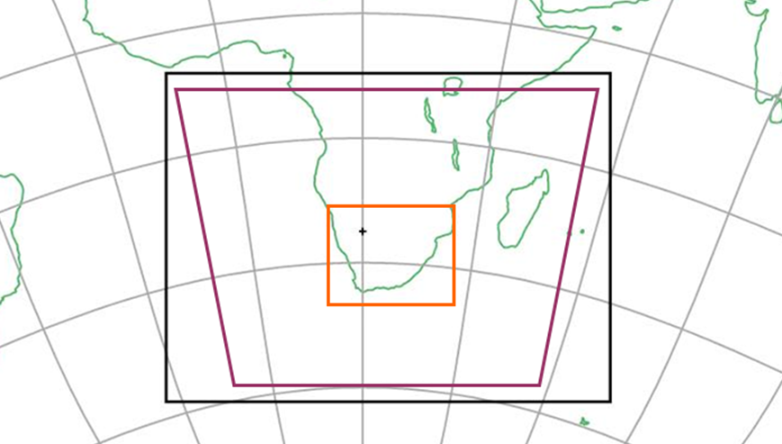
Figure 1. Domain of the SAWS 12 km Unified Model and the 4 km experimental version (inner rectangle).

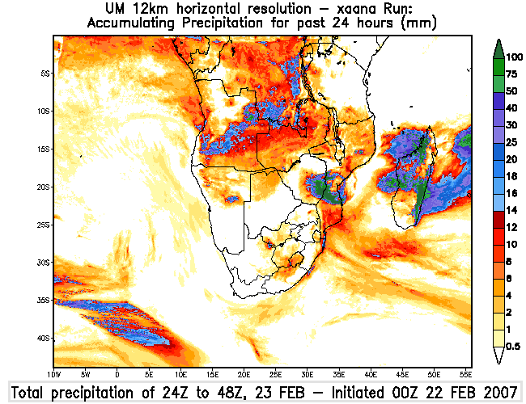
Figure 2. A typical precipitation field available on the RSMC-Pretoria webpage. This one shows prediction of rainfall just after landfall by tropical cyclone Favio in Mozambique.

  - Severe Weather Forecast Demonstration Project (SWFDP) in South-eastern Africa
    - WMO has initiated the SWFDP to test the introduction of operational application of NWP and ensemble prediction systems (EPS) in developing countries where it was not effectively done yet. This process implies the availability of NWP and EPS information from global and regional centres to five NMHSs participating in the project. RSMC-Pretoria also issues daily guidance forecasts for severe weather based on analysis of the NWP and EPS for the next five days to the participating NMHSs. All products are made available through a dedicated RSMC-Pretoria website to the country forecasting offices. These NMHSs in turn use the guidance forecasts and the special NWP and EPS products to aid their decision making to issue warnings or not. The operational phase of the project ran from November 2006 to November 2007. The project was regarded as an overwhelming success and following a request from all the SADC countries it will be rolled out as an operational activity in 2008 to SADC.

- Nowcasting and very short-range forecasting in RA1
  - Weather radars
    - Few countries in Africa have the capability to operate weather radars. In Southern Africa only South Africa (10 radars), Mozambique (3 radars) and Botswana (1 radar) is running radars currently (fig 3). These radars are all linked together to produce a mosaic updated every 15 minutes. Only the Botswana radar is a Doppler radar.
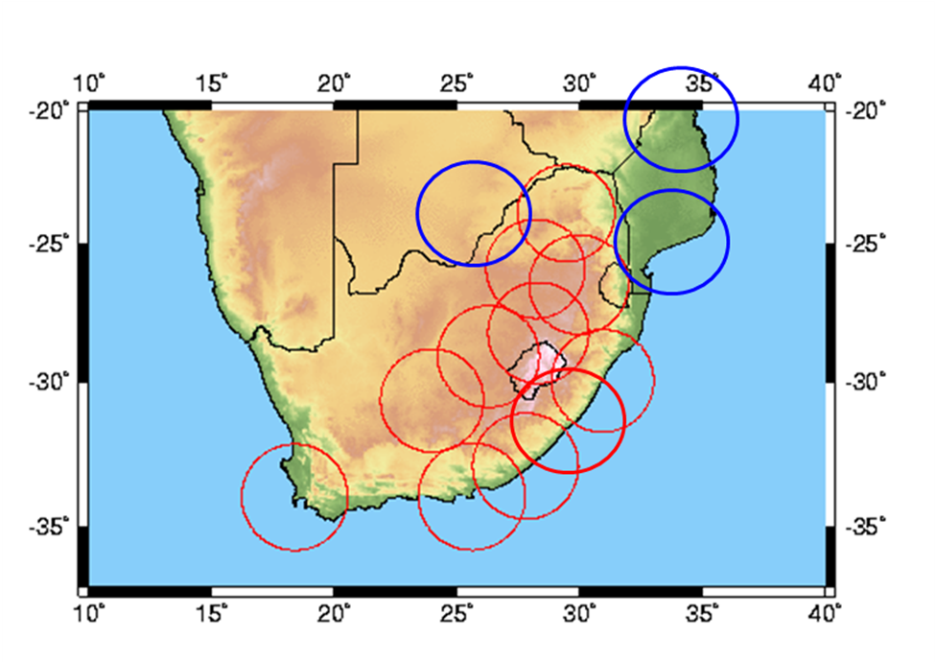
Figure 3. The weather radar network over Southern Africa.

    - Through the NCAR Titan system’s ability to identify storms and project their movement statistically forecasters can issue forecasts for the next hour on the movement of severe storms.
  - Addressing some of the challenges with very short-range forecasting in Africa
    - One of the gaps highlighted by the SWFDP project was the problem of nowcasting in most countries in Africa. Forecasters in the five participating NMHSs stated that the project provided the necessary technology to significantly enhance their ability to issue short- and medium-range forecasts and warnings (through NWP and EPS). However they lack useful nowcasting tools to issue warnings in the very-short time range.
    - The main challenge was the limited number of weather radars and few mesoscale models running in Africa. This is a challenge that the majority of African countries will not be able to address due to the cost and complexity of procuring weather radars and keeping well calibrated radars running.
    - However, all African countries have a satellite receiver giving them access to the 12 channels of MSG and the associated wide range of products. Research internationally are producing a number of useful and exciting new products from combinations of MSG-channels and coupling MSG products with NWP. These developments include new research to identify the potential areas of convection even 12 hours in advance using convective initiation and instability indices. These indices (called GII or Global Instability Indices) like the K-Index, Lifted Index, etc., are calculated by software that analyse vertical profiles estimated through combinations of six MSG channels to correct atmospheric profiles from the ECMWF model on a 15x15 pixel basis. Recently the software was installed at the SAWS, using the higher resolution UM SA12 to produce instability indices for SADC (called the RII) on a 3x3 pixel basis.
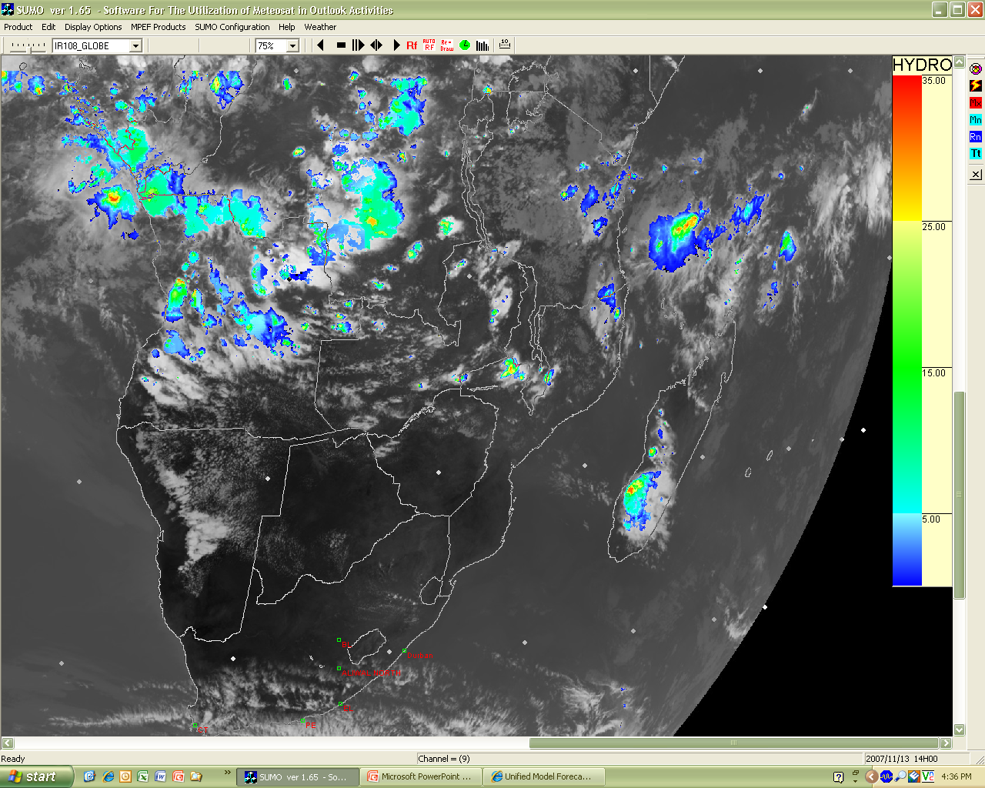
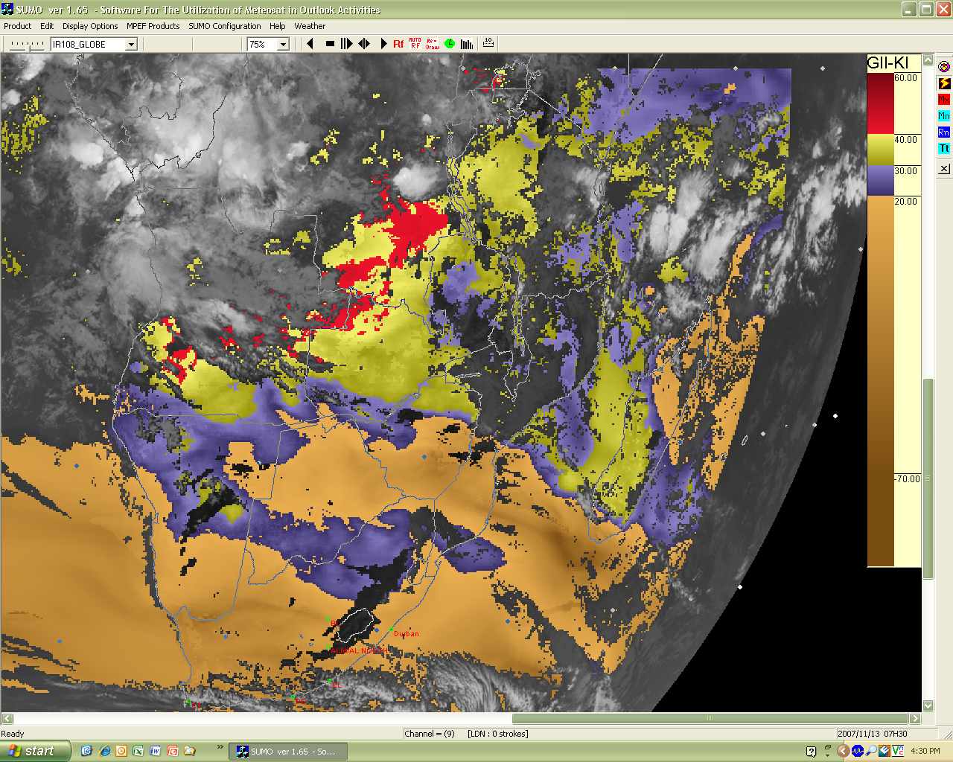
Figure 4. The K-Index of the satellite-based GII predicting the development of severe convection at 07:30 on 13 November 2007, and the verifying satellite image of 14:00 the same day.

    - Since these products are still fairly new its operational application is still virtually non-existent in African countries. Various other combinations of MSG channels giving valuable information for nowcasting is also already available, or in the process of development. Efforts are under way to develop a forecaster friendly interface that will make all these developments readily useful to forecasters. The intention is to transfer this technology into operations through a demonstration project in SADC, following on the SWFDP as a next phase.

Addendum 1: STATUS OF RSMCs AND NMCs RELATIVE TO NUMERICAL MODELS (2005, 2006 or 2007 information) (last update 25/10/07)
GM = Global Model
LAM = Limited Area Model
Perturbation technique for ensemble prediction systems: SV = Singular Vectors, BGM = Breeding of Growing Modes, LAF = Lagged Average Forecasts, StoP = Stochastic Physics, OP = Observation Perturbations, ETKF = Ensemble Transform Kalman Filter

REGION I: Africa

 |  |  |  |  |  |  |  | DISSEMINATION
CENTRE | STATUS | MODELS | DATA ASSIM. | RESOL. | LEVELS | RANGE | Boundary | GTS | SAT. | SPECIAL
DAR ES SALAM | NMC | LAM (WRF) |  |  |  |  | GFS (NCEP)
DAR ES SALAM | NMC | LAM (HRM) |  |  |  |  | GME (DWD)
GABORONE | NMC | LAM (WRF) (soon starting) |  |  |  |  | GFS (NCEP)
GABORONE | NMC | LAM (HRM) (soon starting) |  |  |  |  | GME (DWD)
MAPUTO | NMC | LAM (RAMS) |  |  |  |  | (from Brazil)
MAPUTO | NMC | LAM (HRM) |  |  |  |  | GME (DWD)
ACMAD | Special Centre | access to GM |  |  |  |  |  |  |  | special
LA REUNION | Tropical Cyclone (T.C.) RSMC | full access to GM |  |  |  |  |  | GTS | SAT | special
LA REUNION | Tropical Cyclone (T.C.) RSMC | full access to LAM (ALADIN) |  | 10 km |  |  |  | GTS | SAT | special
ALGIERS | Geo. RSMC | LAM (ETA) |  | 36 km | 24 | 72 h | GFS (NCEP)
ALGIERS | Geo. RSMC | LAM (ALADIN) |  | 12 km | 41 | 48 h | ARPEGE
CAIRO | Geo. RSMC | LAM (ETA) |  | 33 km | 36 | 120 h | GFS (NCEP)
CAIRO |  | LAM nested non-hydro. (MM5) |  | 63, 21and 7 km | 36 | 48 h | GFS (NCEP)
CASABLANCA | Geo. RSMC | LAM (ALADIN-NORAF) |  | 31 km | 37 | 72 h | ARPEGE (France) | GTS |  | special
CASABLANCA | Geo. RSMC | LAM (ALADIN/ALBACHIR) | 3D-VAR | 16 km | 37 | 72 h | ALADIN-NORAF
DAKAR | Geo. RSMC | LAM (ETA) |  | 22 km | 50 | 72 h | COLA, USA) | GTS
DAKAR | Geo. RSMC | LAM (HRM) |  | 22 km | 40 | 72 h | GME (DWD)
NAIROBI | Geo. RSMC | LAM (HRM) |  | 28 km | 40 | 24 h | GME (DWD)
NAIROBI | Geo. RSMC | LAM (WRF) |  |  |  |  | GFS (NCEP)
PRETORIA | Geo. RSMC | LAM (UM) | 3D-VAR | 12 km | 38 | 48 h | GM(UM) UKMO | GTS | Fax | Internet
PRETORIA | Geo. RSMC | ECHAM4.5 Ens. 10 members LAF |  | T30 | L28 | 1 month
TUNIS | Geo. RSMC | LAM (ALADIN) |  | 12.5 km | L41 | 48 h | ARPEGE (France)

- COMPUTERS USED FOR DATA PROCESSING AT RSMCs AND NMCs -
REGION I
CENTRE | MAINFRAME (number cruncher) | SECONDARY COMPUTER(S) | WORK STATIONS
ACMAD |  | INTEL based servers (AMEDIS system) – SUN SPARC | PCs
GABARONE |  | PC cluster
HARARE |  |  | IBM PSs - PCs
ALGIERS |  | PC Pentium IV | 30 PCs
CAIRO | IBM S/390 | 4 HP 750C | 12 IBM PC 300 GL, 18 PC Pentium
CASABLANCA | IBM RS 6000 SP | SUNSPARK 1000 | SGI - 3 DEC ALPHA - MOTOROLA
DAKAR |  |  | PCs
MAPUTO |  | HP wx 9300, Dell Precision 470n
NAIROBI |  | PCs Pentium III, VAX3900 – VAX 11/750 | SGI – PCs
LA REUNION |  |  | Work Stations
PRETORIA | NEC SX8 | Various PC Workstations | PCs
TUNIS | Super calculator | 2 DELL Xeon, HP715/80, HP 755/80

