WORLD METEOROLOGICAL ORGANIZATION  COMMISSION FOR BASIC SYSTEMS  OPAG DPFS  EXPERT MEETING ON  VERY SHORT-RANGE FORECASTING  TOULOUSE, FRANCE, 27–30 NOVEMBER 2007 |  | CBS-DPFS/EM-VSRF/Doc. 4(2)  (20.XI.2007)  _______  ITEM: 4  ENGLISH ONLY

Very short-range forecasting activities within RA IV

(Submitted by André Méthot, Environment Canada)

Summary and purpose of document

This document gives an overview of the current state and foreseen developments for operational implementation in the field of very-short range forecasting in RA-IV

Action Proposed

The meeting is invited to take note of the present document.

_______________

1. Nowcasting and very short-range tools

  - Continental Mesoscale Numerical Weather Prediction Systems

1.1.1 The U.S.A. North American Mesoscale (NAM) Forecast System

The North American Mesoscale Forecast System (NAM) provides high resolution (12 km and 60 levels) forecasts over North America out to 84 hours at 0000, 0600, 1200 and 1800 UTC.

The forecast system is based on the WRF version of the NCEP Non-hydrostatic Mesoscale (WRF-NMM) model since June 2006. The model is based on precise dynamics and numerics, using a hybrid sigma-pressure vertical coordinate. The WRF-NMM includes a full set of parameterizations for physical processes, including Janjic modified Betts-Miller convection, Mellor-Yamada turbulent exchange, Fels-Schwarzkopf radiation, a land surface scheme with 4 soil layers and predictive cloud scheme. The lateral boundary conditions are derived from the prior (6-h old) NCEP global model forecast at a 3 hour frequency.

Initial conditions for the four NAM runs are produced by the regional Grid-point Statistical Interpolation (GSI) analysis, which is a multivariate 3-dimensional variational analysis which uses as its first guess a 3-hour WRF_NMM forecast from the NAM Data Assimilation System (NDAS). The data cut-off time for the NAM initial conditions is 1 hour and 10 minutes past the nominal NAM analysis time. The data time window radius is 1.5 hours about the centre of the data dump cycle time. No initialization is applied.

The NDAS is a fully cycled, self-contained system of 3-hourly WRF-NMM forecasts and regional GSI analyses, using global fields only for lateral boundary conditions. Each NDAS cycle runs prior to the NAM forecast, assimilating all available observations within the 12-h period preceding the NAM initialization time, with a data cut-off time up to 9-10 h past the nominal NDAS analysis times. The data time window radius is 1.5 hours about the centre of the data dump cycle times. No initialization is applied.

1.1.2 The Canadian Regional Forecast System

The Canadian Regional Forecast System is the basis of the short-term forecast leading to products and services provided by Environment Canada. It uses the Global Environmental Multiscale (GEM) model in its variable grid configuration; the computational grid is global with a central uniform high resolution part of the grid covering Canada, USA and adjacent oceans. It is integrated twice a day (00Z and 12Z) producing 48-hour forecasts.

It has an horizontal resolution of 15 km in the central part of the domain, 58 levels in the vertical, and includes a detailed physics package for the surface (a mosaic-type approach with the ISBA land surface scheme) and condensation processes (Kain-Fritsch for deep convection, Sundquist microphysics scheme, moist turbulence, and shallow convection).

The initial conditions are provided by a 6-h cycle of the regional data assimilation system (RDAS) based on the 3DVar-FGAT procedure (First Guess at Appropriate Time). This regional data assimilation is a “spin-up” of trial (“background”) fields obtained from the lower-resolution global data assimilation cycle.

Anticipated changes to the regional forecast system include: assimilation cycle with additional data (winter 2008), the addition of 06Z and 18Z runs leading to 4 runs per day (fall 2008), 15-km Limited Area Model (LAM) continental grid (spring 2008), and finally (early in 2009) an increased resolution to 10 km and improved physics (new radiation package and cloud microphysics scheme).

1.1.3 The U.S.A. (NCEP) Rapid Update Cycle (RUC)

The Rapid Update Cycle (RUC) System generates high-resolution analyses and 9-hour forecasts for the contiguous United States every hour with forecasts extended to 12-hrs at 0000, 0300, 0600, 0900, 1200, 1500, 1800, and 2100 UTC. The model has a 13-km horizontal resolution with 50 vertical levels.

The RUC system was developed by the NOAA/Forecast Systems Laboratory. The RUC run provides high-frequency, short-term forecasts on a domain covering the lower 48 United States and adjacent areas of Canada (southern portions), Mexico, and ocean. Run with a data cutoff of 26 minutes at 0100-1100 and 1300-2300 UTC and 58 minutes at 0000 and 1200 UTC, the analysis relies heavily on high temporal
resolution asynoptic data from surface marine, METAR and mesonet reports, wind profiler, GOES satellite layer PW retrievals, GPS precipitable water observations, and derived wind data, and MDCRS ACARS aircraft data.

One of its unique aspects it is use of a hybrid vertical coordinate that is primarily isentropic. Most of its 50 levels are isentropic except for layers in the lowest 1-2 km of the atmosphere where terrain-following coordinates are used. The two types of surfaces change smoothly from one to another. There is a nudging of soil temperature and moisture. A full package of physics is included with 5 cloud precipitation species carried as historic variables of the model.

1.1.4 A Nowcasting System

A nowcasting system was developed at CMC to help out the routine forecasting of weather elements in Canada. It is basically a stand-alone statistical forecast system based on recent surface observations (METAR), radar and lightning data; satellite information will be added eventually.

The nowcasting system generates hourly forecasts from 0 to 12 hours of sky condition, occurrence and precipitation type, visibility, convection and temperature, at points. The forecasts are always in terms of probability, but can always be converted into categorical forecasts. Verifications have shown some skill at forecasting cloud opacity, precipitation type and visibility, but limited skill at forecasting convection and occurrence of precipitation. In general, the nowcasting system outperforms persistence after one to two hours projection times. The nowcasting system also outperforms the direct NWP model outputs up to 6 hour lead-time, in general. This is especially true for wind, temperature, and clouds. For instance, the Figures 1 and 2 are showing some verification results.

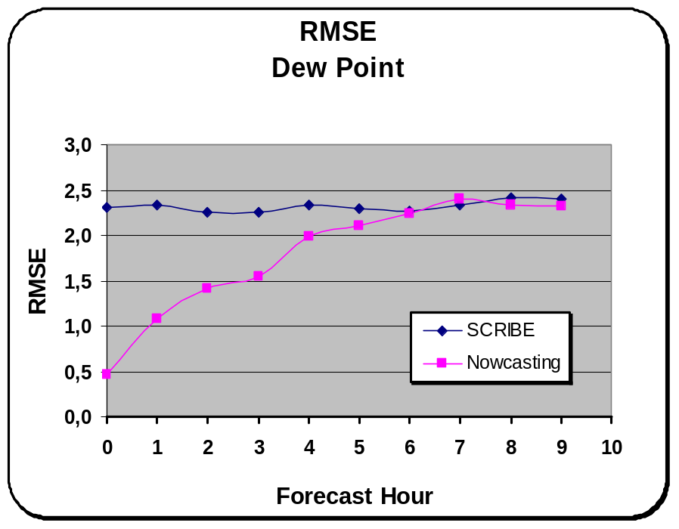

Figure 1 Surface Dew point forecast Root Mean Square Error (RMSE) with respect to 23 observation stations in Canada for May 2004 to August 2004. The lozenge-blue curve denote the performance of the regional forecast system (Scribe including MOS added value) while the squares-magenta line represents the performance of the Nowcasting system.

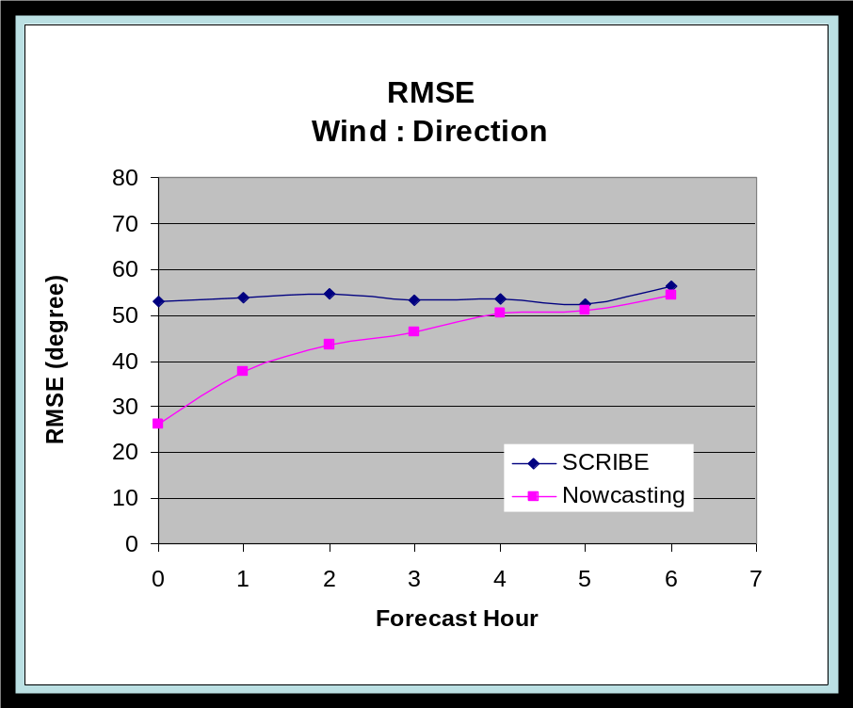

Figure 2 Surface Wind direction forecast Root Mean Square Error (RMSE) with respect to 23 observation stations in Canada for November 2003 to February 2004. The lozenge-blue curve denote the performance of the regional forecast system (Scribe including MOS added value) while the squares-magenta line represents the performance of the Nowcasting system.

1.2 The Short-Range Ensemble Prediction Systems (EPS)

The short-range ensemble prediction systems are not typically designed for the very short-term forecasts lead-time. However, they can be used for 6 to 12-hour lead time, with some usefulness.

    - The NCEP (USA) Short Range EPS

The NCEP Short-Range Ensemble Forecast (SREF) system provides multiple model short-range (0-3 day) ensemble predictions that offer operationally relevant and useful guidance on probabilities of occurrence for various potential weather elements or events. The probabilistic information provided by SREF will help meet the NWS strategic goal of providing probabilistic gridded products to the NWS/WFOs, service centers and other users.

The SREF includes 6 Weather Research and Forecasting (WRF) model members, 10 NAM-Eta model members and 5 Regional Spectral Model (RSM) members. The 6 WRF members are made up of three using the Advanced Research (ARW) WRF core (at 45km resolution)and three with the Nonhydrostatic Mesoscale Model (NMM, running at 40km resolution) core and physics.

Both deterministic and probabilistic verification statistics have shown that the SREF provides improved accuracy and forecast spread (uncertainty) information, especially for key weather elements. In addition, several key products were added to the SREF gridded output files to provide new guidance on winter weather forecast scenarios, such as the possibility of roadway icing and reduced visibility.

    - The Canadian Short Range EPS

A short-range Ensemble Prediction System is currently into development in Canada. The focus is on a North American system at 33-km resolution with around 10-20 members. It would provide guidance for probabilistic forecasts up to a 48-72 hours lead-time. The expected schedule time in the sequence of production suite suggest that this system will not be focussing on the very short-term, rather for days 2 and 3 forecast products. It is expected to become operational at the Canadian Meteorological Centre in 2009.

  - The High Resolution Forecast Systems

1.3.1 The U.S.A High Resolution Experimental Systems

NCEP (USA) is running a set of high resolution window runs of the WRF-NMM and the NCAR Advanced Research WRF model (WRF-ARW) over various domains. See Figure 3 for the coverage of the domains. This NWP system is really addressing the very short-term forecast.
The WRF-NMM model is running at 4-km horizontal resolution while the WRF-ARW runs at 5.1-km horizontal resolution. The configurations of the two models are given in Figure 4. Following is the schedule for the various windows: East/Central U.S. and Hawaii windows at 00Z; West/Central U.S. and Puerto Rico windows at 06Z; East/Central U.S. and Hawaii windows at 12Z; : Alaska and Puerto Rico windows at 18Z. These experimental high resolution forecast windows are subject to cancellation by NCEP Central Operations (NCO) if the NCEP Hurricane Model is running.

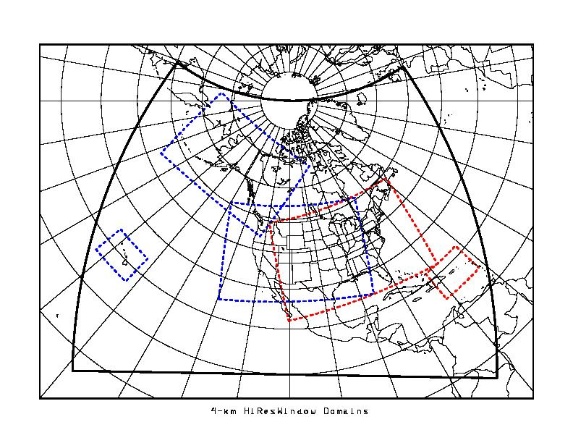
Figure 3 NCEP (USA) High resolution window domains. From west to east, the windows are called: Hawaii, Alaska, West/Central U.S., East/Central and Puerto Rico.
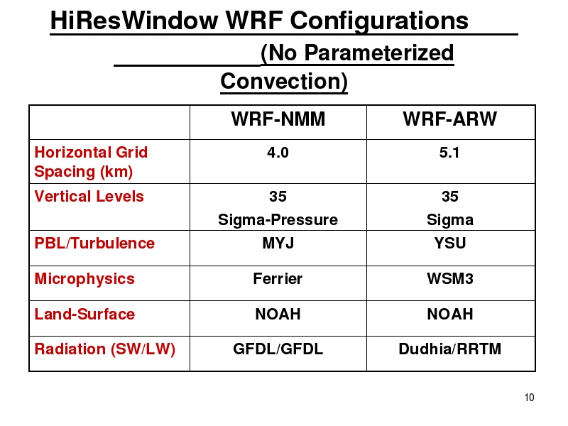
Figure 4 NCEP (USA) High resolution WRF model configurations

Case studies and real-time assessments are conducted in the USA Storm Prediction Center (SPC). Simulated radar reflectivity from WRF high resolution outputs are made available online and the Storm Prediction Centre (SPC). Severe Weather Specialists are participating into the evaluation of these experimental runs. A recent major upgrade, made in September 2007, was strongly supported by SPC representatives.

It appears that these specialized users will increasingly rely on such high resolution guidance in the operational prediction of severe weather over the continental US in the future.

1.3.2 The Canadian High Resolution Experimental System

A high resolution, non-hydrostatic and limited-area configuration of the Canadian GEM model is running in operations in experimental mode at Environment Canada. The model is running once per day at 2.5-km horizontal resolution with 58 levels in the vertical over 4 local area windows (see Figure 5).

The condensation processes are assumed to be represented by the explicit Kong-Yau microphysics scheme (no implicit deep convective scheme).

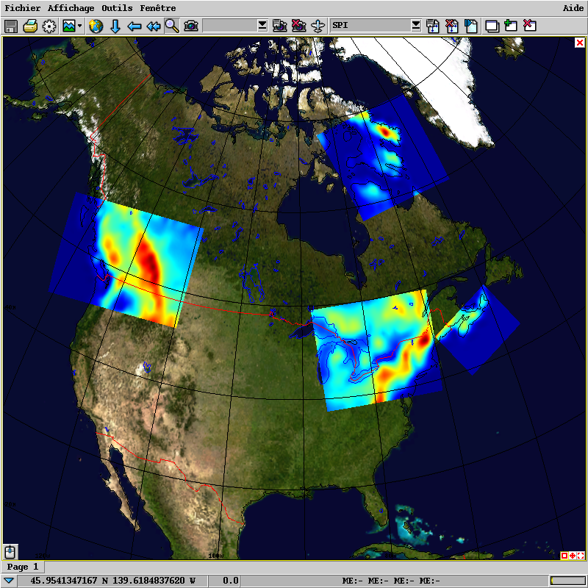

Figure 5 Canadian domains of the LAMs 2.5 km for summer of 2007

Clearly the development efforts at these scales are aiming at better product on the very short-range lead time. However the current version in the production suite is not suitable for a real-time operational usage for very short-range forecast. The 4 window integrations are simply started, in an abrupt fashion, from the 12-h regional-continental forecasts, without any special data assimilation or “spin-up”. The boundary conditions are prescribed (every 3-hour) by the 12- to 36- hour forecasts from the regional forecast system.

The current experimental set up was designed in order to allow the quasi-real-time verification by the operational meteorologists. Similarly to the U.S.A. colleagues, the focus is to assess the added value of such high resolution forecast tools with respect to the lower resolution continental scale guidance, especially for the high impact weather forecast. These validation procedures and verifications activities, in experimental mode, are essential to guide future Research and Development in addressing operational needs.

In the near future, such high resolution windows will become operational. In the mean time, a limited-area mesoscale variational analysis (3DVar-FGAT) system capable of ingesting high spatial and temporal density data (e.g. radar reflectivities and radial velocities, surface precipitation) is presently under development at Environment Canada for the regional forecast system. This procedure will eventually also be applied to the 2.5-km windows with statistics adapted to this scale.
The feedback received so far by Canadian operational meteorologists is mixed. Clearly, the high resolution model provides much more accurate wind and temperature forecast in mountainous areas, along sea shores, and also in the vicinity of large water bodies.
The meteorologists conclude that the high resolution models add value to the forecasting tools in general, but, they are still insufficient in an operational setting since they show some reliability and consistency problems especially with the forecasting of summer severe weather related to thunderstorms.
Finally, it is worth mentioning that a version of the GEM LAM 2.5 km was running over the Alps domain as part of the MAP D-phase international project (see Figure 6 for MAP-D phase domain). The runs were made available in real-time to meteorologists from Switzerland from May to November 2007. The 2.5-km model was piloted by a regional LAM itself piloted, in turn, by the Canadian operational GEM global model.

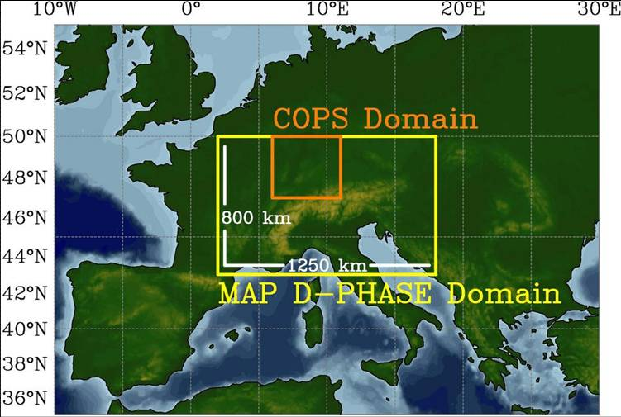
Figure 6 Alpine domain of MAP D-Phase for summer 2007

1.4 Radars and High Resolution Model Outputs

In 2006 a joint effort from Environment Canada Quebec National Severe Weather Lab and Numerical Prediction Research led to the inclusion of synthetic radar reflectivity, computed from the microphysics scheme, into the Canadian numerical model GEM running at 2.5-km resolution. The algorithm, based on customized radar reflectivity, has been transposed to build a severe weather index using numerical synthetic radar reflectivity.
Verification over the summer season of 2006 confirmed that, using this approach, features of severe thunderstorm, very similar to those observed, could be accurately forecasted. It also pointed to some flaws in the algorithm and hinted to the needed improvements.

1.5 Surface Modelling at the Micro Scales

Land surface modelling is traditionally done “in-line” in numerical atmospheric models, with full two-way interactions between the atmospheric and surface components of the model. Following this approach, the computational cost of the atmospheric component of the coupled system severely limits the spatial resolution that can effectively be used for simulations.

Recent studies have shown that significant refinement in surface and near-surface forecasts (e.g., air temperature, low-level winds, soil moisture, and snow canopy) can be achieved by using an “off-line” high resolution surface model. The latter is coupled in a one-way fashion to atmospheric forcing provided by a coarser resolution atmospheric model. Because the surface model runs at a fraction of the cost of the upper air model, its spatial resolution is not limited by the dimension of the atmospheric model, but rather by the resolution of datasets used in defining the surface characteristics.

For instance, two strategies were proposed by Environment Canada for the Vancouver 2010 Winter Olympic Games to achieve this refinement of surface and near-surface numerical forecasts in this mountainous region.

The first strategy is to drive an offline high-resolution surface model using outputs from a high-resolution 1-km GEM-LAM model yielding 16-hour lead time forecast. The atmospheric model provides the forcing required at the surface for: low-level air temperature and humidity, low-level winds, surface pressure, down welling short-wave and long-wave radiation, and precipitation. Using the detailed information available from the high-resolution databases (such as the orography), it is possible to adapt or downscale the atmospheric forcing in order to enhance the realism of the land surface predictions at a 100-metre resolution.

The second strategy to improve surface and near-surface predictions for Vancouver, Canada 2010 Winter Olympic Games is based on a combination of deterministic and statistical procedures. In addition to the gridded land surface models (briefly described above) other implementation of the land surface models will be integrated at particular locations only (single point integrations), for which characteristics such as elevation, vegetation type, vegetation fractional coverage, slope, and aspect, are known and prescribed.

An original aspect of this latter approach is that the atmospheric forcing required to drive the land surface model is not directly provided by a deterministic forecast, rather by statistically-adapted model outputs using the Updatable Model Output Statistics (UMOS) methodology.
2. Verification issues

Larger scale operational continental forecast systems are constantly evaluated, verified against observations and their upgrades are rigorously validated. This is usually made using conventional observing networks such as surface and radio-sounds networks. Typical model output parameters as temperature, geopotential height, wind, pressure, humidity and precipitation are typically verified over these networks.

These verification activities using conventional observing networks are certainly helpful but, not sufficient for the automated validation of the very short-range numerical forecasts. Data from mesoscale observation networks could also be very helpful but they are only available in very few areas, or for limited periods of time from rare observation campaigns.

There is a need for the development of validation and objective verification methods based on higher resolution non-conventional data, and also non-conventional model parameters. For instance, the use of satellite observations, providing high resolution in the horizontal, is certainly a promising area. Radars are also providing very good quality high resolution data, but these data are not as widely available outside U.S.A. and in mountainous areas.

_______________

