Verification of Severe Weather forecasts in support of
the “SWFDP Southern Africa” project

Lawrence Wilson, WMO Consultant
August 2010

1. Introduction – Principles and importance of verification

Allan Murphy, who built his scientific career on the science of verification has said “Verification activity has value only if the information generated leads to a decision about the forecast or system being verified”. This immediately suggests that there must be a user for the verification output, someone who wants to know something specific about the quality of a forecast product, and who is in a position to make a decision based on verification results. The user could be a forecaster for example, who is provided with the output from several models on a daily basis and wishes to know which of the models he can most rely on for forecast guidance. Or, the user could be the manager of a project such as the WMO’s Severe Weather Forecasting Demonstration Project, “SWFDP”, who wishes to know whether the increased access to model guidance products is leading to a measureable improvement in forecasts issued by a NMHS.

1.1 Purposes of verification

In general, different users of verification results will have quite different needs, which means that the target user or users must be known before the verification system is designed, and also that the verification system design may need to be varied or broadened to ensure that the needs of all the users can be met. To summarize briefly, the first principle of verification is: Verification activity has value only if the information generated leads to a decision about the forecast or system being verified. Thus, the user and the purpose of the verification must be known in advance.

Purposes of verification can be classified as either administrative or scientific, or rarely a combination of both. Administrative verification includes such goals as justifying the cost of a weather service or the cost of new equipment, or monitoring the quality of forecasts over long periods of time. Administrative verification usually means summarizing the verification information into as few numbers as possible, using scoring rules. Scientific verification, on the other hand, means identifying the strengths and weaknesses of a forecast in enough detail to be able to make decisions about how to improve the product, that is, to direct research and development activity. Scientific verification therefore means more detail in the verification methodology, and less summarizing of the verification information. The term “diagnostic verification” is often applied to verification with specific scientific goals; an example is “Does the ECMWF model forecast extreme precipitation more accurately than the NCEP model, and under what conditions?”

For the SWFDP it is fair to say that verification needs to be done for both main purposes, administrative and scientific. At the administrative level, the need is to demonstrate the impact of the project in terms of improved operational forecasting services. It might also be to demonstrate improvements in forecast quality, though this implies that there exists some objective measure of forecast quality before the project started. At the scientific level, the main need is to establish the level of accuracy of severe weather forecasts and to determine the accuracy of the various guidance products for African countries.

1.2 Three main principles of verification

The above discussion of purposes of verification can be summarized into a first principle of verification: The user and purpose of the verification must be known in advance. Preferably, user(s) and purpose(s) should be defined in great detail, as specifically as possible. It is useful to actually state the purpose beforehand, for example: “To determine whether the NMC forecasts are increasing in accuracy with the introduction of RSMC guidance forecasts of extreme precipitation.”

A second principle of verification is that no single verification measure provides complete information about the quality of a forecast product. Scores that are commonly used in verification are limited in the sense that they measure only a specific aspect or attribute of the forecast quality. Use of a single score by itself can lead to misleading information; one can improve the forecast according to the score, but at the same time degrade the performance in other ways not measured by the score. Thus it is advisable to use two or more complementary scores to obtain a more complete picture of the forecast accuracy.

A third principle of verification is that the forecast must be stated in such a way that it is verifiable, which implies a completely clear statement about the exact valid time or valid period of the forecast, and the location or area for which the forecast is valid, along with the nature of the predicted event. For example, “Rain accumulations of more than 50 mm are expected in the southern half of Madagascar tomorrow,” is a verifiable forecast if it is known by both forecasters and users what “southern half” refers to, and exactly the hours of “tomorrow”. (Is it 00 UTC to 00UTC, 06UTC to 06UTC, or defined as the 24h day in local time?)

1.3 Verification as a component of quality assurance of forecast services

“Verification” is actually only one aspect of the overall “goodness” of a forecast. By “verification” we usually mean the evaluation of the quality of the forecast, by objectively measuring how well the forecast corresponds with the actual weather, as revealed by observations. Another aspect of forecast “goodness”, no less important, is its “value”. Value is defined as the increase or decrease in economic or other benefit to the user, resulting from using the forecast. The assessment of value requires specific quantitative information on the consequences to the user of taking action on the basis of the forecast, in addition to verification information. Value is most often objectively assessed using methods of decision theory such as cost-loss analysis. In the context of the SWFDP, forecast value accrues mostly in the form of reduction of risks to life and limb arising from severe weather events, which could be subjectively assessed in consultation with disaster management organizations in the SWFDP countries. The discussion in this document is limited to the verification aspects of forecast goodness.

Along with the evaluation of forecast goodness, verification is an integral part of the quality assurance of a forecast and warning production system. A complete evaluation system might also include efforts to answer questions such as: “Are the forecasts issued in time to be useful?” (timeliness); “Are the forecasts delivered to the users in a form they can understand and use?” (relevance); and “Are the forecasts ALWAYS delivered on time?” (robustness). Efforts to answer such questions imply continuing dialogue with user communities such as disaster preparedness agencies in the case of severe weather forecasts.

1.4. The importance of verification

Verification, as an activity has always been recognized as important, an essential ingredient in the forecasting process, however in reality, it has been poorly understood and not well implemented and often not maintained as an continuing activity.

Over the last 10 years, there has been a proliferation on the Internet of daily weather forecasts for hundreds of cities, produced by national and private forecasting centers. In many cases, they are not accompanied by information on their quality. The majority of these forecasts are interpolated automatically from the raw output of the surface weather parameters of the global models, which have not been verified or even validated (during product development), except perhaps within the region of responsibility of the issuing center. This is very poor practice.

In the context of the SWFDP, this means that all the direct model output products which are available from ECMWF, NCEP, and the Met Office UK to the project have not been verified at all for any country in Africa. Given that it is also generally known that models have systematic weaknesses in the tropics, it becomes even more risky to use these products without verifying them. At the very least, verification results should quickly indicate which of the three models performs most reliably as forecasting guidance.

Comprehensive verification of forecast products for the global models is probably best done at the source of the model output, since it is easiest to transfer relatively small datasets of observations to the global center rather than to transfer much larger archives of gridded model output to the individual NMHSs for verification. That being said, the methods presented in this document can be applied to the output from the global deterministic models quite easily as well as to verification of the local severe weather forecasts, and forecasts from the RSMC.

While this document describes procedures for objective verification of SWFDP forecasts, there is a role for subjective verification, and in fact it may be difficult to completely eliminate all subjectivity from the process even in “objective” verification efforts. For the SWFDP, subjective verification or evaluation may be needed in data sparse areas, and is useful for the evaluation of guidance for specific case studies of events. If subjective judgments are used in any part of the verification process, this must be stated clearly.

And finally, this document is about objective verification procedures for “severe weather forecasts”, which derive extra significance because of the need for rapid protective action. The emphasis is on assessment of the meteorological content of the forecasts, and not on the perceived or real value of these forecasts to users, or the effectiveness of the delivery of these forecasts to users, both of which require additional information to evaluate. “Severe weather warnings” are considered to embody the advance public alert of potentially hazardous weather, and for the purposes of the verification measures described herein, are taken to be the most complete description of the severe conditions expected, including location, start and end times and the type of severe weather expected. If a warning is not issued, it is assumed that no severe weather is expected to occur.

2. Verification procedure for the SWFDP severe weather forecasts
The best procedure to follow for verification depends not only on the purpose of the verification and the users, but also on the nature of the variable being verified. For the Southern Africa SWFDP, the main forecast variables are extreme precipitation and strong winds, with “extreme” defined by thresholds of 50 mm in 6 h, 50mm and 100 mm in 24h and “strong” winds being defined by thresholds of 20 kt and 30kt. (see Table 1 of the operational implementation plan). These are therefore categorical variables, and verification measures designed for categorical variables should be applied. In each case, there are two categories, referring to occurrence or non-occurrence of weather conditions exceeding each specific threshold.

The following subsections describe the suggested procedures for building contingency tables and calculating scores.

2.1 Defining the event
Categorical and probabilistic forecasts always refer to the occurrence or non-occurrence of a specific meteorological event. The exact nature of the event being predicted must be clearly stated, so that the user can clearly understand what is being predicted and can choose whether or not to take action based on the forecast. The event must also be clearly defined for verification purposes. Specifically,
-The location or area of the predicted event must be stated
-The time range over which the forecast is valid must be stated, and
-The exact definition of the event must be clearly stated.

Sometimes these aspects will be defined at the beginning of a season or the beginning of the provision of the service and will remain constant, for example, the establishment of fixed forecast areas covering the country. As long as this information is communicated to the forecast user community, then it would not be necessary to redefine the area to which a forecast applies unless the intent is to subdivide the standard area for a specific forecast.

The time range of forecast validity has been established as part of the project definition, for example 6h and 24h total precipitation, and wind maxima over 24h. The 24h period needs also to be stated (the UTC day, 00 to 24, the climatological day, e.g. 06 to 06 UTC, or the local time day, 00 to 24. For verification one needs to use the definition which corresponds to the observation validity period.

For the SWFDP, it would be best if the larger countries were to be divided geographically into fixed (constant) areas of roughly the same size, areas within which are climatologically homogeneous. Each region should have at least one reporting station. The smaller the area size, the more the forecast is potentially useful, but the predictability is lower for smaller areas, giving rise to a lower hit rate, and higher numbers of false alarms and missed events (terminology is defined below, in section 2.2), i.e., more difficult to make a good prediction.. The sparseness of observational data also imposes constraints on the subdivision of areas. One cannot verify a forecast without relevant observations. On the other hand, larger areas make the forecasts potentially less useful, for example, to disaster management groups or other users who need detailed enough location information associated with the predicted severe weather to effectively deploy their emergency resources, or to implement effective protective or emergency actions.

To summarize, in choosing the size and location of fixed domains for severe weather warnings, several criteria should be taken into account:

1. The location and readiness of disaster relief agencies: The domains should be small enough that disaster relief agencies can respond effectively to warnings within the lead time that is normally provided.
2. The availability of observation data. Each domain should have at least one representative and reliable observation site for forecast verification purposes
3. Climatology/terrain type: It is most useful to define regions so that they are as climatologically homogeneous as possible. If there are parts of the domain that are much more likely to experience severe weather than others, these could be kept in separate regions.
4. Severe weather impacts: The domain locations and sizes should take into account factors affecting potential impacts such as population density, disaster-prone areas etc.

Within these guidelines, it is also useful if the warning areas are roughly equal in size, since that will help ensure consistent verification statistics. And, within each country, the warning criteria should be constant for all domains. Finally, for the purposes of the Southern Africa project, and for possible comparisons with the results of verification of the global model forecasts over multiple countries, it would be useful if the subdomains in all countries would be roughly similar in size.

2.2 Preparing the contingency table
The first step in almost all verification activity is to collect a matched set of forecasts and observations. The process of matching the forecast with the corresponding observation isn’t always simple, but a few general guidelines can be stated. If the forecast event and the forecast are clearly stated then it is much easier to match with observations. For the SWFDP, the forecast event is the expected occurrence of severe weather conditions somewhere in the forecast area, sometime during the valid time period of the forecast. Then,

A “hit” (a) is defined by the occurrence of AT LEAST one observation of severe weather conditions, as defined by the thresholds anywhere in the forecast area, anytime during the forecast valid time. Note that by this definition, more than one report of severe weather within the forecast valid area and time period does not add another event.; only one “hit” is recorded.

A “false alarm” (b) is recorded when severe weather is forecast, but there is no severe weather observed anywhere in the forecast valid area during the valid period.

A “missed event” (c) is recorded when severe weather is reported outside the area and/or the time period for which the warning is valid, or, whenever severe weather is reported and no warning is issued. Only one missed event is recorded on each day, for each region where severe weather has occurred that is not covered by a warning.

A “correct negative” or “correct non-event” (d) is recorded for each day and each fixed forecast region for which no warning is issued and no severe weather is reported.

If observational data are sparse, it may be difficult to determine whether severe weather occurred or not, since there is lots of space between stations for smaller scale convective storms which characterize much of the severe weather occurrences. It is permissible to use “proxy” data such as reports of flooding to infer the occurrence of severe weather in the absence of observations, but full justification of these subjective decisions must be included with verification reports.

It is possible to incur missed events, false alarms and hits all at once. Consider the following example, represented schematically in Figure 1:

*
* *
* *
*
O
O

Figure 1. Schematic showing the matching of forecast severe weather threat areas with point precipitation observations.

Here, the yellow regions represent forecast severe weather areas and the stars represent observations of severe weather. The “Os” represent observations of non-severe weather. This case contains one hit (because there are observations of severe weather within the forecast severe weather area), one miss (because there is one or more observations of severe weather that do not lie in a forecast severe weather area) and one false alarm (because there is no severe weather reported in a severe weather forecast area). Note that a false alarm is recorded only because there is a separate forecast area with no report of severe weather. The fact that not all the stations in the larger area reported severe weather doesn’t matter; only one severe weather report is needed to score a hit. If there are no reporting stations in a forecast severe weather area, then forecasts for that area cannot be verified.

In this system, one cannot increase the number of hits by increasing the size of the forecast area. However, increasing the size of the forecast area might reduce the chance of a missed event. This should be kept in mind – If the size of the forecast severe weather area is increased merely to reduce the chance of a missed event, the forecast also becomes less useful since disaster mitigation authorities may not know where to deploy their resources to assist the needy. Each NMHS must seek to achieve its own balance between scale (size) of forecast areas and risk of false alarms and missed events.

A contingency table such as the one below is then produced by totaling up the number of hits, misses, false alarms and correct negatives for a sufficiently large number of daily cases. Since the nominal verification period is one day, it makes sense to record a single case for each day and each fixed geographical region of each country. If more than one result is recorded for a particular day’s forecast (e.g. both a hit and a false alarm) then the result for that day should be divided by the number of different outcomes, 2 or 3. The result is the addition of 1 case to the totals of a,b,c, and/or d for each day, though the “1” case may be partitioned over 2 or 3 boxes of the table. The sum total of the table in the bottom right corner will then equal the number of days times the number of separate geographical parts of the country for which observation data was available.

It might be most convenient to make two columns of 1’s and 0’s, one each for the forecast and the observation. Then the logic functions of Excel, for example, can be used to automatically produce the totals of a,b,c, and d over a sample of cases. A table which is built this way could include several columns for forecasts from different sources, e.g., the RSMC guidance, and the model output from each of the global centers. Each forecast, when combined with the observations, would lead to a different table. The different tables could be scored to give comparative results. An example of an Excel spreadsheet with automatic computation of a,b,c and d. is included with this document, as was used at the WMO SWFDP training workshop (Pretoria, October 2009).

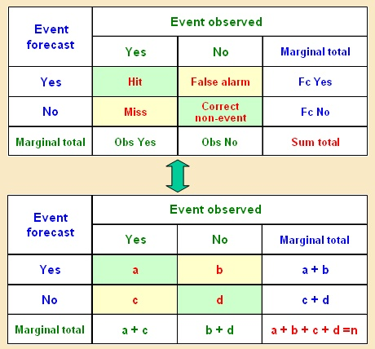

Figure 2. The contingency table for dichotomous (yes-no) events.

2.3 Calculating scores using the contingency table
Scores that can be computed from the contingency table entries are listed in this section, along with their characteristics, strengths and weaknesses. This is not an exhaustive list of scores one can compute from the table, but those listed here are considered to be the most useful for verification of severe weather forecasts. These scores are all functions of the entries of the contingency table as shown in Figure 2, and are easily computed. The formulae shown below are incorporated into the sample Excel spreadsheet that accompanies this document.

Computation of these scores should be considered part of analysis and diagnosis functions that are routinely performed by forecasters. These scores all have specific interpretations, discussed below, which help the forecaster perform these diagnosis tasks. The scores give the most meaningful information if they are computed from large enough samples of cases, say 100 or so. However, severe weather occurrences are rare events, and the number of forecasts and observations of severe weather may be small (fortunately), which makes the task of verification more important, but also more challenging.

2.3.1 Probability of Detection (Hit Rate, or prefigurance) (PoD, HR)

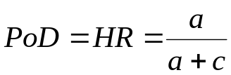

The Hit rate has a range of 0 to 1 with 1 representing a perfect forecast. Since it uses only the observed events a and c in the table, it is sensitive only to missed events and not false alarms. Therefore the HR can generally be improved by systematically over-forecasting the occurrence of the event. The HR is incomplete by itself and should be used in conjunction with either the false alarm ratio (FAR) below or the false alarm rate (FA)

2.3.2 False Alarm Ratio (FAR)
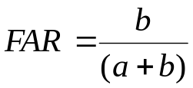

The false alarm ratio is the ratio of the total false alarms (b) to the total events FORECAST (a+b). Its range is 0 to 1 and a perfect score is 0. It does not include c and therefore is not sensitive to missed events. One can improve the FAR by systematically underforecasting rare events. It also is an incomplete score and should be used in connection with the HR above.

2.3.3 Frequency Bias (B)
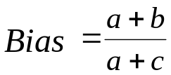

The frequency bias uses only the marginal sums of the contingency table, and so is not a true verification measure, since it does not imply matching individual forecasts and observations. Rather, it compares the forecast and observed frequencies of occurrence of the event in the sample. The forecast is said to be unbiased if the event is forecast with exactly the same frequency with which it is observed, so that the frequency bias of 1 represents the best score. Values higher than one indicate over-forecasting (too frequently) and values less than 1 indicate underforecasting (not frequent enough). When used in connection with the HR or the FAR, the bias can be used to explain the forecasting strategy with respect to the frequencies of false alarms or misses. Note that the bias can be computed for the non-events too, as (c+d)/(b+d). If the frequency bias is computed for all the categories of the variable, then it gives an indication of the differences between the forecast and observed distributions of the variable.

2.3.4 Threat Score (Critical success index) (TS, CSI)
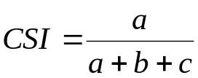

The threat score (or critical success index) is frequently used as a standard verification measure, for example in the U.S.A. It has a range of 0 to 1 with a value of 1 indicating a perfect score. The CSI is more complete than the HR and FAR since it is sensitive to both missed events and false alarms. Thus it is harder to adopt a systematic forecasting strategy that is guaranteed to improve the score. It does, however, share one drawback with many other scores: it tends to go to 0 as the event becomes rarer. This score is affected by the climatological frequency of the event; if one needs to compare forecasts (e.g. same forecasts from different sources) using this score, but based on different verification samples, it might be wiser to use the Equitable Threat Score (ETS) which adjusts for the effects of differences in the climatological frequencies of the event between samples. For evaluation of a forecast or for comparison of the accuracy of forecasts based on the same dataset, the CSI is a good general score. The ETS is given by:
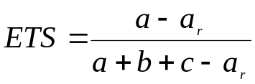
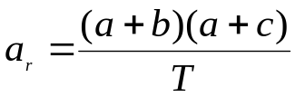,

where T is the sample size. The quantity a_{r} is the number of forecasts that one would expect to get correct by chance, by just guessing the category to forecast.

2.3.5 The Heidke Skill Score (HSS)
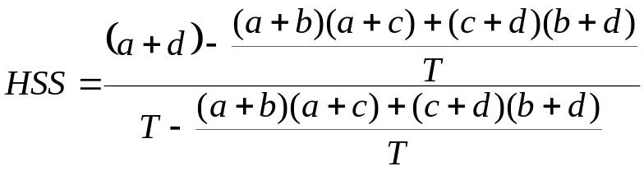

In verification, the term “skill” has a very specific meaning: Skill is the accuracy of a forecast compared to the accuracy of a “standard” forecast. The standard forecast is usually chosen to be a forecast which is simple to produce, and may already be available to users. The idea of a skill score is to demonstrate whether or not the forecast offers an improvement over the choice of an unskilled standard forecast.

The Heidke skill score uses the number correct for BOTH categories to measure accuracy, and the “standard” forecast is a simple “random” guess which of the two categories will occur. The score is in the format:
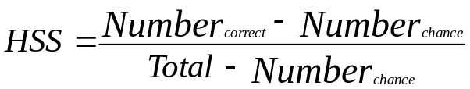

where the “number correct by chance” is the total number of forecasts, both severe and non-severe that you would expect to get right just by random guessing. could you prepare a simple “equation” for this, to replace this text? Also “number correct by chance”, should be connected with the “uneducated guess” (sorry, I am getting picky, but we don’t want to lose them).

The number correct by chance is defined the same way as for the ETS, but both categories are used. The number of forecasts correct is simply the sum of the diagonal elements of the contingency table, (a+d).

The HSS ranges from negative values to +1, Negative values indicate that the standard forecast is more accurate than the forecast; skill is negative. The HSS represents the fraction by which the forecast improves on the standard forecast. A perfect forecast gives a HSS of 1, no matter how good the standard forecast is.

The HSS defined this way is the easiest to apply and use. All the information needed is contained in the contingency table. It turns out that pure chance offers a pretty low standard of accuracy. It is quite easy to improve on a chance forecast. Other standards of comparison are persistence (“no change from the observed weather at the time the forecast was issued” or “what you see is what you get”) or climatology, which for a categorical forecast is defined as the most likely of the two categories. That is, a climatological forecast is a forecast of no severe weather all the time. This wouldn’t be a very useful forecast, but it would score well on most scores since (fortunately) “no severe weather” occurs much more often than “severe weather”. In the contingency table, d is much larger than a, b, or c. A climatological forecast of no severe weather may therefore be difficult to beat. In practice, though, persistence and climatology are not often used in the HSS because one must compile a separate contingency table for the reference forecast.

2.3.6 The False Alarm Rate (FA)
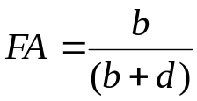

The false alarm rate is often confused with the false alarm ratio, unfortunately. The false alarm rate is simply the fraction of observed non-events that are false alarms. By contrast, the false alarm ratio (FAR) is referenced to the total number of forecasts; it is the fraction of FORECASTS which were false alarms. (see above) The best score for the FA is 0, that is, one wishes to have as few false alarms as possible. The FA is not often used by itself, but rather is used in connection with the hit rate (HR) (see above) in a comparative sense. The HR is also referenced to the observations, specifically, the total number of observed events.

2.3.7 The Hanssen-Kuipers Score (KSS) (True Skill Statistic – TSS)
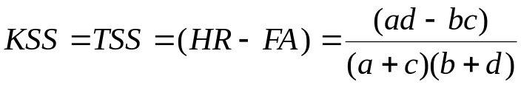

The KSS is easiest to remember as the difference between the hit rate and the false alarm rate, as defined in 2.3.1 and 2.3.6 respectively. This score measures the ability of the forecast to distinguish between occurrences and non-occurrences of the event. The best possible score value is 1, which is obtained when the HR is 1 and the FA is 0. If HR=FA, then the score goes to 0, which is the worst value possible.

This score is used to indicate whether the forecast is able to discriminate situations which lead to the occurrence of the event from those which do not. If, for example, the forecaster attempts to improve his hits by forecasting the event more often, this score will indicate whether he is incurring too many false alarms by doing so. The idea is to increase the HR without increasing the FA too much.

One disadvantage of this score for rare events is that it tends to converge to the HR because the value of d becomes very large.

2.3.8 The Extreme Dependency Score (EDS)
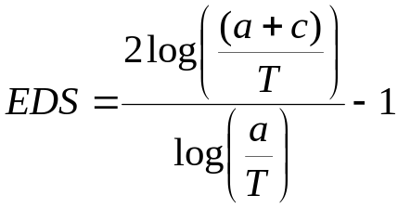

This is a relatively new score, published for the first time only a few years ago, and is included here because it is claimed to be more useful than some of the other scores in rare event situations. The range of the score is -1 to +1, with +1 as a perfect score. An advantage of this score is that it doesn’t go to 0 when the frequency of occurrence of the event in the dataset becomes small. The score is not yet widely used. One possible disadvantage of this score is that it can be improved by incurring more false alarms.

2.4 Interpreting the scores
One might wonder whether it is worth the effort to compute all these scores, or even most of them. Once the table is prepared, then the scores are easily computed anyhow, each requiring only one equation (on a spreadsheet for example) to compute from the entries of the contingency table. But more importantly, the different scores measure different aspects of forecast quality, and the use of several scores permits these different aspects or attributes, to be assessed. This section discusses aspects of the interpretation of the different scores.

2.4.1 Attributes of the forecast measured by the scores – “Accuracy”, “Skill”, and “Discrimination”
The scores defined above can be grouped according to which attributes of the forecast they measure. The HR, FAR, TS, ETS and EDS measure “accuracy”. As an attribute, the accuracy of the forecast is just the level of agreement between forecasts and observations. These scores all measure accuracy in slightly different ways, and are especially useful in different situations. For example, the ETS is best to use if one wants to compare results on different samples, since differences in the observed frequency of the event are taken into account. Both the HR and the FAR can be improved by altering one’s forecasting strategy, so should not be used alone. And, the EDS may be more useful than other scores if the observed frequency of the event in the sample is small.

The frequency bias measures the characteristics of the distribution of forecasts, compared to the distribution of observations, as mentioned above. It is more of a diagnostic tool for the forecast rather than a true verification measure.

The HSS measures the attribute skill, as defined above.

The HR and FA, when used together, and the KSS measure the attribute “discrimination”, in fact, the KSS is sometimes called the Hanssen-Kuipers Discriminant. While the attributes accuracy and skill are of particular importance to forecasters in deciding their forecasting strategy, discrimination is an attribute that relates more to the needs of the user of the forecast. Measures of discrimination tell a user whether he can rely on the forecast to identify hazardous situations or not. The following example illustrates the concept.

Discrimination
0
0.05
0.1
0.15
0.2
0.25
0.3
0.35
0.4
0.45
-3.2
-2.4
-1.6
-0.8
0
0.8
1.6
2.4
3.2
4
4.8
5.6
6.4
7.2
8
8.8
9.6
10.4
Forecast values
Occurrences
Non-occurrences
Frequency
Figure 3. Illustration of the concept of “discrimination”. The red curve is a plot of the frequency of forecasts of different temperatures when the event “temperature lower than 0” did not occur, and the blue curve is the plot of the frequency of forecast temperatures when the event “temperature lower than 0” occurred.

Suppose a user is interested in knowing whether the minimum temperature will be below freezing. The diagram shows a set of temperature forecasts, divided into two groups. The red curve shows the frequency of forecast temperatures when the minimum temperature was above freezing (non-occurrences of the event) and the blue curve shows the frequency of forecast temperatures when the observed minimum temperature was below freezing (occurrences). It can be seen from the diagram that when the observed minimum was above freezing, most of the forecasts were above freezing. There is just a small tail of the “red” distribution where forecasts are below freezing (false alarms). On the other hand, about half of the time when below freezing temperatures occurred, the forecast was for above freezing (missed events). If a user receives a temperature forecast in the range of +1, for example, this diagram shows that more often than not the actual minimum temperature was below 0 (the blue curve is higher than the red curve at temperatures around 1 degree) On the other hand, forecasts above about +4 always verified (blue curve near 0), and forecasts of minimum temperatures below -0.5 also nearly always verified (red curve near 0). It is the area of overlap of the two curves which is of concern to the user. The larger this area, the harder it becomes for the user to be confident in his use of the forecast.

The amount of separation of the two curves is in fact a measure of the ability of the forecast system to discriminate between the two categories. But the important overlap region, where the user would be unsure of the forecast, should be as small as possible. For a particular separation of the two categories, the overlap is minimized if the variation (variance) of the forecast distributions is small. In summary, the usefulness of the forecast for decision-making by a user depends on the ability of the forecast system to discriminate events from non-events. This is measured by comparing the hit rate and the false alarm RATE (not ratio).

2.4.2 An example of discrimination/decision-making ability when “risk” information is included in the forecast.

For Madagascar, the “risk” forecasts from RSMC Pretoria were verified for the first two quarters of 2008-2009 from a user perspective. The guidance forecasts include an estimate of “low”, “medium” or “high” risk. Using each of these risk estimates as a threshold for forecasting the occurrence of severe weather (more than 50 mm rain in 24 h), three contingency tables can be obtained. There are 211 cases in total.

Low | Obs yes | Obs no | Totals
Fcst yes | 35 | 34 | 69
Fcst no | 15 | 127 | 142
Totals | 50 | 161 | 211
Med | Obs yes | Obs no | Totals
Fcst yes | 31 | 18 | 49
Fcst no | 19 | 143 | 162
Totals | 50 | 161 | 211
High | Obs yes | Obs no | Totals
Fcst yes | 13 | 4 | 17
Fcst no | 37 | 157 | 194
Totals | 50 | 161 | 211

Figure 4. Three contingency tables for forecasts of the occurrence of 24 h precipitation greater than 50 mm for Madagascar: Issue a warning if the RSMC forecast indicates at least “low” risk” (top); Issue a warning if the RSMC forecast indicates at least “medium” risk (middle); and Only issue a warning if the RSMC forecast indicates “high” risk (bottom)

One can see from the tables that the use of a more restrictive threshold for forecasting the event (“high” risk only) reduces the number of hits but also reduces the number of false alarms, while the number of misses increases a lot. To determine whether the false alarms are being reduced enough to be useful, one can plot the hit rate against the false alarm rate, to obtain the following diagram.

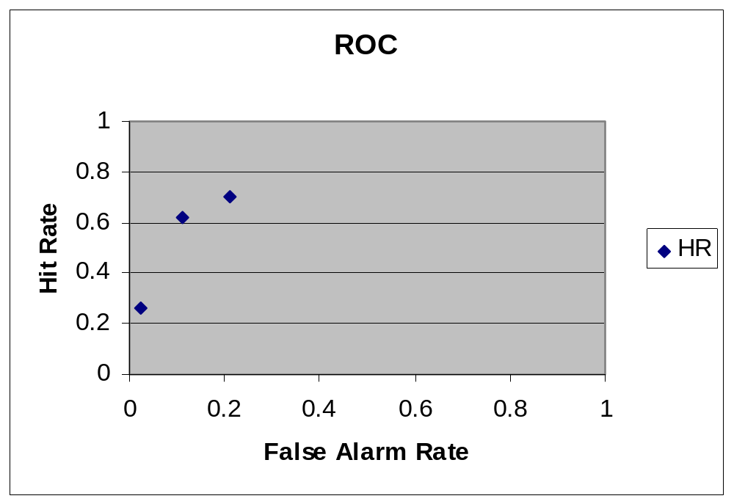

Figure 5. A ROC plot for the Madagascar forecasts. These forecasts show discrimination – no matter which threshold is used, the forecasts show at least some ability to separate active days from non-active days. The forecasts show no discrimination if the hit rate = false alarm rate, along the diagonal line.

This is called a “ROC” curve, for relative operating characteristic. These diagrams have been widely used in many fields, for example, determining the ability of an X-ray picture to show a pathology clearly enough that a doctor can see it in the presence of a noisy background. In our application the “noisy background” is the imperfect model guidance forecast, and the “pathology” is the severe weather event we are trying to forecast. Brought into meteorology in 1982, the ROC diagram is now widely used to verify ensemble probability forecasts.

In the diagram above for the Madagascar/RSMC Pretoria data, the three points obtained by plotting the HR vs. the FA for each of the three contingency tables are shown. It is the fact that the three points remain above the diagonal line that is most important here. This means that, whatever the threshold chosen, the HR is always greater than the FA, and the forecast is able to distinguish situations leading to severe weather from those which do not lead to severe weather, with some skill. If the points lay on the red diagonal line, the user would not be able to distinguish occurrences from non-occurrences on the basis of the forecast, and the forecast would be completely useless for decision-making. The closer the points are to the upper left corner (HR=1 and FA=0), the better the discriminating ability of the forecast.

2.4.3 The troublesome “d”

The number of correct negatives, “d” is often hard to define in the contingency table. The most common problem is the sparseness of observations for determining severe weather occurrences. Since severe weather often happens over a relatively small area, it is often not known whether “no report” of severe weather is a non-occurrence, or an occurrence that is missed by the observations. The effect on the table is possibly to cause hits to be reported as false alarms (forecast but not seen), and to cause missed events to be reported as correct negatives (not forecast and not seen, but occurred).

It is also difficult to define the spatial and temporal boundaries of the non-event. The option proposed in this document is to allow one correct negative for each specific forecast region per day, since the predicted variable is accumulated over 24 h.

Some of the scores defined above do not use “d” from the table. These can be emphasized when there are doubts about the accuracy of the table entries because of missed observations. These scores are the HR, FAR, TS and ETS.

3. Example – Application and interpretation of contingency table results
The table below is taken from the accompanying excel file. In this file, the equations for the scores have been embedded so that filling out the boxes of either table will lead to automatic calculation of the contingency table scores.

Contingency Table -Botswana original
 | OBS YES | OBS NO
FCST YES | 26 | 5 | 31
FCST NO | 27 | 84 | 111
 | 53 | 89 | 142
Contingency Table - Botswana weighted
 | OBS YES | OBS NO
FCST YES | 20 | 4 | 24
FCST NO | 23 | 84 | 107
 | 43 | 88 | 131
Scores | Unweighted | Weighted
Percent correct | 0.77 | 0.79
Hit rate | 0.49 | 0.46
False Alarm Rate | 0.06 | 0.04
Freq bias | 0.58 | 0.55
False alarm ratio | 0.16 | 0.15
Threat Score | 0.45 | 0.42
Equitable threat score | 0.31 | 0.31
No Correct by chance | 81 | 80
Fraction correct by chance | 0.57 | 0.61
Heidke Skill | 0.47 | 0.47
Hanssen-Kuipers score | 0.43 | 0.42
Extreme Dependency Score | 0.16 | 0.18

Figure 6. Contingency tables for a set of severe precipitation forecasts for Botswana, along with the scores for these tables. The accompanying Excel file contains the equations to compute the scores. The lower table and the right hand column show results when forecasts are weighted so that one day produces one event.

The above table shows two contingency tables for forecasts of >50 mm precipitation for Botswana, for the period November 2008 to March, 2009. The top table was created from the list of events provided by the Botswana Meteorological Service. In this case, each observation of severe weather was defined as a severe event, while inactive days were assigned one event each. For the second table, days with multiple observations of severe conditions were weighted to match the weight for inactive days, so that each day totals to one event. This reduced the total to 131 events, which is the total number of days covered by the sample. Entries in the table have been rounded to the nearest whole number for simplicity. Of the 131 events, 43 were severe weather occurrences and 88 were inactive days. The scores were computed for both versions of the table; the differences in the results were not very large in general. For the interpretation, the second table is emphasized though most comments also apply to the first table.

First, note the frequency bias: The severe weather event was predicted only a little more than half as often as it occurred (24 forecasts vs 43 occurrences). The hit rate (0.46) probably could be increased by forecasting the event more often, but the low false alarm ratio (.15) might also rise. If false alarms are to be avoided (so that users will be sure to always heed the forecast, for example), then it may be desirable to keep the false alarms low even at the expense of higher missed events (23)

Next, consider the hit rate, the FAR and the TS together: The FAR is quite low in this case, the hit rate (.46) is in the medium range, and the TS is also in the medium range, but a little lower than the HR because of the false alarms.

The ETS is much lower than the TS in this case because of the number expected correct by chance. When the event happens fairly often (43/131 = 0.33 or 33% of the cases), then the number correct by random guessing would be large enough to matter, so the ETS is lower than the TS. When the event becomes rare, the difference between the TS and ETS would be smaller, and both would normally be lower because of the difficulty of forecasting rare events. The total forecasts of occurrences and non-occurrences that would be correct by guessing is 61%. This compares to a total fraction correct (both categories) of (a+d)/T = 104/131 = 0.79 = 79%. Thus the Heidke skill score (0.47) shows improvement over pure guessing. In this document, the fraction correct (a+d)/T is not emphasized; it is a less useful score for rare events because it becomes dominated by the number of correct negatives (d), which may be very large and which obscures the accuracy of forecasts of the event. The hit rate is the preferred accuracy measure.

For the Botswana forecasts, the Hanssen-Kuipers score is reasonably large too, indicating an important positive difference between hit rate and false alarm rate, and correspondingly, a good discrimination between severe weather days and non-severe weather days.

The extreme dependency score has been included here because it is a new score designed specifically for extreme (or rare) events. As with any new score, it will take time and experience to calibrate oneself to the meaning of the score values. In this case, the score has a positive value, which might increase if the event were to be predicted more often, even if the number of false alarms increases.

4. Contingency Table verification of Spatially-defined forecasts – The RSMC severe weather charts

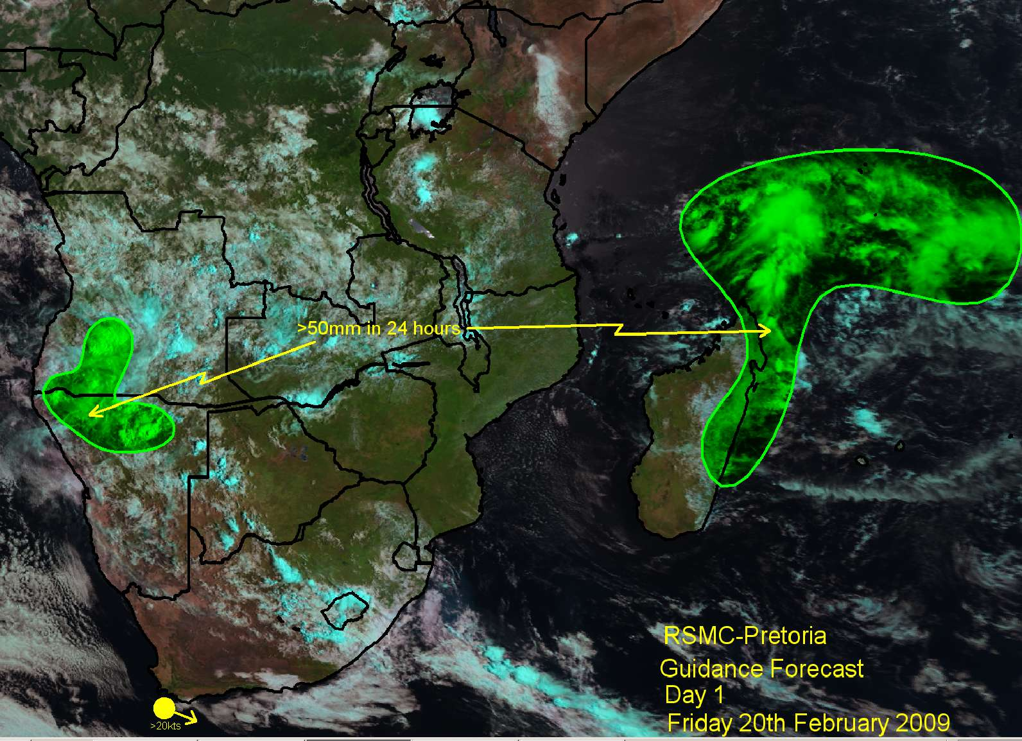

Figure 7. An example of an RMSC Pretoria guidance forecast.

It has been agreed by all concerned that verification of the RSMC daily severe weather forecasting guidance forecasts would be a good idea. The question arises – how should this be done? The method proposed here is one possibility only; there may be other ways to accomplish the verification. In fact there are several new techniques available that are specifically designed for spatially-defined forecasts. The method proposed here is consistent with the contingency table method discussed above, and should give results that can be compared with the contingency table results calculated at the NMHSs.

Consider a spatial definition of the 4 quantities in the contingency table, hits, false alarms, misses and correct negatives, as shown in Figure 8 below. Shown on the diagram are false alarms (areas where severe weather is forecast but is not observed), hits (areas where severe weather is both observed and forecast) and misses (areas where severe weather is observed but not forecast. Definition of the correct negatives is more difficult. In general, this would be the whole area that is not covered by any of the other three, which would usually be most of the domain of the forecast. (all of southern Africa and adjacent oceans)
It is clear that computation of these areas requires at least quasi-continuous observations and forecasts. The RSMC forecasts are shown as continuous areas, but standard observations are far from sufficient to verify spatially continuous forecasts. However the data from the EUMETSAT satellite-based “Hydro-estimator” program (using Met Office UK’s NWP model) are quasi-continuous and would be of interest to use for this verification. A word of caution is needed here: The Hydro-estimator data use a model to assist with the satellite estimates of precipitation (the UK model). Therefore, if these data are used to verify the Met Office UK model precipitation forecasts, the results will be artificially inflated; the forecasts will look better than they should, because there is a statistical dependence between the model and the observations used to verify that model. It should also be noted that the observations themselves are remotely-sensed, and will have lower spatial resolution than surface station observations.
Forecast
Observed
False
alarms
Hits
Missess
Figure 8. Schematic of Contingency table verification for spatial forecasts

To compute the four entries of the table, a,b,c, and d, it is necessary to divide the forecast domain into fixed areas. These areas should be as small as possible, but not smaller than the resolution of the satellite data. They could, for example, be 1 degree latitude by 1 degree longitude. Once the domain is divided up this way, one can always combine the boxes later on for the purpose of verification at lower resolution, but verification at higher resolution would require going back to re-compute the table. This is the main reason for using small boxes. Once the boxes have been determined, any “green” in the box means a forecast of the event, and any Hydro-estimator value over the threshold within the box constitutes an observation of the event.. Forecasts and observations can be compared box by box to determine in which box of the contingency table each forecast-observation pair belongs.

Once the forecast-observation digital database has been created for the spatial severe weather forecasts, this will be a valuable tool for verification work: In addition to the basic contingency table scores, the data can be used for some of the newer diagnostic tools that are available for spatial forecasts, which will help determine whether there are systematic spatial errors in the model forecasts compared to the Hydro-estimator data.

5. A Few Words about verification of ensemble probability forecasts.
The verification of probability forecasts is somewhat different than for categorical forecasts. The observation, which is nearly always categorical – the event occurs or it doesn’t – is compared to a probability forecast of the category. There are numerous scores for probability forecasts, including the Brier Score, the Brier Skill score, and the Rank probability score to name a few. However, one forecast attribute will be explored, the reliability. “Reliability” is the degree to which the forecast probability matches the actual frequency of occurrence of the event. If, on all occasions when one forecasts 30% probability of the event, the event happens 30% of the time, then the forecast is reliable.

Reliability is a little like bias: If the event happens on average on 40% of the occasions when 30% probability is forecast, then this is an underforecast (the probability forecast is too low). Conversely, if only 20% of the forecasts of 30% are associated with occurrences of the event, then this is an overforecast (the probability forecast is too high). Reliability cannot be measured on a single forecast, because the observation is categorical. Since one must collect numerous forecasts of each forecast probability (30%, 40% 50% etc) to obtain a good estimate of the observed frequency of occurrence of the event, quite a large sample of forecasts and observations is needed to calculate the reliability.

A reliability table is a graph of the frequency of occurrence of the event vs the forecast probability. Here is an example, for one year of 24 h precipitation forecasts, for European stations, for 7 of the ensemble systems which are included in the TIGGE archive.

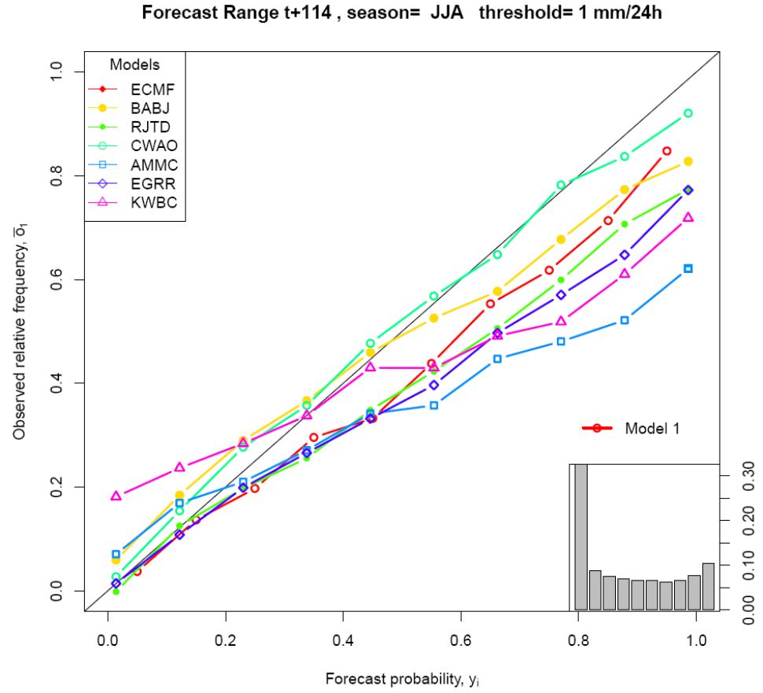
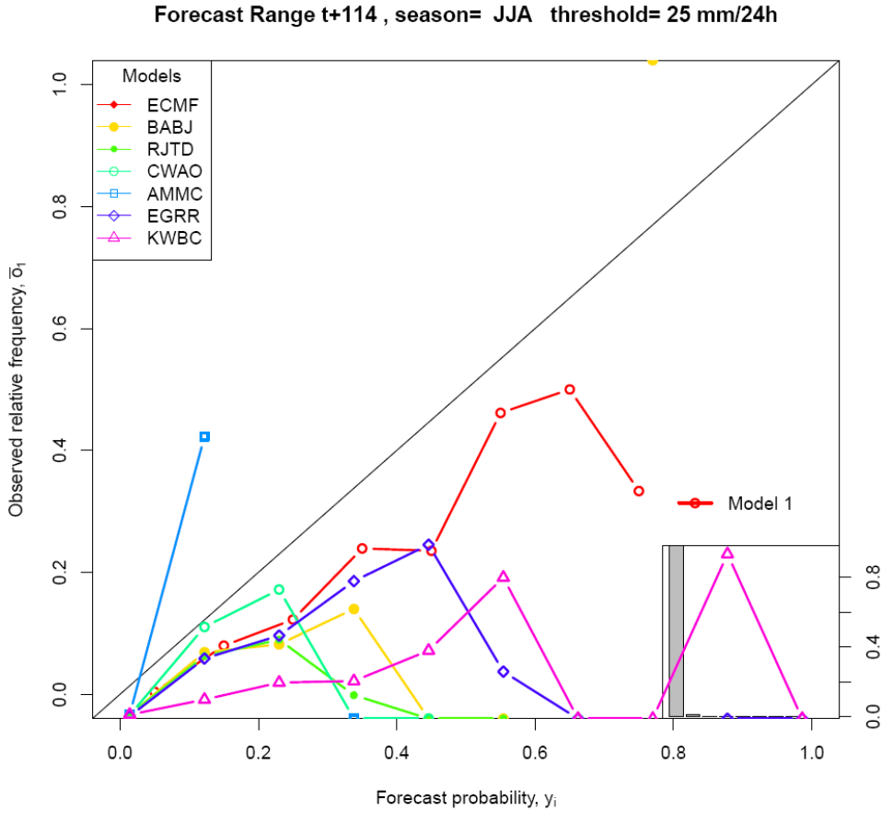

Figure 9. Reliability diagrams for probability forecasts of >1 mm/24 h (left) and > 25 mm /24 h for Europe, for 7 different global ensemble systems, based on one year of data. Observations are averaged over grid boxes for comparison with the ensemble probability estimates.

The three ensembles available to the SWFDP project are included here: ECMWF is in red; the UKMO ensemble is in blue and the NCEP ensemble is in pink with triangles. In the example shown here, all the ensembles are reasonably reliable (close to the diagonal line) for this 114 h forecast, for “any” precipitation, > 1 mm per 24h. For the higher threshold, 25 mm per 24 h, the ECMWF and the UKMO ensembles show some reliability for forecasts up to 50%, though there is some overforecasting, while only the ECMWF ensemble attempts forecasts greater than 50% probability for this uncommon event. These too are fairly reliable, with some tendency to overforecasting. The NCEP ensemble, however, does not perform as well, with serious overforecasting of all probabilities up to 60%.

It would be very useful for the SWFDP if verification like this could be done for African stations. This would mean obtaining a quality controlled dataset of precipitation observations for at least one year (certainly one rainy season) and matching it with the corresponding ensemble forecasts from the three systems. It should be noted that the results shown above are quite optimistic since the precipitation observations have been averaged over grid boxes (1 degree by 1 degree), and the reliability has been computed only for grid boxes where there are at least 9 stations. In Africa and in many other parts of the world, station density isn’t high enough and verification will have to be done with respect to single station observations chosen to represent the precipitation over a grid box. One must expect that reliability and other scores will be lower with respect to point observations, but the relative quality of the forecasts should still be discernable for African stations.

6. Web resources for further information

The EUMETCAL training site on verification – computer aided learning:

http://satreponline.org/vesa/verif/www/english/courses/msgcrs/index.htm

The website of the Joint Working Group on Forecast Verification Research:

http://www.cawcr.gov.au/projects/verification/

This contains definitions of all the basic scores and links to other sites for further information.

