WORLD METEOROLOGICAL ORGANIZATION

COMMISSION FOR BASIC SYSTEMS

MEETING ON THE FUTURE SEAMLESS GLOBAL
DATA-PROCESSING AND FORECASTING

WMO, GENEVA, SWITZERLAND, 10-12 February 2016

REPORT

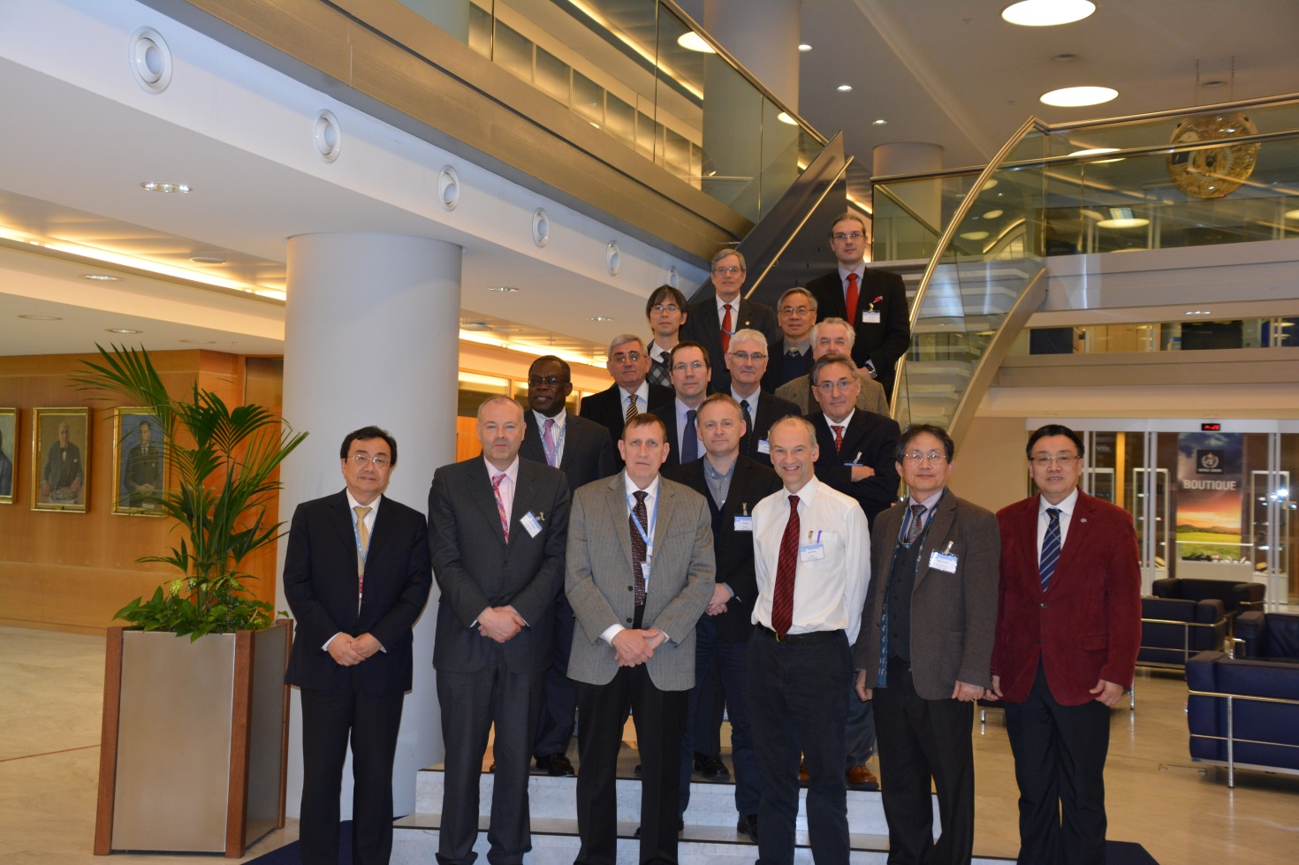

First row: Xu Tang, Gerald Fleming, Fred Branski, Ken Mylne, Byong-Lyol Lee, Wenjian Zhang
Second row: Abdoulaye Harou, Ian Lisk, Michel Béland;
Third row: Valentin Kazandiev, David Richardson, Michel Jean, Gilbert Brunet
Last row: Yuki Honda, Paul Pilon, Hong Yan, Jan Danhelka
EXECUTIVE SUMMARY

The Meeting of the Commission for Basic Systems on the Seamless Global Data-Processing and Forecasting System (GDPFS) was held at WMO Headquarters, in Geneva, Switzerland, from 10 to 12 February 2016. The meeting was opened by the WMO Secretary General, Professor Petteri Taalas and was chaired by the President of the Commission for Basic System, (CBS) Mr Frederick Branski. A summary of the discussions is provided in Annex III as well as the elements for consideration for the white Paper on GDPFS.

Participants to the meeting included representatives of Technical Commissions (except JCOMM and CIMO), Co-chairs of the OPAG-DPFS and representatives of some WMO departments. Essentially the move to Seamless data-processing is supported by the Commissions but there was a strong recommendation to consider Hydrology, Agriculture, Aviation and Climate needs in the development of Seamless Integrated GDPFS. A new proposal for a new relationship between CAgM and CBS/GDPFS was proposed to support the Global Early Warning and Outlook Services (GAMEO). Essentially, CAgM needs high resolution information production (downscaling of climate/observation/forecast and projection data) and coupling NWP with AgModels. The Commission for Hydrology and National Hydrological Services need meteorological and climatological services (data, forecasts) and climate and Meteorological information for water management. It was noted that there is no Regional specialized Hydrological Centre (RSHC) to support regional forecast programs. The Aviation sector highlighted the need to move from product centric to data centric service and to ensure interoperability of GDPFS with users systems. In addition the need for space weather services is growing and will need to be addressed by the GDPFS. The Commission of Climatology see major contribution of the GDPFS in the development of Climate service Toolkit for GFCS which will require the GDPFS downscaling/upscaling functions. In addition the GFCS Climate Services Information System (CSIS) and the User Interface Platform (UIP) will need GDPFS contribution. Training is seen a major gap. Primarily the training of front-line forecasters in, e.g. the use of RSMC products and guidance, in the proper interpretation of EPS data etc. The need to incorporate weather information with data from other sources (vulnerability and exposure data, crowd-sourced observations of weather itself or its impacts etc.) means that there is a need to develop visualisation platforms that allows all of this diverse data to be coherently presented and examined by forecasters (or consulting meteorologists, which is what forecasters may become).

Following the presentations by TCs, Programmes and Partners, the discussion focussed on the development of the vision and the elements of the white Paper. The results of the discussion are available in Annex VI.

Overall, the new GDPFS should extend its functionalities across all time scales, ensuring consistency within the seamless provision of information.

GENERAL SUMMARY OF THE WORK OF THE MEETING

1. OPENING

  - The Meeting of the Commission for Basic Systems on the Seamless Global Data-processing and Forecasting System (GDPFS) was held at WMO Headquarters, in Geneva, Switzerland, from 10 to 12 February 2016. The meeting was chaired by the President of the Commission for Basic System (CBS), Mr Frederick Branski. Mr Xu Tang, Director of the Weather and Disaster Risk Reduction and Services (WDS) department welcomed the participants and the Secretary-General, Professor Petteri Taalas. He asked the participants to introduce themselves then asked the Secretary-General to address the meeting. Following the remarks of the Secretary-General, Mr Branski proceeded to summarize the objectives of the meeting.

  - The Secretary-General indicated that results of the meeting will be important for meteorological services noting that he is continuing to learn acronyms including GDPFS. He also noted that seamless prediction is nowadays a state of the art in developing countries including nowcasting benefiting Aviation and Seasonal forecast benefiting Agriculture. He underlined the move to impact-based forecasting at the national level and the change in forecasters work with technological advances. In addition, he pointed out that the gap is increasing between developed and developing countries in the area of prediction therefore there is a need to use technology to reduce it. He noted the fact that the private sector is increasingly getting in the business and that, the issue is important enough for EC-68 to devote one day on this issue. The Secretary-General indicated his eagerness to get more resources to support WMO developing Members considering that more donors are looking forward to supporting developing countries meteorological services. He provided the example of the Climate Risk and Early Warning System (CREWS) one of the results of COP 21. Finally he recalled that Congress gave us direction to review the structure of WMO and the need to streamline our meetings and their contents to be more efficient. He would welcome any inputs on these issues. He thanked the participants for their willingness to do the work related to the Seamless GDPFS and asked to limit the creation of new acronyms. He wished a successful meeting. Mr Branski, the Chair of the meeting, thanked the SG for opening the meeting and for his guidance.

2. ORGANIZATION OF THE MEETING

2.1 Adoption of the agenda

2.1.1 The participants adopted the provisional agenda with minor change in the order of presentations to accommodate some of the participants. The original agenda is attached as Annex I to this report.

2.2 Working arrangements

2.2.1 All documents submitted for the meeting are referenced and hyperlinked in the Documentation Plan (INF. 1), which had been posted on the WMO website at:

http://www.wmo.int/pages/prog/www/DPFS/Meetings/Seamless-DPFS_Geneva2016/DocPlan.html

2.2.2 The Participants agreed on its hours of work, from 09 to 17:30 with 30 minutes breaks in the morning and in the afternoon. They have also agreed on other practical arrangements for the meeting. The list of participants in the meeting is provided in Annex II to this report.

3. INTRODUCTION

The Chair, Mr Branski, summarized the scope of the meeting in the following terms: the discussion will focus on elements to feed a white paper on Seamless GDPFS to present to EC68. He noted that WIS and WIGOS modernization was addressed and the meeting is organized to address the third component of the World Weather Watch (WWW), the GDPFS. He underlined that this is not a small task and that all Commissions and Programmes of WMO will have to play a role. He noted that although service delivery is part of WWW, it is still the key elements of what we do and within that context, it is necessary to consider how the GDPFS, WIS and WIGOS would fit under service delivery. He also noted that there is also the political issue which are not under our responsibility and that our role is to propose the best technical solution which will then facilitate the resolution of political issues by management. He concluded that a philosophical discussion is necessary and the view of all is needed. In addition, presentations should be kept short so that more time is devoted to the discussion. A summary of the discussions following the presentation is attached in Annex III.

3.1 The WMO GDPFS

3.1.1 Mr Ken Mylne, Chair, OPAG on DPFS, presented on the GDPFS noting that the GDPFS is the third component of the World Weather Watch (WWW), the two other being WIS and WIGOS, formally Global Telecommunication System (GTS) and Global Observing System (GOS) respectively. He described the system and how it is benefiting Members, in particular to Least Developed Countries (LDCs) and Small Island Developing States (SIDs) through the cascading process of the Severe Weather Forecasting Demonstration Project (SWFDP). The presentation triggered discussions in many areas such as the inclusion of water and climate issues in the operation of GDPFS and the whether the linkage between the work of OPAG-DPFS and science is solid. The question of how hydrologists can access the advances in weather to help them improve their predictive capability. An excerpt of the discussions that follow the presentation of Mr Mylne can be found in Annex III.

3.2 Report of the brainstorming session in Dec 2014

3.2.1 Mr Abdoulaye Harou, Chief Data-Processing and Forecasting System (DPFS) presented a summary of the brainstorming meeting of Experts that was held in Geneva, 11 to 12 Dec 2014. He presented the key results of the meeting, including the principles and the elements of a white paper proposed by the Experts for consideration in the development of the Seamless GDPFS. Annex IV and V presents the principles, elements of vision and of the white paper.

3.3 CBS support to GDPFS

3.3.1 Michel Jean (DRR Coordinator) presented on CBS and how it supports the GDPFS. He highlighted that the CBS is composed of 4 OPAGs (Data-Processing and Forecasting – DPFS; Public Weather Service – PWS; Integrated Observing System - IOSS and Information Systems and Services - ISS) facilitating its activities with the World Weather Watch Programmes and cross-cutting activity areas such as Quality Management Framework and Disaster Risk Reduction. Through its OPAGs, CBS maintains strong links with WWRP cross-cutting activities (WIS/WIGOS/QMF/DRR) and with research components (WWRP and WCRP).

3.3.2 Michel also highlighted that CBS does support other WMO priorities and collaborates with other Technical Commissions and other technical programs in fulfilling their role and responsibilities. The move to a seamless and integrated GDPFS would allow Members to address issues in a systematic, coordinated, sustainable, scalable and efficient/effective ways.

4. Understanding the GDPFS Landscape

4.1 Technical Commissions TC and Partners representative presented on what they do in the area of Data-processing and Forecasting and on what they expect the GDPFS of the future would do for them.

4.1.1 The Commission of Atmospheric Science (CAS)

4.1.1.1 The CAS was represented by Mr Gilbert Brunet (Canada). He indicated that over the last decade or so, predicting the weather, climate and atmospheric composition has emerged as one of the most important areas of scientific endeavour. This is partly because the remarkable increase in skill of current weather forecasts has made society more and more dependent on them, day to day, for a whole range of decision making. And, it is partly because climate change is now widely accepted and the realization is growing rapidly that it will affect every person in the world profoundly, either directly or indirectly. He added that one of the important endeavours of our societies is to remain at the cutting-edge of modelling and predicting the evolution of the fully coupled environmental system: atmosphere (weather and composition), oceans, land surface (physical and biological), and cryosphere. This effort will provide an increasingly accurate and reliable service across all the socio-economic sectors that are vulnerable to the effects of adverse weather and climatic conditions, whether now or in the future. The seamless prediction emerging challenge was at the centre of the World Weather Open Science Conference (Montreal, 2014).The outcomes of the conference are described in the World Meteorological Organization (WMO) book: Seamless Prediction of the Earth System: from Minutes to Months, (G. Brunet, S. Jones, P. Ruti Eds., WMO-No. 1156, 2015). It is freely available on line at the WMO website. This book will greatly pave the way for seamless prediction R&D&O for the next two decades.

4.1.1.2 Mr Brunet also indicated that many meteorological services are quite advanced in earth system including hydrology, agriculture. He also indicated that to move to seamless we will need to accelerate improvements in prediction and services through an inclusive approach to Earth-system sciences which will require a suite of diagnostic and prediction models integrated over all spatial and temporal scales (e.g. UK Met Office, Met Service of Canada …) requiring new technological improvements towards new efficient dynamical cores, effort for integration with private initiatives; it would also require increased integration across the disciplines of physics, mathematics, chemistry, social and decision sciences.

4.1.1.3 He concluded his intervention by stressing that WMO needs to implement a GDPFS that will support the implementation of the above seamless prediction vision and identified the following next steps to move forward:

- WMO GDPFS will need to provide the full information needs to assess multi-hazard risk (e.g. probabilistic information) and impacts;
- WMO needs to play a pro-active role in training and explaining to users, stakeholders and NHMSs the utilization of the GDPFS products and their use for decision making;
- WMO should support FDPs, RDPs and the WWRP major projects (PPP, S2S and HIWeather) to implement and communicating the seamless prediction vision. The way forward for funding mechanisms have been documented in the EC-RTT report (see EC-LXI/Doc. 8(1))
- Complexity is an important axis of the seamless prediction challenge. Predicting the full hydro-meteorological cycle (precipitation, hydrology, rivers, lake, soil moisture, surface fluxes, cryosphere, ocean …) is one of the ultimate goals of the seamless prediction vision. This goal is relatively close to our reach with many low hanging fruits. WMO should promote a major cross-cutting project toward that objective with CAS-CHy-CBS. CHAMP is such an initiative.

4.1.2 Commission of Aeronautical Meteorology (CAeM)

4.1.2.1 Mr Ian Lisk (Vice-President of CAeM) highlighted issues that need to be addressed: how should we deal with the paradigm change from “product-centric” to data-centric approach, implying integration of observational and/or forecast data into users’ decision-making systems through task-specific applications. The current practice of providing different products to different aviation users would gradually change to ensuring 4-dimensional data need for “trajectory-based operations” (TBO); the role of forecasters would also change in the process with potential added value in advisory type of service. There will also be an increasing move to regional service delivery of information. He stressed that Interoperability with users systems is also very important, as is the use of Quality Management System (QMS) by the service providers.

4.1.2.2 Mr Lisk underlined the strong links with GDFS in support of international aviation in particular in the area of global forecasting by the World Area Forecast Centres (2), as well as alerts and advisory services provided by Tropical Cyclone Advisory Centres (7) and Volcanic Ash Advisory Centres (9). He indicated that new centres are under development: Regional Hazardous (Aviation) Weather Advisory Centres. In addition Space Weather services are also in development. Secretariat note on the latter: the last CBS-MG meeting held in Geneva 15 -19 Feb 2016, decided to have the IPT-SWISS (Inter-programmes Space Weather Information Systems and services) under the OPAG of DPFS. Development of guidance, technical regulations and standards will continue to be the shared responsibility of the WMO and ICAO.

4.1.3 Joint Commission for Oceanography and Marine Meteorology (JCOMM)
Unfortunately, there was no representative. The secretariat will seek its input.

4.1.4 Commission of Hydrology (CHy)

4.1.4.1 Mr Jan Danhelka (Czech Republic) represented CHy and its activities relevant to GDPFS. He recalled that there is no GDPFS regional centre hydrology and that research in Hydrology is associated mostly with UNESCO-IHP and other organizations. He emphasized that meteorological observation and short range forecasts constitute the basic need for hydrology but highlighted that, given the fact that the majority of National Hydrological Services (NHSs) are separated from NMSs, some WMO standards for weather products might be difficult to use, e.g. GRIB data. Therefore the preference is for tailored products. The needs of CHy and NHSs include meteorological and climatological services (data, forecasts) for hydrological applicacions as well as for applications in water management. Potential contributions to seamless GDPFS include hydrological observation in near real time for use in coupled systems, already operating regional Flash Flood Guidance Systems, short to medium term flood forecast and seasonal runoff prediction. Hydrological community and its users prefer providing forecasting services in seamless way, as the interest is in volumes. He also highlighted some specifics of hydrological applications, including an important role of initial conditions in runoff generation process, unpredictable effects of human decisions in real-time management of reservoirs, variable effects of various factors on inundation and flood transformation etc. All these represent a great challenge in modelling and demands for interactive operation of forecasting services at local scale what might be very difficult if not impossible for Earth’s system models run at global scale. He further stressed a need for clear definition of roles and responsibilities between global and regional centers on one side and NHSs on the other side based on mutual agreement.

4.1.4.2 Secretariat note: Mr Danhelka subsequently reported that the issue of future activities in GDPFS was discussed at a CHy AWG meeting. It was felt that this is a fresh topic for CHy and as such, they did not have any solid feedback for input in the immediate work of the GDPFS white paper drafting team. He however, indictated that they have agreed to include GDPFS and hydrological contribution to its future development in the agenda for the CHy session in December this year. They have also identified GDPFS to be one of potential topics for a CHy Resolution (inc. the mandate for development of regional centers criteria etc.).

4.1.5 Commission for Agricultural meteorology (CAgM)

4.1.5.1 Dr Byong-Lyol LEE, President of CAgM proposed new relationship with GDPFS for the implementation Global Early Warning and Outlook Services (GAMEOS). GAMEOS will address emerging requirements such as a) Climate service innovation for Ag & food security (early warnig for climate extremes); b) technological challenges for better climates services (NWP downscaling in space, time and elements) and; c) implementation strategies for better service provision (dedicated data collection and production centres. Essentially, CAgM needs high resolution information production (downscaling of climate/observation/forecast and projection data) and coupling NWP with AgModels. It also needs some supporting system such as grid and cloud computing. Bridging the gaps between wx and climate is also a requirement. The development of Centre for Agro meteorological service is also considered an asset.

4.1.6 Commission for Instruments and Methods of Observation (CIMO)
Unfortunately, there was no representative. The secretariat will seek its input.

4.1.7 Commission for Climatology (CCl)

4.1.7.1 Jean Pierre Ceron (France) represented CCl. He provided the following as needs and gaps form CCL perspective :

- Specialized centres : Designation and monitoring processes should be improved and should evolve. It should be important to have some clear criteria and metrix to follow the compliance of labeled centres and their activity. There are also strong needs to elaborate standards for operations especially at the regional level (e.g. RCCs and RCOFs) including the needs of labeling the products and services (with also the perspective of WIS compliance). Also related to the following point, some new functionalities should be introduced (e.g. like help desk function / user support, ...). Last but not least, global centres for monitoring are not present while they are for other areas (data & forecast).
- Climate Services perspective : there is a clear need to add the service dimension within the GDPFS ; especially with respect of the CSIS and its interface with the UIP. In this respect, the engagement of organizations/entities which are not "operational" (in the NMHS sense) but which are providing information routinely should be addressed. There is some necessary adaptations related to the tailored information for decision making (especially impact forecasts). The provision of the services should be evaluated and monitored.
- Climate Service Toolkit : the development of such tools should be conducted in close collaboration with CBS and have strong linkage with the GDPFS (functionalities, standards, ...). Note that the necessary Downscaling / Upscaling functions should be part of the process.
- Feedback processes : some feedback processes are missing or are not efficient (e.g. with people outside of our climate community, for the RCCs and GPCs, ...).
- Verification : should be adapted to the Service provision , especially beyond the products themselves the impact of the use of the information (demonstration of the "value" of the provided services).
- Climate Change information : should be integrated in the functionalities described inside the GDPFS.
- New GDPFS : likely we should extend the described functionalities across all the time scales (trying to preserve/ensure consistency within the seamless provision of information).
- Additonal points : certainly that using a system approach should help to get the entire picture and help in getting the right weight and priorities for each components of the system. There is some needs to create (and then monitor) relevant labels for used tools and provision of information (e.g. clear identification of authoritative voices on internet, labels for candidates to the CST, ...).
- About the timeline : At this stage it's difficult to have a clear timeline. Nevertheless, at least we can point out some specific dates in the CCl planning with respect of the EC18 (summer 2019). We will have 2 meetings related to the Tailored Climate Information (end of March) and the CSIS (July) which should be relevant to the purpose. There is also the meeting of the ET-OPSLS in April. In 2017 we should have a meeting dedicated to Operational Predictions where the main entities relevant to the CSIS will meet. Also likely a meeting for the ET-RCC. Last the next CCl session should be held beginning of 2018 (March ?).

4.1.8 CBS (WIS,WIGOS,PWS): The role of CBS in supporting GDPFS was covered under agenda item 3.3 above.

4.1.8.1 Mr Gerald Fleming, Chair OPAG-PWS discussed the needs, gaps, exemplars and requirements as follows:

- Needs: The development of smartphones coupled with fast broadband links has driven the public appetite for highly-localised weather forecast data provided at a high temporal resolution (at least hourly for the first 12-24hrs). While the increased resolution of the LAMs has helped to provide this data, convective activity remains a challenge to predict accurately. Data suites derived from radar-based nowcasting systems, merged into model output at time ranges of 2-4hrs, can address this challenge but the technology is still out of reach for many NMHSs, even in the developed world. EPS systems consume a very significant percentage of the resources of the major centres running global models, but my sense is that we are not exploiting this rich information to anything like the full extent. Many users simply do not have decision-making systems that are sophisticated enough to incorporate this probability-based information. More user-education is needed here, and also more social-science research into how users make decisions, and to what extent they can absorb this complexity of information.
- Gaps: Training is a major gap. Primarily the training of front-line forecasters in, e.g. the use of RSMC products and guidance, in the proper interpretation of EPS data etc. If the NMHSs cannot properly organise for the adequate training of their own staff, what hope is there is providing training for users? While the monthly forecasts now have reasonable skill in Week Two, and some residual signal in Week Three, the signals beyond that are so faint and unreliable as to be effectively useless. Thus, for western Europe at any rate, any sort of reliable skill in the sub-seasonal to seasonal time range is still some way off.
- Exemplars: Clearly the ability to assimilate large volumes of data and to run ever more complex earth system models has been a major achievement of the GDPFS over the past few decades. Can these models be expanded to incorporate all natural and man-made hazards, such as Space Weather, Air Quality, vector-borne diseases etc so that science can deliver to society a truly holistic multi-hazard forecast and warnings system? If so, then how are the other actors and partners to be brought into the picture? The organisational and technical framework that global meteorology has developed could be expanded to encompass many other hazards to civil society, but is this desirable and, if so, how does WMO go about leading this development?
- Requirements: The need to incorporate weather information with data from other sources (vulnerability and exposure data, crowd-sourced observations of weather itself or its impacts etc.) means that there is a need to develop visualisation platforms that allows all of this diverse data to be coherently presented and examined by forecasters (or consulting meteorologists, which is what forecasters may become). These platforms will probably be GIS-based, so the meteorological world needs to get to grips with how best to incorporate this technology.

4.2 WMO Programmes not supported by TCs and Partners –Activities/needs

4.2.1 Tropical Cyclone Programme

4.2.1.1 Mr Taoyong Peng, Chief Tropical Cyclone Programme described the programme and indicated that there are five regional bodies coordinating the regional aspects of TCP: ESCAP/WMO Typhoon Committee; WMO/ESCAP Panel on Tropical Cyclones; RA I Tropical Cyclone Committee for the South-West Indian Ocean; RA IV Hurricane Committee; RA V Tropical Cyclone Committee for the South Pacific and South-East Indian Oceans. The first two are inter-governmental bodies and the other three are Working Groups of WMO Regional Associations. The TCP has two aspects: Capacity development (training) and forecasting.

4.2.1.2 Mr Peng, further underlined the role of Tropical Cyclone Regional Specialized meteorological Centres (TC RSMCs) and of the Tropical Cyclone Warning Centres (TCWCs) in delivering services. The TC RSMCs and TCWCs constitute the strong link with GDPFS. He noted, however, that the TCP is currently not under the CBS but would benefit greatly from being under this Technical Commission.

4.2.2 Disaster Risk Reduction

4.2.2.1 Mr Michel Jean (DRR Coordinator) described the need of the Humanitarian agencies which need support for their Strategic, operational and tactical level operations. In addition they are interested also in the interpretation of the information. He also described the support to the Refugee crisis…and praised WMO, UNHCR and UK-Met and RA VI which work hard together to provide service in support of the Refugees. There are a lot of lessons to be learnt from the refugee crisis, humanitarian and other events. There are however resistance to share information. The role of RSMC/NMHSs is important in addressing the issue of refugees and there may be a need for specially designated RSMC in the future, therefore, the importance of the GDPFS to be flexible and adaptable to support humanitarian agencies at all their three levels of operations.

4.2.3 World Climate Research Programme (WCRP)

4.2.4 WMO Space Weather Programme

4.2.4.1 Mr. Jerome Lafeuille, Senior Scientific Officer, WMO Space Programme, recalled that the last congress decided “space weather observations be integrated into WIGOS. An integrative approach should also be used as concerns (…) data processing within the Global Data Processing and Forecasting System (GDPFS)…” The Four-year plan for space weather activities will be submitted to EC-68, with recommendations by CAeM and CBS to approve it. There is a need for the GDPFS to support space weather activities in terms of best practices for data assimilation and model skill verification and to promote the development and evaluation of whole atmosphere modelling, including the thermosphere, and the coupling of these models to the ionosphere. The activity will focus on building an operational capacity enabling services to society including to air navigation and for instance power grid and GNSS operations, radio-communication, spacecraft launch and operations. The meeting also pointed out the relevance of space weather for climate research. (Secretariat note: the last CBS-MG meeting held in Geneva 15 -19 Feb 2016, decided that the CAeM-CBS IPT-SWISS (Inter-programme Team on Space Weather Information Systems and Services) would be reporting, on the CBS side, under the OPAG of DPFS.)

4.2.5 European Centre for Medium Range Weather Forecast (ECMWF)

4.2.5.1 Mr David Richardson, Head of Evaluation, Forecast Department at ECMWF, highlighted up front the questions/issues that a move to seamless GDPFS should address: a) Seamless forecasts (space, time, application, impact) of multi-hazard events; b) implementation of impact-based forecasting; c) Complexity of running Earth-system models incl. coupling issues; d) use of ensemble data (products, training, big data, delivery) including scalability issue; e) Extended-range forecasts - (Sub-seasonal to Seasonal- S2S); f) Training; g) Evaluation – feedback and h) linkages with Copernicus (a climate change service which includes monitoring and forecasts). All these aspects are very important in supporting service delivery.

4.2.5.2 Mr Richardson described ECMWF operational system and recalled how ECMWF, a Global Prediction Centre of the GDPFS, contributes to GDPFS. ECMWF is a strong partners of WMO, in particular of the OPAG-DPFS and, is involved in a) the Expert Team on Operational Weather Forecasting Process and Support (ET_OWFPS) and the Expert Team on Operational Predictions from Sub-seasonal to Longer-time Scales (ET-OPSLS); b) the severe weather forecast demonstration project (SWFDP) as a global centre and contributes to SWFDP training, and participates in the SWFDP steering committee and; c) acts as the WMO Lead Centre for Deterministic NWP Verification (LC-DNV) and Lead Centre for Radiosonde observation monitoring.

5. Discussion on seamless GDPFS

5.1 Summarizing the needs

5.1.1 Following the presentations, the needs can be summarized as followed: Essentially the move to Seamless data-processing is supported by the Commissions but there was a strong recommendation to consider Hydrology, Agriculture, Aviation and Climate needs in the development of Seamless Integrated GDPFS.

5.1.1.1 A new proposal for a new relationship between CAgM and CBS/GDPFS was proposed to support the Global Early Warning and Outlook Services (GAMEO). Essentially, CAgM needs high resolution information production (downscaling of climate/observation/forecast and projection data) and coupling NWP with AgModels.

5.1.1.2 The Commission for Hydrology and National Hydrological Services need meteorological and climatological services (data, forecasts) for hydrological and water management applications, as well as a clear definition of roles and responsibilities between global and regional centers on one side and NHSs on the other side based on mutual agreement.. It was noted that there is no GDPFS Regional specialized Hydrological Centre (RSHC) to support regional forecast programs, but there are some activities handling a similar role, e.g. Regional Flash Flood Guidance Systems. In addition a possibility to design a future system of GDPFS global and/or regional centres for hydrology is understood as good opportunity.

5.1.1.3 The Aviation sector highlighted the need to move from product centric to data centric service and to ensure interoperability of GDPFS with users systems. In addition the need for space weather services is growing and will need to be addressed by the GDPFS.

5.1.1.4 The Commission of Climatology see major contribution of the GDPFS in the development of Climate service Toolkit for GFCS which will require the GDPFS downscaling/upscaling functions. In addition the GFCS Climate Services Information System (CSIS) and the User Interface Platform (UIP) will need GDPFS contribution.

5.1.1.5 Training is seen a major gap. Primarily the training of front-line forecasters in, e.g. the use of RSMC products and guidance, in the proper interpretation of EPS data etc. The need to incorporate weather information with data from other sources (vulnerability and exposure data, crowd-sourced observations of weather itself or its impacts etc.) means that there is a need to develop visualisation platforms that allows all of this diverse data to be coherently presented and examined by forecasters (or consulting meteorologists, which is what forecasters may become).

5.2 Elements of the White paper

5.2.1 The Chair, Mr Branski, referred to the brainstorming work conducted by a few Experts in Dec 2014, to serve as the basis for discussions on the vision and the elements of the White paper. These documents are available in Annex IV (Vision ingredients and contribution to WMO priorities) and V. The results of the discussion are attached in Annex VI and the timeline for the development the white paper is attached as Annex VII

5.3 Roadmap to seamless, integrated GDPFS

5.3.1 The timeline for the development of the White Paper was discussed and is provided in Annex VII. This timeline is focusing in obtaining guidance from EC-68. A more fulsome roadmap will be developed later. Secretariat note: The CBS MG decided at its meeting on 15-19 Feb, 2015 in Geneva that a Task Team on Seamless GDPFS be established and composed of participants to this meeting.. The Task Team will report directly to the CBS MG.

5.4 Key Recommendations to EC-68

5.4.1 Key Recommendations to EC-68 is for the EC-68 to agree with the draft white paper that will be presented. The new GDPFS should extend its functionalities across all time scales, ensuring consistency within the seamless provision of information.

8. ANY OTHER BUSINESS (AOB)

8.1 No other issues were considered under this agenda item.

9. CLOSING

9.1 The “Meeting of the Commission for Basic Systems (CBS/DPFS) on the Seamless and integrated GDPFS” closed at 15:00 on Friday, 12 February 2016.

Annex I

Provisional Agenda

- Opening of the meeting

- Organization of the meeting
  - Provisional Agenda
  - Annotated Agenda

- Introduction
  - The WMO GDPFS
  - Report of the brainstorming session in Dec 2014

- Understanding the GDPFS Landscape
  - Technical Commissions (TCs) activities/needs related to the GDPFS – Presentations by TCs Representatives
    - CAS
    - CAeM
    - JCOMM
    - CHY
    - CAgM
    - CIMO
    - CCL
    - CBS (WIS, WIGOS, PWS)

  - WMO Programmes not supported by TCs and Partners –Activities/needs
    - TCP
    - DRR
    - WCRP
    - Space Weather Programme
    - ECMWF

- Discussions on seamless GDPFS
  - Summarizing the needs
  - Elements of the White Paper
  - Roadmap to Seamless , integrated GDPFS
  - Key Recommendations to EC-68

- Closure

Annex II

LIST OF PARTICIPANTS

 | PARTICIPANTS
 | Michel JEAN  Chair ET Humanitarian |  | michel.jean2@canada.ca
 | Gilbert BRUNET  CAS rep. |  | gilbert.brunet@canada.ca
 | Michel BELAND  WMO consultant |  | michel.beland@hotmail.com
 | Jean-Pierre CERON  CCl rep. |  | Jean-Pierre.Ceron@meteo.fr
 | Gerald FLEMING  Chair OPAG PWS |  | gfleming@eircom.net
 | David RICHARDSON  ECMWF |  | david.richardson@ecmwf.int
 | Yuki HONDA  Co-chair OPAG DPFS |  | honda.yuuki@met.kishou.go.jp
 | Ken MYLNE  Chair OPAG DPFS |  | ken.mylne@metoffice.gov.uk
 | Prof. Hong YAN |  | yan.hong09@gmail.com
 | Fred BRANSKI  President CBS |  | fred.branski@noaa.gov
 | Dr Jan DANHELKA  CHy rep. |  | danhelka@chmi.cz
 | Prof. Valentin KAZANDJIEV  CAgM rep. |  | Valentin.kazandkiev@meteo.bg
 | Mr Byong-Lyol LEE  President CAgM |  | blleesnu@snu.ac.kr
 | WMO Staff
 | Johannes CULLMANN  D/CLW |  | jcullmann@wmo.int
 | Paul PILON  C/HFWR |  | ppilon@wmo.int
 | Ata HUSSAIN  SPO/DPFS |  | ahussain@wmo.int
 | Paolo RUTI  C/WWRP |  | pruti@wmo.int
 | Xu TANG  D/WDS |  | xtang@wmo.int
 | Jerome LAFEUILLE  SSO/SAT |  | jlafeuille@wmo.int
 | Wenjian ZHANG  D/OBS |  | wzhang@wmo.int
 | Taoyong PENG  C/TCP |  | tpeng@wmo.int
 | Alasdair HAINSWORTH  C/DRR |  | ahainsworth@wmo.int

Annex III

Seamless GDPFS meeting – Notes
Opening
- Fred opened the first meeting meeting on Seamless GDPF. We have . Just a few days for it and we have the honor to have the new SG. He asked for introduction of participants.
- Xu introduced the SG and thanks the participants for attending
- SG---results of our mtg will be important for Met Services. He is learning new acronyms, incl GDPFS. Seamless prediction is now in a state of art in developing countries, incl nowcasting benefiting Aviation and seasonal forecasting supporting Ag. At the national level we are going towards impact based forecasting. Globally, Forecasters work is changing with technology…the gaps between develop to least dev. countries is increasing. We need to use technology to reduce the gaps. In addition, the private sector is increasingly getting in the business…next EC is reserving one day to discus with the private sector.
- Eager to get more resources to support our developing members. More donors eager to support developing countries Met Services. More recently CREWS offers opportunity for resources.
- Previous congress gave us direction to review the structure of WMO. Need to streamline our meeting content and streamline them. Your inputs are most welcome.
- Climate structure.
- Thankful that you are willing to do the work… Don’t create acronyms.
- Wish you all very good meeting
- Fred Thanks
- X days to come up with elements to feed a white paper to present to EC68
- We addressed WIS, GOS and we are now addressing the third component of the WWW.
- It is not a small task. Each of the commission will have a role, all parts of the WMO will need to contribute. Service delivery, not being the part of WWW, but it is still the key elements of what we do. We need to consider how GDPFS, WIS, WIGOS need to fit under service delivery.
- 2 main purposes: Modeling (predictions services) – Technical; there is also the political issue which are not under our responsibility. We need to propose the best technical issue, then the political issue can be solved by management.
- Fred: I want to have a philosophical discussion and want your view points. All presentations will be done today then we will reserve the next two days to discuss plans. How is this going to move through the financial period, who will be doing what etc…
- OPEN the floor for comment or questions: Silence

3.1 The WMO GDPFS
- Ken Mylne presented on GDPFS. History, what it does and how it is benefiting Members.
- Gilbert: Nowcasting and long term weather forecast…Is linkage well done between the work OPAG DPFS and the science group working in this area…we are trying to smooth things out. Relationship with WWRP…which is trying to improve various aspects of forecasting in all time scale. Collaboration between GDPFS and CAS, WWRP all important. Need improvement.
- Dir CLW: if we are talking seamless in temporal is easy to understand.. I am hearing all the time weather but not Water and Climate . need to keep these in mind. New GDPFS manual… should include more of the other elements.
- Need to agree on the standards for partners data…some ordinary data seem to have value.
- Lee (Korea): CAgM is a user service commission: need to work closely together to improve coordination to propose IVCG for GDPFS…This maybe next, as the focus now, is to define what we need to do.
- Michel,Jean: the GDPFS is the integration of National services centres. Need two ways dialogues between DPFS and PWS.
- Gerald: seamless looked at the multi-hazards context, the partnership will be big. Not easy to find out what the users need either. Need to limit what we want to do to something realistic. Need to look at the role of forecasters if they are going to be links between science and users.
- Gilbert: struggling a lot about the role of the forecaster…who will have access to the GDPFS output. Users wants deterministic forecasts ie users need a yes or no answer to their questions on the weather…, need to find the way to educate the people/users. We can use the Ensemble forecast to help us give a yes or no.
- Michel B. need to ask the question what is the gaps that we need to address to allow the GDPFS to meet users’ needs.
- Ken: we have a lot of the components already…more direct coupling of atmosphere with ocean and others. The real understanding of impacts is the challenge
- Michel B: no mention of imbalance between the providers and users…Prof Taalas worried about the spread of gaps between developed and under developed countries…12 GPCS, 192 Members not there…how do we address the concern or imbalance…Does not make sense that each of the GPCs have the capability... we need to share the outputs of the GPCs…this is how we will address the gaps.
- Paul: talk was about Global but no hydrology…manual is not identifiable by hydrologist. How to increase the dialogue to allow the hydrologist to access the advances in weather to help advance their forecast. How to interface the meteorological side with local hydrological information. Not everything in Hydrological forecast needs meteorological forecasts.
- Yan: HyMet services…discussion seems to be top – bottom. Do the National services agree to that. Role and responsibilities of NMHSs within that context may be scary for them.
- David: ECMWF---global ensemble linked to hydrology…
- Fred: get in the white paper some examples such as CHAMPS, work of ECMWF.
- M. Beland: Service issue linked to GDPFS …there is work to do on the system as well. Use of ensemble prediction is the best method we have to address uncertainties thus expanded to their applications area. In principle this is what should be done but huge implications on systems and data that need to be communicated. For Hydrology, we need hi res coupling which is a challenge. The system has to be designed to serve sophisticated and non-sophisticated users.
- Paul, there is also the complexity in transferring data from Met to hydrology
- Jean Pierre Ceron: for RCC we should ask to helpdesk function…need to think about. Verification of products is also well known. In the frame of CSIS one of the goals is to set up climate toolkits…this would need to be integrated. CBS should know that we are planning to have a meeting on CST in July and CBS should contribute to the discussion
- Ken: the new manual will be dynamic and will be updated as necessary (compliance and designation and others)

3.2 Presentation on the brainstorming session
(Abdoulaye: Xu informed the participants that he presented on the seamless GDPFS to PTC/PRA at the absence of the President, Fred Branski.
- Michel: Comments of PTC/PRA?… Xu,: comments were very positive from PTC/PRA.
- Fred: Implementation for Service delivery is also a driver.

3.3 Michel: presentation on CBS…
4.2.4 Jerome Lafeuille: Space Weather…last congress decided not only proceed to observation and forecasting but also integration with weather system. Need to learn from NWP technique. IPT-SWISS Inter program team –space weather information, systems and services…Solar prediction is already there (MB) which is interesting for the way forward. There should be connection with WRP in the future. Aviation, GNS operators and other users.
Yuki: interaction of space weather with NWP not evident. Synergy in terms of integrated services (aviation) and in terms of DRR…synergy in terms of obs. For physical interaction … would it be RSMC for Space Weather…there is discussion with ICAO for a couple of centres for global responsibilities with some small centres.
4.1.2 TCP- Taoyong …consideration of TCP being into CBS: TCP has 2 aspects: capacity development and forecasts...Ken…GDPFS include National Met Services as well.
- Gerald: looking at RSMC structure…there are a lot of effort of SWFDP to help NMCs.
- Yang: it is time to consider that we come here to consider the whole WMO. GDPFS initially was a close system. Are we going to consider new structure or keep the same. Climate information is urgent…SG made the point that we could meet the challenge with our current system.
CAS- Gilbert: Many met services are quite advance in earth system incl hydrology, agriculture. Define seamless to link to multi hazards, etc. Outcome of the conference is available and free on the WMO website. In WWRP the drive is to work together…3 main projects…High impact Weather project (e.g. CHAMP); Polar Prediction Project and S2S in in implementing we will need to work together. A lot of progress was done in terms of high resolution forecasts, particularly around the great lakes. CHAMP: Couple Hydrology-Atmospheric Modeling and Prediction in the st Laurent basin and the great lakes. We need to continue build the relationship with hydrologists. CHAMP can be applied in other regions not involving only the hydrology but also the climate people in terms of energy budget.
Yuki: Sand and dust storm in light of transfer of research to operation.
Michel: ERA resulted from the Chernobyl accident…a good example of research results implemented in operations. Long range transport of diseases…not sure where this is. SDS will need to be included in the GDPFS system
ECMWF: David Richardson... need to send up the chain the gaps & needs etc… Copernicus climate change services included…monitoring, forecasting
Hong..The research has a major role if we are going to go seamless.
Zhang: currently we have 12 applications areas…define what observations they need, GDPFS needs to establish the obs requirements. Requirement analysis for observations needed. Workshop in 2nd week of May in shanghai on impact of obs workshop…what obs is most important to forecast. Need a study to define what information is most important for the seamless GDPFS. Relationship with WIGOS is important.
Gilbert: forecast sensitivity to observations study will be on the work.
Yuki: deterministic, ensemble information and interpretation service.
CHy: Jan CHy: no regional centres in hydrology. No research in Hydrology in WMO it is with UNESCO. Needs from SASCOF…obs and short fcst are the basic need and tailored products no grip. Potential contribution: Obs, FFG, short to medium flood.
Yan: doing seamless will be difficult as some information to help with seamless belong to other organizations.
GRIBs is not understood by hydrologists…it may be that a friendly tool to use GRIB may be a solution.
Gerald/Fred: what appropriate format we should use to convey the information so that it is understood by the users…interoperability needs to be considered.
Event at national level for hydrology it will be considered in GDPFS as we develop a flexible system but
Beyoung Lee: Pres of CAgM - proposed new relationship Global Early Warning (GAMEOS). Emerging Requirements; Climate service innovation for aAg & food security, technological challenges for better climates services and implementation strategies for better service provision. Bigger is downscaling. Need some supporting system such as grid and cloud computing. Bridging the gaps between wx and climate. World Agro meteorological Information service (WAMIS). Centre for Agro meteorological service.
Fred: a good example of domain that is not currently served by GDPFS that should be served by it. What we learn from CAgM will help us as well. For agriculture over the last decades, flood is becoming an important factor. It is suggested that flood be considered in the planning of AgMet System (two types of flood: from rain and snow melting).
Ken -beyong: there is a mention of downscaling? What is it? Requirement of forecast for drought: need to think about the state of science…our ability to forecast in the long range is not quite ready yet.
Beyong: short range of forecast has limited resolution considering the requirement of some users. Downscaling: NWP reluctant of to do hi res modeling because of computing cost…users communities are trying to do their own because they need this kind of information: propose CBS/CAS to develop a way to make hi res model output available.
Ken: needs to investigate the issue of downscaling. Gilbert: suggestion is take out sfc processes from the model which could help out with the solution.
Yan: interesting example of relationship client and provider. Need to set up a conceptual downscaling systems. Need to identify what information the GDPFS should provide. If GDPFS is an open system we don’t need to add “S” at the end of system.
CAeM… Ian Lisk: how we go from the products centric approach to data centric approach. Interoperability with tend users is also very important. Huge changes taking place in the aviation sector. All is about data and less about products and increasing move to regional service delivery products. Moving away from the local service. Guidance, tech regs and standards are our niche to maintain.
Michel J.: is GDPFS subject to QMS or not. QMS should be across GDPFS. This is supported by Cg.
Ian/Gilbert: data centric imply for the forecaster to be advisors, interpreters of data.
Ian: Obs focusing on the tactical level ie 18-24hrs. There is a move to get longer terms forecasts for planning (strategic view). VAAC should not be in GDPFS. ANNEX 3 … procedural issues to ensure all the basis are covered: VAAC are in some cases RSMCs.
Vision, scope/benefit, imperatives/potential success indicators, relationship with WIS/WIGOS, Example of success history, environmental context… (Develop a business case). Incl. some aspect of information that we are not going to change the infrastructure.
White paper: is the decision document going to EC68 to get firm commitment… need to focus on the user in NMHSs.
DRR MJ : described the need of the Humanitarian who need Strategic , operational and tactical support. In addition they are interested also for the interpretation of the information. He also described the support to the Refugee crisis…when praised WMO, UNHCR and UKMetO and RA VI which work hard together to provide service in support of the Refugee. There are a lot of lessons to be learnt from the refugee crisis, humanitarian and other events. There are however resistance to share information.
Ken: there are fear from some Met centres about stepping in other centres field. It may be necessary to have a clear agreement.
MJ: the refugee example was a success because of the involvement of the Regional Association.
MB: Communication processes should be included in the redesign GDPFS.
Paolo : EL nino…need to use the lesson of the last year where Humanitarian are issuing all kind of products from NMCs. WMO seems to be reluctant to take charge of this to support Humanitarian
Gerald Flemming: need to consider the current structure of RSMCs for the support to Humanitarian.
David: Humanitarian needs to know who they need to talk to in WMO for guidance to ensure there is no conflict with NMCs products. GIS is important ie to have information for layers to superimposed on the population, areas of interest for their decision-making
JPC: The three levels of cascading are not that well respected…ie Global centres by-passing the regional centres.
Ken: need to quickly define the structure of RSMCs and get it approved by EC.
Xu: how do we provide urgent assistance to Members
Improve communication, responsiveness and urgent response: how to get that in the GDPFS.
Annex IV

Elements of the White Paper (Dec 2014 meeting)

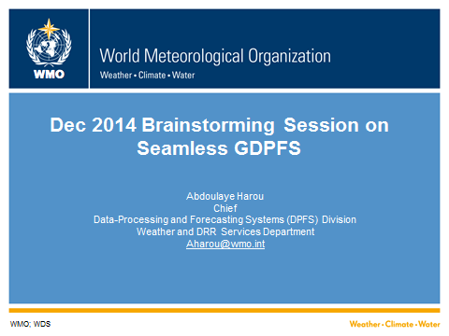

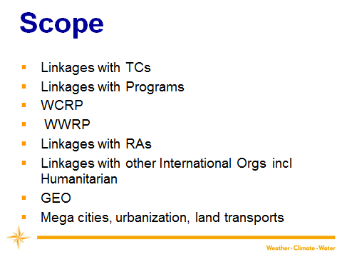
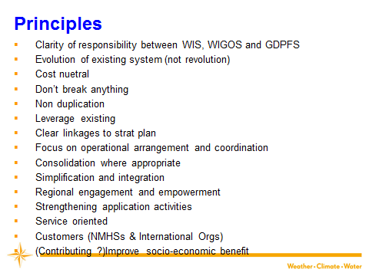

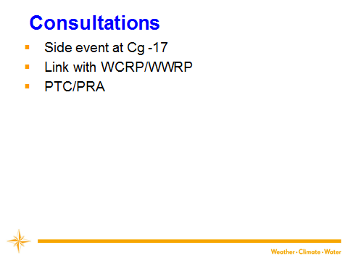

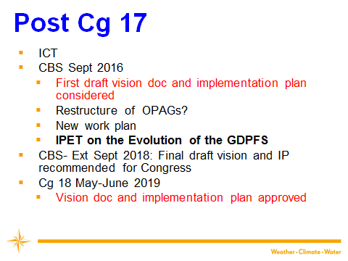

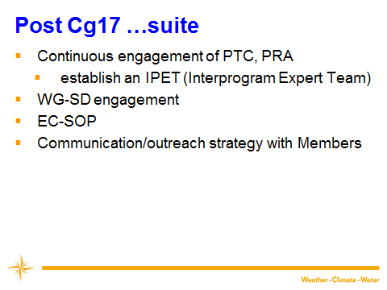
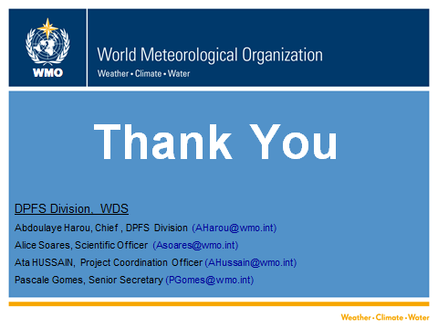

Annex V

Updated Elements of the White Paper
Executive Summary
Preamble- catchy paragraph intended to both introduce idea and raise the interest of the reader.
Vision
- The GDPFS will be an effective and adaptable monitoring and prediction system to enable Members and partners to make better informed decisions.
- The GDPFS will do so through the sharing of weather, water, climate and related environmental data, products and services in a cost effective, timely and agile way, with the effect of reducing the gaps between developed and developing Members .
- The GDPFS will facilitate the provision of impact-based and impact forecasts through partnership and collaboration.
Why are we doing this? Evolution versus Revolution
- Agility, improved communication, dealing with urgent response requirements
- Global enterprise which enables National Centres to fulfill national obligations
- Enhancing WMO role in disaster mitigation and CSIS
- Reducing service capability gaps between developed and developing countries
Scope
- System aspects
  - Role and responsibilities of GDPFS Centres
  - Seamless forecast from very short term up to 1 to 2 years (?)
ii. Service aspects
- Relationship with PWS
- IP-SDS
Linkages with:
- TCs
- Programs
- WCRP/WWRP
- RAs
- Other International Orgs incl Humanitarian Agencies
- GEO

Consideration of issues related to:

- Mega cities, urbanization, land transports

Benefits
Contribution to UN Agendas
Linkages to WMO priorities & strategic thrusts
Examples / exemplars
- SWFDP
- GLOFAS
- MAP
Demonstration projects
- Poll RAs & TCs for examples
- CHAMP
- CREWS
- IGGIS
- GAMOS (ChiNAMOS) (Global Agrometeorological Outlook System) China National Agrometeorological Outlook System)
- IG3IS - Integrated Global Greenhouse Gas Information System
Linkages to WIS/WIGOS
  - Clarity of the role between WIS/WIGOS and GDPFS
Broad Timelime
Risk resulting from not doing this
Partners and stakeholders
  - Humanitarians
  - Constituent bodies
Policy considerations
- Strengthening regional coordination responsibilities of RSMCs to assist Members and provide consistent messages
- Enabling the system to evolve at the rate of technological advances
- Enabling service responsiveness to users needs

Annex to the White Paper: Annotated Draft Structure of Implementation Plan
- Vision
- Current state of the GDPFS, what is it, what works, success stories

  - Success Stories:
    - SWFDP and cascading forecasting process
    - Manual on GDPFS
    - ERA Centres
    - Designation of GDPFS Centres
    - LCs for verification
    - LRFMME (link with CCL)

- Role of Members

- Role of stakeholders and partners (existing and potential) – divide into internal and external

  - Constituent bodies (TCs, RAs, EC )
  - GFCS/CSIS
  - Humanitarian Agencies
  - IAEA/CTBTO
  - ICAO
  - GEO
  - European Commission

- Areas for improvements (this could take a while to properly assess) – possibly would benefit from an external independent review

  - Interoperability between legacy GDPFS and users/partners
  - Services to Humanitarian Agencies
  - Limited recognition of capability of GDPFS among some users (eg. Hydrology)
    - Hydrology cascade
    - EFAS/GLOFAS (internal WMO structure)
  - Medium and long range (Sub-seasonal gap in the Manual)
  - Global centre for climate monitoring (ocean & atmosphere)
  - Lack of global coverage from the cascading process (cascading applied to limited areas)
  - Lack of designation criteria for some specialized centres (e.g. Agriculture, Hydrology)
  - Sustaining linkage of GDPFS goals to other relevant research bodies like WWRP TIGGE (including TIGGE-LAM) and international HEPEX, and other water and environmental research groups (e.g. European JRC).

- Communication & outreach strategy
- Check the language in other docs (ie WIS, GFCS, etc)

- Capacity development & Training
- Check the language in other docs (WIS, GFCS, etc)

- Current and foreseeable trends (external drivers of change) – possibly could go through a ‘scan’ done by a third party (users driven and technology driven)

  - Science
  - Earth system modeling
  - Internet bandwidth in developing countries
  - Technologies (big data, cloud storage and data mining tools, cloud computing, next generation satellite systems, crowdsourcing of everything, the Internet of things)
  - Emerging service needs – Downscaling
  - Socio-economic trends
  - Climate change and global security considerations
  - Urbanization (Mega cities), transports, energy etc

- Success indicators

- Harmonization of regulatory materials
- Centre designation criteria & responsibilities established
- Inclusion of all WMO domains (Ag, Hydrology, marine, etc)
- QMS incl recurrent review of requirements in place
- procedures for continuing evolution in place
- Cascading process implemented across all regions
- Key external stakeholders are engaged
- Members have access to sufficient information to support the issue of multi-hazards early warnings
- Engagement with all TCs and RAs

- Methodology/Principles

- Engagement of TCs, RAs and Programmes
- Clarity of responsibility between WIS, WIGOS and GDPFS
- Evolution of existing system (not revolution)
- Cost neutral
- Don’t break anything
- Non duplication
- Leverage existing system
- Synergy between research and operation
- Clear linkages to strat plan
- Focus on operational arrangement and coordination
- Consolidation where appropriate
- Simplification and integration
- Regional engagement and empowerment
- Strengthening application activities
- Service oriented
- Customers (NMHSs & International Orgs)

- Policy considerations required to facilitate, enable the achievement of the vision (we can identify those, but identify as elements requiring EC guidance and decisions)

  - Clarity of the role between WIS/WIGOS and GDPFS
  - Open data
  - Open source
  - Cascading processing and predictive strategy
  - Evolving WMO governance to enable our vision

  - Role of the private sector?

- How do we get there? Required partnerships, role of the private sector in supporting-enabling the vision

  - Harmonization of regulatory materials

- Roadmap, timelines, resources (high level implementation plan)

  - EC 68, 69, 70
  - CBS (and other meeting of TCs and RAs)
  - CG 2019
  - CBS 2020
Annex VI

Timeline for the development of the White Paper

- Reminding TC Reps to provide the summary of their requirements
- Need to request JCOMM, TCP input
- 24 Feb input from CHy advisory group (delayed)
- 26 Feb – preliminary draft (Michel B, Alice, Abdoulaye)
- 1st March consult Fred/Ken/Yuki/Mich J; 2 days to respond
- 4 March to the TT for review- Inputs expected 9 March
- Week 14 March - SWFDP Steering Group
- 21-22 March Compilation of comments and development of final draft (Michel Béland, Alice Soares, Abdoulaye Harou)
- 23March Discussion on final doc with Ken/Fred/Yuki/Michel Jean /Michel Béland
- 24 March send draft final version to the TT
- April 8, Final comments from TT
- Preparation of Doc for EC-68
- Week of 18 April, teleconference of the TT on the Annex to the White Paper
- Week of 23 May ICT on DPFS

