Severe Weather Forecasting AND DISASTER RISK REDUCTION Demonstration Project (SWFDDP)
REGIONAL SUBPROJECT RA V

PROGRESS REPORT N° 2
For the period 1 March 2010 – 30 June 2010

(04 Aug 2010)



FINAL REPORT


Part of SWFDDP website banner

- Overview:

  - Introduction:

The meeting of the Regional Subproject Management Team (RSMT) of the Severe Weather Forecasting and Disaster Risk Reduction Demonstration Project for the planning of the Regional Subproject in WMO RA V (“SWFDDP – RA V”) was held from April 21-24, 2009. The meeting report can be found at:

Severe Weather Forecasting and Disaster Risk Reduction Demonstration Project (SWFDDP), a regional subproject of SWFDP in RA V, Regional Subproject Management Team

The regional implementation plan can be found at:

Regional subproject Implementation Plan - (pdf)

The principles and the goals of the Project were well outlined in section 1.1 of the plan. The Cascading Forecasting Process of global centres providing products through a lead RSMC to NMHS’s is well described in section 1.2.

It was concluded that the SWFDDP will consist of two phases: a Pilot phase (limited participation, November 2009 to October 2010), and a full Demonstration phase (expanded participation, planned for November 2010 - November 2011).

Pilot Phase Participants:

The NMHSs involved in the Pilot Phase are: Samoa, Vanuatu, Solomon Islands, and Fiji.

The Regional centres include: RSMC Wellington as lead RSMC for the Cascading process, RSMC Darwin (Geographic), and RSMC Nadi (Activity – TCC). Fiji also has the distinction of participating as a NMHS, through its RSMC.

The Global centres ECMWF and the Met Office UK are participating actively. The Met Office has tailor made products for the area 150E – 120W, 10N – 40S which is larger than the 'South Pacific window' - 150E - 150W, 2N -30S of the RSMC Wellington Guidance product (see below).

It was hoped that the Japan (JMA) and the USA (NCEP and Honolulu) would also participate. As well, France (Météo-France) could also participate because of its presence in French Polynesia and New Caledonia.

South Pacific Ocean Map (showing location of participating countries)

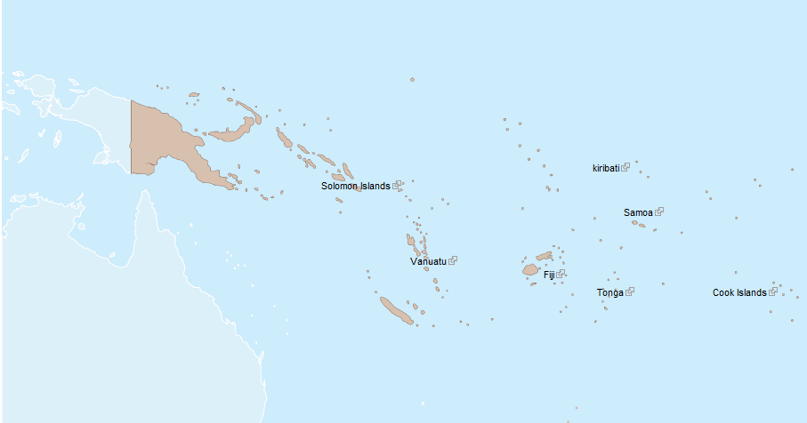

SWFDDP 'South Pacific Window' (subset of the above map)

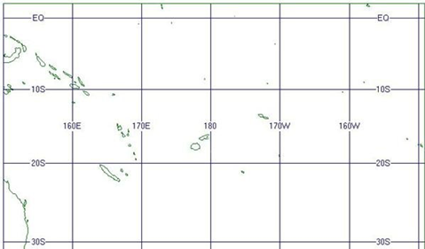

This second 4-monthly Progress Report follows the first Progress Report (Q1: Progress Report: 1 November 2009 - 28 February 2010 ). This progress report compiles the feedback provided from the RSMC’s and the NMHS's in order to determine the quality of the guidance provided by RSMC Wellington as well as the quality and applicability of the global products available. The feedback will also be used in order to ascertain the pertinence and the quality of the warnings and improvement of the warning services the NMHS's delivered to the Disaster Management and Civil Protection Authorities - `DMCPA`. The 4-month evaluation table is used to identify all severe weather events in the reporting period (1 March 2010 – 30 June 2010).

Feedback received from participating RSMC and NMHS`s for the period 1 March 2010 30 June 2010
Centre/Country | 4 month report | 4-month evaluation table | Verification of warnings | Case studies
RSMC Wellington | x | n/a | ¹
RSMC Darwin | x | n/a | n/a
RSMC Nadi | X⁰ | n/a | n/a
NMHS Samoa | x | x | ²
NMHS Solomon Is. | x | x | ²
NMHS Vanuatu | x | x | ²
NMHS Fiji/Nadi | X⁰ | x | ²

X⁰ NMHS Fiji sent in a progress report that referred to some RSMC activities.
¹ RSMC Wellington has begun verification of the SPG as outlined in this report
² No NMHS has presented formal verifications of their warnings yet

SWFDDP news:

The 2nd RSMT meeting will be held on 1-4 November 2010 at the James Cook Grand Chancellor Hotel, Welington N.Z. to discuss (among other items) the expansion of the pilot to the full demonstration phase.

The 3rd progress report should be submitted for the months of July, August and September by Friday 1 October to enable the appropriated processing so the finalised version is available before the RSMT meeting in Wellington.

2. Input from RSMC’s and Global centres:

  - RSMC Wellington:

As the lead RSMC for this project, Wellington provided a platform (MetConnect Pacific at www.swfddp.metservice.com) for the SWFDDP products. This web site also provides helpful background material and links to other global centres, RSMC’s and the NMHS's. Twice daily the RSMC staff produces the RSMC Daily Severe Weather Forecasting Guidance Products or referred to as the “South Pacific Guidance (SPG)” charts. The SPG charts contain forecasts of severe weather phenomena with thresholds for rainfall >50mm/24 hours, winds ≥25 knots, and waves ≥ 2.5m for day-1 to day-5 .

In-country SWFDDP/DRR training was carried out in Kiribati in March; Cook Islands, in May and Tonga, in June.

There is a plan to carry out some additional development work on MetConnect Pacific. The work involves adding extra data; improvements and efficiencies in the way the data is displayed as well as a number of miscellaneous items, including updating contacts, links and evaluation documents. It might NOT be completed before the start of the Full Demonstration phase on 1 November 2010.

  - RSMC Darwin:

. The contribution of RSMC Darwin to the pilot phase of the SWFDDP-RAV continued in the second reporting period via the routine provision of regional analysis, climate diagnostic and NWP products through the MetConnect Pacific and RSMC Darwin web sites. Preparatory work is continuing on the replacement of the existing suite of TXLAPS products for the south Pacific region with equivalent products from the Bureau of Meteorology’s new NWP system, ACCESS. This replacement is anticipated for mid-August 2010.
Plans have been made for a representative of RSMC Darwin to visit south Pacific meteorological services participating in the SWFDDP-RAV during the next 12 months.
A training program is being developed by a Bureau of Meteorology trainer for presentation to meteorologists during an AusAID-funded tour to RSMC Nadi and meteorological services in Samoa, Vanuatu, Solomon Islands and Tonga, later this year.

  - RSMC Nadi

RSMC Nadi (TCC) provided access to its web site through MetConnect Pacific. The 1 to 3 day TC Outlook was based on some of the new products made available through the SWFDDP. In addition, they commented that the SPG charts were useful for coordination purposes.

  - Products from global centres:

ECMWF: As outlined in the previous progress report (Q1: Progress Report: 1 November 2009 - 28 February 2010 ), the ECMWF products continued through this time period and were well received.

Met Office UK: As outlined in the previous progress report,the Met Office’s products continued through this time period. The Met Office has plans to expand its global lightning network into the Pacific region with maybe a lightning detector based in New Zealand. This should have positive spin-offs for Pacific Island countries without radar surveillance technology.

Other centres: As reported in the previous progress report, RSMC Wellington has been liaising with Météo-France, NCEP and JMA about obtaining additional products in the future. RSMC Wellington is still working with the USA about their input into SWFDDP. At the moment, the JMA operational ensemble prediction model only generates perturbations for the northern hemisphere. JMA has plans to go more global with their EPS in a year or so. It is expected Météo-France will provide regional NWP atmospheric and wave model data and EPS data at a later stage.

3. Summary of the severe weather events 1 March to 30 June 2010

3.1 RSMC Wellington:

The cyclone season ended with two (2) further tropical cyclones in March - Tomas and Ului. The centre of Ului passed about 100km south of Rennell Island (southern SOLOMON ISLANDS) around 1200 UTC on 14 March while the eye of TOMAS passed close to Cikobia, just east of Vanua Levu and over the islands of Taveuni and the Lau Group of Fiji between 1800 on 14 March and 1200 UTC on 16 March.
There were non-cyclone related significant rainfall events affecting Fiji on 25 April UTC and Vanuatu, on 23 May, 16 and 27 June UTC. The June event was a typical active cool season event with a sharpening upper trough over the Coral Sea and the equatorward entrance zone of an anticyclonically curving subtropical jet stretched over Vanuatu. Eventually, a shallow low formed at MSL near northern Vanuatu while a 1030hPa+ high became slow-moving over the central Tasman Sea.

3.2 Solomon Islands:

TC Ului: See appendix A for the track. At 0600 UTC on the 9 March 2010, the Solomon Islands Meteorological Service (SIMS) issued the first special advisory on the precursor tropical depression, central pressure 1003 hPa, when it was located 25 nm south of Vanikoro Island in the Temotu province. It was named a tropical cyclone, central pressure 995hPa, at 1200 UTC on the 13 March 2010, located 220 nm southwest of Vanikoro Island, on a westward track. About 70 nm southeast of Rennell Island, with a central pressure of 930 hPa , it reached Category 5. From here, it continued to move westward across the southern waters of Rennell & Bellona Islands into the Coral Sea. In the damage assessments, the NDMO concluded that there was no lives lost due to the storm – only a few injuries. However, here was extensive crop damage in some provinces, and infrastructure including, buildings and water supply were affected. As a result, every day life was disrupted.
.

3.3 Vanuatu:

There were three severe events through this time period - heavy rain on the 23 May (no data submitted yet), 15-16 June, resulted in 245mm falling over the island of Sola, and 26-27 June, resulting in 162mm over Port Vila and severe flooding over the central islands of Vanuatu.

3.4 Fiji:

Tropical Cyclone Ului developed in the northern waters of Vanuatu and steadily moved westwards. It was a Cat 4 cyclone while in Nadi’s area of responsibility.
Tropical Cyclone Tomas developed to the northwest of Samoa and moved generally southwest before turning south through Fiji and eventually southeast as it entered Wellington’s AOR. It attained a maximum intensity of Cat 4.
On the 25 and 26 April 2010, heavy precipitation and squally conditions occurred over Fiji. These were associated with a shallow low which developed to the south of the country.

3.5 Samoa

Tropical depression 14F which eventually became tropical cyclone Tomas was located at about 210 nm northwest of Apia or 170 nm northwest of Asau at 0000 UTC on 10 March 2010 and moving west-southwestwards at 10 knots. Over Samoa, north to northeast winds strengthened to 30-40 knots, mainly over the highlands with gusts to 60 knots; 66 knots was recorded at Mt Fiamoe. No injuries were reported but extensive damage was caused to crops. 15 special weather bulletins were issued over 3 days.
From 19 to 23 June 2010, a fairly intense high pressure system to the south of Samoa directed a fresh to strong easterly flow over Samoa. At 2200 UTC on 20 June, Mt Fiamoe observed 40 knots and Apia 28 knots. Warnings were issued early on the 20th.
.

4. Comments about the SPG and the NWP products.

Nadi found these products very useful and helped trigger warnings for events. Nadi found the ECMWF products the most useful followed by those of the UKMO.
Samoa found the UKMO and ECMWF products very useful, and the SPG charts as an overall assessment of the NWP guidance.
SIMS: SPG charts now enable SIMS to forecast severe weather events. Both the UKMO and the ECMWF provide helpful ensemble wind, wave and precipitation information. TXLAPS products for 10m winds also proved very useful.
Vanuatu found the SPG charts and TC Outlook assisted with their decision-making. The UKMO, ECMWF and RSMC Darwin provided helpful rain and wind guidance.

5. Project evaluation against SWFDDP goals:

5.1 To improve the ability of NMHSs to forecast severe weather events

All NMHSs agreed that the SWFDDP products and, in particular, the SPG charts had increased the NMHSs’ ability to issue warnings and strengthen the forecasters’ confidence in doing so. Samoa finds the centralized access to the products handy.

5.2 To improve the lead time of alerting these events
All NMHSs agreed that the SWFDDP products allowed them to improve the lead time. Nadi indicated the products enabled them to be more proactive in issuing rain and wind warnings. SIMS issued special advisories 3 days before the onset of TC Ului and tracked the TC 5 days before the event. SIMS suggested that Nadi’s and Brisbane’s advisories could be issued more promptly.

5.3 To improve the interaction of NMHSs with Disaster Management and Civil Protection Authorities (DMCPA) before, during and after severe weather events

All NMHSs agreed that the SWFDDP products allowed them to improve links with their national DMCPA. Nadi commented: With Ului and Tomas, interactions with DMCPA were mostly via media releases and direct liaison by the Director. General public enquiries were all handled by various staff on duty. Interaction with local and international media was numerous and has emboldened staff in the process. The collaboration between SIMS and SI NDMO has been outstanding as confidence and timeliness of warnings have improved. SIMS has made several briefings with the SI NDMO before and after the event. SIMS would prefer review sessions on an annual basis rather than have them after every event. Samoa interacts with the DMCPA as a matter of course but this has only been a moderately active severe weather period for them.

5.4 To identify gaps and areas for improvements

Fiji has identified gaps in a debriefing session on 12 May with the Disaster Management Centre (DISMAC) and a top Government Minister. The heavy precipitation event of April 25-26 also identified gaps in operations as well as coordination with Airport authorities. Fiji lost two senior forecasters at the beginning of the second progress report period – this created difficulties in training new staff and forced rearrangements in the duty rosters especially during March. Well appreciated was a secondee from the BoM. SIMS would like additional staff and training; additional manned or automated surface stations in the Solomon Islands would greatly add to the ground truthing of what occurred during the TC. Training for the SWFDDP helped Samoa to identify some gaps.

5.5 To improve the skill of products from Global Centres and RSMCs through feedback from NMHSs

As mentioned in the first progress report, RSMC Wellington noted that there are many, many instances when the SPG charts show waves of 2.5m or more, so will recommend a higher threshold for large waves at the RSMT meeting in November 2010. In addition, the current ECMWF wave products are set at 2m and 4m thresholds, which makes it awkward for RSMC Wellington in preparing the large wave guidance. RSMC Wellington has requested ECMWF to consider providing an additional product at a more suitable threshold.

RSMC Wellington finds that the UKMO and ECMWF ensemble data are very useful in helping to pick heavy rainfall in the range of 50 to 100mm in 24 hours. For amounts in excess of 100mm, the forecaster is usually left to decide how poorly the models have unresolved higher rainfalls.

The wind guidance from both the ECMWF and UKMO has usually proved very reliable. SIMS echoes these assessments and also likes the TXLAPS products. SIMS found the SPG as well as Nadi and Brisbane’s products very useful. SIMS suggests that evaluation be made and be available on all models in all conditions – not only in severe weather.

Whenever they can, RSMC Nadi’s forecasters are encouraged to give real time assessments of the products.

Vanuatu finds the ECMWF and UKMO products very helpful, the products still some improvement as to the timing and the intensity of the forecast precipitation.

6. Evaluation of the weather warnings:

6.1 Feedback from the public

Fiji: continuous public awareness and education was important throughout severe weather activity. Warnings were generally appreciated. Public confidence in SIMS’s warnings increased during TC Ului.
In Samoa, the public appreciated the timeliness of the warnings.
In Vanuatu there was positive feedback from the public as to the warnings issued.
In the Solomon Islands, the public is aware of the improvements of the forecasts and has shown an increased confidence in the warnings.

6.2 Feedback from the DMCPA’s

In Fiji, officials appreciated the amount and quality of warnings. As mentioned above, the 12 May debrief provided an opportunity to identify gaps.

The collaboration between SIMS and SI NDMO (National Disaster Management Office) has been outstanding as confidence and timeliness of warnings have improved. SIMS has made several briefings to the SI NDMO before and after TC Ului.

In Samoa, the DMCPA’s mostly agreed that there had been an improvement in the timeliness and quality of the warnings.

In Vanuatu the DMCPA considered that they were well informed.

6.3 Feedback from the Media

Fiji: Local and international media were very appreciative of the media releases and interviews provided during TC Tomas and Ului, as well as the previous ones that affected the region.
SIMS: There is now a huge coverage of severe weather events throughout the various media. The Media is very active when warnings of severe weather are issued and have requested the Director of Meteorological Services to broadcast directly on a few occasions.
In Samoa, the efforts put into warnings was generally appreciated. A private radio station tried to provide an alternative forecast which stirred up a commotion amongst the public.

6.4 Objective verification by the NMHS's

The following is an objective verification by RSMC Wellington.
As outlined in the first progress report plan Q1: Progress Report: 1 November 2009 - 28 February 2010 , the present criteria (rainfall >50mm, winds >25kts, waves >2.5) over forecast severe weather. A more stringent set of significant criteria (rainfall >100mm, winds >30kts and waves >3 metres) were used to evaluate the charts. A total of 1220 South Pacific Guidance charts were produced by RSMC Wellington Lead meteorologists and posted on MetConnect Pacific. 575 (about 47%) of these charts contained significant guidance (i.e. any charts with one or more rainfalls > 100mm, winds > 30 knots and waves > 3 metres) and only 47 charts (about 4%) displayed NIL SIG.
The following table shows a subset of the total South Pacific Guidance produced - focussing on the most significant guidance i.e. Rain > 100mm per day and/or Winds > 30 knots and/or Large waves > 3m.
Information on South Pacific Guidance charts |  |  |  |  | Mar-10 | Apr-10 | May-10 | Jun-10
Total number of charts produced in each month |  |  |  |  | 310 | 300 | 310 | 300
Number of these charts with SIGNIFICANT guidance for whole area |  |  |  |  | 203 | 125 | 115 | 132
affecting the Solomons only |  |  |  |  | 98 | 3 | 2 | 24
affecting Vanuatu only |  |  |  |  | 129 | 48 | 40 | 97
affecting Fiji only |  |  |  |  | 66 | 38 | 24 | 56
affecting Samoa only |  |  |  |  | 15 | 10 | 8 | 22
No of charts with Heavy Rain > 100mm |  |  |  |  | 27 | 8 | 2 | 5
Solomons |  |  |  |  | 23 | 3 | 2 | 0
Vanuatu |  |  |  |  | 23 | 2 | 0 | 5
Fiji |  |  |  |  | 9 | 4 | 0 | 1
Samoa |  |  |  |  | 5 | 1 | 0 | 0
No of charts with Strong Wind > 30 knots |  |  |  |  | 89 | 40 | 15 | 31
Solomons |  |  |  |  | 5 | 0 | 0 | 0
Vanuatu |  |  |  |  | 47 | 4 | 3 | 26
Fiji |  |  |  |  | 3 | 3 | 3 | 19
Samoa |  |  |  |  | 0 | 0 | 2 | 3
No of charts with Large Waves > 3m |  |  |  |  | 189 | 118 | 105 | 131
Solomons |  |  |  |  | 20 | 0 | 0 | 24
Vanuatu |  |  |  |  | 104 | 47 | 38 | 95
Fiji |  |  |  |  | 19 | 36 | 22 | 55
Samoa |  |  |  |  | 8 | 9 | 6 | 22
No of charts with TC references |  |  |  |  | 83 | 0 | 0 | 0
Solomons |  |  |  |  | 69 | 0 | 0 | 0
Vanuatu |  |  |  |  | 23 | 0 | 0 | 0
Fiji |  |  |  |  | 42 | 0 | 0 | 0
Samoa |  |  |  |  | 2 | 0 | 0 | 0
No of charts with NILSIG |  |  |  |  | 1 | 0 | 32 | 14

The following table contains the guidance produced by RSMC Wellington for Vanuatu, Samoa and Fiji in the lead up to various events. In all cases, the heavy rainfall was confined to just part of Vanuatu and Fiji. The NWP guidance gave no hint of the significant rainfall over Port Vila on 27 June. Mt Fiamoe, the station Samoa used for verifying the two strong wind episodes is positioned nearly 1,000 metres above MSL.
VANUATU | May-10 | Jun-10 | Jun-10
 | 221200-231200 UTC | 151200-161200 UTC | 261200-271200 UTC
 | 23rd | 16th | 27th
 | Heavy RAIN | Heavy RAIN | Heavy RAIN
Forecast on actual day | 50-100mm Moderate | 50-100mm Moderate | None
Forecast issued day before | 50-100mm Moderate | 50-100mm Low | None
Forecast issued 2 days before | None | 50-100mm Low | None
Forecast issued 3 days before | Low | Low | None
Forecast issued 4 days before | Low | Low | None
 |  | 152100-162100 UTC | 262100-272100 UTC
Observations |  | Sola: 245.0mm | Port Vila: 161.7mm
FIJI | Apr-10
 | 251200-261200 UTC
 | 26th
 | Heavy RAIN
Forecast on actual day | 50-100mm Moderate
Forecast issued day before | 50-100mm Moderate
Forecast issued 2 days before | Heavy rain Low
Forecast issued 3 days before | Heavy rain Low
Forecast issued 4 days before | None
 | 242100-252100 UTC
Observations | 152.6mm @ Nausori Airport
Samoa | Mar-10 | Jun-10
 | 101200-111200 UTC | 201200-211200 UTC
 | 11th | 21st
 | Strong wind | Strong wind
Forecast on actual day | Northeast 25-30kt Mod | None
Forecast issued day before | Northeast 25-30kt Low | None
Forecast issued 2 days before | Northeast 25-30kt Low | None
Forecast issued 3 days before | Northeast 25-30kt Low | None
Forecast issued 4 days before | Northeast 25-30kt Low | None
 | 110300 UTC | 202200 UTC
Observations | Mt Fiamoe 66 knots  (anemometer is nearly  1000m above MSL), Apia 27 knots. | Mt Fiamoe 40 knots,  Apia 28 knots.

7. Case studies:

There are no case studies available at this stage.

8. Conclusions:

Overall, it was a good 2nd reporting period for the SWFDDP Pilot phase in RA V.

All NMHSs agreed that the SPG charts were very useful and that overall they had a positive impact on their warning programs. All agreed that the participation in the SWFDPP is a worthwhile endeavour. The NMHS's found the products from the global centres also very useful.

RSMC Wellington will recommend changes to the wind, rain and wave thresholds used in the production of the South Pacific Guidance charts at the RSMT meeting in November 2010.

At the beginning of the Demonstration phase (planned for November 2010), RSMC Wellington will provide additional information on rain/wind/waves for day 1 and day 2 for areas where a TC Outlook is in force while no tropical cyclone exists or has been named. This is designed to help fill the shortfall in specifics about heavy rain/strong winds/large waves when a simple TC Outlook area replaced a combined set of rain, wind and wave areas.

The TC Outlook produced by RSMC Nadi only extended out to 3 days which meant RSMC Wellington had to stretch the use of the 'Heavy Rain' envelope in the South Pacific Guidance tool to include information about a possible formation on days 4 and 5. RSMC Nadi has plans to extend the TC Outlook to 5 days at the beginning of the 2010/2011 cyclone season.

RSMC Wellington has already requested ECMWF to consider providing significant wave forecasts at a more suitable threshold of 2.5 or 3m. A follow-up request was made very recently.

.

Appendix A: Track of TC Ului (From Solomon Islands NDMO report)

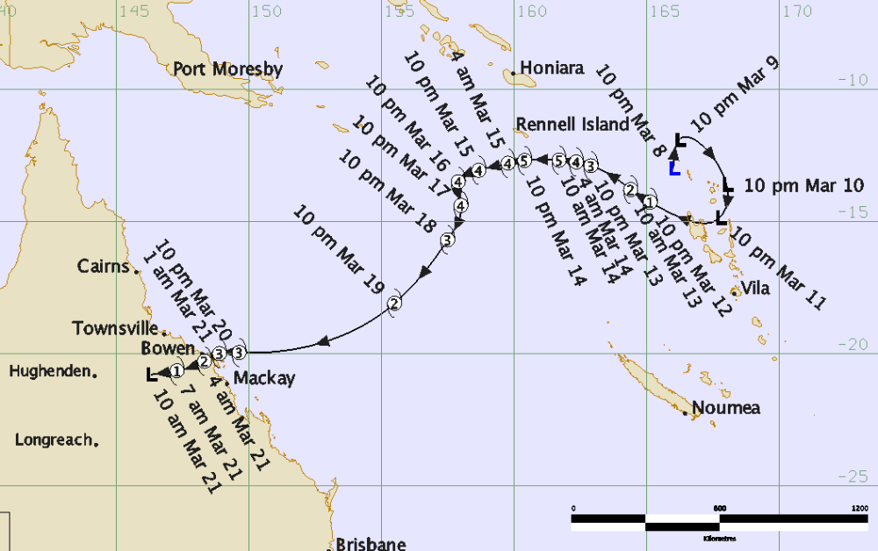

Appendix B: South Pacific Guidance chart issued at 1500 UTC on 13-March-2010 for day 2 - 1200 UTC on 14th to 1200 UTC on 15th during tropical cyclones Ului and Tomas.



