WORLD METEOROLOGICAL ORGANIZATION  COMMISSION FOR BASIC SYSTEMS  STEERING GROUP  SEVERE WEATHER FORECASTING DEMONSTRATION PROJECT (SWFDP)  GENEVA, SWITZERLAND, 14 – 18 March 2016 |  | CBS/SWFDP-SG/Doc. 5.3  (04.III.2016)  _______  ENGLISH ONLY

REVIEW OF SWFDP SUBPROJECTS IN PLANNING AND/OR INITIAL DEVELOPMENT STAGE

Severe Weather Forecasting Demonstration Project (SWFDP) in the Caribbean

DISCUSSION PAPER

By

Tyrone Sutherland
Permanent Representative of the British Caribbean Territories with WMO
Coordinating Director, Caribbean Meteorological Organization

Background
1. The concept of developing a WMO Severe Weather Forecast Demonstration Project (SWFDP) for the southern portions of RAIV was discussed in a formal manner for the first time by the 16th meeting of the RA IV Management Group (MGMT-16), which was held in Geneva from 27 May to 8 June 2015 on the margins of Cg-17. Mr Abdoulaye Harou, Chief of Data Processing and Forecasting Systems in the WMO Secretariat, presented the SWFDP concepts to the Management Group, with some ideas that could apply to RA IV. That meeting gave the preliminary direction to facilitate further study of the matter in the months ahead. Another round of discussions took place at RAIV MGMT-17, which met in New Orleans in January 2016.

2. The meeting of the Steering Group on the SWFDP, scheduled to take place in March 2016, comes too early for RA IV to present any concrete proposals for its consideration. This document will therefore provide information to the Steering Group on what has transpired in connection with both sessions of the RAIV MGMT and immediate follow-up proposals. The RA IV Management Group will welcome guidance and proposals from the Steering Group.

RA IV MGMT-16 Decisions and follow-up Regional Activities
3. The 16th meeting of the RA IV Management Group decided to create an Expert Group (EG), led by Tyrone Sutherland (BCT) and Dr. Albert Martis, Vice-president of RAIV and chair of the Task Team on Disaster Risk Reduction, to provide orientation about this demonstration project. Support would be provided the WMO Secretariat and by the Barbados-based (CIMH), which is a WMO Regional Training Centre (RTC) and a WMO Centre of Excellence (CoE) for Training in Satellite Meteorology, among other functions. The WMO Secretariat also offered guidance to RA IV from experts with experience in other SWFDPs, such as the Southwest Pacific, whenever required. The MGMT-16 tasked the Expert Group to develop initial proposals for discussion at its next session in January 2016.

4. In considering the idea of a SWFDP for the southern portions of RAIV, it is important to look at the States and Territories that would be most impacted and involved. A large number of States and Territories in southern RA IV are actually Member States of the Caribbean Meteorological Organization (CMO), just a few of which are not Members of WMO. Therefore, within the organs of the CMO itself, a range of discussions have taken place on the concept of a SWFDP that would feed into the discussions of the RA IV MG.

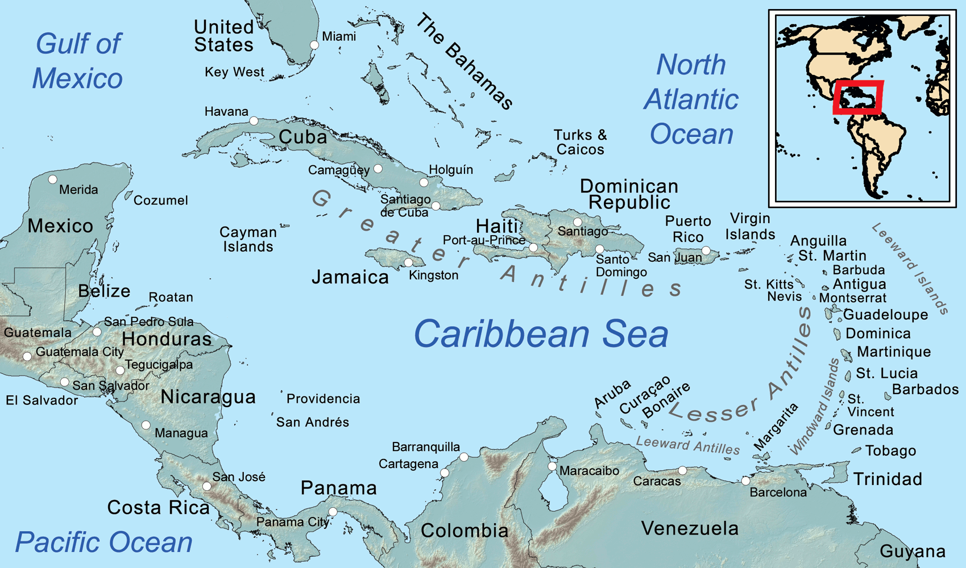
Figure 1: The southern part of RA IV comprising continental areas and a large number of islands (Source: wikipedia.org)

5. In that regard, the CMO envisages a key role for the regional arm of Météo-France (Martinique) in a SWFDP that may focus on the Eastern Caribbean in the first instance (depending on the decision of the RAIV MG). The aim of the CMO is to build on the existing collaboration between CMO and Météo-France, particularly those elements that can be built into a SWFDP. In October 2015, CMO undertook a mission to the Météo-France inter-regional headquarters in Martinique to discuss these and other collaborative matters. CMO and Météo-France have since developed a more formal set of "Working Arrangements" to guide this collaboration, which would be subject to acceptance by the governing structures of both Météo-France and CMO. In November 2015, the Caribbean Meteorological Council, which is the ministerial-level governing Council of the CMO, met in Belize. WMO was represented by Mr Oscar Arango, WMO Representative in Costa Rica. The Council considered the proposed Working Arrangement between CMO and Météo-France, together with a number of severe weather-related documents that dealt with:
(i) Regional Coordination under the WMO Tropical Cyclone Programme (TCP);
(ii) The implementation of the Common Alerting Protocol (CAP) standard;
(iii) Future coordination under a Severe Weather Demonstration Project (SWFDP) in WMO Region IV;
(iv) Impact-based Weather Forecasts and Warnings.

6. In its discussion, the Caribbean Meteorological Council specifically noted that the Caribbean area continued to be extremely well served by a very effective Tropical Cyclone Programme (TCP), which sets out the processes and procedures in the forecast and warning system for tropical cyclones among all States and Territories in the Region. That includes the coordination between the RSMC in Miami (US National Hurricane Center) and individual forecast and warning offices in the Caribbean area. Nonetheless, it was aware that the TCP does not spell out the coordination process between NMHSs themselves when the RSMC was not involved, nor required. Such coordination could be of particular value for the many severe weather events that were not necessarily related to tropical cyclones, or for severe marine conditions on the high seas that adversely affected coastal zones.

7. The CMO governing Council endorsed the establishment of the formal Working Arrangements between the CMO and Météo-France (paragraph 5) and also endorsed the consideration by WMO of a Severe Weather Forecasting Demonstration Project for the region. The endorsement means that the countries of the CMO in RA IV (which includes three non-WMO Members in the Eastern Caribbean) would become fully involved in any SWFDP approved by WMO.

8. With respect to the membership of the Expert Group or Task Team, as called for in paragraph 3, Dr. Martis and T. Sutherland believe that it would be more productive to keep the Group fairly small, hence they proposed to the MG, the following persons - initially:
1. Tyrone Sutherland (BCT);
2. Albert Martis (Curaçao);
3. Keithley Meade (Antigua & Barbuda) [Antigua & Barbuda has forecast/warning responsibility for a large number of islands];
4. Jean-Noel Degrace (Martinique, France);
5. Representative from the Dominican Republic (depending on the western limit of the SWFDP to be decided by the MGMT);

- Support provided by CIMH and Mr Abdoulaye Harou of the WMO Secretariat.

9. In preparation for the RA IV MGMT discussion to take place during AMS in January 2016, Mr Abdoulaye Harou of the WMO Secretariat provided guidance material, particularly a draft of some Terms of Reference that could be built upon, and some examples and/or proposals for regional activities within a Caribbean SWFDP.

Discussions at the 17th Management Group Meeting
10. From all the regional discussions, as well as the material provided by the WMO Secretariat, the 17th RA IV Management Group held discussions to further develop its ideas on SWFDP with the aim to ultimately make decisions that would include the following:
(i) The geographical limits of the SWFDP in RA IV;
(ii) The full membership of the SWFDP Expert Group or Task Team, including the ToR of the Group;
(iii) The establishment of a Regional Subproject Management Team (RSMT);
(iv) Candidates for the establishment of a Regional Forecast Support Centre (RFSC);
(v) A formal request to be made by the President of RA IV to the Secretary-General for the establishment of a SWFDP from the agreed RA IV sub-region, which would then be considered and reviewed by the CBS Project Steering Group for SWFDP (PSG);
(vi) Decide on timelines for the consideration of the ToR etc.

11. In this regard, the RA IV MGMT noted the very pertinent information that (i) the Permanent Representative of France with WMO, Mr Jean-Marc Lacave, had written to the President of RAIV, giving the green light for Météo-France to play a role as a Regional Forecast Support Centre (RFSC) in a SWFDP for the Antilles, if so decided by the MGMT and (ii) Mr Lacave identified Mr Jean-Noel Degrace as the Météo-France Project Manager for the SWFDP.

12. The RAIV MGMT-17 held a long discussion on the proposed SWFDP. The Management Group stressed the point that RA IV was “not starting from zero” in providing guidance in terms of severe weather. The Region has a very well organized and effective warning system for tropical cyclones, in which the RAIV Hurricane Operational Plan is reviewed by regional experts annually. The MG acknowledged that weaknesses in the warning systems in the region did show up when severe weather occurred that was not related to tropical cyclones or when localized weather on the fringes of tropical cyclones resulted in significant damage or loss of life. It was felt that in such situations, Member States could benefit from improved forecast and warning coordination and advice that could be provided by an RFSC or similar facility. It was pointed out that even in situations when tropical cyclones were not involved, the RSMC in Miami could still play a guidance/consultative role with the RFSC.

13. The RA IV Management Group decided that, considering the fact that there was already a Task Team to deal with natural disasters (DRR), the group proposed under paragraph 8 would be called an Expert Group. It decided that, in the first instance, the Expert Group would comprise Tyrone Sutherland, Albert Martis, Keithley Meade and Jean-Noel Degrace, along with a representative each from the RSMC Miami and Canada, and that this Group would further discuss the SWFDP at the RA IV Hurricane Committee session in Puerto Rico in April 2016. The Expert Group would then make further proposals to the Management Group on the way forward, in collaboration with the WMO Secretariat, including proposals for the geographic limits for the SWFDP.

14. In discussing possible funding issues for a Severe Weather Forecast Demonstration Project in the Region, the Management Group expressed some concern that the words “Demonstration” and “Project” gave the impression that there would be a definitive start and end time for this activity, when in fact, the Region was looking for a sustainable long-term operational mechanism that could have its genesis in a SWFDP. Ms. Mary Power, Director of the WMO Office for Resource Mobilization and Development Partnerships, suggested showing a link between this initiative and Regional Climate Centre (RCC) matters, in order not to lose the link to climate where there were funding possibilities. The Canadian representative on the Management Group suggested that the SWFDP initiative could also be associated with the WMO SIDS activities and funding sources.

15. The RA IV Management Group was aware that its discussions this far were not sufficiently advanced to provide the CBS Project Steering Group for SWFDP (PSG) meeting in March 2016 with concrete decisions that would enable the PSG to deliberate on. However, it hoped that the PSG would provide whatever guidance it considered appropriate at this time.

__________________

The CMO comprises the following sixteen (16) Member States: Anguilla, Antigua and Barbuda, Barbados, Belize, British Virgin Islands, Cayman Islands, Dominica, Grenada, Guyana, Jamaica, Montserrat, St. Kitts/Nevis, St. Lucia, St. Vincent and the Grenadines, Trinidad and Tobago, Turks and Caicos Islands. The group comprising Anguilla, the British Virgin Islands, the Cayman Islands, Montserrat, and the Turks and Caicos Islands collectively form a Member Territory of the WMO - The British Caribbean Territories (BCT).

