**PROGRESS OF THE SEVERE WEATHER FORECASTING DEMONSTRATION PROJECT FOR EASTERN AFRICA - RSMC- NAIROBI**

**1 – Overview**

This report summarizes the quarterly reports submitted by the participating NMHSs in the Eastern Africa-SWFDP Regional Subproject, which commenced in October 2010 and has expanded to include the South Sudan. The participating Centres of the “SWFDP – Eastern Africa” project include the following:-

**NMHSs (7):** Kenya, Uganda, Burundi, Rwanda, Tanzania, and South Sudan;

Ethiopia (see Fig. 1):

**Regional Centres (2):** RSMC Nairobi KMD, RSMC Dar es Salaam TMA;

**Global Producing Centres (4):** Exeter (Met Office UK), Washington (NCEP USA), ECMWF and DWD (Germany).



The six (7) participating countries in the SWFDP - Eastern Africa project including Southern Sudan

1. **- OVERVIEW OF PRODUCTS**

Noting the **goals** of the SWFDP as follows:

1. to improve the ability of NMCs to forecast severe weather events;
2. to improve the lead time of alerting of these events;
3. to improve interaction of NMCs with DMCPA before and during events;
4. to identify gaps and areas for improvements;
5. to improve the skill of products from GDPFS centres through feedback from NMCs.

**The Cascading Forecasting Process** was utilized in a coordinated functioning among three types of GDPFS centres in the intelligent generation of the RSMCs (Nairobi and Dar es Salaam) Daily Guidance Products. These were:

* Global NWP Centres to provide available NWP products, including in the form of probabilities;
* Regional Centres to interpret information received from global NWP centres, run limited-area models to refine products, liaise with the participating NMCs;
* NMCs to issue alerts, advisories, severe weather warnings; to liaise and collaborate with Media, and disaster management and civil protection authorities; and to contribute to the evaluation of the project.

The RSMCs focused on **extreme weather events** such as heavy rain, strong winds, sea/lake waves and prolonged dry spells. The criteria agreed on for alerting severe weather in the RSMC Daily Guidance charts were:

* Heavy rain: ≥ 50 mm/24hr;
* Strong winds: ≥ 25 Kts;
* Ocean/lake large waves: ≥ 2m;
* Dry spells: up to 5 days (from LAMs); up to 10 days (from global models).

**RSMC Nairobi Daily Guidance for Severe Weather Events**

The operational Meteorologist at RSMC Nairobi prepared and issued the following Daily Guidance bulletins:

* one that focuses on short-range forecasts (day-1 and day-2), issued in the morning while;
* the other addresses the medium-range forecasts (day-3, day- 4, and day-5), issued in the afternoon.
* The third addresses the agro-meteorology products where maps of Eastern Africa region indicating the comparison of the Normalized Difference Vegetation Index (NDVI) of the current dekatal and the previous one and that of the Rainfall Estimate (RFE) and anomaly.

The skillful and usefulness of the guidance products were verified by the daily discussions by the participating NMHSs (Online and Video teleconferencing) about the validity of the forecast including the hits and misses of the products.

The exercise was supported by the model charts, satellite images, risk table giving, probability of occurrence of severe weather event in the participating NMHSs, and a synthetic map indicating the critical areas for heavy rain, strong winds, and severe convective storms over the Eastern Africa region, with the day-1 map overlaid on a current satellite image.

The RSMC Nairobi as the designed web portal and maintained it (http://192.168.1.99/rsmc/index.php). The required products from the Global NWP Centres and output from Limited Area Models; WRF and

Consortium of Small Scale Modelling (COSMO) were posted on the web for preparation of value-added weather products by the participating NMHSs. Moreover RSMC Nairobi prepared and issued the RSMC Daily Severe Weather Forecasting Guidance Products, including descriptive text, event tables, maps and risk tables, probability tables, sea/lake waves and agro-met products, according to the agreed format, in order to assist forecasters to prepare their own forecasts and warnings in their respective NMHSs. The RSMC Dar es Salaam issued the RSMC Daily Severe Weather Forecasting Guidance Products over the Lake Victoria.

The Civil Protection Authorities, Public Weather Services (PWS) and with the Disaster Risk Reduction, “DRR” programmes, NGOs, Community Based Organizations (CBO), Faith Based Organizations (FBO) were engaged in the delivery of severe weather warning services.

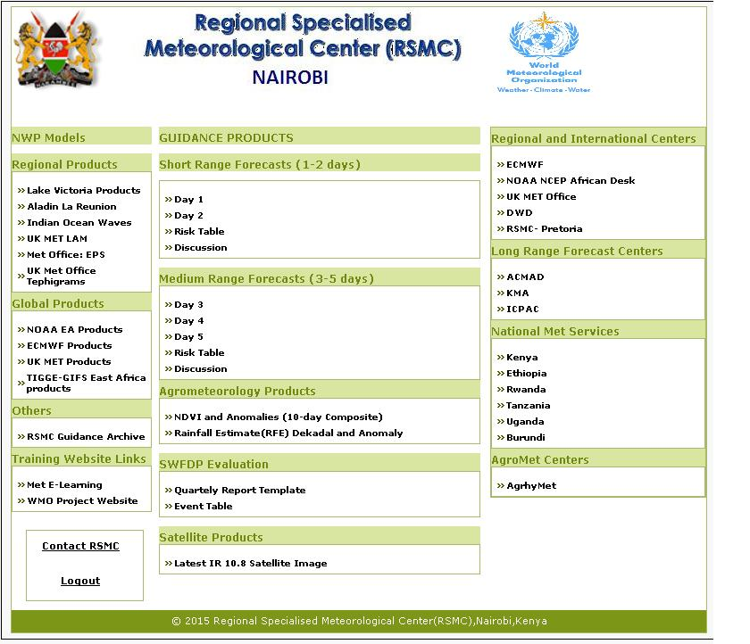

**PROBABILITY TABLES**

In order to provide more information about the geographical location of the severe weather event the following convention was adopted when filling in the cells:

X for the whole country, N for the northern part, S for the southern part,

W for the western part, C for the Central and E for the eastern part.

**Day 3: Wednesday 9th March 2016**

|  |  |  |  |  |  |  |  |  |  |  |  |  |
| --- | --- | --- | --- | --- | --- | --- | --- | --- | --- | --- | --- | --- |
| COUNTRY | HEAVY RAIN | | | | STRONG WINDS | | | | LARGE WAVES | | | |
| RISK | | | | RISK | | | | RISK | | | |
| **No** | **Low** | **Medium** | High | No | Low | Medium | High | No | Low | Medium | High |
| BURUNDI | **X** |  |  |  | **X** |  |  |  | X |  |  |  |
| KENYA |  | W & S |  |  |  | **NW** |  |  |  | E |  |  |
| RWANDA | **X** |  |  |  | **X** |  |  |  | X |  |  |  |
| TANZANIA |  | N, SW, C & E |  |  | **X** |  |  |  |  | E |  |  |
| UGANDA | **X** |  |  |  | **X** |  |  |  | X |  |  |  |
| ETHIOPIA | X |  |  |  | **X** |  |  |  | X |  |  |  |
| S SUDAN | X |  |  |  |  | **SE** |  |  | X |  |  |  |

**Degree of confidence**

These Guidance Products are based on a skilful evaluation of both Regional and Global model outputs for the domain area, Satellite imagery at the hour of issue and, expert interpretation that takes into consideration interactions with the local features**.** For generating the guidance products, the following criteria were used:

* 50mm and above of rainfall in 24 hours is classified as “heavy”;
* Wind speeds in excess of 25kts are classified as “strong”; while
* Wave heights above 2 m are “significant” with regard to maritime activities.

**DEGREE OF CONFIDENCE:** High Confidence is“>75%”, Medium Confidence is“50-75%” and Low Confidence is“<50%”.

**3. PROJECT EVALUATION AGAINST SWFDP GOALS**

3 – **Project Evaluation Against SWFDP Goals**

|  |  |
| --- | --- |
| **SWFDP GOAL** | **PROGRESS AGAINST GOALS** |
| To improve the ability of NMCs to forecast severe weather events | GPCs products were very useful. Both the strike probability for the named storms and the Extreme Forecast Index during heavy rainfall events provided useful guidance to operational meteorologists. |
| To improve the lead time of alerting these events | The lead-time of alerting of these events has greatly improved. |
| To improve the interaction of NMCs with Disaster Management and Civil Protection authorities before, during and after severe weather events | The interaction of NMHSs with the disaster management and civil protection authorities has improved a great deal.. |
| To identify gaps and areas for improvements | The resolutions of some of the models have improved to confirm with the global trend. |
| To improve the skill of products from Global Centres through feedback from NMCs | The RSMCs developed a feedback mechanism with the Global Centers, namely ECMWF, NCEP and UKMO. |

**4- Provisional Issues**

The NMHSs and their respective DMCPAs need to build strong synergies to ensure response and feedback mechanisms to the warnings/advisories by the agencies and communities involved.

NMCs should prepare simple and clear forecast information and warning/advisory messages, giving clear statements on what is happening, forecasts of what may happen and expected impact including what action should be taken.

Encourage active participation of the “Expert Group” to address the key operational issues pertaining to the SWFDP such as internet bandwidth, routine submission of the quarterly reports, 0900 Z video teleconferencing, online discussions, social media (WhatsApp) among others.

**5 – Conclusion**

A clear knowledge of current and expected conditions of weather and climate provides the vital information for important decisions in long-range planning of all the climate sensitive sectors

The participating NMHSs were satisfied by the support that the SWFDP provided, particularly in the detection, analysis and forecasting of the severe weather events or extreme weather events during the rain seasons, which minimized the risks such as loss of life, destruction of property and safeguarding of the environment thus enhancing sustainable socio-economic development of the participating countries.

The EA-SWFDP Sub-project would be considered under the EAC’s Five-years Meteorological Development Plan and Investment Strategy (2013-2018), which aim at enhancing early warning system for disaster risk reduction and management in the EAC region.