WORLD METEOROLOGICAL ORGANIZATION  COMMISSION FOR BASIC SYSTEMS  OPAG on DPFS  Expert Team on Ensemble Prediction Systems (eT-EPS)  Exeter, UK, 5 – 9 October 2009 |  | CBS-DPFS/ET-EPS/Doc. 6.1(8)  (28.IX.2009)  _______  Agenda item : 6  ENGLISH ONLY

REPORT ON EPS in severe weather forecasting including SWFDP

(Submitted by Mr. Masayuki Kyouda, Japan)

Summary and purpose of document

Applications of EPS to tropical cyclone forecasting in East Asia

Action Proposed

The meeting is invited to…

1. Introduction
JMA operates ensemble prediction systems (EPSs) for Typhoon track, one-week, one-month and seasonal forecasts. The ensemble products derived from the EPSs are provided to support the National Meteorological and Hydrological Services (NMHSs) in mitigation of disasters.
In this document, the application of EPSs with emphasis on tropical cyclone (TC) forecasting is described. In Section 2, the applications to TC-related heavy rainfall are introduced. The recent development of EPS operation and the Regional Specialized Meteorological Center (RSMC) Tokyo services are described in Section 3 and 4, respectively.
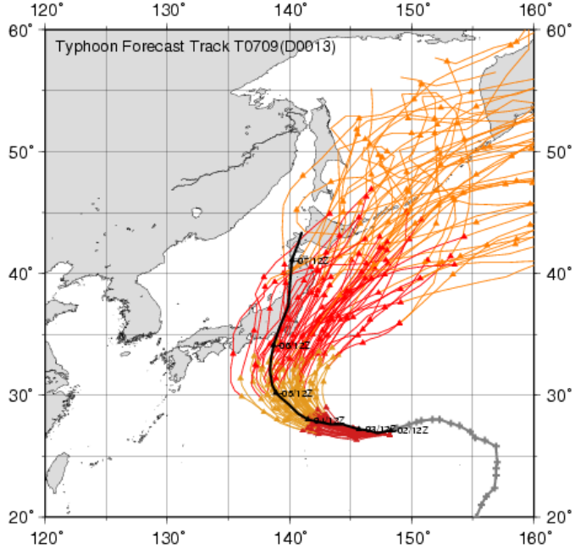
Figure 1: Ensemble TC tracks of Fitow (T0709) up to 9 days derived from JMA One-week EPS. Initial time is 12UTC 2nd September 2007. Black line and color lines indicate the best track and the forecast tracks, respectively. T0709 made landfall on the southwest of Tokyo at about 15UTC on 6th September.

2. Application to heavy rainfall associated with tropical cyclones
Typhoon is a major storm system to causes high-impact weather events such as flood and land slide in East Asia. At early stage in preventing disasters associated with Typhoon, it is indispensable to predict its approach and landfall. Figure 1 shows ensemble track forecasting of Typhoon Fitow (T0709) up to 9 days before its recurvature stage, indicating that the landfall probability of T0709 on Japan depended on the timing of its recurvature.
Almost keeping its peak intensity and northward track after the recurvature, T0709 made landfall in Honshu, the main island of Japan, at about 15UTC on 6th September and brought heavy rainfall. The 2-day accumulated rainfall in mountain region located on the western part of Tokyo exceeded 500mm and the water level of the Tama River running through Tokyo Metropolitan area exceeded dangerous level.
In order to explore the use of medium-range NWP outputs to TC forecasting, it is essential to have an accurate grasp of forecast uncertainties of high-impact weather events controlled by the TC motion, especially whether or not Typhoon will approach. In general, it is not easy for medium-range NWP to predict precious amounts or even the order of strong rainfalls. However, it is possible to create the worst-case scenario of how high-impact weather events might arise. Figure 2 shows the plume diagram of precipitation for the mountain region located on the western part of Tokyo, indicating that there is some potential for heavy rainfall at the timing of T0709 approach. Figure 3 illustrates representative tracks of T0709 from this point of view, hinting that western tracks of the ensemble supported the scenario of bringing heavy rainfall. Actually, T0709 traced the western track with landfall.

3. Operation of the Typhoon EPS
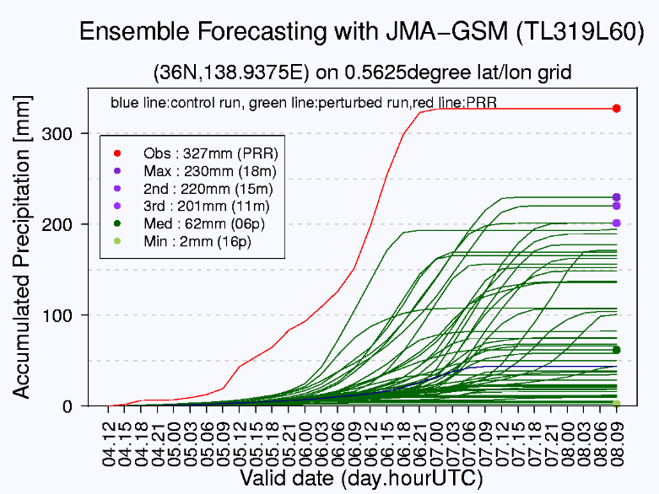
Figure 2: Plume diagram of precipitation associated with T0709 for a 0.5625°-lat/lon grid point corresponding to the mountain region located on the western part of Tokyo. Initial time is 12UTC 2nd September 2007 and accumulation starting time is 12UTC 4th September. Red line, blue line, and green lines indicates the Radar/Raingauge-Analyzed Precipitation, the unperturbed forecast, and all 50 perturbed forecast, respectively. Red dot, purple dots, green dot, and yellow-green dot represent total amount of the observed data (327mm), the forecasted maximum-/2nd-/3rd-values (230/220/201mm), the forecasted median value (62mm), and forecasted minimum value (2mm), respectively.
JMA has developed a new EPS called the Typhoon EPS aiming mainly to improve probabilistic forecast on TC movements in short- and early medium-range. Its full operation has started in March 2008. The Typhoon EPS is performed four times (00, 06, 12, and 18UTC) a day at most with a forecast range of 132 hours only when the following conditions are satisfied.
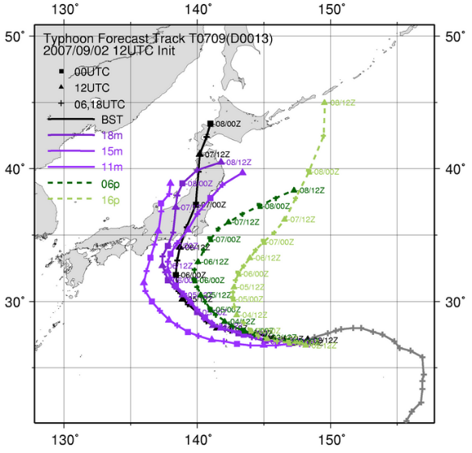
Figure 3: Ensemble tracks of T0709 up to 5 days. Initial time is 12UTC 2nd September 2007. Purple lines, green line and yellow-green line represent the forecast track bringing heavy rainfall, rainfall and almost no rainfall in the mountain region located on the western part of Tokyo, respectively. These colors correspond with the total amount marked colored dots on Figure 2. Black line indicates the observed track.
- TCs of TS/STS/TY intensity exist in the responsibility area of RSMC Tokyo – Typhoon Center (0°-60°N, 100°E-180°).
- TCs of TS/STS/TY intensity are expected to move into the area within the next 24 hours
The operation of the high-frequency EPS enables us to develop the official Typhoon information about its movements up to 5 days (Figure 4). Currently, JMA produces the following forecast guidance on TC forecasting every six hours;
- Strike probability
- Ensemble TC track, intensity and maximum wind with other NWP systems and/or EPSs
- Calibrated precipitation rate of each member
- Empirical POP of each member
They are useful to detect the possibility of severe weather events in short- and early medium-range associated with TC.

4. 5-day track forecast of RSMC Tokyo
JMA is responsible for the analysis and forecast of TCs in the western North Pacific as the RSMC Tokyo - Typhoon Center (referred to below as Typhoon Center), one of the six TC RSMCs within the framework of the WWW Programme of WMO. Typhoon Center issues Typhoon Bulletins eight times a day to provide information on TCs including analysis and forecast on its location, intensity and movement. The track forecast is represented as a geographical circle in which the center will reach with 70% probability. The Bulletins are sent to the relevant organizations in the country as well as NMHSs in the western North Pacific area to support their operations.
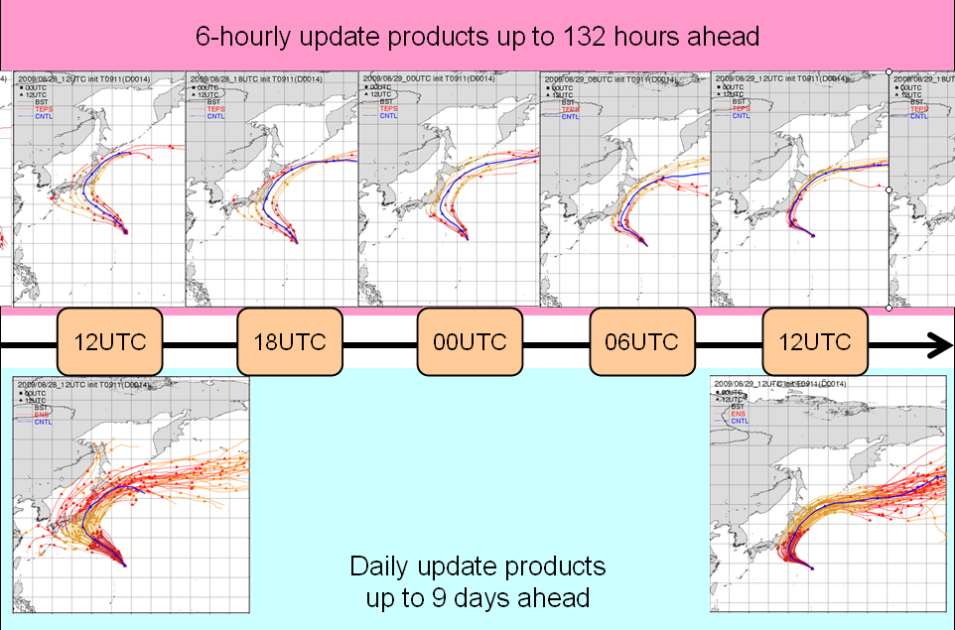
Figure 4: Update cycle of ensemble TC track products derived from two JMA EPSs. The 6-hourly update products derived from JMA Typhoon EPS fully supports Typhoon Bulletins issued by RSMC Tokyo – Typhoon Center.
Typhoon Center started to add 5-day track forecast to the Bulletins initiated at 00, 06, 12 and 18 UTC on 22nd April 2009. The visualized information is available at the JMA Web site: http://www.jma.go.jp/en/typh/. Figure 5 shows an example of 5-day track forecast.
Typhoon Center has maintained the Numerical Typhoon Prediction Web site since October 2004 to assist the NMHSs of the ESCAP/WMO Typhoon Committee Members in improving TC forecasting and warning services. The Web site not only displays TC activities and ensemble TC track forecasting in the western North Pacific but also provides the data (latitude, longitude) of the TC positions. The TC forecasting is derived from a global NWP output operated by each NWP centre and the position is identified by JMA TC position tracker. Currently, 10 global-NWP tracks and 11 Typhoon-EPS tracks are available. Users can obtain an ensemble mean from an arbitrary combination of NWP models with output in both digital and graphical forms.
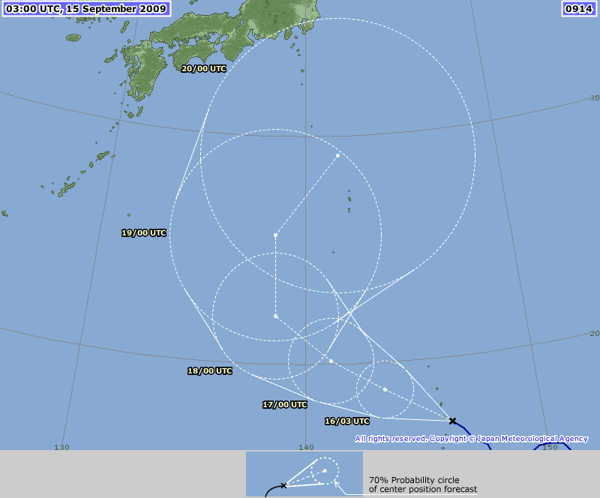

Figure 5: 5-day track forecast of Typhoon Choi-wan (T0914) in Typhoon Bulletins issued by RSMC Tokyo at 03UTC on 15th September 2009.

