WORLD METEOROLOGICAL ORGANIZATION  COMMISSION FOR BASIC SYSTEMS  OPAG on DPFS  Expert Team on Ensemble Prediction Systems (eT-EPS)  Exeter, UK, 5 – 9 October 2009 |  | CBS-DPFS/ET-EPS/Doc. 6.1(1)  (5.X.2009)  _______  Agenda item : 6  ENGLISH ONLY

REPORT OF RAPPORTEUR ON SEVERE WEATHER FORECASTING
_______

ON THE USE OF ENSEMBLE FORECASTING SYSTEMS TO SEVERE WEATHER FORECASTING

(Submitted by the Rapporteur of the OPAG on DPFS on the application of NWP to Severe Weather Forecasting)

Summary and purpose of document

This document presents an overview of the applications of ensemble forecasting systems to severe weather forecasting.

Action Proposed

The meeting is invited to consider the information in this document and provide comments as appropriate.
ON THE USE OF ENSEMBLE FORECASTING SYSTEMS TO SEVERE WEATHER FORECASTING

- INTRODUCTION

Ensemble forecasting systems have been developed in the recent years and are now in operational use in many different weather prediction centres among Members. Such systems are now used for short-range and medium-range forecasting, but research is on-going to extend ensemble forecasting methodologies to nowcasting. We will focus in this paper on the short-range and medium-range applications of ensemble forecasting systems.

In the context of ensemble forecasting, severe weather episodes can be considered as hig-impact events. In this regard, even if the probability of occurrence is low, particular attention must be paid to early detection and decision aids to decision-makers. Human expertise is particularly important in such conditions as the probability distribution function (PDF) of the forecast in the ensemble may be very different from the usual PDF in the case of rare and very rare events. Generally speaking, it is important to take into account as far as possible the cost model of the customer of ensemble forecasts to determine the decision process. In the case of severe weather, the cost of non-detection is most of the time much higher than the cost of false alarms.

We remind here the terminology recommended by WMO (WMO/TD N°1422, Guidelines on Communicating Forecast Uncertainty):

Terminology | Likelihood of the occurrence / outcome
Extremely likely | Greater than 99% probability
Very likely | 90% to 99% probability
Likely | 70% to 89% probability
Probable - More likely than not | 55% to 69% probability
Equally likely as not | 45% to 54% probability
Possible – Less likely than not | 30% to 44% probability
Unlikely | 10% to 29% probability
Very unlikely | 1% to 9% probability
Extremely unlikely | Less than 1% probability

Forecast likelihood scale

- EXISTING APPLICATIONS OF ENSEMBLE WEATHER PREDICTION SYSTEMS TO SEVERE WEATHER FORECASTING

2.1. Forecasters products

Model output statistics
Model output statistics can be used to improve raw model forecasts and applied to ensemble forecasts. The coefficients are usually computed using the unperturbed forecast, then applied to all members of the ensemble to improve over raw forecasts by taking into account local information.

Calibration
It is important that the variability of the forecast parameters (wind, temperature,…) in the ensemble be close to the real variability of the atmosphere. In this respect, ensemble calibration remains necessary.

Visualization of ensemble forecasts
Classical visualization of forecast meteorological fields can be used when the number of ensemble members is not too high.

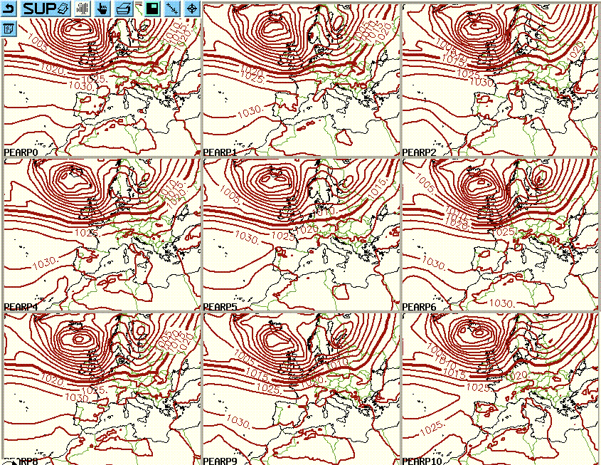

Operational Ensemble short-range numerical prediction of sea-level pressure (11 members)

Météo-France, January 2007
Other kind of forecasters visualization include:
- Probability of reaching or exceeding a given threshold, e.g. on cumulated rain or snow amounts, wind speed, wind direction, wind gusts, CAPE,…
- Mapping of the ensemble dispersion.
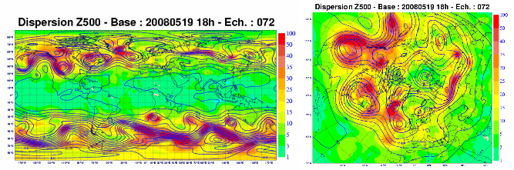

Ensemble dispersion for the geopotential height at 500 hPa. Left : globe. Right : northern hemisphere.

Météo-France, May 2008

- Dispersion evolution over the time, e.g. over the last 30 days.
- Map tracking of depressions : probability that a depression comes at less than e.g. 100 km of given points,...
- Etc

In order to synthesize informations from the distributions, quantiles con be provided and help forecasters in evaluating risks :
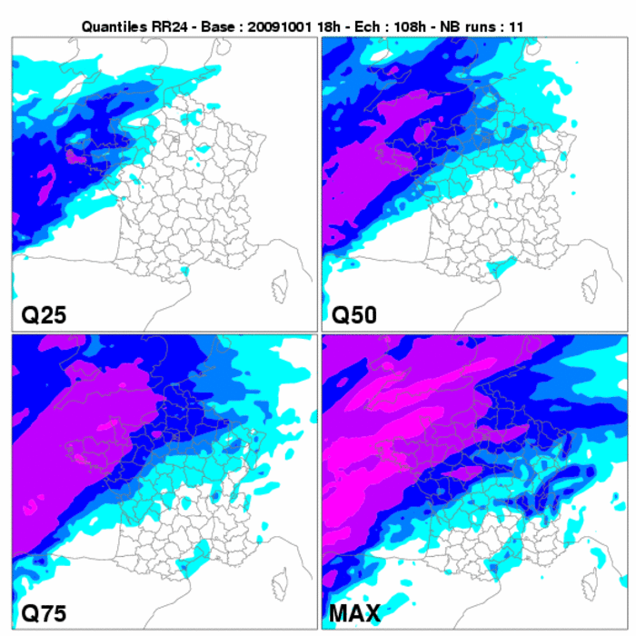
As far as early detection of dangerous phenomena are concerned, the following is an example of a product used for the cyclon tracking : charts of strike-probabilities for the Katrina case :

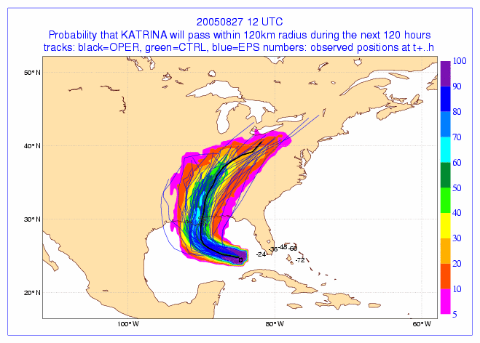

The Extreme Forecast Index (EFI) developed by ECMWF, for instance, provides an assessment of the departure of the current ensemble PDF from the model climatological PDF and is being experimented by forecasters as an indication of how “unusual” the forecast is.

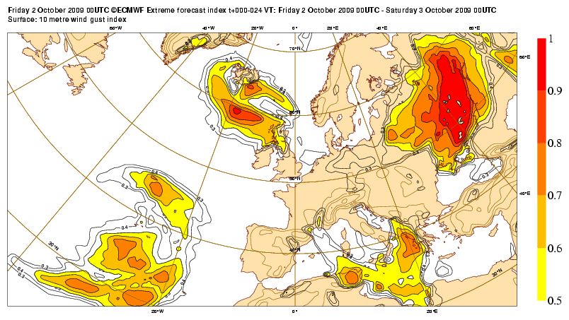
ECMWF Extreme Forecast Index ; 10m wind gusts

and 2.2. End-user products

The main interest of ensemble prediction is for end-users to be informed about the uncertainty of the forecast. Some end-users may be able to take into account the PDF of the forecast parameters or the probability of reaching given thresholds. However, the information must be presented in a way that is understandable and usable. To be usable from an end-user point of view, it may be very useful to study the cost-benefit ratio of the actions the end-user has to conduct depending on the probability of realization of the forecast and adapt the products accordingly.

Following is an example an example of an end-user oriented mixed EPS (ECMWF) / short-range Arpège ensemble forecast (Météo-France) showing confidence intervals for different parameters and probabilities of reaching thresholds. This product is intended for professionals rather than the general public.
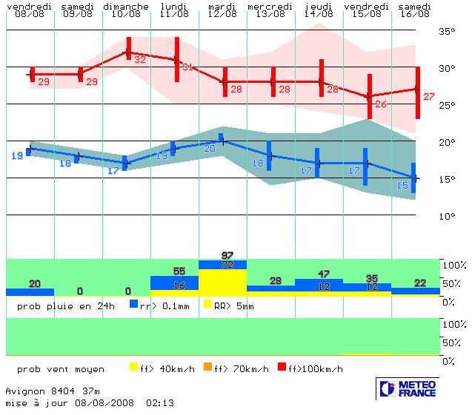

EPSgrams for T_{min} and T_{max} and thresholds probabilities for RR24 and FF (Météo-France)

Another example is given by probabilistic forecasts of reaching heat wave thresholds. The “heat wave” algorithm is based on the persistence of high temperatures (both for minimal and maximal temperatures) over several days and may include supplementary information such as humidity forecasts.

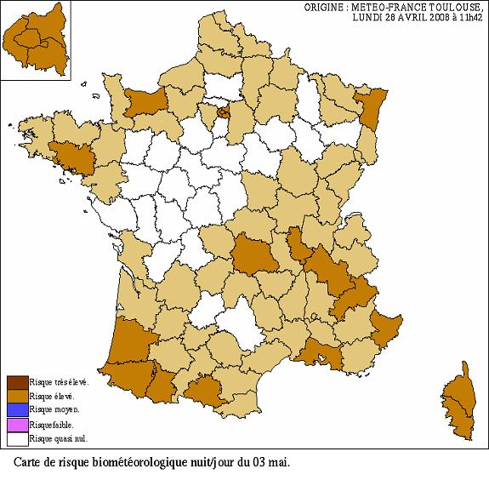
Probabilistic forecast of “bio-meteorological risk” used as a decision aid in France by the National Health Institute for the management of heat-wave situations

- IDEAS FOR NEW APPLICATIONS

3.1. Forecasting methods

3.1.1. Early detection of severe weather

Early detection of severe weather events will certainly remain one of the major objectives of ensemble prediction systems and new algorithms will be developed to better highlight the risk of severe weather in the growing number of data forecasters have to handle.
The following product is an example developed by Météo-France’s forecasters, mixing different forecasts (NCEP, ECMWF,…) to illustrate the evolution of the probability of 12h precipitation over France (4 areas) for different forecast bases. In the case shown here, the probability tends to decrease as the forecast is more recent (from green to blue), which means that the danger is decreasing.

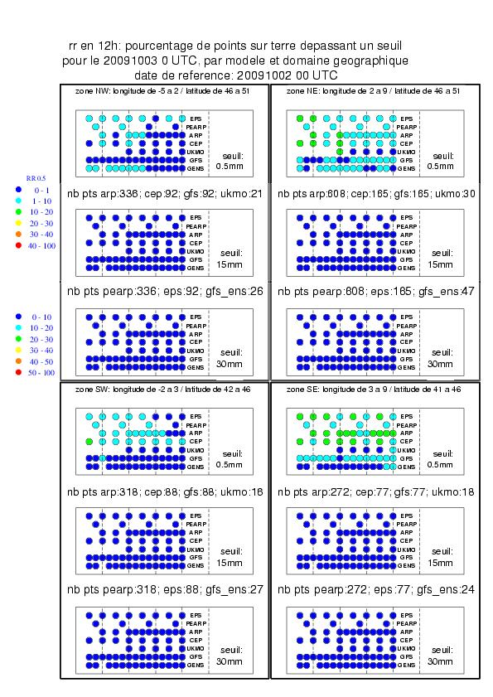

Evolution of the likelihood of 12h precipitation for different thresholds over France (4 areas) for different models and different forecast bases (Météo-France)

3.1.2. Depression tracking

Methods of tracking of depression systems have been developed in meteorological centers. The following is an example of a product developed by the United Kingdom Met Office.

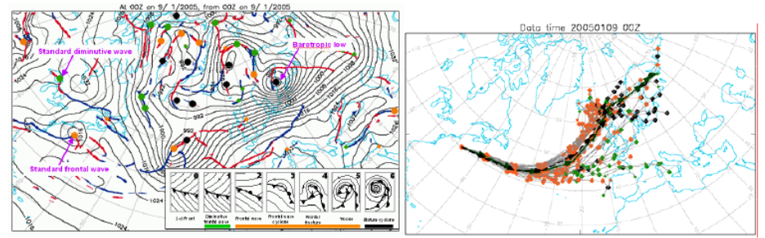
Depression trajectory tracking at the Met Office

3.1.3. Dynamic forcings and weather regimes

Work is on-going to define methodologies to adapt experimental automatic analysis algorithms of dynamic forcings to ensemble prediction systems.

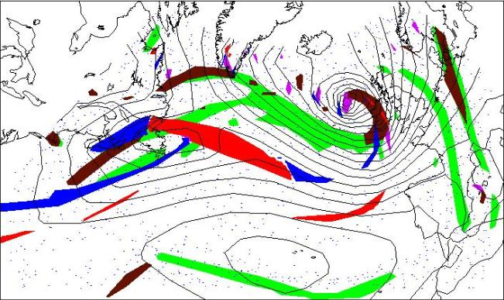
Automatic analysis of dynamic forcings (fronts in red and blue, jet-streams in green and altitude precursors in black) (Météo-France, experimental product)

The forecast of weather regimes is another interesting application of ensemble forecasting. Following is an example of experimental weather regime forecast derived from Météo-France’s short-range ensemble prediction system.
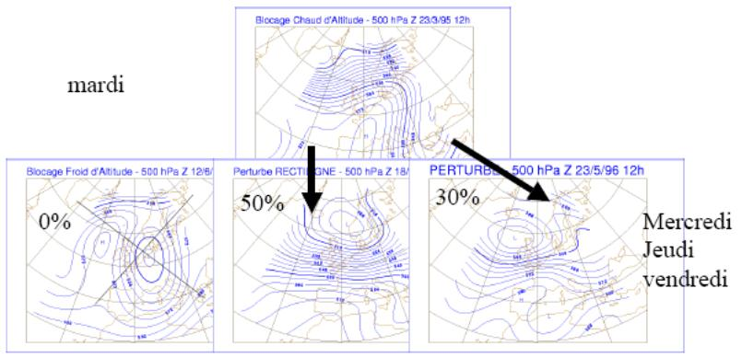
Experimental weather regime forecast (Météo-France)

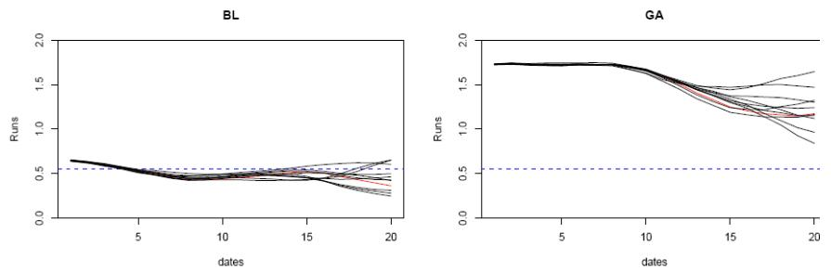
Evolution over forecast time range of the distance from two distinct weather regimes (Météo-France, experimental product)

    - Weather regime and extreme events

Some extreme events (eg “cévenol” types of extreme precipitations and floods in south-eastern France) are associated with certain weather regimes. Therefore, probabilistic forecasting of weather regimes can also give indications on the potential for extreme events.

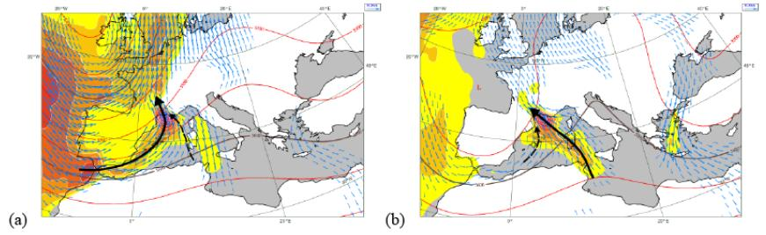
Different types of weather regimes (500 hPa geopotential height, 925 hPa humidity flux and 925 hPa winds) associated with extreme “cévenol” precipitations and flood events (Météo-France)
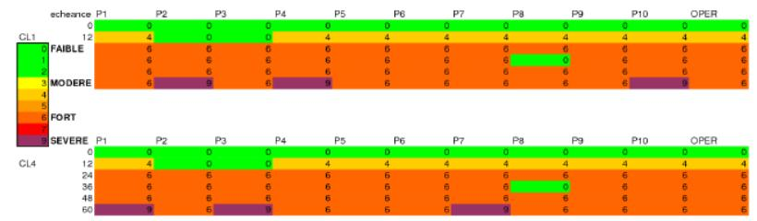
Occurrence risk of a “cévenol” event in the Mediterranean computed from the distance of individual short-range ensemble members to the weather regimes shown above, as a function of forecast range (Météo-France, experimental product)

    - Three-dimensional approaches

The ever growing number of numerical weather predictions available to forecasters brings a change in the analysis methods. Two-dimensional traditional approaches are useful for the analysis of the dynamics of one single numerical forecast. But when it comes to the analysis of a large number of forecasts, three-dimensional exploration of model outputs may be of interest.

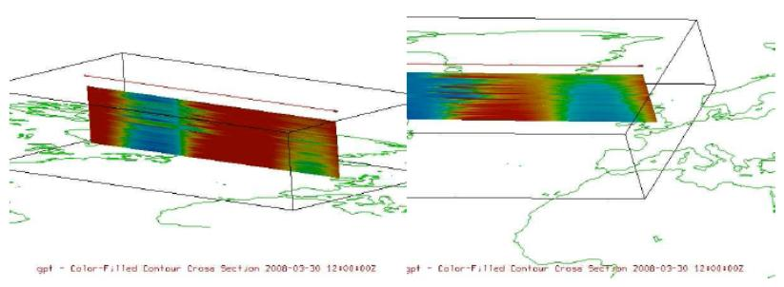
Three-dimensional exploration of the 500 hPa geopotential height among the 51 members of EPS (Météo-France)

  - End-user final products

Work is on-going to extend ensemble prediction to applied weather forecast and coupled systems, eg :
- Marine : probabilistic forecasting of waves, storm surges, pollution transport,…
- Aviation: probabilistic forecasts for airports, aircraft trajectories,…
- Hydrology: probabilistic forecasting of river flows and water levels.

Following is an example of ensemble prediction of river flows for all French main rivers developed by Météo-France and experimented with the French National Flood Prediction Centre.
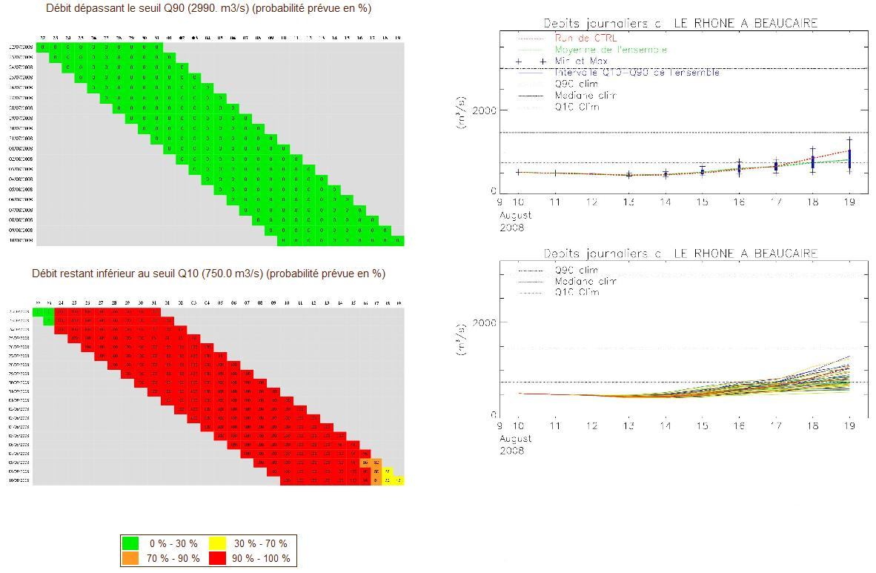

Ensemble prediction of the Rhône river flow at Beaucaire (Météo-France)

- CONCLUSIONS

Ensemble prediction systems are very useful to anticipate severe weather events. Their extension to coupled phenomena allows for probabilistic forecasting of e.g. sea waves, pollution transport, river flows,…
Work is on-going among Members to explore new methodologies to make an optimized use of ensemble prediction systems, both by forecasters or for end-user products.
Some of the most recent ensemble prediction systems (Australia, Canada, France, USA, Japan,…) have been tested in real-time during the 2008 Beijing Olympic Games. The results of these experiments will be analyzed by forecasters after the Games and will be the object of a technical note of the World Weather Research Program.

See for instance www.wmo.ch/pages/prog/www/DPFS/Meetings/EM-VSRF_Toulouse2007/Doc5-2.doc
http://www.wmo.int/pages/prog/amp/pwsp/publicationsguidelines_en.htm, page 10

