WORLD METEOROLOGICAL ORGANIZATION  COMMISSION FOR BASIC SYSTEMS  OPAG on DPFS  Expert Team on Ensemble Prediction Systems (eT-EPS)  Exeter, UK, 5 – 9 October 2009 |  | CBS-DPFS/ET-EPS/Doc. 4.1(8)  (xx.VIII.2009)  _______  Agenda item : 4  ENGLISH ONLY

Report on progress of Operational EPS

(Submitted by André Méthot)

Summary and purpose of document

This document gives an overview of Canadian EPS Operational system as well as some experimental systems, with a brief touch on North American Ensemble Forecast System

Action Proposed

The meeting is invited to read and comment the document.

- Overview of Operational Global Ensemble Prediction System (GEPS)

1.1 Data assimilation
The data assimilation consist of a 6-hour cycle using 4 times 24 configurations of the GEM model providing (96) trial fields over 6-hour time windows. Trial fields at 3, 4.5, 6, 7.5 and 9-h allow interpolation toward time of observations. It is a 4-D data assimilation cycle using Kalman filter (so-called Ensemble Kalman Filter).

The latest update to this assimilation system was the addition of GPS-Radio Occultation observations, and the increase in the number of vertical levels from 28 to 58 in the model configuration.

The table1.1 provides a description of the 24 configurations of GEM model in the assimilation cycle.
# | Deep convection | Surface scheme | Mixing length | Bowen ratio
1  2  3  4  5 | Kain & Fritsch  Oldkuo  Arakawa Schubert  Kuo Symétrique  Oldkuo | ISBA  ISBA  force-restore  force-restore  force-restore | Bougeault  Blackadar  Bougeault  Blackadar  Bougeault | 1.0  0.85  0.85  1.0  1.0
6  7  8  9  10 | Kain & Fritsch  Kuo Symétrique  Arakawa Schubert  Kain & Fritsch  Oldkuo | force-restore  ISBA  ISBA  ISBA  ISBA | Blackadar  Bougeault  Blackadar  Blackadar  Bougeault | 0.85  0.85  1.0  0.85  1.0
11  12  13  14  15 | Arakawa Schubert  Kuo Symétrique  Oldkuo  Kain & Fritsch  Kuo Symétrique | force-restore  force-restore  force-restore  force-restore  ISBA | Blackadar  Bougeault  Blackadar  Bougeault  Blackadar | 1.0  0.85  0.85  1.0  1.0
16  17  18  19  20 | Arakawa Schubert  Kuo Symmetric  Kain & Fritsch  Oldkuo  Arakawa Schubert | ISBA  force-restore  ISBA  ISBA  force-restore | Bougeault  Bougeault  Blackadar  Bougeault  Blackadar | 0.85  1.0  0.85  0.85  1.0
21  22  23  24 | Arakawa Schubert  Oldkuo  Kain & Fritsch  Kuo Symétrique | ISBA  force-restore  force-restore  ISBA | Blackadar  Bougeault  Blackadar  Bougeault | 0.85  1.0  1.0  0.85

Table 1.1 List of distinctive components of the 24 forecast model configurations.

1.2 Forecast model members

From the 96 Ensemble Kalman filter analysis, 20 are randomly selected to provide initial conditions for 20 members (forecast model). The models are integrated out to 16 days, twice a day (00z and 12z), at 0.9 degrees horizontal resolution and the number of levels remains at 28 levels. Recent tests at 58 model levels did not show significant improvement with the 16 day forecast while improvements were found when using 58 model levels in the data assimilation.

The initial condition uncertainties are represented by the perturbed ensemble Kalman Filter data assimilation, while forecast model uncertainties are reproduced by various model physic’s configuration as in table 1.1, with a single dynamic core (GEM model). Also stochastic perturbations are added to tendencies (“à la ECMWF”) in the parameterized physical processes and back-scattering energy (after Shutts, 2005) parameterisation is used in order to augment the spread of the ensemble.

1.3 Operational products:

The Meteorological Service of Canada made an extension to the public forecast service with the addition of day 6 and day 7 forecasts. While day 1 to 5 are based on the deterministic systems (regional for day 1-2, and global for days 3-5) the day 6 and 7 public forecast have been added , thanks to the Ensemble Prediction system. This system is fully automated. This forecast is delivered to the public on the Web weather portal, using weather icons, and text. An attempt was made to use a clustering method (wet versus dry scenarios) in the making of the product but, at the end, the more simplistic reliable Ensemble mean was implemented in this initial implementation.

Otherwise, a series of typical EPS based Operational products are available for internal use as well on the Official external Web site.
(Link to public site: http://www.weatheroffice.gc.ca/ensemble/index_e.html)

Typical products include the so-called Spaghetti plots, maps with probability of exceeding precipitation thresholds, meteograms, etc.

The figure 1.3a depicts, for instance, the mean and the standard deviation of 24-hour precipitation accumulation ending at 96-hour lead time.
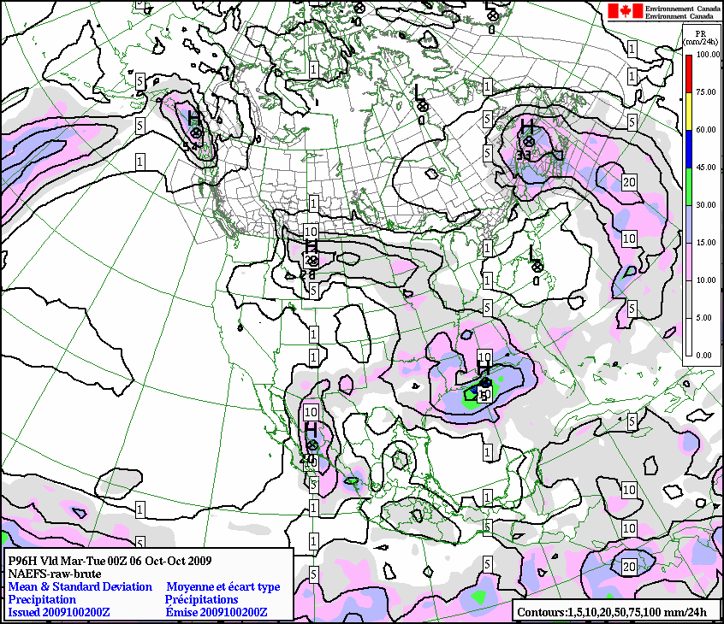

Figure 1.3a: Mean (black contours) and standard deviation (colors) of the 24-hour accumulated precipitation from 72 to 96-hour lead-time.

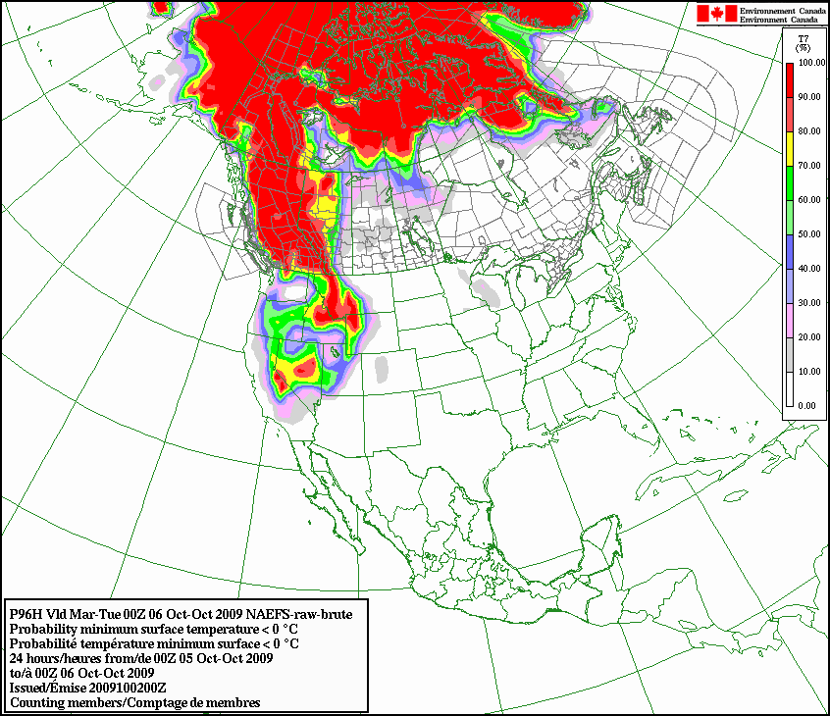

Figure 1.3b : Probability of frost on the ground for a 24-hour period

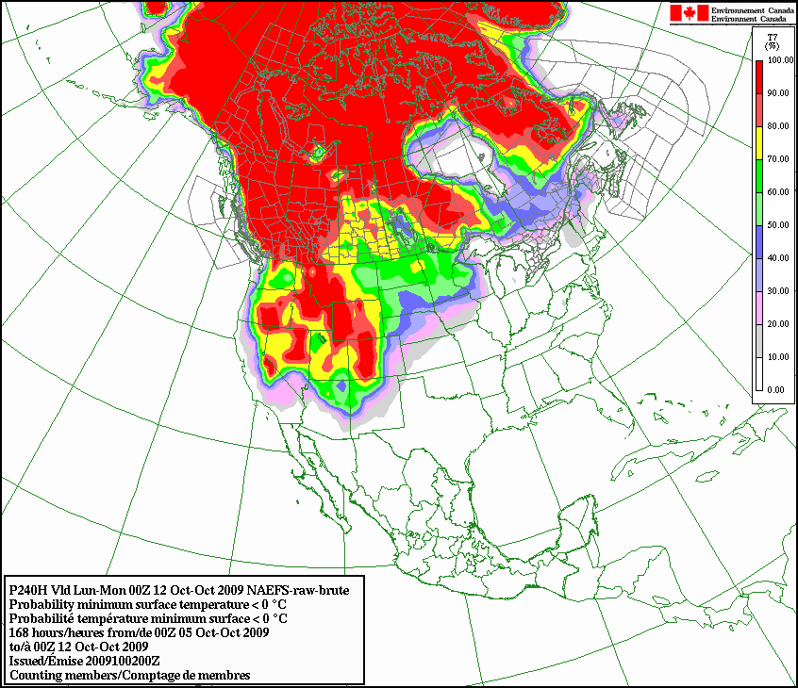

Figure 1.3c: Probability of below zero celcius screen level temperature for a 168-hour period. Similar to figure 1.3b but for a longer period.

Another example of products is the classical map depicting the likelihood of having a parameter exceeding a predetermined threshold. For instance, figures 1.3b and 1.3c show the likelihood of having screen level air temperature below the freezing mark, which could mean frost on the ground.

1.4 Experimental products

Experimental and proof of concept testing activities are ongoing with an interactive user generated meteograms system for preselected sites. Other products will be developed focusing on high impact weather, aiming at offering guidance to operational meteorologists.

- Overview of Experimental Regional Ensemble Prediction System (REPS)

The REPS is a downscaling of the Global EPS, which should provide more sharpness and skill which could be suitable to address severe weather forecast challenges in the short range.

2.1 Data assimilation:

Research plans include the development of an Ensemble Kalman filter for the REPS, but the initial version makes use of the Global Ensemble System analysis.

2.2 Forecast model members

The REPS consists of twenty (20) GEM-LAM members at 33km horizontal resolution and 28 levels. The boundary conditions are provided by the Global EPS 20 members, with a pilot frequency (lateral boundary conditions) of 3 hours. On the contrary to the Global EPS, the REPS uses a single GEM-LAM model configuration, which is equivalent to the 33km Global deterministic forecast model. However, it uses stochastic perturbations of physical tendencies and surface parameters in order to augment the spread of the ensemble. The REPS is now running in experimental mode at 00z and 12z, and will most likely become operational by 2011.

The REPS domain is depicted in figure 2.2.

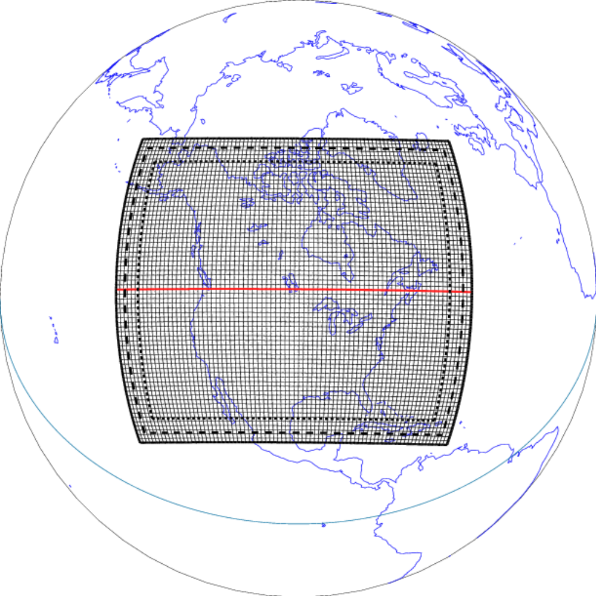

Figure 2.2: domain of the Regional Ensemble Prediction System prototype.

2.3 REPS Experimental Products

Many experimental products are under development while the REPS gradually make its way into Operations. As an example, the following map in Figure 2.3a shows the likelihood of exceeding 5mm of precipitation over a 6-hour period (based on simple counting members’ method).

Many similar products for wind, temperature and other parameters could be developed with user driven thresholds. One could develop an interface allowing users to generate products in a interactive way that would have specific thresholds for given set of parameters and according to specific needs and circumstances.

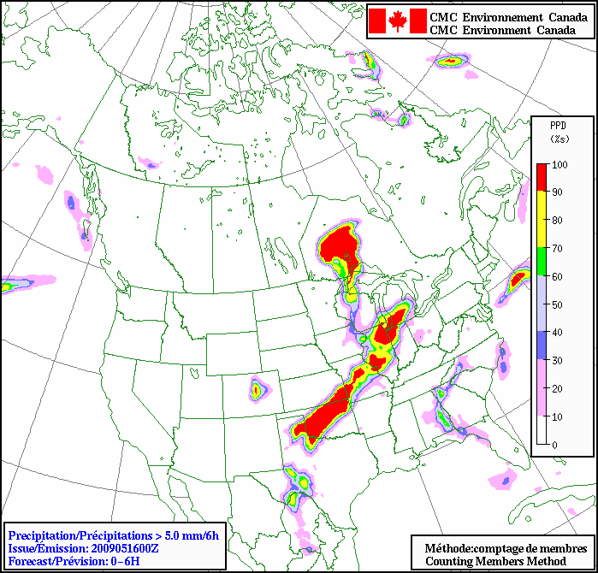

Figure 2.3a Likelihood of more than 5 mm precipitation occurring over a given 6-hour period.

A series of products in support to the warning program could be developed based on REPS.

For instance, the figure 2.3b shows an example of severe weather guidance on the likelihood of moderate thunderstorms over North-America for a 24 to 36 hour forecast period.

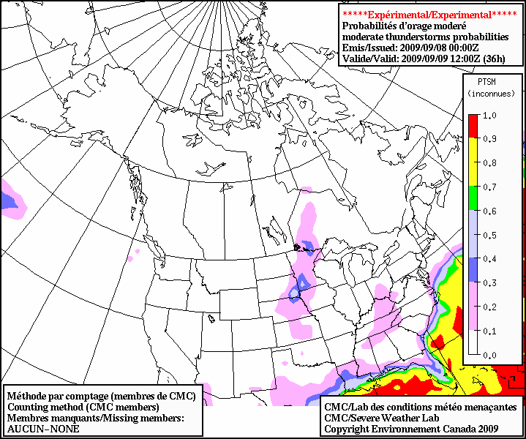

Figure 2.3b: Likelihood of moderate thunderstorms over North-America for 24 to 36 hour forecast period.

A set of similar guidance products for winter severe weather events, such as freezing rain, blizzards, snowstorms, etc., is also available in experimental mode.

- North American Ensemble Forecast System (NAEFS)

NOAA, MSC, NMS of Mexico signed an official agreement on NAEFS in November 2004. Other partners (FNMOC, AFWA, JMA) may join NAEFS at a later time. The advantages of such partnership are numerous: larger ensemble allowing better PDF definitions (super-ensemble), improved probabilistic forecast performance, seamless suite of forecast products across international boundaries and across different time ranges (1-15 days). Also, this partnership leverages computational resources among parties and minimizes investment and operations costs. Furthermore, it encourages synergies between MSC and NCEP on R&D work, collaborative product development and ensures added operational contingencies with another national NWP Centre.

On the other hand, there are technical issues and challenges that need to be managed in this type of partnership such as the difficulties of combining a multi-model ensemble into a super ensemble, and, most importantly, the operational considerations (real time exchanges robustness, timeliness, reliability, etc).

3.1 Current Operational system

The current NAEFS system consists of the exchange in real time of raw model data outputs for 00Z and 12Z, runs. Twenty members of 16 day forecasts are exchanged for about 50 model variables, at 6-hourly output frequency. Data are exchanged in GRIB format.

Both Centers use the same algorithm and code for the bias correction.

3.2 Current activities

Current main challenges relate to the addition of variables to the exchange dataset and to the migration from GRIB I to GRIB II WMO format. Both centers also agreed on the exchange of bias corrected forecasts (rather than raw forecast) in the near future. Some work is ongoing about the bias correction of precipitation. At this point, only the variables associated to classical NWP analysis are available in bias corrected mod (such as temperature, winds, etc.).

The team is also working towards the inclusion of FNMOC (US Navy) Ensemble forecast System into NAEFS. Standards for the assessment of the added value brought by the addition of another set of model outputs into the current NAEFS ensemble have been established. Other operational requirements are also in consideration for the approval of this inclusion (such as timeliness of availability, format of exchange, robustness, etc).

3.3 Operational products

The first combined NAEFS product is the week-2 temperature anomaly forecast. It is produced at both centers, using the shared data, and leads to a coherent North-American product.

Both products are shown in figures 3.3a and 3.3b.

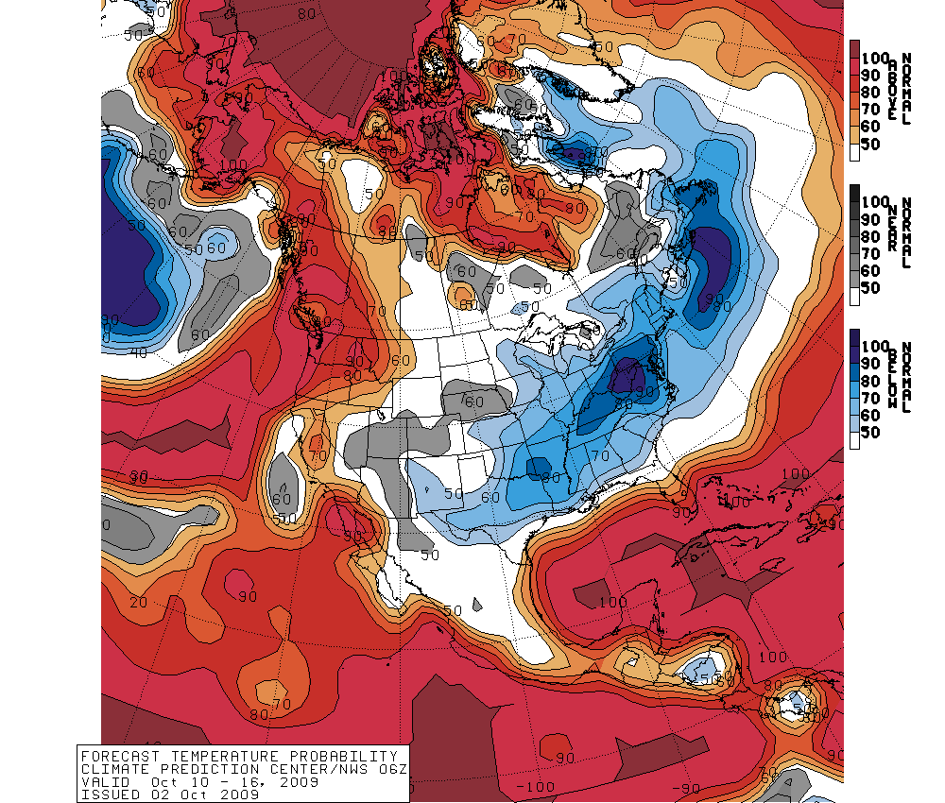

Figure 3.3 a Example of USA NAEFS week-2 forecast temperature anomalies issued on October 2nd, 2009
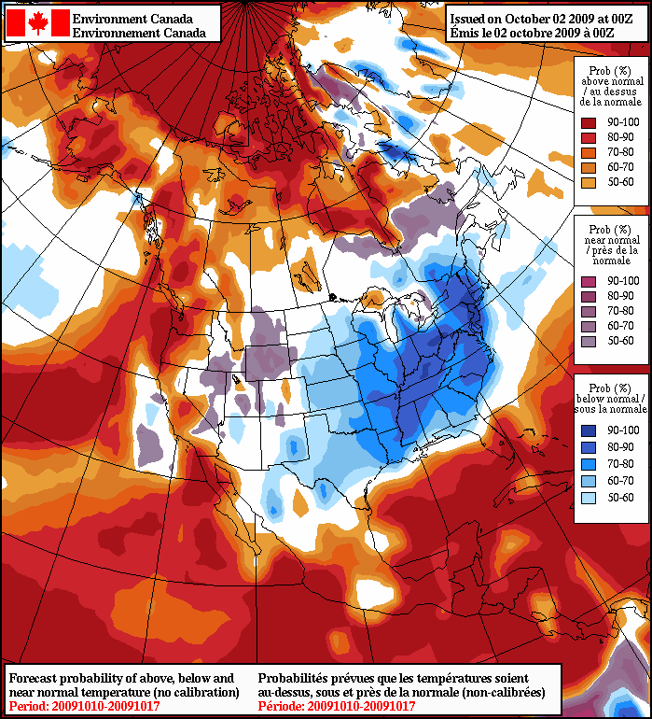

Figure 3.3 b Example of Canadian NAEFS week-2 forecast temperature anomalies issued on October 2nd, 2009

3.4 Plans

We are planning to upgrade the telecommunication link between NOAA’s NWS USA network and the Environment Canada, Canadian Meteorological Centre site located in Dorval. This will allow increases in data volumes of the data exchange under a robust and reliable telecommunication channel.

We expect to add variables to the data exchange, as well as additional members from US Navy Operational EPS.

The day-6 and 7 extended public forecast, now based on Canadian EPS, will be using the NAEFS dataset in the near future (2010-11).

The NAEFS data exchange will eventually include Regional (North American) Ensemble Prediction systems based on LAM models. This is planed for 2013, when the Canadian REPS would be implemented operationally (see section 2 above). This will allow the combination of both regional ensembles as the USA already has a Short Range Ensemble Prediction System in place. The domain of the short range EPS system would have to be revised and enlarged in order to offer a North-America wide coverage, including Alaska, Canadian Arctic and Mexico. A wide variety of products would then be available, focusing on high impact weather.

In parallel, both centers will continue to develop their own Ensemble systems as the science and technology brings innovations to the field of NWP.

Cooperation will also continue with the downscaling of the ensemble output using high resolution surface analysis at resolutions of 1 to 5 km. This type of post-processing shows good added value over mountainous areas and will lead to better products.

Also good synergies could be further developed on the application of the ensemble system to a wide range of areas such as hydrological forecasts, oceanic wave forecast, and eventually, toward the development of a seamless prediction system beyond 15 days which would include oceanic coupling.

