WORLD METEOROLOGICAL ORGANIZATION  COMMISSION FOR BASIC SYSTEMS  OPAG on DPFS  Expert Team on Ensemble Prediction Systems (eT-EPS)  Exeter, UK, 5 – 9 October 2009 |  | CBS-DPFS/ET-EPS/Doc. 4.1(4)  (30.IX.2009)  _______  Agenda item : 4  ENGLISH ONLY

Operational Ensemble Prediction Systems at CMA

(Submitted by Dr Jing Chen, Hua Tian, Guo Deng, Xiaoli Li,Suhong Ma,Yan Tan , China)

Summary and purpose of document

The paper gives an overview of operational EPSs in Chinese Meteorological Administration.

1. Progress of EPS of CMA
The operational ensemble prediction systems at CMA include global medium-range ensemble prediction system (GEPS), regional ensemble prediction system(REPS), tropical cyclone (TC) track ensemble prediction system (TC track EPS and Monthly Extended Range EPS.
  - The current status of the global medium-range EPS (GEPS)
The GEPS is based on T213 spectral model, and the breeding growth mode (BGM) method is used for its initial perturbations. In 2008 the data assimilation system of control run of GEPS was upgraded from OI into 3DVAR system that has ability to assimilate the satellite data. Therefore, the flow chat of GEPS also changed according to this upgrade, and Fig. 1 gives the flowchart of GMEPS with 3D-VAR system. The operational running of upgraded GMEPS began on June 1st 2008. This system has 15 members including control run. This system runs four times daily, in which the 10 days forecasts are performed at 00 and 12 UTC, and assimilation and perturbation cycle are performed at 06 and 18 UTC. The product of global EPS at 12 UTC are provided in terms of ensemble mean, ensemble spread and probabilistic products to the end users.

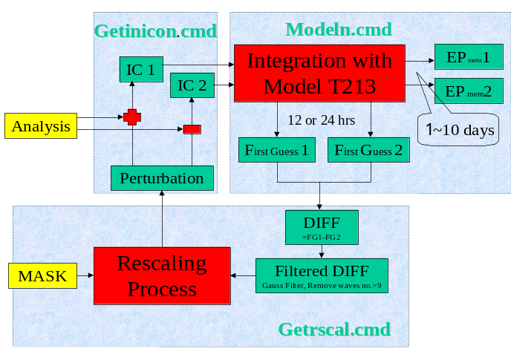
Fig.1 Flowchart of current GEPS at NMC/CMA

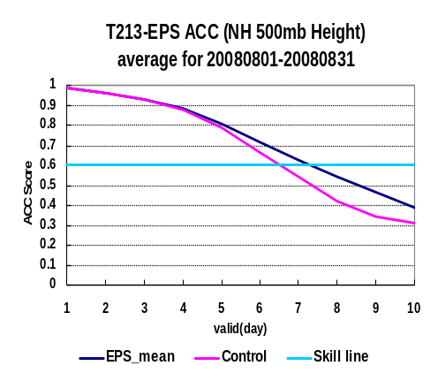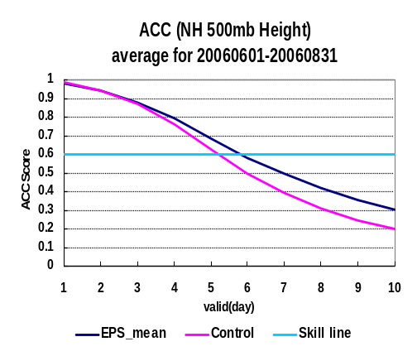
Fig.2 ACC of ensemble mean and control run of T213-EPS for 500-hPa geopotential height for August 2008 (left panel ), and summer 2006 (right panel)

Fig. 2 gives the anomaly correlation coefficient (ACC) of ensemble mean and control run for 500-hPa geopotential height for summer season of 2006 and 2008. It is known that ACC value greater than 0.6 represents the skillful forecast. It can be found that the forecast skill of control run and ensemble mean have been improved in upgraded GEPS compared to old GEPS in 2006, showing that the gain of predictability from control run in 2008 has been improved one day ahead than in 2006, and the same gain also has been found for ensemble mean ( 7 days in 2008 vs 6 days in 2006).

1.2 Regional Ensemble Prediction System(REPS) at CMA
The development of REPS at CMA was collaborative project between NMC and regional meteorological centers (RMCs) of CMA. In order to provide the mesoscale ensemble prediction products to the Beijing 2008 Olympic Games, also contribute to the B08RDP sponsored by WWRP, a REPS based on WRF and GRAPES model with domain covering northern part of China was developed. Besides, REPSs aimed for heavy rainfall forecast and typhoon track forecast were developed at Chengdu RMC and Shanghai RMC, respectively.

1.2.1 WRF-based REPS for North China
The REPS for Northern China developed at NMC was based on WRF model with BGM as initial perturbations. This system has 15 members with horizontal domain covering Northern China, and runs twice a day with 3-h of model output frequency. The lateral boundary conditions of REPS are provided by T213 model-based GEPS. The REPS also includes every 6-h 3D-VAR data assimilation and rescaling cycle for BGM. The illustration of operational running of REPS is given in Figure3.

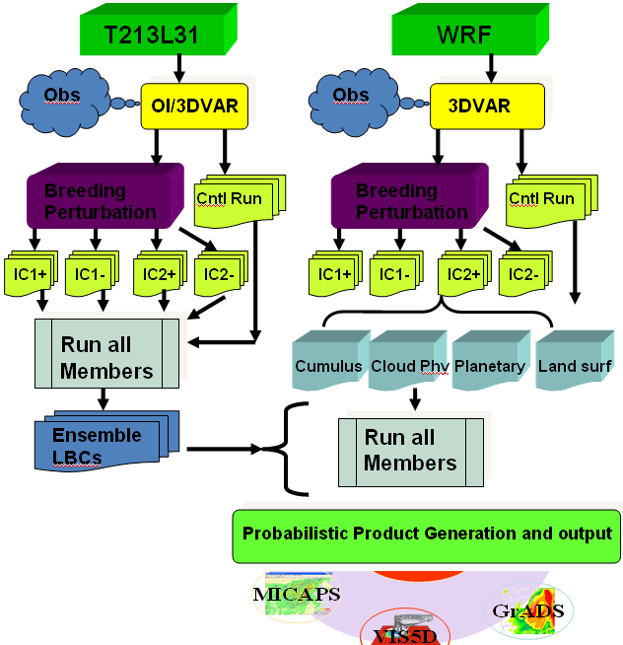
Fig.3 The illustration WRF-based REPS running at NMC

Table 1 The multi-parameterization perturbations used in WRF-based REPS
Ens. mem | Microphysics  scheme | Convective scheme | PBL scheme
Ctrl. | Lin scheme | Betts | MYJ
Pair 1 | Lin scheme | KF | YSU
Pair 2 | Lin scheme | Betts-Miller | YSU
Pair 3 | Lin scheme | Betts-Miller-Janjic | YSU
Pair 4 | Lin scheme | KF | MJY
Pair 5 | WSM6 | Betts-Miller | MJY
Pair 6 | WSM3 | Betts | MJY
Pair 7 | WSM3 | Betts | YSU

1.2.2 GRAPES-based REPS for North China
GRAPES-based REPS has 9 members and uses lateral boundary conditions from GEPS as WRF-based REPS. The control run of this system runs four times a day ( at 00, 06, 12 and 18Z), wherein 36-h forecasts are performed at 00 and 12 Z, and 6-h forecasts are performed at 06 and 18Z. The 6-h forecasts at every running time of system are used as background for next data assimilation cycle. Other 8 members of GRAPES-based REPS can be classified into four pairs because the four different model physics settings are used to represent the model perturbations, and the member in each pair utilizes same model physics. The BGM method also used in GRAPES-based REPS for initial perturbations, in which the breeding perturbations at 00 and 12 UTC are produced by use of assimilated results of control run at corresponding times.

1.2.3 REPS for Southwest China
The REPS for Southwest China (SW-REPS) was developed in 2005 in Chengdu RMC. SW-REPS has 8 members that are produced by mult-physics and mult-initial condition perturbations, and forecast length of SW-REPS is 48-h. The SW-REPS is based on MM5 model with horizontal resolution of 20 km. Four cumulus convective parameterization schemes (Grell, Anthes-Kuo, betts-miller and Kain-Fritsch schemes) and two boundary layer schemes (MRF and HRIR ) were used randomly to construct 8 perturbated models.The initial condition perturbation technique was based on Different Physical Mode Method(DPMM), which was developed by local researchers. The approach of DPMM is attempt to generate initial perturbation structure and amplitude and reflect the uncertainty of convection instability by the prediction difference of the different cumulus convective parameterization schemes. Two cumulus convective parameterization schemes can generate one normalized perturbation mode, therefore 6 normalized initial perturbation would be produced by four schemes. By choosing four optimal perturbation modes and producing eight initial condition perturbations for SW-REPS.

1.3. TC track ensemble prediction

1.3.1 TC track ensemble forecast at NMC
The TC track ensemble prediction system was developed in 2006 based on the perturbed background and BOGUS vortex initialization scheme and was put into real time running in 2007. The perturbed backgrounds were taken from the global medium ranger ensemble prediction system in order to save the computation resource. The same BOGUS vortexes are added in the perturbed backgrounds after the shallow vortexes are removed. The TC track ensemble prediction system has 14 perturbed members and one control run just as the medium range ensemble prediction system does. The TC track ensemble prediction system runs twice a day (00UTC and 12UTC) and provides TC ensemble tracks and strike probability. The flow chart for TC ensemble system is shown as Fig. 4
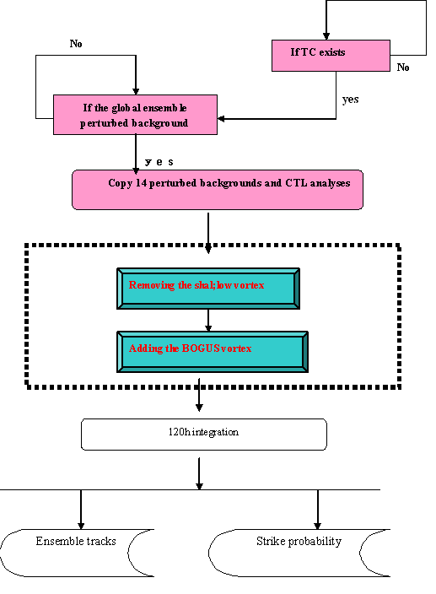
Fig.4 Flow chart for TC EPS

The mean track for all the ensemble members has no obviously difference compared with the track of CTL and a little bit better fir the longer time forecast after 72h. The track errors for the ensemble mean and CTL are shown in Fig.5.
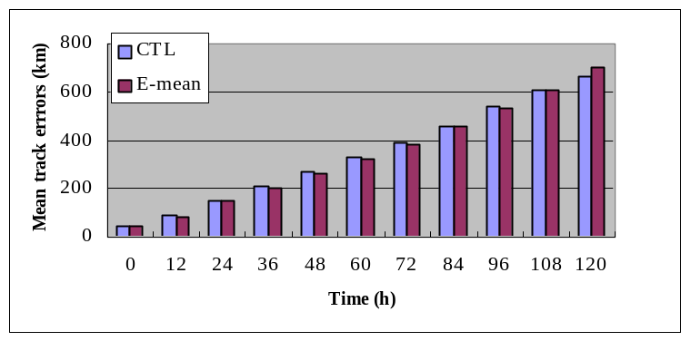
Fig.5 Errors for mean tracks of TC EPS and CTL

The vortex perturbation was developed in 2007 and 2008 and will be put into the TC ensemble prediction system later this year.
1.3.2 Regional Typhoon Track Ensemble Prediction System in Shanghai RMC.
The regional typhoon EPS is based on GRAPES_TCM model, which consists of three parts: the initialization of typhoon vortex, the initial ensemble perturbation and the post-process. This ensemble prediction system has been implemented operationally since 2006 to provide the ensemble products for 72 hours. The products are ensemble tracks, strike probability and the distribution of typhoon positions, as well as the probability distribution of some synoptic fields. Schematic diagram of perturbation using BGM method in Fig.6. With one assumption that the small initial perturbation is come to saturation for 36 hours. The scaling factor is defined by each variable which is used to control the perturbation magnitude to be reasonable for each 12 hour breeding cycle.
12-h forecasts from AVN model are adopted as the initial data(A), After the vortex relocation, reference to the errors of observation, random errors with the normal distribution are added to ensemble members(R). For each scaling process(f), the output of the model should be filtered into two parts-the environment field and vortex itself. Different scaling factors are applied to different parts. The pairs of new perturbations, including the environment and vortex itself(P/N）could be added to the initial data for the next breeding cycle till the whole process of breeding.
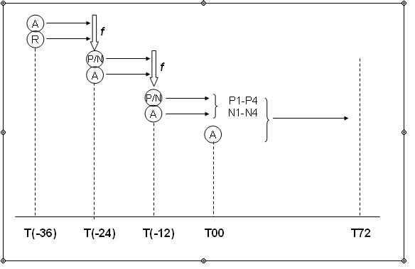
Fig. 6 Schematic diagram of perturbation using BGM method.

1.4 Monthly Extended Range Ensemble Forecast
Monthly dynamic extended range ensemble prediction system (MDEREPS) developed at NCC/CMA includes 8 members which are produced by two initial perturbation method. One is lagged-average-forecast (LAF) method and another is singular-vector-decomposition (SVD) method. For the LAF method, the assimilated data or the reanalysis data at four times daily-00, 06, 12 and 18UTC- are used as four initial conditions of ensemble forecast. For SVD method, its linear model and adjoint model of T42 spectral model are simplified by by decreasing order. For practical operational running, SVD is performed on the assimilated data or the reanalysis data at 12UTC daily, and the first four singular vector perturbations were calculated to generate other four SV perturbed initial condiditions for ensemble forecast. Based on the above initial conditions, the MDEREPS is constructed by running model with different initial conditions with parallel computating techniques. For the operational monthly extended range ensemble forecast, ensemble forecasts are conducted in the first day of each pentad of each month (1st,6th,11th,16th,21th,and 26th day). The ensemble forecasts of each pentad include previous 5 day forecasts which are initialized by both LAF and SVD method. Therefore, the MDEREPS includes 40 members in total. The forecast informations from MDEREPS is processed into operational products by different methods, and sent to different level users.
2 Future plan
2.1 The 15-day extended GEPS based on Ensemble Transfrom (ET) method
The ET method has been used at NMC to produce the initial perturbations for GEPS. The motivation of testing this method is that the perturbations from this method has advantages of orthogonality, which allows to initial perturbations to have maximum number of effective degrees of freedom. Currently ET-based GEPS with 16 members has been initially successfully tested. The preliminary verification results have been done to evaluate the performance of ET-based GEPS by comparing the operational BGM-based GEPS through different verification measures. Fig.7 gives the ACC , and ensemble mean error and spread for 500 hPa geopotential height of two systems, and Fig.8 displays the CRPS and its decompositions of two systems for 500 hPa geopotential height. It can be found that the ET-based GEPS has larger spread and the forecast skill also is slightly higher than BGM-REPS, which is mainly from its better reliability attribute.
Based on above promising results from ET technique, the future work on developing ET-based GEPS will be continued, and the 15-day extended ensemble forecast from ET-based GEPS is planed to conduct by this ET-based GEPS, in order to meet forecast requirement of medium-extended–range weather prediction ( 15 days forecast lead time)

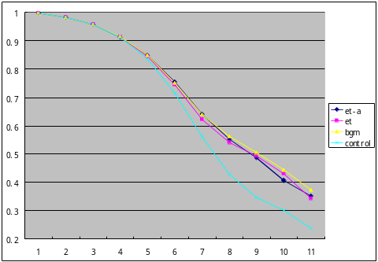
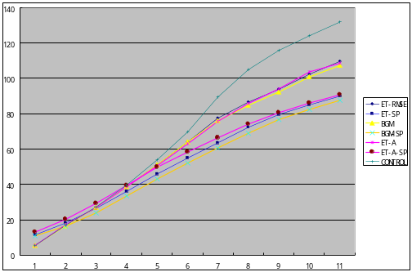

Fig. 7 ACC of ensemble mean and control run of ET-based GEPS and operational BGM-based GEPS T213-EPS for 500-hPa geopotential height(left panel ), and ensemble mean error and spread of both systems for 00-hPa geopotential height (right panel)

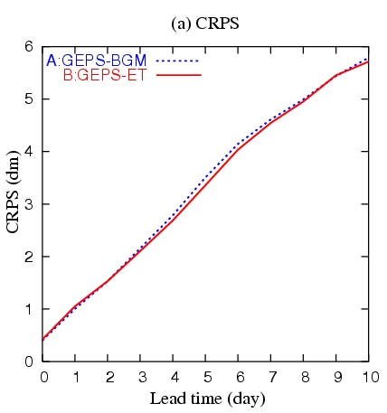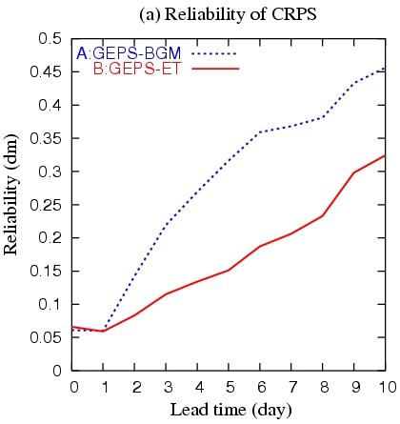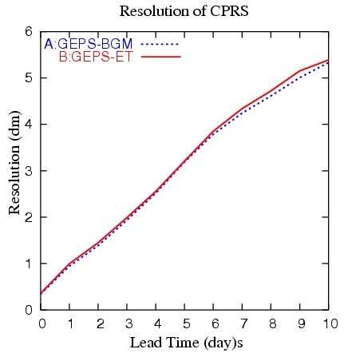
Fig. 8 CRPSs and their reliability and resolution components for ET-based GEPS and operational BGM-based GEPS

2.2、The development of GRAPES model-based GEPS
The future generation GEPS at CMA is planned to be based on the GRAPES model that has been developing by Chinese scientists since 2001. The horizontal resolution of GRAPES for new GEPS initially is 1.0 degree with forecast length of 10 days. The SV method will be used for initial perturbations, and possible members of new GEPS are 15 to 51.
The initial phase of new GEPS from 2010 to 2013 entails developing the calculation module of SVs in the GRAPES-4Dvar system, testing the influences of simplified physics on the SVs, and evaluating the feasibility of parallel calculation of SVs.

