WORLD METEOROLOGICAL ORGANIZATION  COMMISSION FOR BASIC SYSTEMS  OPAG on DPFS  MEETING THE REGIONAL SUBPROJECT MANAGEMENT TEAM (RSMT) OF THE SEVERE WEATHER FORECASTING DEMONSTRATION PROJECT (SWFDP) IN BAY OF BENGAL  Colombo, Sri Lanka,  28 November – 1 December 2018 |  | WDS-DPFS/RAII-SWFDP-BoB-RSMT/Doc. 4.3.3  (25.11.2018)  _______  Agenda item : 4.3.3  ENGLISH ONLY

Severe weather monitoring, forecasting and Warning System in India
(Submitted by Dr M. Mohapatra, IMD)

Summary and purpose of document

This document provides information on the capacity of severe weather monitoring, forecasting and warning services of India Meteorological Department (IMD).

Action Proposed
The meeting is invited to take a note and comment on it and use the information in updating the Regional Subproject Implementation Plan (RISP) of SWFDP-Bay of Bengal.

Annex(es): - …….…….

Severe weather monitoring, forecasting and Warning System in India
- Introduction
The risk management of these natural disasters depends on several factors including (i) hazard analysis, (ii) vulnerability analysis, (iii) preparedness & planning, (iv) early warning, (v) prevention and mitigation. The detection and prediction of these hazards with sufficient lead period and reasonable accuracy is very essential for their management. The India Meteorological Department (IMD), Ministry of Earth Sciences (MoES) is the Nodal National Meteorological agency mandated for issuing seamless operational weather forecast and warnings for various meteorological hazards across the country. IMD also provides forecast guidance to the south Asian countries and members of WMO/ESCAP Panel countries as the WMO designated Regional Specialised Meteorological Centre (RSMC). The regional guidance on severe weather events including cyclone, heavy rain, strong wind, sea waves and storm surge (RSMC, New Delhi, 2018) are provided by RSMC, New Delhi to nine member countries of WMO’s severe weather forecasting demonstration project (SWFDP)-Bay of Bengal.
The warnings and advisories by IMD for national purpose are issued for different temporal ranges and spatial domains. The temporal domain of forecasts and warnings ranges from Now-casting which is valid only for a couple of hours to long range which has the validity of months to a whole season. The components of a forecasting and warning system include (i) detection, monitoring and warning through global, regional, national and local observations, (ii) numerical weather prediction, (iii) forecasts on different timescales (now-casting to several days), (iv) timely dissemination of authoritative warning information, (v) risk Analysis and impact assessment. Mitigation and response actions of recipients depend on content and clarity of the warning, credibility of issuing organization, and preparedness of receiving authorities. The scientific knowledge alone is not sufficient as disaster management needs collaborative efforts of warning organization and hazards Community (other government organizations + local officials + emergency managers + media + voluntary and non-government organizations etc). All these aspects are to be taken into consideration while planning augmentation of early warning system by IMD.
Though there has been significant improvement in forecasting, there is still scope to further improve (i) observational network (ii) global and regional numerical weather prediction modeling, (iii) impact based warning product generation and (v) warning dissemination based on latest tools and technology as per need of disaster managers, various users and general public.
All the above aspects are analyzed and presented in the subsequent sections. The weather forecasting and early warning system in India is presented in Section 2. Recent achievements, gap areas and future plans are presented and analysed in Section 3, 4 and 5 respectively.

2. Weather forecasting and warning services of IMD:
The aim of a National Meteorological Centre is to perform a clear analysis of the present weather, to provide weather forecasts, to evaluate the level of risk associated with the expected important meteorological phenomena and to issue pertinent warnings towards the concerned stake holders, agencies and people at large. Broadly speaking, weather analysis and forecasting is the succession of following tasks:
- to clearly understand the recent evolution and the actual situation of the atmosphere at all time scales (weather analysis);
- to obtain the pertinent information from numerical models and observational systems including satellite & radar and to assess the future evolution of the atmosphere in order to determine the most likely scenario;
- to deduce finally the consequences of the expected synoptic situation in terms of weather elements (weather elements forecasting) and to evaluate the risk of the occurrence of hazardous phenomena (risk assessment);
- to prepare the meteorological information (including possible warnings) to be directed toward the various internal or external users.

2.1 Monitoring Process
The entire process of extreme weather monitoring and forecasting is shown in a schematic diagram (Fig.1). The observational network for monitoring consists of land-based surface and upper-air stations, observations from DWRs and data from geo-stationary and polar orbiting satellites. In addition, observations from ships and buoys are of immense importance for the analysis and forecasting of extreme weather, especially Ocean related hazards like cyclones, monsoonal heavy rainfall etc. It is important to correctly determine the location and intensity of the system, as initial error in location and intensity can lead to increase in error in forecast location and intensity.
IMD has a good network of surface observatories satisfying the requirement of World Meteorological Organization (WMO). There are 559 departmental manned surface observatories of IMD at present. There are 62 pilot balloon observatories. High quality upper air observational data network using the GPS technology has now been extended to 43 locations. There has been augmentation of surface observational network over Indian landmass by increasing the number of Automatic weather stations (AWS) from 125 to 711 and by introducing 1350 Automatic Rain-gauges (ARG) leading to availability of meteorological observations from all the districts of the country (Fig.2). The meteorological data thus collected all over these stations are used on real time basis for monitoring the weather.
Under the National Data Buoy Programme (NDBP) at National Institute of Ocean Technology (NIOT), Chennai, twelve moored data buoys are deployed currently in the NIO. The data buoys are fitted with sensors to measure air pressure, air temperature, wind speed and direction and sea surface temperature among other parameters. These buoys have resulted in better monitoring and reduction of location and intensity error of cyclonic disturbances in association with ship and satellite observations. As per the guidelines issued to Indian voluntary observing fleet (IVOF), synoptic observations are made at the main standard times: 0000, 0600, 1200 and 1800 UTC by the ships. When additional observations are required, they are made at one or more of the intermediate standard times: 0300, 0900, 1500 and 2100 UTC. Over the NIO, 186 ships are registered under IVOF. The sea surface wind as estimated by scatterometer based satellites (ASCAT, Windsat and SCATSAT) is very useful in monitoring weather systems over the seas (Uhlhorn and Black, 2003).
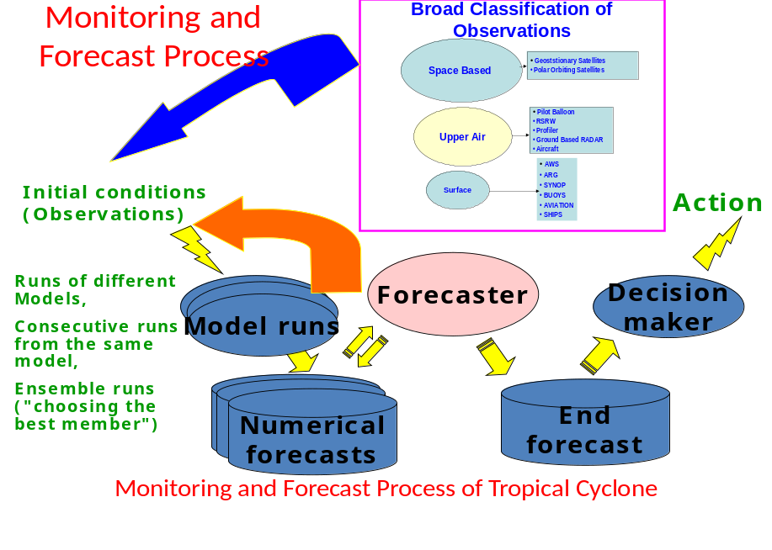

Fig.1.Weather Monitoring and Forecasting process of IMD
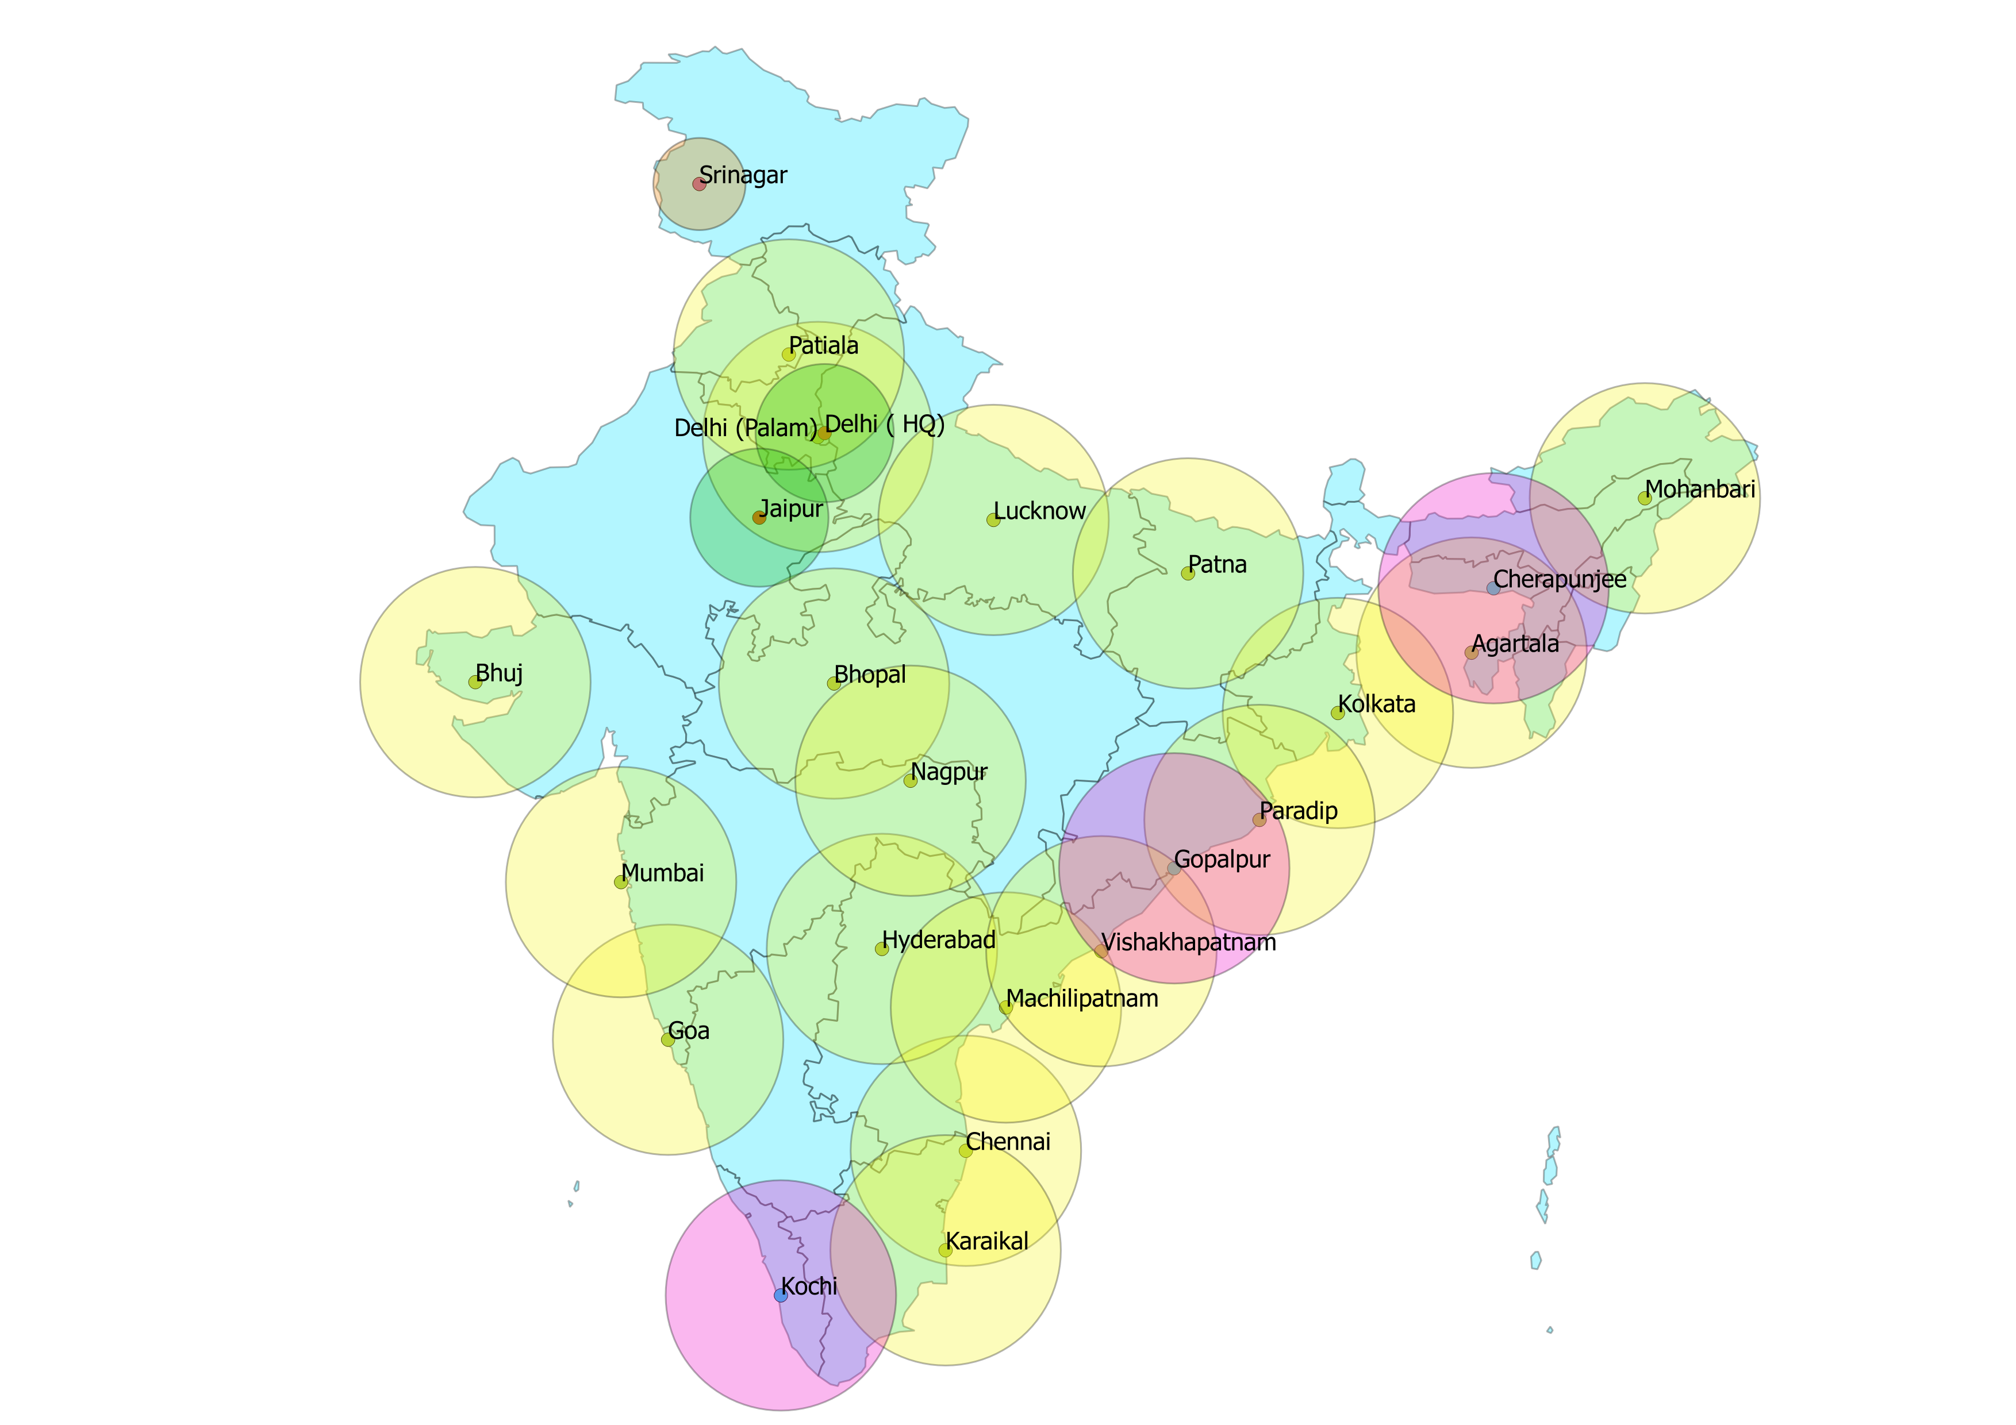
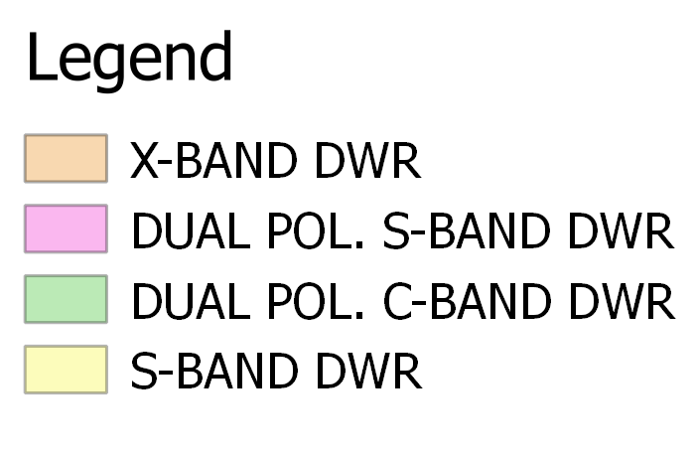
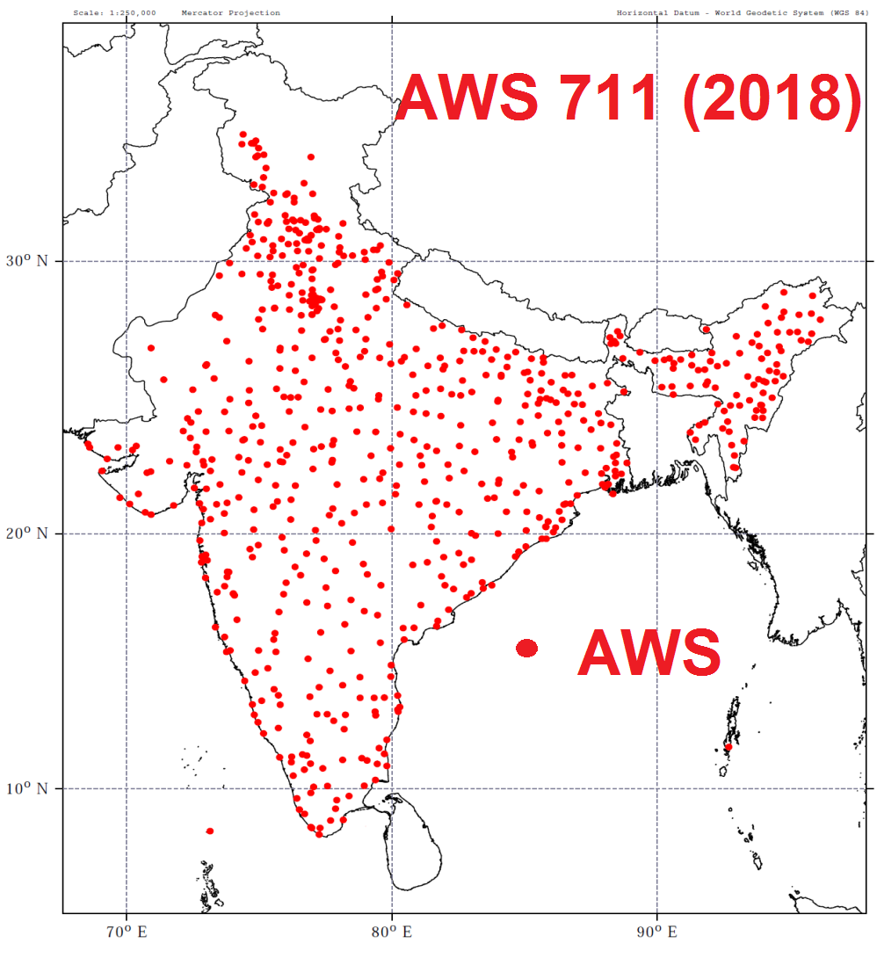
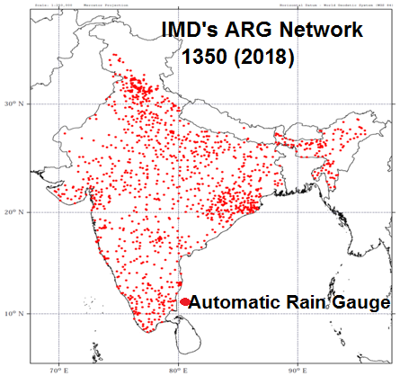
DWR 24 (as on 2018)

Fig.2: AWS, ARG DWR network in India

There are 27 numbers of C/S-band DWR in India. A DWR provides velocity and spectral width data along with various meteorological, hydrological and aviation products which are very useful for forecasters in estimating the storm’s centre, its intensity and predicting its future movement (Raghavan, 1997, 2013). The geostationary satellite, INSAT 3D and 3DR provides imageries in visible (VIS), infrared (IR) and water vapour (WV) channels. In addition to above, the products like outgoing long wave radiation, quantitative precipitation estimates, sea surface temperatures (SST), cloud motion vectors, water vapour derived wind vector, isotherm analysis on Enhanced infrared images are also analyzed on operational mode for monitoring. The microwave imageries are also used for monitoring and guidance, especially the internal structure of weather systems. Apart from Indian Satellite, products from other international Satellites are also used for cyclone monitoring (IMD, 2013b). Past studies (Dvorak, 1984, Kalsi, 2002, Velden et al, 2006, Bhatia & Sharma, 2013) have built up a store-house of knowledge on satellite applications in cyclone monitoring in the NIO. The INSAT 3D based satellite product for (L) detection of simultaneous occurrence of fog and cyclone, Vardah at the time of landfall and (R) RAPID tool for analysis of convective clouds, thunderstorm and dust storm (Fig.3).
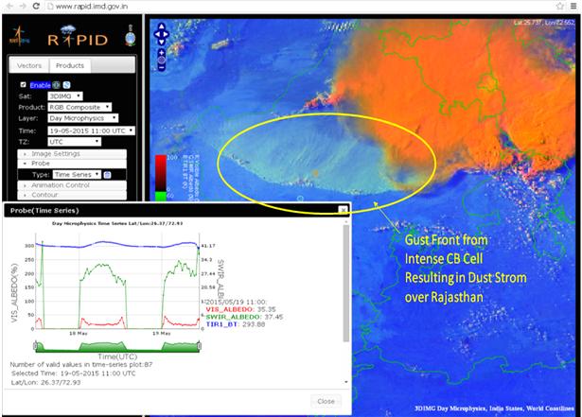
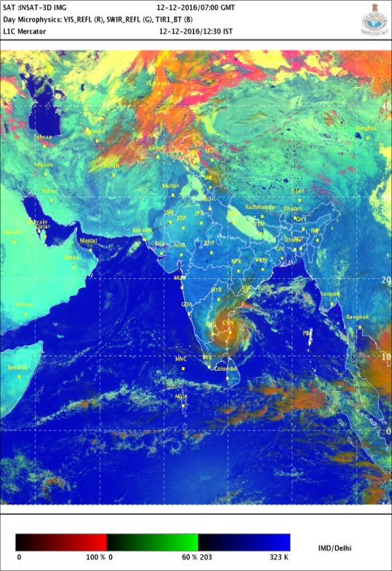

(a)

Fig.3. Typical Example of satellite products for monitoring of fog, cyclone and dust storm.

2.2. Forecasting system
A variety of observational data have been used in India till 1960s to forecast the extreme events. Satellite era, since 1960s, added another feature. There has been rapid development in objective techniques since 1970s and especially in recent years for forecasting extreme weather events. To summarise, currently following methods are used by IMD for short to medium range forecasting.
- Statistical technique(Analogue, Persistence, Climatology, Climatology and persistence(CLIPER)
- Synoptic technique – Empirical technique
- Satellite techniques- Empirical technique
- Radar techniques- Empirical technique
- Numerical weather prediction (NWP) models
- Dynamical statistical models

There are three types of NWP models, viz., individual deterministic models, multi-model ensemble (MME) and single model ensemble prediction system (EPS) for different ranges of forecast as mentioned below (Regional Specialised Meteorological Centre (RSMC), New Delhi, 2018).
- Medium Range Forecast
- Global forecasting system (GFS) global model (horizontal resolution of 12 km and forecast upto 10 days)
- Unified model (horizontal resolution of 12 km and forecast upto 10 days)
- Global Ensemble Forecasting System (GEFS) global probabilistic model (horizontal resolution of 12 km and forecast upto 10 days)
- Unified model ensemble prediction system (horizontal resolution of 12 km and forecast upto 10 days)
- Short Range Forecast
- Weather research forecast (WRF) Meso scale model(horizontal resolution of 3 and 9 km and forecast upto 3 days.
- Unified Meso scale regional model(horizontal resolution of 4 km and forecast upto 3 days
- Hurricane WRF (HWRF) for cyclone prediction ((horizontal resolution of 2 km and forecast upto 5 days)
- MME based cyclone track prediction (forecast upto 5 days)
- There is a suit of dynamical statistical models for prediction of genesis of tropical cyclone (Kotal et al, 2013), intensity of cyclone(Kotal et al, 2008).
- Storm surge (rise of sea water above the astronomical tide due to cyclone) prediction model
  - IMD Nomogram (Ghosh model),
  - IIT Delhi Model (Dube et al, 2013) and
  - INCOIS, Hyderabad model. INCOIS model also provides coastal inundation in terms of aerial extent and height of inundation.
- Nowcast and Very Short Range Forecast
  - Hourly venue specific forecast- WRF (3 km)
  - ARPS model with assimilation of DWR data
  - SWIRL with assimilation of DWR data
All the above models are operational at MoES using IBM based High Power Computing Systems (HPCS). The model is run twice in a day (00 UTC and 12 UTC). The real-time outputs are made available to the national web site of IMD.
IMD also makes use of NWP products prepared by some other operational NWP Centres like, GFS-USA, GFS-NCMRWF, Japan Meteorological Agency (JMA), United Kingdom Meteorological Office (UKMO), Global Tropical model, Meteo-France etc. The MME technique for cyclone track forecast also uses statistical linear regression approach using five operational NWP models. (ECMWF, GFS(IMD), GFS(NCEP), UKMO and JMA). The single model based ensemble forecast products from ECMWF (50+1 Members), NCEP (20+1 Members), UKMO (23+1 Members) and Meteorological Services, Canada (MSC) (20+1 Members) and JMA (20+1 Members) are available near real-time for NIO region. These Products includes: Deterministic and ensemble track forecasts of cyclones, strike probability maps and strike probability of cities within the range of 120 km 4 days in advance. The super-ensemble has also been developed based on above ensembles. In the ensemble prediction system (GEFS and UMEPS) run in MoES, various probabilistic forecast products are generated for severe weather events, probabilistic occurrence of different thresholds of rainfall (heavy rain and deficient rain), temperature (heat wave and cold wave) and wind (squally wind and gale winds) etc at different locations/regions.
2.3. Decision support system (DSS)
In the synoptic method, prevailing environmental conditions are considered. All these fields in the NWP model analyses and forecasts are also considered. The development of characteristic features in satellite and radar observations is also taken into consideration. While, the synoptic, statistical and satellite/radar guidance help in short range forecast (upto 12/24 hrs), the NWP guidance is mainly used for 24-120 hr forecasts. Consensus forecasts that gather all or part of the numerical forecast and uses synoptic and statistical guidance are utilised to issue official forecast. Thus the analysis, prediction and decision-making process is made by blending scientifically based conceptual models, dynamical & statistical models, meteorological datasets, technology and expertise. For this purpose a decision support system (DSS) in a digital environment is used to plot and analyse different weather parameters, satellite, Radar and NWP model products. In this hybrid system synoptic method could be overlaid on NWP models supported by modern graphical and GIS applications to produce high quality analyses and forecast products. It includes:
- Analysis of all synoptic, satellite, Radar and NWP model products for genesis, intensity and track monitoring and prediction
- Preparation of past weather and forecast upto 120 hrs
- Depiction of uncertainty in forecast based on probabilistic assessment

An SOP is followed for analyzing various monitoring and forecast guidance available from different sources to arrive at decision on forecast and formulation of forecast and warning bulletins. There is well defined road map and check list for this purpose. The automation of the process has increased the efficiency of system, visibility of IMD and utility of warning products.
2.4. Warning system of IMD
The goal of the warning system is to maximise actions for safety. To carry out the warning process, there is a well defined Organisation and standard operation procedure (SOP) is in place. The Warning criteria are defined for each parameter. Linkages with Media and Disaster authorities are well defined. Scheduled time of issue and frequency of bulletins along with the content (Text and graphics) are also designed as per the requirement of users. The warnings and advisories by IMD for national purpose are issued for different temporal ranges (from a few hours (nowcast) to five days (short to medium range forecast)) and different spatial domains. The spatial domains range from venue, city, District and State/meteorological subdivisions, each having different temporal domains. However, short and medium range forecast, especially during southwest monsoon season (June-September) and cyclonic disturbances period continues to remain in highest demand by the different users including farming community and other stakeholders and therefore accurate prediction in this range occupies greater significance. Followings are the various types of forecasts and warnings issued by IMD.

2.4.1. Cyclone Warning System
Types of bulletins and warnings issued in the interest of Mariners in cyclone specific situations are:
- Sea area bulletins (for shipping on high seas and for ships plying in coastal waters (unto 75 Kms off the coast line)),
- Bulletins for Indian Navy,
- Port warnings,
- Fisheries warnings,
- Four stage warning for disaster managers
- Bulletin for all India radio (AIR),
- Warnings for Designated/ Registered users,
- Bulletins for Press.

The cyclone warnings are issued to central and state government officials in four stages. The First Stage warning known as "PRE CYCLONE WATCH" issued at least 72 hours in advance contains early warning about the development of a cyclonic disturbance in the north Indian Ocean, it’s likely intensification into a cyclone and the coastal belt likely to experience adverse weather. This early warning bulletin is issued by the Director General of Meteorology himself and is addressed to the Cabinet Secretary and other senior officers of the Government of India including the Chief Secretaries of concerned maritime states. The Second Stage warning known as "CYCLONE ALERT" is issued at least 48 hrs in advance of the expected commencement of adverse weather over the coastal areas. It contains information on the location and intensity of the storm likely direction of its movement, intensification, coastal districts likely to experience adverse weather and advice to fishermen, general public, media and disaster managers. This is issued by the concerned ACWCs/CWCs and CWD at HQ. The Third Stage warning known as "CYCLONE WARNING" issued at least 24 hours in advance of the expected commencement of adverse weather over the coastal areas. Landfall point is forecast more precisely at this stage. These warnings are issued by ACWCs/CWCs/and CWD at 3 hourly interval giving the latest position of cyclone and its intensity, likely point and time of landfall, associated heavy rainfall, strong wind and storm surge alongwith their impact and advice to general public, media, fishermen and disaster managers. The Fourth Stage of warning known as "POST LANDFALL OUTLOOK" is issued by the concerned ACWCs/CWCs/and CWD at HQ at least 12 hours in advance of expected time of landfall. It gives likely direction of movement of the cyclone after its landfall and adverse weather likely to be experienced in the interior areas. However, the above procedure is applicable to the cyclones developing over the open sea area. In case the genesis takes place near the coast and thus restricts the lead time before the landfall, the above procedure may not be applicable. The cyclone warning may be issued directly bypassing the pre-cyclone watch and cyclone alert.
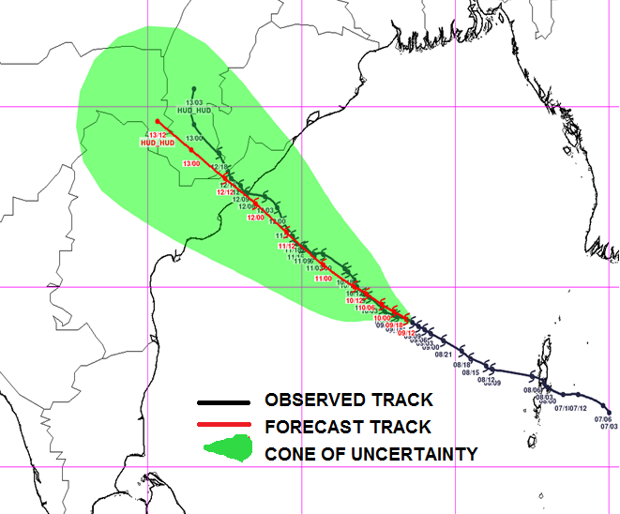

Fig.4. Observed & Forecast track of ESCS Hudhud alongwith cone of uncertainty

At national level, the bulletins are issued from the stage of depression onwards. During the stage of depression/deep depression; it is issued based on 00, 03, 06, 12, and 18 UTC observations. When the system intensifies into a cyclonic storm, these bulletins are issued at 00, 03, 06, 09, 12, 15, 18 and 21 UTC (every three hourly interval) based on previous observations. The cyclone warning is furnished on a real time basis to the Control Room in the Ministry of Home Affairs, Government of India, besides other Ministries & Departments of the Central Government, Doordarshan and All India Radio (AIR) at New Delhi and other electronic and print media and concerned state Governments. Different colour codes are being used since post monsoon season of 2006 at different stages of the cyclone warning bulletins (cyclone alert-yellow, cyclone warning-orange and post landfall outlook-red), as desired by the Government.An example of graphical presentation of track forecast alongwith the cone of uncertainty and actual observed track in case of cyclone Hudhud is presented in Fig.4.

    - Thunderstorm/Duststorm/Lightning warning:
Severe thunder storms are localised phenomena with a life period of about a few hours. These can be detected on real time with a dense network of DWR in the country. The currently available array of numerical weather prediction system is not capable to provide accurate location specific forecast of these thunderstorms and associated weather with reasonable lead time. Worldwide nowcasting, the very short range forecasting upto 3-6 hours is applied to predict and warn against these severe thunderstorms with the help of DWRs supported by dense observational network, satellite observations and suitable numerical modeling and expert system. In India, this nowcasting is limited to 403 cities. At the same time the district level nowcast against the thunderstorm and associated adverse weather is issued by IMD through its state level Meteorological Centres to the disaster managers and general public. As soon as IMD issues any severe weather warning, it is flashed to general public through mass media and register mobile users. IMD through its state level offices is issuing SMS based warning to All India Radio stations, Door Darshan for immediate broadcast/telecast to general public.
    - Heavy Rainfall & Flood warning:
IMD issues heavy rainfall warning at meteorological sub-divisional level through its National Weather Forecasting Centre (NWFC) located at New Delhi. The following are the terminology in use at present to indicate and forecast the rainfall intensity (24 hours accumulated rainfall ending at 0830 hrs IST of each day) in the short & medium range weather forecasts.
Descriptive term | Rainfall (mm) | Descriptive Term | Snow depth (in cm)
Heavy Rain | 64.5 – 115.5 | Heavy snowfall | 64.5 – 115.5
Very Heavy Rain | 115.6 – 204.4 | Very Heavy snowfall | 115.6 – 204.4
Extremely Heavy Rain | >204.5 | Extremely Heavy snowfall | >204.5

The colour codes (red, orange, yellow and green corresponding to warning, alert, watch and no warning) are used (Fig.5) for warning advisories in association with rainfall and snowfall. In order to decide upon the colour to be assigned to a given weather forecast situation under the 5-day forecast scheme, IMD follows this matrix, giving thrust on the probability of occurrence of the event as well as its impact assessment. The probability of occurrence for D1 to D5 is derived based on the ensemble probabilistic forecasts provided by NCMRWF and various Global centres. For an impact assessment, the forecaster goes ahead with the conceptual model of the weather associated with the expected evolution of the synoptic situation based on a proper interpretation of the numerical model outputs along with the topography and land use pattern of the region under consideration. It is carried out through both objective consensus derived from the models and the subjective consensus derived through tele/video conferencing of forecasters within the country everyday utilizing the knowledge, experience and expertise.
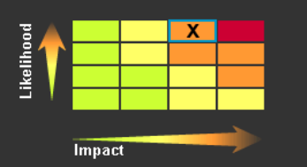

Fig.5. The matrix used by IMD to provide impact based forecast and warning against weather hazards
The work of flood forecasting and warning in India is entrusted with the Central Water Commission (CWC) of Ministry of Water Resources (MoWR). The Hydromet Division of IMD at New Delhi caters to the need of hydromet inputs particularly of water resources development and water related disaster (like floods and drought) monitoring/management. It provides services in the following fields (i) Rainfall monitoring (ii) Hydromet forecasting (QPF) (iii) Hydromet Design. Major work involves meteorological support for flood warning and flood control operations to field units (Flood Forecasting Divisions (FFDs)) of Central Water Commission (CWC) through its Flood Meteorological Offices (FMOs).
A WMO Project for south Asia Flash Flood Guidance system (SAFFGS) has been adapted in collaboration with WMO/South Asia Countries and Hydro Research Centre (HRC), USA. It will be implemented by the end of 2018 to provide flash flood guidance to Nepal, Bhutan, Bangladesh, Myanmar, Sri Lanka and Maldives.
    - Heat and cold waves
The Ministry of Earth Sciences has implemented state-of-the-art coupled climate model for seasonal forecasting. The model has been used to prepare the monsoon forecasts since 2012. The model was used first time to prepare a temperature outlook for the 2016 Hot Weather Season (April –June) and also cold weather season (December-February) since 2016-17. It is interpreted to provide the outlook on sub-divisional levels for expected heat wave and cold wave conditions in the country during the season. It is followed by the extended range outlook on summer maximum and winter minimum temperatures issued every Thursday valid for next two weeks on meteorological sub-divisional level. In short to medium range, heat wave and cold wave warning are issued daily valid up to five days. The colour code system indicating severity of an expected heat wave and cold wave used by IMD is given below.

- Cold wave
Green(No action) | Normal night | Minimum temperatures are near normal
Yellow Alert  (Be updated) | Cold Alert | Cold wave conditions at isolated pockets persists on 2 nights
Orange Alert  (Be prepared) | Severe Cold Alert for night | (i) Severe cold wave conditions persists for 2 days  (ii) Through not severe, but cold wave persists for ≥4 nights
Red Alert  (Take Action) | Extreme cold Alert for night | (i) Severe cold wave persists for more than 2 nights  (ii)Total number of cold/severe cold wave nights > 6 nights.

- Heat wave
Green(No action) | Normal Day | Maximum temperatures are near normal
Yellow Alert  (Be updated) | Heat Alert | Heat wave conditions at isolated pockets persists on 2 days
Orange Alert  (Be prepared) | Severe Heat Alert for day | (i) Severe heat wave conditions persists for 2 days  (ii) Through not severe, but heat wave persists for ≥4 days
Red Alert  (Take Action) | Extreme Heat Alert for day | (i) Severe heat wave persists for more than 2 days.  (ii) Total number of heat/severe heat wave days > 6 days.

    - Fog
There has been drastic Improvement in the Fog monitoring and Forecasting systems at IGI Airport(IGIA) in Winter of recent years. It has been possible because of successful and effective implementation of three new project, viz., (i) installation of thirteen Indigenous Drishti for runway visibility measurement, (ii) Winter fog experiment (WIFEX) and (iii) forecasting demonstration project(FDP) in recent years. The forecast accuracy of different weather hazards in recent years are shown in Fig.6.

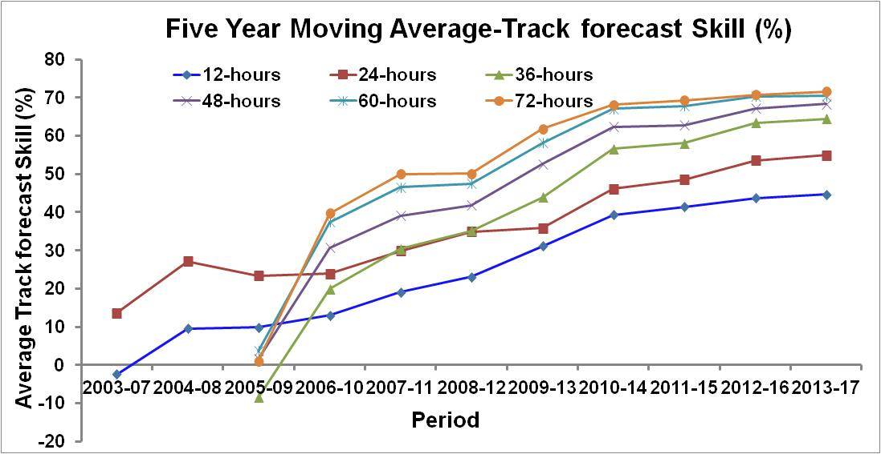
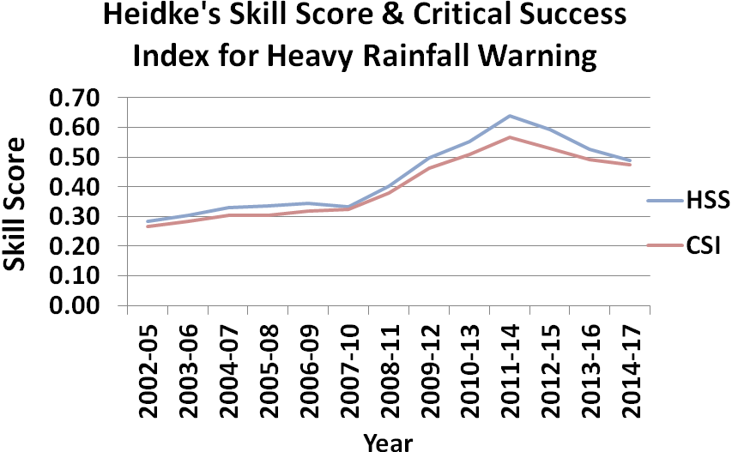
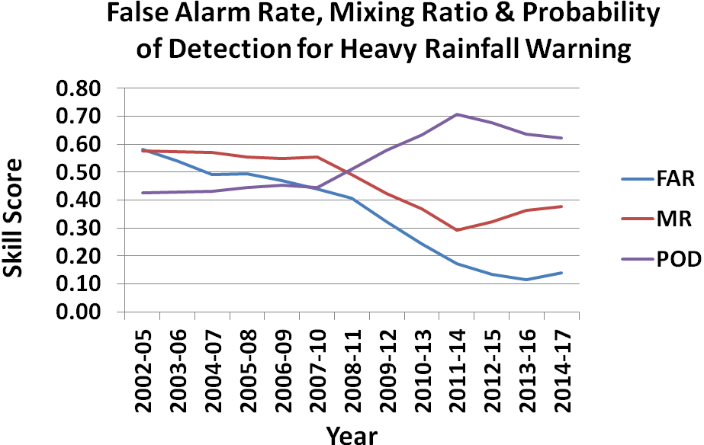
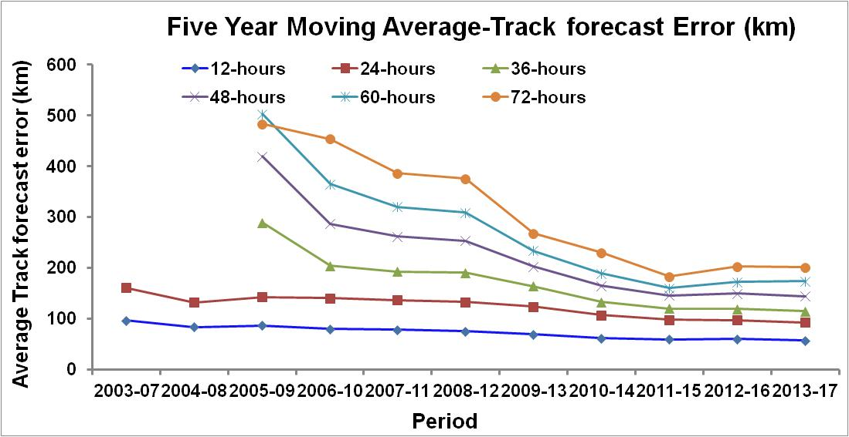
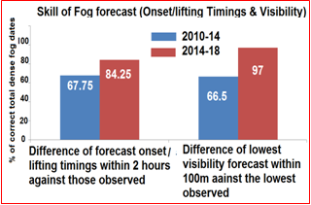
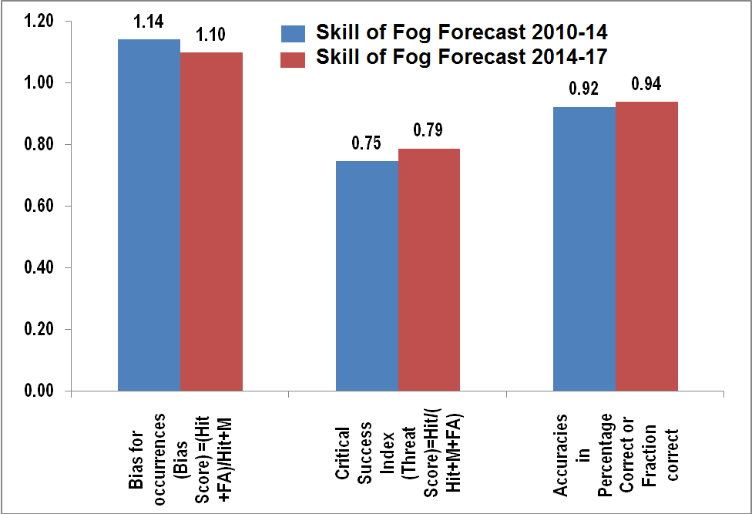
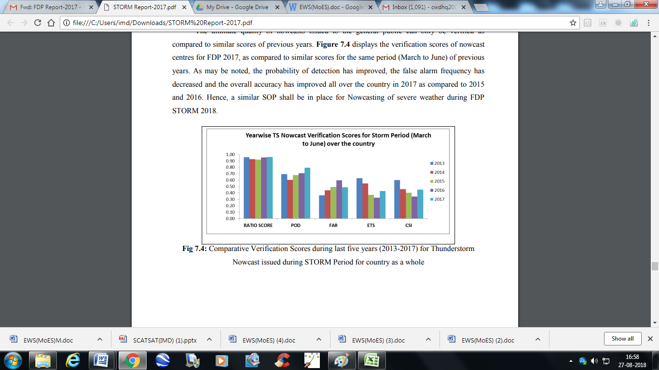
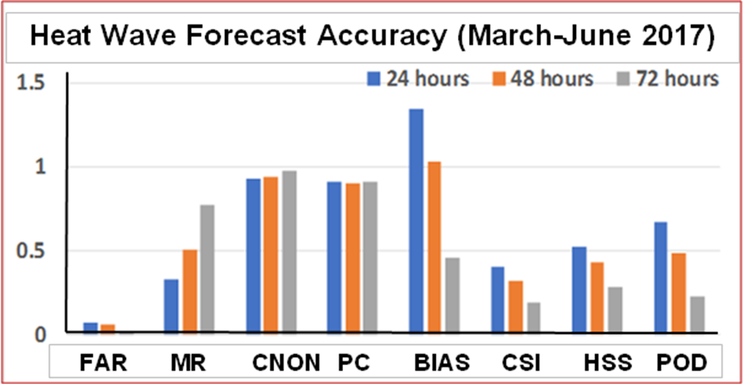
(b)
(a)
(d)
(c)
(f)
(e)
(h)
(g)

Fig.6(a-b) Five Year Moving Average Skill Score of Heavy rainfall warning, (c-d), Five Year Moving Average Track Forecast Errors (km) & Skill (%), (e-f) Comparative analysis of Skill of Fog forecast during 2010-14 and 2014-18, (g) Heat Wave forecast accuracy during 2017, (h) Year-wise Thunderstorm nowcast verification score during March-June. FAR: False alarm rate, MR: Missing rate, CNON: Correct non-occurrence, PC: Percentage correct, BIAS: Bias for occurrence, CSI: Critical success index, HSS: Heidke skill score, ETS: Equitable threat score,
  - Warning Dissemination Mechanism
The warnings are disseminated to various users through telephone, fax, e-mail, SMS, All India Radio, FM and community radios, Television and other print & electronic media. These warnings/advisories are uploaded in the website of IMD (www.imd.gov.in). Also the warning bulletins are disseminated by email and SMS to state and national disaster management authorities. In case of emergency, police wireless and telecommunication lines of railways and aviation authorities are also used. The Cyclone Advisories bulletin for WMO/ESCAP Panel countries and international airports are disseminated through global telecommunication system (GTS) and e-mail.
Recently there is initiative through NDMA for common Alert protocol (CAP) for dissemination of thunderstorm warning. Once, implemented, it will be very useful for quick dissemination to last mile. Further it is recommended that the synergised observational and forecast and warning products in text cum visual graphics format should be generated by IMD with direct CAP-feed facility so as to reach the last mile with no loss of time. Similarly the proposed last mile connectivity through satellite based initiative if ISRO, viz., Gagan Messaing System (GAMES) and Navik in collaboration with MoES and state & central Govt. will be very helpful to mitigate the disasters.
- Achievement in recent years:
In the last decade, there have been considerable improvements in the quality of weather and climate services. This was mainly due to augmentation of observational network, research efforts in weather & climate modelling and specialized training of scientists. Important achievements in weather and climate services during the last the last decade are as follows:
- The Gramin Krishi Mausam Seva (GKMS) is rendered twice a week in collaboration with State Agricultural Universities (SAUs) and Institutions of Indian Council of Agricultural Research (ICAR). District level weather forecasts for next 5- days, weekly cumulative rainfall forecast, and crop specific advisories are provided to farmers (Mahadevaiah et al, 2012). Presently around 2.60 Crores farmers are directly benefitted by this service being provided through SMS as compared to 0.5 Crores farmers in April 2014. As per assessment made by National Council of Applied Economic Research (NCAER), from these agro-meteorological advisories, farmers made economic benefits exceeding Rs. 42,000 crores.
- Noteworthy improvement was made in track and intensity forecast of the tropical cyclones (24 hour forecast error in track prediction reduced from 141 km to 85 km and Landfall error from 99 km to 52 km during 2006 to 2018). Increase in lead time alongwith increase in accuracy of the forecast of genesis, track, intensity (Mohapatra et al, 2013b, 2013c, 2017) and adverse weather (Mohapatra, 2015) in recent years have helped in better management of disaster due to cyclone.
- Though the damage due to cyclones cannot be minimized, the loss of life has been drastically reduced being limited to double digit figure in the recent years. Death toll due to cyclone Phailin (October, 2013) was 22 and Hudhud (October, 2014) was 46 as compared to 9885 due to Odisha Super Cyclone (October, 1999).
- The skill in accurate prediction of track, intensity and landfall point & time has resulted in reduction in damage to property. It has been $4500 million due to Odisha Super Cyclone (1999) as against $696 million due to VSCS Phailin (2013). The ex-gratia paid by Govt. during Odisha Super Cyclone (1999) was Rs 593 crores as against Rs 1.24 crores during VSCS Phailin 6(2013). (Assuming that ex-gartia @ Rs 6 lakhs was paid by Govt. in both the years). The area of evacuation has decreased from 500 km during 1999 Odisha Super Cyclone to 180 km during Phailin. Thus the cost of evacuation has reduced being Rs 180 crores during Phailin (2013) against Rs 500 crores during Odisha Super Cyclone (1999).(Assuming the cost of evacuation as Rs 1 crore per km for both the years)
- improvements in skills of Heavy Rainfall Forecasts (False Alarm Rate reduced from 46% to 11% and Probability of Detection increased from 49% to 67% from 2002 to 2015).
- Increase in validity period of forecasts from 2 days in 2006 to 7 days in 2015 and spatial resolution from met. Sub-division to district level & Block-wise forecasts for selected blocks.
- Increase in city forecasts from around 30 cities in 2006 to 324 cities in 2018.
- Introduction of nowcasts (next six hours) of thunderstorms for 403 cities based on Doppler Weather Radars and highway and tourism forecasts.
- Quantitative precipitation forecast (QPF) to CWC for flood warnings increased from 125 to 146 river sub-basins. Validity of QPF has been increased from 5 days to 7 days in 2015.
- Customized weather forecasts for Shri Amarnathji Yatra, Bhakra and Beas Management Board (BBMB), Indian Coast Guard and defence sectors.
- Services for optimum operation of activities like irrigation, shipping, oil explorations were augmented. Specialized services were introduced for Power & health sectors

- Gap Areas
Weather Prediction Models are used for generating forecasts of weather and climate parameters. However, the present day forecast models are known to have systematic errors and random biases. Inaccurate treatment of physical processes in the models (Physical parameterization schemes) is one of the largest sources of the errors in weather and climate prediction models. Therefore, it is important to improve physical parameterization schemes in the models. This is an important, but difficult task. Development of new physical parameterization schemes or improvement of existing schemes will need many observational data of physical processes. These data are used for testing a physical hypothesis, validating physical processes in the models and also for tuning empirical constants used in the physical parameterization schemes. Therefore, observational campaigns, physical process studies and model development should go together.
As mentioned earlier, the weather and climate services have improved over the time due to investments in observations, modelling, and specialized trainings. At present, there is a skillful short range prediction of weather up to 3-5 days over the Indian region. Since short range forecasts depend on initial conditions, improvement in initial conditions can make a visible improvement in prediction skill. Therefore, observational network (conventional, satellite and Radar) needs to be strengthened and the data assimilation methods to ingest the observations need to improve. More stress is needed to ensure good quality of data and their timely reception for data assimilation. The current skill level of 3-5 days can be improved to 7-8 days by employing an ensemble approach to forecasting in addition to the deterministic forecasting system at very high horizontal resolution of about 10 km.
Significant research has been carried out in the past to enhance the understanding on Indian monsoons, however, challenges and uncertainties still remain with respect to the accuracy of monsoon predictions and precipitation forecast skill improvements across different time-scales, especially in short to medium range. The users also need forecasts for much smaller spatial and temporal scale, for example at district level. Extended range prediction system provides very useful products at time scale of 15 days. This skill needs to be improved beyond 3 pentads. At present, there are very limited applications with the extended range prediction system. The potential areas in which these forecasts can be applied are agriculture, water resources/management, power, energy and health.
On many instances of extreme rainfall having potential of causing floods, flooding events are missed causing loss to economy and life as the meteorological forecasts are not readily usable by various stake holders. Therefore, there is an urgent need to improve and customize meteorological forecasts specifically for floods. For formulating the flood forecast in the real time, the observed meteorological and flow data are used into the calibrated & validated real time flood forecasting model to forecast the flood flow and corresponding water levels for different lead periods varying from few hours to few days depending on the size of catchment and purpose of the forecast.
Accurate forecasts of the intensity of tropical cyclones (TCs) still remain a gap area which sets the basis for research in improving the model. There is a also scope to further improve prediction skill in predicting land fall and associated rainfall, storm surge and winds. The recent research analysis suggests that models do not perform well in predicting associated heavy rainfall during the landfall of tropical cyclones.
Large forecasting and research gaps include the understanding and prediction of thunderstorms and associated adverse weather. Denser Radar network not only would help detecting mesoscale convective system but also would help constraining the model parameters for better representation of convection. Assimilation of meso-network observational data would be necessary to generate mesoscale analyses/reanalyses representing the regional heterogeneity. Predictability of convection initiation and scale interactions associated with superposition of micro-scale, meso-scale, and synoptic-scale processes needs to be studied. There is an urgent need to translate the high resolution weather forecast into lightning probabilities. This remains as one of the most important gap areas at present in areas of forecasting.
We need to improve in predicting prolonged heat and cold wave spells and improve forecast accuracy of flash flood events over the urban and complex topography. Another detrimental weather phenomenon during Indian winter months is the dense fog formation over the Gangetic Valley which has very high damage potential (physical as well as economical). Objective tools for short- and medium-range forecasting of timing of onset, intensity and duration of fog well in advance falls into one of the largest gap areas. A comprehensive understanding of micro-meteorological and chemical processes responsible for the haze or fog formation over the Ganges Basin and fog impact on health and ecosystems is not clearly addressed yet. High-resolution mesoscale model, coupled with interactive aerosol model with chemical details of species is also the need of the hour.
Forecasting urban weather is increasingly important to manage disasters, decision making in the public sector, and for urban planning purposes, etc. Recent introduction of urban development plans such as Atal Mission for Rejuvenation and Urban Transformation (AMRUT), Smart Cities Mission, and Housing for All (Urban) by Prime Minister are modes to increase the opportunity for urban centres and especially urban areas are considered as “growth engines”. India is poised to have 100 smart cities in five years and 2 crore houses will be constructed in next 7 years. These urban development plans also should be supported by adequate weather related support systems for information, management and mitigation of urban hazards such as heat wave, flash floods, heat islands, air pollution dispersion, etc.

5. Conclusions and Future Plans
IMD continuously expands and strengthens its activities in relation to observing strategies, forecasting techniques, disseminating methods and research relating to different aspects of extreme weather events to ensure most critical meteorological support to disaster managers and decision makers.
Demands from the public/private/government sectors are increasing for more accurate prediction of weather at various temporal and spatial scales. Improved and reliable forecast of weather requires high resolution dynamical models. Thus, intensive monitoring of various weather systems through different platform based observing systems provide not only the necessary information about current weather systems, their effective assimilation in numerical models provide important guidance for accurate forecasts. Hence, there is scope to improve further the weather services by providing high resolution customized impact based forecast and risk based warning products for different existing and emerging socio-economic sectors.
There is also scope for improvement of (i) sectoral applications of early warning, (ii) warning communication to last mile and disaster managers through state of art technology, (iii) developing synergized standard operation procedure among the early warning agencies and user agencies and (iv) upgrading and enhancing the link between early warning service provider and disaster managers.

