WORLD METEOROLOGICAL ORGANIZATION  COMMISSION FOR BASIC SYSTEMS  STEERING GROUP  SEVERE WEATHER FORECASTING DEMONSTRATION PROJECT (SWFDP)  GENEVA, SWITZERLAND, 14 – 18 March 2016 |  | CBS/SWFDP-SG/Doc. 4(1)  (14.III.2016)  _______  ENGLISH ONLY

REVIEW AND EVALUATION (INCLUDING PROGRESS AND ISSUES) OF EXISTING SWFDP SUBPROJECTS –
SOUTHERN AFRICA

(Submitted by Eugene Poolman, Chair of the RTIT)

Summary and purpose of document

This document provides background information on the implementation of the SWFDP in Southern Africa

Action Proposed

The meeting is invited to review the progress in the implementation of SWFDP-SA and to identify areas for improvement

SEVERE WEATHER FORECASTING DEMONSTRATION PROJECT – SOUTHERN AFRICA (SWFDP-SA)

- BACKGROUND

The development and progress of the SWFDP-Southern Africa (SWFDP-SA) project can be summarized as follows:
- Phase 1 started with a planning meeting in Aug 2006 in Pretoria, South Africa, followed by the first regional training session in November 2006 in Pretoria, South Africa.
- The demonstration phase (Phase 2) kicked off in November 2006 lasting for one year till November 2007. Five countries were involved in the demonstration phase, namely Botswana, Madagascar, Mozambique, Tanzania and Zimbabwe. The principal regional centre was RSMC Pretoria, and the three global centres involved were ECMWF, NCEP (NOAA) and the UK Met Office. As Phase 2 drew towards a close, the Meteorological Association of Southern Africa, representing the NMSs of the 15 SADC (Southern African Development Community) countries requested WMO to roll SWFDP out to the entire region, based on the successes of the demonstration phase.
- This led to Phase 3 in which the SWFDP activities were rolled out to all 15 SADC countries, as well as the Comoros, and evaluated on the sub-regional scale.
- Following the conclusion of Phase 3 in December 2011, the SWFDP-SA entered Phase 4: Regional Subproject Long-term Sustainability and Future Developments. The following sections elaborate more on Phase 4.

- PROGRESS OF SWFDP-SA IN PHASE 4

General
The RTIT agreed that SWFDP-SA should continue with the cascading concept as the model for Phase 4 in Southern Africa. The support of MASA for the sustainability of SWFDP-SA is crucial, and hence MASA was requested to support the future activities in a number of areas, covering topics under resource mobilization, training, development, promotion and leadership. The RTIT structure continued to ensure seamless technical management, but it evolved from management by CBS to management by the MASA Management, while maintaining regular reporting to the CBS Steering Group for SWFDP. RTIT developed a development plan for Phase 4 to address areas that need to be strengthened within the SWFDP framework beyond Phase 3.

Operation
Since the official conclusion date of Phase 3, activities in the region have continued to function under Phase 4 as before in all respects. The global centres (NOAA, Met Office and ECMWF) continued to provide products from their global models to RSMC Pretoria, operated by the South African Weather Service (SAWS). RSMC Pretoria in turn linked these global products on the SWFDP-SA website used by the countries.

RSMC Pretoria also continued to provide every day guidance products for the next five days on the SAWFDP-SA website. Other products provided by RSMC Pretoria through the same platform include satellite nowcasting tools, and products from the 12 km Unified Model (UM SA12) run by SAWS over the SADC domain. Products from the 10-km Aladin regional model from RSMC Reunion are also linked on the website to cater for the Indian Ocean islands on the border of the UM SA12 domain.

Training
Continued training is regarded as of high importance and needs to be addressed through a variety of approaches. These include traditional training workshops at RSMC Pretoria for forecasters of all the countries, the concept of a SWFDP Training Desk at RSMC Pretoria where forecasters from the region can spend some time on attachment, training visits by regional experts to various NMHSs, and particularly those lagging behind, to train forecasters at their desks. Other initiatives explored include e-learning options and regular internet based monthly training sessions similar to the SATREP-Online sessions conducted by the EUMETSAT Centre of Excellence in Pretoria on a monthly basis.

Annually 2-week SWFDP-SA Training Workshops, funded by donors through WMO, were held in November. The workshops were broken into two weeks: Week 1 comprised of training on NWP/EPS/satellite nowcasting, and Week 2 of training on Public Weather Services, particularly training on disaster management and media relations. During 2014 and 2015 this training workshop included 3-day sessions on using the SARFFG (Southern Africa Regional Flash Flood Guidance) system as a nowcasting tool for flash floods. The approach for both weeks has shifted over the last few years to far less theory and significantly more practical session in small groups. Most presenters for the NPW/EPS/satellite nowcasting sessions came from RSMC Pretoria. Since 2013 the media training in the PWS session entailed a media consultant using a cameraman to train forecasters on conducting media briefings.

The concept of a RSMC Training Desk was quite successfully tested in 2013 (with Malawi and Zambia) and 2014 (with Lesotho and Swaziland) with funding from WMO. A forecaster from the two relevant countries spent two weeks at RSMC Pretoria with the RSMC forecasters to enhance their skills in using NWP, EPS and Nowcasting tools.

- DEVELOPMENTS

Future developments and expansion of the activities of SWFDP are central to Phase 4. In the case of Southern Africa the emphasis is currently on enhancing the warnings against flash floods. The Southern African Regional Flash Flood Guidance (SARFFG) system was operationally implemented in February 2014. SARFFG is part of a WMO hydrology FFGS program to implement regional flash flood warning systems in various regions in the world. RSMC Pretoria is also the regional centre for SARFFG, and 9 SADC NMHSs sharing major catchments from the Zambezi southwards are participating. These are Botswana, Lesotho, Malawi, Mozambique, Namibia, South Africa, Swaziland, Zambia and Zimbabwe.

An important project in the region is the WMO SWFDP-SARFFG Twinning Project, funded by USAID. The rationale behind this project is that, whereas SWFDP guidance supports each country’s NMS with weather forecast guidance and products every day for next 5 days, SARFFG provides hydrological guidance to NMSs and NHSs of potential flash floods within day 1. Both support provision of warnings to Disaster Management. The Twinning Project aims to streamline the activities of SWFDP and SARFFG through integrations of SARFFG processes with SWFDP processes, supported by technological enhancements and enhanced user products for forecasters and disaster management. One of the activities is to integrate the training needs of both into the annual 2-week November Training Workshop. Funding will be provided for this training workshop in 2016 and 2017.

Other enhancements include enhanced products from all three the global centres, NOAA, Met Office and ECMWF.

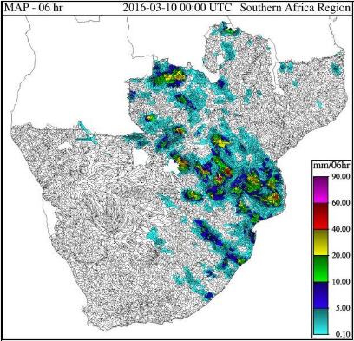 | 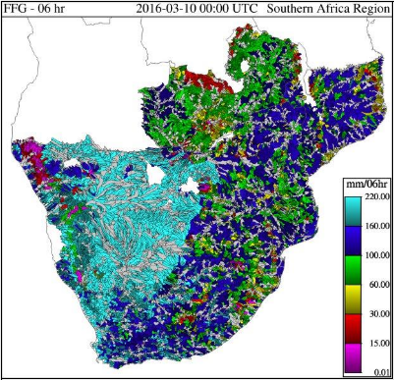 | 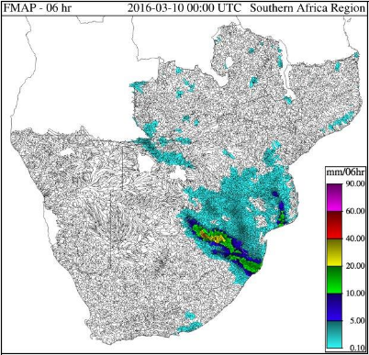
Figure 1: Products of the SARFFG system related to satellite rainfall estimation (left), flash flood guidance values (middle) and the Unified Model rainfall forecast

A significant development is also the operational implementation of a 4-km resolution Unified Model (UM SA4) run by SAWS. The domain is slightly smaller over the western and southern areas, but still covers all the SADC countries as in the past. This high resolution model will become operational on 1 April 2016, and its products will be disseminated via the SWFDP-SA website.
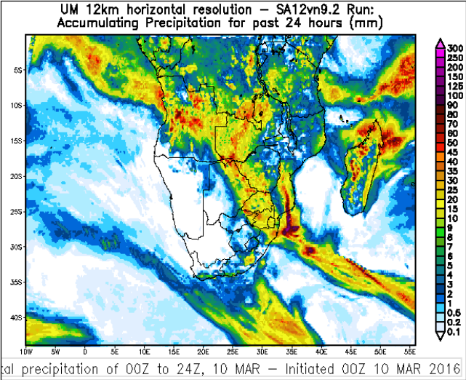 | 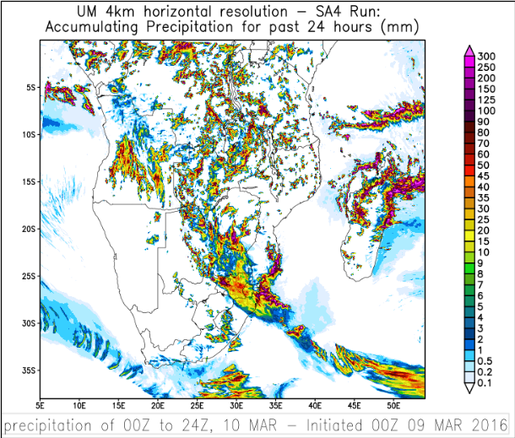
Figure 2: Comparison between the old 12-km version and the new 4-km version of the Unified Model, run at SAWS> UM SA4 will become available from 1 April 2016.

- CHALLENGES

Disaster management collaboration in various countries still needs to be strengthened. Application at local level also needs to be continuously improved, including effective dissemination of warnings and information and end-user response. Enhancement of communication bandwidth by countries is essential since this appears to be a major limiting factor for effective use of products.

Another huge challenge is ensuring future sustainability of SWFDP activities, particularly the training activities, technical team meetings, support with outreach activities, and RSMC contribution.

- SUMMARY AND RECOMMENDATIONS

SWFDP-SA is now an operational activity in Phase 4 of the SWFDP framework as established by the WMO Steering Group on SWFDP. The management of SWFDP-SA has moved to the regional association and specifically MASA while the Steering Group on SWFDP continues to maintain an oversight and broad supportive role.

Synergy with other relevant programs and activities are pursued, the current priority is the twinning of SWFDP with the SARFFG flash flood warning system, particularly regarding the rainfall forecasts needed in this system, and utilizing the framework for disaster management coordination and inter-centre communication of SWFDP.

