WMO’s Severe Weather Forecasting Demonstration Project (SWFDP)
Regional Subproject for Bay of Bengal (SWFDP-BoB)

Meeting of the Regional Subproject Management Team (RSMT)
(28 November to 1 December 2018)
&
Regional Training Workshop on Severe Weather and Impact Based Forecasting and Warning Services
(3-8 December 2018)

Venue: Hotel Janaki, No 43, Fife Road, Havelock Road, Colombo 5, Sri Lanka

INFORMATION NOTE FOR PARTICIPANTS

1. MEETING VENUE
The Meeting of the Regional Subproject Management Team (RSMT) (28 November to 1 December 2018) & Regional Training Workshop on Severe Weather and Impact Based Forecasting and Warning Services (3-8 December 2018) will be organized at the Hotel Janaki, No 43, Fife Road, Havelock Road, Colombo 5, Sri Lanka.
2. LOCAL ORGANIZATION COMMITTEE (LOC)
- Mr Ajith Wijemannage
Tel : 0094112665088 (office)
Mobile : 0094716333088
Fax : 0094112698311
Email : ajithlkw@gmail.com

- Ms Anusha Warnasooriya
Tel : 0094112691443(office)/
Mobile : 0094774368390/
Fax : 0094112698311
Email : rashanthie@yahoo.com

3. REGISTRATION
The Registration will take place as per following:
- On 28 November 2018 from 09.00 to 09.30 a.m. at the meeting venue for Meeting of the Regional Subproject Management Team (RSMT) (28 November to 1 December 2018)

- On 03 December 2018 from 09.00 to 09.30 a.m. at the meeting venue for Regional Training Workshop on Severe Weather and Impact Based Forecasting and Warning Services (3-8 December 2018)
4. WORKING LANGUAGE AND WORKSHOP WEBSITE
Both RSMT Meeting and the Regional Training Workshop will be conducted in English and all documentation will also be in English only. No interpretation service will be provided. The documentation plan for the RSMT Meeting and provisional training program for the Regional Workshop and information note for the participants will be made available on WMO website at the following link: http://www.wmo.int/pages/prog/www/BAS/CBS-meetings.html

5. INTERNET FACILITIES
The meeting/conference rooms will have internet and Wi-Fi facilities. Participants are strongly encouraged to bring their own Wi-Fi/Ethernet-ready laptop computers. Internet access/Wi-Fi is complimentary at the hotel.

6. ACCOMMODATION
The accommodation for single rooms (Bed & Breakfast) has been arranged at the Hotel Janaki (which is also meeting/training venue) by WMO through local organizers for only foreign trainees nominated by the NMHSs (2 trainees per NMHS) from eight participating countries of SWFDP-BoB attending the Regional Training Workshop (3-8 December 2018). In addition, these foreign trainees will be paid Per Diem (by WMO) to meet their incidental and dinner expenses.

The participants of RSMT Meeting (28 November – 1 December 2018) as well as the lecturers for the Regional Training Workshop (3-8 December 2018) will be required to arrange their hotel accommodation by themselves. However, they are encouraged to stay in the Hotel Janaki, the meeting/training venue. A list of hotels is given in the table below. Participants can book the hotel accommodation directly or request for help to the local organizers.

No. | Hotel name | Approx. Price for Single Room(BB) | Address
1 | Hotel Janaki  http://www.hoteljanakicolombo.com/  reservations@hoteljanakicolombo.com | 48 US$  (Rs 8000.00) | 43, Fife Road, Havelock Town, Colombo 5, Sri Lanka  Tel: +94 (0)11 250 2169  +94 (0)11 258 1524 Fax:+9411 2589139
2 | Hotel MeColombo  http://www.mecolombo.com  reservations@mecolombo.com | 65 US$ | 16, Park Road, Colombo 05, Sri Lanka  Tel +94 117 654 321  +94 718 554 306
3 | Best Western Elyon Colombo  http://www.bestwesterncolombo.com/ | 85 US$ | 102 A, Baseline Road, Kirulapone Colombo 5, Sri Lanka.  Tel: + 94 117 527527  Fax:+ 94 11 2514344/  Mobile: +94 768224563
4 | Trillium Hotels – Colombo 07  www.trillium-hotels.com  reservations@trillium-hotels.com | 105 US$ | No. 210, Torrington Avenue, Colombo 07  Tel: +94 77 98 51 204  +94 11 7 999 123

7. WORKING LUNCH DURING THE WORKSHOP
All participants will be provided working lunch during both RSMT Meeting and the Regional Training Workshop at Janaki Hotel (the meeting/training venue). WMO Secretariat, through local organizers, has already made arrangements for this purpose.

8. VISA/ENTRY REQUIREMENTS
Foreign participants may need a visa to enter Sri Lanka and are kindly requested to inquire about visa requirements from the Consulates/Embassies/High Commissions of Sri Lanka in their respective countries. It is advisable to take advance action for obtaining visas, as significant time might be required to process visa requests. The participants are urged to check their passport for required validity and visa requirements well in advance of travel. Online visa can be applied via Electronic Travel Authorization(ETA) official website of the Department of Immigration & Emigration (DI&E) of the Democratic Socialist Republic of Sri Lanka (http://www.eta.gov.lk/slvisa/) or private website (https://www.srilanka-visagov.com/).

Important: Each foreign participant is also requested to complete the attached Bio-Data form (Annex) and return this to Ms. Anusha Warnasooriya (rashanthie@yahoo.com) to issue a letter of invitation in support of the visa application.
9. LOCAL TRANSFERS BETWEEN AIRPORT AND HOTEL

Colombo Airport to Hotel
Taxi/bus service is available from Colombo Airport to Colombo city centre including hotel (≈30 km distance). It may take about 45-60 minutes to reach the city centre and cost (taxi) around Rs 2500.00-3000.00 for one-way trip. Some popular taxi operators like Urber, Pickme are also available.

Local Transport:
The preferred method for tourist round trips and transfers in Sri Lanka is private car-with-driver or taxi, and for short distances three-wheelers (tuk-tuks). Public transport is also available for cheaper rates.

10. FOOD
The main food in Sri Lanka is rice and curry. Indian, Thai and Chinese foods are also available in Sri Lanka.

11. CURRENCY
Sri Lanka currency is the Sri Lankan Rupees. Some major currencies are convertible in Colombo, Sri Lanka. There are currency exchange offices at Colombo International Airport. The exchange rate for converting USD into Rupees is 1 USD ≈ Rs 171.0 However, exchange rates may vary. Information on day-to-day exchange rates can be found at https://www.cbsl.gov.lk/en/rates

There are also banks and foreign currency exchange offices near by meeting/training venue. Money exchange is also available at some hotels. But rates may not be advantageous.

12. ELECTRICITY
The mains supply in Sri Lanka is 220V (50Hz). An adapter with an appropriate universal plug may be needed to use electrical appliances. The majority of electrical outlets in Sri Lanka are shown below

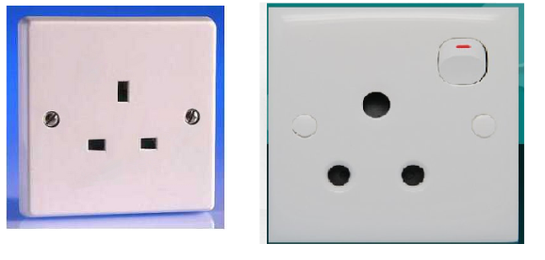
13. CLIMATE OF COLOMBO, SRI LANKA DURING NOVEMBER/DECEMBER
Parameter | November | December
Normal Minimum Temperature | 23.2 ⁰ C | 22.8 ⁰ C
Normal Maximum Temperature | 30.1 ⁰ C | 30.3 ⁰ C
Monthly normal rainfall | 314.4 mm | 175.3 mm
Number of Rainy Days | 15 | 10
Normal Humidity | 75-85% | 70-80%
Generally Inter-monsoon conditions prevails over the country during the month of November and early December and it characterized by afternoon thundershowers. Climatological normal for the month of November/ December in Colombo are as follows:

15. TIME ZONE: The Sri Lanka Standard Time is UTC+5.30.

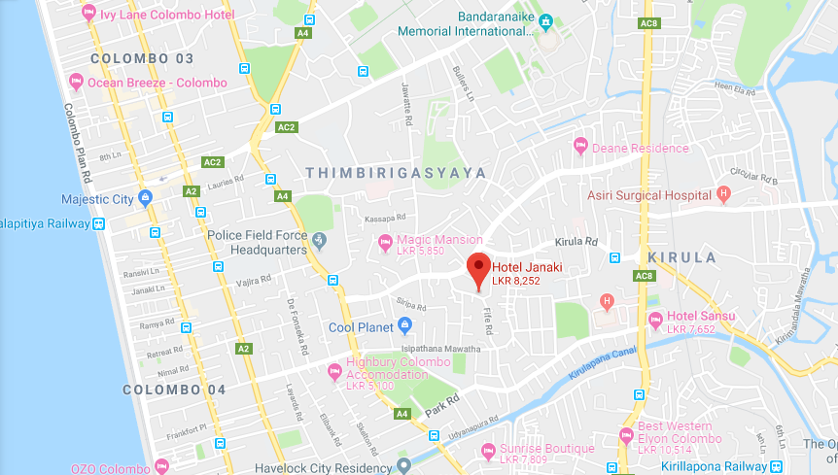
16. LOCATION MAP

Annex

WMO’s Severe Weather Forecasting Demonstration Project (SWFDP)
Regional Subproject for Bay of Bengal (SWFDP-BoB)
Meeting of the Regional Subproject Management Team (RSMT)
(28 November to 1 December 2018)
&
Regional Training Workshop on Severe Weather and Impact Based Forecasting and Warning Services
(3-8 December 2018)

Venue: Hotel Janaki, No 43, Fife Road, Havelock Road, Colombo 5, Sri Lanka

Bio Data Form

1. | Country:
2. | Service or Organization:
3. | Family Name (Dr/Mr/Ms):
4. | Given Name:
5. | Designation
6. rt | Passport Number
7. | Office Address:
8. | City with Zip code
9. | Telephone:
10. | Mobile:
11. | Fax:
12. | Email:

​

