WORLD METEOROLOGICAL ORGANIZATION  COMMISSION FOR BASIC SYSTEMS  OPAG on DPFS  MEETING THE REGIONAL SUBPROJECT MANAGEMENT TEAM (RSMT) OF THE SEVERE WEATHER FORECASTING DEMONSTRATION PROJECT (SWFDP) IN BAY OF BENGAL  Colombo, Sri Lanka,  28 November – 1 December 2018 |  | WDS-DPFS/RAII-SWFDP-BoB-RSMT/Doc.5  (23.XI.2018)  _______  Agenda item : 5  ENGLISH ONLY

Satellite data-processing systems and products for nowcasting and very short-range forecasting in RA II especially for Bay of Bengal (South Asia)

(Submitted by IMD, CMA, JMA and WMO)

Summary and purpose of document

This document provides information about satellite data-processing systems and products for nowcasting and very short-range forecasting in RA II especially for Bay of Bengal (South Asia)

Action Proposed

The meeting is invited to take notes on the report and make comments as appropriate.

Annex(es): - …….

Reference(s): - …….

- Contribution by India

At present IMD is receiving and processing meteorological data from two Indian satellites namely INSAT-3D & INSAT-3DR. INSAT-3D launched on 26 July 2013 is positioned at 82°E and INSAT 3DR launched on 28th Aug 2016 is located at 74°E. INSAT-3D and INSAT-3DR have an advanced imager with six imagery channels {Visible (0.55-0.75 µm), Short wave Infra-Red (SWIR) (1.55-1.70 µm), Medium Infra-Red (MIR) (3.80-4.00 µm), Thermal Infra-Red-1(TIR-1) (10.2-11.3 µm), TIR-2 (11.5-12.5 µm), & WV (6.50-7.10 µm)} and a nineteen channel sounder (18 IR & 1 Visible) for derivation of atmospheric temperature and moisture profiles. It provides 1 km. resolution imagery in visible band, 4 km resolution in IR band and 8 km in WV channel.

At Present about 48 nos. of satellite images are taken daily from INSAT-3D and INSAT-3DR. Images from imager data are available every 15 minutes and Sounder multi-level imagery is obtained half hourly from the sounder channels of INSAT-3D and INSAT-3DR satellites in staggered mode. All the received data from the satellite are processed and archived in National Satellite Data Center (NSDC), New Delhi. INSAT-3D Meteorological Data Processing System (IMDPS) is processing meteorological data from INSAT-3D and INSAT3-DR that supports real time satellite based monitoring of severe weather events. Cloud Imagery Data are processed and available to SWFDP.The following products derived from the satellite are useful for monitoring of severe weather:

- Enhanced grey scale imagery of cyclone.
- Enhanced coloured imagery of cyclone.
- Lower level Vorticity
- Upper level Divergence.
- Lower level convergence.
- Vertical wind shear.
- Wind shear tendency.
- Outgoing Long wave Radiation (OLR) at 0.25⁰X0.25⁰ resolution
- Quantitative Precipitation Estimation (QPE)
- Sea Surface Temperature (SST)
- Cloud Motion Vector (CMV)
- Water Vapour Wind (WVW)
- Upper Tropospheric Humidity (UTH)
- Temperature, Humidity profile
- Value added parameters from sounder products
- Geo-potential Height
- Layer Precipitable Water
- Total Precipitable Water
- Lifted Index
- Dry Microburst Index
- Maximum Vertical Theta-E Differential
- Wind Index

With the Web Archival System developed at IMD, INSAT-3D and 3DR products & imageries are archived and accessible to SWFDP member countries.
The real time satellite products as well as archived products are available in a separate web page of IMD website with the link, http://satellite.imd.gov.in/insat.htm.

Real time Analysis of Products & Information Dissemination called RAPID is a web based quick visualization and analysis tool for satellite data and products. This tool was conceptualized and developed by Satellite Application Centre (SAC), ISRO in collaboration with India Meteorological Department (IMD), New Delhi to enhance the visualization and analysis of INSAT Meteorological Satellite data on real time basis by the forecasting community. This system is operationally sustained by National Satellite Meteorological Centre (IMD), New Delhi. This tool is hosted at http://www.rapid.imd.gov.in/. It is accessible to all including SWFDP member countries. The examples of image products analysis using RAPID tool are given below. It can help to derive geo-referenced information for each pixel so as to monitor severe weather and provide the nowcast.

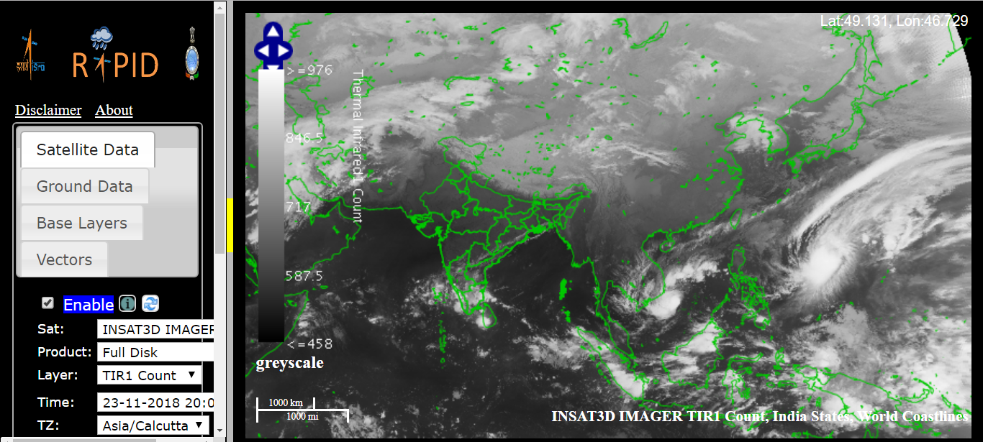

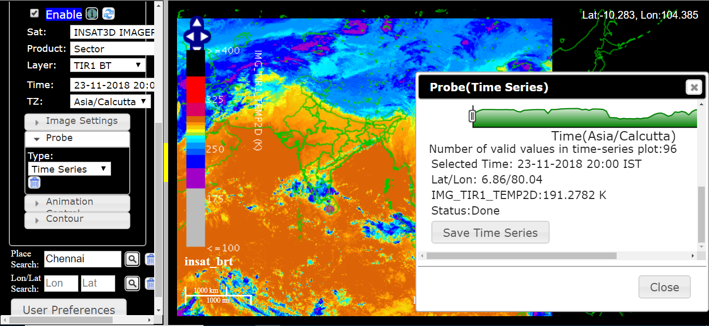

The salient features of RAPID are as follows:
➢ It connects atmospheric science and geosciences.
➢ There is no specific Operating System/ software/ library / compiler required on the desktop to access RAPID. It is accessed through web browser.
➢ It provides features of interest to scientific community
➢ RAPID follows Open Geospatial Consortium’s (OGC) open standards.
➢ Web Mapping Service (WMS) – For visualization of meteorological data (Satellite and ground observations).
➢ Extensions written for scientific community
➢ Zero learning curve
➢ It can overlay Map Boundaries (World Coastline, State, District Boundaries, Gridlines) with configurable: o Color o Opacity o Thickness o Contrast Stretch o Lookup Table Application
➢ It has Probe Data feature (on the fly) i.e. analysis of data Point, Time Series, Vertical Profile, Transect, Area Measurement, Distance Measurement
➢ Animation can be generated and visualized in it.
➢ Day and Night time microphysics RGB Composites imageries are available in it.
➢ Contouring feature over meteorological data.
➢ Map background can be changed based on user preference.

Satellite based nowcast of cloud imagery based on brightness temperature is available based on INSAT-3D through RAPID system. The product is available every half an hour for nowcast upto 3 hours at the interval of every half an hour (i.e. 30, 60, 90, 120, 150 and 180 minutes forecast). An example of 60 minute forecast is given below.
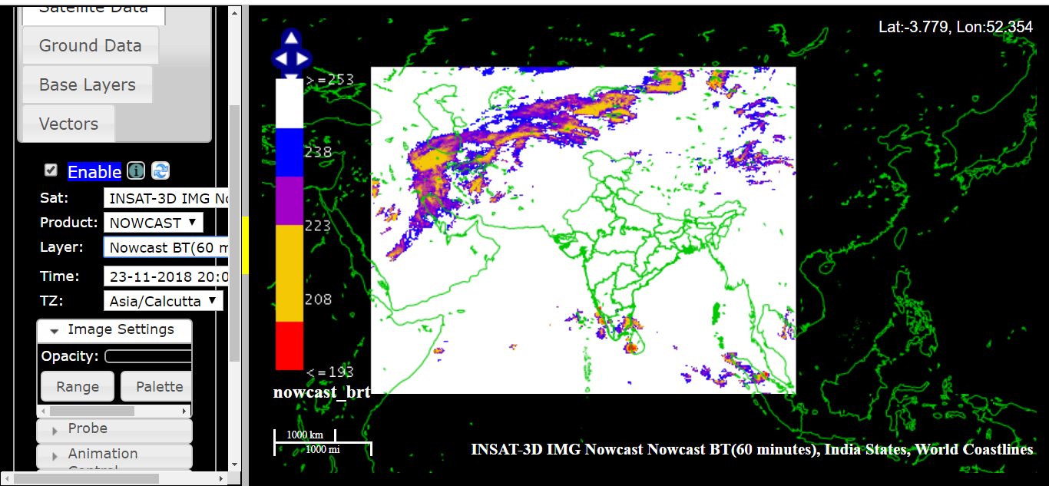

- Contribution China
CMA provided the Visible, Infra-red and Water Vapor satellite imagery products of FY-2E and FY2G for SWFDP-SeA before 2017. FY-2 series are geostationary meteorological satellite with five channels (Visible, Infra-red, Split-window, Water Vapor and Mid-infrared) .
In 2018, the satellite images for SWFDP-SeA have replaced by the geostationary meteorological satellite FY-4A. FY-4A were launched in December 2016, carrying the advanced observing functions. It is located 105° E and the time intervals of full disk are about 15 minutes.

CMA built a website (http://eng.nmc.cn/swfdp/) to provide the satellite images for the SWFDP-SeA.

FY-2H are the 8th(last) flight unit of the FY-2 series lanched in June 2018. It is located at 79° E that well suitable to supporting the Bay of Bengal (South Asia).

A Satellite Weather Application Platform(http://rsapp.nsmc.org.cn/geofy/en/) is built to provide the near-real time satellite imagery sercives of FY-2H and FY-4A for each observing band an RGB composite images. These images are updated every 15 minutes for FY-4A and every 30 minutes for FY2H, respectively.

CMA expects to support nowcasting and very short-range forecasting in RA II especially for Bay of Bengal (South Asia)

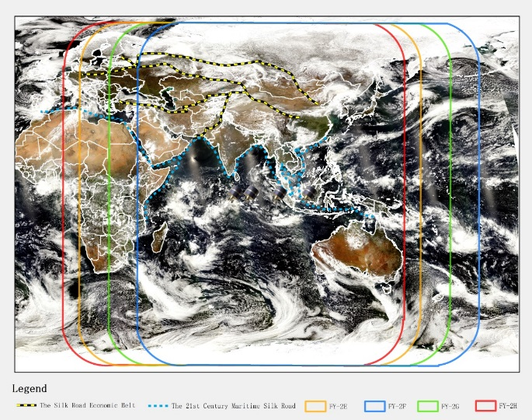
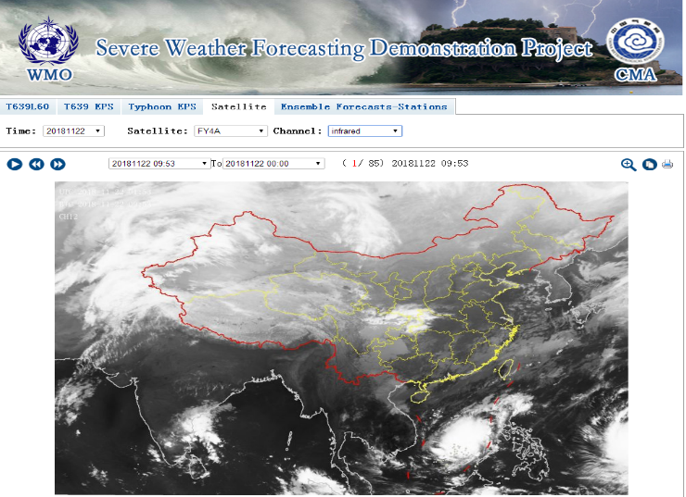
Example satellite images of FY-4A in SWFDP-SeA website and the sketch map of coverage areas for FY-2 series.

- Contribution by Japan: Himawari-8 and -9 operation and products
Himawari-8 and -9 were launched in 2014 and 2016, respectively, carrying the advanced observing functions. Both satellites are located around 140.7 degrees east, and the imagery data of the satellites is disseminated and distributed through the HimawariCast and the HimawariCloud services to the most National Meteorological and Hydrological Services (NMHSs) in the satellite observing coverage including the Bay of Bengal region [1, 2].

JMA provides satellite black-and-white images for each observing band and RGB composite images showing cloud microphysics, convective storm, airmass and dust on the Himawari Real-Time Image website [3]. These images are updated every 10 minutes.

JMA launched its new international service called “HimawariRequest” in January 2018 in collaboration with the Australian Bureau of Meteorology (AuBoM). The service enables registered NMHSs to request Target Area observations of every 2.5 minutes by Himawari-8/9 [4]. JMA expects the service to support disaster risk reduction activities in the Asia and Pacific regions.

[1] http://www.data.jma.go.jp/mscweb/en/himawari89/himawari_cast/himawari_cast.php
[2] http://www.data.jma.go.jp/mscweb/en/himawari89/cloud_service/cloud_service.html
[3] http://www.data.jma.go.jp/mscweb/data/himawari/index.html
[4] http://www.jma.go.jp/jma/jma-eng/satellite/HimawariRequest.html
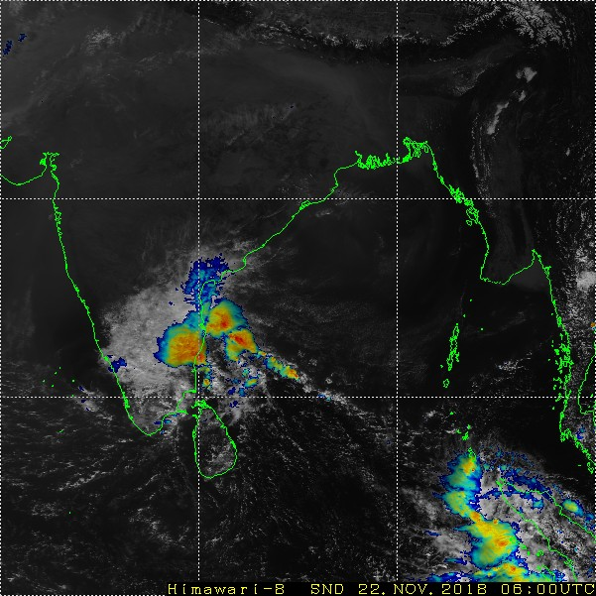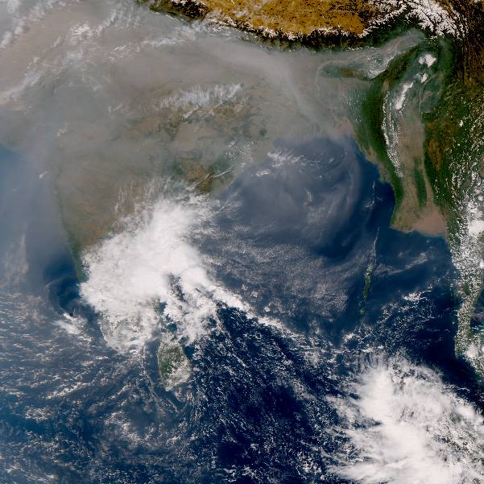
Example images on the Himawari Real-Time Image website: Sandwich (Blended Infrared - High Resolution Visible) product (left) and True Color Reproduction imagery (right; courtesy CSU/CIRA, JMA and NOAA/NESDIS) at 06:00UTC on 22 November, 2018.

- Precipitation products for Nowcasting through SCOPE-Nowcasting (Sustained Coordinated Processing of Environmental Satellite Data for Nowcasting)

The goal of the WMO Sustained, Co-Ordinated Processing of Environmental Satellite Data for Nowcasting (SCOPE-Nowcasting) initiative is to demonstrate continuous and sustained provision of consistent, well-characterized satellite products for nowcasting and severe weather risk reduction. The products for SWFDP sub-regions including for Bay of Bengal are available at: http://sigma.cptec.inpe.br/scope/

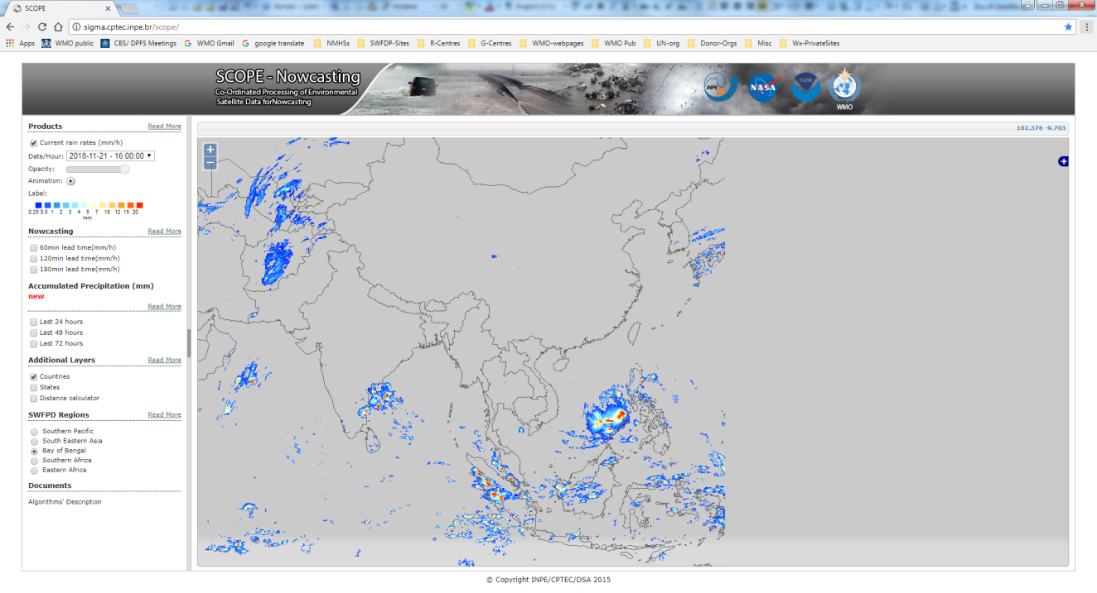

SCOPE-Nowcasting is supported by CGMS satellite operators, and aligned with a number of WMO initiatives, in particular SCOPE-CM and the Severe Weather Forecasting Demonstration Project (SWFDP). The SWFDP is focused primarily on NWP including EPS outputs and its use in severe weather forecasting and early warning services; the observational focus of SCOPE-Nowcasting has the high potential to complement and enhance SWFDP final output and thus lead to improved warning services. More on SCOPE-Nowcasting can be found at http://www.wmo.int/pages/prog/sat/scope-nowcasting_en.php.

- WMO “Guidelines for Nowcasting Techniques (WMO-No 1198)”

WMO has published “Guidelines for Nowcasting Techniques (WMO-No 1198)” to help NMHSs with information and knowledge on how to implement a nowcasting system with available resources on hand and the current state of science and technology. The publication is available on WMO website at the following link:
https://library.wmo.int/opac/doc_num.php?explnum_id=3795

