|  |  |  |  |  |
| --- | --- | --- | --- | --- |
|  | http://www.hrc-lab.org/CAFFG/images/hrc_logo_shadow.png |  |  | \\INTERNAL.WMO.INT\UserData\Redirected\asayin\Desktop\Logo IMN Costa Rica.jpg |

**First Steering Committee Meeting of the**

**Central America Flash Flood Guidance System**

**San José, Costa Rica, 3 – 5 May 2017**

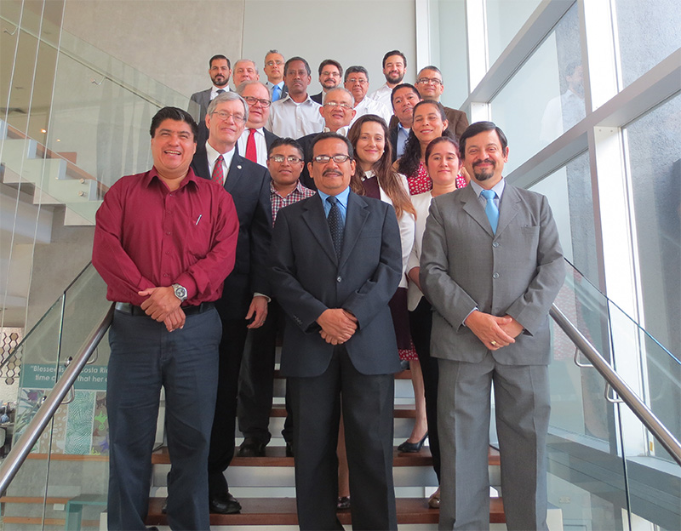

**DRAFT REPORT OF THE FIRST STEERING COMMITTEE MEETING**

**MAY 2017**

(Left blank)

**TABLE OF CONTENTS**

1. Background 4

2. Introduction 4

3. Organization and Reporting on the First Steering Committee Meeting 6

4. Proceedings of the First Steering Committee Meeting 6

5. Conclusions and Recommendations from the First Steering Committee Meeting 9

ANNEX 1 12

List of Participants 12

ANNEX 2 15

FINAL AGENDA 15

ANNEX 3 18

Project Brief 18

ANNEX 4 26

Implementation Requirements 26

Appendix A 34

Regional Centre Roles and Responsibilities 34

Appendix B 38

Data and Information Requirements 38

Appendix C 40

Real-Time Data Specifications and Information 40

ANNEX 5 41

Information on Country Real-Time Precipitation Data Preparation and Upload 41

ANNEX 6 44

List of immediate actions (responsible for implementing them) 44

First Steering Committee Meeting of the Central America Flash Flood Guidance System

San José, Costa Rica, 3 – 5 May 2017

# Background

In Central America, flash floods account for a significant portion of the lives lost and property damages that result from flooding. Given that flash floods can occur at any time or place with disastrous results, it has long been recognized that the development and implementation of a flash flood forecasting system would greatly benefit society. Accurate and timely warning of flash floods enables the mandated national authorities to undertake appropriate measures, thereby contributing to protecting the population at risk from their disastrous effects.

In 1998, Hurricane Mitch produced historical amounts of rainfall that resulted in extreme flooding and land sliding. Nearly 11,000 people were killed, over 11,000 went missing, and over 2.7 million people were made homeless. As a result of this tragedy, the US NOAA National Weather Service (US NWS) and U.S. Agency for International Development/Office of U.S. Foreign Disaster Assistance (USAID/OFDA) worked with the Hydrologic Research Center (HRC), San Diego, USA, as technical developer, in the development and implementation of a flash flood guidance system for Central America. This resulted in the first installation of system software in 2004, with upgraded hardware and software being added in 2006, and capabilities to ingest numerical weather forecasts being introduced in 2011. In 2016, upgraded software was installed that included use of microwave satellite observations and new functionality to evaluate landslide susceptibility.

This initial system stemming from 2004 has seen considerable modifications and is the forerunner of the current Central America Flash Flood Guidance (CAFFG) system. Systems similar to the up-to-date CAFFG are being implemented in several other countries world-wide, as part of WMO’s Flood Forecasting Initiative and on the basis of a 4-party Memorandum of Understanding (MoU) signed by the World Meteorological Organization (WMO), US NWS, HRC, and USAID/OFDA. The signatories have established a cooperative initiative for the Flash Flood Guidance System with Global Coverage Project. To attain global coverage, specific projects are planned and carried out on a regional basis with countries that have committed in writing to participate actively in the implementation and operation of the forecast system. The previous outlined efforts to develop the Flash Flood Guidance System for Central America have now been subsumed under the 4-party MoU, and as such will benefit from additional investments being made in the development of the standard system, a comprehensive training programme, and a new project governance structure, namely the Project Steering Committee.

# Introduction

The First Steering Committee of the CAFFG system was held at the Sheraton San José Hotel from 3 to 5 May 2017. The meeting allowed senior representatives of participating National Meteorological and Hydrological Services, along with participants from the 4-party MoU, to meet and discuss a path forward for the CAFFG system and its continued implementation and use.

In opening the Steering Committee meeting, the President of WMO Regional Association IV and Permanent Representative of Costa Rica with WMO, Mr Juan Carlos Fallas Sojo welcomed everyone to Costa Rica and highlighted the value of working together through regional cooperation particularly to improve early warning systems to help reduce the risks from hydrometeorological hazards, to promote sustainable development, and to attain and maintain economic prosperity. He indicated that this meeting was very important for setting out a clear path for Central American countries on further cooperation and solidarity to enhance their use of the CAFFG system. He also highlighted the importance of the meeting on developing an agreed-upon plan to strengthen use of the system and also presented an opportunity for Members to commit to the on-going initiative to benefit all. Given the meeting’s importance, he wished it success and indicated he was looking forward to the meetings deliberations that he hoped would result in agreement on concrete actions leading to increasing use of the system by Members.

Mr Claudio Caponi (WMO) welcomed everyone to the meeting on behalf of the Secretary-General, Mr Petri Taalas. He noted that an important aspect of effective early warning systems is outreach to people and subsequent actions taken that reduces their risk of being affected by flash floods in a disastrous way. He noted the importance of the CAFFG system for allowing this to happen. He recalled that following Hurricane Mitch in 1998, USAID/OFDA, US NWS and HRC initiated work on the CAFFG system. He recounted that at the time Dr. Georgakakos, who was a member of a working group of the WMO Commission for Hydrology, took up the challenge of showing that flash floods could indeed be forecasted. These early efforts led to the implementation of the initial system in 2004. An updated CAFFG system had been installed in 2011 and was most recently upgraded in late 2016. He noted that early work on the current CAFFG predated the partnership established through the 4-party MoU in 2009.

Mr Caponi also described the purpose of the meeting and the important role played by the project’s Steering Committee in establishing what needs to be done to improve project implementation and sustainability. He noted that a similar governance structure is used to oversee all other partnership projects currently being developed or that have been successfully implemented. He commented that this was the first such meeting for the CAFFG project and that it allows an excellent opportunity for participants to help shape the future of the project and to increase the utility of the system by participating Members. He concluded by saying that this is the opportunity for participants to build a successful path forward for their project and wished the meeting success. In closing, Mr Caponi noted that the US NWS representative, Mr Dan Beardsley, had planned to participate in this meeting, but had fallen ill and was not able to do so.

Dr Konstantine Georgakakos (HRC) indicated that he was very pleased to be part of this meeting and noted that the current Flash Flood Guidance System (FFGS) took a long time in its development. Over the years, modifications have been undertaken to improve the system and to further support forecasters predict something that is very difficult to predict. Given the difficulty in making such predictions, the forecaster should be regarded as the real “heroes” in issuing the early warnings that are provided by their National Meteorological and Hydrological Services and in cooperation with Disaster Management Agencies.

Mr Fernando Calderón (USAID/OFDA), on behalf of his Regional Director, Mr Tim Callaghan, welcomed participants to Coast Rica. He also highlighted the importance of this project and the support they provide to it. He indicated pleasure with formalizing a Steering Committee given the importance of flash flooding in the region and the damages and hardship that they cause. He noted that UAID/OFDA has many connections with national and regional organizations and greatly valued efforts such as the CAFFG system in the area of Disaster Risk Reduction (DRR). He recalled the important role of NMHS, in particular, Instituto Meteorolólico Nacional de Costa Rica, in providing accurate and timely forecasts of last year’s hurricane that allowed for successful preventative measures to be taken.

# Organization and Reporting on the First Steering Committee Meeting

The First Steering Committee Meeting (SCM-1) was attended by representatives of National Meteorological and Hydrological Services (NMHSs) from Belize, Costa Rica, El Salvador, Guatemala, Honduras, Nicaragua, and Panama, which constitute all the countries covered by the CAFFG system. Other participants included representatives from WMO, US NWS, USAID/OFDA and HRC. The list of participants is provided in Annex 1, while the annotated meeting agenda is given in Annex 2, noting that a few minor changes to the draft agenda were agreed upon by participants. The Project Brief and the Implementation Requirements document are attached as Annexes 3 and 4, respectively, and provide important background material for the system development and implementation.

All presentations made at the SCM-1 are available on the WMO website[1]. It is recommended that these presentations be consulted for all pertinent information contained therein.

# Proceedings of the First Steering Committee Meeting

***Country Presentations***

Experts from each country provided in-depth presentations on the current situation of their national services related to flash flood issues including forecasting and warnings and their use in disaster management. Presentations were made by all participating NMHSs, with five providing Power Point presentations that are on the meeting website (link provided below). Participants from Belize and Honduras provided oral presentations. The presentations and subsequent discussions revealed the similarities and differences that exist among the countries regarding their capabilities to deliver weather and flood forecasting and early warnings, especially for those pertaining to flash floods.

It was evident that the use being made of the CAFFG system varied by country, with some using it more than others, with those not actively using the system expressing interest in so doing. Some issues that were raised included:

* Need to develop better real-time rainfall data sharing with the regional centre as this is critical to improve estimation of flash flood guidance and other key products, including understanding data-sharing protocols and increasing number of stations and geographical coverage where data are to be shared;
* Need to incorporate radar data into basin precipitation estimation;
* Need to improve numerical weather prediction (NWP) modelled quantitative precipitation forecasts (QPFs) and ability to access NWP outputs for further hydrological modelling efforts;
* Need to extend modelling to larger river basins and to major urban areas;
* Need for additional training;
* Need for NWP model validation studies as modelled precipitation seems to be overestimated;
* Need for system verification studies to understand performance;
* Need to improve retention of trained staff;
* Need to improve station maintenance and spares;
* Need to deploy additional stations to improve coverage, in some cases; and
* Lack of knowledge of efforts being undertaken with participating countries on further development of the landslide component of the CAFFG system.

It was noted that CAFFG had been designed to have El Salvador run a regional Numerical Weather Prediction Model (NWP) at 6 km resolution. It provided its NWP output to the IMN of Costa Rica for use in the FFGS. From discussions, it was apparent that this dual role of modelling centres was working well. It was further noted that all 7 countries are also running local area models (LAMs) at different resolutions for severe weather forecasting, mostly centred over their countries. As one example, IMN of Costa Rica is currently running an approximate 2 km LAM, which it said could be made available to others and the FFGS.

From the presentations and subsequent discussions, it was clear that participants were wanting to improve involvement and collaboration on the FFGS to further improve their early warning capabilities.

***SWFDP and FFGS Linkages***

Mr. Abdoulaye Harou (WMO) had prepared a presentation on the Severe Weather Forecasting Demonstration Project (SWFDP) of WMO, which was given by Mr Paul Pilon (WMO). The presentation outlined the project’s objectives and goals, progress being made on some SWFDP Regional Subprojects in different areas of the world, and indicated the process to initiate the development of a SWFDP for Central America. He also briefed participants on the potential expansion of SWFDP to cover many areas of the world within next 5 years for the benefit of the developing countries. He also highlighted efforts being undertaken to integrate the SWFDP-Southern Africa with Southern Africa Region Flash Flood Guidance (SARFFG) project and prospects of potential linkages and integration of SWFDP with FFGS projects in due course over time.

The meeting noted the importance of obtaining high resolution quantitative precipitation forecasts from the cascading numerical weather prediction models of the SWFDP for use in the FFGS. Participants discussed the importance of having such high resolution numerical weather prediction model products (possibly of ~2 km resolution) over areas where hazards of flash flooding exist and where populations and infrastructure are at risk.

Participants noted their individual experiences and current operational practices in accessing products from WMO Global Centres and in running local area models. It was apparent as noted form the country presentations and subsequent discussions that there was a variety of NWP activities on-going in most of the participating countries, but that a SWFDP over Central America would be very attractive. There was interest in starting the implementation process of a SWFDP for Central America. In order to be able to make a decision based on complete information, participants suggested that it would be beneficial to hold a clarification meeting (either by teleconference or back-to-back with another regional meeting) with support from WMO that would allow participation of the most senior members of NMHSs.

***FFGS: Need for Local Data and Training***

The importance of using local data in the FFGS to calibrate model parameters was stressed, as was the need of making historical and real-time hydrometeorological data available to HRC, in particular precipitation data. It was mentioned that real-time precipitation data are used to bias-adjust satellite precipitation estimates, which greatly increases the accuracy of quantitative precipitation estimates. It was noted that there were large tracts of the project’s coverage area where no precipitation data were being transferred to the Regional Centre. Participants agreed to work on making the precipitation data available to the Regional Centre in Costa Rica. Dr Georgakakos also offered to assist and indicated that he would provide the data transfer protocols following the meeting via e-mail to all participants [note that this was done and the e-mail is provided as Annex 5].

Training was also mentioned as being an integral part of the on-going project, and extensive training would be provided to the forecasters of each participating country. The schematic diagram outlining the FFGS hydrometeorologıst training programme is shown in Appendix A of Annex 4 of this report. It was mentioned that funding from USAID/OFDA had been secured for the on-line (step 2) training, operational training at HRC (step 3) and a regional operational training (step 4). It was also indicated that the outlined training must be completed by September 2018, and training activities should commence in the near future. When the training has been completed, forecasters would be confident and competent to use FFGS products for flash flood forecasting and the provision of early warnings.

Dr Georgakakos highlighted the importance and the need to move quickly on improving the flow of real-time rainfall data from each country to the Regional Centre in Costa Rica. Should the real-time data be flowing in one month to six weeks, HRC can then develop case studies for training purposes. Having the data flow as soon as possible was imperative for development of the training material. He emphasized the need to start the data flow as soon as possible.

Dr Georgakakos also stressed to participants that it was important to have continuity of trainees throughout the steps 2-4 training process. He indicated that several people could take the on-line training, but only those with the highest grades would be invited to the step 3 training. He also commented that the step 3 training was expensive and, as such, only relatively few people could be trained from the CARFFG project. He noted that if same-sex participants were willing to share accommodations for the step 3 training, it was possibly that each country might be able to have two experts participate. He noted, as well, should countries wish to cover additional trainees, this too could be accommodated, but to a maximum of about 16-18 participants in the course at one time.

***National Centres and Regional Centre(s)***

The roles and responsibilities of National Centres of participating NMHSs and the Regional Centre(s) in a regional project were also reviewed. NMHSs have the following responsibilities: to provide historical data to the project developer, HRC; to provide in-situ data to the Regional Centre; to participate in flash flood hydrometeorological training programme; to issue flash flood warnings and disseminate them to the national Disaster Management Authority; and to cooperate with the Regional Centre on system issues. The roles and responsibilities of the Regional Centre were cited as being: to communicate effectively with WMO, HRC and NMHSs on regional system activities; to have computer hardware and software capabilities and good computer network connections; to monitor routinely the availability of the system’s products; and to conduct flash flood validation studies. Detailed information about roles and responsibilities of NMHSs and RC are provided in Annex 4 and Appendix A in this document.

It was noted that the historical implementation of the “Regional Centre” concept for the Flash Flood Guidance System in Central America had Costa Rica as hosting the computational and dissemination servers and providing some functions of a current Regional Centre. In addition, responsibilities for running the regional numerical weather prediction model and for sharing the model outputs with Costa Rica rested with El Salvador. Although it was noted that this combined responsibility had worked well, there was concern that should a natural or man-made catastrophe strike one of the two entities, the project’s participants would be without the much needed Flash Flood Guidance System. The meeting concluded that having a fully mirrored operation would contribute to greater operational security, and this could be achieved through redundancy developed over the longer term.

Participants agreed to continue the current arrangement, i.e. the Costa Rican IMN as the lead responsible for the Regional Centre and the Environmental Observatory of El Salvador as the alternate responsible, with the long-term objective, and given the current technical limitations, that the two institutions develop and maintain two mirrored versions of the system, for reasons of redundancy. The distribution of responsibilities of the CAFFG Regional Centre between the two institutions will be documented in the Tripartite Cooperation Agreement to be signed by them and WMO.

***Governance Structure***

The governance structure within the project was discussed, and it was concluded that one would be adopted that builds on existing regional governance, while supplementing it to allow full governance of the project from policy to operations. The meeting agreed that the Steering Committee responsibility for policy decisions pertaining to the project would possibly best be provided through an existing inter-governmental entity, namely the Central American Regional Committee for Water Resources (CRRH). It already has members from all the participating countries of the project, with membership residing with the Permanent Representative. Additionally, Hydrological Advisors to the Permanent Representative also participate. An advantage is the CRRH meets regularly, and any activities pertaining to policy decisions regarding the CAFFG system could be added to its agenda.

The CRRH and the project itself would be supported by a technical implementation committee composed of the national focal points and their alternates (an operational meteorologist and an operational hydrologist) for all the technical activities related to the project. The members of this technical level group would be in contact with each other and would allow smooth implementation at the technical level among National Centres and the Regional Centre(s).

The meeting agreed to have the Permanent Representative of Coast Rica with WMO, Mr Juan Carlos Fallas Sojo, raise this with the CRRH. This immediate action is captured along with other actions in Annex 6.

The meeting decided that the best way to capture the outcomes of the discussion was through the conclusions and recommendations section of this report, which is provided below in Section 5, and through an immediate actions or next steps, which is provided in Annex 6. The immediate actions or next steps were prepared to ensure it was clear who would do what immediately following the meeting. This way it was hoped that activities would flow more fluidly in attaining the desired meeting outcomes.

***Closing of the Steering Committee Meeting***

Closing remarks were made by the President of WMO Regional Association IV and Permanent Representative of Costa Rica with WMO, Mr Juan Carlos Fallas Sojo. Thanks were extended to all attendees for their active participation in the meeting and spirited involvement in the discussions, which contributed to the successful conclusion of the Steering Committee Meeting. The President also thanked Costa Rica for hosting the meeting and for the contributions of WMO through its Regional Office for their assistance.

# Conclusions and Recommendations from the First Steering Committee Meeting

*Note that the Conclusions and Recommendations were drafted and agreed upon in Spanish. The Spanish version, whch is available on the WMO webiste, should be used as the definitie text*.

The participants in the First Steering Committee Meeting of the Central America Flash Flood Guidance System (CAFFG), representatives of the 7 countries participating in the project in their capacity as experts in meteorological and/or hydrological forecasting, having examined the technical characteristics of the System, the history and current status of the CAFFG project, and discussed the various aspects related to how to improve its use in the Region, have agreed on the following:

- The CAFFG has provided a number of forecasting tools that have contributed to reducing the loss of life and suffering as well as economic losses in the region.

- The utility of the CAFFG has been increasing progressively, as new versions have been incorporating technological advances.

- However, CAFFG products are not being used optimally in some of the countries, among other reasons due to staff turnover, lack of clarity in the commitments assumed, and lack of knowledge regarding the potential of the System.

- To ensure the sustainability of the CAFFG and raise its status to a regional level, it is necessary to reach agreements on the commitments that the various countries and participating organizations are going to assume, and these agreements should be documented. Due to this, the participants propose that the Steering Committee be the Central American Regional Committee for Water Resources (CRRH), supported by a technical implementation committee composed of the national focal points and their alternates, for which, the proposal will be raised to the CRRH for confirmation.

- Participants will make arrangements upon their return to their respective countries so that their Permanent Representative (or a higher authority) sends a letter of commitment for the CAFFG project to the Secretary General of WMO, designating a focal point and alternate (an operational meteorologist and an operational hydrologist) for all the technical activities related to the project, as well as the institution acting as the National Centre for the CAFFG.

- As the performance of the system improves significantly as more information is available, participants commit to arrange that a spatially distributed reasonable number of their telemetry precipitation stations will report their data in a CSV format in near real time to the Regional Centre, if possible starting before the end of May 2017 or as soon as possible thereafter.

- Countries should carefully select their candidates (an operational meteorologist and an operational hydrologist) for the technical training associated with the Flash Flood Hydrometeorologist Training Program, to begin in the near future, and take appropriate action to ensure their proper dedication to the CAFFG, once they have successfully completed it.

- Countries should undertake related project activities, such as conducting periodical verification of system products to increase understanding of System performance in their country, and share such results with the Regional Centre.

- As for the Regional Centre, the participants agreed to continue the current arrangement, i.e. the Costa Rican IMN as the lead responsible for the Regional Centre and the Environmental Observatory of El Salvador as the alternate responsible, with the long-term objective, and in the knowledge of the current technical limitations with the technology, that the two institutions maintain two mirror versions of the system, for reasons of redundancy. The distribution of responsibilities of the CAFFG Regional Centre between the two institutions will be documented in the Tripartite Cooperation Agreement to be signed with WMO.

- In view of the current situation, a priority activity of the Regional Centre should be the validation of regional simulations of precipitation from the WRF model, to identify persistent biases and proceed with the necessary improvements.

- After being informed of the objectives of the Severe Weather Forecasting Demonstration Project (SWFDP), it is considered that there is interest in starting the implementation process in Central America. To be able to make a decision based on complete information, it is suggested to hold a clarification meeting with support from WMO.

**END**

ANNEX 1

CENTRAL AMERICA FLASH FLOOD GUIDANCE SYSTEM

**FIRST STEERING COMMITTEE MEETING**

**San José, Costa Rica, 3-5 May 2017**

List of Participants

|  |  |  |
| --- | --- | --- |
| **BELIZE** | | |
| **Mr Derrick RUDON**  National Meteorological Service  Ministry of Natural Resources and the Environment  Philip Goldson International Airport  Ladyville  Belize | Phone: +501 225 2011  E-mail: [drudon@hydromet.gov.bz](mailto:drudon@hydromet.gov.bz) | |
| **COSTA RICA** | | |
| **Mr Juan Carlos FALLAS SOJO**  Director General IMN  Representante Permanente de Costa Rica ante la OMM  Presidente de la AR IV de la OMM  Calle 17, avenida 9  San José  Costa Rica | Phone: + 506 2222 5616; + 506 2258 1140  Fax: + 506 2223 1837 E-mail: [jcfallas@imn.ac.cr](mailto:jcfallas@imn.ac.cr) | |
| **Ing. José Alberto ZÚÑIGA MORA**  Centro de Servicio Estudios Básicos de Ingeniería  Instituto Costarricense de Electricidad, Edificio de Recursos Humanos,  Bloque A, 2° piso, ala oeste, Sabana Norte  San José  Costa Rica | Phone: + 506 2000 7568; +506 2000 7309 E-mail: [jzunigam@ice.go.cr](mailto:jzunigam@ice.go.cr) | |
| **Mr Juan Diego NARANJO**  Instituto Meteorológico Nacional  Calle 17, avenida 9  San José  Costa Rica | Phone: +506 2222 5616 E-mail: jnaranjo@imn.ac.cr | |
| **EL SALVADOR** | | |
| **Mr Luis GARCIA GUIROLA**  Gerente Meteorología  Direccion General del Observatorio Ambiental (DGOA), Ministerio de Medio Ambiente y Recursos Naturales  Km. 5 1/2 Calle a Santa Tecla  Av. Las Mercedes  Instalaciones MARN  atras parque de Pelota  San Salvador  El Salvador | Phone: +503 21329671  E-mail: [lgarcia.marn@gmail.com](mailto:lgarcia.marn@gmail.com)  lgarcia@marn.gob.sv    Mobile: +503 7856 3236 | |
| **Mr Roberto CERON**  Direccion General del Observatorio Ambiental (DGOA), Ministerio de Medio Ambiente y Recursos Naturales  Km. 5 1/2 Calle a Santa Tecla  Av. Las Mercedes  Instalaciones MARN  atras parque de Pelota  San Salvador  El Salvador | Phone: +503 2132 9625 E-mail: [rceron@marn.gob.sv](mailto:rceron@marn.gob.sv)  [raceronp@gmail.com](mailto:raceronp@gmail.com) | |
| **GUATEMALA** | | |
| **Ms Monica CUETO LOPEZ**  Departamento de Investigación y Servicios Hídricos  INSIVUMEH  Guatemala | Phone: +502 2310 5041 E-mail: [mcueto@insivumeh.gob.gt](mailto:mcueto@insivumeh.gob.gt) | |
| **Ms Eva GRAMAJO PORRAS**  Meteorología  INSIVUMEH  Guatemala | Phone: +502 2310 5069 E-mail: egramajo1@hotmail.com | |
| **HONDURAS** | | |
| **Mr Martin QUAN CODINA**  Director  CENAOS, COPECO  Honduras | | Phone: +504 2229-0606 – 3397 7095  E-mail: [quan.martin@gmail.com](mailto:quan.martin@gmail.com) |
| **NICARAGUA** | | |
| **Mr Marcio BACA SALAZAR**  Director General de Meteorología  INETER  Frente a Hospital Solidaridad  Apartado 2110  Managua  Nicaragua | | Phone: +505 22492755  Mobile: +505 8288 4825; +505 8701 7643 E-mail: marcio.baca@met.ineter.gob.ni  [ayapal2000@yahoo.com](mailto:ayapal2000@yahoo.com)  [aleyda.moreno@rh.ineter.gob.ni](mailto:aleyda.moreno@rh.ineter.gob.ni) |
| **Mr Isaias MONTOYA BLANCO**  Dirección General de Recursos Hídricos  Instituto Nicaragüense de Estudios Territoriales (INETER)  Frente Hospital Solidaridad  Apartado Postal 2110  Managua  Nicaragua | | Phone: +505 2249 2756  Mobile: +505 8663 1851; +505 8701 7646  Email: [isaias.montoya@rh.ineter.gob.ni](mailto:isaias.montoya@rh.ineter.gob.ni),  [imonbla@yahoo.com](mailto:imonbla@yahoo.com), |
| **PANAMA** | | |
| **Mr Roberto MARTINEZ TEJADA**  Dirección de Hidrometeorología  ETESA  Panamá | | Phone: +507 501 3837 – 6678 9284 E-mail: [rmartinezt@etesa.com.pa](mailto:rmartinezt@etesa.com.pa)  [roberto.martinez06@gmail.com](mailto:roberto.martinez06@gmail.com) |
| **Mrs Ricardina DIAZ ZANARDO** Dirección de Hidrometeorología  ETESA  Panamá | | Phone: +507 501 8938 – 6234 2887  E-mail: [rdiazz@etesa.com.pa](mailto:rdiazz@etesa.com.pa)  ricardinadiaz@gmail.com |

|  |  |  |
| --- | --- | --- |
| **WMO** | | |
| **Mr Oscar ARANGO**  WMO Representative for North and Central America and the Caribbean  Apartado postal 7-3350-1000  San José  Costa Rica | | Phone: +506 22582370  Fax: +506 22568240  E-mail: [oarango@wmo.int](mailto:oarango@wmo.int) |
| **Mr Claudio CAPONI**  Chief, Capacity Building in Hydrology and Water Resources Division  World Meteorological Organization  7bis, avenue de Paix,  Case Postale No. 2300  1211 GENEVA 2  Switzerland | | Phone: +41 (0)22 730 84 07  Fax: +41 (0) 22 730 80 43  E-mail: [ccaponi@wmo.int](mailto:ccaponi@wmo.int) |
| **Mr Federico GOMEZ**  National Officer, WMO Office for North and Central America and the Caribbean  Apartado postal 7-3350-1000  San José  Costa Rica | | Phone: +506 22582370  Fax: +506 22568240  E-mail: [fgomez@wmo.int](mailto:fgomez@wmo.int) |
| **Mr Paul PILON**  Chief, Hydrological Forecasting and Water Resources Division  World Meteorological Organization  7bis, avenue de Paix,  Case Postale No. 2300,  1211 GENEVA 2  Switzerland | | Phone: +41 (0) 22 730 83 58  Fax: +41 (0) 22 730 80 43  E-mail: [ppilon@wmo.int](mailto:ppilon@wmo.int) |
| **USAID** | | |
| **Mr Fernando CALDERÓN**  Disaster Risk Management Specialist / Especialista en Gestión de Riesgo de Desastres International Resources Group (IRG) of RTI  Regional Disaster Assistance Program / Programa Regional de Asistencia para Desastres Office of U.S. Foreign Disaster Assistance (USAID /OFDA). Latin America and the Caribbean  San José, Costa Rica | Phone: +506-2290-4133 ext. 125 /  Directo +506-2519-2445  Cel: +506-8315-8315 Costa Rica  Fax: +506-2231-6805  E-mail: [fcalderon@ofda.gov](https://mail.ofda.gov/owa/redir.aspx?REF=D_I04Skm97wDVEgaB8BWbEXCfZnlP0nBklMmXqlX4jTfLfsRZYrTCAFodHRwczovL21haWwub2ZkYS5nb3Yvb3dhL3JlZGlyLmFzcHg_UkVGPUFkRGxkZFcwOG1WcXl6OTV1b1cwQUtFTWNjcWR6VU5EenVjMmRqZDhMZllfRWMwYlJvclRDQUZ0WVdsc2RHODZabU5oYkdSbGNtOXVRRzltWkdFdVoyOTI.) | |
| **HRC** | | |
| **Dr Konstantine GEORGAKAKOS**  Hydrological Research Centre (HRC)  Director  11440 West Bernardo Court, Suite 375  SAN DIEGO, CA 92127  USA | Phone: +1 858 798 9440  E-mail: kgeorgakakos@hrcwater.org | |

ANNEX 2

|  |  |  |  |  |
| --- | --- | --- | --- | --- |
|  | http://www.hrc-lab.org/CAFFG/images/hrc_logo_shadow.png |  |  | \\INTERNAL.WMO.INT\UserData\Redirected\asayin\Desktop\Logo IMN Costa Rica.jpg |

**First Steering Committee Meeting of the Central America Flash Flood Guidance System(CAFFGS)**

**3 - 5 May 2017, San Jose, Costa Rica**

FINAL AGENDA

**Day 1**

09:00–09:30 Registration of participants

09:30–09:45 Opening remarks by Director General of IMN

09:45–10:00 Welcome speech by WMO

10:00–10:15 Welcome speech by HRC

10:15–10:30 Overview and purpose of the meeting (WMO)

10:30–10:45 Photo Session

***10:45 - 11:15 Coffee Break***

11:15-11:30 Role of WMO and Introduction to the global Flash Flood Guidance (FFG) System (WMO)

11:30-11:45 Role of HRC and Introduction to the FFGS concept *(*HRC)

11:45–12:00 Roles of USAID/OFDA and US NWS *(*USAID*/*OFDA*,* US NWS)

12:00-13:00Country-presentations[2] on flash flood issues – forecasting and warnings and their use in disaster management (NMHSs)

* The nature of the flash flood problem(s) and their impacts;
* The roles of interactions of various agencies including disaster management (in forecasting flash floods, disseminating their warnings, and in informing emergency response);
* How the CAFFGS and its products are specifically being used in developing early warnings of flash flooding
* How are meteorologists and hydrologists cooperating in the development of flash flood forecasts and warnings
* Perceived gaps and weaknesses in the CAFFGS project in general.

***13:00-14:00 Lunch***

14:00-15:00 Country-presentations on the nature of flash flood problems, roles of agencies, use of products, and perceived gaps and weaknesses (Continued)

15:00-15:30Overview of CAFFG Project (HRC)

***15:30-16:00 Coffee Break***

16:00-16:15 The role of the existing regional centre at IMN in providing information and interacting with the NMHSs participating in the CAFFG project (Regional Centre, IMN)

16:15-16:30 The status of the existing WRF implementation in El Salvador and potential for providing information and interacting with CAFFG participating NMHSs (El Salvador)

19:00 Welcome Reception

**Day 2**

09:00-09:15 Summary of Day 1

09:15-10:00 Overview of upgraded CAFFGS products: Forecasters Console and Dashboard (HRC)

10:00-10:30 Brief Overview of upgraded CAFFGS Products and Developments (HRC)

* + - Precipitation and Bias Adjustment
    - Soil Moisture
    - Flash Flood Guidance
    - WRF LAM Implementation and Forecast
    - Flash Flood Threats
    - Baseline Threat Products
    - Landslide Hazard Assessment Products

***10:30-11:00 Coffee Break***

11:00-11:30 Brief Overview of upgraded CAFFGS Products and Developments (HRC) (Continued)

11:30:12:00 Advances in FFGS Functionality under development (HRC)

* + - Multi-model NWP Ingestion
    - Landslide Susceptibility Mapping
    - Riverine Routing
    - Urban FFEWS

12:00-12:30 Flash Flood Hydrometeorlogist Training Programme (HRC)

***12:30-14:00 Lunch***

14:00-14:30 Verification Studies (WMO)

14:30-15:30 Severe Weather Forecast Demonstration Project – Central America (WMO)

***15:30-16:00 Coffee Break***

16:00-16:30 Round-Table 1: Discussion on Perceived Gaps and Weaknesses of Project (WMO led, All)

16:30-17:00 Historical and Real-time Data used for the upgraded FFGS Implementation (HRC)

**Day 3**

09:00-09:15 Summary of Day 2

09:15-09:30 Organizational and Management Aspects of the Project (WMO)

09:30-10:00 Responsibilities of the Regional Centre and NMHSs Revisited (WMO)

10:00-11:00 Round-Table 2: Discussion of National and regional professional and technical capacities needed for project operations including cooperation of meteorologists and hydrologists (All)

***11:00-11:30 Coffee Break***

11:30-12:00Next steps and training plan (HRC)

12:00-12:30Implementation Plan Development/Plan of Action (All)

***12:30 – 14:00 Lunch***

14:00-15:30 Implementation Plan Development/Plan of Action (continued)

15:30-16:00 Coffee Break

16:00-16:30 Next Steps

16:30-17:00 Final remarks and closing of the workshop (All)

------End of Meeting------

ANNEX 3

|  |  |  |  |  |
| --- | --- | --- | --- | --- |
|  | http://www.hrc-lab.org/CAFFG/images/hrc_logo_shadow.png |  |  |  |

**Development and Implementation of International and Regional Flash Flood Guidance (FFG) and Early Warning Systems**

Project Brief

**Central America Flash Flood Guidance (CAFFG) System**

**April 2017**

**SUMMARY**

The purpose of this project is the development and implementation of regional flash flood guidance and early warning systems. The approach will entail development of regional technology, training, protocols and procedures to address the issues of mitigating the impacts of flash floods and the application of such a system allowing the provision of critical and timely information by the National Meteorological and Hydrological Services (NMHSs) of the participating countries.

To accomplish this, the World Meteorological Organization (WMO) will cooperate with the Hydrologic Research Center (HRC), San Diego, USA to implement a flash flood guidance and early warning system designed along the lines of similar systems that have been made operational in different parts of the world. In cooperation with a designated Regional Centre, normally located within one of the participating countries, the project will be executed by the participating national hydrometeorological services with the HRC providing technical assistance in cooperation with NOAA/National Weather Service for the system implementation and training; and WMO providing technical backstopping and supervisory services including Monitoring and Evaluation of the project. USAID/OFDA is providing funding support for the project.

Specifically the countries to be included in the project are proposed to be the followings: **Belize**, **Costa Rica**, **El Salvador**, **Guatemala**, **Honduras**, **Nicaragua**, and **Panama**.

Based on estimation of rainfall from satellite imagery and available gauges, the system will provide the NMHS of each participating country with an estimate of the precipitation amount and an indication (guidance), based on physically-based hydrological modelling, as whether it would generate a bankfull discharge (e.g., minor flooding) at the outlets of small, flash flood prone basins throughout each country. The NMHSs will integrate local knowledge from other sources (their national networks, observers report, etc.) to validate the guidance and issue as required a warning through channels proper to each country.

Technical assistance includes the development and implementation of the flash flood guidance and warning system as well as research and development into system enhancements, including inclusion of infrared and microwave technology for satellite rainfall estimates, as needed for the different implementations, and training and capacity building on system operations and applications to disaster risk reduction (i.e., an end-to-end system approach). The approach will provide a tool for each country within the specified region to access the data and information needed to develop alerts and warnings for flash floods.

***The main objective of this project is, therefore, to contribute towards reducing the vulnerability of the region to hydrometeorological hazards, specifically flash floods, by developing and implementing a flash flood guidance system to strengthen regional and national capacity to develop timely and accurate flash flood warnings.***

**1. Beneficiaries**

In many areas of the world, flash floods are a regular phenomenon accounting for loss of human life and significant economic and social damages, adding up to hundreds of millions of Euros for a single event. Flash floods can affect not only mountainous and hilly rural areas with sparse settlements but also major urban areas. In addition, an increase in their frequency and magnitude is anticipated as a consequence of climate change. Implementation of a flash flood guidance system would provide benefits to all societal and economic stakeholders of each country.

A key benefit of the proposed system is that it is capable to provide early awareness of impending local flash flood threats for all potentially vulnerable communities. A true value of the system will be to provide rapid assessments of the potential of flash floods allowing improvement of the early warnings for the occurrence of a flash flood and therefore allowing for more rapid mobilization of response agencies.

The system implementation also provides capacity building and cooperation for effectively mitigating disasters from flash floods. Training and capacity building will be a strong component of the implementation of this program. There will be opportunities in cross-training of hydrologists and meteorologists from countries within the region and with different backgrounds and skills in hydrometeorology, which forms the basis of flash flood detection and prediction.

The availability of the system guidance products will also help to improve the way flash flood events on transboundary rivers are addressed, encouraging international technical cooperation and regional cooperation in preparing public awareness campaigns and response strategies.

Primarily aiming to improve national service delivery capabilities to deal with flash flood threats, the implementation of the flash flood guidance system will also provide the opportunity for enhancement of regional collaboration of disaster mitigation and response agencies and improvement of community awareness of flash flood disaster threat and mitigation.

Training programs will be designed to include NMHSs to develop strong scientific and technical capabilities to use the FFG system and further to include disaster management agencies where the responsible agencies will be involved in system validation programs which will require determinations of where flooding did or did not occur. The issuing of warnings based on flash flood guidance and flash flood threat products will conform to establish national practices, if existing; alternatively the project could provide support to a national dialogue for their development. The establishment of such criteria requires understanding of the hydrometeorological processes and prediction uncertainties, as well as capabilities of the population to take effective action. Such a process will encourage the national agencies to interact with local communities both in establishing such criteria, and in regular reviews of their effectiveness. The responsible agencies will need to design awareness campaigns for both municipal agencies and the public at large concerning the interpretation of flash flood warnings and effective action strategies (i.e., what to do in when flash flood warnings are received). To be effective, this effort will require input from local community representatives (emergency response agencies and the public at large). Maintaining these public awareness campaigns and information distribution as ongoing efforts required to reduce flash flood casualties will be needed.

The flash flood guidance system functions at one level as a disaster mitigation tool by mitigating loss of life and livelihoods, and by rapidly targeting disaster response agencies to potential problem areas. On another level it can be used to provide maps of flash flood probabilities, threats and decision-aiding for imminent actions. These maps can be used to provide a risk assessment tool and guidance concerning the development of infrastructure – that is, as a guide to where special care should be taken in the design and locations of particular facilities as the population expands to live in flash-flood prone areas.

All these agencies will be involved in system validation programs which will require determinations of where flooding did or did not occur. To be effective, this effort will also require input from local community representatives (emergency response agencies and the public at large).

**2. Sector-Level Coordination**

Through the project partners representing the technical aspects of the system implementation and operation will be brought together with agencies in disaster risk reduction to develop a detailed work plan that will enable operational engagement of technical and disaster risk reduction agencies for implementation of the system.

The work plan for disaster risk reduction will address activities such as joint training programs and public outreach and awareness programs. This effort will provide the opportunity for enhancement of regional collaboration of disaster risk management agencies and improvement of community awareness of flash flood disaster threat and mitigation. Training programs will be designed to include NMHSs and the disaster management agencies.

**3. Technical Design**

Flash floods are a hydrometeorological phenomenon that requires (a) integration of meteorology and hydrology in real time and (b) ingestion of local information and expertise for reliable warnings. The system design aims to allow for both. This system will serve as a catalyst to develop protocols in line with regional and country norms pertaining to other event warnings. The system allows that even within a region different countries will develop their own manner of system configuration and use adapted to local requirements as a tool for developing flash flood warnings and watches together with other local timely information.

Important technical elements of the Flash Flood Guidance and Warning System are the development and use of a bias-corrected satellite precipitation estimate field, high-resolution numerical weather prediction model outputs (where available), and physically-based hydrological modelling to determine flash flood guidance and flash flood threat. These system elements can now be applied anywhere in the world. Real-time estimates of high resolution precipitation data from satellite are now routinely available globally (and can be further enhanced with locally available radar estimates of precipitation). Global digital terrain elevation databases and geographic information systems may be used to delineate small basins and their stream network topology anywhere in the world. In addition, there are global soil and land cover spatial databases available to support the development of physically-based soil moisture accounting models (see flow chart in Figure 1). The real-time satellite precipitation estimates needed to drive the regional systems on a global scale (using global data provided by NOAA and the WMO) will be developed first followed by the development of specialized products.

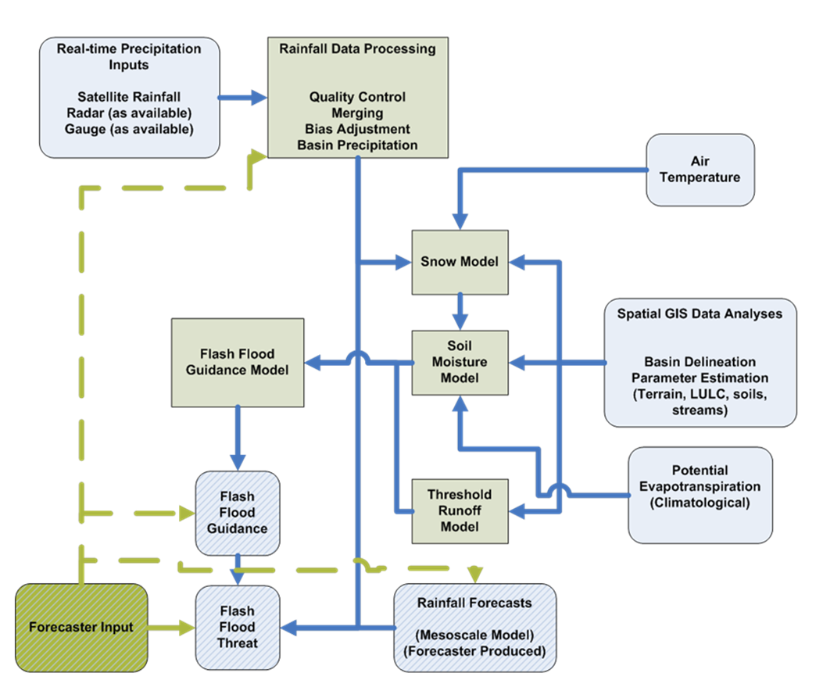

**Figure-1 Schematic Flow Chart of the Flash Flood Guidance System**

The system allows the NMHSs to use local nowcast/short-term-forecast methods they wish to use to issue the warnings, including (and strongly recommended) local forecaster adjustments. The system design allows this coupling with the existing or developing NMHS approaches on a national or even local scale.

System flexibility and system capability to engage local forecasters should help greatly towards the development of regional/local protocols for integration within existing warning dissemination systems.

The system will provide evaluations for the threat of flash flooding over time scales of hourly to six hours and for basins on the order of 150 sq. km. Given the computational burden and depending on available computational resources, it is very likely that the most valuable lead times for system use will be 3 - 6 hours. Efforts might also be undertaken through the application of numerical weather prediction model outputs to extend the range of threat prediction to 48 hours.

## 4. Implementation Approach

## The system design is such that it allows for efficient global data ingest and it supports regional cooperation among NMHSs. The design is characterized by distributed operations and functions. Several centres of computation and product dissemination will support the operational functions of the NMHSs through the timely provision of data, software, hardware and training. The overall organizational structure is shown in Figure-2.

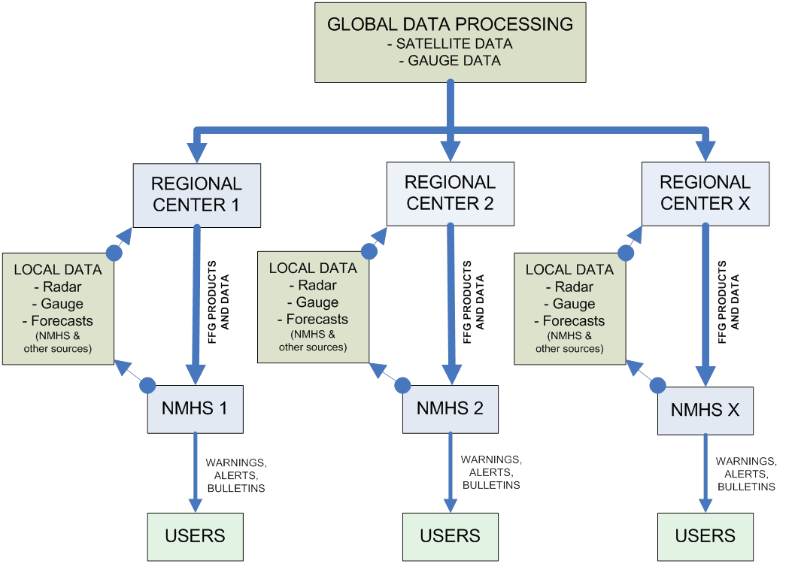

**Figure-2 Flash Flood Guidance and Warning System as a distributed system of computer hardware, data and information to support NMHSs worldwide.**

The interface with global information is the link to real-time global satellite precipitation estimates and global in situ observations will be through one or more of the World Meteorological Organization (WMO) Global Centres.

All requisite real-time data (global, regional, and local) are ingested at servers located at the Regional Centres where the FFG software is installed. Graphical and text products are then provided to the participating countries through a secure internet connection.

It is necessary to designate a focal institution (most probably an NMHS or an existing Regional Centre with proven scientific and technical capabilities) and with existing communications and infrastructure capabilities to support a Regional FFGS centre. Key operational Regional Centre responsibilities are:

* Disseminate real-time country graphical products from the FFGS for the NMHSs in the region;
* Collect available real-time local meteorological data for ingest to the FFGS for the development of regional products;
* Support regional flash flood operations by;
  + Provide regional validation of products and formulation of plans for improvements, and
  + Provide communications for system analyses to NMHSs of the region.
* Provide communications of regional system modifications necessary to system developers;
* Develop a historical archive of the system products;
* Support WMO and developers with regional training of NMHS representatives; and,
* Provide routine maintenance and IT support for the FFGS server.

NMHSs functions pertaining to the use of the flash flood guidance and warning system will include: country hydrometeorological analysis using the system products and information and other local products and information; country modifications of the regional-centre flash flood guidance and precipitation nowcasts on the basis of within-country most-recent data and information; development of local flash flood watches and warnings; monitoring of system performance (availability and effectiveness) and feedback to the regional centre; and links to within-country disaster management agencies for effective disaster risk reduction. Resources of country NMHSs will determine the actual configuration and type of software used in each case, given the provision of within-country baseline software and links to regional centre facilities as discussed previously.

It is expected that the products available from the Regional Centre will be adequate to support a range of processing capabilities at the NMHSs, from those that can be performed on a PC with Excel software to those that support interactive graphical generation of products. This provision will allow the NMHSs of all the countries to develop real time flash flood forecasts and watches/warnings using the global-data information and their local data and information. There will also be a provision for countries that are willing to share local real-time data to produce graphical products and updated guidance information for their areas to complement the locally produced products with the baseline configuration mentioned.

One key to sustainability is confidence in a reliable, accurate system. To accomplish this, reliability evaluations will be included in the concept of operations.

**5. Transition and Exit Strategy**

Upon completion of the project, each country within the region will have access to the flash flood guidance and early warning system data and products via the internet. The required data will be accessed and processed through the regional facilities. At the country level only a PC and internet connectivity will be required to access the data and products required to evaluate potential flash flood threat, making the system very sustainable. The regional centres will be selected based on resource requirements to ensure appropriate access to the required data and maintenance capacity.

Much of the effort to ensure sustainability of the flash flood guidance and early warning system will be through training and cooperative development efforts. This approach is intended to ensure ownership and full operations responsibility. In addition, a concept for the operation of the system within the existing operations protocols of the countries will be outlined for each country during training. A User Guide will be developed for the Regional Centre for system operations and maintenance.

**6. Project Implementation**

Project implementation is based on the basis of a Project Implementation Plan (PIP) that will be discussed during the initial regional planning meeting. The Plan will provide information with regard to essential requirements and criteria that need to be met for the successful implementation of the project. These requirements include: Availability and accessibility of critical input data and information including geo-spatial information, historical and near real-time meteorological and hydrological data, basic institutional infrastructure and technical/professional expertise of participating meteorological and hydrological services.

The PIP including a work plan will be discussed during the initial planning meeting with principal stakeholders and beneficiaries of the project.

## 7. Institutional Status

## In February 2009, WMO signed a Memorandum of Understanding (MoU) with USAID/OFDA, HRC, and NOAA on the implementation of the Flash Flood Guidance System with global coverage project. In June 2012, the MoU was renewed until the end of 2017. Funding is available from USAID/OFDA as the principal donor organization.

As a result of the expression of interest of participating countries of Central Americain the Flash Flood Guidance System, an initial planning meeting has been arranged. This meeting will allow:

* Country experts to see first-hand the technical components of the FFG system;
* Country experts to assess the potential utility of adopting such a system within their operations;
* Understanding of the requirements of national centres and the regional centre;
* Understanding of national implementation requirements including professional staff;
* Understanding of the regional and national primary data collection required for the initiation of the project; and
* Countries to consider the overall project and whether each wishes to commit to undertaking and supporting the implementation of the project in Central America.

Should countries wish to commit to the implementation of the project, countries would then decide on their national centres and the regional centre.

## WMO in collaboration with financial, technical and regional partners now plans to organize the initial planning meeting where interested countries through the Permanent Representatives of WMO Members and their Hydrological Advisors or designated alternates are expected to discuss all aspects of the proposed project and eventually express whether they commit to participate and cooperate in the project activities and provide technical information that is critical for the successful implementation of the project in the region.

Aside from the commitments made by participating national agencies, it will be essential to have full details available on issues such as in-kind contributions through infrastructure and personnel, areal information specifying the area(s) to be covered by project activities in the region, availability of supporting data and information including geospatial and historical hydrometeorological information. Likewise, the governance of the project and the roles and responsibilities of national participating centres and a Regional Centre will be on the agenda of discussion with expected recommendations and decisions to be made during the meeting. This will be compiled through information received from countries and services on the basis of a Requirements Document to be developed.

The project will be phased over a period of several years that will be determined during the initial planning meeting, with the bulk of the development and implementation activities occurring during the first year to two years. The remaining years of the project will focus on training, system operations/evaluation and validation of system outputs to ensure on-going sustainability.

______________

ANNEX 4

|  |  |  |  |  |
| --- | --- | --- | --- | --- |
| http://www.hrc-lab.org/CAFFG/images/hrc_logo_shadow.png |  |  |  |  |

**Global Flash Flood Guidance System**

Implementation Requirements

**Regional Implementation Requirements for the Central America Flash Flood Guidance (CAFFG) System**

**May 2017**

**Document Purpose**

This document provides guidance to project participants, in particular National Meteorological and Hydrological Services (NMHSs) on minimum requirements with respect to professional capabilities, availability of data and information as well as computational and communication infrastructure to implement a **Flash Flood Guidance System (FFGS)** with global coverage. In addition, the document provides information of the functions of the Regional Centre and NMHSs leading to the delivery of flash flood guidance products on regional and national levels.

These requirements reflect a system that provides timely and useful data and information based on robust communication infrastructure in a form that is consistent with the operations in place in many of the National Meteorological and Hydrological Services (NMHSs) throughout the world. Of primary importance is to establish a system that becomes part of NMHS operations and is used as the primary tool by these services for providing flash flood alerts/warnings to the appropriate agencies and/or the public.

**Overview of the FFGS**

The primary purpose of the FFGS is to provide real-time informational guidance products pertaining to the threat of potential flash flooding. The system is designed to address the reduction in devastation caused by flash floods in terms of reductions in the loss of life, suffering and property damage. The system provides the necessary products to support the development of warnings for flash floods from rainfall events through the use of remote sensing-based rainfall estimates (primarily satellite).

The system products outputs are made available to forecasters as a diagnostic tool to analyze weather-related events that can initiate flash floods (e.g., heavy rainfall, rainfall on saturated soils) and then to make a rapid evaluation of the potential for a flash flood at a location.  The system empowers users with readily accessible observed data and products and other information to produce flash flood warnings over small flash flood prone basins. The system is designed to allow the addition of experience with local conditions, incorporate other data and information (e.g., Numerical Weather Prediction output) and any last minute local observations (e.g., non-traditional gauge data), to assess the threat of a local flash flood. Generally, evaluations of the threat of flash flooding are done over hourly to six-hourly time scales for sub-basins from 100 - 150 km2 in size.

Important technical elements of the FFGS are the development and use of a precipitation gauge-based bias-corrected satellite precipitation estimate field and the use of hydrological modelling. The system then provides information on rainfall and hydrological response, the two important factors in determining the potential for a flash flood. The system is based on the concept of **Flash Flood Guidance** and **Flash Flood Threat.** Both indices provide the user with the information needed to evaluate the potential for a flash flood, including assessing the uncertainty associated with the data.

The flash flood guidance approach to developing flash flood warnings rests on the comparison in real time of observed or forecast rainfall volume of a given duration and over a given catchment to a characteristic volume of rainfall for that duration and catchment that generates bank full flow conditions at the catchment outlet. **Flash Flood Guidance** (FFG) is that characteristic rainfall volume for the given duration over the small catchment that generates bank full flow conditions at the catchment outlet. FFG is updated in time based on current soil water deficit (as determined by antecedent soil moisture conditions), rainfall, evaporation, and groundwater losses. If the observed or forecast rainfall volume exceeds the FFG of the same duration, this excess is termed the **Flash Flood Threat (FFT)** and flooding at or near the catchment outlet may be likely (Figure-1).

|  |  |
| --- | --- |
| 03.png | **C:\Users\dell\Desktop\Adsız 14.jpg** |

Figure-1: 6hr-Flash Flood Threat and 1-hr Flash Flood Guidance for Black Sea and Middle East FFG (BSMEFFG) System

**Global Flash Flood Guidance System Program Background**

The purpose of the Global FFGS (GFFGS) program is the development and implementation of regional flash flood guidance and early warning systems. The approach entails development of infrastructure on a global scale to then support the development and implementation of regional flash flood guidance projects comprising of technology, training, protocols and procedures components to address the issues of mitigating the impacts of flash floods.

Regional flash flood guidance and early warning systems are designed based on programs in Central America, Southeast Asia, Black Sea Middle East and Southern Africa. The project approach is to provide a tool for each country within a specified region to access the data and information needed to develop alerts and warnings for flash floods. The main objective of this project is, therefore, tocontributetowards reducing the vulnerability of people around the world to hydrometeorological hazards, specifically flash floods, by developing and implementing flash flood guidance systems to strengthen regional capacity to develop timely and accurate flash flood warnings.

The data and information part of the requirements also provides guidance with respect to the selection of areas/basins on national level that can be covered with a flash flood guidance system based on the availability of critical data and information.

Implementation of this program is in concert with the World Meteorological Organization’s Flood Forecasting initiative guided by the Hydrology and Water Resources Branch of the Climate and Water Department of WMO. In the context of this initiative, the World Meteorological Congress has endorsed the implementation of a Flood Forecasting Initiative. A goal of this initiative is to develop and implement programs that encourage hydrologists and meteorologists to work together towards the improvement of operational flood forecasting services.

The GFFGS program is being accomplished under the Memorandum of Understanding (MoU) noted below[3] through funding by the U.S. Agency for International Development/Office of U.S. Foreign Disaster Assistance (USAID/OFDA).

The system design is such that it allows for efficient global data ingest and support of regional cooperation among NMHSs. The system design is characterized by distributed operations and functions on global, regional and national levels. Centres of computation and product dissemination will support the operational functions of the NMHSs through the timely provision of data, ancillary information, software, hardware and training. A schematic of the global-regional-national system is shown in Figure-2.



Figure-2: GFFG System Schematic – Global Implementation

Implementations of regional projects are achieved through the development of an interface with the global core and with the Regional Centres. The global data core link to real-time global satellite precipitation estimates will be through the U.S. National Oceanic and Atmospheric Administration/National Environmental Satellite, Data and Information Service (NOAA/NESDIS). If required, global in situ observations will be provided through one or more of the World Meteorological Organization (WMO) Global Centres (Washington, DC; Moscow; and Melbourne) and Regional Telecommunication Hubs including Bangkok, Beijing, New Delhi and Tokyo. The primary functions of the global data ingest and processing core are to:

* Provide global data ingest and quality control;
* Access global meteorological information to supplement data collected at the regional level as needed;
* Maintain correspondence with the Regional Centres; and
* Implement computational system changes.

***The Regional Centres*** will require ***appropriate communications*** and ***infrastructure facilities*** to support operations. The proposed responsibilities of the Regional Centres are outlined in Appendix A.

**In summary, the Regional Centres responsibilities are to:**

* Disseminate real-time detailed country graphical products and/or data for the NMHSs in the region;
* Provide routine regional hydrometeorological analysis;
* Provide communications for system analyses to NMHSs of region;
* Provide communications of regional system modifications necessary to developers;
* Provide regional flash flood hazard information;
* Provide regional *validation of products* and formulation of plans for improvements;
* Provide daily *guidance discussion* to NMHSs from a regional perspective;
* Collect available *real-time meteorological data* for the development of regional products;
* Provide *regional training* of NMHSs representatives;
* Provide, if necessary, a *computational platform* for country scale real-time computations and modifications of flash flood guidance products for those NMHSs that lack adequate computational capabilities;
* Provide routine *maintenance and IT support*; and
* Develop *a historical archive* of the system products.

**NMHS functions pertaining to the use of the flash flood guidance and warning system include:**

* Develop country *hydrometeorological analysis* using the system products and information and other local products and information;
* Develop country adaptations of the flash flood guidance and precipitation nowcasts on the basis of within-country most-recent data and information;
* Develop local *flash flood watches and warnings* as required;
* Provide *data and information* to the Regional Centres (based on regional agreements);
* Monitor system (products) performance (availability and effectiveness), conduct country *verification studies* and feedback to the Regional Centres; and
* Communicate with user agencies for effective disaster risk reduction.

Resources of country NMHSs will determine the actual configuration and type of software used in each case, given the provision of within-country basic software and communication links to Regional Centres facilities.

It is expected that the products available from the Regional Centres will be adequate to support a range of desk top computer-based processing capabilities at the NMHSs, from using simple spreadsheet software to those computational facilities that support interactive graphical generation of products (much like the capability of the Regional Centres). This provision will allow the NMHSs of participating countries to develop near real-time flash flood guidance and warnings.

**Data and Information Requirements**

To ensure that the FFGS provides the highest quality data and information to forecasters, various historical and real-time hydrometeorological data and other information are required in order to develop, implement and operate the flash flood guidance systems. Historical data and information are needed for the development of the system and calibration of the models. Real-time data are needed for system operations. Terrain and other spatial-database information are used to delineate the small catchments for which flash flood guidance will be computed, to calibrate the models and to operationalize the flash flood guidance information.

It cannot be emphasized enough that quality data and information are needed to provide the optimum system for use by forecasters for the development of flash flood warnings.

Data and information needs are detailed in Appendix B. Appendix C is a survey of automatic rain gauges and weather stations. This information is important to fully understand the current status of these systems.

**Resource Requirements**

**Personnel**

The system is designed to be used operationally and jointly by meteorologists and hydrologists. The following expertise is recommended at the Regional Centres and country levels for the primary users, mainly the system operators. Recommended minimal available expertizes are given in Table-1.

**Table-1: Minimal personnel Equipment for Regional Centre and NMHSs**

| **Area of Expertise** | **Regional Centres** | **NMHSs** |
| --- | --- | --- |
| Have a meteorological and/or hydrological technical background. | Both meteorological and hydrological forecast expertise. | Either meteorological and/or hydrological forecast expertise. |
| Have experience in operational weather and/or hydrological forecasting specific to the region or country. | Priority | Priority |
| Have experience in weather-related hazard emergency management operations | Priority | Priority |
| Have experience in or knowledge of quantitative analysis of satellite-based rainfall estimates. | Priority | Preferred |
| IT capability for server system administration, network connectivity, and product availability. | Priority | Preferred |

Both the Regional Centre and the country NMHS should operate on a round-the-clock basis either continuously year-round or at the minimum during seasons with significant flash flood risk.

**Computers and Communications**

High performance servers with the LINUX operating system will be run at the Regional Centres through the project. The country NMHSs are required to have current-generation PCs and an internet connection with periphery devices in order to access products from the internet. On the other hand, the Regional Centre will need hi-speed internet service and, potentially, access to GTS/WIS.

**Training Program**

During the course of the FFG System implementation for the region, training will be provided to forecasters on the scientific basis and operations of the system. The training program is a five step blended learning model - known as the Flash Flood Hydrometeorologist Training (FFHT) Program (Figure 3). The five step program includes:

1. Introductory regional workshop;
2. eLearning program to support system operations, product interpretation, system validation, including the use, management, and interpretation of output from the system, and the development of protocols to alert response agencies and the public of an impending or existing threat. For each completed course learners earn an HRC Course Certification, once they have completed the core curriculum they are eligible for Step Three;
3. Advanced Operations and Interactive Simulator Training at the Hydrologic Research Center to assist with reviewing and assessing the operating versions of the system. Included is the Interactive Simulator training to provide the user with the skill to interpret and validate skill using real flash flood events. Upon successful completion of the Advanced Operations Training each learner earns an HRC Advanced Training Operations Certification; once they have completed this step they are eligible for Step Four;
4. Regional Operations Training Workshop – where HRC trainers in combination with Trained Regional Trainers present regional operations workshop. Upon successful completion of this stage of training Regional Trainers earn a WMO Certification as FFG trainers; and
5. Regional Operation Sustainability Workshop led by WMO certified trainers acts as refresher training in operations, overview of data requirements, system verification and user validation.

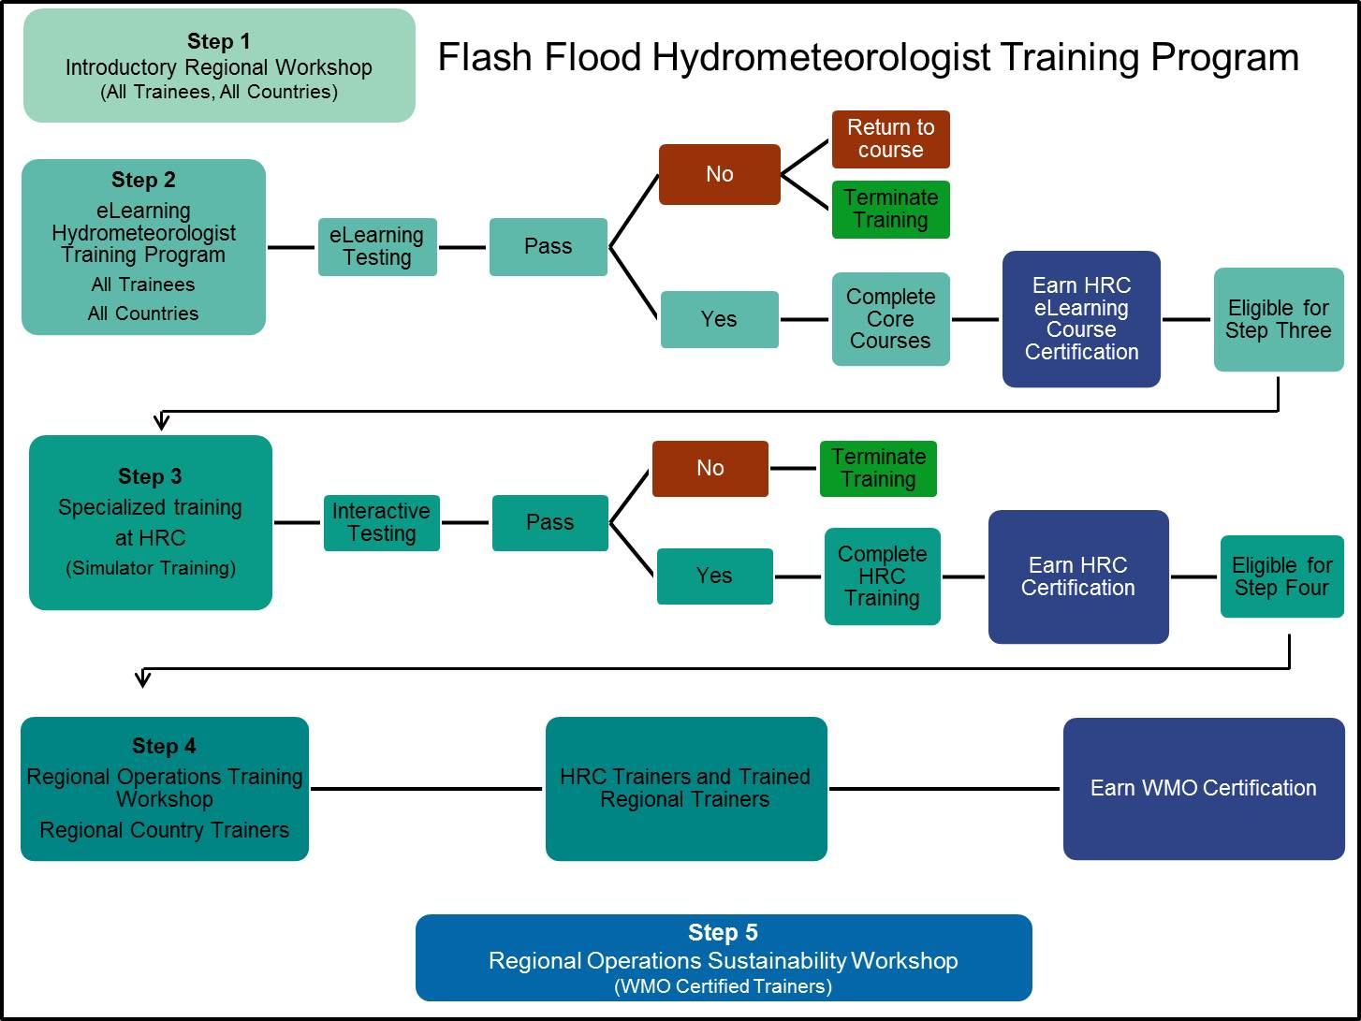

**Figure 3. Illustrating five steps of the Flash Flood Hydrometeorologist Training Program**

Appendix A

Regional Centre Roles and Responsibilities

**System Development**

The Centre has the responsibility to assist with tasks during the regional FFGS development and implementation. These responsibilities include:

* The Centre will be the focal point for the collection of the required spatial and historic hydrometeorological data needed for system development from the countries; and
* The Centre will assist the FFGS developer in coordinating country-specific reviews of various products created and data sets used during system development.

**System Operations Responsibilities**

In meeting its responsibility to maintain the base node of the FFGS system, the Centre will have the following roles, responsibilities, and operations to the extent possible and reasonable:

* The Centre will develop and maintain a local database of contributed, real-time input products from participating NMHS agencies and make available those products to the automated acquisition processes of the FFGS Server. This will require that the Centre work with the countries to develop a set format of the data to be transferred to the Centre for use in developing this real-time database that feeds the FFGS;
* The Centre will provide access via the internet (as primary) to all FFGS products to all key participating agencies from the countries in the in the region in real-time;
* Centre forecasters will work directly with the country forecasters in evaluating and applying the FFGS products and will provide critical hydrometeorological expertise when required;
* When appropriate, the Centre will be available for the briefings and discussions needed to properly evaluate flash flood potential using the FFGS tool. The Centre forecasters will work with the country forecasters to ensure that they understand the weather forecasts and to provide consistency, including evaluating and interpreting the applicability of current and forecast precipitation events;
* The Centre will evaluate the FFGS products from a regional perspective and will communicate this perspective to the countries as appropriate. The Centre will ensure consistency of FFGS products throughout the region;
* The Centre will provide regional and national validation of system results and will advise the countries of the presence of noted biases in system outputs;
* Where appropriate, the Centre will coordinate the issuance of flash flood watches and warnings (as applicable) in a consistent format using the FFGS tool as well as incorporating other information and tools available;
* The Centre will support routine training/workshops on system operations, product interpretation and development, product verification, etc. to country forecasters; and
* The Centre will coordinate with the FFGS global data processing Centre or its equivalent in matters of data flow and communications or for conveying information regarding potential improvements that will affect the region products.

**Centre System Management/Maintenance Roles and Responsibilities**

The Centre will maintain and operate the Regional Linux server which computes and disseminates regional and country FFGS products (text and/or images). A server using the LINUX operating system will be provided for the Regional Centre through the project.

Even though the FFGS servers are designed to be fully automated, there will always remain a critical need for ongoing observation and quality control of its processing tasks and data products. This requires expertise from two basic categories: systems administration and operational quality control of the data products. Skills in both areas of expertise are needed to properly monitor and confirm the overall performance of the system. This can be fully achieved only through the cooperative efforts of both IT Staff and Forecasters. In fulfilling its system maintenance responsibilities, the Centre needs to perform the following activities:

* Maintain Network Connectivity and Data Availability – This relates primarily to the systems administration efforts of IT staff. Of concern are potential problems related to internet and/or GTS service availability, adequate communications throughput to ensure timely data downloads and access by the NMHSs, network cabling, switches, or any one of numerous hardware and security issues related to the servers themselves. The assessment and correction of potential problems relating to any of these areas requires specific technical skill and an understanding of the systems and technologies involved;

* Product Quality Control – This relates to the function of the forecasters at the Centre. Their expertise in hydrology and meteorology is required to properly understand the relative quality of the FFGS input and output products at any given time. Accordingly, Centre forecasters must perform quality control procedures on the data and outputs and determine whether or not any perceived problems are the result of a parametric shortcoming, a failure in one of the FFGS models, or if it might relate to the quality or availability of the real-time input data that drives the system; and

* Operational Process Monitoring – In order to successfully fulfill the specific responsibilities of IT staff and forecasters identified above, both groups must engage in a necessarily cooperative effort of routine and systematic review of system processing activity. This involves regular inspection of system image products, data products, status indicators and log files as a means to confirm the proper operation and health of the system while maintaining a keen familiarity with the status quo in order to immediately recognize any deviation from it.

**Training Responsibilities**

The Centre will be directly involved in the various training programs during implementation and operations. Training programs can involve both Centre staff and country staff. Regional representatives will be equipped to play a fundamental part in the training of country staff, especially during system operations. The primary purpose of training is for Centre representatives to familiarize themselves and develop a level of competency in the FFGS system basics (physical principle, components, operation, and validations), product interpretation and use, and collaboration for prediction and warning. Particular emphasis for the Centre will be placed on validation, operations, trouble shooting and maintenance, data management, communications, realistic scenarios, and preparedness for unusual circumstances or errors. The Centre may offer opportunities for NMHS personnel to serve at the Centre for hands-on training and to support the Centre operations.

**Centre Personnel Recommendations**

Staff that supports the operations of the Centre should possess the following qualifications to the extent possible.

**Staff**

The following expertise is recommended for the staff supporting the Centre.

| **Area of Expertise** | **Regional Centre** |
| --- | --- |
| Have a meteorological or hydrologic technical background | Both meteorological and hydrologic expertise |
| Have experience in operational quantitative weather or hydrologic forecasting specific to the region or country | Priority |
| Have experience in weather-related hazard emergency management operations | Priority |
| Have experience in or knowledge of quantitative analysis of satellite-based rainfall estimates | Priority |
| IT capability for server system administration, network connectivity, and product availability | Priority |

**Focal Point**

It is recommended that the Centre maintain a focal point for all operations and activities. This focal point should meet the following qualifications and responsibilities:

***Qualifications***

The qualifications for the Centre Focal Point are recommended to be as follows:

* Have good knowledge and background in operational meteorology and hydrology in the Central America region;
* Have appropriate experience in providing technical training in hydrometeorology; and
* Have undergone advanced training in the theory and operations of the FFG system from the system developer and implementer.

***Responsibilities***

The responsibilities for the Centre Focal Point are recommended to be as follows:

* Assist the system developer in the collection of required regional spatial and hydrometeorological data needed for system development;
* Be directly involved in the various training programs provided by the Global FFG Program partners during FFG system implementation and operations;
* Provide regional and national validation of FFG System results (with and without forecaster adjustments) to the countries; and, on the basis of such regular feedback, coordinate with the Global Data Processing Centre for potential improvement and to review system products;
* Submit a detailed report annually based on;
  + Number of major events of flash flooding in the region,
  + Deaths/property losses estimates for those events,
  + Performance of the regional FFG,
  + Operations information (percent of hours of system downtime and percent of hours with lack of remotely-sensed and in-situ rain gauge data); and
* When needed, arrange and possibly visit a country’s forecasting operations to provide training if the operations of the regional FFG is not at its optimum in that country (based on outputs from the annual report and country feedback).

**Operation Schedule**

Both the Regional Centre and the country NMHS should operate on a round-the-clock basis either continuously year-round or at the minimum during seasons with significant flash flood risk.

**Summary**

In summary, key Regional Centre responsibilities are:

* Disseminate real-time country graphical products from the FFGS for the NMHSs in the region;
* Collect available real-time meteorological data for ingest to the FFGS for the development of regional products;
* Support regional flash flood operations by:
  + Provide routine regional hydrometeorological analysis,
  + Provide daily guidance discussion to NMHSs from a regional perspective,
  + Provide regional flash flood hazard information,
  + Provide regional validation of products and formulation of plans for improvements, and
  + Provide communications for system analyses to NMHSs of the region.
* Provide communications of regional system modifications necessary to developers;
* Collect spatial and historical hydrometeorological data needed for system development;
* Develop a historical archive of the system products;
* Support regional training of NMHS representatives; and
* Provide routine maintenance and IT support for the FFGS server.

Appendix B

Data and Information Requirements

For each area or basins where flash flood guidance will be provided, various historical, real-time and state variable data and information are needed for the development and operation of the flash flood guidance system. As much of the following data and information as possible should be collected and/or made available from each country within the region. Note that the following items represent the optimum data and information requirements; system development and operations designs will consider which data are available for use.

**Logistical Data (Metadata)**

* Longitude and latitude coordinates (in decimal degrees) and elevation (in meters) of all sensors providing real time data and historical data, type of data, units of measurement and sensor;
* Longitude and latitude coordinates (in decimal degrees) of dams and reservoirs;
* Evaluation of basin delineation:  initial delineations based on hydrologic processing of the SRTM (90-m) resolution digital elevation data and hydrographic information from the Digital Chart of the World;
  + Evaluation of the delineation results with local knowledge and expertise is required for final quality assurance; and
  + Delineation maps may be provided in GIS format; shapefiles are preferred.

**Spatial Digital Data or Maps (for areas of interest)**

* Digitized stream network data;
* Digitized country catchment boundaries data;
* Land-use and land-cover data;
* Soils data to include soil texture or FAO soil classification or soil properties data, and depth of upper soil and sub-soil;
* Local stream cross-sectional survey data for natural streams draining 10-2000km2, including any reports of regional relationships between channel cross-sectional characteristics and catchment characteristics;
* GIS map of bedrock and alluvial channels;
* Population distribution data.

**Reports**

* Flood Frequency Analysis (regional and local);
* Flash Flood Occurrence (regional and local);
* Stream geometry studies for small streams;
* Climatological precipitation and flood studies.

**Historical Data**

Precipitation data (hourly, daily, monthly, climatology);

* Air temperature data (hourly, daily, monthly, climatology);
* Pan evaporation data (daily, monthly, climatology);
* Soil moisture data for top 1 meter of soil (weekly, monthly, climatology);
* Streamflow discharge data for local streams with drainage areas less than 2000 km2 (hourly, daily, monthly, climatology);
* Spring discharge data;
* Stream stage data (hourly, daily, monthly, climatology) and associated stage-discharge curves (rating curves), also for local streams;
* Radiation data for computation of potential evapotranspiration (daily, monthly, climatology);
* Wind, humidity data for computation of potential evapotranspiration (daily, monthly, climatology);
* Historical radar data, once radars become operational, and satellite data
* Groundwater recharge rates, channel transmission losses, and groundwater level data for surficial aquifer: and
* Snow water equivalent data.

**Real Time Data**

* Surface precipitation and weather data (hourly or 6hourly) (**important**);
* River stage + rating curves, or discharge data (hourly, 6hourly or daily);
* Snow water equivalent or depth (daily or weekly data).

Appendix C

Real-Time Data Specifications and Information

Please provide the following information for each real-time rain gauge and automatic weather station:

* + Location of the station as latitude and longitude in decimal degrees and elevation in meters;
  + Deployment status – e.g., in place and operational, in place but not yet operational, planned for installation. If known, please specify the start date of operation;
  + Current operational status (for all in-place stations) – e.g., fully operational, operating but intermittent, operating but erroneous or unreliable, offline for maintenance/repair, etc. Current status should be provided for each sensor of multi-sensor stations. Any additional information relating to problematic stations/sensors will be helpful;
  + Method of data transmission – e.g. Internet, satellite, telephone landline, telephone cellular, telephone SMS, telephone fax, microwave radio, HF/VHF radio (voice or data), etc.;
  + Period of observation (data recording resolution, per sensor) – This is the duration of time over which data is accumulated or averaged, as provided, e.g., 15-minute, 1-hourly, 6-hourly, 12-hourly, daily. ­For any instantaneous measurements, such as temperature, please indicate the interval between recordings;
  + Frequency of data transmission/collection (on what interval is the data received by the responsible agency?) – e.g. randomly, 5-minute, 15-minute, 1-hourly, 3-hourly, daily or manual data logger collection;
* Survey information;
  + - What is the functionality and adequacy of the data-reception and storage systems in the country?
    - What preventive maintenance, calibration or repair needs to be performed on the gauges/stations? What is the typical schedule for routine, operational maintenance of gauges/stations?
    - What is the perceived level of institutional support for the agencies responsible for monitoring?
    - How can real-time data from the currently operating rain gauges and weather stations be accessed for use by the FFGS?

ANNEX 5

|  |
| --- |
| Information on Country Real-Time Precipitation Data Preparation and Upload |

|  |  |
| --- | --- |
| **Konstantine Georgakakos** <kgeorgakakos@hrcwater.org> | Tue, May 9, 2017 at 3:56 PM |
| To: rdiazz@etesa.com.pa, ricardinadiaz@gmail.com, rmartinezt@etesa.com.pa, roberto.martinez06@gmail.com, marcio.baca@met.ineter.gob.ni, ayapal2000@yahoo.com, aleyda.moreno@rh.ineter.gob.ni, isaias.montoya@rh.ineter.gob.ni, imonbla@yahoo.com, quan.martin@gmail.com, mcueto@insivumeh.gob.gt, egramajo1@hotmail.com, Luis Garcia <lgarcia@marn.gob.sv>, Roberto Ceron <raceronp@gmail.com>, lgarcia.marn@gmail.com, rceron@marn.gob.sv, jzunigam@ice.go.cr, Juan Carlos Fallas Sojo <jcfallas@imn.ac.cr>, Juan Diego Naranjo Diaz <jnaranjo@imn.ac.cr>, drudon@hydromet.gov.bz  Cc: Paul Pilon <ppilon@wmo.int>, Claudio Caponi <ccaponi@wmo.int>, fcalderon@ofda.gov, Jason Sperfslage <jsperfslage@hrcwater.org>, Cris Spencer <cspencer@hrcwater.org>, tmodrick@hrcwater.org, Robert Jubach <rjubach@hrcwater.org> | |
| |  | | --- | | Dear CAFFG Participants:   As discussed at the recent (3-5 May 2017) meeting in Costa Rica, I write this message to provide information on how to contribute real-time precipitation data from your automated stations to the CAFFG system.   THE GOAL IS TO:   •         Send real-time gauge precipitation data to an FTP site at the regional center in Costa Rica (IMN) using CSV format (details below).  o   It is desired to send the data every hour with **1-hour rain totals**.  o   If the files cannot be sent every hour, send them whenever the 1-hour data becomes available (for example, every three hours provide the past three hours of data).  o   It is permitted that values for different observation hours can be sent in a single upload file (for example, if values for different hours become available at the same time).  •         Provide a metadata file that includes the station information (name, unique id, longitude, latitude and elevation (if available)).  The file can be sent to [kgeorgakakos@hrcwater.org](mailto:kgeorgakakos@hrcwater.org).  This file is needed to locate the station within the CAFFG domain.   INSTRUCTIONS:   Please name your data files using a pattern similar to the following naming scheme:  •         The file must start with a time stamp (**UTC time zone only**)  •         It must also include a descriptive name also.  (please identify your country in the name)   An example name for a file is:  20150623-172500_caffg_costarica_gauge_precip_report.csv   If your FTP transfer includes more than one file, be certain the file names are unique (not to overwrite each other).   The format of the files should be **comma-separated values (CSV) in plain text files** (no Excel or other special formats) – see example of format below.  •         Each line of the file is a rain value (1-hour total in mm/hr) from one station at one time.  •         Each line should contain the following information:  1.    Full date and timestamp with time zone (**in UTC only**) for the time at the **END** of the observation hour.  (NOTE:  the dates of the rain observations inside the file do not need to match the date of the filename.  Rain values can be reported in any upload file.)  2.    Station Identifier  (this identifier must exactly match the identifier in the metadata file)  3.    1-hour Total Precipitation observation in (mm/hr). The numerical flag -999 can be used to indicate missing or invalid data.   Example contents of a file with the CSV format are shown below:   2015-06-23 17:00:00 UTC,84237,0  2015-06-23 17:00:00 UTC,73149,0  2015-06-23 17:00:00 UTC,88049,3.2  2015-06-23 17:00:00 UTC,74051,0  2015-06-23 17:00:00 UTC,74059,0  2015-06-23 17:00:00 UTC,81005,0.1  2015-06-23 17:00:00 UTC,88047,4.5  2015-06-23 17:00:00 UTC,74063,0  2015-06-23 17:00:00 UTC,85023,0.5  2015-06-23 17:00:00 UTC,76055,-999   Please contact the HRC IT group (Jason Sperfslage [jsperfslage@hrcwater.org](mailto:jsperfslage@hrcwater.org); and Cris Spencer [cspencer@hrcwater.org](mailto:cspencer@hrcwater.org) ) if you need additional clarification.   After you have established the procedure to generate the format of the files with the names as specified above, please contact the HRC IT group or the CAFFG Regional Center in Costa Rica to receive the access information for the appropriate FTP account to which you will be uploading the files in real-time.   Also, and as discussed at the meeting, please begin the process as soon as feasible with a first batch of stations to test the process and then increase the numbers.   Thank you for your consideration and support of this important task for the improvement of the CAFFG products for your country.   With best wishes,   Konstantine (Kosta)   Konstantine P. Georgakakos, Sc.D.  Director  HYDROLOGIC RESEARCH CENTER  **NEW ADDRESS AS OF 1 NOV 2016:**  **11440 West Bernardo Court, Suite 375**  **San Diego, CA 92127, USA**    Tel: [+1-858-798-9440](tel:(858)%20798-9440)  Alternative Tel:[+1-858-461-4560](tel:(858)%20461-4560)  Email: [KGeorgakakos@hrcwater.org](mailto:KGeorgakakos@hrcwater.org)  [http://www.hrcwater.org](http://www.hrcwater.org/)    Also, Adjunct Professor VIII with Scripps Institution of Oceanography, UCSD | | |

ANNEX 6

List of immediate actions (responsible for implementing them)

1. Raise the proposal to the CRRH (Juan Carlos Fallas Sojo)

2. The participants in the meeting will inform their superiors (participants in the meeting)

3. All countries provide letters of national commitment (participants in the meeting)

4. HRC send letter specifying data format for FTP (Konstantine Georgakakos)

5. Countries will provide precipitation information according to the instructions (participants or focal points or substitutes)

6. WMO will inform officially the focal points or alternates or participants on the training activities to be carried out (Paul Pilon and Ayhan Sayin)

7. The representatives of El Salvador, Costa Rica and WMO will work together to draft the agreement (Juan Diego Naranjo, Roberto Cerón, Paul Pilon and Ayhan Sayin)

8. Initiate regional validation (Juan Diego Naranjo, Roberto Cerón and HRC)

9. Organize an explanatory SWFDP session (Oscar Arango)

10. HRC will send participants information about the workshop on landslides (HRC)

11. Distribution of temporary, eventually permanent, passwords (Konstantine Georgakakos)

12. Update the website (immediate: presentations, conclusions, list of participants) and send commitment letter template (Ayhan Sayin)

1. The link to the report of this Initial Planning Meeting and its presentations is <http://www.wmo.int/pages/prog/hwrp/flood/ffgs/caffg/caffg.php>.
2. Country presentations should not exceed 10 slides, 15 minutes presentations with 5 minutes for questions.
3. MoU “Establishing a Cooperative Initiative among the World Meteorological Organization, Hydrologic Research Centres, U.S. National Oceanic and Atmospheric Administration/National Weather Service and the U.S. Agency for International Development/ Office of U.S. Foreign Disaster Assistance for the Flash Flood Guidance System with Global Coverage Project”