This document outlines the following topics and explores variations across tropical cyclone basins and warning agencies:

1. Definitions of tropical cyclone.
2. Complexity of tropical cyclones in relation to the chain of associated hazards
3. Monitoring and observational network for tropical cyclones
4. Historical data bases of tropical cyclones
5. Historical analysis of tropical cyclone characteristics.
6. Forecasting tools/models and methodologies
7. The main centres of tropical cyclone research, modelling and forecasting around the world

This report was prepared by Andrew Burton and Koji Kuroiwa on behalf of the WMO Tropical Cyclone Programme.

## Definitions of tropical cyclone

The definitions and nomenclature applied to tropical cyclones differ between agencies and WMO Regional Associations (RAs). Documentation from the Seventh Tropical Cyclone RSMCs/TCWCs Technical Coordination Meeting, Citeko, West Java Indonesia 12 to 15 November 2012 (TCM7) notes the following:

**TROPICAL CYCLONE** – Generic term for a warm-core non-frontal synoptic scale cyclone originating over tropical or sub-tropical waters with organized deep convection and closed cyclonic surface wind circulation. The term is also used for a storm in the South-West Indian Ocean in which the maximum sustained wind speed is estimated to be in the range of 64 to 89 knots and in the South Pacific and South-East Indian Ocean with the maximum sustained surface wind speed greater than 33 knots.(WMO 2012a)

The situation is further complicated because some agencies have adopted definitions of tropical cyclone that differ slightly from that of their regional association. For example, the Australian Bureau of Meteorology (BoM) complies with the RAV definition of tropical cyclone but adds the requirement that the maximum mean wind speed of 34 knots or greater must extend more than half-way around near the centre and persist for at least six hours. Thus some short lived or highly asymmetric systems may meet the RAV definition but not the BoM definition.

TCM7 Document 4.10.2 lists the classifications of tropical cyclones adopted by the five regional tropical cyclone committees (WMO 2012b).

All classifications share maximum wind speed as the metric of intensity but even where the numerical thresholds for wind are the same, differences can arise due to different wind averaging periods. For example, although all the classification schemes have a demarcation at an average wind speed of 34 knots, a wind speed of 34 knots measured over a 1-minute averaging period is not equivalent to a wind speed of 34 knots measured over a 10-minute averaging period. This becomes particularly relevant when the intensity analysis is based on the Dvorak technique (discussed in more detail below). A Dvorak Current Intensity number (CI) of 2.5 maps to a wind speed of over 33 knots when a one minute averaging period is used, but to less than 33 knots when a 10-minute averaging period is employed. Thus it should be expected that the JTWC tropical cyclone database for the southern Indian Ocean will include more storms with intensity greater than 33 knots than the corresponding databases maintained by Meteo France and BoM. This is confusing for users and makes database storm counts difficult to compare. The above-mentioned TCM7 decided to explore the feasibility of developing a globally-unified classification of tropical cyclones including a category system; which was presented at the 65th session of the WMO Executive Council in May 2013.

## Complexity of associated hazards

Tropical cyclones present challenges in providing an effective early warning system because of the multiple hazards they present, the interrelation of those hazards and their variable temporal and spatial distribution.

As detailed below, the established metric of tropical cyclone intensity is the maximum sustained wind speed of the system. However two tropical cyclones of the same intensity (maximum sustained wind speed) can produce very different impacts depending on a range of other factors. For example, tropical cyclone size and speed of movement influence rainfall (and hence flooding and landslides), wind damage (longer period of damaging winds at any particular location), wave height and storm surge.

The maximum sustained wind speed in a tropical cyclone occurs only in a small fraction of the wind field and other hazards may be present well removed from the location of strongest winds.

Flooding and isolation are often the most significant impacts of a tropical cyclone passage, however the magnitude of flooding is poorly correlated with tropical cyclone intensity and more closely related to other factors such as topographic enhancement of rainfall, speed of translation of the system and antecedent conditions in the catchment.

Storm surge magnitude is dependent on coastal bathymetry, translation speed, angle of approach, shape of the coastline and the size and structure of the wind field as well as the maximum sustained wind speed.

Tornados can occur in the outer rain bands of tropical cyclones while the system centre is hundreds of kilometres away. In February 2011 a tornado caused significant damage in the central business district of Karratha while the community was preparing for the expected impact from TC Carlos the following day. The cyclone centre was over 200 kilometres away at the time the tornado occurred. The tornado caused significantly more damage than the passage of TC Carlos the following day.

The complex temporal and spatial distribution of tropical cyclone hazards complicates the task of delivering an effective warning service. Warnings that focus on a simplified message (such as: “A tropical cyclone of intensity X is expected to reach location Y at time Z.”) can lead to a mischaracterisation of the threat posed from the multiple hazards present

## Observation networks for TCs

Fig. 1 provides an illustration of the instruments that comprise the WMO Global Observing System. Tropical cyclones occur mostly over the oceans where point observations are scarce (Fig.2). The intensity of a tropical cyclone is generally defined with reference to the system’s maximum sustained wind speed; which has a direct relation to the severity of a number of associated hazards (wind damage, wave height, and storm surge). The structure of the wind field is also an important factor in determining the severity and impact of these hazards (eg. Radius to maximum wind speed is correlated with storm surge and wave height). Consequently wind speed measurements are valued by operational warning centres over other parameters. However wind is a difficult parameter to measure and compare in a standardised manner due to its turbulence properties and dependence on a number of sub-synoptic-scale factors. The magnitude of the reported wind is dependent on instrument type, exposure, the roughness of the underlying surface, (which in the case of marine observations varies with wind speed) and the period of measurement.

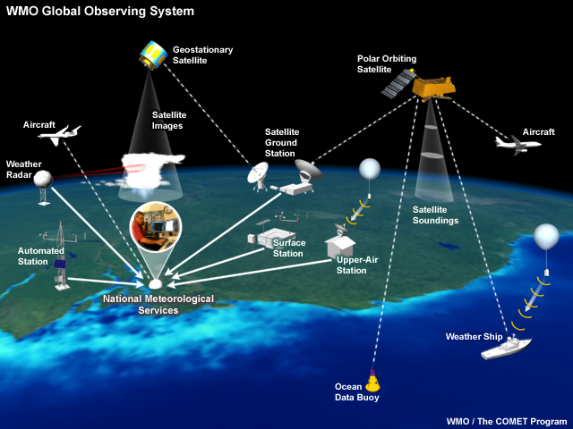

Fig. 1. An illustration of the instruments that comprise the World Meteorological Organization (WMO) Global Observing System [1]

Some warning agencies focus on wind gusts rather than the sustained wind when reporting on and warning for wind hazards. Structural damage from wind is more closely related to the magnitude of the strongest gusts rather than the magnitude of the sustained wind but the variable relation between the two complicates public messaging.

The WMO standard for measuring sustained winds is a 10-minute averaging period but some agencies report 1-minute (USA,) 2-minute (China) or 3-minute (India) winds. This complicates the comparison of wind speed reports from different agencies. A comprehensive review of the issues associated with converting between various wind averaging periods in tropical cyclone conditions can be found in Harper et al 2010. A comparison of tropical cyclone intensity scales and nomenclature can be found at <https://en.wikipedia.org/wiki/Tropical_cyclone_scales>.

The central pressure of a tropical cyclone is related to the maximum sustained wind speed and has historically been used to define tropical cyclone intensity. Pressure measurements are only available from point observation sources, but comparison of observations between stations is easier because pressure measurements lack turbulence properties and are not dependent on exposure. However the sharp gradient in pressure near the tropical cyclone centre makes it difficult to be sure that the minimum central pressure has been observed when a tropical cyclone passes close to a surface station. Operational warning agencies tend to view pressure as the second most important observational parameter. However from a numerical modelling point of view, a point observation of pressure is generally more valuable than a point observation of wind because it is more easily assimilated into NWP models.

### Point observations

#### Ship and buoy reports

Ship and buoy reports are used primarily for their wind, pressure and wave height measurements. Wind reports from ships at sea have become increasingly based on anemometers, replacing widespread use of the Beaufort scale. Anemometers on ships are typically at an elevation of around 30 metres compared with the standard WMO 10 metre mast. This, together with other factors such as airflow disturbance around the ship, results in a high bias in wind speeds reported by ships under high wind conditions (Taylor et al 1995).

#### Surface stations and automated weather stations

There are relatively few weather stations at well exposed coastal locations and on small offshore islands, but they are highly valued for validation of satellite based observations and for their reporting frequency.

The density of coastal and offshore observations varies markedly across the globe. Densely populated areas such as the coast of China have a high density of coastal point observations, while sparsely populated areas such as the north west of Australia have very sparse surface observation networks.

Stations that perform upper air observations are sparsely distributed across the tropics and there are very few that sample tropical cyclogenesis regions. During tropical cyclogenesis a process of moistening the mid-levels of the troposphere must occur before the system can become self sustaining. This process is poorly observed by either upper air stations of satellite instruments.

### Remote sensing: area averaged observations

The maritime nature of tropical cyclogenesis leads to a strong dependence on remote sensing for observing tropical cyclones.

Geostationary (GEO) satellites offer wide spatial coverage and high temporal coverage (every 15-60 minutes); which makes them suitable for tracking tropical cyclones. Although geostationary weather satellites have been operating since the 1970s, global coverage was only achieved in 1998 when Meteosat 5 was displaced to longitude 63⁰E. Early geostationary weather satellites provided resolutions of 8 kilometres in the infrared (IR) and water vapour (WV) channels and 2 kilometres in the visible wavelength (VIS). The current baseline for image resolution is around 1 kilometre in VIS and 4 kilometres in IR and WV but this is set to improve with the next generation of imaging instruments. The next generation of geostationary satellites will have sensors currently available only on Low Earth Orbit (LEO) satellites, e.g., the geostationary lightning mapper on the GOES-R satellites will provide routine [lightning observations](http://www.meted.ucar.edu/tropical/textbook_2nd_edition/print_2.htm#page_6.0.0) for weather analysis and forecasting.

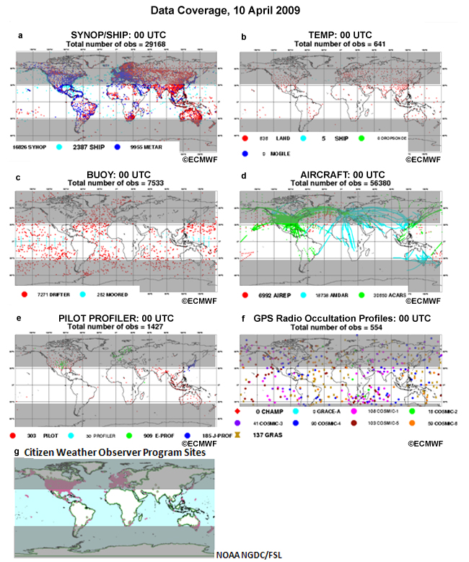

Fig. 2 Global data coverage from various sources at 00UTC 10 April 2009. [2]

Geostationary satellites are considered the mainstay of tropical cyclone observations. This is due to their temporal and spatial coverage and to the development of the Dvorak technique (detailed below).

LEO satellites offer high spatial resolution and are better suited for active instruments and microwave sensors. These satellites observe precipitation, winds, total water vapor, lightning, and air quality. However, they have low temporal resolution and need a constellation to ensure a reasonable temporal sampling. Currently, significant gaps in coverage occur between LEO satellite swaths across the tropics. Another critical tropical data void that satellites fill is atmospheric sounding. In addition to [soundings from geostationary and LEO](http://www.meted.ucar.edu/tropical/textbook_2nd_edition/print_2.htm#page_4.1.0) satellites [temperature and humidity profiles are derived from the occultation of signals from GPS satellites](http://www.meted.ucar.edu/tropical/textbook_2nd_edition/print_2.htm#page_4.2.0).

## Historical databases

TC historical databases are maintained by WMO Regional Specialised Meteorological Centres (RSMCs) and Tropical Cyclone Warning Centres (TCWCs). In addition to these, the US Joint Typhoon Warning Center (JTWC) maintains a database that covers all tropical cyclone basins except the Atlantic[3].

In 2008 the US National Oceanic and Atmospheric Administration’s (NOAA) National Climatic Data Center (NCDC) initiated the International Best Track Archive for Climate Stewardship (IBTrACS) project to combine the available data sources into a single homogeneous global data set. The intent of the IBTrACS project is to overcome data availability issues, and to freely disseminate this new global dataset. The IBTrACS team work directly with all the Regional Specialized Meteorological Centers and other international centers and individuals to create a global best track dataset, merging storm information from multiple centers into one product and archiving the data for public use.

The WMO Tropical Cyclone Programme has endorsed IBTrACS as an official archiving and distribution resource for tropical cyclone “best track” data. IBTrACS contains data from 14 sources including the following organisations:

* [Australian Bureau of Meteorology](http://www.bom.gov.au/weather/cyclone/tc-history.shtml)
* [China Meteorological Administration - Shanghai Typhoon Institute](http://www.typhoon.gov.cn/en/data/detail.php?id=38&type=11)
* [Hong Kong Observatory](http://www.hko.gov.hk/informtc/informtc.htm)
* [Joint Typhoon Warning Center](https://metocph.nmci.navy.mil/jtwc/best_tracks/)
* [RSMC Honolulu, HI, USA (NOAA's Central Pacific Hurricane Center)](http://www.ncdc.noaa.gov/cgi-bin/good-bye.pl?src=http://www.prh.noaa.gov/cphc/)
* [RSMC La Reunion](http://www.ncdc.noaa.gov/cgi-bin/good-bye.pl?src=http://www.meteo.fr/temps/domtom/La_Reunion/)
* [RSMC Miami, FL, USA (NOAA's National Hurricane Center)](http://www.aoml.noaa.gov/hrd/hurdat/Data_Storm.html)
* [RSMC Nadi, Fiji](http://www.met.gov.fj/index.php)
* [RSMC New Delhi, India](http://www.imd.ernet.in/section/nhac/static/welcome.htm)
* [RSMC Tokyo, Japan](http://www.jma.go.jp/jma/jma-eng/jma-center/rsmc-hp-pub-eg/RSMC_HP.htm)
* [TCWC Wellington, New Zealand](http://www.metservice.co.nz/default/index.php)

Fig. 3 shows the variation by tropical cyclone basin for the number of agencies providing best track data for each storm.



Fig. 3. Tropical cyclone positions from the IBTrACS dataset color coded by the number of agencies

providing best-track data for each storm (taken from Knapp, 2011b).

### Parameters stored

All agencies report location via time, latitude and longitude and include information on wind, pressure and cyclone type. Tropical cyclone intensity is generally described either by maximum sustained wind speed or by central pressure; however there is inhomogeneity in the reporting of these data that makes the intercomparison of agency records difficult.

Parameters that are reported by some agencies (with the number of reporting agencies noted in parentheses) include wind radii (5), radius of maximum winds (4), radius of outer more closed isobar (3), pressure of outermost closed isobar (2) and the Dvorak parameters Final T-number and Current Intensity number (2) (Knapp, 2011a).

Variations between agency records can make it difficult to determine if two tracks are the same storm, leading to a single storm being represented multiple times in the IBTrACS record. Fig. 4 provides an illustration of the issue of track “spurs” that can arise when trying to combine agency records (Knapp, 2011b).

|  |  |
| --- | --- |
| JTech-1954240N13151 | JTech-1994263N17170 |
| Split track? | Track merger? |
| Fig. 4 Illustration of storm “spurs” that arise when trying to combine agency records. (Taken from Knapp 2011a) | |

### Information sources for best tracks

#### Satellite data

As noted in the section on observation networks for tropical cyclones, the majority of observations of tropical cyclones are made by satellite based instruments due to the scarcity of surface observations over the oceans. The advent of weather observing satellites and the first availability of GEO satellite coverage mark two important dates in the historical TC record. The historical record prior to the satellite era is considered to be of markedly poorer quality, and likely to be missing TCs due to poor observational coverage.

Improvements in information sources and analysis techniques have continued to improve the quality of the record during the satellite era. As noted in the previous section, the availability of GEO imagery occurred at different times in different basins, only becoming a global capability in 1998. The greater frequency of GEO imagery improves detection of trends in intensity and structure. The tropical cyclone record during the GEO satellite era includes a number of short lived storms that are likely to have previously gone undetected.

Information in historical databases is predominantly sourced from imagery in the infrared and visible wavelengths. The Dvorak Technique (DVK)f or analysing tropical cyclones is discussed in more detail in the following section. Using the Dvorak Technique, position and intensity estimates can be made in a regular manner with reliable results. Size parameters have also historically been inferred from satellite imagery.

In the 90s the increasing availability of data from passive and active microwave sensors allowed improvements in determining location and structure parameters. High resolution passive microwave imagery obtained from LEO satellites can markedly improved location accuracy and provide additional structural information. Microwave imagery is particularly useful during parts of the life cycle where the central area of the tropical cyclone is covered by a dense overcast that obscures structural features in IR and VIS imagery.

Radar scatterometers on LEO satellites provide estimates of the wind by measuring microwave energy backscattered off the ocean surface. Radar scatterometer data can be difficult to interpret due to ambiguities in the signal and limitations in measuring under conditions of high wind and rain, but they provide an estimate of the entire wind field that yields unparalleled size and structure information.

#### Point (surface) observations

Observations from ships, buoys and coastal observing stations comprise a relatively small but important data source for the tropical cyclone record. Fixed observing stations provide a time series at a point that can be used to infer the spatial structure of the wind field if the system structure is not rapidly changing. They also provide important information on the relationship of wind damage to wind speed and duration.

#### Radar observations

Coastal and island radar installations provide high spatial and temporal resolution imagery of TCs as they approach within approximately 250 kilometres. Radar imagery provides accurate and detailed track information as well as information about the rainfall distribution; however this latter information is generally not captured in tropical cyclone databases.

#### Aircraft reconnaissance

Aircraft reconnaissance into TCs began in the mid-40s in the North West Pacific and North Atlantic basins. It was discontinued in the North West Pacific in 1987 but continues in the North Atlantic and North East Pacific basins.

The range of instrumentation, and both the volume and accuracy of data collected has increased markedly over the decades. In the early years estimates of wind speed and direction were made by looking at the sea surface. Modern aircraft reconnaissance includes the use of Doppler radar, Dropsondes and Stepped Frequency Microwave Radiometers, providing wind information in both the vertical and horizontal.

## Historical analysis of tropical cyclone characteristics.

Prior to the satellite era the historical record is incomplete. Analysis prior to the satellite era required interpolation between sparse point observations and consequently the accuracy and frequency of information for this period is poor, to the extent that some TCs will have been missed altogether and others will only have a part of their life cycle captured in the record.

The Dvorak technique (DVK) has been the primary method of analysing tropical cyclones for around four decades. The technique is named after Vernon Dvorak who developed his cloud pattern recognition technique based on a revolutionary conceptual model of TC development and decay. Dvorak and his colleagues derived an empirical method relating TC cloud structures to storm intensity using a simple numerical index. The technique’s practical appeal and demonstrated skill place it among the great meteorological innovations of our time. Brown and Franklin (2004) reported that 50% of Dvorak-derived maximum sustained wind estimates are within 5 knots of reconnaissance aircraft measurement-aided best track estimates.

The Dvorak technique relies on four distinct geophysical properties that relate organized cloud patterns to TC intensity. Two are kinematic, vorticity and vertical wind shear, and two are thermodynamic, convection and core temperature. The strength and distribution of the circular winds (and by implication, vorticity) in a TC organizes the clouds into patterns that Dvorak relates to the maximum sustained wind speed. External (environmental) shear is a kinematic force that acts to distort the vorticity (and hence, the cloud pattern). Dvorak found that the degree of distortion was also related to the maximum sustained wind. Convection in the bands of the outer core of the cyclone also figures in the cloud pattern recognition and scene type assignment. Using satellite-measured IR cloud-top temperatures in the TC inner core, the technique relates convective vigour to intensity. In cases of TCs with eyes, the technique determines the temperatures of the eye and surrounding clouds (eyewall) using IR data and relates them to intensity, with warmer/cooler eye/cloud temperatures indicating greater intensities. Visible imagery can also be very useful in these cases.

The basic steps in the Dvorak technique can be summarized as follows (Fig. 5):

1) Determine the TC centre location.

2) Make two quasi-independent estimates of the intensity of the TC.

3) Choose the best intensity estimate.

4) Apply selected rules to determine the final estimate of intensity.

The first of the two quasi-independent estimates of intensity relies on measurements of cloud system properties that reflect the kinematic or thermodynamic properties mentioned above. The second intensity estimate is reliant on pattern matching concepts and the application of Dvorak’s development/decay model of the TC life cycle.

Since its inception the Dvorak technique has evolved to a greater emphasis on measurement of cloud features. Velden et al (2006) provides a comprehensive review of the evolution of the Dvorak technique. The technique has been subject to a number of regional variations, particularly with respect to some of the constraints that are built into the technique. Variations over time and between agencies in the satellite analysis of tropical cyclones have been investigated and documented via the WMO sponsored First International Workshop on Satellite Analysis of Tropical Cyclones (IWSATC) (Velden et al 2012). The IWSATC proceedings document current operational practices and new objective analysis techniques that are increasingly being incorporated into operational procedures.

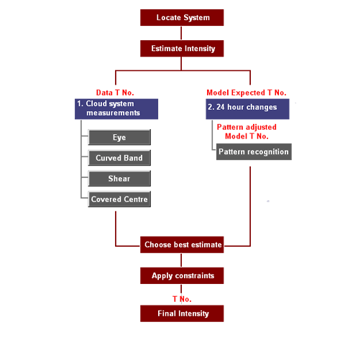

Fig. 5. The basic steps in the Dvorak technique.

## Forecasting tools and methodologies

Forecasting tropical cyclones can be broken down into track, intensity and structure forecasting. Consensus forecasting has become the accepted operational methodology for track (motion) forecasting. Consensus forecasting involves blending a range of guidance tracks. Averaged over many forecasts, consensus forecasts provide greater skill than can be obtained from a single guidance source. The skill of a consensus forecast is dependent on:

1. The number of members (inputs) in the consensus.
2. The skill of each member of the consensus
3. The degree of error independence between consensus members.

In the past, track guidance inputs included both dynamical (NWP) and statistical aids but as the skill of NWP models has improved the use of statistical aids track forecasting aids has declined. Motion forecasting has steadily improved over the last three decades due to improvements in the skill of individual consensus members and application of consensus techniques.

While efforts continue to improve deterministic track forecasts, there has also been increasing effort to define the uncertainty associated with the track forecast. Operational centres now routinely include uncertainty estimates in track forecasts, often depicted graphically as an area surrounding the deterministic track. In the past the track uncertainty information was based on the climatological distribution of position error and consequently did not vary with synoptic conditions. With increasing access to ensemble track forecasts a number of agencies have begun to use the spread of ensemble tracks as guidance for determining track uncertainty. RSMC La Reunion apply an objective algorithm to outputs from the European Centre for Medium Range Weather Forecasting (ECMWF) ensemble to create probabilistic track forecasts that have greater skill than those based solely on the climatology of track forecast errors (Dupont et al 2011). Forecasters in Australian Bureau of Meteorology TCWCs begin with “uncertainty cones” based on the climatology of forecast track errors, but they may subjectively modify the uncertainty taking account of the spread of tracks in the available guidance, including the spread of the ECMWF ensemble tracks.

In contrast to motion forecasting, there has been little improvement in intensity forecasts over recent decades. Intensity forecasting remains reliant on a mix of statistical and dynamical forecast aids and is generally not subject to a well defined forecast process as with track forecasting. The Dvorak technique provides a forecast intensity estimate based on extrapolation of observed trends in intensity. Other empirical and statistical techniques have been developed to provide forecasting guidance; including the Statistical Hurricane/Typhoon Intensity Prediction Schemes (SHIPS/STIPS). SHIPS and STIPS are objective techniques that mirror the synoptic reasoning employed by forecasters to forecast intensity based on expected environmental conditions along the predicted track of the TC.

There are signs that the ongoing development of NWP models is beginning to yield improvements in their guidance skill but there remains a low bias in most dynamical aids and subjective blending of the available aids is still central to operational practice.

Structure forecasting remains subjective and poorly verified but continued improvements in NWP models offer promise of improvements in this area. The relatively poor observational record of TC structure poses challenges for verifying improvements in forecast aids but most operational TC forecasters agree that NWP models have begun to show significant skill in forecasting structural changes in the wind field.

## Research, modelling and forecasting centres

### Research centres

There are many research centres engaged in research related to tropical cyclones and it is not possible to provide a complete listing in this document. Many universities and national meteorological services include some element of TC research in their activities. The following list is a selection of research institutes that are known by the author to have a focus in tropical cyclone research. It does not represent an exhaustive list.

The University of Wisconsin-Madison/Space Science and Engineering Center (SSEC)Cooperative Institute for Meteorological Satellite Studies (CIMSS) focuses on tropical cyclone research from a satellite perspective.

The Cooperative Institute for Research in the Atmosphere (CIRA) is a cooperative institute that is also a research department within the Colorado State University’s (CSU) College of Engineering.

The Hurricane Research Division (HRD) is a part of NOAA’s Atlantic Oceanographic and Meteorological Laboratory (AOML). A key aspect of HRD’s activity is its annual field program of flights into tropical cyclones aboard NOAA’s research aircraft.

The United States Naval Research Laboratory (NRL) is the corporate research laboratory for the Navy and Marine Corps. NRL’s Marine Meteorology Division includes a Satellite Applications Section within the Meteorological Applications Development Branch. One of their notable achievements has been the creation and maintenance of the “TC page”; a web resource which is widely used by operational centres to access pre-processed satellite imagery of TCs.

The Centre for Australian Weather and Climate Research (CAWCR) is a partnership between Australia’s leading atmospheric and oceanographic research agencies: the Bureau of Meteorology (BoM) and the Commonwealth Scientific and Industrial Research Organisation (CSIRO).

The National Center for Atmospheric Research (NCAR) is a federally funded USA research and development centre devoted to service, research and education in the atmospheric and related sciences.

Many national meteorological services have research branches that engage in TC research. These include:

* China Meteorological Administration’s (CMA) Shanghai Typhoon Institute (STI)
* Japan Meteorological Agency’s (JMA) National Typhoon Center
* Indian Meteorological Department(IMD)
* Meteo France
* United Kingdom Meteorological Office (UKMO)

### Modelling centres

Modelling of tropical cyclones occurs both through global numerical weather models and specialised regional models. Numerical weather prediction centres include:

* CAWCR
* CMA
* European Centre for Medium Range Weather Forecasts (ECMWF).
* JMA
* Meteo France
* UKMO
* USA NOAA’s National Centers for Environmental Prediction (NCEP)

### Forecasting centres

The main operational forecasting centres for tropical cyclones are those listed under section 4.0 as providing data to IBTrACS. There are only three centres where forecasters specialise solely in the provision of tropical cyclone warning services:

* RSMC La Reunion: Meteo France’s La Reunion Tropical Cyclone Centre (Regional Specialised Meteorological Centre (RSMC) for the South-West Indian Ocean)
* RSMC Miami: NOAA’s National Weather Service (NWS) National Hurricane Center (NHC)
* Joint Typhoon Warning Center (JTWC)

At other forecasting centres a selection of forecasters from the general pool are provided with training to develop the specialist skills required in TC analysis and forecasting.

## Bibilography

Brown, D. P., and J. L. Franklin, 2004: Dvorak TC wind speed biases determined from reconnaissance-based best track data (1997–2003). Preprints, 26th Conf. on Hurricanes and Tropical Meteorology, Miami, FL, Amer. Meteor. Soc., 86–87.

Dupont, T, M. Plu, P. Caroff and G. Faure, 2011: Verification of ensemble-based uncertainty circles around tropical cyclone track forecasts. *Wea. Forecasting*, 26, 664–676.

doi: <http://dx.doi.org/10.1175/WAF-D-11-00007.1>

Knapp, K., 2011a: IBTrACS Version 3 Updates and Plans. (Powerpoint presentation presented at the Second IBTrACS Workshop 11-13 April 2011, Imin International Conference Centre, Honolulu, Hawaii, USA. <ftp://eclipse.ncdc.noaa.gov/pub/ibtracs/workshop/SecondWorkshop/12-Tuesday/April-12-1400-IBTrACS-WMO-Parameters.ppt> retrieved 31 May 2013)

Knapp, K., 2011b: Best track parameters: IBTrACS perspective (Powerpoint presentation presented at the Second IBTrACS Workshop 11-13 April 2011, Imin International Conference Centre, Honolulu, Hawaii, USA. <ftp://eclipse.ncdc.noaa.gov/pub/ibtracs/workshop/SecondWorkshop/12-Tuesday/April-12-0900-IBTrACS-version3-summary-Knapp.ppt> retrieved 31 May 2013)

Levinson, David H., Howard J. Diamond, Kenneth R. Knapp, Michael C. Kruk, Ethan J. Gibney, 2010: Toward a Homogenous Global Tropical Cyclone Best-Track Dataset. *Bull. Amer. Meteor. Soc.,* 91, 377–380.doi: <http://dx.doi.org/10.1175/2010BAMS2930.1>

Harper, B. A., J. D. Kepert, and J. D. Ginger. 2010: Guidelines for converting between various wind averaging periods in tropical cyclone conditions. *World Meteorological Organization, TCP Sub-Project Report, WMO/TD* 1555 (2010).

Taylor, P. K., Kent, E. C., Yelland, M. J., & Moat, B. I., 1995: The Accuracy of Wind Observations from Ships (paper presented at International COADS Winds Workshop, Kiel, Germany, 31 May-02 Jun 1994). *Berichte aus dem Institut fur Meereskunde an der Christian-Albrechts-Universitat, Kiel*, 132-155.

Velden, C. and Coauthors, 2006: The Dvorak tropical cyclone intensity estimation technique: A satellite-based method that has endured for over 30 years. *Bull. Amer. Meteor. Soc*., 87,

1195–1210.

Velden, C., A. Burton and K. Kuroiwa, 2012: The First International Workshop on Satellite Analysis of Tropical Cyclones: Summary of Current Operational Methods to Estimate Intensity. Tropical Cyclone Research and Review, Volume 1 Number 4: 469-481.

WMO 2012a: List of Terminology of Tropical Cyclones. (A document presented at the Seventh Tropical Cyclone RSMCs/TCWCs Technical Coordination Meeting, Citeko, West Java Indonesia 12 to 15 November 2012, <http://www.wmo.int/pages/prog/www/tcp/documents/d_04.10.1_terminology.doc> retrieved 29 May 2013.

WMO 2012b: Classification of Tropical Cyclones. (A document presented at the Seventh Tropical Cyclone RSMCs/TCWCs Technical Coordination Meeting, Citeko, West Java Indonesia 12 to 15 November 2012, <http://www.wmo.int/pages/prog/www/tcp/documents/d_04.10.2_classification.doc> retrieved 29 May 2013

1. ) (Image taken from <http://www.meted.ucar.edu/tropical/textbook_2nd_edition/print_9.htm#page_2.1.0> retrieved 30 May 2013)
2. Image taken from <http://www.meted.ucar.edu/tropical/textbook_2nd_edition/media/graphics/ecmwf_pointdatacoverage.jpg> retrieved 30 May 2013)
3. There are also several historical datasets that were compiled some years ago and are no longer maintained (eg the IBTrACS source datasets “Neumann”, “9639” and “ds421”)