
WMO Background Material for the Development of Guidelines for Enhanced Participation of National Meteorological and Hydrological Services in Disaster Risk Reduction Coordination Mechanisms
Volume I: Recent Developments in Disaster Risk Reduction and Opportunities for National Meteorological and Hydrological Services
This draft as of 9 November 2007 is only for distribution among participants in the Expert Meeting on National Meteorological and Hydrological Services’ Participation in Disaster Risk Reduction Coordination Mechanisms and Early Warning Systems (Geneva, Switzerland, 26-28 November 2007)
Case studies indicated in the yellow boxes are intentions and will be documented through consultation with country representatives.

These Guidelines build on the conclusions from the Expert Meeting on National Meteorological and Hydrological Services’ Participation in Disaster Risk Reduction Coordination Mechanisms and Early Warning Systems, held in WMO Headquarters (Geneva, Switzerland) from 26 to 28 November 2007.
TABLE OF CONTENT
Introduction 1
1. Frameworks, Strategies and Coordination Mechanisms in Disaster Risk Reduction (DRR) 3
1.1. Hyogo framework for action (HFA): New Paradigm in DRR 3
1.2. National Governance, Legislation and Coordination Mechanisms 5
1.2.1. Policy and Legislative Systems for Sustainable Disaster Risk Reduction 6
1.2.2. DRR Coordination Mechanisms 7
1.3. Regional Strategies and Agreements in DRR for implementation of HFA 11
1.3.1. Regional and Sub-Regional Framework and Action Plans for Implementation of HFA 11
1.3.2. Cross-Boundary Coordination and Cooperation 17
1.4. International Coordination and Collaborations for Implementation of HFA 17
1.4.1. Linking DRR with International Development Agendas 17
1.4.2. International Strategy for Disaster Reduction and Global Platform for Disaster Reduction 19
1.4.3 Other Initiatives of International Organizations Facilitating Implementation of HFA at Regional and National Levels 21
2. NMHSs and stakeholders in DRR 24
2.1. Role of NMHSs in Implementation of HFA at the National Level 24
2.2. Contributions of NMHSs and Specialized Meteorological Centres at the Regional Level 29
2.3. Contributions of WMO at the International Level 32
Annex 1: Terminology of Disaster Risk Reduction I
Annex 2: List of Acronyms III

TABLE OF FIGURES
Figure 1. Economic losses in richest and poorest nations relative to their GDP 1
Figure 2. Prevention and preparedness measures have saved lives over the last five decades. 2
Figure 3. Conceptual framework of disaster risk management 3
Figure 4. Strengthened ISDR System in support of Implementation of HFA 21
Figure 5. Human and economic impacts of disasters 25
Figure 6. Contributions from NMHSs’ products and services to various stages of DRR 28
Figure 7. The six WMO Regional Tropical Cyclone Specialised Centres centralise resources and capacities among countries at risk for provision of best information and advisories 30
Figure 8. WMO Supports Regional Cooperation though Accredited Regional Specialised and Training Centres 31
Figure 9. WMO Coordinated Network for Observation, Telecommunication, Data Processing, Forecasting and Warning 32
Figure 10. Countries participating in the country-level survey 33

TABLE OF TABLES
Table 1. Role of NMHSs for Implementation of HFA Priorities for Action 29
Table 2. WMO strategic goals are derived from HFA and linked to the five priorities for action 34

Introduction
It is a recognised fact that disasters have a devastating impact on the lives of the people, economies and the environment, and have the potential to wipe out or undermine hard-won development gains in a very short time. In countries with limited resources, they remain a major impediment to sustainable development, poverty reduction efforts and the attainment of millennium development goals (MDGs). Despite this recognition, globally, efforts to reduce vulnerabilities and the impacts of hazards have not been successful in stemming the tide of increasing disasters and their consequences over the past decades.
Natural hazards hit every parts of the world, including developed, developing and least developed countries. While absolute economic losses are much higher in the richest countries, they have a higher impact on the poorest relative to their GDP (2% and 13% of GDP respectively).
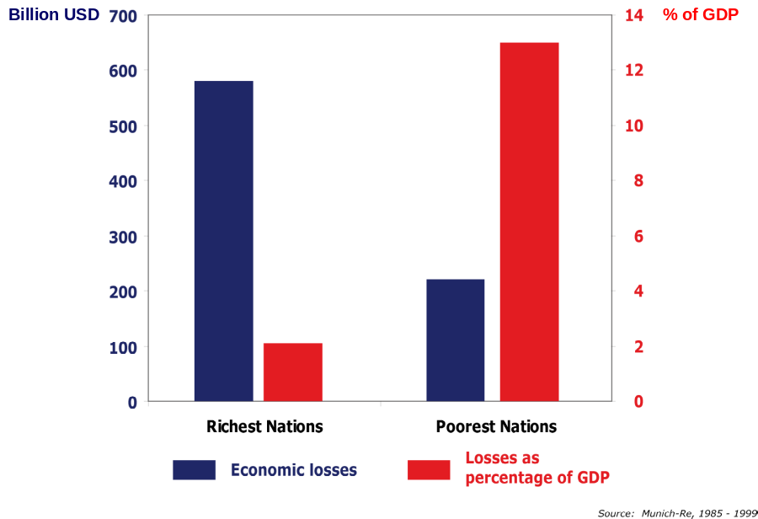
- Economic losses in richest and poorest nations relative to their GDP
Economic losses are increasing due to: i) increasing exposure, determined by changing demographic patterns, unplanned urbanization, environmental degradation, development in high risk zones, competition for scarce resources, current levels of poverty, among others; and ii) rising intensity and frequency of natural hazards such as tropical cyclones, heat waves, drought, heavy precipitation, flooding and marine hazards, as a result of climate variability and change.
Hazards are unavoidable. However, they need not necessarily turn into disasters. Disasters result from failures of societal practices or development processes that increase vulnerability to hazards. Indeed, despite the global rising trend in the occurrence of disasters and associated economic losses, global loss of life associated with meteorological, hydrological or climate-related hazards has considerably decreased by a factor of 10 from the 1950’s to 2005. This remarkable achievement is a demonstration that preparedness and prevention, combined with effective emergency management and early warning systems, can significantly contribute to reducing impacts of hazards on human life. While this is true, the capacity to rip the benefits of science, technology and early warnings to reduce the impact of disasters is limited in most parts of the world, particularly in the developing and least developed countries.
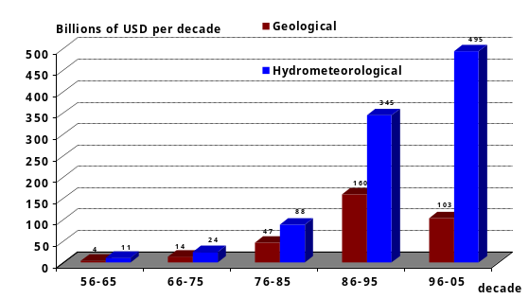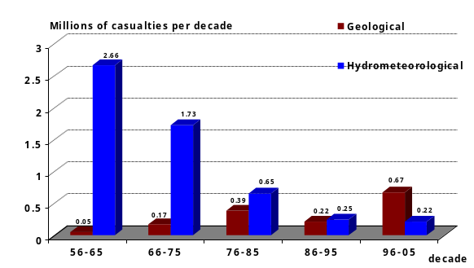
Source: The OFDA/CRED International Disaster Database - Brussels - Belgium
- Prevention and preparedness measures have saved lives over the last five decades.
In terms of human life, between 1980 and 2005, nearly 7500 natural disasters worldwide have taken the lives of over 2 million people. Least developed countries, accounting for 10% of the world’s population, recorded 41% of the global losses of life. Furthermore, over the same period, 5% of disaster events have happened in small island developing states (SIDS), while these countries only cover 0.8% of the planet. Disaster risk reduction should be considered as a priority, and specifically in SIDS, developing and least developed countries.
The impacts of disasters on human lives, assets and the environment contributed to trigger the momentum for disaster risk reduction strategies worldwide.

1. Frameworks, Strategies and Coordination Mechanisms in Disaster Risk Reduction (DRR)

1.1. Hyogo framework for action (HFA): New Paradigm in DRR
Traditionally, attention has been focused almost exclusively on actions taken immediately before, during and shortly after a disaster, in what can be called “crisis management” approach. Today, it is recognized that much attention needs to be given to preparedness and prevention strategies. For this to be true, a paradigm shift is called for, which requires a move from the so called “crisis management” approach to a much more proactive, holistic and systematic approach encompassing risk identification, risk reduction and risk transfer, namely the “disaster risk management” approach.
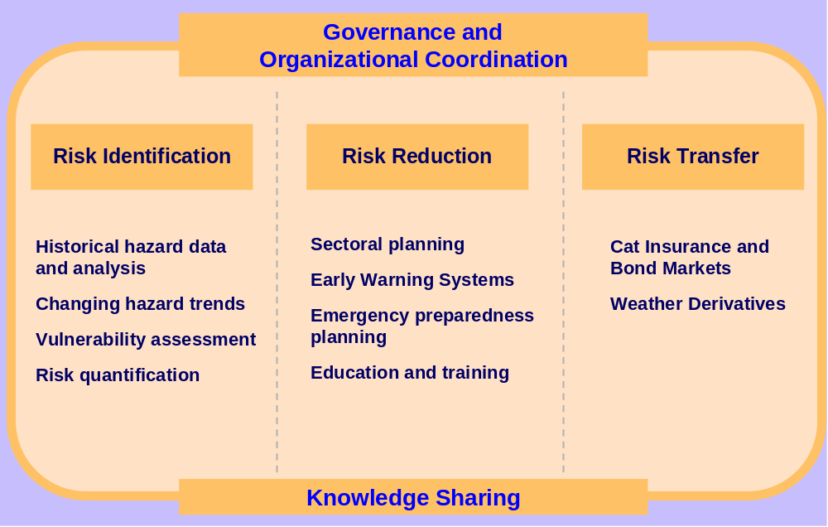
- Conceptual framework of disaster risk management
Disaster risk management is now a priority for Governments and the international community. Effective disaster risk management often marks the difference between a natural hazard and a disaster.
The need for a strategic approach to improving the effectiveness and efficiency of disaster management and disaster risk reduction resulted in the Hyogo Framework for Action 2005-2015 (HFA): Building the Resilience of Nations and Communities to Disasters; a resolve of 168 Governments for action, adopted at the Second World Conference on Disaster Reduction, held in Hyogo, Kobe, Japan in January 2005. HFA is the primary international agreement for disaster risk reduction as it identifies the main actors, the guiding principles, priorities and key activities for achieving disaster risk reduction from the international to the community-level. HFA is a global blueprint for disaster risk reduction efforts during the decade 2005 – 2015.
HFA recognises the inextricable link between natural disasters, poverty, development and environmental issues. It emphasises that disaster risk reduction should be part of every day decision making, as each decision one takes can make us either more vulnerable or more resilient to disasters. It also stresses the need for strong collaboration and cooperation among various agencies. Therefore, efforts to reduce disaster risk require systematic mainstreaming of disaster risk reduction into development policies, strategies and plans, underpinned by appropriate governance and organizational mechanisms, supported by bilateral, regional and international cooperation, including partnerships.
Within HFA, States are considered as primary responsible for taking measures to reduce disaster risks. However, due to the limited capacities, particularly of developing and least developed countries, regional and international cooperation is required to assist high-risk and low-capacity countries, so as to stimulate efforts towards building the resilience of countries and communities concerned.
Efforts are ongoing to institutionalize disaster risk reduction and implement the Hyogo framework for action, by national Governments and Organizations, but their effectiveness is still far from the desired level. The proceedings of the first session of the Global Platform for Disaster Risk Reduction, held in Geneva, 5-7 June 2007, indicate that “…We are not on track to achieve the Hyogo Framework’s sought-after outcome of a substantial reduction in disaster losses by 2015. The need for action is more urgent than ever…”

1.2. National Governance, Legislation and Coordination Mechanisms
The success of disaster risk reduction efforts on the longer term is critically dependent on good governance. Good governance includes the adoption and promotion of robust and sound policies, legislation, regulatory frameworks and the creation of an enabling environment that is characterized by appropriate decentralization of decision making to allow effective participation of the affected people assisted by appropriate allocation of resources. Other features of good governance include the rule of law, transparency, equity, efficiency, effectiveness, responsiveness, consensus orientation, accountability and strategic vision.
In April 2000, the law number 337 was approved, establishing the Venezuelan national system for disaster response, mitigation, and prevention. The National System for Disaster Prevention, Mitigation, and Attention (SINAPRED) and its Executive Secretariat, the implementing system for the new legislation, responded directly to the Presidency of the Republic. At that time, this was considered the most advanced proposal for risk reduction in the region. Since then, CEPREDENAC has promoted similar approach to disaster risk reduction in other countries in South America.
Case study : Venezuela
In some countries, governments have started to integrate disaster risk reduction elements in their Poverty Reduction Strategies (PRSs) and other national development instruments. Disaster risk reduction has also been mainstreamed into some Country Common Assessments (CCAs) and United Nations Development Frameworks (UNDAFs). In parallel, countries have also worked to mainstream disaster risk reduction into development planning in sectors and at the local level. These efforts are supported through different programmes and agencies’ initiatives, such as the UNDP Institutional and Legislative Systems for Disaster Reduction (ILS) Programme and the World Bank’s Global Facility for Disaster Reduction and Recovery (GFDRR).
Different reasons why governments may be reticent to implement preventive measures and disaster risk management include:
- Preventive measures being considered by government and the private sector as costs factors rather than profitable investments, whereas external aid for reconstruction after a disaster are mostly cost-free transfers;
- Expanding infrastructure is often a way of attracting votes during elections. However, construction quality standards that are important for disaster risk reduction are often not a priority for communities;
- Uncertainty as to whether an extreme natural event is actually going to occur often deters decision makers from investing scant existing funds in risk-reduction measures.
However, recent studies by the World Bank, the ProVention Consortium and other development agencies revealed that most disaster-related losses that have occurred in low-income countries over the past ten years could have been critically reduced if simple and inexpensive disaster reduction measures had been implemented. Several analyses have demonstrated the benefits of disaster risk reduction measures, such as integration of risk knowledge for design of infrastructures. According to the World Resource Institute, investments in prevention measures for disaster risk reduction pays off with a ratio of 1 to 7.

1.2.1. Policy and Legislative Systems for Sustainable Disaster Risk Reduction
HFA identifies legislation as a critical component of disaster risk reduction, and calls upon States to “adopt, or modify where necessary, legislation to support disaster risk reduction, including regulations and mechanisms that encourage compliance and that promote incentives for understanding risk reduction and mitigation activities”.
In 1994 South Africa started a process to put in place policies for disaster management through a Green Paper. In January 2000 a White Paper on Disaster Management was launched, a policy document, which underscores the importance of preventing human and economical losses and avoiding environmental degradation. As a follow up to the White Paper, a Disaster Management Act was promulgated in 2003, which among others, provides for an integrated and coordinated disaster management policy with a focus on prevention of risk, mitigation, preparedness, rapid and effective response to disasters and post-disaster recovery. In tandem, various departments have developed national policies and supporting frameworks. In 2005 a National Disaster Management Framework was approved.
Efforts to incorporate disaster risk reduction in the integrated development planning by provincial and local governments are underway. However, mainstreaming disaster risk reduction into all organs of state at all levels is still a challenge.
The success case of South Africa was made possible by a favourable environment underpinned by strong political commitment.
Case study : South Africa
Policy and legislative reform is a long-term process that requires planning and consultation, involving local actors and communities at risk. UNDP’s experience through supporting disaster risk reduction programmes in 63 countries revealed that the review of organisational structures, policies, mechanisms and processes, strategies, laws and regulations, resources and procedures in the light of their performance during a recent disaster, has been the major incentive for reforms. UNDP concludes that policy formulation should be seen as opportunities to build ownership among stakeholders and foster learning and cooperation. The participatory processes may even be as important as the final product and may lead to a greater impact in the longer term.
According to a recent Assessment of National Meteorological and Hydrological Services’ Capacities in Support of Disaster Risk Reduction, based on a survey conducted by WMO in 2006 and participated by 139 countries, legislation governs the way that disaster risk reduction activities are organized in 81% of the participating countries. However, for 55% of countries, the lack of clear legislation or policies regarding the role of the National Meteorological and Hydrological Service limits the effectiveness of their contribution in disaster risk reduction at the national level.
In Costa Rica, the disaster risk reduction legislation, revised in 2006, imposes 3% of the annual budget from each state agency to feed a national fund for prevention. This legislation has had highly beneficial outcomes, and enabled prevention to be considered as an investment, for protection of life and economy.
Case study : Costa Rica

1.2.2. DRR Coordination Mechanisms
Governments, aware of their primary responsibility to protect people in their territories, have setup various institutional mechanisms to prevent or reduce the risks of disasters. During the International Decade for Natural Disaster Reduction (1990-2000), multi-stakeholder national committees have been setup in nearly 20 countries.
After the advent of the Hyogo Framework for Action, to specifically address the first Priority for Action “ensure that disaster risk reduction is a national and a local priority with a strong institutional basis for implementation”, several types of multi-stakeholder coordination mechanisms are being setup or strengthened, namely:
- Governmental Inter-Ministerial Coordination Mechanisms, usually under the head of the government, to coordinate activities of various ministries related to disaster risk reduction;
- National Platforms for Disaster Risk Reduction involving different stakeholders (government institutions, private sector, NGO, academic and research institutions, communities, etc.);
- Strengthening of the role of the Office of the UN Resident Coordinator for the coordination of disaster risk reduction activities among UN agencies and with governments.
As of November 2007, progress with implementation of HFA and disaster risk management had been reported to the UNISDR Secretariat by 106 countries and 5 territories, through the HFA Focal Points.
Coordination mechanisms enable better identification of requirements, roles and responsibilities of various stakeholders in DRR, and often lead to new partnerships to leverage capacities and resources of various agencies towards implementation of HFA. Development of legislation and regulatory frameworks, in many cases, has been instrumental for sustainability and reliability of DRR activities.

1.2.2.1. Governmental Inter-Ministerial Coordination Mechanisms
The Government has played a major role in promoting coordination among ministries for disaster risk reduction. Since 2004, three multidisciplinary councils address disaster risk reduction, namely inter-ministerial council for sustainable development (CIDD), steering committee for prevention of major natural risks (COPRNM), and national council for civil security (CNSC).
Driven by the government, various thematic operational services and action plans, from the national to the local level, have enabled the development of appropriate risk knowledge and sharing of responsibilities among authorities for prevention, preparedness and emergency response.
Case study: France
Usually under the head of the government, Governmental Inter-Ministerial Coordination Mechanisms coordinate activities of various ministries related to disaster risk reduction.
According to the recent WMO Assessment of NMHSs’ Capacities in Support of DRR, 90% participating countries have a mechanism for coordinating activities of the multiple national agencies for disaster risk reduction. Furthermore, 98% of participating NMHSs provide support (through expertise, products and services) at national level to agencies responsible for disaster risk reduction.
HFA focal points are designated by the government to liaise with the ISDR Secretariat, and report on a voluntary basis on the implementation of HFA in their country.For more information about activities of national governments for implementation of HFA, the contact information of the 118 national HFA focal points (113 UN Member States + 5 UK Territories) can be accessed from http://wwww.preventionweb.net/contacts.

1.2.2.2. United Nations Country Team and Office of the UN Resident Coordinator
The role of the United Nations Country Teams for DRR, as recommended by the UN/ISDR, include:
- Strengthening awareness of roles and responsibilities among all stakeholders and helping them build the skills and capacities needed to carry out assigned functions;
- Assisting with the assessment of existing capacities, gaps and needs upon request from the country’s government;
- Identifying relevant actions to assist the HFA implementation;
- Assisting with the development of national policies, strategies, action plans and programmes on DRR, and helping develop institutional and technical capacities in the field of DRR - as identified in the HFA;
- Establishing links and exchanges between different levels of actions (local and intermediary as well as national, regional and international) and/or fostering collaboration and dialogue among national platform members;
- Strengthening decentralized local governance systems for DRR and helping to identify roles and responsibilities; and
- Ensuring the link between national needs and UN assistance in DRR at national and community levels in close cooperation with other multilateral and bilateral donors.
These activities can also be supported by agencies of the ISDR System, including the United Nations, its specialised agencies, as well as the World Bank and the International Federation of the Red Cross and Red Crescent Societies.
Text will be developed with input from WMO Department for Development, Cooperation and Regional Activities.
Specific agreement between WMO and UN Communication Country Teams
“Because so much of our work, particularly in crisis and natural disaster situations, is strongly affected by weather and other environmental factors, it is important that representatives of our partner countries’ National Meteorological and Hydrological Services participate in these discussions” (Mr David Morrison, Director, UNDP Communications Office).
Since May 2007, NMHSs communication focal points (i.e. WMO information and public affairs focal points at the country level) are invited, through the WMO Permanent Representatives, to participate, when relevant, in meetings of the United Nations Communications Group (UNCG) country meetings, together with communicators of all UN entities operating in the countries.
Participation of NMHSs communication focal points in this UN coordination mechanism will ensure critical products and services that could support prevention and emergency operations are accessible and appreciated for decision support. It should enhance media coverage and recognition by all stakeholders for the activities of the NMHSs.

1.2.2.3. National Platform for Disaster Risk Reduction
Case study: Sri Lanka
National Platforms have been set up in 40 countries. Membership and terms of reference are highly variable from country to country.
Sri Lanka established a comprehensive set of legislation, institutions and action plan to support DRR at the national level: the Disaster Management Act was enacted in 2005, the National Council for Disaster Management and the Disaster Management Centre were established in 2005, and the Road Map for Disaster Risk Management “Towards a Safer Sri Lanka”, developed in 2006, clearly identifies the role of the different stakeholders for every stage of disaster risk reduction. A National Policy and Plan for disaster management have also been developed in 2007.
Government Agencies such as the Meteorological Service have managed to strengthen their capacities, with appropriate support from the government, in order to be able to fulfil their responsibilities as clarified in the road map.
Other stakeholders (private, NGO, academia, media, donors, UN) are now getting involved in the coordination process, with the formation of the National Disaster Management Coordination Committee (NDMCC). The possibility of merging the National Disaster Management Coordination Committee with the Inter-ministerial Coordinating Committee is under consideration.
The goal is to strengthen cooperation and coordination among stakeholders representing an array of comprehensive skills and knowledge needed for disaster risk reduction, such as Ministries, UN agencies, civil society organisations including NGOs, the private sector and academic institutions, for implementation of coordinated DRR activities and mainstreaming of DRR into development planning and practices.
In 2005, the UN General Assembly resolution A/RES/59/231 “called upon Governments to establish national platforms […] for disaster reduction [and] encouraged government to strengthen platforms where they already exist”.
Information of national platforms, provided by national contact focal points is available from http://wwww.preventionweb.net/contacts.
Case study in Poland: Creation of an Office for Improved Collaborations between the
Institute of Meteorology and Water Management (IMGW) and Local Governments

With a view to increase collaboration between the Polish National Meteorological and Hydrological Service (IMGW) and local governments for flood management, a special Office was established within the NMHS to: i) facilitate the identification of needs and gaps for strengthening collaboration between IMGW and local governments; ii) facilitate the identification of needs for an educational programme; iii) facilitate the exchange of experiences.
The initiative involved IMGW; local authorities that were the main users of NMHSs products and services, and a private telecommunication operator.
The major achievements of the initiative are:
- Increased financial support to the IMGW to support its activities with the local governments;
- Clear understanding of the requirements of stakeholders related to floods;
- Clear understanding of the growing needs for education and public awareness about floods at the local level as well as flood risk plans;
- Development of cooperation with the ministry of Education, local authorities, local agencies and schools (using educational material produced by the NMHS);
- Increased public awareness on role of meteorology and wider understanding about hazards;
- Increased public utilization of published materials prepared by the NMHSs.
IMGW plays a crucial role in coordination of disaster risk reduction in the country. It coordinated the establishment of the Polish National Platform for disaster risk reduction, a non governmental body through which representatives of the NMHS are also represented in the Central East-European Disaster and Prevention Structure (CEUDIP).

1.3. Regional Strategies and Agreements in DRR for implementation of HFA

1.3.1. Regional and Sub-Regional Framework and Action Plans for Implementation of HFA
Regions are progressing towards the implementation of the HFA at different paces and starting points. In some cases, regions have been pursuing disaster risk reduction for several decades and so have established some degree of capacity to reduce disaster risk, while others have only recently initiated activities motivated by the recent adoption of the HFA. In regions where the incidence of hazards is high, actions to reduce disaster risk have a relatively longer history.

1.3.1.1. Africa
In Sub-Saharan Africa disaster impacts have become a serious impediment to the efforts of governments to reduce poverty and achieve sustainable development. As a whole, Africa is the only continent whose share of reported disasters in the word total has increased over the past decades. More people are affected by natural hazards and the economic losses incurred are rising. These facts have led African leaders to recognise the need for a strategic approach to improve and enhance the effectiveness and efficiency of their efforts to reduce disasters in the continent.
The African Union and its New Partnership for Africa’s Development (NEPAD) spearheaded the efforts for the development of the strategic approach to address disaster risk reduction that resulted in the formulation and adoption of the Africa Regional Strategy for Disaster Risk Reduction, in July 2004. The strategy provides a broad range of strategic directions that Regional Economic Communities (RECs) and countries, the major players in the implementation of the strategy, can select from to suit their respective contexts and needs. Subsequently a programme of action for the implementation of the Africa Strategy for Disaster Risk Reduction for the period 2005 – 2010 was formulated.
Case Study: ECOWAS DRR Action Plan
At sub-regional level, various RECs developed regional strategies and/or frameworks. The existing include i) the SADC disaster management strategy approved in August 2001 by the SADC Council and revised to factor in disaster risk reduction, followed by the approval of the disaster management programme; ii) the IGAD regional strategy to strengthen sub-regional disaster preparedness and response capacities, which features a regional programme for disaster risk management; iii) The ECOWAS disaster management mechanism for West Arica and the ECOWAS sub-regional strategy on disaster. ECOWAS adopted a Policy and Mechanism for disaster risk reduction, and is now drafting an action plan for DRR; and iv) the ECCAS sub-regional centre for disaster risk reduction that was established in Congo. A strategy for this region is being developed.
Case study: West Africa
The ECOWAS Conference on Disaster Risk Reduction (DRR) in West Africa was convened on 17-18 May 2007, under the auspices of the African Union (AU) and ECOWAS, by the World Bank, the United Nations International Strategy for Disaster Reduction (UNISDR), the World Meteorological Organization (WMO) and the United Nations Environment Programme (UNEP), hosted by the government of Côte d’Ivoire. Participants included Ministers responsible for disaster management from all ECOWAS Member Countries.
The Conference recognized that the main causes of loss of life, property and environmental damages in West Africa are related to hydro-meteorological hazards. It identified an urgent need to develop a concrete action plan for implementation of the ECOWAS Policy for DRR that would be translated into national programmes of action. The conference highlighted that such a programme would build upon the Hyogo Framework for Action, the African Regional Strategy for DRR, and the ECOWAS Policy for DRR.
The meeting identified a set of priorities for DRR in the region, including: strengthening of capacities for meteorological, hydrological and climate products and services, early warning systems as an integral part of DRR; risk assessment; mainstreaming DRR in Poverty Reduction Programmes; multi-disciplinary partnerships at all levels through national, regional and thematic platforms for DRR; and recommended the use of the Global Facility for Disaster Reduction and Recovery (GFDRR) for capacity development of institutions and organizations providing services for DRR.
SADC and IGAD were the first to formulate strategies, and have also established the Drought Monitoring Centre and Climate Prediction and Application Centre, respectively, to strengthen their capacities for dealing with climate variability and extremes, particularly drought and floods.
In this region, other relevant strategies include: i) regional strategy and collaboration of national platforms for disaster reduction that is intended to provide a forum for focal points of national platforms in Africa to share their success stories and lessons learnt in coordinating national platforms for disaster risk reduction; ii) the proposed strategy for building resilience for tsunamis in the Indian Ocean 2006-2008 aimed at increasing knowledge and capacity for disaster risk reduction, particularly related to tsunami; iii) the Africa advisory group on disaster risk reduction to advise national platforms, governments, sub-regional and regional authorities to increase their effectiveness in implementing and promoting disaster risk reduction; and iv) the university network for disaster risk reduction in Africa working on capacity building for disaster risk reduction.
Issues of capacity and resources have been often cited as being a major impediment to effective disaster risk reduction in the continent. The political will that has led to the establishment of structures has not been accompanied with appropriate financing of the structures for effective implementation of programmes and activities. At the institutional level, there are many gaps for addressing disaster risk reduction effectively that still need to be addressed.
In North Africa and the Middle East, disaster risk reduction is a relatively new topic of concern. As a result the existing frameworks such as legislation and institutional arrangements are dominated by traditional civil protection structures focusing primarily on response and preparedness. Actions are initiated immediately before, during and in the aftermath of a hazard with seemingly low community engagement. The region does not have a coordinated mechanism or institution for disaster risk reduction.

1.3.1.2. Asia
Asia is a region where efforts to address disaster risk started a long time ago, mainly because of its high exposure to different hazards. Asia has established regional structures to support the mainstreaming of disaster risk reduction in community development programmes, institutionalization of community based disaster risk reduction into policy and planning and the promotion of multi-national cooperation in disaster risk reduction. These include the Asian Disaster Preparedness Centre (ADPC), the Asian Disaster Reduction Centre (ADRC) and the South Asia Regional Cooperation (SAARC) Disaster Management Centre created in 2006.
To further strengthen regional cooperation along the lines of HFA through joint programmes and activities, initiatives have been started to support disaster risk reduction. These include i) Beijing Action Plan for Disaster Risk Reduction for Asia and Pacific endorsed by the Ministerial Conference on Disaster Reduction, held in Beijing, in September 2005; ii) the ASEAN regional Programme on Disaster Management 2004-2010; and iii) The ASEAN Agreement on Disaster Management and Emergency Response.
The United Nations Economic and Social Commission for Asia and Pacific (UNESCAP) has a disaster management and prevention programme for all Asian and Pacific countries, which supports the implementation of the HFA, through its various programmes. Different UN agencies such as ISDR, OCHA, UNDP, are engaged in the implementation of various activities.

1.3.1.3. Latin America and the Caribbean
Latin America and the Caribbean is another region where addressing disaster risk has a long history. Due to this history, there are very good examples of disaster risk reduction practices that are well rooted in community practices.
In this region it is the Centre for the Coordination of Prevention of Natural disasters (Centro de Coordinación para la Prevención de los Desastres Naturales – CEPREDENAC) and the Caribbean Emergency Response Agency (CDERA) that are the major regional mechanisms and specialized institutions for the coordination and implementation of disaster risk reduction.
CEPREDENAC is a specialized institution of the Central American Integration System (SICA). Under its guidance a revised regional strategy for disaster reduction 2005-2015 that aims at contributing to disaster reduction as an integral part of sustainable development of the sub-region is in place.
CDERA facilitated the adoption of the Enhanced Comprehensive Disaster Management Framework by the Caribbean Community (CARICOM). This strategy, first developed in 2001, aims at achieving sustainable development in the Caribbean and links disaster management to national development decision making and planning.
The Committee for Disaster Prevention and Relief (CAPRADE) is the specialized body for disaster risk management in the Andean Community. The sub-region has its Strategy for Disaster Prevention and Relief for the period 2005-2010 that was approved in Quito, in 2004.
The Inter-American Development Bank (IDB) has set a pioneering example by establishing a disaster prevention funding mechanism through which disaster risk management is included as a pre-requisite in the programming process of governments, international, regional and local agencies for positive consideration for funding. This mechanism is an incentive for mainstreaming disaster risk reduction in policies and programmes.
In most Latin America and the Caribbean, the institutional frameworks for disaster risk management pre-date the Hyogo framework for action. These have been and are being updated to align them with the five priorities for action of the HFA.

1.3.1.4. North America
In North America, there are well established coordination and collaboration mechanisms, whose scope include hazard preparedness through emergency management and multi-hazard dissemination systems.
Most of the established mechanisms are interdepartmental in nature, between sister institutions in the two countries. Good examples are those related to management of shared reservoirs and rivers, the north America Drought Monitor (a system that provides watches for droughts), the joint radiological emergency response plan, transboundary air pollution and many more related to technical aspects.
Text to be finalized with input from the meeting.

1.3.1.5. South-West Pacific
In the Pacific Islands, the Applied Geoscience Commission (SOPAC) is the driving force for the implementation of programmes and activities in disaster risk reduction. It runs the Pacific Community Risk Programme aimed at strengthening resilience to disasters, mitigation of the effects of hazards and mainstreaming disaster risk management. A regional framework for action for building the resilience of nations and communities to disasters for the period 2005-2015 has been endorsed by the Pacific Forum Leaders. This strategy is implemented trough a two pronged approach, involving first, the development of national action plans, up to 2006 and the implementation and monitoring of the national action plans. The strategy also supports the development of a robust early warning system in the region.
Text will be developed with input from the meeting.

1.3.1.6. Europe
In Europe, under the umbrella of the European Commission, its various Directorates Generals such as Environment, Development, External Relations, Regional Policy and Research include different aspects of disaster risk reduction in their portfolios. Besides the Commission, the newly created European Network of National Platforms and the Council of Europe that established in 1987 the “EUR-OPA Major Hazards Agreement” that has declared disaster risk reduction a major priority and aims at reinforcing and promoting cooperation among its 25 member states in a multi-disciplinary way to ensure better prevention, protection and organization of relief, are important mechanisms. Under the later various activities have been carried out in member countries in the fields of policy and legislation, education and awareness raising, hazard mapping, among others.
Europe has adopted a regional or transboundary approach in dealing with extreme weather events and river catchments. The international river commissions of Europe provide good practices in this regard.
Text to be developed with input from the meeting.
Danube River Commission
Despite the fact that most European countries are major donors for humanitarian, relief, and disaster assistance elsewhere, the financial resources available in the continent for disaster risk reduction activities are rather modest. At national level, a good number of National Platforms are grappling with lack of adequate funding.

1.3.2. Cross-Boundary Coordination and Cooperation
There is an old saying “weather-, climate-, and water know no boundaries”. Indeed phenomena associated with weather-, climate-, and water can cover vast areas that may go beyond national borders.
To ensure appropriate management of e.g. water resources, pollution (including nuclear pollution), fires, etc., cross-border coordination and cooperation among countries is vital. Good examples relate to the agreements on shared river basins or the establishment of river commissions that are very common in various parts of the world (e.g. International Commission for the Protection of the Danube River, established in 1998 comprising 13 states in Europe; The International Commission for the Protection of the Rhine against Pollution, established in 1999 involving the 5 countries; The Mekong River Commission formed in 1995 comprising 4 countries, the Nile Basin Commission, etc.), as well as to the establishment of environmental emergency response systems to deal with threats of nuclear accidents, fires, among others.
Text to be developed with input from AFPCN.
Network of European Platforms
After the devastating fires that hit South-East Asia in 1997, ASEAN formulated a regional Haze Action Plan to address the problem of recurring forest fires and the resulting transboundary smoke and haze pollution. This initiative lead to the accreditation by WMO of the ASEAN regional specialized meteorological centre in Singapore that provides smoke and haze information and forecasts to NMHSs to assist in environmental emergency situations.
Coordination and cooperation are essential in order to facilitate sharing of data, expertise, exchange of experiences on dealing with the same hazard, regional policies and above all, efficiency of operations.

1.4. International Coordination and Collaborations for Implementation of HFA

1.4.1. Linking DRR with International Development Agendas
In September 2000, the United Nations Millennium Summit, attended by 147 heads of State and governments of a total of 189 represented nations, adopted the Millennium Development Goals (MDGs), drawn from the actions and targets contained in the Millennium Declaration. The MDGs are goals to be achieved by the year 2015 by all nations in response to the world’s main development challenges. All the 8 MDGs are sensitive to or influenced by weather-, climate- and water events, particularly the manifestations of extreme events. By providing access to weather-, climate-, and water information and services as well as capacity to package and interpret such information to support disaster risk reduction, NMHSs contribute directly to the achievements of all MDGs.
Besides the MDGs, DRR is also at the heart of most of the sustainable development issues and major development challenges that governments face. Poverty alleviation, the Programme of Action for the Least Development Countries, the Mauritius Strategy, just to cite a few, will not be fulfilled if concerted action is not taken to address disaster risk reduction.
One of the strategic goals of the HFA is to strengthen the integration of disaster risk considerations into sustainable development policies, planning and programming at all levels, with special emphasis on disaster prevention, preparedness and vulnerability reduction. Hence, the call for international financial institutions and other stakeholders to integrate disaster risk reduction into development assistance frameworks and poverty reduction strategies.
It has been often argued that one of the root causes of vulnerability to hazards is poverty. Poverty is highly correlated to vulnerability, even though the two may not overlap. In reality, poor people and nations suffer the greatest losses of assets (relative to their wealth) and lives and tend to have lesser capacities to cope and recover. On the other hand, disasters can push relatively better-off people into poverty and the poor to poorer extremes, through their vulnerability to disasters and inability to avoid the impacts. Thus, disaster risk reduction adds value to efforts and measures intended to reduce poverty and achieve major development goals, by boosting the capacity of people and nations to mitigate and cope with the impacts of hazards.
By contributing to disaster risk reduction, through monitoring, detecting, analysing, forecasting and issuing warning for weather,- water- and climate – related hazards, NMHSs are directly contributing to poverty reduction and other development goals. NMHSs produce the scientific evidence that can be used in planning and policy making. Evidence of risk factors and risk levels is key for both promoting and enabling a transition from crisis to risk management. Such evidence renders risk factors visible and allows them to be addressed through socio-economic development processes.
With the visible impacts of climate change that are threatening poor nations due to their vulnerability and those that will follow due to past emissions, there is need to integrate longer term adaptation to climate change with immediate disaster risk reduction. In other words, climate change adaptation also needs to be integrated into development policies and avoid development of policies and practices that can increase vulnerability to the impacts of climate change that are known as “maladapation”.
The first essential step in adapting to climate change resides in building the capabilities to cope with climate variability today, that can increase resilience. In many instances adaptation means doing the things that need to be done to reduce climate related risks, but better and systematically.
The Nairobi Work Programme on Impacts, Vulnerability and Adaptation to Climate Change is the main framework for climate change adaptation. This programme intends to improve understanding and assessment of impacts, vulnerability and adaptation and the required measures to respond to climate change. Supported by the National Action Plans for Adaptation (NAPAs) that are intended to identify immediate and urgent needs with regards to adaptation to climate change at country level, implementation of the Nairobi Work Programme requires scientific and technical products and services such as those generated by the NMHSs.
The International WMO Conference on "Living with Climate Variability and Change: Understanding the Uncertainties and Managing the Risks ", held at Espoo, Finland, 17-21 July 2006, reviewed opportunities, requirements and constraints in integrating climate information and services in disaster risk management decision processes, with the view to establish priorities for more coordinated activities in both research and application areas. These activities build upon strong partnerships with agencies such as IFRC, the World Bank, UNDP, UNEP, among others.

1.4.2. International Strategy for Disaster Reduction and Global Platform for Disaster Reduction
On 22 December 2004, the 59th General Assembly of the United Nations called upon the International Strategy for Disaster Reduction (ISDR) to restructure, with a view to strengthen the participation and role of both governments and agencies in DRR, and leverage their capacities. Each international agency work with different counterparts at the national level should endeavour to promote a concerted approach to DRR. It is expected that collaboration and integrated planning among agencies at international to regional level would translate into more efficient and coordinated project at the national level.
In summary, the main elements of the strengthened ISDR system, as presented in the report of the UN Secretary-General to the UN General Assembly on August 2005 (A/60/180) are:
- A Global Platform for Disaster Risk Reduction (GP/DRR) with participation of Governments and agencies, regional organizations and civil society, with a particular role to advise on and commit to support the implementation of the Hyogo Framework, and to guide the various associated networks and platforms (this builds on the Inter-Agency Task Force on Disaster Reduction, functioning 2000-2005);
- A Management Oversight Board (MOB) with the function to provide advice on strategic, managerial and resource mobilization related issues to the Under-Secretary-General for Humanitarian Affairs (John Holmes) in his functions as leader of the ISDR international system, with a representative from the UN Development Group as vice-chair (Kathleen Cravero, UNDP, has been appointed for this function already).
- An ISDR secretariat as an independent entity within the United Nations Secretariat, with a line of accountability to the Under-Secretary-General for Humanitarian Affairs, to serve as “honest broker”, catalyst and main focal point within the UN system on disaster risk reduction issues, to continue to promote ownership and commitment to disaster risk reduction with national, regional and international constituencies, and report on progress;
- National platforms for disaster risk reduction (see 1.2.2.3.);
- Regional networks or coordination platforms for disaster reduction cooperation at regional and sub-regional level, including inter-agency task forces and networks of national platforms, for coordination and mainstreaming of disaster risk reduction in regional settings, and for advocacy and information networking;
- Thematic platforms or networks of expertise in support of priority areas identified in the Hyogo Framework led or supported by the Global Platform (Scientific panel/s- to be developed)
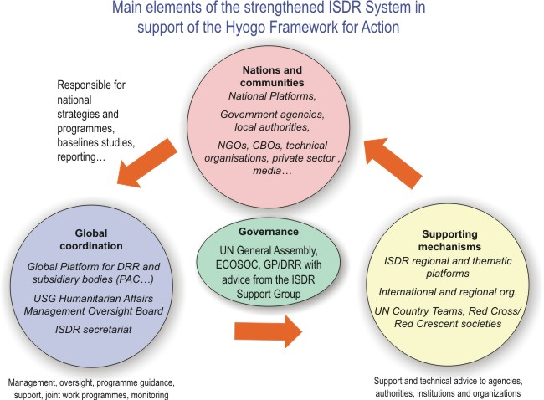
- Strengthened ISDR System in support of Implementation of HFA
Since 2005, the ISDR Management Oversight Board, chaired by the UN Under Secretary-General for Humanitarian Affairs and Emergency Recovery and participated by executive managers of UNDG, World Bank, WMO, IFRC, OCHA and UNEP, defines the strategic priorities of the ISR System. The role of the ISDR Secretariat is to help stakeholders identifying their mandates, roles, complementarities, with respect to implementation of HFA, from the international down to the national level, and to assist with coordination for selected projects. Beyond the Secretariat, the ISDR System includes agencies and governments, on a voluntary basis.

1.4.3 Other Initiatives of International Organizations Facilitating Implementation of HFA at Regional and National Levels

1.4.3.1. Global Facility for Disaster Reduction and Recovery
The Global Facility for Disaster Reduction and Recovery (GFDRR) is a multi-donor facility, established in September 2006 by the World Bank. GFDRR supports operations that provide technical assistance to low- and middle-income countries to mainstream disaster risk reduction in strategic planning frameworks, particularly the Poverty Reduction Strategies, UN Development Assessment Frameworks, National Adaptation Programs of Action (NAPAs), and various sectoral development policies. Assistance provided is demand driven, based on needs identified in national plans in consultation with Governments and stakeholders.
The World Bank is funding 5 millions USD per year and is projecting an annual budget of 15-20 million USD through other donors’ funds:
- Track 1 (5 million USD per year, supported through the World Bank) supports ISDR to develop a coherent and coordinated approach to risk reduction;
- Track 2 (projected to be 15-20 million USD per year, according to donors’ support) is directed towards mainstreaming disaster risks in development strategies in 86 identified natural disaster hotspot countries;
- Track 3 supports disaster-stricken low income countries’ immediate recovery needs before medium and long term recovery programs are formulated and launched.
The GFDRR is an opportunity for WMO and NMHSs, and collaborations could be considered for:
- Evaluation of specific needs of NMHSs in view of existing capacities and DRR stakeholder’s requirements in the 86 country at risk;
- Socio-economic benefits analysis of NMHSs, in order to prioritize governments and partners investments in this area;
- Strengthen coordination capacities of NMHSs for better integration within risk management decision making and better service delivery to potential users' communities;
- Assist less developed member countries to implement or strengthen warning systems.
Text to be finalized with input from World Bank

1.4.3.2. Global Alliance for Disaster Risk Reduction
With millions of National Red Cross and Red Crescent Societies’ members and volunteers living in communities around the globe, the Global Alliance for Disaster Risk Reduction has been setup to mobilize the International Federation’s global, regional, national, and local capacities and mechanisms to progress three programmatic outputs:
- Increased community orientation in global and national disaster risk reduction policies and strengthen national and local institutions for disaster risk reduction;
- Expanded community-based programming to identify and tackle disaster risks;
- Enhanced community-centred disaster risk reduction measures as part of comprehensive disaster response management whenever this is applied.
The global funding benchmarks allocate a proportion of the disaster response funding to follow-on risk reduction interventions. Therefore, this strategy gets reflected at the country- and community-level through various projects and initiatives such as:
- Vulnerability and capacity assessments;
- Promoting recovery that seeks to reduce future vulnerabilities;
- Proactively looking for opportunities to adapt to future risks.
Red Cross and Red Crescent National Societies are “natural partners” of NMHSs, as they have the capacity to undertake direct action at the community-level while also having some influence on policy-makers.
Examples of areas of collaborations involving both NMHSs and RCRC National Societies include:
- Development of public outreach materials;
- Improving and crafting warning messages towards different communities at-risk;
- Dissemination mechanisms.
Text to be finalized with input from IFRC
Since a devastating cyclone in 1991 killed an estimated 139,000 people throughout Bangladesh, the coastline has been studded with concrete shelters raised on 12-foot pillars to allow tidal surges to flow beneath. The government also honed its early warning systems and set up a volunteer network to assist with preparedness planning, drills, alert dissemination and evacuations. The Cyclone Preparedness Programme, built upon very simple products and technology, has demonstrated its benefits and efficiency over the latest events.
NMHS – RCRC Collaborations in Bangladesh

1.4.3.3. UNDP Initiative for Mainstreaming DRR in Development
Led by UNDP’s Bureau for Crisis Prevention and Recovery (BCPR), the Global Mainstreaming Initiative for DRR seeks to:
- Develop tools and strengthen capacities for mainstreaming DRR into development programmes and activities;
- Harmonize institutional policies and approaches for mainstreaming DRR into development plans; and
- Develop practical approaches to advocate for the integration of DRR into global and national level policy commitments and frameworks.
The Initiative has identified ‘high-risk’ countries across Asia, Africa, Latin America and the Caribbean, in which these tools and capacities would be developed in priority.
Text to be finalized with input from UNDP

1.4.3.4. Humanitarian Reform
Text to be developed by OCHA

1.4.3.5. IASC Disaster Risk Reduction Working Group
Text to be developed by UNICEF

2. NMHSs and stakeholders in DRR

2.1. Role of NMHSs in Implementation of HFA at the National Level
Every year, disasters related to meteorological, hydrological and climate hazards, such as floods, tropical cyclones, droughts, and heat waves, are the most frequent and extensive geographically, resulting in the largest share of overall impacts. Between 1980 and 2005, nearly 7500 natural disasters worldwide have taken the lives of over 2 million people and produced economic losses over 1.2 trillion US dollars. Of this total, 90 per cent of the natural disasters, 72.5 per cent of casualties and 75 per cent of economic losses were caused by weather, climate or water related hazards such as droughts, floods, windstorms, tropical cyclones and storm surges, extreme temperatures, land slides, wild fires or by health epidemics and insect infestations directly linked to the meteorological and hydrological conditions.
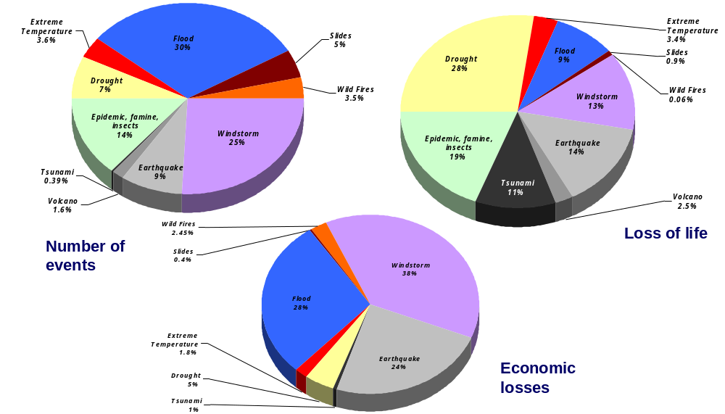
Source: The OFDA/CRED International Disaster Database - Brussels - Belgium
- Human and economic impacts of disasters
In every country, NMHSs observe, detect, analyse, forecast and disseminate information on weather-, water- and climate-related hazards. This information has a great potential for supporting risk assessments and decision-making for various stages of DRR, thus contributing to all 5 priorities for action defined by the HFA.
NMHS therefore play a lead role for the priority for action No 2 “Identify, assess and monitor disaster risks and enhance early warning”, specifically for the following key activities:
- Develop early warning systems that are people centred, in particular systems whose warnings are timely and understandable to those at risk, which take into account the demographic, gender, cultural and livelihood characteristics of the target audiences, including guidance on how to act upon warnings, and that support effective operations by disaster managers and other decision makers.
- Support the improvement of scientific and technical methods and capacities for risk assessment, monitoring and early warning, through research, partnerships, training and technical capacity- building. Promote the application of in situ and space-based earth observations, space technologies, remote sensing, geographic information systems, hazard modelling and prediction, weather and climate modelling and forecasting, communication tools and studies of the costs and benefits of risk assessment and early warning.
- Cooperate regionally and internationally, as appropriate, to assess and monitor regional and trans-boundary hazards, and exchange information and provide early warnings through appropriate arrangements, such as, inter alia, those relating to the management of river basins.
- Research, analyse and report on long-term changes and emerging issues that might increase vulnerabilities and risks or the capacity of authorities and communities to respond to disasters.
Effective disaster management requires that the multiple latent causes that can lead to disasters be identified, particularly with respect to low frequency hazards, for which the attention of decision makers and the general public has to be maintained.
Risk information associated with cost benefit analysis for disaster management initiatives can instigate political commitment to implement disaster risk reduction. In this regards, disaster risk reduction should be considered as an integral part of sectoral and development investments and planning rather than competing for attention and scarce resources with other pressing development needs and priorities.
Scientific evidence, particularly when associated with past experience (as was the case with hurricane Mitch in 1998 in Nicaragua, the earthquake in Pakistan in 2005, the drought in the Sahel in the 80s, etc.) plays a catalytic role for the adoption of appropriate mechanisms for disaster risk reduction. Unfortunately, it is only after a disaster that the need to effectively address disaster risk reduction tends to gain momentum.
Furthermore, NMHS also play a major role (joint lead role with other stakeholders, or contributing through products and services) for every single priority for action of HFA.
Under priority for action No 1 “Ensure that disaster risk reduction is a national and local priority with strong institutional basis for implementation”, hazard information and awareness generated by NMHSs serves as an input to motivate the adoption, at national level, of appropriate policy, legislation, coordination structures to address disaster risk reduction. Before a disaster, risk assessment can support the incorporation of disaster risk reduction and risk transfer measures into development planning. After the occurrence of disasters, risk information is critical for reconstruction as it allows preventing planning and reconstruction that may lead to the previous levels of exposure and vulnerability that may have induced the disasters or worsen them.
Under priority for action No 3 “Use of knowledge, innovation and education to build a culture of safety and resilience at all levels” NMHSs contribute to changing the mind set of entire communities by working with the ministries of education or the structures responsible for both formal and informal education to introduce content on risk, vulnerability and hazards in the school curricula.
By promoting the teaching of disaster risk reduction concepts at school, NMHSs reach a much wider community than the school pupils, as these pass on the message to their parents and people in their communities. NMHSs are also involved in the training of local authorities and other targeted audience, including the media with a view to expand the knowledge on risks, vulnerabilities, hazards and disasters.
Under priority for action No 4 “Reduce the underlying risk” it is important to note that 90% of the natural disasters, 72.5 % of casualties and 75% of economic losses are caused by weather-, climate- or water related hazards such as droughts, floods, windstorms, tropical cyclones, and storm surges, extreme temperatures, land slides, wild fires or by health epidemics and insect infestations, directly linked to meteorological and hydrological conditions. The above indicates that food security, sustainable ecosystem and environmental management, poverty reduction, health, water resources management, infrastructure, etc. can be severely impacted. Thus, failure to take into account risk information in the planning and management of these sectors can perpetuate underdevelopment and push people to more vulnerability. Furthermore, development that fails to take into account risk information can increase vulnerability and lead to disasters. That is why risk information must to be an integral part of all development planning, be it at institutional or individual level.
NMHSs as providers of risk and early warning information can influence policy formulation and development planning, through advocating for the inclusion of risk considerations into the major development processes such as Country Strategy Papers, Poverty Reduction Strategy Papers, UN Development Assistance Frameworks, National Adaptation Programmes of Action (NAPAs), among others. On the other hand, instruments such as the World Bank’s Facility on disaster reduction and the Inter-American’s Bank disaster prevention funding mechanism can be used as entry points for mainstreaming disaster risk reduction into development.
NMHSs have an essential role to play in the adaptation to and mitigation of climate change impacts. They are leading institutions in observing and understanding weather-, climate-, and water and in providing meteorological, hydrological and water related products and services in support of adaptation needs e.g. climatological databases and customized seasonal to inter-annual climate forecasts. NMHSs can bring together strong scientific and technical capacity, along with local, regional and global knowledge to support adaptation. Thus, they contribute to the Nairobi Work Programme through expertise, knowledge, data and tools.
Under priority for action No 5 “Strengthen disaster preparedness for effective response at all levels”, appropriate preparedness and response can only be possible if based on adequate risk knowledge and early warning information. Appropriate risk knowledge allows the development of appropriate disaster management capabilities and the necessary institutional and coordination mechanisms that are crucial to prevent hazards and in times when hazards strike.
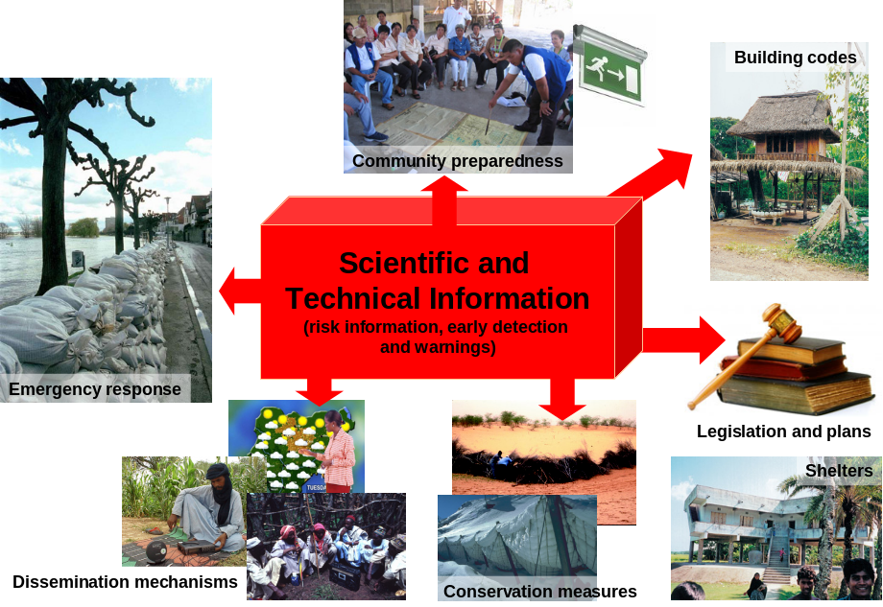
- Contributions from NMHSs’ products and services to various stages of DRR
The priorities for action of HFA have been classified in the table below according to the role NMHSs play in their implementation:
HFA Priorities for Action | 1. Ensure that disaster risk reduction is a national and a local priority with a strong institutional basis for implementation | 2. Identify, assess and monitor disaster risks and enhance early warning | 3. Use knowledge, innovation and education to build a culture of safety and resilience at all levels | 4. Reduce the underlying risk factors | 5. Strengthen disaster preparedness for effective response at all levels
Priorities’ components | (i) National institutional and legislative frameworks | (i) National and local risk assessments | (i) Information management and exchange | (i) Environmental and natural resource management | (i) Organisational capacities and coordination among stakeholders
Priorities’ components | (ii) Resources | (ii) Early warning | (ii) Education and training | (ii) Social and economic development practices | (ii) Preparedness and contingency plans
Priorities’ components | (iii) Community participation | (iii) Capacity | (iii) Research | (iii) Land-use planning and other technical measures | (ii) Preparedness and contingency plans
Priorities’ components | (iii) Community participation | (iv) Regional and emerging risks | (iv) Public awareness | (iii) Land-use planning and other technical measures | (ii) Preparedness and contingency plans
- Role of NMHSs for Implementation of HFA Priorities for Action
Legend: Lead role of NMHS ; Joint role of NMHS with other agencie(s) ; NMHS contribute

2.2. Contributions of NMHSs and Specialized Meteorological Centres at the Regional Level
Regional cooperation is a critical part of the solution to make accessible the latest hazard analysis and forecasting information to those countries with fewer resources. WMO has promoted strong regional cooperation among Members in terms of meteorological, hydrological and climate services. WMO facilitates information and capacity building through its Regional Training Centres, Drought Monitoring Centres and a Regional Tropical Cyclone Specialized Centre, as well as other specialised centres. Strengthening of these regional facilities and enhanced cooperation enables NMHSs to provide better information in support of decision-making.
At regional level, NMHSs are organized in Regional Associations. All of these associations (but one) have working groups on disaster risk reduction, whose major task is to advise on how best to address issues related to disaster risk reduction in their respective regions. In regional associations there are also 40 Regional Specialized Meteorological Centres (RSMCs) and 30 Regional Training Centres (RTCs).
RSMCs develop a number of regional and global products and services relevant to natural disaster management that NMHSs use in support of national disaster risk reduction. Examples are:
- The six WMO Tropical Cyclone Regional Specialized Centres, through which all tropical cyclones around the globe are monitored from their early stages of formation and throughout their life time, located in Honolulu (Hawaii, USA), La Réunion (France), Miami (Florida, USA), Nadi (Fiji), New Delhi (India), and Tokyo (Japan), as well as by tropical cyclone warning centres (TCWCs) in Brisbane, Darwin, Perth, Port Moresby and Wellington and other centres of national Meteorological and Hydrological Services (NMHSs). These centres provide information/advisories on the behaviour of the tropical cyclones, their movement and changes in intensity and on associated storm surges and floods, which assist countries at-risk in their responsibility to issue warnings. Each of these six centres is supported by a Regional Tropical Cyclone Committee, involving NMHSs and major stakeholder involved in tropical cyclone disaster risk management.
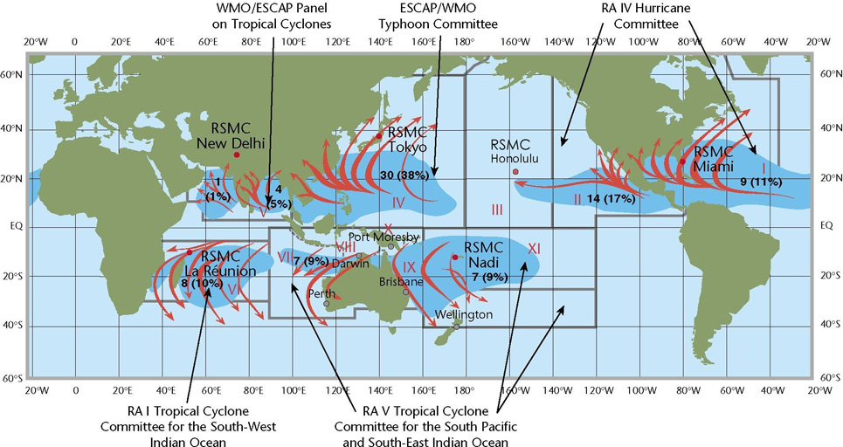
- The six WMO Regional Tropical Cyclone Specialised Centres centralise resources and capacities among countries at risk for provision of best information and advisories
- The eight designated Regional Specialized Meteorological Centres (RSMCs) for nuclear and radiological emergencies - Exeter (UK) and Toulouse (France) for Europe and Africa; Montréal (Canada) and Washington (USA) for the Americas; Beijing (China), Obninsk (Russia) and Tokyo (Japan) for Asia; and Melbourne (Australia) for Southwest Pacific with backup from RSMCs Montréal and Washington. They use sophisticated atmospheric simulation models to provide information on actual and forecasted transport / dispersion / deposition in the atmosphere and at the earth’s surface;
- The ASEAN Specialised Meteorological Centre (ASMC), in Singapore, facilitates the development of weather prediction models and related research and development programmes to predict the conditions that lead to incidents of fire and haze in the region;
- 30 Regional Training Centres (RTCs) provide equipment, facilities, instruction and training to respond to the needs of each region. Through the activities of these centres, NMHSs have received extensive training ranging from in hazard monitoring to issue of early warnings.
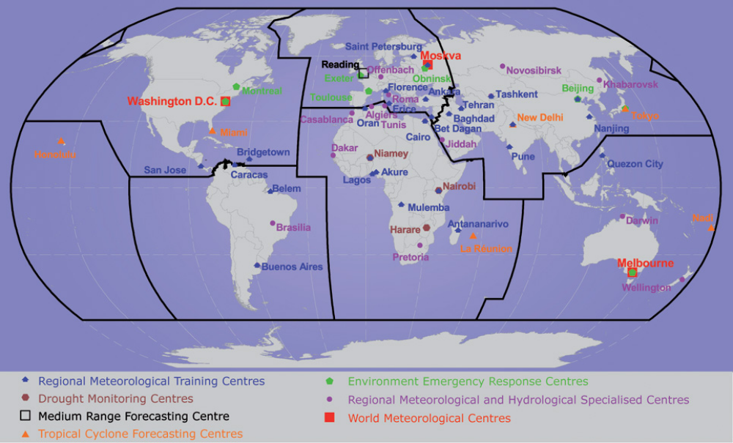
- WMO Supports Regional Cooperation though Accredited Regional Specialised and Training Centres
Additionally there are nine ICAO designated Volcanic Ash Advisory Centres (VAACs): Anchorage (USA), Buenos Aires (Argentina), Darwin (Australia), Exeter (UK), Montreal (Canada), Tokyo (Japan), Toulouse (France), Wellington (New Zealand) and Washington (USA).
The regional centres can provide guidance to regional bodies and direct them to NMHSs for more detail. Good examples are the North American Drought Monitoring Centre, the Drought Monitoring Centre of SADC, the Climate Prediction and Application Centre of IGAD and the various Regional Specialized Meteorological Centres that can provide information to NMHSs in their constituencies and support the planning of regional entities when requested.

2.3. Contributions of WMO at the International Level
WMO has a long history of assisting national efforts to combat the threat of disasters of hydrometeorological origin. Through the coordination of the activities of its 10 programmes, 8 technical commissions, 2 world meteorological centres, 6 regional associations, 40 regional specialized meteorological centres, 30 regional meteorological training centres, 188 Members’ National Meteorological and Hydrological Services (NMHSs), and various partners, WMO leverages capacities so that national meteorological and hydrological services can effectively contribute to all stages of disaster risk management, including risk identification, risk reduction and risk transfer.
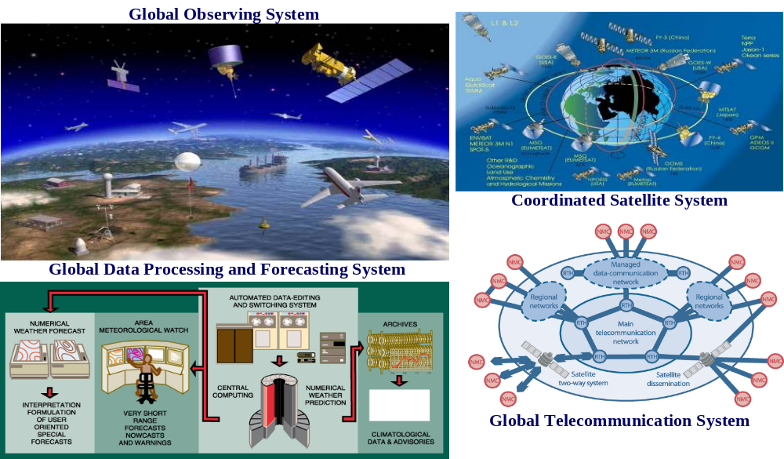
- WMO Coordinated Network for Observation, Telecommunication, Data Processing, Forecasting and Warning
Following a recommendation by the Global Survey of Early Warning Systems, WMO conducted a detailed assessment of technical capacities for observing, monitoring, detecting and warning of weather-, climate- and water-related hazard at national and regional levels. 139 countries contributed to the national survey. The report provides a detailed analysis of the capacities of National Meteorological and Hydrological Services to support disaster risk reduction at the national level, and identifies opportunities for collaborations and partnerships at the regional level.
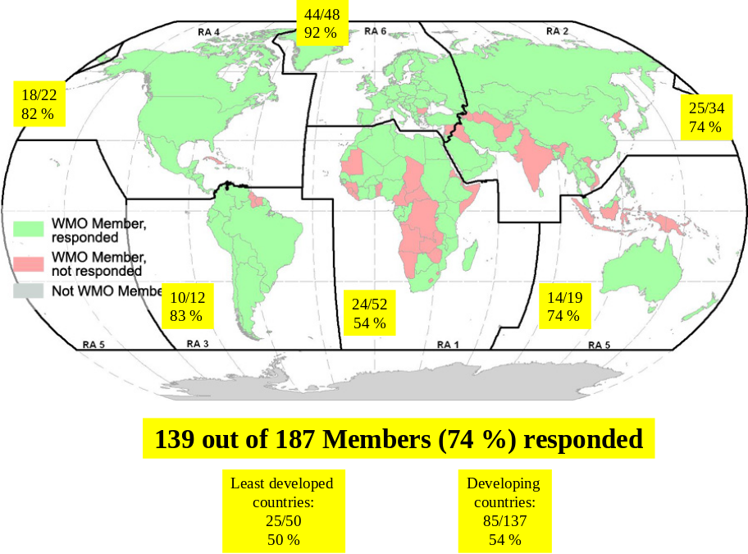
- Countries participating in the country-level survey
WMO has adopted the HFA for realigning its strategic goals in disaster risk reduction to ensure that operational meteorological, hydrological and climate services will be further strengthened and integrated within the disaster risk reduction process in all countries, particularly in those with least resources. The resulting DRR strategic goals are the following:
- Strategic Goal 1: Development, improvement and sustainability of early warning systems in particular related to scientific and technical infrastructures, systems and capabilities for research, observing, detecting, forecasting and warning of weather-, water-and climate-related hazards;
- Strategic Goal 2: Development, improvement and sustainability of systems, methods, tools and applications of modern technologies such as geographical information systems for recording, analyzing and providing hazard information for risk assessment, sectoral planning and other informed decision-making;
- Strategic Goal 3: Development and delivery of warnings, specialized forecasts and other products and services that are timely, understandable to those at risk and driven by requirements of disaster risk reduction decision processes and operations;
- Strategic Goal 4: Stimulate a culture of disaster preparedness through strengthening of capacities for better integration of NMHSs’ products and services in disaster risk reduction, and continued public education and outreach campaigns;
- Strategic Goal 5: Strengthening cooperation and partnerships of WMO and NMHSs in national, regional and international mechanisms and structures for implementation of disaster risk reduction.
WMO strategic goals relate to HFA as shown in the table below.
1) Ensure that disaster risk reduction is a national and a local priority with a strong Institutional basis for implementation
2) Identify, assess and monitor disaster risks and enhance early warning
3) Use knowledge, innovation and education to build a culture of safety and resilience at all levels
4 ) Reduce the underlying risk factors
5) Strengthen disaster Preparedness for effective response at all levels
National and local risk assessments
Early warning
Capacity
Regional and emerging risks
Information management and exchange
Education and training
Research
Public awareness
Environmental and natural resource management
Social economic development Practices
Land-use planning and other technical measures
National institutional and legislative frameworks
Resources
Community participation
Priorities
Focus
Disaster Preparedness for effective response at all levels
Strategic Goal 1: Development, improvement and sustainability of early warning systems in particular related to scientific and technical infrastructures, systems and capabilities for research, observing, detecting, forecasting and warnings of weather-, water- and climate-related hazards
Strategic Goal 2: Development, improvement and sustainability of systems, methods, tools and applications of modern technologies such as geographical information systems for recording, analyzing and providing hazard information for risk assessment, sectoral planning and other informed decision-making;
Strategic Goal 3: Development and delivery of warnings, specialized forecasts and other products and services that are timely, understandable to those at risk and driven by requirements of disaster risk reduction decision processes and operations;
Strategic Goal 4: Stimulate a culture of disaster preparedness through strengthening of capacities for better integration of NMHSs' products and services in disaster risk reduction, and continued public education and outreach campaigns;
Strategic Goal 5: Strengthening cooperation and partnerships of WMO and NMHSs in national, regional and international mechanisms and structures for implementation of disaster risk reduction;
Strategic Goals in DRR
Hyogo Framework for Action 2005-2015
World Meteorological Organization
- WMO strategic goals are derived from HFA and linked to the five priorities for action
These strategic goals underpin the DRR’s sustainable integrated capacity development plan, which builds upon the following major thrusts: (i) modernization of NMHSs and observing networks; (ii) implementation of national operational multi-hazard early warning systems; (iii) strengthening of hazard analysis and hydrometeorological risk assessment tools; (iv) strengthening NMHSs cooperation with civil protection and disaster risk management agencies; and (v) coordinated training and public outreach programmes. This integrated action plan is being implemented through national and regional projects involving WMO Programmes, Technical Commissions, Regional Associations and external partner organizations.
WMO, through regional and national projects in Africa, South Eastern Europe, Central America and Asia is working to strengthen regional cooperation to make available the latest information on hydro-meteorological hazard information, mapping and analysis as well as forecasting capabilities to the countries with least resources. A number of projects have been initiated to support severe weather, riverine and flash floods, drought, sand and dust storm, tropical cyclone and related storm surge national warning capacities through strengthened regional cooperation involving its networks of regional drought monitoring centres, regional tropical cyclone forecasting centres, other regional meteorological specialised centres and regional training centres.
To further the collaborative efforts of agencies towards enhanced coordination and integrated planning in the field of early warning systems, WMO and IFRC, supported by PPEW Secretariat, are establishing and co-chairing a Global Coordination Group for early warning systems. Welcomed by the first Session of the Global Platform for Disaster Risk Reduction, this initiative would foster partnerships among operational agencies involved in the four components of early warning systems. It will also serve as a formal advisory group for the International Early Warning Programme, to carry out international activities that will strengthen early warning systems globally.

Annex 1: Terminology of Disaster Risk Reduction
Acceptable Risk The level of loss a society or community considers acceptable given existing social, economic, political, cultural, technical and environmental conditions
Capacity A combination of all the strengths and resources available within a community, society or organization that can reduce the level of risk, or the effects of a disaster
Disaster A serious disruption of the functioning of a community or a society causing widespread human, material, economic or environmental losses which exceed the ability of the affected community or society to cope using its own resources
Exposure Exposure is the total value of elements at-risk. It is expressed as the number of human lives, and value of the properties, that can potentially be affected by hazards. Exposure is a function of the geographic location of the elements
Hazard Potentially damaging physical event that may cause the loss of life or injury, property damage, social and economic disruption or environmental degradation. Hazards can include latent conditions that may represent future threats and can have different origins. Each hazard is characterised by its location, intensity, and probability
Hazard Analysis Identification, studies and monitoring of any hazard to determine its potential, origin, characteristics and behaviour
Hydrometeorological Hazards
Natural processes or phenomena of atmospheric, hydrological or oceanographic nature, which may cause the loss of life or injury, property damage, social and economic disruption or environmental degradation
Intensity Physical parameters describing the hazard. For major hydrometeorological hazard phenomena, standards have been developed by WMO and adopted by 188 Member States for monitoring and reporting of hazard phenomena
Natural Hazards Natural processes or phenomena occurring in the biosphere that may constitute a damaging event
Probability Likelihood of an event happening. Probability is statistically higher for low-intensity hazards. Probability reflects the future frequency of occurrence of hazard event, and cannot be drawn using historical statistics alone. For hydro-meteorological hazards, probability assessments need to reflect trends related to ongoing evolutions (i.e. climate change, deforestation, etc.)
Resilience Capacity to recover the normal functioning and development after being hit by a disaster. A high resilience reduces indirect impacts of disasters, such as business and services interruptions in the aftermath of a disaster
Resistance Resistance is the ability to cope and resist to a disaster. Resistance is increased by prevention and preparedness measures.
Risk Probable impacts, expressed in terms of expected loss of lives, people injured, property, livelihoods, economic activity disrupted or environmental damage
Risk Assessment/Analysis A methodology to determine the nature an extent of risk by analysing potential hazards and evaluating existing conditions of vulnerability that could pose a potential threat or harm to people, property, livelihoods and the environment on which they depend
Risk Identification The process used to determine what can happen, why and how events arise
Risk Management The systematic management of administrative decisions, organization, operational skills and capacities to implement policies, strategies and coping capacities of the society and communities to lessen the impacts of natural hazards and related environmental and technological disasters. This comprises all forms of activities, including structural and non-structural measures to avoid (prevention) or to limit (mitigation and preparedness) adverse effects of hazards
Risk Reduction The conceptual framework of elements considered with the possibilities to minimize vulnerabilities and disaster risks throughout a society, to avoid (prevention) or to limit (mitigation and preparedness) the adverse impacts of hazards, within the broad context of sustainable development
Risk Transfer Insurance and reinsurance both for physical damage and business interruption, coverage that would provide cash compensation immediately after a disaster
Vulnerability Physical, social, economic, and environmental factors which increase the susceptibility to be impacted by hazards. Vulnerability engages resistance and resilience

Annex 2: List of Acronyms
ADPC Asian Disaster Preparedness Centre
ADRC Asian Disaster Reduction Centre
ASEAN Association of Southeast Asian Nations
CAPRADE Committee for Disaster Prevention and Relief
CARICOM Caribbean Community
CCAs Country Common Assessments
CDERA Caribbean Emergency Response Agency
CEPREDENAC Centre for the Coordination of Prevention of Natural Disasters
CICD Inter-ministerial Council for Sustainable Development (France)
CNSC National Council for Civil Security (France)
COPRNM Steering Committee for Prevention of Major Natural Risks (France)
DRR Disaster Risk Reduction
ECCAS Economic Community of Central African States
ECOWAS Economic Community of West African States
GFDRR Global Facility for Disaster Reduction and Recovery
GP/DRR Global Platform for Disaster Risk Reduction
HFA Hyogo Framework for Action 2005-2015: Building the Resilience of Nations and Communities to Disasters
IDB Inter-American Development Bank
IFRC International Federation of Red Cross
IGAD InterGovernmental Authority on Development
ISDR International Strategy for Disaster Reduction
MDG Millennium Development Goal
MOB Management Oversight Board
NAPA National Action Plans for Adaptation
NDMCC National Disaster Management Coordination Committee
NEPAD New Partnership for Africa’s Development
NGO Non Governmental Organization
NMHSs national Meteorological and Hydrological Services
OCHA Office for Coordination of Humanitarian Affairs
PRS Poverty Reduction Strategy
REC Regional Economic Community
SADC Southern Africa Development Community
SARC Southern Asia Regional Cooperation
SICA Central American Integration System
SOPAC Pacific Islands GeoScience Commission
UK United Kingdom
UNDAF United Nations Development Frameworks
UNDG United Nations Development Group
UNDP United Nations Development Programme
UNESCAP United Nations Economic and Social Commission for Asia and Pacific
UNISDR United Nations International Strategy for Disaster Reduction
WMO World Meteorological Organization

(Members include Angola, Botswana, Democratic Republic of Congo, Madagascar, Malawi, Mauritius, Mozambique, Namibia, Seychelles, South Africa, Swaziland, Tanzania, Zambia, Zimbabwe and Comoros as observer)
(Members include Djibouti, Eritrea, Ethiopia, Kenya, Somalia, Sudan and Uganda)
(Members include Benin, Burkina Faso, Cape Verde, Côte d’Ivoire, Gambia, Ghana, Guinea, Guinea-Bissau, Liberia, Mali, Niger, Nigeria, Senegal, Sierra Leone, Togo)
(Members include Angola, Burundi, Chad, DR Congo and Rwanda)
(Members include Antiqua & Barbuda, Aruba, Barbados, Belize, Colombia, Costa Rica, Cuba, Dominican Republic, Dominica, El Salvador, France, Grenada, Guatemala, Guyana, Haiti, Honduras, Jamaica, Mexico, Netherland Antilles, Nicaragua, Panama, St Kitts Navis, St Lucia, St Vincent & the Grenedines, Suriname, The Bahamas, Trinidad & Tobago and Turku & Caicos)
(Members include Antigua and Barbuda, The Bahamas, Barbados, Belize, Dominica, Grenada, Guyana, Haiti, Jamaica, Montserrat, Saint Lucia, St. Kitts and Nevis, St. Vincent and the Grenadines, Suriname, Triniddae and Tobago,. Associate members include Anguilla, Bermuda, British Virgin Islands, Cayman Islands, Turks and Caicos Islands.
Goals to be achieved by all nations by the year 2015: - Goal 1: Eradicate extreme poverty and hunger; - Goal 2: Achieve universal primary education; - Goal 3: Promote gender equality and empower women; - Goal 4: Reduce child mortality; - Goal 5: Improve maternal health; - Goal 6: Combat HIV/AIDS, malaria and other diseases; - Goal 7: Ensure Environmental sustainability; - Goal 8: Develop a Global Partnership for Development.

