Informal Planning Meeting (IPM) of the Voluntary Cooperation Programme (VCP)

When: March 6thand 7th2012

Where: Mexico City, Mexico

Venue: SRE – Ministry of Foreign Affairs,
Ave. Juárez #20, Col. Centro, CP 06010, Cuauhtémoc, Phone: (+5255) 3686 - 5100

Accommodation:

Hotel Fiesta Inn Centro Historico

Av. Juárez 76 Col. Centro

06010, Ciudad de México

Distrito Federal, México

LOGISTICAL INFORMATION FOR PARTICIPANTS

Mexico overview
The official name is United Mexican States (better known as Mexico). It is a federal constitutional republic made up of 31 states and one federal district – Distrito Federal, the capital city. Its national holiday is September 16 (Independence Day).
Mexico is located in the northern region of the American continent between the Gulf of Mexico on the east and the Pacific Ocean on the west. It is bordered by the United States on the north and by Guatemala and Belize on the south. Mexico’s land area extends 1,964,375 sq km. Climate: varies from tropical to desert.
Mexico ranks fifth-largest country in the world and first in the Americas bynumber of UNESCOWorld Heritage Sites with 31. In 2007 was the 10th most visited country in the world with 21.4 million international arrivals.

With an estimated population of 112 million, Mexico has the largest Spanish-speaking population in the world, almost a third of all Spanish native speakers live in Mexico. It is one of the world's largest economies and one of the 18megadiverse countries of the world. With over 200,000 different species, Mexico is home of 10–12% of the world's biodiversity. In Mexico, 170,000 square kilometers (65,637 sq mi) are considered "Protected Natural Areas".
Mexico is the twenty-third highest tourism spender in the world, and the highest in Latin America.Mexico City is most popular with tourists as an ancient Meso-American city and the site of many popular tourist attractions such as the Pyramid of the Sun and the Pyramid of the Moon. The city is also home to the Plaza de toros México and to the Mexican National Palace, built on the site of Montezuma's palace, and the huge Metropolitan Cathedral, the largest in the Western Hemisphere, built over the even greater Temple of Teocalli.

Mexico City overview
It is located in Mexico’s central region in a valley with a magnificent backdrop of two volcanoes: Popocatepetl and Iztaccihuatl. The nation’s capital has a pleasant climate with an average year-round temperature of 22º C (72º F).

Known as the City of Palaces, the Federal District has two areas that were declared World Heritage sites by the UNESCO. The first one is the Historic Center, where you can admire beautiful religious and historic buildings like the CatedralMetropolitano and Palacio de BellasArtes. In this city you’ll see diverse colonial and modern architecture. The other site is Xochimilco Ecological Park, often referred to as the Venice of Mexico due to its beautiful canals. You can tour the canals on a trajinera (a wooden boat adorned with painted flowers). North of Mexico City, you can visit the Basilica de Guadalupe, one of the most visited basilicas in the world and a must-see for those who want to learn more about Mexico’s customs and traditions.
Like most cosmopolitan cities, Mexico City offers a wide variety of cultural events, shopping areas and tourist attractions. During your stay, visit the museums to see some amazing collections that depict the evolution of Mexico’s art and history, from the pre-Hispanic era to present day. If shopping is your thing, the city has numerous bazaars, plazas, malls and exclusive boutiques where you’ll find crafts, brand-name clothes and jewelry. In the neighborhoods of Coyoacan and San Angel, you can enjoy a bohemian atmosphere, while in Santa Fe and Polanco you’ll experience the glamour of the boutiques and modern hotels.
More information:
http://www.visitmexico.com/en_us/Visitmexico/Visi_Distrito_Federal
http://www.sre.gob.mx/en/index.php?option=com_content&view=article&id=10&Itemid=271
http://www.mexico.com.mx/
http://www.visitmexico.com/wb2/

Venue
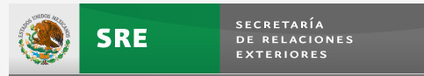 | SRE – Ministry of Foreign Affairs,  Ave. Juárez #20, Col. Centro, CP 06010, Cuauhtémoc, Phone: (+5255) 3686 - 5100  www.sre.gob.mx  Point of contact at SRE: Mrs. Laura Aguirre  e-mail: laguirre@sre.gob.mx

Map SRE

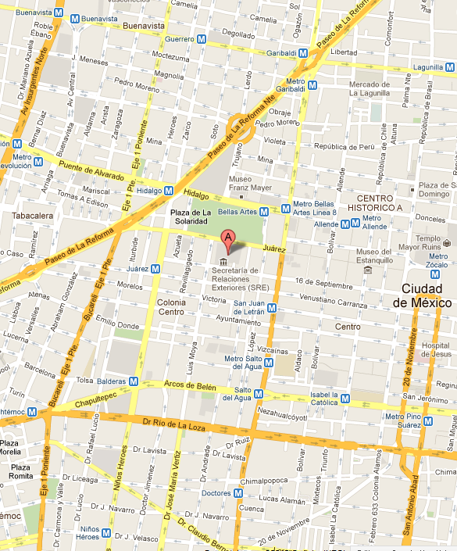

Immigration and Health Requirement

A valid passport (and visa if applicable) is necessary for all persons entering Mexico. You need to go to a Mexican consulate abroad to ask about the requirements and to take the necessary steps to get your visa. The requirements differ from country to country.
If you are a citizen of Andorra, Argentina, Aruba, Australia, Austria, Bahamas, Belgium, Bulgaria, Canada, Chile, Costa Rica, Cyprus, the Czech Republic, Denmark, Estonia, Finland, France, Germany, Great Britain, Greece, Hong Kong, Hungary, Ireland, Iceland, Israel, Italy, Japan, Latvia, Liechtenstein, Lithuania, Luxembourg, Malta, Monaco, Netherlands, New Zealand, Norway, Panama, Poland, Portugal, Puerto Rico, Romania, San Marino, Singapore, Slovakia, Slovenia, Spain, South Korea, Sweden, Switzerland, The United States of America, Uruguay or Venezuela, you do not need a visa to enter Mexico, although you must present a valid passport and fill out an immigration form for tourists, businessmen or women, stopovers or “visiting advisors”, which can be obtained in travel agencies, airlines or at the point of entry to Mexico.
If you are a citizen of any other country, you need to go to a Mexican consulate to request a visa. If you have a family member, friend or acquaintance in Mexico, he or she can do this at the INM.
Consult the requirements or go to any of the INM delegations throughout Mexico for detailed information about requesting a visa.
Invitation letters for processing of your visa will be issued upon receipt of your confirmation of your participation in the IPM meeting.

More information:
http://portal3.sre.gob.mx/english/index.php?option=com_content&task=view&id=25&Itemid=14

Mexicanconsulatesabroad:
http://www.sre.gob.mx/index.php/representaciones/consulados-de-mexico-en-el-exterior

Mexicanembassiesabroad:
http://www.sre.gob.mx/index.php/representaciones/embajadas-de-mexico-en-el-exterior

Arrival and transport arrangements

Participants have to arrange their own transport to the hotel. The International Airport of Mexico City "Benito Juárez" is located within Mexico City. Taxis are easily available at the arrival terminal, there are several kinds of transport available. Including the Metro (subway lines, are available for the city). Participants are advised to purchase fixed-priced taxi coupon at the taxi counter located at the airport exit.
More information:
http://www.aicm.com.mx/home_en.php
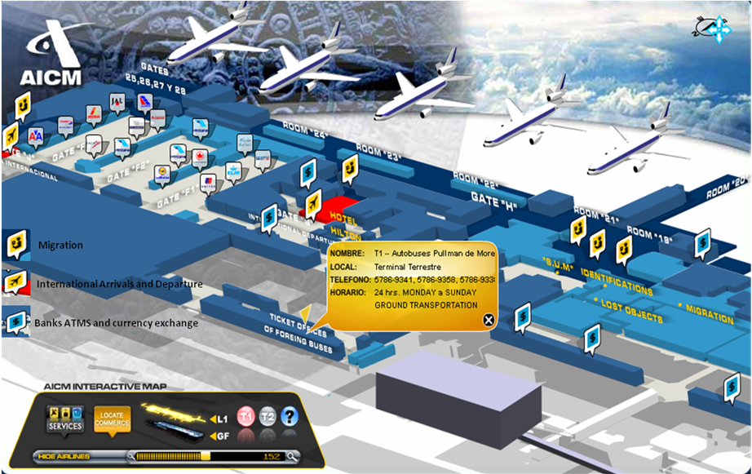

Time Zone
Most of Mexico is in the GMT-6 time zone.
More information:
http://www.timeanddate.com/worldclock/difference.html?p1=155

Accommodation
The IPM meeting will be held at Hotel Fiesta Inn Centro Historico in Mexico City. Reservations are available from 8th February 2012.
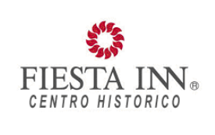
Hotel Fiesta Inn Centro Historico
Av. Juárez 76 Col. Centro
06010, Ciudad de México
Distrito Federal, México
http://www.fiestainn.com/es/mx-ciudad-de-mexico/hotel-centro-historico

Room rates for single or double room:
$ 130 dollars (approximately 1,246 pesos) (Tax Included)

Point of contact at hotel:
Mr. Julio Cesar CASTILLO
Sales Executive
Fiesta Inn Centro Histórico
Tel. (55) 5130 2907
e-mail: ventasficen@posadas.com

The name of the group for booking a room is: IPM/WMO. It is necessary to give the name of group for reserving a room.

Please do not book the room by the link of the hotel. It is better to email to Mr. Julio as POC of Hotel Fiesta Inn.
The Hotel Fiesta Inn Centro Historico has been blocked with 20 rooms for whole the group. The rooms are guaranteed for theperiod 4 to 8 March.
There is a needtohave thelist of namesof participantsby 22th February 2012 to ensure the reservation. Please take note that hotel receptionwill have alist of namesof all theparticipants.Each participant mustprovide their nameand indicate the dates that they will stay.

Room rates are subject to change by the operators. Participants are required to fill up the Hotel Reservation Form and send a fax to theNational Meteorological Service of Mexico: Fax: (+52 55) 2636-4605.

Map CONAGUA and Hotel Fiesta Inn Centro Historico in Mexico City
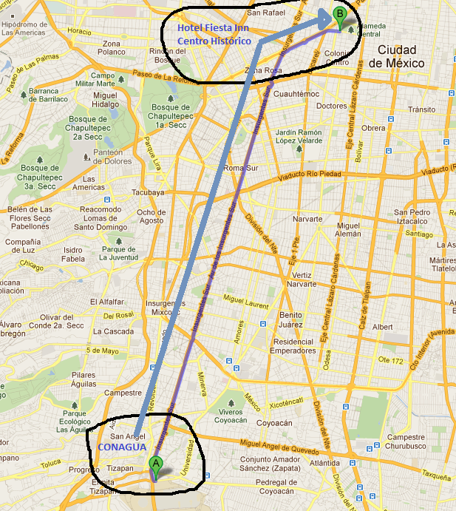

Weather

The nation’s capital has a pleasant climate with an average year-round temperature of 22º C (72º F). Most of the year is sunny. In November, the average temperature is 24°C (75°F) and the nights may be cool.

More information:
http://smn.cna.gob.mx/smmpt/estadosrm/ciudades/cd_de_mexico.html

Language
The official language in Mexico is Spanish, but English is widely spoken especially at tourist destinations.

Food
Both in hotel area and downtown, you will find a large selection of restaurants offering a variety of cuisines, including Mexican and international cuisine, as well as fast food.
http://travel.nytimes.com/travel/guides/north-america/mexico/mexico-city/restaurant-listings.html
More information:
http://travel.nytimes.com/travel/guides/north-america/mexico/mexico-city/restaurant-listings.html
Mexico.com.mx

Currency
The official currency in Mexico is the Mexican peso ($ or MXN). The exchange rate fluctuates and is quoted daily. To learn more about the exchange rate:
More information:
http://www.visitmexico.com/wb/Visitmexico/Visi_cambio_de_moneda
In Mexico, banknotes are issued in the following denominations: $20.00, $50.00, $100.00, $200.00, $500.00 and $1,000.00. Coins are issued in: 10¢, 20¢, and 50¢, $1 MXN, $2 MXN, $5 MXN, $10 MXN and $20 MXN.
In accordance with the Mexican regulations in effect, all payments of goods and services (including hotels and restaurants) should be made in Mexican Pesos. It is advisable to exchange some cash upon your arrival, at the airport or hotel. Currency exchange will also be available at the bank located nearby hotel.
International credit cards are accepted throughout the country. ATMs are located in all local bank branches and are linked to all major international banks.
Traveller’s checks can be cashed from the Banks in Mexico City Banking hours: 9.30am – 4:00 pm week days (Monday - Friday). Those arriving during the weekends are advised to change some money at the Airport.
More information:
http://www.mexicocity.gob.mx/

Tobacco
Smoking is forbidden in public areas as well as in restaurants and bars

Tipping
It is customary to tip between 10% and 15% in restaurants. It is also customary to tip hotel staff, but there is no set rate for this.

Electricity
Voltage in Mexico is 110 volts. The plugs have two parallel flat prongs. In some places, three-pronged grounded plugs are used.

Making telephone calls
To make international phone calls from Mexico, dial: 00 + country code + area code + local number.The country code for Mexico is 52, and the area code for Mexico City is 55.

Emergency
Emergency services in Mexico City include civil protection agencies, police and fire stations, as well as public and private hospitals.
http://www.solutionsabroad.com/en/communications/communication-category/emergency-phone-numbers.html
More information
Information on the embassies and consulates accredited in Mexico:
http://www.sre.gob.mx/index.php/representaciones/misiones-extranjeras-acreditadas-en-mexico

IPM meeting contacts

For further information or to seek the assistance of the organizers of this workshop before or during the event, please contact:

Mrs. Dalia HIDALGO, telephone number: (+5255) 2636-4601
E-mail: dalia.hidalgo@conagua.gob.mx

Registration and Accommodation Form

Registration

Country: ……………………………………………………………………………………………

Mr / Mrs / Ms
Last Name: …………………………………………………………………………………………
First Name: …………………………………………………………………………………………
Organization/Company: ……………………………………………………………………………
Phone: ………………………… Fax: …………………………
E-mail: …………………………

Flight number.DateTime

Arrival _________________ _________________________________

Departure____________________________________________________

Date (day/month/year): _____________________ Signature: ________________________

Accommodation

Please select one option:
□ I will book my own accommodation
□ Please reserve an accommodation for me according to the details below

Number of bedrooms: __ Bedroom Type: □ Single □ Twin □ Double
Credit card number ______________________________________

Arrival Date:…………………………… Arrival Time: …………………………
Departure Date: ………………………… Departure Time: …………………………
Number of nights: …………………………

If you need an Invitation Letter for your visa: passport details

Nationality: …………………
Date / Place of Birth:………………………………………………
Passport Number: ……………………………………………………………………………………
Date / Place of Issue of passport: ……………………………………………………………..……
Passport Expiry Date: …………………………………………………………………………………
Location of Mexican Embassy Where You Will Apply for Visa: ……………………………………

I will be attending,

DEVELOPMENT PARTNERS ROUND TABLE - ANNUAL INFORMAL PLANNING MEETING (IPM) OF THE VOLUNTARY COOPERATION PROGRAMME (VCP)
Mexico City, March 2012

Please return this form as soon as possible and in any case not later than 22th February 2012, by e-mail or fax to:
Dalia HIDALGO / Avelina FLORES / Norma RAMÍREZ
dalia.hidalgo@conagua.gob.mx
avelina.floresr@conagua.gob.mx
norma.ramirez@conagua.gob.mx

Servicio Meteorológico Nacional, SMN-CONAGUA
Av. Observatorio 192, Col. Observatorio,
Del. Miguel Hidalgo, CP. 11860
MEXICO, DF.
Teléfonos: (55) 2636-4601Fax: (+52 55) 2636-4605

