WORLD METEOROLOGICAL ORGANIZATION  _______________________________  INFORMAL PLANNING MEETING OF THE  VOLUNTARY COOPERATION PROGRAMME  MEXICO CITY, MEXICO  6th – 7th MARCH 2012 |  | IPM/2012/Doc. 4  _________  ITEM: 1  Original: ENGLISH

WORLD METEOROLOGICAL ORGANIZATION


FINAL REPORT OF THE FIRST MEETING
OF
EXECUTIVE COUNCIL WORKING GROUP ON CAPACITY DEVELOPMENT

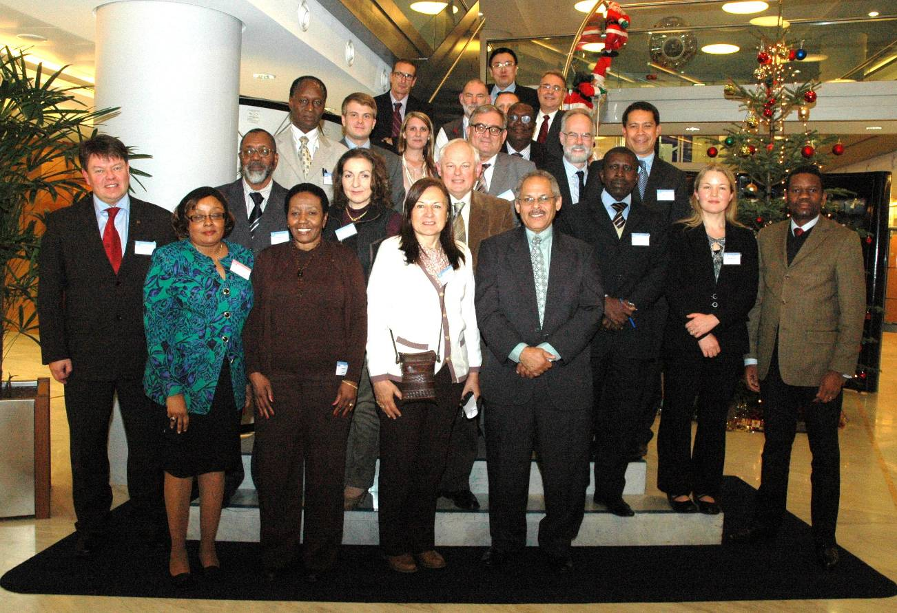

GENEVA, SWITZERLAND

13-15 DECEMBER 2011
- OPENING OF THE MEETING

The Executive Council Working Group on Capacity Development (EC-WG/CD) held its first formal meeting from 13 to 15 December 2011, after it had been renamed from EC Working Group on Capacity Building (EC-WG/CB) at EC-LXIII in June 2011 in Geneva. The meeting was attended by EC-CB Members or their representatives from Guinea, Congo, Sudan, Uzbekistan, Saudi Arabia, Argentina, Bahamas, British Caribbean Territory, Croatia, Spain and Finland, and IPM representatives of Finland, New Zealand, UK, Republic of Korea and USA. The meeting was chaired by Mr. Tyrone Sutherland (British Caribbean Territory) with assistance from Ivan Cacic (Croatia). The full list of participants is given in Annex 1.

Brief opening remarks were provided by Mr Michel Jarraud, Secretary General of WMO.

- ADOPTION OF THE AGENDA

The Agenda agreed upon by the meeting is given in Annex 2.

- REVIEW – TERMS OF REFERENCE AND DISCUSSION OF Cg-XVI and EC-LXIII ON CAPACITY DEVELOPMENT
Review of Terms of Reference and Review of Cg-XVI and EC-LXIII

The Working Group considered its Terms of Reference (EC LXII, Res. 10) as well as the discussions arising from Cg-XVI and EC-LXIII. A breakout group was created and was chaired by Professor Taalas (Finland) to consider the evolving role of the EC-WG/CD. A number of changes to the Terms of Reference were proposed for consideration by the Executive Council at its next Session (Annex 3).

Review of the relevant documents to the WMO capacity development activities

The WMO Strategic Plan (2012-2015), the most recent abridged reports of eight Technical Commissions (TCs), and the current Strategic Plans of six Regional Associations (RAs) were reviewed in the context of their capacity development activities. It was emphasized that Capacity Development is directly related to Strategic Thrust 3 and Expected Result 6 of the WMO Strategic Plan (2012-2015). It was noted that Capacity Development (CD) was viewed as one of the essential activities for all TCs and RAs, and the need for better coordination across them was highlighted.

Review of GFCS consultations relating to capacity development

The GFCS Office provided a brief overview of the recent development of the GFCS, with particular focus on the outcomes of the recent consultation meetings to determine capacity building requirements. The requirements were considered for different socio-economic sectors that are vulnerable to climate change. The requirements were further broken down into four different areas of capacity including human capacity, infrastructural capacity, institutional capacity and procedural capacity. The common needs across the different sectors were then extracted and presented for each capacity. The importance of the consultation meeting approach was emphasized as it allows for the integration of diverse opinions of all stakeholders.

- PROCESS AND ESSENTIAL STEPS OF CAPACITY DEVELOPMENT
WMO Capacity Development Process and Essential Steps

The Working Group discussed and agreed on the basic process of WMO Capacity Development which includes the 8 Essential Steps, starting from Step 1: Definition of requirements, followed by Step2: Baseline Establishment, Step 3: Gap Analysis, Step 4: Elaboration of Strategic Plan, Step 5: National Ownership and Commitment, Step 6: Resource Mobilization, Step 7: Implementation of a Capacity Development Response and Step 8: Monitoring and Evaluation. The evaluation defines new requirements and baseline, completing the cycle as shown in the diagram below. It was noted that the monitoring would be a continuous iterative process throughout the cycle. A description of the process and each step are summarized in Annex 4.
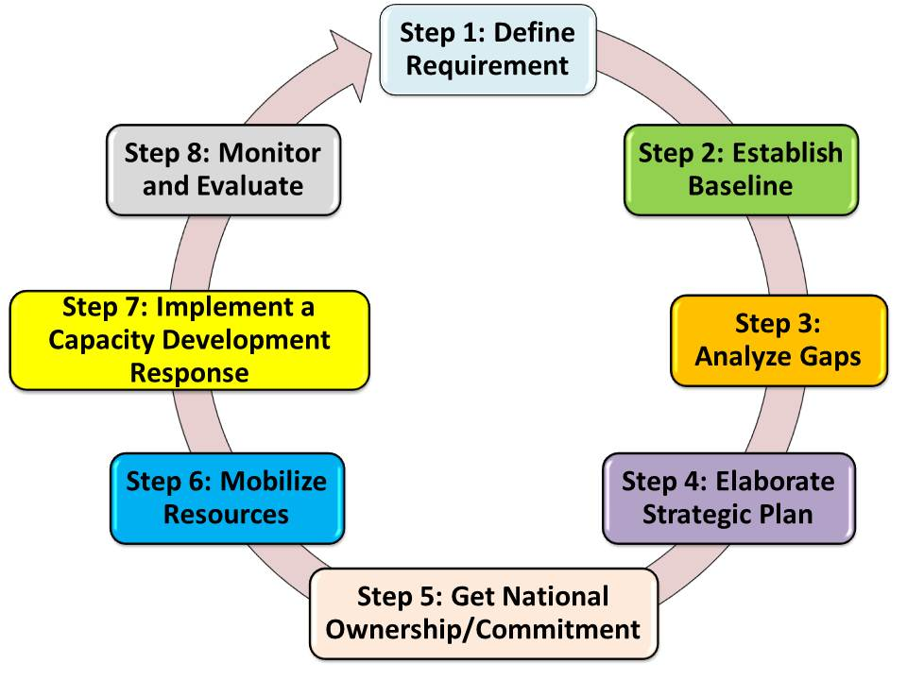

The Working Group recognized the need for better coordination of the WMO priorities: DRR, GFCS, Aviation and WIS/WIGOS to be included in the WMO Capacity Development Strategy (CDS). The Working Group agreed that in order to capture capacity issues holistically, the WMO CDS needs to focus on the following four areas of capacity: Human Capacity, Infrastructural Capacity, Procedural Capacity and Institutional Capacity, as articulated below, in national, regional and global contexts.
- Human resource capacity that equips individuals with the understanding, skills, information, knowledge and training to enable them to generate, communicate and use decision-relevant weather, water and climate information;
- Infrastructural capacity that enables access to the resources that are needed to generate, archive and use of weather, water and climate data and decision-relevant information, including observing networks, data management systems, computer hardware and software, internet, manuals and scientific literature;
- Procedural capacity that defines, implementing and advancing best practices for generating and using weather, water and climate information;
- Institutional capacity that elaborates management structures, processes and procedures that enable effective weather, water and climate services, not only within organizations but also in managing relationships between the different organizations and sectors (public, private and community, including international collaboration).

SWOT analysis

Participants were requested to consider WMO assistance to its Members with regard to CD. A series of key questions listed in Annex 5 were discussed in order to identify Strengths, Weaknesses, Opportunities and Threats at each CD step discussed in paragraph 4.1. Overall conclusions and recommendations were presented to the participants on the following day and are discussed in paragraph 6.1 - 6.4. “Key CD Outcomes identified from the SWOT analysis”.

- BACKGROUND ON WMO CAPACITY DEVELOPMENT
Case Studies including that of Haiti

Participants were presented with a total of ten case studies (A, B, C, D, E, F, G, H, Haiti and RA-V) to analyze as part of the process for developing a WMO Capacity Development Strategy. Congress (Cg-XVI) requested that Haiti be considered as a case study in the preparation of the CDS.

The analyses of the case studies were aimed at stimulating discussion to draw out insight to the possible scenarios that WMO will likely encounter when responding to CD requests by Members. Participants were required to test the proposed 8-step capacity development model and begin to ponder on how WMO will be guided to respond in a holistic and cohesive manner, for long-term capacity development benefits.

The exercise was carried out in three breakout groups where each group appointed a spokesperson and a secretary to write up group deliberations on the case studies. Case studies outcomes for each group were presented and the outcomes for all three groups were synthesized. The outcomes reflected a trend for 8 out of the 10 cases with the exception of cases H and RA-V which most groups felt they were emergency cases requiring a different approach considering their circumstances. However it was also pointed out that even in an emergency case, the 8-step approach can be applied, while the criteria for measuring success would be limited to the provision of emergency services rather than sustained capacity.

Eight cases indicated steps 1, 2 and 3 were fairly well addressed where requirements were defined, baselines established and gaps were analyzed. Generally and across all cases, problems were evident at Steps 4, 5, 6, 7and 8 where strategic plans were not prepared and there was a lack of national ownership. Subsequently, limited resources were mobilized. A lack of monitoring and evaluation was also evident.

The Working Group agreed that the 8-Step model was a useful tool for addressing NMHS CD overall and in the preparation of the CDS.

In addition to the 8-Step model, the Working Group agreed that WMO CD efforts need to be linked to broader regional and international programmes to avoid duplication and streamline the overall approach.
Development of Guidance for Management of NMSs

The Working Group considered the progress on the development of new Guidelines on the Role, Operation and Management of NMSs. It will use as a basis the WMO/TD-No.947 National Meteorological and Hydrometeorological Services for Sustainable Development - Guidelines for Management (1999), and other relevant materials.

The need for updating and enhancing the available WMO guidance material on the management of NMSs has been emphasized at a number of WMO meetings, including the EC-LXII (2010), which … “requested the Secretary-General to continue giving priority to skill development activities for senior and middle-level managers of NMSs in the areas of management, strategic planning, product development and communication as well as in project development and resource mobilization, including through e-learning”.

The Working Group emphasized that the new Guidelines should take into account recent developments, such as the adoption of the WMO Strategic Plan (2012-2015) as well as new high-level priorities such as the GFCS. The Working Group noted that the Guidelines will be prepared in a user friendly, easily updated and convenient electronic format based on web technology. The development of the guidance material is closely related to the new WMO Capacity Development Strategy focusing on more effective assistance in the institutional development and ensuring the sustainability of the NMSs. In addition to providing useful information to PRs, senior and mid-level managers of NMSs, the Guidelines will be designed to allow development of baseline functions of the NMSs, assessment of NMSs against these functions, and tracking of deficiencies to be used in preparation of national development plans and related advocacy. The Working Group expressed its satisfaction on the progress and provided comments.

Country Profile Data Base

The meeting was informed of the recent progress on the development of the Country Profile Data Base (CPDB). It was explained that the current approach to CPDB was to build a modular system upon the already existing and operational databases, and the demo CPDB site was briefly introduced to the participants. The Working Group also discussed the feedback given during the Side Event on the Country Profile Database which was held on 12 December 2012 prior to EC-WG/CD, including issues of authentification, consistency and accuracy of information, availability of regional and financial information in the future development, and survey results. The Working Group welcomed the tangible output of the CPD project and expressed its expectation for further development.

Regional Programme/ South-South Cooperation

The Working Group was reminded of the key role of the Regional Programme in CD, whose main objectives include “to focus, as part of the WMO capacity development effort, on the assistance given at regional level to bridge gaps in the capabilities of all Members, especially LDCs, SIDS and countries in transition, to produce, utilize and benefit from hydrometeorological information, products and services.”

It was noted that the south-south cooperation has become an increasingly important modality to address the various development challenges in the developing nations. In order to further reinforce such a process, the Working Group recommended the need to designate a Secretariat Focal Point for South-South Cooperation and D/RAP could possibly take up such a role.

LDC Programme

The Secretariat briefed the Working Group on the LDC Programme of WMO in the context of the recent development of the UN wide discussion at the Fourth UN Conference on LDCs in Istanbul in 2011, which approved the Istanbul Programme of Action for the Decade 2011-20 (IPoA). It was highlighted that a number of IPoA priority areas of action are related to WMO activities and many of them encompass Capacity Development. It was noted that one of the IPoA actions specifically calls for support to enhance the capacity of meteorological and hydrological services of least developed countries. The Working Group was reminded of the decision by Congress to support IPoA and to raise the profile of NMHSs with the national development outcome and increase government and stakeholders support to the NMHSs, through advocacy and institutional capacity building, among others.

It was noted that RAs would play a coordinating role in the implementation of the WMO Programme for LDCs.

Education and Training Programme

The Secretariat explained the ETRP activities aiming at enhancing Technical and Management capabilities of NMHSs.

In order to monitor the overall progress of CD, it was suggested a similar approach as the GFCS, which categorizes NMHSs in accordance with their level of climate services provision, could be extended in CD. The Working Group noted the possibility of adopting the approach for the CD.

Resource mobilization and outreach

The Secretariat presented the current activities within the Resource Mobilization Office. Three areas of activity were highlighted, these being work at WMO Secretariat level such as cross programme cooperation, the setting up of the new Project Coordination Unit and staff secondments; secondly donor activity was touched on, for example the Adaptation Fund and relationship-building with new donors and lastly, in-country work was discussed such as VCP, the recently signed Norwegian agreement and others.

The Working Group was updated on the CPA matters including the revision of WMO Communications and Public Affairs strategy, recent emphasis on outreach to Members and also to policy makers, funders and new target audiences, training workshops, and increase of visibility. It was noted that both the UNFCCC Executive Secretary and the UN Secretary General mentioned WMO in their keynote speeches at COP-17, indicating the increase of WMO visibility in recent years.

It was also emphasized that public outreach should not only target journalists but also a wider audience that includes policy makers and potential donors.

The Working Group expressed its satisfaction on the recent progress on resource mobilization and outreach.

Monitoring and Evaluation

The Secretariat gave an overview of the definitions and logic of the WMO strategic planning approach specified by the WMO Strategic Plan and WMO Operating Plan. The WMO Strategic Plan summarized the high-level statement of strategic directions and priorities expressed through Strategic Thrusts and organization-wide Expected Results and Performance Indicators addressing the Global Societal Needs, while the WMO Operating Plan converted the organization-wide ERs into specific outcomes/ deliverables, indicators and targets that are used to monitor the progress. It was emphasized that the WMO CD monitoring and evaluation should be in harmony with this overall WMO process at all levels of programming for continuous improvement. In particular, the Key Outcomes and Key Performance Indicators corresponding to the Strategic Thrust 3, Expected Results 6 will need to be measured and closely monitored with periodic reporting in the context of CD.

The types of tools to monitor and evaluate progress could be empirical, qualitative, index, breadbasket, case histories, and available economic, social or environmental indicators. Information and data gathering for monitoring and evaluation reporting will require data credibility and consistency, and can be gathered through self reporting, country assessments, national records, reports and the Country Profile Data Base. In this regard, the Working Group was informed of the recent discussion at EC-WG/SOP held in 2011, which reviewed a standardized questionnaire to assess the impacts of the achieved results that could help create baselines and targets. The Working Group reviewed the relevant questionnaire and welcomed its approach.

- CAPACITY DEVELOPMENT STRATEGY
Key CD Outcomes identified from SWOT analysis

The Working Group examined the overall conclusions of the SWOT analysis on WMO assistance to the capacity development of NMHSs (see Section 4 and Annex 5) conducted the previous day. The examination highlighted some of the strategy elements where WMO could take advantage of its strengths, address its weaknesses, use relevant opportunities, and minimize threats across the CD process.

The Group considered at each step WMO’s Strengths, Weaknesses, Opportunities, and Threats and extracted common elements. These strategy elements can be categorized in four items: (a) Better defined roles and roles limits for better coordination; (b) Increased visibility and national ownership through advocacy, enhanced outreach and communication; (c) Optimized knowledge management; (d) Focused resource mobilization and project management.

It was concluded that for each of the strategy elements, WMO could implement key activities that would help NMHSs develop better their capacities. Some of the key activities are listed below, as recommendations of the Working Group.

(a) Better defined roles and roles limits for a better coordination

The Working Group recommended that WMO define better, the role of each entity involved in capacity development and propose a Governance approach to CD.

The Group also noted that the better coordination of the technical issues with other U.N. agencies, especially with the Environment stakeholders would be important.

(b) Increased visibility and national ownership through advocacy, enhanced outreach and communication

It was further discussed that WMO could facilitate the CD process by proposing tools to Members such as the Country Profile Database, NMHS management guidelines, survey tools, users’ Fora to bring together major stakeholders and NMHS, and effective advocacy to decision makers with emphasis on the socio-economic benefits of NMHSs

The Working Group, while recognizing the need for strategic capacities development of the NMHSs, recommended that WMO assist NMHSs in developing their strategic and development plans, ensuring the plans were embedded in broader national development plans while adhering to regional strategic plans and priorities.

Proposed actions in this area could include the development of a marketing toolkit for Public Weather Services, while highlighting the success stories in Natural Disaster Risk Reduction projects, and producing specific communication tools for user communities and the national media.

A “hands-on” approach by NMHSs needs to be encouraged.

(c) Optimized knowledge management

Noting the insufficient management skills in some NMHSs, the Working Group expressed interest in further developing member-to-member networks such as INTADs, in order to assist managers of developing country NMHS in CD. Tools to develop could be specific career development packages to enhance their management and leadership skills in the form of workshops, coaching sessions and mentoring programmes.

In order for CD to be a sustainable process, the Working Group agreed that continuous feedback mechanisms must be in place in the CDS, and the proper application of the evolving modern knowledge society model, such as strategic Human Resource management approach, needs to be considered continuously.

(d) Focused resource mobilization and project management

The Working Group agreed that a more systematic approach to resource mobilization is needed, and that NMHSs need to participate in major international events and assisted in accessing funds related to climate change and natural disasters risk reduction issues such as Adaptation Fund. It was also considered important that NMHSs strengthen relationships with national planning, financial and political authorities, and establish stronger links to donors and regional partners, while utilizing existing financial schemes. The Working Group suggested the development of pilot projects linked to national priorities as well as those of donors. WMO assistance could also include outreach at ministerial level, national workshops, increased advocacy missions and a strengthened user focus.

The Working Group also suggested that WMO assist NMHSs in developing project proposals, ensure their execution, and strengthen partnerships with donors.

The participants considered the use of the proposed 8-step process useful to the SWOT analysis and applicable to the WMO Capacity Development process. The Working Group welcomed the SWOT approach for the identification of WMO CD activities and requested the Secretariat to adopt this approach in the preparation of WMO CDS.

Basic structure of Capacity Development Strategy to be presented to EC

The Working Group agreed the basic structure of CDS given in Annex 6 should include sections for Executive Summary, Purpose, Introduction, CDS elements with key activities to accomplish, Roles of Constituent Bodies, and Governance. Annexes to CDS will discuss how the process applies to concrete examples by providing different case studies. The Implementation Plan for the CDS for the period 2012-2015 will also be developed.

Governance

The importance of a well coordinated governance structure of the CDS was underscored and the Working Group re-emphasized that the aim of the WMO CD Strategy was to ensure all actors in Met/Hydro/Climate would work towards the same overall objective in a holistic manner. Noting the mandate given to the EC-WG/CD, the Working Group recommended that the EC-WG/CD provide oversight and governance of the CD process. A new approach to CD governance was proposed.

The proposed structure emphasizes the overall responsibility of the Executive Council and suggests under the EC-WG/CD, Sub Working Groups on ETR, VCP (Informal Planning Meeting), LDC and Regional Programme and Infrastructure could be created with the overall Working Group being chaired by the WMO President. The EC-WG/CD would consist of the chairs of Sub-Working Groups while D/DRA would provide secretariat support.

The Working Group expressed its concern about the complexity of the structure. The IPM chair commented that it was important that the IPM mechanism continue as an open forum as it is today and that additional formalization of the coordination process was unlikely to improve governance of the WMO CD process.

The Working Group agreed that better coordination within the current governance structure relating to CD would be needed. The Working Group unanimously agreed to continue the discussion on the governance matter.

Way forward

The Working Group agreed on the roadmap for CDS Preparation as given in Annex 7. The main milestones are;
- Inputs from EC-WG/CD members to the basic structure of CDS discussed above, by the end of December 2011;
- First draft of CDS for review by EC-WG/CD members by the end of January, 2012;
- A 6-10 pages draft CDS to be approved by the EC-LXIV with Annexes including references, list of documents, background materials, case studies and Implementation Plan (2012-2015) by the end of April 2012.

- FUTUREWORK OF THE EC-CD

Among other roles, the Working Group agreed that its work in the first half of 2012 would concentrate on the management of the overall process of the development of the Capacity Development Strategy leading to its approval at EC-LXIV in June 2012. The Working Group concluded that the future work of EC-WG/CD would be based on the new TOR shown in Annex 3 once approved by EC-LXIV.

- ANY OTHER BUSINESS

No additional items were raised.

- CLOSURE OF THE MEETING

There being no other business, the meeting was adjourned on time.

All related documents of the meeting can be downloaded from http://www.wmo.int/pages/prog/dra/ECCD2011.html

Annex 1

LIST OF PARTICIPANTS
EC Working Group on Capacity Building & Associated Side Events

Geneva, Switzerland, 12-16 December 2011

Name | Country | Capacity | Tel/Fax/E-mail
Dr M.Lamine BAH | Guinea | EC-M | Tel: + 224 60278393/68544064  Email: lamine_bah@yahoo.fr
Mr Paul DINGA | Congo | EC-M (Rep.) | Tel: +242 22281 2090  Fax: +242 222281 1679  Email: dinga_paul@yahoo.fr
Mr Abdel GADIR | Sudan | EC-M | Tel: + 249 912 163701  Fax: +249 183 771693  Email: INFO@ERSAD.gov.sd
Prof. Viktor CHUB | Uzbekistan | EC-M | Tel: + 99871 2336180/233 6113  Fax: + 99871 2332025  Email: uzhymet@meteo.uz
Mr Sergey MYAGKOV | Uzbekistan | Adviser | Te: + 99871 235 2983  Fax: +99871 2331150  Email: NIGMI@ALBATROS.UZ
Dr Saad M. S. MOHALFI | Saudi Arabia | EC-M | Tel:+ 966 566 776648  Fax: +966 26572921  Email: saadpme@yahoo.com
Mr Mohmmed BABIDHAN | Saudi Arabia | Adviser | Tel: 1 966 507 703136  Fax: 1 966 26530297  Email: babidhan@gmail.com
Dr Monica B. MARINO | Argentina | EC-M  (Rep.) | Tel: + 5411 5167 6715  Fax: + 5411 5167 6767 int. 18218  Email: marino@smn.gov.ar
Mr Arthur ROLLE | Bahamas | EC-M | Tel: + 1-242-356-3726  Fax: +1 242-356-3739  Email: rollearthur@gmail.com
Mr Tyrone Sutherland  (chairperson) | BCT | EC-M | Tel: +1 868 622 4711  Fax: + 1 868 622 0277  Email: Tshutherland@cmo.org.tt  suthcmo@tdtt.nett
Mr Ivan CACIC | Croatia | EC-M | Tel: 1 385 1 4565 693  Fax + 385 1 485 1 901  Email: cacic@cirus.dhz.cr
Mr Kreso PANDZIC | Croatia | Adviser | Tel: +385 1 4565684  Fax +385 1 4851901  Email: Pandzic@cirus.dhz.hr
Mr J. A. FERENANDEZ MONISTROL | Spain | EC-M (Rep.) | Tel: + 34 91 5819 880  Email: ifernandezm@aemet.es
Mr P. TAALAS | Finland | EC-M | Tel: 358 50 56 35172  Email: petteri.taalas@fmi.fi
Mr Jaakko NUOTTOKARI | Finland | IPM | Tel: + 358 50 589 5820  Fax: + 358 9 1929 4129  Email: Jaako.Nuottokari@fmi.fi
Mr Pene LEFALE | New Zealand | IPM | Tel: + 644 4700 818  Email: pene.lefale@metservice.com
Mr Steve PALMER | UK | IPM | Tel: 1 441392 886784  Fax: +44 1392 885681  Email: steve.palmer@metoffice.gov.uk
Mr Ian LISK | UK | IPM | Tel: + 44 77 388 0672  Email: ian.lisk@metoffice.gov.uk
Ms Karen McCOURT | UK | IPM | Email: karenmccourt@metoffice.gov.uk
Ms Cathy MOORE | UK | IPM | Tel: + 44 1392 885680  Email: catherine.moore@metoffice.gov.uk
Dr Chang-Heum LEE | Korea | IPM | Tel: + 41 22 748 0000  Fax:+ 41 22 748 0001  Email: changheum22@gmail.com
Ms Courtney DRAGGON | USA | IPM | Tel: +1 301713 1787  Email: Courtney.draggon@noaa.gov
Mr Fredrick BRANSKI | USA | CBS | Tel: +1 301 713 3538 ext. 121  Fax: +1 301 7139450  Email: fred.branski@noaa.gov

WMO SECRETARIAT

Mr Robert O. MASTERS (D/DRA)
Mr Kaliba KONARE (D/LDC, DRA)
Mr Jeffery Wilson (D/ETR)
Mr Dimitar IVANOV (C/EUR, DRA)
Ms Clare Nullis (CPA)
Mr Wayne ELLIOTT (RMO, DRA)
Ms Yvette Ramos (Consultant, DRA)
Ms Winnie Mutuli (Consultant, DRA)
Mr Makoto Suwa (DRA)

Annex 2

WORLD METEOROLOGICAL ORGANIZATION
_______________________________

FIRST MEETING
EC WORKING GROUP ON CAPACITY DEVELOPMENT

GENEVA, SWITZERLAND
13 - 15 DECEMBER 2011

AGENDA

- OPENING OF THE MEETING

- ADOPTION OF THE AGENDA
  - Adoption of the agenda
  - Working Arrangements of the meeting

- REVIEW – TOR AND DISCUSSION OF Cg-XVI and EC-LXIII ON CAPACITY DEVELOPMENT
  - Review of TOR
  - Review of Cg-XVI and EC-LXIII
  - Review of the relevant documents to the WMO capacity development activities
  - Review of GFCS consultations relating to capacity development

- PROCESS AND ESSENTIAL STEPS OF CAPACITY DEVELOPMENT
  - WMO Capacity Development Process and Essential Steps
  - SWOT* analysis

- BACKGROUND OF THE WMO CAPACITY DEVELOPMENT
  - Case Studies including that of Haiti
  - Development of Guidance for Management of NMSs
  - Country Profile Data Base
  - Regional Programme/ South-South Cooperation
  - LDC Programme
  - Education and Training Programme
  - Resource mobilization and outreach
  - Monitoring and Evaluation

- CAPACITY DEVELOPMENT STRATEGY
  - Key CD Outcomes identified from SWOT analysis
  - Basic structure of Capacity Development Strategy to be presented to EC
  - Governance
  - Way forward

- FUTURE WORK OF THE EC-CD

- ANY OTHER BUSINESS

- CLOSURE OF THE MEETING

_________
* Strengths, Weaknesses, Opportunities, Threats
Annex 3

Executive Council Working Group on Capacity Development
Terms of Reference
(ADD RESOLUTION)
--------------

THE EXECUTIVE COUNCIL,
Noting:
- Resolution 1 (EC-LV) – Executive Council Advisory Group of Experts on Technical Cooperation,
- Resolution 24 (Cg-XV) – The WMO Voluntary Cooperation Programme,
- Resolution 4 (EC-LIX) – Executive Council Working Group on Capacity-Building,
- Resolution 10 (EC-LX)- - Executive Council Working Group on Capacity Development as modified at EC-LXIII,
Considering the need for a continued mechanism to review on a regular basis issues related to capacity development of Members in respect of the eight Expected Results of the WMO Strategic Plan (2012-2015), in particular ER 6,: Enhanced capabilities of National Meteorological and Hydrological Services in developing countries, particularly least developed countries, to fulfill their mandates,
Decides:
- To revise the terms of reference of the Executive Council Working Group on Capacity Development established by Resolution 4 (EC-LIX), revised by Resolution 10 (EC-LX) to address all aspects of assistance provided by WMO and its partners to Members, in particular developing and least developed Member countries, and to request the Working Group on Capacity-Development to provide advice and pursue a coherent approach towards:
  - Identifying national, sub-regional, regional and global development priorities based on the needs of the national NMHS end users and stakeholders. Development of a process to set levels of priorities.
  - Preparing of an overarching WMO Capacity Development strategy for a four-year period to give concrete guidance to all WMO Members, development partners, and WMO constituent bodies (RAs, TCs) and Secretariat (all departments) with the goal of improving Members’ service delivery capabilities to meet end user needs.
  - Improving capacity in all WMO regions with a special emphasis on developing countries and creation of a system for monitoring of concrete WMO action at country level.;
  - Advocating socio-economic benefits of products and services of National Meteorological and Hydrological Services, including their achievement of the United Nations Millennium Development Goals;
  - Developing strategic partnerships with external stakeholders;
  - Mobilizing resources in support of the above;
- To achieve these objectives the Working Group shall:
  - Use the development priorities set by the Regional Associations and the Congress to guide the concrete work of the Technical Commissions, the Secretariat and other development partners;
(b) Prepare a concrete development action plan with clear responsibilities, milestones and measurable outcomes. These should be reported to the Executive Council on an annual basis and to the Congress to allow these bodies to give more informed guidance for WMO capacity development activities; Provide guidance on the coordination of the Voluntary Cooperation Programme and Trust Funds to the Informal Planning Meeting;
  - Strengthen the interface between technical and human resource development including the establishment of appropriate coordination with the Executive Council Panel of Experts on Education and Training;
  - Strengthen the interface between WMO and relevant organizations leading to enhanced capacity development of the NMHSs.;
  - Invite relevant funding and development agencies including the World Bank and the European Commission to contribute to the work of the Working Group;
  - Invite interested Members to designate experts and representatives of stakeholder communities in capacity-building to participate in the work of the Working Group and attend sessions of the Group;
Authorizes the Working Group to establish sub-groups and task teams as and when required;
Requests the Secretary-General to promote active participation of all WMO departments leading to externally funded development projects and take relevant actions to support the Working Group’s activities and to create a concrete system to monitor, verify and report on the actions taken;
Requests the Chairperson in consultation with Working Group members, the Secretary-General, relevant technical commissions, regional associations and WMO departments to propose changes in the terms of reference of the Group to be approved by the Executive Council.
_______
Note: This resolution replaces Resolution 10 (EC-LX), which is no longer in force.

--------------

Annex 4

Process and essential steps of capacity development – definitions and diagram
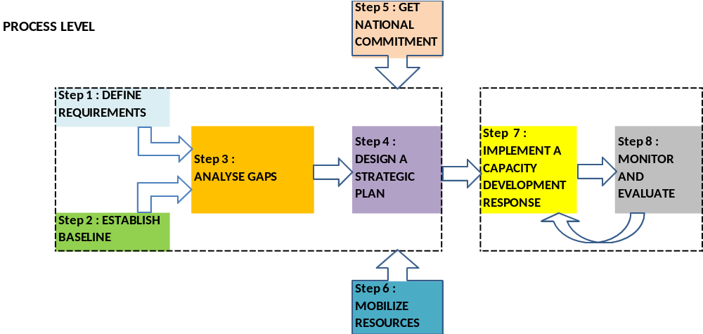

Step # | Proposed definition | Key issues | Key questions
Step 1 | Defining requirements of the NMHSs in terms of Capacity Development from the different dimensions (geographical, priorities, perspectives) | National needs,  TC (Technical Commissions) Guidelines  Regional priorities  international requirements  others? | What do we need?
Step 2 | Establishing the baseline | National and Regional information mapped to requirements | Where are we?
Step 3 | Analysing the gaps | Incentives to act, political awareness, Users support | What capacities we need to develop?
Step 4 | Designing a strategic plan | WMO strategic plan, Regional strategic plans, Sub-regional plans, Others? | What major decisions we take forward to address deficiencies and accomplish sustainable development?
Step 5 | Getting the national commitment and ownership | National Development Plans (NAPA) | How do we get the national commitment and ownership?
Step 6 | Mobilizing resources | Regional, International | How do we get the necessary funding for actions?
Step 7 | Implementing a Capacity development response | Plan of specific actions | What are the concrete actions we need to put in place, what do we do with Members and others to build NMHSs?
Step 8 | Monitoring and evaluating progress at each step of the process | Key outcomes, Key Performance Indicators, Indices,.. | How do we measure the progress of such actions all along the 8-Steps process and refine next steps?
Annex 5

SWOT questions and results summary

SWOT questions
step 1 | Were the requirements defined? Do they have a clear set of requirements from users? Has compliance with WMO Technical Regulations been considered?
step 2 | Were the country’s capabilities evaluated against the requirements to establish a baseline in terms of HR, infrastructure, institutional, and procedural capabilities?
step 3 | Are deficiencies identified from step 2 in terms of the capacities of the NMHS to meet the requirements (HR, infrastructure, institutional, procedures, institutional…)? Have these “gaps” been analyzed to determine the cause and possible ways to meet the requirements?
step 4 | Has a strategic plan been developed to address the deficiencies? Was it done in coordination with the national planning authorities and partner organizations?
step 5 | Was national commitment to the strategic plan secured? How? Was it reflected in National Development Plans, Budget, etc.?
step 6 | Was support provided in terms of national and external funding? Were stakeholders and partner organizations involved in voicing support for funding the plan?
step 7 | Were the plans implemented? Was appropriate oversight of the plan established? Was a project leader identified for each element of the plans? Were resources, milestones, timelines and deliverables clearly defined?
Step 8 | Is a monitoring and evaluation plan in place? Are the metrics to measure success against the baseline appropriate and integrated into the plans? Was this process used for continuous improvement?

Results of the SWOT analysis:
 | Steps 1-3 | Steps 4-6 | Steps 7-8
Strengths | - Recognized worldwide technical specifications and technical requirements as there is a great need for climate knowhow, early warning systems.  - Helping Members anticipate their needs through global standards, set of established and recognized bodies that help to answer those questions (RAs, TCs, ..) | - Existing workshops and projects in favour of strategic planning and management,  - Examples of pilot projects demonstrating socio-economic benefits to the population living and goods safety  - RMO unit facilitating access to new resources such as Adaptation Fund | - Existence of Country base Surveys  - WMO KPIs existence, country assessments  - Existence of pilot projects with evaluation and monitoring tools
Weaknesses | - NMHS don’t know how to get the information?  - Processes and manuals are not always followed  - Not enough coordination among the different groups and UN bodies for ex.  - WMO more focused on the “coordination” and less on the «Management» of projects | - WMO does not help advocate enough on what the Met purpose is : primarily should be on Service focused (incl. PWS)  - Lack of guidelines to prioritize capacity building agenda at sub-regional and local levels | - WMO not active enough in helping plans to be executed, for ex. weak mechanisms for transition of demo and pilot projects to sustainable capacity  - WMO has a visibility challenge in general.
Opportunities | - WMO is a multilateral organization and thus has a great opportunity to lead and/or coordinate with the other UN agencies on such topics (climate, met, hydro…)  - Less developed regions (Africa, ..) are bridging the Digital Divide | - Modernization national plans are opportunities  - Some of the MDGs are deeply associated with the work of NMHSs  - Disaster is an opportunity : have plans ready for disaster is a challenge and yet an opportunity here | - Quality Management Systems to implement represents a huge opportunity to speed up the process  - Some projects offer a large visibility (HK center, WIGOS..), which is a good outreach opportunity
Threats | - Users are not aware of benefits of good forecasts / Services  - Mission creep, Definitions of roles are unclear and this give space to threats  - Duplicated projects, programmes, documents, events on same topics/issues/. | - Lack of coordination with Environment actors  - Weak inter-organizational and inter-programme coordination.  - Competition for resources with donors and other multilateral institutions especially in the domain of climate change and disaster risk reduction. | - Incoherent and sketchy monitoring of the capacity of Members, inertia from within (low responses to surveys, ..)  - Poor evaluation and monitoring tools (IT)  - Lack of management orientation to project follow-up  - Loss of knowledge over time

Annex 6

CAPACITY DEVELOPMENT STRATEGY – Proposed Outline

Executive Summary

- Purpose
- Purpose of WMO CDS

- Introduction
- Definition of Capacity
- Definition of Capacity Building and Capacity Development
- Aspects of NMHS Capacity
- Attributes of CD for NMHSs
- WMO QMS linkage
- Capacity Development Process (8 Steps)
- Linkages to WMO SOP (2012-2015)

- CDS Elements w/Key activities to accomplish
- CD Elements derived from SWOT Analysis of each of the Eight Essential Steps in Process
(Define requirements, Establish Baseline, Gap Analysis, Strategic Plan, National Commitment, Resource Mobilization, Implementation, Monitoring and Evaluation)

- Roles of Constituent Bodies
- Role of Regional Associations in WMO CD
- Role of Technical Commissions in WMO CD
- Role of Programmes in WMO CD
- Role of WMO Secretariat in WMO CD

- Governance
- EC-CD structure, especially coordination with ETRP, IPM, LDC and Regional Programmes, Infrastructure related

Annexes
- SWOT on WMO assistance to NMHS CD
- Haiti analysis
- Case Examples (corresponding to CD Elements)

IMPLEMENTATION PLAN (2012-2015)
- In a form of an action plan (using for example the 5W+2H model)
Annex 7

Roadmap for CDS preparation

13-15 Dec, 2011 | By the end of Jan, 2012 | Early Feb, 2012 | 30 Jan-3 Feb, 2012 | By early March, 2012 | March, 2012 | 5-9 March, 2012 | By the end of April, 2012 | 18-28 June, 2012
EC-WG/CD | Secretariat | EC-WG/CD members | Coordination with TCs, and Bureau | Secretariat | EC-WG/CD members | EC-WG/SOP | Secretariat | EC-LXIV
- Process for CD  - SWOT on WMO role  - Initial outline  - Coordination process | - 1st draft of CDS | - Review of the 1st draft of CDS | - Brief on the 1st draft and get feedbacks | - 2nd draft of CDS  - 1st draft of Implementation Plan | - Review of the 2nd draft of CDS and the 1st draft of Implementation Plan | - Brief on the 2nd draft of CDS and the 1st draft of Implementation Plan | - Final draft of CDS and Implementation Plan | - Consideration/ Approval of CDS and Implementation Plan

Action by EC-WG/CD
Action by Secretariat

Who, What, When, Where, Why(= Strategy Element), How (Actions), How much (Budget). This method is derived from the Latin: "Quis, Quid, Ubi, Quibus auxiliis, Cur, Quomodo, Quando" that can be interpreted by "the person, the fact, place, means, motives, manner, time".

