WORLD METEOROLOGICAL ORGANIZATION  ----------------------------  SECOND MEETING OF THE RA VI  WORKING GROUP ON Technology  Development and Implementation  Istanbul, Turkey, 14-15 September 2015 |  | RA VI WG-TDI-2 / Doc. 7.3  ITEM 7.3, 6.3  ENGLISH ONLY

Report on R-ISS-East
Submitted by Leonid Bezruk (Russian Federation)

________________________________________________________________

Summary and Purpose of Document

The document describes the state of information systems in RA VI
________________________________________________________________

ACTION PROPOSED

The meeting is invited to take the content of this document into consideration.

Monitoring of observation data receipt from Member States of RA-VI of Eastern Europe
The RTH Moscow conducts continuous monitoring of observational data reception from Member States of RA-VI, including countries of Eastern Europe. Below is given the monitoring of observational data reception from Member States of Eastern Europe.
Results of monitoring for SM/SI, US, CS bulletins of RA VI (EAST EUROPE)

CENTRE | COUNTRY
LCLK | Cyprus - Кипр
LDZM | Croatia – Хорватия
LJLM | Slovenia – Словения
LQSM | Bosnia and Herzegovina – Босния и Герцеговина
LUKK | Republic of Moldova - Молдавия
LYBM | Serbia - Сербия
LYPG | Montenegro - Черногория
LZSO | Bulgaria - Болгария
MJSK | Macedonia, Republic of - Республика Македония
OSDI | Syrian Arab Republic - Сирийская Арабская Республика
RUMS | Russian Federation – Российская Федерация
UAAA | Kazakhstan - Казахстан
UBBB | Azerbaijan - Азербайджан
UGEE | Armenia - Армения
UGGG | Georgia - Грузия
UKMS | Ukraine - Украина
UMMN | Belarus - Беларусь
YRBK | Romania - Румыния
ZATI | Albania – Албания
LYPG | Montenegro - Черногория

SM AREA RA VI (EAST) Tue Aug 11 11:09:57 2015

Period: [01/05/15 - 31/05/15]
-------------------------------------------------------------------------
! CENTRE | PLAN KS+ KS- NIL DEL NOT %-NIL %+NIL
-------------------------------------------------------------------------
! LCLK | 558 492 417 75 4 62 75.45% 88.89%
! LDZM | 4960 4939 4087 852 21 0 82.82% 100.00%
! LJLM | 1488 1476 1476 0 12 0 100.00% 100.00%
! LQSM | 1550 945 669 276 5 600 43.48% 61.29%
! LUKK | 372 369 369 0 3 0 100.00% 100.00%
! LYBM | 3968 3943 3558 385 25 0 90.30% 100.00%
! LZSO | 620 613 613 0 7 0 100.00% 100.00%
! MJSK | 1612 1607 1127 480 5 0 70.22% 100.00%
! OSDI | 1984 895 333 562 3 1086 16.94% 45.26%
! RUMS | 44720 44213 44019 194 507 0 99.57% 100.00%
! UAAA | 7936 7827 7759 68 109 0 99.14% 100.00%
! UBBB | 868 836 836 0 32 0 100.00% 100.00%
! UGEE | 372 369 369 0 3 0 100.00% 100.00%
! UGGG | 1612 1597 1225 372 15 0 76.92% 100.00%
! UKMS | 3968 3928 3927 1 40 0 99.97% 100.00%
! UMMN | 2170 2153 2153 0 17 0 100.00% 100.00%
! YRBK | 2852 2824 2823 1 28 0 99.96% 100.00%
! ZATI | 1860 1283 965 318 382 195 72.42% 89.52%
-----------------------------------------------------------------------
! SUM | 83470 80309 76725 3584 1218 1943 93.38% 97.67%
----------------------------------------------------------------------

SI AREA RA VI (EAST) Tue Aug 11 11:11:04 2015

Period: [01/05/15 - 31/05/15]
-------------------------------------------------------------------------
! CENTRE | PLAN KS+ KS- NIL DEL NOT %-NIL %+NIL
-------------------------------------------------------------------------
! LCLK | 558 488 401 87 3 67 72.40% 87.99%
! LDZM | 2852 2682 1851 831 24 146 65.74% 94.88%
! LJLM | 2108 2091 2091 0 17 0 100.00% 100.00%
! LQSM | 1116 681 557 124 3 432 50.18% 61.29%
! LUKK | 372 369 369 0 3 0 100.00% 100.00%
! LYBM | 4092 3939 3554 385 29 124 87.56% 96.97%
! LZSO | 620 615 615 0 5 0 100.00% 100.00%
! MJSK | 1612 1546 1044 502 14 52 65.63% 96.77%
! OSDI | 1736 1382 373 1009 37 317 23.62% 81.74%
! RUMS | 42891 42184 41769 415 707 0 99.03% 100.00%
! UAAA | 7936 7832 7764 68 104 0 99.14% 100.00%
! UBBB | 868 859 858 1 9 0 99.88% 100.00%
! UGEE | 372 369 369 0 3 0 100.00% 100.00%
! UGGG | 1953 1911 1321 590 42 0 69.79% 100.00%
! UKMS | 3968 3910 3909 1 58 0 99.97% 100.00%
! UMMN | 2108 2090 2090 0 18 0 100.00% 100.00%
! YRBK | 2852 2829 2829 0 23 0 100.00% 100.00%
! ZATI | 1860 1520 1141 379 112 228 67.37% 87.74%
-----------------------------------------------------------------------
! SUM | 79874 77297 72905 4392 1211 1366 92.79% 98.29%
----------------------------------------------------------------------

SM AREA RA VI (EAST) Tue Sep 1 07:02:30 2015

Period: [01/08/15 - 31/08/15]
--------------------------------------------------------------------------
! CENTRE | PLAN KS+ KS- NIL DEL NOT %-NIL %+NIL
--------------------------------------------------------------------------
! LCLK | 558 495 428 67 1 62 76.88% 88.89%
! LDZM | 4960 4927 4042 885 3 30 81.55% 99.40%
! LJLM | 1488 1488 1488 0 0 0 100.00% 100.00%
! LQSM | 1550 1544 1170 374 6 0 75.87% 100.00%
! LUKK | 372 372 372 0 0 0 100.00% 100.00%
! LYBM | 3968 3968 3577 391 0 0 90.15% 100.00%
! LYPG | 316 312 290 22 0 4 91.77% 98.73%
! LZSO | 620 618 618 0 2 0 100.00% 100.00%
! MJSK | 2455 2322 1936 386 11 122 79.31% 95.03%
! OSDI | 1984 915 318 597 0 1069 16.03% 46.12%
! RUMS | 44733 44596 44352 244 137 0 99.45% 100.00%
! UAAA | 7936 7923 7923 0 13 0 100.00% 100.00%
! UBBB | 868 851 850 1 17 0 99.88% 100.00%
! UGEE | 372 372 372 0 0 0 100.00% 100.00%
! UGGG | 1612 1594 1221 373 18 0 76.86% 100.00%
! UKMS | 3968 3964 3964 0 4 0 100.00% 100.00%
! UMMN | 2170 2170 2170 0 0 0 100.00% 100.00%
! YRBK | 2852 2849 2848 1 3 0 99.96% 100.00%
! ZATI | 1860 1414 1165 249 292 154 78.33% 91.72%
-----------------------------------------------------------------------
! SUM | 84642 82694 79104 3590 507 1441 94.06% 98.30%
----------------------------------------------------------------------

SI AREA RA VI (EAST) Tue Sep 1 07:02:30 2015

Period: [01/08/15 - 31/08/15]
--------------------------------------------------------------------------
! CENTRE | PLAN KS+ KS- NIL DEL NOT %-NIL %+NIL
--------------------------------------------------------------------------
! LCLK | 558 492 424 68 0 66 75.99% 88.17%
! LDZM | 2852 2727 1840 887 1 124 64.55% 95.65%
! LJLM | 2108 2108 2108 0 0 0 100.00% 100.00%
! LQSM | 1116 1093 901 192 23 0 82.80% 100.00%
! LUKK | 372 372 372 0 0 0 100.00% 100.00%
! LYBM | 4092 3968 3576 392 0 124 87.39% 96.97%
! LYPG | 320 305 284 21 3 12 89.69% 96.25%
! LZSO | 620 619 619 0 1 0 100.00% 100.00%
! MJSK | 2455 2320 1958 362 0 135 79.76% 94.50%
! OSDI | 1736 1551 404 1147 20 165 24.42% 90.50%
! RUMS | 42997 42892 42386 506 105 0 98.82% 100.00%
! UAAA | 7936 7868 7868 0 68 0 100.00% 100.00%
! UBBB | 868 854 853 1 14 0 99.88% 100.00%
! UGEE | 372 372 372 0 0 0 100.00% 100.00%
! UGGG | 1953 1946 1354 592 7 0 69.69% 100.00%
! UKMS | 3968 3932 3932 0 36 0 100.00% 100.00%
! UMMN | 2108 2108 2108 0 0 0 100.00% 100.00%
! YRBK | 2852 2846 2842 4 6 0 99.86% 100.00%
! ZATI | 1860 1506 1283 223 108 246 74.78% 86.77%
-----------------------------------------------------------------------
! SUM | 81143 79879 75484 4395 392 872 93.51% 98.93%
----------------------------------------------------------------------

US AREA RA VI (EAST) Tue Aug 11 10:41:35 2015

Period: [01/05/15 - 31/05/15]
--------------------------------------------------------------------------
! CENTRE | PLAN KS+ KS- NIL DEL NOT %-NIL %+NIL
--------------------------------------------------------------------------
! LCLK | 31 20 20 0 0 11 64.52% 64.52%
! LDZM | 124 120 120 0 0 4 96.77% 96.77%
! LUKK | 62 0 0 0 0 62 0.00% 0.00%
! LYBM | 62 62 62 0 0 0 100.00% 100.00%
! LZSO | 31 31 31 0 0 0 100.00% 100.00%
! MJSK | 31 0 0 0 0 31 0.00% 0.00%
! OSDI | 31 0 0 0 0 31 0.00% 0.00%
! RUMS | 2294 2281 2160 121 13 0 94.73% 100.00%
! UAAA | 558 555 540 15 3 0 97.31% 100.00%
! UBBB | 62 0 0 0 0 62 0.00% 0.00%
! UGEE | 31 31 30 1 0 0 96.77% 100.00%
! UKMS | 434 433 150 283 1 0 34.79% 100.00%
! UMMN | 31 31 31 0 0 0 100.00% 100.00%
! YRBK | 62 62 62 0 0 0 100.00% 100.00%
-----------------------------------------------------------------------
! SUM | 3844 3626 3206 420 17 201 83.84% 94.77%
----------------------------------------------------------------------

US AREA RA VI (EAST) Tue Sep 1 07:02:30 2015

Period: [01/08/15 - 31/08/15]
--------------------------------------------------------------------------
! CENTRE | PLAN KS+ KS- NIL DEL NOT %-NIL %+NIL
--------------------------------------------------------------------------
! LCLK | 31 20 20 0 0 11 64.52% 64.52%
! LDZM | 124 122 122 0 0 2 98.39% 98.39%
! LUKK | 62 0 0 0 0 62 0.00% 0.00%
! LYBM | 62 62 62 0 0 0 100.00% 100.00%
! LZSO | 31 31 31 0 0 0 100.00% 100.00%
! MJSK | 5 0 0 0 0 5 0.00% 0.00%
! OSDI | 31 0 0 0 0 31 0.00% 0.00%
! RUMS | 2294 2283 2266 17 11 0 99.26% 100.00%
! UAAA | 558 551 550 1 1 6 98.75% 98.92%
! UBBB | 62 0 0 0 0 62 0.00% 0.00%
! UGEE | 31 31 29 2 0 0 93.55% 100.00%
! UKMS | 434 434 153 281 0 0 35.25% 100.00%
! UMMN | 37 37 36 1 0 0 97.30% 100.00%
! YRBK | 62 62 62 0 0 0 100.00% 100.00%
-----------------------------------------------------------------------
! SUM | 3824 3633 3331 302 12 179 87.42% 95.32%
----------------------------------------------------------------------
CS AREA RA VI (EAST) Tue Aug 11 10:48:20 2015
-----------------------------------------------------------------------
CENTRE PLAN KS+ KS- NIL DEL NOT %-NIL %+NIL
-----------------------------------------------------------------------
RUMS 67 67 67 0 0 0 100.00% 100.00%
UMMN 16 16 16 0 0 0 100.00% 100.00%
UKMS 31 27 27 0 0 4 87.10% 87.10%
LUKK 4 4 4 0 0 0 100.00% 100.00%
UBBB 6 6 6 0 0 0 100.00% 100.00%
UGEE 4 4 4 0 0 0 100.00% 100.00%
UGGG 7 2 0 2 5 0 71.43% 100.00%
UAAA 42 41 41 0 0 1 97.62% 97.62%
LZSO 4 4 4 0 0 0 100.00% 100.00%
LCLK 1 1 1 0 0 0 100.00% 100.00%
YRBK 14 14 14 0 0 0 100.00% 100.00%
OSDI 7 0 0 0 0 7 0.00% 0.00%
LYBM 3 3 3 0 0 0 100.00% 100.00%
LDZM 2 2 2 0 0 0 100.00% 100.00%
LQSM 5 5 5 0 0 0 100.00% 100.00%
LJLM 2 2 2 0 0 0 100.00% 100.00%
-------------------------------------------------------------------
TOTAL 215 203 203 2 5 12 93.49% 94.42%
-------------------------------------------------------------------

CS AREA RA VI (EAST) Tue Sep 7 07:11:24 2015
------------------------------------------------------------------------
CENTRE PLAN KS+ KS- NIL DEL NOT %-NIL %+NIL
------------------------------------------------------------------------
RUMS 67 0 0 0 0 0 100.00% 100.00%
UMMN 16 0 0 0 0 0 100.00% 100.00%
UKMS 31 1 0 1 0 4 83.87% 87.10%
LUKK 4 0 0 0 0 0 100.00% 100.00%
UBBB 6 6 6 0 0 0 100.00% 100.00%
UGEE 4 0 0 0 0 0 100.00% 100.00%
UGGG 7 2 0 2 0 0 71.43% 100.00%
UAAA 42 0 0 0 0 1 97.62% 97.62%
LZSO 4 0 0 0 0 0 100.00% 100.00%
LCLK 1 0 0 0 0 0 100.00% 100.00%
LYPG 2 0 0 0 0 2 0.00% 0.00%
YRBK 14 0 0 0 0 0 100.00% 100.00%
OSDI 7 0 0 0 0 7 0.00% 0.00%
LYBM 3 0 0 0 0 0 100.00% 100.00%
LDZM 2 0 0 0 0 0 100.00% 100.00%
LQSM 5 0 0 0 0 0 100.00% 100.00%
LJLM 2 0 0 0 0 0 100.00% 100.00%
-------------------------------------------------------------------
TOTAL 217 9 6 3 0 14 92.17% 93.55%
--------------------------------------------------------------------
Note: The following meanings are inserted in the table:
PLAN - Plan of data entry over a period
KS+ - A number of operational reports received for a check time
KS- - A number of reports with observational data
NIL - A number of reports without observational data (NIL)
DEL - A number of delayed operational reports
NOT - A number of reports not arrived
%-NIL – Percent of reports received with observational data
%+NIL – Percent of operational reports received
Output Evaluation of Observation Data Receipt Monitoring from Member States of Eastern Europe in the period from 01.03.2015 till 31.03.2015, 01.05.2015 till 31.05.2015, 01.08.2015 till 31.08.2015
SYNOP, Main Hour of Observation (SM)
In general, data arrival remains stable at the level just above 93 per cent (March – 93.60 per cent; May – 93.38 per cent; August – 94.06 per cent). Nonetheless, mean values over Region VI exceed 96 per cent. Data arrival with NIL exceeds 98 per cent, which indicates the stability of communication with national centres. Data collection results are under 90 per cent from the schedule (Meteorological Bulletin Catalogue – Vol. С1) were shown by Cyprus (LCLK) – 76.88 per cent, Croatia (LDZM) – 81.55 per cent, Bosnia and Herzegovina (LOSM) – 75.87 per cent, Republic of Macedonia (MJSK) – 79.31 per cent, Syrian Arab Republic (OSDI) – 16.03 per cent, Georgia (UGGG) – 76.86 per cent, Albania (ZATI) – 78.33 per cent. In this context it is necessary to note that as compared to May in August the number of data arrived in the GTS increased by 2.379 reports, i.e. by 0.7%. The majority of countries (centres) improved their results during that time period but the greatest progress can be seen in Bosnia and Herzegovina (LQSM), Republic of Macedonia (MJSK), Russia (RUMS), Albania (ZATI).
SYNOP, Intermediate Hour of Observation (SI)
Data arrival indices practically comply with the data arrival indices for a main hour.
Upper Air (US)
Data arrival in general over the Eastern part of Europe increased essentially from March – 79.27 per cent to May – 87.42 per cent, and to August – 86.80 per cent, and approached to average indices over Region VI. However, a series of Member States does not carry out observations: Republic of Moldova (LUKK), Republic of Macedonia (MJSK), Syrian Arab Republic (OSDI), Azerbaijan (UBBB). Data arrival is less than 90 per cent from: Cyprus (LCLK) – 64.52 per cent, Ukraine – 35.25 per cent.
CLIMAT (CS)
Data arrival in general over the Eastern part of Europe grew from 90.23 per cent to 93.49 per cent for July and 92.17 per cent for August. Syrian Arab Republic (OSDI) and Montenegro (LYPG) do not transmit their data, Georgia starts transmitting its data.
We would like to turn your attention to the weather observational data arrival from Montenegro and Macedonia: sometimes for particular hours observational data did not come in the FM12 SYNOP code: it came only in the BUFR code. Notice of termination of observational data transmission in the FM12 SYNOP code of these Member States in METNO messages did not come. In August after appeal to the RTH Sofia such occasions were not watched.

Monitoring of RMTN in RA-VI
Over the past period, any essential changes in the RMTN are absent, except that the NMC Kiev substituted its digital channel with Moscow with a tunnel via Internet. At the same time significant changes in the RMDCN have taken place, a large number of connections not having any formal status appeared. This can be seen in the improved Figure 1 where they are green colored. The majority of these circuits close on the ECMWF; they are also arranged in favor of the WIS. So, for example, some circuits between GISCs that should have the status of core network circuits were arranged. It is desirable to clarify the existing status of the circuits available and to assign formally a status to those that do not have it.
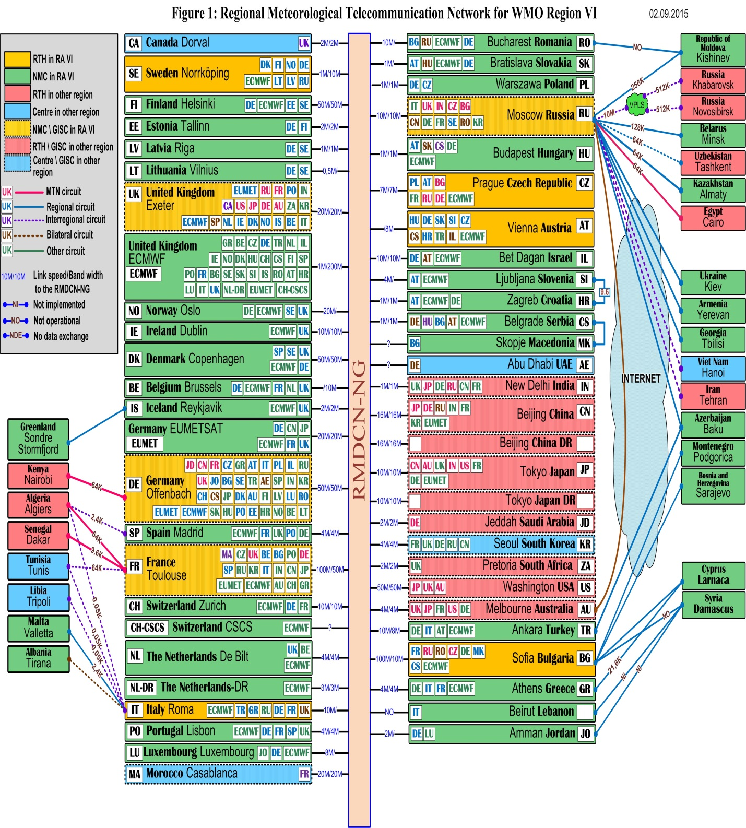

As for the WIS core network in Region VI, it looks as follows:
Network of Moscow GISC
