World Meteorological Organisation

Regional Association VI

Management Group

Second meeting

14-15 May 2014

Tallinn, Estonia

REPORT

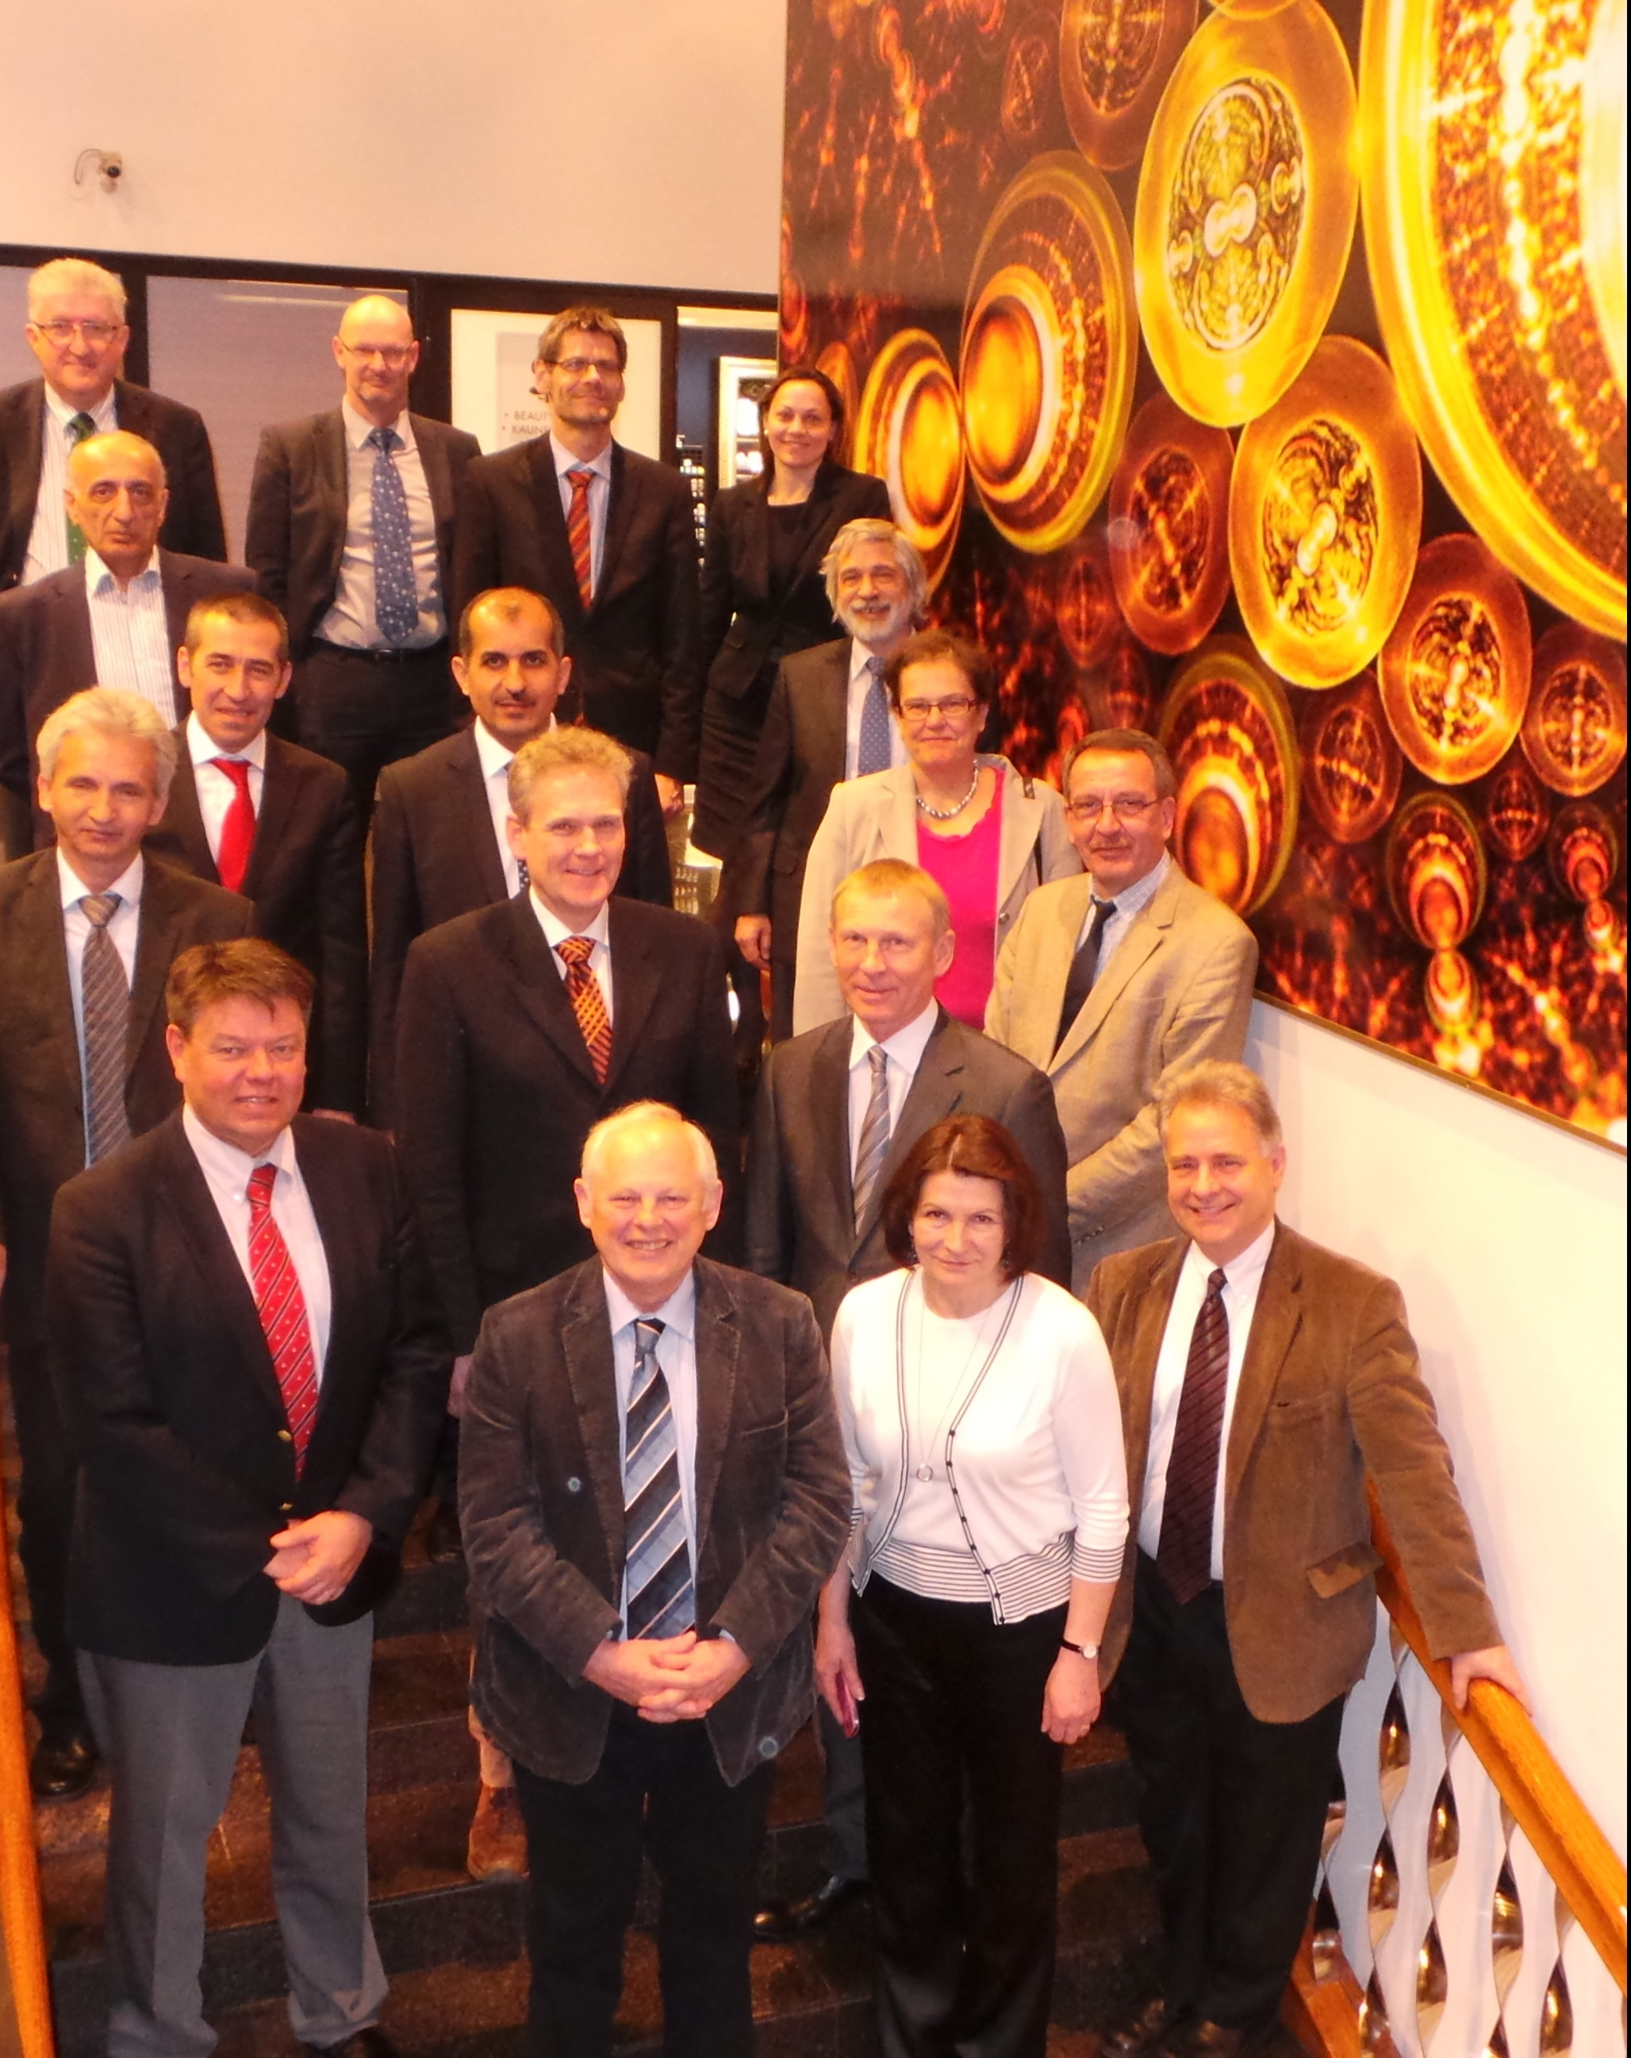

EXECUTIVE SUMMARY

On 14 and 15 May 2014, the Management Group of RA VI met in Tallinn, Estonia with the view to:

- Review and follow up the actions requested by the RA VI at its sixteenth session,
- Approve the working structure and the work plan of RA VI Subsidiary Bodies,
- Prepare for the sixty-sixth session of the Executive Council, planned for 18-27 June 2014,
- Plan for the seventeenth session of the Congress, tent. planned for 25 May-12 June 2015,
- Plan the regional events, and
- Discuss any other relevant business.

I. INTRODUCTION

I.1 Background

The Regional Association VI at its sixteenth session, held from 11 to 17 September 2013 in Helsinki, Finland re-established the RA VI Management Group with a revised composition and terms of reference through adoption of the Resolution 5.3/1 (RA VI-16) - RA VI Management Group (INF.7).

The re-established Management Group held its first meeting in Helsinki, on 16 September 2013. A summary of meeting’s discussions is available on the following web link: http://www.wmo.int/pages/prog/dra/eur/documents/RA6_MG1_SoD.pdf.

I.2 Dates and venue

The second meeting of the Management Group was held from 14 to 15 May 2014 in the Allegro conference room of Sokos Hotel Viru Conference Centre, located on Viru väljak 4, in Tallinn, Estonia. The Estonian Environmental Agency kindly facilitated the local arrangements, described in an information Note for participants.

I.3 Agenda

The agenda is attached as Doc.1.

I.4. Participants

The meeting was attended by 22 participants: 10 MG members, 3 WMO officers and 9 invited observers. The List of participants is attached as INF.1.

II. SUMMARY OF DISCUSSIONS

II.1 Opening

Mr Ivan Cacic, the RA VI president and the chair of the Management Group opened the meeting addressing welcome words to all participants, especially to the new coming members and invited observer. The Chair initiated a round-table introduction of participants.

Mr Jalmar Mandel, the Director of the Estonian Environment Agency, the hosting institution welcomed all participants, wished all fruitful discussions and a nice stay in Tallinn. Mrs Rosin Kai, his International Adviser was delegated to attend the MG meeting on his behalf as observer.

Mr Robert O. Masters, the Director of the WMO Development and Regional Activities Department thanking the host country and institution for the invitation, highlighted the advanced status of the European NMHSs vis-a-vis the NMHSs of the other WMO Regions.
The Chair presented the Meeting Tentative Agenda and Programme and mentioned that due to the fact that some MG members were not able to attend the first day of the meeting, the items related to the Planning of regional activities as well as the Composition and Work Programmes of the RA VI Subsidiary Bodies were planned to be considered during the second day of the meeting. The proposed working arrangements were unanimously accepted.

Mrs Rosin provided information on local arrangements, made available to participants prior to the meeting, as INF.2.

Mr Dimitar Ivanov provided an overview of the working arrangements for RA VI Subsidiary Bodies.

II. 2 Activities between the two MG meetings

Report of RA VI president

The Chair of the RA VI Management Group reported on the activity progress for the inter-meeting period, i.e. since September 2013 to May 2014.

The Chair directed the attention of the Management Group to a list of actions required by the RA VI at its sixteenth session in September 2013 and asked the Chairs of the RA VI WGs to take proper account of the required actions. The list is attached as Doc.3.1.

Activity Report of the Task Team on Regional Operating Plan

Mrs Maria Hurtola, the Leader of the Task Team on Regional Operating Plan reported on the objectives and outcomes of the Team’s first meeting, which was held in January 2014 in Geneva.

The Task Team Leader provided an overview of the Regional Operational Planning for the next intersession period. The Activity report is attached as Doc.3.2.

Actions requested:

- Ask the WMO Secretariat and Executive Council WG SOP to provide further guidance on the planning process; in particular, on how can we influence the KOs and KPIs;
- Discuss in EC WG SOP the best way to establish links between the global working subsidiary bodies and the regional subsidiary bodies;
- Improve communication with Governments and promote: (1) Social and Economic Benefits of NMHSs, being a clear regional priority, and (2) Research, as the global priority, where the inputs of the WMO Commission on Atmospheric Sciences are expected.
- Inform Members on the ROP 2016-2019 encouraging using it in the national planning process,
- Develop the culture of interaction with the customers in the process of the Operating Planning,
- Capacity development is apparent but the Work Plan of each Working Group should include actions to address the regional gaps,
- Perform a survey study on the Members’ capacity building needs.

II.3 Composition and Work Programmes of the RA VI Subsidiary Bodies

RA VI Task Team on Regional Operating Plan (TT-ROP)

Maria Hurtola, the Leader of the RA VI Task Team on Regional Operating Plan presented the composition and the Work Programme of the Task Team.

It has been noted that the Regional Operating Plan reflects the regional prioritized needs to be addressed through development of projects and partnership and resource mobilization. Difficulties exist with alignment of the different planning levels. E.g., the backbone is the work plans of the RA VI WGs, which are firstly approved by the MG and only then are incorporated into the Regional Operating Plan. Working Groups also play a role in identifying and addressing the gaps.

Actions requested:
- Ensure inter-regional actions for bridging the development gap between Members at global and regional level, using the Country Profile Data Base and other informative sources;
- Link to the EU activities like Copernicus, analyse overlaps and opportunities;
- Provide a tabular presentation of the regional experts represented in the WMO Subsidiary Bodies (Technical Commissions, Expert Panels) to enable better coordination and alignment of tasks;

MG Decisions:

The ToRs and the Composition of the TT on ROP were approved without amendments, as attached in Doc 4.1.

RA VI Working Group on Technical Development and Implementation (WG-TDI)

Mr Dieter Schroeder, the Chair of the WG-TDI presented the composition and the Work Programme of the Group.

It was noted that roles and responsibilities are shared by the Chair and vice chair, thus, the chair will focus on Information Technology-related matters, while the vice-chair will focus on Observation–related matters of the Work Programme.

As part of the Work Programme, a couple of Training Workshops on Table Driven Code Forms and Nowcasting Techniques are being planned for each year. Moreover the Programme reflected the readiness of the Working Group to deploy experts to the concerned Members requiring support in the migration to TDCFs.

Actions requested:

- Identify an appropriate Rapporteur on Information Technology,
- Identify an appropriate Rapporteur on Radar Networking and
- Identify an appropriate on Regional Network of Instrument Centres,
- Enhance cooperation on nowcasting related matters with ESSL, EUMETSAT SAFs and others,
- Ensure that the Hydrology related matters are linked to WIGOS,
- Synergies with Copernicus Programme activities to be reflected in the programme.

MG Decisions:

The WG-TDI’ Composition and Work Programme were approved as attached in Doc. 4.2.

RA VI Working Group on Climate and Hydrology (WG-CH)

Mr Dominique Berod, the Co-chair on Hydrology-related matters and Mr Vladimir Kryjov, the Co-chair on Climate related matters of the WG on Climate and Hydrology proposed the Composition and Work Programme.

As part of the Work Programme, two consecutive regional events are being planned to be hosted by the National Institute of Meteorology and Water Management of Poland from 22 to 26 September, accordingly, as follows:

- The First Meeting of RA VI WG-CH, 22-23/09/2015,
- RA VI Hydrology Forum, 24-26/09/2015.

A series of Regional Climate Outlook Forums is being planned back to back with the regional consultations meeting with the users of the GFCS’ priority sectors, such as health, water, agriculture & food security and DRR.

The meeting appreciated the Work Programme oriented towards the development of synergies between climate and hydrology activities, serving as a good example of collaboration.

Actions requested:

- Identify an appropriate expert to lead the TT on Regional Climate Centers and Regional Climate Outlook Forum,
- Ensure the participation of hydrologists in RCOF sessions,
- Clarify the definition of Climate Watch,
- Identify synergies of the TT on CWS and TT on RCC and RCOF,
- Take into account the recommendations of the Network of RCC Focal Points on the composition of the RA VI Task Team on RCC.
- Support the data management related matters;
- Request the WMO Commission on Climatology to develop guidance on homogenization of climate data in case of transition from manual to automatic stations,
- Develop an Action Plan as the main output of the RA VI Hydrology Forum to contribute to the 7th World Water Forum, planned for 12-17 April 2015 in Korea.

MG Decision:

The Composition and Work Programme were approved as attached in Doc.4.3.

RA VI Working Group on Service Delivery and Partnership (WG-SDP)

Mr Axel Thomalla, the Chair of the WG-SDP proposed the MG to consider and approve the Composition and Work Programme for 2014-2017.

As part of the Work Programme, early meetings of the WG are being planned for the coordination of the Work Programme activities as well as for monitoring of the implementation progress.

To support the regional human capacity building, a Communication Workshop for Information and Public Affairs Focal Points is being planned back to back with the EMS/ECAC in October 2014 in Prague.

In addition to that, a European Conference on meteorological service provision to civil aviation is being planned for autumn 2015 in Vienna, Austria.

Actions required:

- Identify an appropriate expert to lead the TT on Aviation.

MG decision:

The Group’ Composition and Work Programme were approved as attached in Doc.4.4.

II.4 Planning of regional events

Several regional events are being planned in the next intersession period as follows:

- September 2014, Warsaw, Poland - RA VI Hydrology Forum

- Communication Workshop for Information and Public Affairs Focal Points, back to back with the EMS/ECAC in October 2014, Prague

- Regional Consultation Meeting for SEE back to back with the Regional Climate Outlook Forum for SEE, November 2014, Turkey

- INTAD-6 Training-Workshop, September 2015, Alanya, Turkey.

- Regional Directors’ Conference on the future of meteorological service provision to civil aviation in Europe (see Resolution 2 to the RA VI-16 report), October 2015, Vienna, Austria.

II.5 Preparation for EC-66 and Cg-17

EC will hold its sixty-six session from 18 to 27 June 2014 in Geneva, Switzerland at WMO Headquarters. The WMO Congress will hold its seventeenth session from 25 May to 12 June 2015 in Geneva, Switzerland in the International Congress Centre.

The MG has accepted the position of RAVI as exposed by RA VI president in his presentation.

II.6 Any other business

Information from Intergovernmental Council for Hydrometeorology of Commonwealth of Independent States

Mr Levon Vardanyan, the Chair of the Intergovernmental Council for Hydrometeorology of Commonwealth of Independent States (ICH/CIS) informed the Management Group on the ICH/CIS’ decisions related to the establishment of the Interregional Office for CIS in the sub-region and asked the MG members and the WMO Secretariat to request the support of EC for this initiative. An Information Note on the related ICH/CIS decisions is attached as INF.3.

MG supports in principle this initiative, provided that further institutional, administrative and financial matters are clarified.

Actions requested:

Mr Alexander Frolov, the Vice-chair of the ICH/CIS will:

- inform RA II Management Group, planned for the end of May 2014 in Doha

- make an intervention during EC-66 highlighting the proposals of the ICH/CIS related to the establishment of a WMO Interregional Office for CIS, which is supported by both RA II and RA VI.

The Chair of ICH/CIS will provide more information on the financial plan.

Cooperation with EUMETNET

Mr Steve Noyes, the Executive Director of EUMETNET recalled that the RA VI requested EUMETNET to support RA VI activities. He briefed the RA VI MG on the activities of EUMETNET, which could be extended to the other sub-regions. One such area is WIGOS implementation. EUMETNET will work on AMDAR, another area is OPERA – these activities could be extended further to the East. EUMETNET infrastructure for AMDAR could be used that could generate more revenue from the airlines. This is an issue to be considered. The cooperation agreement for an extended use of AMDAR will require funding. Current AMDAR budget is 1.8 Million a year and about 600K will be needed for the extension.

III. Closure

The Chair wrapped up the discussions and announced that the meeting documents will be uploaded to the WMO ROE web site in due time. The following conclusions and decisions were made. The following actions were recommended:

Conclusions:

- The meeting achieved its goals, as follows:
- The actions requested by the RA VI at its sixteenth session were reviewed and the responsibilities for the implementation and follow up were agreed as reflected in Doc.3.1.
- The regional events were tentatively planned as listed under item II.4.
- The relevant matters for the sixty-sixth session of the Executive Council and for the seventeenth session of the Congress were discussed.
- The next MG meeting was agreed be held in Turkey in spring (March or April) 2015.

Decisions:

Nr | Decision | Responsible | Deadline | Status | Notes
MG2/1 | To approve the ToRs and the composition of the Task Team on Regional Operating Plan, as reflected in Document 4.1. | Leader of TT/ROP | with immediate effect by the RA VI seventeenth session | Completed
MG2/2 | To approve the composition and the work programme for 2014-2017 of the Working Group on Technology Development and implementation, as reflected in Document 4.2. | Chair of WG/TDI | with immediate effect by the RA VI seventeenth session | Completed
MG2/3 | To approve the composition and the work programme for 2014-2017 of the Working Group on Climate and Hydrology, as reflected in Document 4.3. | Co-chairs of WG/CH | with immediate effect by the RA VI seventeenth session | Completed
MG2/4 | To approve the composition and the work programme for 2014-2017 of the Working Group on Service Delivery and Partnership, as reflected in Document 4.4. | Chair of WG/SDP | with immediate effect by the RA VI seventeenth session | Completed

The Recommendations are attached to this report in form of an Action List (INF.4).

The Chair addressed thankful words to all for active participation, to the Regional Office for Europe for the preparation of the meeting documents and to the host for the excellent meeting facilities. The meeting was closed at 13:00.

IV. Annexes

There are nine documents attached to this report:

- INF.1- List of participants
- INF.2- Info on local arrangements
- Doc.1- Agenda
- Doc.3.1 –Report of the RA VI president
- Doc.3.2- Activity Report of TT/ROP
- Doc.4.1- ToRs, Composition on Regional Operating Plan
- Doc.4.2- ToRs, Composition and the Work Programme of WG on TDI
- Doc.4.3- ToRs, Composition and the Work Programme of WG on Climate and Hydrology
- Doc.4.4- ToRs, Composition and the Work Programme of WG on Service Delivery and Partnership
- INF.3- Information Note on the ICH/CIS decisions related to the establishment of the Interregional Office for CIS
- INF.4- Action List

