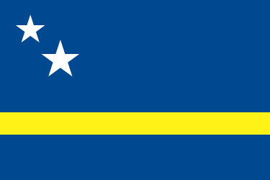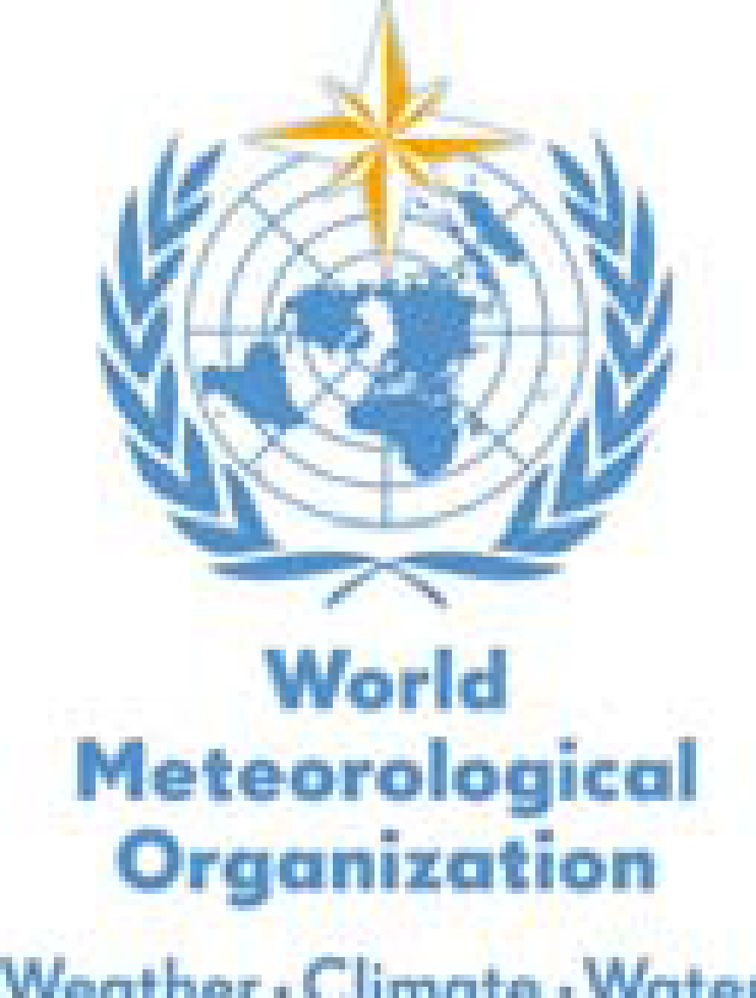
WMO RA IV WIGOS Implementation Workshop (English)
(Willemstad, Curaçao, 1 December – 3 December, 2015)
PROGRAMME

Tuesday, 1 December 2015
08:00-09:00 | Registration
09:00-09:30 | Opening and organization of the workshop  - Haime Pieter, on behalf of Dr Albert Martis, WMO Permanent Representative for Curaçao and Sint Maarten, and Vice President of RA-IV Regional Association  - Dr Wenjian Zhang, WMO, Director of Observations
09:30-10:00 | Introduction to WIGOS and the pillars of the Plan of the WIGOS Pre-Operational Phase | L.P. Riishojgaard, PM/WIGOS
10:00-10:30 | Outcome of the TT-PWPP-2: Regional and National Implementation planning | L.P. Riishojgaard, PM/WIGOS
10:30-11:00 | COFFEE & TEA BREAK
11:00-11:30 | Plans for the WIGOS Data Quality Monitoring System | Robert  Grumbine (NOAA/NCEP)
11:30-12:00 | WIS’s role in implementing WIGOS | David Thomas, WIS (via teleconference)
12:00-12:30 | Upcoming impacts on national operations as a result of WIGOS | L.P. Riishojgaard, Shanna Pitter, WIGOS
12:30-14:00 | LUNCH BREAK
14:00-14:30 | Introduction to OSCAR | Shanna Pitter,  WIGOS
14:30-15:00 | How to use OSCAR/Surface | Shanna Pitter,  WIGOS
15:00-15:30 | COFFEE & TEA BREAK
15:30-17:25 | Practical Session on OSCAR/Surface  (Note: Participants need to bring their own laptop computers with wifi capabilities and an internet browser) | Participants
17:25-17:30 | Closure of Day 1 | Haime Pieter

Wednesday, 2 December 2015
9:00-9:30 | Overview of WIGOS activities in RA-IV and status of the WIGOS implementation | Glendell De Souza (BCT)
9:30-10:30 | National WIGOS Implementation status (10 mins each):  - Antigua and Barbuda  - Bahamas  - Barbados  - British Caribbean Territories (represented by Cayman Islands)  - Belize  - Canada | Participants
10:30-11:00 | COFFEE & TEA BREAK
10:30-12:30 | National WIGOS Implementation status (10 mins each):  - Curacao and Sint Maarten  - Dominica  - Guyana  - Haiti  - Jamaica  15 min break  - Netherlands (representing Aruba)  - St Lucia  - Suriname  - Trinidad and Tobago  - United States of America | Participants
12:30-14:00 | LUNCH BREAK
14:00-14:20 | Overarching Automated Weather Stations (AWS) Issues | Jitze Van Der Meulen (Netherlands)
14:20-14:40 | Regional AWS issues for RA-IV | Tentatively: Marvin Forde (CIMH)
14:40-15:00 | WMO Plans to address AWS issues | Igor Zahumensky, WIGOS
15:00-15:30 | COFFEE & TEA BREAK
15:30- 17:25 | Discussion on AWS and other observing network issues | Participants
17:25- 17:30 | Close of Day 2 | Haime Pieter

Thursday, 3 December 2015
9:00-9:15 | Review of RA-IV WIGOS Regional Implementation plan | Glendell De Souza
9:15-10:30 | Discussion: Regional implementation of WIS and WIGOS; Regional WIGOS Center and collaborations. | Led by Glendell De Souza and L.P. Riishojgaard
10:30-11:00 | COFFEE & TEA BREAK
11:00-12:30 | Round table discussion on tangible WIGOS topics in the region. Updates to the Regional Implementation Plan | Led by Glendell De Souza and L.P. Riishojgaard
12:30-14:00 | LUNCH BREAK
14:00-15:15 | Round-table discussions on tangible projects, regional collaborations, next steps. | Led by Glendell De Souza and L.P. Riishojgaard
15:15-15:30 | Summary and Closure of the workshop; Next Steps for the WMO members | Haime Pieter

