Around the world National Meteorological and Hydrological Services (NMHS’s) and agencies are implementing hundreds of crowdsourcing approaches, citizen science programs, and other efforts to harness the collective ingenuity of people in the advancement of science.
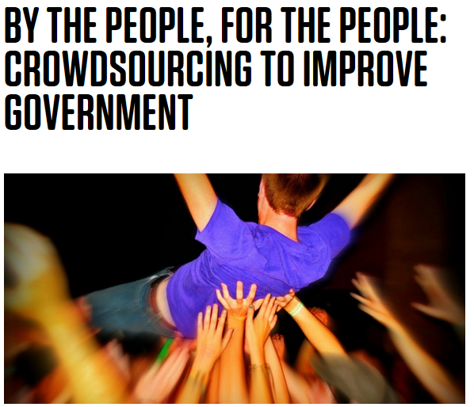
Task Team Summary Report Oct 2017:
This informal Task Team (TT) has been asked to assess current capabilities of NMHSs to successfully engage in crowdsourcing activities.
Early discussions:
Task Team members individually tapped into their own various networks to (first) anecdotally and then (secondly) to systematically compile a list of NMHSs that were actively engaged in some form of crowdsourcing weather and climate information.
It became obvious very quickly that nearly all NMHSs have engaged “citizen scientists” in some way, shape or form (see Annex 1).
Then, during the European Meteorological Society meeting in Dublin, Ireland Sept 2017, researchers led by Thomas Krennert from the Central Institute of Meteorology and Geodynamics in Vienna, Austria, presented a paper surveying NMHSs Crowd Sourcing activities (poster - see Annex 2).
From this preliminary work it was discovered that 86% of the surveyed European NMHSs actively applied or used crowdsourcing as a way to gather and report on various weather related parameters. Furthermore of the 14% of NMHSs not actively asking for information, internal forecasters and scientists were encouraged to access available and open information via different sources.
Recommended next steps:
It is now quite clear that further investigation is required with following recommendation.
- The preliminary survey of the European NMHSs should be extended internationally with the following questions being addressed:
- That the “crowd” definition be refined into groups i.e. are they trained weather spotters?
- Was it a “push” or “pull” mechanism by which the information came to the NMHS i.e. did a forecaster scour social media reports for (say) hail? Was the information sent directly to the NMHS via (say) a mobile device?
- What type of meteorological information is being collected? Storm reports? Hydrographic events? Hurricane or Tsunami impact reports?
- How is the data being stored or archived?
- Is the NMHS making this data collectively available publically?
- Is any of the data being assimilated into forecast models?
From a large extension of the European survey it will then be possible to assess a collective NMHS ability, resources, capability and usefulness for the data. It will also become apparent as to best practices for data collection as well as guidelines for public data access.
Considerations moving forward:
That the TT meets to develop the tactical implementation plan for expanding the research into international use of NMHS crowdsourced meteorological information.
It is also recommended that the WMO consider the future possibility of leveraging its online portal http://worldweather.wmo.int/en/home.html as a possible collection “hub” for global crowdsourced weather data.

Annex 1 – Examples of various NMHS crowdsourcing projects
- The Dutch systematically verify the quality of crowdsourced weather data, specifically from Personal Weather Stations (PWSs) and from smartphones.
https://www.knmi.nl/kennis-en-datacentrum/project/quantifying-quality-of-crowd-sourced-weather-data
- NOAA’s National Severe Storms Laboratory (NSSL) in the US have expanded their crowd-sourced weather reporting site https://mping.nssl.noaa.gov/ to include all parts of the world citing great success with information gathered from US participants.

- The UKMO posts mass-crowdsourced weather and climate data to an open platform – making the most of APIs and the internet of things. Upon inception (2011) then Met Office CIO Charles Ewen stated “Businesses and organisations will be encouraged to funnel data through WOW, and the platform will include a full set of APIs, so users can grab and manipulate weather data through an API, available in an open forum”.
https://wow.metoffice.gov.uk/

Annex 2 – Poster Crowd Sourcing of Weather Observations at European National
Meteorological Services
From: ZAMG Central Institute of Meteorology and Geodynamics, Vienna, Austria
Presented by Thomas Krennert & Christian Csekits.
https://edrop.zamg.ac.at/owncloud/index.php/s/AbMsDIdXae6tUAK

The practice of obtaining weather related information or content by soliciting contributions from a large group of people (citizens) rather than from traditional employees or suppliers. For the purposes herein, it was decided that the data collected need not necessarily be assimilated in any formal or academic process.

