WORLD METEOROLOGICAL ORGANIZATION

REPORT OF THE STAKEHOLDER WORKSHOP TO IMPLEMENT AN IMPACT-BASED FORECSTING AND WARNING SERVICE IN MAURITIUS

MAURITIUS, 26-30 OCTOBER 2015

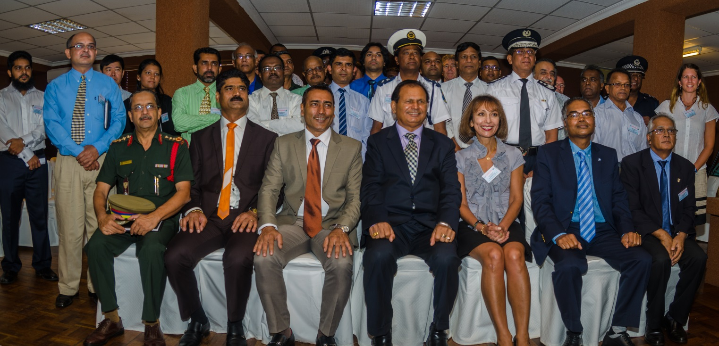

FINAL REPORT
INTRODUCTION

At the invitation of the Government of the Republic of Mauritius and the Mauritius Meteorological Services (MMS), WMO convened a Stakeholder Workshop in Mauritius (26-30 October) to provide guidance and assistance to MMS and national Stakeholders on the implementation of a pilot project on impact-based forecasting for Mauritius. The Meteorological Services is under the Prime Minister’s Office and works in close collaboration of the Ministry of Environment, Sustainable Development, and Disaster & Beach Management.

In addition to the senior staff from MMS, the stakeholders who attended the workshop represented a variety of the most important user communities for the products and services of MMS, including ministries and departments responsible for agriculture, water resources, electricity production, the disaster management, environment, education, transport, fire and rescue services, police force, and emergency medical service. The list of participants and invited experts (Deltares, UK Met Office, GFDRR and WMO) is attached (Annex I).

As the first activity of the workshop, a number of presentations were made by MMS and the Stakeholders on the current status of operational warning systems for meteorological, hydrological and geophysical hazards (tsunamis, landslides and rockfalls), the challenges posed by those systems, and the disaster reduction activities.

Mauritius consists of a number of islands in the Indian Ocean, the furthest of which is Diego Garcia at a distance of 2204 Km from Mauritius Island and the two other major islands of Rodrigues and Agalega are situated at 595 and 1080 Km respectively from Mauritius Island. This spread across the Indian Ocean in itself presents an important challenge in terms of planning for and responding to severe weather and other hazards, as well as communicating the warnings. In addition, weather systems and consequent hazards can impact the country in different ways, for example, while heavy downpours leading to flash floods can be experienced in one part of the relatively small Mauritius Island, the weather can remain benign in another part.

The presentations illustrated that the changing living environment and increasing urbanization of Mauritius have modified the way in which the most important hazards such as heavy rainfall are impacting the country and people’s lives in recent times, whereas once a natural calamity was seen in the form of cyclones only. It must be noted however, that strong winds and storm surges associated with cyclones are still considered as important hazards as well as, heavy waves. The very informative presentations made during the workshop can be viewed on the following link

https://www.wmo.int/pages/prog/amp/pwsp/Stakeholders_Workshop_Mauritius_Presentations.htm

Important steps have been taken in recent years to improve the services provided by MMS and with the planned installation of a Doppler Radar in 2017, MMS hopes to be able to more accurately forecast the formation of convective systems over the country, which are responsible for heavy rainfalls leading to flash flooding especially in urban areas.

The 30 March 2013 flood event which cost the lives of 11 people in the Capital Port Louis, highlighted the need for a National Disaster Risk Reduction & Management Programme for the Republic of Mauritius, and in October 2013, the National Disaster Risk Reduction and Management Centre (NDRRMC ) was set up under the Prime Minister’s Office. Since December 2014 the NDRRMC has moved to the Ministry of Environment, Sustainable Development, and Disaster & Beach Management. The NDRRMC has an overall coordinating role among all other actors in the case of severe meteorological, hydrological or geophysical hazards.
Presentations by stakeholders highlighted common needs which include, but are not limited to the following: more accurate and location-specific forecast of the hazards and provision of early warning of hazard impacts; open data, data sharing and access; sensitization of the public to the use of a standard colour coding of hazards and impacts; more effective use of mobile technology and SMS; improved dissemination systems to warn people especially during the night and in the remote communities, including the implementation of Common Alerting Protocol (CAP) which has already been introduced to Mauritius by WMO; the use of simple warning systems such as sirens and flags in beaches:

A first step in the implementation of a Pilot Project would be determining and agreeing in a subjective manner on the impacts of hazards on individual stakeholders. A main goal of the workshop was thus to help stakeholders develop individual (a) hazard matrices for those hazards that impacted their particular sector and to separate those into primary, secondary and tertiary hazard, (b) impact matrices to show the impact of a hazard on their particular sector and classify it in terms of the severity of the impact, and (c) mitigation advice matrices for each hazard. This exercise occupied the main duration of the workshop and was a clear first step towards proceeding with thinking about cascading consequences of hazards into impacts and the necessary mitigation actions. (Annex II). These matrices form a major outcome of the workshop.

A number of technical presentations related to mapping and modeling in meteorology and hydrology, and introduction to multi-hazard impact-based forecasting and warning services, were made by the invited experts and highlighted the technologies that exist today and would make impact-based forecasting in Mauritius a reality. Figure 1 below shows the operational shift needed in the basic practices of a Meteorological Service to allow the move from hazard threshold-based to impact-based forecasting.
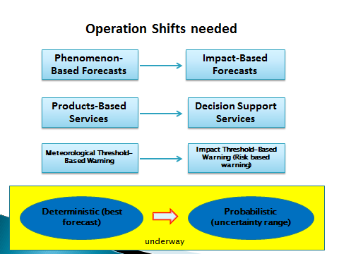

Figure 1. The operational shift to move from hazard-based to impact-based forecasting (Chen Boade, CMA)

Figure 2 illustrates the relationship between different elements of an impact-based forecast and the data, information and tools required for arriving at such forecasts.

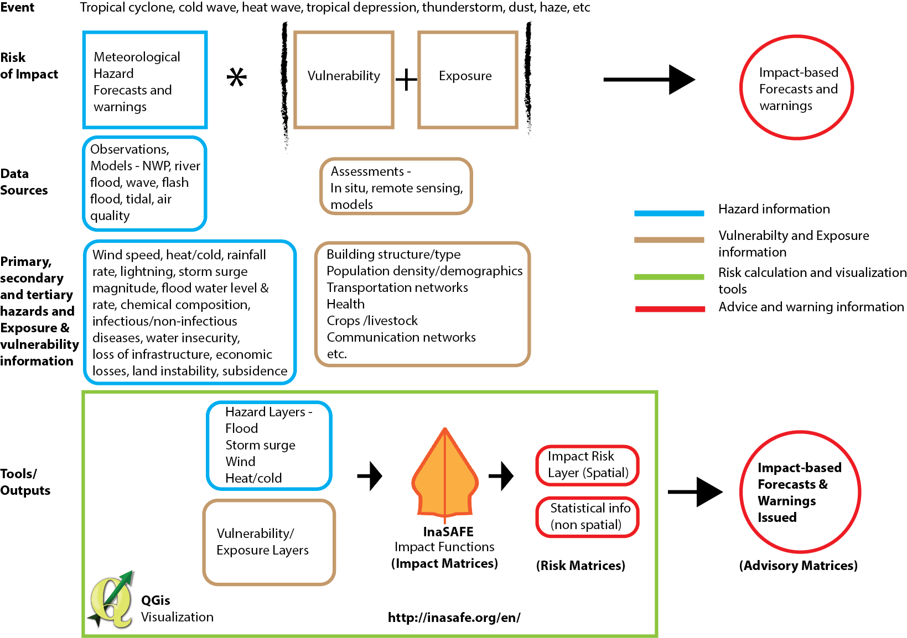

Figure 2: The cascading depiction of elements required for an impact-based forecast (D. Rogers, GFDRR)

Concluding Meeting and the Way Ahead

Based on the outcome of the analysis of the matrices produced at the workshop and discussions on the requirements for next steps, a technical discussion was held on 30 October with the participation of the Director-General of NDRRMC and senior management of MMS to map out a follow-up plan for the implementation of impact-based forecasting in Mauritius.

It was agreed that a major problem facing all stakeholders in Mauritius is flooding (flash floods, urban flooding, and river flooding). In the case of flash floods, since most of such floods occur as a result of short-lived thunderstorms for which TRMM data is not of adequate resolution, radar data is required. In the absence of radar data and while waiting for the installation of the Doppler radar in 2017, there is a need to build up a climatology (or catalogue of cases) of flash floods to guide forecasters to use the past experience in judging the probability of flash floods occurring as a result of particular weather regimes affecting the country. Other issues relating to the dissemination of alerts/warnings need to be considered as well since at the moment dissemination systems are not effective in reaching the population at night or in remote areas. Forecasts need to be communicated in simple language to allow understanding by lay people. It is envisaged that the implementation of CAP will to a large extent alleviate this problem.

It was also agreed that there was a need for free exchange of data among various stakeholder organizations which at the present time does not exist. The Director-General of NDRRMC stated that this issue could be addressed since following the 2013 floods a recommendation was made to set up a national data infrastructure at the Ministry of Housing to gather data such as construction maps and flood hazard maps. In order to have free access to data a process needs to be set up and followed. The MMS needs to take the lead to prepare a Project plan based on the outcome of the Stakeholder Workshop, including the proposals for the way ahead and timelines, for submission to the Prime Minister’s Office (PMO) for approval. The Project will propose roles and responsibilities of each participating entity. Once approved, the way will be clear for the implementation of the impact-based forecast and warnings in the country, including the authority to access and share data among the entities, for the public good.

It was stated that no organization currently has responsibility for flood forecasting in Mauritius. In order to address this issue, during the meeting it was agreed that Mr Deepak Vatvani would, with the financial support of WMO, make a follow up visit to Mauritius to install intermediate and detailed wave models (coupled to the flow model) on the research computing system of the MMS. He would train the forecasters on the use of these models as part of the capacity development in MMS and the incorporation of these new model results into the storm surge Early Warning System of MMS.(This mission will take place from 14-18 December 2015). In addition, once the Doppler radar is installed to produce reliable warnings for flash floods, it will be natural that MMS should take the lead for flood forecasting, in collaboration with water authorities. The Director-General of NDRRMC suggested the inclusion of the flood forecasting in the proposed Project plan so that once the Prime Minister’s Office approves the plan, other authorities would be required to comply. (Action: MMS to prepare the Project Plan for submission to the PMO )

ANNEX I

LIST OF PARTICIPANTS

COUNTRY/ORGANIZATION | PARTICIPANT
MAURITIUS | Premchand GOOLAUP  Deputy Director  Meteo  Mauritius  6861031/6861033  Email: Prem.goolaup@gmail.com
Ram Kumar DHURMEA
Divisional Meteorologist
Meteo
Mauritius
6861031/6861033
Email: Sadrame75@gmail.com

Renganaden VIRASAMI
Divisional Meteorologist
Meteo
Mauritius
6861031/6861033
Email: vganessen@yahoo.com

Jules Kune LAM CHOK SING
Principal Engineer
CEB
Mauritius
4042056/4670349
Email: jules.lam@ceb.intnet.mu

Mohammad Khalid MOSAHEB
Engineer/Senior Engineer
Min. of Public Infrastructure & Land Transport
Mauritius
6011600/6864506
Email: mkmosaheb@govmu.org

Dhurumrajsing SEESAHYE
Deputy Chief Fire Officer
MF & Rescue Service
Mauritius
2120214/2115709
Email: dseesahye@govmu.org

Chandrasen MATADEEN
Principal Engineer
CWA
Mauritius
6015000/6967111
Email: matadeen_c@cwa.intnet.mu

Vishnu MOKOONLALL
ATC Supervisor
CAD
6032000/6374164
Email: civil_aviation@govmu.org

Dinesh GOPY
ASP
MPF-SMF
Mauritius
6011300/6863048
Email: dgopy@hotmail.com

Ramdass Luthmoodoo REDDY
ASP
MPF-NCG
6319236/6319065
Email: moodoo005@yahoo.com
Veer Abhimanyu PUNCHOO
Chief Agricultural Officer
Agricultural Services
Mauritius
4012800/4648749
Email: vpunchoo@govmu.org

Rajen GUNGABISSOON
Chief Road Transport Off
NTA
Mauritius
2022813/2129399
Email: rgungabissoon@govmu.org

Vijay Anand DOORGHA
Police Sergeant
MPF
Mauritius
2080034/2114444
Email: Doo.gopal@yahoo.com
Denis Josue PAUL
Police Constable
NDRRMC
Mauritius
2073900/2073927
Email: jpaul@govmu.org

Prithiviraj BOONEEADY
Divisional Meteorologist
NDRRMC
Mauritius
2073900/2073927
Email: pbooneeady@govmu.org

Navin MAHADOO
Disaster Management Coordinator
Mauritius Red Cross
Mauritius
6701274/6748855
Email: navin.mahadoo.dmc@outlook.com

Oodaye Prakash SEEBALUCK
Assistant Director
GIS-PMO
2011879/2088243
oseebaluck@govmu.org

Daneshar BABOOA
Chairperson, MACOSS
MACOSS
Mauritius
2120242/2086370
Email: macoss@intnet.mu

Mahendra Kumar BISSESSUR
Senior Engineer
Water Resources Unit
Mauritius
4035400/4657177
Email: mkbissessur@govmu.org

Oomarsing GOOROOCHURN
Associate Research Scientist
MOI
Mauritius
4274434/4274433
Email: ogooroochurn@moi.intnet.mu

Seeneevassen COOLEN
Director, Safety and Health Unit
Min. of Civil Service and A.R.
Mauritius
4054100/2088642
Email: scoolen@govmu.org

Ashan PURMESSUR
Project Manager
Min. of Education
Mauritius
6015270/6975351
apurmessur@govmu.org

Anand Kumar DHOOMUN
Environment Enforcement Officer
Ministry of Environment
Mauritius
2036200
Email: adhoomun@govmu.org

Khishma MODOOSOODUN
ARS
MOI
Mauritius
7274434/4274433
Email: kmodoosoodun@moi.intnet.mu

Antoine YEN LUK
Senior Meteorological Technician
Meteo
Mauritius
6861031/6861033
Email: meteo@intnet.mu

Vijay SOONEECHUR
Meteorological Telecommunication Technician
Meteo
Mauritius
6861031/6861033
Email: meteo@intnet.mu

THE NETHERLANDS | Mr Deepak Vatvani  Sr. Advisor  Marine and Coastal System  Environmental Hydrodynamics  Boussinesqweg 1  Delft, 2629 HV  The Netherlands  Email: deepak.vatvani@deltares.nl
UNITED KINGDOM | Ms Eleanore Hunt  International Expert Meteorologist/Senior Operational Meteorologist (Hazard Centre)  The Met Office  FitzRoy Road, Exeter  DEVON EX1 3PB  United Kingdom  Email: eleanore.hunt@metoffice.gov.uk
UNITED KINGDOM | Mr Steve Manktelow  The Met Office  FitzRoy Road, Exeter  DEVON EX1 3PB  United Kingdom  Email: steve.manktelow@metoffice.gov.uk
GFDRR | Dr Richard Murnane  Manager, NatCatRisk  P.O. Box 405  Garrett Park MD 20896  USA  Email: rmurnane@natcatrisk.com
WMO SECRETARIAT | Ms Haleh Kootval  Chief, Public Weather Services Division  Weather and Disaster Risk Reduction Services Department  World Meteorological Organization  7bis avenue de la Paix  CH 1211 Geneva 2  Email: hkootval@wmo.int

ANNEX II
Flash Flood Impacts Matrix for First Responders
Minimal impacts | Minor Impacts | Significant impacts | Severe impacts
- 1cm Surface water on road  - Low visibility  - Slow traffic  - Very short duration | - 3-5 cm surface water on road  - Traffic jam  - Sporadic accumulation of water (compounds)  - Disrupt outdoor activities  - Small area affected  - Short duration (15 min) | - 30cm surface water  - Accidents  - Heavy traffic jam  - Disrupt socioeconomic activities (schools, transport, business)  - Increased exposure  - Stranded students/workers  - Flooding in basements/ underground parking,  - Larger area affected  - Longer time duration (30 min)  - Accumulation of debris (branches, rocks, silt)  - Blocked drains and other water courses  - Affect certain essential services (communication, waste water/sewage overflow)  - Reduced sea activities  - Small area of vegetation/agriculture affected  - Cancelled public and outdoor events  - Minor damage to infrastructures (road/ bridges/ buildings | - Up-to and above 1m  - Casualties  - Vehicles washed away  - Drowning  - Inundation of larger areas  - Plied vehicles along water courses  - Major damage to all infrastructure  - Overflooded basement and underground parking  - Trapped persons  - Major Disruptions of essential services (public transport, communication, power supply, access to hospitals, etc)  - Delayed access emergency responders  - Contaminated potable water  - Significant accumulation of debris  - Larger area of vegetation/agriculture affected
Landslide Impacts Matrix for First Responders
Minimal impacts | Minor Impacts | Significant impacts | Severe impacts
- Slight sign of cracks | - Larger Cracks observed | - Blocked access  - Wider cracks at several places  - Injuries  - Rock fall  - Mud flow  - Few infrastructural damage (road, water supply, power supply)  - Traffic diversion  - Ground displacement/deformation  - Vegetation/Agriculture damage  - Cancelled public and outdoor events  - Schools in the region closed | - Collapsed buildings  - Casualties  - Trapped persons in debris (soil, buildings)  - Major infrastructural damage (inaccessibility, collapse of roads)  - Vegetation/Agriculture damage  - Permanent disruption to traffic  - Disrupted socioeconomic activities  - Delayed access emergency responders
Large Waves Impacts Matrix for First Responders
Minimal impacts | Minor impacts | Significant impacts | Severe impacts
- Affect sea-based activities  - Slow socioeconomic activities along the coasts | - Reduced sea-based activities  - Minor localised beach erosion (small distance)  - Temporary traffic disruption  - Small amount debris on beaches | - Reduced sea-based activities Coastal flooding  - Beach erosion along longer distance  - Reduced socioeconomic activities along the coasts  - Blocked river estuaries  - Coastal infrastructural damaged  - Accumulated debris  - Trapped persons  - Injuries  - Minor damage to fishing boats and pleasure crafts  - Traffic disruption | - Stopped sea-based activities  - Major Coastal flooding  - Major Beach erosion along longer distances  - Stopped socioeconomic activities along the coasts  - Blocked river estuaries  - Major damage to coastal infrastructure  - Voluminous accumulated debris  - Trapped persons  - Injuries/casualties  - Road cut off  - Loss of fishing boats and pleasure crafts

Drought Impacts Matrix for First Responders
Minimal impacts | Minor impacts |  | Significant impacts |  | Severe impacts
- Occasional Small Fire in vegetation field | - Frequent small Fire outbreaks  - Reduced water level in reservoirs  - Reduced supply of water  - Reduced water level in water level  - Localised crop failures |  | - Frequent large Fire outbreaks  - Water shortage  - Public health problem  - Limited agricultural products  - Reduced supply of livestock  - Disrupt economic activities  - Reduce irrigation |  | - Major fire outbreaks  - Acute Water shortage  - Major Public health problem  - Food crisis  - Major sanitation issues  - Reduced power supply  - Stop operation of certain industry  - Affected livelihood  - Dam/Reservoirs drying up  - Stop irrigation
Flash Flood Impacts Matrix for Public
Minimal impacts |  | Minor Impacts |  | Significant impacts |  | Severe impacts
- Traffic jam and public stranded  - Power supply disruption  - Dam failure |  | - Soil erosion  - Crop damage |  | - Panic behaviour  - Debris flow  - Socio-economic activities disruption  - Mass casualty |  | - Flooding (Commercial & Residential)  - Drowning  - Deaths  - Animal deaths  - Property damage ( Commercial & Residential)  - People and cars stranded in underground parking  - Communication disruption
Landslide Impacts Matrix: Public
Minimal impacts |  | Minor Impacts |  | Significant impacts |  | Severe impacts
- Slope failure |  | - Power supply disruption  - Road accidents  - Traffic jam |  | - Flow of debris and mud  - House cracked  - Relocation of people  - Psychological trauma  - Socio –economic disruption  - Village cut-off (accessibility) |  | - Collapse of infrastructure (Roads & Buildings)  - Casualties  - Deaths  - Death of animals  - Communication disruption
High Waves Impacts Matrix for: Public
Minimal impacts |  | Minor impacts |  | Significant impacts |  | Severe impacts
- Property damaged  - Coastal livelihood disruption( fishermen, tourist guide, hawkers)  - Relocation of coastal community  - Sea sports activities disruption |  | - Coastal erosion |  | - Coastal inundation  - Coastal infrastructure damage (road damage) |  | - Disruption of Ports’ activities
Drought Impacts Matrix for: Public
Minimal impacts |  | Minor impacts |  | Significant impacts |  | Severe impacts
- Wild fires  - Hydro-electric generation |  |  |  | - Sanitation  - Spike in vegetables prices |  | - Agriculture sector (crops & livestock)  - Domestic water supply  - Social unrest

Flash Flood Impacts Matrix for WATER
Minimal impacts | Minor Impacts | Significant impacts | Severe impacts
- Excessive spills from dams causing high peak flows | - Damage and loss of equipment  - Reduce workforce  - Telecommunication damage  - Health impact  - Electricity supply cut | - Disruption of water supply, electricity, transport  - Siltation and blockage of water intake  - Water contamination & proliferation of diseases  - Damage of pipeline  - Disruption of air traffic services, road traffic  - Damage water resources infrastructure (feeder canals, dams, boreholes, etc.)  - Socio-economical activities | - Immediate casualties  - Disruption  - Sedimentation of lagoons (death of aquaculture organisms)  - Overflow of feeder canals, dams, rivers, etc.  - Agriculture loss
Landslide Impacts Matrix for WATER
Minimal impacts | Minor Impacts | Significant impacts | Severe impacts
 | - Destabilization of terrain  - Telecommunication damage  - Loss of agriculture (flora & fauna)  - Relocation | - Disruption of transport, water supply, electricity  - Weaken existing infrastructure  - Psycho-social trauma  - Blockage of water courses causing overflow | - Immediate causalities
Large Waves Impacts Matrix for WATER
Minimal impacts | Minor impacts | Significant impacts | Severe impacts
- Unpleasant environment | - Psycho-socio trauma  - Damage and loss of equipment  - Telecommunication damage | - Socio-economic disruption (e.g. tourism, beach activities)  - Fishermen lost jobs  - Loss of soil fertility  - Freshwater contamination  - Weakening of coastal structures & utilities (houses, roads, hotels)  - Debris flow/Pollution | - Immediate Death  - Beach/coastal erosion  - Loss of ecosystem & biodiversity (flora & fauna)  - Agriculture losses
Drought Impacts Matrix for WATER
Minimal impacts | Minor impacts | Significant impacts | Severe impacts
- Unpleasant environment | - Health impact  - Social unrest  - Disruption of work  - Reduced hydro-electrical activities | - Socio-economical disruption  - Imbalance of ecosystem & biodiversity  - Spread of diseases  - Poor sanitary conditions | - Excessive agriculture loss  - Disruption of potable water supply  - Wildfire

Flash Flood Mitigation and Advice Matrix for First Responders
(Analysis of the MMS F/C)
Very Low Risk (GREEN) | Low Risk (YELLOW) | Medium Risk (AMBER) | High Risk (RED)
- Inform stakeholders to be on readiness | - Bring together Emergency Responders views through NEOC  - Activate SOP  - Patrols and feedback / situation reports from personnel on ground  - Prepare SitRep NOEC  - Public aware of the situation | - Updates from MMS rainfall/ wx F/C  - Provide Regular SitRep to HQ, eventually to NOEC  - NEOC prepared consolidated SitRep to inform Crisis Cell  - NOEC issues advice to public through different communication channels  - Frequent Feedback/SitReps from personnel on ground  - Advise public to take necessary precautions | - Actions on ground based on advice from Crisis Cell- evacuation, traffic diversion,  - assist public (school children, workers, )  - assist essential services (MMS, MBC, Hospital….)  - Advise public not to venture/expose themselves  - Activate Recovery SOP
Landslide Mitigation and Advice Matrix for First Responders
Analysis of the observation on extensometers/rainfall/crack obs
Very Low Risk (GREEN) | Low Risk (YELLOW) | Medium Risk (AMBER) | High Risk (RED)
- Inform stakeholders to be in readiness | - Bring together Emergency Responders views through NEOC  - Activate SOP  - Patrols and feedback / situation reports from personnel on ground  - Prepare SitRep NOEC  - Public aware of the situation (prepare kit) | - Updates from LMU, MMS rainfall/ wx F/C  - Provide Regular SitRep to HQ, eventually to NOEC  - NEOC prepared consolidated SitRep to inform Crisis Cell  - NOEC issues advice to public at risk through different communication channels  - Frequent Feedback/SitReps from personnel on ground  - Advise public to prepare for evacuation | - Actions on ground – evacuation, Actions on ground based on advice from Crisis Cell- evacuation, traffic diversion,  - Ensure safety of the scene  - assist public (trapped…. )  - Activate Recovery SOP
Large Waves Mitigation and Advice Matrix for First Responders
(Analysis of the MMS F/C)
Very Low Risk (GREEN) | Low Risk (YELLOW) | Medium Risk (AMBER) | High Risk (RED)
- Inform stakeholders to be in readiness | - Bring together Emergency Responders views through NEOC  - Activate SOP  - Patrols and feedback / situation reports from personnel on ground  - Prepare SitRep NOEC  - Public aware of the situation | - Updates from MMS wave height/ time of incidence of wave  - Provide Regular SitRep to HQ, eventually to NOEC  - NEOC prepared consolidated SitRep to inform Crisis Cell  - NOEC issues advice to public through different communication channels  - Frequent Feedback/SitReps from personnel on ground  - Advise public to take necessary precautions | - Actions on ground based on advice from Crisis Cell- evacuation, traffic diversion,  - assist essential services (eg SAMU)  - Advise public not to venture/expose themselves  - Activate Recovery SOP
Drought Mitigation and Advice Matrix for First Responders
Very Low Risk (GREEN) | Low Risk (YELLOW) | Medium Risk (AMBER) | High Risk (RED)
- Inform stakeholders to be in readiness | - Bring together Emergency Responders views through NEOC  - Activate SOP  - Advise from the Water Resource Monitoring Committee (WRMC)  - Prepare SitRep NOEC  - Regular monitoring of water level in different sources  - Public aware of the situation | - Updates from WRMC  - Provide Regular SitRep to HQ, eventually to NOEC  - NEOC prepared consolidated SitRep to inform Crisis Cell  - Frequent monitoring of water level in the different sources  - Frequent Feedback/SitReps from personnel on ground  - Advise public to make economic use of water  - Regular Patrols  - Ensure enforcement of the law (contravene wash of floors and cars)  - Water management SOP for drought | - Actions on ground based on advice from Crisis Cell,  - Frequent patrols at affected regions and strategic sites
Flash Flood Mitigation and Advice Matrix for Public Sector
Very Low Risk (GREEN) | Low Risk (YELLOW) | Medium Risk (AMBER) | High Risk (RED)
 | - Do not venture on mountain’s slope | - Be calm, vigilant and remain inform on latest updates  - Do not venture out unnecessarily in affected areas  - Secure property and personnel in premises likely to be affected; stock basic needs: food & water  - Evacuate to safe places for those in need of medical assistance | - Be calm, vigilant and remain inform on latest updates  - Do not venture out unnecessarily in affected areas  - Evacuate to safe places as per instructions from first responders
Landslide Mitigation and Advice Matrix for Public Sector
Very Low Risk (GREEN) | Low Risk (YELLOW) | Medium Risk (AMBER) | High Risk (RED)
 | - Do not venture in landslide prone areas | - Be calm, vigilant and remain inform on latest updates  - Request for help in case of emergencies  - Avoid affected areas  - Evacuate to safe places | - Be calm, vigilant and remain inform on latest updates  - Avoid affected areas  - Evacuate to safe places as per instructions from first responders
Large Waves Mitigation and Advice Matrix for Public Sector
Very Low Risk (GREEN) | Low Risk (YELLOW) | Medium Risk (AMBER) | High Risk (RED)
 | - Follow advice on rough seas (fishermen, hotel operators, pleasure crafts) | - Secure boats  - Follow instructions of NCG  - Do not venture at seas and certain beaches affected by coastal inundation | - Do not venture at seas and certain beaches affected by coastal inundation  - Stay inform on latest updates of the sea state  - Evacuate to safe places as per instructions from first responders
Drought Mitigation and Advice Matrix for Public Sector
Very Low Risk (GREEN) | Low Risk (YELLOW) | Medium Risk (AMBER) | High Risk (RED)
 | - Do not waste water | - Limit watering of lawns, flowers and wash cars and pavements | - Do not water lawns, flowers and wash cars and pavements

Flash Flood Mitigation and Advice Matrix for WATER
Very Low Risk (GREEN) | Low Risk (YELLOW) |  | Medium Risk (AMBER) |  | High Risk (RED)
- Business as usual |  | - Routine monitoring of level of borehole and reservoir  - Closure of feeder canals and dam outlets |  | - Reduce in hours of water supply  - To monitor water quality  - To activate of internal protocol  - To deploy the maintenance team for cleaning intake. |  | - Apply Acute water cut  - Close water intake temporarily
Landslide Mitigation and Advice Matrix for WATER
Very Low Risk (GREEN) | Low Risk (YELLOW) |  | Medium Risk (AMBER) |  | High Risk (RED)
- Business as usual  - Routine monitoring | - Daily monitoring of water supply and wastewater system on sites.  - Regular maintenance of pipelines (CWA and wastewater) |  | - Monitoring closely of the inflow of water  - Monitoring of wastewater manholes  - Monitoring of pumping stations. |  | - Shut down of water supply.  - Deployment of water tankers.  - Contamination of ground water by wastewater
Large Waves Mitigation and Advice Matrix for WATER
Very Low Risk (GREEN) | Low Risk (YELLOW) |  | Medium Risk (AMBER) |  | High Risk (RED)
- Business as usual | - To monitor constantly of existing pipeline on the coastal areas. |  | - To monitor very closely of existing pipeline on the coastal areas. |  | - Damage to existing pipeline  - Disruption of water supply  - Shutdown of water supply network
Drought Mitigation and Advice Matrix for WATER
Very Low Risk (GREEN) | Low Risk (YELLOW) |  | Medium Risk (AMBER) |  | High Risk (RED)
- Business as usual | - To sensitize the public through various means of media  - To monitor constantly level of water in reservoirs and boreholes  - To regulate water irrigation activities  - To report constantly to water resources monitoring committee |  | - To issue immediate Communiqué to media  - To monitor more frequently reservoirs, boreholes and water abstraction  - To apply water cut  - To activate internal protocol for drought  - To enforce law on the usage of water  - To control Water-Rights  - To stop irrigation  - To activate water crisis committee at ministry level  - To monitor water quality  - To harness additional sources of water |  | - To apply acute water cut-off at domestic and industrial level  - To sensitise the public on the usage of water  - To monitor the level of water  - To control Water-Rights

