WORLD METEOROLOGICAL ORGANISATION

Shanghai World EXPO 2010 Nowcasting Service Demonstration Project (WENS)

Shanghai China,

24 – 29 November 2008

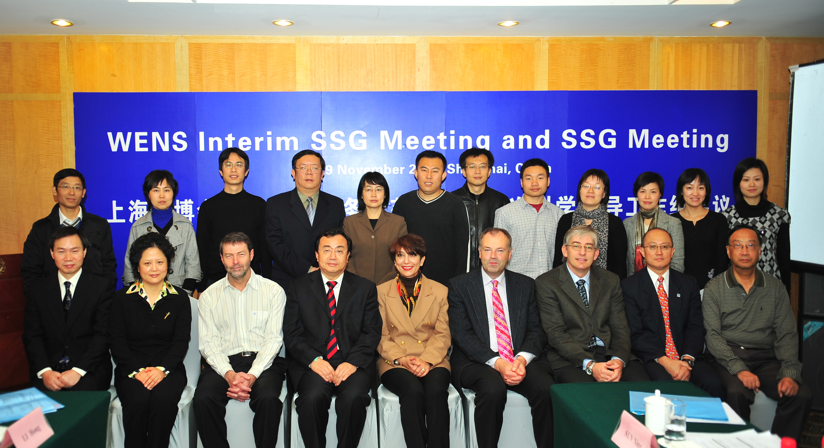

FINAL REPORT



The first meeting of the Science Steering Group (SSG) of the World EXPO 2010 Nowcast Services Demonstration Project (WENS) was convened in Shanghai from 26 to 29 November 2008 in Shanghai, China. The SSG meeting was preceded by a two-day meeting of the Interim SSG to prepare for the full meeting.

The WENS structure was based on a concept document developed by the Public Weather Services Implementation and Coordination Team (PWS-ICT) at their meeting in Shanghai (May 2008). The agenda of the meeting is attached as Appendix A.

In addition to the participants as listed in Appendix B of the attached document, representatives from Emergency Response Management Office; Water Affairs Bureau; CACC East China Regional Administration; Harbour Management Office; Expo Bureau; Ya Tong Enterprise; and Electric Power Company also participated at a one-day round-table discussion on the identification of the user requirements and the potential impact of the WENS project.

The meeting considered the Concept Document and the draft Implementation Plan document prepared by Shanghai Meteorological Bureau (SMB). Based on these two documents the SSG prepared the Project Implementation Plan (PIP) attached to this report. This Plan represents the principal output of the meeting. The PIP contains detailed description of the project, including its goals and objectives, mode of operation, the structure and membership of its various bodies. These include the Science Steering Group (SSG), the Management Group (MG), the Nowcasting Service Product Providers (NSPPs). The Terms of Reference of these bodies were developed during the Interim SSG meeting and adopted by the full SSG. .

In addition to consideration of the WENS project, discussions were held between CMA/SMB regarding plans for participation of the International Association of Broadcast Meteorology (IABM) at the World EXPO 2010. Several options were prepared for further study by CMA/SMB as regards capacity building activities and the possible broadcasts to be made from the CMA/WMO Pavilion during World EXPO 2010. The final outcome will formulate the activities of WMO, CMA/SMB and IABM in this regard.

The SSG meeting closed on Saturday 29th November 2008 at 17.00hrs.

