WORLD METEOROLOGICAL ORGANIZATION

PUBLIC WEATHER SERVICES EXPERT TEAM ON
PRODUCT DEVELOPMENT AND SERVICE ASSESSMENT

HONOLULU, USA
3-7 December 2001

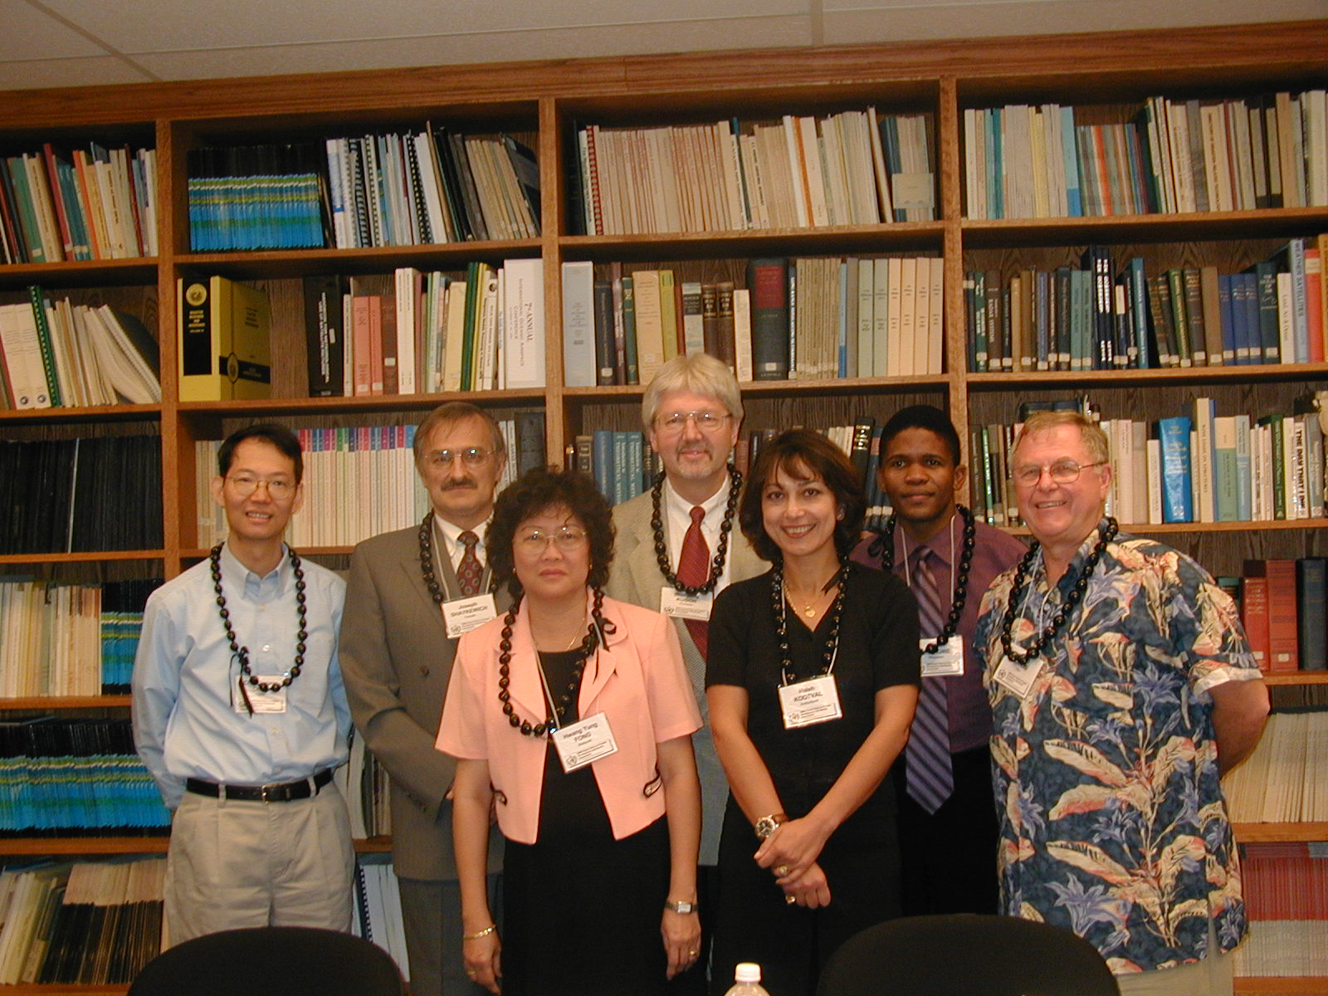

FINAL REPORT


EXECUTIVE SUMMARY

A meeting of the Public Weather Services (PWS) Expert Team on Product Development and Service Assessment (ET/PDSA) was held in Honolulu, USA from 3 to 7 December 2001. The meeting was chaired by Mr Robert Landis (USA). Under its terms of reference the Expert Team had to develop guidelines on: (I) the application of new technology and research to public weather services and (II) service assessment.

The key conclusions from the work of the Expert Team are summarised below.

(i) As regards the current status of the two pilot projects on Severe Weather Information Centre (SWIC) and official city forecasts:

- The SWIC Project moved into an operational trial basis in September 2001, and the first phase of the official city forecasts (providing climate information for the cities participating in the project) was launched in December 2001. The second phase of this project to provide the actual forecasts will be launched in 2002.

(ii) The application of new and emerging technology will continue to benefit public weather services particularly in the following areas:

- Advances in computer technology, both software and hardware, in the form of improved workstations and servers that can better assimilate diverse data, run local numerical models, and automate the generation of public forecast products in graphical, digital, and narrative formats.

- Improved accuracy and resolution of observations from satellites, radars, other remote sensing systems, and from automated surface observing systems.

- Integration of data-and forecast-related products for enhanced distribution to major dissemination mechanisms such as TV, radio, wireless technologies (e.g. personal data assistants, pagers, etc), and the Internet.

(iii) The application of research and scientific understanding will allow for significant improvements in the quality and quantity of weather services to the public in the following areas:

- The ability to provide a seamless timely suite of forecast products spanning from the nowcast to seasonal forecasts including information on documenting and monitoring climate.

- The availability of a wider spectra of possibilities for providing education and training beyond just the traditional, but still important, centralized instruction so as to include the use of academic expertise and recent real case studies through the use of computer assisted learning and interactive training modules.

- The increased responsiveness to public users by making available bio-meteorological forecast products that deal to a large degree with influences of weather on human health and safety.

Accordingly, a set of guidelines will be developed by the Expert Team on the application of new technologies and research to public weather services.

(iv) The new supplementary guidance material on service assessment integrates scientific verification with user-based assessments for specific forecast applications. The quality and effectiveness of weather services to the public are enhanced through the application of service assessment techniques that take into account the following:

- The recognition by smaller NMSs, who partner with neighbouring NMSs for the development and production of weather services, that their individual requirements might vary from that agreed by the partnering group for which the shared services and products are designed.

- The careful selection of appropriate assessment techniques for individual applications and allowance for the meteorological and climatological context within which forecast element or event being assessed was produced.

- The development of presentations of assessment information in a manner appropriate for the intended audience.

- The development of performance assessment methodologies for service delivery activities and public education.

1. Introduction

1.1 At the kind invitation of the US National Weather Service (NWS), a meeting of the Public Weather Services (PWS) Expert Team on Product Development and Service Assessment (ET/PDSA) was held in Honolulu, USA from 3 to 7 December. The Chair of the Expert Team, Mr James Lee (USA) had been unavoidably prevented from participation at the meeting due to a last minute change in his schedule and consequently the meeting was chaired by Mr R. Landis (USA). Ms Haleh Kootval (WMO Secretariat) welcomed the participants on behalf of the Secretary-General and provided background information on the structure of the PWS Programme within the CBS Open Programme Area Group (OPAG) framework, and especially on the objectives and expected outcome of the meeting of the ET/PDSA. These are deliverables under the Terms of Reference (TOR) of the team defined by CBS as follows:

- TOR (a) Evaluate developments and provide appropriate guidance on new technologies e.g. the Internet, as applicable to public weather services;
- TOR (b) Investigate and document opportunities for capitalizing on the benefits of research and improved technology for more effective production and delivery of public weather services;
- TOR (c) Identify and study the likely future requirements of public weather services for new and improved products;
- TOR (d) Provide advice on the exchange of such products to be delivered through a modernized WMO Information System, with emphasis on the needs of developing countries;
- TOR (e) Develop further guidance material, including relevant case studies and quantitative information, to assist NMSs in developing their skills in the planning and implementation of effective service assessment procedures to monitor user satisfaction and act on the findings.

1.2 Terms of reference a, b, c, and d were led by Bob Landis with the participation of Hwang Yung Fung, Chick-Cheung Chan, and Wolfgang Kusch. Term of reference e was led by Joseph Shaykewich, with the participation of Sam Shongwe. Each group discussed its TORs and prepared a report separately on the details of its work.

1.3 The list of participants is given in Annex I. The programme of the meeting is contained in Annex II.

2. Background

2.1 The meeting was briefed by Ms Kootval that the Twelfth Session of the Commission for Basic Systems (CBS) (Geneva, November-December 2000) had approved the composition of all CBS Open Programme Area Groups (OPAG) teams including those under the PWS Programme. The work of the PWS Programme is coordinated through three expert teams and an implementation and coordination team whose membership have been considered carefully to reflect a balance of both regional representations and expertise. These are the Expert Team on Product Development and Service Assessment (ET/PDSA); the Expert Team on Media Issues (ET/MI); the Expert Team on Warnings and Forecasts Exchange, Understanding and Use (ET/WAFU); and the Implementation/Coordination (IC) Team on PWS. It was recalled that these teams had been established by the extra-ordinary session of CBS (1998) under the new OPAG structure for the Commission. The terms of reference of the teams had however, been modified to reflect the areas of work still outstanding or those which needed emphasis in each team. The subsequent changes in the membership of each team was based on the areas of expertise required accordingly. The expert team was further informed that the new terms of reference of the OPAG/PWS covered all the broad issues of concern to the PWS Programme.

  - The first session of the CBS Management Group met in January 2001 and approved the deliverables expected under the new teams and their terms of reference. (Annex III).

2.3 The expert team reviewed the report of the former Expert Team on Product Development and Verification and Service Evaluation (ET/PDVSE), (Hong Kong, 1999) and where appropriate, used it as background for its own work. The results of work under the two groups of TOR of the Expert Team are summarized below.

3. Expert Team Work Programme
  - Status report on the two pilot projects on Severe Weather Information Centre (SWIC) and Official City

    - Although not directly connected to the TORs of the present Expert Team, but because the two projects were of relevance to the work of the team and since the original idea for the SWIC Project had been developed by the (ET/PDVSE), Ms Kootval briefed the Expert Team on the status of implementation of the tropical cyclone pilot project currently under development by experts at the Hong Kong Observatory, Hong Kong, China. The latest features added to the Website had taken account of two recent developments namely:
- The potential for long term development of the concept to also cover other weather events as agreed to by CBS-XII.
- The Website developed under the Tropical Cyclone Programme (TCP) which provides links to up-to-date advisories on tropical cyclones.

The latest version of the Website has the following features:
- The front page contains explanatory notes to allow coverage of "other weather types" in addition to tropical cyclones.
- Links have been made to the TCP web pages on tropical cyclones
- Icons can link to information on tropical cyclones provided by RSMCs specializing in tropical cyclone advisories, and participating NMSs.
- A simplified layout of the website to facilitate contributions by participating Members.

The Website has been posted on the Internet since its completion in April 2001 for comments by participating NMSs in the ESCAP/WMO Typhoon Committee region. The website was launched on an operational trial basis on 10 September 2001 and can be viewed at
http://typhoon.worldweather.org

    - It was recalled that the meeting of the PWS Expert Team on Warnings and Forecasts Exchange Issues (WAFEI) that met in Montreal in July 2000, had recommended the development of a Website to collect and collate official city forecasts in order to provide more accurate, authorized information to the public. (the report can be accessed on the PWS Website on www.wmo.ch/web/aom/pwsp/ProjectsAndPublications/expertmeetings).

Subsequently, a pilot project to undertake this task was approved by CBS and the Executive Council. To date 90 WMO Members had expressed their agreement to participate in the project as shown in the table below:

Region | No of Member | No of participating Members
I Africa | 55 | 22 (40%)
II Asia | 33 | 16 (45%)
III South America | 12 | 7 (58%)
IV North and Central America | 23 | 10 (43%)
V South-West Pacific | 18 | 8 (44%)
VI Europe | 48 | 28 (58%)
Total | 189 | 90 (48%)

The first phase of the project (providing climate information for the cities concerned) was launched in December 2001.

3.2 Guidelines on the Application of New Technologies and Research to Public Weather Services (TORs a,b,c,d)

    - The Expert Meeting recognized that great achievements and strides have been made in meteorological research in the past decade, especially in numerical weather prediction (NWP). NWP products are now more accurate spanning from the short-range up to the seasonal time frame. The availability of ensemble forecasts increases the reliability of medium-range forecasts. With the advent of computer technology and high speed computing facilities, it is now also possible to run regional NWP models at a resolution of only a few kilometres. The advances in remote-sensing equipment such as Doppler weather radar and wind profilers as well as observations from a dense network of automatic weather stations make improved nowcasting a reality. The increasing popularity of the Internet and other telecommunication technologies render the dissemination of weather information and products in more effective multi-media formats.

    - The meeting also noted that the influence of the atmosphere and weather on human health is attracting more and more interest from the public and the media. Research on human biometeorology has yielded useful results on the effects of meteorological factors on human health.

    - The meeting agreed that it becomes a challenge for NMSs to capitalize on these new technologies in the integrated display of weather information for assimilation by forecasters, for the generation of new products for the public, the media and specialized users, and to assist policy makers in making weather-related decisions to maximize public safety and at the same time to minimize adverse effects on economic development due to severe weather events.

    - The meeting further agreed that the increased use of advanced technologies and forecasting techniques in weather forecasting has become more demanding on the professional level of operational forecasters. Moreover, these new technologies are fast-developing. There is a growing need for improved methods of education and training. The wide use of workstation systems and improved Information Technology networks inside NMSs offer a good opportunity for providing education and training beyond just the traditional, but still important, centralized instruction so as to include the use of academic expertise and recent real case studies through the use of computer assisted learning and interactive training modules.

    - In order to assist NMSs to benefit from the advances of technologies and meteorology in the provision of public weather services, a set of guidelines was prepared by the Expert Team. These guidelines are aimed primarily for NMSs and provide information that NMSs may utilize to enhance and improve their services to the public.

    - The guidelines provide a comprehensive review of the latest available research and technology and their impact on public weather services. Workstation systems employed by NMSs in the display and assimilation of data, preparation of forecasts and warnings are described. The integration and packaging of weather information and forecast products in relation to new methods of dissemination is also discussed. In particular, the increasing popularity of the Internet now enables new weather products in multi-media format to be generated and disseminated to TV stations and other channels such as personal data assistants (PDA) and pagers. The guidelines also mention mature push-technology including FTP which makes possible a more active communication between NMSs and emergency organizations and other users.

    - The guidelines give an overview of the present state-of-the-art of forecasting capability ranging from nowcasting of the next couple of hours to seasonal forecasting of a few months ahead. The guidelines also touch on the issue of climate change and some new developments in climate modelling. A brief account on the use of Satellite Application Facility (SAF) on climate monitoring is also given. The applications of results in biometeorolgy to provide services and products on human health are illustrated with examples from some NMSs.

    - Noting the increasing need for the continual training of meteorological personnel to make the most out of fast-developing technologies and forecasting techniques, a section of the guidelines is dedicated to computer assisted learning (CAL). Finally, the guidelines provide the latest information on the modernized WMO Information System and how NMSs can benefit from the new system.

3.3 Supplementary Guidelines on Service Assessment (TOR e)

    - The Expert Meeting noted the benefits that accrue from the application of service assessment methodologies to public weather services. Many NMSs currently benefit from the practical application of scientific verification and user-based assessments. The Expert Team supported the assembly of this information into a supplementary guidance document on service assessment that integrates scientific verification with user-based assessments for specific forecast applications. In the development of the supplement a number of factors were also considered.

    - The meeting recognized that for many smaller NMSs forecast production duties might be shared amongst partnering NMSs for cost and efficiency reasons. Depending on the amount of local modification of the shared forecast product that were produced by an individual partnering NMS for the use by all within the partnering group, the user-based assessments may not be comparable if, for example, the individual NMSs user communities have varying requirements.

    - The meeting further recognized that depending on the individual forecast element or type being assessed there is a need to carefully assess the appropriateness of specific assessment techniques. Also considered was that it might not be appropriate to use scientific verification techniques for second order meteorological forecast products such as UV, Wind chill, etc. While qualitative information derived from user-based assessment was considered useful, for the purposes of scientific verification only the primary meteorological parameters might be appropriate. Further, the need to place assessment information in an appropriate contextual framework was considered as essential as there may be mitigating circumstances that influence the results achieved.

    - The meeting considered that it was important to take into account the audience being addressed in communicating assessment information. The assessment information needs to be presented in a manner appropriate for the intended audience. This can vary from an easily understood presentation for the public at large to a highly complex presentation to a scientific audience. This is an area where further development and sharing of exemplary practices would be beneficial.

    - A significant shortcoming was noted in the current efforts to undertake performance assessment of service delivery and public education activities as compared to forecast production activities. Effective communication of the forecast and warning messages to the user community affected, is considered essential for the successful execution of NMS meteorological programs. Most assessment efforts for this area have been qualitative and have depended on discretionary funding as opposed to being built in formal components of program delivery.

4. Conclusions and Further Actions

  - The key conclusions arising from the meeting of the ET/PDSA are given in the Executive Summary of this report. The team accomplished its task of preparing outlines and preliminary drafts of two sets of guidelines according to its terms of reference.

4.2 The Expert Team agreed that each sub-group leader in the team submit their final drafts to the Secretariat by end of February 2002. The Secretariat will aim to produce the final and edited versions of the guidelines by end of March 2002, with a view to publishing them by May 2002.

4.3 The Chairman of ET/PDSA will provide the OPAG/PWS Chair with the final report of the expert team meeting.

5. Closing

The meeting of the Expert Team closed in the afternoon on Friday 7 December 2001.

ANNEX I

PARTICIPANTS AT THE MEETING OF THE EXPERT TEAM ON
PRODUCT DEVELOPMENT AND SERVICE ASSESSMENT

Robert Landis, Chair  NOAA/NWS, OS22  1325 East-West Hwy, Rm. 13148  Silver Spring, MD 20910  U.S.A.  Tel: (001) 301 713-1858 est.108  Fax: (001) 301 713-1598  Email: Robert.Landis@noaa.gov | Chik-Cheung CHAN  Hong Kong Observatory  134A Nathan Road  KOWLOON  Hong Kong, China  Tel: (852) 2826 8371  Fax: (852) 2311 9448  Email: ccchan@hko.gov.hk
Hwang Yung Fong  Malaysian Meteorological Service  46667 Jalan Sultan  4667 PETALING JAYA, SELANGOR  DARUL EHSAN  Malaysia  Tel: (603) 7957 8052  Fax: (603) 7957 8052/79588221  Email: hyf@kjc.gov.my | Wolfgang Kusch  Deutscher Wetterdiesnt  Zentralamt. Frankfurter Str. 135  D-63067 OFFENBACH  Germany  Tel: (49 69) 8062 2972  Fax: (49 69) 8062 3971  Email: wkusch@dwd.de
Sam Shongwe  National Meteorological Service  P.O. Box 58  MBABANE  Swaziland  Tel: (268) 4045728/4046274  Fax: (268) 4041530  Email: ss_shongwe@swazimet.gov.sz | Joseph Shaykewich  Meteorological Service of Canada  Environment Canada  4905 Dufferin St.  DOWNSVIEW, ONTARIO  Canada M3H 5T4  Tel: (1 416) 739 4702  Fax: (1 416) 739 4967  Email: joseph.shaykewich@ec.gc.ca
Haleh Kootval
WMO Secretariat
Case Postale No 2300 CH-1211
Geneva 2,
Switzerland.
Tel: (4122) 730 8333
Fax: (4122) 730 8021
Email: hkootval@www.wmo.ch

PUBLIC WEATHER SERVICE EXPERT TEAM ON PRODUCT DEVELOPMENT ANNEX II
AND SERVICE ASSESSMENT
(HONOLULU, USA, 3 to 7 December 2001)

 | Monday, 3 December | Tuesday, 4 November | Wednesday, 5 November | Thursday, 6 November | Friday, 7 November
AM  0900 | 1. Organization of the meeting  Opening | TOR (c): Status report | General discussion on the  Expert Team Work  TORs a, b, c, d, and e | Presentation of work plans  to the expert team | Preparation of report of the expert team (continue)
AM  0900 | 2. Background information and objectives | Discussion of key issues  related to TOR (c) |  | General discussion | Preparation of report of the expert team (continue)
AM  0900 | 3. Expert Team work programme  TOR (a): status report | TOR (d): status report | Start individual group work under  each TOR) | General discussion | Preparation of report of the expert team (continue)
1200 | Discussion of key issues  related to TOR (a) | Discussion of key issues  related to TOR (d) |  | Arrangements for  follow-up action
 | Lunch | Lunch | Lunch | Lunch  International Coordination | Lunch
PM  1330 | TOR (b): status report   Discussion of key issues  related to TOR 2 | TOR (e): status report | TOR (a): Work Plan (development  of guidelines)   TOR 2: Work Plan (Preparation  of guidelines)   Enhancing public response  to severe weather warning | 5. Expert Team input into the work of the IC Team on PWS  Preparation of report of the  expert team | Review and adoption of  the report of the expert  team
PM  1330 | Discussion of key issues  related to TOR (b) | Discussions of key issues  related to TOR (e) | TOR (b): Work Plan (development  of guidelines) |  | Review and adoption of  the report of the expert  team
1700 |  | Discussions of key issues  related to TOR (e) | TOR (c): Work Plan (development  of guidelines) |  | 6. Close
1700 | 4. Visit to the local Met. Office | Discussions of key issues  related to TOR (e) | TORs (d,e): Work Plan (development of guidelines) |  | 6. Close
1700 | 4. Visit to the local Met. Office | Discussions of key issues  related to TOR (e) | TOR (e): Work Plan (preparation  of guidelines) |  | 6. Close

