European Centre for Medium-Range Weather Forecasts

SUMMARY REPORT ON THE MONITORING OF ASAP SHIP DATA

January-December 2015
1. Summary

In 2015, the number of ASAP reports received at ECMWF have increased compared to 2014 period. However, a slight reduction in the number of reporting platform identifiers was noticeable. ECMWF started assimilating BUFR encoded ASAPs in November 2014. In cases where the BUFR encoded reports are assimilated, the TAC counterparts are no longer assimilated. The percentage of ascents reaching the 100 hPa level have been comparable to 2014 levels.

The problem of wrongly located reports has been reduced to only two cases in 2015 involving ASFR4 and DBLK platforms. The quality of the data has continued to be good and highly valuable. Some BUFR encoded ASAP identifiers (ASFR*) are not in the assimilation whitelist. Therefore TAC counterparts are assimilated instead.

2. Data reception

Figures 1 to 3 show time series from January 1994 to January 2016 with monthly counts of ASAP reports for the 4 main synoptic hours (00, 06, 12 and 18 UTC) at different levels. In general, monthly totals have increased slightly compared to previous years. In previous years we have assessed the percentage of launches reaching the lower stratosphere (100 hPa). In 2015, the percentage of reports reaching 100hPa have been comparable to levels in the previous year (Figure 4). Table 1 and Table 2 show annual counts for each ship as well as their encoding and assimilation status. It is worth noting that number of reports has increased slightly compared to last year'
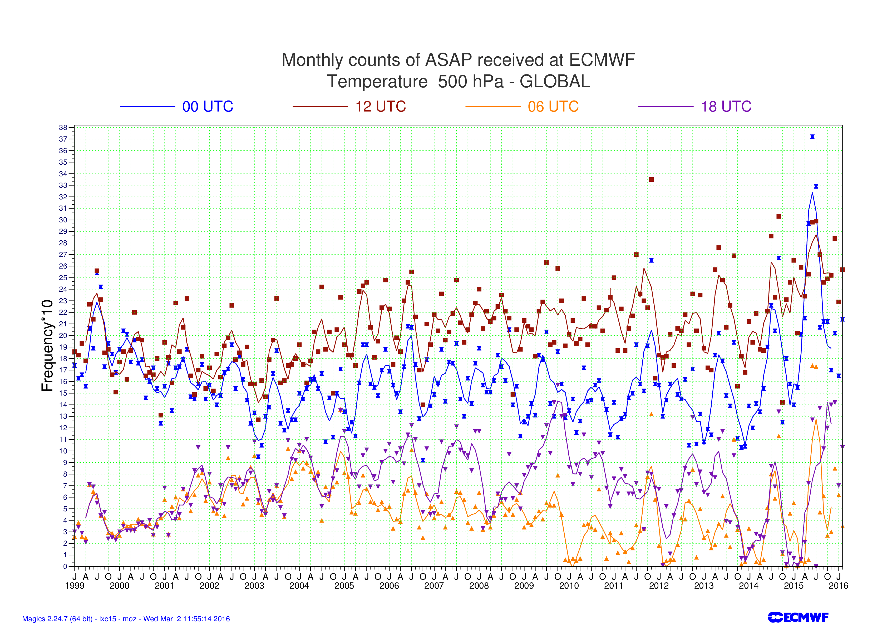

Figure 1: ASAP temperature data received at ECMWF 500 hPa (Jan 1994 to January 2016). Symbols show monthly totals and lines show moving averages.

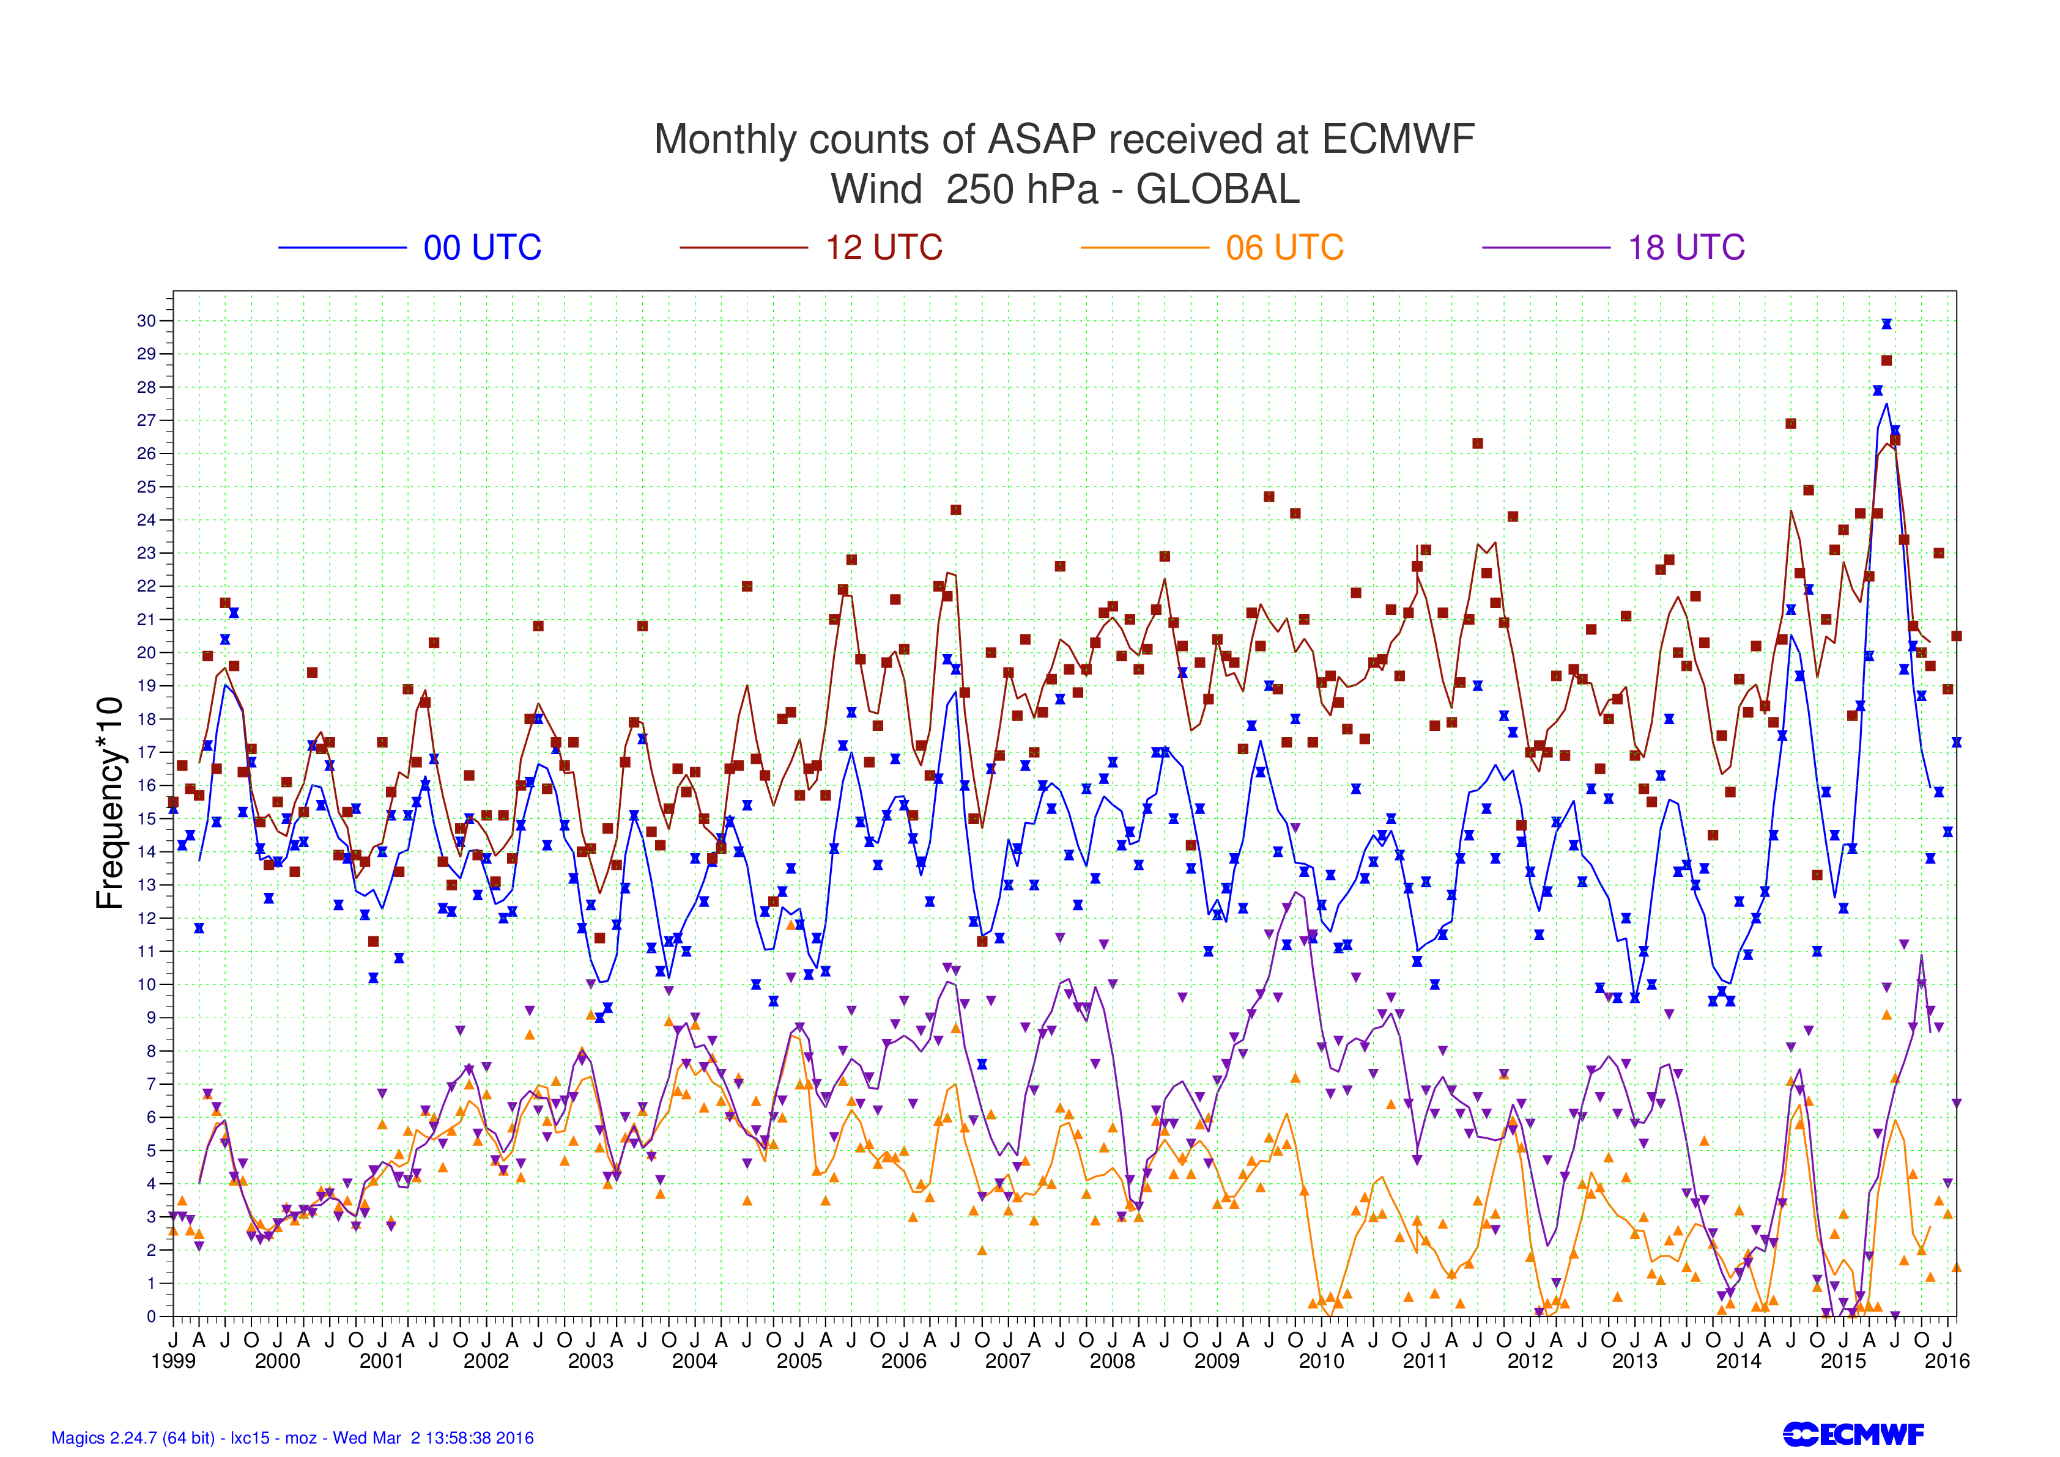

Figure 2: ASAP wind data received at ECMWF 250 hPa (Jan 1994 to January 2016).
Symbols show monthly totals and lines show moving averages.

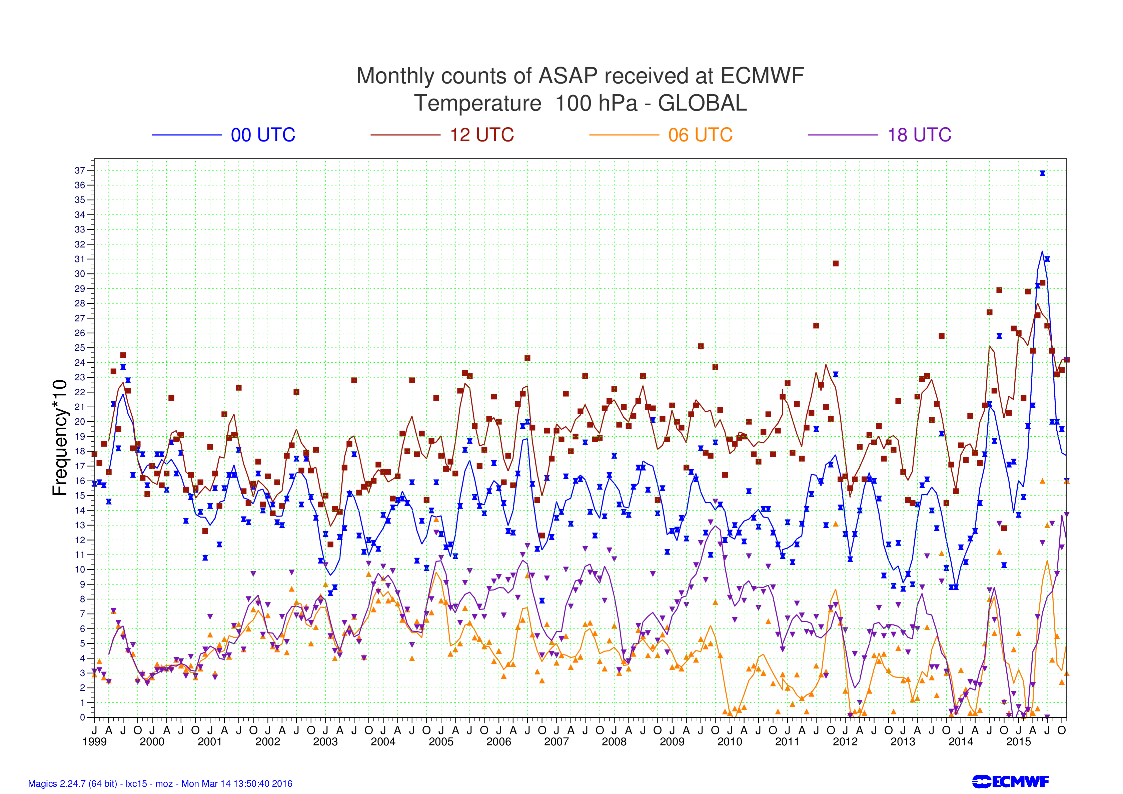

Figure 3: ASAP wind data received at ECMWF 100 hPa (Jan 1994 to January 2016).
Symbols show monthly totals and lines show moving averages.

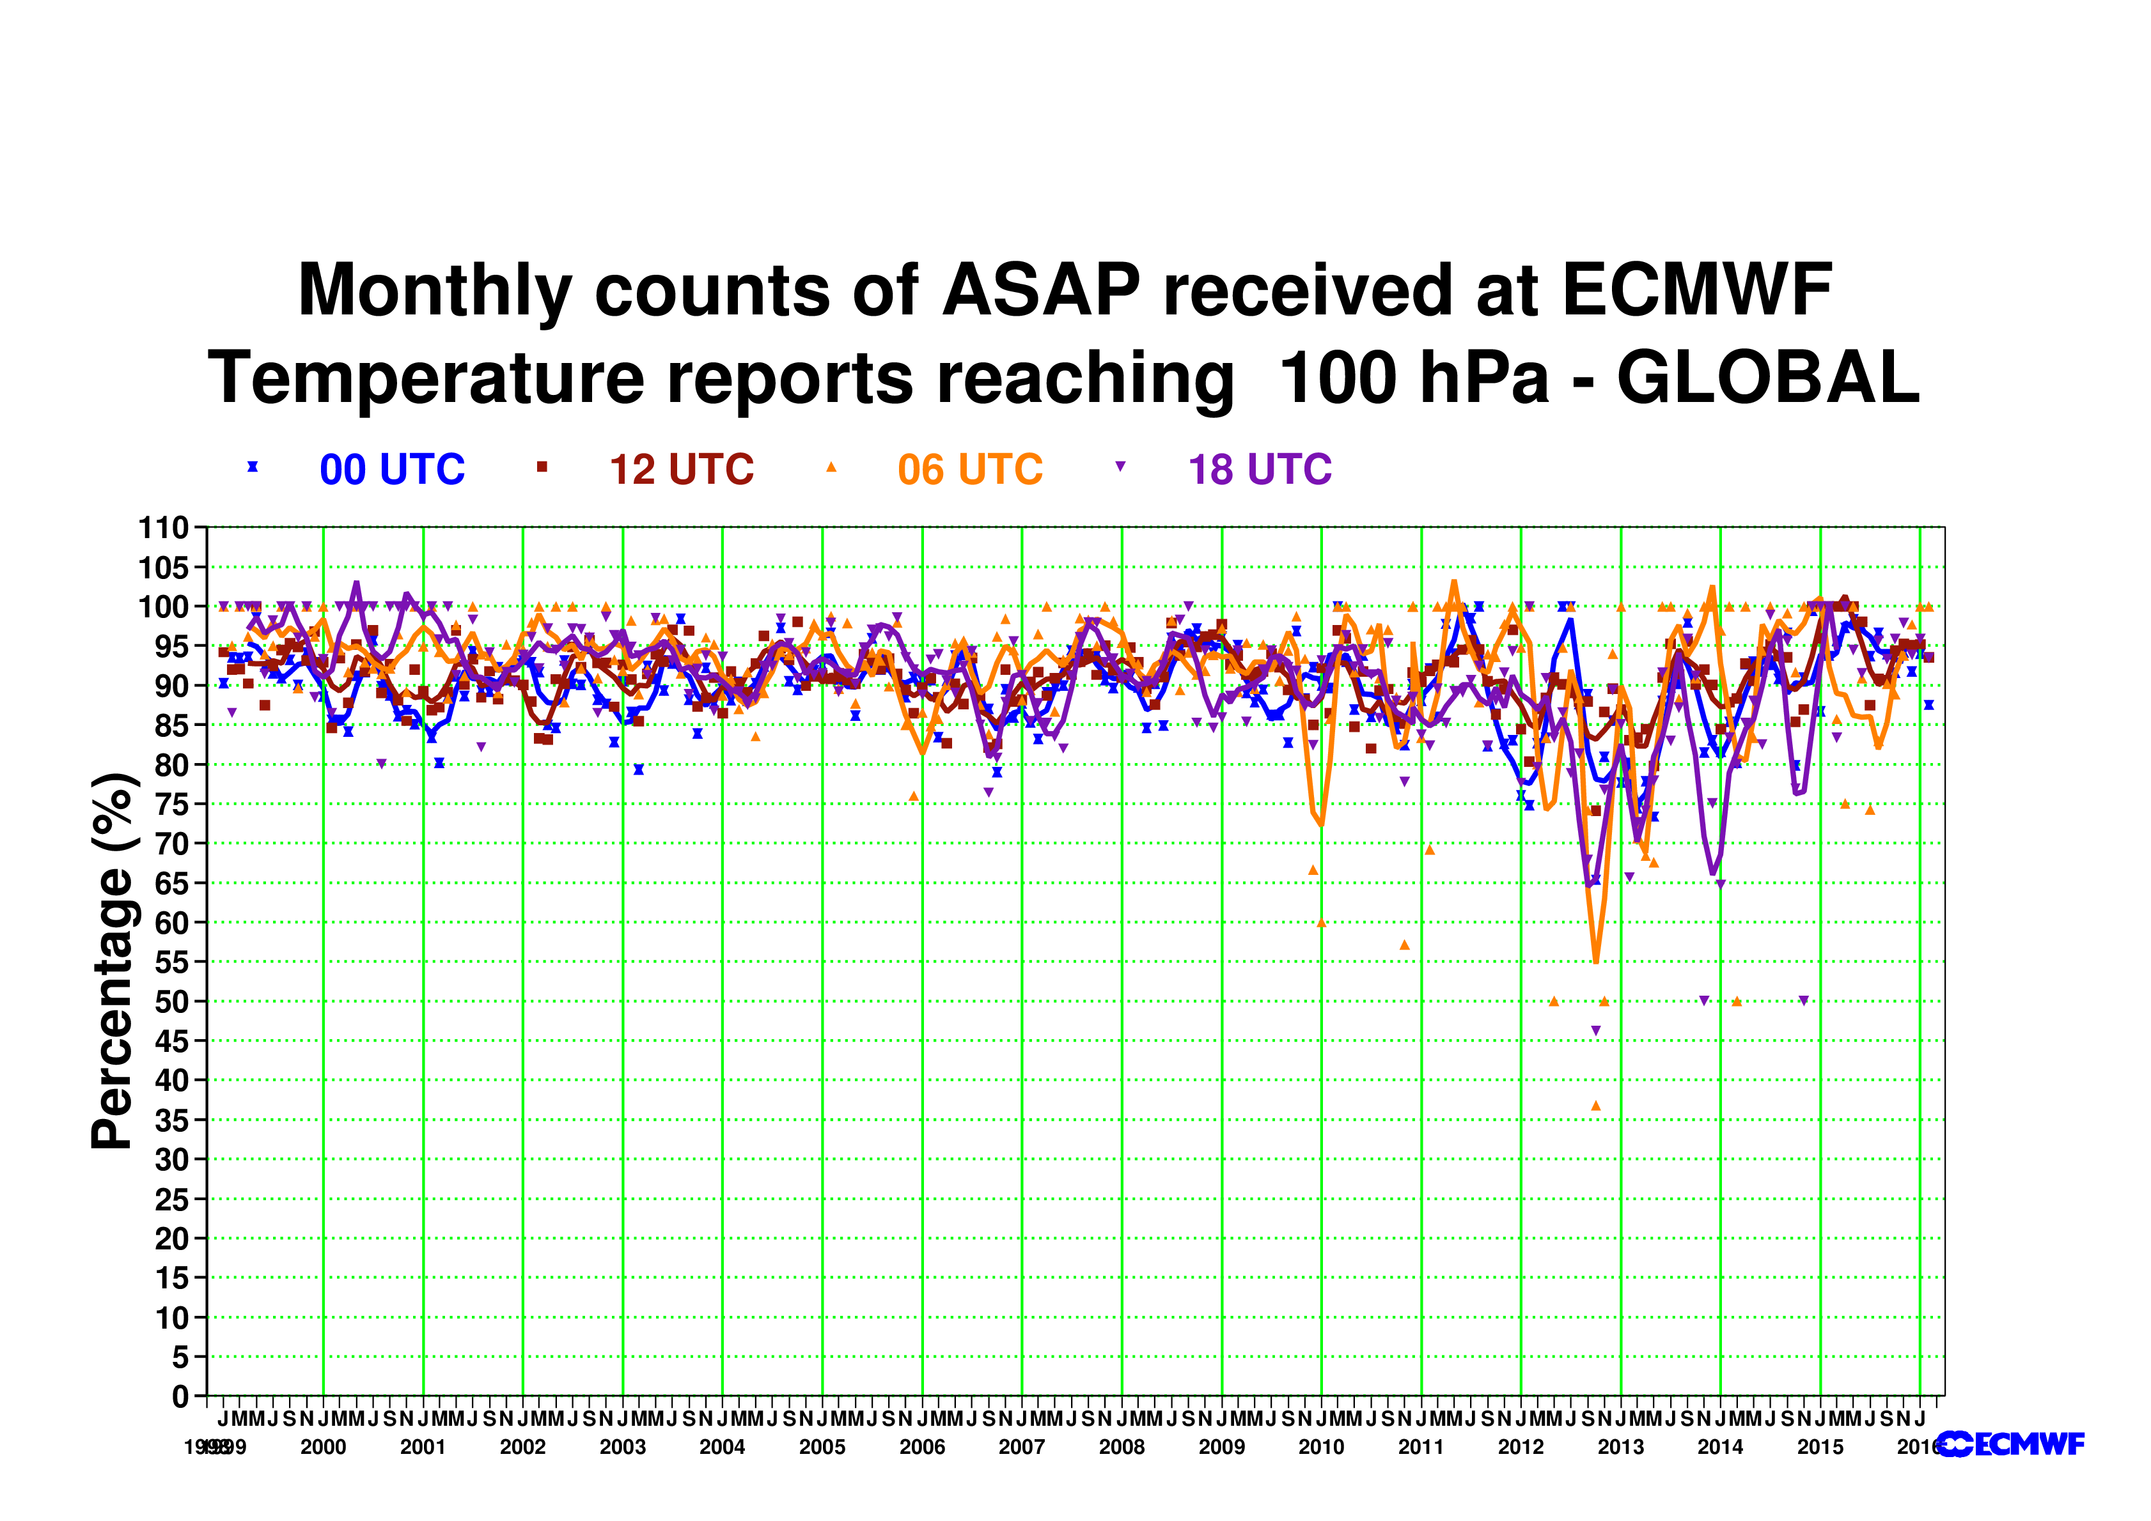

Figure 4: Percentage of ASAP reports reaching the 100 hPa level (Jan 1994 to January 2016)
Symbols show monthly values and lines show moving averages.

TABLE 1: Number of ASAP reports received at ECMWF January-December 2014 at 500 hPa

RECEPTION OF TEMP/TEMPSHIP/PILOT/PILOTSHIP DATA AT ECMWF
FOR Jan 2014 to Dec 2014
500 hPa level

TEMPERATURE WIND
----------- ----
ID 00 06 12 18 TOTAL 00 06 12 18 TOTAL Encoding
---------------------------------------------------------------------------------------
ASDE01 17 0 16 2 35 16 0 16 1 33 BUFR
ASDE02 1 0 20 3 24 1 0 19 2 22 BUFR
ASDE03 12 0 11 0 23 12 0 11 0 23 BUFR
ASDE04 15 0 13 0 28 15 0 13 0 28 BUFR
ASDE1* 98 1 106 0 205 97 1 104 0 202 TAC
ASDE2* 20 1 114 17 152 20 1 114 17 152 TAC
ASDE3* 104 0 103 0 207 104 0 102 0 206 TAC
ASDE4* 72 0 67 50 189 70 0 67 50 187 TAC
ASDE9 0 3 8 1 12 0 3 7 1 11 TAC
ASDK01 6 0 8 0 14 4 0 4 0 8 BUFR
ASDK02 18 0 24 0 42 14 0 21 0 35 BUFR
ASDK1* 96 9 99 12 216 88 9 88 12 197 TAC
ASDK2* 123 17 153 26 319 121 17 152 26 316 TAC
ASDK3 102 2 43 3 150 102 2 43 3 150 TAC
ASES01 0 0 34 0 34 0 0 34 0 34 BUFR
ASES1* 0 0 153 3 156 0 0 150 3 153 TAC
ASEU02 4 0 10 0 14 4 0 9 0 13 BUFR
ASEU03 21 0 18 0 39 18 0 18 0 36 BUFR
ASEU04 14 0 14 0 28 10 0 14 0 24 BUFR
ASEU05 13 0 11 0 24 12 0 11 0 23 BUFR
ASEU06 12 0 14 0 26 9 0 13 0 22 BUFR
ASEU1 0 0 92 5 97 0 0 92 5 97 TAC
ASEU2* 73 0 76 60 209 70 0 75 60 205 TAC
ASEU3* 94 0 101 0 195 93 0 99 0 192 TAC
ASEU4* 69 0 75 61 205 65 0 74 60 199 TAC
ASEU5* 78 0 89 0 167 75 0 88 0 163 TAC
ASEU6* 63 1 58 1 123 60 1 57 1 119 TAC
ASFR1 136 0 111 0 247 135 0 109 0 244 TAC and BUFR
ASFR2 106 0 109 0 215 105 0 109 0 214 TAC and BUFR
ASFR3 147 0 140 0 287 145 0 139 0 284 TAC and BUFR
ASFR4 141 0 151 2 294 140 0 149 2 291 TAC
ASUK2 81 78 80 79 318 80 78 80 78 316 TAC
DBLK 18 154 249 17 438 17 133 241 17 408 TAC/BUFR
DFCG 22 16 20 16 74 22 16 20 16 74 TAC
JGQH 83 0 79 0 162 79 0 74 0 153 TAC and BUFR
JNSR 93 93 92 88 366 44 41 41 40 166 TAC and BUFR
-----------------------------------------------------------------------------
1952 375 2561 446 5344 1847 302 2457 394 5000

TOTAL NUMBER OF STATION IDENTIFIERS 36 (24 without duplicate ids)

* denotes duplicate ids(TAC) with a BUFR counterpart

TABLE 2: Number of ASAP reports received at ECMWF between March 2015 - Feb 2016 at 500 hPa

RECEPTION OF TEMP/TEMPSHIP/PILOT/PILOTSHIP DATA AT ECMWF
FOR March 2015-Feb 2016
500 HPA LEVEL

STATIONS REPORTING AT OTHER LEVELS ARE NOT INCLUDED. ASSIMILATED FORMAT SHOWN IN GREEN

GEOPOTENTIAL WIND

ID 00 06 12 18 Total 00 06 12 18 UTC Total Encoding Assimilated
ASDE01 136 1 137 98 372 124 1 129 69 323 BUFR (B)
ASDE02 111 7 85 23 226 107 4 80 19 210 BUFR (B)
ASDE03 150 0 125 86 361 138 0 120 67 325 BUFR (B)
ASDE04 73 0 77 68 218 63 0 72 47 182 BUFR (B)
ASDE09 0 15 41 1 57 0 7 37 1 45 BUFR (B)
ASDK01 48 0 38 35 121 47 0 38 27 112 BUFR (B)
ASDK02 150 0 127 77 354 133 0 121 58 312 BUFR (B)
ASDK03 58 0 51 43 152 52 0 48 38 138 BUFR (B)
ASDK1* 69 0 63 39 171 68 0 63 39 170 TAC N/A
ASDK2* 147 0 127 71 345 146 0 127 71 344 TAC N/A
ASDK3* 90 0 77 60 227 89 0 77 60 226 TAC N/A
ASES01 0 2 187 2 191 0 1 179 1 181 BUFR (B)
ASEU01 64 0 155 6 225 62 0 142 4 208 BUFR (B)
ASEU02 77 0 75 59 211 69 0 70 43 182 BUFR (B)
ASEU03 117 0 118 58 293 111 0 111 48 270 BUFR (B)
ASEU04 79 0 78 2 159 70 0 64 1 135 BUFR (B)
ASEU05 43 0 41 28 112 40 0 40 15 95 BUFR (B)
ASEU06 95 5 105 74 279 88 3 97 55 243 BUFR (B)
ASFR1 156 0 145 0 301 149 0 145 0 294 BUFR and TAC (T)
ASFR2 116 0 131 0 247 114 0 131 0 245 BUFR and TAC (T)
ASFR3 133 0 132 0 265 130 0 129 0 259 BUFR and TAC (T)
ASFR4 119 0 127 1 247 116 0 125 1 242 BUFR and TAC (T)
DBLK 13 270 336 39 658 11 132 212 21 376 BUFR and TAC (B)
DFCG 17 13 15 16 61 13 11 13 13 50 TAC (T)
JGQH 79 0 79 0 158 79 0 79 0 158 BUFR and TAC (T)
JNSR 122 112 126 105 465 74 59 73 56 262 BUFR and TAC (T)
------------------------------------------------------------------------------------
2262 425 2798 991 6476 2093 218 2522 754 5587

TOTAL NUMBER OF STATION IDENTIFIERS 26 (23 without duplicate ids)

* denotes duplicate ids(TAC) with a BUFR counterpart
As in previous years most of the ASAP units were operating in the North Atlantic and some in the South Atlantic, East Siberian Sea and Indian Ocean. We can also see in Figure 4 the Japanese ASAP operating close to Japan.
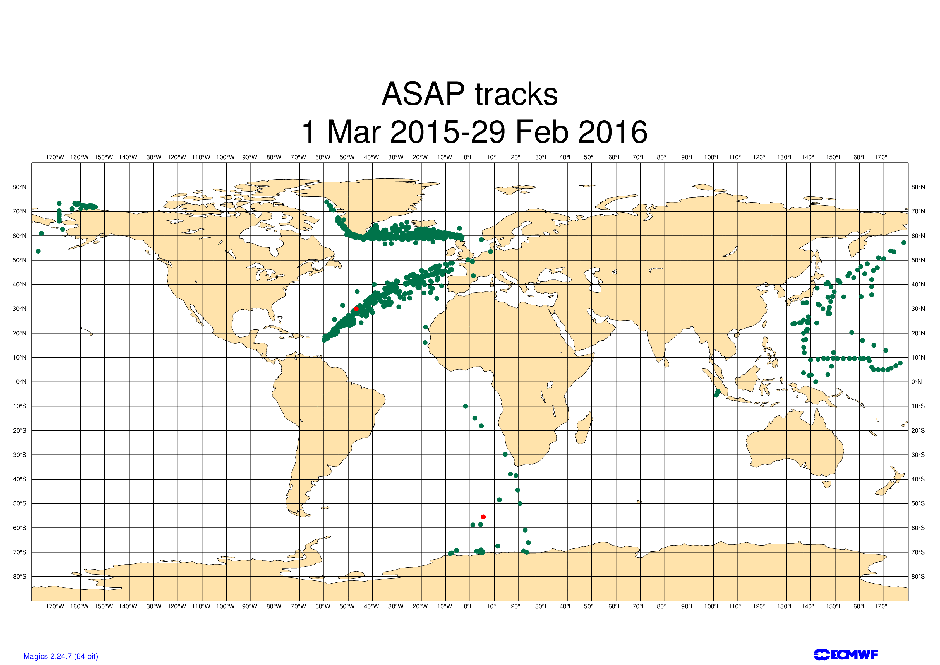

Figure 5: ASAP tracks for March 2015 to February 2016 period

ECMWF started assimilating BUFR encoded Radiosonde and ASAP observations in November 2014.

See Table 3 and Table 4 for platform ids encoding in BUFR. Observations considered here are assimilated BUFR encoded.

We noticed that some platforms changed their identifiers when they moved to BUFR encoding while reporting both TAC and BUFR encoded reports from the same ascent. Few of these platforms report low resolution BUFR, mainly ASFR* (Bruce Ingleby/ECMWF).

Table 3 BUFR encoded assimilated ASAPs in February 2016

ASDE02 ASDE04 ASDK02 ASDK03 ASES01 ASEU02 ASEU04 DBLK

Table 4 BUFR encoded ASAP identifiers without TAC counterpart for the same identifier in February 2016

ASDE01 ASDE02 ASDE03 ASDE04 ASDE09 ASDK02 ASDK03 ASES01 ASEU02 ASEU03 ASEU04 ASEU06 DBLK

4. Quality Control.

We run, on a monthly basis, vertical statistics for all units. The results are included in the ECMWF Monthly Monitoring Report, which is freely available at the ECMWF web site.

For the assimilated reports, compared to 2014, in 2015 we see a similar standard deviation and bias curve for temperature and winds for most levels (Figures 6 and 7). The high rejection numbers seen in the plots are misleading and unrepresentative of other levels not shown which are not rejected. The ECMWF model assimilation system applies thinning for the hi-res data and rejects many of the levels which happen to be sampled to prepare these plots. The large bias and standard deviation seen at upper levels in Figure 6 was due to bad reports from ASEU03 and ASEU06 platforms in July and August 2015, respectively.

Furthermore, while looking at individual vertical profiles, we had seen noise issues with individual profiles from BUFR encoded observation identifiers starting with ASFR. Due to this issue, at the moment we assimilate TAC counterparts from identifiers starting with ASFR (Bruce Ingleby/ECMWF).

We have also noticed a decrease in number of reports from ASDK* platforms in their BUFR formatted reports at upper levels (>70hPa) in 2015. TAC versions of the same ascent did not show this problem. We have reported this to the data provider and now the BUFR formatted reports have the complete reports for upper levels.

Particular problems related to wrong positions are detected in the Daily Monitoring carried out by the Met Analyst on duty.

The quality of the ASAP data continues to be good and is highly valuable over the oceans where data with high quality and high vertical resolution are needed.

The profiles as seen in Figures 6 and 7 show high quality standards fully comparable to land-based radiosondes as in previous years.

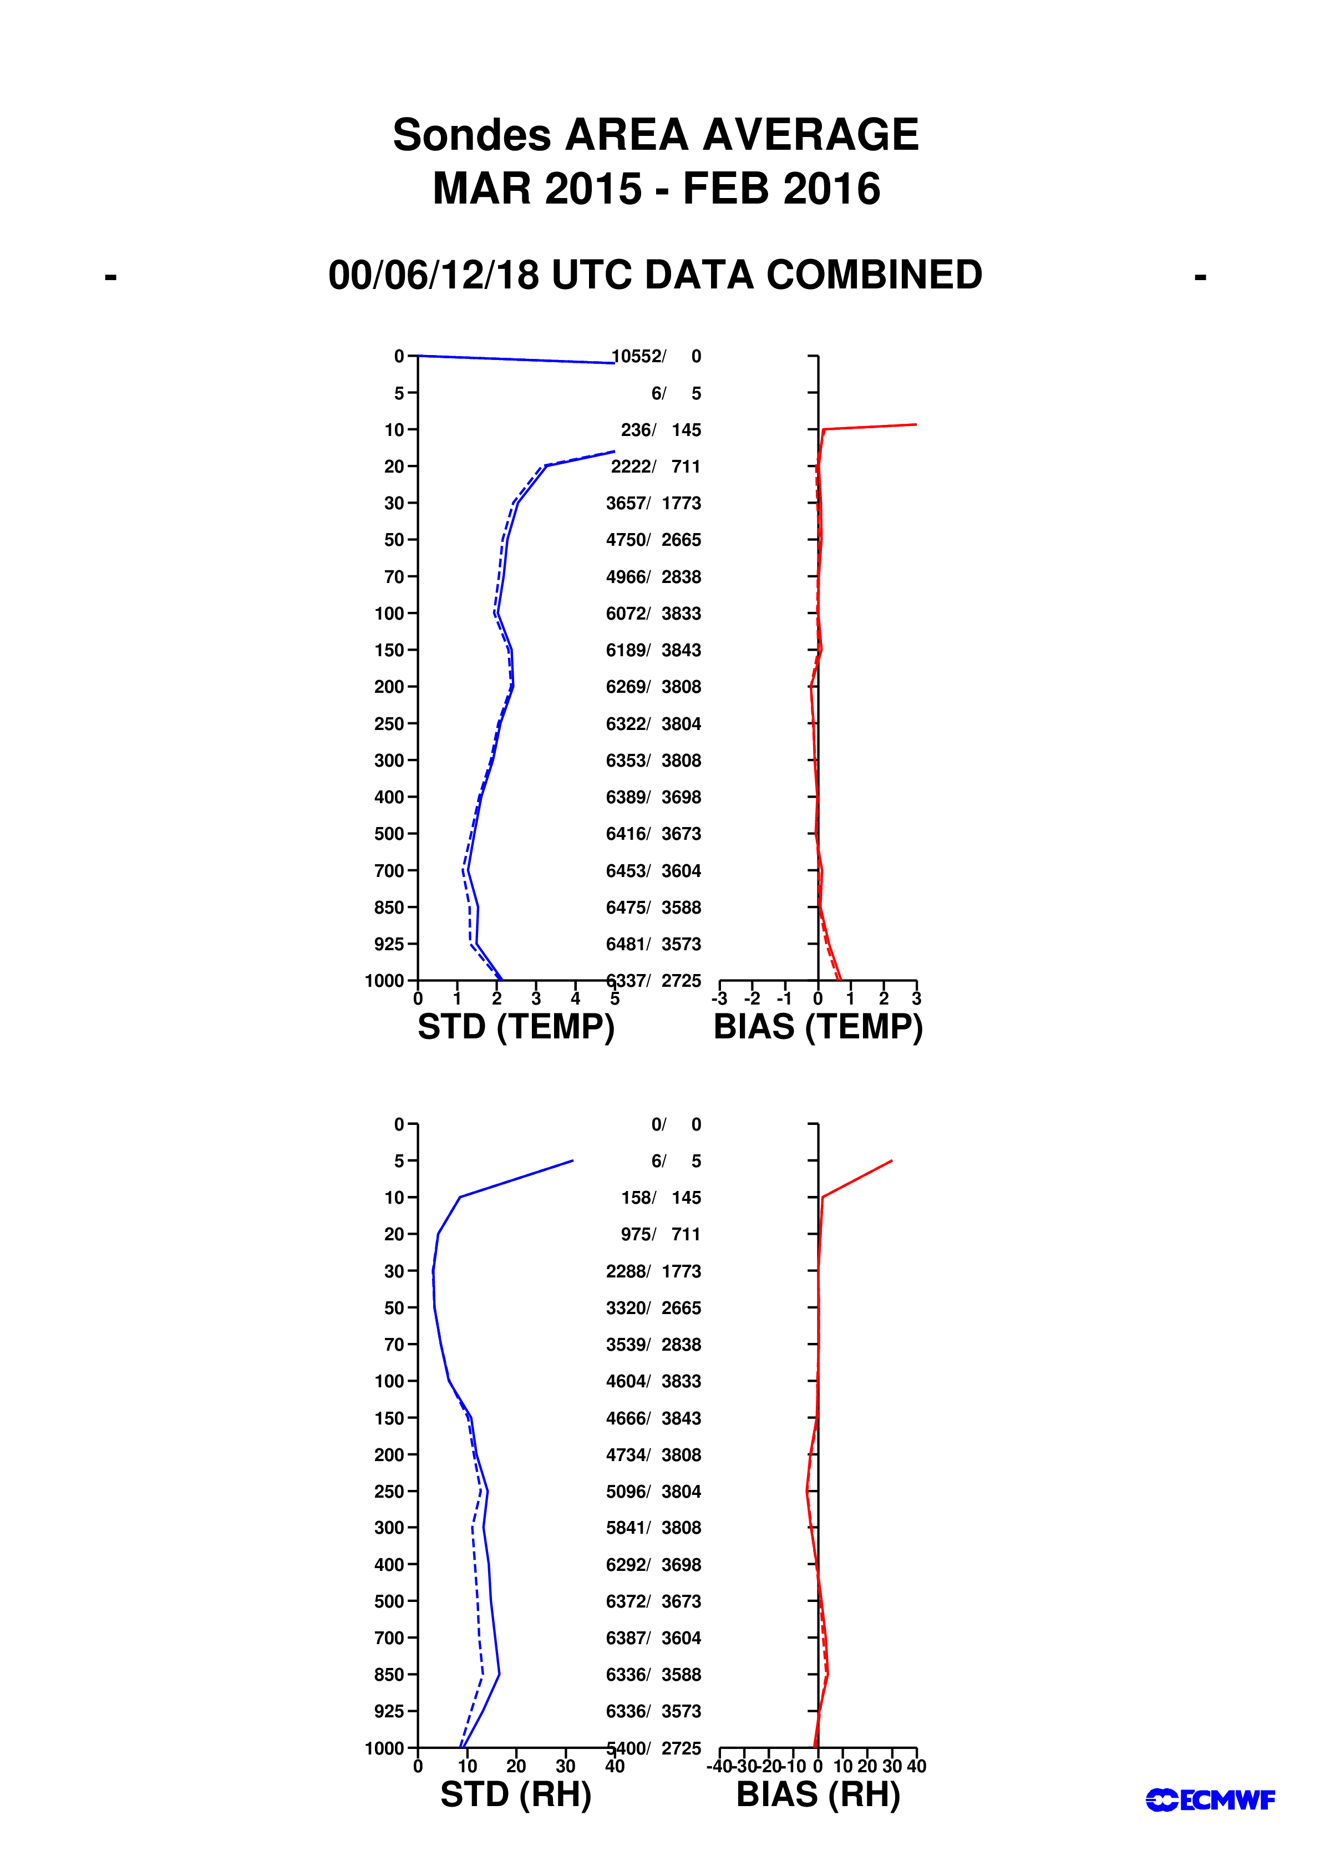
Figure 6: Vertical statistics for ASAPs’ temperature and relative humidity March 2015 to February 2016
Solid lines : Obs-First guess (background)
Dashed lines : Obs-Analysis
Middle scale : Number of reports for each level/Number of rejected reports for each level
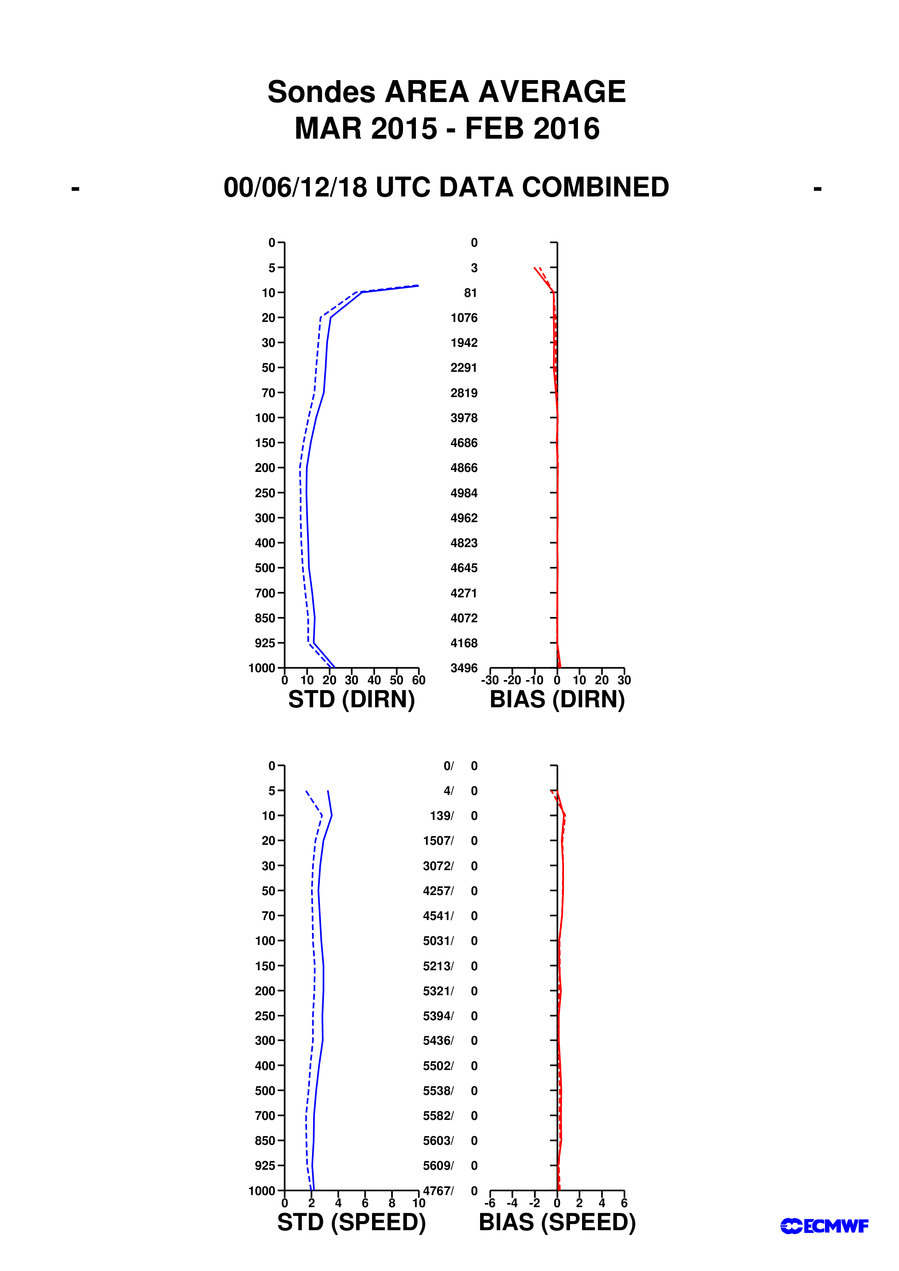

Figure 7: Vertical statistics for ASAPs’ wind direction and speed March 2015 to February 2016
Solid lines : Obs-First guess (background)
Dashed lines : Obs-Analysis
Middle scale : Number of reports for each level/Number of rejected reports for each level

