Intergovernmental Oceanographic |  | World
Commission of UNESCO |  | Meteorological Organization
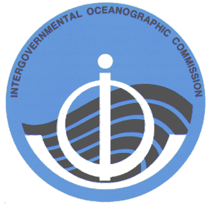 | 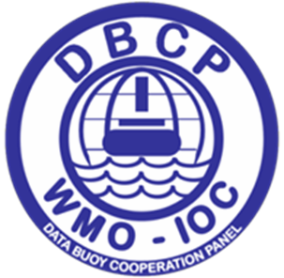 |  | 

DATA BUOY COOPERATION PANEL

Proceedings of the Second Capacity Building Workshop of the DBCP for the North Pacific Ocean and Its Marginal Seas (NPOMS-2), Hangzhou, China, 22-24 October 2013

Application of Regional Ocean Observations for

Increasing Society’s Understanding and Forecasting of Typhoons

DBCP Technical Document No. 49

– 2014 –

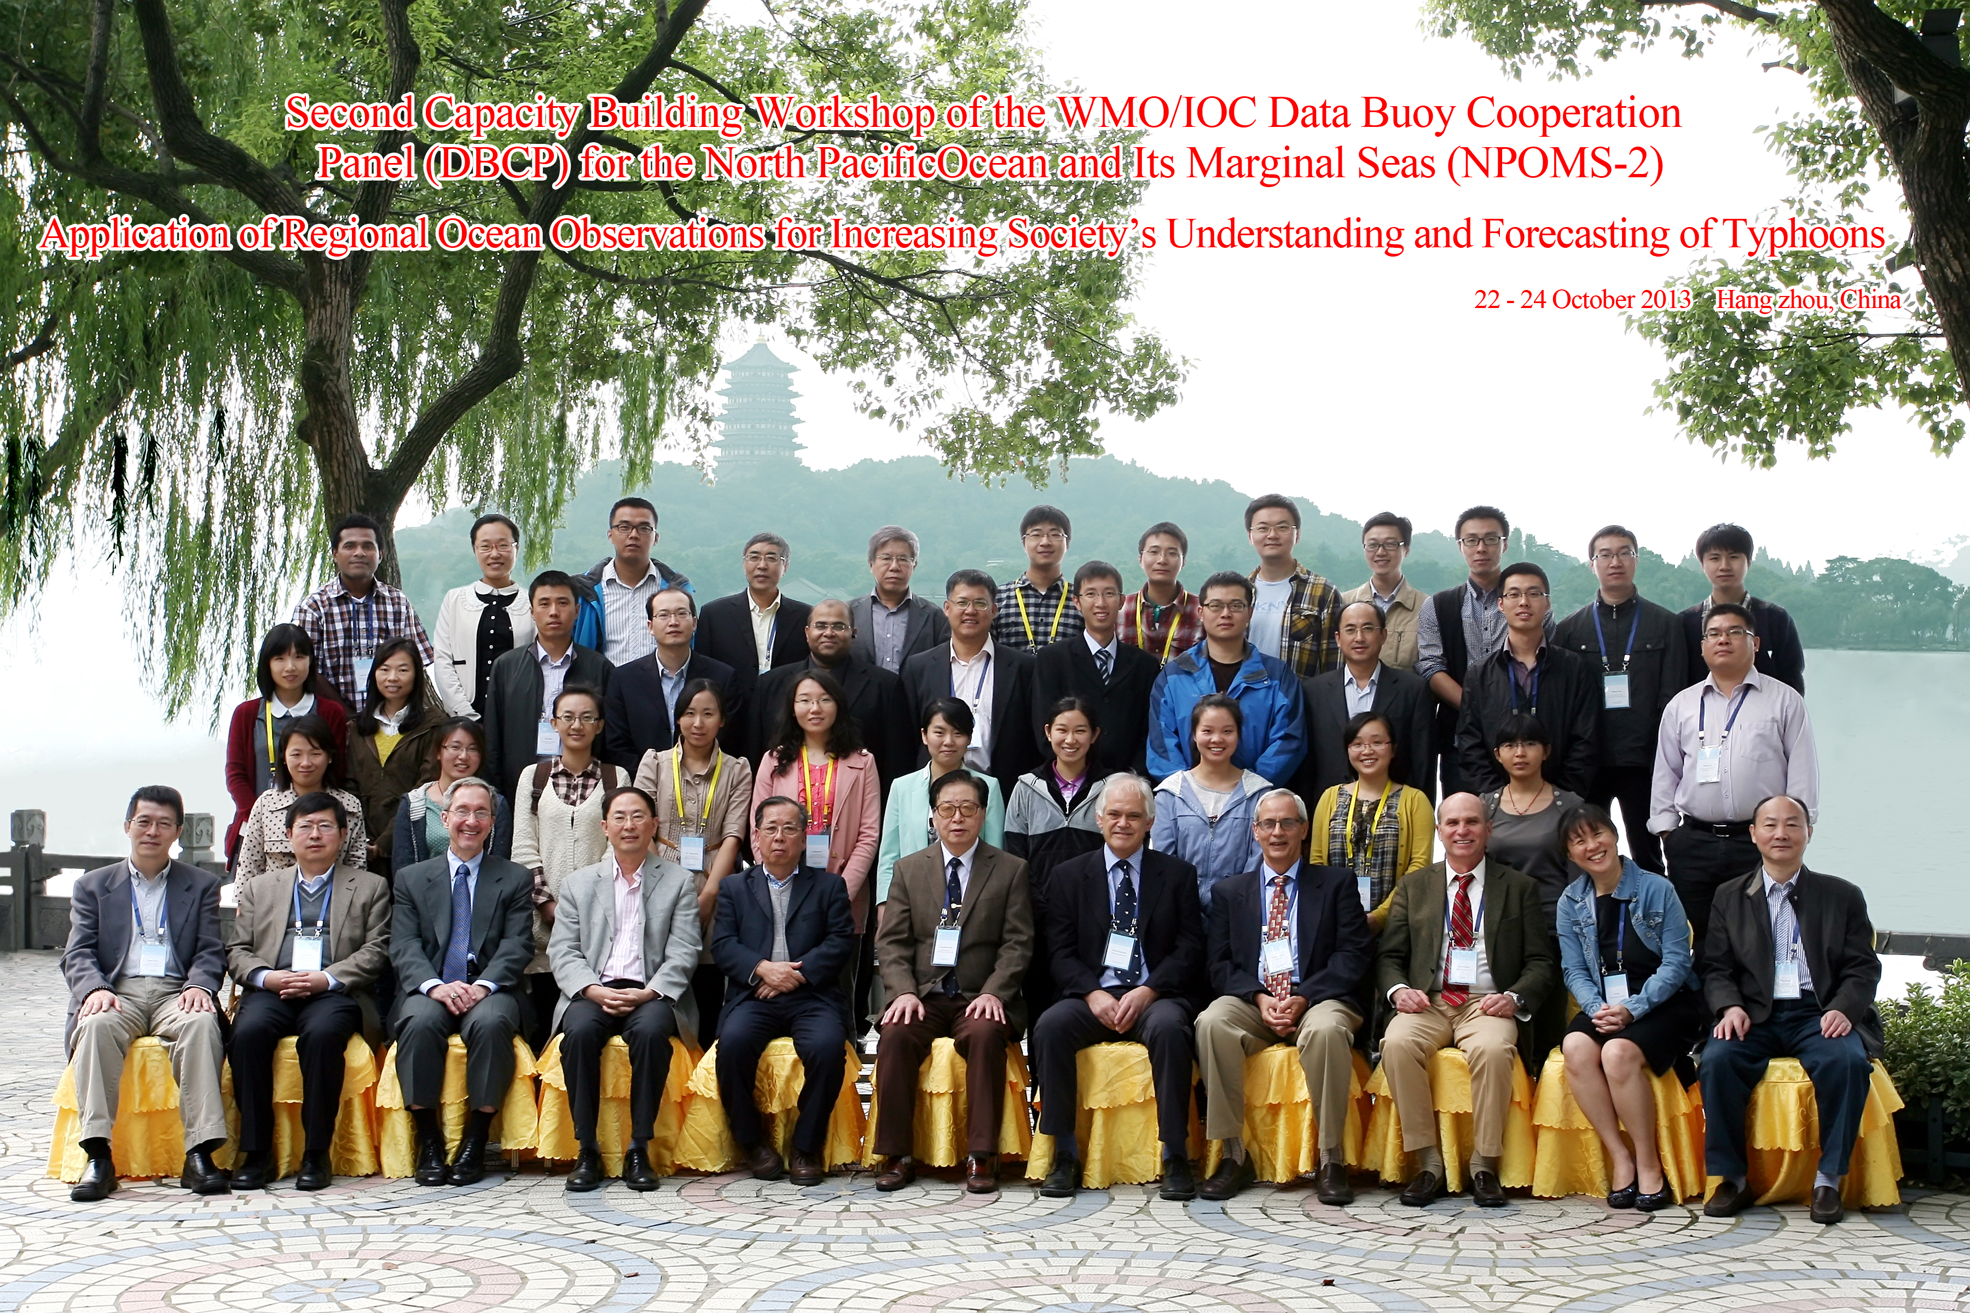
(Group photo)

Intergovernmental Oceanographic | World
Commission of UNESCO | Meteorological Organization

DATA BUOY COOPERATION PANEL

Proceedings of the Second Capacity Building Workshop of the DBCP for the North Pacific Ocean and Its Marginal Seas (NPOMS-2), Hangzhou, China, 22-24 October 2013

Application of Regional Ocean Observations for

Increasing Society’s Understanding and Forecasting of Typhoons

Venue: LiuYing Hotel

Hosted by China’s
Key Lab of Satellite Ocean Environment Dynamics (SOED)
Second Institute of Oceanography (SIO)
State Oceanic Administration (SOA)

Editor: Sidney Thurston, Ph.D.
DBCP Task Team for Capacity Building

DBCP Technical Document No. 49

2014

[page left intentionally blank]
CONTENTS

Workshop report 9

Annex 1 Workshop Agenda 33
Annex 2 List of participants 36
Annex 3 Organizing committee 39
Annex 4 Terms of Reference of the workshop 40
Annex 5 Resolutions of the workshop 41

_______________

[page left intentionally blank]

NPOMS-2 Workshop Report

NPOMS-2 is a Workshop in a Series of IOC/WMO JCOMM PANGEA Workshops:

1st Western Indian Ocean Capacity Building Workshop
2nd Western Indian Ocean Capacity Building Workshop
3rd Western Indian Ocean Capacity Building Workshop
4th Western Indian Ocean Capacity Building Workshop, Video
1st In-Region Capacity Building Workshop for Asian Countries

The DBCP Capacity Building Task Team Wishes to Recognize with Sincere Gratitude the Kind and Warm Hospitality and Support of our Local Hosts Dr. Jiabiao Li, Deputy Director General, Professor Dake Chen and Lianghong Jiang of China’s Second Institute of Oceanography.

NPOMS-2 was Co-Sponsored by the IOC/WMO Data Buoy Cooperation Panel (DBCP) and NOAA’s Office of Climate Observation (OCO).

This effort is dedicated to the victims of Typhoon Haiyan, the strongest Tropical Cyclone on record to make landfall, which battered the Philippines two weeks after the NPOMS-2 Workshop. By uniting the Scientific Experts of the Region, NPOMS-2 Colleagues seek to collaborate to empower the vulnerable against future extreme events.

[page left intentionally blank]

Workshop Report

Round Table Discussion:

NPOMS Scientific Community Design of the Optimal Observing System for Regional Cyclogenesis Research and Forecasting

The two-hour discussion centered on how international Partners could potentially augment China’s new “973” Moored-Buoy Array for Typhoon Observations (Figure 1). The basic objective is to improve the quality of Regional Typhoon prediction, which requires better models and better Observational System data, for the social and economic benefit of the large NPOMS population.

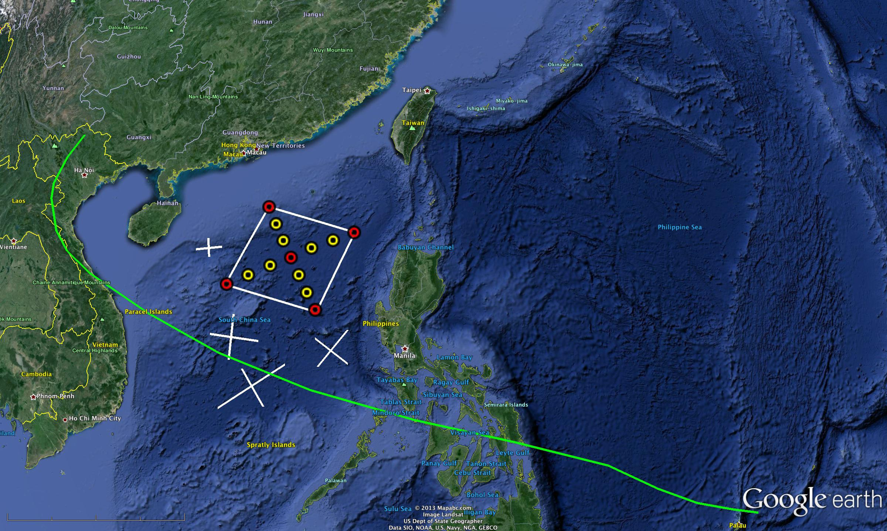
Figure 1 Proposed China 973 Moored-Buoy Array for Typhoon Observations:
5 Met-Ocean Buoys (Red) and 8 Tall Moorings (Yellow).
Green line is the track of typhoon Haiyan 7-9 November 2013.
(Map Courtesy of Rutgers University Coastal Ocean Observation Laboratory COOL)

Gliders (proposed flight paths are depicted by white lines in Figure 1) were identified as a major gap filler however there were several reasons for not deploying gliders into China especially regarding technology transfer issues and China’s Exclusive Economic Zone (Figure 2). Generally, it was agreed that flying gliders near the moored-buoy array, just outside the EEZ region, in international waters would achieve the scientific objectives of providing key ocean observations while not complicating technology transfer matters.

General Glider, Drifter Scheme for Augmenting “973” Moored Array (Figure 1):
1. Flying Borders of “973” mooring Array (3 gliders),
2. Targeted nearest Eddys—larger eddy field (3 gliders),
3. Target Nearest Cyclone (ahead of array—get to leave their position and follow cyclone)—released from ship—year duration, keep sensors off until interacts with cyclone. Surface twice per day.
4. Rapid air-deployed drifters for targeted observations with subsurface thermistor chains,
5. One set of glider tracks focuses on circling the outer boundary of the mooring array. The other set of glider tracks are x's that target eddies along the forecast track of the typhoon.

Salient Objectives of NPOMS Tropical Cyclone Observing System Design:
- 21N Line is very important for China Luson strait to observe the Kuroshio Western Boundary Current,
- Critical to understand seasonal prediction, this is the large scale under which such episodic events are happening,
- Add dropsonde capability,
- Most energy carried in upper 150m range,
- Currently OSEs are missing subsurface data so this is critical,
- Deploy drifters with subsurface thermistor chains,
- Deploy Gliders as adaptive piece of network, with preplanned flying patterns (Figure 1) looking for processes---best initial conditions,
- Long duration mode—one year,
- Minimum Number of gliders required: 10,
- Observe 3 eddies and 3 gliders/eddy, sampled continuously—better to target them for modelers—better free travel for observations,
- Vertical levels of gliders: upper 1km,
- For eddy field, 200m huge error at mixed layer,
- Surface is adequately observed from satellites,
- Argo observes adequately below 1km.

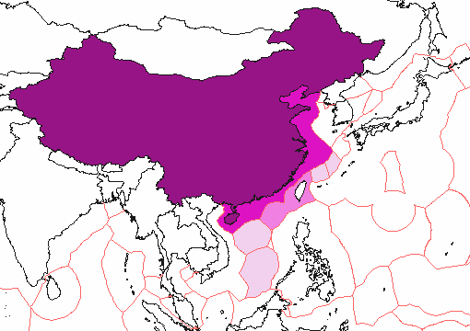
Figure 2 China's Exclusive Economic Zone (EEZ)
- China's EEZ
- EEZ claimed by China, disputed by the Republic of China (Taiwan)
- EEZ claimed by China, disputed by others
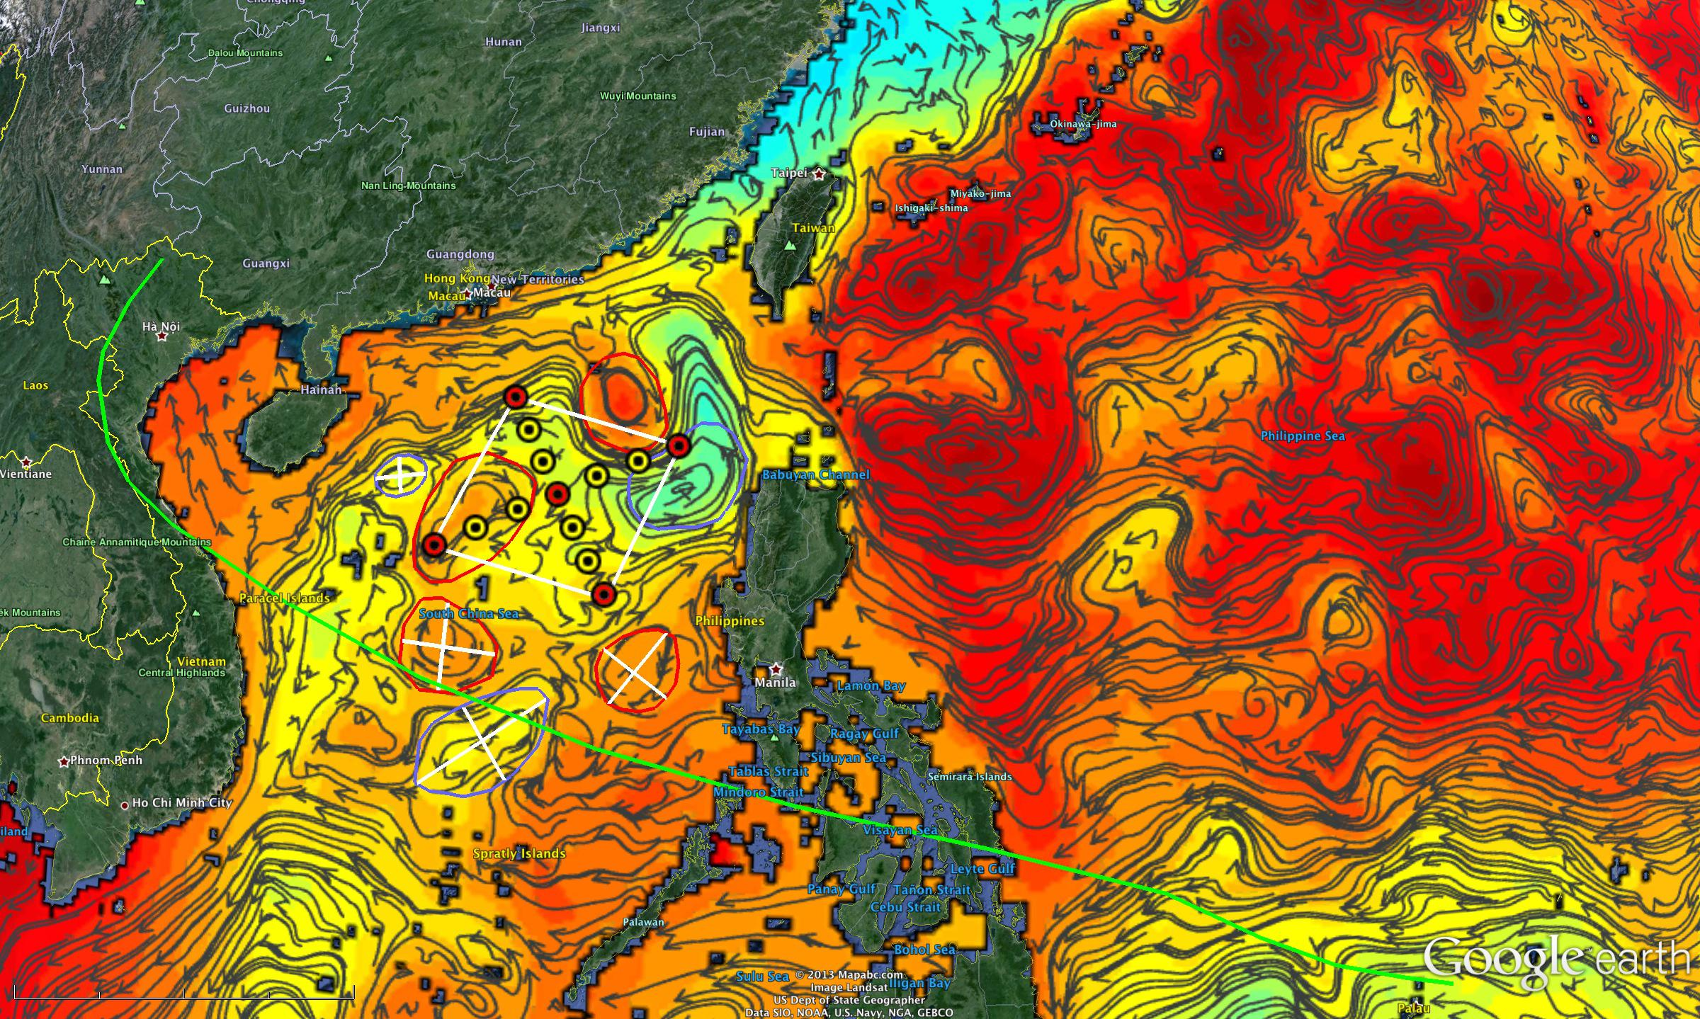
Figure 3 NPOMS-2 Workshop Augmented Observations with NOAA/NCEP Global Real-Time Ocean Forecast System (RTOFS-Global)
(Map Courtesy of Rutgers University Coastal Ocean Observation Laboratory COOL)

The global operational Real-Time Ocean Forecast System (Global RTOFS) at the NOAA National Centers for Environmental Prediction (NCEP) is based on an eddy resolving 1/12° global HYCOM (HYbrid Coordinates Ocean Model) and is part of a larger national backbone capability of ocean modeling. Figure 3 shows the NPOMS surface currents (black arrows) and sea surface height (color fill - red is high, blue is low) for 7 January 2014 as a prototype product. The hand-drawn circles are the warm (red) and cold (blue) eddies observed in the RTOFS model. The green line is the track of typhoon Haiyan 7-9 November 2013.

By using the NOAA RTOFS global ocean model to illustrate the best estimates of the current eddy field, combined with NPOMS real-time in-situ and remote ocean observations, it is possible to refine adaptive subsurface sampling plans for gliders or air deployed profilers (white lines) that will further help improve typhoon track and intensity forecasts.

NPOMS-2 Workshop Opening Remarks:

Dr. Jiabiao Li, Deputy Director General of China’s Second Institute of Oceanography,
Hangzhou China.
First of all, on behalf of the Second Institute of Oceanography, the State Oceanic Administration, I welcome you all to our beautiful city Hangzhou. It is a great pleasure for us to have you here to attend the Second Workshop of DBCP Capacity Building for the North Pacific Ocean and Its Marginal Seas, with a special focus on typhoon.

The second Institute of Oceanography is a non-benefit oceanographic research institute established in 1966 by the State Oceanic Administration (SOA). It is currently engaged in oceanographic research in the China seas, the Pacific and Indian Oceans, and the polar regions, with emphasis on cutting-edge science, environmental issues as well as marine resources. The institute has one state key lab, three SOA key labs, and five R&D centers, working on a broad range of research areas, including physical, geological and biogeochmical oceanography and engineering. At present, there are more than 300 scientists and technicians in the institute, with an annual budget of external funding over 200 million RMB. We are now undertaking a couple of projects on ocean-typhoon interaction, supported by SOA as well as the Ministry of Science and technology. Dr. Dake Chen, the director of the State Key Lab of Satellite Ocean Environment Dynamics, is serving as the chief scientist of these projects.

As we know, typhoon ranks in the top ten natural disasters. China is one of the countries which are most severely affected by typhoons. Each year, typhoons result in several tens of billion RMB of economic losses and take a few hundred lives in China. A powerful typhoon, Fitow, which just hit China this month, has forced tens of thousands out of their homes and has caused enormous damage to our home province Zhejiang. Therefore, it is an important and urgent matter to learn more about typhoons to reduce the economic damages and the life losses.

It is still a big challenge to accurately predict where, when and at what strength a typhoon will strike. NPOMS-2 provides us with an opportunity to get together and discuss this important issue. I believe that this meeting will further our understanding of typhoons, and strengthen our capacity to observe and predict typhoons. At the same time, I hope that the NPOMS-2 Workshop will enhance the international cooperation in this important research area in particular, and in oceanography in general.

David Meldrum, Co-Chair JCOMM Observations Coordination Group
Sidney Thurston, Chair DBCP Capacity Building Task Team, NOAA’s Office of Climate Observation (OCO) -

The Partnership for new GEOSS Applications (PANGEA) is a concept developed by the Joint WMO-IOC Technical Commission for Oceanography and Marine Meteorology (JCOMM) with the goal to develop partnership between developed and developing countries to realize the socio-economic benefits of ocean observing systems at global and regional scales.

PANGEA Partnerships in the Indian Ocean Region are underway to help build sustainable capacity for ocean observations and their societal applications. PANGEA Partnerships have been successful towards implementing the IOGOOS/CLIVAR Indian Ocean Observing System (IndOOS) Research Moored Array for African-Asian-Australian Monsoon Analysis and Prediction (RAMA) and other in-situ ocean-climate observations. For the past six years PANGEA Partners have been convening in-country, practical, socio-economic applications training for Regional decision-makers, policy and budget administrators, scientists, end-users and other stakeholders, so that RAMA is now over two-thirds completed. By building on and complementing existing capacity building programs, a sustainable capacity for the region is being achieved through the increases in both near real-time in-situ ocean observational data and information as well as demonstrating the more effective applications of, and access to, these existing and new data. This presentation will provide an updated brief on NOAA’s ongoing PANGEA collaboration with India, Indonesia, Japan, the Agulhas-Somali Current Large Marine Ecosystem (nine East African Nations) Program and now with Australia and emerging Partnerships with China, Korea and Chile; highlights of the DBCP’s PANGEA Fourth In-Region Capacity Building Workshop for the Western Indian Ocean (WIO-4) in Zanzibar Tanzania, Typhoon Workshop for the North Pacific Ocean and Marginal Seas (NPOMS-2) and 2014 Workshop for the South Pacific Region; and near-term opportunities for the DBCP, NOAA and other ocean Institutes to expand the PANGEA concept globally for Data Buoy & potentially future Glider implementation and training.

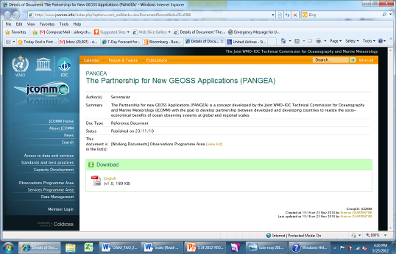
Figure 4 PANGEA Website

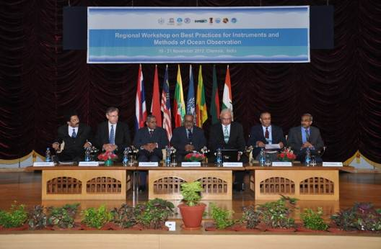
Figure 5 DBCP Regional Workshop on Best Practices for Instruments, Methods of Ocean Observation India National Institute of Ocean Technology (NIOT), Chennai India 19-21 November 2012
Scientific Presentations (Original Presentations)
1. Lianshou Chen, Chinese Meteorological Administration CMA –

Rapid Intensification (RI) over coastal oceans, stratification of RI and RW cases making landfall suggest RI has strong monsoon trough interaction and monsoon surge of moisture into TC. Binary TC merger can result in RI while ERC and shear can cause RW. Monsoon trough episodic events drive many of the TC issues in the NWPAC.

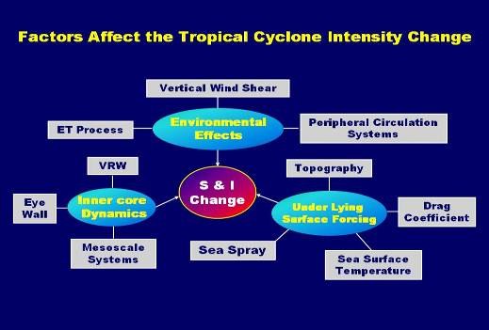
Figure 6 Rapid Intensity Change for Tropical Cyclones on the Coastal Ocean Area

2. Ronghui Huang, LASG/CAS –
Overview of TC interactions from the perspective of collaborative research between mainland China and Taiwan. Again the Monsoon trough episodic events are a key to triggering TC developments
3. Frank Marks, NOAA Hurricane Research –
The U.S. National Oceanic and Atmospheric Administration (NOAA) Hurricane Forecast Improvement Program (HFIP) provides the basis for NOAA and other agencies to coordinate hurricane research needed to significantly improve guidance for hurricane track, intensity, and storm surge forecasts. It also engages and aligns the inter-agency and larger scientific community efforts towards addressing the challenges posed to improve hurricane forecasts. The goals of the HFIP are to improve the accuracy and reliability of hurricane forecasts; to extend lead time for hurricane forecasts with increased certainty; and to increase confidence in hurricane forecasts. These efforts will require major investments in enhanced observational strategies, improved data assimilation, numerical model systems, and expanded forecast applications based on the high resolution and ensemble-based numerical prediction systems.
The specific goals of the HFIP are to reduce the average errors of hurricane track and intensity forecasts by 20% within five years and 50% in ten years with a forecast period out to 7 days. The benefits of HFIP will significantly improve NOAA's forecast services through improved hurricane forecast science and technology. Forecasts of higher accuracy and greater reliability (i.e., user confidence) are expected to lead to improved public response, including savings of life and property.

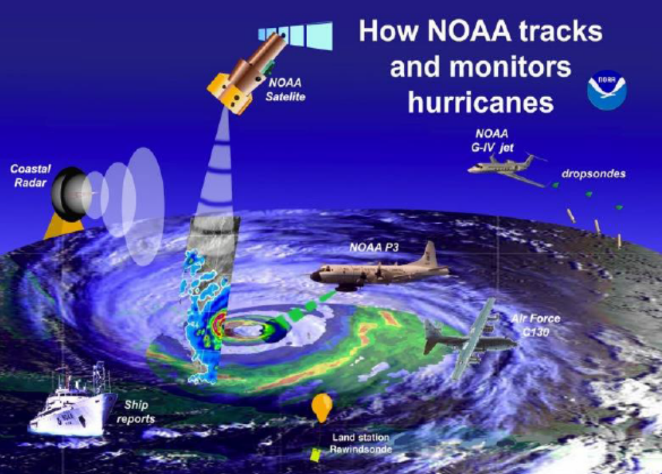
Figure 7 US Tropical Cyclone Observing Network
4. Dake Chen, SIO/SOED -
China is one of the countries in the world that are most severely affected by typhoon, with an annual economic loss of nearly 100 billion RMB and casualty over 1000 as a direct result of typhoon disaster. Due to global warming and the rapid growth of China’s coastal and marine economy, typhoon-induced oceanic and meteorological disasters are getting worse and have become a limiting factor for our country’s sustainable development. Therefore, understanding and predicting typhoon and the associated oceanic environmental variability is an important national need.
At present, a bottleneck in typhoon research and prediction is the lack of understanding of the ocean’s role in typhoon processes. It has been shown that when typhoon passes, the upper ocean dynamical and thermal structures undergo violent changes, which in turn influence the further development of typhoon; it has also been recognized that the low-frequency variability of typhoon’s intensity and occurrence are modulated by the large-scale oceanic background, and on the other hand can have a strong impact on ocean circulation. Elucidating the mechanisms of the multi-scale ocean-typhoon interaction is a hot research topic in oceanic and atmospheric sciences.
Aiming at national need and scientific frontier, this project focuses on the western North Pacific and the South China Sea, the area most frequented by typhoon. By combing new observational technologies, theoretical analyses and ocean-atmosphere coupled numerical models, the present study intends to solve two key scientific problems: 1) the response mechanisms of the upper ocean multi-scale circulation system to typhoon; and 2) the modulating effects of the upper ocean dynamical and thermal structures on typhoon intensity.
In order to achieve the above objectives, the project has five components: 1) the interaction of oceanic meso-scale processes with typhoon; 2) the low-frequency response and modulation of ocean circulation on typhoon; 3) the physical mechanism and parameterization of typhoon’s impact on upper ocean; 4) oceanic data compilation and assimilation under typhoon conditions; and 5) the key forecasting technologies for typhoon intensity and oceanic environment. The first three components focus on processes and mechanisms while the last two serve practical purposes.
The general goals of the project are: to clarify the mechanisms of ocean’s response to and modulation on typhoon, from the viewpoint of air-sea interaction, on synoptic as well as climatic time scales; to develop and improve ocean-atmosphere coupled typhoon forecast models and data assimilation system, thus providing scientific and technical supports for typhoon intensity and ocean environment predictions; and to build a world-class team for air-sea interaction studies, serving the national need while carrying out original basic research.

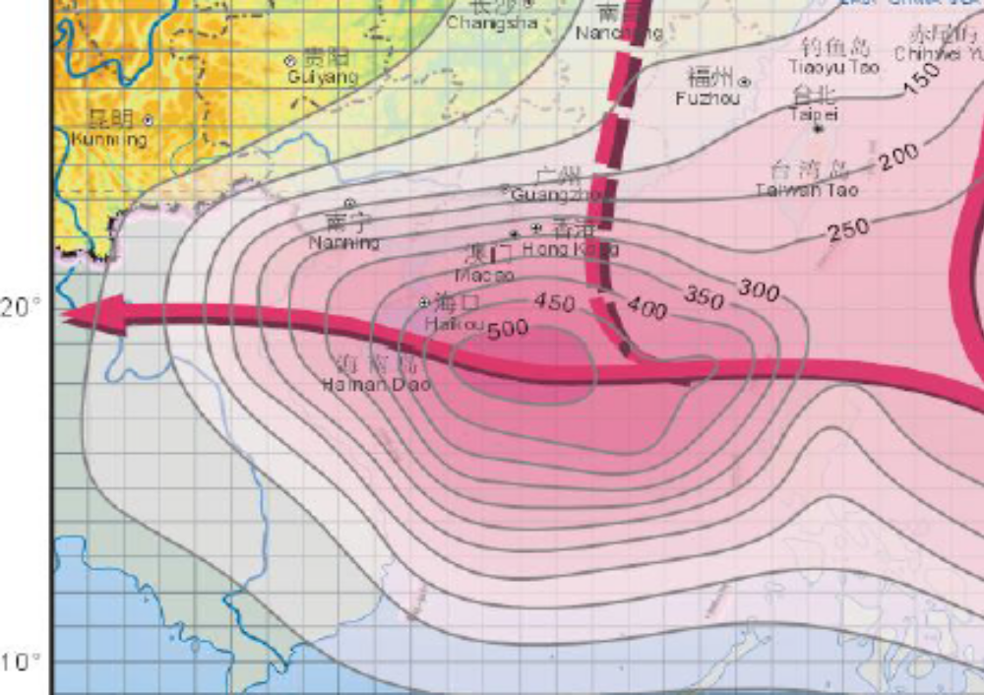
Figure 8 Tropical Cyclone Formation

5. Anthony Kali, Papua New Guinea Weather Service -
Tropical Cyclone Season is from from November to May, Port Moresby produces a daily Tropical Cyclone Potential Bulletin for National Disaster Centre (NDC) to keep them abreast of the latest expectations of cyclone activity in the South Pacific and to help them with their disaster relief planning. Additional advisories are also provided as necessary during the life of a tropical cyclone to fill any information gaps. During this same period, a routine weekly forecaster-to-forecaster conference call is carried out between Brisbane TCWC and Port Moresby TCWC to discuss the situation and developments over the next few days. PNGNWS issue warnings before TC disasters and bulletins during TC disasters.
After the disaster, our officials visit the affected areas and conduct a post mortem / an assessment on the scale of damage/loss and make recommendations for future improvements to the appropriate stakeholders. Internet Access Models, satellite, telephones/ Fax are used for real time weather data download and analysis for daily weather forecasts and issuance of severe weather and TC warnings.
Dissemination of TC information to users and general public is via email and fax which are then aired by the local media stations or passed onto Ships by Port Moresby/ Coastal Radio Station through VHF Radios. PNG does not have any ocean observing system in place and would like to get involved in any Project that would provide us with instrument deployment opportunities in order to help us in our understanding and forecasting of TCs in our area of responsibility.

6. I. I. Lin, Taiwan National University –
During the 20 August to 20 October 2010 ITOP field experiment (Figure 9), three typhoon cases, Fanapi, Malakas, and Megi were studied. Using airborne C130 dropwindsonde data, C130 AXBT (Airborne Expendable Bathythermograph) data, in situ upper ocean thermal structure data from the Argo floats, satellite sea surface temperature and altimetry data together with an ocean mixed layer model, the impact of ocean’s thermal structure to the intensity of these 3 typhoons are investigated. It is found that all three typhoons passed over regions of similarly warm sea surface temperature (SST) of ~ 29.5˚C. However, much distinction is found in the subsurface. Category-2 Typhoon Malakas passed over region of the shallowest subsurface warm layer, as characterized by the depth of the 26˚C isotherm (D26) of about 37-40m and Upper Ocean Heat Content (UOHC) of ~ 38-44 kj/cm2. Category-3 typhoon Fanapi passed over region of moderate subsurface warm layer, with D26 of ~ 60-70m and UOHC of ~ 65-78 kj/cm2. Category-5 typhoon Megi passed over region of the deepest subsurface warm layer, with D26 reaching 124-132m and UOHC reaching 136-138 kj/cm2. It is found that this distinction in the subsurface thermal structure played critical role in the intensification of the three typhoon cases. Due to the very deep D26 and high UOHC, very little typhoon-induced ocean cooling negative feedback (typically < 1˚C) for Megi was found. This very minimal negative feedback enabled ample air-sea enthalpy flux supply to support Megi’s intensification. Based on the preliminary report from the Joint Typhoon Warning Center (JTWC), Megi’s peak intensity reached 160kts, a very high intensity not often observed even for category-5 typhoons. In contrast, though with very warm pre-typhoon SST of ~ 29.5˚C, the subsurface ocean condition for Malakas and Fanapi was much less favorable. As a result, the subsurface cold water could be much easily entrained and upwelled to the surface to limit the intensification for Malakas and Fanapi.

Based on detail in situ air-deployed ocean and atmospheric measurement pairs collected during the Impact of Typhoons on the Pacific (ITOP) field campaign, we modify the widely used Sea Surface Temperature Potential Intensity (SST_PI) index by including information from the subsurface ocean temperature profile to form a new Ocean Cooling Potential Intensity (OC_PI) index. Applied to a 14-year (1998-2011) western North Pacific TC archive, OC_PI reduces SST_PI-based overestimation of archived maximum intensity by more than 50% and increases the correlation of maximum intensity estimation from r2=0.08 to 0.31. For slow-moving TCs that cause the greatest cooling, r2 increases to 0.56 and the root-mean square error in maximum intensity is 11 ms-1. As OC_PI can more realistically characterize the ocean contribution to TC intensity, it thus serves as an effective new index to improve estimation and prediction of TC maximum intensity.

I-I Lin, P. Black, J. F. Price, C.-Y. Yang, S. S. Chen, C.-C. Lien, P. Harr, N.-H. Chi, C.-C. Wu and E. A. D'Asaro, An ocean coupling potential intensity index for tropical cyclones, Geophysical Research Letters. Vol. 40, Issue 9, p. 1878-1882, doi: 10.1002/grl.50091, May. 2013.
Iam-Fei Pun, I-I Lin, and Min-Hui Lo, Recent Increase in High Tropical Cyclone Heat Potential Area in the Western North Pacific Ocean, Geophysical Research Letters,doi:10.1002/grl.50548, 3 Sep., 2013a.
Iam-Fei Pun, I-I Lin, Dong S. Ko, New Generation of Satellite-Derived Ocean Thermal Structure for the Western North Pacific Typhoon Intensity Forecasting, Progress in Oceanography, in press 2013b.

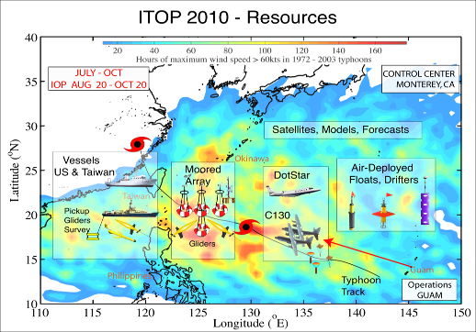
Figure 9 Impact of Typhoon on the Pacific (ITOP)

7. Badee Khayyat, Saudia Arabia Meteorology/Environment –
Unusual weather events in Saudi Arabia, waterspouts and flash floods increasing in the past 5 years particularly along Red Sea. Radar network along the Red Sea coastline.

8. Scott Glenn, US Rutgers University Coastal Ocean Observation Laboratory COOL, A Member of the Mid-Atlantic Regional Association Coastal Ocean Observing System (MARACOOS) of the US Integrated Ocean Observing System (IOOS) -
Hurricanes Irene and Sandy both made landfall in New Jersey in subsequent years, causing significant damage and loss of life. For Atlantic hurricanes, Irene ranks seventh with greater than $16 M in damage and Sandy ranks second with greater than $68 M in damage. The tracks for both hurricanes were accurately forecast days in advance, but the intensity and impact of Irene was over-predicted, while the intensity and impact of Sandy was under-predicted. Regional-scale ocean observations made in the Mid-Atlantic Bight during both hurricanes, combined with ocean and atmospheric model sensitivity studies, have identified key coastal processes that, if resolved, can improve the intensity and impact forecasts of both storms as they are making landfall.

Hurricane Irene traveled rapidly northward along the coast, making landfall on August 26, 2011 during the highly stratified summer season. Wind driven surface currents towards the coast on the leading edge of the storm resulted in a cross-shelf pressure gradient that accelerated an offshore countercurrent in the bottom layer, limiting the storm surge impact. Regional-scale ocean model results indicate that the strong shear across the intense thermocline resulted in mixing across the thermocline that is the dominant process resulting in significant cooling of the surface water of 6-10C on the scale of the Mid-Atlantic Bight. Observations indicate that the mixing and cooling occurred rapidly during the strong wind forcing of the leading edge, well before the eye passed over the Mid-Atlantic. Comparisons of atmospheric model runs using the warm Sea Surface Temperature (SST) observed before storm with the same model using the cold SST observed after the storm indicate that the cold SST is sufficient to reduce the predicted intensity of Irene to correspond to what was observed (Figurer 10). A sensitivity matrix of over 100 atmospheric model runs used to rank the numerous model dependencies reveals SST as the most significant sensitivity impacting Irene’s intensity forecast.

Hurricane Sandy approached the New Jersey coast slowly from offshore, making landfall on October 29, 2012 (Figure 11) after the fall transition to a less stratified continental shelf. Cold bottom water was advected offshore with little mixing, so there was little further cooling of the single layer ocean as the storm approached. With no offshore escape route in the bottom layer, the strong onshore winds from Sandy produced a storm surge that was under-predicted. Ocean model sensitivities to the windfield indicate that the acceleration and intensification of Sandy just before landfall can improves the storm surge forecast, indicating that the extreme storm surge of Sandy was predictable if the full ensemble of wind forcing was used.

These observations and model results are being used to further inform a new NOAA storm intensity and impact research project focused on severe storms in the northeast U.S. Two types of storms are targeted for dedicated rapid-response sampling and modeling activities. These include winter storms that approach the coast slowly from offshore that typically occur in March, and summer hurricanes that travel along the coast that typically occur in September.

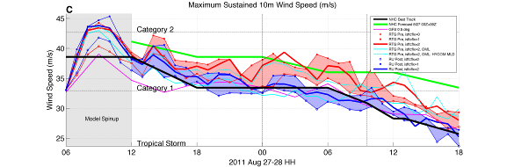
Figure 10 Time series of maximum sustained winds for Hurricane Irene illustrating the top model sensitivities. Thick green line is the overpredicted forecast and thick black line is the best fit post-analysis. The sensitivities to different air-sea flux parameter

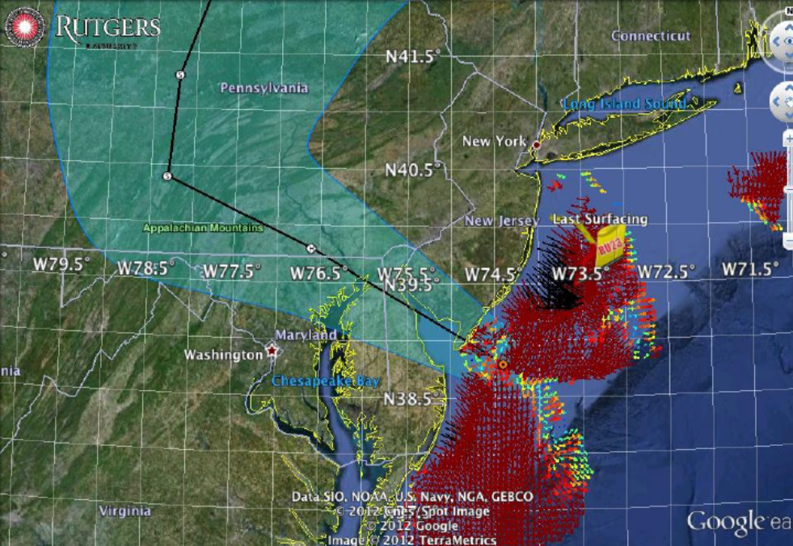
Figure 11 Super Storm Sandy Landfall
It is clear that gliders have a role in a targeted observing program focused on coastal areas of interest or ecosystems (coral reefs, marine sanctuaries, wind farms, etc.) that may be effected by TCs. Clear that for TC targeted observing program we need airborne deployable platforms (drifters, floats, and even gliders if possible) to insure most effective sampling.

9. Hui Wang, SOA National Marine Environmental Forecast Center NMEFC –
China's Global Operational Oceanography Forecast System (CGOFS) - 3 regional centers plus 11 provincial marine forecast centers. Use spectral GFS and GSI for global coupled model. Couple to Chinese global Ocean forecast system CGOFS based on MOM4 with OI DA system. For regional model they use WRF coupled to regional ocean model ROMS and SODA for bringing in observations. For waves they use WW3 on the global model and SWAN for regional models. In polar region they use the MIT Global Circulation Model forced by GFS BC.

10. Yongping Li, Shanghai Typhoon Institute/CMA –
Summary of “973” Project on Unusual Variation of Landfall Tropical Cyclone Behavior and Associated Physical Mechanism.

11. Etienne Charpentier, WMO, remote Skype call from Geneva –
The WMO Integrated Global Observing System (WIGOS) is an integrated, comprehensive, and coordinated system which is comprised of the Global Observing System (GOS), the observing component of the Global Atmosphere Watch (GAW), the WMO Hydrological Observing Systems – including the World Hydrological Cycle Observing System (WHYCOS) – and the observing component of the Global Cryosphere Watch (GCW), including their surface-based and space-based components. The above component systems include all WMO contributions to the co-sponsored systems, i.e., the WMO-IOC-UNEP-ICSU Global Climate Observing System (GCOS), the IOC-WMO- UNEP-ISCU Global Ocean Observing System (GOOS), the FAO-WMO-UNESCO-UNEP-ICSU Global Terrestrial Observing System (GTOS), as well as the WMO contributions to the Global Framework for Climate Services (GFCS) and the Global Earth Observing System of Systems (GEOSS).

The implementation of the WIGOS was decided by the WMO Sixteenth Congress through Resolution 50 (Cg-16, 2011) for the financial period 2012 to 2015 so that WIGOS becomes operational in 2016. The integration concept of WIGOS includes the following elements: (i) the integration of WMO-owned observing systems; (ii) enhanced standardization (e.g. instruments and methods of observation, metadata); (iii) promotion of interoperability between observing system components; (iv) integration of in situ and satellite data; (v) addressing the evolving observational user requirements, gaps, and proposing observing system network design; (vi) addressing synergies and sharing costs; and (vii) collaborating with partner organization (e.g. IOC) for the co-sponsored observing systems (e.g. GOOS).

The WIGOS Framework Implementation Plan (WIP) was adopted by the sixty-fourth Session of the WMO Executive Council (EC-64, Geneva, 2012), and updated by the sixty-fifth Session of the WMO EC (EC-65, Geneva, May 2013). The WIP addresses the necessary activities to establish an operational WIGOS by the end of the period 2012-2015, as per the direction of WMO Congress. The WIP includes estimation of resource requirements, targets with dates for tasks’ completion and identification of risks. Effective implementation and operation of WIGOS will depend on sufficient resources and commitments. Available resources will be targeted at ensuring the priority elements of the global WIGOS framework are implemented by the seventeenth Session of WMO Congress (Cg-17) in 2015.

To migrate the existing observing systems listed above into a more integrated single system that is WIGOS, focused effort is required in the following Key Activity Areas (KAAs) identified and described in the WIP:

- Management of WIGOS implementation;
- Collaboration with WMO and co-sponsored observing systems;
- Design, planning and optimized evolution;
- Integrated Observing System operation and maintenance;
- Integrated Quality Management;
- Standardization, system interoperability and data compatibility;
- The WIGOS Operational Information Resource;
- Data and metadata management, delivery and archival;
- Capacity development;
- Communication and outreach.

The WIP also addresses a number of additional activities that would substantially improve the operational capabilities of WIGOS beyond the 2012-2015.

The comprehensive information collected for the globe on both requirements and capabilities will be quantitatively recorded in a database accessible through the Observing Systems Capability Analysis and Review tool (OSCAR) of the WIGOS Operational Information Resource (WIRError: Reference source not found). Currently, observational users requirements, and space-based observing system capabilities are already recorded and available through OSCARError: Reference source not found.

The 29th Session of the Data Buoy Cooperation Panel (DBCP-29, Paris, France, September 2013) recalled its response made at DBCP-27 and re-iterated at DBCP-28 to the legacy recommendations of the JCOMM Pilot Project for WIGOS, which provided an excellent contribution of the Panel to WIGOS implementation (see DBCP-27 final report, paragraph 11.5.3). DBCP-29 further noted JCOMM’s contribution to the ten WIGOS framework implementation Key Activity Areas (KAAs), and proposed the following DBCP response:

WIP  KAA No. | WIP Key Activity Area (KAA) | Proposed DBCP response
1 | Management of WIGOS implementation | DBCP Executive Board and Technical Coordinator to provide DBCP input to the ICG-WIGOS and its Task Teams through the JCOMM representatives in those groups.
2 | Collaboration with the WMO co-sponsored observing systems & international partner organizations & programmes | Strong collaboration established between WMO and IOC for the DBCP since 1985
3 | Design, planning & optimized evolution | See agenda item 11.4  DBCP Contribution to JCOMM OPA Implementation Goals for the surface drifters (1250 units) and the tropical moored buoys (125 units)
4 | Observing System operation & maintenance | DBCP to continue contributing to JCOMMOPS  DBCP to contribute to the Satcom Forum  DBCP to continue pilot activities (PP-HRSST, PP-WET)
5 | Quality Management | Keeping DBCP TD No. 37 up to date (Guide to buoy data QC tests to perform in real time by a GTS data processing centre)  Continue operating the DBCP QC guidelines  Promoting quality information feedback mechanisms between ocean in situ & satellite observation communities through the DBCP Pilot Project on HRSST  DBCP TT-IBP to continue evaluating performance of buoy data
6 | Standardization, system interoperability & data compatibility | To consider migrating some of the DBCP ongoing activities of the DBCP Implementation Strategy to the WIGOS Technical Regulations
7 | WIGOS Operational Information Resource (WIR) | Buoy operators to make sure that buoy metadata are made available via JCOMMOPS on a routine basis.
8 | Data & metadata management, delivery & archival | Buoy operators to make sure that buoy metadata are made available via JCOMMOPS on a routine basis.
9 | Capacity development | DBCP to continue supporting Capacity Building activities
10 | Communications & outreach | DBCP to continue to be informed about WIGOS implementation at regular DBCP sessions.

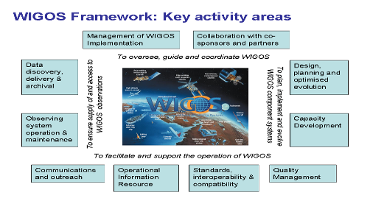
Figure 12 WMO Integrated Observing System (WIGOS)

23 October - Day 2

12. Jiwei Tian
Described ocean response to typhoon Megi (Figure 13) in the north South China Sea SW of Taiwan from moored buoy observations. Not only did the typhoon excite the inertial oscillation but amplified the diurnal internal tide signal. Explored the non linear interaction between the tide and inertial oscillation. Inertial oscillation was relatively weak, but the diurnal internal tide in the upper 100 m was enhanced.

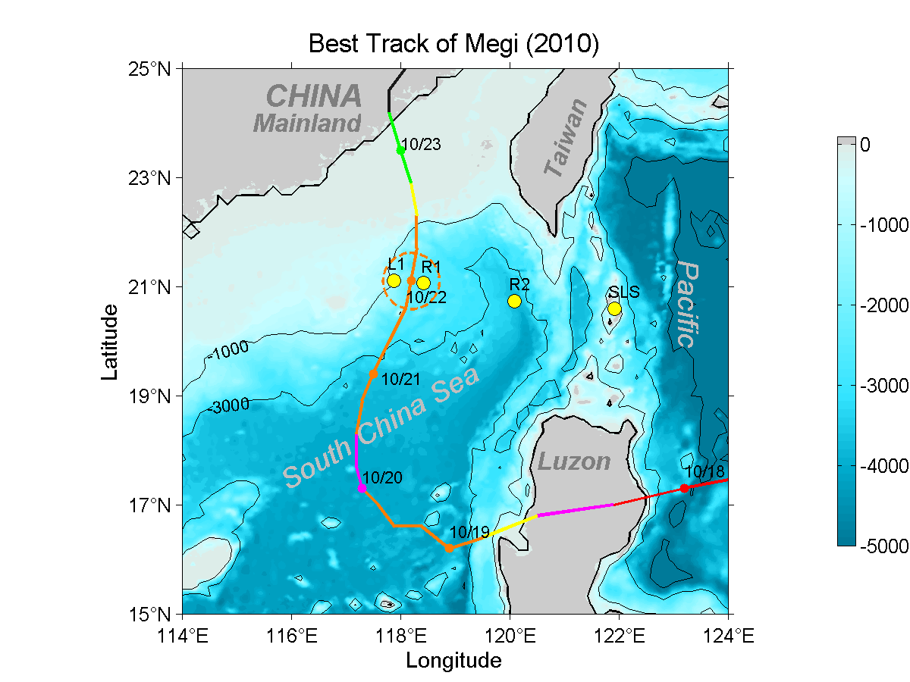


Figure 13 Best Track of Super Typhoon Megi (2010)—Megi would have been nicely observed by China’s new “973” Moored Buoy Array for Typhoon Observations, See Figure 1.

13. Tony Liu, Ocean College, Zhejiang University and NASA/GSFC ( Emeritus),
Observation of Typhoon Eye over Ocean Surface by Multiple Sensors. In this study, typhoon eyes have been delineated using wavelet analysis from the synthetic aperture radar (SAR) images of ocean surface roughness and from the warmer area at the cloud top in the infrared (IR) images, respectively. Radarsat and Envisat SAR imagery, and multi-functional transport satellite (MTSAT) and Feng Yun (FY)-2 Chinese meteorological satellites IR imagery were used to examine the typhoons in the western North Pacific, especially in the East China Sea, from 2005 to 2011. Nine cases of various typhoons in different years, locations, and conditions have been used to compare the typhoon eyes by SAR (on the ocean surface) with IR (at the cloud-top level) images. Furthermore, the best track data getting from the Joint Typhoon Warning Center (JTWC), Chinese Meteorological Administration (CMA), and the Japan Meteorological Agency (JMA) are checked for the calibration and validation along with the Moderate Resolution Imaging Spectroradiometer (MODIS) image (Figure 14). Because of the vertical wind shear, which acts as an upright tilt, the location of the typhoon eye on the ocean surface differs from that at the top of the clouds. Consequently, the large horizontal distance between typhoon eyes on the ocean surface and on the cloud top as summarized in this review implies that the associated vertical wind shear profile is considerably more complex than generally expected. The upright tilt structure may be caused by the ocean's feedback or the effect of island obstruction. The difference between MTSAT and FY-2 IR results also brings up the issues on the project distortion and navigation system errors. However, this result demonstrates that SAR can be a useful tool for typhoon monitoring study over the ocean surface.
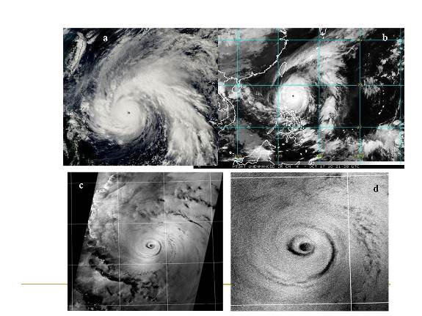
Figure 14 Satellite images of Typhoon Megi collected over the southeast of Taiwan on October 17, 2010 from (a) MODIS, (b) MTSAT, and (c) ENVISAT, respectively. The typhoon eye as a dark circle can be easily detected in (d) the zoom-in ENVISAT SAR subscene.

14. Tom Evans, US NOAA Pacific Hurricane Center -
Tropical Storm Flossie 2013 was the first time tropical storm warnings had been issued for the main Hawaiian Islands since 2007. Once TS Flossie crossed 135W it had been moving at a relatively constant speed and direction as it approached the main Hawaiian Islands from the east. Therefore, our confidence was relatively high on TS Flossie making landfall on the eastern portion of the big island with its strength only in question. TS Flossie was moving into an area of increasing vertical shear. However, TS Flossie had a trick up its sleeve. At the last forecast issuance before landfall, the forecasters had to make a crucial decision which was going to affect last minute preparations by emergency managers and families alike. This is when the forecasters effectively used the total observation concept to build their confidence on making a consequential change of the forecast track of TS Flossie. Using the total observation concept is crucial when data are sparse or conflicting. In the case of TS Flossie, data was sparse so finding them to build confidence was what the forecasters needed to change the forecast track of TS Flossie from a direct hit on the big island to a glancing blow.

Expanding the total observation concept to include possible impacts the forecasters knew this forecast was going to be critical for decision makers. The latest model runs changed from previous runs introducing a track farther north. The track was not out of the question the forecasters just didn’t have the data to support it. There was one last piece of data that arrived in the nick of time allowing the forecasters to have confidence in moving the forecast track to the north, similar to what the forecast models indicated – The VIIRS night-visible band. The Central Pacific Hurricane Center is receiving this imagery in its experimental mode through the GOES-R test bed. In any case it provided the last piece of data necessary to announce to the emergency management community, the media and the public of a new forecast track which will only provide a glancing blow to the big island and higher impacts to Maui.

15. Chun-wing Choy, Hong Kong Observatory -
The talk shared Hong Kong Observatory’s aircraft experience in capturing weather data of Tropical Cyclone Haima (2011), Tembin (2012), Kai Tak (2012), Talim (2012), Vicente (2012). The flight level observations on penetrations through the storm centers and compared to buoy, scatterometers and NOAA Multi-platform Satellite Surface Wind Analysis. Incorporating the flight level data into NWP applications in HK (Meso NHM), the results showed positive impacts in wind structure, tracks, and rainfall. Plan for next year is to add dropsonde capability in the aircraft and the data could be transmitted to the Observatory in near real-time and can be used operationally.

16. Tetsuya Takemi, Japan DPRI -
A mechanism for the transition of tropical cyclones (TCs) to the spontaneous rapid intensification (RI) phase is proposed based on numerical results of a three-dimensional full-physics model. The intensification phase of the simulated TC is divided into three subphases according to the rate of intensification: 1) a slowly intensifying phase, 2) an RI phase, and 3) an adjustment phase toward the quasi-steady state. The evolution of a TC vortex is diagnosed by the energy budget analysis and the degree of axisymmetric structure of the TC vortex, and the simulated TC is determined to be axisymmetrized 12 h before the onset of RI. It is found that equivalent potential temperature θe in the lowest layer suddenly increases inside the radius of maximum azimuthally averaged horizontal wind rma after the TC becomes nearly axisymmetric. Forward trajectory analyses revealed that the enhanced convective instability in the TC core region where the eyewall subsequently forms results from the increased inertial stability of the TC core after the axisymmetrization. Since fluid parcels remain longer inside rma, owing to the increased inertial stability, the parcels obtain more enthalpy from the underlying ocean. As a result, low-level θe and hence convective available potential energy (CAPE) increase. Under the condition with increased CAPE, the eyewall is intensified and the secondary circulation is enhanced, leading to the increased convergence of low-level inflow; this process is considered to be the trigger of RI. Once the eyewall forms, the simulated TC starts its RI.

17. Wei Zhao, NMC CMA –
A brief introduction is delivered on the TC forecasting operations, TC observation system and TC numerical forecast systems in CMA.

Discuss the typhoon forecast operations at CMA. TC forecast, observing and NWP. WNP averages 27 TCs per year of which 7 landfall in China. Responsibility from Dateline west to China coast and north of the Equator. There is also a 48 h and 24 h warning lines for forecast responsibility (when TC is potentially 48 and 24 h from landfall in China). Utilize Dvorak for intensity estimates. Use color alarm alert system (blue, yellow, orange, red in increasing severity from TS to typhoon). 158 Doppler radars in the CMA network. 30000 automated weather stations. 290 buoys. Global model T639 and 15 member ensemble at T213. Use multi model ensemble with EC, GFS, JMA. Regional model GRAPES-TYM. Have a wave and storm surge model driven by global deterministic model although storm surge is responsibility of the National Marine Data and Information Service (NMDIS).
18. Shuangquan Wu, NMDIS –
Typhoon induced wave and storm surge studies in China Seas. Utilize POM (surge) and SWAN (wave) for forecasts guidance what model provides the atmospheric forcing?).
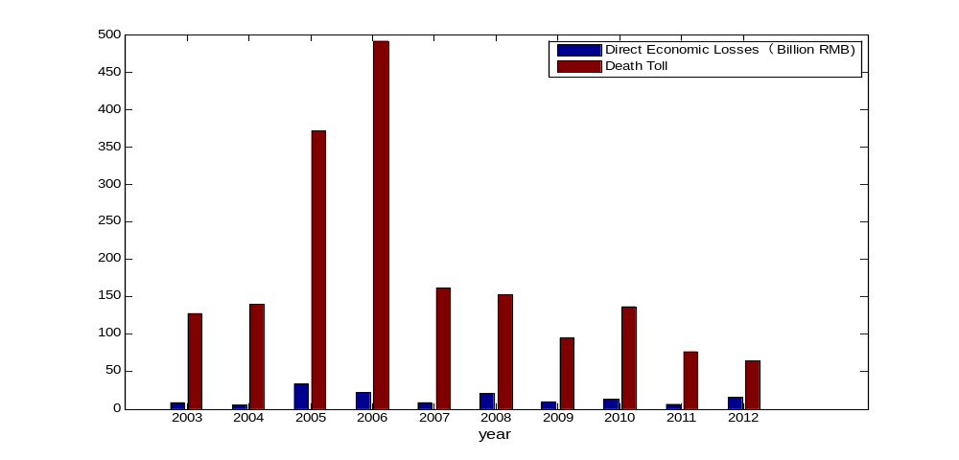
Figure 15 The Economic Losses and Casualties Caused by
Marine Disasters in China During the Past Ten (10) Years

19. Jinbao Song, IOCAS –
Measurements and estimations of air-sea turbulent fluxes from a buoy
Knowledge of air–sea fluxes is crucial for air-sea interactions, coupled ocean–atmosphere modeling, surface wave and current prediction, air-sea exchange and climate variation. Recent advances in measurements and analysis techniques have enabled air–sea fluxes to be measured directly from moving platforms at sea. These direct flux measurements supplement and improve the inertial-dissipation and bulk flux estimation techniques that have been applied for many years.
A few years ago, under the support of the “863” project of China, we developed a buoy to directly measure air-sea fluxes. The structure and functionality of the buoy are quite similar to that of the ASIS (Air–Sea Interaction Spar) buoy designed by University of Miami. The buoy can reliably measure directional wave spectra, air-sea fluxes, and radiation fluxes in the open ocean. In this talk, the buoy instrumentation are introduced and data collected during the experiments in the North Yellow Sea are used to estimate the air-sea fluxes. The air-sea turbulent fluxes of momentum, heat, CO₂ and moisture are estimated from data obtained at different levels above the mean sea surface using the eddy covariance method, including the necessary corrections using the moving sensors data for the velocity measurements to remove the effects of motion contamination. To remove other non-turbulent contaminations, a method based on HHT (Hilbert–Huang Transform) is used to remove the non-turbulent modes from the time series. Results show that the motion correction applied is effective, and the fluxes at three heights derived by HHT have the highest correlation and the smallest relative error compared with three methods that are commonly used to calculate perturbation: the block average, moving average, and Multi-Resolution Decomposition. The application of HHT is successful in reducing the influence of non-turbulent motions on the eddy-covariance flux.

20. Frank Marks, US NOAA HFIP -
The historical objective of the NOAA Hurricane Field Program was the collection of data required to support analytical and theoretical tropical cyclone (TC) studies designed to improve the understanding of storm structure and behavior. Whereas the NOAA research aircraft initially provided storm location and intensity information, the gradual increase in the amount of aircraft data transmitted to the ground led to wider support of operations. Under the NOAA Intensity Forecast Experiment (IFEX) begun in 2005, aircraft observing efforts into tropical cyclones are geared toward (1) collecting observations that span the TC life cycle in a variety of environments for model initialization and evaluation; (2) developing and refining measurement strategies and technologies that provide improved real-time monitoring of TC intensity, structure, and environment; and (3) improving the understanding of physical processes important in intensity change for a TC at all stages of its life cycle. This data collection is part of the development of coupled atmosphere-ocean modeling systems, and involves research into data assimilation, understanding and parameterization of physical processes (including the interaction and response of the upper ocean), and model evaluation and validation with comprehensive datasets collected by airborne platforms, including upper ocean observations.

As part of NOAA’s Hurricane Forecast Improvement Program (HFIP), IFEX addresses the important role of aircraft observations in TC model physics validation and improvement. A model developmental strategy for improving the physical parameterizations uses quality-controlled and post-processed aircraft observations, with steps that include model diagnostics, physics development, physics implementation and further evaluation. Model deficiencies are first identified through model diagnostics by comparing the simulated axisymmetric multi-scale structures to observational composites (Figure 16). New physical parameterizations are developed in parallel based on in-situ observational data from specially designed hurricane field programs. The new physics package is then implemented in the model, which is followed by further evaluation. The developmental framework presented here is found to be successful in improving the surface layer and boundary layer parameterization schemes in the operational atmosphere-ocean coupled Hurricane Weather Research and Forecast (HWRF) model.
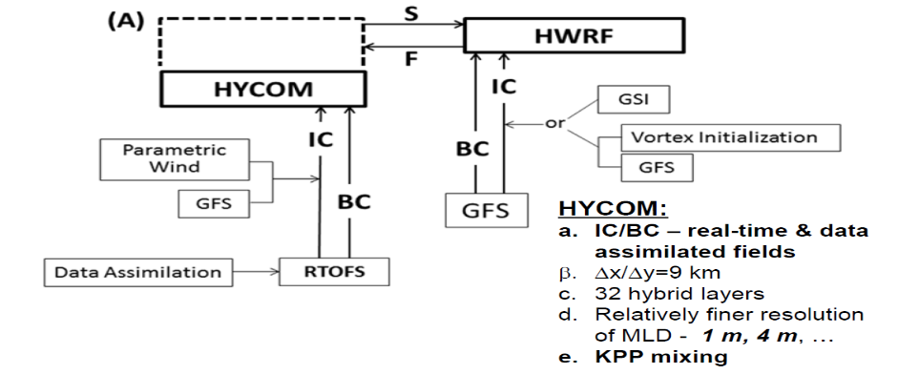
Figure 16 Improved Models and Data: HYCOM-HWRF (HY-HWRF)

21. Boram Lee, WMO, remote Skype call from Geneva -
The Global Framework for Climate Services (GFCS) has developed four exemplars, or models, to illustrate how climate services can support decision-making in priority sectors (Figurer 17). The four exemplars are: 1) Agriculture and Food Security, 2) Disaster Risk Reduction, 3) Health and 4) Water. Building on the broad concepts of the GFCS, the exemplars provide detailed descriptions of how climate services can work in practice. They explore how to design a climate service, engage users and partners, and mobilize resources.

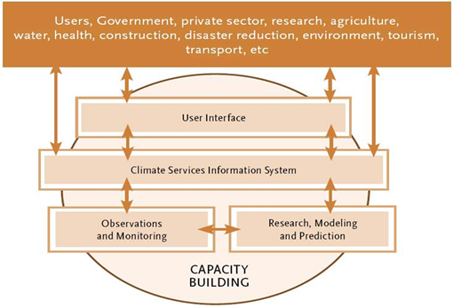
Figure 17- The Vision of the Global Framework for Climate Services (GFCS)

22. Chujin Liang, SIO –
Moored buoys for ocean monitoring in S. China Sea. Placed met ocean buoy and subsurface mooring in the water in 2008. Similar to NDBC 6-ft buoys with CO2 and ADCP at bottom mooring. Use acoustic telemetry to recover data. Useful for monitoring typhoon passage. Hagupit in 2008 went directly over buoy. Measured significant wave height of 12 m and max wave height of 20 m. Measured current development by typhoon with very high frequency showing enhanced currents before and after the typhoon passage. Plan to set up 5 met ocean buoys and 4 tall moorings in South China Sea to enhance typhoon observations. Need ocean temperature obs in mixed layer that were not available from original buoy observations.

24 October - Day 3

23. Sidney Thurston, NOAA Office of Climate Observations (OCO) - A Future Sustained Tropical Pacific Ocean Observing System for Research and Forecasting (TPOS-2020),
27 - 30 January 2014, La Jolla, United States: Workshop Goals/Terms of Reference

- Review the scientific and operational achievements of the TAO/TRITON component of the tropical observing system,

- Highlight the impacts of tropical Pacific observing on the delivery of information/services of societal importance and relevance,

- Evaluate and prioritise existing and potential requirements for sustained observations of Essential Ocean Variables (EOVs) in tropical Pacific Ocean* (15°S-15°N) and update them to reflect new knowledge and needs for a range of applications (scientific to societal). Key applications to be considered include; Tracking Climate Change and processes, ENSO and Ocean Circulation research, Modelling and Forecasting (Climate, Ocean, Seasonal, NWP), Biogeochemistry and Fisheries,

- Evaluate the adequacy of existing observing strategies to deliver EOV requirements, characterize their impacts, and evaluate their adequacy. Characterize how in situ (e.g., Argo, Gliders, etc.) and remote sensing observing systems are contributing to meet these scientific and functional requirements, and identify gaps, inefficiencies and vulnerabilities,

- Recommend revisions and/or adjustments to the current suite and configuration of observing systems to enhance their resilience and robustness; in order to produce data in a more cost-efficient and sustainable manner feasible within the anticipated envelope of capability and resources,

- Identify potential expansion or reconfiguration of this sustainable observing suite to address gaps, and new requirements,

- Evaluate logistical and resource requirements for implementation of the recommended Tropical Pacific Observing System,
  - Assess interests, as well as potential contributing capabilities, of existing and new collaborators towards implementing Tropical Pacific observing needs.
  - Recommend strategies (e.g., training, development assistance, technology transfer programs and observing system management) to address long-term observing capabilities of potential contributors in order to improve robustness and resilience of observational data from the Tropical Pacific Ocean observing system.

- Evaluate requirements for delivery of data, and derived products and information, in real time and delayed mode (e.g. availability, quality, latency, integration/interoperability); evaluate the existing data systems for fitness for purpose,

- Assess readiness of new technologies, their potential impact and feasibility in addressing requirements, and their potential to contribute towards addressing gaps, improving robustness/resilience, and/or lowering costs per observation in the tropical Pacific Ocean region; Recommend new technologies with greatest potential to meet critical requirements and suggest approaches to improve the readiness for inclusion in the sustained observing system,

- Provide recommendations on the development of a process for the ongoing evaluation of the observing system.

* The needs, strategies, and recommendations, as they apply to sustained observing data of the Tropical Atlantic and Indian Oceans, may also be considered.

24. Dong-Ping Wang, Stony Brook/SIO –
The impact of high-frequency winds on the generation and propagation of inertial currents during a severe storm on 9-16 November 2001 is evaluated in an ocean circulation model of the Palamós submarine canyon (northwestern Mediterranean). Moored current meter time series collected in and around the canyon during the storm are assimilated with an ensemble adjustment Kalman filter (EAKF) to adjust wind forcing through a simultaneous state and parameter estimation approach. Winds are included as time-dependent parameters and updated in each assimilation step as part of the model state. A simulation forced by the estimated wind significantly outperforms simulation with winds from the atmospheric reanalysis. This is due to the higher energy for the estimated wind at inertial period in the clockwise rotating component, which enhances near-inertial motions in the ocean. The surface inertial energy however does not decay as rapidly as in a simulation including full data assimilation. The results from the data-assimilated model contain rich submesocale structures that are not present in the simulation with high-frequency wind forcing only. It is suggested that the submesoscales could be effective in channeling a spatially heterogeneous vertical propagation of near-inertial motions.

25. Saji Hameed, ARC-ENV Japan –
Discuss EDT the role of Indo-Pacific climates modes effect the decades variability of TC of NWPAC. Barcikowska et al 2012 did a nice study of NWPAC TC seasonal variability similar to Landsea's work in ATL. NWPAC has multi-decadal variability. ENSO flavors defined as in Carmargo et al 2007 effect TC activity and the nonlinear behavior of ENSO is critical to understanding the variability. Relate Carmargo et al 2007 cluster type analysis with the monsoon trough outbreaks with numerous interacting storms. The Indian Ocean Dipole relationship is shown in Figure 18.

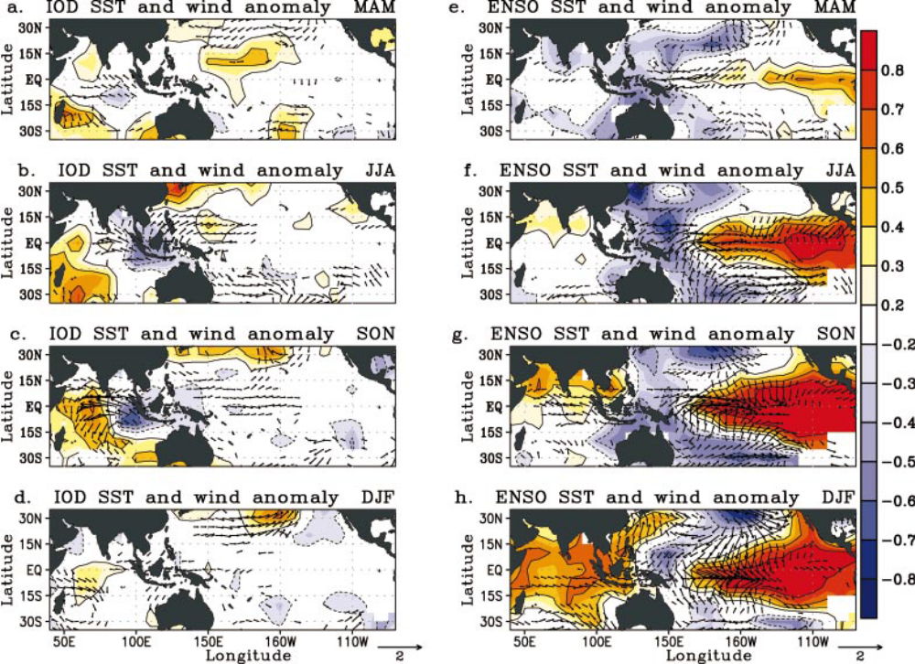
Figure 18 Saji and Yamagata 2003

26. Changlong Guan, Ocean University of China, Qingdao
Development of a wave-ocean-atmosphere coupled model. Adding sea spray to try to show model results compare well to observations. Use WRF, POM, and SWAN in the coupled system with additional sea spray parameterization. Show very little difference between ocean and ocean with waves. Then the question is do you need to have the extra model to couple to improve the forecast. Wave coupling is primarily driving asymmetries in fluxes but are those asymmetries important to model evolution. HWRF results suggest that they are not that important in the evolution of the vortex relative to atmospheric structure differences (e.g., shear and dry air asymmetries). However, the more complex coupled models could be used to diagnose when these effects may be important in the vortex evolution as we do not know if HWRF is getting a good answer for the wrong reason. Given that the surface enthalpy flux is driven by the evaporation of spray and not direct evaporation from the ocean surface itself, the reason that Ch is relative constant with wind speed suggests that the enthalpy flux once the spray generation reaches a saturation level due to the wind speed the flux is constant. If that is the case it may explain why changes in waves does not matter at much as the fluxes are driven by the presence of spray to evaporate the water and as long as the wave field is developed enough to produce whitecaps there will be plenty of spray particles to support the flux.

27. Zhumin Lu, SCSIO
Inertial upwelling induced by hurricanes. Compared analytical and theoretical results to 3D model results using HYCOM with KPP mixed layer to look at SST response with different storm speed and size. Upwelling due to inertial waves is symmetric about the track but differential horizontal current shear induced by the TC (behind the TC) the cooling in always a max to the right of track.

28. Zheng Lin, SIO/SOA
Linkage between TC activity in South China Sea and NWPAC. Compare the number of TCs formed locally in South China Sea (SCS) and those advected into the sea shows they are out of phase over the period 1951-2010. When stratifying the TCs >1 SD from the large scale variations shows a dramatic difference in two classes of variability, one with anomalously strong monsoon circulations (more local SCS development) versus no strong monsoon gyre. Strong monsoon gyre results in subtropical high farther to the east and few TCs advecting into SCS.

29. Sidney Thurston, DBCP – Future DBCP North Pacific Ocean and Marginal Seas (NPOMS-3) Typhoon Capacity Building Workshop Planning
During the DBCP-29 Meeting (Paris 23-27 September, 2013) the Executive Board approved funding allocation to support the offer from Japan’s Disaster Prevention Research Institute (DPRI) to kindly Host NPOMS-3 in Kyoto, Japan October 2014. Details will be forthcoming. Additional co-sponsors are always most welcome. If your Agency is keen to engage in this DBCP NPOMS Typhoon Observations Capacity Building Process please contact the Editor (Sidney.thurston@noaa.gov).

Annex 1

Final Workshop Agenda

TIME | SUBJECT | LEAD
Day 1: Tuesday 22 October
Opening Day Remarks, Reviews of Relevant Research Programs and Regional Studies
08:30-09:00 | Opening Ceremony  (Registration, VIP addresses) | Dr. Jiabiao Li  Deputy Director  General of SIO,  David Meldrum  JCOMM Representative
09:00-09:30 | WMO/IOC Partnerships for  New GEOSS Applications (PANGEA) | Sidney Thurston  (NOAA Office of Climate Observation)
09:30-10:00 | Rapid Intensity Change of Tropical  Cyclones over the Coastal Ocean Area | Lianshou Chen  (CMA)
10:00-10:30 | Cross-Strait Collaboration on Typhoon Research | Ronghui Huang  (LASG/CAS)
10:30-11:00 | Tea Break & Group Photography – All Workshop Participants
11:00-11:30 | Advancing Tropical Cyclone Forecasts Using Aircraft Observations | Frank Marks  (NOAA Hurricane Research)
11:30-12:00 | A New China 973 Project on Ocean-Typhoon Interaction | Dake Chen  (SIO/SOA)
12:00-13:00 | Buffet Lunch
13:00-14:00 | PNG National Weather Service's Overview and Preparational Steps for Tropical Cyclone | Anthony Kalai  (Papua New Guinea Weather Service)
14:00-14:30 | A New Ocean Coupling Potential Intensity Index for Tropical Cyclones - Results from the ITOP Experiments | I.I. Lin  (National Taiwan University)
14:30-15:00 | Abnormal Weather Phenomena and Forecasting | Badee Khayyat  (Saudia Arabia Meteorology/Environment)
15:00-15:30 | U.S. Integrated Ocean Observing System (IOOS)  Responds to Hurricanes Irene and Sandy | Scott Glenn  (Rutgers University)
15:30-16:00 | Afternoon Tea Break
16:00-16:30 | China’s Operational Oceanography | Hui Wang  (Environmental Forecast Center/SOA)
16:30-17:00 | Progress of a 973 Project on Landfall Typhoon | Yongping Li/Xiaotu Lei  (Shanghai Typhoon Institute/CMA)
17:00-17:30 | WIGOS Implementation | Etienne Charpentier  (WMO, via VTC)
18:00~ | Banquet Hosted by Second Institute of Oceanography

TIME | SUBJECT |  | LEAD
Day 2: Wednesday 23 October
Technology of Ocean Data Buoys, Applying Ocean Observation to Typhoon Research and Forecast
08:30-09:00 | What Drives Deep Penetration of Near-inertial Waves - An Inverse Model Approach | Dong-Ping Wang  (Stony Brook/SIO)
09:00-09:30 | Moored Observation of Typhoon Impact:  Progress and Future Plans | Jiwei Tian  (Ocean University of China)
09:30-10:00 | Using the Total Observation Concept in Determining a Consequential Change in Track for Tropical Storm Flossie | Tom Evans – Presented by Sidney Thurston (NOAA Central Pacific Hurricane Center)
10:00-10:30 | Morning Tea Break
10:30-11:00 | Hong Kong Observatory's Recent Experience in Using Aircraft Reconnaissance Data in Tropical Cyclone Analysis and Model Forecast |  | Chun-wing Choy  (Hong Kong Observatory)
11:00-11:30 | Understanding the Processes and Mechanisms of Typhoon-Ocean Interaction |  | Tetsuya Takemi – Presented by Sidney Thurston  (Japan Disaster Prevention Research Institute)
11:30-12:00 | CMA Typhoon Forecasting Operations |  | Wei Zhao  (National Meteorological Centre/CMA)
12:00-12:30 | The Study on Typhoon Waves  and Storm Surges in China Coastal Seas |  | Shuangquan Wu  (National Marine Data and Information Service)
12:30-14:00 | Buffet Lunch
14:00-14:30 | Measurements and Estimations of  Air-Sea Fluxes from a Buoy |  | Jinbao Song  Institute of Oceanology, Chinese Academy of Sciences (IOCAS)
14:30-15:00 | Using Ocean Observations to Improve Typhoon Forecasts |  | Frank Marks  (NOAA Hurricane Research)
15:00-15:30 | Afternoon Tea Break
15:30-16:00 | Global Framework for Climate Services  (GFCS) |  | Boram Lee  (WMO, via VTC)
16:00-16:30 | Moored Buoys for Ocean Monitoring in the South China Sea |  | Chujin Liang  (SIO/SOA)
16:30-17:00 | Discussion of Today's Hot Topics |  | Sidney Thurston (DBCP)  Dake Chen (SIO)
18:00~ | Banquet Hosted by State Key Lab of Satellite Ocean Environment Dynamics

TIME | SUBJECT | LEAD
Day 3: Thursday 24 October
Understanding the Processes and Mechanisms of Typhoon-Ocean Interaction, Concluding Remarks
08:30-09:00 | Observation of Typhoon Eye over  Ocean Surface by Multiple Sensors | Tony Liu  (ONR/SIO)
09:00-09:30 | Cyclones Modulated by Monsoon Over Bay of Bengal | Weidong Yu  (SOA/FIO)
09:30-10:00 | Role of Indo-Pacific modes on the decadal variation of typhoon activity in the western north Pacific | Saji Hameed  ARC-ENV, Japan
10:00-10:30 | Morning Tea Break
10:30-11:00 | Development of Atmosphere-Wave-Ocean Coupled Model | Changlong Guan  (Ocean University of China)
11:00-12:00 | Round Table Discussion: Designing the Optimal Observing System for NPOMS Cyclogenesis Forecasting | Lead: Dake Chen  All Workshop Participants
12:00-14:00 | Buffet Lunch
14:00-14:30 | Inertial Upwelling Induced by a Hurricane | Zhumin Lu  (SCSIO/CAS)
14:30-15:00 | Relationship between Tropical Cyclones Generated in the Northwest Pacific Ocean and the South China Sea | Zheng Lin  (SIO/SOA)
15:00-15:30 | Afternoon Tea Break
15:30-16:30 | Workshop Recommendations and  Future DBCP NPOMS-3 Capacity Building Planning | Sidney Thurston (DBCP)
16:30- | Conclude the Second DBCP-CB NPOMS

Annex 2
List of NPOMS-2 Participants

No. | Name | Institute | Email
1 | Jiabiao Li | Deputy Director  General of Second Institute of Oceanography | jbli@sio.org.cn
2 | Dake Chen | State Key Laboratory of Satellite Ocean Environment Dynamics, Second Institute of Oceanography, SOA | dchen@sio.org.cn
3 | Chujin Liang | State Key Laboratory of Satellite Ocean Environment Dynamics, Second Institute of Oceanography, SOA | cjliang@sio.org.cn
4 | Scott Glenn | Rutgers University, USA | glenn@marine.rutgers.edu
5 | Anthony Kalai | Papua New Guinea National Weather Service | ASolok@gmail.com
6 | Badee Khayyat | Early warning Department, Saudi Arabia | badee_k@hotmail.com
7 | Saji Hameed | University of Aizu, Japan | saji@u-aizu.ac.jp
8 | David Meldrum | SMI, Oban, Scotland-UK | dtm@sams.ac.uk
9 | Choy Chun Wing | Hong Kong Observatory | cwchoy@hko.gov.hk
10 | I I Lin | National Taiwan University | iilin@as.ntu.edu.tw
11 | Lianshou Chen | Chinese Academy of Meteorological Sciences, CMA | lschen@cams.cma.gov.cn
12 | Yongping Li | Shanghai Typhoon Institute, CMA | liyp@mail.typhoon.gov.cn
13 | Wei Zhao | National Meteorological Center, CMA | zhaowei@cma.gov.cn
14 | Qingliang Zhou | National Meteorological Center, CMA | zhouql@cma.gov.cn
15 | Ronghui Huang | Institute of Atmospheric Physics, CAS | hrh@mail.iap.ac.cn
16 | Zhumin Lu | South China Sea Institute of Oceanography, CAS | luzhumin@scsio.ac.cn
17 | Jingbao Song | Institute of Oceanology, CAS | songjb@qdio.ac.cn
18 | Jiwei Tian | Ocean University of China | tianjw@ouc.edu.cn
19 | Changlong Guan | Ocean University of China | clguan@ouc.edu.cn
20 | Weidong Yu | First Institute of Oceanography, SOA | wdyu@fio.org.cn
21 | Li Zhi | First Institute of Oceanography, SOA | lizhi@fio.org.cn
22 | Hui Wang | Environmental Forecast Center, SOA | wangh@nmefc.gov.cn
23 | Ting (Julia) Yu | National Marine Data and Information Service, SOA | tacula@gmail.com
24 | Shuangquan Wu | National Marine Data and Information Service, SOA | 03shuangquan@163.com
25 | Yulong Liu | National Marine Data and Information Service, SOA | yulong0631@163.com
26 | Dongping Wang | State Key Laboratory of Satellite Ocean Environment Dynamics/ Stony Brook University, USA | dong-ping.wang@stonybrook.edu
27 | Tony Liu | State Key Laboratory of Satellite Ocean Environment Dynamics / NASA, USA | tonyakliu@gmail.com
28 | Frank Marks | NOAA Hurricane Forecast Improvement Program | Frank.Marks@noaa.gov
29 | Sidney Thurston | NOAA’s Office of Climate Observation | Sidney.Thurston@noaa.gov
30 | Zheng Ling | State Key Laboratory of Satellite Ocean Environment Dynamics, Second Institute of Oceanography, SOA | lingzheng@sio.org.cn
31 | Lei Zhou | State Key Laboratory of Satellite Ocean Environment Dynamics, Second Institute of Oceanography, SOA | lzhou@sio.org.cn
32 | Lianghong Jiang | State Key Laboratory of Satellite Ocean Environment Dynamics, Second Institute of Oceanography, SOA | grace@sio.org.cn
33 | Xiaoyan Chen | State Key Laboratory of Satellite Ocean Environment Dynamics, Second Institute of Oceanography, SOA | cxy_hz@163.com
34 | Tetsuya Takemi | Japan Disaster Prevention Research Institute | takemi@storm.dpri.kyoto-u.ac.jp
35 | Etienne Charpentier | World Meteorological Organization | ECharpentier@wmo.int,
36 | Boram Lee | World Meteorological Organization | BLee@wmo.int
37 | Tom Evans | NOAA Pacific Hurricane Center | Tom.evans@noaa.gov

_______________
Annex 3

NPOMS-2 Organizing Committee

- Dake Chen (Chair) - Director, China State Key Laboratory of Satellite Ocean Environment Dynamics, Second Institute of Oceanography
- Byung Gul Lee - Chair NPOMS-1, Director Jeju South Korea Sea Grant
- Hui Wang – Director, SOA's Environmental Forecast Center
- Frank Marks – Director, NOAA Hurricane Research
- Xiaotu Lei - Director, Shanghai Typhoon Institute
- Weidong Yu - China First Institute of Oceanography, also representing the IOC Sub-Commission for the Western Pacific (WESTPAC)
- Prof. I. I. Lin – National Taiwan University
- Etienne Charpentier - WMO Secretariat
- Tom Gross - IOC Secretariat
- Sidney Thurston - DBCP Task Team for Capacity Building

______________
Annex 4

Terms of Reference of the workshop

The Following Goals and Actions reflect the needs of this NPOMS-2 Workshop and of the Regional long-term Ocean-Climate Monitoring Capacity for Cyclogenesis Research and Forecasting:

- Review recent, on-going and planned regional programs on typhoon and its interaction with the ocean,

- Discuss new advances in our understanding of the processes and mechanisms of typhoon-ocean interaction,

- Explore the possibility of regional collaboration to improve typhoon observations and prediction,

- Design an Optimal and cost-effective Observing System for NPOMS Cyclogenesis Research and Forecasting,

- Demonstrate the crucial role of Western Pacific (WESTPAC) ocean observations, such as for understanding and predicting regional cyclogenesis,

- Build Regional and National human, institutional and infrastructure capacity needed to acquire, process and deliver social-economic benefits from ocean observations,

- Continue to learn practical implementation skills for the deployment of operational data buoys at sea, the collection of buoy data, and related data management,

- Continue to align with objectives of the Global Framework for Climate Services (GFCS) to deliver ocean data to the End-User,

- Enhance coordination and cooperation between the DBCP Task Team for Capacity Building (TT-CB), WMO Regional Associations (RA-II/V) and the IOC Regional Office for WESTPAC.

______________
Annex 5

NPOMS-2 Workshop Resolutions

- Provide expert recommendations and observing requirements for China’s consideration to augment the domain of China’s Proposed “973” Moored-Buoy Array for Typhoon Observations (Figure 1) with gliders, rapidly deployable drifters with subsurface thermistor chains and other in-situ ocean observations,

- Explore and report-out on logistics and regulations in deploying such in-situ ocean observations, to include: China’s Exclusive Economic Zone (EEZ, Figure 2) considerations, Export Administration Regulations (EAR), Scientific Cooperation, Deployment Locations, SAR Imagery over Observing Domain and other issues to be resolved,

- Engage NPOMS-2 User Group with coupled ocean-atmosphere modeling community to identify regional model(s) with Tropical Cyclone capability,

- Invite JCOMM to coordinate ocean observations to NPOMS-2 States, such as Papua New Guinea which currently has no ocean observations,

- Clarify NPOMS Regional Data sharing policy and mechanisms needed for international collaboration, such as disseminating via GTS and Internet, for both background and response data,

- Coordinate new Chinese Research Vessel Opportunities for International Collaboration,

- Circulate Foreign Postdoc Opportunities at China’s Second Institute of Oceanography,

- Formalize China’s participation in DBCP and other JCOMM Panels during DBCP-30 in Tianjin China October 2014,

- Commence preparations for NPOMS-3 at Japan’s Disaster Prevention Research Institute (DPRI) in Kyoto Japan October 2014,

10. Acquire aircraft deployment capacity.

______________

Global Observing System – http://www.wmo.int/pages/prog/www/OSY/GOS.html
Global Atmosphere Watch – http://www.wmo.int/pages/prog/arep/gaw/gaw_home_en.html
World Hydrological Cycle Observing System – http://www.whycos.org/whycos/
Global Cryosphere Watch – http://www.wmo.int/pages/prog/www/polar/index_en.html
WMO-IOC-UEP-ICSU Global Climate Observing System – http://gcos.wmo.int/
IOC-WMO-UNEP-ICSU Global Ocean Observing System – http://www.ioc-goos.org/
Global Terrestrial Observing System – http://www.fao.org/gtos/
Global Framework for Climate Services – http://www.gfcs-climate.org/
Global Earth Observing System of Systems – http://www.earthobservations.org
http://www.wmo-sat.info/oscar/
http://www.jcomm.info/components/com_oe/oe.php?task=download&id=14982&version=1.0&lang=1&format=1
http://www.wmo.int/wigos/wir

