New generations of Marlin drifters. The results of development and testing.

Motyzhev S.*, Horton E.**, Lunev E.*, Kirichenko A.*, Tolstosheev A.*,Yachmenev V.
* Marine Hydrophysical Institute NASU/Marlin-Yug Ltd, Kapitanskaya,2, Sebastopol, Ukraine, 99011
** Naval Oceanographic Office, 1002 Balch Boulevard, Stennis Space Center, MS 39522-5001,USA

Deployment of the 1250 drifter has been a remarkable event for drifter community, because the drifter segment has become the first element of global ocean monitoring system, which has gotten the completed operational status. It seems, that among the different goals, which were denoted during last DBCP meeting in Argentina, the idea of Smart Buoy has been one of the important problems. This idea means that a drifter should have a capability to analyze the measuring data inside itself to choose the necessary mode of measurement and data transfer according to variability of the parameters under control [1]. The reason to develop the Smart Buoy idea is that WOCE buoy should be less and cheaper, but it has to have same or better measuring capabilities in comparison with current generation of drifters. Also, the increased lifetime plays very important role, because the more lifetime, the less financial spending to support necessary density of measurement. On the other hand, it could be more buoys in operation on current level of investment from side of drifter community.

To be realized, the idea isn't a problem of a manufacturer only. It has a complex issue and acceptable solution could be found if the user needs, manufacturer capabilities, ways for data transfer and variants of deployments will be taken together into account. According our point of view, the current status of coordination between user needs and manufacturer capabilities could be reflected in Fig.1 below.

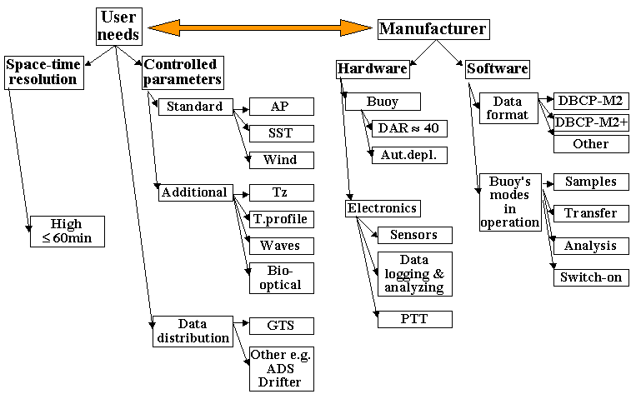

Fig.1. Current status of coordination between users and manufacturers relating to drifter monitoring of ocean’s active layer and nearsurface atmosphere
In general, the modern drifters are intended for investigation of physical processes in active layer of ocean and nearsurface atmosphere with one-hour time resolution. There is a set of standard parameters, which can be measured by buoys. For a few last years the additional measurements to study the heat processes inside active layer have become possible for scientific and applied applications. Manufacturers produce a reliable enough product, which fully corresponds with functioning specifications for drifters. There is a high level of reliability and organization for the data transfer from buoy to a user via satellite link.

Nowadays it could be said that a technological phase of development of drifter activity is behind, because there is low power consumption and reliable electronic hardware inside a buoy, lifetime of drifter is long enough and special-temporary resolution of drifter network is according to the IOC and WMO requests.

The first attempt to develop the Smart Buoy idea was so called Storm Buoy a batch of which was deployed for the first time in 2003 in the Tropical Atlantic [2]. There were a few versions of this buoy and the goal of first deployment was an evaluation of the buoy's capability to investigate the tropical waves transformation in air pressure depression and so on (disturbance of air pressure, tropical storm, etc.). Due to this goal, the buoy was equipped by modified AP sensor with new algorithm to calculate the value of air pressure. Second generation of this buoy has been equipped by additional temperature sensors to study the heat processes inside active layer. Deployments of these buoys allowed investigating the air pressure and temperature variability before, during and after tropical storms as it is shown in Fig.2.

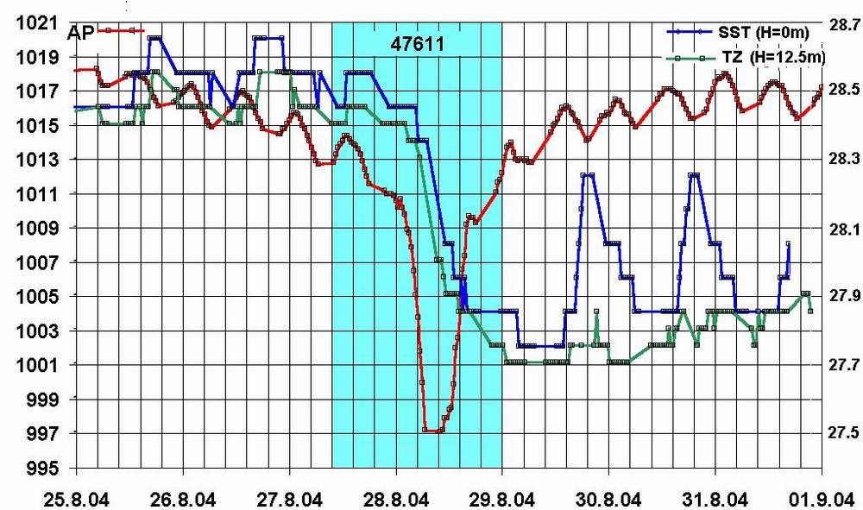
Fig.2. Variability of air pressure (red), sea surface temperature (blue) and subsurface temperature (green) before, during and after of the hurricane Frances that took place in August-September 2004 in the Tropical Atlantic
Introduction by Argos of multisatellite service and using of Rank=5 for DBCP-M2 data format have allowed to increase the temporary resolution of observations and had the uninterrupted set of data with half-hourly intervals between samples. This fact has more scientific applications than to be used for operational goals, because operational activity needs to have instantaneous data, while scientific activity is connected in general with archived data. However, both areas of interests could be completely satisfied by the results of hurricane Katrina registration with half-hourly resolution as it is shown in Fig.3.

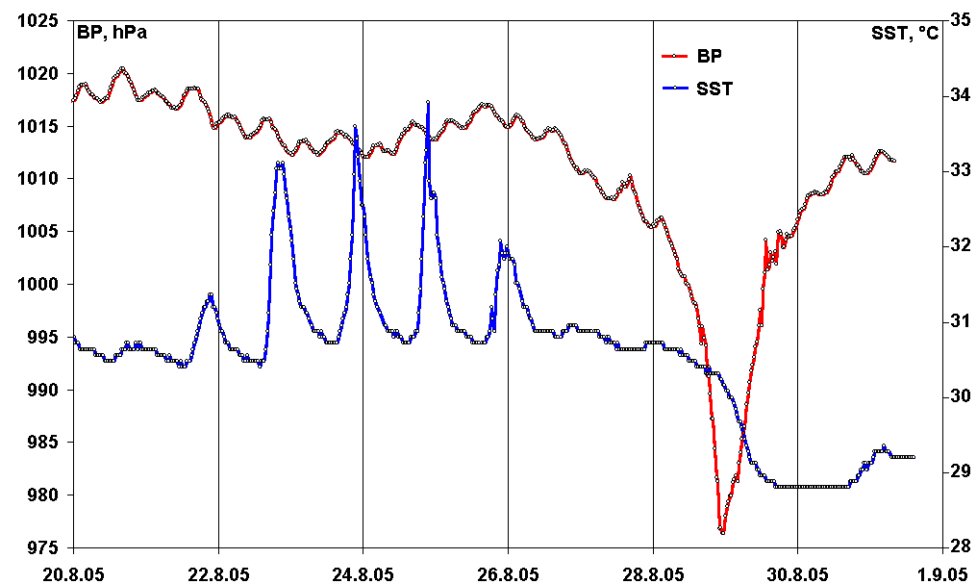
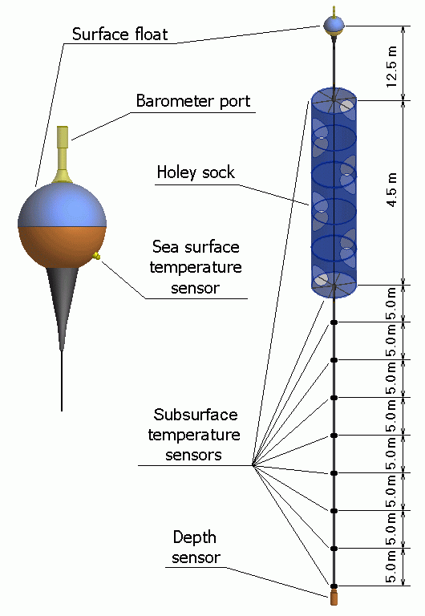
Fig.3. Variability of air pressure (red) and sea surface temperature (blue) before, during and after of the hurricane Katrina that took place in August-September 2005 in the Tropical Atlantic

The more parameters under control could have a perspective Smart Buoy, the more areas of applications could be found for this tool. From this point of view the SVP-BTC drifter with temperature chain could have a wide variety of applications. Structure of this buoy is shown in Fig.4.

Fig.4. Structure of the SVP-BTC drifter with temperature chain connected with lower ring of drogue

Investigation of heat processes in active layer plays a great role, because they are directly connected with climate processes on the planet. In particular, the study of heat accumulation in the ocean's tropical areas could provide better forecasting about storm activity and possible power (category) of hurricanes and typhoons to prevent large financial and economic losses. Pilot deployments of these buoys were completed in the Black Sea for 2004-2005 as it is shown in Fig.5 and Fig.6.

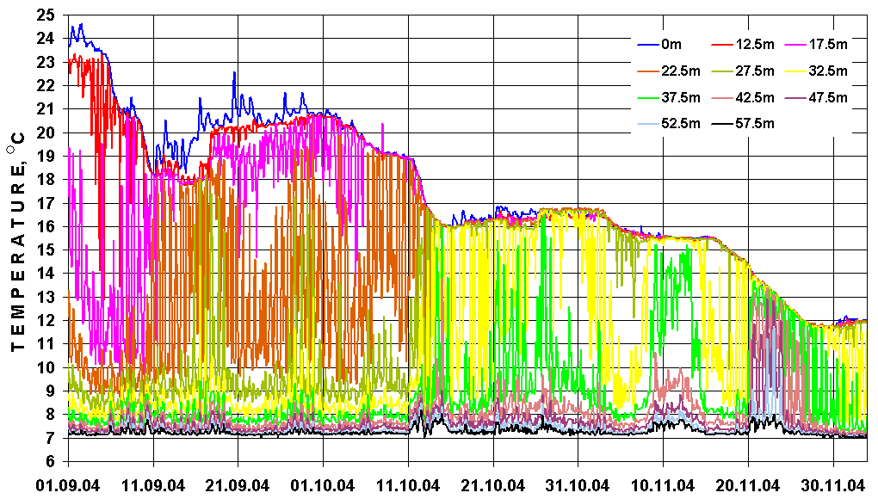
Fig.5. Cooling of upper layer of the Black Sea from August to November 2004 on the basis of SVP-BTC drifter data
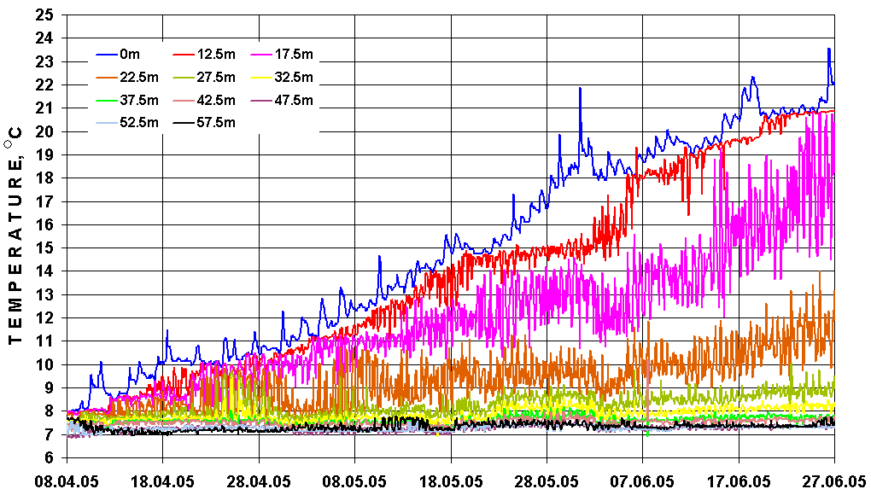

Fig.6. Heating of upper layer of the Black Sea from April to June 2005 on the basis of SVP-BTC drifter data

Heat processes within active layer with higher resolution for 16-17 May 2005 are shown in Fig.7.
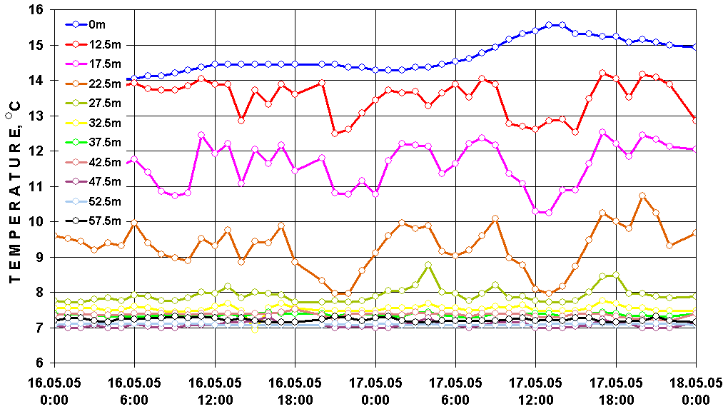
Fig.7. Variability of temperatures for different depths for 16-17 May 2005

One of the problems concerned with applications of this buoy is that the chain could have a deflection from vertical orientation under the influence of ambient currents. In this case, the real depths of temperature sensors could differ from theoretical values. To increase the accuracy of a sensor's location the mathematical model of a chain profile has been developed. This model uses the data from depth sensor, located at the lower point of chain, and describes chain's profile on basis of polynomial function.

To make sure that the buoy provides a correct data a comparative experiment was organized in the Black Sea on 10 October 2004. The temperature data from SVP-BTC drifter and ARGO profiling float were used during this experiment. The results are shown in Fig.8.

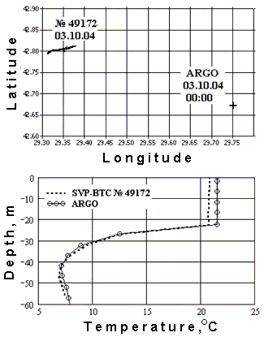
Fig.8. Locations of SVP-BTC drifter and ARGO profiling float and the results of temperature profiles measurements by both buoys

A distance between the buoys was 35 km approximately. Lower figure shows that the temperatures at the same depths from 60 m to 20 m were identical. Some shift of temperature data from 20 m to surface could be explained by special variability of temperature values in upper layer of the sea.

One of the goals to create Smart Buoy is that it should have smaller sizes of float as well as drogue and correspondingly have less number of batteries inside itself. On the other hand, it should have same lifetime and measuring capabilities with standard drifter. It is possible if a buoy will have another structure of data transfer, e.g. the transfer of rare data with decreased space-time resolution of measurements. To have some approach the drifter experiment was completed in the Black Sea.
New version of the barometric buoy with 34-cm surface float and additional temperature sensor at the end of tether line was developed in 2004 and 2 buoys were deployed in the Black Sea in January 2005. Main view of this buoy is shown in Fig. 9 together with 40-cm surface float of SVP-B standard barometric buoy.
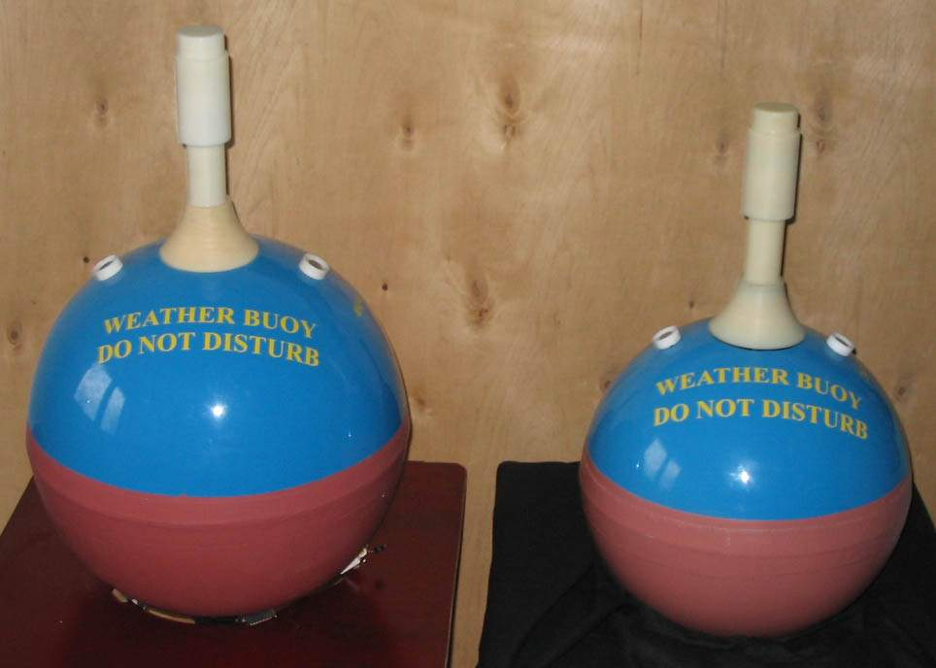
Fig.9. Surface float of standard 40-cm barometric buoy and surface float of new barometric buoy with 34-cm surface float

After deployment one buoy was very quickly picked up by a ship near Bosporus. Another buoy was in operation from January to August 2005. Both buoys were keeping all the sensors in operation up to stop transmitting. Trajectories of the buoys are shown in Fig.10.

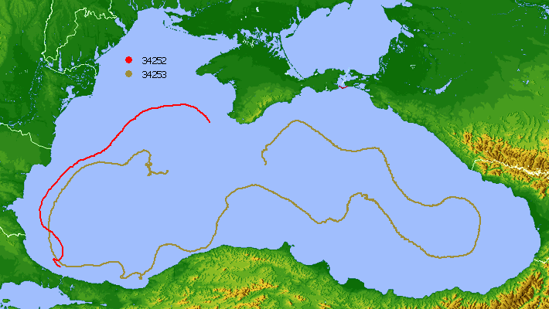
Fig.10. Trajectories of new SVP-BT mini drifters in the Black Sea from January to August 2005

Variability of air pressure, sea surface and subsurface temperatures from the buoy with longer lifetime is shown in Fig.11.
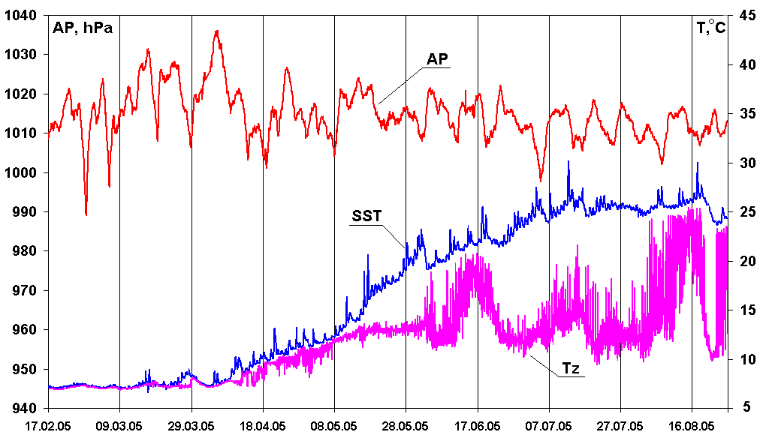

Fig.11. Variability of air pressure, sea surface and subsurface temperatures from the SVP-BT mini drifter
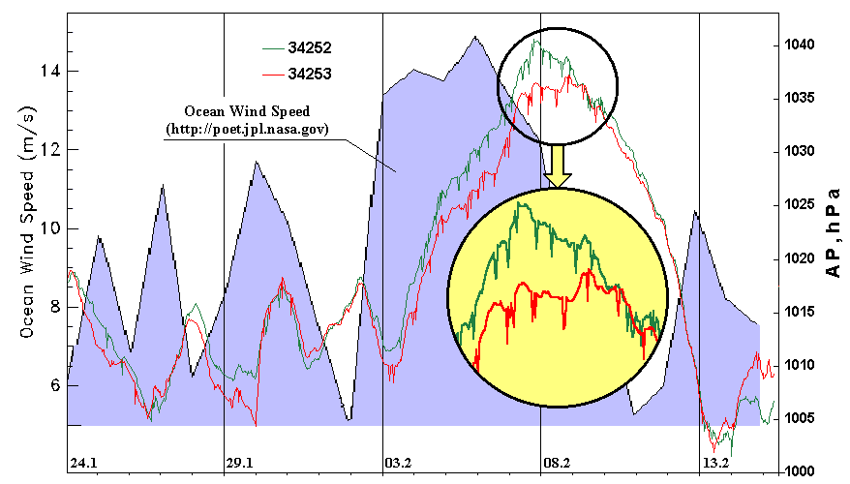
However, there were two problems as for this kind of drifter. One of them was that the buoy had insufficient reserve of positive buoyancy, the result of which was that the buoy sank after 7,5 months in operation because of biology fouling. Another problem was that the buoy with smaller surface float had so called spikes of air pressure, when velocity of environmental wind was more than 8-10 m/c. This phenomenon is shown in Fig.12. In contrast with 34-cm buoy the buoy with 40-cm hull does not have similar spikes when any wind takes place as it is shown in Fig.3. Thus, there is here a matter for further investigation to have a reliable SVP-B mini drifter.

Fig.12. Air pressure spikes when environmental wind velocity is more that 8-10 m/s

The results of these jobs have allowed suggesting of the following way to develop Smart Buoy idea (Fig.13).
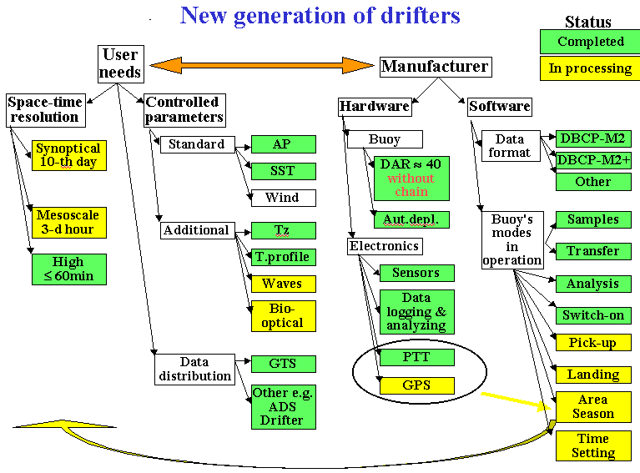
Fig.13. Suggested status of coordination between users and manufacturers relating to drifter monitoring of ocean’s active layer and nearsurface atmosphere by means of Smart Buoy
Fig.13 is identical with Fig.1 as for the items of green color. Nowadays, these items could be defined as technologically completed ones. Another thing is the items of yellow color that is an entity of our suggestion. The determinant factor of the proposal is that users (buoy operators) in coordination with manufacturers should determine what minimal space-time resolution is necessary when ocean has stable calm conditions. For example, this situation could take place in areas of tropical convergence after the tropical storm season. In this case, the buoy could provide single measurement for 10-day period. For many meteorological goals the 3-hour measurements are enough. This matter should be a thing to be discussed for nearest time during dialogue between users, manufacturers and data transfer experts. The results of this discussing should be the following: “What space-time resolution needs to be used for different areas for appointed time”.

It is obviously also that new measuring capabilities should be added to current buoys. First of all, the wave parameters are very important for many operational and scientific goals. Study of biological and optical variability is becoming more and more important to support a full control of complex processes in the ocean.

What could be an entity of Smart Buoy from our point of view? A manufacturer produces the buoy with installed software, which includes the blocks of geographical and temporary data. Each block should be connected with corresponding frequency of samples and data format to transfer the information. After deployment, the buoy has to determine what is the current time (month, day, hour and minutes) as well as its geographical location. After these procedures, the buoy according to installed program has to determine what version of measurements needs to be used (e.g. hourly, 3-hour or 10-day). Because the buoy has astronomic time inside itself, the measurement can be provided in round hours. After some time (e.g. start of tropical storm season), the buoy changes the mode of measurement and uses for example most often samples.

Our suggestion is that the GPS receiver could be used to provide these functions for a drifter. Its role will be not only locations (that allows to economy power consumption by means of decreasing the power of transmitting), but also the determination of area and current astronomic time. More, GPS could be used for self-determination if the buoy came ashore with following its self-switching off. Fig.14 shows the new Argos 0,5 W PTT integrated with GPS receiver that is developed now in Marlin to be used according the goals described above.
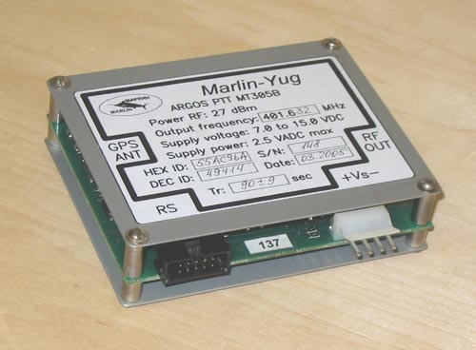
Fig.14. Marlin MT305A Argos PTT with 0,5 W transmitting power and integrated with GPS receiver.
Conclusions

1.Deployment of the 1250th drifter has marked that the technological phase of drifter technology development is behind.

2.Further investigations could be directed to have more drifters in operation, more parameters under reliable control as well as longer lifetime when constant hardware budget.

3.One of the possible ways might be a creating of drifter networks, when each drifter could choose resolution of sensors, frequency of samples, number of sensors in operation, variants of data transfer, etc. according variability of the parameters under control.

4.The further efforts of network operators, data users and drifter creators could be directed to develop some requests for those drifters to be realized by manufacturers with smallest financial and material spending.

Reference
1. Motyzev S., Horton E., Brown J. “Smart Buoy” project its possibilities and advantages. Argos forum. Special Ocean observation. No.59. Ramonville cedex, France. 2002. P.18.

2. Motyzhev S., Brown J., Horton E., Lunev E., Tolstosheev A., Motyzhev V. Practical Steps for “Smart Buoy Project Realization. Research, Applications and Developments Involving Data Buoys. UNESCO DВCP CD ROM Technical Document Series, No.24, 2004. P.1-9.

