14411-05/APP/O/MC, ANNEX

GLOBAL COLLECTING CENTRES FOR MARINE CLIMATOLOGICAL DATA

ANNUAL REPORT 2004

Germany United Kingdom

Deutscher Wetterdienst Met Office
GCC GCC (S9)
Saughton House
P.O.-Box 30 11 90 Broomhouse Drive
D-20304 Hamburg Edinburgh, EH11 3XQ
Germany Scotland, UK
email: gcc@dwd.de email: gcc@metoffice.gov.uk
homepage

Introduction
The GCCs started their operations in 1994, as a result of the revision of the Marine Climatological Summaries Scheme, in line with Rec. 11, CMM-XI and Resolution 10, EC-XLV 1993. This had the goal of simplifying, improving the quality, and accelerating the data flow within the scheme. The contributions by members should be made quarterly. It is the responsibility of each GCC to check if the minimum control procedures have been applied and then to dispatch a copy of all the quality controlled data, collected from Contributing Members, to the remaining Responsible Members (also on a quarterly basis). The GCCs are expected to work in close cooperation, applying identical principles and being able to continue the total dataflow in the scheme, even in the case of possible failure of one of them.

This 2004 report marks the eleventh year of GCC operation.

Data Contributions 2004
In 2004, the total amount of collected data was a little over 1.1 million observations (see Table 1), which is about a 3% increase on last year. The contributions came from 17 countries and although this number is the same as last year, this still only represents less than one third of the total potential Contributing Members.

In figure 1, it is possible to see that the volumes of data over the last eleven years have often varied significantly. However, figure 2, displays a notably smoother variation with the chart displaying only unique data (non-duplicates), implying that in some years there has been large submissions of duplicated data.

The distribution of observing periods within the 2004 continues to be spread over more than a decade (figure 3 and 4). It is possible to see that data has been received for as far back as 1988 and that 44% of the observations were from 2003 and 2004 alone. Although the percentage of old data is small it still represents a valuable addition to the global database. The amount of data received per month can still vary greatly (figure 5). Contributors do tend to submit data quarterly but the number of members only reporting once a year (or ad hoc) is getting larger.

The areal distribution map, in figure 6, shows the main shipping lanes between continents with data concentrated at the coasts. The map displays clearly that there are still numerous occasions where ships are reporting an ‘on-land’ position. Although this number appears to be decreasing, it is still something the Contributing Members need to consider.

VOSClim Contributions 2004
The IMMT-2 format, which allowed the delayed mode submission of VOSClim elements, came into effect in January 2003. This format is integral to the VOSClim Project, which is an ongoing study within JCOMM's Voluntary Observing Ships' Scheme. It aims to provide a high-quality subset of marine meteorological data, with extensive associated metadata, to be available in both real-time and delayed mode to support global climate studies. Since the project commenced, nine CMs have recruited VOSClim ships. However, in 2004, only three CMs have submitted data from these ships and only one country has provided data with the extra VOSClim additional to the GCCs.

In 2004, the VOSClim contributions made up 4% of submissions to the GCCs. However, the number of observations that contained actual VOSClim additionals was only 5249 (0.5%).

(Website http://lwf.ncdc.noaa.gov/oa/climate/vosclim/vosclim-survey.html provides further information on the project and details of these ‘listed’ ships.)

Data Processing
- The received data were in IMMT format (40% IMMT-1, 46% IMMT-2 and 14% already in IMMT-3 format (see Development section)). Some contributors still continued the mistaken practice of coding "/" or "-" for "missing data" (as in FM13) rather than the blank required by IMMT.

- As before, the GCCs corrected, where possible, simple errors in organizational data (elements 2-8, 42: date/time, position and identifier) normally after consultation with contributors. Correct values of these data are essential for any successful archival and retrieval. Correct positioning still seems to be an issue to be considered by the Contributing Members.

- Subsequent processing checked the data consistency by applying the WMO Minimum Quality Control (MQC) standards. Flags were set by the GCC MQC procedure where a quality control query was raised, especially when the original data were without any flag information. The proportion of data sets that required this action decreased slightly to about 2% (2003: 4%). The existing flags in the remaining reports were checked and changed where necessary as described in the 1994 report.

- Most data were exchanged by e-mail. If appropriate the transfer was also achieved by anonymous ftp. Floppy disk is of course accepted, or any transfer medium bilaterally agreed between contributor and GCCs.

Errors
The general error rate has decreased to 0.1% in 2004 (occasions where flagging by national quality control was inconsistent with GCC MQC control). No particular type of error dominated. Duplicate data from one source still occurred and had to be rejected due to bilateral consultation.

Some records with uncorrectable errors had to be rejected, in particular those having an invalid date, time or position. Rejected data were placed in a "dregs" data file which accompanies the collective of good data and dispatched quarterly to the Responsible Members. GCCs found these to be about 0.3% in 2004, which mostly arose from duplicate data.

Looking at figure 7, there is evidence that the percentage of elements reported blank is generally increasing. Figures 7a and 7b show the percentage of reported blank elements for VOShips and automated stations. It is interesting to see that for several elements there have been some significant changes since 2003. The most commonly reported blank elements are those which require to be observed by eye (i.e. visibility, present weather and clouds) and, for automated stations (figure 7b), these elements are reported blank in more than 80% of observations. However, for this analysis to be valid it is essential that observation platform (element 41) is accurate.

Detailed bilateral correspondence was conducted with many countries on the improvement of data quality and resolving of problems.

Dispatch of Data
During the reporting period four data collectives were dispatched to Responsible Members at the end of each quarter. The dispatched data comprised of three files, as usual; the first holding all those reports which passed MQC successfully, the second contained all those which were rejected because of errors in organisational information and the third holding information on rejected observations. It is up to each Responsible Member to decide how to proceed with these data, either ignoring or correcting the “dregs”.

It has been noted that on some occasions Contributing Members have resent parts of their data in later datasets. These duplicates cannot be rejected by the GCCs if they are submitted within different quarters and are only noticed by the Responsible Members after further processing.

Developments
In July 2004, there was a meeting of the JCOMM Expert Team on Marine Climatology and the review of the MQCS and IMMT format took place. It was agreed that QC indicators for the VOSClim elements should be added to the IMMT format, and a fifth version of the MQCS was also agreed. These can be found in the annex of the ETMC report on the JCOMM publications Webpage:

http://www.wmo.ch/web/aom/marprog/Publications/publications.htm.

The third update of the MQCforCM software should be ready for distribution shortly. This will include changes to the checks according to MQCS-V, checking present weather codes from automatic stations, checking of the VOSClim additional elements and the addition of the new flags in the IMMT-3 format.

Summary
Most contributors are applying MQC or other kinds of advanced quality control before sending their data to the GCCs. Best results can be achieved if data are corrected, instead of being flagged as "doubtful" or "erroneous". This can be done most competently by the Contributing Members themselves. A good preventive tool may be the results of the quality monitoring activities by WMO and UK, or the use of an automatic system which provides immediate minimum quality checks just after the composition of an observation. Avoiding errors at the origin appears to be the best strategy for the improvement of quality.

Two tools are available free of charge: 1. Electronic journal software (for example TurboWin, this can be ordered from KNMI, The Netherlands). 2. A consolidated MQC-software is offered by GCCs.

Members are encouraged to improve the steadiness of their contributions where applicable and to realise the quarterly cycle of the data flow to enable the archives to respond to the needs of the climatological user community for timely and complete marine climate data.

GCCs invite all members to provide further feedback, as well as data, for the benefit of the whole system and the integrity of the marine database.

Abbreviations
CM | Contributing Member
GCC | Global Collecting Centre (MCSS / JCOMM)
IMMT | International Maritime Meteorological Tape
JCOMM | Joint WMO/IOC Technical Commission for Oceanography and Marine Meteorology
KNMI | Koninklijk Nederlands Meteoroloisch Instituut
MQC | Minimum Quality Control (WMO Standard)
UK | United Kingdom
VOS | Voluntary Observing Ship
VOSCLIM | VOS Climate (Subset for High Quality Data - Project)
WMO | World Meteorological Organization

Country Name | ISO Alpha-2 code | Number of observations
Argentina | AR | 472
Australia | AU | 49474
Denmark | DK | 41104
France | FR | 137581
Germany | DE | 589681
Hong Kong, China | HK | 6065
India | IN | 10407
Israel | IL | 8766
Japan | JP | 39626
Malaysia | MY | 5801
Netherlands | NL | 43722
Norway | NO | 11390
Poland | PL | 2194
Russian Federation | RU | 100840
Singapore | SG | 211
South Africa | ZA | 2381
United Kingdom | GB | 65280
Total for 2004 |  | 1114995
 | Table 1

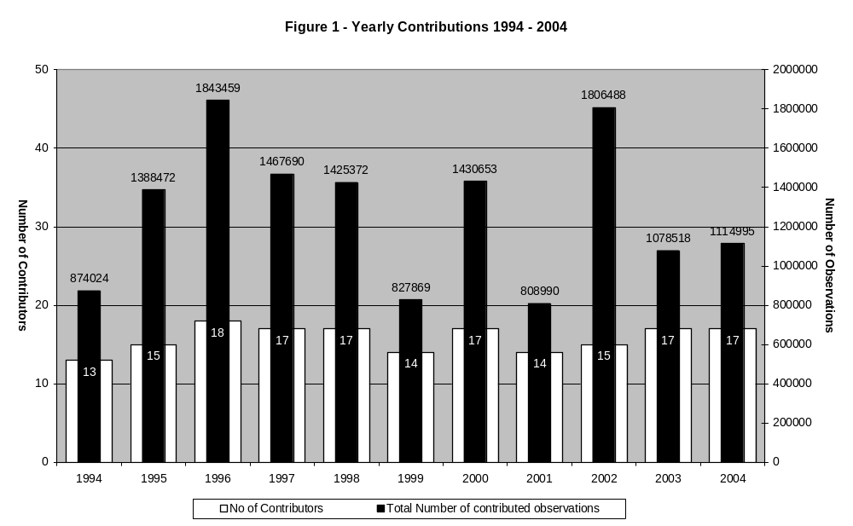
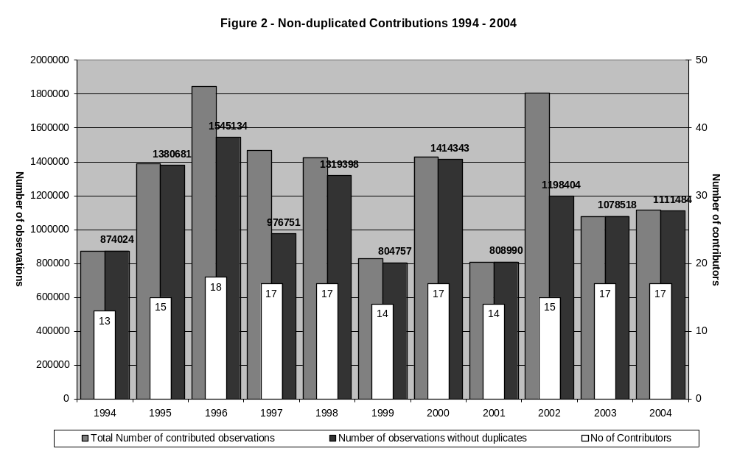
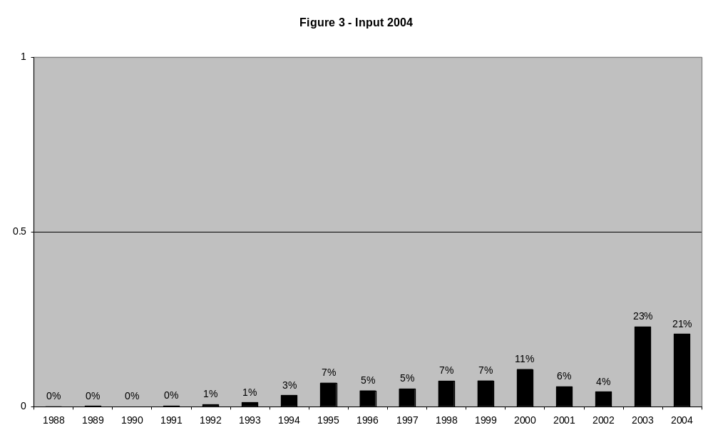
Figure 4 – Input by Country
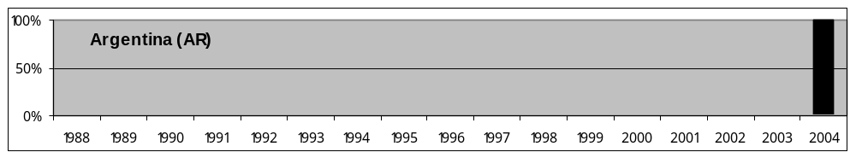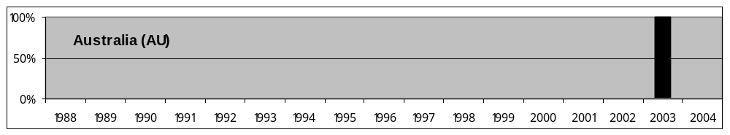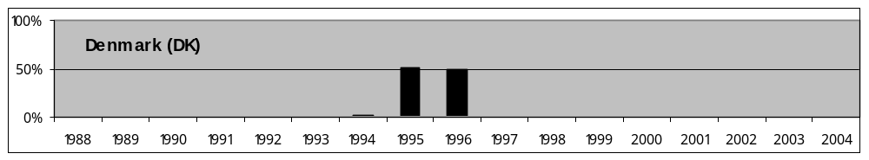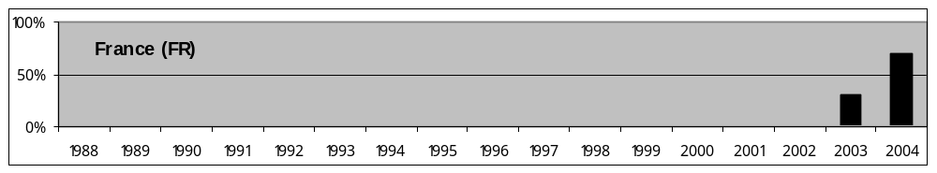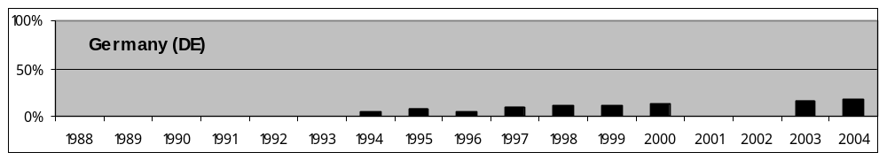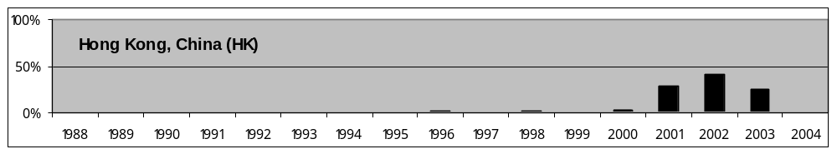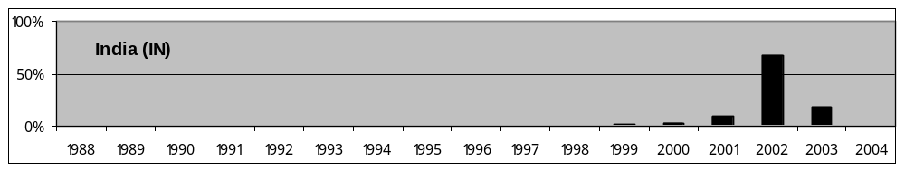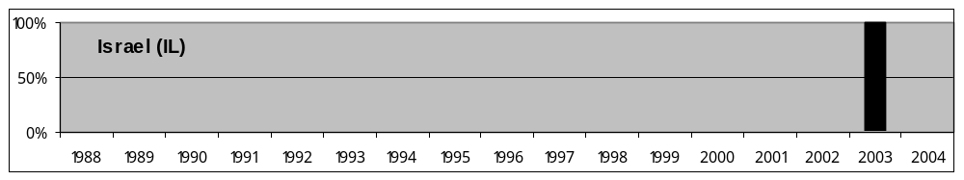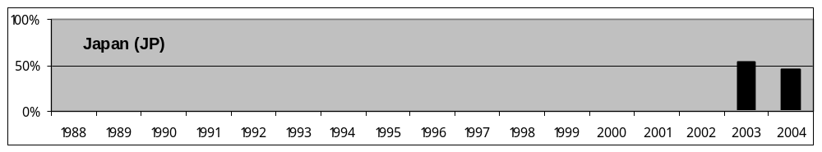

Figure 4 cont. – Input by Country
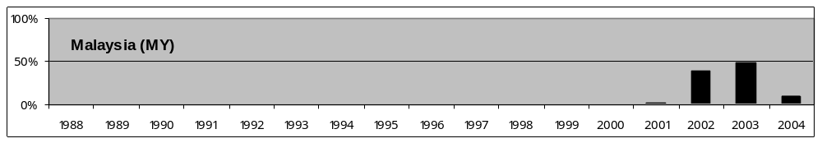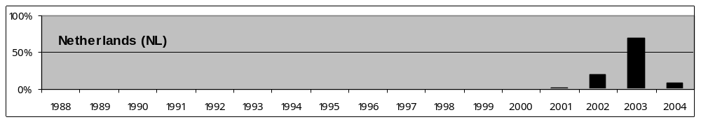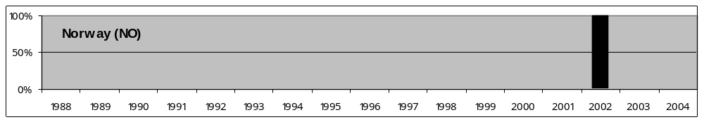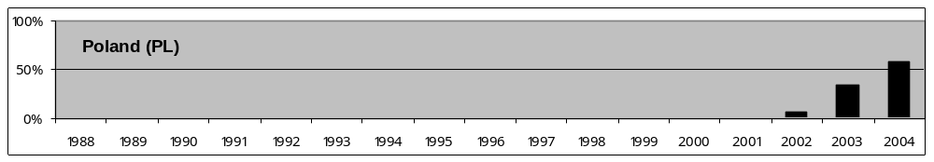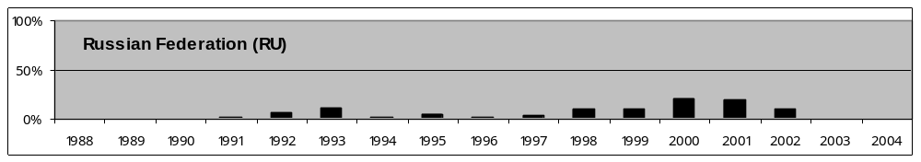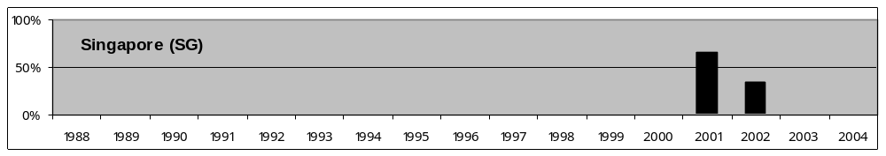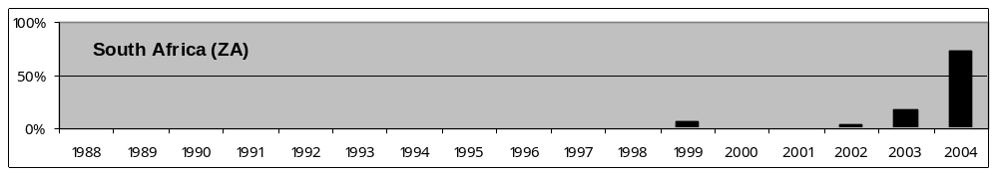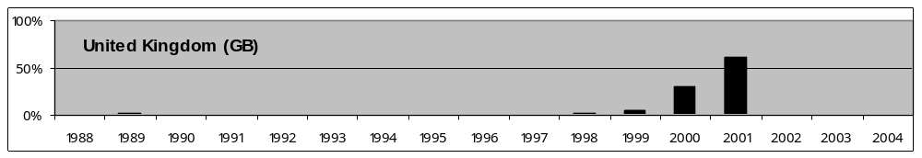

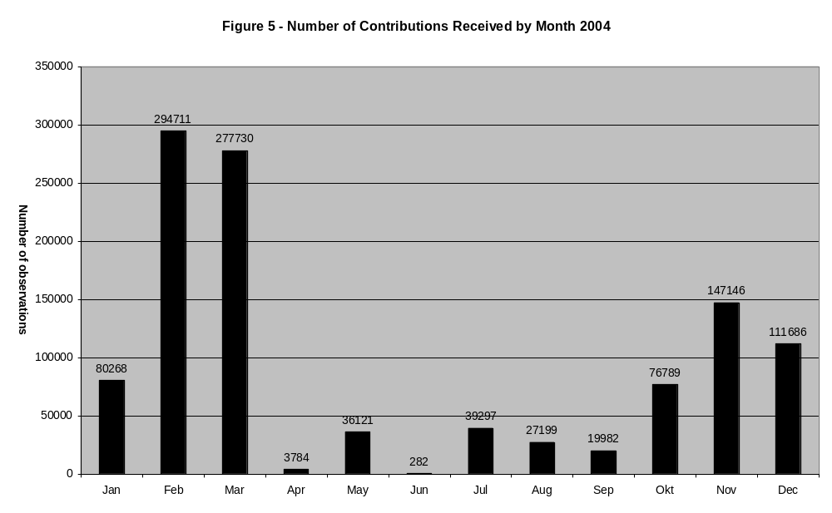

Figure 6 – Areal Distribution of Reported Positions
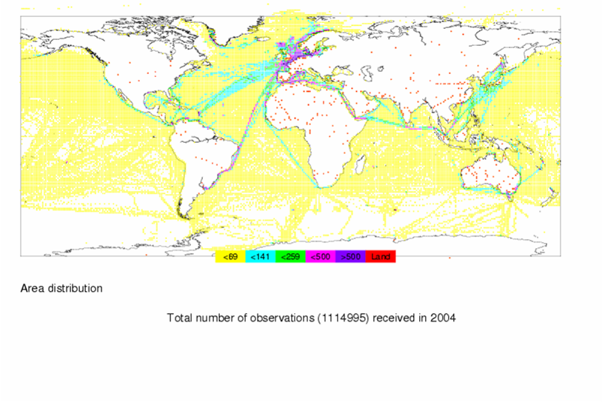
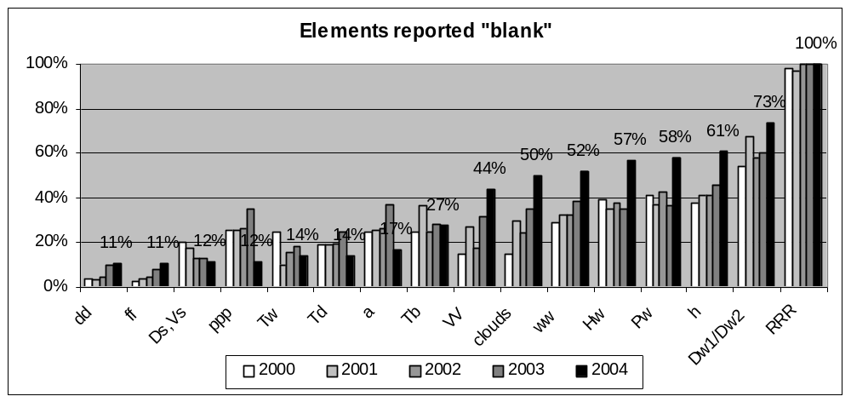Figure 7

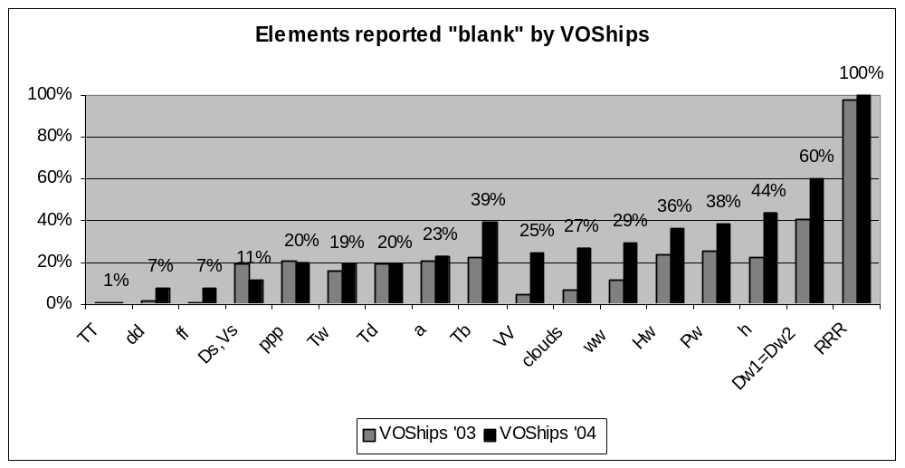Figure 7a

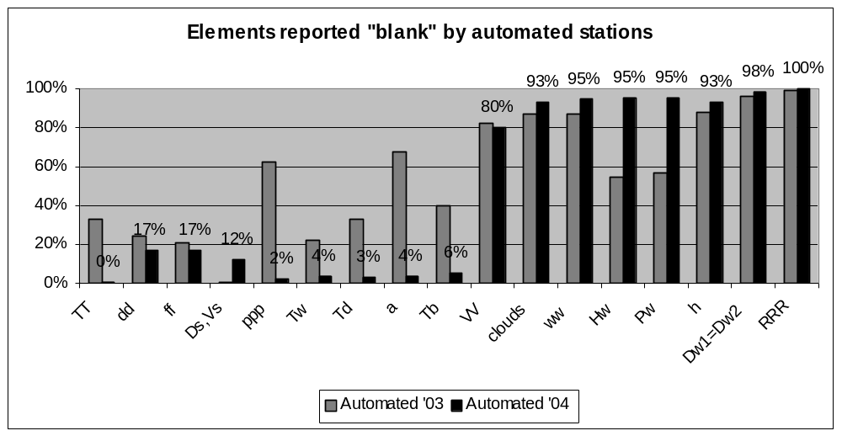Figure 7b

http://www.dwd.de/en/FundE/Klima/KLIS/int/GCC/GCC.htm

