INTERGOVERNMENTAL OCEANOGRAPHIC COMMISSION (OF UNESCO)  _____________ |  | WORLD METEOROLOGICAL ORGANIZATION  ___________

ARGOS JOINT TARIFF AGREEMENT
TWENTY-EIGHTH MEETING

Cape Town, Republic of South Africa, 17-18 October 2008

FINAL REPORT

NOTES

WMO DISCLAIMER

Regulation 42
Recommendations of working groups shall have no status within the Organization until they have been approved by the responsible constituent body. In the case of joint working groups, the recommendations must be concurred with by the presidents of the constituent bodies concerned before being submitted to the designated constituent body.

Regulation 43
In the case of a recommendation made by a working group between sessions of the responsible constituent body, either in a session of a working group or by correspondence, the president of the body may, as an exceptional measure, approve the recommendation on behalf of the constituent body when the matter is, in his opinion, urgent, and does not appear to imply new obligations for Members. He may then submit this recommendation for adoption by the Executive Council or to the President of the Organization for action in accordance with Regulation 9(5).

© World Meteorological Organization, 2008

The right of publication in print, electronic and any other form and in any language is reserved by WMO. Short extracts from WMO publications may be reproduced without authorization provided that the complete source is clearly indicated. Editorial correspondence and requests to publish, reproduce or translate this publication (articles) in part or in whole should be addressed to:

Chairperson, Publications Board
World Meteorological Organization (WMO)
7 bis, avenue de la Paix Tel.: +41 (0)22 730 84 03
P.O. Box No. 2300 Fax: +41 (0)22 730 80 40
CH-1211 Geneva 2, Switzerland E-mail: Publications@wmo.int

IOC (of UNESCO) disclaimer

The designations employed and the presentation of material in this publication do not imply the expression of any opinion whatsoever on the part of the Secretariats of UNESCO and IOC concerning the legal status of any country or territory, or its authorities, or concerning the delimitation of the frontiers of any country or territory.

_______________

C O N T E N T S

Report of the Meeting 4

Annex I - List of Participants 12

Annex II - Agenda 15

Annex III - Report on the 2008 Agreement 16

Annex IV - Report on 2007-2008 Operations 25

Annex V – 2007-2008 System Improvement 43

Annex VI - Review of the structure of the Tariff Agreement and related matters 59

Annex VII - Terms and Conditions of the Global Agreement for 2009 68

Annex VIII – Role of the JTA Representative of Country (ROC) 72

Annex IX - Format for the national reports to the JTA 77

Annex X - National report on current and planned programmes 78

Annex XI – List of Representatives of Country (ROCs) for Argos 97

Annex XII - List of Acronyms and Other Abbreviations 100

REPORT OF THE MEETING

1. INTRODUCTION

For more quarter of a century, the Joint Tariff Agreement (JTA) scheme has served as a robust example of international cooperation that is managed at the working level. It continues to provide an effective, self-governing global forum through which users’ needs and requirements are presented, reviewed, and carried forward as an influential part of a wider decision-making process.

The JTA is now regarded to be mature, and the tariff structure has been greatly simplified, bringing benefits both to CLS and to the majority of users, including the Data Buoy Cooperation Panel. The mature status of both the DBCP and Argos JTA, as well as the participants’ request for efficient use of available resources, has raised the need to rationalize the modus-operandi of both bodies. The 27th meeting of the JTA (2007, Jeju, Republic of Korea) therefore agreed to reduce the length of the regular meeting from 3 to 1.5 days – 1 day for review/negotiation of the tariff and discussion on users’ requirement, and half a day for wrap-up/conclusion and agreement on the workplan. It was hoped that the new structure would ensure efficiency for future meetings, and reduce pressure on participants’ time and budget.

The following format is introduced from this year’s meeting report:

- Introduction;
- Actions and decisions of past meeting with review status;
- Action sheet of this meeting, with records of necessary information and decisions;
- Records of formalities, including elections and decision on next meeting;
- Annexes containing all necessary information

The format of the report is to be reviewed and decided upon at the regular meetings. As in the case of previous meetings, the report will be available online via the JCOMM website.

2 sTATUS OF ACTIONS FROM the Previous Meeting

No | Action item | By whom | Deadline | Status
1 | To assist the JTA Chairperson in the completion of the report “OPSCOM and the JTA” | Chris O’Connors /  JTA Chair | JTA-XXVIII  (Oct. 2008) | Done
2 | To implement the PMT pilot activity as soon as possible and to reactivate the offer concerning new generation PMTs | CLS | ASAP | Done
3 | Users who need downlink capability to start using the demonstration PMTs as soon as they become available | Users | JTA-XXVIII  (Oct. 2008) | Ongoing
4 | To promote the PMT pilot activity at the national level | ROCs | JTA-XXVIII  (Oct. 2008) | Ongoing
5 | To bring the issue of cost implications for installing METOP compatible antennas to the attention of the next OPSCOM (GTS delays). | CLS | OPSCOM- 42  (mid 2008) | Done
6 | To install new antennas according to the following priority areas: the South Atlantic, the Indian Ocean, and the Southwest Pacific Ocean. | CLS | JTA-XXVIII  (Oct. 2008) | Ongoing
7 | To offer solutions for improving data timeliness and to develop data timeliness monitoring tools | CLS | JTA-XXVIII  (Oct. 2008) | Partly done ⁽¹⁾
8 | To print and distribute the vandalism leaflets in appropriate languages to the fishing industry or fishing authorities | CLS | Ongoing | Done
9 | To translate the vandalism leaflet in Korean | KMA | JTA-XXVIII  (Oct. 2008) | Pending
10 | To translate the leaflet in other languages as required | DBCP Members | JTA-XXVIII  (Oct. 2008) | Done (Japanese)
11 | To provide the WMO and IOC Secretariats with the list of countries using Service Argos for fishing vessel monitoring | CLS | ASAP | Done
12 | To continue with the current arrangements for the independent Chairperson, and JTA to provide a limited funding for covering DBCP Members having activities on behalf of the JTA. CLS to contribute to the DBCP Trust Fund (total USD 17,500) | CLS | Early 2008 | Done
13 | To write to the OPSCOM co-chairpersons in order for OPSCOM to consider the issue of providing datasets on a free and unrestricted basis. | Chairperson | OPSCOM-42 | Done
14 | To develop further the tool regarding status of local receiving stations (percentage of time they are operational) so that to display additional information such as what operational satellites are being received via each station. | CLS | JTA XXVIII  (Oct. 2008) | Done
15 | To make the Brazilian Satellites data available via the new Argos data processing system. | CLS | ASAP | Pending ⁽²⁾
16 | To study new scenarios regarding the unused IDs | CLS | JTA XXVIII  (Oct. 2008) | Done ⁽³⁾
17 | To draft the next Five Year Plan (FYP) to be discussed at the next JTA meeting. | CLS | JTA XXVIII  (Oct. 2008) | Done ⁽⁴⁾
18 | To produce a more simple JTA Session final report for the next Session that will stress on recommendations, agreements, and agreed action | Secretariat | JTA XXVIII  (Oct. 2008) | Proposed at JTA-28
19 | To lead the revision process of the Role of the ROC document and make a synthesis to be reviewed at the next JTA Session. | Chairperson | JTA XXVIII  (Oct. 2008) | Done
20 | To establish a mailing list and provide the ROCs with information via an electronic mailing. | CLS/  JCOMMOPS | Early 2008 | Done
21 | To draft out a new template for the national reports to be attached as an annex to this meeting’s final report | Secretariat | ASAP | Done ⁽⁵⁾

Notes:
(1) Monitoring tools done, working with antenna operators for “bad” antennas.
(2) Reference: Annex V to this report.
(3) See discussion recorded under item 3.4.
(4) Reference: item 3 of this report.
(5) Reference: Annex IX to this report.

3 Actions and Decisions of the current Meeting

No. | Ref. | Action item | By whom | Deadline
1 | 3.2.2-3.2.4  Annex V | To report on the progress of Argos-3 Pilot Project | CLS | JTA-XXIX  (Oct. 2009)
2 | 3.3.1-3.3.2 | To send a Joint WMO-IOC letter to OPSCOM to address data delay issues, including NESDIS’ efforts for blind orbit data being collected by the NPOES antenna in Svalbard | Secretariat / DBCP and JTA chairs | ASAP
3 | 3.3.1-3.3.2 | To pursue negotiations for the installation of new antennas to cover the South Atlantic and the Indian Ocean regions | CLS / SAWS | ASAP  (to report to JTA-XXIX)
4 | 3.3.1-3.3.2 | To enhance Hyderabad LUT station performance | INCOIS / CLS | Nov. 2008
5 | 3.3.1-3.3.2 | To ensure data from NOAA-15, 16, 17, and 18 are being received by IRD and Météo France stations in La Réunion Island | IRD-Météo France - CLS | ASAP
6 | 3.3.1-3.3.2 | 1)Investigate existing antennas in the Indian Ocean area and 2) try to connect them to the Argos network | CLS | 1) Dec. 2008  2) ASAP in 2009
7 | 3.3.1-3.3.2 | Study other possibilities to add new antennas in Indian Ocean (Ideally in central Indian Ocean) | CLS | 2009
8 | 3.3.3  Annex V | To continue efforts for making the Brazilian Satellites data available via the new Argos data processing system | CLS | ASAP
9 | 3.4.1 | To circulate the CLS Financial information – as presented by CLS during the Meeting – at least 3 weeks prior to the JTA meeting (via ROC mailing list) | CLS | 15 days before JTA-XXIX  (Oct. 2009)
10 | 3.4.3 - 3.4.5 | To inform ROCs on new tariff scheme for unused IDs, with the list of unused IDs for each country. | CLS | 9 Nov. 2008
11 | 3.5.1 – 3.5.2 | [5-Year Plan] To issue a questionnaire (to their users to collect information on future usage of the Argos system), and a list of users to the ROCS for distribution | CLS | 15 Mar. 2009
12 | 3.5.1 – 3.5.2 | [5-Year Plan] To answer to the CLS questionnaire on foreseen usage for their country or area of responsibility, in terms of type of activity (animals, buoys, drifters, …) and yearly evolution | ROCs | 1 June 2009
13 | 3.5.1 – 3.5.2 | [5-Year Plan] To circulate a preliminary five year plan for review by the ROCs | CLS | 1 Sep. 2009
14 | 3.5.3 | To review the “role of ROCs” document and update as necessary | Jrev | to report to JTA-XXIX
15 | 3.5.4 | To explore possible support mechanism for ROCs to attend JTA Meetings | Chair, Jrev, CLS | ASAP  (to report to JTA-XXIX)
16 | 3.5.5 | To collect WMO and IOC governing bodies’ decision regarding the JTA and make them available to the ROCs | Secretariat | ASAP
17 | 3.5.5 | To provide financial estimation for the Joint Secretariat support to the JTA | Secretariat | ASAP
18 | 3.5.5 | To discuss on a possible arrangement for funding to cover the cost of the Joint Secretariat’s support for JTA activities | JTA and CLS | To be reported at JTA-XXIX (Oct. 2009)
19 | 5.1.1 | To continue with the current arrangements for the independent Chairperson, and JTA to provide a limited funding for covering DBCP Members having activities on behalf of the JTA. CLS to contribute to the DBCP Trust Fund (total USD 15,000) | CLS | Early 2009
20 | -- | To communicate with OPSCOM on incorporating various users’ requirements, including the animal trackers | ROCs | ASAP and ongoing
21 | -- | To communicate with various users to incorporate their requirements in the regular meeting | ROCs | JTA-XXIX (Oct. 2009)
22 | -- | To circulate a note (via email) to ROCs and major participants, on 1) purpose of the regular meeting, 2) list of issues, and 3) outcome to be sought in the meeting. | Chair | Before JTA-XXIX (Oct. 2009)
23 | -- | To provide a brief summary of the OPSCOM | Chair | After regular OPSCOM meeting
24 | -- | To organize an open, informal pre-discussion meeting | Chair, Vice-chair | 1 day before JTA-XXIX (Oct.2009)
25 | -- | CLS to provide updated ROC list to Secretariat | CLS | ASAP and ongoing

3.1 Review 2008 Global Agreement

3.1.1 Detailed information on the 2008 Global Agreement is given in Annex III.

3.2 Technical Development

3.2.1 The full reports on 2007-2008 operations, on system improvements and development projects are attached as Annex IV and Annex V, respectively.

ARGOS-3 PILOT PROJECT

3.2.2 At the 24th Session of the Data Buoy Cooperation Panel (13-16 October 2008, Republic of South Africa), CLS proposed to establish an Argos-3 Data Buoy Evaluation Pilot Project. With support from CLS, two drifter manufacturers and one float manufacturer are now performing the necessary engineering work to replace the standard Argos PTTs in their products with the new Argos-3 PMT manufactured by Kenwood. Each would develop a prototype Argos-3 platform, test it, apply modifications if needed, then produce 10 pre-production drifters (2-3 floats) for evaluation by interested members of the community.

3.2.3 Following the rationale adopted by the DBCP Iridium Pilot Project, CLS suggested that a community-wide Steering Group be established to: (i) identify users interested in deploying the pre-production buoys to evaluate Argos-3; (ii) define the evaluation criteria, methods and procedures; (iii) coordinate and harmonize the desired multiple evaluations, and (iv) provide a community-wide forum to present and disseminate the evaluation results and conclusions.

3.2.4 CLS offered to purchase 50 SVPs (10 buoys from each manufacturer), including 25 SVPBs, while the participants would support the Argos service charges. With appreciation for the generous offer, the DBCP endorsed the Pilot Project. The DBCP also agreed to fund the upgrading with barometers of the remaining 25 units buoys within the PP framework.

3.3 Review Users’ Requirements

3.3.1 The 24th Session of the Data Buoy Cooperation Panel (13-16 October 2008, South Africa) expressed the following specific recommendations to the JTA:

The Panel sincerely thanked CLS for its ongoing efforts to improve the quality of service available to its members, but remained seriously concerned about the delays in collecting buoy data from certain ocean regions. These delays, resulting in many observations failing to meet the cut-off for forecast model ingestion, brought into stark focus the cost effectiveness of data buoy operations in these areas.

Moreover, these delays had been brought to CLS's attention by the Panel for several years, yet an effective remedy remained to be put in place. As establishing cost effectiveness for data buoy deployments was a core objective of the Panel, the Panel was now very anxious to seek a timely resolution to these problems, and urged CLS to prioritise the matter and respond to it with a time-lined action plan.

The delay problems appeared to be the result of two separate technical issues, both of which seemed capable of relatively easy resolution if priorities were asserted:

- the lack of adequate LUT cover in the Indian Ocean and South Atlantic;
- the lack of blind orbit retrieval through the NPOESS antenna at Svalbard, principally affecting timeliness for stored datasets from the South Atlantic and Southern Pacific.

In consequence, the Panel made the following urgent recommendations to CLS via the JTA:

- CLS should explore all available options for improving LUT data retrieval from affected areas, and, as time was of the essence, report back during the intersessional period with a detailed time-lined action plan to resolve the problems;

- Efforts should continue to allow ingestion by NESDIS of blind orbit data being collected by the NPOESS antenna in Svalbard. The DBCP appreciated the efforts being undertaken by NESDIS on this project, but remained frustrated by the apparent lack of progress after several years. In this context, the DBCP Chair had agreed to make further representations to NESDIS regarding the collection of blind orbit data via Svalbard, and would welcome any further weight that the JTA might add to its request.

3.3.2 In response to this request, the Meeting agreed on the actions to be taken during the intersessional period, as listed in the table of actions (item 2 to 7).

3.3.3 The report on developments having occurred since the Twenty-seventh meeting, in response to requirements expressed by users are reproduced in Annex V.

3.4 Tariff Agreement and related matters

3.4.1 Details of the finalized Argos operating costs for 2007 are given in Annex VI.

3.4.2 Regarding the requirement for the application of time slot accounting to all programmes, that had been identified at the previous meeting (paragraph 6.12 of the Final Report for the JTA-27) and subsequently implemented by CLS, the meeting agreed that the scheme appeared to be working equitably and efficiently. It agreed to continue the current scheme without modification.

TARIFF ISSUES CONCERNING THE UNUSED IDs

3.4.3 At the request of the 27th Meeting in 2007, the CLS presented a new scenario of the Tariff regarding the unused IDs (in Annex VI to this report). After extensive discussion on possible solution to enhance ID return, the Meeting agreed on the following decisions:

- to maintain the unused ID mechanism unchanged;

- to increase the unused ID fee from 3.62 to 5 Euros per month per unit, with the purpose of speeding-up the ID returns,;

- the new price to be implemented only from 1st March 09, in order to give the users the opportunity to give back their unused IDs before this is applied.

SILENT SERVICE

3.4.4 The issue of ID's in use and operational but silent was already discussed at JTA-27. In order to distinguish between silent but operational IDs and Unused IDs, the meeting decided to introduce a new category, Silent service for which an administrative charge of EUR 3 per month per unit was to be applied beginning March 1, 2009..

3.4.5 The above decisions are reflected in the 2009 Global Agreement, as reproduced in Annex VII.

  - Future Plans

FIVE-YEAR OPERATING PLAN (FYP) 2010 - 2014

3.5.1 In preparation for the Five Year Plan (FYP) for 2010-2014, the meeting agreed that the current JTA guidelines had been successfully applied during the past four years and that they should be retained as the basis of the next FYP. The meeting agreed on the following principles:

- The benefits of JTA participation should be shared equally amongst all participants (Users);

- The revenue collected from Users should meet the costs of providing the service;

- Developments required by Users should be funded by Users;

- Costs of developments not of benefit (or of marginal benefit) and not driven by User requirements should not fall on Users;

- There should be a clear division between basic (funded) services and other (e.g. value added) services;

- The tariff structure should be kept simple with as few service categories as possible.

3.5.2 The FYP will be proposed for adoption at the 29th meeting in 2009. In order to achieve a wide and timely participation of ROCs in the development of the FYP, the meeting agreed on the intersessional actions, as listed in the Table of Actions (items 11 to 13).

ROLE OF THE ROCs

3.5.3 The 27th meeting agreed to review the document on the role of the JTA Representatives of Country (ROCs), which had been drafted during the 2007 meeting. After a few changes, the meeting adopted the document as reproduced in Annex VIII.

3.5.4 The meeting also recalled the discussion during its 27th meeting, on a possible mechanism to support some ROCs to attend the JTA meetings. It was agreed that in order for the ROCs to retain independence, any ROC support should come directly from JTA revenues. The meeting requested to its Chairperson, assisted by the JTA review mechanism (Jrev) and by CLS, to explore possibilities for such a mechanism during the intersessional period.

INTERGOVERNMENTAL STATUS OF THE JTA AND JOINT SECRETARIAT SUPPORT

3.5.5 The JTA chairperson emphasized that the JTA should remain as an intergovernmental forum, and in this context, the JTA should keep the support by the WMO-IOC Joint Secretariat in the conduct of the meeting as well as for the intersessional activities. In the meantime, the meeting noted difficulties facing both organizations due to lack of resources. It also noted that the rationales for the organizations to support the JTA activities needed to be reviewed and re-emphasized. Therefore, the meeting agreed in principle that the JTA could provide funding for Secretariat support out of JTA revenues, and requested the Secretariat and CLS to further explore possible options. Relevant action items are listed in the Table of Actions (above).

4. 2009 Global Agreement

4.1 The Terms and Conditions for the 2009 Agreement are given in Annex VII.

4.2 From the 2008 Agreement, the following modifications were introduced to the 2009 Agreement:

- 2008 is replaced by 2009;

- Under “TIME PERIOD OF COVERAGE”, These Terms and Conditions are valid for the time period beginning on January 1 and ending on December 31, 2009;

- Under “DEFINITIONS”, 366 is replaced by 365;

- Under “USER BASIC SERVICE CHARGES”, the charge/fee for “UNUSED IDs” are changed taking into account the decision which is recorded under item 3.4 of this report.

5. Formal issues

5.1 Elections

5.1.1 The Meeting re-elected Mr Yves Tréglos as its independent Chair, to hold office until the end of JTA-XXIX.

5.1.2 The Meeting re-elected Mr Frank Grooters as its unpaid Vice-Chair, to hold office until the end of JTA-XXIX .

5.2 Dates and Venues of the Next Meeting

5.2.1 In line with the agreement of the preceding 24th session of the Data Buoy Cooperation Panel, it was agreed to hold the 29th Meeting of the JTA in Paris, France, through the kind offer from the Intergovernmental Oceanographic Commission of UNESCO.

5.2.2 Tentative dates for the meeting were agreed as 2 to 3 October 2009, on Friday and Saturday of the same week as the 25th Session of the DBCP.

5.3 Closure of the Meeting

5.3.1 The meeting thanked the South African Weather Service for hosting meeting, and congratulated its success in running and supporting the DBCP and JTA sessions.

5.3.2 The meeting closed at 1200 hours on 18 October 2008.

_____________________
Annex I

List of participants

I. Participants from Member states

AUSTRALIA

Mr Graeme Ball
Chairperson, JCOMM Ship Observations
Team
Chairperson, SOT Task Team on Callsign
Masking and Encoding
Chairperson, SOT Task Team on Metadata
for WMO Pub. No. 47
Manager, Marine Operations Group
Australian Bureau of Meteorology
GPO Box 1289
MELBOURNE, Vic. 3001
Australia
Telephone: +61-3 9669 4203
Telefax: +61-3 9669 4168
E-mail: g.ball@bom.gov.au
smmo@bom.gov.au
marine_obs@bom.gov.au
(group address)

Mr Ken Jarrott
Vice-chairperson, DBCP, Southern
Hemisphere
Head, Observation Systems Section
Observations and Engineering Branch
Australian Bureau of Meteorology
GPO Box 1289
MELBOURNE, Vic. 3001
Australia
Telephone: +61-3 9669 4163
Telefax: +61-3 9669 4168
E-mail: k.jarrott@bom.gov.au

Canada

Mr Joseph Linguanti
Fisheries and Oceans Canada
Ocean Sciences Division
Institute of Ocean Sciences
PO Box 6000
9860 W. Saanich Road
SIDNEY, British Columbia V8L 4B2
Canada
Telephone: +1-250 363 6586
Telefax: +1-250 363 6746
E-mail: Joe.Linguanti@dfo-mpo.gc.ca

Mr Chris Marshall
Manager of Marine Networks
Environment Canada (EC)
4905 Dufferin Street
TORONTO,Ontario
M3H 5T4
Canada
Telephone: +1 419-739-4468
TeleTelefax: +1 416-739-4261
E-mail: Chris.Marshall@ec.gc.ca

Mr Al F. Wallace
Co-chairperson, North Pacific Data
Buoy Advisory Panel (NPDBAP)
Director, Weather and Environmental
Operations
Meteorological Service of Canada
201-401 Burrard Street
VANCOUVER, BC V6C 3S5
Canada
Telephone: +1-604 664 9090
Telefax: +1-604 664 9004
E-mail: al.wallace@ec.gc.ca

CONGO BRAZZAVILLE

Mr Joachim Koubemba
Merchant Marine and Maritime Transportation Ministry
CONGO, Brazzaville
E-mail joachim_koubemba@yahoo.fr

France

Mr Jean Rolland
Programme Coordinator, IBPIO
E-SURFMAR Data Buoy Manager
Météo-France
Centre de Météorologie Maritime
13 rue du Chatellier
BP 90411
29604 BREST Cedex
France
Telephone: +33-2 98 22 18 53
Telefax: +33-2 98 22 18 49
E-mail: jean.rolland@meteo.fr

GERMANY

Dr. Olaf Klatt
Alfred Wegener Institute
E-mail: oklatt@awi-bremerhaven.de

INDIA

Dr Rajendran Velayutham
Project Director
National Institute of Ocean Technology
PALLIKARANI, Chennai – 600100
India
Telephone: +91 44 22462039
Telefax: +91 44 22460645
E-mail: raju@niot.res.in

Republic of Korea

Dr Sangwook Park
Researcher / Korea Meteorological Administration
National Institute of Meteorological Research
45 Gisangcheong-gil
Dongjak-gu
SEOUL 156-720
Republic of Korea
Telephone: +82 2-6712-0357
Telefax: +82 2-841-2787
E-Mail: swpark@kma.go.kr

Republic of South Africa

Ms Lithakazi Mkatshwa
Senior Scientist
South African Weather Service
Private Bag X97, PRETORIA, 0001,
Republic of South Africa
Telephone: +27 21 9340450
Telefax: +27 21 9343296
E-mail: lithakazi.mkatshwa@weathersa.co.za

Mr Johan Stander
Regional Manager
South African Weather Service
Private Bag X97, PRETORIA, 0001,
Republic of South Africa
Telephone: +27 21 9340450
Telefax: +27 21 9344590
E-mail: johan.stander@weathersa.co.za

THE NETHERLANDS

Mr A.T. Frank Grooters
Vice-Chairperson, JTA
Senior Consultant
International Relations Department
Royal Netherlands Meteorological Institute
P.O. Box 201
3730 AE DE BILT
The Netherlands
Telephone: +31-30 220 6691
Telefax: +31-30 221 0407
E-mail: frank.grooters@knmi.nl

United Kingdom

Mr David Meldrum
Chairperson, DBCP
Leader, Technology Development
Scottish Association for Marine Science
Dunstaffnage Marine Laboratory
Dunbeg
OBAN PA37 1QA
United Kingdom
Telephone: +44-1631 559 273
Telefax: +44-1631 559 001
E-mail: dtm@sams.ac.uk

USA

Dr William H. Burnett
National Data Buoy Center
National Weather Service
NOAA
1100 Balch Blvd.
STENNIS SPACE CENTER, MS 39529-5001
USA
Telephone: +1-228 688 4766
Telefax: +1-228 688 1364
E-mail: bill.burnett@noaa.gov

Mr Eric R. Locklear
US Representative of Country
Climate Program Office
NOAA
1315 East-West Highway, Room 12102
SILVER SPRING, MD 20910
USA
Telephone: +1-301 734 1236
Telefax: +1-301 713 0518
E-mail: eric.locklear@noaa.gov

II. Internacional Organizations and Programmes

JCOMMOPS/DBCP

Ms Hester Viola
Technical Coordinator, DBCP and SOT
JCOMMOPS
Parc Technologique du Canal
8-10 rue Hermes
31526 RAMONVILLE SAINT-AGNE
France
Telephone: +33-5 6139 4782
Telefax: +33-5 6139 1014
E-mail: viola@jcommops.org

Secretariat

Mr Etienne Charpentier
Ocean Affairs Division
Applications Programme Department
World Meteorological Organization
7 bis, Avenue de la Paix
Case postale No 2300
CH-1211 GENEVE 2
Switzerland
Telephone: +41-22 730 8223
Telefax: +41-22 730 8128
E-mail: echarpentier@wmo.int

Ms Boram Lee
Intergovernmental Oceanographic
Commission (IOC)
UNESCO
1, rue Miollis
75732 PARIS Cédex 15
France
Telephone: +33-1 45 68 39 88
Telefax: +33-1 45 68 58 12
E-mail: b.lee@unesco.org

Argos JTA

Mr Yves Tréglos
Chairperson, Argos Joint Tariff Agreement
1, rue de Reims
94700 MAISON- ALFORT
France
Telephone: +33 1 43 75 33 77
Telefax:
E-mail: yves.treglos@wanadoo.fr

III. Others

CLS

Mr Christophe Vassal
Chief Executive Office
CLS/Service Argos
8-10 rue Hermès
Parc technologique du canal
31520 RAMONVILLE ST AGNE
France
Telephone: +33 5 61 39 48 60
Telefax: +33 5 61 39 47 97
E-mail: cvassal@cls.fr

Mr Christian Ortega
CLS/Service Argos
8-10 rue Hermès
Parc technologique du canal
31520 RAMONVILLE ST AGNE
France
Telephone: +33-5 61 39 47 29
Telefax: +33-5 61 39 47 97
E-mail: cortega@cls.fr

Fabienne Jacq
Director, CLS Data Collection & Location Dpt
8-10 rue Hermès
Parc technologique du canal
31520 RAMONVILLE ST AGNE
France
Telephone: +33 5.61.39.47.64
Telefax: +33 5 61 39 47 97
E-mail: fjacq@cls.fr

CLS AmerIca

Ms Seema Owen
Controller
CLS America
1441 McCormick Drive, Suite 1050
LARGO, MD 20774
USA
Telephone: +1-240 492 1902
Telefax: +1-301 925 8995
E-mail: sowen@clsamerica.com

Mr William E. Woodward
President
CLS America
1441 McCormick Drive, Suite 1050
LARGO, MD 20774
USA
Telephone: +1-240 492 1901
Telefax: +1-301 925 8995
E-mail: bwoodward@clsamerica.com

Annex II

Agenda

1. ORGANIZATION OF THE MEETING

1.1 Opening of the Meeting
1.2 Adoption of the Agenda
1.3 Working Arrangements

2. REPORT OF THE CHAIRPERSON OF THE JTA

3. REPORT ON THE 2008 GLOBAL AGREEMENT

4. REPORT ON THE DEVELOPMENT OF CLS

5. REVIEW OF USER'S REQUIREMENTS

6. REVIEW OF THE STRUCTURE OF THE TARIFF AGREEMENT AND RELATED MATTERS

7. TERMS AND CONDITIONS OF THE 2009 GLOBAL AGREEMENT

8. THE FUTURE OF THE JOINT TARIFF AGREEMENT

9. FUTURE PLANS AND PROGRAMMES

10. ELECTION OF THE CHAIRPERSON AND VICE-CHAIRPERSON

11. DATE AND PLACE OF THE NEXT MEETING

12. CLOSURE OF THE MEETING

_______________________
Annex III

Report on the 2008 agreement

Recall of 2007 participation

 | Buoys & Others |  | Floats
COUNTRY | Average active PTTs/month | Total PTT-years | Average Active PTTs/month | Total PTT- years
AUSTRALIA | 45 | 32.5 | 147 | 8.5
AUSTRIA
BRAZIL
CANADA | 59 | 42.1 | 97 | 6.7
CHILE | 2 | 1.9 | 7 | 1.0
CHINA | 4 | 1.8 | 13 | 1.1
DENMARK
EUROPE | 63 | 54.0
FINLAND | 1 | 1.0
FRANCE | 137 | 74.1 | 197 | 14.4
GERMANY | 40 | 20.2 | 143 | 11.3
INDIA | 17 | 13.6 | 82 | 7.9
ITALY | 7 | 1.8 | 11 | 1.0
KOREA, REPUBLIC OF | 10 | 7.6 | 104 | 6.3
NETHERLANDS | 1 | 0.1 | 11 | 0.8
NEW ZEALAND | 10 | 8.7
NORWAY | 13 | 6.6 | 8 | 0.4
SOUTH AFRICA | 9 | 8.3
SPAIN | 9 | 5.4 | 6 | 0.6
SWEDEN | 1 | 0.1
SWITZERLAND
TANZANIA, UNITED REP
UNITED ARAB EMIRATES
UNITED KINGDOM | 37 | 24.0 | 99 | 5.5
UNITED STATES | 2102 | 1 633.1 | 1715 | 132.8
OTHER
TOTAL | 2 569 | 1 936.6 | 2 639 | 198.4

Table 1a: Average number of active PTTs per month and total PTT-years per country and per PTT category, in 2007 (First half table)

Note: we have added country “Europe” for E-Surfmar program, which explains the decrease of France consumption.

 | Animals |  | Fixed Stations
COUNTRY | Average Active PTTs/month | Total-PTT.years | Average Active PTTs/month | Total PTT-years
AUSTRALIA | 182.5 | 30.6 | 19 | 17.7
AUSTRIA | 3 | 0.3
BRAZIL | 10 | 2.0
CANADA | 931 | 117.8
CHILE | 5 | 0.2
CHINA | 10 | 1.2
DENMARK | 54 | 7.5 | 16 | 15.5
EUROPE
FINLAND | 5 | 0.5
FRANCE | 57 | 13.4 | 22 | 14.7
GERMANY | 107 | 17.6 | 0 | 0.2
INDIA | 14 | 2.3
ITALY | 72 | 10.1 | 11 | 10.6
KOREA, REPUBLIC OF | 1 | 0.1 | 0 | 0.1
NETHERLANDS | 11 | 3.5 | 7 | 4.4
NEW ZEALAND | 16 | 4.3 | 0 | 0.0
NORWAY | 67 | 10.1 | 4 | 3.4
SOUTH AFRICA | 18 | 2.8 | 2 | 2.0
SPAIN | 120 | 29.1
SWEDEN | 21 | 3.0
SWITZERLAND | 13 | 1.6
TANZANIA, UNITED REP | 0 | 0.0
UNITED ARAB EMIRATES | 93 | 26.9
UNITED KINGDOM | 142 | 29.2 | 3 | 2.4
UNITED STATES | 1937 | 349.4 | 74 | 64.1
OTHER | 5 | 0.4
TOTAL | 3 892 | 663.8 | 158 | 135.3

Table 1b: Average number of active PTTs per month and total PTT.years per country and per PTT category, in 2007 (Second half table)

 | Average active PTTs/month | Total PTT.years
All countries | 9 258 | 2 934.1

Table 1c: Average number of active PTTs per month and total PTT.years all countries and all categories, in 2007

Report on 2008

Average active PTTs per month per country

COUNTRY | 2007 actual average active PTTs/month | 2008 extrapolated average active PTTs/month
AUSTRALIA | 393 | 449
AUSTRIA | 3 | 3
BOTSWANA |  | 2
BRAZIL | 10 | 7
CANADA | 1 087 | 1 466
CHILE | 14 | 21
CHINA | 27 | 56
DENMARK | 70 | 97
EUROPE(*) | 63 | 46
FINLAND | 6 | 10
FRANCE(*) | 413 | 421
GERMANY | 290 | 314
INDIA | 113 | 113
ITALY | 115 | 116
KOREA, REPUBLIC OF | 101 | 121
NETHERLANDS | 30 | 44
NEW ZEALAND | 26 | 26
NORWAY | 91 | 135
PORTUGAL |  | 5
RUSSIA |  | 1
SOUTH AFRICA | 29 | 73
SPAIN | 135 | 163
SWEDEN | 22 | 20
SWITZERLAND(**) | 13 | 16
OTHERS | 5 | 12
TANZANIA, UNITED REP | 0 | 3
UNITED ARAB EMIRATES | 93 | 127
UNITED KINGDOM | 280 | 302
UNITED STATES | 5 828 | 6 248
Total | 9 258 | 10 414

(*) E-SURFMAR program was attached to “FRANCE” in 2006 and attached to “EUROPE” in 2007.
(**) Switzerland joined JTA in 2007

Table 2: Average number of Active platforms per month and per country, actual in 2007 and extrapolated in 2008 from January-August average

An active PTT is a PTT which is transmitted at least once in a month. The average is the total number of Active PTTs divided by number of months.

2008 Consumption per country

COUNTRY | Actual 2007 PTT.years | Extrapolated 2008 PTT.years
AUSTRALIA | 89.3 | 94.5
AUSTRIA | 0.3 | 0.1
BOTSWANA |  | 0.1
BRAZIL | 2.0 | 1.5
CANADA | 166.5 | 213.5
CHILE | 3.1 | 3.2
CHINA | 3.9 | 6.2
DENMARK | 23.0 | 26.1
EUROPE(*) | 54.0 | 52.6
FINLAND | 1.5 | 1.7
FRANCE(*) | 116.6 | 124.1
GERMANY | 49.2 | 42.0
INDIA | 23.9 | 26.1
ISRAEL
ITALY | 23.5 | 22.4
KOREA, REPUBLIC OF | 14.1 | 10.2
NETHERLANDS | 8.8 | 10.2
NEW ZEALAND | 13.1 | 13.5
NORWAY | 20.5 | 33.1
SOUTH AFRICA | 13.2 | 21.9
SPAIN | 35.0 | 34.7
SWEDEN | 3.1 | 2.5
SWITZERLAND(**) | 1.6 | 2.8
TAIWAN, ROC | 0.4 | 1.4
TANZANIA, UNITED REP
UNITED ARAB EMIRATES | 26.9 | 27.4
UNITED KINGDOM | 61.1 | 56.7
UNITED STATES | 2 179.3 | 2 135.0
Total | 2 934.1 | 2 940.9

(*) E-SURFMAR program was attached to "FRANCE" in 2006 and is attached to "EUROPE" in 2007.
(**) Switzerland joined JTA in 2007

Table 3: Numbers of PTT.years. Actual consumption in 2007 and extrapolation for 2008 based on January-August actual consumption

The PTT-years are the numbers of day units, with time slot calculation where appropriate, divided by 366 days.

Consumption evolution over year 2008

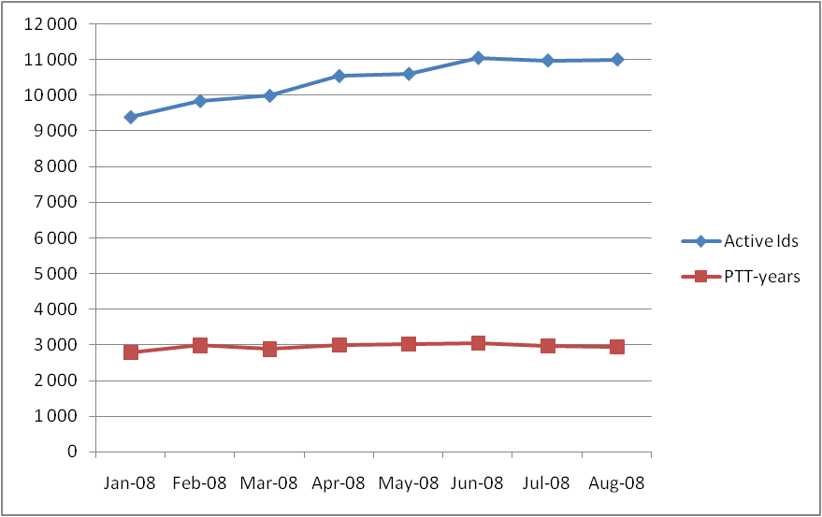

Figure 1: Consumption evolution over the year in Active PTTs and PTT.years

During the 8 first months of 2008, the number of active PTTs has an increasing trend; the number of PTT-years is rather stable.

Monthly evolution by platform category – Drifters & others, Floats, Animals, Fixed stations

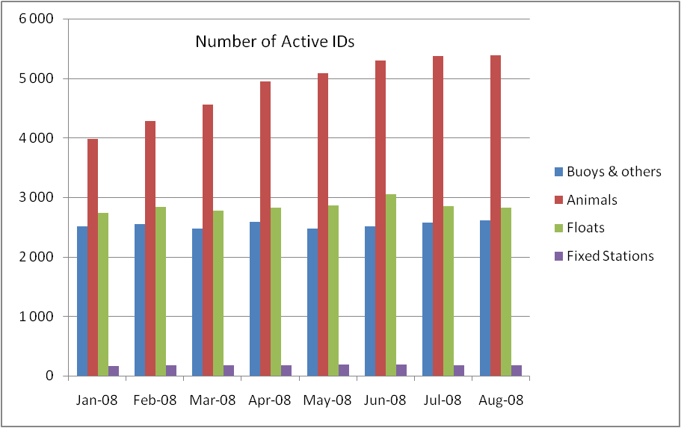

Figure 2: Active PTT evolution

Overall, the active PTTs and thus the number of transmitters in the field are increasing. The main category producing this increase is clearly the “Animals” family. The “Buoys” and “Subsurface floats” are rather stable.

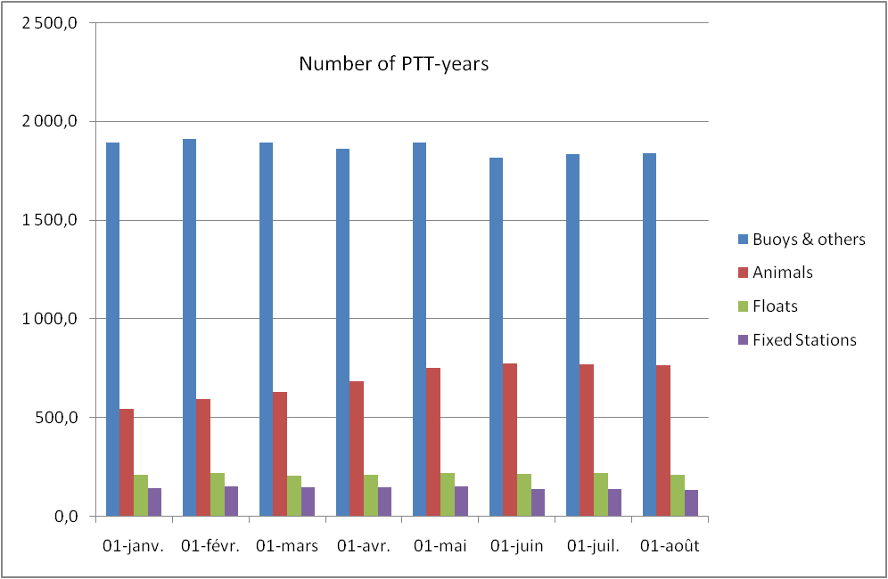

Figure 3: PTT-years evolution
Figure 3 above shows:

The PTT-years figures shows consequent differences in terms of actual consumption between the following categories:
- “Drifters & Others” - also referred as the “Full time” category in the JTA meeting report – is still the major player followed by the “Animals” which consumption is increasing.
- “Floats” and “Fixed Stations” consumptions in PTT-years are close.
- every day).

Time slot analysis

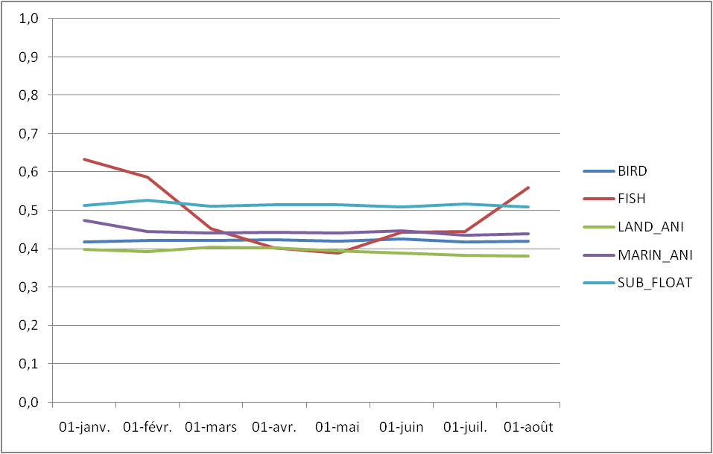

Figure 4: Average time slot level by platform category

This diagram shows the monthly evolution of the average time slot ratio per category of PTTs benefiting from time slot accounting since 2005. For a given PTT, the monthly time slot ratio is calculated as the number of day units divided by the number of transmission days in the month.

It can be noticed that:
- All categories except "Fish" look pretty stable on average.
- The average ratio is 0.45, and is decreasing - 0.50 in 2007- which reflects that manufacturers and users have well adapted their transmission duty cycles to benefit from the time slot mechanism,
- The ratio for Marine animals is lower than the last years - i.e. 0.45 against 0.55 in 2007 and 0.60 in 2006) which indicates that PTTs in this category can also enjoy the time slots.

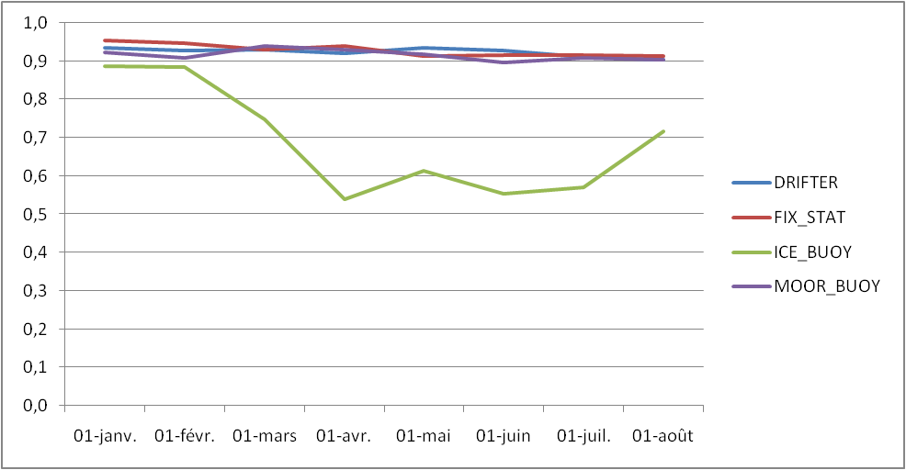

Figure 5: Average time slot level by platform category

This diagram shows the monthly evolution of the average time slot ratio for the categories “Buoys & Others” and “Fixed Stations” which started benefiting from time slot accounting in 2007.

It can be noticed that, for these latter categories, the time-slot ratio is pretty high – i.e. higher than 90%, except for ice-buoys. With the time slots, the overall consumption of these platforms is reduced by 46.1 PPT-years (16 900 day-units).

Impact of the 12 day.unit capping

Further to JTA XXVII decision the consumptions for animal platforms are capped at 12 day-units (48 time slots) in 2008.

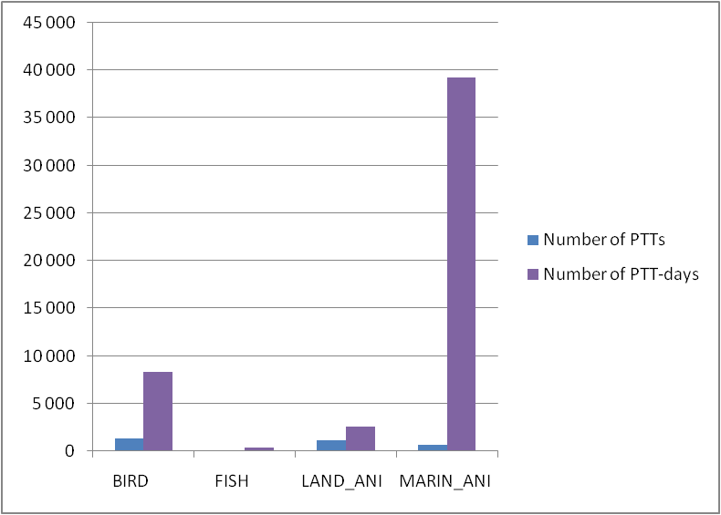

Figure 5: Projected Day-units “gain” by animal category

As expected, the category highly benefiting from the capping is the Marine Animals. Still birds, and also land animals, are also benefitting from this price mechanism.
In total, the capping represents a projected impact of ~138 PTT-years (~50 600 day-units) for 2008.

Inactive status

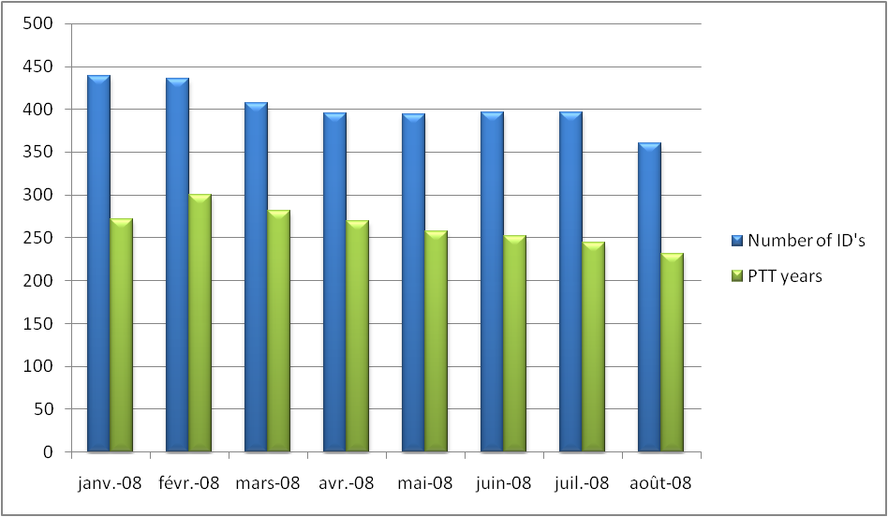

Figure 5: Inactive PTTs evolution in term of number of IDs and PTT-years

Recall: since year 2004, transmissions from inactive IDs are no longer charged.

As seen in figure 5, the number of IDs in Inactive status varies between 360 and 440 - 350-400 in 2007. The PTT-year projected consumption for 2008 is around 264 PTT-years (250 PTT-years in 2007).

Though the monthly consumptions are decreasing along the year 2008, the total projected year consumption is higher than previous the years’ – i.e. about 14 PTT-years are more in 2007.

As already mentioned in previous JTA reports, these PTTs are increasing the system occupancy for no use. CLS insists again on the recommendation to users and manufacturers to take this into account by programming their PTTs for the duration of the experiment.

History of the JTA participation from 1982 to 2008

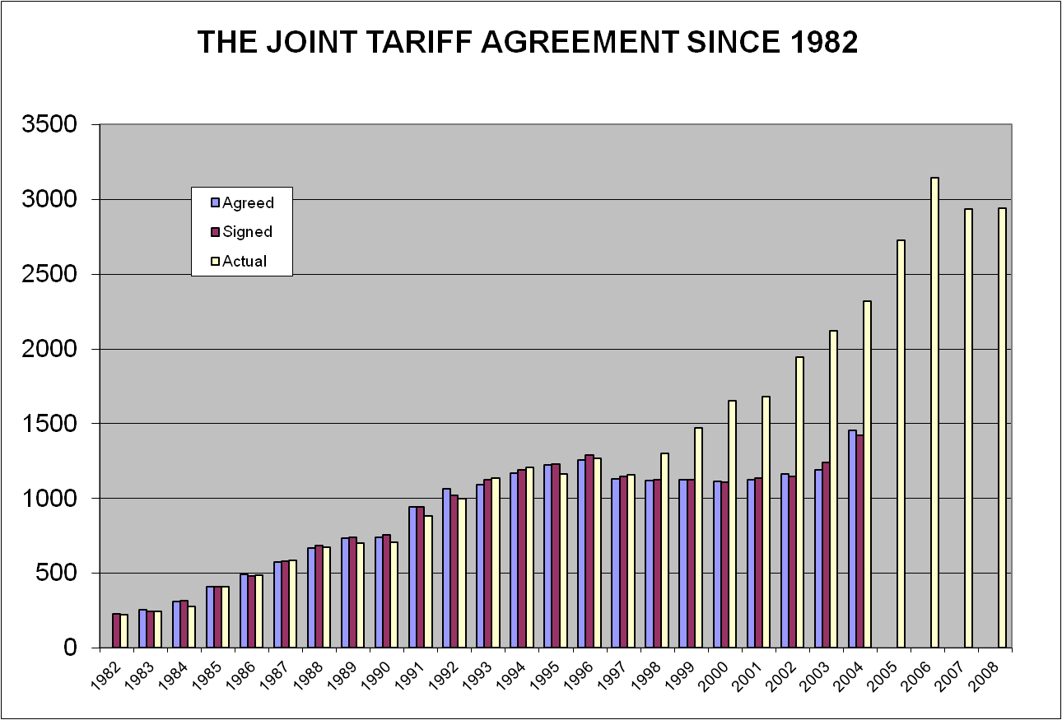

Figure 6: Agreed, signed and actual consumption in PTT-years for all countries

Notes:
- Since the implementation of the new tariff structure in 2005, we only provide actual consumption.
- Consumption was reduced in 2007 (~46 PTT-year) by applying the time slots to all categories.
- Value for 2008 is a projection based on January to August 08 consumptions.

Since 2008, the consumption in PTT-years has reduced by ~138 PTT-years by the capping mechanism being applied to all animals, and also by applying the time slots to all categories.

_________________________

Annex IV

Report on 2007-2008 Operations

2007 Operations Highlights

- 2 ARGOS satellites decommissioned (NOAA-12 and -14)
- METOP A Data delivered to all ARGOS users on August 1st, 2007
- METOP HRPT OFF since July 5th, 2007
- ARGOS2001 Phase3 in operation since September 9th, 2007
- 9 new antennae added to ARGOS Realtime network
- 2 Regional Processing Centers OFF
- Power outage test done successfully in October 2007

Space Segment

Argos constellation includes 5 satellites.
Satellites | Launch date | NOAA status | Real time data (HRPT) | Stored data (STIP) | Data AVHRR
METOP-A (MA) | 19-Oct-06 | AM Primary | ko | Svalbard | ok
NOAA-18 (NN) | 20-May-05 | PM Primary | ok | Gilmore, Wallops | ok
NOAA-17 (NM) | 24-Jun-02 | AM Backup | ok | Gilmore, Wallops | ok
NOAA-16 (NL) | 21-Sep-00 | PM Secondary | ok | Gilmore, Wallops | ok
NOAA-15 (NK) | 13-May-98 | AM Secondary | ok | Gilmore, Wallops | ok
NOAA-14 (NJ) | 30-Dec-94 | Decommissioned 23 May 2007
NOAA-12 (ND) | 19-Oct-06 | Decommissioned 10 August 2007
NOAA-11 (NH) | 24-Sep-88 | Decommissioned 16 July 2004
Figure 1

Figure 2 shows Local Equator crossing time (ascending node) and associated predictions for 6, 12 and 24 months in March 2008.

Figure 2 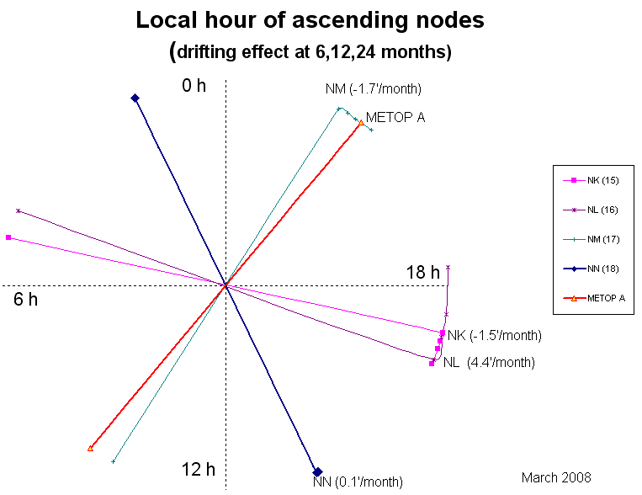

Ground Segment

Ground receiving stations

Global stations

Picture 1 shows Global stations

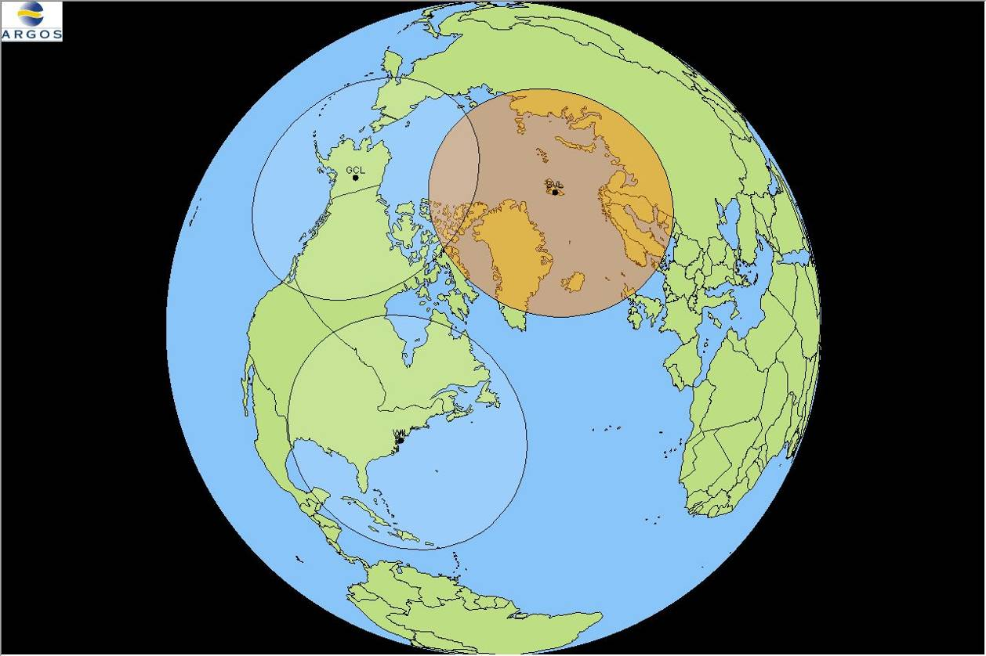
Picture 1

Operations were nominal on the two NOAA global stations (Fairbanks (AK, USA) and Wallops Island (VA, USA)) able to acquire the STIP telemetry from NOAA satellites.

Since METOP-A Launch, EUMETSAT global station (Svalbard (Norway)) is acquiring ADCS data and relaying these data through EUMETCAST network to CLS and CLSA (through NOAA/NESDIS).

On August 7, the blind orbit global datasets from the NOAA-18 spacecraft have been switched so that the data now comes through the Swalbard (SV) site instead of the Wallops Island (WI) and Gilmore Creek (GC) Command and Data Acquisition stations. Beginning on the 7th, the NOAA-18 blind orbits were no longer available from the DOMSAT. Users benefit from an immediate improvement in data timeliness since there’s no more N18 blind orbits. In the event of problems retrieving the data through the Svalbard station, the Wallops Island and Gilmore Creek stations will capture the data.

NOAA-15, NOAA-16, NOAA-17 and NOAA-18 global datasets (STIP) data were delivered by these global stations (14 datasets per day on average).

Figure 3 shows daily NOAA global dataset acquisition by the Global Processing Center in December 2007

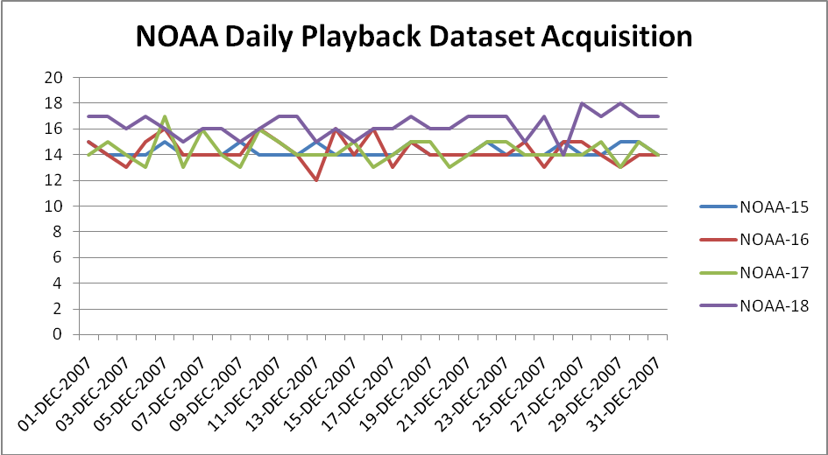
Figure 3

Figure 4 shows daily METOP-A global dataset acquisition into a Global Processing Center in December 2007 (METOP-A global dataset are 15 minutes data files)

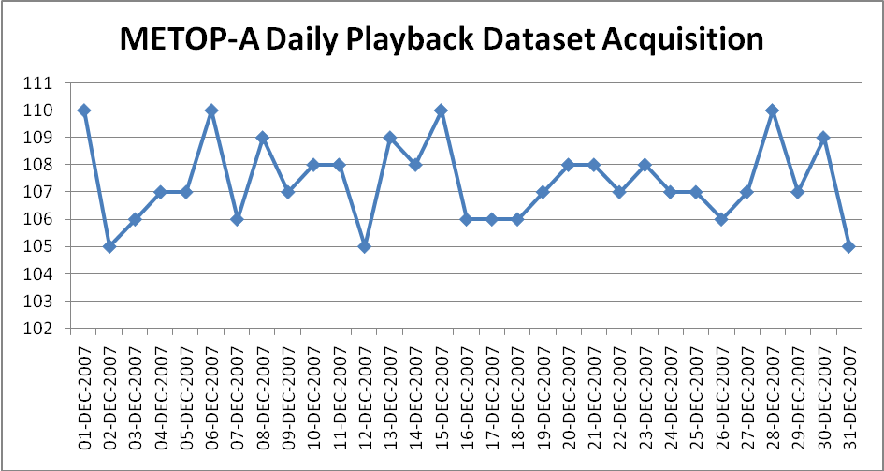
Figure 4

Figures 5 to 9 show global dataset arrival times (On December 31st,2007) into a Global processing Center in 2007.

Figure 5 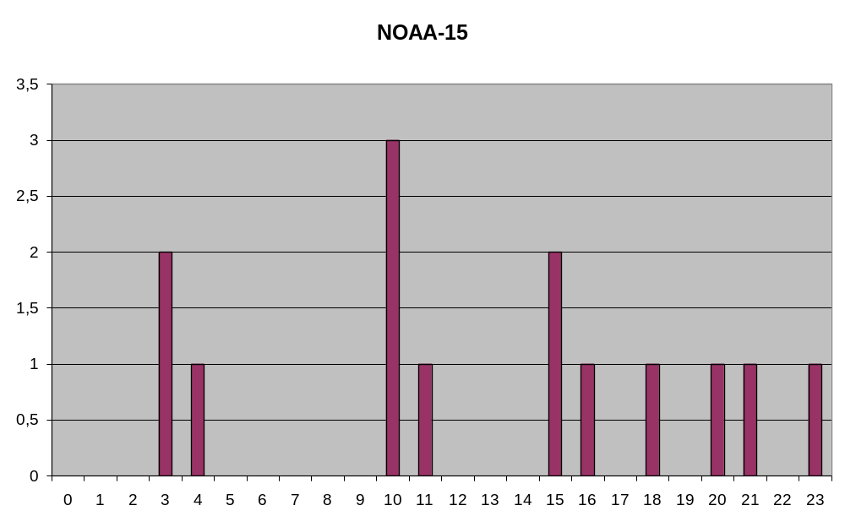
Figure 6 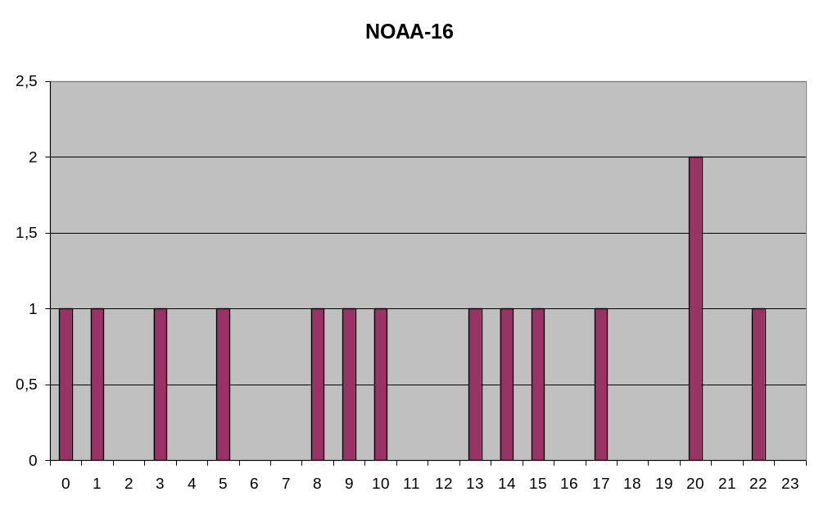

Figure 7 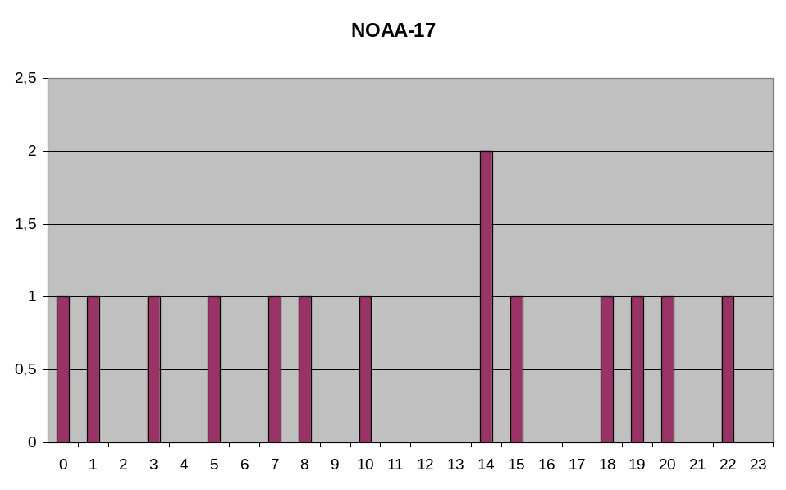

Figure 8 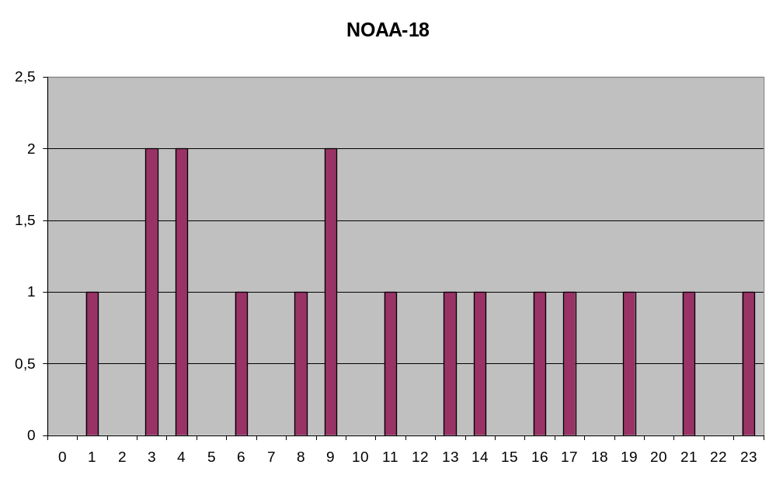

Figure 9 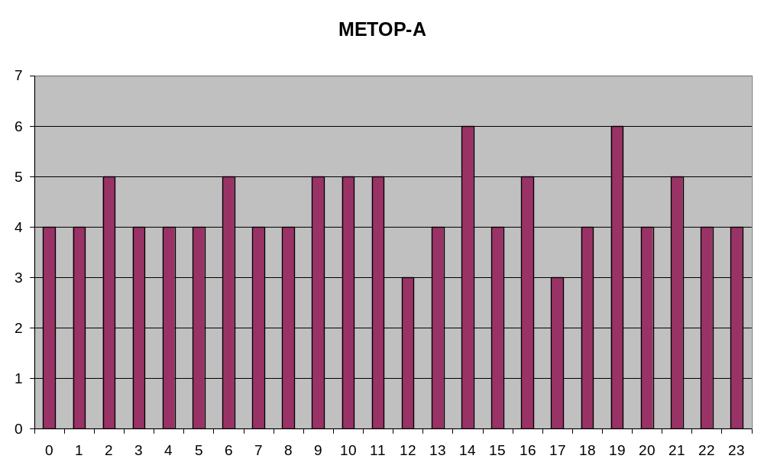

Regional stations

Picture 2 shows the 2007/2008 ARGOS real-time coverage

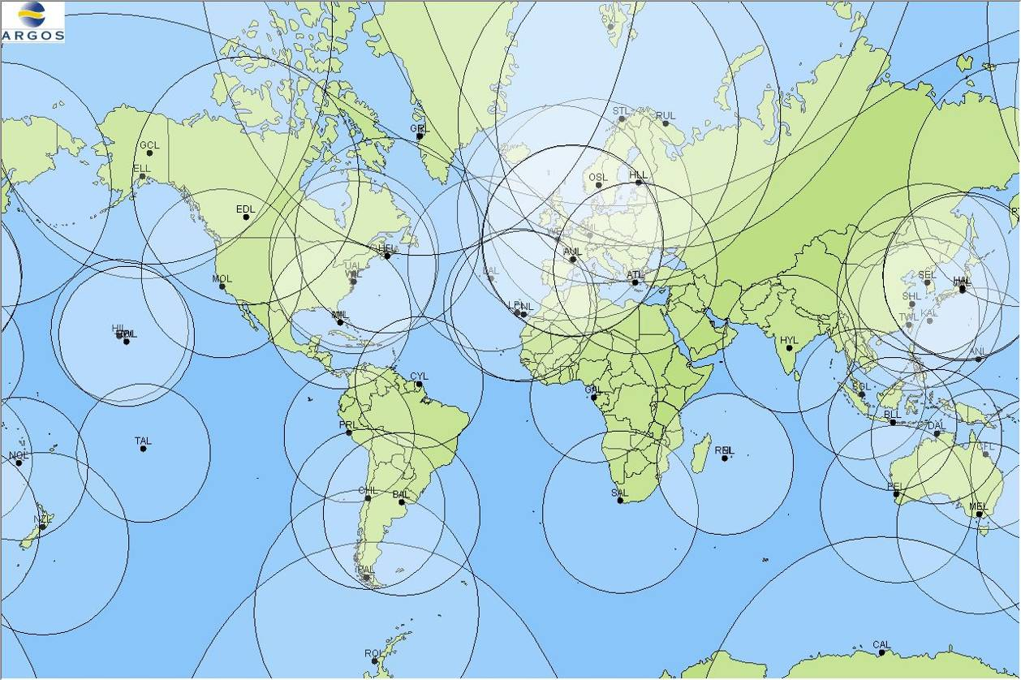
Picture 2

CLS and CLS America Inc. pursued their efforts in 2007 to increase and to consolidate the number of receiving stations able to provide TIP data sets from the NOAA and METOP satellites.

9 stations joined the Argos network during the year:

- 7 antennas operated by US Air Force
- 1 antenna in Libreville (Gabon, CLS) operated by CNES
- 1 antenna in Hatoyama (Japan, CLS) operated by JAXA



The 7 USAF antennae are located in:

- Sembach (Air Base, Germany)
- Kadena (Air Base, Okinawa Japan)
- Andersen (Air Force Base, Guam ~Western Pacific)
- Hickam (Air Force Base, Honolulu Hawaii)
- Elmendorf (Air Force Base, Anchorage Alaska)
- Lajes (Air Base, Azores Portugal)
- Valley Forge (Lockheed Martin Development/Test system, Pennsylvania)

Picture 3 shows the 7 USAF antennae coverage

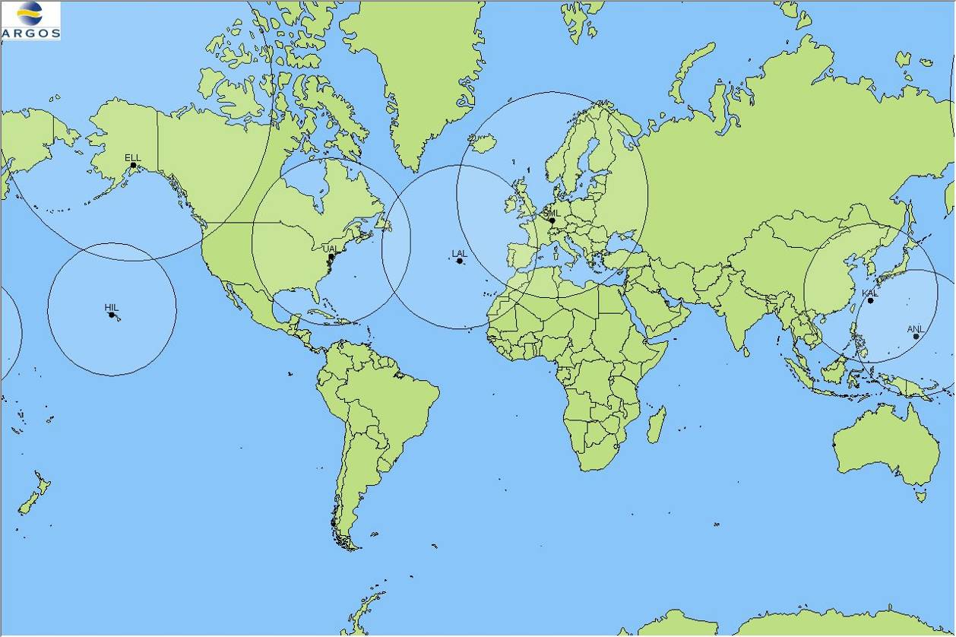
Picture 3

In 2007, they were 51 stations delivering real-time datasets (TIP) to CLS and CLS America Inc. Most of them process data from NOAA-18, NOAA-17, NOAA-16 and NOAA-15, allowing us to maintain a good throughput times for results delivery.

Bitung, Fidji and Ryadh antennae were removed from operation monitoring in 2007.

List of regional receiving stations:

Antennas | Sigle | Country | Operator | Possible satellites
Andersen USAF | AN | UNITED STATES | CLS | NK,NM,NN
Athenes | AT | GREECE | CLS | NK,NL,NM,NN
Aussaguel | AU | FRANCE | CLS | NK,NL,NM,NN
Buenos Aires* | BA | ARGENTINA | INTA | NK,NL,NM
Bali | BL | INDONESIA | PT CLS | NK,NL,NM,NN
Casey | CA | AUSTRALIA | BOM | NK,NL,NM
Cape Ferguson NOAA | CF | AUSTRALIA | NOAA | NL,NM,NN
Santiago | CH | CHILE | Meteo Chile | NK,NL,NM,NN
Las Palmas | CN | SPAIN | CLS | NK,NL,NM,NN
Cayenne | CY | FRANCE | IRD | NK,NL,NM
Darwin | DA | AUSTRALIA | BOM | NK,NM
Edmonton | ED | CANADA | Envir. Canada | NK,NL,NM
Elmendorf USAF | EL | UNITED STATES | CLS | NK,NM,NN
Libreville | GB | GABON | CNES/CLS | NK,NL,NM,NN
Gilmore | GC | UNITED STATES | NOAA/NESDIS | NK,NL,NM,NN,MA
Sondre | GR | GREENLAND | DMI | NK,NL,NM
Hatoyama | HT | JAPAN | JAXA/EOC | NK,NL,NM,NN,MA
Halifax | HF | CANADA | Can. Coast Guard | NK,NL,NM
Hickam USAF | HI | UNITED STATES | CLS | NK,NL,NM,NN
Helsinki | HL | FINLAND | CLS | NK,NL,NM,NN
Hawai | HW | UNITED STATES | NOAA/NWS | NK,NL,NM
Hyderabad | HY | INDIA | INCOIS | NK,NL,NM,NN
Tokyo | JM | JAPAN | Jamstec | NK,NL,NM,NN
Kandena USAF | KA | JAPAN | CLS | NK,NM,NN
Lajes USAF | LA | SPAIN | CLS | NK,NM,NN
Lima METOP | LM | PERU | CLS Perou | NK,NL,NM,NN,MA
Las Palmas | LP | SPAIN | Univ. Las Palmas | NK,NL,NM
Miami NOAA | MA | UNITED STATES | NOAA/AOML | NK,NL,NM
Melbourne | ME | AUSTRALIA | BOM | NK,NL,NM,NN
Noumea Meteo France | NC | NEW CALEDONIA | Meteo France | NK,NM,NN
Noumea IRD | NO | FRANCE | IRD | NK,NM
Wellington | NZ | NEW ZEALAND | Met Office | NK,NL,NM
Oslo | OS | NORWAY | NMI | NK,NL,NM,NN
Perth | PE | AUSTRALIA | BOM | NK,NL,NM,NN
Lima | PR | PERU | CLS peru | NK,NL,NM,NN
Petropavlosk | PT | RUSSIAN FEDERATION | Complex System | NK,NL,NM,NN
Ile de la Reunion | RE | FRANCE | IRD | NK,NL,NM
Ile de la Reunion | RN | FRANCE | Meteo France | NL,NM
Rothera | RO | INDONESIA | PT CLS | NK,NL,NM,NN
Cape Town | SA | SOUTH AFRICA | CLS/SAWB | NK,NL,NM,NN
Seoul | SE | KOREA, REPUBLIC OF | KMA | NL,NM,NN
Singapore | SG | CHINA | SMM | NK,NM
Shangai | SH | CHINA | East China Sea Fisheries | NK,NL,NM,NN
Sembach USAF | SM | GERMANY | CLS | NK,NM,NN
Tromsoe | ST | NORWAY | KSAT | NL,NM,NN
Papeete | TA | FRANCE | IRD | NL,NM,NN
Taiwan | TW | TAIWAN, REPUBLIC OF CHINA | National Taiwan Ocean Uni | NL,NM,NN
Valley Forge USAF | UA | UNITED STATES | CLS | NK,NL,NM,NN
Lannion | WE | FRANCE | Meteo France | NL,NM,NN,MA
Wallops | WI | UNITED STATES | NOAA/NESDIS | NK,NL,NM,NN,MA
* the only station to locate the satellites when they are situated at a 20° or greater site angle
Antennas under agreement
CLS and subsidiaries antennas
Customer antennas under CLS maintenance contract
Antennas without written agreement ("Best effort")

Future METOP Real-time coverage is shown on Picture 4.

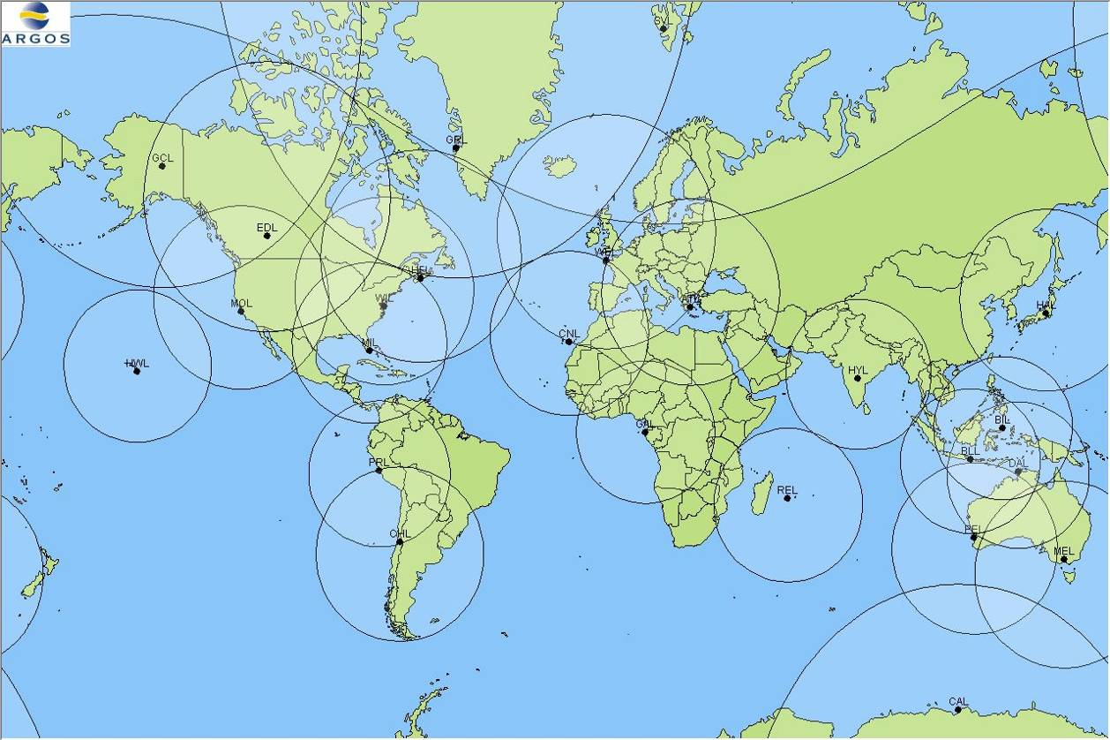
Picture 4

Today, Gilmore, Wallops, Lannion and Hatoyama are fully operational and compatible with METOP real-time.

Figure 10 shows daily real-time dataset acquisition into a global processing center in December 2007. High tracking Priority is given to NOAA-17 and Low priority tracking to NOAA-15.

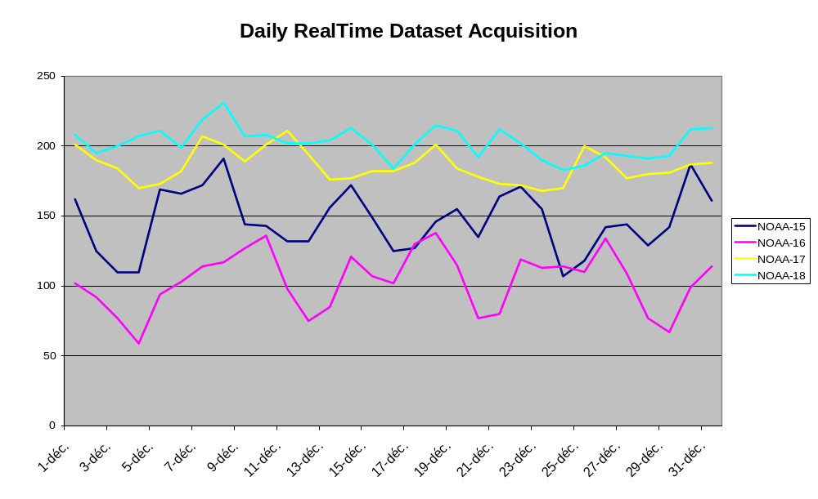
Figure 10

Orbitography PTT network

Picture 5 displays CLS Orbitography beacons location.

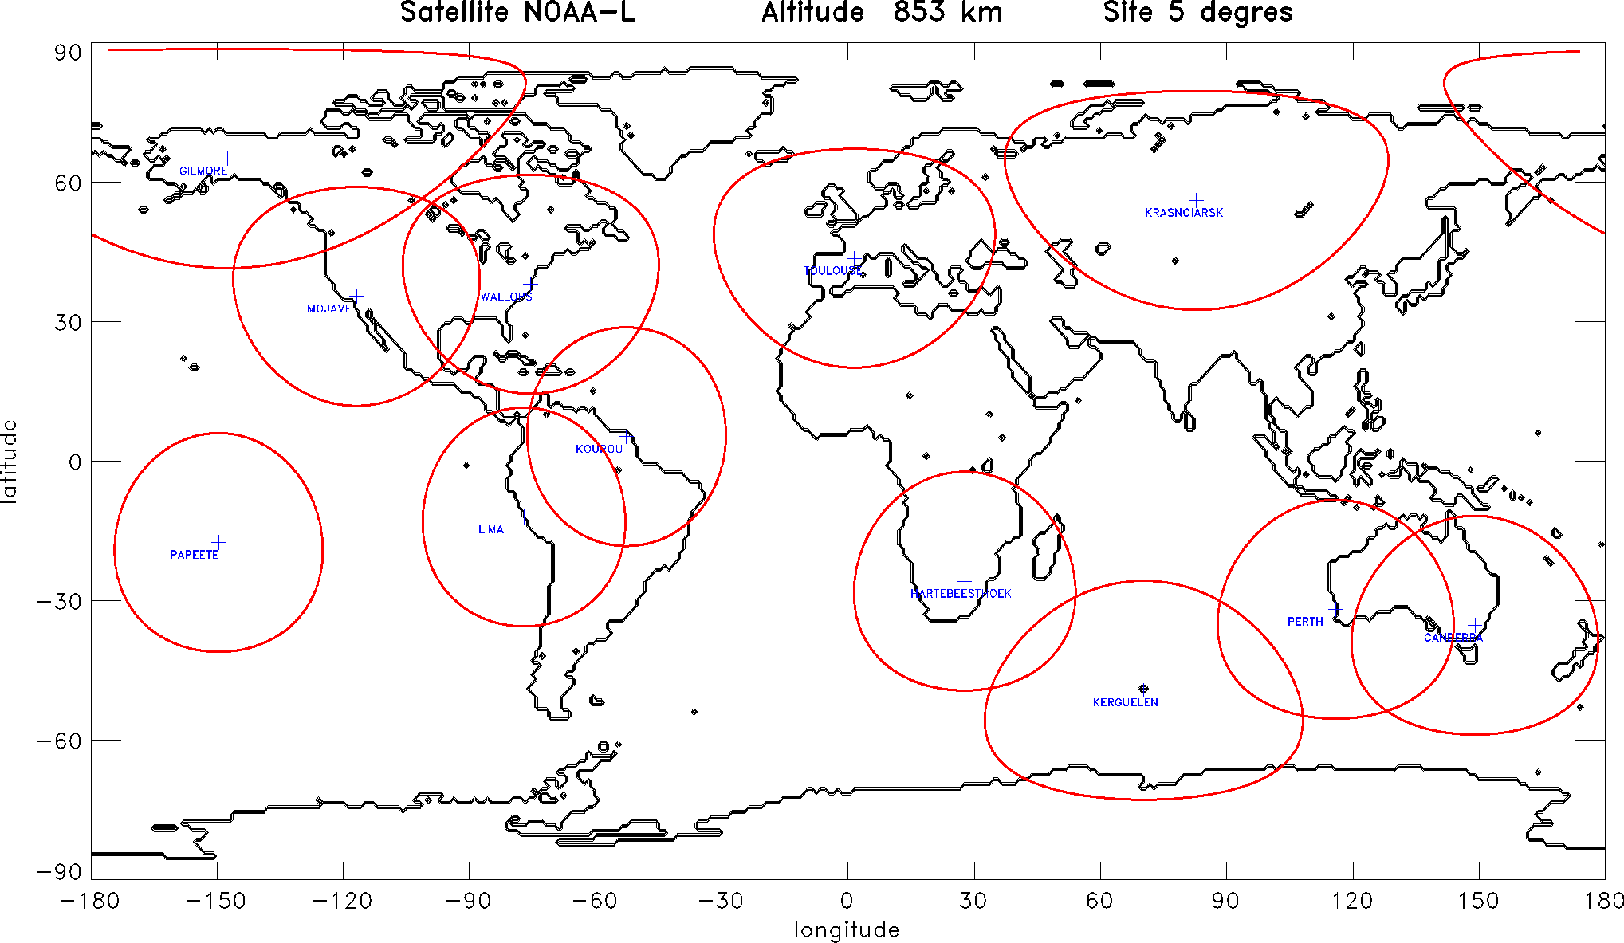
Picture 5

1- TOULOUSE | OK
108 - GILMORE_N | OK
109 - KOUROU_N | OK
111 - HARTBEES_N2 | Small amount data on NOAA 12
112 - CANBERRA_N | OK
113 - LIMA-N | OK
114 - KRASNOIARSK | Stopped on 01/26/06. Expecting administrative paper in order to restart this PTT. A. Salman in charge.
116 - PAPEETE | OK
118 - WALLOPS | OK
119 - KERGUELEN_N | OK
149 - PERTH | OK
110 - MOJAVE | Stopped on 12/12/06. Power problem. CLS America in charge.

Processing centers

Picture 6 displays CLS Group processing centers.

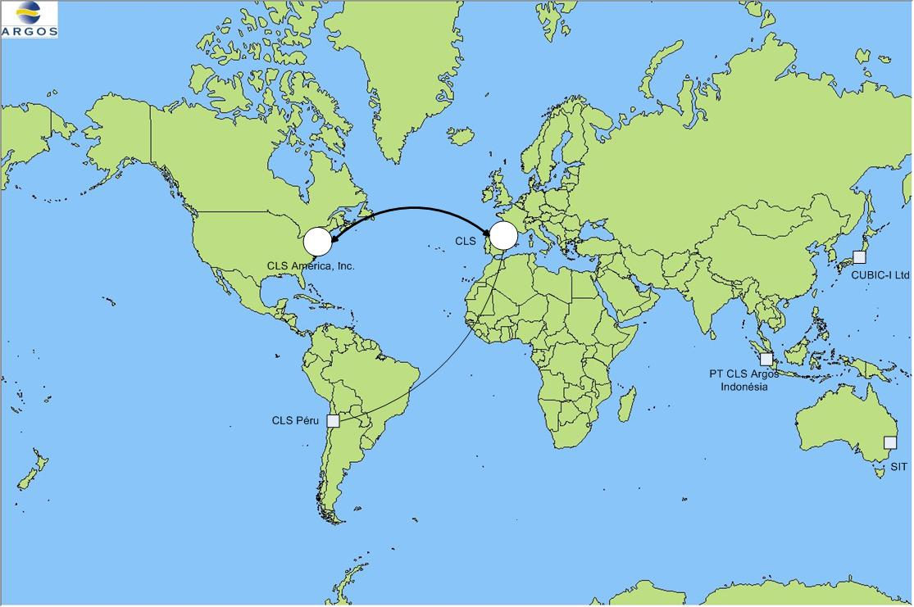
Picture 6

Global processing centers

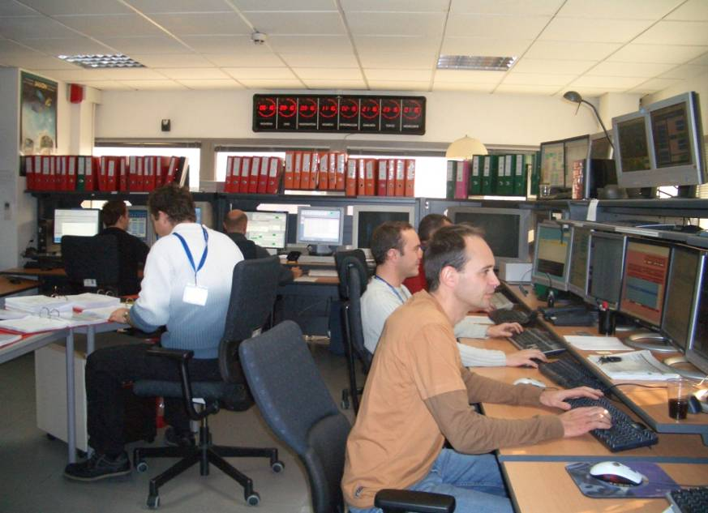

The two global processing centers in Toulouse and Largo were nominal. More than 800 (200 less than in 2006) data sets per day (200 global (STIP) data sets, 600 Real-time (TIP) data sets) are processed in each centers (see Figure 11).

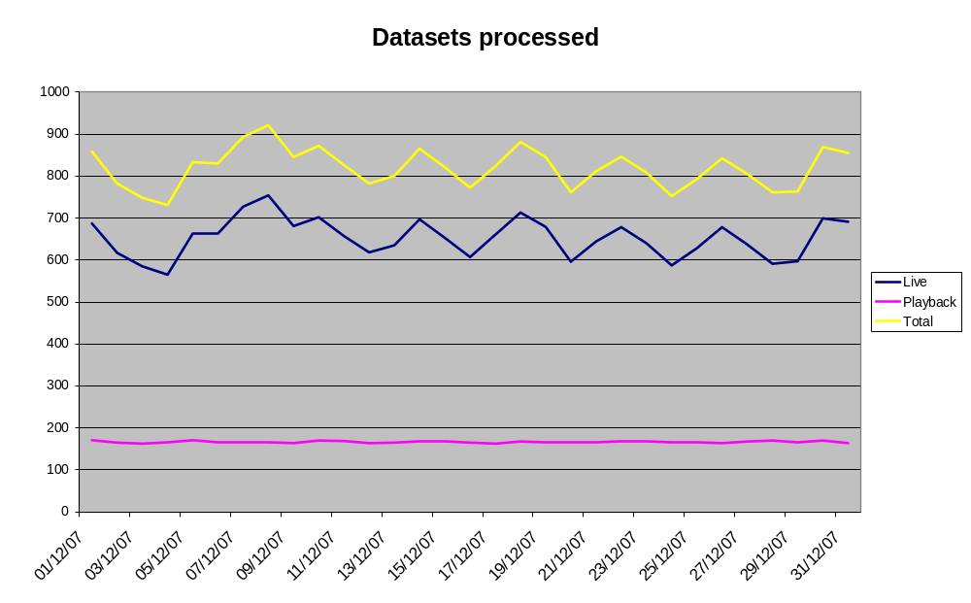
Figure 11

A major software change was implemented in both global processing centers in 2007. ARGOS2001 Phase3A is now in place and operated by CLS and CLS America, Inc. Operational teams.

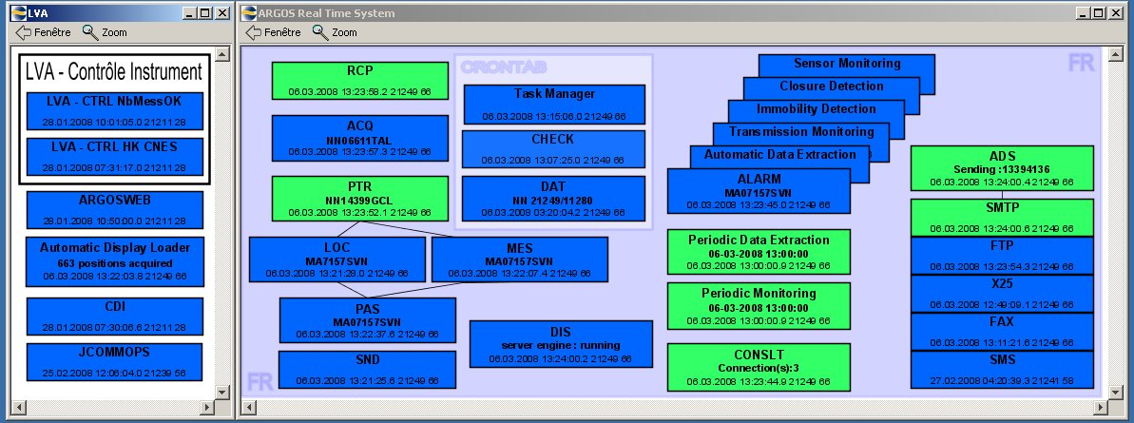

CLS is monitoring JCOMMOPS Web Services and computer architecture since December 2007.

CLS is executing a power outage test once a year. The one in October 2007 went really well and all system operation procedures (SOPs) were successfully tested. CLS America, Inc was in backup mode during the test.

Regional Processing Centers

2 Regional Processing Centers were stopped in 2007. CUBIC-I (Japan) and PT CLS Indonesia (Indonesia) are not anymore hosting a Regional Processing Center architecture.
Lima (Peru) center was nominal.

Reminder: A regional processing center only process data sets from stations covering their region. Supplementary data providing global coverage are supplied by the Toulouse center or by the Largo center if necessary.

Communication links

CLS has improved his Internet link and are now connected each other to 2 different providers: Two lines (10M each) with Bandwidth Tunnelling by application.

The Internet is still the main communication link used to distribute processed data to users and to retrieve data sets from receiving stations. Security functionalities are available SSH, PGP, HTTPS.

The X25 protocol is only used and maintained by the Toulouse center to send data to a few users (less than 20) concerned by security reasons.

Statistics

Daily and Monthly Active PTT

The number of Argos platforms operating continues to increase. In June 2007, more than 9500 platforms were seen on average per day. However, each of the two global centers processed data from 17 800 individual platforms during this month (figure 11).

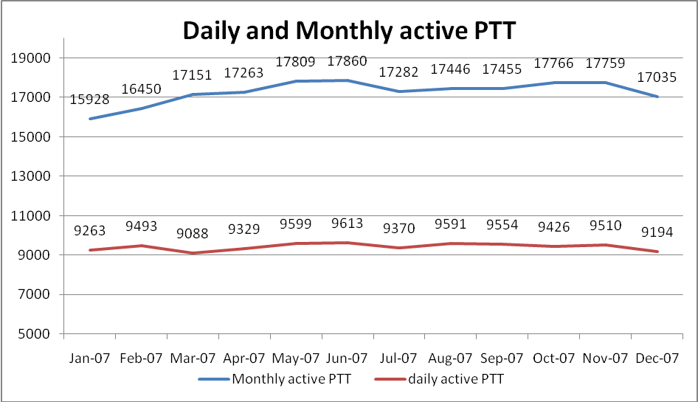
Figure 11

TELNET access

Figure 12 shows the connexion number on July 1st, 2007 and the user number using TELNET that day.

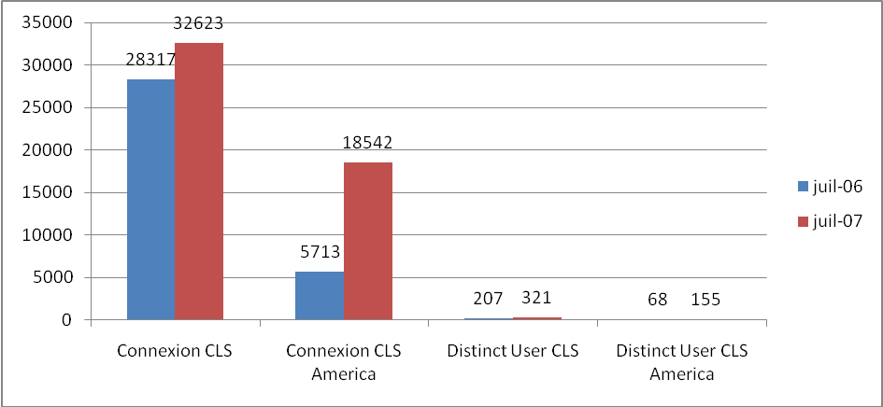
Figure 12

Figure 13 shows the number of commands used on July 1st, 2007 per ARGOS available commands in CLS

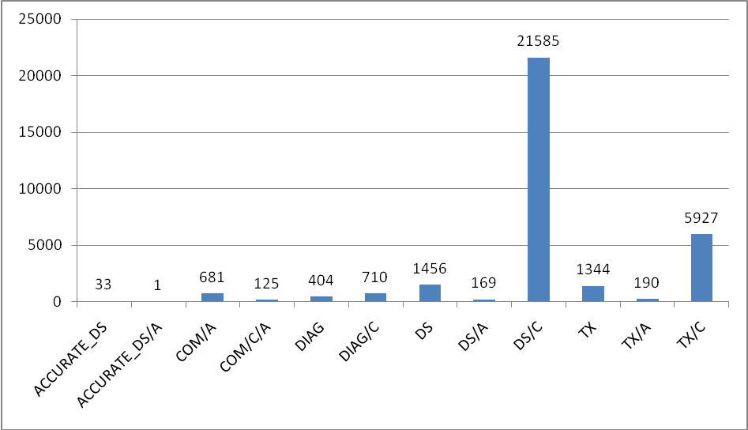
Figure 13

Figure 14 shows the number of commands used on July 1st, 2007 per ARGOS available commands in CLS America, Inc.

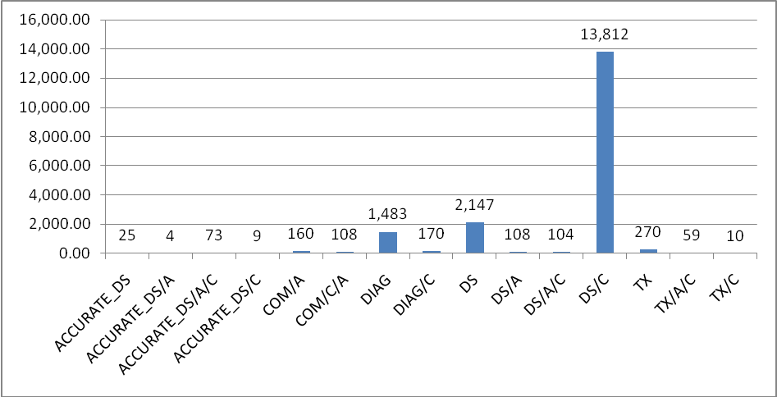
Figure 14

ArgosWeb access

Figure 15 shows average connections per hour on ArgosWeb (Operational only in CLS).

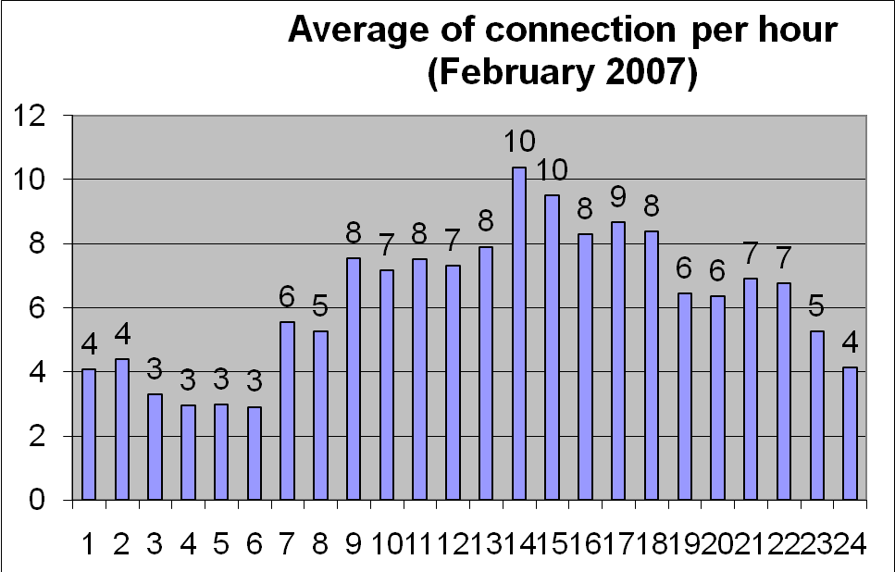
Figure 15

In average, ArgosWeb receives 150 connexions per day (80 during the W-E).

ARGOS Messages

In 2007, the number of locations and messages computed every day by the Largo and Toulouse centers are, in average:

Messages received: 1 957 500 / day
Distinct Messages received : 972 000 /day
Argos Locations : 66 750 /day
GPS Locations : 163 150 / day

Access availability

The average availability is 99,77% in 2007.

Figure 16 shows the ARGOS Processing system availability at CLS in 2007. During the unavailability of the services in CLS, data was delivered by CLS America, Inc. in accordance with the back-up procedure.
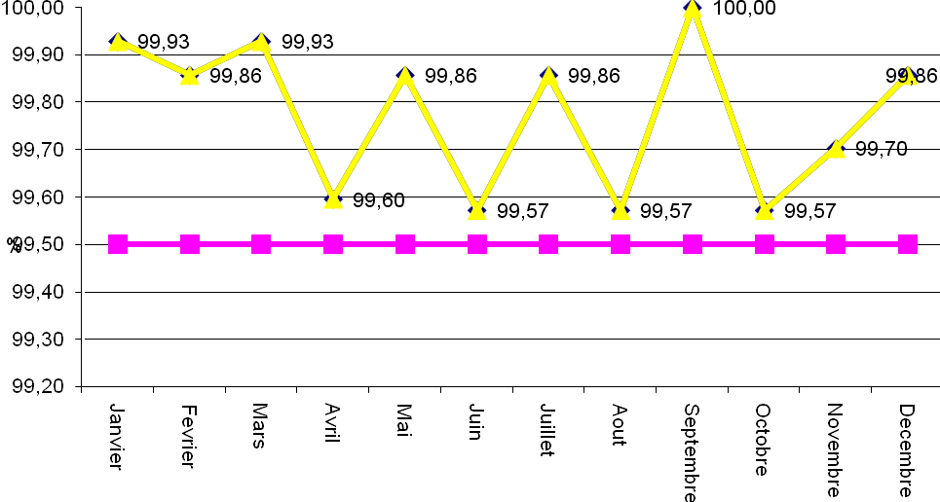

Figure 16

No major anomalies have impacted the ARGOS data availability.

2008 Perspectives

- ARGOS3 (Downlink) into operation
- New antennae with EARS network
- Disaster Recovery implementation
- ARGOS2001 Phase3B (GTS) in operation
- Monthly Argos operation report available*

* Throughput time calculation has been redefined and will be implemented in 2008. Statistics on throughput times will be again available in Mid-2008.

_________________________
Annex V

2007-2008 System Improvements

1. Hardware configuration

The computing architecture dedicated to the Argos system is still the same and no significant modification is to be mentioned in 2007.

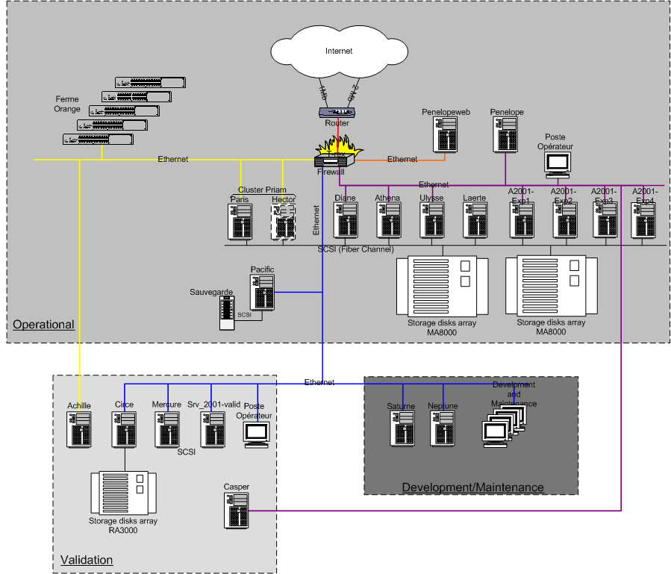

The heart of the architecture is composed of two high performance disk storage arrays on which are connected, via fiber channel links, the servers involved in the processing of the Argos data. Most significant modifications which have been done in 2007 have concerned the increasing of the space disk.
The operational configuration is of course dedicated to the acquisition, the processing and the dissemination of the Argos data, 24 hours a day, all along the year. The development and the maintenance of the Argos software are performed on a dedicated architecture. The third configuration, the validation configuration, is used to validate all the software modifications and corrections before being installed at the level of the operational configuration.
In 2007, we did significant progress with our project of creating a second computing center in addition to the existing CLS computing center. We succeeded to fix most of the problems we had and now the project is running well. The second computer room, located in CNES premises, is ready (air conditioning, secured power supply…) and is connected, via optical fiber links, to the CLS computer room. Servers, disk shelf arrays, switches,.. have to be moved now to the second computer room. It will be done in fall 2008.
This project aims at improving the operation level of our services as well as assuring the continuity of the processing and distribution of the Argos data even in case of disaster such fire, flooding, …

2. Ground segment architecture

The Argos ground segment is composed as follow :
- the delayed time acquisition network
- the real time acquisition network
- the Global Argos Control and Processing centre
- the PTT and PMT
- the regional processing centers

2.1 The global mode acquisition network

It is composed of the three NOAA global stations (Fairbanks, Wallops Island & now Svalbard) for the acquisition of the NOAA satellites data and the Eumetsat antenna (Svalbard) for the acquisition of the MetOp data.
In August 2007, in order to eliminate the blind orbits, some successful trials of NOAA-18 data acquisition have been done by using the Svalbard antenna. Thanks to this antenna, there were no more blind orbits for NOAA-18.
Removing blind orbits from NOAA-17 & 15 by collecting the datasets by NPOESS antenna in Svalbard is still under study.

2.2 The real time acquisition network

In 2006/2007, 9 new NOAA HRPT ground stations have joined the Argos real time acquisition network. On the other hand, 3 stations (Bitung, Fidji and Ryadh) have been removed which brings the total number to 53 antennas.

The 9 new ground stations added in 2006/2007 are the following:

Location | Country | Operator | Satellites
Andersen | Guam | USAF | NOAA-18, NOAA-17, NOAA-16, NOAA-15
Elmendorf | Alaska | USAF | NOAA-18, NOAA-17, NOAA-15
Hickam | Hawai | USAF | NOAA-18, NOAA-17, NOAA-16, NOAA-15
Kadena | Japan | USAF | NOAA-18, NOAA-17, NOAA-15
Lajes | Portugal (Azores) | USAF | NOAA-18, NOAA-17, NOAA-15
Sembach | Germany | USAF | NOAA-18, NOAA-17, NOAA-15
Valley Forge | USA (Pennsylvania) | Lockheed Martin | NOAA-18, NOAA-17, NOAA-16, NOAA-15
Libreville | Gabon | CLS | NOAA-18, NOAA-17, NOAA-16, NOAA-15
Hatoyama | Japan | CLS | NOAA-18, NOAA-17, NOAA-16, NOAA-15, Metop-A

Argos real time acquisition network

This network was built to answer to the needs of covering specific areas of the world and sometimes by taking advantage of the cooperation opportunities which were offered.

In the section DBCP requirements below, performance of individual antennae is displayed. It can be noticed that though the number of antennae is high, the overall time performance is affected by the performance of some of these antennae. CLS keep putting effort in getting enhancements from these antennae. This not an easy task since most antennae are not operated by CLS.

Even if we are ready to consider any new opportunity of cooperation, we wanted, in 2007, to focus our efforts on adding new ground stations compatible with NOAA and METOP satellites.

This is the reason why CLS bought three NOAA/METOP ground stations (Konsberg antennas) and started negotiation with NOAA, EUMETSAT (EARS network) and several other meteorological agencies such Environment Canada, Meteo Chile, Meteo France and Bureau of Meteorology (Australia) because they were in the process of upgrading their existing stations to be compatible with METOP-A.

Our plan for 2007 was to implement the following NOAA/METOP network

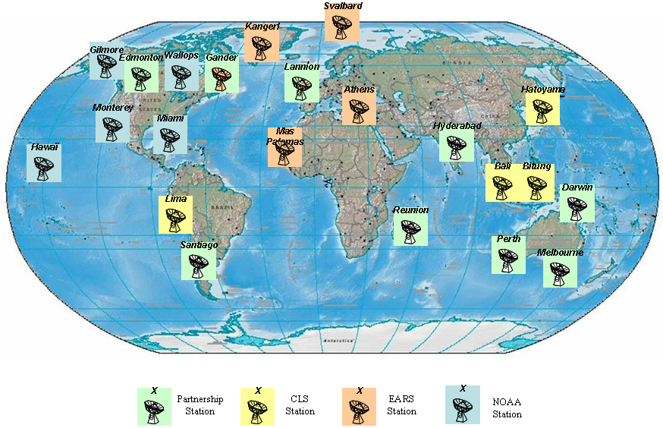

 | Antennas | Country | Operator
1 | Darwin | Australia | BOM
2 | Melbourne | Australia | BOM
3 | Perth | Australia | BOM
4 | Bali | Indonesia | CLS
5 | Bitung | Indonesia | CLS
6 | Hatoyama | Japan | CLS
7 | Lima | Peru | CLS
8 | Kangerlussaq | Greenland | EARS - Danish Meteo Institute
9 | Svalbard | Norway | EARS - EUMETSAT
10 | Athens | Greece | EARS - HNMS (Meteo)
11 | Mas Palomas | Spain | EARS - INTA
12 | Edmonton | Canada | Environnement Canada
13 | Gander | Canada | Environnement Canada
14 | Hyderabad | India | INCOIS
15 | La Reunion | France | IRD
16 | Santiago | Chile | Meteo Chile
17 | Lannion | France | Meteo France
18 | Gilmore / Fairbanks | USA | NOAA
19 | Hawaii | USA | NOAA
20 | Miami | USA | NOAA
21 | Monterey | USA | NOAA
22 | Wallops | USA | NOAA

In term of coverage, we could expect:

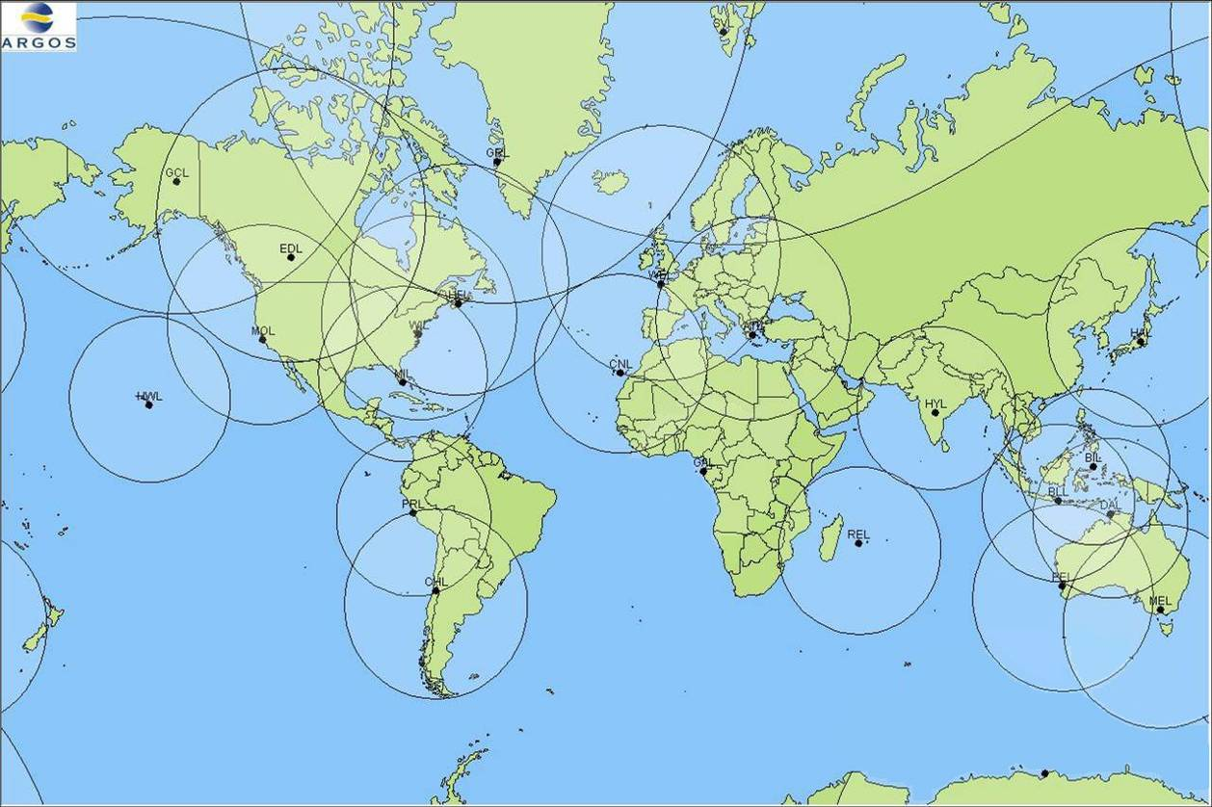

Unfortunately, in July 2007, the failure of METOP-A HRPT transmitter stopped the implementation of this network. Today, we are still in the same situation. No HRPT data is transmitted by METOP-A and the upgrade of the ground stations was slowed down.

2.3. Argos Control and processing centre
The project Argos 2001, which consisted in renewing all the hardware and software components of the Argos Control and Processing centres, is now finished. The purpose of the Argos 2001 project was vital for the long-term continuity of the Argos system and needed to offer a better level of services to our users in terms of new functionalities, reliability, availability and responsiveness to their requests.

In order to keep control of the developments, the Argos 2001 project was split into four different phases

Phase I: Development and implementation of a new user interface allowing users to access data and view and update technical files via a Web server. Data are stored and managed by a database management system designed to be responsive to users' needs. Our objective was to give users more versatility if they require. Consequently, we expect to offer them quick and efficient support.

Phase II: Improvement and development of value-added services as well as tools for the Argos system monitoring

Argos-3 project: This project, driven in parallel with the Argos 2001 phase III, aimed at taking into account all the changes in the current Argos ground segment brought by the third generation of Argos instruments. It includes the downlink and the new format for the uplink messages (new modulation, high bit data rate…) as well as the interface with EUMETSAT.
The Argos-3 project covered the following developments:
- Argos 3 control and processing: it includes
  - Evolutions of the Argos Core Processing and distribution i.e. all sub-systems modified due to the Argos 3 capabilities and characteristics,
  - The DMMC (Downlink Message Management Center) dedicated to Argos 3
- Time Reference Beacon,
- A new network of master beacons (High data rate platforms),
- Argos PTT/PMT test bench.

Phase III: Fully redesign of the Argos Core processing called phase IIIA (i.e. mainly acquisition, preprocessing, location) and the GTS processing called phase IIIB.

The phase IIIB, the last one, has been opened to the users in May 2008.

GTS processing enhancements

Here, the list of GTS enhancements done in 2008 with the phase IIIB :

- In May 2008, A2001 phase IIIB is operational with:

- All GTS templates (#80) implemented and validated in the new system.
- Processing performances are improved.
- GTS processing is now more flexible (more calibration options, …).
- Observation data available on ArgosWeb (can be a good monitoring tool for PI).
- Development of CFG tool (which replace GTSMOD) and FTP calibration for ATLAS.

- A GTS processing monitoring tool will be soon available (October 2008).

- Corrections on BUOY code =
- Buoy pressure is now distributed only on Air Pressure reduced at sea level in block 4 (section 1 of the BUOY).
- Block 0 in section 1 is not providing if no wind data (no more 0////).
- Better filtering on Argos location quality (no more loc 0;0 + minimum Argos location class is 1 + Ql = quality control indicator is now fixed with the radius error < 7 km).

- GTS Iridium data processing for IPP (only SBD format) has been operational since July 2008.

- Corrections on BUFR code, CLS BUFR processing is now in agreement with WMO regulation BUFR V.3. Next step in BUFR development = BUFR V.4.

- GTS templates description: all GTS templates use in the CLS subsystem are described (message length, binary cutting and WMO code) in an Excel file available on request via useroffice.

- CLS is working on BUFR code to develop BUFR for TESAC, SHIP and SYNOP (soon available).

- WMO historical table updates and monitors in Argos system for JCOMMOPS.

- A monthly meeting with JCOMMOPS is done at CLS.

- A monthly report on Argos Science activities and GTS monitoring provided to JCOMMOPS.

2.4 PTT/PMT for users

The Argos-3 instrument generation provides to users a two-way communication as well as a larger data bandwidth through the high data rate channel. To benefit from these new capabilities, users need to implement a PMT (Platform Message Transceiver) in place of their current one-way PTT.
The PMT, which works as a modem, supports:
- transmission of uplink messages using several possible modulation links as well as satellite pass predictions
- reception and processing of the commands (system and user predefined commands, satellite acknowledgement,…).
- Interactive data transfer mode: satellites acknowledges the receipt of (good) messages sent by the PMT.

In terms of strategy, we decided to develop:
- A first generation of PMT so that users can quickly access to the new Argos-3 functionalities
- Industrial PMT for global use.

2.4.1 First generation PMTs

First PMTs were developed in 2002 / 2003 by Bathy Systems (Boston / USA) in collaboration with Seimac Ltd (Halifax / Canada), a major transmitter manufacturer. These units worked only with uplink BPSK modulation (400 bits/sec.) and a downlink BPSK modulation (200 bits/sec.). They were built around existing modules making the end-product rather large and expensive but fine for running demos.
This work, as well as the collaboration between different manufacturers, gave CLS the opportunity to order in May 2005 a set of 80 of these “First generation PMTs” to Seimac Ltd with the implementation of some evolutions to take into account the Argos-3 main new features (downlink at 400 bits/sec. and new high data rate uplink). Seimac delivered 80 of these units in June 2006.

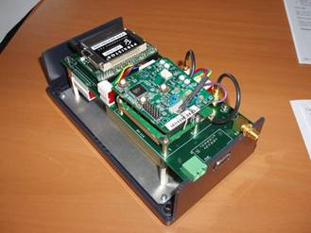
Seimac PMT RFM

Following the authorization given by Cnes to communicate with MetOp A, CLS did the first interactive communication sessions on May 10th with a user PMT!

2.4.2 Industrial PMT RF module

The success of the Argos-3 project is certainly based on the availability of low cost, low consumption and tiny “PMT RF modules”. These modules functionally correspond to the previous first generation PMT demo units but designed “from scratch”. In other words, instead of building a final product with the assembly of existing modules we have redesigned the complete product to make it simpler on a single “electronic board”. This work started early in 2005 with some consultancy studies on possible technical solutions as an analysis of the volume of the market.
CLS issued late 2005 a Tender to select the best candidates for this development. Selection of providers was done late February 2006 with the choice of Kenwood in Japan and Elta in France. Both companies presented to CLS an excellent and complete proposal (technical financial, quality,..).

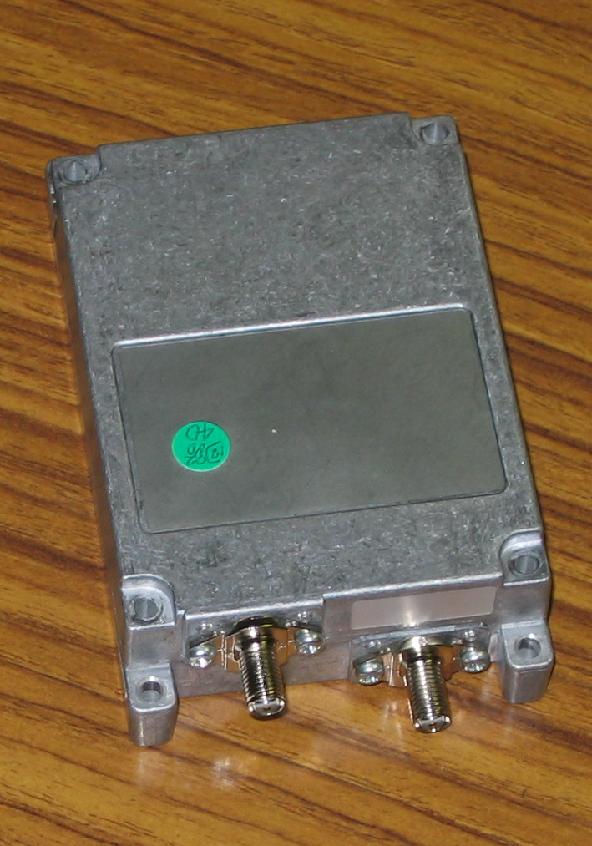Today, both manufacturers successfully fulfilled the certification process and delivered their final product version in December 2007. This development has reached its goals in terms of product definition and constrains (size, consumption,..) as well as on the costs.

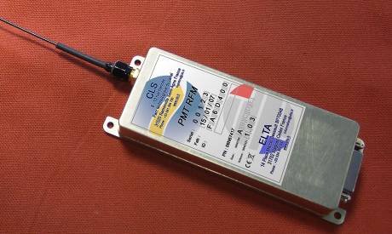

Elta PMT RF
Kenwood PMT RFM

The first 500 Kenwood PMT units have been received by CLS in May 2008.

2.5 Argos-3 & PMT implementation project

Today, all the Argos-3 components – that is the instrument, the platforms (PMT) as well as the processing centres – are operational and perfectly capable of acquiring, processing and disseminating the Argos-3 data. So, the system is ready and operational.

Yet, actual PMT implementation by users was delayed because:
- Argos-3 is a new system and the transition between Argos-2 and Argos-3 requires more important changes than the ones needed for the transition between Argos-1 and Argos-2.
- There is only one Argos-3 instrument for the moment,
- The commissioning of this totally new Argos-3 instrument and the few incidents which impacted MetOp delayed by some 6 months the operational set-up.
- In this context, manufacturers were reluctant to invest in new generations of Argos platforms which would include the Argos-3 PMT and, without any PMT products off-the-shelf, no user will use the new Argos-3 functionalities.

In order to encourage user access to these new capabilities, CLS together with CNES, has begun a large Argos-3 implementation and promotion plan.

The objectives of this plan are:
- To enhance our knowledge and control of the Argos-3 system
- To promote the Argos-3 system
- To deploy, in 2009, a significant number of Argos-3 platforms of various types.

In terms of organization, the project will be divided into two phases.
A first phase, the Evaluation phase, intended for:
- improving our knowledge of the system performance and setting up control tools
- defining strategies and scenarios well adapted to user needs and the various platform types based on test on prototypes.

A second phase, a Large scale implementation phase, intended for:
- communication, & involvement of both users and manufacturers in the Argos-3 launch program
- Signing contracts with manufacturers for the integration of PMTs in their platforms and the manufacturing of units (Argo floats, drifting buoys, animal platforms).
- setting-up pilot projects with users and coordinating bodies such as DBCP and ARGO for the deployment and the follow-up of these platforms during a significant time period (about 9 months).
- Comparing their performance with the Argos-2 ones.
- Organizing an Argos-3 forum where results will be presented to the Argos user community.

This project is planned over 2008 and 2009.

A separate document describes terms of reference and principles of a DBCP Pilot Project which would include PMT units.

2.4 Regional processing centers

As announced last year, Indonesian and Japanese processing centers have been closed. The Peruvian centre is the only Argos regional centre to still be alive.

At the origin (the first one dates from 1989), the regional centers were created to be a local structure capable of processing and disseminating Argos data faster and cheaper than a global processing center to the users of a specific area. With the generalization of Internet and the multiplication of the regional ground stations, the global processing centers offer the same level of service and even better if we consider the high level of availability of the global centers.

Moreover, the new functionalities of the Argos 2001 software cannot be implemented without deeply modifying the hardware architecture of the regional center.

A new concept of Argos regional processing center has been developed by CLS in order to offer a solution to users who wish to be autonomous and not to depend on the global processing centers.

2.5 DBCP Requirements

Data Timeliness and Monitoring

Overview
“To offer solutions for improving data timeliness and to develop data timeliness and to develop monitoring tools” (5.2)

Data timeliness depends on:
- the number of satellites,
- the real time antenna network and the performance of each antenna
- the recovery of the global dataset at each orbit (elimination of blind orbits)
- Ultimately, the data processing time.

Monitoring system time response

“To develop further the tool regarding status of local receiving stations (percentage of time they are operational) so that to display additional information such as what operational satellites are being received via each station.” 5.10-iv

Delivery times are now closely monitored in with the new processing system implemented at the end of June 08. Statistics are based on platform type and templates. First results will be presented during the DBCP session.

Delivery times are affected primarily by the performance of each real time receiving station.

Table below displays the antenna performance characteristics:

Name | City | Country | Antenna  Operator | # satellites processed | % datasets received/  expected | Mean dataset availability at CLS | Comments
AN | Andersen | USA | CLS | 3 | 64% | 00:28:14
AT | Athens | GREECE | CLS | 4 | 4% | 00:18:24 | Electrical problems
AU | Aussaguel | FRANCE | CLS | 4 | 49% | 00:17:41
BA | Buenos Aires | ARGENTINA | INTA | 3 | 31% | 00:30:25 | Connection failure since July 4th
BL | Bali | INDONESIA | PT CLS | 4 | 26% | 00:21:57 | Antenna problem in January 2008
CA | Casey | AUSTRALIA | BOM | 4 | 59% | 00:25:02
CF | Cape Ferguson | AUSTRALIA | NOAA | 3 | 84% | 01:11:44
CH | Santiago | CHILE | Meteo Chile | 2 | 74% | 00:39:04
CN | Las Palmas | SPAIN | CLS | 4 | 42% | 00:17:31 | Computer problem from February to May 2008
CY | Cayenne | FRANCE | IRD | 3 | 45% | 01:56:56
DA | Darwin | AUSTRALIA | BOM | 4 | 74% | 00:27:26
DV | Davis | AUSTRALIA | BOM | 4 | 16% | 00:18:37 | Start in July 2008
ED | Edmonton | CANADA | Envir. Canada | 4 | 87% | 00:21:57
EL | Elmendorf - Anchorage | USA | CLS | 4 | 27% | 00:29:08
GB | Libreville - N Koltang | GABON | CNES/CLS | 4 | 70% | 00:25:45
GC | Gilmore Creek | USA | NOAA/NESDIS | 4 | 61% | 00:23:08
GR | Sondre | GREENLAND | DMI | 4 | 72% | 00:16:18
HF | Halifax | CANADA | Can. Coast Guard | 3 | 86% | 01:22:47
HI | Hickam - Honolulu | USA | CLS | 3 | 65% | 00:20:41
HL | Helsinki | FINLAND | CLS | 4 | 51% | 00:17:54 | Antenna in repair at CLS since July 2008
HT | Hatoyama | JAPAN | JAXA/EOC | 4 | 81% | 00:13:18
HW | Hawaïi | USA | NOAA/NWS | 4 | 68% | 00:37:56
HY | Hyderabad | INDIA | INCOIS | 3 | 65% | 02:49:03 | datasets are sent by pack of 5-6 passes
JM | Jamstec - Tokyo | JAPAN | Jamstec | 4 | 74% | 00:17:23
KA | Kandena- Okinawa | JAPAN | CLS | 4 | 62% | 00:29:45
LA | Lajes - Azores | SPAIN | CLS | 3 | 0% | 00:00:00 | Antenna problem since May 2007
LM | Lima | PERU | CLS Perou | 4 | 69% | 00:12:55
LP | Las Palmas | SPAIN | Univ. Las Palmas | 2 | 81% | 02:03:53 | Antenna problem
MA | Miami | USA | NOAA/  AOML | 4 | 68% | 01:06:57
ME | Melbourne | AUSTRALIA | BOM | 4 | 91% | 00:31:37
MO | Monterey | USA | US Navy /NWS | 2 | 69% | 00:42:01
NC | Nouméa | NEW CALEDONIA | Meteo France | 3 | 34% | 00:59:39 | PC problem since July 2008
NO | Nouméa | FRANCE | IRD | 3 | 55% | 02:01:00
NZ | Wellington | NEW ZEALAND | Met Office | 4 | 68% | 00:25:38
OS | Oslo | NORWAY | NMI | 2 | 26% | 00:15:39
PE | Perth | AUSTRALIA | BOM | 4 | 65% | 00:21:56
PR | Lima | PERU | CLS peru | 4 | 82% | 00:18:36
PT | Petropavlovsk | RUSSIA | Complex System | 4 | 43% | 00:18:26 | Computer replacement in March & April 2008
RE | Reunion Island | FRANCE | IRD | 3 | 59% | 01:54:54
RN | Reunion Island | FRANCE | Meteo France | 2 | 100% | 00:21:59
RO | Rothera | INDONESIA | PT CLS | 3 | 57% | 00:12:37
SA | Cape Town | SOUTH AFRICA | CLS/SAWB | 4 | 77% | 00:20:31
SE | Séoul | KOREA | KMA | 2 | 52% | 00:17:11
SG | Singapore | CHINA | SMM | 2 | 83% | 00:39:26
SH | Shanghai | CHINA | East China Sea Fisheries | 4 | 16% | 00:19:14 | Data transfer problem until May 2008
SM | Sembach | GERMANY | CLS | 3 | 56% | 00:27:19
ST | Tromsoe | NORWAY | KSAT | 3 | 51% | 00:24:27
TA | Papeete | FRANCE | IRD | 3 | 72% | 02:11:06
TW | Taïwan | TAIWAN | National Taiwan Ocean Uni | 4 | 33% | 00:30:40
UA | Valley Forge | USA | CLS | 4 | 34% | 00:22:09 | Test station
WE | Lannion | FRANCE | Meteo France | 2 | 100% | 00:14:07
WI | Wallops Island | USA | NOAA/NESDIS | 4 | 85% | 00:20:20

Real time receiving stations - 2008 performance (Januay-08 to August-08)

Top performers are indicated in green. Explanations on poor performance are given in “comment” column when available.

Delivery times

Global datasets

The next table shows the throughput time for the global datasets result delivery from NOAA-18, NOAA-17, NOAA-16 and NOAA-15 in August-2008:

Satellite delivery | NOAA-15, NOAA-16, NOAA-17, NOAA-18
< 1 h | 18%
< 1 h 30 | 37%
< 2 h | 58%
< 2 h 30 | 77%
< 4 h | 91%

Stored data availability for NOAA-18, -17, -16 and -15

The delivery times are significantly improved: ~60% of the data in less than 2 hours to be compared to 45% in 2007. This is mainly due to the Svalbard stations and the removal of the blind orbits: NOAA-18 datasets are collected by orbits the Eumetsat station and NOAA-17 & 15 ones by the NPOESS antenna.

The throughput time for stored data result delivery from MetOp-A:

Satellite delivery | MetOp-A
< 2 h | 25%
< 2 h 30 | 50%
< 4 h | 99%

Stored data availability for MetOp-A

Real time datasets
Next table shows the throughput time for real-time delivery from NOAA-18, NOAA-17, NOAA-16 and NOAA-15 in August-2008:

Satellite delivery | NOAA-15, NOAA-16, NOAA-17, NOAA-18
< 10 minutes | 12%
< 15 minutes | 42%
< 30 minutes | 87%
< 45 minutes | 91%

Real-time data availability

87% of the data are received in less than 30 mn to be compared to the 85% of last year. We need to pursue our work to enhance receiving antennae performance. The performance table above will help us direct our efforts.

The figure below shows, per 30°x30° square, the real time mean data availability delay and the percentage of data received in real time via the regional stations during the month of August 2008. It also shows the delayed mode mean data availability delay for the rest of the data.

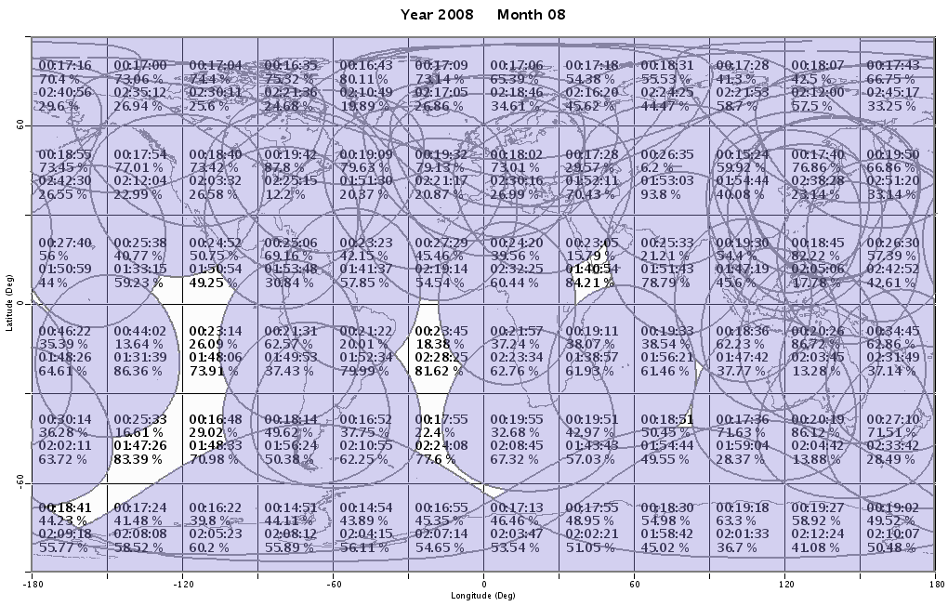

Improving data timeliness

Enhancing antenna network
“To install new antennas according to the following priority areas: the South Atlantic, the Indian Ocean, and the Southwest Pacific Ocean.”5.3

9 new antennas were installed in 2006/2007 –see above (North Pacific, Central Pacific, Atlantic, Japan…). There’s a need to complete Indian Ocean network. First of all we need to enhance performance of existing stations.

We are discussing with SAWS the installation of two or three receiving stations (at least Marion and Gough islands). This would enhance coverage in South Atlantic and Indian Ocean. This is planned for 2009.

Brazilian satellites
“To make the Brazilian Satellites data available via the new Argos data processing system” 5.10-v

Data was made available through the old Argos 86 processing system and solely for the Peruvian fishing vessels. Some piece of software has been developed on the new processing system which needs completion & tests prior operational implementation. But the current agreement with INPE is only for the fishing vessels in Peru. On another hand, only a few tens of buoys are currently under the footprint of the Brazilian antenna.

Anti-vandalism

“To print and distribute the vandalism leaflets in appropriate languages to the fishing industry or fishing authorities” 5.3

CLS provided information to fishing fleets about data buoys. CLS provided the secretariats with a list of countries using Argos VMS and in we received in return leaflet in pdf translated in several languages.

These leaflets were provided to our agents for disseminations to the fisherman.
As preliminary actions:
- Leaflets were disseminated in Russia in a seminar in Sakhaline (14-20 June). They were also given in a meeting of the National Fishing vessel monitoring center, the regional centers and scientific institutes which were held at the Fishing federal agency.
- Leaflet was translated in Japanese and disseminated to fishermen in contact with CLS agents
- Our Australian representative disseminated them to fishing administrations of Tonga, Niue, Samoa, PNG, Cooks, Marshalls, Aust, NZ and also SPC et FFA. See email below:

“Dear All,

We have been requested by:

•WMO (World Meteorological Organisation)
•DBCP (Data Buoy Cooperation Panel)
•IOC of UNESCO (Intergovernmental Oceanographic Commission of United Nations Educational, Scientific and Cultural Organization)

to distribute the attached document to as many Fisheries administration and regional agencies as part of our work on ocean-weather data buoys.

We would very much appreciate if you could forward the document your local fishers and/or fisheries co-operative.

Thank you very much,

Sincerely,

Guan Oon
Managing Director
Satellite IT Pty Ltd / CLS Argos Aust-NZ-South Pacific”

New feed-back on these actions will be reported at the DBCP session.

Argos-3 / PMT

“To implement PMT pilot activity as soon as possible and to reactivate the offer concerning new generation PMTs” (4.3, 5.8

The text below describes CLS proposal for a PMT pilot project made to the DBCP for consideration and action:

“DBCP ARGOS-3 DATA BUOY EVALUATION PROJECT PROPOSAL

The active pursuit of technology evaluation initiatives is a primary element of the Data Buoy Cooperation Panel (DBCP). In that context a proposal is made herein to the DBCP by CLS to establish an ARGOS 3 DATA BUOY EVALUATION PROJECT.

BACKGROUND

There are currently more than 2,000 drifting buoys and 3,000 profiling floats in operation that are relaying their ocean and meteorological data via Argos-2, the second generation Argos system. The third generation Argos system, Argos-3, has been operational on one satellite since August 2007. The next satellites carrying Argos-3 will be launched in February 2009 and July 2010. The increased capabilities of Argos-3 should significantly improve the performance of existing Argos equipped data buoys. Argos-3 drifters are expected to be smaller and less expensive, transmit more data and have longer lifetimes. Argos-3 floats are expected to have much shorter surface times, higher resolution profiles and significantly less energy consumption resulting in increased lifetimes. Because DBCP members could significantly benefit from these improvements, CLS proposes the establishment of a DBCP EVALUATION PROJECT, along the lines of the existing Iridium Pilot Project, to evaluate Argos 3 capabilities for the buoy community.

APPROACH

With support from CLS, two drifter manufacturers and one float manufacturer are now performing the necessary engineering work to replace the standard Argos PTT’s in their products with the new Argos-3 PMT manufactured by Kenwood. Each will develop a prototype Argos-3 platform, test it, apply modifications if needed, then produce 10 pre-production drifters (2-3 floats) for evaluation by interested members of the community.

CLS believes that a DBCP EVALUATION PROJECT is the best way to independently and objectively evaluate Argos-3 for use by the global buoy community. Following the rationale adopted by the Iridium Pilot Project, CLS suggests that a community-wide steering group be established to : i) identify users interested in deploying the pre-production buoys to evaluate Argos-3, ii) define the evaluation criteria, methods and procedures, iii) coordinate and harmonize the desired multiple evaluations, and iv) provide a community-wide forum to present and disseminate the evaluation results and conclusions.

The DBCP is invited to consider this proposal and, if in favor, move immediately to the recruitment of a steering group, possibly from within the existing Task Team on Technology Development.

Opscom

“To bring the issue of cost implications for installing METOP compatible antennas to the attention of the next OPSCOM (GTS delays)” 5.2.

CLS compiled the elements below in answer to this question:

HRPT instrument on MetOp-A is still not operative. Next Argos-3 instrument is on NOAA satellite and so it is compatible with the current Argos antennas network.
Next launch of MetOp satellite is scheduled in 2012, so there is time to implement the MetOp compatible antennas network. However, 3 actions are in course at CLS on this subject :

- CLS will soon integrate the EARS network (Argos processing system is already ready). EARS antennas are compatible with NOAA and MetOp satellites.

- The EUMETSAT antenna in Svalbard will soon work also like a real time antenna.

- In 2009, a new project will be launched with the CNES with the aim to replace Argos real-time network with antennas compatible Argos-3 (NOAA & MetOp) + SARAL (Satellite with ARgos and ALtika) + Argos-4.

_________________________
Annex VI

Review of the Structure of the Tariff Agreement and related matters

1. Report and recommendations from the Operations Committee

42nd Operations Committee (June 2008)

G-1-1. Report on JTA Meeting

Yves Tréglos presented a report of the 27th JTA meeting which took place in Jeju (Republic of Korea) from 22nd to the 24th of October 2007.
The main issue was linked to the soft landing being made necessary for a few tracking animal programs. An agreement was reached to cap the number of day units to 12 for those programs when computing their monthly charges (15+9xday units €). This agreement could remain valid until 2009. The opscom co-chairmen endorsed this proposal.
The JTA history report is under preparation with a specific section on the relationship between OPSCOM and JTA. This report will be transmitted to the co-chairmen for analysis before March 2009.
A letter was sent by the JTA chairman to the OPSCOM co-chairmen concerning a wish from the DBCP to investigate direct access to raw global data as an alternative mechanism to recover user data. NOAA noted that at the JTA meeting Oct. 2007, they reported their position which was to continue their existing processing arrangements. The OPSCOM co-chairmen will prepare a formal answer along this line before September 2008.

G-1-2. Status of U.S. processing agreement

Eric Locklear began his presentation by discussing his role as the U.S. Representative of Country (ROC) and began discussing what he presented at the 41st Opscom meeting in St. Jean de Luz, and what has changed since then. The users continue to be pleased with ARGOS and CLS data processing. However, there is a growing interest in using Iridium as a data processor. As technology evolves and program requirements change, we want to ensure we stay responsive to user needs.

He then discussed that even though we know growth will level off for the U.S. science users, the rapid rise in deployment asset operating costs is making it difficult for the U.S. to maintain its current capacity and keep the U.S. network from contracting. The U.S. has re-directed costs to maintain the system, however, there is no long-term strategy to deal with this problem.

Lastly, Eric Locklear reported that all legal issues regarding the transfer of funds to pay CLS invoices have been resolved. Also, the small user accounts that were negative have begun to be replenished.

In conclusion, Mr. Locklear reported his concern about the revenue and cost implication to the science family of costs CLS charges the JTA because of the potential loss in revenue from a possible transition to Iridium and the contraction of the U.S. programs through a slowed deployment.

The U.S. Chairman asked what the revenue implication was for a loss of the ARGO float community and Eric Locklear reported it was estimated at $400,000 US annually. However, this doesn’t mean there would be a loss of $400,000 US immediately, but a phased scheduled as new floats are deployed.

Eric Locklear concluded that even though he reported factors that may negatively affect CLS and the JTA, these issues were to be watched over the next 24 months to see how they develop.

Chris O'Connors commented that he would like to see an ARGO float cost/benefit analysis and Eric Locklear said he would make available any information that he has but that it will likely be the 2008 DBCP when more information will be made available.

G-1-5. Financial status of Agent

Methodology to derive Argos costs to be attributed to the JTA:

Christophe Vassal presented the meeting with the CLS methodology to derive the Argos basic costs to be attributed to the JTA.
It showed that the Argos basic costs have remained at approximately the same level from 12.24 in 2006 M€ to 12.25 M€ in 2007.
The Argos basic costs for science have slightly decreased as well as the Argos basic costs for fishing due, primarily to a decrease in activity. The Argos basic costs for sensitive use have increased due principally to more promotion in the US.
In 2007, the costs to be attributed to the JTA are calculated at 6.43 M€. Or a 0.8% increase compared to an increase of 5.5% in the average active PTTs processed and distributed (9258 in 2007 compared to 8777 in 2006). Also in 2007, all platforms benefited from the time slot calculations. This represented a few percent savings for every transmitter.

At the 27th JTA meeting, the following was agreed:

- Soft landing: The Meeting recalled the agreement in JTA-26 to continue to provide the “soft landings” to several marine animal programs through 2007, with the clear understanding that all programmes would move towards the agreed tariff structure over the course of the following years. It was indeed recognized that there was great difference between those who were benefiting from the soft landing and others. The meeting noted that this arrangement would cease as from 1 January 2008.
- The meeting agreed, in principle, that PTTs that have not transmitted during a period of 24 months would be charged 3.85 € per month from the 25th month until the ID numbers are returned to CLS/Service Argos. This fee would not apply to PTTs deployed for mooring monitoring indicated as such in advance to CLS by the user. The Meeting considered that this should be negotiated and decided together with new definition of the ROC roles. CLS to study new scenarios regarding the unused IDs (action, CLS).
- Downlink tariff & high data rate channel policy: METOP 1 which carries an Argos-3 instrument, equipped with a downlink capability and the 4.8 kbps high data rate channel, was launched on 19th October 2006. The meeting considered to continue with the proposed Downlink Tariff Policy presented at JTA XXII, that was 1) a fixed monthly fee of possibly 20 € per active PTT, 2) to add a category “high data rate” with a specific day unit rate, for example 1/3 more than the “Large Volume – Float” category, 12 €. To foster the test and use of these new capabilities, CLS kept the current proposal to grant free access to these new services for a one year period begining on 1st January 2008. The meeting agreed to keep this arrangement. It was also agreed that the downlink tariff should be further discussed in 2008 taking the status of Iridium usage and services into account.
- Processing for Iridium data: The pricing structure for Iridium transmissions and service was under study: the Meeting noted that such a study should take into account the feasibility of integrating Iridium data sets directly in the Argos data base, as well as possible bundling it in the GTS processing. The meeting also requested CLS to include Iridium services into the global planning including possibly the next 5-Year Plan.

The meeting noted the agreement following which the current Argos monthly charge would be capped at a maximum of 12 days-unit for animal trackers. CLS pointed out this pricing would be defined for, and apply to, animal categories only. After review, the meeting approved this arrangement.

In 2007, CLS recorded revenues from JTA participating countries at a level of 6.52 M€. This was slightly different from the revenues expected from the JTA at 6.81 M€. This shortage in revenue is explained by Soft landing provided for user programs tracking marine animals at a level of 0.29M€.
So in 2007, the JTA is going to expect a small excess of 0.09 M€ which is going to add up to the excess carried forward from the previous year of 0.24 M€ to bring the cumulative balance to 0.33 M€.
The non-JTA incomes decreased significantly in 2007 from 7.36 M€ to 6.79 M€, but the corresponding applications are still exceeding their portion of the costs.
Consequently, the non-JTA accumulated loss at the end of 2007 is calculated at 6.72 M€.

At the date of this meeting, we believe the JTA in 2008 may pay its portion of the cost.
However, two uncertainties remain with regards to the JTA income in 2008:
- the impact of the capping at 12 days per month for all animal tracking programs,
- the impact of the competition from IRIDIUM even though we believe it is going to be limited.
The Argo program still favours the robustness and the reliability of the Argos system and the oceanographic drifter programs do not generally need the capabilities of IRIDIUM.

2. The 2005-2009 Year Operating Plan

The 5 Year plan table updated with actual 2007 and projected 2008 numbers is provided here below.

Extrapolation Jan-Aug 08
 | 2005 | 2006 | 2007 | 2008 | 2009
In euro | Actual | Actual | Actual | Extrapolated
JTA Costs (M€)
cost increase % | 2.0% | 2.0% | 2.0% | 2.0% | 2.0%
Actual & Forecast | 6.13 | 6.38 | 6.43 | 6.65 | 6.78
Agreed 5YP JTA Cost | 6.00 | 6.40 | 6.40 | 6.40 | 6.40
JTA Income
Activity: Actual and Forecast
Growth Active PTTs (%) | 21% | 14% | 6% | 2% | 2%
Growth PTT-yrs (%) | 20% | 10% | -7% | 2% | 2%
Active Ptfs (Total) | 7720 | 8768 | 9258 | 10420 | 9304
PTT-yrs (Total) | 2852 | 3140 | 2934 | 2941 | 3000
Active PTTs (w/o large program) | 5244 | 5910 | 6108 | 7157 | 7300
PTT-yrs (Buoys & Others) | 682 | 663 | 584 | 559 | 570
PTT-yrs (floats w/o large pgm) | 105 | 117 | 85 | 90 | 92
PTT-yrs (Animal) | 580 | 630 | 664 | 696 | 710
PTT-yrs (Fixed stations) | 156 | 149 | 135 | 146 | 149
Active PTTs (large pgm) | 2476 | 2858 | 3150 | 3263 | 3328
PTT-yrs (large pgm) Buoys & Others | 1258 | 1495 | 1353 | 1322 | 1596
PTT-yrs (large pgm) Floats | 71 | 85 | 113 | 127 | 129
Basic Service Income
Monthly fee (€) | 15 | 15 | 15 | 15 | 15
Daily fee (€) | 6.00 | 6.00 | 6.00 | 6.00 | 6.00
Month unit income (M€) | 0.94 | 1.06 | 1.10 | 1.29 | 1.31
Day unit income (M€) | 3.91 | 4.07 | 3.89 | 3.97 | 4.05
Large pgm Day Unit Income (M€) | 1.94 | 1.70 | 1.68 | 1.69 | 1.91
Total basic service expected (M€) | 6.80 | 6.83 | 6.67 | 6.95 | 7.27
Additional revenue | 0.14 | 0.14 | 0.14 | 0.16 | 0.05
Revenue shortage
Former JTA - CA, CN, UK | 0.15 | 0 | 0
Soft Landings (or Animal price capping from 08) | 0.26 | 0.31 | 0.29 | 0.00 | 0.1
Revenue above Large Program Fixed price | 0.59 | 0.35 | 0.00
Total Actual basic service (M€) | 5.94 | 6.31 | 6.52 | 7.11 | 7.22
Year Balance | -0.19 | -0.07 | 0.09 | 0.46 | 0.44
Carried forward from previous year | 0.50 | 0.31 | 0.24 | 0.33 | 0.79
Cumulated Balance | 0.31 | 0.24 | 0.33 | 0.79 | 1.22

3. Financial Statement

3.1 Annual Expenses (in kEuros) for Year 2007

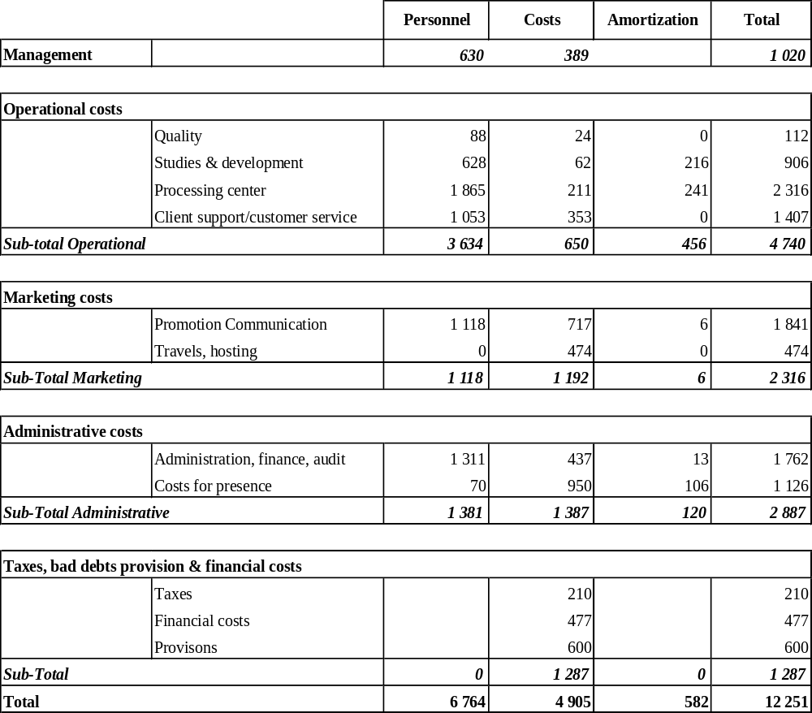

Table 3.1: Detail on 2007 Expenses in k€

3.2 Details of Amortization Items

 | Amortization | Description
Operational costs
Quality | 0
Studies & development | 216 | GTS, SSA3, Argos 2001
Processing center | 241 | Maintenance processing center (hardware and software)
Sub-total | 456
Marketing costs
Promotion | 3 | Exhibit, International meetings, User Conference Costs
Communication | 3 | Exhibit, documentation Costs
Sub-total | 6
Administrative costs
Management control | 13 | Accounting system, Argos registred mark
Costs for presence | 106 | Office furniture, safety, general equipment
Sub-total | 120
Total | 582

Table 3.2: Detail of Amortization Items in k€

3.3 Annual Incomes (in millions of Euros)

Incomes (M€) | 2006 | 2007
JTA | 6.31 | 6.52
Non JTA | 7.36 | 6.79
Total | 13.67 | 13.31

Table 3.3: JTA and non JTA 2006, 2007 Incomes

3.4 Details of JTA and non JTA Incomes and Expenses (in million Euros)

 | 2006 | 2007
Incomes
JTA CLS | 2.44 | 2.60
JTA SAI | 3.87 | 3.92
 | 6.31 | 6.52 | +3.38%
Non JTA CLS | 6.58 | 5.93
Non JTA SAI | 0.78 | 0.86
 | 7.36 | 6.79
Total basic Argos incomes | 13.67 | 13.31 | -2.60%
Expenses
Total basic Argos expenses | 12.24 | 12.25 | +0.08%

Table 3.4: Detail of JTA and non JTA Incomes and Expenses

3.5 JTA Annual Balance (in millions of Euros)

 | 2006 | 2007
JTA Operating Costs* | 6.38 | 6.43
JTA Income | 6.31 | 6.52
Difference | -0.07 | 0.09
Accumulated Difference | 0.37 | 0.28
* The remaining difference from 2004 was 0.30 M€.

Table 3.5: Annual Balance

For year 2007, the costs to be attributed to the JTA, calculated using the methodology developed by CLS science 3 years now, is 6.43 M€.

4. Other Issues Relating to Argos Funding

4.1 Management of ID numbers

Unused ID Numbers and 28 bit IDs

JTA XXV meeting (2007)

“..The phasing out of the unused ID charges: The meeting agreed not to take any action on this issue until the end of the FYP, and to consider it again at JTA-XXIV”
JTA-XXVII : “To study new scenarios regarding the unused IDs” 6.6-vi

In August 2008 there were 32 367 ID (29 892 in Aug. 2076) numbers allocated to JTA applications out of which some 81% (against 76% last year) – 26 203 IDs - were 28 bit. Though the situation is improving, there’s still a fair amount of 20 bit IDs in JTA programs (7 278 IDs) thus we strongly encourage to initiate new mechanism to the ID numbers.

Further to JTA XXVII request to study new scenarios, and as already discussed at the previous meeting, we propose the implementation of an ID fee in replacement of the unused ID fee.

The advantages expected are:

- this is an incentive for the user to efficiently manage his IDs during the lifetime of his program,
- the ID invoice acts as a swift reminder to the owner of a stopped program to release the IDs. It’s received no later than two months after the end of the experiment.

We are confident that this is an efficient mechanism that will alert the users in shortest possible time and that ID numbers will be returned much sooner to CLS.

The following proposal is made to the meeting:

The current pricing formula:
Price per PTT per month = A + n x B

Would be replaced by
Price per PTT per month = (S + A’) + n x B

Where:
- S is a subscription fee by ID applied whether the platform transmit or not,
- A the monthly fee on Active platform
- A’ the new monthly fee on Active platform
- n the number of day units in the month
- B the price coefficient applied to the platform type category (unchanged)

It is proposed to set up the ID fee at 2 € - as a recall the unused ID fee is 3.62 € - and to reduce the A coefficient by the same amount.

The table below gives the results of the calculation using 2008 projection:

Item | Numbers | Revenue
Assigned IDs | 32 367 | 776 808
Active IDs | 10 420 | - 250 078
Unused Ids | 3 684 | - 160 000
Net revenue |  | 366 730

With the implementation of this fee, it is expected that the IDs will be returned much quicker and that the net revenue indicated in table above will also quickly decrease.

4.2 Time slot accounting for all PTTS

As agreed at the JTA XXVI, the time slot accounting has been extended in 2007 to all Argos platform categories. The financial loss for 2007 for “Buoy & others” and “Fixed stations” categories was 107 k€ and is projected to be 96 k€ for 2008 (46.1 PPT-years).

4.3 Marine Animal tariff structure adjustment

As agreed at the JTA XXVII, the price capping to 12 day-units (48 time-slots) per month was applied to all animal platforms with, as a consequence, a projected loss of revenue for 2008 of 455 k€ (138 PTT-years) – Section 1 § 1.6 for further details.

4.4 Inactive Status service

Since year 2004, transmissions from IDs in inactive status are no longer charged. Yet, as shown in Chapter 1, in 2008 there are some 360 to 440 PTTs - ~370 PTTs in 2007- in inactive status and the related projected consumption is 264 PTT-years (250 PTT-years in 2007). These numbers have increased again this year compared to last year. This significant number of PTTs participates to the system occupancy and can bring some competition to the operational transmitters in normal service. These are most frequently autonomous expendable transmitters with large batteries (drifters) and/or solar panels (animal tags). Thanks to the PMTs and the Argos two-way, it will be possible in the near future to stop the transmissions when they are no longer needed. To regulate the increase of PTTs in inactive status and the related system occupancy, it is wise to consider levying a charge that will discourage the transmissions after the end of the experiment. This could possibly be a fee per ID in inactive status.

4.5 Downlink tariff and high data rate channel policy

METOP 1 which carries an Argos-3 instrument, equipped with a downlink capability and the 4.8 kbps high data rate channel, was launched on 19th October 2006.
The proposed Argos-3 tariff recalled at JTA XXVII, that is a fixed monthly fee of possibly 20 € per active PTT for downlink messaging and 12 € per day-unit for the High data rate is still under consideration.
It was decided at Opscom 42 (Germany) that the Argos-3 pricing should be re-defined after gaining experience on the actual usage during the PMT pilot projects.

4.6 Processing Iridium data

In January 2007 CLS became a global Iridium VAR (Value Added Reseller) for the Iridium modems and data service.
Since 2006, CLS America has been processing for GTS dissemination the Iridium data from ARGO floats deployed by the University of Washington.
In parallel, CLS has developed an Iridium processing center.
Three Indian drifters from INCOIS are currently being processed by this center and data relayed onto GTS.
The pricing structure for Iridium transmissions and service will be presented and discussed at the DBCP meeting.

5. Development Projects of the Argos System

These projects are presented in three categories:

5.1. Latest Projects Completed:
Argos 2001 project (Argos processing chain renewal) step1
On-line access to Argos technical files
BUFR code development
Argos 2001 project (Argos processing chain renewal) step 2
ADEOS II/Argos processing sub-system upgrade
GTS distribution of sub-surface floats
Argos 2001 project (Argos processing system renewal) step 3A (without observations and GTS processing)
Argos 2001 project (Argos processing system renewal) step 3B (with observations and GTS processing) – completed in June 07.

5.2. Projects Being Developed (or which started in 2007)
GTS Subsystem adjustments and developments (open action item)
Improved delivery times (open action item)
Argos data web: first phase completed, service open in September 06 to all users.
Argos – Downlink Messaging Monitoring Center upgrade and related web interface
Implementation of METOP compatible network of LUT antennas (ongoing)
Processing Iridium data (step 1)
ArgosWeb evolutions (ongoing)

5.3. Projects under study
Argos 4 instrument.

_________________________
Annex VII

Terms and Conditions of the Global Agreement for 2009

.
These Terms and Conditions outline costs for and services to be provided by Collecte Localisation Satellites (affiliate of CNES)...

TIME PERIOD OF COVERAGE:

These Terms and Conditions are valid for the time beginning on January 1 and ending on December 31, 2009.

DEFINITIONS

"Platform-year" is defined as 365 days of operation of an acceptable Platform Transmitter Terminal (PTT).

“ROC” is the Representative of Country representing a country or a group of countries.

“RO” is the Responsible Organization representing an agreed set of Argos User programs for the purposes of their collective participation in the JTA.

The "Agreement" includes all those participating countries which agree to the Terms and Conditions contained herein and are listed in Annex A to this Agreement.

The “Large Programmes” are defined as those programmes that are funded and managed by a single organisation.

BASIC SERVICES PROVIDED BY CLS

CLS will perform the following categories of services associated with PTTs of the authorized users:

(1) Location determination or both location determination and data collection for PTTs with a repetition period equal to or less than 120 seconds, application of calibration curves to the data when appropriate, access to the data and distribution of the data according to the paragraph below entitled "Distribution of processed data" and archiving for three months;

(2) Data collection for (fixed station) PTTs with a repetition period equal to or greater than 200 seconds, application of calibration curves to the data when appropriate, access to the data and the distribution of the data according to the paragraph below entitled "Distribution of processed data" and archiving for three months;

(3) Location service plus / auxiliary location

(4) On-line data access

(5) GTS Processing and Distribution

USER BASIC SERVICE CHARGES

BASIC SERVICE

Basic service charges for authorized users under this Agreement are in accordance with the payment on consumption.

They are calculated according to the following formula:

Price per month, per platform = A + B x n

where:

- A represents the monthly charge per active PTT (an active PTT is one that transmits at least once during a given calendar month)

- B represents the PTT-day unit rate.

- n is the number of day units. The day is divided into 4 time slots (0 - 6; 6 - 12; 12 - 18; 18 – 24 UTC). Any PTT transmission collected into a given time slot produces a 0.25 day unit. .

A and B coefficients for all platform categories are provided in table below:

Category | A (€) | B (€)
Buoys and others | 15 | 6
Fixed Stations | 15 | 3
Animals* | 15 | 9
Subsurface Floats | 15 | 9

Buoys and others – PTTs in this category are drifting and moored buoys and, more generally, all those PTTs which do not belong to categories below.

Fixed Stations – PTTs in this category are land fixed PTTs.

Animals – PTTs in this category are those that are used.
*Charges for Platforms in this category will be capped at n=12 Day Units per month.

Floats – PTTs in this category are subsurface floats such as the ARGO program floats.

DISCOUNT SCHEME FOR LARGE PROGRAMMES

Number of platform-years | PTT–day unit (B)
300 | 5
600 | 4
900 | 3
1200 | 2

UNUSED IDs

PTTs which have not transmitted during a period of 24 months will be charged 5 € per month from the 25th month until the ID numbers are returned to CLS. This amount of unit charge will be implemented from 1 March 2009, and previous amount (3.62 € per month) will be applied until then. The purpose of this fee is to recover IDs no longer required.

SILENT SERVICE

From January 2009, a “Silent Service” with an administration charge of 3 € per month per unit will be applied to the IDs remaining silent but still being used.

INACTIVE STATUS

This status is intended for those platforms that continue to transmit but for which the location or data collection are of no further use to the user or the community. The following conditions must be met to qualify:

(1) Inactive Status will apply if, and only if, Inactive Status is declared by the signatory of the System Use Agreement for platforms which continue to transmit beyond the programme termination. In that case, further charges will no longer be levied;

(2) The platforms must have operated in Basic Service for a minimum of 2 months;

(3) Data or location information cannot be retrieved nor can the platform revert to any category of service;

- It is intended that Location and/or data collection may not be computed using a Local User Terminal or other direct readout facility;

- ID numbers of such platforms are actually returned to CLS who will recycle them after the platform stops transmitting.

ADDITIONAL SERVICES PROVIDED BY CLS AND NOT INCLUDED IN BASIC SERVICES

Additional services such as ArgosDirect (the former ADS, Databank) service, ArgosMonitor, Moored Buoy monitoring and others are provided by CLS and charged according to the yearly catalogue of prices.

DESIGNATED ROC / RO

..................................................................
..................................................................
..................................................................
..................................................................

DISTRIBUTION OF PROCESSED DATA

(1) These Terms and Conditions do not cover the costs of special additional services made to provide the processed data back to the users. These must be made by the user directly with CLS;
(2) However, it is understood that CLS will continue to provide data from PTTs via the World Weather Watch Global Telecommunication System (WWW/GTS) of the World Meteorological Organization (WMO) according to procedures established by WMO.

BILLING AND PAYMENT

CLS will send invoices on a two monthly basis (CLS America on a monthly basis) based on consumption to the organizations covered by the country agreement.

GENERAL CONDITIONS OF AGREEMENT

(1) The designated ROC / RO and CLS jointly agree the list of users included in the Agreement and will update this list as appropriate. To assist in this process CLS will notify the ROC/RO of any new programmes that might qualify for this agreement.
(2) For additional services not provided within this Agreement, individual users under this Agreement must negotiate directly with CLS. Payments associated with these negotiations must be settled on receipt of the invoice. If these conditions are not met, CLS may stop the distribution of the user's processed data.
(3) Authorized users are defined as those implementing PTTs which are government funded. However, other users of agencies or organizations which are considered "non-profit" may be authorized. PTTs funded partly or entirely by private companies or organizations cannot be included in the conditions of this Agreement, even if data are supplied free of charge to national or international organizations.
If these rules are not followed, CLS may stop the distribution of this user's data. Should this situation occur, CLS will immediately notify the ROC / RO. Nevertheless, active PTTs received by the system will be counted in the platform-year total and data stored.
(4) All authorized users must sign a purchase order for each programme, either for the current year or for the duration of the programme, in order to clearly specify the services they request, whether these services are provided under this Agreement or not.
(5) VAT will be charged to EU Members in accordance with EU rules.

________________________  Signed on behalf of the participating countries by the JTA Chairperson | _______  / / | ____________  Signed by CLS  Chief Executive Officer  Christophe VASSAL | _______  / /

______________________

Annex VIII

Role of the JTA Representative of Country (ROC)

(as agreed at the Meeting)

HISTORICAL OVERVIEW

The concept of ROC was introduced at the first meeting on Argos Joint Tariff Agreement
(JTA-I) (Geneva, Switzerland, December 1981). The Meeting adopted a proposal «which foresees that agreements will be signed directly between the user Representative* and Service Argos.» The note under the * reads: «Representative is a unique Representative Organization for a country or a group of countries as given in the Global Agreement.» The Global Agreement starts with the following sentence: «These Terms and Conditions outline costs to and services to be provided by Service Argos of CNES and the (*)....... jointly providing support to their own authorized users for the location and data processing associated with the implementation and testing of remote platforms communicating with the satellites of the TIROS-N series.» The note under the (*) reads: «Quote the country and its own organization in charge of the Agreement with regards to CNES Service Argos. Hereafter defined by "ROC", i.e., a unique Representative Organization for a Country or a group of countries.»

That wording remained unchanged (except «Service Argos of CNES» being replaced by «Collecte Localisation Satellites», beginning in 1987, and «the satellites of the TIROS-N series» being replaced by «Argos capable satellites», beginning in 2003) until and including the "usual" Global Agreement for 2005. In the Agreement for 2005 regarding the Pilot Programme for the New Tariff Scheme, one reads: «These Terms and Conditions outline costs to and services to be provided by Collecte Localisation Satellites (1) hereafter referred to as "CLS" and the countries listed below, but not be limited to: [etc.]», and the note reads: «Quote the country and its own organization in charge of the Agreement with regard to CLS. Hereafter defined by "ROC / RO / Programme Manager", i.e. a unique Representative Organization for a country, a group of countries, or a single programme.» In addition, under DEFINITIONS, the following is added: «"RO" is the responsible Organization representing an agreed set of Argos User programs for the purpose of their collective participation in the JTA.»

The Global Agreement for 2006 comes back to the initial wording, with a slight change in the note: «Quote the country and / or the organization in charge of the Agreement with regard to CLS, hereafter defined by "ROC / RO”» and the addition, under DEFINITIONS, of: «“ROC” is the unique Responsible Organization representing a country or a group of countries.»

The Global Agreement for 2007 reads: «These Terms and Conditions outline costs to and services to be provided by Collecte Localisation Satellites (affiliate of CNES in charge of operating the Argos system), hereafter referred to as "CLS" and all the countries participating in the JTA.» The definitions of ROC and RO remain unchanged.

Lastly, the Global Agreement for 2008 reads: «These Terms and Conditions outline costs for services to be provided by Collecte Localisation Satellites (affiliate of CNES).» The definition of ROC becomes the one adopted by JTA-XXVII and used in this document.

CONTEXT

The terms of the Joint Tariff Agreement require that the agreement is negotiated within an intergovernmental forum. This is achieved because, and only because, the invitation letters to the meetings are addressed by the joint Secretariat to the official representatives of Members / Member States of WMO / IOC. These invitation letters are systematically copied to the ROCs, who therefore may attend the meetings, whatever their official status may be (governmental representatives or "advisers"). This has been done on purpose since the first meeting because: (i) the ROCs are the only really knowledgeable people in their countries regarding JTA activities; and (ii) nobody could foresee what might be the official status of the ROC in each and every country (see "NOMINATION AND RECOGNITION OF ROC" below).

The tariff agreement has been negotiated annually since its inception, with the objective of assuring the long term viability and development of the CLS / Argos data service, and in turn securing preferential (cost-recovery) and globally-consistent pricing arrangements for government or not-for-profit funded environmental monitoring programs within the JTA participant countries.

The Representative of Country (ROC) is the person representing a country or a group of countries from a responsible government organization. The ROC may be required to keep other government agencies informed of the activities of CLS / Argos in order to justify the use of the Argos transmitters (PTTs) within national boundaries and their status within current communication policies. The ROC is the Responsible Authority representing an agreed set of Argos User Programs for the purposes of their collective participation in the JTA.

The tariff structure, price-setting arrangements and relationships between CLS / Argos, User Programs and the ROCs have changed significantly since 2005. Changes include the introduction of a simplified tariff, the establishment of direct contracts and billing arrangements between CLS / Argos and end-user programs, and, in some cases, the entry of local CLS / Argos representatives with the capacity to provide end user support. In the process, the “traditional” role of ROCs, their relationship with users and with CLS / Argos, and their contribution to annual tariff negotiations have been altered. ROCs’ roles around the world have also become less homogeneous.

This document sets out the role of a ROC, and the relationships, expectations and obligations between ROCs, end users, CLS / Argos and other stakeholders (e.g., OPSCOM), in the context of the current tariff structure.

NOMINATION AND RECOGNITION OF ROC

Each and every country nominates (or not, see below) its ROC as it wishes. In general, the ROC is nominated by an official representative of the Member / Member State of WMO / IOC and has therefore the status of a governmental representative. But this is not always the case: in some instances, for example, the ROC may be just "defined" through an agreement between a programme manager and CLS, and accepted as such by the JTA Meeting because of its de facto position. Other possibilities may (and do) happen. None would impinge upon the intergovernmental status of the Meeting on Argos Joint Tariff Agreement (see 1st paragraph in the "CONTEXT" section above).

ROLE OF THE ROC - GENERAL

The ROC is to ensure that the Argos system meets the basic requirements of all system user groups in the most cost-effective way within the principles of fairness, openness and the promotion of science.

ROC ROLES – CLS/ARGOS INTERFACE

- Tariff charge rate negotiation. Review CLS / Argos financial analyses, and approve the level of expenses to be attributed to JTA user programs support. Negotiate tariff structures (including for Iridium services) that will fund the costs of the JTA service, to achieve globally consistent, predictable and equitable service pricing arrangements for all user classes (i.e. across the range of environmental science applications);

- High level advocacy of user programs and user service classes. Provide high level collective advocacy of all user programs and user service classes to CLS / Argos to assure long term stability of the environmental data service for all end user service classes, and effective management of service or charge rate transitions;

- Representation of user requirements: Gather user requirements (current service, shortcomings, enhancements and future requirements) and relay to CLS/Argos as a basis for system enhancement, ground system corrective actions, enhancements or strategic investment.

- Endorsement of service investments. Review and endorse investments needed to sustain and enhance the CLS / Argos provision of basic services, and ensure the forward funding basis for such investments;

- Provision of independent advice to end-users. Represent CLS / Argos service capabilities to end-users (existing or candidate) and provide limited support to enable users to make appropriate decisions, and to resolve service problems. Support may be in the form of technical advice, referral to peer programs, etc. It is to be provided in the context of existing primary support through equipment suppliers and CLS / Argos channels, not as an alternative to those arrangements;

- Adjudication of JTA program eligibility. On referral from CLS / Argos, adjudicate the eligibility of new user programs for inclusion in the JTA;

- Submission of a National Report to the JTA Meeting. Provide a National Report to the JTA meeting, at least one month prior to the meeting. The content shall follow the current report guidance; and

- Attendance at JTA meetings. ROCs are expected to attend JTA meetings. Alternatively they are to consider the materials circulated prior to the JTA meeting, and to ensure that the interests of the user programs they represent are adequately conveyed through a ROC who will be attending the meeting, or else through their National Report.

Enabling Actions to Support the ROC’s Role

- CLS / Argos is to provide transparent and timely disclosure of the costs attributed to providing JTA services, and the basis for such cost attribution, at least 3 weeks in advance of new tariff negotiations;

- Outcomes of the most recent OPSCOM review of CLS finances are to be made available to ROCs through the JTA Chairperson’s report to the JTA;

- CLS / Argos is to notify ROCs of user sign-ups as they occur, and to provide regular reporting of service usage by programs in the country (or countries) represented by a ROC. The CLS / Argos Usage Reports are to be provided quarterly, in a spreadsheet form that enables ready analysis of the data;

- The CLS / Argos is to provide advice to all users on the ROC’s role, and the contact details of the local ROC at the time of initiating new service contracts; and

- CLS / Argos is to provide the ROCs on a quarterly basis with the list of unused IDs (and the date of the last transmission) for each programme.

- ROCs are to invite user communication, and may solicit specific user feedback on matters pertinent to their role, but are not expected to initiate formal user group surveys. CLS/Argos shall notify ROCs of user forums that it organises.

Issues

- Commercial sensitivity of material. The potential for the introduction of competitors to CLS / Argos in data communications and data management services may further affect the role of the ROC, and the nature of the JTA’s strategic planning and budgeting process. It may also increase the potential for perceived conflict in the relationships between CLS / Argos and ROCs, and the sensitivity of information disclosures needed for the tariff negotiation. In such circumstances, it may become prudent to conduct some aspects of tariff negotiation through a smaller group, operating on behalf of the full ROC membership; and

- Funding of ROC participation in JTA. CLS / Argos is requested to consider options for collecting funding through the JTA revenues for funding of ROC participation in the JTA. Any funding of the ROC through CLS must be done very carefully to avoid a real or perceived conflict of interest. A suggestion might be that the ROC controls the billing of his/her clients to support his/her activities and CLS could provide an arm's-length role as bill collector.

ROC ROLES - INTERFACE WITH END USER PROGRAMS

ROC’s provide the following value to end users:

- Insight into CLS / Argos operation and directions. Provide insight into the operations of the CLS / Argos data service, how it (and the tariff) operates, how it might change in the future, and what affect that might have on user programs;

- Assurance of global tariff consistency, stability and predictability;

- Opportunities for cross - fertilization. Provide a point of reference to other (like or complementary) programs, nationally or globally; and

- Impartial, high-level representation to CLS / Argos. Provision of an influential, impartial voice in tariff negotiations and in specific problem resolution.

ROC ROLES – SUPPLIER INTERACTIONS

- There is no formal relationship or exchange required between ROCs and suppliers, but ROCs are encouraged maintain a level of familiarity with PTT technology appropriate to their role.

Enabling Actions to Support the ROC’s Role

- CLS / Argos is to ensure suppliers are familiar with the ROC’s role, and to encourage supplier contact with ROCs; and

- CLS / Argos is to facilitate ROC / supplier interactions, e.g., by invitation to user-supplier forums organised by CLS / Argos.

ROC ROLE - OPSCOM RELATIONSHIP

OPSCOM requires nationally-based user representation in tariff negotiations. No formal direct relationship is required with the ROC, only interactions through the JTA.

ROC - ROC RELATIONSHIP

- It would be a time challenge but regular teleconferences (once every three months), to discuss user issues and provide recommendations to the JTA meeting, might be an idea. It is probably more realistic to have the discussion using email in which case a ROC’s mailing list needs to be hosted somewhere; and

- To be further developed.

______________________

Annex IX

Format for the national reports to the JTA

JTA National Report

Year: 2008
Country:

(please delete text in italic and replace with actual information)

Section 1. Overall Summary

The objective of this section is to provide a short narrative statement that characterizes a country’s ARGOS participation, program, and future directions. This section can also be looked at as an abstract of section 2 – section 6.

Section 2. User Types by family (Table of PTT use by the country)

(please complete the table below based on actual and estimated use for the current year)

 | Average active PTTs per month | Total PTT.Years
Buoys and others
Profiling floats
Animals
Fixed stations
TOTAL

The objective of this section is to provide some data on platform distribution and use. Historical graphs and charts depicting the country’s program is encouraged.

Section 3. Technological Changes that Affect User Requirements

This objective of this section is to provide information on any advances in instrument development, techniques, or other technology that may affect future development of the ARGOS system.

Section 4. User issues, problems, and level of satisfaction with ARGOS

The objective of this section is to highlight any user issues that need to be brought to the attention of the JTA and CLS Executives.

Section 5. Successful program use of ARGOS

The objective of this section is to highlight the successful use of ARGOS in helping users achieve their objective.

Section 6. Analysis of Local Operational Issues

The objective of this section is to present any ARGOS issue that affects users in a particular location, country, or platform family that may not shared by other user groups.

________________________
Annex X

National reports on current and planned programmes

Year: 2008
Country: Canada

Agency | Purpose of Programme | Program Number | Platforms deployed in 2008 | Platforms planned for 2009 | Estimated PPT usage for 2008 | Estimated PPT usage for 2009 | Comments from Program Coordinators
Fish and Wildlife Division, Government of Alberta | To monitor wolves and grizzly bears to reduce conflict with livestock producers/landowners. | 12599 | 3 | 3 | 2.750 | 2.750 | 2007: 4 wolf, 1 grizzley bear  2008: 7 wolf, 3 grizzley bear
Ministère des Ressources naturelles et de la Faune, Government of Quebec | Barren Ground Caribou tracking in northern Québec. | 959 | 117 | 117 | 23.400 | 23.400
 | Woodland Caribou monitoring | 22857 | 28 | 28 | 10.000 | 10.000
Environment Canada, Meteorological Service | Pacific Drifter Program | 5626, 5693, 6693, all programs | 76 | 76 | 30.000 | 30.000 | Platform type: SVP-B.  Operational deployments in North East Pacific.
 | Atlantic Drifter Program |  |  |  |  |  | Platform type: SVP-BW.  Operational deployments in St. Lawrence River and North West Atlantic Ocean.
 | International Artic Buoy program |  |  |  |  |  | Platform type: ICEX ice beacons.  Operational deployments in Arctic Basin. The number of buoys deployed in program 627 is higher than normal in support of the International Polar year.The numbers in this report reflect buoys which are transmitting. Many buoys are expected to run for 18 months or more.
 | Operational moored deployments in North East Pacific, and East Atlantic Ocean |  |  |  |  |  | These three programs are covered under separately negotiated Moored Buoy Monitoring contract with Environment Canada.
Environment Canada, Canadian Wildlife Service | Greater Snow goose monitoring | 3082 | 17 | 17 | 1.270 | 4.270 | Type of platforms: GPS/ARGOS solar transimitters (2x 30g + 20x 45g)
Environment Canada, Canadian Wildlife Service | Track movement of sea ducks in Beaufort Sea and Chukchi Sea | 1706 | 28 | 30 | 2.900 | 3.300
Environment Canada, Canadian Wildlife Service | Track Barrows Goldeneye movements over the annual cycle. | 22375 | 40 | 40 | 3.000 | 3.000 | The number of PTTs deployed each year is correct but the number of PTT-years is a prediction based on the attrition (mortality) rate of birds and/or PTTs over the course of the current year (from January 2007 to the present and from now to December 2007) and estimated for 2008.
Environment Canada, Canadian Ice Service | Track ice floes / ice island and validate sea ice and iceberg drift model. | 633 | 4.4 | 4 | 3.400 | 3.400 | Type of platform: CALIBS
Department of Environment, Government of Yukon | Porcupine Caribou Satellite Collar Project. | 1207, 9207 | 15 | 15 | 1.438 | 1.670 | This project documents the seasonal range use and migration patterns of the Porcupine Caribou Herd (Rangifer tarandus granti), numbering 123,000 animals. Annual herd movements cover an area of approximately 250,000 square kilometers, making frequent conventional radio telemetry locations expensive. With financial support of co-operating agencies, we’ve maintained satellite collars on the herd since October 1997. Location data have helped us document seasonal ranges used, timing of migration, and helped us determine the geographical areas we need to travel to in order to conduct our fieldwork.
 | YNNK Old Crow Flats Moose. | 3535 | 16 | 19 | 1.110 | 1.320 | Using satellite GPS collars, we will track seasonal migration and distribution of moose (Alces alces) and examine how moose habitat use within the OCF is related to variation in microclimate, hydrology, and shrub distribution, as well as the timing and spatial extent of moose migration.
 |  | 2979 |  |  | 0.950 | 0.950
 | Moose tracking. | 3346 | 24 | 24 | 1.630 | 1.630
University of Alberta | Grizzly bear and polar bear tracking. | 2846, 12846, 22846 | 20 | 35 | 9.000 | 8.600
 | Learn about the interactions, population dynamics and spatial ecology of Dall sheep (Ovis dalli), grizzly bears (Ursus arctos) and wolves (Canis lupus) in the Richardson Mountains, Northwest Territories. | 3288 | 20 | 20 | 20.000 | 20.000 | Deployed current year: 20 Terrestrial animal platforms, among which 10 Telonics TGW-3580 and 10 Telonics TGW-3680.  Planned next year: Approximately 16 Terrestrial animal platforms, among which 6 Telonics TGW-3580 and 10 Telonics TGW-3680.
 |  | 3682 | 20 | 20 | 3.900 | 3.900
 | Tracking of adult female forest dwelling woodland caribou | 3219 | 5 | 13 | 3.000 | 13.000
Fisheries and Oceans Canada | Arctic Marine Mammal tracking and dive recording | 1142 | 20 | 20 | 2.500 | 3.270 | Central & Arctic Region. All platform types are ARGOS linked time-depth recorders. Our interest, marine mammal trackers, lies in obtaining the best possible quality (i.e.: many points) of tracks, given a limited energy budget and intermittent transmission opportunities.  The present JTA tariff proposal is punishing us because we cannot conform to a slot system without loosing location and dive data.
Fisheries and Oceans Canada | Monitor Surface and Subsurface moored scientific installations | 704 | 15 | 15 | 0.250 | 0.250 | Witness program.
Fisheries and Oceans Canada | Tracking floats launched by Canada in support of the international Argo program. | 2442 | 110 | 110 | 5.300 | 5.300 | Canadian Argo recently deployed its first float using the CLS/RUDICS system to track a float broadcasting on the Iridium network. Experience is slight, we have only three profiles received as of writing, but the preliminary conclusion is that this is an extraordinarily successful process and I am very happy to be able to continue the good relationship I have with CLS. I do not yet know what this will actually cost me and am anxious to find out.
Universite du Quebec a Rimouski | Characterization of large scale movements of arctic and red foxes in the Canadian Arctic | 3297 | 22 | 16 | 3.390 | 8.416
Universite Laval | migration, reproductive and wintering strategy of two arctic avian predators, the snowy owl (Bubo scandiaca) and the long-tailed jaeger (Stercorarius longicaudus). | 13471 | 10 | 0 | 1.140 | 0.000
Universite Laval | Monitoring of migratory movements of Snowy Owls in the Canadian Arctic | 3471 | 13 | 0 | 0.420 | 0.000
Environment & Natural Resources, Government of the Northwest Territories | Document seasonal range use, distribution, movements, and fidelity of female boreal caribou throughout their range in the Dehcho. | 2814 | 30 | 30 | 8.140 | 8.000 | During Jan/Feb 2007 we deployed 17 collars: 9 were Telonics ARGOS/GPS platforms (TGW3680) and 8 were Telonics satellite collars (ST-20). This brought the total number of collars deployed on the project at that time to 31 (9 TGW3680’s and 22 ST-20’s). During February 2008 we plan on deploying 4 TGW3680 and 1 ST-20 collars which should bring us up to 33 functioning collars in the program (13 TGW3680’s and 20 ST-20’s).
 | Document seasonal range use and movements of male and female wood bison of the Nahanni bison population. | 12814 | 4 | 4 | 0.400 | 0.400 | During July 2007 we deployed 5 collars: 2 were Telonics ARGOS/GPS platforms (TGW3780) and 3 were Telonics satellite collars (ST-20). This was an initial deployment and we may deploy more collars later this year or in March 2008. We would deploy up to 3 more collars (2 TGW3780’s and 1 ST-20) during the scheduled capture operation.  Given that we usually have transmission times of 5 or 6 hours maximum for our collars it would be nice if we were only charged for the actual usage instead of being charged for one half of a day of use because our transmission times cross some subjective 6 hour boundary.
 | Other programs | 1572, 10572, 14572, 31572 | 124 | 124 | 13.800 | 13.800
Long Point Waterfowl & Wetlands Research Fund | Determining migration pathways and breeding and wintering ground affinities of Lesser Scaup and Greater Scaup. | 3031 | 28 | 28 | 1.400 | 1.400
Parks Canada | Grizzly Bear monitoring and bear management within Kluane National Park. | 1015 | 1 | 1 | 0.150 | 0.150
Kintama Research | Fish tracking. | 3065 | 2 | 2 | 0.670 | 0.500
Department of Defence, Canada | drdc | 2176 | 2 | 2 | 0.660 | 0.660
Bird Studies Canada | Bird monitoring including bald eagles. | 2670 | 6 | 6 | 1.200 | 1.200
TOTALS |  |  | 820.4 | 819 | 157.168 | 174.536

Polling of users is incomplete since only 30 of the 83 programs reported. The number of PTT-Years used through August 2008 is reported as 141.76. Accounting for reduced activity in the winter and extrapolating to the end of the year gives an estimate of about 208 PTT-Years for 2008. The returned estimates show a slight decrease but this can be attributed to some programs not knowing how many ppts they were going to deploy in 2008. I would expect the usage to be about the same in 2009.

CANADIAN ARGOS USAGE THROUGH AUGUST 2008 from CLS America
Service | Family | PTT Days | Total Cost (Euros) | % total time | % of total cost | PPT Years
TSLP | Land Animal | 29541.5 | € 390,974 | 56.94 | 65.15
TSLP | Bird | 3643.25 | € 54,359 | 7.02 | 9.06
TSLP | Marine Animal | 2444.5 | € 27,688 | 4.71 | 4.61
TSLP | Fish | 281.5 | € 3,959 | 0.54 | 0.66
TOTAL | Animals | 35,910.75 | € 476,979 | 69.22 | 79.48
TS | Sub Float | 1720.5 | € 27,845 | 3.32 | 4.64
STD | Drifter & Others | 9244 | € 62,229 | 17.82 | 10.37
STD | Moored Buoy | 5001.25 | € 32,978 | 9.64 | 5.50
STD | UNDW_STAT | 0.5 | € 33 | 0.00 | 0.01
STD | UNDW_VEH | 4.75 | € 59 | 0.01 | 0.01
TOTAL | To August | 51,881.75 | € 600,122 |  |  | 141.75
TOTAL | To December (est) | 75,881.75 | € 900,182 |  |  | 207.33

_________________

Year: 2008
Country: New Zealand

Section 1. Overall Summary

The NZ JTA Argos usage consists of one large programme (MetService Buoy programme, one other small application using buoys and 11 animal tracking programmes which are all very small. The range and type of animals applications is growing with 7 types of birds, 2 types of fish and 2 types of mammals being tracked. Animal applications are expected to grow.

Section 2. User Types by family (Table of PTT use by the country)

Table below is completed with data provided by Service Argos and is the best estimate of likely NZ usage for 2008.

 | Average active PTTs per month | Total PTT.Years
Buoys and others | 12 | 12
Profiling floats
Animals | Approx 14 | Approx 1.3
Fixed stations
TOTAL | 26 | 13.3

Section 3. Technological Changes that Affect User Requirements

The MetService Buoy programme will trial some buoys with Iridium transmitters in the next year. A move to using Iridium for all buoys would impact greatly on NZ Argos usage. Miniaturisation of tags will allow the monitoring of smaller fish species than is currently possible. Improvements in Argos location accuracy will increase the use of Argos for animal tracking applications.

Section 4. User issues, problems, and level of satisfaction with ARGOS

Only 5 NZ users responded to requests for input to this report. One user stated that lack of position accuracy makes analysis of data and inference about animal behaviour difficult and another said that much of their tag battery was used up when there was no satellite coverage.

Section 5. Successful program use of ARGOS (good news)

In general NZ users’ level of satisfaction with Argos was high. One user said “expensive, but great data” and stated that they had collected and published new information learned from their application. Users were in general very pleased with the assistance provided by the Melbourne User Office.

Section 6. Analysis of Local Operational Issues

No particular issues were raised.

_________________
Year: 2008
Country: The Netherlands - IMAU

Section 1. Overall Summary

Institute for Marine and Atmospheric Research (IMAU)
Land ice change and sea level change monitoring (1238)
As a contribution to the European Project on Ice Coring in Antarctica (EPICA) IMAU has installed at one time a maximum of eight Automatic Weather Stations (AWS) in Dronning Maud Land, Antarctica. Four are currently operational. These AWSs were installed on a transect ranging from the coast to the plateau Amundsenisen, along the Swedish research stations Wasa and Svea.. The goal of this project is to extend the knowledge of the climatological conditions of this particular part of Antarctica and to obtain a better understanding of the surface energy and mass balance of the Antarctic ice sheet. Therefore surface and subsurface (bore holes up to 600 meters) temperatures, relative humidity, wind speed and direction, snow height, air pressure, short and long wave incoming and outgoing radiation is measured. Together with GPS positioning the data are transmitted as two hour averaged values through the ARGOS system. See for more information: http://www.phys.uu.nl/~wwwimau/research/ice_climate/aws/aws_ antarctica.html.
Besides we also started to combine ARGOS in our GPS systems in Svalbard this year and Antarctica next year. Furthermore, at the end of this year/beginning next year our total number of AWS will be extended on Antarctica from 5 (2008) to 8 (2009).

Section 2. User Types by family (Table of PTT use by the country)

 | Average active PTTs per month | Total PTT.Years
Buoys and others
Profiling floats
Animals
Fixed stations | 215 (2008) and 340 (2009) | 2580 (2008) and 4080 (2009)
TOTAL | 215 (2008) and 340 (2009) | 2580 (2008) and 4080 (2009)

Section 3. Technological Changes that Affect User Requirements

Section 4. User issues, problems, and level of satisfaction with ARGOS

Section 5. Successful program use of ARGO (good news)

Section 6. Analysis of Local Operational Issues

Year: 2008
Country: The Netherlands – Bureau Waardenburg for Birdlife netherlands

Section 1. Overall Summary

Bureau Waardenburg for Birdlife Netherlands

Dutch Purple Herons Ardea purpurea with Satellite Transmitters (3447)

Herons are equipped with transmitters. These include standard solar PTT transmitters as well as GPS-PTT transmitters. The aim is to track down migration routes and habitat use of Purple Herons in order top get information about protection of habitats. The project started in 2007 and is continued in 2008. Prolongation depends on results in the first two years and cannot be foreseen at this stage.

Section 2. User Types by family (Table of PTT use by the country)

 | Average active PTTs per month | Total PTT.Years
Buoys and others
Profiling floats
Animals | 2-8 | 2007-2008
 | 8 | 2008
Fixed stations
TOTAL

Section 3. Technological Changes that Affect User Requirements
Bureau Waardenburg; most relevant issues are related to the transmitters. Smaller types and types with stronger batteries will improve possibilities for bird research. A significant problem for bird research with migrants passing the Mediterranean is the data deficiency in this region. For Purple herons so far it seems of minor importance although it might have influenced birds in the eastern part of Spain crossing the Mediterranean.

Section 4. User issues, problems, and level of satisfaction with ARGOS
Bureau Waardenburg; The PTT manufacturer provides a parser software program in order to organize data files (from GPS-PTTs) supplied by ARGOS. This implies extra data handling for us users. As internet capacity is not limiting nowadays, any improvement in this would increase the efficiency of data handling for us.

For us it is still not clear what terms of payment are in use. If birds are dead or transmitters are lost, we still receive invoices. It is not clear if payment is needed.

Section 5. Successful program use of ARGOS (good news)

Bureau Waardenburg; The data handling and speed of data provision is satisfactory.

Section 6. Analysis of Local Operational Issues

Bureau Waardenburg; no issues to address.
Year: 2008
Country: The Netherlands - IMARES

Section 1. Overall Summary

IMARES (formerly: ALTERRA,) dept. of Ecology.
Seals Feeding (1877)

The harbour seal population in the Dutch Wadden Sea has increased exponentially over the past 10 years. Mainly because of the difficulty of obtaining information, very little is known about the diet of these animals, let alone the potential effect this population growth has on the (commercial) fish stocks. This project, which is commissioned by the Ministry of Agriculture, Nature Management and Fisheries of the Netherlands, is designed to obtain data on possible feeding locations of the seals and on the fish species present in these seas.
To achieve this, harbour seals were equipped with satellite tags to determine their location and data on diving. Concurrently, fish will be sampled in the areas where seals are located and assumed to feed (based on the diving data). This will yield a first insight in possible dietary preference, and mostly in preferred feeding locations. In addition to this, several ways directed the diet of the seals will be explored.

Harbour seal, but also grey seals turn out to show much small scale movement. ARGOS location, though proven very valuable, is not accurate enough to define this. Current development in GPS localisation of marine mammals proves much more adequate. As high resolution also requires large amount of data to be sent the GSM transmitter turns out to be much more suitable, providing receptors are at hand. For these marine mammals, that regularly come close to shore the method is more promising. Especially In the light of the costs that have strongly increased with the new ARGOS method, the institute has chosen for the other system.

Section 2. User Types by family (Table of PTT use by the country)

 | Average active PTTs per month | Total PTT.Years
Buoys and others
Profiling floats
Animals | 0 | 0
Fixed stations
TOTAL

Section 3. Technological Changes that Affect User Requirements

In the past years, Imares (formerly Alterra) have tested new tags based on a data logger, a GPS and a GSM transmitter. As said above, the results received were much more complete; i.e. almost a continuous record of dive behaviour, whilst ARGOS success was far less than a half. Also location accuracy is much higher and frequency of GPS-quality location with these tags is now dependant on the tag settings (20 min is possible). For these reasons ,we have chosen to continue using this new system in the Netherlands. There are possibilities of combining the GPS and ARGOS, which could come handy in areas were GSM coverage is poor. In 2009 there are no plans to do so. We are currently exploring possibilities of deploying ARGOS-tags on water birds.
This objective of this section is to provide information on any advances in instrument development, techniques, or other technology that may affect future development of the ARGOS system.

Section 4. User issues, problems, and level of satisfaction with ARGOS

It is a pity that the cost calculation was changed, for the study of seals this, the use of ARGOS unjustifiably high. Data of seals through ARGOS is so sparse and unpredictable the duty cycling is not an option.

Section 5. Successful program use of ARGO (good news)

Section 6. Analysis of Local Operational Issues

Year: 2008
Country: China /The Netherlands

Section 1. Overall Summary

Beijing Wetland Biodiversity Protection (Capital Normal University) and International Institute for GEO-Information Science and Earth Observation (ITC), Department of Natural Resources/Environmental Modelling
Chinese Crane Grus grus Monitoring Program (3803)

For the sake of mastering migratory bird’s partial habitat and migratory route, thereby providing migratory bird protection with scientific evidence, the research group of Beijing Wetland Biodiversity Protection (Capital Normal University) plans to cooperate with Netherlands International Institute for GEO-Information Science and Earth Observation (ITC) on the study of tracking the common crane Grus grus. .

Section 2. User Types by family (Table of PTT use by the country)

 | Average active PTTs per month | Total PTT.Years
Buoys and others
Profiling floats
Animals | 10 ptt-gps transmitters in 2009
Fixed stations
TOTAL

Section 3. Technological Changes that Affect User Requirements
As the programme has to be started next year (microwave cannot supply the transmitters before july 2009) no comments yet

Section 4. User issues, problems, and level of satisfaction with ARGOS
As the programme has to be started next year (microwave cannot supply the transmitters before july 2009) no comments yet

Section 5. Successful program use of ARGO (good news)
As the programme has to be started next year (microwave cannot supply the transmitters before july 2009) no comments yet

Section 6. Analysis of Local Operational Issues
What worries us a bit is the capacity of the transmitters in relation to the data transmitting/receiving in China region (it seems to be problematic)
Year: 2008
Country: The Netherlands - NIOZ

Section 1. Overall Summary

Royal Netherlands Institute for Sea Research (NIOZ)
PROCS (1996)

The mission of NIOZ is to gain and communicate scientific knowledge on seas and oceans, among others through scientific projects, for the understanding and sustainability of our planet. Subsurface Mooring Monitoring ARGOS beacons are used to monitor the presence of its moorings and landers. Moorings and landers are being deployed as part of scientific projects, carried out by NIOZ in the North Sea, the Atlantic Ocean, the Mediterranean Sea and the Indian Ocean.

Section 2. User Types by family (Table of PTT use by the country)

 | Average active PTTs per month | Total PTT.Years
Buoys and others | 23 | 0.01
Profiling floats
Animals
Fixed stations
TOTAL | 23 | 0.01

Section 3. Technological Changes that Affect User Requirements

Section 4. User issues, problems, and level of satisfaction with ARGOS
ARGOS PTTs are used to alarm NIOZ that a mooring or lander has come to the surface, which should not happen for a very long time. This means that ARGOS PTTs are not supposed to transmit until a mooring or lander is no longer subsurface. This is an unusual application of the ARGOS System!

Section 5. Successful program use of ARGOS (good news)
Efficient operation of User Office.
Safe idea that ARGOS PTTs can be used for subsurface beacons coming at the surface.

Section 6. Analysis of Local Operational Issues
No data collection, only location.
Year: 2008
Country: The Netherlands - KNMI

Section 1. Overall Summary

Royal Netherlands Meteorological Institute, Scientific Department
Dutch Argo (2936)
Contribution to the ARGO programme.

Section 2. User Types by family (Table of PTT use by the country)

 | Average active PTTs per month | Total PTT.Years
Buoys and others
Profiling floats | 16 | 0.5
Animals
Fixed stations
TOTAL

Section 3. Technological Changes that Affect User Requirements

n/a

Section 4. User issues, problems, and level of satisfaction with ARGOS

highly satisfied – no problems

Section 5. Successful program use of ARGO (good news)

n/a

Section 6. Analysis of Local Operational Issues

n/a

______________________

Year: 2008
Country: Republic of South Africa

Section 1. Overall Summary

The Argos Service is used to transmit marine meteorological data from the drifting and fixed weather buoy network via the Argos Satellite system to data processing centres and onward to the Global Telecommunications System for use in operational forecasting, and other services.

We have not received any input from other users within South Africa

Section 2. User Types by family (Table of PTT use by the country)

 | Average active PTTs per month | Total PTT.Years
Buoys and others | 3 | 2.85
Profiling floats
Animals
Fixed stations | 2 | 2
TOTAL | 5 | 4.85

Section 3. Technological Changes that Affect User Requirements

South Africa is currently reviewing an internal proposal to replace the Local User Terminals on the Sub-Antarctic islands (Gough Island in the South Atlantic and Marion Island (of the Prince Edward Island group) in the Southern Ocean) with Advanced High Resolution P Transmission stations. The reason for this project is to improve the data transmission times of data in order for it to be readily available for surface analyses and forecasts. Quotations for the equipment, installation and training have been obtained from the CLS and the decision now rests with the South African Weather Services' Steering Committee. It is hoped that the Steering Committee will approve this proposal and that the project will commence within the coming financial year; April 2009 – March 2010.

Section 4. User issues, problems, and level of satisfaction with ARGOS

The SAWS has noted the issue of data delivery times as well as the discussions that have taken place around this issue. We are also aware that CLS is mindful of the problem and are working at improving data transmission times and we hope that the installation of AHRPT stations will improve the situation.

Section 5. Successful program use of ARGO (good news)

X

Section 6. Analysis of Local Operational Issues

______________________
Year: 2008
Country: USA

Section 1. Overall Summary

Overall, the United States continues to value the ARGOS system, and usage continues to grow. Because of the high number of U.S. users, this report consists of extracts from survey responses by U.S. users.

- “…ARGOS PTTs are used in research based in the vicinity of Palmer Station, Western Antarctic Peninsula, Antarctica. The research primarily focuses on the foraging strategies of Southern Giant Petrels and Adélie penguins…”

- “…Telemetry of seal movements and dive behavior in high-latitude seas. Our program has been active since 1986, working on 10 different species of Arctic and Antarctic pinnipeds.”

- “Our research is examining dispersal movements of cougars. During dispersal, cougars make large and unpredictable movements, which preclude tracking their movements by conventional means. Despite occasional difficulties with missing data downloads we have been very pleased with Service ARGOS products and service. We appreciate the new window they have helped open into cougar ecology and supplying new opportunities for large carnivore conservation.”

- “The Navy Marine Mammal Program uses a variety of Argos satellite transmitters to track Navy dolphins and sea lions while operating in open waters all over the world.”

- “…I am using internal implanted PTTs to track ducks throughout North America in order to document migration corridors and affiliations of breeding and wintering areas…”

- “…participation in the ARGOS program began in 2005 with 10 platforms on caribou from the Mulchatna Herd in southwestern Alaska. In 2006, the herd numbered about 45,000 animals and ranged over a 155,000 km2 area.”

- “The conservation programs that we develop are based on the use and application of satellite technology. The tracking of the condors in an environment so rough and isolated like is the Andes Mountain Chain is practically impossible without the use of satellite technology.”

- “This study uses Telonics Model TGW-3680 GPS satellite collars to acquire frequent locations of grizzly bears in a remote area of northern Alaska. Locations are uplinked to Argos satellites, relayed to ground stations and are available from the Argos website.”

- “United States Coast Guard International Ice Patrol (IIP) is a small, but long-term user of ARGOS services. Since the early 1980s IIP has been deploying 12 to 15 drifters into the Northwest Atlantic Ocean to measure ocean currents. The currents are used to predict the movement of icebergs that threaten transatlantic mariners.”

- “We are using Pop-up Archival Transmitting (PAT) tags to study the movements and migrations of Atlantic tarpon (Megalops atlanticus).”

- “Office of Naval Research performs surface drifter programs in various marginal seas and coastal areas of specific scientific interest to the US Navy, mainly in the Mediterranean (Ligurian, Levantine and Marmara seas) but also in the Altantic off Africa.”

- “We track Florida manatees using the Argos system to provide information on seasonal movement patterns, migratory behavior, site fidelity, diel movement patterns, travel paths, habitat use, behavior, and distribution…”

- “The Hawaii Institute of Marine Biology uses ARGOS programs to track the movements of pelagic fishes (tunas, billfish) and sharks. These research programs are designed to provide data for improved biological resource management and conservation of living ocean resources.”

- “We operate only one platform, installed at the summit of Kilimanjaro (Tanzania) in February 2001. Our hope is to keep it going for a 10-year period. Argos has worked really well there, with great reliability! Studying climate…”

- “We use satellite-linked telemetry to observe the ranging and dive patterns of dolphins under two circumstances: 2) in biological studies of wild populations, and 2) for follow-up monitoring of rehabilitated stranded dolphins after release, in order to evaluate the success of the rehabilitation, and to learn about dolphin species that are otherwise difficult to study in the wild…”

Section 2. User Types by family (Table of PTT use by the country)

 | Average active PTTs per month | Total PTT.Years
Buoys and others | 2,102 | 1,633.1
Profiling floats | 1,715 | 132.8
Animals | 1,937 | 349.4
Fixed stations | 74 | 64.1
TOTAL | 5,828 | 2,179.4

Section 3. Technological Changes that Affect User Requirements

The following are highlights from survey responses by U.S. users.

- Additional data gathering capacity on PTTs,

- Long wait for 2-way communication capability, consequently, customer went with Iridium

- GPS incorporated into long battery-life implant PTTs for more accurate locations

- Continued reduction of size and weight and increased battery life of the Argos transmitters.

Section 4. User issues, problems, and level of satisfaction with ARGOS

The relevant user issues have already been transmitted to CLS America.

Section 5. Successful program use of ARGO (good news)

The following are highlights from survey responses by U.S. users.

- The use of multi-sat at no additional cost has provided a great increase in the amount of data available on the GTS.

- Overall we have been very pleased with service ARGOS. The large an unpredictable movements made by dispersing mountain lions could not be effectively tracked using conventional radio-telemetry or GPS collars. Service ARGOS has allowed us to gain unprecedented information on the movements of dispersing mountain lions.

- The Andean Condor Binational Conservation Program has managed the re-introduce of 82 specimens in all South America. The success of the project is based fundamentally on the ability to track the specimens in wild life.

- ARGOS has provided us with reliable and accurate data over the nearly three decades of our use of the system. Any system is only as good as the people who run it. The people associated with ARGOS, particularly the User’s Office, are always responsive and friendly.

Section 6. Analysis of Local Operational Issues

The following are highlights from survey responses by U.S. users.

- Would like to see data servers with faster responses and higher-capacity for backlog (i.e., more than 10 days).

- Faster receipt of data in Argentina, and Mongolian region of Asian continent

________________________
Annex XI

List of Representatives of Country (ROCs) for Argos

Australia

Mr Ken Jarrott
Head, Observation Systems Section
Bureau of Meteorology
G.P.O. Box 1289
MELBOURNE, Vic. 3001
Australia
Telephone: +61-3 9669 4163
Telefax: +61-3 9669 4168
E-mail: k.jarrott@bom.gov.au

Brazil

Mr Wilson Yamaguti
Instituto Nacional de Pesquisas Espaciais
(INPE)
Av. dos Astronautas, 1758
12227-010 SAO JOSE DOS CAMPOS
Brazil
Telephone: +55-12 3322 9977
Telefax: +55-12 3321 8743
E-mail: yamaguti@dss.inpe.br

Canada

Mr Joe Linguanti
Institute of Ocean Sciences
Ocean Sciences Division
9860 West Saanich Road
SIDNEY, BC V8L 4B2
Canada
Telephone: +1-250 363 6584
Telefax: +1-250 363 6746
E-mail: Joe.Linguanti@.dfo-mpo.gc.ca

China

Mrs Lin Shaohua
State Oceanic Administration
National Marine Data and Information
Service
93 Liuwei Road.
Hedong District
Tianji, 300171
P.R. China
Telephone: +86-22 24010 859
E-mail: ioi@mail.nmdis.gov.cn

Denmark

Mr Claus Nehring
Danish Meteorological Institute
100 Lyngbyveg
DK-2100 COPENHAGEN 0
Denmark
Telephone: +45 3915 7500
Telefax: +45 3927 1080
E-mail: cn@dmi.dk

Finland

Mr Simo Kalliosaari
Mr Hannu Gronvall
Finnish Marine Research Institute
P.O. Box 2
FIN-00561 HELSINSKI
Finland
E-mail: simo@ice.fmi.fi
Hannu.gronvall@fimr.fi

Germany

Mr Hartmut Heinrich
Federal Maritime and Hydrographic Agency (BSH)
Bernhard-Nocht-Strasse 78
D-20359 Hamburg
Telephone.: 0049-40-3190-3200
Telefax: 0049-40-3190-5000
E-mail: hartmut.heinrich@bsh.de

Iceland

Mr Magnus Jonsson
Icelandic Meteorological Office
Vedurstofa Islands
Bustadavegur 9
150 REYKJAVIK
Iceland
Telephone: +354 560 0600
Telefax: +354 552 8121
E-mail: office@vedur.is

India

Dr K. Radhakrishnan
Director
Indian National Centre for Ocean
Information Services (INCOIS)
Plot No 3, Nandagari Hills Layout
Jubilee Hills
HYDERABAD 500 033
India
Telephone: +91-40 355 3542/43
Telefax: +91-40 355 1096
E-mail: director@incois.gov.in

Italy

Mr Stephano Fioravanti Ph.D
NATO Saclant Undersea Research Centre
Viale San Bartolomeo 400
19138 LA SPEZIA
Italy
Telephone: +39 1875271
Telefax: +39 187524600
E-mail: steve@saclantc.nato.int

New Zealand

Mr J. Lumsden
c/o Julie Fletcher
Meteorological Service of New Zealand Ltd
P.O. Box 722
WELLINGTON
New Zealand
E-mail: fletcher@metservice.com

Norway

Mr Anton Eliassen
Norwegian Meteorological Institute
Attn: Lilian Swenden
P.O. Box 43, Blindern
N-0313 OSLO 3
Norway
Telephone: +47-22 963000
Telefax: +47-22 963050
E-mail: met.inst@met.no
Lillian.Swendsen@met.no

Republic of Korea

Mr Jang-Won Seo
Senior Research Scientist
National Institute of Met. Research, KMA
45 Gisangcheong-gil
Dongjak-gu
SEOUL 156 720
Republic of Korea
Tel: +82 2 841 2786
Fax: +82 2 841 2787
E-mail: jwseo@kma.go.kr

South Africa

Mr Johan Stander
Resional Manager
South African Weather Service
P.O. Box 21
Cape Town International Airport
7525
South Africa
Telephone: +27 21 9340450
Telefax: +27 21 9344590
E-mail: johan.stander@weathersa.co.za

Spain

Ms Asuncion Ruiz
Sociedad Espanola de Ornitologia
SEO/BIRDLIFE
c/o Melquiades Biencinto, 34
28053 MADRID
Spain
Telephone: +34-91 3511045
Telefax: +34-91 4340911
E-mail: aruiz@seo.org

Sweden

Mr Gunlog Wennerberg
Swedish Meteorological and Hydrological
Institute (SMHI)
Folkborgsvنgen 1
S-601 76 NORRKOPING
Sweden
Telephone: +46-11 158000
Telefax: +46-11 170207
E-mail: gunlog.wennerberg@smhi.se

Switzerland

Dr Adrian Aebischer
Museum of Natural History
Chemin du Musee 6
CH-1700 FRIBOURG
Switzerland
Tel: +41 26 300 9040
Fax: +41 26 300 9760
E-mail: adaebischer@dplanet.ch

The Netherlands

Mr A.T. Frank Grooters
Observations and Modeling Department
Royal Netherlands Meteorological Institute
P.O. Box 201
3730 AE DE BILT
The Netherlands
Telephone: +31-30 220 6691
Telefax: +31-30 221 0407
E-mail: frank.grooters@knmi.nl

United Arab Emirates

Mr Olivier Combreau
National Avian Research Centre
P.O. Box 45553
ABU DHABI
United Arab Emirates
Telephone: +971 3747555
Telefax: +971 3747607
E-mail: ocombreau@erwda.gov.ae

United Kingdom

Mr David Meldrum
Scottish Association for Marine Science
Dunstaffnage Marine Laboratory
Dunbeg
PA37 1QA OBAN ARGYLL
Scotland
United Kingdom
Telephone: +44-1631 559000
Telefax: +44-1631 559001
E-mail: dtm@sams.ac.uk

USA

Mr Eric Locklear
Climate Program Office
NOAA
1315 East-Weat Hgwy.
SSMC 3, 12701
SILVER SPRING, MD 20910
USA
Telephone: +1 301 427 2361
Telefax: +1 301 427 2222
E-mail: eric.locklear@noaa.gov

OTHER

Dr I-Jiunn Cheng
National Taiwan Ocean University
Institute of Marine Biology
No. 2 Pei-Ning Road
202 KEELUNG
Taiwan
Telephone: +886-2 2462 2192-5303
Telefax: +886-2 2462 8974
E-mail: b0107@mail.ntou.edu.tw

________________________

Annex XII

List of Acronyms and Other Abbreviations

ADS Automatic Distribution System (Argos)
AHRPT Advanced High Rate Picture Transmission
BUFR Binary Universal Form for Representation of Meteorological Data
BUOY Report for Buoy Observations
CDA Command Data Acquisition
CLS Collecte Localisation Satellites
CNES Centre National d`Etudes spatiales (France)
DBCP Data Buoy Cooperation Panel (WMO-IOC)
E-SURFMAR Surface Marine programme of the Network of European Meteorological Services, EUMETNET
EUMETNET Network of European Meteorological Services
EUMETSAT European Organization for the Exploitation of Meteorological Satellites
ESPC NOAA Environmental Satellite Processing Centre (USA)
FRGPC French Argos Global Processing Centre
FYP Five-Year Plan (of JTA)
GAC Global Area Coverage
GIS Geographic Information System
GTS Global Telecommunication System (WMO)
HRPT High Rate Picture Transmission
IABP International Arctic Buoy Programme
IBPIO International Buoy Programme for the Indian Ocean
ID Platform Identification Number
IJPS Initial Joint Polar-Orbiting Operational Satellite System (NOAA, EUMETSAT)
IMB Ice Mass Buoy
INPE Instituto Nacional de Pesquisas Espaciais (Brazil)
IOC Intergovernmental Oceanographic Commission (of UNESCO)
IRD Institut français de recherche scientifique pour le développement en coopération (formerly ORSTOM)
ISABP International South Atlantic Buoy Programme
JCOMM Joint WMO/IOC Technical Commission for Oceanography and Marine Meteorology
JCOMMOPS JCOMM in situ Observing Platform Support Centre
Jrev permanent JTA review mechanism
JTA Argos Joint Tariff Agreement
LAC Local Area Coverage
LDR Low Data Rate
LUS Limited Use Service (Argos)
LUT Local User Terminal (Argos)
METOP Meteorological Operational satellites of the EUMETSAT Polar System (EPS)
MOU Memorandum Of Understanding
NESDIS NOAA Satellites and Information Service
NOAA National Oceanographic and Atmospheric Administration (USA)
NORI National Oceanographic Research Institute (Korea)
NPDBAP North Pacific Data Buoy Advisory Panel
NPOESS National Polar-orbiting Operational Environmental Satellite System (USA)
NWP Numerical Weather Prediction
OCO NOAA Office of Climate Observation (USA)
OPSCOMM Argos Operations Committee (NOAA, CNES, EUMETSAT)
PDF Adobe Portable Document Format
PMT Platform Messaging Transceivers
POES Polar-orbiting Operational Environmental Satellite
PTT Platform Transmitter Terminal (JTA)
PTT.year Equivalent to a PTT reporting every day during one year
QC Quality Control
RO Responsible Organization representing an agreed set of Argos User programs (JTA)
ROC Representative of Country representing a country or a group of countries participating in the JTA
SAI Service Argos, Inc. (USA, now CLS America)
SCD Satélite de Coleta de Dados (Data Collection Satellite, Brazil)
SOOP Ship-of-Opportunity Programme
SOOPIP JCOMM Ship-of-Opportunity Programme Implementation Panel
SOT Ship Observations Team (JCOMM)
SSA3 Argos 3 Ground Segment project
SST Sea Surface Temperature
SUA Argos System Use Agreement
TAO Tropical Atmosphere Ocean Array
TIP TAO Implementation Panel
UNESCO United Nations Educational, Scientific and Cultural Organization
USD US Dollar
VOS Voluntary Observing Ship
WMO World Meteorological Organization

________________________

