INTERGOVERNMENTAL OCEANOGRAPHIC COMMISSION (OF UNESCO)  _____________ |  | WORLD METEOROLOGICAL ORGANIZATION  ___________

ARGOS JOINT TARIFF AGREEMENT
THIRTIETH MEETING

Oban, United Kingdom, 1-2 October 2010

RECORD OF DECISIONS

NOTES

WMO DISCLAIMER

Regulation 42
Recommendations of working groups shall have no status within the Organization until they have been approved by the responsible constituent body. In the case of joint working groups, the recommendations must be concurred with by the presidents of the constituent bodies concerned before being submitted to the designated constituent body.

Regulation 43
In the case of a recommendation made by a working group between sessions of the responsible constituent body, either in a session of a working group or by correspondence, the president of the body may, as an exceptional measure, approve the recommendation on behalf of the constituent body when the matter is, in his opinion, urgent, and does not appear to imply new obligations for Members. He may then submit this recommendation for adoption by the Executive Council or to the President of the Organization for action in accordance with Regulation 9(5).

© World Meteorological Organization, 2008

The right of publication in print, electronic and any other form and in any language is reserved by WMO. Short extracts from WMO publications may be reproduced without authorization provided that the complete source is clearly indicated. Editorial correspondence and requests to publish, reproduce or translate this publication (articles) in part or in whole should be addressed to:

Chairperson, Publications Board
World Meteorological Organization (WMO)
7 bis, avenue de la Paix Tel.: +41 (0)22 730 84 03
P.O. Box No. 2300 Fax: +41 (0)22 730 80 40
CH-1211 Geneva 2, Switzerland E-mail: Publications@wmo.int

IOC (of UNESCO) disclaimer

The designations employed and the presentation of material in this publication do not imply the expression of any opinion whatsoever on the part of the Secretariats of UNESCO and IOC concerning the legal status of any country or territory, or its authorities, or concerning the delimitation of the frontiers of any country or territory.

_______________

C O N T E N T S

RECORD OF THE DECISIONS

Annex I List of Participants

Annex II Agenda

Annex III Report on the 2010 Agreement

Annex IV Report on 2009-2010 Operations and System Improvement

Annex V Review of the structure of the Tariff Agreement and related matters

Annex VI Analysis and Rationale for an Unused ID monthly fee or a Monthly ID Charge

Annex VII Terms and Conditions of the Global Agreement for 2011

Annex VIII Argos Joint Tariff Agreement Operating Principles

Annex IX National reports on current and planned programmes

Annex X List of Representatives of Country (ROCs) for Argos

Annex XI Argos Joint Tariff Agreement Executive Committee Budget

Annex XII List of Acronyms and Other Abbreviations

RECORD OF THE DECISIONS

1. INTRODUCTION

1.1 The Argos Joint Tariff Agreement (JTA) scheme has served as a robust example of international cooperation for more than a quarter of a century, that is managed at the working level. It continues to provide an effective, self-governing global forum through which users’ needs and requirements are presented, reviewed, and carried forward as an influential part of a wider decision-making process.

1.2 As in previous cases, this final report of the JTA Session comprises of the following items:
- Introduction;
- Actions and decisions of past meetings with review status;
- Action sheet of this meeting, with records of necessary information and decisions;
- Records of formalities, including elections and decisions for the next meeting;
- Annexes containing all necessary information

1.3 Mr Frank Grooters, the Chairperson of the Argos JTA, led the meeting. Mr Eric Locklear (USA, Vice-chair of the Argos JTA), Mr Johan Stander (South Africa), Mr William Woodward (CLS), and Dr Boram Lee (IOC of UNESCO) participated in the Writing Group of the final report to assist the Chairperson.

1.4 The list of participants and agenda are reproduced as Annex I and Annex II of this report. Nineteen participants including eight Representatives of Country (ROCs) and Responsible Organizations (ROs) attended to the Meeting.

2 sTATUS OF ACTIONS FROM the Previous Meeting, and pending actions from previous meetings

2.1 Status of actions from the previous meeting

No.  (JTA-29) | Ref.  (JTA-29) | Action item | By whom | Deadline | Status  (ref. JTA-30)
1 | 3.3 | Implement strategy for the improvement of data timeliness | CLS | 2012 | Pending (see Annex VI, 3.2.2)
2 | 3.4.8 | Produce a thorough analysis, and rationale on an unused ID monthly fee or a monthly ID charge, and submit it to the JTA-EC | CLS | 15 Mar 2010 | Done  (see 3.4)
3 | 3.4.8 | JTA-EC to work with CLS on possible alternative options and to come up with a solution to be approved at the next JTA meeting | JTA-EC & CLS | JTA-XXX | Done  (see 3.4.2)
4 | 3.4.9 | Provide information, and solicit ROCs to return unused IDs | CLS | JTA-XXX | Done  (see 3.4)
5 | 3.5.11 | Argos developments and the status/evolution of Argos use in their countries | CLS | Ongoing | Ongoing
6 | 3.5.11 | Develop guiding principles regarding the tariff structure for negotiating the tariff | JTA-EC | JTA-XXX | Convert to JTA-XXX action  (see 3)
7 | 3.5.14 | Analyze the JTA administrative costs to be reimbursed by the JTA, and make recommendations to the Chairperson who will make the final decision | JTA-EC | End 2009 | Done (see Annex XI)
8 | 3.5.10 | Review the text of the operating principles to ensure consistency and check the language | Ken Jarrott | End 2009 | Ongoing (see 5.1)
9 | 3.5.15 | CLS to contribute to the DBCP Trust Fund for the contract of the independent Chairperson | CLS | Jul 2010 | Done  (see 3.5)

2.2 Pending and continuous actions from previous meetings

Ref. | Action item | By whom | Deadline | Status
JTA-29 2.1  No.3 | To pursue negotiations for the installation of new antennas to cover the South Atlantic and the Indian Ocean regions | CLS / SAWS | ASAP | Ongoing
JTA-29 2.1  No.4 | To enhance Hyderabad LUT station performance | INCOIS / CLS | Nov. 2008 | Done
JTA-29 2.1  No.5 | To ensure data from NOAA-15, 16, 17, and 18 are being received by IRD and Météo France stations in La Réunion Island | IRD-Météo France - CLS | ASAP | To be done in 2011
JTA-29 2.1  No.6 | 1)Investigate existing antennas in the Indian Ocean area and 2) try to connect them to the Argos network | CLS | 1) Dec. 2008  2) ASAP in 2009 | Done
JTA-29 2.1  No.7 | Study other possibilities to add new antennas in Indian Ocean (Ideally in central Indian Ocean) | CLS | 2009 | Done
JTA-29 2.1  No.8 | To continue efforts for making the Brazilian Satellites data available via the new Argos data processing system | CLS | ASAP | Done
JTA-29 2.1  No.20 | To communicate with OPSCOM on incorporating various users’ requirements, including the animal trackers | ROCs | ASAP and ongoing | Ongoing  (JTA chair to take actions)
JTA-29 2.1  No.21 | To communicate with various users to incorporate their requirements in the regular meeting | ROCs | JTA-XXIX (Oct. 2009) | Ongoing  (link to action #1 for JTA-30)
JTA-28 2.2  No.3 | Users who need downlink capability to start using the demonstration PMTs as soon as they become available | Users | JTA-XXVIII  (Oct. 2008) | Ongoing
JTA-28 2.2  No.4 | To promote the PMT pilot activity at the national level | ROCs | JTA-XXVIII  (Oct. 2008) | Ongoing
JTA-28 2.2  No.6 | To install new antennas according to the following priority areas: the South Atlantic, the Indian Ocean, and the Southwest Pacific Ocean. | CLS | JTA-XXVIII  (Oct. 2008) | In process
JTA-28 2.2  No.7 | To offer solutions for improving data timeliness and to develop data timeliness monitoring tools | CLS | JTA-XXVIII  (Oct. 2008) | Done
JTA-28 2.2  No.15 | To make the Brazilian Satellites data available via the new Argos data processing system. | CLS | ASAP | Closed

3 Actions and Decisions of the current Meeting

No.  (JTA-30) | Ref.  (JTA-30) | Action item | By whom | Deadline
1 | 3.1.2 | Design a strategy for improving ROC participation, particularly comprising animal trackers and other type of users | JTA-EC | JTA-EC-3 in May 2011
2 | 3.1.3 | ROCs to provide national reports | ROCs | JTA-XXXI
3 | 3.3.1, 3.3.2 | To investigate the possibility of installing a third new station over the southern part of the Indian Ocean | CLS | DBCP-XXVII
4 | 3.3.1, 3.3.2 | To support the Argos-3 PP Steering Team for its independent evaluation of the Argos-3 technology | CLS | Continuous
5 | 3.3.1, 3.3.2 | To work with DBCP representatives and respond to requirements from the evaluation of the new Argos location scheme | CLS | ongoing
6 | 3.3.1, 3.3.2 | To provide the data to JCOMMOPS relating to the new monitoring tools | CLS | ASAP
7 | 3.4.2 | Project Team to produce the results of a review of the 20 bit unused ID numbers and submit to the JTA-EC | AM.Breonce,S.Owen, J.Linguanti | March 2011
8 | 4.3 | CLS to provide a scanned, signed copy of the Terms and Conditions for 2011 Global Agreement | CLS | December 2010
9 | 5.2 | Develop guiding principles regarding the tariff structure for negotiating the tariff | E.Locklear lead / JTA-EC | March 2011
10 | 5.4 | Continue budgetary support for 1) JTA Executive Committee, 2) WMO and IOC Secretary, and 3) Independent JTA Chairperson. | JTA-EC | JTA-XXXI

3.1 Review of the 2010 Global Agreement

3.1.1 Detailed information on the 2010 Global Agreement is given in Annex III.

3.1.2 Upon completion of the report, the Meeting noted the continuing under-representation of ROCs at the JTA from the top ten countries. The Meeting considered that a discussion should be reactivated to analyze attributable causes and to design a strategy for improving ROC participation, including animal trackers and other type of users (see action 1 in the table under item 3).

3.1.3 In the same context, the JTA Chairperson encouraged the ROCs to submit national reports if they have not already done so.

3.2 Technical Development

3.2.1 The full reports on 2009-2010 operations, on system improvements and progress in projects are reproduced in Annex IV.

3.2.2 Bill Woodward presented to the meeting a summary of the status of Argos operations and systems improvements. The two global ground stations at Gilmore Creek and Wallops Island continued to deliver Stored TIROS Information Processing (STIP) data from NOAA-15, NOAA-16, NOAA-17, and NOAA-18 throughout the past year and from NOAA-19 since mid-2009. TIP or real-time data are delivered to CLS & CLS America (CLSA) on reception now from 60 stations around the globe. METOP-A Data Collection System (DCS) data was acquired and relayed via the internet to CLS & CLSA and to all Argos users during 2009. Blind orbits from NOAA-18 & 19 from the METOP antenna in Svalbard are also being collected and distributed. The two global centers, Toulouse and Largo, processed approximately 1100+ playback and real-time datasets per day and the two centers continue to be fully redundant with an average of 1-3 backups per month. The number of operating Argos platforms continues to increase with more than 10,400 platforms (up from 10,000 in 2008) seen on average per day and more than 20,000 active platforms (up from 18,000 in 2008) per month in 2009. The amount of data from the National Oceanographic and Atmospheric Administration (NOAA, USA) satellites and METOP-A that is available within one hour is now between 60 % and 70%.

3.2.3 Recent system developments in the different components of the Argos system include, in particular, the introduction of a machine-to-machine Argos web service interface and availability of Extensible Markup Language (XML) and Keyhole Markup Language (KML) formatted data, initialization of the Argos-3 PMT location, implementing the 6-digit ID capability, and implementing the full BUFR format to distribute the data onto the GTS. Particularly important new developments are, i) the New location processing technique based on Kalman filtering and ii) a very ambitious real-time antenna upgrade project now being implemented. No more image locations and better location accuracy are the main improvements expected with the new version of the Argos location processing. The real-time antenna upgrade project will include upgrading the antenna capability (to collect data from all satellites carrying Argos, to provide antenna availability of ~95%, and mean time for data retrieval of ~18 minutes) of 16 – 18 existing stations and installing 2 new antennas. Delay times to receive buoy data of importance to the Data Buoy Cooperation Panel (DBCP) will be reduced significantly with the improved network.

ARGOS-3 PILOT PROJECT

3.2.4 At the 26th DBCP Session (September 27- 30, 2010, Oban, Scotland) Dr. Luca Centurioni (USA) reported on the development and status of the implementation of the Argos-3 Pilot Project. Developments have been conducted in collaboration with the manufacturers (Pacific Gyre, Clearwater, Metocean and Marlin-Yug. The Panel noted that some units had been deployed with limited success. There were plans to deploy new units, all with barometers. Some PMT/system evaluations were done at CLS. Most of such compiled statistics are in the process of being verified and new statistics are also being computed by AOML (Mayra Pazos).

3.2.5 The Panel agreed that it is crucial to have an independent assessment of the new Argos-3 technology through the Pilot Project Steering Team. The Panel thanked the Steering team for its effort, agreed that the evaluation of the Argos-3 technology should continue, the Pilot Project kept alive, and requested the Steering team to continue its evaluation and report on its findings at the next Panel Session.

3.3 Review Users’ Requirements

3.3.1 The Meeting received a report by the DBCP Chairperson, Mr Al Wallace (Canada), regarding the DBCP requirements and recommendations to the CLS:

The Panel recognized the improvements in timeliness that has been seen in the past year, and welcomes the upgrades proposed for the satellite antenna network. The DBCP would like to be kept informed on progress of the implementation, and impacts on data availability and timeliness. At DBCP XXVI (reference paragraph 7.4.4) the Panel requested that another antenna position be considered and endorsed the recommendations from the IBPIO that CLS investigate the possibility of installing a third new station over the southern parts of the Indian Ocean to further improve data timeliness across the entire basin. The IBPIO is willing to assist CLS in identifying a suitable position.

The DBCP will continue to support a Pilot Project on Argos 3, and requests the ongoing participation and contribution from CLS and the JTA. (Reference DBCP XXVI Final Report, Paragraph 8.2) The Panel agreed that the evaluation of the Argos-3 technology should continue, the Pilot Project kept alive, and requested the Steering team to continue its evaluation and report on its findings at the next Panel Session.

The DBCP recognized that the new Kalman filter location processing was a proposal to provide improved service but expressed some concerns. As a result (reference DBCP XXVI Final Report, paragraph 10.3.5) the Panel requested CLS to work collaboratively with representatives of the Panel and respond to requirements and results from the evaluation of the new Argos location scheme.

The Panel noted with appreciation the new monitoring tools that are now routinely provided by CLS, including regarding data timeliness in specific WMO areas. The Panel invited CLS to provide the data to JCOMMOPS. (Reference DBCP XXVI Final Report, paragraph 10.3.6)

3.3.2 The Meeting noted with appreciation that CLS has agreed to the proposed actions for the above-mentioned requirements, and agreed on the according actions for the intersessional period, as listed in the table of actions (see item 3).

3.3.3 The Meeting further noted the following recommendation by DBCP to the JTA. Relevant discussion take place under agenda item 5.

The Panel noted that the JCOMM Pilot Project recommendation (reference DBCP XXVI Final Report, paragraph 11.5.7) regarding establishing an international forum of satellite data telecommunication users. The Panel endorsed the principle of this recommendation, and suggested that the JTA consider this proposal during their meeting (JTA XXX).

3.4 Tariff Agreement and related matters

3.4.1 Details of the finalized Argos operating costs for 2009 are given in Annex V.

ID Management

3.4.2 At the 29th meeting (2009), CLS was requested to do an analysis and a rational for the Un-used ID fee and to work with the JTA-EC on the possible alternative options. A quantitative analysis was presented at the meeting (Annex VI). Based on this analysis done by CLS they proposed implementing a dedicated recovery project for the 20 bit Identification numbers (IDs) and to continue the existing un-used ID fee for at least 3 years as an incentive for the recycling and management of ID’s while the JTA reviews annually the return rate of these ID’s. The Meeting noted and agree to the CLS proposal; 1) to maintain the current Unused ID fee, and; 2) to establish a project team to recover unused 20 bit IDs. The JTA requested that the team, comprised of Anne Marie Breonce (CLS), Seema Owen (CLSA), and Joe Linguanti (Canada), provide a first analysis on the nature of the unused 20 bit ID numbers at the next JTA-EC meeting (May 2011).

ARGOS USE

3.4.3 The use of Argos is progressing well as seen from the previous years statistics, especially since 2007. The growth is mainly concentrated on the science segment while the fisheries and sensitive use domains have decreased in the last few years. Science represents 70,2% use of the Argos system. The growth in Science is mainly related to an increase use by the Wildlife community which represents 51% of the JTA incomes in 2009. Physical oceanography and meteorology applications remain stable: The Argo program is stable, EUROArgo is planned for 2011-2012 onwards, BioArgo is still in the beginning stages. DBCP is a consolidated program with projected plans detailed in the DBCP annual report. Fixed stations are stable with maybe a small decrease.

3.4.4 The analysis of the Argos system showed that the JTA consumes 61% of Argos capacity, making it the largest application of Argos. The number of active PPTs increased by a factor of 2.6 - 5000 to 14233 – in 10 years. The income increased by a factor of 1.5 only.

TIME SLOT - 12 DAYS UNIT CAPPING

3.4.5 The use of these services to optimize Argos costs is used extensively by the users as recommended during JTA-XXVII until JTA-XXIX.

- Optimization of costs related to time slot was calculated at 95.21 Platform Transmitter Terminal (PTT) x years (PTT x years) in 2009.

- Optimization of costs related to 12 days unit capping was calculated at 142 PTT x years in 2009.

  - Future Plans

5 YEAR PLAN – PROJECTION FOR 2010

3.5.1 The projection of the 2010 year has been calculated based on a 7-months consumption projected until the end of the year and is presented in Annex V.

3.5.2 The analysis of 2010 year emphasizes the following opportunities and risks :

- The wildlife consumption is currently above expectations by 5%, and this should be confirmed when considering the seasonal decrease usually observed in fall and w inter

- The large program, related to buoys, had unexpected increase of 10% due to additional deployments from the inventory. A similar increase in deployment is not expected in 2011.

- Estimated number of fixed stations have decreased by 5%.

- Drifters programs had 10% decrease in consumption, potentially due to migration towards alternative telecom solutions

3.5.3 The final income was expected to remain positive compared to the 5-Year Plan. Additional revenues have been added due to the incomes linked to the unused ID fee for a total amount of 194K€. This should not be considered as a recurring revenue for the next years if the Unused ID recovery.

3.5.4 The projected annual balance is expected to be positive by 460K€ with a cumulated balance above 2 M€. When considering the 2009 income growth and expenses decrease, optimization of Argos cost of ownership has been optimized by 1.6%.

3.5.5 In conclusion, the expected financial situation for 2010 is considered healthy in conforming with estimation in 2009 in the new Five Year Plan (5YP).

3.5.6 The income trends are confirmed on non-science applications, buoys and others and physical oceanography, wildlife.

3.5.8 Monitoring of costs is effective and compliant with the expected optimizations. The Argos3 implementation is terminated and the Argos-4 implementation will start Q4 2010. Priorities have been observed in terms of market loss risk mitigation and marketing priorities.

3.5.9 The 5YP recommendations have been effective on due time and will be pursued as planned for 2011.

RISK MITIGATION

3.5.10 Risk mitigation is performed twice a year. The latest risk was found to be related to “Less Fishing”. Impact of the financial crisis persisted therefore it has to be monitored. In the meantime, opportunities were expected in terms of increase in wildlife usage from 2010. The opportunities related to Argos-3 HD potential has not been investigated yet. Migration to other systems is still effective and should be monitored on a bi-annual basis.

4. 2011 Global Agreement

4.1 The meeting adopted the Terms and Conditions for the 2011 Agreement as given in Annex VII.

4.2 From the 2010 Agreement, the following modifications were introduced to the 2011 Agreement:

- 2010 is replaced by 2011;

- Under “USER BASIC SERVICE CHARGES”, A and B coefficients for all platform categories are provided in table below:

Category | A (€) | B (€)
Buoys and others | 15 | 5
Fixed Stations | 15 | 3
Animals* | 15 | 7.5
Subsurface Floats | 15 | 7.5
* 12 days capping

(iii) Under “DISCOUNT SCHEME FOR LARGE PROGRAMMES”, replace table by the one below:

Number of platform-years | PTT–day unit (B)  Buoys & others | PTT-day unit (B)  Floats
600 | 4 | 6
900 | 3 | 4.5
1200 | 2 | 3

4.3 As in previous years, CLS was requested to provide a scanned, signed copy of this Terms and Conditions to ROs and ROCs.

5. Formal issues

5.1 JTA Operating Principles

5.1.1 The Meeting reviewed the JTA Operating Principles and approved them with modifications, as described in Annex VIII.

5.1.2 As for the guiding principles regarding the tariff structure for negotiating the tariff, the Meeting requested Mr Eric Locklear to lead preparing a draft for consideration of the JTA Executive Committee in 2011, in prior to the submission to the JTA-XXXI. Upon the Meeting’s approval, the principles would be included in the Operating Principles.

5.2 Status of the JTA and support to the Joint Secretariat and the Executive Committee

5.2.1 The Meeting reaffirmed that, following the 29th JTA meeting, the present status of JTA’s international nature should be maintained with WMO and IOC involvement, which would facilitate involving wider groups of users.

5.2.2 The Meeting agreed and acknowledged that, at a level not exceeding 0.5% of the Argos costs attributed to the JTA, the JTA will continue 1) budgetary support for the JTA Executive Committee, and 2) contribution to the WMO and IOC Secretariats. The Meeting also agreed to maintain the present arrangements for the funding of the independent JTA Chairperson through the DBCP Trust Fund as a level of USD 15k.

5.3 Plan on international forum of satellite data telecommunication users

5.3.1 In receiving the recommendation by DBCP-26 (see item 3.3), the Meeting discussed an action item from the WMO Commission for Basic Systems (CBS) Implementation/Coordination Team on the Integrated Observing System (ICT/IOS). The recommendation was that WMO Secretariat approach partner organizations such as IOC and Food and Agricultural Organization (FAO), in the view to expand the scope of the Argos Joint Tariff Agreement (JTA) to address remote data communication requirements system deficiencies negotiate tariffs and potential improvements for automatic environment observing systems (coordinated through WMO and those partner organization) with all relevant operators of satellite data telecommunications systems (see also DBCP XXVI Final Report, paragraph 11.5.7).

5.3.2 After discussion, the JTA thanked the CBS for recognizing the benefits provided to the ocean observing community over the past 30 years, and welcomed the opportunity to assist CBS in designing an appropriate framework for extending these benefits to other user groups.

5.4 Elections

5.4.1 The Meeting noted the Terms of Reference of the JTA Chairperson (Annex F to the Operating Principle), indicating the term for this position as two years. The Meeting therefore endorsed the continuation of Mr Frank Grooters as its independent Chairperson, to hold office until the end of JTA-XXXI.

5.4.2 The Meeting noted the Terms of Reference of the JTA Vice-Chairperson (Annex G to the Operating Principle), indicating the term for this position as two years. The Meeting therefore endorsed the continuation of Mr Eric Locklear as its unpaid Vice-Chairperson, to hold office until the end of JTA-XXXI.

5.4.3 The Meeting noted the Terms of Reference of the JTA Executive Committee (Annex H to the Operating Principle), and reaffirmed on the membership. The Meeting accepted the Chairperson’s proposal and welcomed Dr Birgit Klein (Germany), Mr Joe Linguanti (Canada), and Mr Johan Stander (South Africa) as members of the Executive Committee together with the Chairperson, Vice-Chairperson, WMO representative, and IOC representative.

5.5 Dates and Venues of the Next Meeting

5.5.1 In line with the agreement of the preceding 26th session of the Data Buoy Cooperation Panel, it was agreed to hold the 31st Meeting of the JTA in Geneva, Switzerland, to be hosted by WMO. Tentative dates for the meeting were agreed as 30 September to 1 October 2011 (with informal discussions to take place on 29 September before the formal Meeting). The Meeting thanked SAMS and in particular Mr David Meldrum for hosting the meeting, and CLS for supporting the JTA.

_____________________

Annex I

List of participants

PARTICIPANTS FROM MEMBER STATES

Mr Ross HIBBINS
Supervisor, Instrument Engineering
Australian Bureau of Meteorology
700 Collins St, Docklands
PO Box 1289
Melbourne VIC 3001
Australia
Tel: +61 3 9669 4640
Fax: +61 3 9669 4168
Email: R.Hibbins@bom.gov.au

Mr Ken JARROTT
Head, Business Process and Projects Section
Bureau of Meteorology, Melbourne
700 Collins Street
Docklands
GPO Box 1289
Melbourne VIC 3001
Australia
Tel: + 61 3 9669 4163
Fax: + 61 3 9669 4168
Email: k.jarrott@bom.gov.au

Mr Joe LINGUANTI
Department of Fisheries and Oceans Canada
PO Box 6000
9860 W. Saanich Road
Sidney V8L 4B2
B.C.
Canada
Tel: +1 250 363 6586
Fax: +1 250 363 6746
Email: Joe.Linguanti@dfo-mpo.gc.ca

Mr Chris MARSHALL
Manager of Marine Networks
Environment Canada
4905 Dufferin Street
Toronto M3H 5T4
Ontario
Canada
Tel: +1 416 739 4468
Fax: +1 416 739 4261
Email: Chris.Marshall@ec.gc.ca

Ms Mingmei DONG
National Marine Data & Information Service, SOA
No.93 Liuwei Road
Hedong District
Tianjin
China
Tel: +86 22 24010834
Fax: +86 22 24010834
Email: Mingmei_Dong@mail.nmdis.gov.cn

Mr Zhaobin SUN
Meteorological Observation Center
China Meteorological Administration
No.46,Zhongguancun Nandajie,Haidian District
Beijing
China
Tel: +86 10 58995861
Fax: +86 10 58995846
Email: sunzhaobinedu@163.com

Mr Jean ROLLAND
Météo-France, CMM
13 rue du Chatellier – CS 12804
29288 BREST CEDEX 2
France
Tel: +33 2 98 22 18 53
Fax: +33 2 98 22 18 49
Email: jean.rolland@meteo.fr

Dr Birgit KLEIN
Bundesamt fuer Seeschifffahrt und Hydrographie (BSH, Federal Maritime and Hydrographic Agency)
Bernhard-Nocht Straße 78
20359 Hamburg
Germany
Tel: +49 40 3190 3228
Fax: +49 40 3190 5000
Email: birgit.klein@bsh.de

Mr Johan STANDER
Regional Manager
P O Box 21, Cape Town International Airport, Cape Town 7525
South Africa
Tel: +27 21 934 0836
Fax: +27 21 934 4590
Email: johan.stander@weathersa.co.za

Mr David MELDRUM
Research Fellow, Technology Development
Scottish Association for Marine Science
Scottish Marine Institute
Oban, Scotland
PA37 1QA
United Kingdom
Tel: +44 1631 559 273
Fax: +44 1631 559 001
Email: dtm@sams.ac.uk

Mr Eric R LOCKLEAR
Vice-chair, Argos Joint Tariff Agreement
National Oceanic and Atmospheric Administration, Office of Global Programs
1100 Wayne Ave., Suite 1210
Silver Spring MD 20910-5603
United States
Tel: +1 301 427 2361
Fax: +1 301 427 2222
Email: eric.locklear@noaa.gov

INTERNATIONAL ORGANIZATIONS AND PROGRAMMES

Mr Etienne CHARPENTIER
Scientific Officer
Observing and Information Systems Department
Observing Systems Division
World Meteorological Organization
7bis, av. de la Paix
Case Postale 2300
1211 Genève 2
Switzerland
Tel: +41 22 730 82 23
Fax: +41 22 730 81 28
Email: ECharpentier@wmo.int

Mr Frank GROOTERS
Chair, Argos Joint Tariff Agreement
Senior Consultant, International Relations Department
Royal Netherlands Meteorological Institute
Postbus 201
NL-3730AE de Bilt
the Netherlands
NL-3730AE de Bilt
Netherlands
Tel: +31 30 220 6691
Fax: +31 30 221 1195
Email: frank.grooters@knmi.nl

Dr Boram LEE
Programme Specialist
Intergovernmental Oceanographic Commission of UNESCO
1 rue Miollis
75732 Paris cedex 15
France
Tel: +33 1 45 68 39 88
Fax: +33 1 45 68 58 12
Email: b.lee@unesco.org

Mr Al WALLACE
DBCP Chairperson
Meteorological Service of Canada
Environment Canada
201-401 Burrard Street
Vancouver V6C 3S5
BC
Canada
Tel: +1 604 664 9090
Fax: +1 604 664 9004
Email: al.wallace@ec.gc.ca

OTHERS

Ms Anne Marie BREONCE
Head of Department Sciences
Collecte et Localisation par Satellite (CLS/Service Argos)
Parc Technologique du Canal
8-10, rue Hermès,
31520 Ramonville Saint-Agne
France
Tel: +33 5 61 39 47 21
Fax: +33 5 61 39 47 97
Email: abreonce@cls.fr

Ms Fabienne JACQ
Director, CLS Data Collection & Location Dpt
Collecte et Localisation par Satellite
8-10 rue hermes
31526 RAMONVILLE SAINT AGNE
France
Tel: +33 5.61.39.47.64
Fax: +33 5 61 39 47 97
Email: fjacq@cls.fr

Ms Seema OWEN
Manager, Accounting & Finance
CLS America
1441 McCormick Drive, Suite 1050
Largo MD 20774
United States
Tel: +1 240 492 1902
Fax: +1 301 925 8995
Email: sowen@clsamerica.com

Mr William WOODWARD
President
CLS America
1441 McCormick Drive, Suite 1050
Largo MD 20774
United States
Tel: +1 240 492 1901
Fax: +1 301 925 8995
Email: bwoodward@clsamerica.com

________________

Annex II

Agenda
(drafted by the JTA Executive Committee, agreed at the JTA-30 meeting)

1. ORGANIZATION OF THE MEETING

1.1 Opening of the Meeting
1.2 Adoption of the Agenda
1.3 Working Arrangements
1.4 Selection of the Writing Group (WG)

2. REPORT OF THE CHAIRPERSON OF THE JTA

3. Review of the action items from JTA-XXIX

4. REPORT ON THE 2010 GLOBAL AGREEMENT

5. REPORT ON THE DEVELOPMENT and operations OF CLS

6. REVIEW OF USER'S REQUIREMENTS

7. REVIEW OF THE STRUCTURE OF THE TARIFF AGREEMENT AND RELATED MATTERS

7.1 Review of the guiding principles for negotiating the Tariff
7.2 Review the Five Year Plan

8. TERMS AND CONDITIONS OF THE 2011 GLOBAL AGREEMENT

9. review of the operating principles

10. FUTURE PLANS AND PROGRAMMES

11. RounDtable

12. ELECTION OF THE CHAIRPERSON AND VICE-CHAIRPERSON

13. DATE AND PLACE OF THE NEXT MEETING

14. CLOSURE OF THE MEETING

________________
Annex III

Report on the 2010 agreement
(submitted by CLS)

Country Name | Buoys and Others |  | Floats
 | Average Active PTTs/Month | PTT YEARS | Average Active PTTs/Month | PTT YEARS
Australia | 48 | 34,24 | 225 | 13,76
Austria
Belgium
Botswana
Brazil
Canada | 75 | 50,22 | 114 | 7,67
Chile | 1 | 0,03 | 9 | 1,75
China | 24 | 14,22 | 39 | 3,88
Denmark
Europe | 33 | 27,55
Finland | 2 | 1,56
France | 144 | 79,39 | 169 | 15,38
Germany | 25 | 10,91 | 156 | 8,68
India | 17 | 12,15 | 75 | 6,03
Italy | 15 | 6,19 | 4 | 0,30
Korea, Republic of | 12 | 7,80 | 103 | 5,77
Netherlands | 2 | 0,21 | 24 | 1,73
New Zealand | 13 | 11,49
Norway | 11 | 4,58 | 4 | 0,97
Russia | 1 | 0,49
South Africa | 5 | 4,59 | 0 | 0,01
Spain | 24 | 12,34 | 7 | 0,44
Sweden | 2 | 0,10
Switzerland
Other | 1 | 0,15 | 1 | 0,06
Tanzania
United Arab Emirates
United Kingdom | 37 | 23,22 | 124 | 6,84
United States | 2120 | 1578,42 | 1864 | 151,67
Grand Total | 2608 | 1879,83 | 2919 | 224,93

Table 1a: Average number of active PTTs per month and total PTT-years per country and per PTT category, in 2009 (First half table)

Note: we have added country “Europe” for E-SURFMAR program since 2008.

Country Name | Animals |  | Fixed Stations
 | Average Active PTTs/Month | PTT YEARS | Average Active PTTs/Month | PTT YEARS
Australia | 245 | 35,61 | 17 | 15,17
Austria | 3 | 0,08
Belgium | 7 | 0,38
Botswana | 11 | 0,76
Brazil | 6 | 0,50
Canada | 1631 | 182,33
Chile | 21 | 1,59
China | 22 | 3,04 | 0 | 0,08
Denmark | 131 | 20,57 | 14 | 12,93
Europe
Finland | 15 | 1,43
France | 93 | 19,84 | 26 | 16,23
Germany | 225 | 29,51
India | 32 | 5,84
Italy | 123 | 19,21 | 11 | 10,58
Korea, Republic of | 7 | 0,83 | 1 | 1,00
Netherlands | 44 | 5,40 | 24 | 10,60
New Zealand | 16 | 2,40
Norway | 93 | 13,60 | 2 | 1,86
Russia | 10 | 1,40
South Africa | 59 | 11,00 | 3 | 2,40
Spain | 238 | 37,65
Sweden | 20 | 2,88
Switzerland | 9 | 1,63
Other | 13 | 1,56
Tanzania | 4 | 0,49
United Arab Emirates | 208 | 38,20
United Kingdom | 260 | 42,32 | 1 | 0,63
United States | 2466 | 350,47 | 87 | 75,26
Grand Total | 6009 | 831,43 | 186 | 146,76

Table 1b: Average number of active PTTs per month and total PTT.years per country and per PTT category, in 2009 (Second half table)

All countries  Average Active PTTs/Month | All countries  PTT YEARS
11 722 | 3 082.94

Table 1c: Average number of active PTTs per month and total PTT.years all countries and all categories, in 2009

1 Average active PTTs per month per country

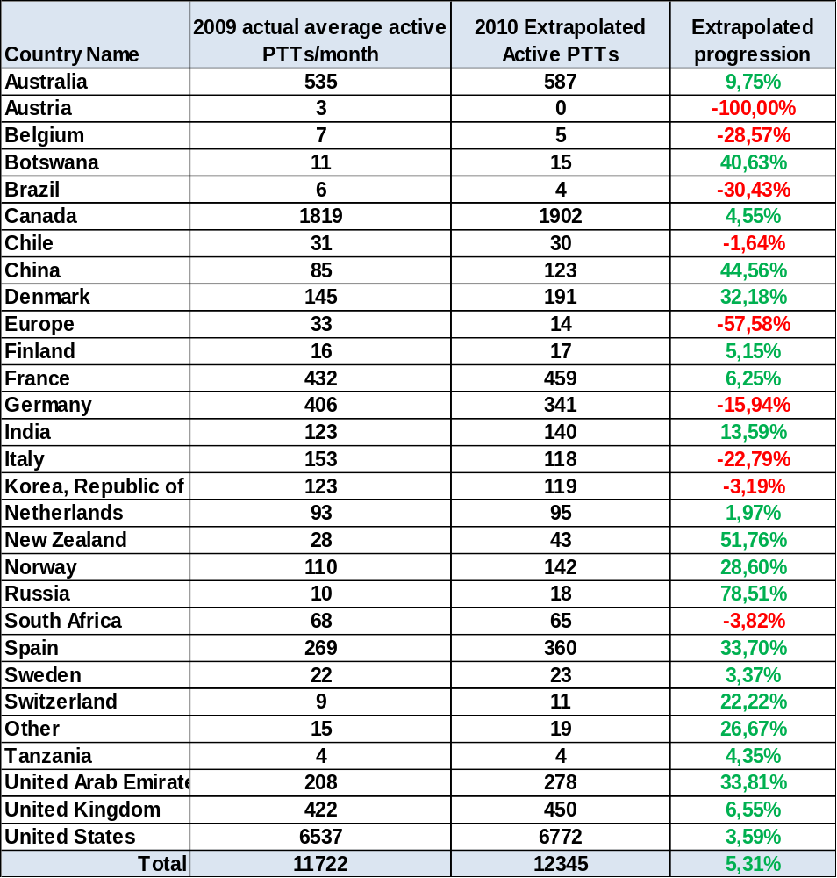
Table 2: Average number of Active platforms per month and per country, actual in 2009 and extrapolated in 2010 from January-July average
(*) E-SURFMAR program was attached is attached to “EUROPE” in 2008.

An active PTT is a PTT which transmitted at least once in a month. The average is the total number of Active PTTs divided by number of months.

2 Consumption per country (PTTs.years)

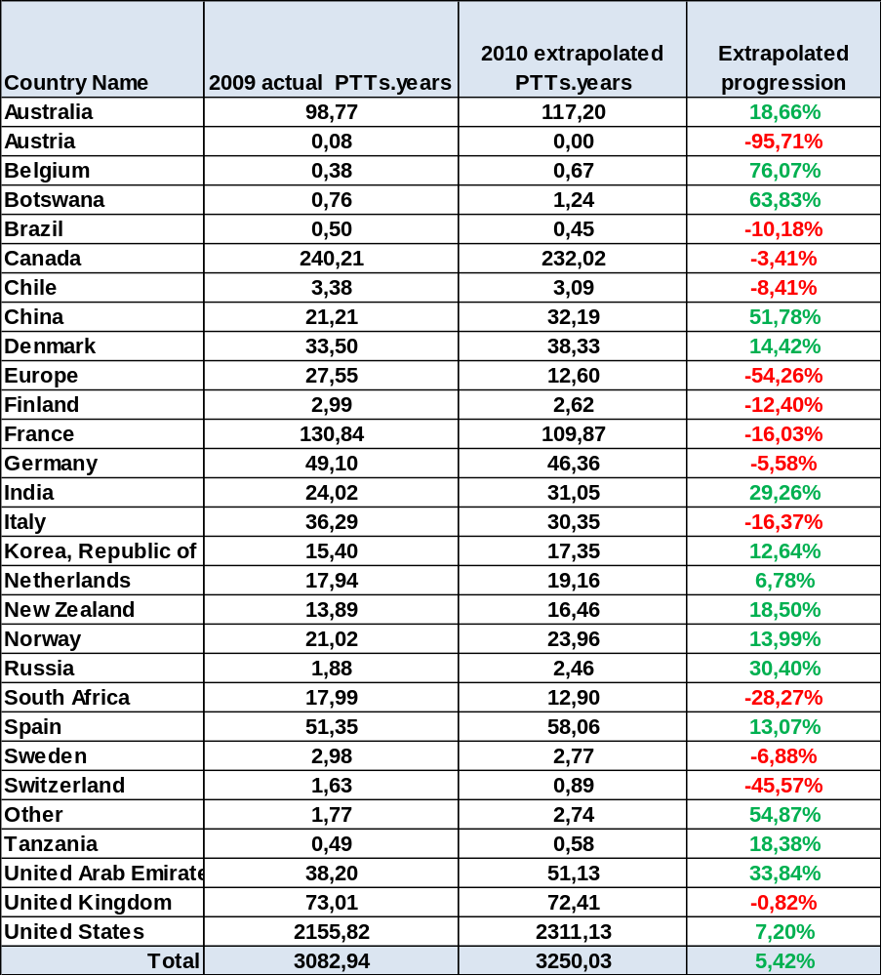
Table 3: Numbers of PTT.years. Actual consumption in 2009 and extrapolation for 2010 based on January-July actual consumption
The PTT-years are the numbers of day units with time slot calculation where appropriate divided by 365 days

3 Consumption evolution over 1 year
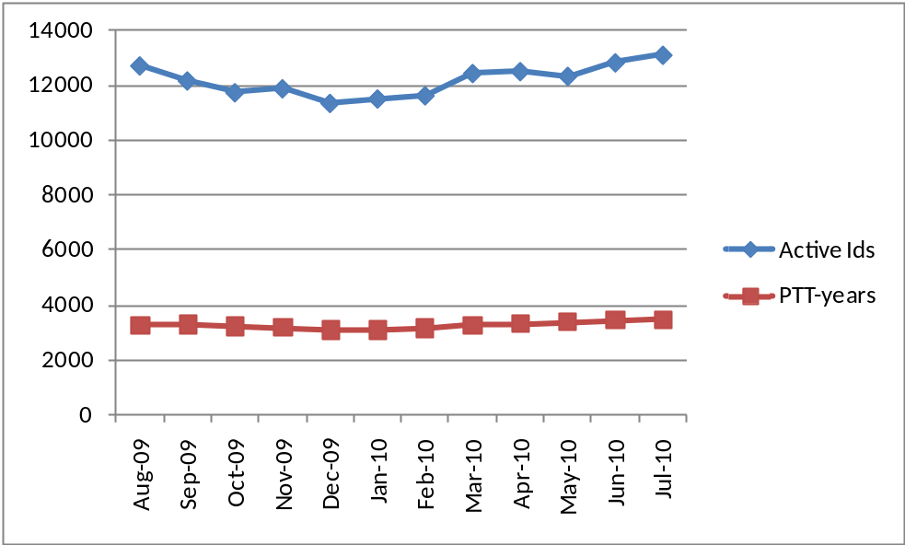
Figure 1: Consumption evolution over the year in Active PTTs and PTT.years

The number of active PTTs shows a regular increasing trend while the number of PTT-years remains rather stable. This is explained by the time slot accounting and capping up to 12 days applicable to animal platforms.

4 Monthly evolution by platform category
Drifters & others. Floats. Animals. Fixed stations

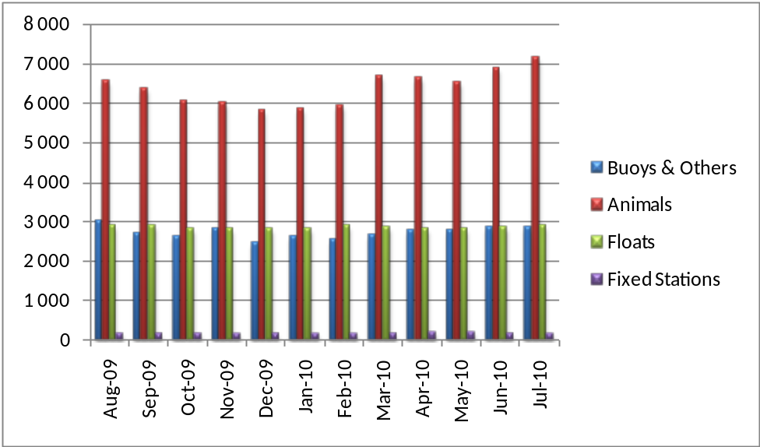
Figure 2: Active PTT evolution

Overall, the active PTTs and thus the number of transmitters in the field are increasing. The main category contributing to this increase is, as previous in years, the “Animals” family. The “Buoys” and “Subsurface floats” are rather stable.

. 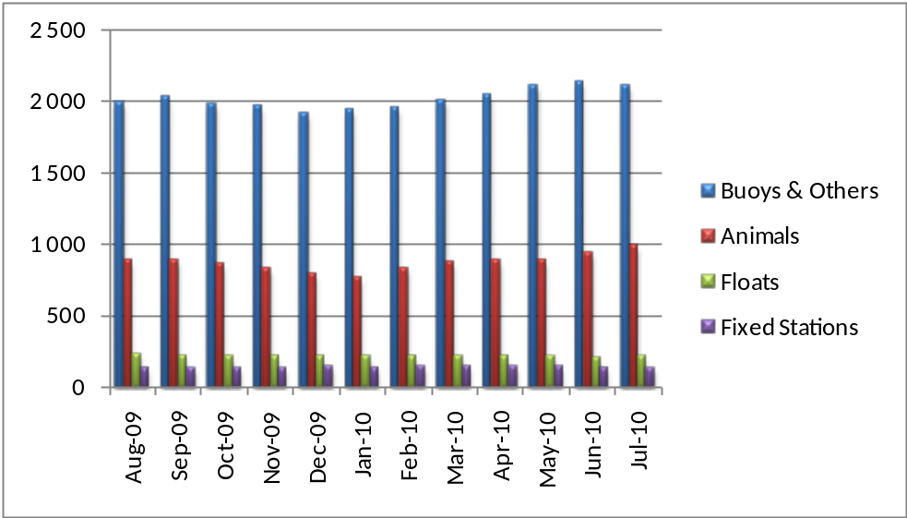
Figure 3: PTT-years evolution
It can be noticed that:
The PTT-years picture shows consequent differences in term of actual consumption between categories:
- “Drifters & Others” is still the major player followed by the “Animals” for which consumption keeps increasing.
- “Floats” and “Fixed Stations” consumptions in PTT-years are close.

5 Time slot analysis
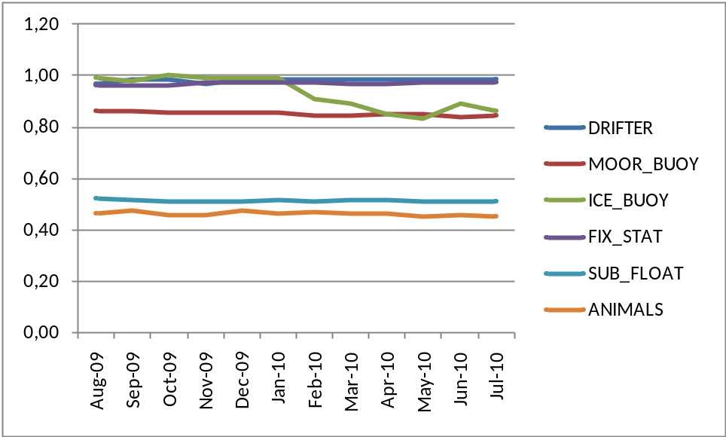
Figure 4: Average time slot level by platform category

This diagram shows the monthly evolution of the average time slot ratio for the all platforms categories.
(“Animals and sub_floats” have benefited from time slot accounting since 2005. “Buoys & Others” and “Fixed Stations” started benefiting from time slot accounting in 2007).
For a given PTT, the monthly time slot ratio is calculated as the number of day units divided by the number of transmission days in the month.

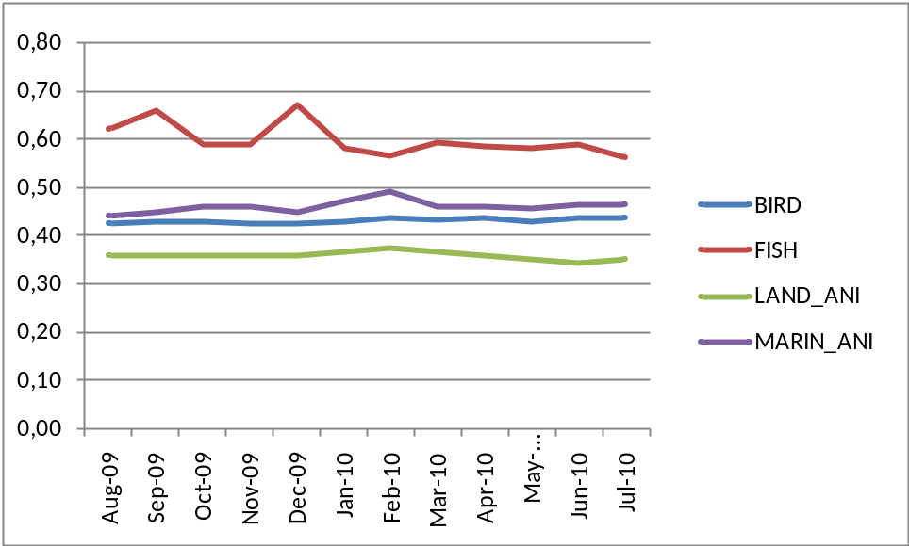
Figure 5: Average time slot level by Animals platform category

It can be noticed that all animal categories are significantly benefitting from the time slots and that the ratios are quite stable for all on average.

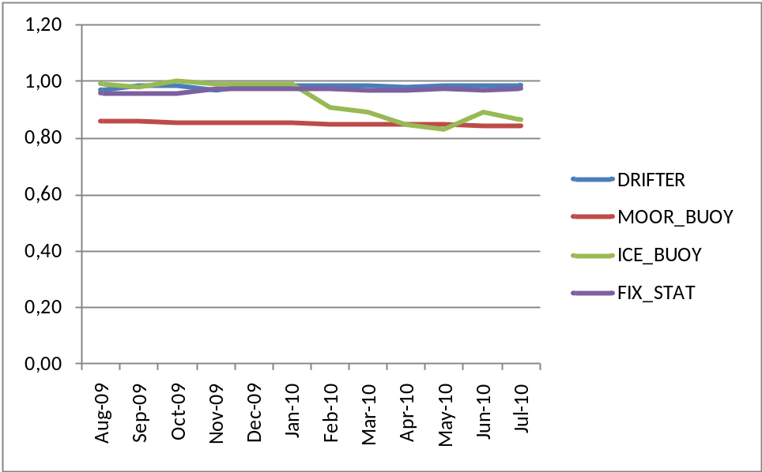
Figure 6: Average time slot level by platform category (buoys and others)
In 2009, due to the time slot accounting, the overall consumption of these platforms has been reduced by 95.21 PTTYears.

6 Impact of the 12 day.unit capping
Further to JTA XXVII decision the consumptions for animal platforms are capped at 12 day-units (48 time slots).

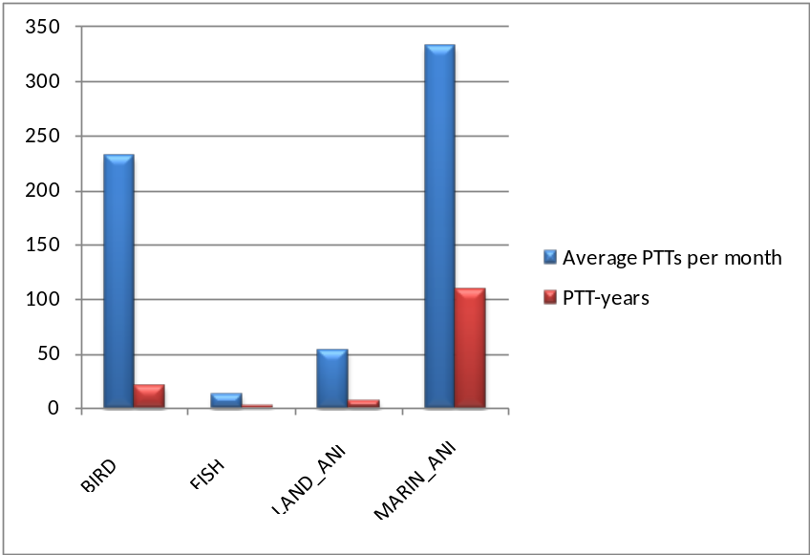
Figure 7: Average PTTs affected and Projected PTT-years “gain” by animal category

In 2009 more than 630 PTTs actually took advantage of the capping, representing 142 PTT-years.
For 2010 the capping represents a projected impact of ~158 PTT-years (~57 700 day-units).

7 Inactive status:
Recall: since year 2004, transmissions from inactive IDs are no longer charged.

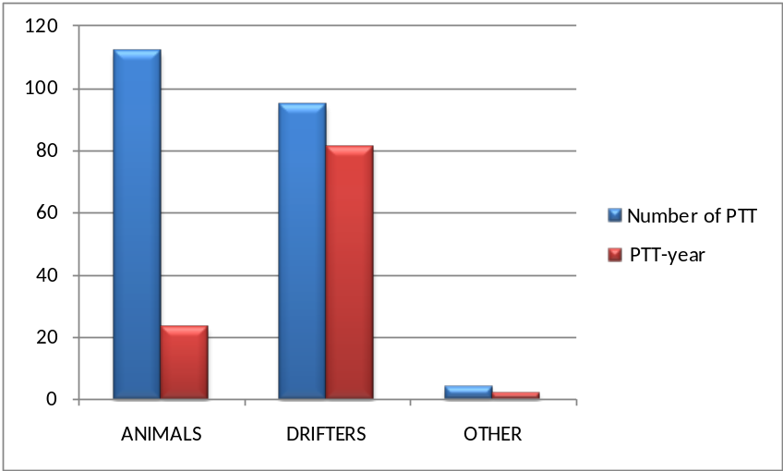
Figure 8: Inactive PTTs in term of number of IDs and PTT-Years for 2009

It can be noticed that in 2009 the number of IDs in Inactive status varies around 210 representing 106,68 PTT-year. Mainly “Animals & Drifters” platforms benefit from this service, continuing to transmit when the data is no longer useful to the project..

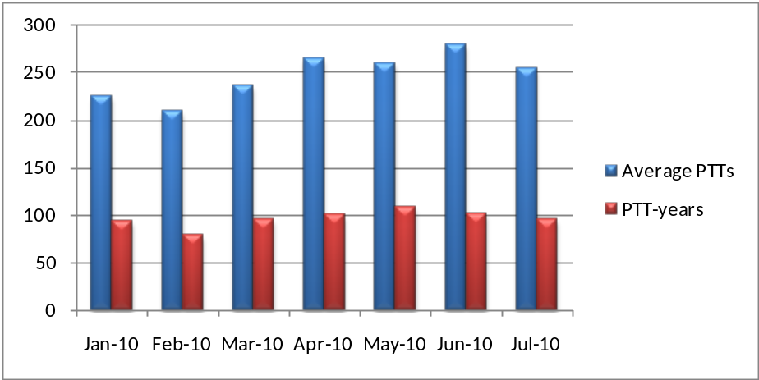
Figure 9: Inactive PTTs evolution in term of number of IDs and PTT-years

As already mentioned in previous JTA reports, these PTTs are increasing the system occupancy. CLS insists again on the recommendation to users and manufacturers to take this into account by programming their PTTs for the duration of the experiment.

8 History of the JTA participation from 1982 to 2010
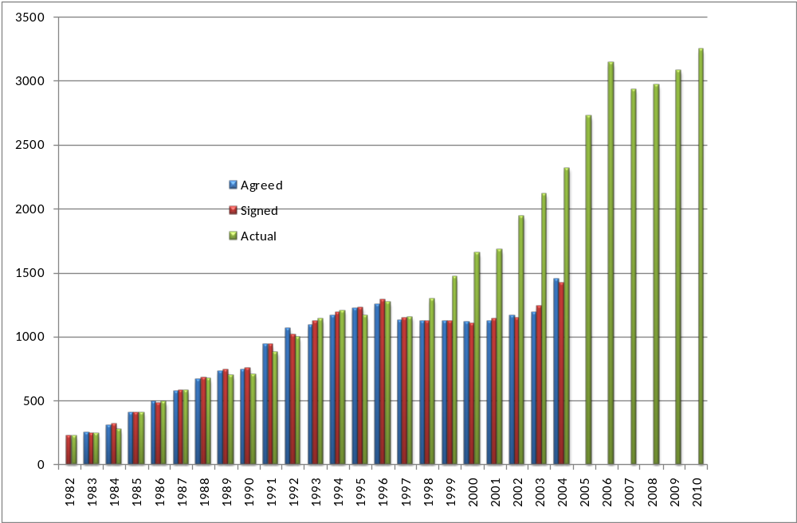
Figure 10: Agreed, signed and actual consumption in PTT-years for all countries

Notes:
- Since the implementation of the new tariff structure in 2005, we only provide actual consumption.
- Consumption decreased in 2007 (~46 PTT-year) by applying the time slots to all categories.
- In 2008 and 2009, the consumption in PTT-years decreased by ~138 PTT-years due to the capping mechanism being applied to all animals, and also by applying the time slots to all categories.
- Value for 2010 is a projection based on January to July 2010 consumption. We can still notice a continuous progress in the use of the system not impacted by the crisis or the arrival of alternative technologies.
________________

Annex IV

Report on 2009-2010 Operations and system improvements
(Submitted by CLS)

2009-2010 Argos Highlights

Operations
- NOAA-19 launch - February 6th 2009
- 6 Argos operational satellites since June 2009
- NOAA-19 Downlink OFF on November 13th 2009 per NOAA Request.
- No Power outage test done in 2009
- Argos real time antennas network still grows up to 60 stations

System improvements
- Implementation of the 6-digit platform identification number
- Surveillance of the satellites housekeeping telemetry
- Initialization of the Argos-3 PMTs location
- Development of the Argos-3 downlink simulator
- Improvement of the Argos web functionalities
- Improvement of the Argos data processing performances
- Access to the Argos data using Web service with new formats (XML, KML, CSV)

Outlook
- Integration of SARAL in the Argos processing
- SARAL satellite launch in 2011 with an Argos-3 instrument
- Data archiving in XML format
- New location processing based on Kalman filtering. No more image locations and better location accuracy are the main improvements expected with this new version of the Argos location.
- Real time data acquisition network upgrade
- Procuring and installing new ground stations
- “One way” Declarative data Replication between the 2 global processing Centers.

Argos space segments

Operational status

Argos instruments are onboard 5 POES’s spacecrafts and METOP A. The current status information on each spacecraft and its Argos various subsystems is described as follow:

Satellites | Launch date | NOAA status | Real time data (HRPT) | Stored data (STIP) | Data AVHRR
METOP-A (MA) | 19-Oct-06 | AM Primary | Ok/Nok* | Svalbard | Ok
NOAA-19 (NP) | 06-Feb-09 | PM Primary | ok | Gilmore, Wallops,Svalbard | Ok
NOAA-18 (NN) | 20-May-05 | PM Secondary | ok | Gilmore, Wallops | Ok
NOAA-17 (NM) | 24-Jun-02 | AM Backup | ok | Gilmore, Wallops | Ok
NOAA-16 (NL) | 21-Sep-00 | PM Secondary | ok | Gilmore, Wallops | Ok
NOAA-15 (NK) | 13-May-98 | AM Secondary | ok | Gilmore, Wallops | Ok
NOAA-14 (NJ) | 30-Dec-94 | Decommissioned 23 May 2007
NOAA-12 (ND) | 19-Oct-06 | Decommissioned 10 August 2007
NOAA-11 (NH) | 24-Sep-88 | Decommissioned 16 July 2004
Figure 11: Argos constellation

*A-HRPT: Regional service covering Europe and the North Atlantic A-HRPT scheduled activities are defined on Orbit Switch ON and Switch OFF.

METOP-A HRPT Switch Zone

To minimize the risk of failure to the AHRPT-B unit whilst still offering the user community a service, EUMETSAT has implemented a "partial" AHRPT service in those areas where the risk of damage from heavy ion radiation is reduced.
For southbound passes, AHRPT side B will be activated for all orbits over the North Atlantic and European area, starting at around 60°N. The AHRPT will then be switched off before the spacecraft reaches the Southern Atlantic Anomaly region at around 10°N. Figure 2 indicates the zone of activation of the AHRPT.
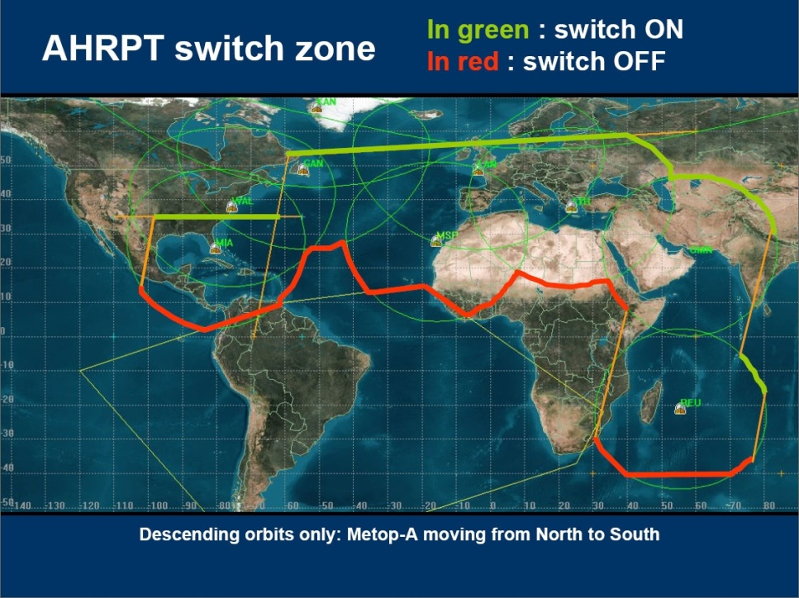
Figure 12: MetOp-A HRPT Switch Zone

Ascending Nodes Local hour

Situation in March 2010 with SARAL:
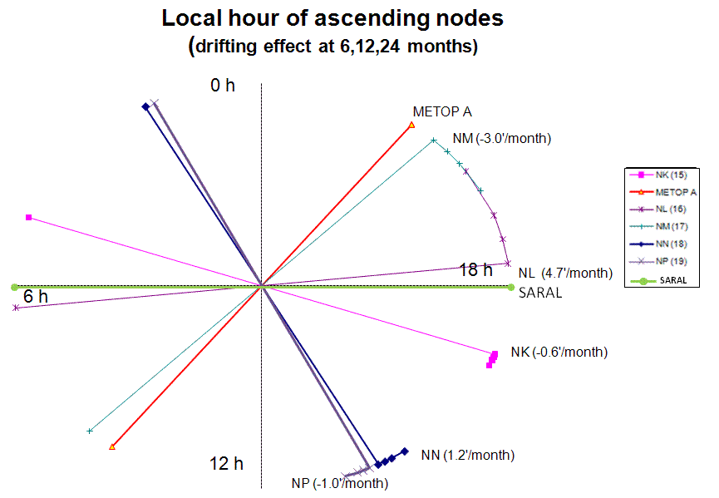
Figure 13: Local Equator crossing time

Next launches of satellites with Argos instrument

- SARAL (ISRO) with an Argos-3 instrument in 2011
- METOP-B (EUMETSAT) with an Argos-3 instrument in 2012
- METOP-C (EUMETSAT) with an Argos-4 instrument in 2017

The National Polar-orbiting Operational Environmental Satellite System (NPOESS) was a joint program designed to meet both civil and military weather-forecasting, storm-tracking, and climate-monitoring requirements. As of last year, the program was behind schedule, over budget, and underperforming. Independent reports and an administration task force concluded that the program couldn’t be successfully executed with the existing management structure and accompanying budget.

On 1st February 2010 the United States Government Executive Branch released its budget request for Fiscal Year 2011 (October 2010 - September 2011). In this new budget, the management of the NPOESS satellite program was restructured such that NOAA and Department of Defense (DoD) will develop two separate polar weather satellite missions, eliminating the NPOESS tri-agency structure. NOAA and NASA will take the primary responsibility for the afternoon orbit, which is most important for weather and climate forecasting for the nation, and DoD will take primary responsibility for the early morning orbit. NOAA’s new polar satellite program will be named the Joint Polar Satellite System (JPSS). NOAA will have the lead for the procurement of satellites under JPSS, and NASA will provide technical expertise and launch support similar to the relationship on the current Polar-orbiting Operational Environmental satellites (POES) series. NOAA and DoD will continue to partner in those areas that have been successful in the past, such as a shared ground system.

NOAA has a strong partnership with Europe through the European Organization for the Exploitation of Meteorological Satellites (EUMETSAT) that will continue to be a cornerstone of NOAA’s polar-orbiting constellation, providing continuous measurements from the mid-morning orbit.

To prevent gaps in the climate and weather missions, NOAA plans to operate the NPOESS Preparatory Program (NPP) satellite developed under the NPOESS Program. Preparations are continuing with a fall 2011 launch readiness date. The NPP mission will not fly an A-DCS payload as it was designed with a smaller bus to hold only the mission critical instruments with no secondary services such as SAR, Argos data collection, or direct broadcast.

Since the February restructure announcement, NOAA and NASA have formed a transition team to review the scope of the NPOESS program and propose activities that need to be transitioned to the JPSS Program. NOAA, with NASA as its acquisition agent, is in the final process of determining how to transition the spacecraft, instrument and ground system contracts to the JPSS Program.

The core JPSS instruments will still include the Advanced Technology Microwave Sounder (ATMS), Clouds and Earth’s Radiant Energy System (CERES), Earth Radiation Budget Sensor (ERBS), Cross-track Infrared Sounder (CrIS), Ozone Mapping and Profiler Suite (OMPS), and the Visibile/Infrared Imager/Radiometer Suite (VIIRS). NOAA is currently in negotiations with Japan Aerospace Exploration Agency (JAXA) to obtain Advanced Microwave Scanning Radiometer (AMSR) sensor data from the Global Change Observing Mission (GCOM) satellite. That data would replace data from the previously planned microwave sounder (MIS) instrument.

NOAA/NASA have undertaken a rigorous review of spacecraft bus options and are reviewing those findings. NOAA expects to be able to make a spacecraft bus decision in the coming days to weeks that will move the JPSS program forward in a risk-reducing, cost-efficient, and effective manner.

NOAA is carefully studying possible approaches for continuing to fly A-DCS on LEO satellites and to minimize the impact of the program restructuring on the performance of the Argos System. To that end, and in accordance with discussions held with CNES in March 2010, NOAA has engaged in preliminary discussions with the DoD regarding potential accommodation of A-DCS on a Defense Meteorological Satellite Program (DMSP) follow-on program satellite, recognizing that the 2008 Implementing Arrangement between NOAA and CNES calls for Argos capability in both the early-morning and afternoon orbits. Initial discussions have been productive, with DoD agreeing to continue engagement. Upon request from DoD, NOAA has provided essential instrument specifications for consideration as they evaluate options for their follow-on program. NOAA agreed to further facilitate dialogue between CNES and the DoD.

NOAA is committed to working with international partners to ensure an efficient and effective transition and will share any updates as soon as they are available.

Argos ground segment

Global antennas (delayed mode)

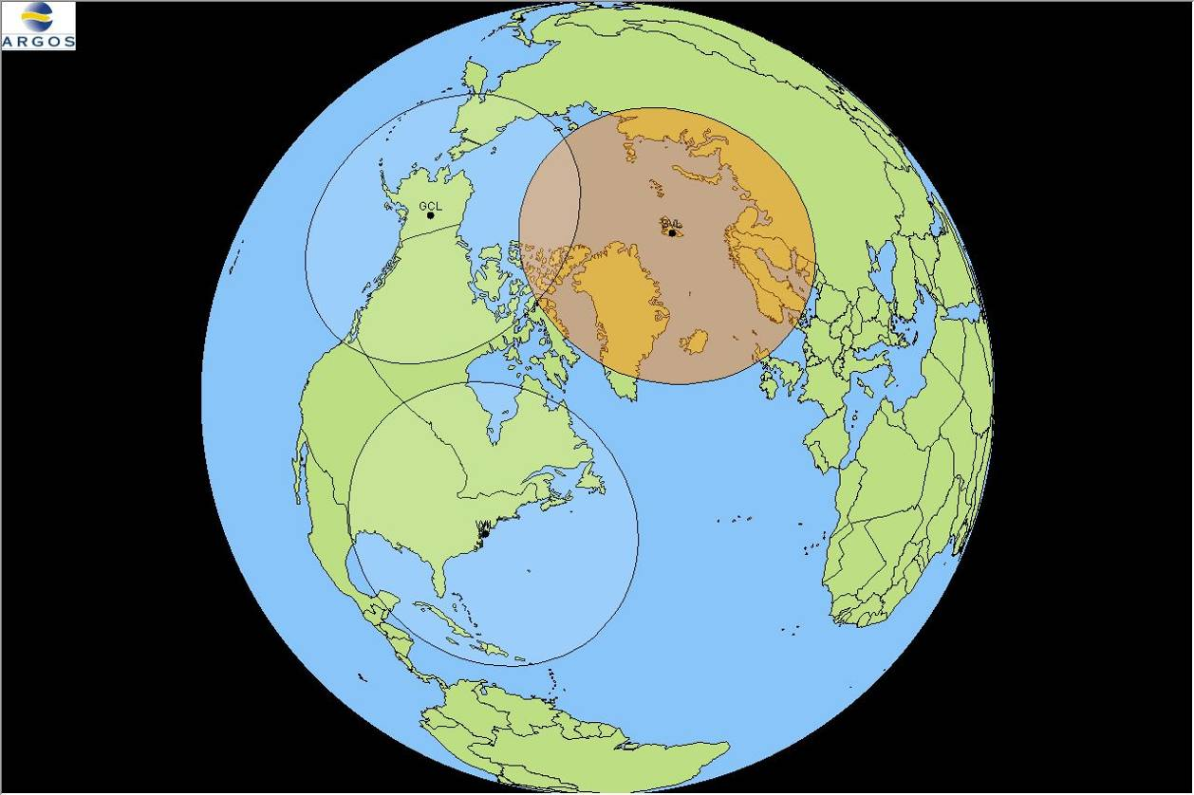
Figure 14: Global Processing Antennae

Operations

Operations were nominal on the two NOAA global stations (Fairbanks (AK, USA) and Wallops Island (VA, USA)) able to acquire the STIP telemetry from NOAA satellites.
NOAA-15, NOAA-16, NOAA-17, NOAA-18 and NOAA-19 STIP data were delivered by these 2 global stations (14 datasets per day in average).
EUMETSAT global station (Svalbard (NO)) has acquired ADCS data and relaying these data through internet to CLS and CLSA (through NOAA/NESDIS) on a nominal mode during 2009.
Blind Orbits were delivered through Svalbard station for NOAA-19 and NOAA-18 (2 per day).

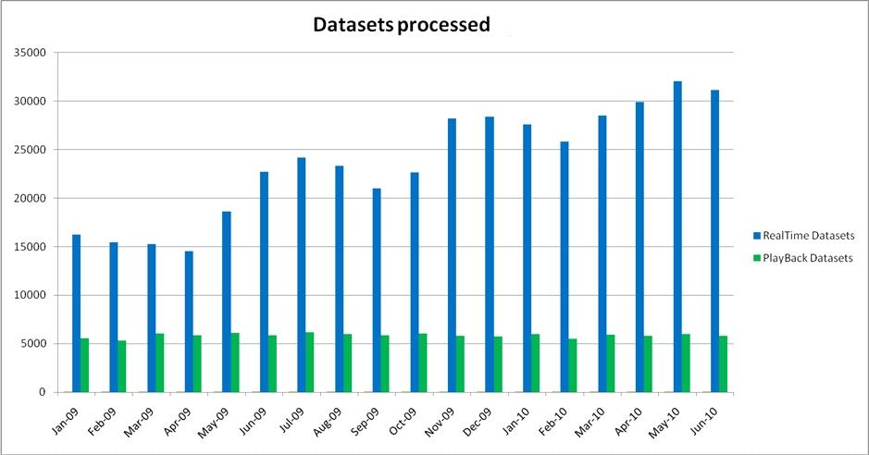
Figure 15: NOAA and METOP playback and Real-time datasets processed per Month in 2009

The increase in June-09 is due to the opening of the NP satellite.
The increases in November-09 and March-10 are due to the addition of new real-time stations (like the 5 Eumetsat EARS stations: Svalbard, Moscow, Gander, Edmonton & Muscat) in the Argos network.

System improvements

No modifications to report in 2009 and for the first half of 2010 concerning the Argos global receiving stations network.

Regional antennas (real-time mode)

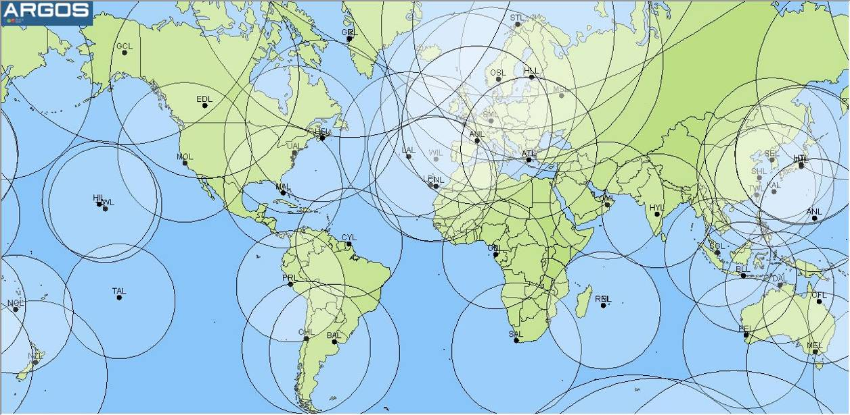
Figure 16: Real-time coverage map network
CLS and CLS America Inc. pursued their efforts in 2009 and 2010 to consolidate the number of receiving stations able to provide TIP data sets from the NOAA and METOP satellites. In July 2010, 57 stations are operational.

Operations

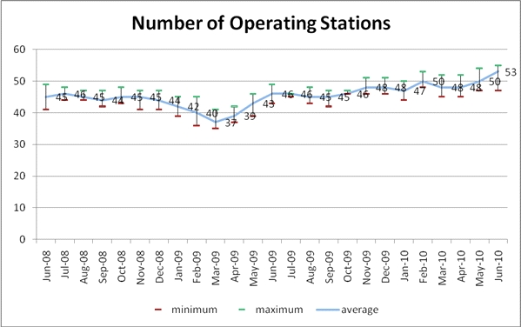
Figure 17: Real-time antenna monthly availabilityOperations
Regional antennas removed from the Argos real-time network
4 real-time stations were removed between June 2009 and June 2010 from the Argos network:
- Following the end of the contract with KAST, STL stations (Tromsoe / Norway) and LOL (Svalbard) were removed from the Argos network.
- CNL real-time antenna of Las Palmas (Spain)
- AUL real-time antenna of Aussaguel (France)

Regional antennas added to the Argos real-time network
6 new real-time stations were added between June 2009 and June 2010 to the Argos network:
- Svalbard (XSL, Norway) belongs to EARS network, activated since 13/08/2009
- Moscow (XRL, Russia) belongs to EARS network, activated since 06/05/2010
- Gander (XGL, Canada) belongs to EARS network, activated since 30/03/2010
- Edmonton (XEL, Canada) belongs to EARS network, activated since 30/03/2010
- Resolute Bay (RBL, Canada) activated since 27/01/2010
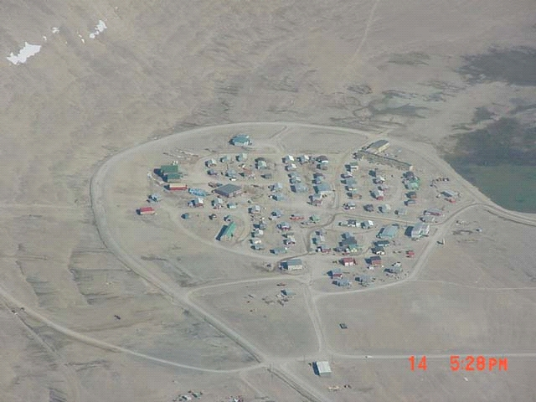
Figure 18: Resolute Bay City

- Muscat (XOL,Oman) belongs to EARS network, activated since 27/07/2010

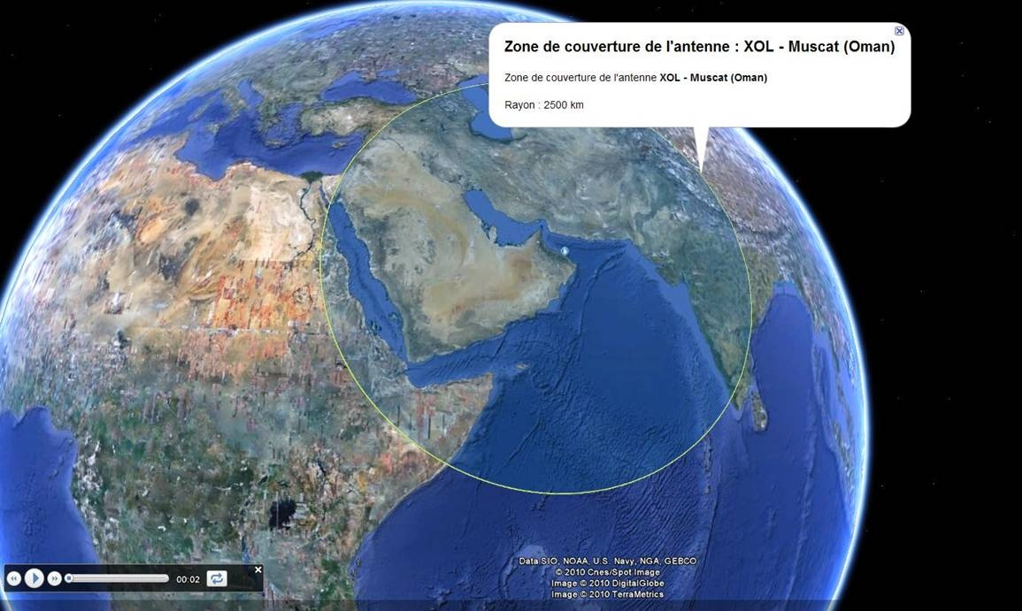
Figure 19: HRPT coverage of Muscat station

Argos real-time network for MetOp satellite
In 2009, Lannion, Svalbard, Athens, Maspalomas were operational with METOP real-time.
In 2010, Moscow, Gander, Edmonton, Wallops, Ile de la Réunion and soon Oman were added in the real-time network for MetOp satellite. See below the currently real-time coverage for MetOp-A.

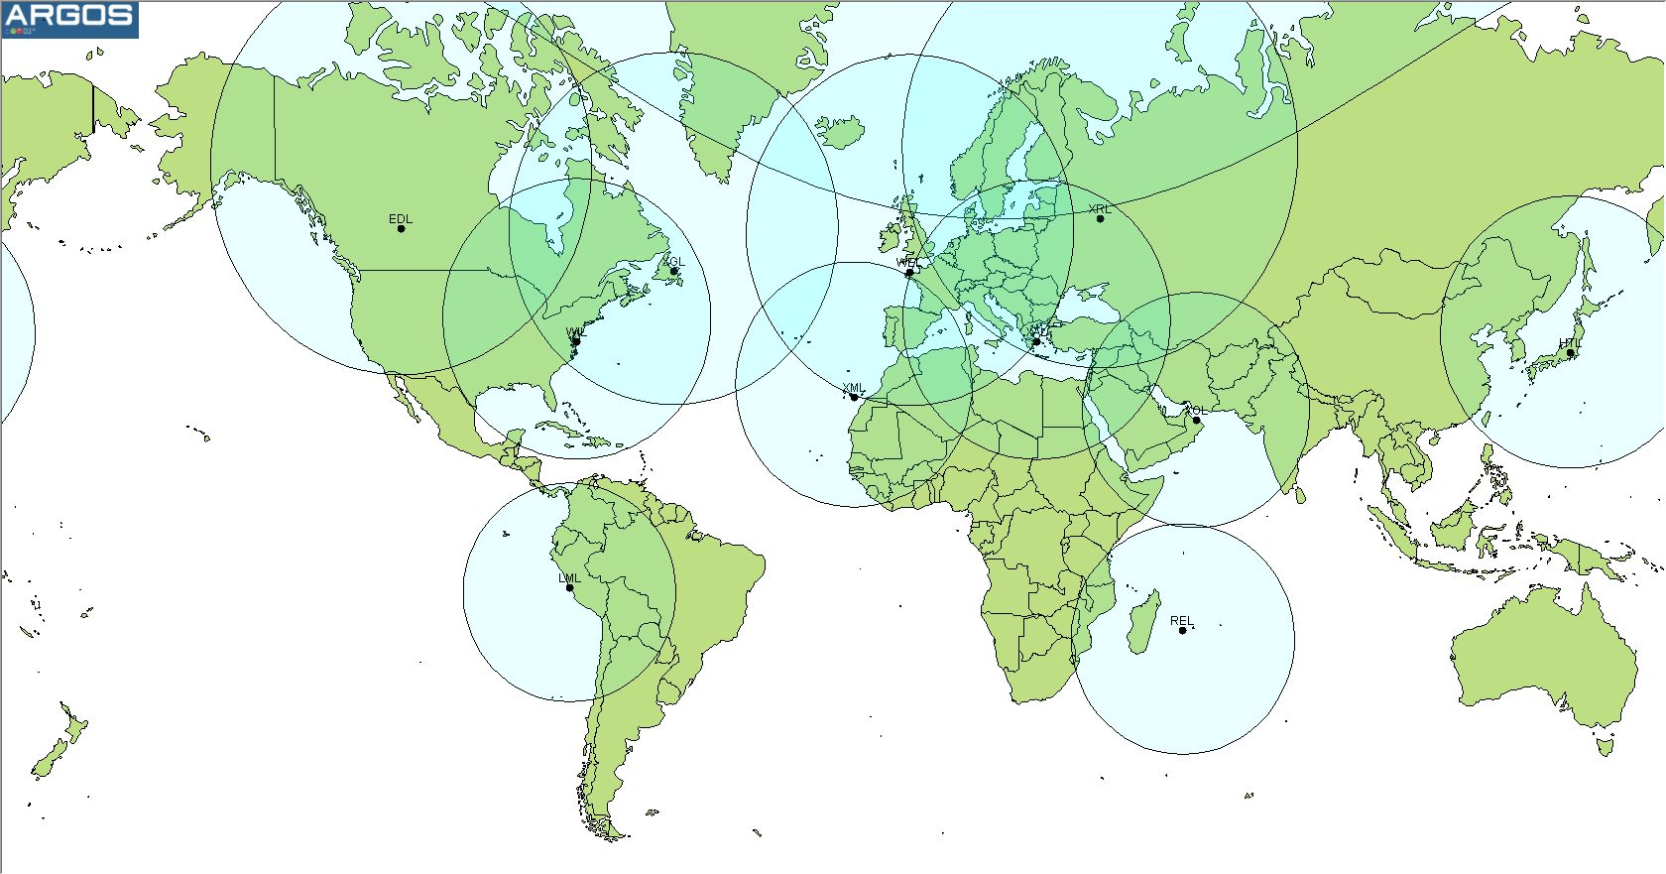
Figure 20: METOP-A real-time Coverage (2010)

Note that Metop-A AHRPT is Off over Lima and Hatoyama.

Regional antennas statistics monitoring
As requested by the DBCP, CLS is monitoring the status of each local receiving stations regarding:
- the number of satellites received,
- the dataset availability,
- the number of days they are operational,
- the percentage of datasets received/expected.

The table below displays the antenna performance characteristics for the current Argos real-time network of 57 antennas between July 2009 and July 2010:

Name | City | Country | Number of satellites received | Mean dataset availability at CLS | Number of days in operation | % of dataset received
AN | Andersen | GUAM | 5 | 00:20:56 | 361 | 50%
AT | Athens | GREECE | 5 | 00:15:18 | 318 | 50%
BA | Buenos Aires | ARGENTINA | 3 | 00:21:51 | 302 | 35%
BL | Bali | INDONESIA | 5 | 00:23:07 | 91 | 17%
CA | Casey | AUSTRALIA | 5 | 00:23:49 | 222 | 34%
CF | Cape Ferguson | AUSTRALIA | 5 | 00:56:48 | 364 | 64%
CH | Santiago | CHILE | 4 | 00:44:31 | 359 | 39%
CY | Cayenne | FRANCE | 4 | 00:16:48 | 199 | 39%
DA | Darwin | AUSTRALIA | 5 | 00:17:38 | 343 | 76%
DV | Davis | AUSTRALIA | 5 | 00:18:02 | 363 | 49%
ED | Edmonton | CANADA | 5 | 00:10:52 | 365 | 71%
EL | Elmendorf - Anchorage | USA | 5 | 00:22:56 | 364 | 43%
FI | FIDJI | FIDJI | 4 | 00:18:16 | 237 | 88%
GB | Libreville - N Koltang | GABON | 4 | 00:15:36 | 180 | 54%
GC | Gilmore Creek | USA | 5 | 00:19:52 | 365 | 50%
GR | Sondre | GREENLAND | 4 | 00:14:17 | 365 | 80%
HF | Halifax | CANADA | 4 | 00:31:23 | 363 | 62%
HI | Hickam - Honolulu | USA | 5 | 00:21:39 | 343 | 50%
HT | Hatoyama | JAPAN | 5 | 00:10:07 | 242 | 75%
HW | Hawaïi | USA | 5 | 00:33:38 | 362 | 67%
HY | Hyderabad | INDIA | 4 | 00:24:20 | 246 | 65%
JM | Jamstec - Tokyo | JAPAN | 4 | 00:13:55 | 241 | 42%
KA | Kandena- Okinawa | JAPAN | 5 | 00:23:29 | 359 | 55%
LM | Lima | PERU | 5 | 00:12:14 | 347 | 64%
LP | Las Palmas | SPAIN | 5 | 00:19:25 | 277 | 42%
MA | Miami | USA | 5 | 00:33:56 | 340 | 63%
ME | Melbourne | AUSTRALIA | 5 | 00:14:34 | 363 | 82%
MO | Montererey | USA | 2 | 00:34:18 | 360 | 73%
NO | Nouméa | FRANCE | 3 | 00:17:56 | 317 | 60%
NZ | Wellington | NEW ZEALAND | 4 | 00:17:51 | 352 | 32%
OS | Oslo | NORWAY | 4 | 00:16:58 | 237 | 11%
PE | Perth | AUSTRALIA | 5 | 00:14:51 | 354 | 69%
PR | Lima | PERU | 5 | 00:17:22 | 343 | 76%
PT | Petropavlovsk | RUSSIA | 5 | 00:18:59 | 338 | 71%
RB | Resolute Bay | CANADA | 4 | 00:15:56 | 180 | 71%
RE | Reunion Island | FRANCE | 3 | 00:14:36 | 362 | 55%
RN | Reunion Island | FRANCE | 3 | 00:13:33 | 364 | 87%
RO | Rothera | UNITED KINGDOM | 3 | 00:11:36 | 353 | 46%
RS | Lannion - MetOp | FRANCE | 1 | 00:12:41 | 365 | 57%
SA | Cape Town | SOUTH AFRICA | 5 | 00:16:38 | 365 | 66%
SE | Séoul | SOUTH KOREA | 4 | 00:10:19 | 214 | 68%
SG | Singapore | SINGAPORE | 5 | 00:26:13 | 208 | 50%
SH | Shanghai | CHINA | 4 | 00:15:25 | 10 | 22%
SM | Sembach | GERMANY | 5 | 00:18:57 | 360 | 42%
TA | Papeete | FRANCE | 3 | 00:22:31 | 234 | 78%
TW | Taïwan | TAIWAN | 5 | 00:54:14 | 365 | 32%
UA | Valley Forge (Test) | USA | 5 | 00:20:46 | 365 | 65%
WE | Lannion | FRANCE | 3 | 00:12:50 | 365 | 100%
WI | Wallops Island | USA | 5 | 00:19:57 | 364 | 77%
XA | Athens EARS | GREECE | 5 | 00:16:26 | 365 | 64%
XE | Edmonton Ears | CANADA | 4 | 00:28:00 | 155 | 99%
XG | Gander Ears | CANADA | 4 | 00:27:58 | 365 | 83%
XK | Kangerlussuaq EARS | GREENLAND | 4 | 00:17:18 | 91 | 78%
XM | Maspalomas EARS | SPAIN | 6 | 00:16:44 | 92 | 88%
XOL | Muscat | OMAN | 6 | 00:10:00
XR | Moscou Ears | RUSSIA | 5 | 00:15:59 | 93 | 63%
XS | EARS Svalbard | NORWAY | 6 | 00:19:44 | 322 | 56%
Average |  |  | 4 | 00:20:38 | 295 | 60%

These statistics are also displayed on different graphs in annexes. CLS and CLSA efforts on the operational maintain of the Argos real time stations network are rewarded by:
- Average dataset availability for the entire Argos real-time network is close to 20 minutes. It was twice 2 years ago :

 | 2010 | 2009 | 2008
Average dataset availability | 00:20:38 | 00:28:22 | 00:40:25

- Only 3 stations have a mean dataset availability > 35 minutes, so CLS group has to help the following stations to improve their time responses :
  - Cape Ferguson (CF, Australia)
  - Santiago (CH, Chile)
  - Taiwan (TW, Taiwan)

System improvements

Presentation of Argos real-time stations upgrade project
As presented last year during the DBCP XXVI, a new project was launched in 2009 with CNES with the aim to replace antennas in the existing Argos real-time network with antennas compatible with NOAA, MetOp and SARAL (Satellite with Argos and Altika). Several steps have been defined for this project:

- System design studies and engineering
  - Studying the existing network
  - Identifying applications where data delivery time is a particularly sensitive issue
  - Identifying geographical areas requiring priority coverage
  - Defining the optimum network to be set up to meet requirements
  - Defining the station network upgrade strategy
  - Identifying stations qualifying for upgrade
  - Studying these stations (in terms of upgradeability)
  - Conducting negotiations with the owners of these stations.

- NOAA/METOP/SARAL/NPOESS receiver development
  - Using the CNES feasibility study and making any necessary adjustments
  - Selecting the upgrading contractor
  - Negotiating the upgrading contract
  - Monitoring upgrading work
  - Conducting test, validation and acceptance activities.

- Upgrading the three CLS stations ("Konsberg")
  - Implementing the new receiver
  - Implementing the new station control software
  - Conducting test, validation and acceptance activities.

- Upgrading non-CLS stations (about eight)
  - Eight is an approximate figure and must be confirmed during the first-phase system study.
  - This activity comprises the following tasks:
    - Procuring a receiver
    - Upgrading the station control software
    - Implementing the new receiver
    - Implementing the station control software
    - Conducting test, validation and acceptance activities.

- Procuring and installing new ground stations (around two)
  - Two is an approximate figure and must be confirmed during the first-phase system study. The new stations, which will join the existing network, will be installed in spots where they are most likely to improve performance for users (geographical coverage, density of beacons in area, real-time advantages, etc.)
  - Issuing the invitation to tender, selecting the contractor and negotiating station procurement contracts
  - Preparing installation sites
  - Installing the stations
  - Conducting test, validation and acceptance activities

Status of the Argos real-time stations upgrade project
Step 1: Is over except the part of negotiation with the station owners which is currently running. A list of 20 stations selected according their operational interest has been made. This list is composed by:
- 13 stations will be updated with new equipment developed by the Spacetec Company.
- 2 new stations will be installed.
- 5 existing stations of the Australian manufacturer ACS that can received NOAA, MetOp and Saral without large modifications.

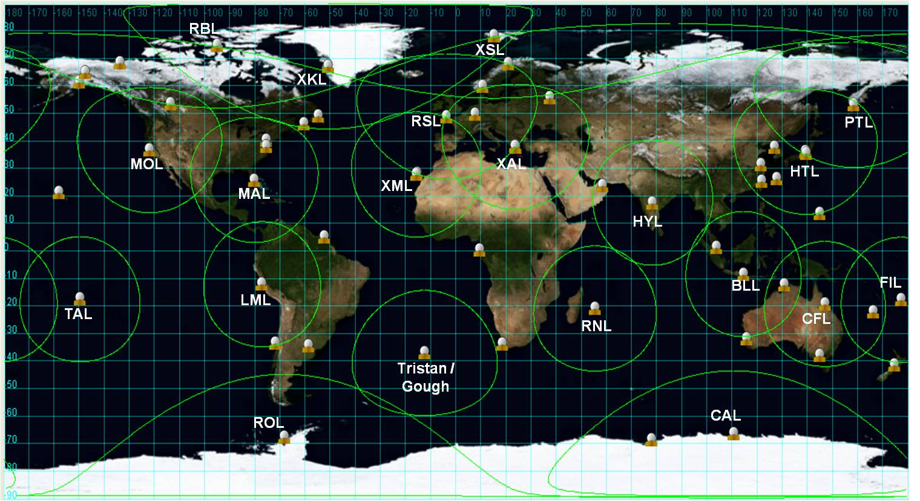
Figure 21: Current Argos HRPT network with 20 selected real-time stations

Step 2: A contract has been signed with Konsberg Spacetec for the development of a new receiver capable of acquiring data from NOAA, METOP, SARAL satellites. Onsite acceptance tests will be performed in September 2010.
Step 3: Lannion (France), Lima (Peru) and Hatoyama (Japan) stations will be upgraded with this new receiver before the end of 2010.
Step 4: Is planned in 2011. The new receivers are purchased in 2010.
Step 5: Is planned in 2011. The two antennas are purchased to Konsberg Spacetec in 2010.

Expected results of the Argos real-time stations upgrade project
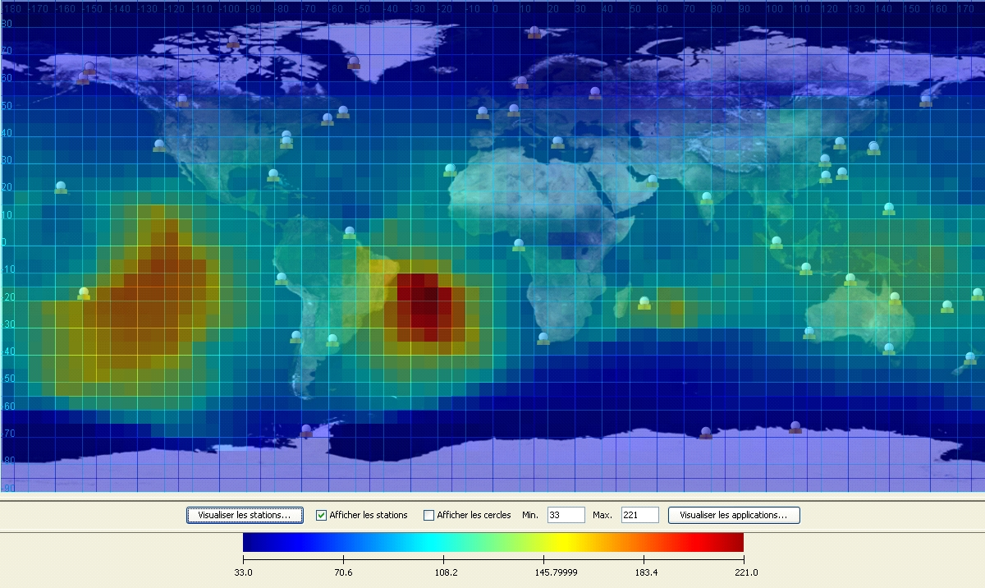
Figure 22: Data time availability (in minutes) with the current Argos real-time network
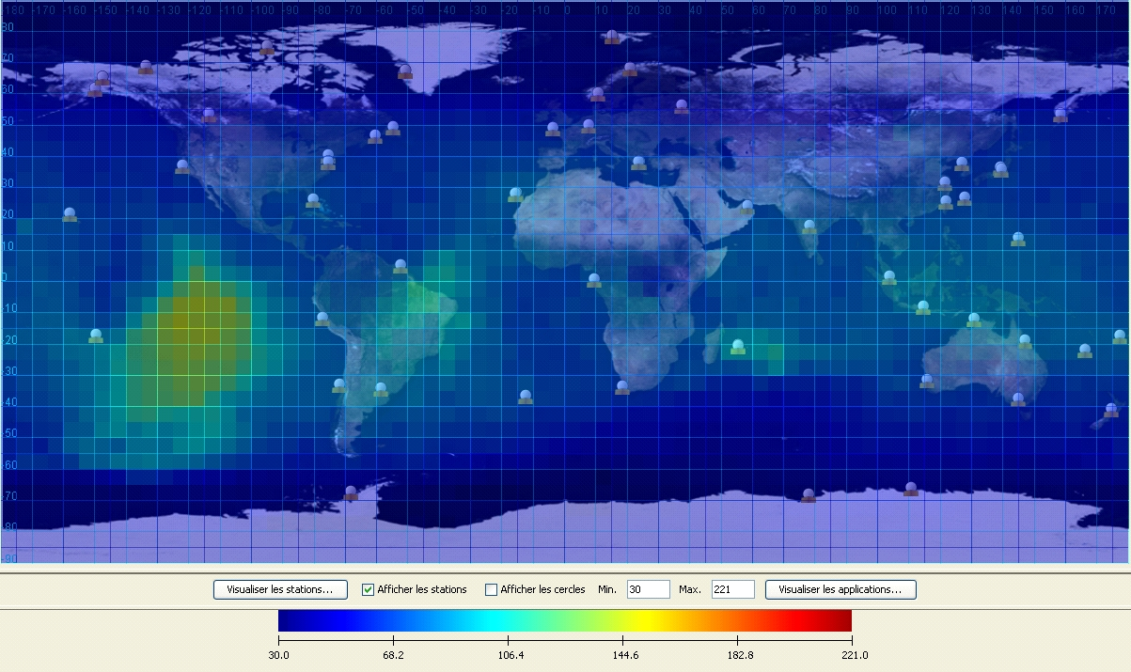
Figure 23: Data time availability (in minutes) with the Argos real-time network upgraded

- Blind Orbit Support

NOAA plans to use the Integrated Program Office (IPO) Svalbard antenna for blind-orbit supports of NOAA-15, 16, 17 and 18. Testing of the transfer process from the NPOESS Svalbard (NSV) antenna to NOAA Satellite Operations Facility (NSOF) has been tested several times since fall 2009. All major tests have been conducted successfully. There are still issues to resolve with transfer of data to the Environmental Satellite Processing center (ESPC). Data needs to be ingested by the ESPC to ensure proper formatting and distribution. No schedule was given of when this will be fully implemented.

The remaining issues include a network change which must be made by NOAA to allow data to flow properly to ESPC. NOAA’s Satellite Operations Office (OSO) is working to place a contract to address this issue. A second issue is with the quality of the GAC files being received by the front end processor. In initial tests in November and December of 2009 data transfer to ESPC was successful with good quality. New testing in 2010 has produced files with internal gaps.

Troubleshooting is underway to identify potential issues, but has not yet been resolved.

Processing centers

Each global processing center is autonomous and can work alone. In normal mode, both processing centers receive process and distribute Argos data to:
- North American users for CLS America,
- Users of the rest of the world for CLS France.

In case of a problem with one of the two centers, the other one stays alive and is capable of receiving, processing and distributing Argos data to ALL users. The switch to the remaining alive center is completely transparent for the users. It means that the users continue to receive or to access their data, without changing anything on their side.

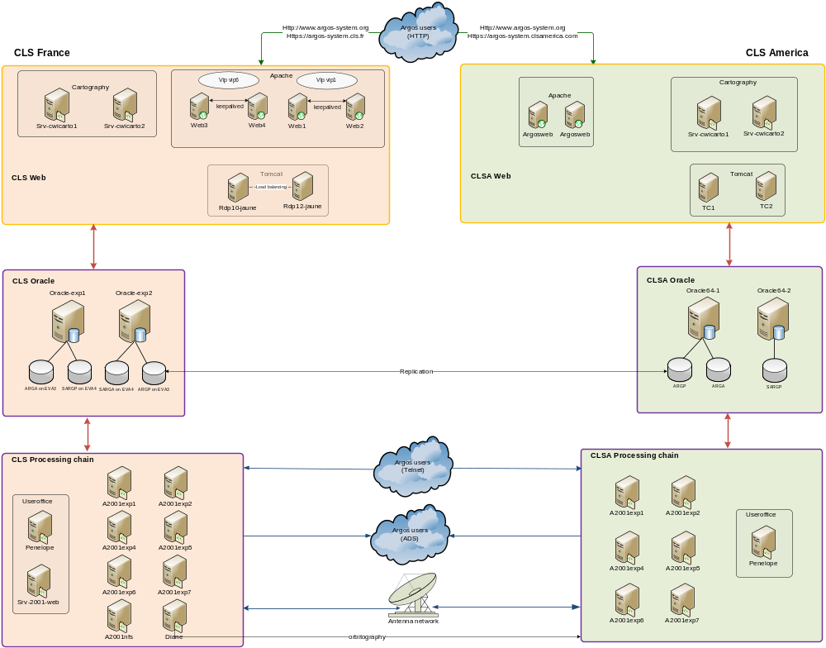
Figure 24: Architecture of the CLS France and the CLS America global processing centers

The architectures of CLS France and CLS America processing centers are quite similar and based on the same principle. Ea ch have the same three main subsets:
- the processing chain
- the Oracle database service
- the Web distribution
Processing chain
Composed of different software modules, the processing chain is in charge of receiving and processing the Argos data issued from the satellites and acquired by the global and real-time ground stations networks.
Argos data are processed in terms of collect and location, and stored into a database.
The processing chain is also in charge of distributing the data by ADS (Automatic Distribution System) or allowing users to access to their data using Telnet.

Oracle database service
At the heart of the computing architecture, the Oracle database is used to store the Argos declarative data as well as the processed data.
In order to keep a perfect coherency between CLS France and CLS America centers (mandatory to guarantee the redundancy between both centers), an automatic mechanism of replication is implemented between CLS France and CLS America databases.

Web distribution
Based on a farm of Apache Web servers, the Web distribution allows the users to access their data using a Web cartographic interface. The service of maps is supported by two cartographic servers on which are running the mapping engines C-Map for the marine cartography and MapInfo for the terrestrial one. The application server is supported by Tomcat.

Operations

The two global processing centers (GPC) in Toulouse and Largo were nominal over 2009 and first half of 2010.

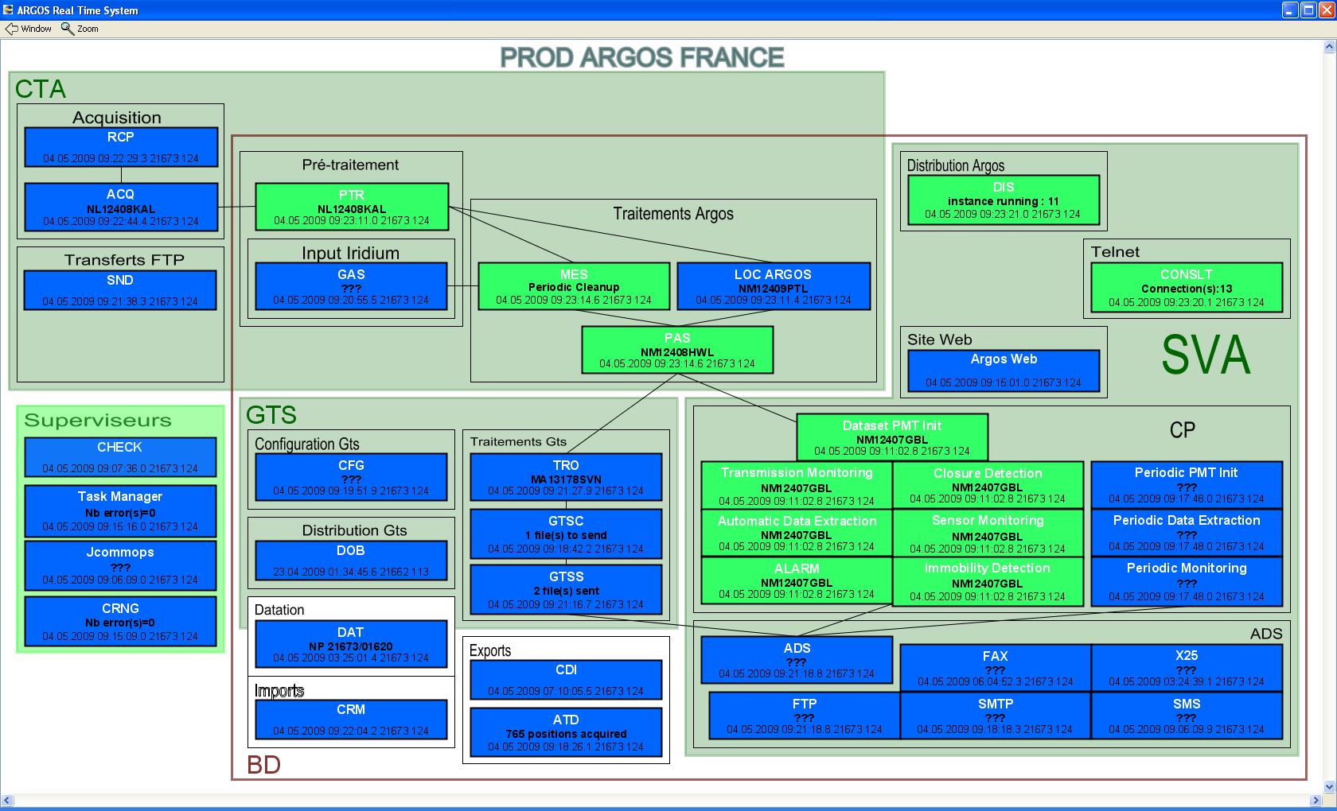
Figure 25: Argos French global processing center synoptic

CLS is monitoring JCOMMOPS Web Services and its computer architecture since December 2007.
Redundancy was used at least once a month (Up to 4 times in one month). Redundancy means all Argos users were rerouted to CLS or CLSA during an anomaly on the nominal GPC.
Disaster recovery architecture implementation is still in progress. The computer room is located in CNES Toulouse. Some of the Argos architecture components are DR compliant in order to improve services availability. But the main backup is still based on the 2 GPCs.

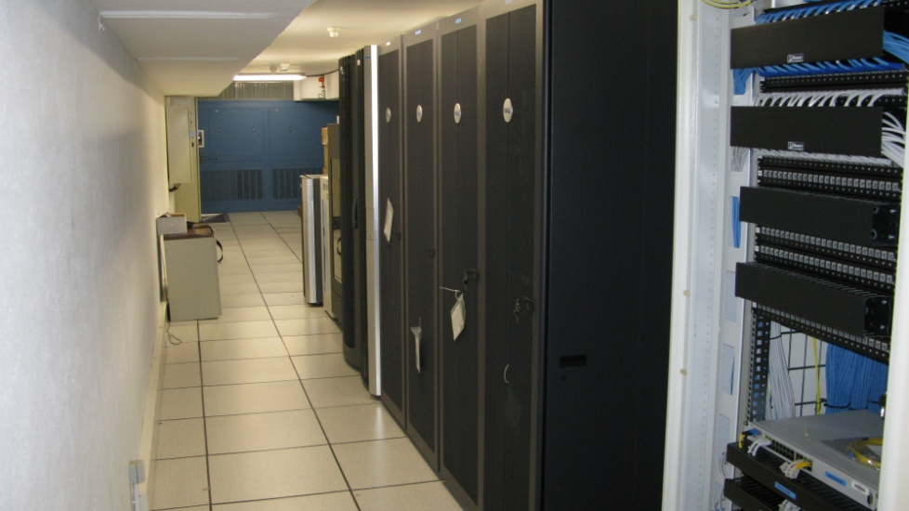
Figure 26: Disaster Recovery Room located in CNES (Toulouse, France)

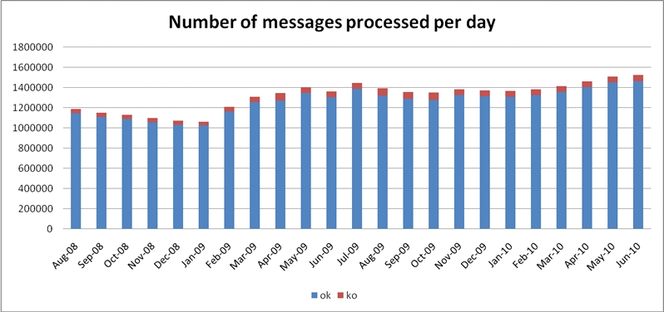
Figure 27: Average Number of messages processed per day

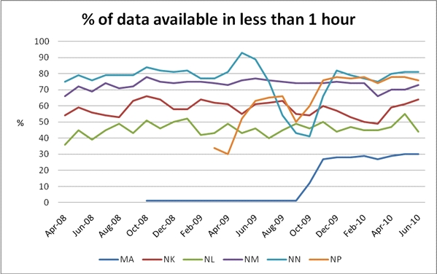
Figure 28: Data Available in 1 hour

Percentage of data available in 1 hour means which percentage of raw data has been processed before 1 hour or less after it’s recording on board the Argos Instrument (i.e. real-time spacecraft global coverage per spacecraft).
We can see the increase of MA data availability with the implementation of the HRPT Metop compatible network since September-09 (Athens, Lannion, Svalbard, Maspalomas, Moscow, Gander, Edmonton, Wallops …).
NOAA N and M, operational satellites, get a better coverage than NK and NL.
NP and NN are on the same orbit plane and there was HRPT frequency Conflict during co-visibility data reception over Real-time Station (NN going down on the graph).
10th November 2009, HRPT transmitter on NOAA-18 (NN) was changed from STX2 (1702.5 MHz, LHCP) to STX3 (1707 MHz, RHCP) to fix this co visibility issue. (NN going up again on the graph)

System improvements

As every year, several software improvements were implemented in 2009 and for the first half of 2010 in order to satisfy the user requirements. These application improvements are:

- Implementation of the 6-digit platform identification number
By now using 6 digits instead of 5 to encode the identification number of each platform, we can assign all available id numbers. This implementation, which is operational since March 30th 2010, required a very long period of validation.

- Surveillance of the satellites housekeeping telemetry
The module of surveillance of the Argos instruments housekeeping parameters is implemented allowing the CLS operators to check that the instruments are in good working order. This surveillance also allows making statistics about the long term functioning of the Argos instruments.

- Initialization of the Argos-3 PMTs location
When a PMT is waking up after a long period of non activity, it doesn't know its location which is a real problem to compute the satellite pass predictions and to transmit only when it is useful. To fix this difficulty, a specific protocol has been implemented between the PMT and the DMMC (Downlink Messaging Management Center). First, the PMT sends a specific request asking to the DMMC "Where am I?". In fact, this request is a series of low rate messages which are used first to identify the location request and then to compute the location of the PMT. Once the location is computed, the DMMC sends it to the PMT.

- Development of the Argos-3 downlink simulator
Without a simulator of the Argos-3 downlink, the correction or the improvement of a DMMC software functionality is complex and takes a long time because the satellites have to be used to test and to validate! Simulating the downlink, the debugging / tuning of the software is easier and above all shorter in time of validation.

- Consolidation of the Downlink Messaging Management center (DMMC)
2009 has been an intensive validation period for the DMMC in order to make it strong and reliable.

- Access to the JTA reports through the Argos web site
According to the request issued during the last JTA, reports are now available through the Argos web site. Different access rights are granted depending of the user profile. A ROC can access to the report of the country whose he is the representative while a user has only access to the part of the report relative to his platforms.
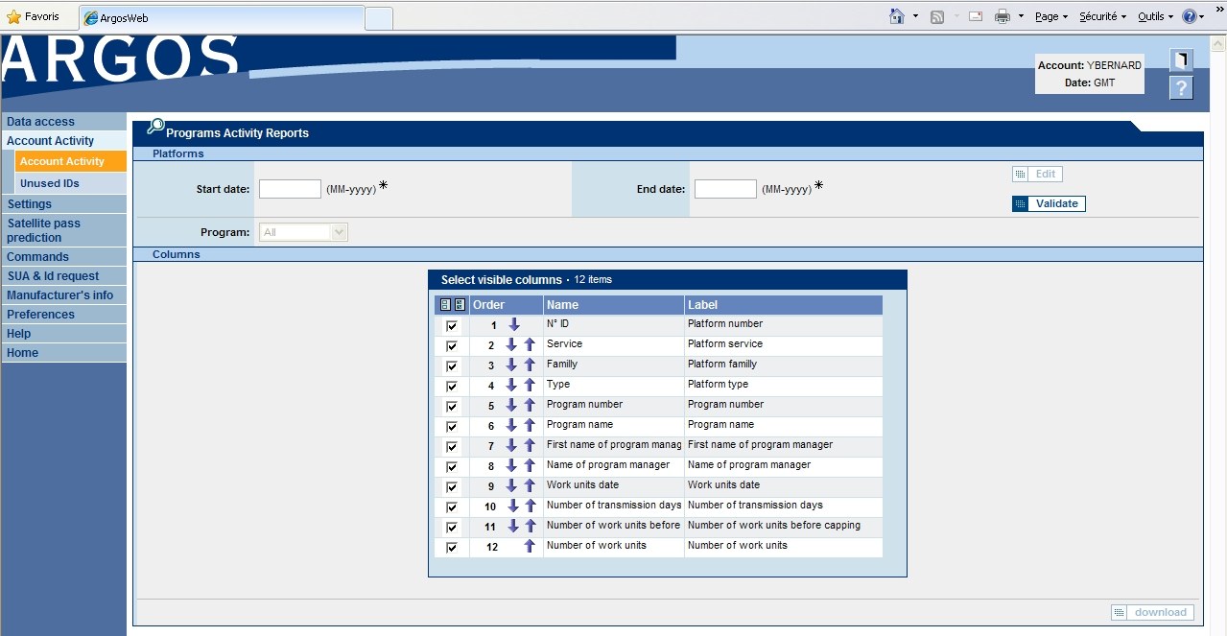
Figure 29: Account activity menu on ArgosWeb

- Improvement of the Argos web functionalities
Cartographic tools have been added to the Argos web site: Course, Estimated Time of Arrival, trajectories, locations of the observations, KML exported files compatible with Google Earth’s Time Bar.

- Improvement of the Argos data processing performance
By reviewing some parts of the software but especially by tuning and resizing the database, the performance in terms of processing time have been significantly improved. For some cases, processing time has been divided by 2. In order to illustrate this improvement, the GTS delivery time has been improved by twenty minutes in one year.

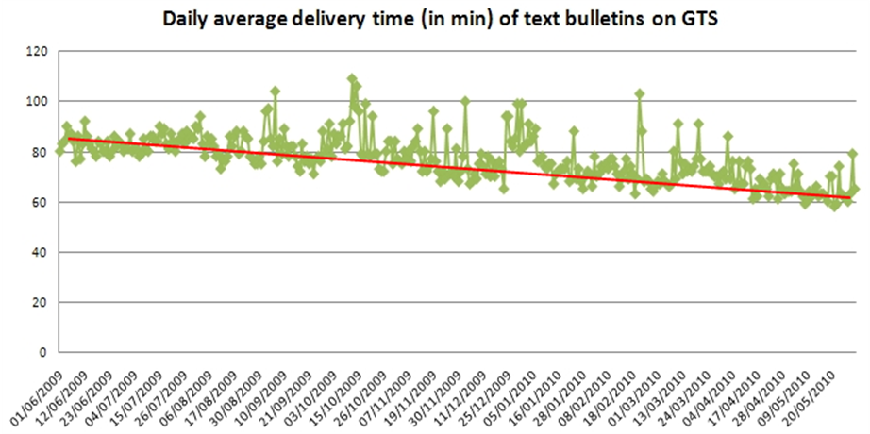
Figure 30: Average delivery time in minutes of GTS bulletins

- Implementation of a new Argos distribution format : XML
The new xml distribution provides a more complete (XML contains all diagnostic data) and flexible format (the XML is self-descriptive) for Argos Data. XML is also easily compatible with most user applications and it offers the possibility to retrieve both raw and processed data in the same file.
The new XML format contains all the relevant information such as location, parameters of error ellipses, diagnostic information, raw messages, sensor data…By using filters, users can choose which type of data they wish to download.
CLS recommends Users to switch to this new format for retrieving their data since traditional “old fashioned” formats such as COM, PRV, or DIAG commands will be gradually take out from Telnet distribution in the coming years.

- Access to the Argos data using a Web service
In 2010 CLS implemented a new web service for the distribution of Argos data. This new machine-to-machine distribution tool allows users to directly consult the CLS database via the Internet. Data in XML, CSV and KML formats can be acquired trough the Argos web service.
One of the advantage of this new web service is the ability to automatically download by SOAP (Simple Object Access protocol) data in an XML (Extensible Mark-up Language) format.
The SOAP protocol is an RPC (Remote procedure Call) object-oriented XML. Please refer to http://www.w3.org/TR/soap for a description of SOAP.

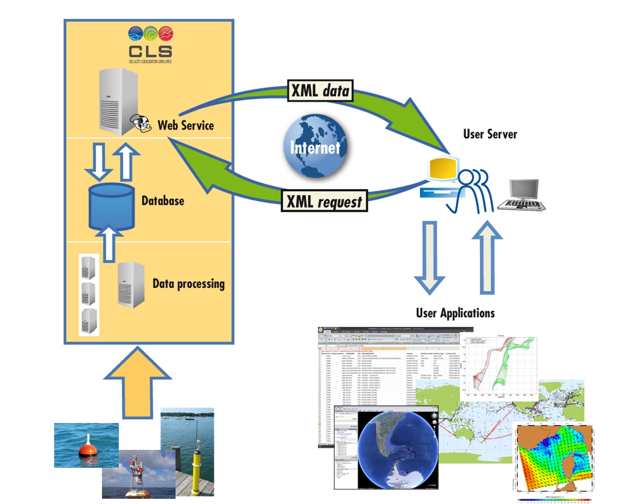
Figure 31: Argos web service scheme

- SUA on line through the Argos web site
In order to ease SUA renewal, this process is now available through new Argos Web dedicated menus. Each Argos users can now renew or update the registered information, submit a new program registration and ask for ID numbers online.

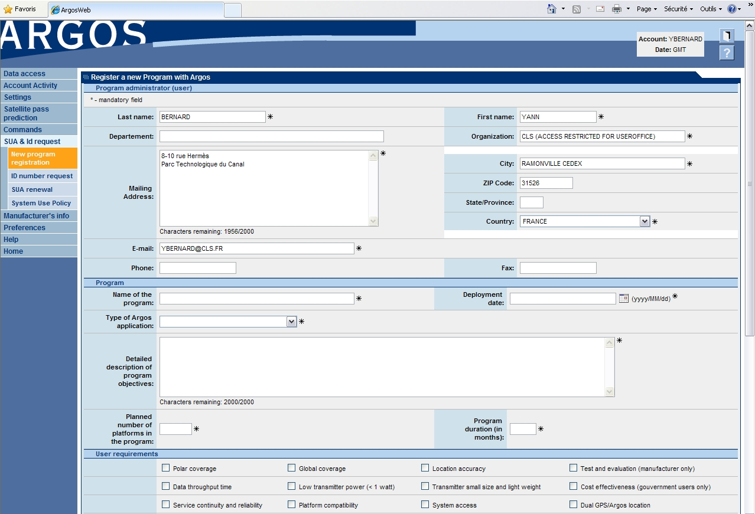
Figure 32: SUA & Id request menu menu on ArgosWeb

- New location processing based on Kalman filtering
CLS has developed a new processing algorithm for Argos, implemented in September 2010. Of course, the new technique keeps using measurements of the Doppler Effect while introducing two major improvements: the integration of platform dynamics and the use of a Kalman filter to calculate positions.
Thanks to this new technique, all Argos system users will benefit from:
- More positions,
- More precision (an error estimate will be provided for all positions),
- Automatic correction or elimination of all unrealistic positions.
This new processing technique makes it possible to distribute up to 40% more positions and to improve precision by up to 65%. Finally, the error estimate is provided for each position, regardless of the number of messages received. These improvements are particularly impressive for applications like animal tracking, where relatively few messages are received with each satellite pass.
Argos Location using least squares analysis Argos Location using Kalman filter
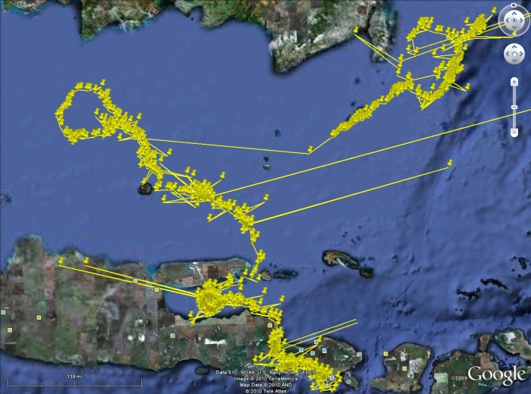 | 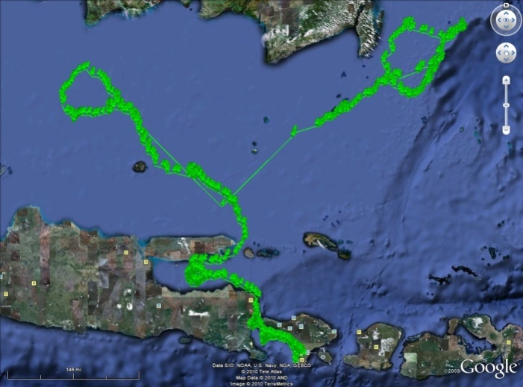
Figure 33: Same Argos track processes by the old method (at left) and the new one (at right)
More positions:
The processing system is now able to calculate positions using one message per satellite passage.
The number of positions distributed increases primarily due to the inclusion of one-message positions. Other previously discarded positions are also now considered as valid by the new processing system’s quality control.

More precision:
CLS measured positioning errors on several hundred Argos/GPS platforms, by comparing the Argos positions with the GPS fixes. For location classes 0,1,2,3 (at least four messages),the median errors* in positioning were reduced by nearly 20%. With two to three messages (Class A and B), the gain in precision is even more noticeable since the positioning error has been reduced from 10% to 65% depending on the application. The improvement is thus particularly impressive for applications where few messages are received per satellite pass.
Platform Type | 4 messages or more | 2 or 3 messages
Birds | 0 % | 40-45 %
Land animals | 2-6 % | 60-65 %
Marine animals | 10-15 % | 10-50 %
Boats | 15-20 % | 40-50 %
Buoys | 13 % | 50 %
*Percent reduction of median error. For example, a 50% reduction would mean that an observed error decreased from 1000 to 500 m.

The same error measurements demonstrated that the new technique is more robust when it comes to unrealistic positions: it corrects them by bringing them closer to the platform’s trajectory or eliminates them completely. This means that the dispersion of positioning errors is now weaker.

Error estimations for all location classes:
One of the new system’s strong points is that it provides an error estimate regardless of the location class. Users working with Class A and B locations will now benefit from additional information regarding their precision and can thus compare these positions with those of Class 0,1,2,3.

DBCP Requirements

Data Timeliness & Real-Time Antennas

This Section covers the following Action Items:

- JTA-XXIX Final Report, Parag. 2.1 Status of actions from the previous meeting (JTA-XXVIII)

Item 3. To pursue negotiations for the installation of new antennas to cover the South Atlantic and the Indian Ocean Regions

Item 4. To enhance Hyderabad LUT station performance

Item 5. To insure data from NOAA-15, 16, 17 and 18 are being received by IRD and Meteo France stations in La Réunion Island.

Item 6. 1) Investigate existing antennas in the Indian Ocean area and 2) try to connect them to the Argos network

Item 7. Study other possibilities to add new antennas in Indian Ocean (ideally in central Indian Ocean)

- JTA-XXIX Final Report, Parag. 2.2 Status of actions from previous meetings

Item 6. To install new antennas according to the following priority areas: the South Atlantic, the Indian Ocean and the Southwest Pacific Ocean

Item 7. To offer solutions for improving data timeliness and to develop data timeliness monitoring tools

- JTA-XXIX Final report, Parag. 3 Actions and Decisions of the Current Meeting

Item 1. Implement strategy for the improvement of data timeliness

Minimizing the elapsed time between when a meteorological/oceanographic observation is collected and when it is inserted onto the Global Telecommunications system (GTS) is a high priority requirement of the DBCP community. By establishing operational regional satellite receiving stations at critical locations the data transmitted to the Argos system, and then immediately retransmitted by the satellite to the ground in real-time, can be received by CLS and disseminated within a very short period of time.
CLS has been managing an evolving network of regional receiving stations for many years responding primarily to the expressed needs of the DBCP community for timeliness of their data. An update of the current efforts and plans is given below.

Indian Ocean Delays

Improving the Argos data timeliness continues to be a high priority for CLS, particularly in the Indian Ocean. The Hyderabad HRPT antenna has been the subject of special attention and with strong cooperation from the operator, INCOIS, the antenna performance has improved dramatically (85%) from 2009 to 2010. The Hyderabad station has been also selected by CLS to be upgraded as part of the Argos real-time stations upgrade project (see 4.3.3 below for more details).
Similarly, the Reunion Island antenna performance is also increased by 67% from 2009 to 2010.
Lastly, on July 27, 2010 CLS began receiving operational datasets from the EUMETSAT EARS antenna located in Muscat, Oman for satellites N-15, N-17, N-18, N-19, and METOP-A.
These three antennas (Hyderabad, Reunion and Muscat) will provide nearly 100% real-time coverage of the critical Indian Ocean region.

Real-Time Monitoring for GTS Data and Timeliness

CLS is monitoring 7/7 24/24 the GTS processing system with real-time operational surveillance on the processing modules, the quality of the data and the system performance (time to process the data, number and size of bulletins)

In 2009 developed a GTS monitoring tool, with following statistics computed each day:
- Number of GTS platforms (with a WMO id) processed,
- Number of observations processed,
- Average disposition time (observation time –time inserted onto the GTS)

These 3 statistics are provided for:
- All types of bulletins
- Each type of text bulletins (BUOY, SHIP, TESAC, and SYNOP)
- Each type of buoy (ATLAS, DRIFTERS, ICE, TRITON and OTHERS)

Some examples of monitoring products displayed by this tool are shown below:
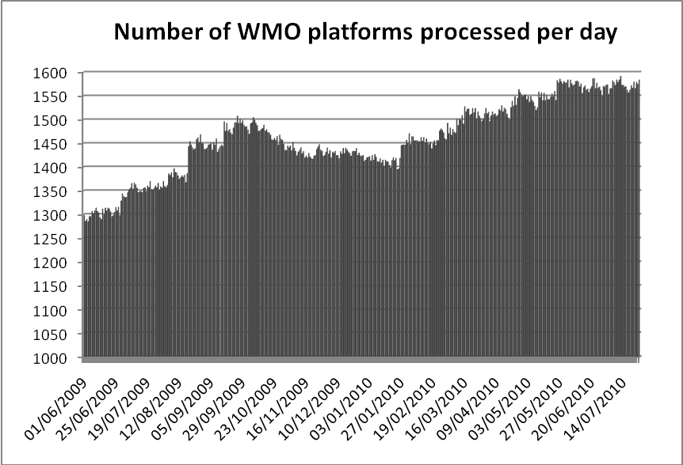
Figure 34: Argos platforms GTS processed per day

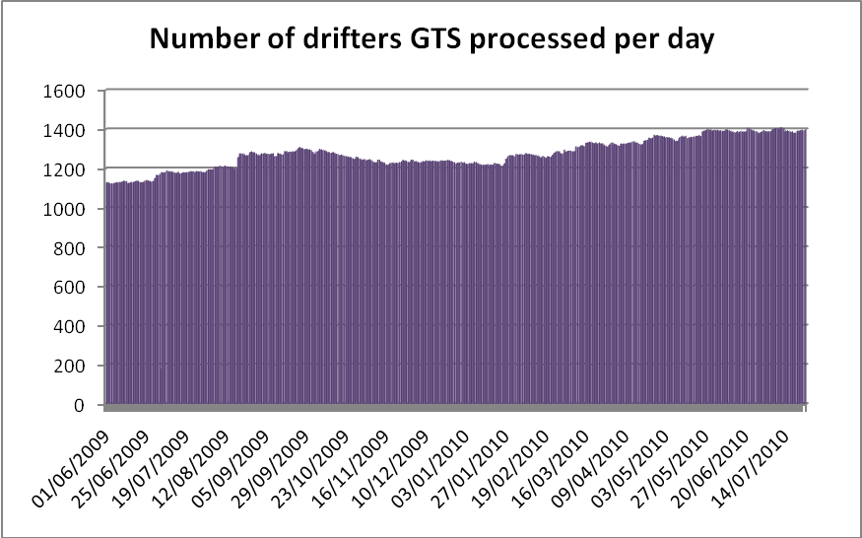
Figure 35: Argos drifters GTS processed per day

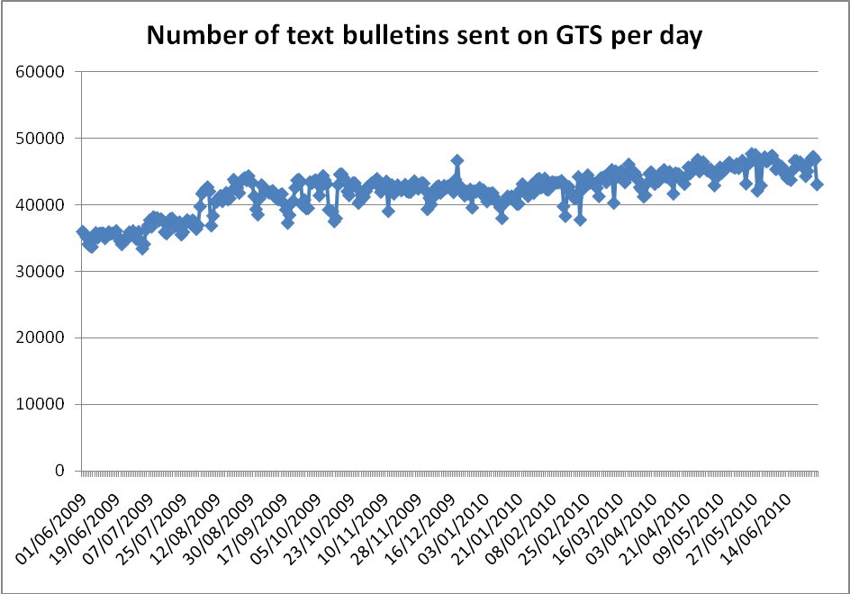
Figure 36: Number of GTS text bulletins produced by CLS per day

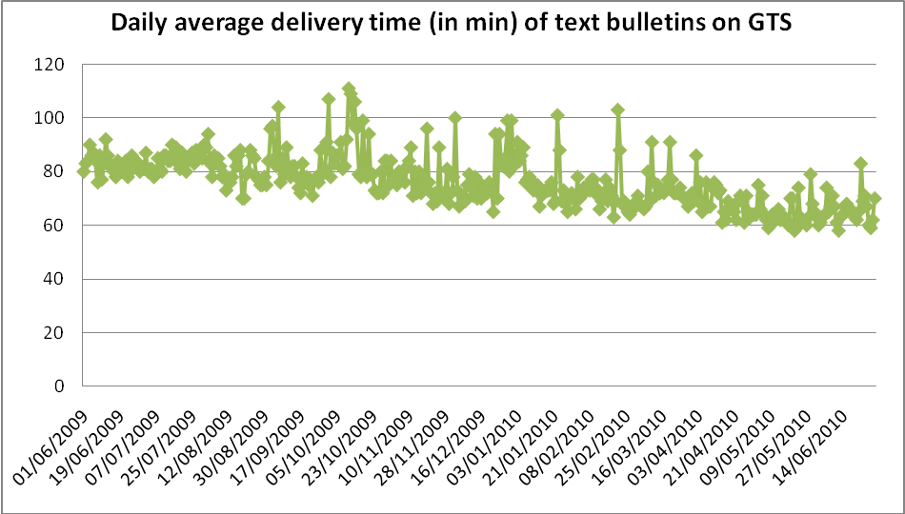
Figure 37: Daily average delivery time for all Argos GTS platforms processed by CLS

It’s important to note that in one year the average GTS delivery time has been improved by 20 min. This improvement is due to:
- A sixth Argos operational satellite in August 2009 (NOAA NP)
- Improvements on CLS Argos-GTS processing system
- Optimum management of settings on processing templates

In 2010, CLS has developed improvements on this GTS monitoring tool with same statistics provided now by ocean basin. This tool is in course of validation and first results will be presented at the DBCP XXVI session in Oban, Scotland.

CLS Real-Time Antenna Upgrade Project

Please refer to Section 2.3.5.1 for the details of this project.
Recall that Step 5 of this project is:
Procuring and installing new ground stations (around two)
- Two is an approximate figure and must be confirmed during the first-phase system study. The new stations, which will join the existing network, will be installed in spots where they are most likely to improve performance for users (geographical coverage, density of beacons in area, real-time advantages, etc.)
- Issuing the invitation to tender, selecting the contractor and negotiating station procurement contracts
- Preparing installation sites
- Installing the stations
- Conducting test, validation and acceptance activities

In response to the DBCP requests for increased LUT coverage in the Indian Ocean and the South Atlantic CLS has made the decision that one of the new ground stations referenced above will be installed in cooperation with the South African Weather Service (SAWS) on either Gough Island or Tristan de Cunha Island in the South Atlantic. This will substantially improve the Argos real-time geographical coverage in the South Atlantic Ocean and bring to a minimum the time delays currently experienced with buoy observations in this region being inserted onto the GTS.

Recall also, (above in Section 2.4.1.1) the connection has been made to the EARS antenna in Muscat, Oman. This antenna in combination with the Hyderabad and Reunion antennas, both of which have substantially improved performance in 2010, will provide nearly 100% coverage of the Indian Ocean.

Argos-3

The third generation Argos system, Argos-3, is functioning 100%. It has been and continues to be operationally available on the METOP-A satellite since early 2007. Although the Argos-3 downlink signal on NOAA-19 is currently turned off, more Argos-3 systems are scheduled to be launched. Specifically in mid-2011 an Argos-3 system on-board the SARAL satellite will be launched by the Indian Space Research Organization (ISRO). This will be followed in 2012 with another Argos-3 system to be launched on board the METOP-B satellite.
Many manufacturers have already integrated the Argos-3 PMT transceivers into their products and others are encouraged to do the same. Users are strongly encouraged to evaluate the Argos-3 capabilities for their data collection needs.

Argos-3 Test Program (DBCP 22, item 8.3.17)

At the DBCP 22 meeting in La Jolla the Argos-3 PMT was featured and a CLS “PMT Giveaway Program” was introduced as the mechanism whereby PMT’s would be made available to users interested in ‘test-driving’/evaluating the Argos-3 capabilities for their needs. The meeting invited participants and manufacturers willing to participate in this test program to make contact with the Argos team right away. The meeting stated that the “goal of the test program is to test Argos-3 new capabilities, define useful commands to users and make available ready-to-deploy platforms by the end of 2007. “
In 2008 this ‘test program’ was formalized by CLS with the help and the cooperation of CNES, to create a project called the “Argos-3 Implementation Plan.”
The objectives of this project are:
- To know and control the Argos-3 system
- To promote the Argos-3 system
The project is split into two distinct and consecutive phases:
A first phase, called Evaluation phase, has the following objectives:
- knowing and controlling the system by deploying a network of Argos-3 reference platforms
- pointing out, from a user point of view, the advantages and the disadvantages of the system
- getting all the elements to objectively promote the system
- developing Argos-3 platform prototypes which are representative of the user applications in order to validate optimized usage scenario of transmission and take advantage of the new Argos-3 functionalities
A second phase, called Promotion phase, has the following objectives:
- making aware, encouraging, involving and convincing both users and manufacturers to use the Argos-3 system
- developing operational user platforms (Argo floats, drifting buoys, animal platforms), using the experience gained from the Argos-3 platform prototypes, This includes development contracts with manufacturers.
- making these operational platforms available for the users in order to include them in organized pilot projects
- monitoring these Argos-3 platforms for at least 9 months or more and comparing their performance with similar Argos-2 platforms
- organizing an Argos-3 forum at which the results of the promotion phase will be presented to the Argos user community

The first phase is nearly completed. Prototypes of profiling floats are still under development
The second phase started in 2009. 600 Kenwood PMTs have been sold to Argos platform manufacturers.
Four manufacturers have completed the implementation of the Argos-3 PMT into their drifters: Clearwater, Marlin-Yug, Metocean and Pacific Gyre. These drifting buoys use the interactive data collection mode with Argos-3 and the “pseudo-ack” mode with Argos-2 (message transmitted N times under one satellite pass) since the PMT modem calculates satellite pass predictions. Preliminary studies showed that these improvements can reduce message transmissions by as much as 75% thereby increasing the buoys’ life expectancy.

DBCP Pilot Project for the Evaluation of Argos-3 Technology

The objectives of the Project are to:
- Independently and objectively evaluate Argos-3 for use by the global data buoy community.
- Foster Argos-3 integration by buoy manufacturers.
- Provide Argos-3 equipped drifting buoys to the community for evaluation. The first Argos-3 buoys were deployed during the summer of 2009. At this time 24 Argos-3 buoys have been deployed in Pacific, Atlantic oceans, Black and Mediterranean Sea in order to test Argos-3 capabilities all over the world Thanks to Dr. Luca Centurioni (Scripps Institution of Oceanography), the chairman of the Argos-3 Pilot Project steering team, ship opportunities were well coordinated for deployment of the drifters by interested users (see Fig 27).


IMEDEA
Figure 38: Argos-3 buoy (Clearwater) deployment in Med. Sea

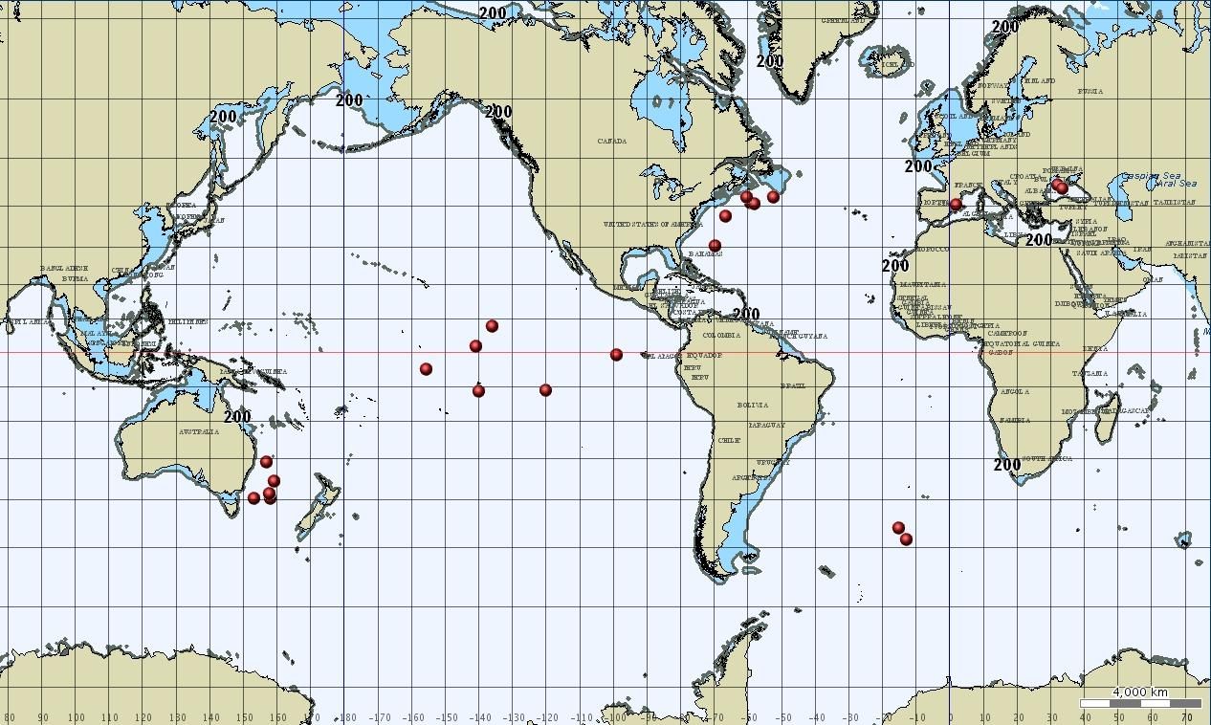
Figure 39: Map of Initial Argos-3 DBCP Pilot Project Deployments

A total of 60 drifters are scheduled for deployment for Argos-3 system evaluation. CLS has provided technical assistance to all manufacturers involved in the Argos-3 integration effort and is participating in the evaluations of the performance of the buoys. CLS is processing the Argos-3 buoy data in real-time and inserting the data onto the GTS via the National Weather Service (in the U.S.) and Météo-France (in France). More than 57 000 hourly observations have been collected during the first 10 months of the pilot project and the initial conclusions are:
• A high performance for collecting hourly sensor acquisitions (>95%) for those buoys that are operating
• A large reduction (~75%) of the power consumption used for the data transmission, allowing a reduction in the size of the battery pack and/or increasing the drifter lifetime,
• Improved synoptic measurements (on average, more than 22 hourly observation collected per day),
• Optimization of the transmission leading to a better use of the satellite network and then better performance for users,
• Secure uplink transmission with an automatic checksum control,
• Remote commands via the Argos-3 downlink way to change the mission parameters.

Please find in Annexes chapter a table with detailed statistics for each Argos-3 buoy currently deployed in the pilot project.
A full report of the Argos-3 Pilot Project will be provided by Dr. Centurioni.

Argos-3 Downlink

44th Operations Committee (June 2010)

D-1-1 NOAA-19 Status
Dave Benner presented a final report on the interference issue from NOAA-19 ADCS downlink into US alarm systems performed by Alion Science and Technology after switching-off the Argos transponder on NOAA-19 in November 2009 due to legal implications in the US.
For the moment, it does not appear that anything can be done to resolve this issue for Argos-3 & N19. The long-term solution should be to reduce the power flux density at the Earth's surface to meet the existing limit of -152 dBW/m*m/4 kHz by using spread spectrum technology. This approach is being considered for Argos-4

A number of comments and questions were raised on the content and conclusions of Dave Benner’s report by CNES and EUMETSAT that could not be immediately answered.
It was agreed that CNES and EUMETSAT will develop a consolidated set of comments and questions by end of June and provide them to Dave Benner (Co-Chair OPSCOM). A response to those comments and questions are expected to be provided by NOAA by mid September. A teleconference will be organized in September to review the received answers and evaluate status in due time taking into account the opportunity of a frequency meeting early October 2010.

D-1-2 Metop-A Status
As reported by Vincent Mean (CNES), before taking any action regarding the Argos-3 downlink on Metop-A EUMETSAT and CNES are awaiting evidence and detailed characteristics of the interference reported by the U.S. In addition, EUMETSAT and CNES share the view that the approach for evaluating the level of the interference should be probabilistic, not deterministic, taking into account possible mitigating factors such as the percentage of the visibility of Metop-A, the Doppler frequency shift, etc.

Status of Proposed Reallocation of the 1675 – 1710 MHz Frequency Band

A Public Notice issued June 4, 2010 by the U.S. Federal Communications Commission (FCC) requested information on the current use of the 1675-1710MHz band by non-federal entities, the impact of any potential changes in the allocation of this portion of the spectrum and the band’s potential utility for mobile broadband use. This band is heavily used today to support public safety activities and other public benefit purposes, as well as critical meteorological-related applications which specifically include the HRPT transmissions from the NOAA satellites which carries the real-time Argos data. Consequently, significant concerns are raised by any proposals to make this spectrum available for mobile wireless broadband. A substantial amount of comments were sent to the FCC in response to this request which specifically addressed the concerns of NOAA. The FCC has not taken any action as of this date.
NOAA International Affairs has briefed senior NOAA leadership on the issues & concerns.

Status of Brazilian satellites data availability

Only one Brazilian Satellite is flying (SCD2). No policy agreement was obtained so far for the distribution of the (few) Argos data collected by this satellite to the community so the situation is still withheld.
CLS proposes to close this action item until additional information becomes available.

ANNEXES
- Table statistics on current Argos-3 DBCP Pilot Project buoys deployed
- Mean dataset availability time by Argos station between July 2009 and July 2010
- Number of days in operation by Argos station during 1 year (July 2009-July 2010)
- Mean dataset availability time by Argos station

Argos ID | WMO ID | Dep. area | Manuf. | Type | Date of dep. | Hourly obs coll. | % of Obs. coll. | Comments/Status on July 21th, 2010 | GTS disrib.
82223 | 51682 | Pacific Eq. | Clearwater | SVP-B | 10/09/2009 | 2270 | 96% | Failed on December 18th | Y
82224 | 61687 | Med. Sea | Clearwater | SVP-B | 23/07/2009 |  |  | Failed at deployment
82226 | 51683 | Pacific Eq. | Clearwater | SVP-B GPS | 23/09/2009 | 5069 | 96% | Failed on May 3rd | Y
82227 | 51684 | Pacific Eq. | Clearwater | SVP-B GPS | 11/10/2009 | 2378 | 93% | Failed on January 30th | Y
82233 | 61688 | Med. Sea | Clearwater | SVP-B GPS | 21/09/2009 | 4158 | 70% | Noise in Med. Sea + beached on May 25th | Y
82258 | 33543 | South Atlantic | Metocean | SVP | 20/09/2009 | 89 | 29% | No more data received since 03/10/2009 | Y
82273 | 33544 | South Atlantic | Metocean | SVP | 20/09/2009 | 330 | 99% | No more data received since 03/10/2009 | Y
82274 | 55629 | Tasman Sea | Metocean | SVP-B | 14/09/2009 | 423 | 97% | No more data received since 03/10/2009 | Y
82276 | 55630 | Tasman Sea | Metocean | SVP-B | 15/09/2009 | 231 | 57% | No more data received since 02/10/2009 | Y
82279 | 55961 | Tasman Sea | Metocean | SVP-B | 18/09/2009 | 391 | 99% | No more data received since 02/10/2009 | Y
82280 | 55962 | Tasman Sea | Metocean | SVP-B | 20/09/2009 | 206 | 94% | No more data received since 02/10/2009 | Y
82282 | 55963 | Tasman Sea | Metocean | SVP-B | 20/09/2009 | 236 | 96% | No more data received since 01/10/2009 | Y
82236 | 44856 | NW Atlantic | Pacific Gyre | SVP | 21/09/2009 | 2407 | 97% | Failed on December 28th | Y
82239 |  | NW Atlantic | Pacific Gyre | SVP | 13/09/2009 |  |  | Failed at deployment
82240 | 44859 | NW Atlantic | Pacific Gyre | SVP | 22/09/2009 | 3799 | 98% | Failed on March 2nd | Y
82241 |  | NW Atlantic | Pacific Gyre | SVP | 22/09/2009 |  |  | Failed at deployment
82242 | 41632 | NW Atlantic | Pacific Gyre | SVP | 13/09/2009 | 5510 | 98% | Failed on May 6th | Y
82244 | 44857 | NW Atlantic | Pacific Gyre | SVP | 21/09/2009 | 3359 | 99% | Failed on February 10th | Y
82245 | 44858 | NW Atlantic | Pacific Gyre | SVP | 21/09/2009 | 3500 | 99% | Failed on February 16th | Y
82234 | 32596 | Pacific Eq. | Pacific Gyre | SVP | 04/11/2009 | 3386 | 95% | Failed on April 1st | Y
82235 | 32597 | Pacific Eq. | Pacific Gyre | SVP | 05/11/2009 | 5917 | 95% | Active | Y
82237 | 32598 | Pacific Eq. | Pacific Gyre | SVP | 05/11/2009 | 6029 | 97% | Active | Y
82534 | 61503 | Black Sea | Marlin Yug | SVP-B | 24/11/2009 | 5015 | 88% | Active | Y
82537 | 61504 | Black Sea | Marlin Yug | SVP-B | 24/11/2009 | 2230 | 92% | Beached on March 6th | Y
Table statistics on current Argos-3 DBCP Pilot Project buoys deployed
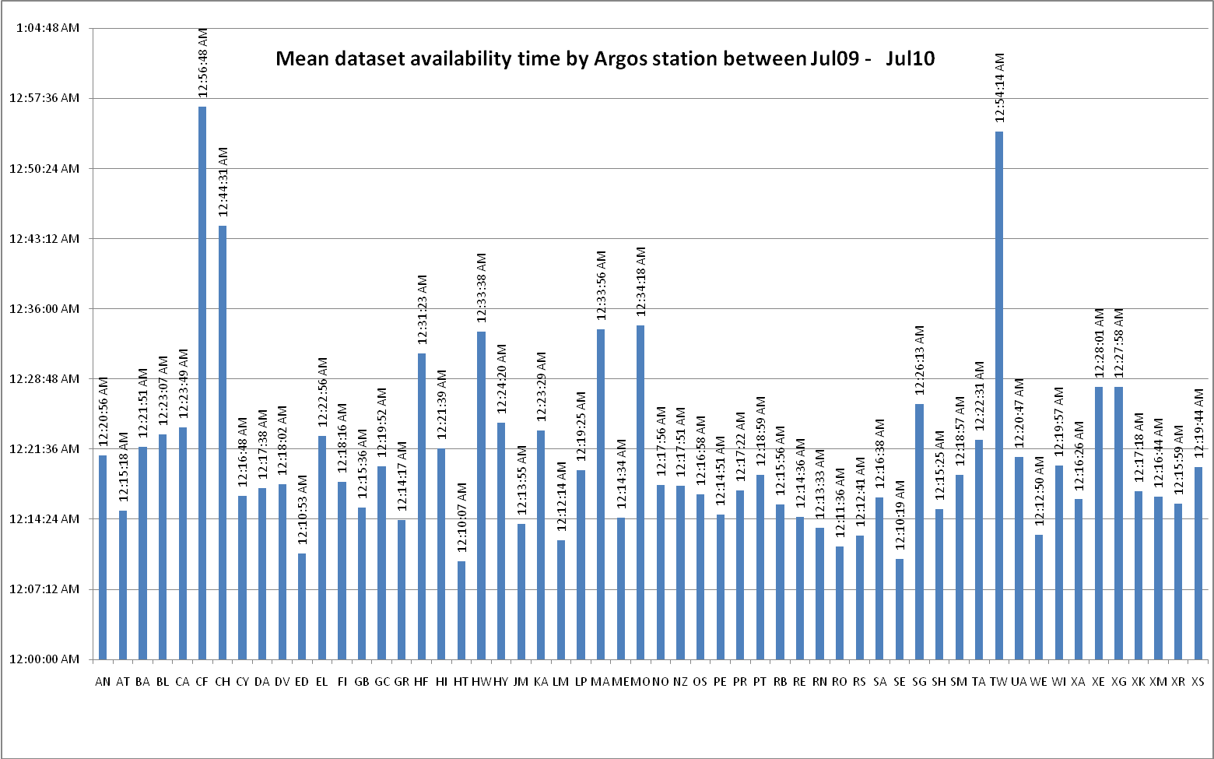
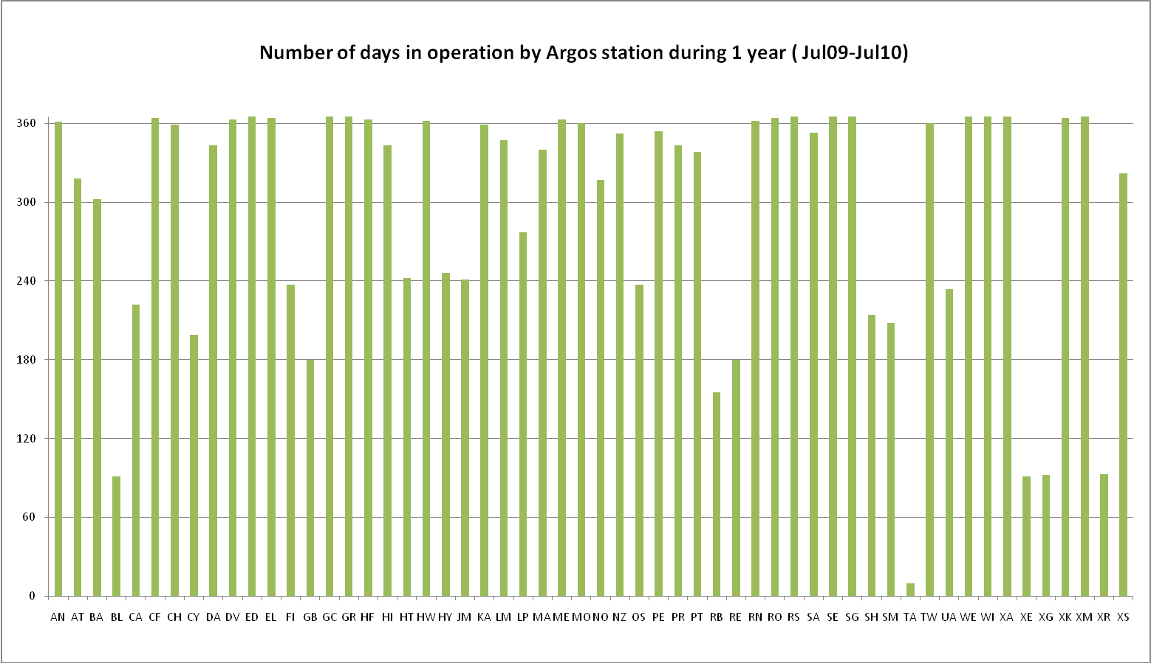
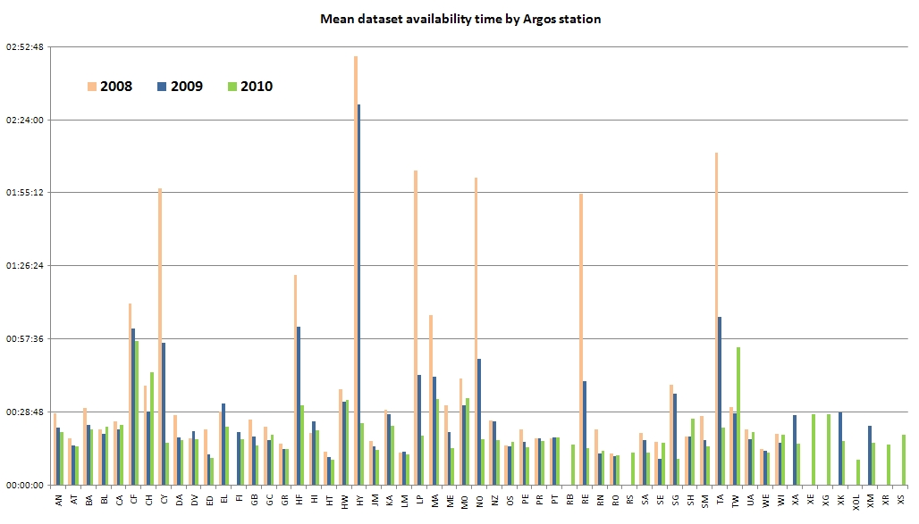

________________
Annex V

Review of the Structure of the Tariff Agreement and related matters
(Submitted by CLS)

Report and recommendations from the Operations Committee

44th Operations Committee (June 2010)

Report on JTA XXIX Meeting

Frank Grooters presented the report on the 29th JTA meeting.

- The 29th meeting on the Argos JTA was hosted by the International Oceanographic Commission (IOC) of UNESCO in Paris, France, from 2 to 3 October 2009. Seven ROC’s were present at the meeting, together with CLS/Service Argos, the DBCP Chairman, the DBCP TC and several representatives of the user community (Marine, Environment, Animals). The meeting was organized and served by the Joint Secretariat for JCOMM (IOC and WMO Secretariats).

- The meeting discussed in an appropriate way the several JTA issues, in particular the User’s Requirements, the Tariff Agreement and the Future Plans.

- Under the User’s Requirements concern was expressed regarding the data timeliness, especially in certain regions such as in the South Atlantic Ocean, the Indian Ocean and in the South Pacific. The meeting requested CLS to draft an Implementation Strategy for the improvement of data timeliness.

- Under the Tariff Agreement the Argos operating costs were presented. The introduction of the Time Slots seemed to be working well and a trend towards an increased use of the time slot was noticed for the “buoy and other” category. It was agreed to continue the current scheme without modification.

- About 600 PTTs are benefiting from the 12-day unit capping (decided on at JTA-27) for
animal platforms, with an impact estimated at 122 PTT years.

- The number of ID’s in Inactive Status is in the order of 300 platforms (projected consumption for 2009 of about 153 PTT-years). The meeting once again urged users and manufactures to program their PTTs in accordance with the duration of the experiments.

- At JTA-28 an unused ID fee of €5/Month and a Silent Service fee of €3/Month was introduced. The Meeting discussed a CLS proposal to introduce a general monthly ID charge of €0.50/Month assigned to every ID in a program me. Because the Meeting felt that users should be informed on the issue before the JTA, it was decided to keep the existing system and request CLS to conduct a thorough analysis to be presented at the next JTA meeting for discussion and asked the Executive Committee to discuss this issue prior to the next JTA meeting.

- The 5-Year Plan for 2010-2014 was presented and discussed in depth. It was noted that the “Large Program” category, if not materialized in the initial years, would deepen the annual deficits as of 2010. The Meeting requested the Executive Committee to explore options with CLS in case this scenario was realized. Taking potential risks and uncertainties into account, the Meeting agreed on a revised version of the FYP, starting the FYP at a tariff for 2010 slightly less than in the FYP 2005 to 2009), resulting in a lower positive cumulative balance during all the five years (see approved table in exhibit XXX)

- As a result of concerns expressed by JTA members after the 28th Meeting in 2009, an informal pre-JTA meeting was held 2-3 July 2009 at IOC, Paris, to discuss the evolution of the Argos JTA. Among others the purpose of the JTA, the status of the JTA within the international framework and the users’ representation in the JTA were discussed. The pre-JTA drafted recommendations and Operating Principles for discussion and agreement in JTA-29. Only slightly modified these Operating Principles were adopted at the JTA meeting.

- One of the proposals made by the pre-JTA was the establishment of an Executive Committee, “to conduct the sessional and intersessional business, as well as matters in support of the Chairperson’s duties to meet the needs of the JTA members”. At JTA-29 the members of the JTA Executive Committee were elected. The JTA-EC held its first meeting on 3 October 2009.

- The JTA-EC held his 2nd meeting 4 to 6 May 2010 at the kind invitation of the Canadian Institute of Ocean Sciences. The JTA-EC reviewed the Action Items from JTA-29, the JTA Operating Principles and the status of the Five Year Plan. Possible solutions for the management of Argos IDs were proposed and the status of the current Argos network, in relation with specific user requirements, was discussed.

- Specifically the issue of the blind orbit and the accuracy of the Argos location were seen as a matter of concern. CLS presented a plan for updating the processing resulting is a better accuracy of the locations. The JTA-EC also re-emphasized the critical importance of the data timeliness issue (being one of the most relevant user requirements) particularly with respect to the real-time coverage in those regions identified in several reports by the JTA (e.g. the South Atlantic, the Indian Ocean, and the South East Pacific). The JTA-EC requested that CLS provide a presentation at the upcoming meeting describing the CLS plans for an optimized HRPT antenna network and the extent to which that network will improve the real-time Argos coverage in the regions identified as critical by the JTA.

- The JTA-EC stressed the importance of the Argos-3 Pilot Project and supported the continuation of the evaluation since Argos-3 is still functioning 100% on Metop-A.

- At JTA-29 the Meeting noted the desire of Mr. Yves Tréglos not to continue as the JTA Chairman. The Meeting expressed its gratitude to Mr. Tréglos for his outstanding long-term dedicated service to the JTA since almost the inception of the JTA.

- The Meeting elected Mr. Frank Grooters as the Chairperson and Mr. Eric Locklear as its Vice-Chairperson.

Status of U.S. processing agreement

The U.S. ROC (Eric Locklear) opened the discussion by thanking the chairs and members of the OPSCOM for the invitation to present on the U.S. Processing Agreement. He noted that he is the only ROC that is invited and doesn’t take this privilege lightly. He continued by referring to the updated charts introduced at OPSCOM 43 with the JTA usage chart on the average active monthly PTTs, and the JTA annual consumption by country. He recalled that the bottom 5 countries make up 84% and 88% respectively of the monthly and annual usage. A new graphic introduced this year was the composition of the U.S. programs annual consumption. Mr. Locklear noted that the dominant user family for the U.S. was the oceanographic and meteorological programs at 83%. The smaller group was the animal users at 17%. He also noted that even though the animal users are many in number, they only comprise 17% of the annual PTT use. The last graphic Mr. Locklear presented on the program status was the analysis of the differences between the assigned IDs, active IDs, and unused IDs. It has been discussed in previous OPSCOM and JTA meetings about the problems managing inactive IDs. Mr. Locklear went on to say this would be a big challenge to decrease the difference between these numbers. The EUMETSAT Co-Chair Mr. Cohen asked how Mr. Locklear would do this. Mr. Locklear responded that while it would be a huge challenge, he would start with the programs with the largest differences. On a side note, Mr. Locklear thanked CLS for working with the ROCs to make detailed information available to them to allow for better analysis and information sharing. Mr. Chris O’Connors asked a question that if the animal user group is growing the fastest in CLS, why didn’t that growth happen in the U.S.? Mr. Locklear responded that the recent state of the U.S. economy was probably the cause of the little to no growth and their lack of cohesion to influence budgets. Lastly, Mr. Locklear went on to discuss the future direction of the U.S. programs and noted that the oceanographic community will continue to evaluate the use of Argos 3 in meeting their requirements, he also went on to note that the U.S. ROC has begun sponsoring research projects in the animal community because of their limited access to budgetary resources. Mr. Locklear went on to discuss sponsoring animal programs and while he may not sponsor enough projects to increase the number of animal users, he can make a difference to those programs that merit research funds. At the conclusion, Mr. Faup recommended that the report that is presented by the U.S. ROC be changed from “Status of U.S. Processing Agreement “ to “Status of U.S. Programs”.

Financial status of Agent

Methodology to derive Argos costs to be attributed to the JTA

Fabienne Jacq presented the meeting with the CLS methodology to derive the Argos basic costs to be attributed to the JTA.

It showed that the Argos basic costs have slightly decreased from 12.38 M€ in 2008 to 12.28 M€ in 2009. The Argos basic costs for science have increased approximately by 4% for an income increase greater than 9%, whereas the Argos basic costs for fishing have decreased significantly following a decrease of the incomes. The Argos basic costs for sensitive use remain stable while the activity is smoothly decreasing also.

In 2009, the costs to be attributed to the JTA are calculated at 6.84 M€ which represents an increase of 5.2% (mainly due to the implementation of Argos-3 upgrades at the technical level and to the promotion of these new services). Meanwhile the activity under the JTA continues to increase significantly: +11.66% in the average active PTTs processed and distributed (11722 in 2009 compared to 10498 in 2008).

At the 29th JTA meeting, the following was agreed:
- The present status of JTA with international nature should be maintained with WMO and IOC involvement, which would facilitate involving wider groups of users such as the animal trackers.
- An executive committee has been created to reinforce the intersession work.
- To provide funding for secretariat and executive committee support and lodging for some members of the JTA at a level not exceeding 0.5% of the Argos costs attributed to the JTA.
- To adopt a slightly different 2010-2014 5YP than the one presented at the previous OPSCOM to consider the following main topics:
→target an 1M€ approximative cumulative balance all the five years of the plan
→ provide an immediate 8.3% decrease of the B coefficient (daily processing fee)
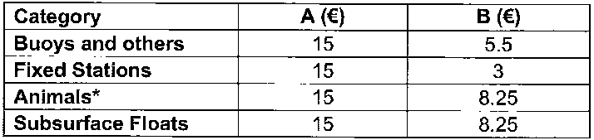
*the animal platforms benefit from the 12 day-unit capping

Financial status of the Agent:

In 2009, CLS recorded revenues from JTA participating countries at a level of 7.59 M€. This was slightly above the revenues expected from the JTA at 7.23 M€. Also in 2009, all platforms continued to benefit from the time slot calculations. This represented a few percent savings for every transmitter. As decided at past JTA meeting, the implementation of a fee for unused ID has contributed to JTA incomes at a level of 280 K€ while waiting for users to revert to CLS these IDs for reallocation.

So in 2009, the JTA realized a small excess of 0.75 M€ which is going to add to the excess carried forward from the previous year of 0.91 M€ to bring the cumulative balance to 1.66 M€. The non JTA incomes decreased in 2009 from 6.72 M€ to 6.34 M€, but the corresponding applications are still exceeding their portion of the costs all together.
Consequently, the non JTA accumulated loss at the end of 2009 is calculated at 5.20 M€.

The financial status in 2009 confirms the expectations. It validates the decision taken at JTA 29th to adopt a new five year plan contemplating a significant tariff decrease right from year 1 of the plan.

At the date of the meeting, we believe the JTA in 2010 will likely be able to pay its portion of the cost.
It has been agreed that future JTA FYP tables will make reference to large programs instead of OCO

The JTA Five Year Operating Plan

The Five Year Plan for 2005 - 2009

The Five Year Plan below is updated with actual 2009 Cost and Income numbers.

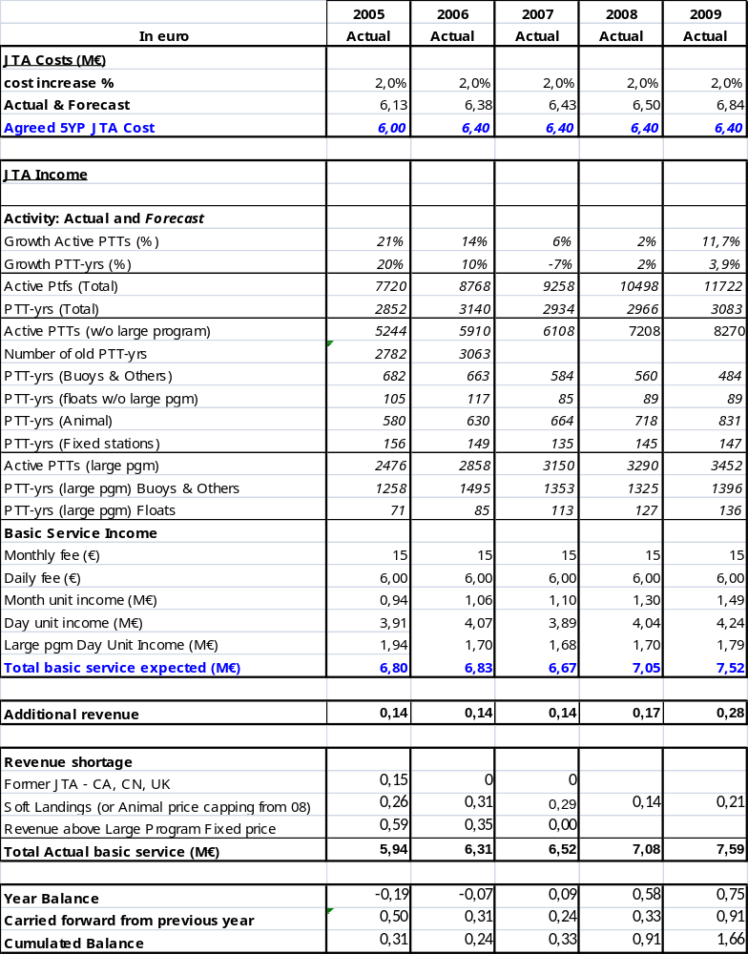

As illustrated in the Plan, the 2009 costs to be attributed to the JTA were 6.84 M€ which represents an increase of 5.2% (mainly due to the implementation of Argos-3 upgrades at the technical level and to the promotion of these new services). An encouraging sign is that the activity under the JTA continues to increase significantly: +11.7% increase in the Active PTTs which follows a +10.6% increase in 2008. The Total PTT-Yrs consumed in 2009 increased by 4% compared to a 1% increase in 2008.

The total revenue in 2009 was 7.59 M€ (up from 7.08 M€ in 2008) resulting in a 2009 Year-end Cumulated Balance of 1.66 M€. This balance will be carried forward and applied in Year 2010 (see the 2010 – 2014 Five Year Plan below).

The Five Year Plan for 2010 – 2014

The Five Year Plan below is the Plan approved at the JTA 29 meeting which is updated with projected year-end numbers for Year 2010.

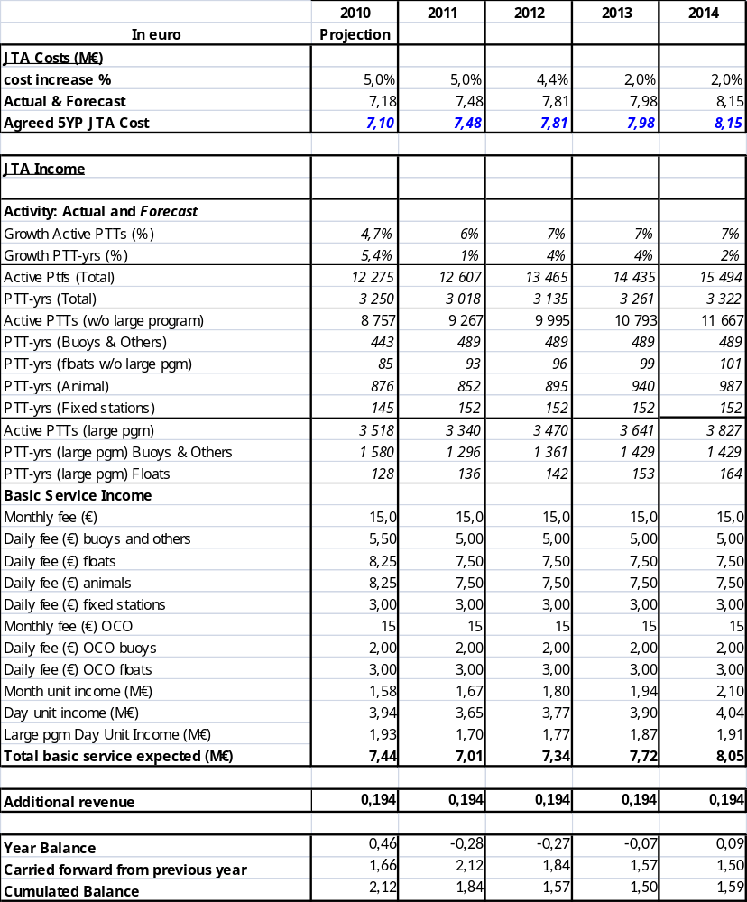

The projections for 2010 in the above Plan for the total Active PTTs (12,275) is 4.7% and the PTT-Yrs consumed (3,250) reflect anticipated increases from 2009 of 5,4 %. Growth is anticipated in nearly all applications with Active PTT and PTT-Yr consumption projections, the highest prediction being on the Large Program Buoys and Others.

Financial Statement

Annual Expenses (in kEuros) for Year 2009

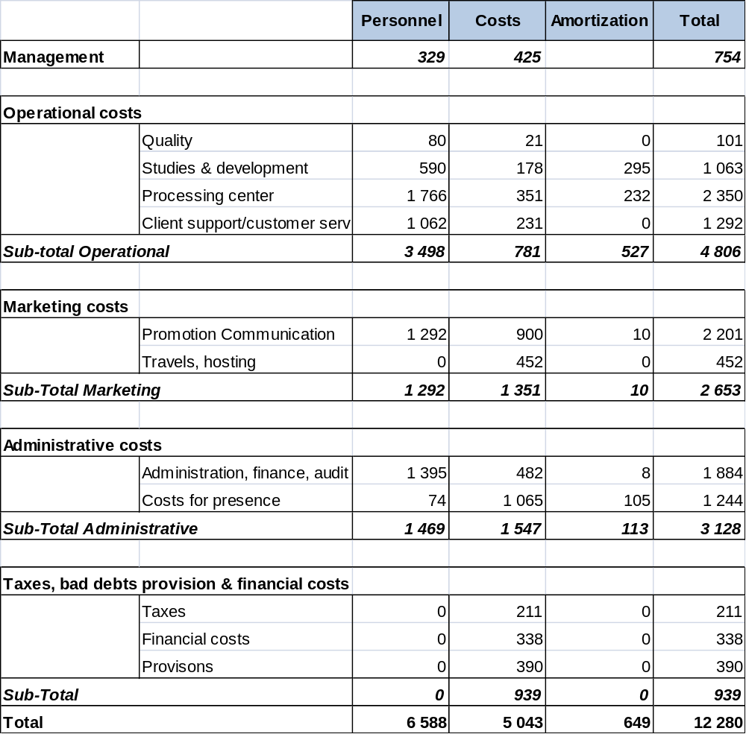

Table 4.3.1: Detail on 2009 Expenses in k€

Details of Amortization Items

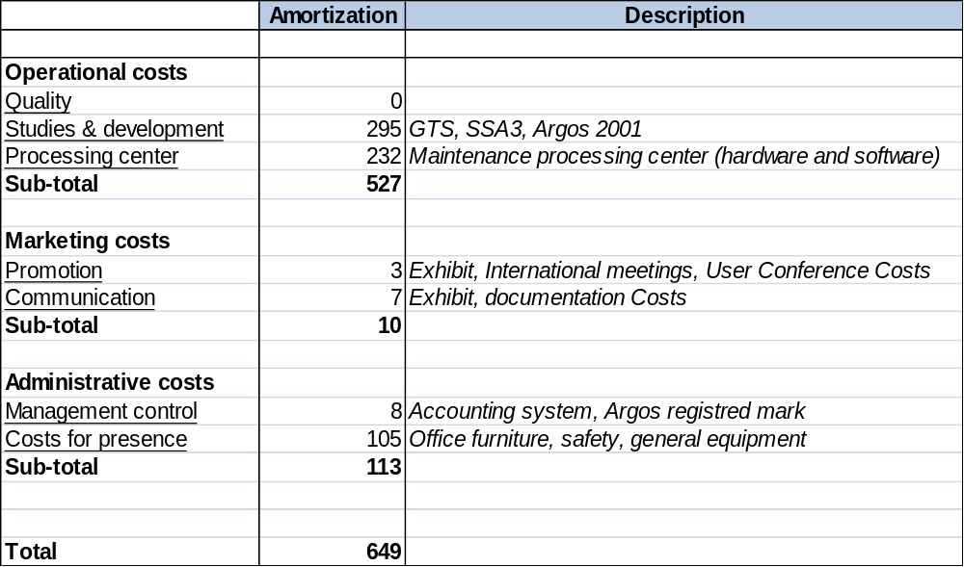

Table 4.3.2: Detail of Amortization Items in k€

Annual Incomes (in millions of Euros)

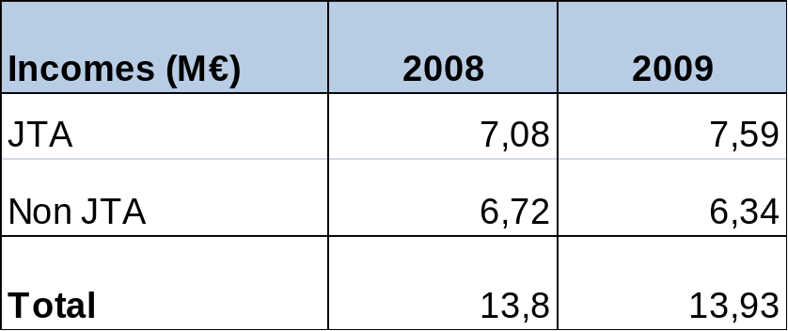

Table 4.3.3: JTA and non JTA 2008, 2009 Incomes

Details of JTA and non JTA Incomes and Expenses (in million Euros)

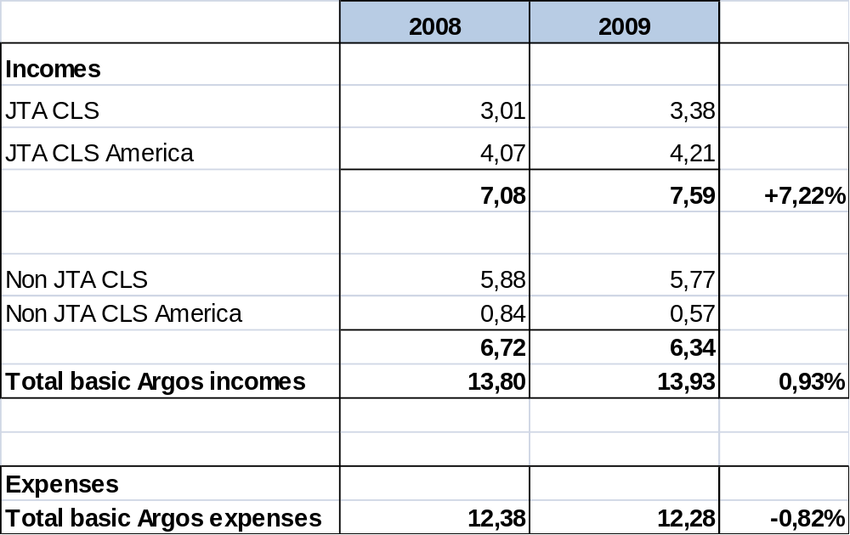

Table 4.3.4: Detail of JTA and non JTA Incomes and Expenses

JTA Annual Balance (in millions of Euros)

 | 2008 | 2009
JTA Operating Costs | 6.50 | 6.84
JTA Income | 7.08 | 7.59
Difference | 0.58 | 0.75
Accumulated Difference | 0.91 | 1.66
The remaining difference from 2007 was 0.33 M€
Table 4. 3.5: Annual Balance

For year 2009, the costs to be attributed to the JTA, calculated using the methodology developed by CLS since 3 years now, is 6.84 M€.

Other Issues Relating to Argos Funding

Management of ID numbers

JTA XXIX Meeting (2009)

3. ACTIONS AND DECISIONS OF THE CURRENT MEETING

Number 2: Produce a thorough analysis and rationale on an unused ID monthly fee or a monthly ID charge, and submit it to the JTA-EC

Number 3: JTA-EC to work with CLS on possible alternative options and to come up with a solution to be approved at the next JTA meeting

Analysis and conclusion

See Annex VI to this report.

Argos-3 (Downlink messaging and high data rate channel) tariff

It was decided at OPSCOM 42 (Germany) and again at OPSCOM 43 (U.S.) that the Argos-3 pricing should be defined after gaining experience on the actual usage during the DBCP Argos-3 pilot project.

________________
Annex VI

Analysis and Rationale for an Unused ID monthly fee or a Monthly ID Charge
(submitted by CLS)

Background

The management of ID numbers is an essential part of all communication systems. Applying an unused fee to ID numbers that have not transmitted in 24 months has been the management method of choice in recent years for the JTA. At the JTA 27 meeting CLS was asked to explore and report on alternative methods. This reporting has been done on several occasions but no decision has been made to change from the current method.

The recent improved capability for the Argos data distribution system to accommodate ID numbers of 6 decimal digits has accelerated interest in projecting the future availability of Argos ID numbers. The theoretical possible maximum number of IDs is 524,272. However, this can be reached only if all 20 bit IDs (32,767) are available at CLS to create 28 bit IDs (32,767 x 16 = 524,272). Not all of the 20 bit IDs are available today though, because many (21,959) are currently assigned. Therefore, projections of future ID availability depend directly on the rates at which both the 20 bit and the 28 bit IDs are returned. Today there are only 104,192 28 bit ID numbers available for assignment.

Model and Analysis

To provide a mathematical basis for future projections CLS created a simple model that takes into account several parameters including, the number of IDs currently assigned, the number of 28 bit IDs currently available to be assigned, the number of 20 bit and 28 bit IDs returned each year and the number of 28 bit IDs assigned each year. Some of these model parameters are known and some can be estimated based on recent yearly numbers. The model is able to make projections of how many 28 bit ID’s will be available in the out-years as a function of the values selected for the different parameters.

The model was run using three scenarios each differing primarily in anticipated rates of return to CLS of the 20 bit and 28 bit ID numbers.

Scenario 1

- Zero 20 & 28 bit ID’s returned per year.
- 8360 28 bit ID’s assigned per year
Scenario 1, the worst case, had NO ID numbers being returned at all. For the number of 28 bit ID’s that are assigned each year in this scenario the 6 year (2004 – 2009) averaged number of 8,360 was applied. Under these conditions the number of 28 bit ID’s available to be assigned goes to zero in year 2022, only 12 years from now.

Scenario 2

- Zero 20 bit ID’s returned per year.
- 3500 28 bit ID’s returned per year.
- 8360 28 bit ID’s assigned per year.
Scenario 2 also had no 20 bit ID’s being returned but did have 3500 28 bit ID’s being returned per year (a six year averaged rate). The average assignment rate of 8,630 was also applied in this scenario. Under these conditions the number of 28 bit ID’s available to be assigned goes to zero in year 2031. This scenario shows that another 9 years are gained when 28 bit ID’s only, no 20 bit ID’s, are returned per year.

Scenario 3

- 100 20 bit ID’s returned per year.
- 3500 28 bit ID’s returned per year.
- 8360 28 bit ID’s assigned per year.

Scenario 3 was the same as Scenario 2 except that a return rate of one hundred 20 bit ID’s per year was added. The average assignment rate of 8,630 was also applied in this scenario. For Scenario 3 the number of 28 bit ID’s available to be assigned goes to zero in year 2041. Thus by returning 100 20 bit ID’s per year another 10 years are gained in the availability of ID numbers for assignment.

Conclusion

The analysis indicates clearly that returning 28 bit ID numbers can help. But, the long-term availability of 28 bit ID numbers for assignment depends critically on the return to CLS of the currently assigned 20 bit ID numbers so that 16 more 28 bit ID’s (per 20 bit number) can be created for future assignment. In recognition of this, CLS is implementing a dedicated project which will take all possible steps to recover those 20 bit ID’s that are currently assigned to users.

Because this recovery project will likely span several years and because the rate of 20 bit ID recovery is at this point unpredictable, it is essential that the ongoing recovery/recycling of 28 bit ID’s is maintained in the near-term at least at the current rate. Therefore, CLS recommends that the JTA continues to apply the existing unused ID fee for at least the next three years during which time the rate of 20 bit ID recovery will be monitored closely and reported annually. The success of the 20 bit ID recovery project will be the primary determining factor in the length of time the unused ID fee remains applied.

No other ID management methods or fees are proposed at this time.

________________
Annex VII

Terms and Conditions of the Global Agreement for 2011
(As agreed at JTA-XXX, 2010)

These Terms and Conditions outline costs for and services to be provided by Collecte Localisation Satellites (affiliate of CNES)...

TIME PERIOD OF COVERAGE:

These Terms and Conditions are valid for the time beginning on January 1 and ending on December 31, 2011.

DEFINITIONS

"Platform-year" is defined as 365 days of operation of an acceptable Platform Transmitter Terminal (PTT).

“ROC” is the Representative of Country representing a country or a group of countries.

“RO” is the Responsible Organization representing an agreed set of Argos User programs for the purposes of their collective participation in the JTA.

The "Agreement" includes all those participating countries which agree to the Terms and Conditions contained herein and are listed in Annex A to this Agreement.

The “Large Programmes” are defined as those programmes that are funded and managed by a single organisation.

BASIC SERVICES PROVIDED BY CLS

CLS will perform the following categories of services associated with PTTs of the authorized users:

(1) Location determination or both location determination and data collection for PTTs with a repetition period equal to or less than 120 seconds, application of calibration curves to the data when appropriate, access to the data and distribution of the data according to the paragraph below entitled "Distribution of processed data" and archiving for three months;

(2) Data collection for (fixed station) PTTs with a repetition period equal to or greater than 200 seconds, application of calibration curves to the data when appropriate, access to the data and the distribution of the data according to the paragraph below entitled "Distribution of processed data" and archiving for three months;

(3) Location service plus / auxiliary location

(4) On-line data access

(5) GTS Processing and Distribution

USER BASIC SERVICE CHARGES

BASIC SERVICE

Basic service charges for authorized users under this Agreement are in accordance with the payment on consumption.

They are calculated according to the following formula:

Price per month, per platform = A + B x n

where:

- A represents the monthly charge per active PTT (an active PTT is one that transmits at least once during a given calendar month)

- B represents the PTT-day unit rate.

- n is the number of day units. The day is divided into 4 time slots (0 - 6; 6 - 12; 12 - 18; 18 – 24 UTC). Any PTT transmission collected into a given time slot produces a 0.25 day unit. .

A and B coefficients for all platform categories are provided in table below:

Category | A (€) | B (€)
Buoys and others | 15 | 5
Fixed Stations | 15 | 3
Animals* | 15 | 7.5
Subsurface Floats | 15 | 7.5

Buoys and others – PTTs in this category are drifting and moored buoys and, more generally, all those PTTs which do not belong to categories below.

Fixed Stations – PTTs in this category are land fixed PTTs.

Animals – PTTs in this category are those that are used to track animals.
*Charges for Platforms in this category will be capped at n=12 Day Units per month.

Floats – PTTs in this category are subsurface floats such as the ARGO program floats.

DISCOUNT SCHEME FOR LARGE PROGRAMMES

Number of platform-years | PTT–day unit (B)  Buoys & others | PTT-day unit (B)  Floats
600 | 4 | 6
900 | 3 | 4.5
1200 | 2 | 3

UNUSED IDs

PTTs which have not transmitted during a period of 24 months will be charged 5 € per month from the 25th month until the ID numbers are returned to CLS. This amount of unit charge will be applied until the ID number is formally returned to CLS by the User. The purpose of this fee is to recover IDs no longer required.

SILENT SERVICE

IDs remaining silent but still being used in an agreed programme will be considered by CLS on a case-by-case basis.

INACTIVE STATUS

This status is intended for those platforms that continue to transmit but for which the location or data collection are of no further use to the user or the community. The following conditions must be met to qualify:

(1) Inactive Status will apply if, and only if, Inactive Status is declared by the signatory of the System Use Agreement for platforms which continue to transmit beyond the programme termination. In that case, further charges will no longer be levied;

(2) The platforms must have operated in Basic Service for a minimum of 2 months;

(3) Data or location information cannot be retrieved nor can the platform revert to any category of service;

- It is intended that Location and/or data collection may not be computed using a Local User Terminal or other direct readout facility;

- ID numbers of such platforms are actually returned to CLS who will recycle them after the platform stops transmitting.

ADDITIONAL SERVICES PROVIDED BY CLS AND NOT INCLUDED IN BASIC SERVICES

Additional services such as ArgosDirect (the former ADS, Databank) service, ArgosMonitor, Moored Buoy monitoring and others are provided by CLS and charged according to the yearly catalogue of prices.

DESIGNATED ROC / RO

..................................................................
..................................................................
..................................................................
..................................................................

DISTRIBUTION OF PROCESSED DATA

(1) These Terms and Conditions do not cover the costs of special additional services made to provide the processed data back to the users. These must be made by the user directly with CLS;
(2) However, it is understood that CLS will continue to provide data from PTTs via the World Weather Watch Global Telecommunication System (WWW/GTS) of the World Meteorological Organization (WMO) according to procedures established by WMO.

BILLING AND PAYMENT

CLS will send invoices on a two monthly basis (CLS America on a monthly basis) based on consumption to the organizations covered by the country agreement.

GENERAL CONDITIONS OF AGREEMENT

(1) The designated ROC / RO and CLS jointly agree the list of users included in the Agreement and will update this list as appropriate. To assist in this process CLS will notify the ROC/RO of any new programmes that might qualify for this agreement.
(2) For additional services not provided within this Agreement, individual users under this Agreement must negotiate directly with CLS. Payments associated with these negotiations must be settled on receipt of the invoice. If these conditions are not met, CLS may stop the distribution of the user's processed data.
(3) Authorized users are defined as those implementing PTTs which are government funded. However, other users of agencies or organizations which are considered "non-profit" may be authorized. PTTs funded partly or entirely by private companies or organizations cannot be included in the conditions of this Agreement, even if data are supplied free of charge to national or international organizations.
If these rules are not followed, CLS may stop the distribution of this user's data. Should this situation occur, CLS will immediately notify the ROC / RO. Nevertheless, active PTTs received by the system will be counted in the platform-year total and data stored.
(4) All authorized users must sign a purchase order for each programme, either for the current year or for the duration of the programme, in order to clearly specify the services they request, whether these services are provided under this Agreement or not.
(5) VAT will be charged to EU Members in accordance with EU rules.

________________________  Signed on behalf of the participating countries by the JTA Chairperson | _______  / / | ____________  Signed by CLS  Chief Executive Officer  Christophe VASSAL | _______  / /

________________

Annex VIII

JTA Operating Principles
(as agreed at the JTA-30 Meeting)

Table of content

1. Introduction

2. Basic aims and principles of the Argos Joint Tariff Agreement (JTA)

3. The Stakeholders representation
3.1 Representatives of Country (ROCs)
3.2 Responsible Organizations (ROs)
3.3 Representative of a User Group (RUG)
3.4 Service Argos
3.5 The Argos Operations Committee (OPSCOM)
3.6 The WMO and IOC Secretariats

4. JTA office bearers

5. The JTA Executive Committee (JTA-EC)

6. Regular meeting of the JTA
6.1 Structure
6.2 Desired outcome:
6.3 Invited participants
6.4 Secretariat
6.5 Typical agenda for JTA meetings
6.6 Frequency

7. Typical intersessional workplan, and reporting process

Annex A Role of the JTA Representative of Country (ROC) (as agreed at the JTA-28)
Annex B Terms of Reference of the Argos Joint Tariff Agreement (JTA)
Annex C Terms of reference of the Representative of country (ROC)
Annex D Terms of reference of the Responsible Organization (RO)
Annex E Terms of Reference of a JTA Representative of a User Group (RUG)
Annex F Terms of Reference of the JTA Chairperson
Annex G Terms of Reference of the JTA vice-Chairperson
Annex H Terms of Reference of the JTA Executive Committee
Annex I Typical agenda for JTA Sessions
Annex J Typical JTA intersessional workplan, and reporting process
Annex K Format for the National Reports to the JTA
1. Introduction

The JTA provides for an international mechanism to provide for cost-effective location and data processing of data collected through the Argos system. The JTA is functioning through stakeholders whose roles are mainly to negotiate the Argos service level and tariff, and ensure appropriate coordination amongst Argos users in order to represent their collective interests with regard to Argos tariff and requirements. Stakeholders include:

- Representatives of Country (ROCs) representing a country or a group of countries from responsible government organizations using Argos;
- Responsible Organizations (ROs) representing an agreed set of Argos user programmes;
- Representatives of Users Groups (RUGs);
- Representatives of the Argos satellite system operator and service provider;
- Representatives of the Argos Operations Committee (OPSCOM);
- Representatives of the WMO and IOC Secretariats.

2. Basic aims and principles of the Argos Joint Tariff Agreement (JTA)

2.1 The basic aims and principles, based on the discussion at the JTA-XXIII (Angra dos Reis, 2003), was agreed at the JTA-XXIX (Paris, 2009) as follows:

- The benefits of JTA participation should be shared equally amongst all participants (Users).
- The revenue collected from Users should meet the costs of providing the service.
- Developments required by Users should be funded by Users.
- Costs of developments not of benefit (or of marginal benefit) and not driven by User requirements should not fall on Users.
- There should be a clear division between a basic (funded) service and other (e.g. value added) services.
- The Tariff structure should be simplified to reduce the number of service categories.
- System developments should be fully endorsed by JTA and those affecting Users agreed in advance.

2.2 The Terms of Reference of the Argos Joint Tariff Agreement (JTA) are provided in Annex B.

3. The Stakeholders representation

3.1 Representatives of Country (ROCs)

ROCs are representing a country or a group of countries from responsible government organizations using Argos. The role of the ROCs is detailed in Annex A. The Terms of Reference of the ROCs, including mechanism for their nomination are provided in Annex C.

3.2 Responsible Organizations (ROs)

3.2.1 An RO is the Responsible Organization representing an agreed set of Argos User programs for the purposes of their collective participation in the JTA. The concept of RO can accommodate groups of countries such as E-SURFMAR, as well as large individual programmes as necessary or convenient.

3.2.2 As agreed at JTA-XXIV, the functions of an RO include:

(i) preparing consolidated estimates of Argos usage for the annual JTA budget planning and negotiation of tariff Terms and Conditions;

(ii) representing the collective interests of the User programs in respect of the Argos service provision and forward planning

3.2.3 A RO would provide local support for Argos applications, and facilitate the interface between CLS Argos and the User programs for which the RO is responsible, including

(i) responsibility for organizing the payment of CLS Argos invoices for its Users

(ii) providing support to members of the RO’s User group

3.2.4 The Terms of Reference of the ROs are provided in Annex D.

3.3 Representative of a User Group (RUG)

3.3.1 A Representative of a User Group (RUG) is an individual who can fairly represent the overall consensus view of a significant Argos JTA user community. Such communities might reasonably include the operators of data buoys, floats, ice platforms, animal tags, land stations, ship stations and airborne stations, or bodies with agreed international responsibilities for the promotion, sponsorship or validation of any aspect of environmental observation using Argos (e.g. IOC, WMO, WWF). The RUG will work with CLS and the JTA Executive Committee to identify opportunities that might bring the JTA session into closer contact with his/her user group, with a view to establishing within that group the benefits of the JTA process.

3.3.2 The Terms of Reference of a JTA Representative of a User Group (RUG), including mechanism for their nomination are provided in Annex E.

3.4 CLS

3.4.1 CLS is the designated agent of CNES to operate the Argos system ground segment and to promote the use of it. Those Argos basic services are provided at cost to the users under the oversight of the Argos Operation Committee (CNES, NOAA, EUMETSAT).

3.4.2 CLS role with regard to the Argos and the JTA is:

- to report to the JTA on developments and operations, related to the use and performances of the system;
- to report to the JTA on overall costs and recovery of expenditures through service charges; this includes, in particular, the preparation of and the annual assessment of the JTA Five Year Plan (FYP);
- to collect requirements from the user community and implement required solutions when possible;
- to interface with the participating space agencies to assist in providing system upgrades if requested;
- to interface with manufacturers to certify their transmitter products and to provide engineering assistance to them to insure their hardware operates correctly and efficiently with the Argos system, thereby increasing and optimizing Argos system usage;
- to develop and maintain the ground system and the Global data processing centres;
- to operate the Argos ground segment;
- to operate the Global processing centres under quality of service agreements and deliver data collected to the user community according to international standard data exchange requirements and protocols;
- to perform multiple levels of quality of control on the data;
- to store all data processed for a duration of 12 months and to make it easily extractable in response to user requests;
- to monitor and control the overall performances of the systems so as to guarantee the level of quality and continuity of service;
- to promote the use of the Argos system and market new user communities, with the goal of minimizing the cost of using Argos;
- to support users through responsive customer service for any request, claim or declaration of equipment;
- to support the JTA Executive Committee in JTA management and operations;
- to support ROCs and ROs as needed especially by facilitating access to and interaction between them and the user communities.

3.5 The Argos Operations Committee (OPSCOM)

3.5.1 The Argos Operations Committee (OPSCOM) was established by the Memorandum of Understanding (MoU) signed by the National Oceanic and Atmospheric Administration (NOAA) of the United States of America, and the Centre National d'Etudes Spatiales (CNES) of France, who affirmed their desire to conduct a space applications project of mutual interest for peaceful purposes. The MoU was intended to govern the cooperation between NOAA and CNES for the implementation and the use of the Argos Data Collection and Platform Location System (Argos Data Collection System).

3.5.2 Agencies signing the MoU recognize their common interest in promoting maximum use of the Argos system through enhanced service and cost-effective operations. In this context, one of the objectives is to achieve a self-sustaining system with revenues from users fully offsetting operating costs. The Argos Operations Committee is reviewing the implementation and supervising the operations of the Argos Data Collection System. The Committee meets in principle, annually.

3.5.3 The OPSCOM in particular reviews the Argos Data Collection System development and implementation activities and recommends to the Project Managers and the signatories to the MOU appropriate measures for accomplishing the objectives of the project. It reviews and approves applications and formulates criteria for approval of applications received from prospective platform operators for the use of the Argos Data Collection System.

3.5.4 The arrangements, including cost considerations, for the performance of platform allocation, verification of the calibration data, system quality control, conversion of telemetry data into physical parameters, and computations for platform location is delegated by CNES to its agent and operations capacity according to the tariff structure and other guidelines submitted to and approved by the Operations Committee.

3.5.5 Tariffs associated with these functions are collected to offset the operating costs of the Argos Data Processing System. Tariff receipts that exceed these costs are used for Argos Data Processing System improvements and/or to reduce tariffs to System platform users as approved by the Operations Committee.

3.6 The WMO and IOC Secretariats

The World Meteorological Organization (WMO) and the Intergovernmental Oceanographic Commission (IOC) of UNESCO recognize that satellite data telecommunication systems are important components for the implementation and sustainability of global met-ocean observing networks. WMO and IOC endorse the JTA as a mechanism to cost-effectively address the requirements of WMO and IOC Programmes and Co-sponsored Programmes, in particular in terms of satellite data telecommunication and related data processing, quality control, data encoding according to international standards, and data distribution to their end users. In order to facilitate the JTA achieving its goals, the Secretariats of both Organizations will provide support for the following functions:

- Support the JTA Chairperson for the preparation of the JTA meeting, including; 1) circulation of invitation letters, 2) coordination for the collection, and electronic publication of the preparatory documentations, and 3) electronic publication of the final reports.

- Upon request by JTA Chairperson, and as appropriate, issue the general communication with JTA stakeholders as appropriate (e.g. for the nomination of Representatives), and the publication of documents.

- Serve as members of the JTA Executive Committee.

The representatives of WMO and IOC will participate in JTA Sessions as stakeholders, representing the interests of both Organizations.

Reimbursement to the IOC and WMO for Administrative support should be made by the JTA. The amount reimbursed is to be reviewed annually by the JTA-EC and approved by the Chairperson for the upcoming session.

4. JTA office bearers

4.1 The JTA elects a Chairperson and vice-Chairperson at JTA Sessions. The primary duty of the Chairperson is to ensure that the JTA negotiations proceed in as open and equitable a way as possible, and to assist in reconciling the needs of Argos stakeholders through an agreed negotiation process regarding future service level provision and costs. The vice-Chairperson shall deputize for the Chairperson in his/her duties if required by the Chairperson.

4.2 The Terms of Reference for the JTA Chairperson, and the JTA vice-Chairperson, details about their election and terms are provided in Annexes F and G respectively.

5. The JTA Executive Committee (JTA-EC)

5.1 The function of the JTA Executive Committee (JTA-EC) is to conduct the sessional and intersessional business, as well as all other matters in support of the Chairperson’s duties to meet the needs of the JTA members.

5.2 The Terms of Reference of the JTA Executive Committee are provided in Annex H.

6. Regular meeting of the JTA

6.1 Structure

The structure of the meeting consists of deliberative sessions over 2 days that are directed by the Chairperson to achieve the desired outcome. It is expected that the agenda, as adopted by the JTA at the start of the session, will be followed.

6.2 Desired outcome:

The desired outcome of the JTA Session is to be an open forum for all members to discuss and agree by consensus on any matter that affects their use of the Argos satellite data communications and processing system.

6.3 Invited participants

There is an open invitation to all members of all stakeholder groups to attend the JTA annual meeting. However, official invitation by the IOC and WMO will be made to the following:

- Representatives of Country (ROCs) representing a country or a group of countries from responsible government organizations using Argos

- Responsible Organizations (ROs) representing an agreed set of Argos user programmes

- Representatives of the Argos satellite system operator and service provider

- Representatives of the Argos Operations Committee (OPSCOM)

6.4 Secretariat

Secretariat for the running of the Session, and writing of the final report is the responsibility of the JTA Chairperson with support from Session participants as necessary.

6.5 Typical agenda for JTA meetings is provided in Annex I

6.6 Frequency

The JTA Session should be held annually, but the schedule may be changed at the discretion of the Chairperson.

7. Typical intersessional workplan and reporting process

The following schedule is proposed. The actual workplan will be implemented by the Chairperson and will include a combination of meetings, teleconferences, and email. typical intersessional workplan, and reporting process is provided in Annex J.

______________

Annex A

Role of the JTA Representative of Country (ROC)
(as agreed at the JTA-30)

HISTORICAL OVERVIEW

The concept of ROC was introduced at the first meeting on Argos Joint Tariff Agreement (JTA-I) (Geneva, Switzerland, December 1981). The Meeting adopted a proposal «which foresees that agreements will be signed directly between the user Representative* and Service Argos.» The note under the * reads: «Representative is a unique Representative Organization for a country or a group of countries as given in the Global Agreement.» The Global Agreement starts with the following sentence: «These Terms and Conditions outline costs to and services to be provided by Service Argos of CNES and the (*)....... jointly providing support to their own authorized users for the location and data processing associated with the implementation and testing of remote platforms communicating with the satellites of the TIROS-N series.» The note under the (*) reads: «Quote the country and its own organization in charge of the Agreement with regards to CNES Service Argos. Hereafter defined by "ROC", i.e., a unique Representative Organization for a Country or a group of countries.»

That wording remained unchanged (except «Service Argos of CNES» being replaced by «Collecte Localisation Satellites», beginning in 1987, and «the satellites of the TIROS-N series» being replaced by «Argos capable satellites», beginning in 2003) until and including the "usual" Global Agreement for 2005. In the Agreement for 2005 regarding the Pilot Programme for the New Tariff Scheme, one reads: «These Terms and Conditions outline costs to and services to be provided by Collecte Localisation Satellites (1) hereafter referred to as "CLS" and the countries listed below, but not be limited to: [etc.]», and the note reads: «Quote the country and its own organization in charge of the Agreement with regard to CLS. Hereafter defined by "ROC / RO / Programme Manager", i.e. a unique Representative Organization for a country, a group of countries, or a single programme.» In addition, under DEFINITIONS, the following is added: «"RO" is the responsible Organization representing an agreed set of Argos User programs for the purpose of their collective participation in the JTA.»

The Global Agreement for 2006 comes back to the initial wording, with a slight change in the note: «Quote the country and / or the organization in charge of the Agreement with regard to CLS, hereafter defined by "ROC / RO”» and the addition, under DEFINITIONS, of: «“ROC” is the Representative of Country and “RO” is Responsible Organization.»

The Global Agreement for 2007 reads: «These Terms and Conditions outline costs to and services to be provided by Collecte Localisation Satellites (affiliate of CNES in charge of operating the Argos system), hereafter referred to as "CLS" and all the countries participating in the JTA.» The definitions of ROC and RO remain unchanged.

Lastly, the Global Agreement for 2008 reads: «These Terms and Conditions outline costs for services to be provided by Collecte Localisation Satellites (affiliate of CNES).» The definition of ROC becomes the one adopted by JTA-XXVII and used in this document.

CONTEXT

The terms of the Joint Tariff Agreement require that the agreement is negotiated within an intergovernmental forum. This is achieved because, and only because, the invitation letters to the meetings are addressed by the joint Secretariat to the official representatives of Members / Member States of WMO / IOC. These invitation letters are systematically copied to the ROCs, who therefore may attend the meetings, whatever their official status may be (governmental representatives or "advisers"). This has been done on purpose since the first meeting because: (i) the ROCs are the only really knowledgeable people in their countries regarding JTA activities; and (ii) nobody could foresee what might be the official status of the ROC in each and every country (see "NOMINATION AND RECOGNITION OF ROC" below).

The tariff agreement has been negotiated annually since its inception, with the objective of assuring the long term viability and development of the CLS / Argos data service, and in turn securing preferential (cost-recovery) and globally-consistent pricing arrangements for government or not-for-profit funded environmental monitoring programs within the JTA participant countries.

The Representative of Country (ROC) is the person representing a country or a group of countries from a responsible government organization. The ROC may be required to keep other government agencies informed of the activities of CLS / Argos in order to justify the use of the Argos transmitters (PTTs) within national boundaries and their status within current communication policies. The ROC is the Responsible Authority representing an agreed set of Argos User Programs for the purposes of their collective participation in the JTA.

The tariff structure, price-setting arrangements and relationships between CLS / Argos, User Programs and the ROCs have changed significantly since 2005. Changes include the introduction of a simplified tariff, the establishment of direct contracts and billing arrangements between CLS / Argos and end-user programs, and, in some cases, the entry of local CLS / Argos representatives with the capacity to provide end user support. In the process, the “traditional” role of ROCs, their relationship with users and with CLS / Argos, and their contribution to annual tariff negotiations have been altered. ROCs’ roles around the world have also become less homogeneous.

This document sets out the role of a ROC, and the relationships, expectations and obligations between ROCs, end users, CLS / Argos and other stakeholders (e.g., OPSCOM), in the context of the current tariff structure.

NOMINATION AND RECOGNITION OF ROC

Each and every country nominates (or not, see below) its ROC as it wishes. In general, the ROC is nominated by an official representative of the Member / Member State of WMO / IOC and has therefore the status of a governmental representative. But this is not always the case: in some instances, for example, the ROC may be just "defined" through an agreement between a programme manager and CLS, and accepted as such by the JTA Meeting because of its de facto position. Other possibilities may (and do) happen. None would impinge upon the intergovernmental status of the Meeting on Argos Joint Tariff Agreement (see 1st paragraph in the "CONTEXT" section above).

ROLE OF THE ROC - GENERAL

The ROC is to ensure that the Argos system meets the basic requirements of all system user groups in the most cost-effective way within the principles of fairness, openness and the promotion of science.

ROC ROLES – CLS/ARGOS INTERFACE

- Tariff charge rate negotiation. Review CLS / Argos financial analyses, and approve the level of expenses to be attributed to JTA user programs support. Negotiate tariff structures (including for Iridium services) that will fund the costs of the JTA service, to achieve globally consistent, predictable and equitable service pricing arrangements for all user classes (i.e. across the range of environmental science applications);

- High level advocacy of user programs and user service classes. Provide high level collective advocacy of all user programs and user service classes to CLS / Argos to assure long term stability of the environmental data service for all end user service classes, and effective management of service or charge rate transitions;

- Representation of user requirements: Gather user requirements (current service, shortcomings, enhancements and future requirements) and relay to CLS/Argos as a basis for system enhancement, ground system corrective actions, enhancements or strategic investment.

- Endorsement of service investments. Review and endorse investments needed to sustain and enhance the CLS / Argos provision of basic services, and ensure the forward funding basis for such investments;

- Provision of independent advice to end-users. Represent CLS / Argos service capabilities to end-users (existing or candidate) and provide limited support to enable users to make appropriate decisions, and to resolve service problems. Support may be in the form of technical advice, referral to peer programs, etc. It is to be provided in the context of existing primary support through equipment suppliers and CLS / Argos channels, not as an alternative to those arrangements;

- Adjudication of JTA program eligibility. On referral from CLS / Argos, adjudicate the eligibility of new user programs for inclusion in the JTA;

- Submission of a National Report to the JTA Meeting. Provide a National Report to the JTA meeting, at least one month prior to the meeting. The content shall follow the current report guidance; and

- Attendance at JTA meetings. ROCs are expected to attend JTA meetings. Alternatively they are to consider the materials circulated prior to the JTA meeting, and to ensure that the interests of the user programs they represent are adequately conveyed through a ROC who will be attending the meeting, or else through their National Report.

Enabling Actions to Support the ROC’s Role

- CLS / Argos is to provide transparent and timely disclosure of the costs attributed to providing JTA services, and the basis for such cost attribution, at least 3 weeks in advance of new tariff negotiations;

- Outcomes of the most recent OPSCOM review of CLS finances are to be made available to ROCs through the JTA Chairperson’s report to the JTA;

- CLS / Argos is to notify ROCs of user sign-ups as they occur, and to provide regular reporting of service usage by programs in the country (or countries) represented by a ROC. The CLS / Argos Usage Reports are to be provided quarterly, in a spreadsheet form that enables ready analysis of the data;

- The CLS / Argos is to provide advice to all users on the ROC’s role, and the contact details of the local ROC at the time of initiating new service contracts; and

- CLS / Argos is to provide the ROCs on a quarterly basis with the list of unused IDs (and the date of the last transmission) for each programme.

- ROCs are to invite user communication, and may solicit specific user feedback on matters pertinent to their role, but are not expected to initiate formal user group surveys. CLS/Argos shall notify ROCs of user forums that it organizes.

Issues

- Commercial sensitivity of material. The potential for the introduction of competitors to CLS / Argos in data communications and data management services may further affect the role of the ROC, and the nature of the JTA’s strategic planning and budgeting process. It may also increase the potential for perceived conflict in the relationships between CLS / Argos and ROCs, and the sensitivity of information disclosures needed for the tariff negotiation. In such circumstances, it may become prudent to conduct some aspects of tariff negotiation through a smaller group, operating on behalf of the full ROC membership; and

- Funding of ROC participation in JTA. CLS / Argos is requested to consider options for collecting funding through the JTA revenues for funding of ROC participation in the JTA. Any funding of the ROC through CLS must be done very carefully to avoid a real or perceived conflict of interest.

ROC ROLES - INTERFACE WITH END USER PROGRAMS

ROC’s provide the following value to end users:

- Insight into CLS / Argos operation and directions. Provide insight into the operations of the CLS / Argos data service, how it (and the tariff) operates, how it might change in the future, and what affect that might have on user programs;

- Assurance of global tariff consistency, stability and predictability;

- Opportunities for cross - fertilization. Provide a point of reference to other (like or complementary) programs, nationally or globally; and

- Impartial, high-level representation to CLS / Argos. Provision of an influential, impartial voice in tariff negotiations and in specific problem resolution.

ROC ROLES – SUPPLIER INTERACTIONS

- There is no formal relationship or exchange required between ROCs and suppliers, but ROCs are encouraged maintain a level of familiarity with PTT technology appropriate to their role.

Enabling Actions to Support the ROC’s Role

- CLS / Argos is to ensure suppliers are familiar with the ROC’s role, and to encourage supplier contact with ROCs; and

- CLS / Argos is to facilitate ROC / supplier interactions, e.g., by invitation to user-supplier forums organized by CLS / Argos.

ROC ROLE - OPSCOM RELATIONSHIP

OPSCOM requires nationally-based user representation in tariff negotiations. No formal direct relationship is required with the ROC, only interactions through the JTA.

ROC - ROC RELATIONSHIP

- It would be a time challenge but regular teleconferences (once every three months), to discuss user issues and provide recommendations to the JTA meeting, might be an idea. It is probably more realistic to have the discussion using email in which case a ROC’s mailing list needs to be hosted somewhere; and

- To be further developed.

_________________
Annex B

Terms of Reference of the Argos Joint Tariff Agreement (JTA)

The JTA provides for an international mechanism to provide for cost-effective location and data processing of data collected through the Argos system. The JTA is functioning through stakeholders whose roles are mainly to negotiate the Argos service level and tariff, and ensure appropriate coordination amongst Argos users in order to represent their collective interests with regard to Argos tariff and requirements. Stakeholders include:

- Representatives of Country (ROCs) representing a country or a group of countries from responsible government organizations using Argos;
- Responsible Organizations (ROs) representing an agreed set of Argos user programmes;
- Representatives of Users Groups (RUGs);
- Representatives of the Argos satellite system operator and service provider;
- Representatives of the Argos Operations Committee (OPSCOM);
- Representatives of the WMO and IOC Secretariats.

The JTA shall:

- be responsible for negotiating on a yearly basis fair, cost-effective, and simple terms and conditions of the global agreement covering Argos user charges that are applicable to Argos programmes funded by national governments of WMO and IOC Members/Member states and/or other JTA approved organizations;

- review requirements from Argos user groups and make proposals for inclusion of specific developments in the Argos development programme taking into account their potential impact on the Argos tariff;

- approve the role of the ROCs;

- elect an Executive Committee, chaired by the JTA Chairperson, and including the vice-Chairperson, and stakeholder representatives;

- review and agree on its operating principles;

- report, through the Chairperson, to the Argos Operations Committee (OPSCOM) and submit its recommendations regarding Argos tariff and required Argos system developments for agreement.

Decisions shall be agreed unanimously by the JTA. If decisions cannot be agreed unanimously, they will be deferred to the Executive Committee for further discussion and decision.

_________________
Annex C

Terms of reference of the
Representative of country (ROC)

The Representative of Country (ROC):

1. should be nominated by a (semi-) governmental (e.g. non-profit) organization being an official representative of a Member (State) of WMO or IOC;

ROCs are designated through either of the following mechanisms:

- An agency or consortium who wishes to become a ROC consults with CLS to check whether there is already a ROC in the country, and whether there are other institutions using Argos in the country;
- The agency or consortium consults with other Argos users in the country;
- The agency or consortium writes to the JTA Chairperson asking to be added in the list of ROCs;
- In case there are two or more agencies in a country asking to be a ROC, the JTA Chairperson writes to the WMO or IOC Secretariats asking them to contact the Permanent Representative of the Country with WMO, or the IOC action addressee from that country in order to suggest that the country makes a formal nomination through the WMO and/or IOC channels, i.e. by means of either:
  - A letter issued by the Permanent Representatives of a country to WMO to the Secretary General of WMO;
  - A letter issued by the IOC Action Addressee of a country to the Executive Secretary, IOC;
- The ROCs are formally endorsed at annual JTA session.

2. should collect (changes in) requirements from national users and bring these to the attention of CLS/Argos at JTA meetings;

3. could designate an alternate to act on its behalf at JTA meetings by means of a letter to the JTA Chairperson;

4. decides on nominations and proposals put forward by the Executive Committee (JTA-EC);

5. is the only authority in the JTA to represent the user groups in a country and to decide on matters related to the global tariff and service level;

6. should initiate interaction with their users, or act as the focal point when deemed to be appropriate or being considered necessary;

7. will provide basic support to (new) users based on information made available by CLS;

8. interacts with CLS when deemed to be necessary or required;

9. participates in the yearly negotiation for the tariff and service level based on a financial review by the OPSCOM and the JTA-EC;

10. monitors the usage of the Argos system by its users using statistical information made available on a quarterly basis by CLS;

11. will provide a report to the JTA meeting at least 1 (one) month prior to the meeting date, in a format following the current reporting structure;

12. will, at the request of CLS, agree on new user programmes that qualify for inclusion under the Global Agreement;

13. may, if national law requires that, be obliged to keep other national governmental agencies informed about the activities of CLS in order to justify the use of the Argos transmitters (PTTs, PMTs) within national boundaries and their status within current communication policies;

14. should, upon request of CLS, not distribute or communicate commercially sensitive information provided by CLS to the ROCs.

_________________
Annex D

Terms of reference of the
representative of Organization (RO)

The Representative of Organization (RO):

1. should be nominated by a (semi-) governmental (e.g. non-profit) organization being an official representative of a Member (State) of WMO or IOC;

ROs are designated through either of the following mechanisms:

- An agency or consortium who wishes to become a RO consults with CLS to check whether there is already a RO for the consortium, and whether there are other institutions using Argos in the corresponding country(ies);
- The agency or consortium consults with other Argos users and ROCs in the corresponding country(ies);
- The agency or consortium writes to the JTA Chairperson asking to be added in the list of ROs;
- The ROs are formally endorsed at annual JTA session.

2. should collect (changes in) requirements from its users and bring these to the attention of CLS/Argos at JTA meetings;

3. could designate an alternate to act on its behalf at JTA meetings by means of a letter to the JTA Chairperson;

4. decides on nominations and proposals put forward by the Executive Committee (JTA-EC);

5. is the only authority in the JTA to represent the agency or consortium and to decide on matters related to the global tariff and service level;

6. should initiate interaction with their users, or act as the focal point when deemed to be appropriate or being considered necessary;

7. will provide basic support to (new) users based on information made available by CLS;

8. interacts with CLS when deemed to be necessary or required;

9. participates in the yearly negotiation for the tariff and service level based on a financial review by the OPSCOM and the JTA-EC;

10. monitors the usage of the Argos system by its users using statistical information made available on a quarterly basis by CLS;

11. will provide a report to the JTA meeting at least 1 (one) month prior to the meeting date, in a format following the current reporting structure;

12. will, on request of CLS, agree on new user programmes that qualify for inclusion under the Global Agreement;

13. may, if national law requires that, be obliged to keep other national governmental agencies informed about the activities of CLS in order to justify the use of the Argos transmitters (PTTs, PMTs) within national boundaries and their status within current communication policies;

14. should, upon request of CLS, not distribute or communicate commercial sensitive information provided by CLS to the ROs.

_________________

Annex E

Terms of Reference of a
JTA Representative of a User Group (RUG)

The Argos JTA meeting is an open meeting that solicits views from Argos ‘stakeholders’ (representatives of user groups, ROCs, intergovernmental and international bodies, the satellite operators and service providers), and attempts to address and reconcile the needs of these bodies through negotiation regarding future service level provision and costs.

In this context a Representative of User Group’ (RUG) is defined as follows, with the following Terms of Reference:

- A RUG will be an individual who can fairly represent the overall consensus view of a significant Argos JTA user community. Such communities might reasonably include the operators of data buoys, floats, ice platforms, animal tags, land stations, ship stations and airborne stations, or bodies with agreed international responsibilities for the promotion, sponsorship or validation of any aspect of environmental observation using Argos (e.g. IOC, WMO, WWF).
- In order to participate in the substantive negotiation process, the prospective RUG must satisfy the JTA Executive Committee (JTA-EC) that he/she has the necessary credentials to fairly represent the relevant user group.
- It is accepted that for certain user groups (e.g. animal trackers), accreditation as above might be difficult to establish in the short term. Nonetheless the JTA-EC will work proactively to seek and encourage the identification of RUGs as essential components of any meaningful JTA negotiation process, and will be lenient in applying the above constraint.
- Notwithstanding the above, the JTA sessions are open with observer status to any interested person (see JTA TORs).
- If accredited, a RUG will be obliged to consult as widely as possible with his/her user community regarding their use and expectations of the Argos system, and to make the results of these consultations publicly available well in advance of JTA sessions.
- The RUG will also be expected to act as an impartial focal point for the dissemination of relevant information regarding Argos that might be of benefit to his/her user community.
- In return, the RUG will receive a letter of accreditation, and may be able to request some level of financial support from CLS for attendance at meetings and for other activities approved by the JTA-EC and CLS.
- The RUG will work with CLS and the JTA-EC to identify opportunities that might bring the JTA session into closer contact with his/her user group, with a view to establishing within that group the benefits of the JTA process.

_________________

Annex F

Terms of Reference of the
JTA Chairperson

The Argos JTA meeting is an open meeting that solicits views from Argos ‘stakeholders’ (representatives of user groups, ROCs, intergovernmental and international bodies, the satellite operators and service providers), and attempts to address and reconcile the needs of these bodies through an agreed negotiation process regarding future service level provision and costs. The primary duty of the Chairperson is to ensure that these negotiations proceed in as open and equitable a way as possible.

The JTA shall elect a Chairperson and vice-Chairperson at JTA Sessions. The term for the Chairperson will be for two years. The Chairperson shall be eligible for re-election in his/her capacity as Chairperson, but only for one subsequent term.

Terms of Reference for the JTA Chairperson:

- The Chairperson shall be impartial and shall not favour any particular group, organisation or country.

- In consultation with the Executive Committee (JTA-EC) and CLS, the Chairperson shall prepare the agenda, and confirm the venue for the annual session for distribution by the secretariat.

- The Chairperson shall conduct the annual session of the JTA, and promote free, equitable and open discussion of agenda items.

- The Chairperson shall convene intersessional meetings of the JTA-EC as necessary.

- The Chairperson shall regularly liaise with CLS with regard to developments that might impact the JTA and its members;

- The Chairperson shall routinely circulate information to the JTA participants during the intersessional period as appropriate;

- The Chairperson shall deputise the vice-Chairperson if required.

- The Chairperson shall represent the agreed views, decisions, and requirements of the JTA at OPSCOM and other sessions as appropriate, and report back on the outcomes to subsequent meetings of the JTA-EC and JTA.

- The Chairperson, assisted by members of the JTA-EC if required, shall prepare and finalize reports of the JTA and its JTA-EC, and submit them to the Secretariats for publication if necessary.

- The Chairperson, in consultation with the JTA-EC and other stakeholders, shall nominate membership of the JTA-EC, and approve new ROCs and ROs.

_________________

Annex G

Terms of Reference of the JTA vice-Chairperson

The Argos JTA meeting is an open meeting that solicits views from Argos ‘stakeholders’ (representatives of user groups, ROCs, intergovernmental and international bodies, the satellite operators and service providers), and attempts to address and reconcile the needs of these bodies through an agreed negotiation process regarding future service level provision and costs. The primary duty of the Chairperson is to ensure that these negotiations proceed in as open and equitable a way as possible.

The JTA shall elect a Chairperson and vice-Chairperson at JTA Sessions. The term for the vice-Chairperson will be for two years. The vice-Chairperson shall be eligible for re-election in his/her capacity as vice-Chairperson, but only for one subsequent term.

Terms of Reference for the JTA vice-Chairperson:

- The vice-Chairperson shall deputize for the Chairperson in all of the above duties (except for item number 7 of the JTA Chairperson’s ToR) if required by the Chairperson.

_________________
Annex H

Terms of Reference of the
JTA Executive Committee

The function of the JTA Executive Committee (JTA-EC) is to conduct the sessional and intersessional business, as well as all other matters in support of the Chairperson’s duties to meet the needs of the JTA members.

Terms of Reference

The specific tasks of the JTA-EC are to:

1. Assist the chairperson in the preparation of reports, and their submission, if needed, to the IOC and WMO Secretariats for distribution.

2. Annually review the functions and duties of the JTA and recommend any changes to the Chairperson for discussion and approval at the JTA Session.

4. Annually review the tariff structure and recommend changes to the chairperson.

5. Analyze the JTA administrative costs to be reimbursed by the JTA, and make recommendations to the Chairperson.

Membership

1. The membership shall include:

- Chairperson
- Vice-Chairperson
- IOC Secretariat
- WMO Secretariat
- Three additional members proposed by the Chairperson and elected by the JTA. These members will serve a term of 2 years with an optional 2-year appointment.

2. Careful consideration should be made to ensure a proper mix that represents nations, user groups, and subject matter experts.

Meetings

1. As necessary, the Chairperson will convene and organize all JTA-EC meetings. The meetings can be in person, or teleconference.

2. If decisions are needed by the JTA-EC as permitted/requested by the JTA Session or the Chairperson during the intercession, elections for those decisions may be organized with a quorum consisting of at least four members of the JTA-EC, including the Chairperson or his nominated deputy.

_________________
Annex I

Typical agenda for JTA Sessions

(here in case the session is held in year YYYY)

1. ORGANIZATION OF THE MEETING

1.1 OPENING OF THE MEETING
1.2 ADOPTION OF THE AGENDA
1.3 WORKING ARRANGEMENTS
1.4 SELECTION OF THE WRITING GROUP (WG)

2. REPORT OF THE CHAIRPERSON OF THE JTA

3. REPORT ON THE YYYY GLOBAL AGREEMENT

4. REPORT ON THE DEVELOPMENT OF CLS

5. REVIEW OF USER'S REQUIREMENTS

6. REVIEW OF THE STRUCTURE OF THE TARIFF AGREEMENT AND RELATED MATTERS

7. TERMS AND CONDITIONS OF THE YYYY+1 GLOBAL AGREEMENT

8. THE FUTURE OF THE JOINT TARIFF AGREEMENT, including review of the operating principles

9. FUTURE PLANS AND PROGRAMMES

10. ELECTION OF THE CHAIRPERSON AND VICE-CHAIRPERSON

11. DATE AND PLACE OF THE NEXT MEETING

12. CLOSURE OF THE MEETING

_________________
Annex J

Typical JTA intersessional workplan, and reporting process

- JTA Session : 0 Months October

- E-mail from the Secretariat informing ROCs about the achievements of the meeting (final report on the web)
2 Month December

- Intersession #1 3 Months January
  - Email from Chairperson that outlines the work to be accomplished and assign actions to JTA-EC.

- Intersession #2 6 Months April
  - Prepare documents and Chairperson for OPSCOM meeting in June

- Intersession #3 7 Month May
  - - Secretariat issues invitation letters
  - - Agenda, and documentation plan for the next Session

- Intersession #4 9 Months July
  - - Status of actions assigned in Intercession #1. Make adjustments as necessary
  - - Report from the OPSCOM Meeting
  - - Chairperson communicating to the JTA on recent outcomes, and plans for the next Session

- Intersession #5 11 Months September
  - - Preparatory documents for the JTA Session made available to all participants

- JTA Session: 12 Months October

_________________

Annex K

Format for the national reports to the JTA

JTA National Report

Year: YYYY
Country:

(please delete text in italic and replace with actual information)

Section 1. Overall Summary

The objective of this section is to provide a short narrative statement that characterizes a country’s Argos participation, program, and future directions. This section can also be looked at as an abstract of section 2 – section 6.

Section 2. User Types by family (Table of PTT use by the country)

(please complete the table below based on actual and estimated use for the current year)

 | Average active PTTs per month | Total PTT.Years
Buoys and others
Profiling floats
Animals
Fixed stations
TOTAL

The objective of this section is to provide some data on platform distribution and use. Historical graphs and charts depicting the country’s program is encouraged.

Section 3. Technological Changes that Affect User Requirements

This objective of this section is to provide information on any advances in instrument development, techniques, or other technology that may affect future development of the Argos system.

Section 4. User issues, problems, and level of satisfaction with Argos

The objective of this section is to highlight any user issues that need to be brought to the attention of the JTA and CLS Executives.

Section 5. Successful program use of Argos

The objective of this section is to highlight the successful use of Argos in helping users achieve their objective.

Section 6. Analysis of Local Operational Issues

The objective of this section is to present any Argos issue that affects users in a particular location, country, or platform family that may not shared by other user groups.

________________
Annex IX

National reports on current and planned programmes

The 2010 National Reports were received from:

  - Germany
  - Malaysia
  - The Netherlands
  - New Zealand
  - South Africa
  - Russia
  - Sweden
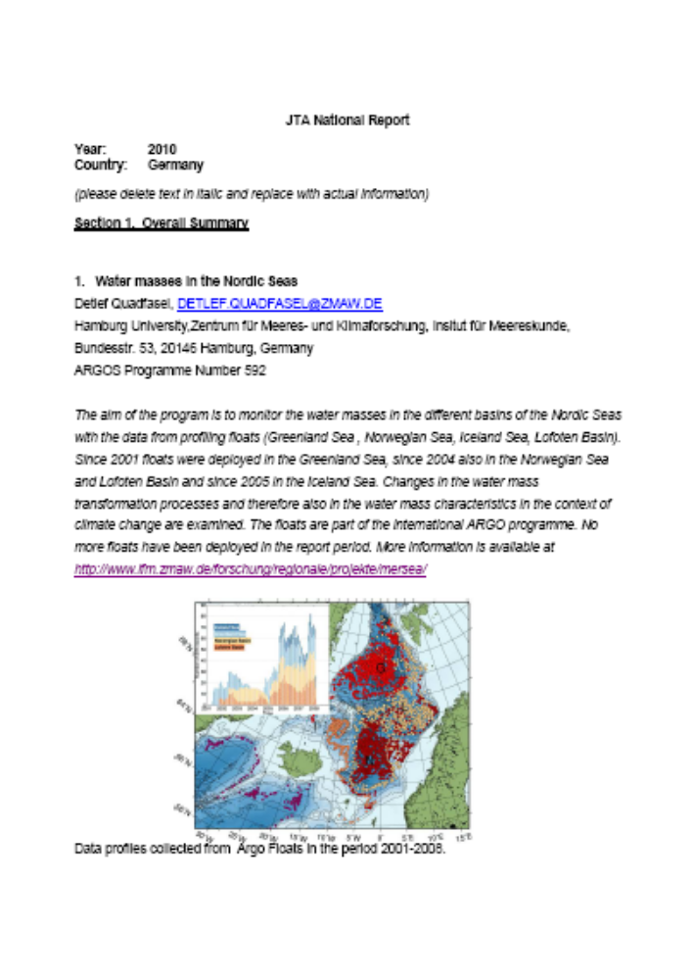

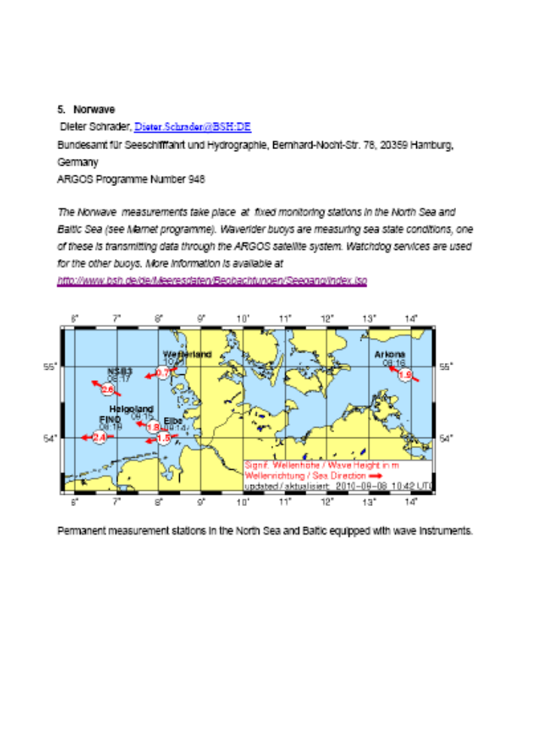





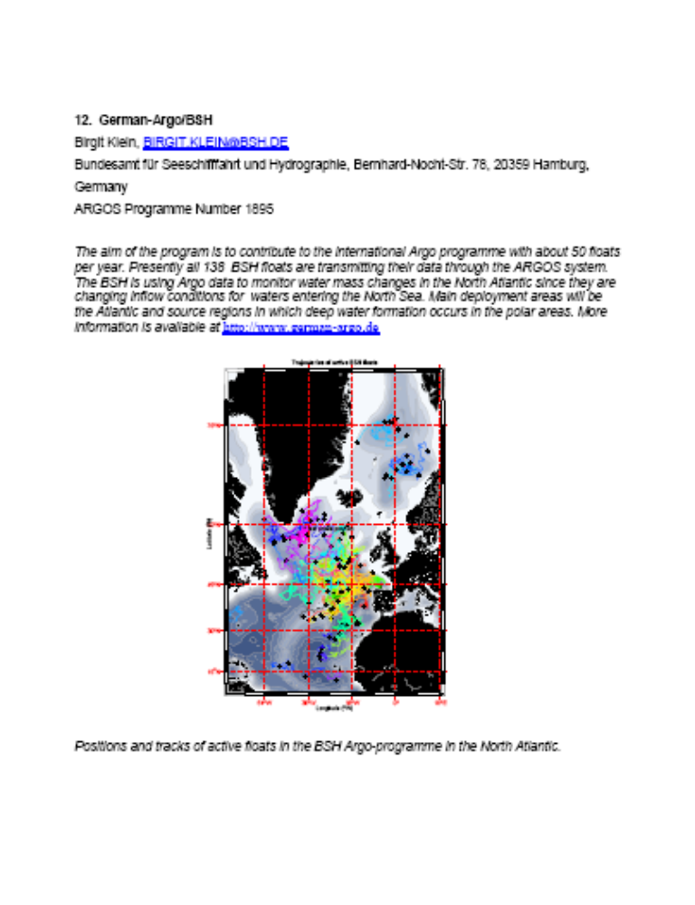
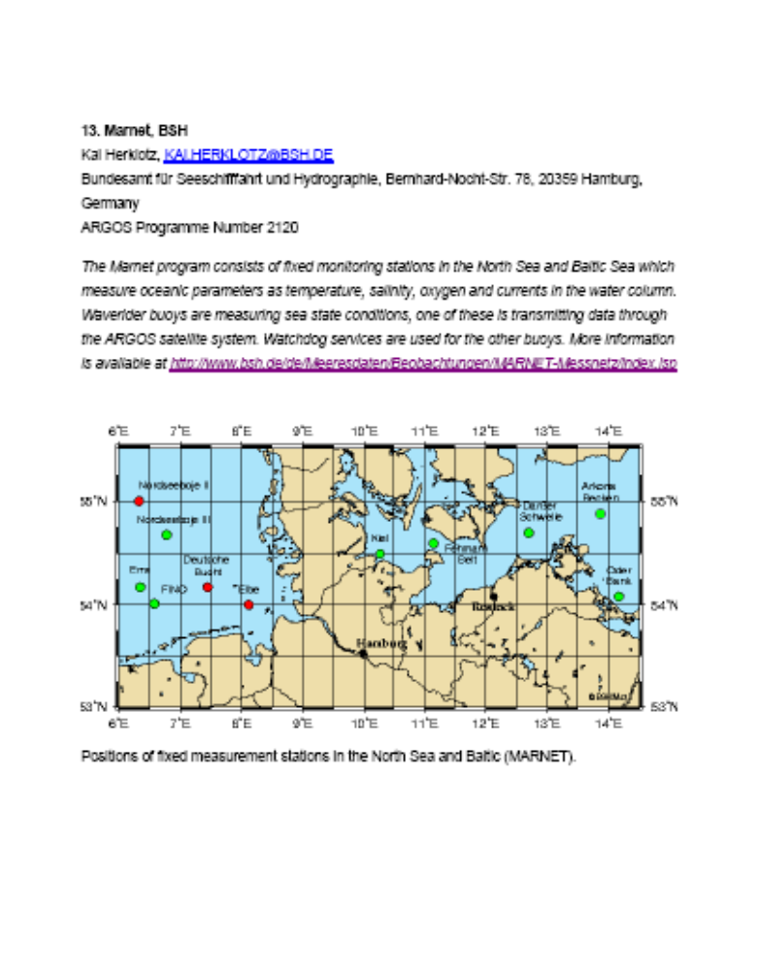
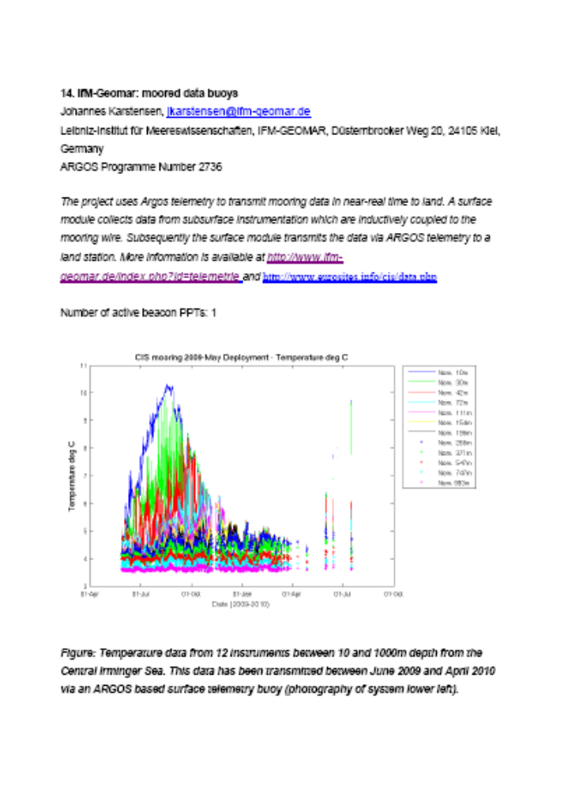

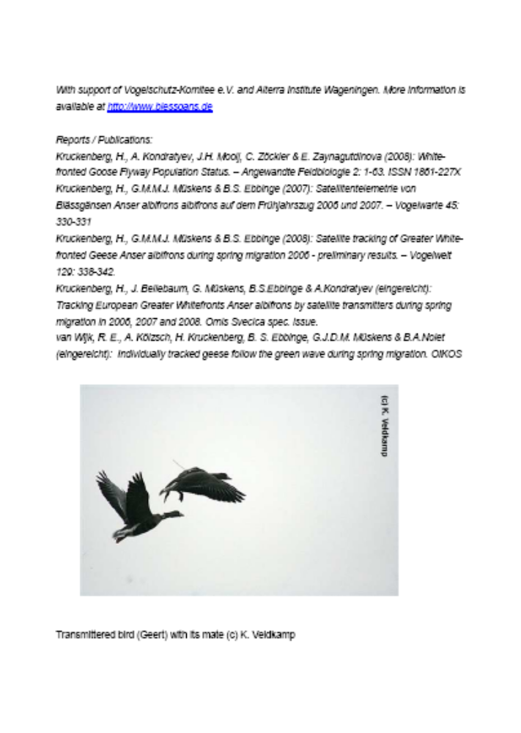










Year: 2010
Country: Malaysia

Section 1. Overall Summary
Since 2006, Argos has been used by the Department of Environment / Department of Fisheries in collaboration with WWF-Malaysia to study about Hawksbill Turtles on the migration patterns in the Strait of Malacca and the foraging habitat of the hawksbills turtles by tracking the turtles.
There has been recent interest from Malaysia NGO in cooperation with groups from Thailand, Indonesia and Singapore in using Argos to study raptor migration in the region.

Section 2: User Types by Family (Table PTT use by the country

 | Average active PTTs per month | Total PTT. years
Buoys and others
Profiling floats
Animals |  | 4 (Hawksbill turtles)
Fixed stations
TOTAL

Section 3. Technological Changes that Affect User Requirements

Section 4. User issues, problems, and level of satisfaction with Argos

Section 5. Successful program use of Argos
The research study of Hawksbill turtles using satellite tracking provided by Argos has shown some promising result, as the group is deploying more transmitters gradually.

Section 6. Analysis of Local Operational Issues

_________________

Year: 2010
Country: The Netherlands

Section 1. Overall Summary

Royal Netherlands Meteorological Institute, Scientific Department
Dutch Argo (2936)
Contribution to the ARGO programme.

Section 2. User Types by family (Table of PTT use by the country)

 | Average active PTTs per month | Total PTT.Years
Buoys and others
Profiling floats | 25 | 1
Animals
Fixed stations
TOTAL

Section 3. Technological Changes that Affect User Requirements

n/a

Section 4. User issues, problems, and level of satisfaction with Argos

highly satisfied – no problems

Section 5. Successful program use of ARGO (good news)

n/a

Section 6. Analysis of Local Operational Issues

n/a
Year: 2010
Country: Netherlands

Section 1. Overall Summary

University of Groningen, The Netherlands
The Black-tailed Godwit Program 3935 was carried out learn more about migration routes, migration phenology, wintering and staging sites of this wader species.

Section 2. User Types by family (Table of PTT use by the country)

 | Average active PTTs per month | Total PTT.Years
Buoys and others
Profiling floats
Animals | 2.5 (only 5 were active till 1-7) | 2.5
Fixed stations
TOTAL

Section 3. Technological Changes that Affect User Requirements

NA

Section 4. User issues, problems, and level of satisfaction with Argos

Accuracy was often quite poor especially in the Mediterranean and we missed a lot of locations of our animals because the satellites were not able to pick up the signal. But I have no idea to what extent we can “blame” Argos/ CLS for that.

Section 5. Successful program use of Argos

We have gained a lot of information on the migratory movements and important areas for this particular species.

Section 6. Analysis of Local Operational Issues

NA
Year: 2010
Country: The Netherlands

Section 1. Overall Summary

Institute for Marine and Atmospheric Research (IMAU)
Land ice change and sea level change monitoring (1238)
As a contribution to the European Project on Ice Coring in Antarctica (EPICA) IMAU has installed at one time a maximum of eight Automatic Weather Stations (AWS) in Dronning Maud Land, Antarctica. Four are currently operational. These AWSs were installed on a transect ranging from the coast to the plateau Amundsenisen, along the Swedish research stations Wasa and Svea.. The goal of this project is to extend the knowledge of the climatological conditions of this particular part of Antarctica and to obtain a better understanding of the surface energy and mass balance of the Antarctic ice sheet. Therefore surface and subsurface (bore holes up to 600 meters) temperatures, relative humidity, wind speed and direction, snow height, air pressure, short and long wave incoming and outgoing radiation is measured. Together with GPS positioning the data are transmitted as two hour averaged values through the Argos system. See for more information: http://www.phys.uu.nl/~wwwimau/research/ice_climate/aws/aws_ antarctica.html.

Beside the AWS we have also a combine Argos / GPS system, Automatic Velocity Monitoring System (AVMS) in Svalbard and Antarctic. At the end of this year/beginning next year our total number of ;
AVMS ( GPS ) will be extended on Svalbard from 8 (2010) to 18 (2011).
AVMS ( GPS ) will be extended on Antarctica from 4 (2010) to 7 (2011).
AWS will be extended on Antarctica from 8 (2010) to 9 (2011).

Section 2. User Types by family (Table of PTT use by the country)

 | Average active PTTs per month | Total PTT.Years
Buoys and others
Profiling floats
Animals
Fixed stations | 23 (2010) and 38 (2011) | 13 (2010) and 18 (2011)
TOTAL | 23 (2010) and 38 (2011) | 13 (2010) and 18 (2011)

The objective of this section is to provide some data on platform distribution and use. Historical graphs and charts depicting the country’s program is encouraged.

Section 3. Technological Changes that Affect User Requirements

Section 4. User issues, problems, and level of satisfaction with Argos

Section 5. Successful program use of ARGO (good news)

Section 6. Analysis of Local Operational Issues

Year: 2010
Country: The Netherlands

Section 1. Overall Summary

Bureau Waardenburg for Birdlife Netherlands

Dutch Purple Herons Ardea purpurea, Eurasian Bittern Botaurus stellaris and Greylag Geese Anser anser with Satellite Transmitters (3447)

Herons and geese are equipped with transmitters. These include standard solar PTT transmitters as well as GPS-PTT transmitters. The aim is to track down migration routes and habitat use of birds in order top get information about protection of habitats. The project started in 2007 and is continued in 2010-2010. Prolongation depends on results in the first years and available budgets.

Section 2. User Types by family (Table of PTT use by the country)

 | Average active PTTs per month | Total PTT.Years
Buoys and others
Profiling floats
Animals | 6-20 | 2007-2010
 |  | In 2010 a maximum of 22 platforms was active; tot date 9 left
Fixed stations
TOTAL

Section 3. Technological Changes that Affect User Requirements

Bureau Waardenburg; most relevant issues are related to the transmitters. Smaller types and types with stronger batteries will improve possibilities for bird research. A significant problem for bird research with migrants passing the Mediterranean is the data deficiency in this region. For Purple herons so far it seems of minor importance although it might have influenced birds in the eastern part of Spain crossing the Mediterranean. Information of transmitter altitude (of migrating birds) would be extremely useful.

Section 4. User issues, problems, and level of satisfaction with Argos

Bureau Waardenburg; The PTT manufacturer provides a parser software program in order to organize data files (from GPS-PTTs) supplied by Argos. This implies extra data handling for us users. We have developed an automatic download system to facilitate dataprocessing and to lower the risks of mistakes.

Section 5. Successful program use of Argos (good news)

Bureau Waardenburg; The data handling and speed of data provision is satisfactory. Additional overviews of costs per transmitter ID provided by CLS, make it very easy to split costs for our subsequent customers.

Section 6. Analysis of Local Operational Issues

Bureau Waardenburg; no issues to address.

Year: 2010
Country: New Zealand

Section 1. Overall Summary

The NZ JTA Argos usage in 2010, consists of one large programme (MetService Buoy programme), and 9 smaller programmes covering a range of animal tracking applications and land conservation projects. The range and type of animal applications has grown in recent years with 2 types of birds, 2 types of fish and 4 types of mammals being tracked. A new application monitoring crater lake levels on an active volcano began in 2009.

Section 2. User Types by family (Table of PTT use by the country)

The Table below shows the major 2010 NZ usage, but is incomplete because only 4 Users (out of 10) provided input to this report.

 | Average active PTTs per month | Total PTT.Years
Buoys and others | 12 | 12
Profiling floats
Animals | Number unknown | ?
Fixed stations | 1 | 1
TOTAL | ? | ?

Section 3. Technological Changes that Affect User Requirements

MetService NZ participated in the Iridium Buoy Pilot Programme by deploying 2 Iridium buoys in the Tasman Sea in May 2010. Although one buoy failed soon after deployment, data received from the other buoy is more timely than Argos data, and early trials indicate that the communications costs are significantly lower. A move to using Iridium for all buoys would impact greatly on NZ Argos usage. MetService has also participated in the Argos3 Pilot Project, with 2 of 6 buoys deployed in September 2010.

Section 4. User issues, problems, and level of satisfaction with Argos

In general, a high level of satisfaction with Argos was expressed by Users. MetService reported that User Office support was excellent and the processing and QC of buoy data for GTS is highly reliable. An animal tracker advised that the Argos usage and applications were comprehensive and that the online accessibility of data was prompt and reliable, with User Office Help available as required.

Section 5. Successful program use of Argos (good news)

One user advised that many successful papers had been published on Sea Lion tracking. The MetService buoy programme is an operationally excellent programme for which data is delivered 24/7.

Section 6. Analysis of Local Operational Issues

Good comments have been received during the year about the Argos User Office in Melbourne. Users like the pay on consumption tariff, it is simpler for all and easier to understand and administer. MetService has some concerns about how the increased use of Iridium will impact on the future Argos JTA tariff price.

_________________
Year: 2010
Country: Republic of South Africa

Section 1. Overall Summary

The Argos Service is used by various institutions around the country in for applications ranging from operational meteorology, to research oceanography to animal tracking. The SAWS uses the Argos Service to transmit marine meteorological data from the drifting and fixed weather buoy network via the Argos Satellite system to data processing centres and onward to the Global Telecommunications System for use in operational forecasting, and other services.

Ezemvelo KZN Wildlife uses Argos in the satellite tracking of the Bearded vulture in southern Africa. This programme was initiated in 2007. Three birds were tracked in 2007, two additional ones in 2008, 6 additional birds in 2009 and 4 in 2010. Three birds remain to be fitted with transmitters in 2010.

The Percy FitzPatrick Institute has been using Argos for tracking two species of duck (Red-billed Teal and Egyptian Goose) since 2007.

The South African Environmental Observation Network (SAEON) in conjunction with the South African National Antarctic Programme (SANAP) use Argos for transmission and processing of ARGO float data.

Section 2. User Types by family (Table of PTT use by the country)

 | Average active PTTs per month | Total PTT.Years
Buoys and others | 1(SAWS) | 1
Profiling floats | 2 | 0.1
Animals | 10+15 -varies considerably and 1/2 seem to go into and out of action on a 2-3 month scale, depending on insolation and battery charge | 3 + 8
Fixed stations | 0 | 0
TOTAL | 0 | 12

Section 3. Technological Changes that Affect User Requirements

The last of the active buoys under the SAWS programme 243 has ceased transmitting, but we are planning to resuscitate the programme. We already have ICEX buoys available but they haven’t been used as they are due for maintenance services. Two units will be refurbished and deployed on South Thule in turn. The first ICEX buoy will be deployed on South Thule, in the South Sandwich Islands, in December 2010.

The SAWS is taking part in the Iridium Pilot Project, for the evaluation of Iridium satellite technology in buoy data transmission. Five buoys were acquired, of which three have already been deployed (the remaining two will be deployed in September 2010). The results of the pilot project will shed light on the viability of utilizing Iridium communications.

We are also in the process of planning for coastal mooring – these however will use a GSM modem and will not be transmitting via the Argos satellite constellation. Our forecasting desk has indicated that they would like to see a balance between coastal and open ocean platforms, but the open ocean platforms will naturally be more proportionally.

Section 4. User issues, problems, and level of satisfaction with Argos

- The SAWS has noted the issue of data delivery times as well as the discussions that have taken place around this issue. We are also aware that CLS have undertaken to extend their IS antenna network to the southern hemisphere in order to counter the data delays from the ocean areas with lesser satellite coverage.

- The overall costs are still quite high, especially with many PTTs active and especially for non-profit conservation projects. The costs are prohibitive but necessary in some cases where conventional telemetry won’t work.
Response time of Argos to email queries can be also improved. It was very quick in the beginning but now there are many days delay before responses are received. (EKZNW)

- High level of satisfaction. We had difficulty with the smaller birds (red-billed teal), probably because of feather regrowth and preening covering over the solar panels. But our results for Egyptian Geese have been fantastic and we now have some birds tracked for over two years. (FitzPatrick Institute)

Section 5. Successful program use of ARGO (good news)

- Argos has satisfactorily managed data transmission and processing of our buoy data.

- Valuable information on the home range use of the bearded Vulture has been obtained as well as identifying the causes of mortality of the species. The Argos system allows for recovery of the PTTs when downed.

- Other uses have collected great data for Egyptian Geese – with one bird recorded having travelled 900km in a single day! Comprehensive results still to be published by the users

Section 6. Analysis of Local Operational Issues

- The SAWS is currently paying for unused ID’s. These have been returned in order to avoid unnecessary spending. We’re encouraged to learn that the data transmission times will improve as a result of the proposed extension of the IS antenna network.

- Transmitter recovery difficult and at least one bird shot by a local farmer. Other than that, no ‘local operational issues’.

_________________

Year: 2010
Country: Russia

Section 1. Overall Summary

In 2010, Russian organizations continued to expand their activity in the field of animal tracking, using ocean buoys and developing Argos transmitters for various applications.

Russia’s scientific institutions are currently involved in the following programs : tracking tigers, bears, wolves, reindeer, polar bears, beluga whales, seals, and Siberian cranes. At the same time, they are working on projects that involve leopard tracking, snow leopards, gray whales and musk oxen.

In the field of Maritime and Arctic studies, Russian organizations are studying currents and sea ice movements in the Sea of Okhotsk, they are tracking pack ice and icebergs North of Russia in the Arctic Ocean, and are monitoring maritime chemical pollution with the help of Argos beacons. These programs should continue to expand in 2011.

In addition, we plan to begin several programs for transmitting environmental data with stationary Argos beacons. We plan to use Argos to monitor volcanoes as well as track underground water along Russian natural gas pipelines.

Most of the above mentioned projects have been implemented with transmitters developed and manufactured in Russia. In 2010, Russian companies manufactured transmitters destined for beluga whale and seal tracking as well as those that were used to monitor chemical pollution. Furthermore, the Russian companies developed collars for wolf, brown bear, polar bear, reindeer, tiger and snow leopard tracking.

Section 2. User Types by family (Table of PTT use by the country)

 | Average active PTTs per month | Total PTT.Years
Buoys and others | 3 - 10 | 0,25
Profiling floats | 0 | 0
Animals | 5 - 35 | 1,5
Fixed stations | 1 | 0,25
TOTAL | 10 - 45 | 2

Section 3. Technological Changes that Affect User Requirements

For the past few years, Russian scientific organizations have been working on animal tracking projects in the Far East, where dense forests and unfavorable topography contribute to difficult conditions. Unfortunately, the use of animal collars developed by foreign manufacturers has lead to unsatisfactory results. That’s why Russian organizations have decided to specialize in manufacturing transmitters for animal tracking in difficult conditions.
Today, Russian companies have developed and tested collars with integrated antennas that automatically correct bit errors in the Argos messages. These collars are particularly reliable from a mechanical point of view and lose only a small amount of useful information. The first results of programs using these collars are very positive.

Section 4. User issues, problems, and level of satisfaction with Argos

In 2008 and 2009, Russian specialists had trouble when tracking tigers and bears in the Far East. Dense vegetation and unfavorable topography made it difficult to transmit messages to the Argos satellites. Users were unable to determine location coordinates for the animals on a regular basis. Therefore, they were unable to implement true monitoring of the animal’s behavior.

A series of tests was organized to test collars made by a different manufacturers (Russian and foreign) in the Far East in order to determine the most efficient way to track animals. Upon analysis of the results, Russian scientists were able to determine what factors lead to optimal emission strategy for receiving Argos messages in this region and defined the necessary performance traits for transmitters used in the Far East. We are currently undergoing first tests of Russian collars designed particularly for this geographic zone.

Section 5. Successful program use of Argos

In Sakha (Yakutia) province, Russian scientists are tracking 11 wild deer with Russian Argos collars with integrated antennas. This project’s first results are very positive because the scientists regularly receive an important number of Class 2 and 3 Argos locations.

_________________

Year: 2010
Country: Sweden (below are status for Argos program of Thomas Alerstam, Lund University reported)

Section 1. Overall Summary
Satellite tracking of migrating birds (projectnr 1204)

Section 2. User Types by family (Table of PTT use by the country)

 | Average active PTTs per month | Total PTT.Years
Buoys and others
Profiling floats
Animals | 20 | 2,5
Fixed stations
TOTAL

Section 3. Technological Changes that Affect User Requirements

Section 4. User issues, problems, and level of satisfaction with Argos

Tomas Alerstam is satisfied with the support Argos is giving to the research program.

Section 5. Successful program use of ARGO (good news)

Section 6. Analysis of Local Operational Issues

Year: 2010
Country: Sweden (below are status for Argos program of Susanne Åkesson, Lund University reported)

INFORMATION MISSING

Section 1. Overall Summary
Tracking migration of sea turtles and sea birds

Section 2. User Types by family (Table of PTT use by the country)

 | Average active PTTs per month | Total PTT.Years
Buoys and others
Profiling floats
Animals
Fixed stations
TOTAL

Section 3. Technological Changes that Affect User Requirements

Section 4. User issues, problems, and level of satisfaction with Argos

Section 5. Successful program use of ARGO (good news)

Section 6. Analysis of Local Operational Issues

________________
Annex X

List of Representatives of Country (ROCs) for Argos

Australia

Mr Ken Jarrott
Head, Observation Systems Section
Bureau of Meteorology
G.P.O. Box 1289
MELBOURNE, Vic. 3001
Australia
Telephone: +61-3 9669 4163
Telefax: +61-3 9669 4168
E-mail: k.jarrott@bom.gov.au

Belgium

Didier Vangeluwe
Institut Royal des Sciences Naturelles de la Belgique
Centre Belge de Baguage
29, rue Vautier
1000 Bruxelles
Belgique
Telephone: +32 2 6274355
E-mail : didier.vangeluwe@naturalsciences.be

Brazil

Mr Wilson Yamaguti
Instituto Nacional de Pesquisas Espaciais
(INPE)
Av. dos Astronautas, 1758
12227-010 SAO JOSE DOS CAMPOS
Brazil
Telephone: +55-12 3322 9977
Telefax: +55-12 3321 8743
E-mail: yamaguti@dss.inpe.br

Canada

Mr Joe Linguanti
Institute of Ocean Sciences
Ocean Sciences Division
9860 West Saanich Road
SIDNEY, BC V8L 4B2
Canada
Telephone: +1-250 363 6584
Telefax: +1-250 363 6746
E-mail: Linguantij@pac.dfo-mpo.gc.ca

China

Mrs Lin Shaohua
State Oceanic Administration
National Marine Data and Information
Service
93 Liuwei Road.
Hedong District
Tianji, 300171
P.R. China
Telephone: +86-22 24010 859
E-mail: ioi@mail.nmdis.gov.cn

Denmark

Mr Claus Nehring
Danish Meteorological Institute
100 Lyngbyveg
DK-2100 COPENHAGEN 0
Denmark
Telephone: +45 3915 7500
Telefax: +45 3927 1080
E-mail: cn@dmi.dk

Finland

Milla Johansson
Finnish Institute of Marine Research
Erik Palménin aukio 1
PO Box 2
FI-00561 Helsinki
Finland
E-mail: Milla.Johansson@fimr.fi

Germany

Hartmut Heinrich
Federal Maritime and Hydrographic Agency (BSH)
Bernhard-Nocht-Strasse 78
D-20359 Hamburg
Telephone.: 0049-40-3190-3200
Telefax: 0049-40-3190-5000
E-mail: hartmut.heinrich@bsh.de

Iceland

Mr Magnus Jonsson
Icelandic Meteorological Office
Vedurstofa Islands
Bustadavegur 9
150 REYKJAVIK
Iceland
Telephone: +354 560 0600
Telefax: +354 552 8121
E-mail: office@vedur.is

India

Dr K. Radhakrishnan
Director
Indian National Centre for Ocean
Information Services (INCOIS)
Plot No 3, Nandagari Hills Layout
Jubilee Hills
HYDERABAD 500 033
India
Telephone: +91-40 355 3542/43
Telefax: +91-40 355 1096
E-mail: director@incois.gov.in

ISRAEL

Yossi Leshem
Faculty of Lye Sciences
69978 TEL AVIV
Israel
E-Mail : yleshem@post.tau.ac.il

Italy

Mr Stephano Fioravanti Ph.D
NATO Saclant Undersea Research Centre
Viale San Bartolomeo 400
19138 LA SPEZIA
Italy
Telephone: +39 1875271
Telefax: +39 187524600
E-mail: steve@saclantc.nato.int

New Zealand

Mr J. Lumsden
c/o Julie Fletcher
Meteorological Service of New Zealand Ltd
P.O. Box 722
WELLINGTON
New Zealand
E-mail: fletcher@metservice.com

Norway

Mr Anton Eliassen
Norwegian Meteorological Institute
Attn: Lilian Swenden
P.O. Box 43, Blindern
N-0313 OSLO 3
Norway
Telephone: +47-22 963000
Telefax: +47-22 963050
E-mail: met.inst@met.no
Lillian.Swendsen@met.no

Republic of Korea

Jang-Won Seo
Senior Research Scientist
National Institute of Met. Research, KMA
45 Gisangcheong-gil
Dongjak-gu
Seoul 156 720
Republic of Korea
Tel: +82 2 841 2786
Fax: +82 2 841 2787
E-mail: jwseo@kma.go.kr

South Africa

Mr Johan Stander
P O Box 21, Cape Town International Airport, 7525 South Africam
Cape Town
7525
Western Cape
South Africa
Telephone: + 27 (0)21 934 0450
Telefax: +27 (0) 21 934 4590
E-mail: Johan.Stander@weathersa.co.za

Spain

Ms Asuncion Ruiz
Sociedad Espanola de Ornitologia
SEO/BIRDLIFE
c/ Melquiades Biencinto, 34
28053 MADRID
Spain
Telephone: +34-91 3511045
Telefax: +34-91 4340911
E-mail: aruiz@seo.org

Sweden

Mr Ilmar Karro
Swedish Meteorological and Hydrological
Institute (SMHI)
Folkborgsvنgen 1
S-601 76 NORRKOPING
Sweden
Telephone: +46-11 158000
Telefax: +46-11 170207
E-mail: gunlog.wennerberg@smhi.se

Switzerland

Dr Adrian Aebischer
Museum of Natural History
Chemin du Musee 6
CH-1700 Fribourg
Switzerland
Tel: +41 26 300 9040
Fax: +41 26 300 9760
E-mail: adaebischer@dplanet.ch

The Netherlands

Mr A.T. Frank Grooters
Observations and Modeling Department
Royal Netherlands Meteorological Institute
P.O. Box 201
3730 AE DE BILT
The Netherlands
Telephone: +31-30 220 6691
Telefax: +31-30 221 0407
E-mail: frank.grooters@knmi.nl

United Arab Emirates

Mr Olivier Combreau
National Avian Research Centre
P.O. Box 45553
ABU DHABI
United Arab Emirates
Telephone: +971 3747555
Telefax: +971 3747607
E-mail: ocombreau@erwda.gov.ae

United Kingdom

Mr David Meldrum
Scottish Association for Marine Sciences
Dunstaffnage Marine Laboratory
Dunbeg
PA37 1QA OBAN ARGYLL
Scotland
United Kingdom
Telephone: +44-1631 559204 / 559000
Telefax: +44-1631 559001
E-mail: dtm@sams.ac.uk
E-mail: ilmar.karro@smhi.se

USA

Mr Eric Locklear
Climate Program Office
NOAA
1100 Wayne Avenue Suite 1210
Silver Spring, MD 20910
USA
Telephone: +1 301 427 2361
Telefax: +1 301 427 2222
E-mail: eric.locklear@noaa.gov

OTHER

Dr I-Jiunn Cheng
National Taiwan Ocean University
Institute of Marine Biology
No. 2 Pei-Ning Road
202 KEELUNG
Taiwan
Telephone: +886-2 2462 2192-5303
Telefax: +886-2 2462 8974
E-mail: b0107@mail.ntou.edu.tw

________________

ANNEX XI

Argos Joint Tariff Agreement (JTA) Executive Committee Budget

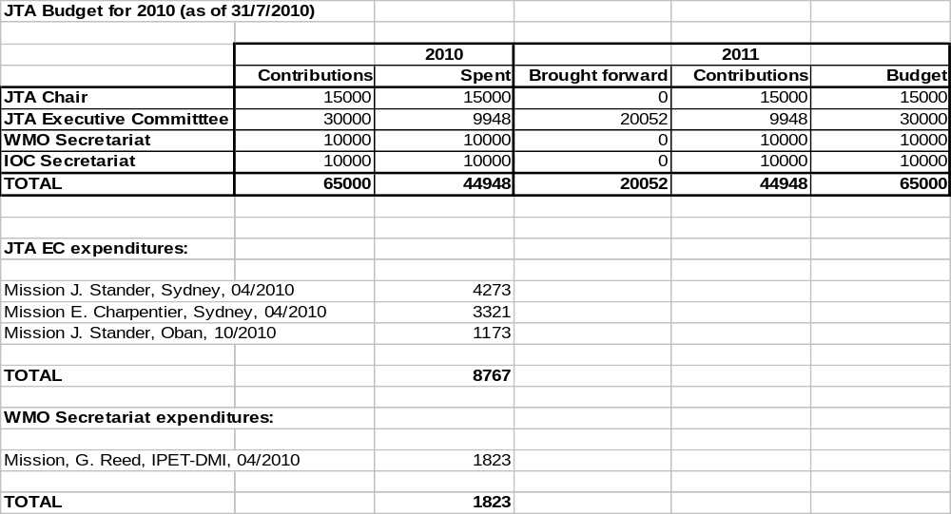

_______________

ANNEX XII

List of Acronyms and Other Abbreviations

5YP Argos JTA Five Year Plan
ADS Automatic Distribution System (Argos)
AHRPT Advanced High Rate Picture Transmission
AOML Atlantic Oceanographic and Meteorological Laboratory, NOAA (USA)
Argo International profiling float programme (not an acronym)
ASAP As soon as possible
BUFR Binary Universal Form for Representation of Meteorological Data
BUOY Report for Buoy Observations
CBS WMO Commission for Basic Systems
CDA Command Data Acquisition
CLS Collecte Localisation Satellites
CLSA Collecte Localisation Satellites America
CNES Centre National d`Etudes spatiales (France)
DBCP Data Buoy Cooperation Panel (WMO-IOC)
DCS Data Collection System
EC JTA Executive Committee
E-SURFMAR Surface Marine programme of the Network of European Meteorological Services, EUMETNET
EUMETNET Network of European Meteorological Services
EUMETSAT European Organization for the Exploitation of Meteorological Satellites
EUROArgo European component of the Argo array
ESPC NOAA Environmental Satellite Processing Centre (USA)
FAO Food and Agriculture Organization
FRGPC French Argos Global Processing Centre
FYP Five-Year Plan (of JTA)
GAC Global Area Coverage
GDP Global Drifter Programme
GIS Geographic Information System
GTS Global Telecommunication System (WMO)
HRPT High Rate Picture Transmission
IABP International Arctic Buoy Programme
IBPIO International Buoy Programme for the Indian Ocean
ICT/IOS CBS Implementation/Coordination Team on the Integrated Observing Systems
ID Platform Identification Number
IJPS Initial Joint Polar-Orbiting Operational Satellite System (NOAA, EUMETSAT)
IMB Ice Mass Buoy
INCOIS Indian National Centre for Ocean Information Services
INPE Instituto Nacional de Pesquisas Espaciais (Brazil)
IOC Intergovernmental Oceanographic Commission (of UNESCO)
IRD Institut français de recherche scientifique pour le développement en coopération (formerly ORSTOM)
ISABP International South Atlantic Buoy Programme
JCOMM Joint WMO/IOC Technical Commission for Oceanography and Marine Meteorology
JCOMMOPS JCOMM in situ Observations Programme Support Centre
Jrev permanent JTA review mechanism
JTA Argos Joint Tariff Agreement
JTA-EC JTA Executive Committee
KML Keyhole Markup Language
LAC Local Area Coverage
LDR Low Data Rate
LUS Limited Use Service (Argos)
LUT Local User Terminal (Argos)
METOP Meteorological Operational satellites of the EUMETSAT Polar System (EPS)
MOU Memorandum Of Understanding
NESDIS NOAA Satellites and Information Service
NOAA National Oceanographic and Atmospheric Administration (USA)
NPDBAP North Pacific Data Buoy Advisory Panel
NPOESS National Polar-orbiting Operational Environmental Satellite System (USA)
NWP Numerical Weather Prediction
OCO NOAA Office of Climate Observation (USA)
OPSCOM Argos Operations Committee (NOAA, CNES, EUMETSAT)
PDF Adobe Portable Document Format
PMT Platform Messaging Transceivers
POES Polar-orbiting Operational Environmental Satellite
PTT Platform Transmitter Terminal
PTT x year Equivalent to a PTT reporting every day during one year
QC Quality Control
RO Responsible Organization representing an agreed set of Argos User programs (JTA)
ROC Representative of Country representing a country or a group of countries participating in the JTA
RUG Representative of a User Group
SAI Service Argos, Inc. (USA, now CLS America)
SAWS South African Weather Service
SCD Satélite de Coleta de Dados (Data Collection Satellite, Brazil)
SOOP Ship-of-Opportunity Programme
SOOPIP JCOMM Ship-of-Opportunity Programme Implementation Panel
SOT Ship Observations Team (JCOMM)
SSA3 Argos 3 Ground Segment project
SST Sea Surface Temperature
STIP Stored TIROS Information Processing
SUA Argos System Use Agreement
TAO Tropical Atmosphere Ocean Array
TIP TAO Implementation Panel
UNESCO United Nations Educational, Scientific and Cultural Organization
USD US Dollar
VOS Voluntary Observing Ship
WMO World Meteorological Organization
XML Extensible Markup Language

________________

: The format of the report was decided at the 28th Meeting (2008) and noted in the JTA Operating Principle, which is subject to change by the annual review of the Operating Principle. As in the case of previous meetings, the report will be available online via the JCOMM website.
: International Buoy Programme for the Indian Ocean
: Joint WMO-IOC Technical Commission for Oceanography and Marine Meteorology (JCOMM) in situ Observations Programme Support Centre (JCOMMOPS)
: The purpose of the WG is to take the minutes, compile a draft report of the proceedings for approval of the JTA and submission to the Chairperson.
: The purpose of the WG is to take the minutes, compile a draft report of the proceedings for approval of the JTA and submission to the Secretariats.

