|  |  |  |
| --- | --- | --- |
| **INTERGOVERNMENTAL OCEANOGRAPHIC COMMISSION (OF UNESCO)  _____________** |  | **WORLD METEOROLOGICAL ORGANIZATION  ___________** |

**ARGOS JOINT TARIFF AGREEMENT**

**Thirty-Fourth meeting**

Weihai, China, 3 – 5 November 2014

JTA-34 record of decisions

Revision 1

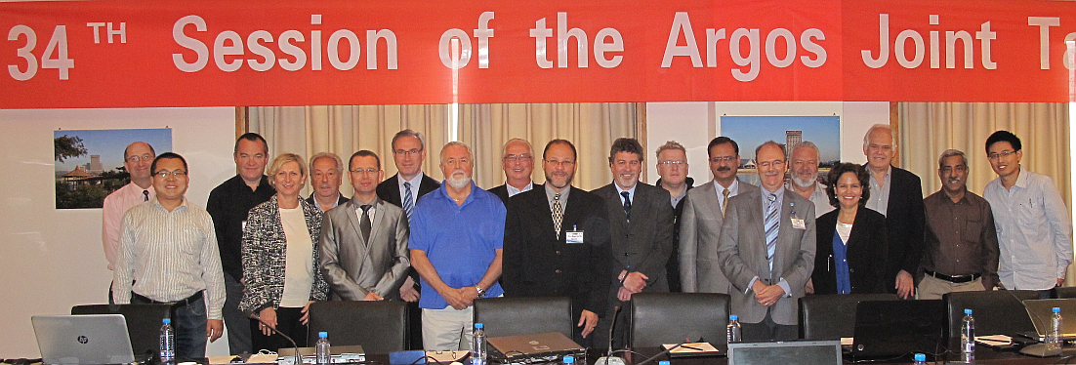

**Attendees of JTA-34 (from left to right):** Scott ROGERSON; Liu SHOUHUA; Gilbert Nicolas EMZIVAT; Anne Marie BREONCE; Jean ROLLAND; Johan STANDER; Etienne CHARPENTIER; William WOODWARD; Al WALLACE; Eric R LOCKLEAR; Graeme BALL; Ross BANNISTER; Arshid JAVED; Thomas GROSS; Joe LINGUANTI; Seema OWEN; David MELDRUM; Salim JAVED; Fan JIANG. (Also attended, but not in photo: R. VENKATESAN ; Adoté Blim BLIVI)

|  |  |  |
| --- | --- | --- |
| **INTERGOVERNMENTAL OCEANOGRAPHIC COMMISSION (OF UNESCO)  _____________** |  | **WORLD METEOROLOGICAL ORGANIZATION  ___________** |

**ARGOS JOINT TARIFF AGREEMENT**

**Thirty-Fourth meeting**

Weihai, China, 3 – 5 November 2014

RECORD OF DECISIONS

NOTES

WMO DISCLAIMER

**Regulation 42**

Recommendations of working groups shall have no status within the Organization until they have been approved by the responsible constituent body. In the case of joint working groups, the recommendations must be concurred with by the presidents of the constituent bodies concerned before being submitted to the designated constituent body.

**Regulation 43**

In the case of a recommendation made by a working group between sessions of the responsible constituent body, either in a session of a working group or by correspondence, the president of the body may, as an exceptional measure, approve the recommendation on behalf of the constituent body when the matter is, in his opinion, urgent, and does not appear to imply new obligations for Members. He may then submit this recommendation for adoption by the Executive Council or to the President of the Organization for action in accordance with Regulation 9(5).

© World Meteorological Organization, 2014

The right of publication in print, electronic and any other form and in any language is reserved by WMO. Short extracts from WMO publications may be reproduced without authorization provided that the complete source is clearly indicated. Editorial correspondence and requests to publish, reproduce or translate this publication (articles) in part or in whole should be addressed to:

Chairperson, Publications Board

World Meteorological Organization (WMO)

7 bis, avenue de la Paix Tel.: +41 (0)22 730 84 03

PO Box No. 2300 Fax: +41 (0)22 730 80 40

CH-1211 Geneva 2, Switzerland E-mail: Publications@wmo.int

**IOC (of UNESCO) disclaimer**

The designations employed and the presentation of material in this publication do not imply the expression of any opinion whatsoever on the part of the Secretariats of UNESCO and IOC concerning the legal status of any country or territory, or its authorities, or concerning the delimitation of the frontiers of any country or territory.

_______________

**C O N T E N T S**

**RECORD OF DECISIONS** 1

**Annex I**List of participants 21

**Annex II**Agenda 24

**Annex III**Report of the 9th meeting of the JTA Executive Committee (JTA EC-9) 26

**Annex IV**Abridged report of the 10thmeeting of the JTA Executive Committee (JTA EC-10) 29

**Annex V**Report by the JTA Chairperson to the 48th meeting of OPSCOM 45

**Annex VI**List of actions 50

**Annex VII**Report on the 2014 Agreement 55

**Annex VIII**Report on 2013-2014 operations and system improvement 69

**Annex IX**Review of the structure of the Tariff Agreement and related matters 100

**Annex X**Terms and Conditions of the Global Agreement for 2015 107

**Annex XI**Argos Joint Tariff Agreement operating principles 111

**Annex XII**National reports on current and planned programmes 137

**Annex XIII**List of Representatives of Country (ROCs) for Argos 138

**Annex XIV**Joint Tariff Agreement Executive Committee budget 142

**Annex XV** Recommendations of the Ad Hoc Satcom Forum 145

List of acronyms and other abbreviations 147

*[this page left blank intentionally]*

RECORD OF DECISIONS

1. INTRODUCTION

1.1 The Argos Joint Tariff Agreement (JTA) scheme has served as a robust example of international cooperation for more than 30 years. It continues to provide an effective, pragmatic, self-governing global forum through which users’ needs are presented, reviewed, and carried forward in a constructive dialogue with CLS. As such, it may serve as a model for similar arrangements that may in due course be established with other service providers.

1.2 As in previous years, the report of the JTA-34 Session covers the following topics[1]:

* Introduction;
* Actions and decisions of past meetings with review status;
* Action sheet of this Meeting, with records of necessary information and decisions;
* Records of formalities, including elections and decisions for the next Meeting;
* Annexes containing all necessary supplementary information.

1.3 Mr Eric Locklear, the Chairperson of the Argos JTA, led the Meeting. Many participants subsequently assisted Mr Locklear and the secretariat in the production of this report.

1.4 Mr Locklear opened the session by thanking the hosts, the Government of China, the State Oceanic Administration (SOA), the SOA National Center For Ocean Standards and Metrology (NCOSM), the Weihai government, the Shandong Academy of Science Institute of Oceanographic Instrumentation (SDIOI), and the Regional Marine Instrumentat Centre for the Asia Pacific region (RMIC/AP) for providing nice facilities and personnel support. Mr Locklear emphasized that the JTA should be an opportunity for engaging dialogue as well as the more formal aspects of the session. Decisions should be a result of the dialogue and not prepared prior to the session in the absence of broad discussion.

1.5 After discussion, it was agreed to adopt the provisional agenda as originally proposed.

1.6 The list of participants and the agenda are reproduced as ***Annex I*** and ***Annex II*** of this report. 21participants, including 11Representatives of Country (ROCs) and Responsible Organizations (ROs), attended the Meeting.

**2 REPORT OF THE CHAIRPERSON OF THE JTA**

**2.1 Overview of the JTA**

2.1.1 The Chairperson of the JTA, Mr Eric Locklear, presented a report on his activities in support of the participants in the JTA since the previous Meeting (JTA-33, Paris, France, 30 September – 2 October 2013). The chair reiterated the overview of the origins of the JTA which he delivered to the Argos Manufacturers Meeting in Annapolis, Maryland, USA in April, 2014; the ARGOS JTA-Executive Committee (JTA-EC) Meeting in Hamburg, Germany in May, 2014; and the ARGOS Operations Committee (OPSCOM) 48th Meeting in Berlin, Germany in June, 2014.The chair explored how the OPSCOM and JTA relate by demonstrating that Argos JTA is influenced by the users. The OPSCOM is not set up to work directly with the user groups, while the JTA is able to audit and describe the user groups and the current status of their participation in the programme.

2.1.2 An overview of the ARGOS Joint Tariff Agreement (ARGOS JTA) was published in Annex XI of the ARGOS JTA 26th Meeting, La Jolla, CA Final Report. In short, the Argos System emerged from a long-standing partnership of environmental research between the National Oceanographic and Atmospheric Administration (NOAA) of the United States of America and the Centre national d'études spatiales (CNES) of France. The objective of the Argos system was to provide for the global location, acquisition, and dissemination of environmental data. Argos would not only improve and expand the global operational weather system, but also support ocean, weather, and other environmental research.

2.1.3 First signed in 1974 then again in 1986, a Memorandum of Understanding (MOU) between the US National Oceanic and Atmospheric Administration (NOAA) and the French Space Agency (CNES) set forth their respective roles and responsibilities for operating the Argos System. NOAA would be responsible for the procurement, launch, and operation of the satellites, and CNES would be responsible for instrument development, operate the data processing system, and serve at the intersection of Argos Data Collection System Management, monitoring and operations.[2] They had a joint objective of promoting the maximum use of the system through enhanced services and cost-effective operations with the goal of achieving a self-sustaining system with revenues from users fully offsetting operating costs. Obviously the end-2-end costs of the Argos System are not being collected by the users, and the JTA tariffs that are collected are used to offset the operating costs of data processing for the JTA users. These MOUs have been modified over the years as necessary to meet changing user requirements as well as the needs of NOAA and CNES.

2.1.4 An important outcome of these MOU’s was also the establishment of an Operations Committee (OPSCOM) with 3 objectives. The OPSCOM was initially made up of NOAA and CNES, but now includes EUMETSAT and ISRO. The OPSCOM exists to review and manage the development and operation of the Argos System, the OPSCOM reviews and approves applications for the use of the system, and the tariff structure adopted by the Argos JTA.

2.1.5 It wasn’t until 1981 that the first Argos JTA meeting was convened, by the WMO, to make available the Argos system to all interested nations for weather prediction and environmental research. The JTA was born. Additional information on the history of the JTA can be found in Annex XI of the ARGOS JTA-26 Final Report.

**2.2 Report on the JTA Activities during the intercessional period**

2.2.1 On behalf of the Argos JTA, the Chairman attended 3 meetings during the intercessional period since JTA-33 in Paris. The meetings were the Argos Manufacturers Meeting in Annapolis, Maryland, USA in April, 2014; the ARGOS JTA-Executive Committee (JTA-EC10) Meeting in Hamburg, Germany in May, 2014; and the ARGOS OPSCOM 48 Meeting in Berlin, Germany in June, 2014. A brief summary of the meetings is provided below:

2.2.2 Argos Manufacturers Meeting (AMM): The Chairman was asked to present to the assembled manufacturers a brief presentation on the JTA and the following 3 questions were discussed:

*2.2.3 Why do we need the JTA?*

The JTA is needed to analyze and recommend rates in an equitable manner to accumulate the necessary revenues to offset the Argos system costs attributable to the JTA membership. The JTA is also necessary to oversee and safeguard “public” funds. As such the JTA has a fiduciary responsibility to ensure an equitable cost reimbursable arrangement that meets the needs of its users. The JTA also encourages collaboration and use of the system.

*2.2.4 Who are the JTA members?*

The first JTA meeting was sponsored by the WMO in 1981 and had the following 9 countries in attendance: Argentina, Australia, Canada, Denmark, France, Germany, Netherlands, Norway, United States. The JTA now has over 25 nations participating.

*2.2.5 How does the JTA work?*

The JTA works in the following ways:

* Meet annually to review its operating principles and its tariff structure
* Reports annually to the OPSCOM about system usability
* Is organized under the auspices of the WMO and IOC.
* Has a robust management structure with an executive committee and designated Representatives.
* Issues a “Record of Decisions” from all meetings through its reports

2.2.6 After briefly summarizing the outcome of the previous JTA Session (JTA-33), Mr Locklear reported that the JTA EC met immediately after JTA-33 on 3 October 2013 for a ninth meeting (JTA EC-9) to review the session and to decide on necessary actions to be made in relation to the decisions and agreements reached at JTA-33. The report of JTA EC-9 is given in ***Annex III***.

2.2.7 As agreed at JTA EC-9, the Executive Committee met for its tenth meeting (JTA-EC-10) in Hamburg, Germany at the kind invitation of Birgit Klein (JTA-EC member) to discuss matters from the JTA-EC 8th and 9th meetings as well as from the JTA-33 meeting in Paris. The report of the Tenth Meeting of the JTA EC is provided in ***Annex IV***. An updated list of ROCs is available in ***Annex XIII***. A summary of key issues discussed and decided by the JTA-EC at JTA-EC-10 are as follows:

1. New 5-YP Format: Agreed to the new format of the ARGOS JTA 5 Year Plan

2. Decreased Large Programme Usage: The decrease of the large programme Argos usage slightly below the 1200 threshold in 2013 was essentially due to the unexpected drifter failures beyond their control. Assuming that the Argos usage in 2014 is going to remain below the 1200 threshold, the meeting suggested on an exceptional basis that since the average of the past (2010-2014) large programme Argos usage was above the 1200 threshold, the large programme discount at the 1200 level should remain in effect during the whole period. The issue will be brought to JTA-34 for discussion and decision.

3. Secretariat Support: The meeting agreed that the current operating scheme and support from the Secretariats of WMO and IOC was satisfactory. The meeting agreed to continue to provide financial support to the Secretariats at the same level as for previous years.

4. Future of the JTA: The meeting agreed that a medium to long term (e.g. five to ten years) strategy should be developed for the JTA, and requested the Chair and the vice-Chair to lead this and make a proposal at the JTA-34 Session on the way forward for developing such a strategy. They were tasked also to draft a Vision of the JTA for discussion at JTA-34, but will now be presented at JTA-35. (Action: Chair and vice Chair; JTA-35).

2.2.8 At the kind invitation of the ARGOS OPSCOM, the ARGOS JTA Chairman presented a status of the current and expected future situation of the JTA. The ARGOS JTA Chairman’s presentation is available for review (JTA-34 Doc 3 Annex) and the minutes provided below:

“Mr. Eric Locklear, the JTA Chair, noted with thanks to the OPSCOM for the opportunity to discuss the JTA. He opened his presentation with a discussion of three topics: 1) Why is the ARGOS JTA here? 2. What is the current status of the program? 3. Where is the program heading? A brief history was discussed that the first tariff agreement was adopted in 1979 between NOAA and CNES. Then the first ARGOS JTA international agreement was organized by the WMO in 1981 to encourage participation of the ARGOS system. Mr. Locklear went on to discuss text from the NOAA/CNES 1986 MOU regarding their role in approving the JTA rates. He also stated that the ARGOS JTA serves the purposes of the responsibility to safeguard the use of public funds, and provides for a documented process for establishing rates. He concluded this section by pointing out that the size of the JTA revenues and costs makes oversight important. Mr. Locklear went on to discuss the current status of the program and noted the ARGOS’ unique position as the interface between many organizing bodies (WMO, IOC, User Groups, and the OPSCOM) and also pointed out that the JTA has an objective to determine the rates as well as the OPSCOM. Mr. Locklear went on to discuss who the JTA members are and what their usages are, summarizing with the top five nations use of the system for each service family. Mr. Locklear gave a summary of the current 5 year plan as well as the projected ending accumulated balance exceeding 3.0 million euros for the end of 2014, which is a good situation. Mr. Locklear concluded his presentation with a discussion on the next 5 year plan (2015 - 2019), and discussed his objectives over the coming years, as well as asking the OPSCOM if they had any particular concerns. Of particular concern to the OPSCOM is the endorsement of the upcoming 5 year plan from 2015 - 2019, which will be presented at the upcoming JTA meeting in China. An action was taken by the ARGOS JTA chairman that he will send a recommendation to the OPSCOM chairs of the tariff structure after the JTA meeting for their review and endorsement.”

**2.3 Report on the JTA Executive Council Budget**

2.3.1 The chair reported that JTA expenses for 2014 are considerably less than in the past for 2 reasons. The first is that the JTA Chair is not under contract and the work provided by Mr. Locklear is in-kind support provided by the U.S. government. Second, travel savings have also been achieved as the U.S. continues to sponsor the JTA Chairs travel and members of the JTA EC as necessary. Considerable savings were also achieved through the generous support of China to JTA-34. However, this situation may not continue and it is the suggestion of the chair that no change be made to the JTA budget at this time because additional expenses may be accrued. Annex XIV.

**3. FEEDBACK FROM THE 2013 NATIONAL REPORTS**

3.1 The JTA-EC requested that the National Report information actually be used in an official capacity, by including this agenda item within the JTA session. Mr. Locklear presented to the JTA the feedback provided in the Australian, Chinese, and Indian national reports from 2013. The purpose of this presentation is to ensure the users’ needs are completely taken care of by members of the JTA. He also presented the solution provided. In summary, there were three issues raised in the Australian Report, 2 issues raised in the Chinese Report, and one issue raised in the Indian Report. Examples of issues of concern identified in National reports include: complicated or unclear terminology used in Argos forms, which are difficult to understand; additional training was requested; and more flexible payment schedules were requested.

3.2 The JTA noted that the challenging issues identified in the National Reports, must be moved into JTA action items if they were not addressed over the previous intersessional period. Representatives of CLS noted that CLS takes National Report issues as actions upon themselves prior to their becoming JTA actions. Open action items must be reviewed by the JTA as possible substantive issues, and followed up as required. Specific issues, such as India’s problems with manufacture’s work with seals on battery packs, should not be included. But reporting that the issue has been addressed should be included in this agenda item. The session noted that some of these issues are addressed by the continuous dynamic relationship that exists between the JTA, CLS, manufacturers, users and ROCs.

3.3 Regular review of all issues arising from national reports shall be reported as an on-going agenda item of JTA sessions. It was noted that some national issues were not highlighted and should be in the future. Items should be reviewed by the ROCs as much as possible. Future JTA Reports will include an annex with these issues. (Action: JTA-EC, Secretariat; On-going)

**4. Review of the action items from JTA-33**

4.1 The meeting reviewed the action items from past JTA Sessions, as well as those pending actions items from the tenth meeting of the JTA-EC (JTA-EC-10).

4.2 While reviewing the action items, the meeting decided on the following actions:

Amend future Agendas to move the Review of Action Items to the end of session. (Action: JTA-EC, Secretariat; JTA-EC 12)

4.3 Updated status of actions from these Meetings, along with those arising at JTA-34, are listed and described in *Annex VI*.

5. REVIEW OF THE 2014 GLOBAL AGREEMENT

5.1 Anne-Marie Breonce (CLS France) presented a report on activity within the 2014 Global Agreement. The full report, given in ***Annex VII***, is summarised below:

OVERALL USAGE TRENDS

5.2 Overall, the active PTTs (Platform Transmitter Terminals) and thus the total number of transmitters in the field and corresponding consumption have slightly decreased from 2012 levels. The total number of active PTTs should slightly increase in 2014 compared to 2013 (100 additional PTTs representing + 0.89%). The decreasing number of floats is compensated by the number of platforms deployed on buoys, animals or fixed stations. However, the corresponding usage of the system is projected to increase in 2014 (+4.7%). This is due to the deployment of buoys that far outweigh the float’s consumptions which transmit much less in a month. Animal tracking applications continue their steady growth.

5.3 The JTA noted that the core of the Argos system activity is with the animal tracking community.

5.4 Overall, the active PTTs and thus the number of transmitters in the field for all applications are relatively stable. The following was noted in terms of actual PTT-Year (Platforms transmitting, received & processed at least once during a month) consumption among categories:

* Consumption of “Buoys and Others” (45% of 2013 activity) has been decreasing since 2010. However, in 2013-2014 this trend is reversing due to deployment of more buoys with longer lifetimes. This category still represents the highest consumption compared to the other categories.
* “Floats” consumption (7.8% of 2013 activity) should decrease by 23 PTT-years (11.5%) compared to 2013.
* “Fixed Stations” consumption (5% of 2013 activity) is slightly progressing, even if this category represents only 4.4% of the total agreement.
* Consumption of “Animals” continue to progress (40% of 2013 activity).This year the animal consumption is expected to increase by 6%.

TIME SLOTS and 12 DAY CAPPING

5.5 Further to JTA-27 decision the consumptions for animal platforms are capped at 12 day-units (48 time slots). These features of the tariff have been used extensively by users in order to decrease Argos costs, as recommended during JTA-27 to JTA-29.

5.6 “Animals and Subsurface floats” Platforms have benefited from time slot accounting since 2005. “Buoys & Others” and “Fixed Stations” started benefiting from time slot accounting in 2007.

“Animals” and “Subsurface Floats” categories are significantly benefitting from the time slots. As an average “Animals” PTT are transmitting 41% of the day, Moored Buoys are transmitting 80% and “Subsurface Floats” PTT are transmitting 51% of the day. Other categories of platforms keep transmitting 94% of the day.

5.7 In 2013, **841** PTTs (average active PTT per month) took advantage of the capping, representing **187 PTT-year**. The number of animals taking advantage of the capping is increasing by **10%**: 841 in 2013, compared to 757 in 2012 and more particularly “Birds and Marine animals”. A detailed analysis of transmissions shows that “Marine animals” are those who are benefiting the most of the capping: 43% transmit more than 12 days per month and 27% of them transmit more than 20 days units per month. The income impact of the capping is about 500K euro per year on revenue. This is not the same as the “cost” to deliver this service, rather it is a reduction in charges to the wildlife community. Support of the wildlife community is quite different than support for the drifter programmes, and thus support costs are quite different.

INACTIVE STATUS[3]

5.8 As stated in the Terms and Conditions of the Global Agreement, this status is intended for those platforms that continue to transmit but for which the location or data collection are of no further use to the user or the community. The following conditions must be met to qualify:

(*1) Inactive Status will apply if, and only if, Inactive Status is declared by the signatory of the System Use Agreement for platforms, which continue to transmit beyond the programme termination. In that case, further charges will no longer be levied.*

*(2) The platforms must have operated in Basic Service for a minimum of 2 months.*

*(3) Data or location information cannot be retrieved nor can the platform revert to any category of service.*

1. *It is intended that Location and/or data collection may not be computed using a Local User Terminal or other direct readout facility.*
2. *ID numbers of such platforms are actually returned to CLS who will recycle them after the platform stops transmitting.*

5.9 The JTA noted that in 2013 the number of IDs in Inactive status remain stable compared to 2012: **418 PTTs** are counted every month representing **114.77** PTT-year

5.10 As discussed at previous JTA Sessions, those PTTs, which are unused but are still transmitting are increasing the system occupancy. The data is processed but is not accessible by the users. The JTA noted that CLS keeps highlighting this to the users and manufacturers encouraging them to program their PTTs only for the duration of the experiment.

5.11 The JTA again urged users and manufacturers to consider this issue when programming their PTTs. CLS continues to work with manufacturers to decrease the inactive platforms.

5.12 CLS were thanked for their excellent presentation and were requested to ensure that future documentation contains the same information as presentations.

**6. REPORT ON THE DEVELOPMENT AND OPERATIONS OF CLS**

ARGOS OPERATIONS AND SYSTEM IMPROVEMENTS

6.1 Mr Bill Woodward (CLS America) presented reports on Argos operations and system improvements during 2013-2014.The JTA recalled that Argos is a global satellite-based location and data collection system dedicated to studying and protecting our planet's environment. CLS, as a unique operator of the Argos system on behalf of NOAA, CNES, EUMETSAT and ISRO, continues to maintain and improve a high operational service for all Argos users, especially for the meteorological and oceanographic community.

6.2 Mr Woodward described the status and future of the Argos satellite constellation and commented on the effect of different satellite attributes on the coverage and timeliness of Argo data transmission.

6.3 Operations highlights from the last 12 months include:

* Replacement of the Argos processing servers by Virtual Servers in CLS - July 2013
* Upgrade of the Oracle database version. Migration CLS/CLSA Archive databases to the Oracle 11GR2 version - December 2013
* Upgrade of Oracle database version. Migration CLS/CLSA Real time database to the Oracle 11GR2 version - January 2014
* Launched in September 2000, NOAA-16 completed over thirteen years of service. NOAA-16 was decommissioned on June 9, 2014 at 14:23 UTC due to a major spacecraft anomaly.

6.4 The meeting noted the following system developments:

* SHARC (Satellite High-performance ARGOS-3/-4 Receive/transmit Communication) chipset development project
* Argos Real-Time Antenna Network Upgrade Project continues
* 2 new ground HRPT Argos stations added in 2013: Tahiti station (French Polynesia) & Bali (Indonesia)
* On-line data extraction from the archive database via ArgosWeb – October 15th 2013
* Access to Argos Data through ArgosWeb and web services extended from last 10 days to last 20 days - February 18th 2014
* A new Android cartography application developed to allow users to access to their PTTs locations through Smartphones – June 2014
* Integration of a new BUFR sequence for drifting buoys in the Argos processing chain
* Improving Argos locations with a new Digital Elevation Model (DEM): as of July 2014, Argos users benefit from a new DEM derived from ACE2.

6.5 The meeting noted the following outlook for ongoing and future developments:

* Argos Real-Time Antenna Network optimization
* New Argos Orbitography
  + The adaptation of orbitography module (ZOOM) by CNES for Linux environment is done. The integration in Argos processing center is started and will be completed in 3rd quarter of 2014.
* New earth elevation model
  + For Kalman location only, a new earth elevation model (ACE3) has been integrated to compute more precise locations in some earth areas, and give better altitude accuracy. The integration is completed and it will be put in operation during 3rd quarter of 2014.
* Improvement of web services for Argos-3
  + The Argos Web Service regularly receives new capabilities. The possibility to send user messages to PMTs will be the next major improvement.
* BCH (Bose, Ray-Chaudhuri et Hocquenghem) message decoding
  + The study of a BCH message coding to improve Argos message transmission in noisy regions is finished. The development will be realized in 2014. The integration into the processing chain is scheduled beginning 2015.
* New databank formats
  + On-line data extraction on archive database service will support xml and kml formats
* Mass production of a low-cost Argos-3/4 chipset (SHARC project)
* Argos Doppler location algorithmic improvements
* End of Upgrade of the Oracle database version 11GR2
* CLSA datacenter upgrade
  + New ESX+Lefthand storage dedicated for production (Virtualization of Argos processing servers) - F5 BigIP for Local traffic management – Firewall and Switch upgrade.
* GTS processing chain refactoring

*Optimization of Real-Time Antenna Network*

6.6 The JTA noted that improvements are still focused on redundancy locations and coverage extension. Today, both Toulouse and Lanham processing centres receive Argos real-time data from approximately 65 stations located all over the world.

6.7 In 2013, the real-time network is quite steady with 2 new ground stations added (Tahiti station (French Polynesia) operated by Meteo France, and Bali (Indonesia) station operated by CLS). These two new stations are part of the HRPT-A4 project and are compatible will all Argos satellites: NOAA, METOP and SARAL.

6.8 The HRPT ground stations operated by IRD have been removed in 2013 from the network due to operation maintenance difficulties (Noumea, Cayenne, and La Réunion)~~.~~

6.9 The real-time Argos ground station network consists of about 65 antennas. If most of them are capable of receiving NOAA POES satellites data, only 22 out of these 65 stations receive METOP satellites data and, for the moment, 10also receive SARAL data.

6.10 In 2013, CNES and CLS efforts were still focused on increasing the number of ground stations capable of receiving POES, METOP and SARAL data. This is what we call the HRPTA4 project consisting in adding new antennas as well as upgrading a set of existing antennas in order to be compatible with all the satellites in orbit. This project also aims at optimizing performances of the real-time receiving stations network with fewer stations for better performances.

6.11 During 2013 - 2014, Operational Argos Services were opened for two Argos-3 payload (Metop-B, SARAL) and two Argos-2 payloads were decommissioned (NOAA-17, NM and NOAA-16, NL). Argos instruments are onboard 6 POES’s spacecrafts.

6.12 The JTA appreciated the improvement to Disposal time which is anticipated as a result of these improvements to the ground station system. In addition users will experience improvements with the ability to use the Argos-3 and soon, Argos-4 systems.

6.13 Projects to improve the user experience include development of an improved Goniometer for tag location, Android app for data displays and the new ARTIC modem chipset. The Argos ARTIC Chipset will reduce the size, weight and costs of transmitters, in particular for wildlife tags. This should be greatly beneficial to the number of tags which will subscribed within the wildlife community.

6.14 The JTA asked for clarification on the data availability timeliness requirements of different systems. It varies greatly from 3 minutes for Tsunami applications, 15 minutes for NWP and 60 minutes for MetOcean application. The wildlife community may require only three or more hours.

6.15 In thanking Mr Woodward for his presentation, the Meeting noted that the full report on 2013-2014 operations, on system improvements and progress in projects is reproduced as ***Annex VIII***.

**7 Review of User Requirements and issues**

***7.1 Requirements of the Data Buoy Cooperation Panel (DBCP)***

7.1.1 The former DBCP Chair, Mr Al Wallace (Canada) reported on DBCP requirements on behalf of the Panel. The DBCP noted that Argos is a global satellite-based location and data collection system dedicated to studying and protecting our planet's environment. CLS, is the operator of the Argos system on behalf of NOAA, CNES, EUMETSAT and ISRO, and continues to maintain and improve an operational service for all Argos users, especially for the meteorology and oceanography communities at a >99% level of availability.

7.1.2 The Panel expressed its appreciation to CLS for their ongoing efforts to meet their telecommunications and data processing needs. It also noted that CLS continues to develop technology such as the project to design, build and test a miniature, low-cost ARGOS-3/4 chipset (Asic) that enables two-way data communications and is fully backward compatible with Argos 2.

7.1.3 Data timeliness continues to be an issue in both the South Atlantic and South Pacific. The close cooperation between CLS and the TC ensure the sharing of information that enable inter-comparison of data. The Panel noted that CLS is continuing its efforts to upgrade antennas, and to improve the coverage of the real-time antennas in the South Atlantic and the Southwest Pacific. Concerning the South Atlantic area, new antennas are scheduled to be installed in late 2014 to early 2015 in Ascension Island and French Guyana. Concerning the Southwest Pacific area, a collaborative installation and operation plan has been established and a new antenna is planned to be installed in the framework of the WMO RARS project on Easter Island in late 2014 to early 2015. The Panel also noted that CLS is continuing to modernize its IT infrastructure to ensure sustainability of operations.

7.1.4 The Panel also noted that for many users the costs of operating Iridium platforms was apparently much less than for Argos counterparts. However, Iridium did not offer an equivalent of the Argos service, which included a number of value-added functions, including conversion of raw data to physical units, both real-time and delayed mode QC, GTS formatting and insertion, archiving, and open access to all parts of this chain by the JCOMMOPS TCs. As a result, many operators had created their own ‘back-office’ services and took care of their own GTS insertion using their existing infrastructure. The Panel was concerned that the existence of multiple data processing centres could potentially affect data integrity and uniformity, particularly for climate applications, and restricted the TC’s ability to monitor all parts of the data chain. Nor was this user community currently in any position to exert influence over future Iridium pricing policy: a situation that diverged from the current Argos JTA arrangements.

7.1.5 It is important to the DBCP that both Argos and iridium providers present integrated end to end solutions that is sustainable and affordable. The JTA is encouraged to support both the existing system, and consider how it might influence the development of an analogous business model for the iridium value added resellers.

***7.2 Requirements of the Wildlife Tracking Community***

7.2.1 David Meldrum presented a brief history of animal tracking with the JTA. The system review of 2006 revealed inconsistencies in tariffs for animal trackers verses other user groups. The review led to the 12 day capping, but animal trackers were still paying inappropriate prices without proper representation in the JTA. As a result of the inhomogeneity of the tracking community, and a perception that JTA is country based and a part of DBCP, the animal tracking community has not become as involved in the JTA as desired. The Biologging Symposium (Strasbourg, Sept. 21-26, 2014), responded to the need for better representation by forming an Animal Tracking Advocacy Group (ATAG). The JTA noted that the ATAG will complement the JTA Wildlife Task Team. The ATAG recommended the following actions to the JTA:

* The JTA should invite the ATAG to become a user group.
* The ATAG should participate in the drafting of the ToRs for the Wildlife TT.
* The ATAG to be asked to nominate a representative of user group in accordance with JTA ToRs
* The ATAG to be invited to participate in the JTA Wildlife TT

7.2.2 The JTA-EC was asked to review these recommendations (Action: JTA-EC; JTA-EC-12)

**8. REVIEW OF THE STRUCTURE OF THE TARIFF AGREEMENT AND RELATED MATTERS**

**8.1 Review of the guiding principles for negotiating the Tariff**

8.1.1 The Chair of the JTA opened this item with a discussion of how the CLS Expenses for the costs of ARGOS are allocated, and how the JTA negotiates the tariffs. The CLS allocates the costs generated by the JTA to the Argos. Next Argos costs are allocated to Science, which in turn are allocated to Basic Services and finally Basic Services are allocated to JTA. Standard accounting rules are followed and auditable books are kept for this common business practice of cost allocation. Basic services include the location and collection data, id assignments and other processing to provide the data. 2013 CLS costs are: ARGOS 19.973K; Science 10.617K; Basic 7.401K; JTA 7.028K.

8.1.2 Transparency of information demands more accountability, such as additional breakdowns of costs between categories, such as animals, floats, fixed stations, buoys etc. necessary to negotiate tariffs. Recalling that this is a Cost Recovery Program, Mr Locklear pointed out that changes in tariff need to be based on clear principles. The JTA should be able to demonstrate direct connectivity between program costs allocated and costs recovered. This is a principle, but the pursuit of these numbers may not be practical. Metrics to be used to answer the question about how much Argos satellite message processing costs should be carefully considered, and metrics proposed other than simply PTT-years. The JTA-EC will evaluate and analyse the CLS charging algorithm, (Action: CLS, JTA-EC; JTA-EC-13)

**8.2 Review the Five-Year (5Y) Plan**

2013 FINANCIAL SITUATION: CLOSE OF ACOUNTS

8.2.1 Ms Seema Owen (CLS America) presented the 2013 JTA usage and revenues in a new format which included using pie chart displays. These charts were distributed by platform category and displayed the respective active PTT’s and their corresponding usage. The categories include Buoys & Others; Floats; Animals; Fixed Stations; Large Program Buoys & Others; and Large Program Floats. The total basic incomes displayed in the above categories demonstrated that the Animals category contributed 62% of the total JTA incomes in 2013. The new Five Year Plan for 2015 through 2019 will be presented with these categories in one table. The session appreciated the displays and advised that this be included in future documentation.

8.2.2 Details of the finalized Argos operating costs for 2013 are given in ***Annex IX***, and are summarised below:

* The Argos basic costs have slightly increased from 12.01 M€ in 2012 to 12.29 M€ in 2013. The Argos basic costs for science have remained stable whereas the Argos basic costs for fishing have increased, mainly because of a continued interest in Argos from a number of countries to track their fishing vessels. The Argos basic costs for sensitive use have slightly increased while the corresponding income has decreased. There is a need to continue to develop actions towards that user community to increase their usage of Argos.
* In 2013, the costs to be attributed to the JTA are calculated at 7.03 M€ : it represents a 0.72% increase with respect to 2012 while the average active PTTs processed and distributed decreased to 12 080 compared to 12 488 in 2012.
* In 2013, CLS recorded revenues from JTA participating countries at a level of 7.10 M€. This was slightly different from the projected 2013 revenues presented at the JTA 33 meeting in Paris (7.90 M€). This shortage in revenue is explained mainly by the technical issues affecting the global drifter program. Henceforth, in 2013, the JTA realized a small excess of 60 K€. The non JTA incomes have remained essentially stable in 2013 (slight increase from 6.27 M€ to 6.29 M€), and the corresponding applications (fishing and sensitive) are still exceeding significantly their portions of the costs.

2014 JTA PROJECTION TO YEAR END

8.2.3 The JTA projection for the year 2014 is estimated from figures based on seven months of usage, extrapolated until the end of the year, and is detailed in ***Annex IX***.

8.2.4 At this point of time, the JTA considered that the JTA in 2014 will likely be able to pay its portion of the cost even though the plan shows a small revenue decrease of 50K€.

8.2.5 Overall, the JTA basic income is expected to be 6.88 M€ in 2014, 14.5% under the figure planned in the original 5Y plan. The breakdown of expected income by platform type is shown in the table 1 below:

|  |  |
| --- | --- |
|  | **Total in M€** |
| Buoys | 0.57 |
| Floats | 0.46 |
| Animals | 4.36 |
| Fixed stations | 0.16 |
| Large program Buoys/Floats | 1.33 |
| **Total** | **6.88** |

Table 1: Breakdown of expected income by platform type

8.2.6 The additional revenues are expected to be in the order of 301K€ in 2014- based on the invoicing of unused Id.

8.2.7 As in 2013, the JTA costs have been closely controlled in 2014.

8.2.8 Non-JTA activity remains stable and may increase should CLS continue to find new applications eligible to the Argos System.

8.2.9 Total projected income is expected to be 7.18 M€ in 2014, compared to projected costs of 7.13 M€, resulting in a small positive year-end balance of 0.06 M€, and a net accumulated balance of 3.26 M€.

8.2.10 In conclusion, the expected financial situation for 2014 is considered safe. The accumulated balance would remain significantly positive. Nevertheless, risks will continue to be monitored very closely by CLS.

8.2.11 In reviewing the current five year plan, the meeting noted that the 2013 usage by the Large programme had not quite reached the threshold of 1200 PTT-years that were required to justify its preferential day rate (40% of the basic rate paid by all other users) due to the dramatic drifter failures experienced. The chairman referenced a decision taken at JTA EC 10 in Hamburg that for purposes of calculating whether usage meets the discounted threshold levels the usage will be averaged over the duration of this current five year plan.

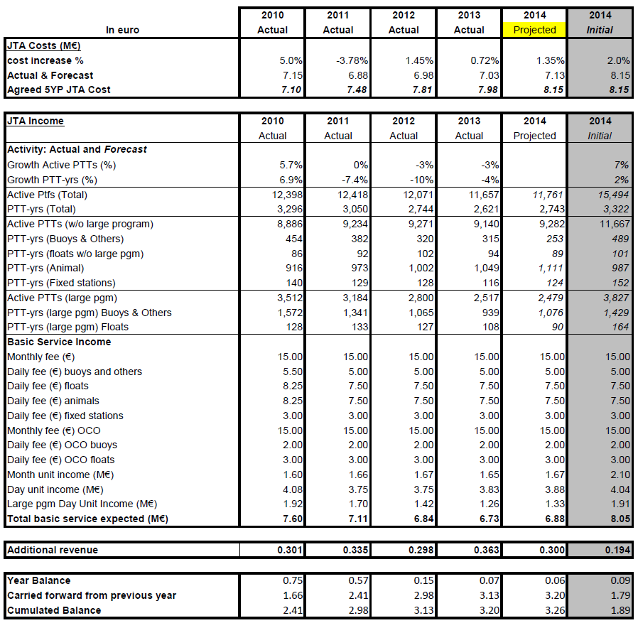

*Five Year Plan 2010 - 2014*

***8.3 Next Five-Year Plan (2015-2019)***

8.3.1 Based on a request from the JTA, Ms Seema Owen (CLS America) presented the Five Year Plan for 2015-2019 in a new and more simplified format than in previous years and requested comments/suggestions.

8.3.2 The Plan includes projections of usage which are based on the number of active PTT’s for the next five years and are conservative extensions of recent trends and program management forecasts. The Wildlife usage is expected to increase by a conservative 3% in each of the next five years and the fixed stations are projected to decrease by 10% per year. Based on the future plans of the Argo Float community, the number of active PTT’s is expected to decrease by 50 floats per year through 2019 in both the Large and the global Argo programs. Furthermore, due to a continuing shift toward Iridium usage by the DBCP programmes, the number of active PTT’s in the Large Program, buoys and others , is expected to decrease by 200 from 2015 to 2016 and by 100 in each of the following years.

8.3.3 With the decrease in the PTT year usage for the Large programs, it was noted their volume discounted rate will increase to the higher 900 PTT year level in 2015. For purposes of calculating their discounted rate the level of PTT usage will continue to be averaged over the 2015 – 2019 period. As always, the five-year plan will be reviewed annually.

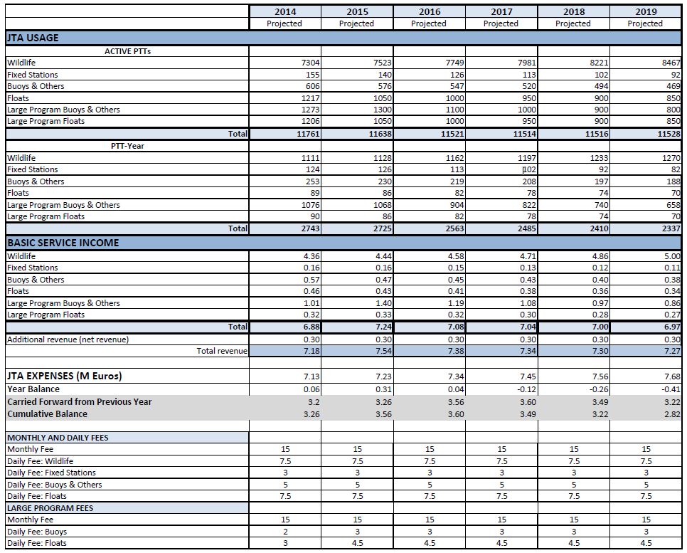

*Five Year Plan 2015 - 2019*

**9. TERMS AND CONDITIONS OF THE 2015 GLOBAL AGREEMENT**

9.1 In response to an action item from JTA EC-10, CLS made a proposal to adjust the daily tariff to provide a 10% compensation so that the non-USA wildlife trackers would enjoy a reduced fee to reduce the difference in pricing between US and non-US wildlife trackers. An examination of the effect of this compensation on the Five Year Plan showed a minimal effect on projected revenues as CLS proposed a reduction to the non-US wildlife users.

9.2 It was noted that the US is benefiting from a fixed exchange rate calculation, (see Annex 4 EC 10 Final Report Section 2.5). Another proposal could be to increase the USA rates [and/or decrease the non-US rate] so that in five years the rates would be equitable for all nations. A solution which aligns with the JTA principle to negotiate fair, cost effective and simple conditions is necessary.

9.3 It was requested that the USA ROC should seek agreement to sign for a non-fixed rate, or pay in Euros. (Action: USA ROC; JTA-35)

9.4 The EC will review the JTA tariff to ensure it is fair, equitable and simple with respect to currency conversion. (Action: JTA-EC; JTA-35)

9.5 The JTA recommends that CLS do not take the non-USA compensation approach until after the review of the JTA tariff by the EC and a proposal made at JTA-35.

9.6 Based on (i) the projections for 2014 and 2015, in which it was expected that the income was balancing the JTA cost, (ii) the positive situation in the accumulated balance in the FYP at this moment, the meeting decided not to change the Tariff in 2015. The Meeting adopted the Terms and Conditions for the 2015 Agreement as given in ***Annex X*** and agreed in principle to the proposed 5-year plan.

9.7 The 2015 Agreement is materially identical to the 2014 Agreement, with the following minor amendments:

1. 2014 is replaced by 2015;

9.8 The essential elements of the tariff remain unchanged for 2015, namely:

1. “USER BASIC SERVICE CHARGES”, A and B coefficients for all platform categories are as follows:

| **Category** | **A (€)** | **B (€)** |
| --- | --- | --- |
| **Buoys and others** | 15 | 5 |
| **Fixed Stations** | 15 | 3 |
| **Animals\*** | 15 | 7.5 |
| **Subsurface Floats** | 15 | 7.5 |

*12 days per month cap applied

1. “DISCOUNT SCHEME FOR LARGE PROGRAMMES”, the rates are as follows:

|  |  |  |
| --- | --- | --- |
| **Number of platform-years** | **PTT-day unit (B)**  **Buoys & others** | **PTT-day unit (B)**  **Floats** |
| 600 | 4 | 6 |
| 900 | 3 | 4.5 |
| 1200 | 2 | 3 |

9.9 As in previous years, CLS was requested to provide a scanned, signed copy of these Terms and Conditions to ROs and ROCs.

**10. FUTURE PLANS AND PROGRAMMES**

***Presentations***

10.1 Scott Rogerson, USA/NOAA Secretariat Argos DCS OPSCOM, Argos DCS Program Manager presented a brief on the Argos Space Segment. The constellation has transformed from an all USA constellation to a more diverse system, including EUMETSAT and ISRO satellites. Future plans will support a complete constellation for the foreseeable future, with launches planned for 2018, 2019, 2022, 2025 and 2029. From the OPSCOM viewpoint the environmental or governmental data collection satellite services are provided at no cost to the user. CLS provides the ground station and data analysis services.

***National reports***

10.2 Eleven national reports were submitted in written form by Australia, Canada, China, Germany, India, New Zealand, South Africa, Spain, Sweden, UAE, and USA. The National Reports submitted by ROCs for Argos related national activities during the last intersessional period (2013-14) are available in document JTA-34/Doc.9, which can be downloaded from <http://www.jcomm.info/JTA-34>, or requested of the IOC or WMO secretariats.

10.3 Representatives of Country (ROCs) present at the meeting also presented the following national reports: Australia, Canada, China, India, New Zealand and USA. The JTA was unanimous in agreeing that such reports were central to its prime motivation in being a practical and open forum for the exchange of information, experience (both positive and negative), problems and needs arising from the extensive Argos user community.

10.4 The meeting thanked all the presenters, and noted the following from the national reports presentations:

* Small and volunteer organizations are concerned about the cost of the Argos system;
* Additional technical training is desirable.
* Possibility to pay the bill on a more flexible basis (semestrial or yearly) is desirable;
* There is still demand to extend the free on-line availability of Argos data (now 20 days);

10.5 The meeting noted that CLS has continued to be responsive to the Member States national report issues and has acted upon all of the above issues on a nation by nation basis.

**11. review of the operating principles**

11.1 The session discussed the proposed Terms of Reference of the Wildlife Task Team as proposed by the EC-10. The ToRs are in alignment with the requirements of the Biologging Symposium. The session suggested that “Task Team” be replaced by “Technical Advisory Group” (TAG). The session decided to appoint Salim Javed (Terrestrial Assessment &Conservation Environment Agency Abu Dhabi, UAE) as the first chair of the TAG.

11.2 The Terms of Reference for the Wildlife Technical Advisory Group were amended and adopted by the Session. Representation of the wildlife community will be solicited, and the TAG will be formed. (Action: Chair TAG; EC12)

11.3 The Meeting reviewed the JTA Operating Principles and proposals for changes offered by EC-10. The chair questioned whether “the process” in the JTA Operating Principles (4.1) was sufficiently well defined. The Session suggested that a codified standard operating procedure may be counterproductive to flexibility. The role of the EC has been to define the activities, and is the mechanism providing “the process”.

11.4 The approved Operating Principles are provided in ***Annex XI***.

**12. ANY OTHER BUSINESS**

***International forum of Users of Satellite Data Telecommunication Systems***

12.1 The WMO Secretariat reported that during the week following the JTA-33 the international Forum of Users of Satellite Data Telecommunication Systems (SATCOM) met inUNESCO headquarters in Paris, France, from 3 to 4 October 2013. The Forum made eleven recommendations which are listed in the final report of the meeting, and Annex XV of this report. The SATCOM discussions and recommendations emphasized methods to expand the use of satellite communications to additional user groups, such a emergency responders and wildlife community, while controlling access to GTS and other services.

12.2 The JTA noted that the WMO EC-66 requested WMO Commission for Basic Systems(CBS) to review the reports of the initial ad hoc Satcom meetings, for consideration by Cg-17, including assessment of budget implications associated with the organizational and operating practices should a Forum be established. Per EC-66 guidance, CBS Ext. (2014) (Asuncion, Paraguay, 8 - 12 September 2014) adopted Resolution 2.3(1)/6 - Establishment of a Satcom Users Forum. CBS Ext. (2014 also noted the potential benefits to Members of establishing a close alliance between the Satcom forum and the Argos Joint Tariff Agreement and encouraged earlier dialogue amongst the various stakeholders to consider how such an alliance could be developed. Formal approval by the WMO Congress and IOC Assembly the Satcom forum ToRs are expected in the coming year. By the JTA-35 the SATCOM forum should have been formed and the JTA can take action to formalize the JTA status as an effective established programme under the Forum. Future discussions must include how the secretariat of WMO and IOC will allocate support to JTA and the SATCOM Forum.

***Argos Wildlife Data Analysis***

12.3 Bill Woodward (CLS America) reported on a recent Argos wildlife data usage analysis performed by CLS which had been recommended by the Ad Hoc SATCOM Forum held in Paris in November 2013 and which subsequently became a JTA-EC Action for CLS. The analysis was similar to a 2006 usage study performed by D. Meldrum that focused on system occupancy by Argos wildlife tracking programs. This recent CLS study was aimed at seeking answers to questions such as: **How much and how long does each type of Argos application effectively transmit?**  and **Is there any inequality of the service as a function of geographical region?**

The CLS effort included Argos usage data (monthly work units and PTT-year data) for the entire calendar year 2013. The analysis specifically included the theoretical satellite visibility times by latitude, the number of messages received by each application, the geographical distribution of the Argos platforms by application, the number of locations delivered per platform and the volume of data transmitted by platforms in each application category (average Kbytes/Mo/PTT).

12.4 While the analysis is still ongoing, the preliminary results indicate that of the four wildlife categories Birds, Land Animals, Marine Animal and Fish(tags), the Fish (tags) application, i) transmits the largest volume of data (18 Kbytes/Mo/PTT compared to Marine Animals at 8.8 Kbytes/Mo/PTT), ii) benefits the most from the 12 day capping because ~25% of them transmit 12 days or more during a month and, iii) has the largest number of locations delivered per PTT.

***Future of the JTA***

12.5 The chair solicited feedback from the session on ways to improve the JTA and how the experiences of the JTA can be shared with the greater satcom community. Questions were posed to the JTA such as: How can JTA do things better to be more efficient?; Should JTA meetings remain linked to the DBCP schedule?

12.6 In the future when many of the DBCP programmes may move to Iridium, and the majority of country users are wildlife trackers there is less reason to remain organized in parallel to the DBCP sessions. The costs of attendance to meetings is becoming more difficult to control. A Saturday - Sunday meeting following the DBCP could save attendance expenses.

12.7 The session discussed whether the JTA face to face meetings could consist of only the EC. Such meetings would be able to negotiate the tariff but do little else. Representation of all ROCs in tariff negotiations could not be assured.

12.8 The session questioned what will be the level of autonomy of the JTA if it becomes a sub-programme of the SATCOM and what future responsibilities will be required? The session anticipates only a responsibility to report on JTA activities to the SATCOM Forum.

12.9 The session suggested that as the JTA transitions away from buoys to animal tracking, the member states will emphasize this by selecting their ROCs accordingly. Changes in composition of the JTA may arise naturally, reflecting the user community of Argos. In conclusion, the JTA agreed that the principle benefit of the JTA is an agreed upon tariff structure, and that an area of improvement is a more inclusive user representation at the meeting.

***International User Conference on ARGOS Wildlife Applications***

12.10 CLS announced the International User Conference on ARGOS Wildlife Applications to be held in Baltimore, November 18-20, 2014 at the National Aquarium. The best Argos conference you will ever see, with 40 speakers from around the world to show the breadth of the activities and how Argos has contributed to conservation programmes. There should be tangible results form sessions on the future of Argos. The programme is available on the website:http://CLSamerica.com. CLS to report to JTA on the results of the International User Conference on ARGOS Wildlife Applications (Action: CLS; JTA-35)

***Other***

12.11 The meeting wished to remind all those contributing documents in preparation for the JTA Sessions that these documents should be posted on the website before the event, and all should include summaries suitable for inclusion to the meeting report.

**13. ELECTION OF THE Executive Committee**

13.1 The chair noted that elections were not necessary because his term and that of the vice-chair will not expire until JTA-35. He noted that 2 members of the JTA-EC would be vacating their positions and they are not available to serve in those capacities. The meeting noted with thanks the efforts provided by Ms. Birgit Klein and Mr. Joseph Linguanti. The chair noted that replacement candidates to the EC were not being made at this time because careful consideration must be made and suitable candidates found to ensure successful succession planning and user representation. Action: The EC finds 2 suitable candidates for the EC by EC-12 to be nominated at JTA 35.

13.2 The Meeting noted the Terms of Reference of the JTA Chairperson (***Annex F*** to the Operating Principles), indicating the term for this position as two years, eligible for re-election but in principle only for one subsequent term.

13.3 The Meeting noted the Terms of Reference of the JTA Vice-Chairperson (***Annex G*** to the Operating Principles), indicating the term for this position as two years, eligible for re-election but in principle only for one subsequent term.

13.4 The Meeting noted the Terms of Reference of the JTA Executive Committee (***Annex H*** to the Operating Principles), and recalled that the membership shall include the Chairperson, the Vice-Chairperson, the IOC Secretariat, the WMO Secretariat, and three additional members proposed by the Chairperson and elected by the JTA, serving a term of two years with an optional two-year re-appointment.

13.5 The Meeting noted the current composition of the JTA EC as detailed in Table 2 below:

|  |  |  |  |  |
| --- | --- | --- | --- | --- |
| ***Role*** | ***Current incumbent*** | ***Elected at*** | ***Until*** | ***Status*** |
| Chair | Eric Locklear (USA) | JTA-33 | End of JTA-35 | Beginning of 1st Term (first elected at JTA-33), and available for re-election for this post at JTA-35 |
| vice-Chair | Johan Stander (South Africa) | JTA-33 | End of JTA-35 | Beginning of 1st Term (first elected at JTA-33), and available for re-election for this post at JTA-35 |
| Member | Salim Javed (UAE) | JTA-33 | End of JTA-35 | Beginning of 1st Term (first elected at JTA-33), and available for re-election to this post at JTA-35 |
| Member | Joe Linguanti  (Canada) | JTA-32 | End of JTA-34 | In the middle of his 2nd Term (first elected at JTA-30); not available in principle for re-election to this post at JTA-34 |
| Member | Birgit Klein  (Germany) | JTA-32 | End of JTA-34 | In the middle of her 2nd Term (first elected at JTA-30) not available in principle for re-election to this post at JTA-34 |
| Ex-officio | Tom Gross  (IOC) | n/a | n/a | n/a |
| Ex-officio | Etienne Charpentier  (WMO) | n/a | n/a | n/a |
| Ex-officio | CLS | n/a | n/a | n/a |

Table 2: Current composition of the JTA-EC (for the past intersessional period until the end of this JTA Session)

13.6 The meeting recalled the requirements for succession planning, and noted that two of the JTA-EC members were not eligible for re-election. The session thanked outgoing members, Joe Linguanti and Birgit Klein for their diligence and support of JTA. The chair desired to delay recommendations for filling the vacant offices until appropriate representatives of the wildlife tracking community can be found. It is not thought that this will impact intersessional activities of the EC for the coming year. The chair shall provide recommendations for the two open positions by the EC-12 (Action: Chair; EC-12)

|  |  |  |  |  |
| --- | --- | --- | --- | --- |
| ***Role*** | ***Current incumbent*** | ***Elected at*** | ***Until*** | ***Status*** |
| Chair | Eric Locklear (USA) | JTA-33 | End of JTA-35 | 1st Term (first elected at JTA-33), and available for re-election for this post at JTA-35 |
| vice-Chair | Johan Stander (South Africa) | JTA-33 | End of JTA-35 | 1st Term (first elected at JTA-33), and available for re-election for this postat JTA-35 |
| Member | Salim Javed (UAE) | JTA-33 | End of JTA-35 | 1st Term (first elected at JTA-33), and available for re-election to this post at JTA-35 |
| Member | To be recommended by EC-12 | Anticipated:JTA-35 | End of JTA-37 | 1st Term (first elected at JTA-35), and available for re-election to this post at JTA-37 |
| Member | To be recommended by EC-12 | Anticipated:JTA-35 | End of JTA-37 | 1st Term (first elected at JTA-35), and available for re-election to this post at JTA-37 |
| Ex-officio | Tom Gross  (IOC) | n/a | n/a | n/a |
| Ex-officio | Etienne Charpentier  (WMO) | n/a | n/a | n/a |
| Ex-officio | CLS | n/a | n/a | n/a |

Table 3: New composition of the JTA-EC (for the next intersessional period until the end of JTA-35)

13.7 The meeting congratulated and thanked Mr Eric Locklear and the EC members for their work on behalf of the JTA during the last intersessional period

13.8 In order to prepare the elections for JTA-35, the meeting invited the ROCs to consider becoming JTA-EC members, and being candidates for the JTA Chair and Vice-Chair positions at JTA-35.

**14. DATE AND PLACE OF THE NEXT MEETING**

14.1 The meeting noted the following event of interest to the JTA:

* The Thirty-first session of the Data Buoy Cooperation Panel (DBCP-31), Geneva, Switzerland, tentatively scheduled for 26 – 30 October 2015;

14.2 The meeting decided to organize the JTA-35 in Geneva in Switzerland in conjunction with DBCP-31 in October 2015. The dates tentatively will be Nov. 2, 3 and 4, 2015 dependent upon finalized scheduling of the DBCP-31.

(Note: After JTA-34 the DBCP rescheduled DBCP-31 to 19 - 23 October 2015. JTA-35 is now tentatively scheduled for 26 – 27 October 2015.)

**15. CLOSURE OF THE MEETING**

15.1 In closing the Meeting, the Chairperson, Mr Eric Locklear, thanked all participants for their contributions to the Meeting. In so doing, he particularly thanks the Secretariat for the excellent organisation of the meeting, the Government of China, the State Oceanic Administration (SOA), and the National Centre for Ocean Standards and Metrology (NCOSM) for the excellent venue, and CLS for their continued openness in interacting as fully as possible with the JTA community, and for their efforts to reduce the operating cost induced by the JTA.

15.2 Mr Locklear also asked the Meeting to note and thank the important and continued contributions of the WMO and IOC secretariats in ensuring the success of the Meeting.

15.3 The Chairperson reminded the Meeting of the valuable work done by the Executive Committee during the inter-sessional period, which definitely contributes to an efficient and effective formal JTA meeting.

15.4 Mr Locklear and the host concluded in wishing all participants a safe journey back to their home destinations.

15.5 Finally the meeting thanked the Chair for his leadership to run this meeting and support the work of the JTA during the intersessional period.

15.6 The Meeting closed at 13:30 on 5 November 2014.

_____________________

**Annex I**

**List of Participants**

**Representatives of Country (ROCs) member of the Executive Committee**

Dr Salim JAVED

Manager, Terrestrial Assessment &

Conservation Environment Agency

Murour Road , P.O. Box 45553

ABU DHABI

Abu Dhabi

United Arab Emirates

Tel: +971 2 6934711

Fax: +971 22 4997282

Email: sjaved@ead.ae

Mr Joseph LINGUANTI

Fisheries and Oceans Canada,

Institute of Ocean Sciences

PO Box 6000

9860 W. Saanich Road

Sidney, B.C. V8L 4B2

Canada

Tel: +1 250 363 6586

Email: Joe.Linguanti@dfo-mpo.gc.ca

Mr Eric R LOCKLEAR

National Oceanic & Atmospheric

Administration, Silver Spring

Climate Program Office

1315 East-West Highway,

Room 12107, SSMC 3

Silver Spring MD 20910-5603

United States

Tel: +1 301 734 1236

Fax: +1 301 713 0518

Email: eric.locklear@noaa.gov

Mr Johan STANDER

South African Weather Service

Weather Office,

P O Box 21,

International Airport

Cape Town

7525

South Africa

Tel: +27 (0) 21 935 5700

Fax: +27 (0) 21 934 4590

Email: Johan.Stander@weathersa.co.za

**Other Representatives of Country (ROCs)**

Captain M. Arshid JAVED

Director Hydrography

Pakistan Navy

Naval Headquarters

Islamabad

Pakistan

Email: maj4102@yahoo.com

Mr Graeme BALL

Manager, Marine Operations Group

Bureau of Meteorology, Melbourne

700 Collins Street

Docklands

GPO Box 1289

Melbourne VIC 3001

Australia

Tel: +61 3 9669 4203

Fax: +61 3 9669 4168

Email: g.ball@bom.gov.au

Dr R. VENKATESAN

DBCP vice-Chairperson for Asia

National Institute Of Ocean Technology

Pallikaranai

Velachery - Tambaram Road

Chennai 600100 India

India

Email: dr.r.venkatesan@gmail.com

**Other Representatives**

Mr David MELDRUM

Research Fellow, Technology Development

Scottish Association for Marine Science

Scottish Marine Institute

Oban, Scotland

PA37 1QA

United Kingdom

Tel: +44 1631 559 273

Fax: +44 1631 559 001

Email: dtm@sams.ac.uk

Mr Jean ROLLAND

Météo France

Météo-France, CMM

13 rue du Chatellier – CS12804

29288 BREST CEDEX 2

France

Tel: +33 2 98 22 18 53

Fax: +33 2 98 22 18 49

Email: jean.rolland@meteo.fr

Mr Liu SHOUHUA

China

Email: huazai950@hotmail.com

Mr Ross BANNISTER

Network Operations –

Port Meteorological Officer

Meteorological Service of New Zealand

Limited

30 Salamanca Road,

Kelburn,

PO Box 722

Wellington 6140

New Zealand

Tel: +64 4 4700 789

Fax: +64 4 4735 231

Email: [Ross.Bannister@metservice.com](mailto:Ross.Bannister@metservice.com)

Prof Adoté Blim BLIVI

Professor

Université de Lomé,

Centre De Gestion Integrée du

Littoral et de Environnement

Université de Lomé

BP 1515

Lome

Togo

Tel: 0022822216817/0022890053914

Email: bliviadoteblim@gmail.com

Mr Gilbert Nicolas Emzivat

Météo France

Météo-France, CMM

13 rue du Chatellier – CS12804

29288 BREST CEDEX 2

France

Mr Christopher Kyle RUSHING

NAVOCEANO

Head, code NP322

United States

Tel: +1 228-688-5021

Email: christopher.rushing@navy.mil

Mr Al WALLACE

DBCP Chairperson

Environment Canada,

Meteorological Service of Canada,

Pacific and Yukon Region

201-401 Burrard Street

VANCOUVER V6C 3S5

BC

Canada

Tel: +1 604 664 9090

Fax: +1 604 664 9004

Email: alton.wallace@shaw.ca

**Secretariat**

Mr Etienne CHARPENTIER

Scientific Officer

World Meteorological Organization

Observing and Information Systems

Department

Observing Systems Division

World Meteorological Organization

7bis, av. de la Paix

Case Postale 2300

1211 Genève 2

Switzerland

Tel: +41 22 730 82 23

Fax: +41 22 730 81 28

Email: ECharpentier@wmo.int

Dr Thomas GROSS

Programme Specialist GOOS

Intergovernmental Oceanographic

Commission of UNESCO

7, place de Fontenoy

75732 Paris cedex 07

France

Tel: +33 1 45 68 39 92

Fax: +33 1 45 68 58 12

Email: t.gross@unesco.org

**CLS**

Ms Anne Marie BREONCE

Head of Department Sciences

Collecte et Localisation par Satellite (CLS/Service Argos)

Parc Technologique du Canal

8-10, rue Hermès,

31520 Ramonville Saint-Agne

France

Tel: +33 5 61 39 47 21

Fax: +33 5 61 39 47 97

Email: abreonce@cls.fr

Ms Seema OWEN, CPA

Controller

CLS America, Inc.

4300 Forbes Blvd., Suite 110

Lanham MD 20706

United States

Tel: +1 240 492 1902

Fax: +1 301 925 8995

Email: sowen@clsamerica.com

Mr William WOODWARD

President, CLS America

CLS America, Inc.

4300 Forbes Blvd., Suite 110

Lanham MD 20706

United States

Tel: +1 240 492 1901

Fax: +1 301 925 8995

Email: bwoodward@clsamerica.com

________________

**Annex II**

**Agenda**

**ARGOS JOINT TARIFF AGREEMENT**

**Thirty Fourth SESSION**

1. **Organization of the meeting** 
   1. Opening of the meeting
   2. Adoption of the agenda
   3. Working arrangements
   4. Selection of the Writing Group (WG)
2. **Report of the Chairperson of the JTA** 
   1. Overview of the JTA
   2. Report on the JTA activities during the intersessional period
3. **Feedback from the 2013 national reports**
4. **Review of Action Items from JTA-33**
5. **Report on the 2014 Global Agreement**
6. **Report on the development and operations of CLS**
7. **Review of user requirements and issues** 
   1. Discussion of establishment of a Task Team on Best Practices for Wildlife Argos Applications
8. **Review of the structure of the Tariff Agreement and related matters** 
   1. Review of the guiding principles for negotiating the Tariff
   2. Review the Five Year Plan (FYP) for 2010 to 2014
   3. Proposed FYP for 2015 to 2019 and new format
9. **Terms and Conditions of the 2015 Global Agreement**
10. **Future plans and programmes**
11. **Review of the Operating Principles**
12. **Any other business** 
    1. Report on the establishment of an International Forum of Users of Satellite Data Telecommunication Systems (SATCOM Forum)
    2. Roundtable
13. **Elections**
14. **Date and place of the next meeting**
15. **Closure of the meeting**

________________

**annex iii**

**Report of the Ninth meeting of the**

**Executive Committee of the Argos Joint Tariff Agreement (JTA-EC-9)**

*(Paris, 2 October 2013)*

**Participants:**

*JTA-EC members:*

Johan Stander (South Africa), JTA vice-Chair

Frank Grooters (former Chair)

Joe Linganti (Canada)

Birgit Klein (Germany)

Salim Javed (UAE)

*Ex-officio members:*

Bill Woodward (CLS America)

Anne-Marie Bréonce (CLS)

Seema Owen (CLS America)

Tom Gross (IOC Secretariat)

Etienne Charpentier (WMO Secretariat)

**General comments about the JTA-33 Session**

JTA-EC thanked the IOC for hosting the JTA Session, and the WMO Secretariat for providing Secretariat support to this Session.

Following financial presentations were made:

* How Argos basic costs are calculated
* History and background financial information, including accumulated losses
* CLS budget
* Proposed new format for the next FYP

**Items to be discussed at JTA-EC-10**

The JTA-EC proposed items for discussion at JTA-EC-10

1. **Easter Island Antenna**

CLS to prepare a report on the status and funding, and installation date to be discussed at JTA-EC-10.

1. **Large programmes**

*1200 threshold issue & Wildlife large programmes*: Proposal to be prepared and presented by the JTA Chair in consultation with Salim Javed (UAE) and CLS at JTA-EC-10.

1. **Format of the next FYP**

CLS to consolidate the format, and present it at JTA-EC-10, and populate it with best estimates of predicted Argos use (more accurate predicted numbers for the next 5 years to be presented at JTA-34).

1. **Task Team on Best Practices for Wildlife Argos Applications (TT-Wildlife)**

*Terms of Reference and membership:*

The JTA-EC recommended that Salim Javed should lead the development of the ToR and membership of the Task Team in the view for him to make a proposal one month prior to JTA-EC-10.

Guidance of JTA-EC for the ToR:

* + - * To constitute a group of Wildlife Argos users;
      * To deal with Technical issues, such as optimizing the use of Argos;

*Issues to be considered by the TT-Wildlife according to JTA-33 for its workplan:*

* + - * With increasing number of data relayed tags a clearer policy of data transmission cost is needed;
      * Absence of GPS locations for Argos mapping on ArgosWeb;
      * Consider new opportunities to reduce tariff for very large programmes; and
      * A Study could be made of system occupancy for various range of users, and how this could impact on the tariff structure so that the scheme will remain fair to all users.

1. **Operating Principles**

Johan Stander will review the ToR of the ROCs and RUGs and investigate whether nomination through WMO/IOC should be required.

1. **Wildlife community and the JTA**

There is a distinction between the two levels of representation (see JTA-EC-8 report):

* + - * Intergorvernmental perspective (e.g. Secretariat support, etc.). CLS in liaison with Salim Javed should approach intergovernmental organizations, including Movebank, UNEP, WWF
      * Argos user representation (Salim Javed to play this role)

1. **FYP 2013 results, and the status of 2014**

To be considered at JTA-EC-10 pending updated figures from OPSCOM.

1. **Preparation for the OPSCOM-48**

CLS informed the JTA-EC that the OSPCOM-48 will tentatively be organized in Germany around May or June 2014, organized by EUMETSAT.

1. **Situation regarding the drifter failures, and expected effects on the FYP until JTA-34**

CLS to provide information, and seek feedback from the DBCP.

1. **Relationship with the Satcom Forum**
   * + - Report of Satcom1 to be prepared and presented by Frank Grooters or Bill Woodward (TBD) at JTA-EC-10
2. **Inviting users to JTA-EC-10 to make presentations**

Birgit Klein, and CLS to propose names for Wildlife and other applications.

1. **Tentative Date and place of the JTA-EC-10**

Tentative date: 6-8 May 2014

Place: Hamburg (BSH or DWD), Germany

1. **Agenda of the next JTA meeting**

JTA-EC-10 will discuss the agenda for JTA-34.

1. **Financial information to be presented to the JTA**

The JTA-EC recommended that the presentation of the financial information should be made clearer.

In any case, the JTA necessary supporting documentation needs to be made available in time before the meeting. The JTA-EC recognized that some of the information can be regarded as confidential or sensitive, and can only be reviewed by the JTA-EC or the JTA Chair.

The JTA-EC recommended that the CLS report should be divided into several documents to make it clear to what agenda item each section relates.

CLS was requested to make a proposal regarding the presentation of financial information for JTA meetings at the next JTA-EC meeting (***action; CLS; JTA-EC-10***).

1. **Need to organize a JTA-EC meeting between JTA Sessions**

JTA-EC-10 will discuss whether it should be required to have JTA-EC meetings between JTA Sessions.

1. **Interactions with the ROCs**

JTA-EC need to think about how the JTA-EC should interact with the ROCs. Some background information need to be provided to them.

1. **Tariff**

Certain users seem to be charged different tariffs, possibly due to differences and fluctuations of exchange rates. Joe Linguanti will be investigating and reporting on this issue at JTA-EC-10.

1. **Consultant for JTA-EC**

JTA-EC-10 to discuss the need for a consultant to support the work of the JTA-EC-

Note: some other items for JTA-EC-10 to discuss are also included in the action list.

_____________________

**Annex IV**

**Abridged[4] Report of the 10th meeting of the**

**JTA Executive Committee (JTA EC-10)**

|  |
| --- |
| ARGOS JTA Logo 2 |
| **Tenth meeting of the Argos Joint Tariff Agreement (JTA)**  **Executive Committee (JTA-EC)**  ***(Hamburg, Germany, 6-8 May 2014)*** |
| ***FINAL REPORT*** |

**Participants:**

Members, JTA-EC:

* Eric Locklear (USA), JTA Chair
* Johan Stander (South Africa), JTA vice-Chair
* Joe Linguanti (Canada)
* Birgit Klein (Germany)
* Salim Javed (UAE)
* Anne-Marie Bréonce (CLS) – *ex officio*
* Seema Owen (CLS America) – *ex officio*
* Bill Woodward (CLS America) – *ex officio*
* Etienne Charpentier (WMO) – *ex officio*

Invited persons:

* Dr Klaus Wysujack (Institute of Fisheries Ecology, Germany)
* Prof. Detlef Quadfasel (Institut für Meereskunde, Universität Hamburg, Germany)

**Table of contents:**

Meeting report 30

Annex I List of participants (removed4)

Annex II Action items (see below) 24

Annex III JTA-34 provisional agenda (removed4)

Annex IV JTA-34 Documentation plan (removed4)

Annex V Proposed Terms of Reference of the TT-Wildlife (removed4)

Annex VI Draft new Five Year Plan format for CLS reporting to JTA (removed4)

Annex VII Format for the National Report to the JTA (removed4)

**REPORT OF THE 10th JTA EXECUTIVE COMMITTEE MEETING**

**(Hamburg, Germany, 6-8 May 2014)**

**1 Organization of the Meeting**

1.1 The tenth Meeting of the Argos Joint Tariff Agreement (JTA) Executive Committee took place at the Bundesamt für Seeschifffahrt und Hydrographie[5] (BSH) in Hamburg, Germany, from 6 to 8 May 2014.

1.2 The Chair of the JTA, Mr Eric Locklear (USA) opened the official meeting of the JTA Executive Committee with welcome and discussion of logistics.

1.3 The Committee adopted its draft agenda for this meeting.

**2 Status of Action Items from JTA-33**

2.1 The meeting reviewed action items from past JTA and JTA-EC meetings, and updated status. The updated list is provided in Annex I. The committee noted that, compared to previous years, the JTA action items have been satisfactorily executed and the list of previous year action items reduced. The meeting agreed to move some ongoing actions to the Operating Principles if not already there.

2.2 The meeting also recalled the actions from JTA-33 for the JTA-EC to undertake prior to JTA-34:

* to consider the large programme situation for 2013 at its next meeting and find a way forward to address the 1200 threshold issue (see agenda item 3.2);
* to discuss the proposal of CLS concerning the format of the next FYP (see item 5, and Annex VI);
* to approach groups representing the wildlife community, including for example Movebank in the view to seek their participation in the JTA to represent the animal tracking community. The meeting proposed to close this action noting that a meeting with Movebank was organized in late 2013, but that their participation at the JTA was unlikely according to the outcome of this meeting;
* to propose Terms of Reference and membership of the Task Team on Best Practices for Wildlife Argos Applications (TT-Wildlife) for discussion and possible adoption at the next JTA Session (see item 10.2). The proposed ToR are provided in Annex V.

*JEC9#11 action item on user charges:*

2.3 The meeting recalled that certain users seem to be charged different tariffs. Joe Linguanti investigated this and reported on this issue. This action item resulted as an issue raised by Dr. Christophe Guinet during his presentation at JTA EC-9. He mentioned that there was concern among collaborators of different rates being charged for exactly the same service.

2.4 An examination of several JTA Argos Catalogues showed that there were three different tariff charges. The first was the tariff published in the JTA Global Agreement in Euros, the second was the tariff charged to the Canadian users in US dollars and the third was the tariff charged to U.S. users also in US dollars.

2.5 The table 1 below clearly indicates that the US tariffs **are** lower, by about one third, compared to the non-U.S. tariffs. CLS America was requested to explain the difference in the tariffs and provided the following information:

*The Canadian tariff is the Global tariff in Euros converted on a quarterly basis to US dollars using the prevailing exchange rate. The U.S. tariff on the other hand is calculated based on an historical decision by the JTA that, 1) the U.S. will pay CLS in U.S. dollars and, 2) a fixed exchange rate (based on the prevailing rate at the time) would be established between the U.S. dollar and initially the French Franc, followed later with the Euro, Thus, the U.S. tariff is the Global Tariff in Euros converted to U.S. dollars using this historically determined fixed exchange rate.*

|  |  |  |  |  |
| --- | --- | --- | --- | --- |
|  | Global | Canadian | American | American |
|  | Prices | Users | Users | Users |
| **Category** | **Euro** | **US $** | **US $** | **Euro** |
| K01 Active Platform Fee | € 15.00 | $20.66 | $13.90 | € 10.09 |
| A01 Buoys & Others | € 5.00 | $6.89 | $4.63 | € 3.36 |
| A02 Animals & Floats | € 7.50 | $10.33 | $6.95 | € 5.05 |
| A03 Fixed Stations | € 3.00 | $4.13 | $2.80 | € 2.03 |

Table 1: Different tariffs charged to the users.

2.6 The meeting agreed that this issue should be addressed, and requested CLS to make a proposal at the next JTA meeting.

**3 Issues from the Eighth and Ninth Meeting of the JTA EC**

**3.1 Five-Year Plan 2010-2014: review 2013**

3.1.1 CLS presented the current 5 year plan (2010-2014) with the actual JTA usage activity for 2013 in the new format. The meeting noted that the continued growth of the animal applications Argos usage exceeded expectations (1151 ptt.years expected compared to the planned 987 ptt.years). Also, the ptt.years for large programmes (986 ptt.years) is expected to continue to be lower than the initial planned level (1429 ptt.years).

3.1.2 The total revenues for 2013 were € 6.73 M plus the € 0.363 M for Additional Revenue (Unused ID fee). The total expenses for 2013 are expected to be € 7.03 M which will be finalized at the OPSCOM meeting in June. The balance for the year resulted at € 0.07 M. Suggestions were made to include the new Five Year Plan 2015 to 2019 in the new format.

3.1.3 The meeting agreed with the new format for reporting on the 2013 status of the FYI as provided in Annex VI.

**3.2 Discuss Large Program Usage**

3.2.1 The meeting noted that the decrease of the large programme Argos usage slightly below the 1200 threshold in 2013 was essentially due to the unexpected drifter failures beyond their control. Assuming that the Argos usage in 2014 is going to remain below the 1200 threshold, the meeting suggested on an exceptional basis that since the average of the past (2010-2014) large programme Argos usage was above the 1200 threshold, the large programme discount at the 1200 level should remain in effect during the whole period. The issue will be brought to JTA-34 for discussion and decision.

**4 Review of the JTA Operating Principles (see record of decisions of JTA-33)**

**4.1 History and purpose of the JTA**

4.1.1 Mr. Locklear opened this agenda item by discussing the importance of reviewing the history and purpose of the JTA to remind the EC of its responsibilities and he recommended an agenda item for the JTA open session to educate the attendees of the JTA about its history and purpose, and to communicate the benefits of the JTA to the Argos users.  He presented 3 slides from a recent ARGOS manufacturers meeting from the perspective of the CNES and NOAA OPSCOM chairs, as well as his own presentation on the history, purpose, and workings of the JTA.

4.1.2 The meeting agreed with the proposal of Mr Locklear.

**4.2 Membership of the Executive Committee**

4.2.1 The meeting recalled the status of elected positions of the JTA Executive Committee as listed in Table 2 below.

|  |  |  |  |  |
| --- | --- | --- | --- | --- |
| ***Role*** | ***Current incumbent*** | ***Elected at*** | ***Until*** | ***Status*** |
| Chair | Eric Locklear (USA) | JTA-33 | End of JTA-35 | Beginning of 1st Term (first elected at JTA-33), and available for re-election for this post at JTA-35 |
| vice-Chair | Johan Stander (South Africa) | JTA-33 | End of JTA-35 | Beginning of 1st Term (first elected at JTA-33), and available for re-election for this postat JTA-35 |
| Member | Salim Javed (UAE) | JTA-33 | End of JTA-35 | Beginning of 1st Term (first elected at JTA-33), and available for re-election to this post at JTA-35 |
| Member | Joe Linguanti  (Canada) | JTA-32 | End of JTA-34 | In the middle of his 2nd Term (first elected at JTA-30); not available in principle for re-election to this post at JTA-34 |
| Member | Birgit Klein  (Germany) | JTA-32 | End of JTA-34 | In the middle of her 2nd Term (first elected at JTA-30) not available in principle for re-election to this post at JTA-34 |
| Ex-officio | Tom Gross  (IOC) | n/a | n/a | n/a |
| Ex-officio | Etienne Charpentier  (WMO) | n/a | n/a | n/a |
| Ex-officio | CLS | n/a | n/a | n/a |

Table 2: Composition of the JTA-EC (for the next intersessional period until the end of JTA-34) as decided by JTA-33.

4.2.2 Mr. Locklear brought for discussion that Mr. Joseph Linguanti and Ms. Birgit Klein are not available in principle for reelection to the EC at JTA-34 according to the Operating Principles.  He also noted that a follow-up with potential candidates is necessary regarding their possible election to the JTA-EC at JTA-34.

**4.3 Discuss Finances**

4.3.1 Mr. Locklear brought for discussion a review of the JTA-EC finances to ensure proper and judicious stewardship of the funds.  Mr. Charpentier provided an accounting of the DBCP Trust Fund (managed by the WMO) portion of the JTA trust fund, and an action was taken to regularly review the JTA-EC finances at JTA-EC meetings.

**5 Discussion on Draft Five-Year Plan 2015-2019**

5.1 The meeting discussed the draft of the new Five-Year Plan (FYP) for the period 2015 to 2019 taking into account the recommendations from JTA-33. The new format is aimed at streamlining the planning process and more easily informing the JTA members of the evolution of the expected and actual usage and revenues regarding the individual application areas

5.2 The new proposed FYP is taking into account increased competition with other satellite data telecommunication systems, and thereby anticipated decrease of Argos usage for some applications (e.g. buoys, floats, fixed stations). Some categories (e.g. animal tracking) are also expected to continue to slowly increase. A conservative approach is adopted (worse case scenario). In the proposal, the tariff would remain the same except for a small increase of the tariff for the large programmes. The cumulative balance would be expected to slowly decrease from about € 3.4 M to € 2.1 M.

5.3 The meeting discussed how Argos usage, income, and expenditures should be reported to the JTA, and provided guidance to CLS in that regard for the figures to be presented at JTA-34.

5.4 The meeting agreed with the new format (Annex VI) and provided CLS with some guidance for the reporting at JTA-EC-34 (see details in the list of actions from the meeting in Annex II).

**6 Organizational Issues**

**6.1 Ad-hoc Forum of Users of Satellite Data Communication Systems: Update Activities**

6.1.1 The Secretariat reported on the development of an International Forum of Users of Satellite Data Telecommunication Systems (Satcom Forum).

6.1.2 The meeting noted the recommendation of the ad hoc Satcom Forum *to analyze six months of traffic from Argos JTA platforms by platform class in the view to highlight actual use of the system and to do a comparison with the Argos charges paid by the users of each class*. The meeting, while noting that the JTA is acting independently from the Satcom Forum, agreed to react pro-actively to the recommendation, and proposed this issue to be taken up by the TT-Wildlife once established.

**7 JTA-34**

**7.1 Draft Agenda**

7.1.1 The meeting reviewed and amended the draft agenda for the forthcoming JTA 34th Session (Tianjin, China, 3-5 November 2014)

7.1.2 The proposed provisional annotated agenda for JTA-34 is provided in Annex III.

7.1.3 The proposed report for the national report to the JTA is provided in Annex VII.

**7.2 Documentation Plan**

7.2.1 According to discussion under the previous agenda item, the meeting proposed the documentation plan in Annex IV.

**7.3 Support WMO/IOC**

7.3.1 The meeting agreed that the current operating scheme and support with/from the Secretariats of WMO and IOC was satisfactory. The meeting agreed to continue to provide financial support to the Secretariat at the same level as for previous years.

**7.4 Discussion on how to secure/maintain stability in JTA**

7.4.1 The meeting discussed how to secure and maintain stability in the JTA.

Maintaining ROC enthusiasm is always a challenge. This issue will be discussed at the JTA-34 meeting. The meeting agreed that a medium to long term (e.g. five to ten years) strategy should be developed for the JTA, and requested the Chair and the vice-Chair to lead this and make a proposal at the JTA-34 Session on the way forward for developing such a strategy. They were tasked also to draft a Vision of the JTA for discussion at JTA-34.

**8 48th OPSCOM Meeting, 3-5 June 2014, Berlin, Germany**

8.1 Chair informed the EC of preparations of the Report to be delivered to 48th Operations Committee (Berlin, Germany, 3-5 June 2014) on behalf of the JTA. The report will take into account the outcome of JTA-33 and JTA-EC-10, including proposals with regard to the new Five Year Plan.

**9 User presentations**

9.1 The meeting received the following presentations from the Argos users:

* Dr Klaus Wysujack (Institute of Fisheries Ecology, Germany) on the Marine Migrations of European eel (Anguilla lausla); and
* Prof. Detlef Quadfasel (Institut für Meereskunde, Universität Hamburg, Germany) on Float Observations during the Nordic Winter.

9.2 The meeting noted that when asked if there is any issue with the Argos service the presenters responded very favorably about the level and quality of service. It was noted that one presenter noted the high cost of the pop-up tag as an issue.

**10 Any other Business**

**10.1 Real-time antenna network update**

10.1.1 Bill Woodward gave a short presentation describing the status and schedule of the CLS Argos real-Time Antenna Upgrade Project. The objective of the Project is to implement an optimized and reliable global network of real-time antennas which minimizes the delivery time of Argos PTT/pmt data.

10.1.2 Based on system studies conducted at CLS a subset of 14 of the current network of 60 antennas has been selected for upgrading in order to collect data from all satellites carrying Argos and 5 new locations have been identified for installation of new antennas.

10.1.3 Nine stations have already been upgraded and 5 more remain to be upgraded. The new antennas are being installed at locations that are critical to the DBCP requirements for maximizing global Argos data timeliness (Cape Town/installed; Ascension Island, Libreville, Guyana, and Easter Island).

10.1.4 The remaining new antennas are scheduled for installation in late 2014 through 2015.  When completed, in late 2015, the network is projected to provide average Argos global data timeliness at a level of  one hour. The figure 1 below illustrates the expected timeliness when the Project is completed.

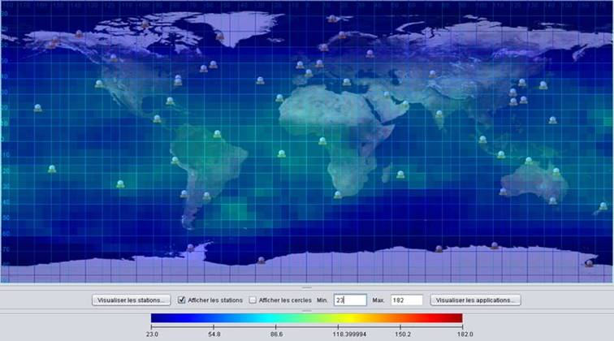

Figure 1:  Simulation of the expected timeliness when the real-time antenna project will be completed

10.1.5 The meeting noted these developments with appreciation, and thanked CLS for its efforts at improving Argos data timeliness.

**10.2 Task Team on Best Practices for Wildlife Argos Applications (TT-Wildlife)**

10.2.1 The meeting agreed with the draft Terms of Reference for the TT-Wildlife as provided in Annex V. The draft ToR will be submitted to JTA-34 for its review and adoption.

**10.3 Argos chipset**

10.3.1 Bill Woodward started the presentation with the evolution of the Argos services and products from 1997 Erems transmitter (Argos 2) to the current new project of the chipset (ARTIC) built by Ansem to support the new Argos 4 generation system. The ARTIC chipset will include the Argos 2, 3 and 4 capabilities. We need to facilitate the use of Argos, help new beacon manufacturers to get more active units in the field and eventually to drive the price of equipment down. This is an ESA funded project.

10.3.2 The meeting noted that 80 prototype units have been built, and beta testing will be done later this year.

**11 Review Draft EC 10 Report**

11.1 The meeting reviewed and approved this EC-10 draft final report, including action items from the meeting reflected in Annex II.

**12 Closure of the Meeting**

12.1 The chair thanked the Executive Committee for a substantive and effective meeting. The chair also thanked the host (BSH), and Birgit Klein for the pleasant meeting facilities and activities.

The meeting closed at 11:00 on 8 May 2014.

_________________

ANNEX II OF ANNEX IV (JTA-EC-10 Final Report)

List of action Items

*(Past JTA and JTA-EC meetings action items with status, and action items arising from JTA-EC-10)*

1. Status of open actions from previous JTA Sessions

| ***No.*** | ***Ref.*** | ***Action/decision item*** | ***By whom*** | ***Deadline*** | ***Status*** |
| --- | --- | --- | --- | --- | --- |
| J31#4 | J31/5.8 | Action: DBCP to report to JTA-EC on its needs, if any, for access to archived raw data | JTA Chair | JTA-34 | JTA chair will contact TC DBCP and seek further information on related requirements, while informing about CLS data policy |
| J32#6 | J32/6 | Action: to address the issue of installing an antenna on Easter Island, and possibly propose solutions at the next JTA meeting | JTA-EC | JTA-33 | Done (action addressed, as timeliness is planned to be improved in the area of interest) |
| J33#1 | J33/3 | To work with the manufacturers to make sure that they take into account the Argos 2-way telecommunication specifications in such a way that the PTTs can switch off after they have ceased to collect useful data | CLS | JTA-34 | Ongoing |
| J33#2 | J33/3 | DBCP to provide Argos 3 Pilot Project report | DBCP Chair | JTA-34 | Propose to close (JTA-EC-10 action proposed for JTA Chair to request DBCP to provide the report) |
| J33#3 | J33/7.13 | JTA EC to consider the large programme situation for 2013 at its next meeting and find a way forward to address the 1200 threshold issue | JTA-EC | JTA-34 | On the agenda of JTA-EC-10. To be reported at JTA-34 |
| J33#4 | J33/7.12 | CLS to manage the cost in the view to control the losses to the minimum | CLS | JTA-34 | Propose to close (ongoing process to be included in the operating principles. To also be part of the new FYP) |
| J33#5 | J33/7.12 | User communities to take steps to possibly increase their Argos usage | Argos users | JTA-34 | Propose to close. To be included in the operating principles (action for the ROCs to reach out with Argos users in their countries). |
| J33#6 | J33/7.14 | To refine the proposal for the format of the next FYP to be discussed at the mid-year 2014 JTA-EC meeting, and submitted to the next JTA Session | CLS | JTA-EC-10 | Included in the JTA-EC-10 agenda |
| J33#7 | J33/7.14 | To populate the new FYP according to the draft format proposed by JTA-EC | CLS | JTA-34 | Planned for JTA-34 |
| J33#8 | J33/7.14 | To discuss the proposal of CLS concerning the format of the next FYP | JTA-EC | JTA-34 | Included in the JTA-EC-10 agenda |
| J33#9 | J33/9.7 | Assist users with regarding to the estimation of Argos costs for research proposals (shark community in particular) | CLS | Ongoing | Propose to close. To be included in the operating principles. |
| J33#10 | J33/9.6 | To approach groups representing the wildlife community, including Movebank in the view to seek their participation in the JTA to represent the animal tracking community | JTA-EC | JTA-34 | Propose to close. Meeting with Movebank organized in late 2013. However, their participation at JTA is unlikely. This action also to be included in the operating principles if not already there. |
| J33#11 | J33/9.4 | To address the issues identified in the national reports session | CLS | JTA-34 | Done. Report to be presented at JTA-34 by CLS. |
| J33#12 | J33/9.5 | To consider the same issues to also be considered as part of the Terms of Reference of the new proposed Task Team on Best Practices for Wildlife Argos Applications | JTA-EC | JTA-34 | Progressing. CLS to report on status at JTA-34 |
| J33#13 | J33/9.8 | to propose Terms of Reference and membership of the TT-Wildlife for discussion and possible adoption at the next JTA Session | JTA-EC | JTA-34 | JTA Chair to assist S. Javed for setting up the TT ToR and membership. |

**2 – Status of open action items from previous JTA-EC meetings**

| ***No.*** | ***Ref.*** | ***Action item*** | ***By whom*** | ***Deadline*** | ***Comment*** |
| --- | --- | --- | --- | --- | --- |
| JEC6#7 | JTA-EC-6 | To write to the Secretariat, to reaffirm that the JTA can continue to operate as an independent body under the Forum once established, and express the desire to have other communities (e.g. biologists, animal trackers, who are also using Argos and other Satcom systems) involved in the future Forum | Chair | 1 Jan 2013 | No letter was sent. Email communication took place between JTA Chair and Satcom committee Chair |
| JEC9#1 | JEC9/1 | CLS to prepare a report on the status and funding, and installation date of Easter Island antenna to be discussed at JTA-EC-10. | CLS | May 2014 | Done |
| JEC9#2 | JEC9/2 | 1200 threshold issue & Wildlife large programmes: Proposal to be prepared and presented by the JTA Chair in consultation with Salim Javed (UAE) and CLS at JTA-EC-10. | E. Locklear  (& S. Javed) | May 2014 | Not done.  Usage should be encouraged. Conditions for benefiting from discounts to be defined (e.g. standards, funding, quantities, single organization, etc.).  To be presented at JTA-34 |
| JEC9#3 | JEC9/3 | CLS to consolidate the format, and present it at JTA-EC-10, and populate it with best estimates of predicted Argos use (more accurate predicted numbers for the next 5 years to be presented at JTA-34). | CLS | May 2014 | New FYP format presented at JTA-EC-10 |
| JEC9#4 | JEC9/4 | The JTA-EC recommended that Salim Javed should lead the development of the ToR and membership of the Task Team in the view for him to make a proposal one month prior to JTA-EC-10. | S. Javed | May 2014 | ToR discussed at JTA-EC-10, and proposed for discussion at JTA-34 |
| JEC9#5 | JEC9/5 | Johan Stander will review the ToR of the ROCs and RUGs and investigate whether nomination through WMO/IOC should be required. | J. Stander | Sep. 2014 | Will be completed by JTA-34 working with JTA Chair. |
| JEC9#6 | JEC9/7 | FYP 2013 results, and the status of 2014 to be considered at JTA-EC-10 pending updated figures from OPSCOM. | JTA-EC-10 | May 2014 | CLS reported at JTA-EC-10 |
| JEC9#7 | JEC9/9 | CLS to provide information, and seek feedback from the DBCP on the situation of drifter failures, and expected effects on the FYP until JTA-34 | CLS | Sep. 2014 | Information available from the GDP on a weekly basis. 1250 operational units target has been resumed but sustainability is unclear. Projections in the new FYP taken into account. |
| JEC9#8 | JEC9/10 | Report of Satcom1 to be prepared and presented by Frank Grooters or Bill Woodward (TBD) at JTA-EC-10 | F. Grooters & W. Woodward | May 2014 | Done. Secretariat prepared the report, which was presented at JTA-EC-10 |
| JEC9#9 | JEC9/11 | Birgit Klein, and CLS to propose names for TT-Wildlife and other applications. | B. Klein | May 2014 | Completed. Bird watching community names proposed. |
| JEC9#10 | JEC9/14 | CLS was requested to make a proposal regarding the presentation of financial information for JTA meetings at the next JTA-EC meeting | CLS | May 2014 | To be reported at OPSCOM-48 (June 2014).  OPSCOM is the body certifying the financial status of the Agent (i.e. CLS for operating Argos).  JTA needs to full understand the process for producing the financial status of the Agent.  Summary of the financial report then to be presented by the JTA Chair (who also participates at the OPSCOM meetings). |
| JEC9#11 | JEC9/17 | Certain users seem to be charged different tariffs, possibly due to differences and fluctuations of exchange rates. Joe Linguanti will be investigating and reporting on this issue at JTA-EC-10. | J. Linguanti | May 2014 | J. Linguanti reported on the issue during JTA-EC-10. |
| JEC9#12 | JEC9/18 | JTA-EC-10 to discuss the need for a consultant to support the work of the JTA-EC | JTA-EC-10 | May 2014 | There is no specific need for a consultant at this point. Can be discussed again if the need arises. |

1. Actions and decisions of the present JTA-EC-10 meeting

| ***No.*** | ***Ref.*** | ***Action/decision item*** | ***By whom*** | ***Deadline*** | ***Comment*** |
| --- | --- | --- | --- | --- | --- |
| JEC10#1 | JEC10/2 | To request DBCP to provide the Argos 3 Pilot Project report | JTA Chair | JTA-34 |  |
| JEC10#2 | JEC10/2 | To review the list of ongoing actions from JTA-EC and JTA meetings, and propose updates to the operating principles accordingly. | J. Stander | JTA-34 |  |
| JEC10#3 | JEC10/2 | Membership of the TT-Wildlife to be proposed by S. Javed in consultation with JTA Chair | S. Javed | JTA-34 |  |
| JEC10#4 | JEC10/2  JEC10/4.1 | Presentation on the JTA (goals, structure, mechanisms, etc.) to be made at the beginning of each JTA Session, including on financial information reporting (processes, link with OPSCOM, etc.) | Chair JTA | JTA-34 | Need for such a presentation to be included in the operating principles as an ongoing action |
| JEC10#5 | JEC10/2 | To organize an informal meeting of the JTA-EC prior to JTA-34 | Chair JTA | JTA-34 |  |
| JEC10#6 | JEC10/5 | The 2013 annual report on the global agreement by CLS should include a new column by each country on the revenue (ref. to Annex 7 to JTA-33 report). | CLS | JTA-34 |  |
| JEC10#7 | JEC10/2.6 | To make a proposal on how to better balance service charges globally | CLS | JTA-34 |  |
| JEC10#8 | JEC10/3.2 | To make the proposal regarding large programme discount to the JTA meeting | Chair JTA | JTA-34 |  |
| JEC10#9 | JEC10/4.3 | To compile, with assistance from the Secretariats, a financial statement on the JTA-EC budget for review at JTA-EC meetings | Chair JTA | JTA-EC-12 |  |
| JEC10#10 | JEC10/2 | To review the operating principles and make proposal at next JTA-EC meeting | Chair JTA | JTA-EC-12 |  |
| JEC10#11 | JEC10/6.1 | To look at the *ad hoc* Satcom Forum recommendation #10, and provide a report to the JTA-EC | CLS | JTA-34 |  |
| JEC10#12 | JEC10/7.4 | To draft a Vision for the JTA, and propose the way forward for developing a medium to long term strategy for the JTA | Chair & vice-Chair JTA | JTA-34 |  |

______________

*[this page left blank intentionally]*

**annex v**

**Report on the 33rdJTA meeting at the 48th Meeting of the**

**Argos Operations Committee (OPSCOM)**

*(June 2 - 4, 2014, Berlin, Germany)*

# Report and recommendations from the Operation Committee

## Report of the JTA Chairman

Mr. Eric Locklear, the JTA Chair, noted with thanks to the OPSCOM for the opportunity to discuss the JTA. He opened his presentation with a discussion of three topics:

1. Why is the ARGOS JTA here?

2. What is the current status of the program?

3. Where is the program heading?

A brief history was discussed that the first tariff agreement was adopted in 1979 between NOAA and CNES. Then the first ARGOS JTA international agreement was organized by the WMO in 1981 to encourage participation of the ARGOS system. Mr. Locklear went on to discuss text from the NOAA/CNES 1986 MOU regarding their role in approving the JTA rates. He also stated that the ARGOS JTA serves the purposes of the responsibility to safeguard the use of public funds, and provides for a documented process for establishing rates. He concluded this section by pointing out that the size of the JTA revenues and costs makes oversight important.

Mr. Locklear went on to discuss the current status of the program and noted the ARGOS’ unique position as the interface between many organizing bodies (WMO, IOC, User Groups, and the OPSCOM) and also pointed out that the JTA has an objective to determine the rates as well as the OPSCOM.

Mr. Locklear went on to discuss who the JTA members are and what their usages are, summarizing with the top five nations use of the system for each service family. Mr. Locklear gave a summary of the current 5 year plan as well as the projected ending accumulated balance exceeding 3.0 million euros for the end of 2014, which is a good situation.

Mr. Locklear concluded his presentation with a discussion on the next 5 year plan (2015 - 2019), and discussed his objectives over the coming years, as well as asking the OPSCOM if they had any particular concerns. Of particular concern to the OPSCOM is the endorsement of the upcoming 5 year plan from 2015 - 2019, which will be presented at the upcoming JTA meeting in China. An action was taken by the ARGOS JTA chairman that he will send a recommendation to the OPSCOM chairs of the tariff structure after the JTA meeting for their review and endorsement.

## Status of U.S. Programs

Mr. Locklear provided a status of the U.S. programs and focused on two items, past reported issues and the future of the Global Drifter Program. The past problems with the global drifter buoys shortened lifetimes have been well documented, but what wasn’t known were the costs of these failures.

Mr. Locklear reported that the current estimate of the cost to the U.S. program of the drifter failures is $800,000. He went on to report that the Climate Program Office, which funds the Global Drifter Program has lost approximately $50.0 million over the last 3 years. However, due to a different description of the GDP program, they are now expected to be protected from future budget cuts.

Lastly, Mr. Locklear reported that while the global drifter array is still expected to remain at 1,250, the proportion of ARGOS equipped drifters may drop to 75%. If this reduction happens, the upcoming ARGOS JTA 5 year plan will be adjusted as the U.S. may no longer benefit from the highest discount tariff for large programs.

## Financial Status of Agent

Christophe Vassal presented the CLS methodology to derive the Argos basic costs to be attributed to the JTA.

He showed that the Argos basic costs have slightly increased from 12.01 M€ in 2012 to 12.29 M€ in 2013. The Argos basic costs for science have remained stable whereas the Argos basic costs for fishing have increased, mainly because of a continued interest in Argos from a number of countries to track their fishing vessels. The Argos basic costs for sensitive use have slightly increased while the corresponding income has decreased. There is a need to continue to develop actions towards that user community to increase their usage of Argos.

In 2013, the costs to be attributed to the JTA are calculated at 7.03 M€ : it represents a 0.72% increase with respect to 2012 while the average active PTTs processed and distributed decreased to 12 080 compared to 12 488 in 2012.

At the 33rd JTA meeting in 2013, the following was decided:

* The JTA projection for the year 2013 is estimated from figures based on seven months of usage, extrapolated until the end of the year. At this point in time, the JTA considered that, in 2013, the JTA will likely be able to pay its portion of the cost. In view of the above summarized situation, the JTA encouraged CLS to pursue their efforts to reduce operational costs while promoting increased usage.
* Overall, the JTA basic income is expected to be 6.68 M€ in 2013, 13.5% under the figure planned in the original [2009 ; 2014] 5Y plan.
* In conclusion, the expected financial situation for 2013 is considered safe. The accumulated balance would remain significantly positive. Nevertheless, risks will continue to be monitored very closely by CLS.

The JTA acknowledged that CLS has been successful in reducing the cost. The meeting nevertheless requested CLS to manage the cost in view to reduce the losses to the minimum. In parallel, the JTA also invited the user community to take steps to possibly increase their Argos usage.

**Confirmation of 2014 tariffs at 33rd JTA meeting:**

Based on (i) the projections for 2013 and 2014, in which it was expected that the income was balancing the JTA cost, (ii) the positive situation in the accumulated balance in the FYP at this moment, (iii) the uncertainties and possible risks due to the technical problems of the drifters, the JTA meeting decided not to change the Tariff in 2014.

The JTA Meeting has adopted the Terms and Conditions for the 2014 Agreement on the following basis:

* ***BASIC SERVICE***

Basic service charges for authorized users under this Agreement are in accordance with the payment on consumption.

They are calculated according to the following formula:

Price per month, per platform = **A** + **B** x **n**

where:

* **A** represents the monthly charge per active PTT (an active PTT is one that transmits at least once during a given calendar month);
* **B** represents the PTT-day unit rate;
* **n** is the number of day units. The day is divided into 4 time slots (0 - 6; 6 - 12; 12 - 18; 18 – 24 UTC). Any PTT transmission collected into a given time slot produces a 0.25 day unit.

A and B coefficients for all platform categories are provided in table below:

| **Category** | **A (€)** | **B (€)** |
| --- | --- | --- |
| **Buoys and others** | 15 | 5 |
| **Fixed Stations** | 15 | 3 |
| **Animals\*** | 15 | 7.5 |
| **Subsurface Floats** | 15 | 7.5 |

**Buoys and others** – PTTs in this category are drifting and moored buoys and, more generally, all those PTTs which do not belong to categories below.

**Fixed Stations** – PTTs in this category are land fixed PTTs.

**Animals** – PTTs in this category are those that are used to track animals.

*Charges for Platforms in this category will be capped at n=12 Day Units per month.

**Floats** – PTTs in this category are subsurface floats such as the ARGO program floats.

* ***DISCOUNT SCHEME FOR LARGE PROGRAMMES***

|  |  |  |
| --- | --- | --- |
| **Number of platform-years** | **PTT–day unit (B)**  **Buoys & others** | **PTT-day unit (B)**  **Floats** |
| 600 | 4 | 6 |
| 900 | 3 | 4 |
| 1200 | 2 | 3 |

**2013 JTA financial close of accounts**

In 2013, CLS recorded revenues from JTA participating countries at a level of 7.10 M€. This was slightly different from the revenues expected from the JTA (7.90 M€). This shortage in revenue is explained mainly by the technical issues affecting the global drifter program. As a consequence, in 2013, the JTA realized a small excess of 60 K€. The non JTA incomes have remained essentially stable in 2013 (slight increase from 6.27 M€ to 6.30 M€), and the corresponding applications (fishing and sensitive) are still exceeding significantly their portions of the costs.

At the date of the meeting, we believe the JTA in 2014 will likely be able to pay its portion of the cost even though the plan shows a small loss of 50 K€.

The OPSCOM gave its appreciation concerning the clarity of the information provided andencouraged CLS and CLS America to pursue efforts to reduce Argos operational costs while actively promoting the system to existing and future users.

At the end of 2013, it appears that the combined JTA and non JTA excess over the last 27 years has fully offset the initial contribution from CNES (15 M€) to the operation and promotion of the Argos system.

From now on, all excess from a given year in the JTA may be used to finance investments required by users, or to decrease the prices for all or some categories of users.

As a consequence, it was agreed by OPSCOM to simplify the presentation in H-1.5 Financial Status of Agent to stick to the JTA 5YP (2015 - 2019) which is to be finalized at the 2014 JTA and subsequently presented at the December 2014 intersession meeting.

Christophe Vassal proposed to present the co-chairmen with a template of his new presentation at least one month before the next OPSCOM in order to make sure the information provided will meet the OPSCOM's expectations

## The Five Year Plan for 2010-2014



______________

ANNEX VI – LIST OF ACTIONS

1. Status of open actions from previous JTA Sessions

| **No.** | **Ref.**  **(agenda item)** | **Action/decision item** | **By whom** | **Deadline** | **Status** |
| --- | --- | --- | --- | --- | --- |
| J31#4 | J31/5.8 | Action: DBCP to report to JTA-EC on its needs, if any, for access to archived raw data | JTA Chair | JTA-34 | JTA chair will contact TC DBCP and seek further information on related requirements, while informing about CLS data policy  Closed |
| J33#1 | J33/3 | To work with the manufacturers to make sure that they take into account the Argos 2-way telecommunication specifications in such a way that the PTTs can switch off after they have ceased to collect useful data | CLS | Ongoing | Ongoing |
| J33#3 | J33/7.13 | JTA EC to consider the large programme situation for 2013 at its next meeting and find a way forward to address the 1200 threshold issue | JTA-EC | JTA-34 | On the agenda of JTA-EC-10. To be reported at JTA-34  Closed |
| J33#6 | J33/7.14 | To refine the proposal for the format of the next FYP to be discussed at the mid-year 2014 JTA-EC meeting, and submitted to the next JTA Session | CLS | JTA-EC-10 | Included in the JTA-EC-10 agenda  Closed |
| J33#7 | J33/7.14 | To populate the new FYP according to the draft format proposed by JTA-EC | CLS | JTA-34 | Planned for JTA-34  Closed |
| J33#12 | J33/9.5 | To consider the same issues to also be considered as part of the Terms of Reference of the new proposed Task Team on Best Practices for Wildlife Argos Applications | JTA-EC | JTA-34 | Closed |
| J33#13 | J33/9.8 | to propose Terms of Reference and membership of the TT-Wildlife for discussion and possible adoption at the next JTA Session | JTA-EC | EC-12 | Tasked the chair of the TAG to complete the membership by EC-12 |
|  |  |  |  |  |  |

**2 – Status of open actions from previous JTA-EC meetings**

| **No.** | **Ref.** | **Action item** | **By whom** | **Deadline** | **Comment** |
| --- | --- | --- | --- | --- | --- |
| JEC9#2 | JEC9/2 | 1200 threshold issue & Wildlife large programmes: Proposal to be prepared and presented by the JTA Chair in consultation with Salim Javed (UAE) and CLS at JTA-EC-10. | Task Team on Wildlife(& S. Javed) | JTA-35 | Usage should be encouraged. Conditions for benefiting from discounts to be defined (e.g. standards, funding, quantities, single organization, etc.).  To be presented at JTA-34  Reassigned to Task Team on Wildlife |
| JEC9#4 | JEC9/4 | The JTA-EC recommended that Salim Javed should lead the development of the ToR and membership of the Task Team in the view for him to make a proposal one month prior to JTA-EC-10. | S. Javed | May 2014 | ToR discussed at JTA-EC-10, and proposed for discussion at JTA-34  Done |
| JEC9#5 | JEC9/5 | Johan Stander will review the ToR of the ROCs and RUGs and investigate whether nomination through WMO/IOC should be required. | J. Stander | Sep. 2014 | Closed |
| JEC9#7 | JEC9/9 | CLS to provide information, and seek feedback from the DBCP on the situation of drifter failures, and expected effects on the FYP until JTA-34 | CLS | Sep. 2014 | Closed |
| JEC9#10 | JEC9/14 | CLS was requested to make a proposal regarding the presentation of financial information for JTA meetings at the next JTA-EC meeting | CLS | May 2014 | Closed:  JTA chair is now responsible for presenting financial information for the JTA. |
| JEC10#1 | JEC10/2 | To request DBCP to provide the Argos 3 Pilot Project report | JTA Chair | JTA-34 | Closed  Pilot Project has been finalized. Refer to DBCP-29 final report. |
| JEC10#2 | JEC10/2 | To review the list of ongoing actions from JTA-EC and JTA meetings, and propose updates to the operating principles accordingly. | J. Stander | JTA-34 | Closed  Added to Operating Principles as an EC responsibility to review and report ongoing actions. |
| JEC10#3 | JEC10/2 | Membership of the TT-Wildlife to be proposed by S. Javed in consultation with JTA Chair | S. Javed | EC-12 | Closed |
| JEC10#4 | JEC10/2  JEC10/4.1 | Presentation on the JTA (goals, structure, mechanisms, etc.) to be made at the beginning of each JTA Session, including on financial information reporting (processes, link with OPSCOM, etc.) | Chair JTA | JTA-34 | Need for such a presentation to be included in the operating principles as an ongoing action  Closed  Added to the Operating Principles |
| JEC10#5 | JEC10/2 | To organize an informal meeting of the JTA-EC prior to JTA-34 | Chair JTA | JTA-34 | Closed |
| JEC10#6 | JEC10/5 | The 2013 annual report on the global agreement by CLS should include a new column by each country on the revenue (ref. to Annex 7 to JTA-33 report). | CLS | JTA-34 | Closed |
| JEC10#7 | JEC10/2.6 | To make a proposal on how to better balance service charges globally | CLS | JTA-34 | Closed |
| JEC10#8 | JEC10/3.2 | To make the proposal regarding large programme discount to the JTA meeting | Chair JTA | JTA-34 | Closed |
| JEC10#9 | JEC10/4.3 | To compile, with assistance from the Secretariats, a financial statement on the JTA-EC budget for review at JTA-EC meetings | Chair JTA | JTA-EC-12 | F. Grooters has turned over financial documents. Progress has been made. |
| JEC10#10 | JEC10/2 | To review the operating principles and make proposal at next JTA-EC meeting | Chair JTA | JTA-EC-12 | Closed |
| JEC10#11 | JEC10/6.1 | To look at the *ad hoc* Satcom Forum recommendation #10, and provide a report to the JTA-EC | CLS | JTA-EC-12 | Closed |
| JEC10#12 | JEC10/7.4 | To draft a Vision for the JTA, and propose the way forward for developing a medium to long term strategy for the JTA | Chair & vice-Chair JTA | JTA-EC-12 | Open  Will be Closed during Future of JTA |

**4. Actions and decisions of the present JTA-34 meeting**

| **No.**  **(JTA-34)** | **Ref.**  **(JTA-34)** | **Action/decision item** | **By whom** | **Deadline** | **Comment** |
| --- | --- | --- | --- | --- | --- |
| J34#01 | JTA34/ 2.2.7 | Draft a Vision of the Future of the JTA | Chair & Vice Chair JTA | JTA-35 | Continuation of JEC10#12 |
| J34#02 | JTA34/ 3.3 | JTA Reports will include an annex of issues arising from national reports | JTA-EC, Secretariat | On-going |  |
| J34#03 | JTA34/ 4.2 | Amend future Agendas to move the Review of Action Items to the end of session | JTA-EC, Secretariat | JTA-EC 12 |  |
| J34#04 | JTA34/ 7.2.2 | Review recommendations of Animal Tracking Advocacy Group (ATAG to become RUG and participate on JTA Wildlife TAG) | JTA-EC | JTA-EC 12 |  |
| J34#05 | JTA34/ 8.1.2 | Evaluate and analyse the CLS charging algorithm and metrics. | CLS, JTA-EC | JTA-EC 12 |  |
| J34#06 | JTA34/ 9.3 | USA ROC should seek agreement to sign for a non-fixed rate, or pay in Euros | USA ROC | JTA-35 |  |
| J34#07 | JTA34/ 9.4 | Review the JTA tariff to ensure it is fair, equitable and simple with respect to currency conversion | JTA-EC | JTA-35 |  |
| J34#08 | JTA34/ 11.2 | Representation of the wildlife community will be solicited, and the Wldlife Technical Advisory Group (WTAG) will be formed. | Chair WTAG | JTA-EC 12 |  |
| J34#09 | JTA34/ 12.10 | CLS to report to JTA on the results of the International User Conference on ARGOS Wildlife Applications | CLS | JTA-35 |  |
| J34#10 | JTA34/ | The chair shall provide recommendations for the two open positions of JTA-EC | Chair | JTA-EC 12 |  |

________________

**Annex vii - Report on the 2014 agreement**

*(submitted by CLS)*

|  |
| --- |
| **Table of Contents** |

1. REPORT ON THE 2013 ACTIVITY 56

1.1. Animals activity in 2013 56

1.2. Floats activity in 2013 57

1.3. Fixed stations activity in 2013 57

1.4. Buoys and others activity in 2013 58

2. 2013-2014 GLOBAL AGREEMENT 59

2.1. Average active PTTS per month per country: 2013 and extrapolated 2014 59

2.2. Consumption per country (PTT-year): 2013 and extrapolated 2014 60

2.3. Consumption evolution over 1 year 61

2.3.1. Monthly evolution by platform category up to July 2004 – Active PTT 61

2.3.2. Monthly evolution by platform category up to July 2004 – PTT-years 62

2.3.3. Extrapolated consumption per platform category for 2014 62

2.4. Consumption evolution over the last 5 years 64

2.5. Time slot analysis for year 2013 65

2.6. Impact of the 12 days unit capping in 2013 66

2.7. Inactive status in 2013 67

2.8. History of the JTA participation from 1982 to 2014 68

|  |
| --- |
| **List of Figures** |

Figure 1: Consumption evolution over the previous 12 months in Active PTTs and PTT.years 61

Figure 2: Active PTT evolution for 12 months 61

Figure 3: PTT-year evolution for 12 months 62

Figure 4: 2013-2014 activity per platform category 63

Figure 5: PTT-year evolution over 5 years 64

Figure 6: Average time slot level by platform category 65

Figure 7: Average PTTs affected and PTT-year “gain” by animal category 66

Figure 8: Average number of active PTT and corresponding days units of transmission 66

Figure 9: Inactive PTTs - number of IDs and PTT-Years for 2013 67

Figure 10: Actual consumption in PTT-years for all countries since 1982 68

# REPORT ON THE 2013 ACTIVITY

The following tables present the usage of the Argos system in each country per type of platforms. In addition to the average number of active platforms and corresponding consumption calculated in PTT-years, the third column shows corresponding annual revenue in K-€uros.

## Animals activity in 2013



## Floats activity in 2013



## Fixed stations activity in 2013



## Buoys and others activity in 2013



**Synthesis of 2013 Agreement**



# 2013-2014 GLOBAL AGREEMENT

## Average active PTTS per month per country: 2013 and extrapolated 2014



An active PTT is a PTT which transmitted at least once in a month. The average is the total number of Active PTTs divided by number of months.

Based on the actual activity from January to July 2014, extrapolated until December 2014, the number of active platforms is expected remaining stable, with a small increase of 0.9%.

## Consumption per country (PTT-year): 2013 and extrapolated 2014



The PTT-years are the numbers of day units with time slot calculation where appropriate divided by 365 days

Based on the actual activity from January to July 2014, extrapolated until December 2014, it is estimated there will be **4.7%** increase in number of PTT-Years compared to 2013 usage.

## Consumption evolution over 1 year

Overall, the active PTTs and thus the total number of transmitters in the field and corresponding consumption are increasing.

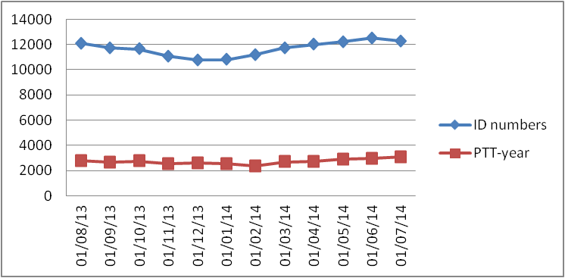

Figure 1: Consumption evolution over the previous 12 months in Active PTTs and PTT.years

### Monthly evolution by platform category up to July 2014 – Active PTT

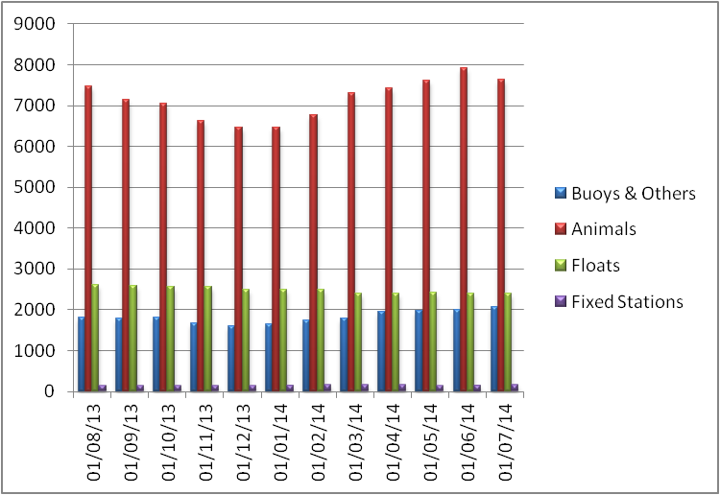

Figure 2: Active PTT evolution for 12 months

### Monthly evolution by platform category up to July 2014 – PTT-years

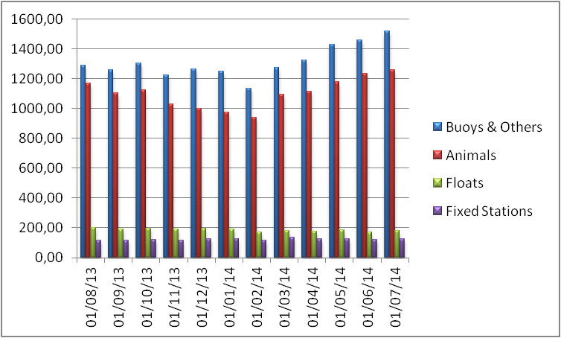

Figure 3: PTT-year evolution for 12 months

### Extrapolated consumption per platform category for 2014

The following analysis is based on 7 months of system usage (from January to July 2014)

The total number of active PTTs should slightly increase in 2014 compared to 2013 as summarized in the following table (100 additional PTTs representing + 0.89%). The decreasing number of floats is compensated by the number of platforms deployed on buoys, animals or fixed stations.



However the corresponding usage of the system will increase in 2014 (+4.7%). This is due to the deployment of buoys that far outweigh the floats consumptions which transmit much less in a month. Animal tracking applications continue their steady growth.



The following graphs present the 2013 activity and forecast 2014 including the weight of each category of platform in term of active PTTs and corresponding system usage:

**Active PTT PTT-Year**

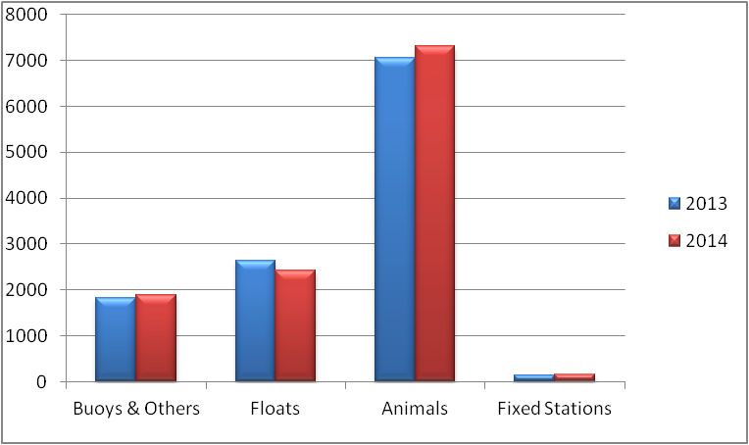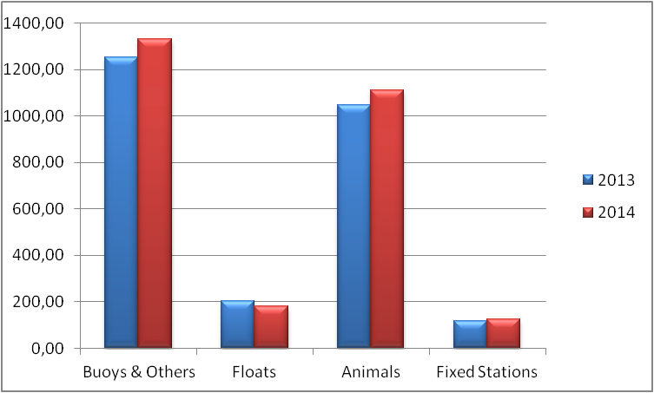

Figure 4: 2013-2014 activity per platform category

The PTT-years picture shows the differences in terms of actual consumption among categories:

* Consumption of “Buoys and Others” has been decreasing since 2010. However, in 2013-2014 this trend is reversing due to deployment of more buoys with longer lifetimes. This category still represents the highest consumption compared to the other categories.
* Consumption of “Animals” continue to progress. This year the animal consumption increase is expected to be 6%.
* “Floats” consumption should decrease by 23 PTT-years (11.5%) compared to 2013.
* We can note that “Fixed Stations” consumption is slightly progressing, even if this category represents only 4.4% of the total agreement.

## Consumption evolution over the last 5 years

The monthly evolution per category of platforms from August 2009 to July 2014 is presented here under:

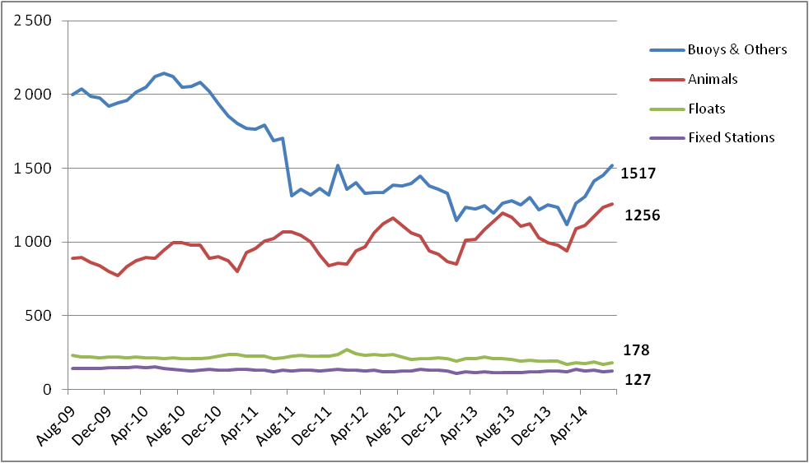

Figure 5: PTT-year evolution over 5 years

Here is the activity synthesis of the past four years with the extrapolated 2014:

Active PTT PTT-Year

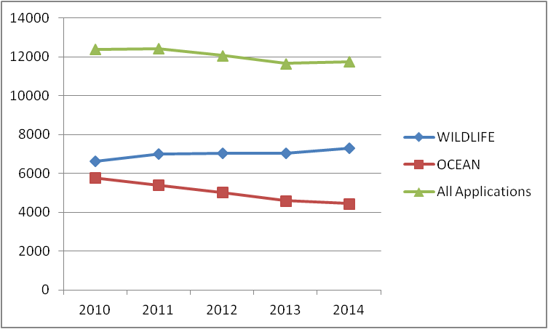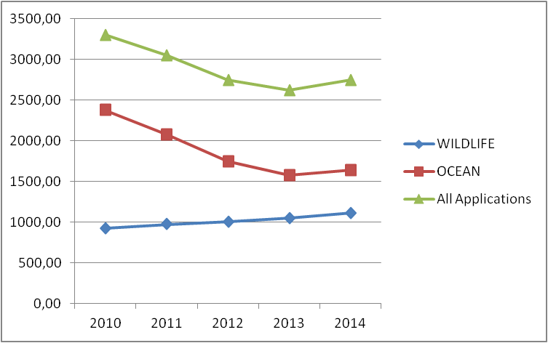

## Time slot analysis for year 2013

In order to take into account the platforms’ emission cycles, a system of time slots accounting has been implemented in 2005.

The day is thus divided into 4 time slots, each with a duration of 6 hours

(UTC Time). Any PTT transmission collected into a given time slot produces 0.25 day

units.

“Animals and Sub floats” Platforms have benefited from time slot accounting since 2005. “Buoys & Others” and “Fixed Stations” started benefiting from time slot accounting in 2007.

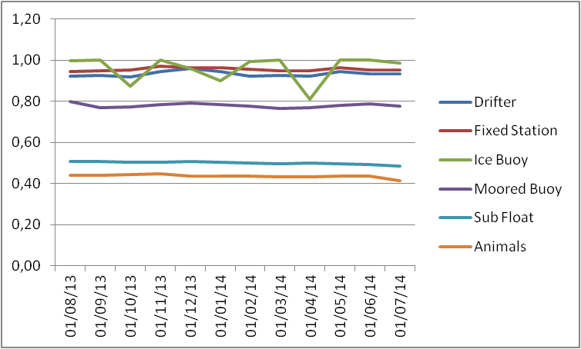

Figure 6: Average time slot level by platform category

This diagram shows the monthly evolution of the average time slot ratio for the all platforms categories.

For a given PTT, the monthly time slot ratio is calculated as the number of day units divided by the number of transmission days in the month.

It can be noticed that all “Animals” and “Sub Floats” categories are significantly benefitting from the time slots. As an average “Animals” PTT are transmitting 41% of the day, Moored Buoys are transmitting 80% and “Sub Floats” PTT are transmitting 51% of the day. Other categories of platforms keep transmitting 94% of the day.

## Impact of the 12 days unit capping in 2013

Further to JTA XXVII decision the consumption for animal platforms is capped at 12 day-units (48 time slots).

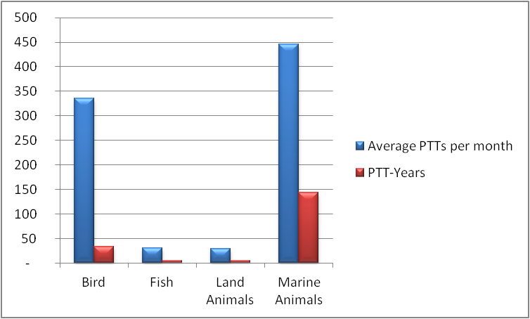

Figure 7: Average PTTs affected and PTT-year “gain” by animal category

In 2013, **841** PTTs (average active PTT per month) took advantage of the capping, representing **187 PTT-year**. The number of animals taking advantage of the capping is increasing by **10%** : 841 in 2013, compared to 757 in 2012 and more particularly “Birds and Marine animals”. A detailed analysis of transmissions shows that “Marine animals” are those who are benefiting the most of the capping: 43% transmit more than 12 days per month and 27% of them transmit more than 20 days units per month.



 

Figure 8: Average number of active PTT and corresponding days units of transmission

## Inactive status in 2013

Recall: since year 2004, transmissions from Inactive IDs are no longer charged.

As stated in the Terms and Conditions of the Global Agreement, this status is intended for those platforms that continue to transmit but for which the location or data collection are of no further use to the user or the community. The following conditions must be met to qualify:

(*1) Inactive Status will apply if, and only if, Inactive Status is declared by the signatory of the System Use Agreement for platforms which continue to transmit beyond the programme termination. In that case, further charges will no longer be levied.*

*(2) The platforms must have operated in Basic Service for a minimum of 2 months.*

*(3) Data or location information cannot be retrieved nor can the platform revert to any category of service.*

1. *It is intended that Location and/or data collection may not be computed using a Local User Terminal or other direct readout facility.*
2. *ID numbers of such platforms are actually returned to CLS who will recycle them after the platform stops transmitting.*

We can note that in 2013 the number of IDs in Inactive status remain stable compared to 2012: **418 PTTs** are counted every month representing **114.77** PTT-year.

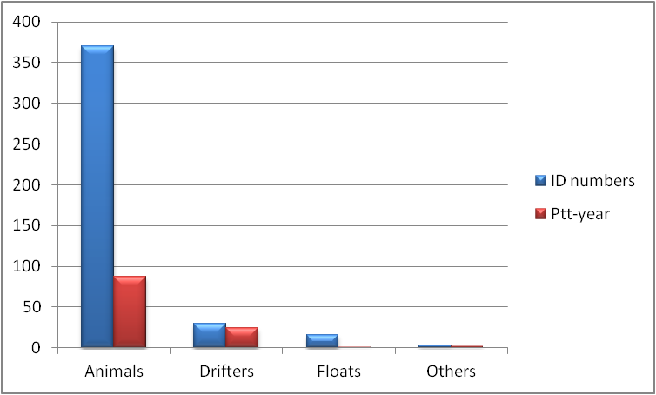

Figure 9: Inactive PTTs - number of IDs and PTT-Years for 2013

As mentioned in previous JTA reports, these PTTs which are unused but are still transmitting are increasing the system occupancy. CLS keeps highlighting this to the users and manufacturers encouraging them to program their PTTs only for the duration of the experiment.

## History of the JTA participation from 1982 to 2014

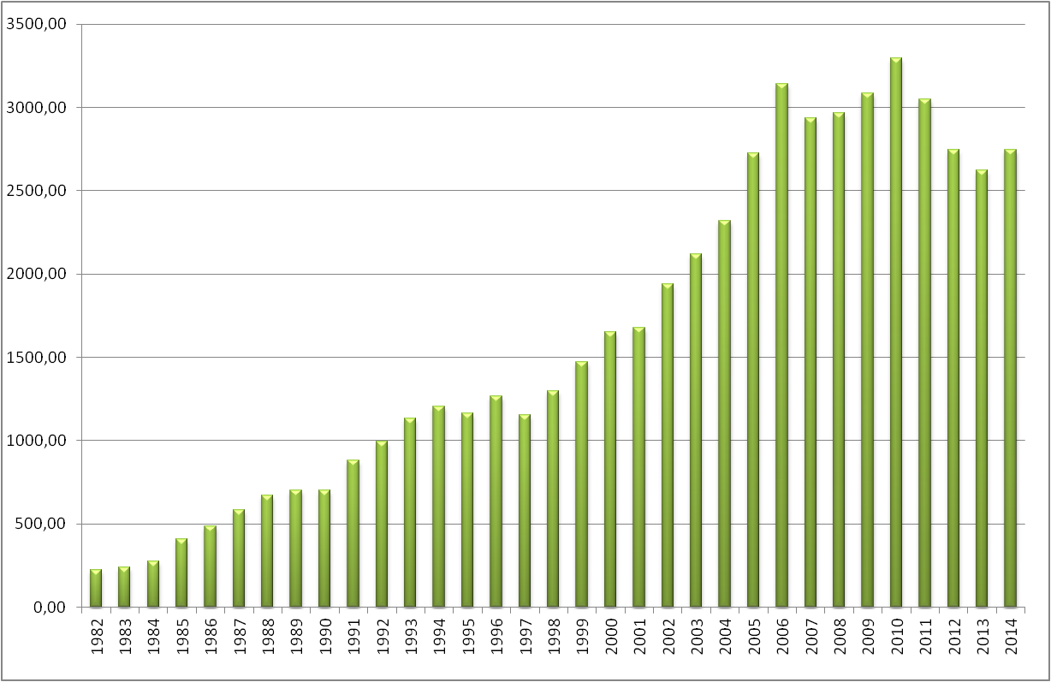

Figure 10: Actual consumption in PTT-years for all countries since 1982

**Notes**:

1. Consumption decreased in 2007 (~46 PTT-year) by applying the time slots to all categories.
2. In 2008 and 2009, the consumption in PTT-years decreased by ~138 PTT-years due to the capping mechanism being applied to all animals, and also by applying the time slots to all categories.
3. The increase in 2010 is due to a combination of increased animal program activity and maximum deployment opportunities with increased buoy lifetimes for the Global Drifter program.
4. The decrease in consumption since 2011 is due to a combination of both premature buoy failures in the Global Drifter program and migration away from Argos.
5. Value for 2014 is a projection based on actual consumption from January to July 2014: We can notice a trend of growth in the total usage which is mainly due to new deployments of buoys and the continuous development of the animal tracking applications.

_______________

**Annex viii**

**Report on 2013-2014 Operations and system improvements**

*(Submitted by CLS)*

|  |
| --- |
| List of Contents |

1 2013-2014 Argos Highlights 71

1.1 Operations 71

1.2 System developments 71

1.3 Outlook 72

2 Argos space segments 73

2.1 Operational status 73

2.2 METOP-A HRPT Switch Zone 73

2.3 Ascending Nodes Local hour 75

3 Argos ground segment 75

3.1 Global antennas (store and forward mode) 75

3.2 Regional antennas (real-time mode) 77

3.2.1. Operation and improvements 77

3.2.2. METOP real-time coverage 80

3.2.3. HRPT-A4 project 81

3.3. Processing centers 83

3.3.1. Argos global processing centres architecture 84

3.3.2. The CLS Argos processing chain 85

3.3.3. The Oracle database 86

3.4. The Argos data distribution and processing 86

3.4.1. ArgosWeb site 86

3.4.2. ArgosServer 87

3.4.3. ArgosDirect 88

3.4.4. Argos WebService 89

3.4.5. Disaster recovery architecture 90

3.4.6. Data processing statistics 90

3.4.7. Number of Argos messages and locations processed 91

3.4.8. Argos location and data collection latencies 92

3.4.9. Monthly active Argos platforms 94

3.5. System improvements 94

3.6. ARGOS-4 ground segment upgrade 95

3.7. Argos-3/Argos-4 chipset 96

3.8. Argos goniometer 97

4 Review of Users Requirements mentioned in the 2013 national reports 98

4.1 Issues mentioned in the Australian report 98

4.2 Issues mentioned in the Chinese report 98

4.3 Issue mentioned in the Indian report 99

|  |
| --- |
| List of Figures |

Figure 1 Argos Constellation 73

Figure 2 : METOP-A HRPT Extended Switch Zone (Descending and Ascending orbits) 74

Figure 3: Local Equator crossing time in June 2014 75

Figure 4 : The Argos Global antenna network (without McMurdo) 76

Figure 5 : METOP-B Mc Murdo Global antennas coverage and principle 76

Figure 6 : Argos HRPT Tahiti station 77

Figure 7 : May 2014 Argos Real-time coverage map 78

Figure 8 : List for Operational Antennas on July 2014 and tracked satellite 79

Figure 9 : Operational Argos real-time antennas since January 2008 80

Figure 10 : NOAA/METOP/SARAL Playback and Real-time datasets processed per Month 80

Figure 11 : Current METOP-A (and soon METOP-B) coverage 81

Figure 12 : Argos HRPT-A4 network 81

Figure 13 : Global and Regional Processing Centers 83

Figure 14 : CLS Toulouse new building 83

Figure 15 : CLS Toulouse Control Room 84

Figure 16 : CLS Global Processing Data Center 84

Figure 17 : CLS Toulouse and CLS America IT architecture 85

Figure 18: Synoptic of the CLS Argos processing chain 86

Figure 19 : ArgosWeb availability in 2013 87

Figure 20 : Number of daily ArgosWeb accesses in 2013 87

Figure 21 : ArgosServer availability in 2013 88

Figure 22 : Number of ArgosServer requests in 2013 88

Figure 23 : Daily number of files sent by ArgosDirect in 2013 89

Figure 24 : Argos WebService availability in 2013 89

Figure 25 : Number of Argos WebService connections in 2013 90

Figure 26 : Disaster Recovery Room located in CNES 90

Figure 27 : Argos Processing chain availability in 2013 91

Figure 28 : Argos messages and locations per day (table view) 91

Figure 29 : Argos messages and locations per day (Chart view) 92

Figure 30 : Average latency on Argos data collection for sample platforms* since 2008 92

Figure 31 : Average latency on Argos locations for sample platforms* since 2008 93

Figure 32 : Data available in 1 hour 93

Figure 33: Monthly active Argos platforms in 2013 94

Figure 34 : Argos-3/4 chipset and tag scheme 97

Figure 35 : New Argos goniometer 97

# 2013-2014 Argos Highlights

## Operations

* Replacement of the Argos processing servers by Virtual Servers in CLS - July 2013
* Upgrade of the Oracle database version. Migration CLS/CLSA Archive databases to the Oracle 11GR2 version - December 2013
* Upgrade of Oracle database version. Migration CLS/CLSA Realtime database to the Oracle 11GR2 version - January 2014
* Launched in September 2000, NOAA-16 completed over thirteen years of service. NOAA-16 was decommissioned on June 9, 2014 at 14:23 UTC due to a major spacecraft anomaly.

## System developments

* SHARC (Satellite High-performance ARGOS-3/-4 Receive/transmit Communication) chipset development project
* Argos Real-Time Antenna Network Upgrade Project continues
* 2 new ground HRPT Argos stations added in 2013: Tahiti station (French Polynesia) & Bali (Indonesia)
* On-line data extraction from the archive database via ArgosWeb – October 15th 2013
* Access to Argos Data through ArgosWeb and web services extended from last 10 days to last 20 days - February 18th 2014
* A new Android cartography application developed to allow users to access to their PTTs locations through Smartphones – June 2014
* Integration of a new BUFR sequence for drifting buoys in the Argos processing chain
* Improving Argos locations with a new Digital Elevation Model (DEM): as of July 2014, Argos users benefit from a new DEM derived from ACE2.

## Outlook

* **Argos Real-Time Antenna Network optimization**
* **New Argos Orbitography**

The adaptation of orbitography module (ZOOM) by CNES for Linux environment is done. The integration in Argos processing center is started and will be completed in 3rd quarter of 2014.

* **New earth elevation model**

For Kalman location only, a new earth elevation model (ACE3) has been integrated to compute more precise locations in some earth areas, and give better altitude accuracy. The integration is completed and it will be put in operation during 3rd quarter of 2014.

* **Improvement of web services for Argos-3**

The Argos Web Service regularly receives new capabilities. The possibility to send user messages to PMTs will be the next major improvement.

* **BCH (Bose, Ray-Chaudhuri et Hocquenghem) message decoding**

The study of a BCH message coding to improve Argos message transmission in noisy regions is finished. The development will be realized in 2014. The integration into the processing chain is scheduled beginning 2015.

* **New databank formats**

On-line data extraction on archive database service will support xml and kml formats

* **Mass production of a low-cost Argos-3/4 chipset** (SHARC project)
* **Argos Doppler location algorithmic improvements**
* **End of Upgrade of the Oracle database version 11GR2**
* **CLSA datacenter upgrade**

New ESX+Lefthand storage dedicated for production (Virtualization of Argos processing servers) - F5 BigIP for Local traffic management – Firewall and Switch upgrade.

* **GTS processing chain refactoring**

# Argos space segments

## Operational status

During beginning 2013 - 2014, Operational Argos Services where opened for two Argos-3 payload (Metop-B, SARAL) and two Argos-2 payload was decommissioned (NOAA-17, NM and NOAA-16, NL).

Argos instruments are onboard 6 POES’s spacecrafts.

The current status information on each spacecraft and its Argos various subsystems is described as follow:

|  |  |  |  |  |  |
| --- | --- | --- | --- | --- | --- |
| **Satellites** | **Launch date** | **Status** | **Real time data (HRPT)** | **Stored data (STIP)** | **Data AVHRR** |
| **SARAL (SR)** | 25-Feb-13 | N/A | Ok | Inuvik, Kiruna | N/A |
| **METOP-B (MB)** | 17-Sep-12 | AM Primary | Ok | Svalbard, McMurdo | Ok |
| **METOP-A (MA)** | 19-Oct-06 | AM Backup | Ok/Nok* | Svalbard | Ok |
| **NOAA-19 (NP)** | 06-Feb-09 | Prime Services Mission (ADCS,SARSAT)  *PM Primary is now Suomi-NPP for other products* | Ok | Gilmore, Wallops, Svalbard | Ok |
| **NOAA-18 (NN)** | 20-May-05 | PM Secondary | Ok | Gilmore, Wallops | Ok |
| **NOAA-17 (NM)** | 24-Jun-02 | DECOMMISSIONED on 10 April, 2013 |  |  |  |
| **NOAA-16 (NL)** | 21-Sep-00 | DECOMMISSIONED on 9 June, 2014 |  |  |  |
| **NOAA-15 (NK)** | 13-May-98 | AM Secondary | Ok | Gilmore, Wallops | Ok |

Figure 11 Argos Constellation

* Scheduled activities are defined on Orbit Switch ON and Switch OFF (see below for more details).

## METOP-A HRPT Switch Zone

To minimize the risk of failure to the AHRPT-B unit whilst still offering the user community a service, EUMETSAT has implemented a "partial" AHRPT service in those areas where the risk of damage from heavy ion radiation is reduced.

For southbound passes, AHRPT side B was activated for all orbits over the North Atlantic and European area, starting at around 60°N. The AHRPT will then be switched off before the spacecraft reaches the Southern Atlantic Anomaly region at around 10°N.

In January 2011, EUMETSAT announced the extension of this activation zone while maintaining the same operational restrictions over the polar caps and South Atlantic anomaly. Furthermore, AHRPT operations will also be made in ascending orbits, but with more stringent risk reduction measures than applied for the descending passes given the availability of data via the Fast Dump Extract System (FDES) to cover the North Hemisphere.

Figure 2 shows the extended activation zone of the AHRPT for both descending and ascending parts of the orbit. The extended AHRPT coverage is effective since 18 January 2011 as a pre-operational service.

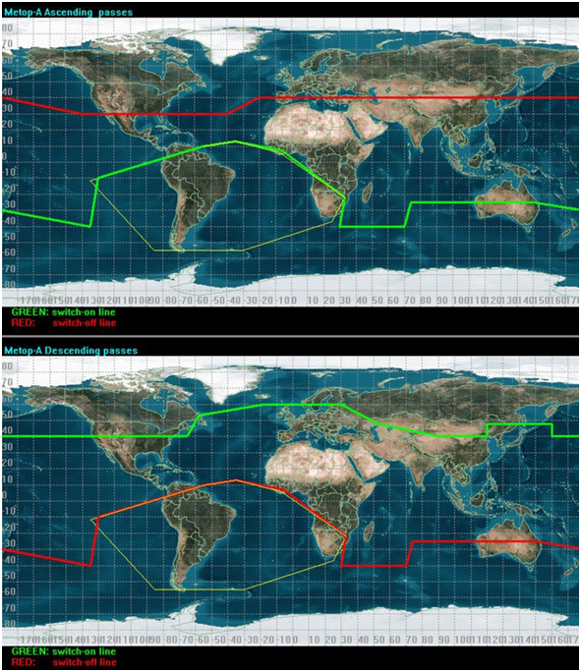

Figure 12 : METOP-A HRPT Extended Switch Zone (Descending and Ascending orbits)

## Ascending Nodes Local hour

The diagram here below presents the local time of ascending notes in June 2014

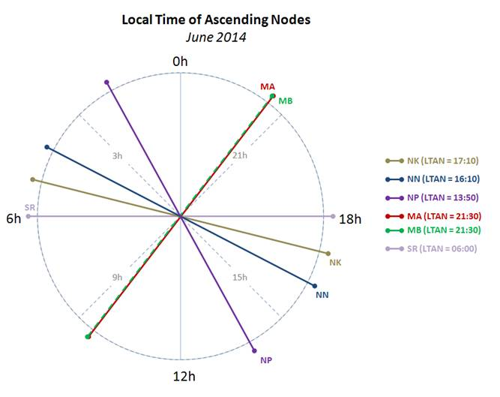

Figure 13: Local Equator crossing time in June 2014

# Argos ground segment



## Global antennas (store and forward mode)

The Argos global antennas network is composed by seven stations:

* The two NOAA global stations of Fairbanks and Wallops acquire the global recorded telemetry transmitted by NOAA-15, NOAA-18 and NOAA19.
* The EUMETSAT global receiving station of Svalbard acquires the global recorded telemetry transmitted by Metop-A and Metop-B as well as the 2 daily blind orbits of NOAA-19 for NOAA stations.
* The NOAA Svalbard antenna that delivers NOAA-15 and NOAA-18 blind orbits for Fairbanks and Wallops when not in conflict with NOAA-19.
* Inuvik (Canada) and Kiruna (Sweden) stations for SARAL operated by EUMETSAT.

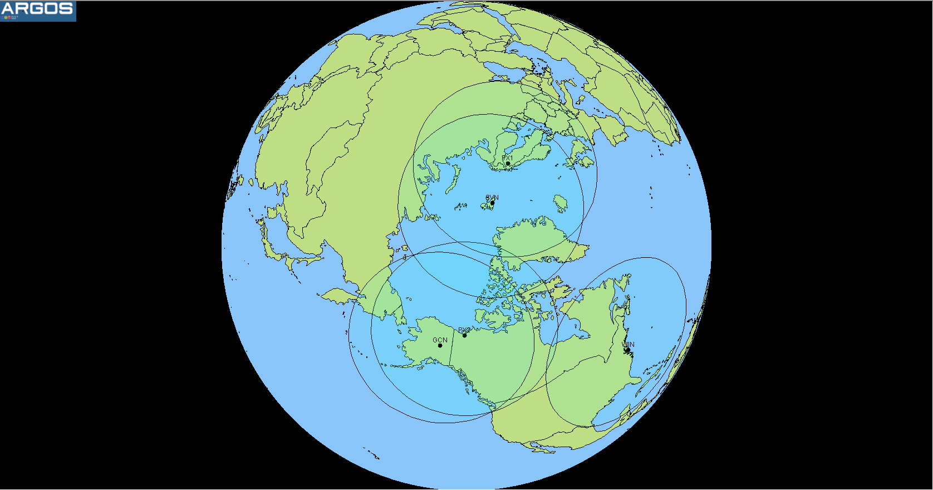

Figure 14 : The Argos Global antenna network (without McMurdo)

* Data recovery from MetOp-B will occur at Svalbard and McMurdo (ADA).  Timeliness benefit of McMurdo data recovery is for MetOp-B only. MetOp-A data will continue to NOAA on a best effort basis and without the timeliness benefits of half orbit dumps at McMurdo.

|  |  |
| --- | --- |
| MML | METOP-A global antennae in Antarctica |

Figure 15 : METOP-B Mc Murdo Global antennas coverage and principle

## Regional antennas (real-time mode)



### Operation and improvements

Improvements are still focused on redundancy locations and coverage extension. Today, both Toulouse (France) and Lanham (USA) processing centers receive Argos real-time data from 65 stations located all over the world.

In 2013, the real-time network is quite steady with 2 new ground stations added:

- Tahiti station (French Polynesia) operated by Meteo France

- Bali (Indonesia) station operated by CLS

This two new stations are part of the HRPT-A4 project and are compatible will all Argos satellites: NOAA, METOP and SARAL.

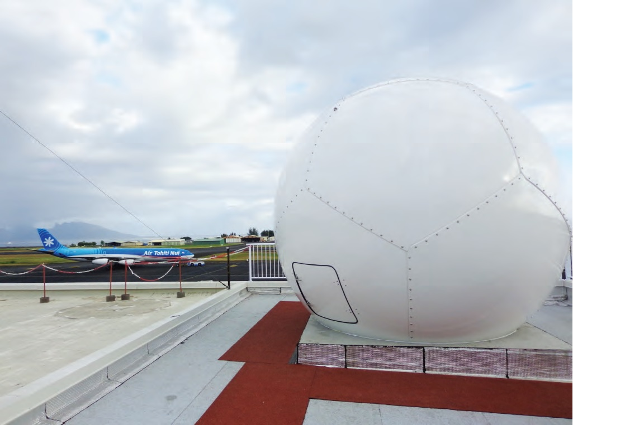

Figure 16 : Argos HRPT Tahiti station

The HRPT ground stations operated by IRD have been removed in 2013 from the network due to operation maintenance difficulties (Noumea, Cayenne, La Réunion…).

The real-time Argos ground station network consists of about 65 antennas. If most of them are capable of receiving NOAA POES satellites data, 22 out of these 65 stations receive METOP satellites data and, for the moment, only 10 receive SARAL data.

In 2013, CNES and CLS efforts were still focused on increasing the number of ground stations capable of receiving POES, METOP and SARAL data. This is what we call the HRPTA4 project consisting in adding new antennas as well as upgrading a set of existing antennas in order to be compatible with all the satellites in orbit. This project also aims at optimizing performances of the real-time receiving stations network with fewer stations for better performances.

Here below are displayed the Argos HRPT coverage world map and the list of the 66 operational stations part of the Argos real-time antennas network in 2014.



Figure 17 : May 2014 Argos Real-time coverage map

|  |  |  |  |  |  |  |  |  |  |
| --- | --- | --- | --- | --- | --- | --- | --- | --- | --- |
| Name | Code | Country | Operator | Possible satellites | | | | | |
| Andersen | AN | GU | US AIR FORCE | NK | NN | NP |  |  |  |
| Ali Al Salem | AS | KW | US AIR FORCE | NK | NN | NP |  |  |  |
| Athens | AT | GR | CLS |  |  | NP |  |  |  |
| Buenos Aires | BA | AR | INTA | NK | NN | NP |  |  |  |
| Bali | BL | ID | PT CLS INDONESIA | NK | NN | NP | MA | MB | SR |
| Casey | CA | AU | BOM | NK | NN | NP |  |  |  |
| Cape Ferguson | CF | AU | NOAA NESDIS | NK | NN | NP |  |  |  |
| Santiago | CH | CL | METEO CHILE |  | NN | NP |  |  |  |
| Darwin | DA | AU | BOM | NK | NN | NP |  |  |  |
| Davis | DV | AU | BOM | NK | NN | NP |  |  |  |
| Edmonton | ED | CA | ENVIRONNEMENT CANADA | NK | NN | NP |  | MB |  |
| Elmendorf | EL | US | US AIR FORCE | NK | NN | NP |  |  |  |
| Lannion | FL | FR | METEO-FRANCE |  |  |  |  |  | SR |
| Reunion Island | FR | FR | METEO FRANCE | NK | NN | NP | MA | MB | SR |
| Libreville | GB | GA | CLS | NK | NN | NP | MA | MB | SR |
| Gilmore Creek | GC | US | NOAA NESDIS | NK | NN | NP |  | MB |  |
| Sondre | GR | GL | DMI | NK | NN | NP |  |  |  |
| Halifax | HF | CA | CANADIAN COAST GUARD | NK | NN |  |  |  |  |
| Honolulu | HI | US | US AIR FORCE | NK | NN | NP |  |  |  |
| Halley | HR | GB | British Antarctic Survey |  | NN | NP |  |  |  |
| Hatoyama | HT | JP | Jaxa | NK | NN | NP | MA | MB | SR |
| Hawaïi | HW | US | NOAA NWS |  | NN | NP | MA | MB |  |
| Hyderabad | HY | IN | INCOIS | NK | NN | NP |  |  |  |
| Tokyo | JM | JP | CUBIC-I | NK | NN |  |  |  |  |
| Okinawa | KA | JP | US AIR FORCE | NK | NN | NP |  |  |  |
| Lajes (Acores) | LA | PT | US AIR FORCE | NK | NN | NP |  |  |  |
| Lima | LM | PE | CLS PERU | NK | NN | NP | MA | MB | SR |
| Miami | MA | US | NOAA AOML | NK | NN | NP | MA | MB |  |
| Melbourne | ME | AU | BOM | NK | NN | NP |  |  |  |
| Miami Capture | MI | US | CLS FR |  |  |  | MA | MB | SR |
| Mc Murdo | MM | AQ | NOAA |  |  |  |  | MB |  |
| Manas | MN | KG | US AIR FORCE |  | NN | NP |  |  |  |
| Montererey | MO | US | NOAA NESDIS | NK | NN | NP | MA | MB |  |
| Wellington | NZ | NZ | NIWA |  | NN | NP |  |  |  |
| Perth | PE | AU | BOM | NK | NN | NP |  |  |  |
| Lima | PR | PE | CLS PERU | NK | NN | NP |  |  |  |
| Kiruna | PX | SE | Eumetsat |  |  |  |  |  | SR |
| Resolute Bay | RB | CA | Environment Canada | NK | NN | NP |  |  |  |
| Reunion Island | RN | FR | METEO FRANCE |  | NN | NP |  |  |  |
| Rothera | RO | GB | British Antarctic Survey | NK | NN | NP |  |  |  |
| Lannion | RS | FR | Meteo France |  |  |  | MA | MB |  |
| Ramonville | RV | FR | CLS | NK | NN | NP |  |  |  |
| Cape Town | SA | ZA | SAWB |  | NN | NP | MA | MB | SR |
| Soto Cano | SC | HN | USAF | NK | NN | NP |  |  |  |
| Séoul | SE | KR | KMA |  | NN | NP |  |  |  |
| Singapore | SG | SG | SMM | NK | NN | NP |  |  |  |
| Shanghai | SH | CN | EAST CHINA SEA FISHERIES | NK |  | NP |  |  |  |
| Sembach | SM | DE | US AIR FORCE | NK | NN | NP |  |  |  |
| Svalbard | SN | NO | NOAA |  |  | NP | MA | MB |  |
| Svalbard | SV | NO | EUMETSAT |  |  |  | MA | MB |  |
| Svalbard NOAA | SW | US | NOAA | NK |  |  |  |  |  |
| Papeete | TA | FR | METEO-FRANCE | NK | NN | NP | MA | MB | SR |
| Toulouse | TE | FR | CLS |  | NN | NP |  |  | SR |
| Taïwan | TW | TW | NTOU | NK | NN | NP |  |  |  |
| Valley Forge | UA | US | US AIR FORCE | NK | NN | NP |  |  |  |
| Lannion | WE | FR | METEO FRANCE |  | NN | NP |  |  |  |
| Wallops Island | WI | US | NOAA NESDIS | NK | NN | NP |  | MB |  |
| Athens EARS | XA | GR | EUMETSAT |  | NN | NP | MA | MB |  |
| Edmonton EARS | XE | CA | EUMETSAT | NK | NN | NP |  |  |  |
| Gander EARS | XG | CA | EUMETSAT | NK | NN | NP |  |  |  |
| Kangerlussuaq EARS | XK | GL | EUMETSAT | NK | NN | NP |  | MB |  |
| Maspalomas EARS | XM | ES | EUMETSAT | NK | NN | NP | MA | MB |  |
| Muscat EARS | XO | OM | EUMETSAT EARS |  | NN | NP | MA | MB | SR |
| Moscou EARS | XR | RU | EUMETSAT | NK | NN | NP | MA |  |  |
| Svalbard EARS | XS | NO | EUMETSAT |  | NN | NP | MA | MB |  |

Figure 18 : List for Operational Antennas on July 2014 and tracked satellite

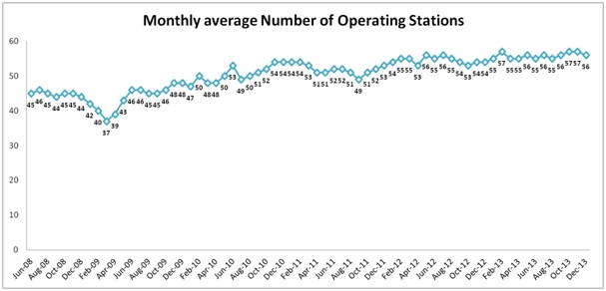

Figure 19 : Operational Argos real-time antennas since January 2008

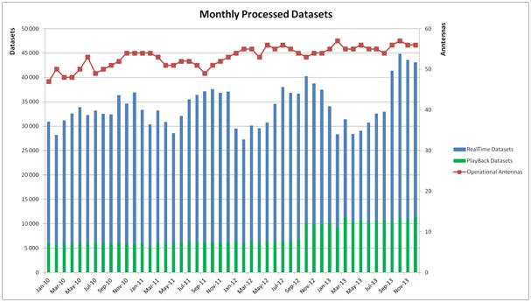

Figure 20 : NOAA/METOP/SARAL Playback and Real-time datasets processed per Month

### METOP real-time coverage

All METOP HRPT compatible antennas were configured to track Metop-B except some of the EARS Station network.

* Metop-A by NOAA ESPC: Monterey, Ewa Beach, Miami
* Metop-B by NOAA ESPC: Ewa Beach, Miami, Gilmore Creek, Wallops Island, Monterey
* Metop-A by Eumetsat : EARS network
* Metop-B by Eumetsat : EARS network except Moscow, Edmonton, Gander

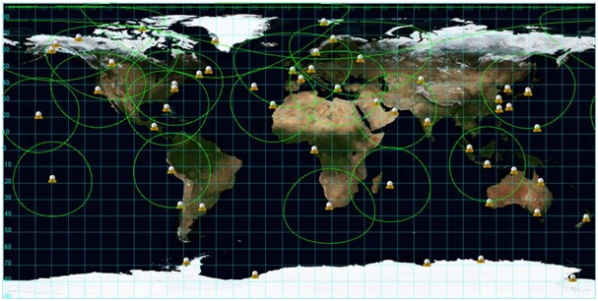

Figure 21 : Current METOP-A (and soon METOP-B) coverage

### HRPT-A4 project

This project had been initiated in 2010 and was presented for the first time during the 43rd Operation Committee. It consists in upgrading a significant part of the network so that it is capable of acquiring data from NOAA, METOP and SARAL satellites. The very flexible technology of the receiver should make it compatible with the future satellites which will carry Argos-4 payloads.

On the basis of a system study aiming at selecting the minimal subset of ground stations to be upgraded to get the better overall system performances, a group of 20 stations as shown on the map below have been chosen.

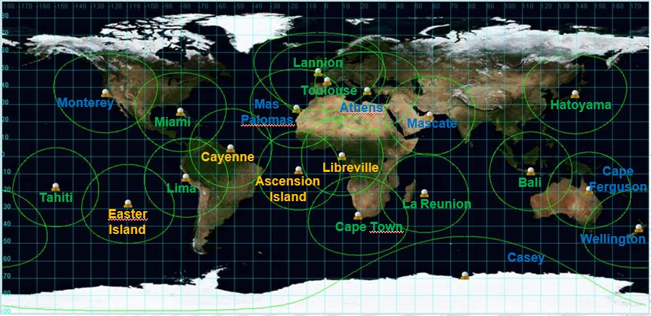

**Figure 22 : Argos HRPT-A4 network**

From an engineering point of view, all the equipment requested to upgrade an existing station is tested and ready to be deployed.

From a deployment point of view, it has to be noticed that the negotiation with the host organizations is taking much more time than expected at the beginning of the project.

On the date of August 2014, the status of the deployment is as follows:

**11 Operational ground stations:**

* Lima
* Lannion
* La Réunion
* Hatoyama
* Miami
* Cape Town
* Bali
* Tahiti
* Libreville
* Oman
* Toulouse (spare equipment)

**6 Upgrade scheduled end of 2014:**

* Mas Palomas (waiting for authorization)
* Athens (waiting for authorization)
* Monterey (waiting for authorization)
* Cape Ferguson (under discussion with the Australian Bureau Of Meteorology waiting for authorization)
* Wellington (under discussion with the Australian Bureau Of Meteorology waiting for authorization)
* Casey (under discussion with the Australian Bureau Of Meteorology waiting for authorization)

**3 Upgrade scheduled in 2015:**

* Ascension Island (Under discussion with European Space Agency)
* Cayenne – French Guyana
* Easter Island

## Processing centers

The two global processing centers in Toulouse and Lanham were nominal over 2013 and first semester of 2014. Redundancy is used at least once a month (Up to two times on one month). Redundancy means all Argos users rerouted to CLS or CLSA during an anomaly on the nominal global processing center.

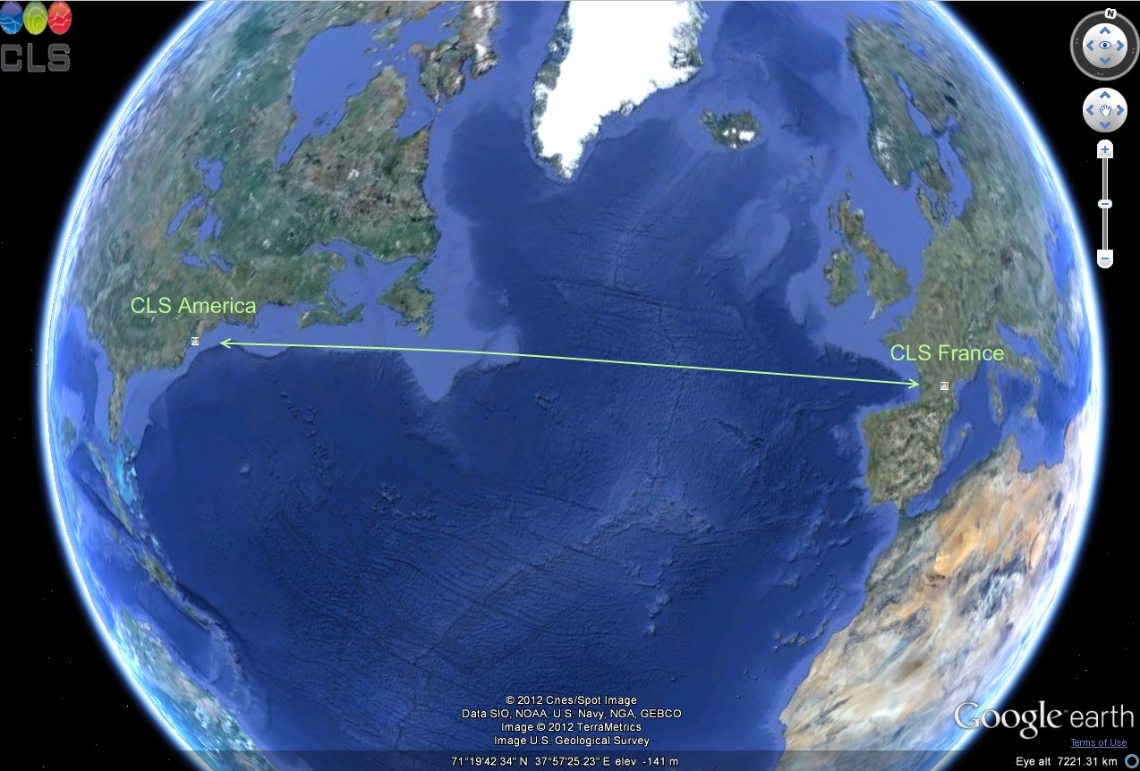

Figure 23 : Global and Regional Processing Centers



Figure 24 : CLS Toulouse new building

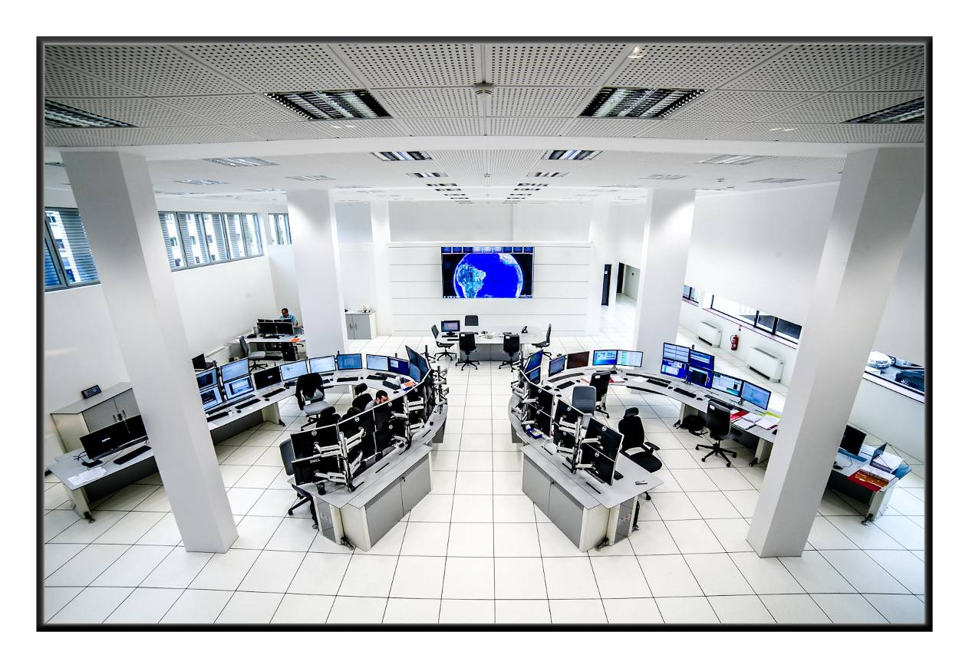

Figure 25 : CLS Toulouse Control Room



Figure 26 : CLS Global Processing Data Center

### Argos global processing centres architecture

In 2011, https architecture in CLS France was updated and CLS America firewalls were replaced to get the same hardware and software version as CLS France. We also initiated a rebuilt of ARGOS application servers, in order to prepare the next decade. This process was started on the development configuration in CLS France. The application server is now based on CentOS Linux release 6.0, 64 bits (rather than RedHat, 32bits).

In 2012, these changes on operating systems have been propagated up to the operational configurations, both in CLS America and CLS France datacenters. In order to address the increase of quantity of data to be processed (due to the launch of METOP-B and SARAL spacecraft), space disk have been increased and few processing servers have been added. The databases backup mechanism has been optimized and updated.

In 2013 and 2014 most of the improvements regarding the Argos processing centers have concerned the performances as well as the scalability:

- the physical servers have been replaced by virtualized servers (Vmware)

- the two physical database servers have been changed by two new powerful servers

- the Argos database has been split into two distinct database : short term database which contains data < 18 months and a long term database for data beyond 18 months.

Each global processing center is autonomous and can work alone. In normal mode, both processing centers receive, process and distribute Argos data to:

* North American users for CLS America
* Users of the rest of the world for CLS France

In case of problem with one of the two centers, the other one stays alive and is capable of receiving, processing and distributing Argos data to ALL users. The switch to the remaining alive center is completely transparent for the users. It means that the users continue to receive or to access to their data, without changing anything on their side, as if nothing has happened.

The figure here below represents the architecture of CLS France and CLS America global processing centers.

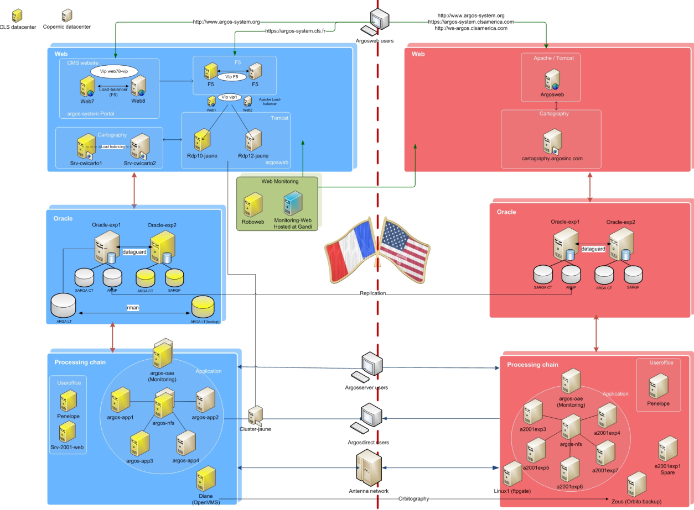

Figure 27 : CLS Toulouse and CLS America IT architecture

The architectures of CLS France and CLS America processing centers are quite similar and based on the same principle. We find three main subsets detailed in the following chapters:

* the processing chain
* the Oracle database service
* the Web distribution

### The CLS Argos processing chain

Composed of different software modules, the processing chain is in charge of receiving and processing the Argos data issued from the satellites and acquired by the global and real-time ground stations networks.

Argos data are processed in terms of collect and location, and stored into a database.

The processing chain is also in charge of distributing the data by ADS (Automatic Distribution System) or allowing users to access to their data using Telnet, ArgosWeb or the web services.

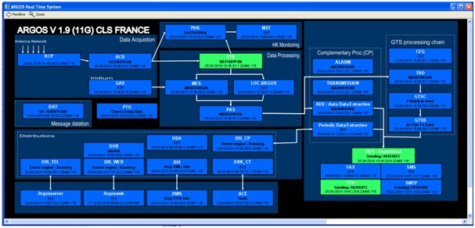

Figure 28: Synoptic of the CLS Argos processing chain

### The Oracle database

At the heart of the computing architecture, the Oracle database is used to store the Argos declarative data as well as the processed data.

In order to keep a perfect coherency between CLS France and CLS America centers (mandatory to guarantee the redundancy between both centers), an automatic mechanism of replication is implemented between CLS France and CLS America databases.

## The Argos data distribution and processing

### ArgosWeb site

Based on a farm of Apache Web servers, the Web distribution allows the users to access their data using a Web cartographic interface. The service of maps is supported by two cartographic servers on which are running the mapping engines C-Map for the marine cartography and MapInfo for the terrestrial one. The application server is supported by Tomcat. ArgosWeb is a free web site for Argos users. They can access their data via the Internet, by logging on to a secure [website](http://www.argos-system.org) ([http://www.argos-system.org](http://www.argos-system.org/)) with their username and password (assigned to them by User Services).

ArgosWeb gives users secure and easy access to Argos data via an attractive and user-friendly website. With ArgosWeb, users can view platform trajectories on land and marine maps. Users can also personalize data download formats (table or map format). Users have immediate access to information on their Argos account, as well as platform and program settings.

The annual availability of the French ArgosWeb site (FR) in 2013 is 99.74%

The annual availability of the U.S. ArgosWeb site (US) in 2013 is 99.68%

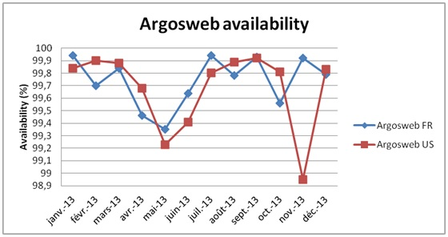

**Figure 29 : ArgosWeb availability in 2013**

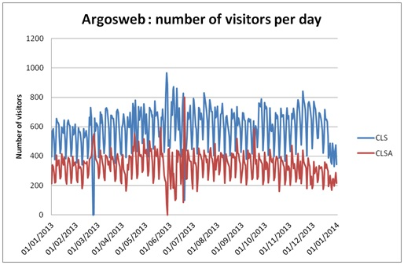

**Figure 30 : Number of daily ArgosWeb accesses in 2013**

### ArgosServer

With ArgosServer, the Argos users can logon to Argos Processing Centers and access their data via TELNET. TELecommunication NETwork is a network protocol used by all TCP/IP compatible networks. A Telnet session with CLS's servers can be opened by typing the "Telnet" command on most operating systems (Windows, Unix...). Addresses of the both ArgosServers are:

* + ArgosServer.cls.fr
  + ArgosServer.clsamerica.com

The annual availability of the French ArgosServer site (FR) in 2012 is 99.85%

The annual availability of the U.S. ArgosServer site (US) in 2012 is 99.72%

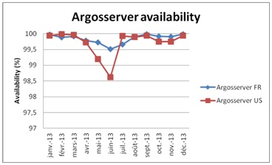

**Figure 31 : ArgosServer availability in 2013**

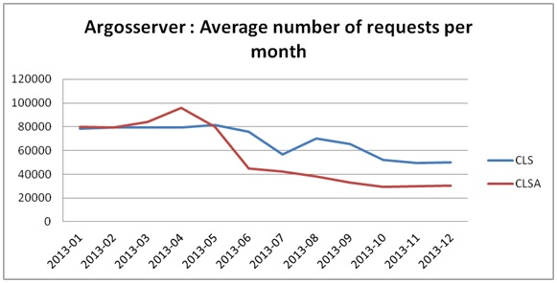

**Figure 32 : Number of ArgosServer requests in 2013**

### ArgosDirect

ArgosDirect automatically sends data to users by e-mail, FTP or CD-ROM. ArgosDirect allows users to receive their data in several available formats (tabular, DS, DIAG…).

Backup periods (One processing centre is sending data of the other processing centre) are clearly identified on the graph below.

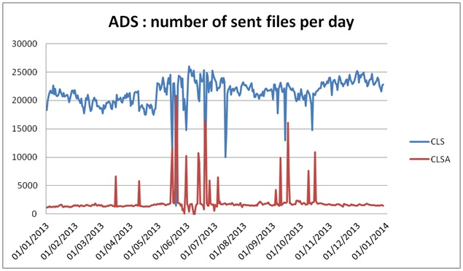

**Figure 33 : Daily number of files sent by ArgosDirect in 2013**

### Argos WebService

Argos WebService is a machine-to-machine/automatic interface for Argos data distribution. This modern alternative to ArgosServer (Telnet) is free of charge and makes it possible for Argos users to contact CLS’s database directly, via internet, and receive their data in **CSV, XML and KML (Google Earth) format**. The Argos WebService delivers useful information such as positions, error estimates, diagnostic data, raw messages, sensor data, etc. The user can choose the different types of data to download via filters.

The annual availability of the French WebService (FR) in 2012 is 99.89%

The annual availability of the U.S. WebService (US) in 2012 is 99.91%

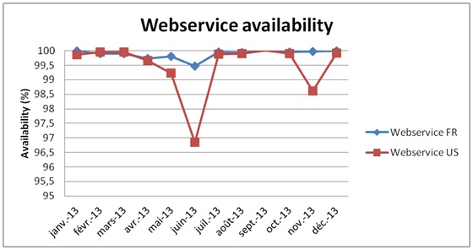

**Figure 34 : Argos WebService availability in 2013**

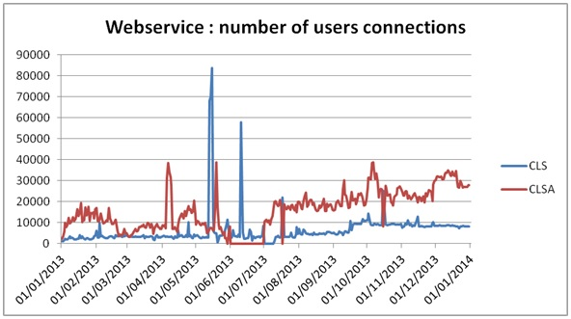

**Figure 35 : Number of Argos WebService connections in 2013**

### Disaster recovery architecture

Disaster recovery architecture implementation is completed since 2012. The computer room is located into CNES Toulouse. Some of the Argos architecture components are DR compliant in order to improve services availability. However, the main backup is based on the 2 global processing centers (Toulouse & Lanham).

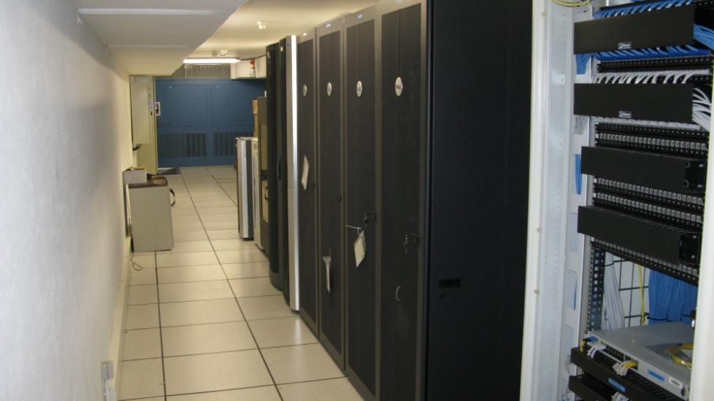

Figure 36 : Disaster Recovery Room located in CNES

### Data processing statistics

The Argos Operations missions at CLS are:

* Availability and reliability of Argos Products and Services in accordance with the SLAs,
* Support internal or external Argos projects, or proposals,
* Control and reduce operational risks and costs in order to ensure 24h/24, 7 days per week operational services.

In order to monitor the Argos processing centers, statistics are produced in real-time:

* on the availability of Argos data distribution tools,
* on the data delivery time for sample platforms,
* on Argos location delivery time for sample platforms,
* and on the percentage of data available in less than one hour.

**In 2013, the processing performance indicator is 97,57%.** This indicator corresponds to the percentage of real time datasets processed in less than 10 minutes (Between Pre-Processing component PTR and PAS component in charge of inserting data in database for user requesting). This number does not include periods when French site was in backup mode on the US site.

In this context, decreasing availability could be observed in case of pending datasets inside the processing chain. For example, when several Global datasets are received at the same time, during these periods, other datasets are queued and are waiting to be processed increasing the time they passed between PTR and PAS modules. Priority to Realtime datasets processing was added in July 2013 to avoid this queuing effect

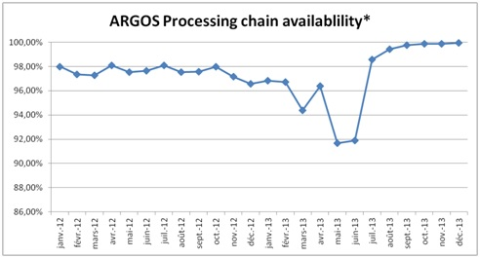

Figure 37 : Argos Processing chain availability in 2013

*(% of Realtime datasets processed in less than 10 minutes)

### Number of Argos messages and locations processed

Number of locations and messages computed every day by the Lanham and Toulouse Centers are, in average:

|  |  |  |  |  |  |
| --- | --- | --- | --- | --- | --- |
| **Number Per day** | **2009** | **2010** | **2011** | **2012** | **2013** |
| Messages received | 2 273 233 | 2 871 885 | 2 904 476 | 2 790 580 | 3 060 434 |
| Distinct Messages received | 1 272 459 | 1 470 953 | 1 451 938 | 1 443 247 | 1 513 630 |
| Argos Locations | 77 837 | 94 151 | 92 168 | 93 343 | 94 626 |
| GPS Locations | 185 496 | 205 259 | 212 587 | 224 857 | 243 366 |

Figure 38 : Argos messages and locations per day (table view)

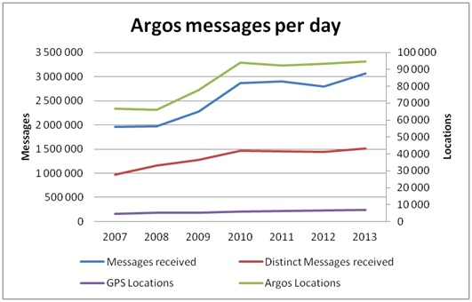

Figure 39 : Argos messages and locations per day (Chart view)

### Argos location and data collection latencies

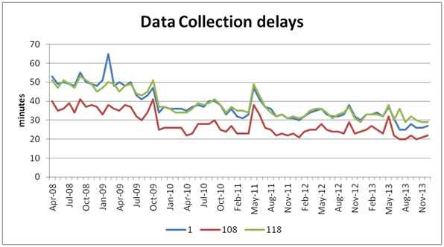

Figure 40 : Average latency on Argos data collection for sample platforms* since 2008

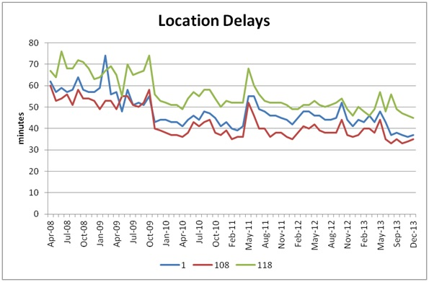

Figure 41 : Average latency on Argos locations for sample platforms* since 2008

* Sample platforms are timing and orbit determination platforms. Every hour, the last data collection and location times for these three platforms are controlled. Collection and location latency on ID 108 (Fairbanks) is under latency of Ids 1(Toulouse) and 118 (Wallops Island) due to the transmitter location and the higher number of passes over this transmitter.

We can see major improvement on data and Argos location delivery time since 2008 due to a better real-time antennas network, new operational Argos satellites (NOAA-19, METOP-B and SARAL) and enhancements of the Argos data processing performance. Increase during May 2011 is due to processing issue (Database insertion driver issue). The average latency on Argos data collection in Northern hemisphere is now less than 30 minutes.

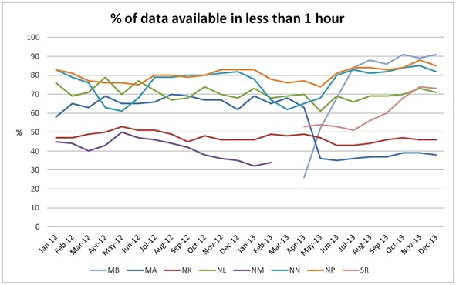

Figure 42 : Data available in 1 hour

Percentage of data available in less than one hour means which percentage of raw data has been processed one hour after its recording on board of the Argos Instrument. NOAA N, M and P operational satellites get a better coverage than NK and NL. For clarification, the Data Timeliness calculations include this metric plus the satellite revisit time.

### Monthly active Argos platforms

The number of Argos platforms operating is quite stable in 2013. There is still more activity in Spring/Summer due to the higher number of deployments.

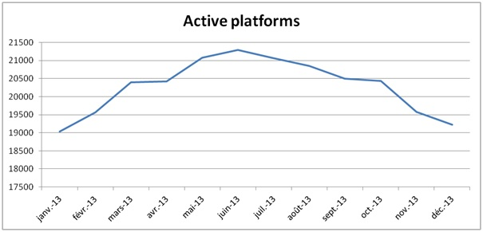

Figure 43: Monthly active Argos platforms in 2013

## System improvements

As every year, several software improvements were implemented in 2013 in order to fit with the user requirements. During this year, 114 anomaly forms have been treated as well as 137 system change proposals. These application improvements have concerned:

* **On-line data extraction on archive database**

Until now there was no possibility for the users to extract its own data on archive database. We have developed a new module allowing the users to extract their own data on archive database (last 12 months of data available). The users create a request using ArgosWeb interface. The data are extracted in less than 30 minutes within 99% of the cases. When the extraction is finished a mail is sent to the user with a link for downloading its data.

* **Migration Oracle 11G plus opening of 20 days on-line data extraction for ArgosWeb and Web service**

Before giving access to the users to 20 days on-line, we needed to migrate Oracle version to 11G to have better performances on database accesses. The access to 20 days on-line was opened in early 2014.

* **Migration of Argos operating system (OS)**

The migration of production environments has been done at the end of 2013.

* **Android application**

A new Android cartography application has been developed to allow users to access to their PTTs locations through Smartphones.

* **Integration of a new BUFR sequence for drifting buoys**

The new BUFR sequence for drifting buoys has been qualified. The sequence is ready for deployment, awaiting the official publication of the BUFR tables by the WMO.

2014/2015 will see new improvements. Among the ones which are already planned, we can list:

* **New Argos Orbitography**

The adaptation of orbitography module (ZOOM) by CNES for Linux environment is done. The integration in Argos processing center is started and will be completed in 3rd quarter of 2014.

* **New earth elevation model**

For Kalman location only, a new earth elevation model (ACE3) has been integrated to compute more precise locations in some earth areas, and give better altitude accuracy. The integration is completed and it will be put in operation during 3rd quarter of 2014.

* **Improvement of web services for Argos-3**

The Argos Web Service regularly receives new capabilities. The possibility to send user messages to PMTs will be the next major improvement.

* **BCH message decoding**

The study of a BCH message coding to improve Argos message transmission in noisy regions is finished. The development will be realized in 2014. The integration into the processing chain is scheduled beginning 2015.

* **New databank formats**

On-line data extraction on archive database service will support xml and kml formats.

## ARGOS-4 ground segment upgrade

This project is aiming at identifying and implementing all the modifications of the existing Argos ground segment to take into account the new generation of Argos-4 instrument as well as a general enhancement of the Argos ground segment. This activity has been delegated to CLS by CNES.

Despite the fact that we do not know when the first Argos-4 payload will fly, the decision of starting the Argos-4 ground segment upgrade has been made, at least the part dedicated to the general enhancement of the Argos ground segment. The project includes the following activities:

**Developments:**

* Major developments will concern the Argos Processing Center, which will be able to manage all the operational Argos instruments.
* New Master Beacons will be produced. They will have to be compatible with Argos-2, Argos-3 and Argos-4 instruments. They will replace the current Master Beacons.
* New Reference Beacons will be produced. They will be compatible with Argos-2, Argos-3 and Argos-4 instruments.

**Qualification on a dedicated Argos Processing Center instance:**

* The ground segment technical qualification will follow the development phase. It will include the qualification of technical specifications, the compatibility tests with Argos-2 and Argos-3 processing. In order not to disturb or impact the existing and operational Argos processing centers, all the qualification operations will be performed by using an Argos Processing Center specifically built for the Argos-4 project. This dedicated center will be available for CNES compatibility tests.
* Next step will be the ground segment operational qualification. The processing center performances will be checked; the operational documentation will be upgraded for Argos-4; the operational team will be trained. The dedicated Argos-4 Processing Center will be available for CNES end-to-end tests.
* Final step will concern the system operational qualification which will start after the satellite launch. The system performance will be validated; the operational procedures will be conducted; the operational instrument monitoring will start. During this phase, CNES will use the Argos-4 Processing Center for the instrument in-orbit commissioning.

**Operation:**

* Before the satellite launch, the new Master Beacons will be deployed, probably at Svalbard, Fairbanks, and Toulouse.
* After the instrument in-orbit commissioning and the system operational qualification, the production Argos Processing Center will be upgraded and configured.
* It will start Argos-4 (and of course Argos-2 and Argos-3) routine processing.
* After the CNES to CLS handover, CLS will operate the instrument and distribute the Argos-4 products.

**Status of the project:** The project has just started.

## Argos-3/Argos-4 chipset

Thanks to the Argos-3 implementation plan, we learned about the importance of low power consumption PMTs as well as an Argos-3/Argos-4 receiver for the Argos community.

The objective of the "Argos chipset" project is to design, manufacture and test a prototype of a miniaturized and low-cost ARGOS-3/-4 satellite chipset (Asic) that enables two way communications (Argos-3, Argos-4) and provides improved battery lifetime.

The project is called SHARC (**S**atellite **H**igh-performance **A**RGOS-3/-4 **R**eceive/transmit **C**ommunication) and is aimed at:

* Developing a low-cost Argos-3/4 chipset
* Developing a pop-up tag which uses the Argos chipset

In the frame of the European Artes-5 Program, the Belgium Space Agency together with CNES are supporting a 2 M€ contract for developing such solutions.

The project led by ANSEM (manufacturer of chipset) is in good shape:

* the ARGOS-3/4 has been fully defined and the first run of foundry has taken place. Currently, tests are being conducted at ANSEM facility
* The popup tag that will support the field application has been fully defined by StarOddi and will be manufactured at the beginning of this summer
* Finally CLS trough its expertise of the ARGOS system has provided all necessary information to ANSEM as well as to StarOddi to insure a well defined tag/chipset system

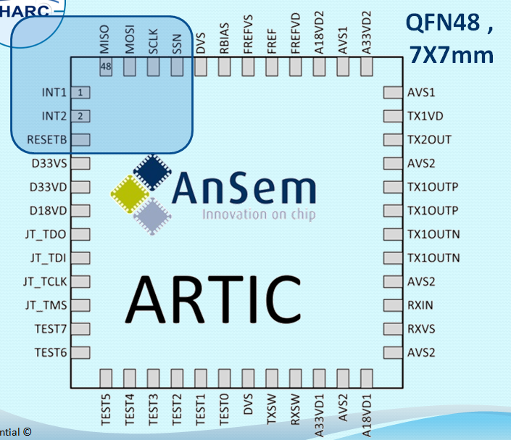 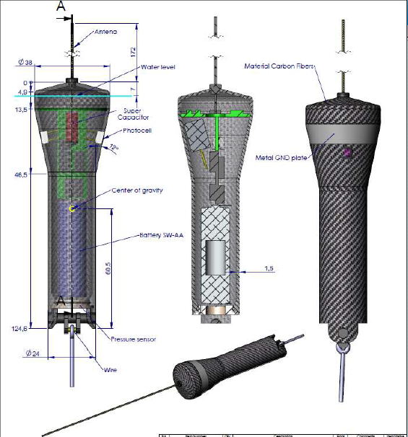

Figure 44 : Argos-3/4 chipset and tag scheme

Next important steps before the end of 2014:

* Tests and certification of the chipset at CNES facilities
* First tests at sea of the popup tag including the chipset

The SHARC project started in October 2012 and will end in March 2015. We expect the chipset to be 5mm X 5mm. It will include the Rx and Tx RF modules that will apply the Argos-3 and Argos-4 capabilities.

A key objective of this project is to offer to all Argos platform manufacturers the capability to integrate Argos-3 and Argos-4 functionalities at very low cost.

## Argos goniometer

|  |  |
| --- | --- |
| De Profil  **Figure 45 : New Argos goniometer** | At the request of the Argos users who want to be able to retrieve their Argos transmitters (animal tracking, floats, drifting buoys,…) CLS contracted with the company Xerius, located in Toulouse to develop a new Argos direction finder.  After one year of study and development, the first prototype was delivered to CLS in March 2013. The tests and validation performed since April have been successful. SHOM, the French Navy, has already tested and approved the new Argos goniometer.  Depending to the goniometer antenna altitude, the Argos platform transmission power and the environmental conditions, the Argos signal can be received by the RXG-134 from few meters to more than 100 km.  Received Argos demodulated messages and Argos platform transmitter terminal (PTT) reception angle are displayed on the screen and available on the serial port.  The CLS goniometer is fully compatible with all Argos transmitter generations: from Argos-1 to Argos-3 including the PMT. |

# Review of User Requirements mentioned in the 2013 national reports

At JTA-33, the meeting requested CLS to address the following issues arising from the national

reports presentations in 2013 (*action: J33#11 CLS; JTA-34*):

## Issues mentioned in the Australian report

*“There is a complicated or unclear terminology used in Argos forms, which are difficult to interpret*”

CLS doesn’t have any details about the referenced Argos forms but the main Argos forms used are the following:

* **SUA:** The Argos system is dedicated to studying and protecting the environment. For this reason, a specific policy governing system use is applied and programs must first be reviewed and approved by the Argos Operations Committee. The SUA is the official form, including the policies governing the use of the Argos DCS, which must be submitted for getting the approval of using the Argos system. It is established by the OPSCOM (Operation Committee and participating agencies, NOAA, CNES, EUMETSAT and ISRO) and cannot be changed by CLS. However, the procedures have been simplified and CLS teams can help the Users to fill in the SUA form.
* **ID number request:** This form is necessary for requiring ID numbers allocated to platforms. There is very few technical information required as CLS has pre-registered most of the formats developed by the manufacturers who can also help the Users with information required about the platforms models.
* **Dedicated form for Value Added Services such as ADS or Buoys Monitoring**

CLS has developed a set of value added services. When specific data processing is required, some technical information is mandatory for providing corresponding services.

For providing the best support to the Users CLS has implemented over the years Offices worldwide. In case of problem for filling out the forms, support teams can help and explain the terminology used if required.

Please clarify what specific terminology is complicated or unclear and we will be happy to assist.

## Issues mentioned in the Chinese report

The topics presented by the ROC seem to be the subjects that had been discussed and fixed during the year by the CLS representative in China:Tianjin Haihua Technology

* *National Huidong Sea Turtle Reserve: Technical training is required.*

User has attended the CLS workshop in June 2012, where CLS teams provided training on Argosweb and dedicated technical support.

* + *National Ocean Technology Center: Possibility to pay the bill on a semestrial basis.*

A prepayment is set up for facilitating the management and the payment of invoices

* + *Tianjin Hydrowise Technology Development Center*

*• Extend the free on-line availability of Argos data*

Access to 20 days on line was implemented in January 2014.

*• Check the correctness of the mailbox and addresses regularly to guarantee the reception of invoices by the customers.*

CLS has been facing difficulties to ensure the payment of its invoices by China for several years. Invoices sent by postal mails were lost. Some are now sent by email upon the Client's request. However, some addresses are faulty, program managers have changed without notification and our sales management teams have spent a lot of time chasing down the outstanding invoices. Unfortunately, over the years, some users funding is no longer available and invoices remain unpaid. It is a big challenge for CLS and its representative in China to recover the payment of invoices.

## 4.3 Issue mentioned in the Indian report

*The Indian ROC reported an inconsistent performance of some Argos transmitters of their buoy systems.*

This complaint relates to a specific buoy sold in 2013 to INCOIS and which had a defective battery. CLS sent a new battery pack to INCOIS in February 2014 to replace the faulty one.

________________

**Annex ix**

**Review of the Structure of the Tariff Agreement and related matters**

*(Submitted by CLS)*

# Report and recommendations from the Operation Committee

## Report of the JTA Chairman

For the JTA Chairperson’s report, see Annex V.

## Status of U.S. Programs

Mr. Locklear provided a status of the U.S. programs and focused on two items, past reported issues and the future of the Global Drifter Program. The past problems with the global drifter buoys shortened lifetimes have been well documented, but what wasn’t known were the costs of these failures.

Mr. Locklear reported that the current estimate of the cost to the U.S. program of the drifter failures is $800,000. He went on to report that the Climate Program Office, which funds the Global Drifter Program has lost approximately $50.0 million over the last 3 years. However, due to a different description of the GDP program, they are now expected to be protected from future budget cuts.

Lastly, Mr. Locklear reported that while the global drifter array is still expected to remain at 1,250, the proportion of ARGOS equipped drifters may drop to 75%. If this reduction happens, the upcoming ARGOS JTA 5 year plan will be adjusted as the U.S. may no longer benefit from the highest discount tariff for large programs.

## Financial Status of Agent

Christophe Vassal presented the CLS methodology to derive the Argos basic costs to be attributed to the JTA.

It showed that the Argos basic costs have slightly increased from 12.01 M€ in 2012 to 12.29 M€ in 2013. The Argos basic costs for science have remained stable whereas the Argos basic costs for fishing have increased, mainly because of a continued interest in Argos from a number of countries to track their fishing vessels. The Argos basic costs for sensitive use have slightly increased while the corresponding income has decreased. There is a need to continue to develop actions towards that user community to increase their usage of Argos.

In 2013, the costs to be attributed to the JTA are calculated at 7.03 M€ : it represents a 0.72% increase with respect to 2012 while the average active PTTs processed and distributed decreased to 12 080 compared to 12 488 in 2012.

At the 33rd JTA meeting in 2013, the following was decided:

* The JTA projection for the year 2013 is estimated from figures based on seven months of usage, extrapolated until the end of the year. At this point in time, the JTA considered that, in 2013, the JTA will likely be able to pay its portion of the cost. In view of the above summarized situation, the JTA encouraged CLS to pursue their efforts to reduce operational costs while promoting increased usage.
* Overall, the JTA basic income is expected to be 6.68 M€ in 2013, 13.5% under the figure planned in the original [2009 ; 2014] 5Y plan.
* In conclusion, the expected financial situation for 2013 is considered safe. The accumulated balance would remain significantly positive. Nevertheless, risks will continue to be monitored very closely by CLS.

The JTA acknowledged that CLS has been successful in reducing the cost. The meeting nevertheless requested CLS to manage the cost in view to reduce the losses to the minimum. In parallel, the JTA also invited the user community to take steps to possibly increase their Argos usage.

**Confirmation of 2014 tariffs at 33rd JTA meeting:**

Based on (i) the projections for 2013 and 2014, in which it was expected that the income was balancing the JTA cost, (ii) the positive situation in the accumulated balance in the FYP at this moment, (iii) the uncertainties and possible risks due to the technical problems of the drifters, the JTA meeting decided not to change the Tariff in 2014.

The JTA Meeting has adopted the Terms and Conditions for the 2014 Agreement on the following basis:

* ***BASIC SERVICE***

Basic service charges for authorized users under this Agreement are in accordance with the payment on consumption.

They are calculated according to the following formula:

Price per month, per platform = **A** + **B** x **n**

where:

* **A** represents the monthly charge per active PTT (an active PTT is one that transmits at least once during a given calendar month);
* **B** represents the PTT-day unit rate;
* **n** is the number of day units. The day is divided into 4 time slots (0 - 6; 6 - 12; 12 - 18; 18 – 24 UTC). Any PTT transmission collected into a given time slot produces a 0.25 day unit.

A and B coefficients for all platform categories are provided in table below:

| **Category** | **A (€)** | **B (€)** |
| --- | --- | --- |
| **Buoys and others** | 15 | 5 |
| **Fixed Stations** | 15 | 3 |
| **Animals\*** | 15 | 7.5 |
| **Subsurface Floats** | 15 | 7.5 |

**Buoys and others** – PTTs in this category are drifting and moored buoys and, more generally, all those PTTs which do not belong to categories below.

**Fixed Stations** – PTTs in this category are land fixed PTTs.

**Animals** – PTTs in this category are those that are used to track animals.

*Charges for Platforms in this category will be capped at n=12 Day Units per month.

**Floats** – PTTs in this category are subsurface floats such as the ARGO program floats.

* ***DISCOUNT SCHEME FOR LARGE PROGRAMMES***

|  |  |  |
| --- | --- | --- |
| **Number of platform-years** | **PTT–day unit (B)**  **Buoys & others** | **PTT-day unit (B)**  **Floats** |
| 600 | 4 | 6 |
| 900 | 3 | 4 |
| 1200 | 2 | 3 |

**2013 JTA financial close of accounts**

In 2013, CLS recorded revenues from JTA participating countries at a level of 7.10 M€. This was slightly different from the revenues expected from the JTA (7.90 M€). This shortage in revenue is explained mainly by the technical issues affecting the global drifter program. As a consequence, in 2013, the JTA realized a small excess of 60 K€. The non JTA incomes have remained essentially stable in 2013 (slight increase from 6.27 M€ to 6.30 M€), and the corresponding applications (fishing and sensitive) are still exceeding significantly their portions of the costs.

At the date of the meeting, we believe the JTA in 2014 will likely be able to pay its portion of the cost even though the plan shows a small loss of 50 K€.

The OPSCOM gave its appreciation concerning the clarity of the information provided and encouraged CLS and CLS America to pursue efforts to reduce Argos operational costs while actively promoting the system to existing and future users.

At the end of 2013, it appears that the combined JTA and non JTA excess over the last 27 years has fully offset the initial contribution from CNES (15 M€) to the operation and promotion of the Argos system.

From now on, all excess from a given year in the JTA may be used to finance investments required by users, or to decrease the prices for all or some categories of users.

As a consequence, it was agreed by OPSCOM to simplify the presentation in H-1.5 Financial Status of Agent to stick to the JTA 5YP (2015 - 2019) which is to be finalized at the 2014 JTA and subsequently presented at the December 2014 intersession meeting.

Christophe Vassal proposed to present the co-chairmen with a template of his new presentation at least one month before the next OPSCOM in order to make sure the information provided will meet the OPSCOM's expectations

## The Five Year Plan for 2010-2014



# Financial Statement

## Annual Expenses (in kEuros) for Year 2013



**Detail on 2013 Expenses**

## Details of Amortization Items (in K€)



**Detail of Amortization Items in** K€

## Annual Incomes (in millions of Euros)



**JTA and non JTA 2012, 2013 Incomes**

## Details of JTA and non JTA basic Argos Incomes and Expenses (in million Euros)



**Detail of JTA and non JTA Incomes and Expenses**

## JTA Annual Balance (in millions of Euros)



For year 2013, the costs to be attributed to the JTA, calculated using the methodology developed by CLS since 4 years now, is 7.03 M€.

_______________

**ANNEX X**

**Terms and Conditions of the Global Agreement for 2015**

*(As agreed at JTA-34, November 2014)*

These Terms and Conditions outline costs for services to be provided by Collecte Localisation Satellites (affiliate of CNES).

**TIME PERIOD OF COVERAGE:**

These Terms and Conditions are valid for the time period beginning on **January 1 and ending on December 31, 2015.**

**DEFINITIONS**

"Platform-year" is defined as 365 days of operation of an acceptable Platform Transmitter Terminal (PTT).

“ROC” is the Responsible Organization representing a country or a group of countries.

“RO” is the Responsible Organization representing an agreed set of Argos User programs for the purposes of their collective participation in the JTA.

The "Agreement" includes all those participating countries which agree to the Terms and Conditions contained here in and are listed in Annex A to this Agreement

The “Large Programmes” are defined as those programmes that are funded and managed by a single organisation.

**BASIC SERVICES PROVIDED BY CLS**

CLS will perform the following categories of services associated with PTT's of the authorized users:

1. Location determination or both location determination and data collection for PTT's with a repetition period equal to or less than 120 seconds, application of calibration curves to the data when appropriate, access to the data and distribution of the data according to the paragraph below entitled "Distribution of processed data" and archiving for three months;

(2) Data collection for (fixed station) PTT's with a repetition period equal to or greater than 200 seconds, application of calibration curves to the data when appropriate, access to the data and the distribution of the data according to the paragraph below entitled "Distribution of processed data" and archiving for three months;

(3) Location service plus / auxiliary location

(4) On-line data access ;

1. GTS Processing and Distribution

**USER BASIC SERVICE CHARGES**

*BASIC SERVICE*

Basic service charges for authorized users under this Agreement are in accordance with the payment on consumption.

They are calculated according to the following formula:

Price per month, per platform = **A** + **B** x **n**

where:

* **A** represents the monthly charge per active PTT (an active PTT is one that transmits a least once during a given calendar month)
* **B** represents the PTT-day rate.
* **n** is the number of day units. The day is divided into 4 time slots (0 - 6; 6 - 12; 12 - 18; 18 – 24 UTC). Any PTT transmission collected into a given time slot produces a 0.25 day unit. In 2006 the time slots will be applied only to Animals and Subsurface Float categories.

A and B coefficients for all platform categories are provided in table below:

|  |  |  |
| --- | --- | --- |
| **Category** | **A (€)** | **B (€)** |
| **Buoys and Others** | 15 | 5 |
| **Fixed Station** | 15 | 3 |
| **Animal** | 15 | 7.5 |
| **Subsurface Float** | 15 | 7.5 |

**Buoys and Others**– PTT’s in this category are drifting and moored buoys, and more generally all those PTTs which do not belong to categories below.

**Fixed Station** – PTTs in this category are land fixed PTTs, a specific and set apart subset of Full Time PTTs.

**Animals** – PTT’s in this category are those that are used to track animals.

*Charges for platforms in this category will be capped at n = 12 Day Units per month

**Floats** – PTT’s in this category are subsurface floats such as the ARGO program floats.

**DISCOUNT SCHEME FOR LARGE PROGRAMMES**

|  |  |  |
| --- | --- | --- |
| **Number of platforms** | **PTT–day unit (B)**  **Buoys & Others** | **PTT-day unit (B)**  **Floats** |
| 600 | 4 | 6 |
| 900 | 3 | 4.5 |
| 1200 | 2 | 3 |

*UNUSED IDs*

PTTs which have not transmitted during a period of 24 months will be charged 5 € per month from the 25th month until the ID numbers are returned to CLS/Service Argos. This amount of unit charge will be applied until the ID number is formally returned to CLS by the User. The purpose of this fee is to recover IDs no longer required.

*SILENT SERVICE*

IDs remaining silent but still being used in an agreed programme will be considered by CLS on a case-by-case basis

*INACTIVE STATUS*

This status is intended for those platforms that continue to transmit but for which the location or data collection are of no further use to the user or the community. The following conditions must be met to qualify:

(1) Inactive Status will apply if, and only if, Inactive Status is declared by the signatory of the System Use Agreement for platforms which continue to transmit beyond the programme termination. In that case, further charges will no longer be levied;

(2) The platforms must have operated in Basic Service for a minimum of 2 months;

(3) Data or location information cannot be retrieved nor can the platform revert to any category of service;

1. It is intended that Location and/or data collection may not be computed using a Local User Terminal or other direct readout facility;
2. ID numbers of such platforms are actually returned to CLS/Service Argos who will recycle them after the platform stops transmitting.

**ADDED SERVICES PROVIDED BY CLS AND NOT INCLUDED IN BASIC SERVICES**

Added services such as ArgosDirect (the former ADS, Databank) service, ArgosMonitor, Moored Buoy monitoring and others are provided by CLS and charged according to the yearly catalogue of prices.

**DESIGNATED ROC / RO**

..................................................................

..................................................................

..................................................................

..................................................................

**DISTRIBUTION OF PROCESSED DATA**

(1) These Terms and Conditions do not cover the costs of special additional services made to provide the processed data back to the users. These must be made by the user directly with CLS ;

(2) However, it is understood that CLS will continue to provide data from PTT’s via the World Weather Watch Global Telecommunication System (WWW/GTS) of the World Meteorological Organization (WMO) according to procedures established by WMO.

**BILLING AND PAYMENT**

CLS will send invoices on a two monthly basis (CLS America on a monthly basis) based on consumption to the organizations covered by the country agreement.

**GENERAL CONDITIONS OF AGREEMENT**

(1) The designated ROC / RO and CLS jointly agree the list of users included in the Agreement and will update this list as appropriate. To assist in this process CLS will notify the ROC/RO of any new programmes that might qualify for this agreement.

(2) For additional services not provided within this Agreement, individual users under this Agreement must negotiate directly with CLS. Payments associated with these negotiations must be settled on receipt of the invoice. If these conditions are not met, CLS may stop the distribution of the user's processed data.

(3) Authorized users are defined as those implementing PTT’s which are government funded. However, other users of agencies or organizations which are considered "non-profit" may be authorized. PTT’s funded partly or entirely by private companies or organizations cannot be included in the conditions of this Agreement, even if data are supplied free of charge to national or international organizations. If these rules are not followed, CLS may stop the distribution of this user's data. Should this situation occur, CLS will immediately notify the ROC / RO. Nevertheless, active PTT’s received by the system will be counted in the platform-year total and data stored.

(4) All authorized users must sign a purchase order for each programme, either for the current year or for the duration of the programme, in order to clearly specify the services they request, whether these services are provided under this Agreement or not.

(5) VAT will be charged to EU Members in accordance with EU rules.

|  |  |  |  |
| --- | --- | --- | --- |
|  |  |  |  |
| ________________________  Signed on behalf of the participating countries by the JTA Chairperson, Mr. Eric LOCKLEAR | ________  / / | ____________  Signed by CLS  Chief Executive Officer  Christophe VASSAL | _________  / / |

______________

**Annex XI**

**JTA Operating Principles**

*(as agreed at the JTA-34 Meeting)*

**Table of contents**

1. Introduction

2. Basic aims and principles of the Argos Joint Tariff Agreement (JTA)

3. The stakeholders’ representation

3.1 Representatives of Country (ROCs)

3.2 Responsible Organizations (ROs)

3.3 Representative of a User Group (RUG)

3.4 Service Argos

3.5 The Argos Operations Committee (OPSCOM)

3.6 The WMO and IOC Secretariats

4. JTA office bearers

5. The JTA Executive Committee (JTA-EC)

6. Regular meeting of the JTA

6.1 Structure

6.2 Desired outcome:

6.3 Invited participants

6.4 Secretariat

6.5 Typical agenda for JTA meetings

6.6 Frequency

7. Typical intersessional workplan, and reporting process

Annex XI- A Role of the JTA Representative of Country (ROC) (as agreed at the JTA-28)

Annex XI-B Terms of Reference of the Argos Joint Tariff Agreement (JTA)

Annex XI-C Terms of reference of the Representative of country (ROC)

Annex XI-D Terms of reference of the Responsible Organization (RO)

Annex XI-E Terms of Reference of a JTA Representative of a User Group (RUG)

Annex XI-F Terms of Reference of the JTA Chairperson

Annex XI-G Terms of Reference of the JTA vice-Chairperson

Annex XI-H Terms of Reference of the JTA Executive Committee

Annex XI-I Typical agenda for JTA Sessions

Annex XI-J Typical JTA intersessional workplan, and reporting process

Annex XI-K Format for the National Reports to the JTA

Annex XI-L Terms of Reference of the Technical Advisory Group on Wildlife Argos Applications

**1. Introduction**

The JTA provides for an international mechanism to provide for cost-effective location and data processing of data collected through the Argos system. The JTA is functioning through stakeholders whose roles are mainly to negotiate the Argos service level and tariff, and ensure appropriate coordination amongst Argos users in order to represent their collective interests with regard to Argos tariff and requirements. Stakeholders include:

1. Representatives of Country (ROCs) representing a country or a group of countries from responsible government organizations using Argos;
2. Responsible Organizations (ROs) representing an agreed set of Argos user programmes;
3. Representatives of Users Groups (RUGs);
4. Representatives of the Argos satellite system operator and service provider;
5. Representatives of the Argos Operations Committee (OPSCOM);
6. Representatives of the WMO and IOC Secretariats.

**2. Basic aims and principles of the Argos Joint Tariff Agreement (JTA)**

2.1 The basic aims and principles, based on the discussion at the JTA-23 (Angra dos Reis, 2003), was agreed at the JTA-29 (Paris, 2009) as follows:

1. The benefits of JTA participation should be shared equally amongst all participants (Users).
2. The revenue collected from Users should meet the costs of providing the service.
3. Developments required by Users should be funded by Users.
4. Costs of developments not of benefit (or of marginal benefit) and not driven by User requirements should not fall on Users.
5. There should be a clear division between a basic (funded) service and other (e.g. value added) services.
6. The Tariff structure should be simplified to reduce the number of service categories.
7. System developments should be fully endorsed by JTAand those affecting Users agreed in advance.

2.2 The Terms of Reference of the Argos Joint Tariff Agreement (JTA) are given in Annex XI-B.

**3. The stakeholders’ representation**

3.1 Representatives of Country (ROCs)

ROCs are representing a country or a group of countries from responsible government organizations using Argos. The role of the ROCs is detailed in Annex XI-A. The Terms of Reference of the ROCs, including mechanism for their nomination are provided in Annex XI-C.

3.2 Responsible Organizations (ROs)

3.2.1 An RO is the Responsible Organization representing an agreed set of Argos User programmes for the purposes of their collective participation in the JTA. The concept of RO can accommodate groups of countries such as E-SURFMAR, as well as large individual programmes as necessary or convenient.

3.2.2 As agreed at JTA-24, the functions of an RO include:

1. preparing consolidated estimates of Argos usage for the annual JTA budget planning and negotiation of tariff Terms and Conditions;
2. representing the collective interests of the User programmes in respect of the Argos service provision and forward planning

3.2.3 A RO would provide local support for Argos applications, and facilitate the interface between CLS Argos and the User programmes for which the RO is responsible, including:

1. providing support to members of the RO’s User group

3.2.4 The Terms of Reference of the ROs are provided in Annex XI-D.

3.3 Representative of a User Group (RUG)

3.3.1 A Representative of a User Group (RUG) is an individual who can fairly represent the overall consensus view of a significant Argos JTA user community. Such communities might reasonably include the operators of data buoys, floats, ice platforms, animal tags, land stations, ship stations and airborne stations, or bodies with agreed international responsibilities for the promotion, sponsorship or validation of any aspect of environmental observation using Argos (e.g. IOC, WMO, WWF). The RUG will work with CLS and the JTA Executive Committee to identify opportunities that might bring the JTA session into closer contact with his/her user group, with a view to establishing within that group the benefits of the JTA process.

3.3.2 The Terms of Reference of a JTA Representative of a User Group (RUG), including mechanism for their nomination are provided in Annex XI-E.

3.4 CLS

3.4.1 CLS is the designated agent of CNES to operate the Argos system ground segment and to promote the use of it. Those Argos basic services are provided at cost to the users under the oversight of the Argos Operation Committee (CNES, NOAA, EUMETSAT).

3.4.2 CLS role with regard to the Argos and the JTA is:

1. to report to the JTA on developments and operations, related to the use and performances of the system;
2. to report to the JTA on overall costs and recovery of expenditures through service charges; this includes, in particular, the preparation of and the annual assessment of the JTA Five Year Plan (FYP);
3. to collect requirements from the user community and implement required solutions when possible;
4. to interface with the participating space agencies to assist in providing system upgrades if requested;
5. to interface with manufacturers to certify their transmitter products and to provide engineering assistance to them to insure their hardware operates correctly and efficiently with the Argos system, thereby increasing and optimizing Argos system usage;
6. to develop and maintain the ground system and the Global data processing centres;
7. to operate the Argos ground segment;
8. to operate the Global processing centres under quality of service agreements and deliver data collected to the user community (including international programmes such as WIGOS, IODE, GFCS, MOVEBANK, OBIS, etc.) according to international standard data exchange requirements and protocols;
9. to perform multiple levels of quality of control on the data;
10. to store all data processed for a duration of 12 months and to make it easily extractable in response to user requests;
11. to monitor and control the overall performances of the systems so as to guarantee the level of quality and continuity of service;
12. to promote the use of the Argos system and market new user communities, with the goal of minimizing the cost of using Argos;
13. to support users through responsive customer service for any request, claim or declaration of equipment;
14. to support the JTA Executive Committee in JTA management and operations;
15. to support ROCs and ROs as needed especially by facilitating access to and interaction between them and the user communities;
16. CLS to present breakdown of JTA income by platform type.
17. to ensure web availability of data required by ROC’s

3.5 The Argos Operations Committee (OPSCOM)

3.5.1 The Argos Operations Committee (OPSCOM) was established by the Memorandum of Understanding (MoU) signed by the National Oceanic and Atmospheric Administration (NOAA) of the United States of America, and the Centre National d'Etudes Spatiales (CNES) of France, who affirmed their desire to conduct a space applications project of mutual interest for peaceful purposes. The MoU was intended to govern the cooperation between NOAA and CNES for the implementation and the use of the Argos Data Collection and Platform Location System (Argos Data Collection System).

3.5.2 Agencies signing the MoU recognize their common interest in promoting maximum use of the Argos system through enhanced service and cost-effective operations. In this context, one of the objectives is to achieve a self-sustaining system with revenues from users fully offsetting operating costs. The Argos Operations Committee is reviewing the implementation and supervising the operations of the Argos Data Collection System. The Committee meets in principle, annually.

3.5.3 The OPSCOM in particular reviews the Argos Data Collection System development and implementation activities and recommends to the Project Managers and the signatories to the MOU appropriate measures for accomplishing the objectives of the project. It reviews and approves applications and formulates criteria for approval of applications received from prospective platform operators for the use of the Argos Data Collection System.

3.5.4 The arrangements, including cost considerations, for the performance of platform allocation, verification of the calibration data, system quality control, conversion of telemetry data into physical parameters, and computations for platform location is delegated by CNES to its agent and operations capacity according to the tariff structure and other guidelines submitted to and approved by the Operations Committee.

3.5.5 Tariffs associated with these functions are collected to offset the operating costs of the Argos Data Processing System. Tariff receipts that exceed these costs are used for Argos Data Processing System improvements and/or to reduce tariffs to System platform users as approved by the Operations Committee.

3.6 The WMO and IOC Secretariats

The World Meteorological Organization (WMO) and the Intergovernmental Oceanographic Commission (IOC) of UNESCO recognize that satellite data telecommunication systems are important components for the implementation and sustainability of global met-ocean observing networks. WMO and IOC endorse the JTA as a mechanism to cost-effectively address the requirements of WMO and IOC Programmes and Co-sponsored Programmes, in particular in terms of Argos satellite data telecommunication and related data processing, quality control, data encoding according to international standards, and data distribution to their end users. In order to facilitate the JTA achieving its goals, the Secretariats of both Organizations will provide support for the following functions:

Support the JTA Chairperson in the following manner:

1. Working with the JTA Executive Committee (JTA-EC), and its Chairperson to identify hosts for the regular meetings; and to work with the hosts to gather and disseminate logistical information to the participants;
2. Providing financial assistance and administrative support to JTA participants who have been nominated by the JTA-EC to receive such assistance;
3. Issuing JTA meetings’ invitation letters to the Argos JTA Representatives of Countries (ROCs) with copies to the Permanent Representatives of WMO Members participating in JCOMM activities;
4. Managing the documentation in preparation of the JTA meetings;
5. Participating at the Sessions of the JTA and its Executive Committee meetings;
6. Preparing the session’s final report template, and collaborating with the Chair, and the JTA Executive Committee for recording the Session's decisions, and issuing reports of JTA Sessions;
7. Finalizing the issuance and distribution of Session reports of the JTA to WMO Members, IOC Member States, as well as to the ROCs and other participants;
8. Coordinating and communicating with the ROCs, the JTA Chair and the Executive Committee on all related issues during the intersessional periods;
9. Need to capture actions and issues from national reports, as well as reporting upon action items as stipulated at JTA and JTA-EC meetings, and provide them to the Chairperson;
10. Serve as members of the JTA Executive Committee (*ex officio*).

The representatives of WMO and IOC will participate in JTA Sessions as stakeholders, representing the interests of both Organizations.

Reimbursement to the IOC and WMO for Administrative support should be made by the JTA. The amount reimbursed is to be reviewed annually by the JTA-EC and approved by the Chairperson for the upcoming session.

**4. JTA office bearers**

4.1 The JTA elects a Chairperson and vice-Chairperson at JTA Sessions. The primary duty of the Chairperson is to ensure that the JTA negotiations proceed in as open and equitable a way as possible, and to assist in reconciling the needs of Argos stakeholders through an agreed negotiation process regarding future service level provision and costs. The vice-Chairperson shall deputize for the Chairperson in his/her duties if required by the Chairperson.

4.2 The Terms of Reference for the JTA Chairperson, and the JTA vice-Chairperson, details about their election and terms are provided in Annexes XI-F and XI-G respectively.

**5. The JTA Executive Committee (JTA-EC)**

5.1 The function of the JTA Executive Committee (JTA-EC) is to conduct the sessional and intersessional business, as well as all other matters in support of the Chairperson’s duties to meet the needs of the JTA members.

5.2 The Terms of Reference of the JTA Executive Committee are provided in Annex XI-H.

**6. Regular meeting of the JTA**

6.1 Structure

The structure of the meeting consists of deliberative and report producing sessions over 3 days that are directed by the Chairperson to achieve the desired outcome. It is expected that the agenda, as adopted by the JTA at the start of the session, will be followed.

6.2 Desired outcome:

The desired outcome of the JTA Session is to be an open forum for all members to discuss and agree by consensus on any matter that affects their use of the Argos satellite data communications and processing system.

6.3 Invited participants

There is an open invitation to all members of all stakeholder groups to attend the JTA annual meeting. However, official invitation by the IOC and WMO will be made to the following:

* Representatives of Country (ROCs) representing a country or a group of countries from responsible government organizations using Argos
* Responsible Organizations (ROs) representing an agreed set of Argos user programmes
* Representatives of the Argos satellite system operator and service provider
* Representatives of the Argos Operations Committee (OPSCOM)
* The Executive Committee may appoint a consultant(s)/advisor(s) which may not necessarily be formally related to a particular group, organisation or country to assist in specific tasks.

6.4 Secretariat

It is expected that Secretariat support for the JTA meetings will be provided by the WMO and IOC on a rotating basis. Responsibilities of the Secretariats in administering the meeting are outlined in letters from IOC and WMO to the JTA Chair.

6.5 The typical agenda for JTA meetings is provided in Annex XI-I.

6.6 Frequency

The JTA Session should be held annually, but the schedule may be changed at the discretion of the Chairperson.

**7. Typical intersessional workplan and reporting process**

The following schedule is proposed. The actual workplan will be implemented by the Chairperson and will include a combination of meetings, teleconferences, and email. A typical intersessional workplan and the reporting process is detailed in Annex XI-J.

_____________

**ANNEX XI-A**

Role of the JTA Representative of Country (ROC)

(as agreed at the JTA-28)

HISTORICAL OVERVIEW

The concept of ROC was introduced at the first meeting on Argos Joint Tariff Agreement (JTA-I) (Geneva, Switzerland, December 1981). The Meeting adopted a proposal «which foresees that agreements will be signed directly between the user Representative* and Service Argos.» The note under the * reads: «Representative is a unique Representative Organization for a country or a group of countries as given in the Global Agreement.» The Global Agreement starts with the following sentence: «These Terms and Conditions outline costs to and services to be provided by Service Argos of CNES and the (*)....... jointly providing support to their own authorized users for the location and data processing associated with the implementation and testing of remote platforms communicating with the satellites of the TIROS-N series.» The note under the (*) reads: «Quote the country and its own organization in charge of the Agreement with regards to CNES Service Argos. Hereafter defined by "ROC", i.e., a unique Representative Organization for a Country or a group of countries.»

That wording remained unchanged (except «Service Argos of CNES» being replaced by «Collecte Localisation Satellites», beginning in 1987, and «the satellites of the TIROS-N series» being replaced by «Argos capable satellites», beginning in 2003) until and including the "usual" Global Agreement for 2005. In the Agreement for 2005 regarding the Pilot Programme for the New Tariff Scheme, one reads: «These Terms and Conditions outline costs to and services to be provided by Collecte Localisation Satellites (1) hereafter referred to as "CLS" and the countries listed below, but not be limited to: [etc.]», and the note reads: «Quote the country and its own organization in charge of the Agreement with regard to CLS. Hereafter defined by "ROC / RO / Programme Manager", i.e. a unique Representative Organization for a country, a group of countries, or a single programme.» In addition, under DEFINITIONS, the following is added: «"RO" is the responsible Organization representing an agreed set of Argos User programmes for the purpose of their collective participation in the JTA.»

The Global Agreement for 2006 comes back to the initial wording, with a slight change in the note: «Quote the country and / or the organization in charge of the Agreement with regard to CLS, hereafter defined by "ROC / RO”» and the addition, under DEFINITIONS, of: «“ROC” is the Representative of Country and “RO” is Responsible Organization.»

The Global Agreement for 2007 reads: «These Terms and Conditions outline costs to and services to be provided by Collecte Localisation Satellites (affiliate of CNES in charge of operating the Argos system), hereafter referred to as "CLS" and all the countries participating in the JTA.» The definitions of ROC and RO remain unchanged.

Lastly, the Global Agreement for 2008 reads: «These Terms and Conditions outline costs for services to be provided by Collecte Localisation Satellites (affiliate of CNES).» The definition of ROC becomes the one adopted by JTA-27 and used in this document.

CONTEXT

The terms of the Joint Tariff Agreement require that the agreement is negotiated within an intergovernmental forum. This is achieved because, and only because, the invitation letters to the meetings are addressed by the joint Secretariat to the official representatives of Members / Member States of WMO / IOC. These invitation letters are systematically copied to the ROCs, who therefore may attend the meetings, whatever their official status may be (governmental representatives or "advisers"). This has been done on purpose since the first meeting because: (i) the ROCs are the only really knowledgeable people in their countries regarding JTA activities; and (ii) nobody could foresee what might be the official status of the ROC in each and every country (see "NOMINATION AND RECOGNITION OF ROC" below).

The tariff agreement has been negotiated annually since its inception, with the objective of assuring the long term viability and development of the CLS / Argos data service, and in turn securing preferential (cost-recovery) and globally-consistent pricing arrangements for government or not-for-profit funded environmental monitoring programmes within the JTA participant countries.

The Representative of Country (ROC) is the person representing a country or a group of countries from a responsible government organization. The ROC may be required to keep other government agencies informed of the activities of CLS / Argos in order to justify the use of the Argos transmitters (PTTs) within national boundaries and their status within current communication policies. The ROC is the Responsible Authority representing an agreed set of Argos User programmes for the purposes of their collective participation in the JTA.

The tariff structure, price-setting arrangements and relationships between CLS / Argos, User Programmes and the ROCs have changed significantly since 2005. Changes include the introduction of a simplified tariff, the establishment of direct contracts and billing arrangements between CLS / Argos and end-user programmes, and, in some cases, the entry of local CLS / Argos representatives with the capacity to provide end user support. In the process, the “traditional” role of ROCs, their relationship with users and with CLS / Argos, and their contribution to annual tariff negotiations have been altered. ROCs’ roles around the world have also become less homogeneous.

This document sets out the role of a ROC, and the relationships, expectations and obligations between ROCs, end users, CLS / Argos and other stakeholders (e.g. OPSCOM), in the context of the current tariff structure.

NOMINATION AND RECOGNITION OF ROC

Each and every country nominates (or not, see below) its ROC as it wishes. In general, the ROC is nominated by an official representative of the Member / Member State of WMO / IOC and has therefore the status of a governmental representative. But this is not always the case: in some instances, for example, the ROC may be just "defined" through an agreement between a programme manager and CLS, and accepted as such by the JTA Meeting because of its de facto position. Other possibilities may (and do) happen. None would impinge upon the intergovernmental status of the Meeting on Argos Joint Tariff Agreement (see 1st paragraph in the "CONTEXT" section above).

ROLE OF THE ROC - GENERAL

The ROC is to ensure that the Argos system meets the basic requirements of all system user groups in the most cost-effective way within the principles of fairness, openness and the promotion of science.

ROC ROLES – CLS/ARGOS INTERFACE

* Tariff charge rate negotiation. Review CLS / Argos financial analyses, and approve the level of expenses to be attributed to JTA user programmes support. Negotiate tariff structures (including for Iridium services) that will fund the costs of the JTA service, to achieve globally consistent, predictable and equitable service pricing arrangements for all user classes (i.e. across the range of environmental science applications);
* High level advocacy of user programmes and user service classes. Provide high level collective advocacy of all user programmes and user service classes to CLS / Argos to assure long term stability of the environmental data service for all end user service classes, and effective management of service or charge rate transitions;
* Representation of user requirements: Gather user requirements (current service, shortcomings, enhancements and future requirements) and relay to CLS/Argos as a basis for system enhancement, ground system corrective actions, enhancements or strategic investment.
* Endorsement of service investments. Review and endorse investments needed to sustain and enhance the CLS / Argos provision of basic services, and ensure the forward funding basis for such investments;
* Provision of independent advice to end-users. Represent CLS / Argos service capabilities to end-users (existing or candidate) and provide limited support to enable users to make appropriate decisions, and to resolve service problems. Support may be in the form of technical advice, referral to peer programmes, etc. It is to be provided in the context of existing primary support through equipment suppliers and CLS / Argos channels, not as an alternative to those arrangements;
* Adjudication of JTA programme eligibility. On referral from CLS / Argos, adjudicate the eligibility of new user programmes for inclusion in the JTA;
* Submission of a National Report to the JTA Meeting. Provide a National Report to the JTA meeting, at least one month prior to the meeting. The content shall follow the current report guidance; and
* Attendance at JTA meetings. ROCs are expected to attend JTA meetings. Alternatively they are to consider the materials circulated prior to the JTA meeting, and to ensure that the interests of the user programmes they represent are adequately conveyed through a ROC who will be attending the meeting, or else through their National Report.
* News items. Provide suitable Argos news items to CLS and to NESDIS

Enabling Actions to Support the ROC’s Role

* CLS / Argos is to provide transparent and timely disclosure of the costs attributed to providing JTA services, and the basis for such cost attribution, at least 3 weeks in advance of new tariff negotiations;
* Outcomes of the most recent OPSCOM review of CLS finances are to be made available to ROCs through the JTA Chairperson’s report to the JTA;
* CLS / Argos is to notify ROCs of user sign-ups as they occur, and to provide regular reporting of service usage by programmes in the country (or countries) represented by a ROC. The CLS / Argos Usage Reports are to be provided quarterly, in a spreadsheet form that enables ready analysis of the data;
* The CLS / Argos is to provide advice to all users on the ROC’s role, and the contact details of the local ROC at the time of initiating new service contracts; and
* ROCs are to invite user communication, and may solicit specific user feedback on matters pertinent to their role, but are not expected to initiate formal user group surveys. CLS/Argos shall notify ROCs of user forums that it organizes.

Issues

* Commercial sensitivity of material. The potential for the introduction of competitors to CLS / Argos in data communications and data management services may further affect the role of the ROC, and the nature of the JTA’s strategic planning and budgeting process. It may also increase the potential for perceived conflict in the relationships between CLS / Argos and ROCs, and the sensitivity of information disclosures needed for the tariff negotiation. In such circumstances, it may become prudent to conduct some aspects of tariff negotiation through a smaller group, operating on behalf of the full ROC membership; and
* Funding of ROC participation in JTA. CLS / Argos is requested to consider options for collecting funding through the JTA revenues for funding of ROC participation in the JTA. Any funding of the ROC through CLS must be done very carefully to avoid a real or perceived conflict of interest.

Decision regarding the use of the funds should be made by the JTA Chairperson after consultation with the EC. The JTA Chairperson will then inform the DBCP Chairperson who will in turn request WMO to make expenditures.

ROC ROLES - INTERFACE WITH END USER PROGRAMMES

ROCs provide the following value to end users:

* Insight into CLS / Argos operation and directions. Provide insight into the operations of the CLS / Argos data service, how it (and the tariff) operates, how it might change in the future, and what affect that might have on user programmes;
* Assurance of global tariff consistency, stability and predictability;
* Opportunities for cross - fertilization. Provide a point of reference to other (like or complementary) programmes, nationally or globally; and
* Impartial, high-level representation to CLS / Argos. Provision of an influential, impartial voice in tariff negotiations and in specific problem resolution.

ROC ROLES - SUPPLIER INTERACTIONS

* There is no formal relationship or exchange required between ROCs and suppliers, but ROCs are encouraged maintain a level of familiarity with PTT technology appropriate to their role.

Enabling Actions to Support the ROC’s Role

* CLS / Argos is to ensure suppliers are familiar with the ROC’s role, and to encourage supplier contact with ROCs; and
* CLS / Argos is to facilitate ROC / supplier interactions, e.g., by invitation to user-supplier forums organized by CLS / Argos.

ROC ROLE - OPSCOM RELATIONSHIP

OPSCOM requires nationally-based user representation in tariff negotiations. No formal direct relationship is required with the ROC, only interactions through the JTA.

ROC - ROC RELATIONSHIP

* It would be a time challenge but regular teleconferences (once every three months), to discuss user issues and provide recommendations to the JTA meeting, might be an idea. It is probably more realistic to have the discussion using email in which case a ROC’s mailing list needs to be hosted somewhere; and
* *To be further developed*.

_________________

**ANNEX XI-B**

Terms of Reference of the Argos Joint Tariff Agreement (JTA)

The JTA provides for an international mechanism to provide for cost-effective location and data processing of data collected through the Argos system. The JTA is functioning through stakeholders whose roles are mainly to negotiate the Argos service level and tariff, and ensure appropriate coordination amongst Argos users in order to represent their collective interests with regard to Argos tariff and requirements. Stakeholders include:

1. Representatives of Country (ROCs) representing a country or a group of countries from responsible government organizations using Argos;
2. Responsible Organizations (ROs) representing an agreed set of Argos user programmes;
3. Representatives of Users Groups (RUGs);
4. Representatives of the Argos satellite system operator and service provider;
5. Representatives of the Argos Operations Committee (OPSCOM);
6. Representatives of the WMO and IOC Secretariats.

The JTA shall:

1. be responsible for negotiating on a yearly basis fair, cost-effective, and simple terms and conditions of the global agreement covering Argos user charges that are applicable to Argos programmes funded by national governments of WMO and IOC Members/Member states and/or other JTA approved organizations;
2. review requirements from Argos user groups and make proposals for inclusion of specific developments in the Argos development programme taking into account their potential impact on the Argos tariff;
3. approve the role of the ROCs;
4. elect an Executive Committee, chaired by the JTA Chairperson, and including the vice-Chairperson, and stakeholder representatives;
5. review and agree on its operating principles;
6. report, through the Chairperson, to the Argos Operations Committee (OPSCOM) and submit its recommendations regarding Argos tariff and required Argos system developments for agreement.

Decisions shall be agreed unanimously by the JTA. If decisions cannot be agreed unanimously, they will be deferred to the Executive Committee for further discussion and decision.

_________________

**ANNEX XI-C**

Terms of reference of the

Representative of country (ROC)

The Representative of Country (ROC):

1. should be nominated by a (semi-) governmental (e.g. non-profit) organization being an Permanent Representative of a Member (State) of WMO or IOC; ROCs are designated through either of the following mechanisms:

1. An agency or consortium who wishes to become a ROC consults with CLS to check whether there is already a ROC in the country, and whether there are other institutions using Argos in the country;
2. The agency or consortium consults with other Argos users in the country;
3. If not being the Permanent Representative of a Member (State) of WMO or the IOC Action Addressee, the agency or consortium writes to the Permanent Representative of a Member (State) of WMO or the IOC Action Addressee asking the Permanent Representative of a Member (State) of WMO or the IOC Action Addressee to inform the JTA Chairperson that the agency is to be added in the list of ROCs;
4. In case there are two or more agencies in a country asking to be a ROC, the JTA Chairperson writes to the WMO or IOC Secretariats asking them to contact the Permanent Representative of the Country with WMO, or the IOC Action Addressee from that country in order to suggest that the country makes a formal nomination through the WMO and/or IOC channels, i.e. by means of either:
   1. A letter issued by the Permanent Representatives of a country to WMO to the Secretary General of WMO;
   2. A letter issued by the IOC Action Addressee of a country to the Executive Secretary, IOC;

2. should collect (changes in) requirements from national users and bring these to the attention of CLS/Argos at JTA meetings;

3. could designate an alternate to act on its behalf at JTA meetings by means of a letter to the JTA Chairperson;

4. decides on nominations and proposals put forward by the Executive Committee (EC);

5. is the only authority in the JTA to represent the user groups in a country and to decide on matters related to the global tariff and service level;

6. should initiate interaction with their users, or act as the focal point when deemed to be appropriate or being considered necessary;

7. will provide basic support to (new) users based on information made available by CLS;

8. interacts with CLS when deemed to be necessary or required;

9. participates in the yearly negotiation for the tariff and service level based on a financial review by the OPSCOM and the EC;

10. monitors the usage of the Argos system by its users using statistical information made available by CLS on the Argos Website;

11. will provide a report to the JTA meeting at least 1 (one) month prior to the meeting date, in a format following the current reporting structure which will include the capturing of actions and issues from the national report for circulation prior to the meeting and for discussion;

12. will, at the request of CLS, agree on new user programmes that qualify for inclusion under the Global Agreement;

13. may, if national law requires that, be obliged to keep other national governmental agencies informed about the activities of CLS in order to justify the use of the Argos transmitters (PTTs, PMTs) within national boundaries and their status within current communication policies;

14. should, upon request of CLS, not distribute or communicate commercially sensitive information provided by CLS to the ROCs;

15. Need to capture actions and issues from national reports, and provide them to the Chairperson;

16. to consult web list of unused IDs and to be proactive with their users;

17. to provide suitable Argos news items to CLS.

_________________

**ANNEX XI-D**

Terms of reference of the

representative of Organization (RO)

The Representative of Organization (RO):

1. should be nominated by a (semi-) governmental (e.g. non-profit) organization being an official representative of a Member (State) of WMO or IOC;

ROs are designated through either of the following mechanisms:

1. An agency or consortium who wishes to become a RO consults with CLS to check whether there is already a RO for the consortium, and whether there are other institutions using Argos in the corresponding country(ies);
2. The agency or consortium consults with other Argos users and ROCs in the corresponding country(ies);
3. If not being the Permanent Representative of a Member (State) of WMO or the IOC Action Addressee, the agency or consortium writes to the Permanent Representative of a Member (State) of WMO or the IOC Action Addressee asking the Permanent Representative of a Member (State) of WMO or the IOC Action Addressee to inform the JTA Chairperson that the agency is to be added in the list of ROs;
4. The ROs are formally endorsed at the annual JTA session.

2. should collect (changes in) requirements from its users and bring these to the attention of CLS/Argos at JTA meetings;

3. could designate an alternate to act on its behalf at JTA meetings by means of a letter to the JTA Chairperson;

4. decides on nominations and proposals put forward by the Executive Committee (EC);

5. is the only authority in the JTA to represent the agency or consortium and to decide on matters related to the global tariff and service level;

6. should initiate interaction with their users, or act as the focal point when deemed to be appropriate or being considered necessary;

7. will provide basic support to (new) users based on information made available by CLS;

8. interacts with CLS when deemed to be necessary or required;

9. participates in the yearly negotiation for the tariff and service level based on a financial review by the OPSCOM and the EC;

10. monitors the usage of the Argos system by its users using statistical information made available by CLS on the Argos website;

11. will provide a report to the JTA meeting at least 1 (one) month prior to the meeting date, in a format following the current reporting structure which will include the capturing of actions and issues from the national report for circulation prior to the meeting and for discussion;

12. will, on request of CLS, agree on new user programmes that qualify for inclusion under the Global Agreement;

13. may, if national law requires that, be obliged to keep other national governmental agencies informed about the activities of CLS in order to justify the use of the Argos transmitters (PTTs, PMTs) within national boundaries and their status within current communication policies;

14. should, upon request of CLS, not distribute or communicate commercial sensitive information provided by CLS to the ROs;

15. Need to capture actions and issues from national reports, and provide them to the Chairperson;

16. to consult web list of unused IDs and to be proactive with their users;

17. to provide suitable Argos news items to CLS.

_________________

**ANNEX XI-E**

Terms of Reference of a

JTA Representative of a User Group (RUG)

The Argos JTA meeting is an open meeting that solicits views from Argos ‘stakeholders’ (representatives of user groups, ROCs, intergovernmental and international bodies, the satellite operators and service providers), and attempts to address and reconcile the needs of these bodies through negotiation regarding future service level provision and costs.

RUGs are designated through either of the following mechanisms:

i. An agency or consortium who wishes to become a RUG consults with CLS to check whether there is already a RUG for the consortium, and whether there are other institutions using Argos in the corresponding country(ies);

ii. The agency or consortium consults with other Argos users, ROCs, and ROs in the corresponding country(ies);

iii. If not being the Permanent Representative of a Member (State) of WMO or the IOC Action Addressee, the agency or consortium writes to the JTA Chairman that the agency is to be added in the list of RUGs

iv. The RUGs are formally endorsed at the annual JTA session.

In this context a Representative of User Group’ (RUG) is defined as follows, with the following Terms of Reference:

1. A RUG will be an individual who can fairly represent the overall consensus view of a significant Argos JTA user community. Such communities might reasonably include the operators of data buoys, floats, ice platforms, animal tags, land stations, ship stations and airborne stations, or bodies with agreed international responsibilities for the promotion, sponsorship or validation of any aspect of environmental observation using Argos (e.g. IOC, WMO, WWF).
2. It is accepted that for certain user groups (e.g. animal trackers), accreditation as above might be difficult to establish in the short term. Nonetheless the JTA-EC will work proactively to seek and encourage the identification of RUGs as essential components of any meaningful JTA negotiation process, and will be lenient in applying the above constraint.
3. Notwithstanding the above, the JTA sessions are open with observer status to any interested person (see JTA TORs).
4. If accredited, a RUG will be obliged to consult as widely as possible with his/her user community regarding their use and expectations of the Argos system, and to make the results of these consultations publicly available well in advance of JTA sessions.
5. The RUG will also be expected to act as an impartial focal point for the dissemination of relevant information regarding Argos that might be of benefit to his/her user community.
6. In return, the RUG will receive a letter of accreditation, and may be able to request some level of financial support from CLS for attendance at meetings and for other activities approved by the JTA-EC and CLS.
7. The RUG will work with CLS and the JTA-EC to identify opportunities that might bring the JTA session into closer contact with his/her user group, with a view to establishing within that group the benefits of the JTA process.
8. Need to capture actions and issues from national reports, and provide them to the Chairperson;
9. To consult web list of unused IDs and to be proactive with their users;
10. To provide suitable Argos news items to CLS.

_______________

**ANNEX XI-F**

Terms of Reference of the JTA Chairperson

The Argos JTA meeting is an open meeting that solicits views from Argos ‘stakeholders’ (representatives of user groups, ROCs, intergovernmental and international bodies, the satellite operators and service providers), and attempts to address and reconcile the needs of these bodies through an agreed negotiation process regarding future service level provision and costs. The primary duty of the Chairperson is to ensure that these negotiations proceed in as open and equitable a way as possible.

The JTA shall elect a Chairperson from WMO and IOC Members/Member States at JTA Sessions. The term for the Chairperson will be for two years. The Chairperson shall be eligible for re-election in his/her capacity as Chairperson, but in principle only for one subsequent term.

Terms of Reference for the JTA Chairperson:

1. The Chairperson shall be impartial and shall not favour any particular group, organisation or country.
2. In consultation with the Secretariat, the Executive Committee (JTA-EC) and CLS, the Chairperson shall prepare the agenda, and confirm the venue for the annual session for distribution by the secretariat.
3. The Chairperson shall conduct the annual session of the JTA, and promote free, equitable and open discussion of agenda items.
4. The Chairperson shall convene intersessional meetings of the JTA-EC as necessary.
5. The Chairperson shall regularly liaise with CLS with regard to developments that might impact the JTA and its members and may visit CLS as the need arises;
6. The Chairperson shall routinely circulate information to the JTA participants during the intersessional period as appropriate;
7. The Chairperson shall deputize the vice-Chairperson if required.
8. The Chairperson shall represent the agreed views, decisions, and requirements of the JTA at OPSCOM and other sessions as appropriate, and report back on the outcomes to subsequent meetings of the JTA-EC and JTA.
9. The Chairperson, assisted by the secretariat and members of the JTA-EC if required, shall prepare and finalize reports of the JTA and its JTA-EC, and submit them to the Secretariats for publication if necessary.
10. The Chairperson, in consultation with the JTA-EC and other stakeholders, shall nominate membership of the JTA-EC, and approve new ROCs and ROs.
11. Need to capture and summarize actions and issues from national reports.

_________________

**ANNEX XI-G**

Terms of Reference of the JTA vice-Chairperson

The Argos JTA meeting is an open meeting that solicits views from Argos ‘stakeholders’ (representatives of user groups, ROCs, intergovernmental and international bodies, the satellite operators and service providers), and attempts to address and reconcile the needs of these bodies through an agreed negotiation process regarding future service level provision and costs. The primary duty of the Chairperson is to ensure that these negotiations proceed in as open and equitable a way as possible.

The JTA shall elect a vice-Chairperson from WMO and IOC Members/Member States at JTA Sessions. The term for the vice-Chairperson will be for two years. The vice-Chairperson shall be eligible for re-election in his/her capacity as vice-Chairperson, but in principle only for one subsequent term.

Terms of Reference for the JTA vice-Chairperson:

* The Chairperson shall deputize the Vice-Chairperson for all of the duties (except for item number 7 of the JTA Chairperson’s ToR) if required.

_________________

**ANNEX XI-H**

Terms of Reference of the JTA Executive Committee

The function of the JTA Executive Committee (JTA-EC) is to conduct the sessional and intersessional business, as well as all other matters in support of the Chairperson’s duties to meet the needs of the JTA members.

Terms of Reference

The specific tasks of the JTA-EC are to:

1. Assist the chairperson and secretariat in the preparation of reports, reviewing action items of previous JTA meetings, and their submission, if needed, to the IOC and WMO Secretariats for distribution.

2. Annually review the functions and duties of the JTA and recommend any changes to the Chairperson for discussion and approval at the JTA Session.

3. Review and facilitate the implementation of action items from previous JTA sessions;

4. Annually review the tariff structure and recommend changes to the chairperson.

5. Analyze the JTA administrative costs to be reimbursed by the JTA, and make recommendations to the Chairperson.

Membership

1. The membership shall include:

1. Chairperson
2. Vice-Chairperson
3. Representative of the IOC Secretariat (ex officio)
4. Representative of the WMO Secretariat (ex officio)
5. Three additional members proposed by the Chairperson and elected by the JTA. These members will serve for one term and may in principle be eligible only for one subsequent term.
6. Representative of CLS Argos

2. Careful consideration should be made to ensure a proper mix that represents nations, user groups, and subject matter experts.

3. JTA members may attend the JTA-EC meetings as an observer, subject to the availability of adequate meeting room space. If required, the Chairperson of the JTA-EC will make a final decision as to which observers may attend, and may also invite other persons to attend at his / her discretion

Meetings

1. As necessary, the Chairperson will convene and organize all JTA-EC meetings. The meetings can be in person, or teleconference.

2. If decisions are needed by the JTA-EC as permitted/requested by the JTA Session or the Chairperson during the intercession, elections for those decisions may be organized with a quorum consisting of at least four members of the JTA-EC, including the Chairperson or his nominated deputy.

_________________

**ANNEX XI-I**

Typical agenda for A JTA Session in year *yyyy*

1. ORGANIZATION OF THE MEETING

1.1 OPENING OF THE MEETING

1.2 ADOPTION OF THE AGENDA

1.3 WORKING ARRANGEMENTS

1.4 SELECTION OF THE WRITING GROUP (WG)[6]

2. REPORT OF THE CHAIRPERSON OF THE JTA

2.1 REPORT ON THE EC

3 REVIEW OF ACTIONS

4. REPORT ON THE *YYYY* GLOBAL AGREEMENT

5. REPORT ON THE DEVELOPMENT OF CLS

6. REVIEW OF USER'S REQUIREMENTS AND ISSUES

7. REVIEW OF THE STRUCTURE OF THE TARIFF AGREEMENT AND RELATED MATTERS

8. TERMS AND CONDITIONS OF THE *YYYY*+1 GLOBAL AGREEMENT

9. FUTURE PLANS AND PROGRAMMES

10. review of the operating principles

9. NATIONAL REPORTS

11. ANY OTHER BUSINESS

12. ELECTION OF THE CHAIRPERSON, VICE-CHAIRPERSON, and EC MEMBERSHIP

13. DATE AND PLACE OF THE NEXT MEETING

14. CLOSURE OF THE MEETING

_________________

**ANNEX XI-J**

Typical JTA intersessional workplan and reporting process

* JTA Session : 0 Months October
* E-mail from the Secretariat informing ROCs about the achievements of the meeting (final report on the web) 2 Months December
* Intersession #1 3 Months January
  + Email from Chairperson that outlines the work to be accomplished and assign actions to JTA-EC.
* Intersession #2 6 Months April
  + Prepare documents and Chairperson for OPSCOM meeting in June
* Intersession #3 7 Months May
  + Secretariat issues invitation letters
  + Agenda, and documentation plan for the next Session
* Intersession #4 9 Months July
  + Status of actions assigned in Intercession #1. Make adjustments as necessary
  + Report from the OPSCOM Meeting
  + Chairperson communicating to the JTA on recent outcomes, and plans for the next Session
* Intersession #5 11 Months September
  + Preparatory documents for the JTA Session made available to all participants
* JTA Session: 12 Months October

_________________

**ANNEX XI-K**

Format for the national reports to the JTA

**JTA National Report**

|  |  |
| --- | --- |
| **Year** | **20xx** |
| **Country** |  |

Section 1. Overall Summary

*The objective of this section is to provide a short narrative statement that characterizes a country’s Argos participation, programme, and future directions. This section can also be looked at as an abstract of section 2 – section 6.*

Section 2. Future Plans

*Please provide information on national future plans.*

Section 3. Technological Changes that affect User Requirements

*This objective of this section is to provide information on any advances in instrument development, techniques, or other technology that may affect future development of the Argos system.*

Section 4. User issues, problems, and level of satisfaction with Argos

*The objective of this section is to highlight any user issues that need to be brought to the attention of the JTA and CLS Executives.*

Section 5. Successful programme use of Argos

*The objective of this section is to highlight the successful use of Argos in helping users achieve their objective.*

Section 6. Analysis of Local Operational Issues

*The objective of this section is to present any Argos issue that affects users in a particular location, country, or platform family that may not shared by other user groups.*

_______________

**ANNEX XI-L**

TERMS OF REFERENCE OF THE TECHNICAL ADVISORY GROUP ON WILDLIFE ARGOS APPLICATIONS

*(Adopted by JTA-34)*

**The Technical Advisory Group on Argos Wildlife Applications** is a forum of wildlife user groups, which is providing an effective interface between users and CLS, and is bringing its experience with regard to activities related to use of Argos data for wildlife applications in order to address the issues below. The Technical Advisory Group shall**:**

1. Identify issues and challenges related to Argos services, such as the cost of - Argos data, efficient use and management of the technology, data distribution, including real-time distribution and archiving;
2. Liaise with CLS Argos in raising and resolving identified issues as appropriate;
3. Liaise with Argos equipment manufacturers in raising and resolving identified issues as appropriate;
4. Evaluate the impacts and benefits of new developments, such as investigating the enhancement of location precision;
5. Develop best practice guidelines for use of tracking technology in wildlife, including tagging methods, data collection and analyses;
6. Provide recommendations to the Argos JTA through the Executive Committee of the JTA; and
7. Provide a summary report to the JTA EC on the work done during the year, including plan of work for the coming year.

**Proposed Membership:**

The membership is open to all relevant Argos users. The JTA appoints the Chair of the Technical Advisory Group, who will be tasked to decide on the full membership in liaison with the JTA Chair.

_______________

**Annex XII**

**national reports to the JTA**

***(JTA National Report on Current and Planned Argos Use)***

The National Reports submitted by ROCs for Argos related national activities during the last intersessional period (2013-14) are now made available through JTA-34/Doc. 9, which can be downloaded from <http://www.jcomm.info/JTA-34>, or requested of the IOC or WMO secretariats.

National Reports are available from:

* Australia
* Canada
* China
* Germany
* India
* New Zealand
* South Africa
* Spain
* Sweden
* UAE
* USA

**Annex XIII**

**List of Representatives of Country (ROCs) for the Argos jta**

*(November 2014)*

***Australia***

Mr Graeme BALL

Manager, Marine Operations Group

Australian Bureau of Meteorology

700 Collins Street, Docklands

VIC, 3008, Australia

GPO Box 1289, Melbourne

VIC 3001, Australia

Tel: +61-3 9669 4203

Fax: +61-3 9669 4168

Email: g.ball@bom.gov.au

***BOTSWANA***

Kyle Good

Programs Manager

Cheetah Conservation Botswana,  
Mokolodi Nature Reserve,  
Private Bag 0457,  
Gaborone,  
BOTSWANA

Telephone: +(267) 72356782

Telefax: + (267) 3500613

E-mail:

kmgood@accelerate-it.co.bw

***Brazil***

Mr Wilson Yamaguti

Instituto Nacional de Pesquisas Espaciais

(INPE)

Av. dos Astronautas, 1758

12227-010 SAO JOSE DOS CAMPOS

Brazil

Telephone: +55-12 3322 9977

Telefax: +55-12 3321 8743

E-mail: yamaguti@dss.inpe.br

***Canada***

Mr Joe Linguanti

Fisheries and Oceans Canada

9860 West Saanich Road

SIDNEY, BC V8L 4B2

Canada

Telephone: +1-250 363 6584

Telefax: +1-250 363 6746

E-mail: joe.linguanti@dfo-mpo.gc.ca

***China***

Yu Ting, Ming Mei Dong

NMDIS - NATIONAL MARINE DATA & INFORMATION SERVICE

National Marine Data and Information

Service

93 Liuwei Road.

Hedong District

Tianji, 300171

P.R. China

Telephone: +86-22 24010 859

E-mail:

[tacula@gmail.com](mailto:tacula@gmail.com)

Mingmei_Dong@mail.nmdis.gov.cn

***Denmark***

Mr Claus Nehring

Danish Meteorological Institute

100 Lyngbyveg

DK-2100 COPENHAGEN 0

Denmark

Telephone: +45 3915 7500

Telefax: +45 3927 1080

E-mail: cn@dmi.dk

***Finland***

Milla Johansson

Finnish Meteorological Institute

Erik Palménin aukio 1

PO Box 503

FI-00101 Helsinki

Finland

Telephone: +358 9 1929 6425

Telefax: + 356 9 3231 025

E-mail: Milla.Johansson@fmi.fi

***Germany***

Dr Birgit Klein

Bundesamt fuer Seeschifffahrt und Hydrographie (BSH)

Bernhard-Nocht-Strasse 78

D-20359 Hamburg

Telephone.: 0049-40-3190-3228

Telefax: 0049-40-3190-5000

E-mail: birgit.klein@bsh.de

***Iceland***

Mr

Magnus Jonsson

Icelandic Meteorological Office

Vedurstofa Islands

Bustadavegur 9

150 REYKJAVIK

Iceland

Telephone: +354 560 0600

Telefax: +354 552 8121

E-mail: office@vedur.is

***India***

Dr K. Radhakrishnan

Director

Indian National Centre for Ocean

Information Services (INCOIS)

Plot No 3, Nandagari Hills Layout

Jubilee Hills

HYDERABAD 500 033

India

Telephone: +91-40 355 3542/43

Telefax: +91-40 355 1096

E-mail: director@incois.gov.in

***ISRAEL***

Yossi Leshem

Faculty of Lye Sciences

69978 TEL AVIV

Israel

E-Mail : yleshem@post.tau.ac.il

***Italy***

Mr Stephano Fioravanti Ph.D

NATO Saclant Undersea Research Centre

Viale San Bartolomeo 400

19138 LA SPEZIA

Italy

Telephone: +39 1875271

Telefax: +39 187524600

E-mail: steve@saclantc.nato.int

***New Zealand***

Mr Ross BANNISTER

Network Operations –

Port Meteorological Officer

Meteorological Service of New Zealand

Limited

30 Salamanca Road,

Kelburn,

PO Box 722

Wellington 6140

New Zealand

Tel: +64 4 4700 789

Fax: +64 4 4735 231

Email: Ross.Bannister@metservice.com

***Norway***

Mr Anton Eliassen

Norwegian Meteorological Institute

Attn: Lilian Swenden

P.O. Box 43, Blindern

N-0313 OSLO 3

Norway

Telephone: +47-22 963000

Telefax: +47-22 963050

E-mail: met.inst@met.no

***Republic of Korea***

Jang-Won Seo

Senior Research Scientist

National Institute of Met. Research, KMA

45 Gisangcheong-gil

Dongjak-gu

Seoul 156 720

Republic of Korea

Tel: +82 2 841 2786

Fax: +82 2 841 2787

E-mail: jwseo@kma.go.kr

***Russian Federation***

Dr Viatcheslav V. Rozhnov

Head of the Laboratory of Behaviour and Behavioural Ecology of Mammals

Deputy-Director

A.N. Severtsov Institute of Ecology and Evolution

Russian Academy of Sciences

33, Leninsky prospect

119071 Moscow

Russian Federation

Tel: (+7) 495 952 73 05

Telefax: (+7) 495 954 55 34

E-mail: rozhnov.v@gmail.com

***South Africa***

Mr Johan Stander

P O Box 21, Cape Town International Airport, 7525 South Africam

Cape Town

7525

Western Cape

South Africa

Telephone: + 27 (0)21 935 5700

Telefax: +27 (0) 21 934 4590

E-mail: Johan.Stander@weathersa.co.za

***Spain***

Ms Ana Bermejo

Centro de Migración de Aves

Área de Estudio y Seguimiento de Aves

C/ Melquiades Biencinto, 34

28053 MADRID

Spain

Telephone: +34-91 434 0910

Telefax: +34-91 434 0911

E-mail: abermejo@seo.org

***Sweden***

Mr Ilmar Karro

Swedish Meteorological and Hydrological

Institute (SMHI)

Folkborgsvنgen 1

S-601 76 NORRKOPING

Sweden

Telephone: +46-11 158000

Telefax: +46-11 170207

E-mail: ilmar.karro@smhi.se

***Switzerland***

Dr Adrian Aebischer

Museum of Natural History

Chemin du Musee 6

CH-1700 Fribourg

Switzerland

Tel: +41 26 300 9040

Fax: +41 26 300 9760

E-mail: adaebischer@pwnet.ch

***Tanzania***

Neil Baker

Tanzania Bird Atlas Project

TANZANIA

E-mail: tzbirdatlas@yahoo.co.uk

***The Netherlands***

Mr Hans Roozekrans

Co-ordinator International Relations

International Relations

Royal Netherlands Meteorological Institute (KNMI)

Ministry of Infrastructure and Environment

PO BOX 201

3730 AE De Bilt

The Netherlands

Tel: +31 30 2206421

Fax: +31 30 2211371

Mobile: +31 6 52062552

E-mail: [Hans.Roozekrans@knmi.nl](mailto:Hans.Roozekrans@knmi.nl)

***United Arab Emirates***

Mr Sálim Javed

Manager, Terrestrial Assesment & Monitoring

Biodiversity Management Sector

Environment Agency - Abu Dhabi

PO Box 45553, Abu Dhabi, United Arab Emirates.

Phone: +971-2- 681 7171

Phone: +971-2-6934711 (direct)

Fax: +971-2-4997282

E-mail: sjaved@ead.ae

***United Kingdom***

***USA***

Mr Eric Locklear

Climate Program Office

NOAA

1100 Wayne Avenue Suite 1210

Silver Spring, MD 20910

USA

Telephone: +1 301 427 2361

Telefax: +1 301 427 2222

E-mail: eric.locklear@noaa.gov

***OTHER***

Dr I-Jiunn Cheng

National Taiwan Ocean University

Institute of Marine Biology

No. 2 Pei-Ning Road

202 KEELUNG

Taiwan

Telephone: +886-2 2462 2192-5303

Telefax: +886-2 2462 8974

E-mail: [b0107@mail.ntou.edu.tw](mailto:b0107@mail.ntou.edu.tw)

_______________

**Annex XIV**

**Argos Joint Tariff Agreement (JTA) Executive Committee Budget**

|  |  |  |  |  |  |  |  |  |  |
| --- | --- | --- | --- | --- | --- | --- | --- | --- | --- |
|  | **Argos Joint Tariff Agreement (JTA) budget within DBCP Trust Fund** | | |  |  |  |  |  |  |
|  | (as of 1 Oct. 2014, estimates in blue) |  |  |  |  |  |  |  |  |
|  |  |  |  |  |  |  |  |  |  |
|  |  | **Income &** | **1 CHF** | **Income &** | **Income &** | **JTA** | **Income &** | **WMO** | **Comment** |
|  |  | **Expenditure** |  | **Expenditure** | **Expenditure** | **balance** | **expenditure** | **balance** |  |
| **Year** | **Item** |  |  |  | **for JTA** |  | **for WMO** |  |  |
|  |  | *CHF* | *USD* | *USD* | *USD* | *USD* | *USD* | *USD* |  |
| **2010** | **Initial JTA balance** |  |  |  |  | ***0*** |  | **0** |  |
|  | CLS Contribution to DBCP TF at WMO (2010) |  |  | 55 000 | 45 000 | 45 000 | 10 000 | 10 000 |  |
|  | Mission, J. Stander, JTA-EC, Sydney, 04/2010 |  |  | -4 273 | -4 273 | 40 727 | 0 | 10 000 |  |
|  | Mission, E. Charpentier, JTA-EC, Sydney, 04/2010 |  |  | -3 321 | -3 321 | 37 406 | 0 | 10 000 |  |
|  | Mission, J. Stander, JTA-30, Oban, 10/2010 |  |  | -2 402 | -2 402 | 35 004 | 0 | 10 000 |  |
|  | Mission, Greg Reed, IPET-DMI, 4/2010 |  |  | -1 823 | 0 | 35 004 | -1 823 | 8 177 |  |
|  | Frank Grooters JTA contract (SSA), 10/2010 |  |  | -15 437 | -15 437 | 19 567 | 0 | 8 177 |  |
| **2011** | **CLS Contribution to DBCP TF at WMO (2011)** |  |  | **35 269** | **25 269** | **44 836** | **10 000** | **18 177** |  |
|  | Mission, J. Stander, JTA-EC, Miami, 4/2011 |  |  | -1 224 | -1 224 | 43 612 | 0 | 18 177 |  |
|  | Mission, D. Meldrum, RMIC2, Tianjin, 7/2011 |  |  | -3 247 | 0 | 43 612 | -3 247 | 14 930 |  |
|  | Mission, S. Issara, RMIC2, Tianjin, 7/2011 |  |  | -3 829 | 0 | 43 612 | -3 829 | 11 101 |  |
|  | Mission J. Trinanes, IPET/DRC, Melbourne, 9/2011 |  |  | -1 638 | 0 | 43 612 | -1 638 | 9 463 |  |
|  | Mission ROC Botswana, JTA-31, Geneva, 9/2011 |  |  | -4 051 | -4 051 | 39 561 | 0 | 9 463 |  |
|  | Mission J.Stander, JTA-31, Geneva, 9/2011 |  |  | -3 781 | -3 781 | 35 780 | 0 | 9 463 |  |
|  | Frank Grooters JTA contract (SSA), 10/2011 |  |  | -15 000 | -15 000 | 20 780 | 0 | 9 463 |  |
|  | Mission, E. Charpentier, Toulouse, 12/2011 |  |  | -2 178 | 0 | 20 780 | -2 178 | 7 285 |  |
| **2012** | **CLS Contribution to DBCP TF at WMO (2012)** |  |  | **34 028** | **24 028** | **44 808** | **10 000** | **17 285** |  |
|  | Mission J. Stander, JTA-EC, Toulouse, 4/2012 |  |  | -3 080 | -3 080 | 41 728 | 0 | 17 285 |  |
|  | Mission E. Charpentier, JTA-EC, Toulouse, 4/2012 | -2216 | 1,06045 | -2 350 | -1 175 | 40 553 | -1 175 | 16 110 | 50% JTA support (Satcom - JTA-EC) |
|  | Mission J. Stander, JTA-32, Fremantle, 10/2012 | -3113 | 1,06045 | -3 301 | -3 301 | 37 252 | 0 | 16 110 |  |
|  | Frank Grooters JTA contract (SSA), 10/2012 |  |  | -15 000 | -15 000 | 22 252 | 0 | 16 110 |  |
| **2013** | **CLS Contribution to DBCP TF at WMO (2013)** |  |  | **32 748** | **22 748** | **45 000** | **10 000** | **26 110** |  |
|  | IODE-22 (S. Woodruff, G. Rosenhagen) |  |  | -2 357 | 0 | 45 000 | -2 357 | 23 753 |  |
|  | JTA-EC 2013, Annapolis (J. Stander, T. Gross) |  |  | -2 379 | 0 | 45 000 | -2 379 | 21 374 |  |
|  | RMIC workshop for RA-I, Casablanca, 2013 |  |  | -5 781 | 0 | 45 000 | -5 781 | 15 592 |  |
|  | Frank Grooters JTA contract (SSA), 10/2013 |  |  | -15 000 | -15 000 | 30 000 | 0 | 15 592 |  |
|  | Satcom forum |  |  | -4 046 | 0 | 30 000 | -4 046 | 11 546 |  |
|  | JTA-33 (J. Stander, J. Linguanti) |  |  | -7 587 | -7 587 | 22 413 | 0 | 11 546 |  |
| **2014** | **CLS Contribution to DBCP TF at WMO (2014)** |  |  | **28 342** | **18 342** | **40 755** | **10 000** | **21 546** | Invoice FIN13-352 (12/11/2013) |
|  | JTA-EC-10, Hamburg, 6-8 May 2014 |  |  | -11 333 | -11 333 | 29 422 | 0 | 21 546 |  |
|  | CLIMAR-4, Asheville, 9-12 June 2014 |  |  | -4 236 | 0 | 29 422 | -4 236 | 17 310 |  |
|  | ETDMP-4, Ostend, 23-26 June 2014 |  |  | -2 878 | 0 | 29 422 | -2 878 | 14 432 |  |
|  | JTA-34, Tianjin, 3-5 Nov. 2014 |  |  | 0 | 0 | 29 422 | 0 | 14 432 |  |
| **2015** | **CLS Contribution to DBCP TF at WMO (2015)** |  |  | **25 578** | **578** | 45 000 | **25 000** | 39 432 |  |
|  | PMO-5, Valparaiso, Chile, Jul. 2015 |  |  | -7 000 | 0 | 30 000 | -7 000 | 32 432 |  |
|  | RMIC/RA-IV |  |  | -8 000 | 0 | 30 000 | -8 000 | 24 432 |  |
|  | Satcom1 |  |  | -5 000 | 0 | 30 000 | -5 000 | 19 432 |  |

_______________

**Annex XV**

**RECOMMENDATIONS OF THE AD HOC SATCOM FORUM**

The ad hoc International Forum of Users of Satellite Data Telecommunication Systems (Satcom Forum, Paris, France, 3-4 October 2013) made the following recommendations:

1. Recommendations regarding the use of the Inmarsat satellite data telecommunication system:
   1. Inmarsat is used for moored data buoys and tsunami buoys for the transmission of data terminal to terminal and terminal to server. For many countries including India, Inmarsat is a Government approved satellite telecommunication system and is critical for data transfer applications. All buoy systems have been developed with suitable hardware and software capability and the meeting stressed that Inmarsat should continue services of SAT C transmitter which is suitable for buoy applications, and thus Inmarsat may appreciate this societal need. This technology is well accepted and proven and hence should be retained and not withdrawn;
   2. Inmarsat charges vary between Land Earth Station (LES) and there would be value in establishing a common tariff arrangement among all LES operators / Service providers;
   3. Efforts should be made to prioritize data transmission according to applications, and give high priority to disaster risk reduction applications so that tsunami buoys would transmit their data as quickly as possible. Inmarsat can propose specific serial numbers, and the LES should ensure transfer within 3 minutes of the data required for tsunami early warning;
   4. As there are many Government approved satellite communication, Inmarsat should not withdraw SAT C unless an alternative plan is made available for the scientific community;
   5. On technological improvisation, transceiver manufacturers could be asked to provide Inmarsat transceiver to have additional USB based connectivity port to interface with desktop PC / Laptop PC, since PCs with serial ports are becoming obsolete;
   6. Inmarsat LES provides a very good service and are available for support. However at times, when faced with specific issues, a working mechanism with Inmarsat HQ/LES and Buoy operators could be developed to address transmission issues faced by Buoy operators;
   7. Inmarsat can consider providing data transfer as free a service because they are linked to societal application as weather services are being provided to Ships. Moored buoy data would also be made available to the global community in GTS/WIS.
2. For operational systems (and in particular those used for disaster warning and mitigation purposes), any terrestrial telemetry solution should be supported by a backup Satcom system, and Satcom service providers need to recognize their importance in this regard and not impose punitive fixed charges for a backup service;
3. A certification process should be established for companies providing GTS data distribution service on the basis of environmental data collected via satellite;
4. To develop guiding materials with inclusion of synthetic description of the capabilities of the relevant Satcom systems, using metrics to be agreed upon;
5. To establish a mechanism to allow for a useful dialogue to take place between the users and the Satcom service providers in particular for (i) informing Satcom providers about the userrequirements; and (ii) informing users about the Satcom capabilities. Appropriate metrics should be developed for both aspects;
6. In order to facilitate communication between Satcom users, Satcom service providers, and equipment manufacturers, explore the use of (i) conferences and exhibitions where users would make scientific and technical presentations, and vendors would be offered table to display their equipments; (ii) social media (explore existing sites, and define #hashtags), and (iii) Internet forums like Wikipedia;
7. Investigate whether a special tariff for low data rate applications could be negotiated with the Satcom service providers;
8. To consider placing the Satcom Forum not only under the umbrella of the CBS, but also of JCOMM, so that the Satcom Forum becomes a joint JCOMM-CBS body;
9. To widen the scope of the Forum as much as possible in terms of the user communities represented, and to approach organizations such as the World Wildlife Fund (WWF), Movebank, and Bio-Loggingin the view to invite them to join the Forum as co-sponsors;
10. To analyse six months of traffic from Argos JTA platforms by platform class in the view to highlight actual use of the system and to do a comparison with the Argos charges paid by the users of each class.

_______________

**List of Acronyms and Other Abbreviations**

5YP Argos JTA Five Year Plan

ADS Automatic Distribution System (Argos)

AHRPT Advanced High Rate Picture Transmission

AOML Atlantic Oceanographic and Meteorological Laboratory, NOAA (USA)

Argo International profiling float programme (not an acronym)

ASAP As soon as possible

BOM Bureau of Meteorology (Australia)

BUFR Binary Universal Form for Representation of Meteorological Data

BUOY Report for Buoy Observations

CBS WMO Commission for Basic Systems

CDA Command Data Acquisition

CLS Collecte Localisation Satellites

CLSA Collecte Localisation Satellites America

CNES Centre National d’Etudes spatiales (France)

DBCP Data Buoy Cooperation Panel (WMO-IOC)

DCS Data Collection System

EC JTA Executive Committee

E-SURFMAR Surface Marine programme of the Network of European Meteorological Services, EUMETNET

EUMETNET Network of European Meteorological Services

EUMETSAT European Organization for the Exploitation of Meteorological Satellites

EUROArgo European component of the Argo array

ESPC NOAA Environmental Satellite Processing Center (USA)

FAO Food and Agriculture Organization

FRGPC French Argos Global Processing Centre

FTP File Transfer Protocol

FYP Five-Year Plan (of JTA)

GAC Global Area Coverage

GDP Global Drifter Programme

GIS Geographic Information System

GTS Global Telecommunication System (WMO)

HRPT High Rate Picture Transmission

IABP International Arctic Buoy Programme

IBPIO International Buoy Programme for the Indian Ocean

ICT/IOS CBS Implementation/Coordination Team on the Integrated Observing Systems

ID Platform Identification Number

IJPS Initial Joint Polar-Orbiting Operational Satellite System (NOAA, EUMETSAT)

IMB Ice Mass-balance Buoy

INCOIS Indian National Centre for Ocean Information Services

INPE Instituto Nacional de Pesquisas Espaciais (Brazil)

IOC Intergovernmental Oceanographic Commission of UNESCO

IRD Institut français de Recherche scientifique pour le Développement en coopération (formerly ORSTOM)

ISABP International South Atlantic Buoy Programme

JCOMM Joint WMO/IOC Technical Commission for Oceanography and Marine Meteorology

JCOMMOPS JCOMM *in situ*Observations Programme Support Centre

Jrev permanent JTA review mechanism

JTA Argos Joint Tariff Agreement

JTA-EC JTA Executive Committee

KML Keyhole Markup Language

LAC Local Area Coverage

LDR Low Data Rate

LUS Limited Use Service (Argos)

LUT Local User Terminal (Argos)

METOP Meteorological Operational satellites of the EUMETSAT Polar System (EPS)

MOU Memorandum Of Understanding

NARC National Avian Research Center

NESDIS NOAA Satellites and Information Service

NOAA National Oceanographic and Atmospheric Administration (USA)

NPDBAP North Pacific Data Buoy Advisory Panel

NPOESS National Polar-orbiting Operational Environmental Satellite System (USA)

NWP Numerical Weather Prediction

OCO NOAA Office of Climate Observation (USA)

OPSCOM Argos Operations Committee (NOAA, CNES, EUMETSAT)

PDF Adobe Portable Document Format

PMT Platform Messaging Transceivers

POES Polar-orbiting Operational Environmental Satellite

PTT Platform Transmitter Terminal

PTT-year Equivalent to a PTT reporting in every time-slot during one year

QC Quality Control

RO Responsible Organization representing an agreed set of Argos User programmes (JTA)

ROC Representative of Country representing a country or a group of countries participating in the JTA

RUG Representative of a User Group

SAI Service Argos, Inc. (USA, now CLS America)

SATCOM Satellite Data Telecommunication

SAWS South African Weather Service

SCD Satélite de Coleta de Dados (Data Collection Satellite, Brazil)

SLA Service Level Agreement

SOOP Ship-Of-Opportunity Programme

SOOPIP JCOMM Ship-Of-Opportunity Programme Implementation Panel

SOT Ship Observations Team (JCOMM)

SSA3 Argos 3 Ground Segment project

SST Sea Surface Temperature

STIP Stored TIROS Information Processing

SUA Argos System Use Agreement

TAO Tropical Atmosphere Ocean array

TIP TAO Implementation Panel

TT Task Team

TT-DM DBCP Task Team on Data Management

TT-IBP DBCP Task Team on Instrument Best Practices and Drifter Technology Development

UAE United Arab Emirates

UNESCO United Nations Educational, Scientific and Cultural Organization

US United States (of America)

USD US Dollar

VOS Voluntary Observing Ship

WMO World Meteorological Organization

XML Extensible Markup Language

________________

*[this page left blank intentionally]*

1. The format of the report was decided at the 28th Meeting (2008) and noted in the JTA Operating Principles. As in the case of previous meetings, the report will be available online via the JCOMM website.
2. NOAA/CNES MOU 1986
3. Recall: since year 2004, transmissions from Inactive IDs are no longer charged.
4. The annexes of the report have been removed to avoid duplication with other annexes of this JTA report. The complete JTA-EC-10 report can be obtained upon request from the JTA Chair, the Secretariat, or downloaded from: http://www.jcomm.info/JTA-34
5. Federal Maritime and Hydrographic Agency
6. : The purpose of the WG is to assist the Secretariats in taking the minutes and compiling a draft report of the proceedings for approval of the JTA.