World Meteorological Organization &  Intergovernmental Oceanographic Commission (of UNESCO)  JOINT WMO/IOC TECHNICAL COMMISSION FOR OCEANOGRAPHY AND MARINE METEOROLOGY  Ship Observation Team Ninth Session  London, United Kingdom, 27-31 March 2017 | SOT-9/Doc. 8.3
Submitted by:
S.North/H.Kleta/E. Steventon/P.Rychtar
14.02.2017
DRAFT 1
AGENDA ITEM 8: VOS DEVELOPMENTS
AGENDA ITEM 8.3: VOS automation Status
SUMMARY
This document provides a report on VOS automation Status including recommendations to the panel for approval and actions required. The document also includes information decisions and recommendations on AMOS, EUCAWS and other AWS developments
A. DECISIONS/ACTIONS REQUIRED:
(a) Adopt draft Decision — Decision title;
Other Shipborne AWS systems;

- VOS operators that have installed other types of AWS systems on their VOS (i.e. other than AMOS or EUCAWS systems) are invited to share basic information on such systems and developments at the next session (Action VOS Operators; SOT10)
(b) Adopt draft Recommendation—

B. DISCUSSION (Draft text for inclusion in the final report):
8.2.2 VOS automation Status
8.3.1.2 Ms North drew the Panels attention to information she had extracted from VOS national reports between 2002 and 2016 to show the status of of automation on VOS (Appendix A.) It was noted that the expected growth in the use of shipborne AWS systems had not yet materialised and that there had been very little growth in the overall number of automated systems since the last session. She suggested that there were probably two main reasons for this – the delayed introduction of the E-SURFMAR EUCAWS system, and financial/resource constraints on VOS Operators
8.2.2.1 AMOS Developments
8.2.2.1.1 Ms North reported on the roll out status of Met Office’s Autonomous Marine Observing System (AMOS). She explained that 59 systems had now been installed on UK VOS. Most of the systems had been installed on ferries and coastal vessels operating around the UK coast and in near continental European waters. However systems had also been on several research and survey ship operating in the data sparse areas of the Southern Ocean.
8.2.2.1.2 It was planned to install a further fifteen AMOS systems in 2016 with an eventual target of 100 AMOS systems, set by the Met Office. However, these plans have now changed as a second generation model is being developed and trialed, hence there are no plans to roll out further AMOS(1) systems.
8.2.2.1.3 At the end of 2015, the system was granted a Provisional Production License and is now considered a licensed Met Office Service/System. In order to obtain this, the procedures and processes necessary for dealing with fault and asset management have been developed, and fully documented work instructions prepared. A production Readiness Review will be initiated, where consideration for a full license will be given.
8.2.2.1.4 It was noted that there were currently two variants of the AMOS system – a stand- alone solar powered version that required no links to the ships systems, and a 24 volt that only required connection to the ships power supply. Whilst both systems were now operating well the preference was to install 24V version, and to increasingly move over to using such systems in the future. However several ship owners had expressed a preference for the solar variant. A new 2-sided solar cell arrangement is currently being trailed on a number of ships, with plans to phase out installation of the original solar cube in preference to the newer design
8.2.2.1.5 A Mk2 version of the AMOS has been developed and is currently being trialed on a variety of marine platforms, including coastal buoys. The new system has the capability to connect, either wirelessly (via Bluetooth) or via cable, to a visual display on the ships bridge (although the display has yet to be developed). Many captains had expressed a wish to have such display information available to them to assist with their shipboard and navigational operations
8.2.2.1.6 It was noted that internal monitoring web pages for AMOS have been further developed within the Met Office. Based on Google Maps, the site offers the facility to view the whole network on a map or select individual ships to view a track from the last two weeks, with clickable hourly data points giving the position, reported elements and engineering data. Each data point also has links to a time-series which is displayed on the page and to Meteo France Quality Monitoring QC tools page.
8.2.2.1.6 At present the raw CSV data from the AMOS systems is being processed by a third party and converted into FM-13 ship code. However the Met Office is in the process of developing a new marine data gateway which would soon permit the raw data to be processed within the Met Office and converted into BUFR format for circulation to Members via the GTS. However, these plans have been subject to multiple delays and the future plans remain uncertain.

8.2.2.2 EUCAWS developments
8.2.2.2.1 The Panel recalled that E-SURFMAR, as Surface Marine Operational Service of the EUMETNET Observations Programme, published in 2012 an invitation to tender in order to design a common system for European ships: the EUropean Common Automatic Weather Station (EUCAWS).
8.2.2.2.2 Due to there being a wide variety of members involved in its design, the EUCAWS was specified to be highly flexible and adaptable to different kind of sensors. Stringent specifications were applied regarding data quality and operating environment.
8.2.2.2.3 The EUCAWS is straightforward to install and operate. Interaction with the host ships equipment is limited to power supply. The station can be configured locally and remotely by two dedicated software packages. Transmission of weather messages is ensured through Iridium satellite communication at very low cost using Short-Burst Data (SBD). The costs can be as low as 35€/month depending on the Iridium contract, or even lower for those countries that have access to US DoD Iridium unlimited airtime SBD (where only a one-time activation fee of around 50$ is required). This low cost is made possible by an optimised data format for transmission from ship to shore, similar to what has been used for years for buoys.
A key difference here is the use of two-way communication, to interrogate the status of the AWS, change reporting settings, etc… The station can also be connected onboard to the TurboWin software, to display measurements for the crew, and/or to complement weather observation with manual input of visual parameters.
8.2.2.2.4 After intensive tests in laboratories and on ships coordinated between Météo-France, DWD and KNMI, the EUCAWS prototypes were validated in March 2016. Several national members of EUMETNET have already purchased EUCAWS series, with installations started since early 2017.
8.2.2.2.5 In addition, E-SURFMAR has been tasked with purchasing every year a limited number of EUCAWS (2 in 2016), for capacity building inside the participating countries. This “adoption program” works by entrusting the EUCAWS stations to National Meteorological Services members of E-SURFMAR or other partner institutes from participating countries, in order to help them to start and develop their own AWS fleet. The stations are to become part of the National fleet recruited by the receiving country. Help with the installation is offered on a best-effort basis by the E-SURFMAR members who already operate EUCAWS stations.
8.2.2.2.6 The sensors to be installed on such capacity building EUCAWS are those already used by the national institutes, and shall not be much different from those used already for the land stations, allowing thus to save on procurement and calibration costs and procedures. If the sensors cannot be interfaced yet with the EUCAWS, the E-SURFMAR management team offers help to develop the necessary software. Note that it is presently not in E-SURFMAR remit or intention to ensure calibration and maintenance of the national instruments. For such capability, it is hoped that a Regional Marine Instrument Center (RMIC) can fulfil this role.
8.2.2.2.7 It was further noted that E-SURFMAR can provide the common denominator to European countries, namely for the GTS transmission of the weather messages. Handling the monitoring of data transmitted, and switching on/off sensors, remains a responsibility of the national institutes (note E-SURFMAR has developed web-based tools for these tasks).
8.2.2.2.8 The Panel noted that the first two EUCAWS stations to be provided nder this capacity building scheme will be adopted by Spain and Portugal, covering areas where maritime safety is essential for the safe transportation of passengers and goods.

8.2.2.3 Other AWS developments
8.2.2.3.1 The Panel noted that KNMI were currently trialling a system whereby a GPS and a TurboWin compatible digital barometer are linked to a ships computer in the ships wheelhouse. Subject to agreement with the shipowners/managers the system had the potential to be an inexpensive alternative to installing a full shipborne AWS system
8.2.2.3.2 It was further noted that several other VOS operators has declared in their national VOS reports that they had installed other types of AWS systems on their ships (i.e. other than AMOS and EUCAWS systems). These operators were invited to share basic information on such systems and developments to the next session (Action VOS Operators; SOT10)

annex a

Country | Type of AWS | Method | Manual | Number of Ships with AWS (@ 31 December )
 |  | of | Entry
 |  | Comms | Facility | 2002 | 2004 | 2005 | 2006 | 2007 | 2008 | 2009 | 2010 | 2011 | 2012 | 2013 | 2014 | 2015 | 2016
Argentina | Campbell Scientific | Inmarsat | Yes |  |  |  |  |  |  |  |  |  |  |  |  |  | 2
Australia | Vaisala Milos 500 AWS | Inmarsat C (Data Mode) | Yes | 9 | 11 | 10 | 8 | 9 | 9 | 8 | 8 | 8 | 6 | 6 | 5 | 3 | 3
 | TECHSAS/ Other | Inmarsat Fleet Broadband | No | - | - | - | - | - | - | - | 1 | 1 | 1 | 1 | 0 | 0 | 0
Brazil | VAISALA Maritime Observation System MAWS410 | (not known) | No |  |  |  |  |  | - |  | 4 | 6 | 6 | (6) | 6 | 6 | 6
Canada | AVOS – AXYS Technologies | Inmarsat C | Yes | 13 | 14 | 14 | 39 | 41 | 45 | 35 | 18 | 4 | 2 | - | - | - | -
 |  | Iridium | Yes | - | - | - | - | 1 | 1 | 17 | 35 | 48 | 49**** | 52 | (52) | 53 | 55
China | DJQ-1 | BDS | No | - | - | - | - | - |  | - | 33 | (2) | 2 | (2) | 15 | 10 | 10
 | XZC2-2SA | Inmarsat C CDMA,BDS | Yes | - | - | - | - | - |  | - | 12 | (12) | 12 | (12) | 11 | - | -
 | ZZ6-5 | GPRS | No |  |  |  |  |  |  |  |  |  |  |  | 5 | 5 | 5
 | XZC5-1 | (non real time) | Yes |  |  |  |  |  |  |  |  |  |  |  | 5 | 5 | 5
 | ZQZ-A/ZQZ-C II-Pro | GPRS | No |  |  |  |  |  |  |  |  |  |  |  | 44 | 44 | 44
 | XZC2-2SC/XZC2-2S | Inmarsat C CDMA,BDS, BeiDou nav satellite | Yes | - | - | - | - | - |  | - | - | (36) | 36 | (36) | 8 | 12 | 12
 | XZC6-1 | Inmarsat C CDMA, BDS, BeiDou nav satellite | Yes | - | - | - | - | - |  | - | 35 | (17) | 17 | (17) | 18 | 15 | 15
 | Other | CDMA/ BeiDou nav satellite | No | - | - | - | - | - |  | - | - |  | - |  | - | 7 | 7
Croatia | BAROS | Iridium SBD | No |  |  |  |  |  |  |  |  | 1***** | 1***** | 1***** | 1***** | (1*****) | -
Denmark | BATOS | Inmarsat C (Data Mode) | Yes | - | - | - | 2 | ***** | ***** | ***** | ***** | ***** | ***** | ***** |  | [1]
Ecuador | Vaisala 101C | [Tarjeta/none?] | Yes | - | - | - | - | - | - | - | - | - | - | - | 1 | 1 | 1
EUMETNET | BATOS | Inmarsat C (Data Mode) | Yes | - | - | - | - | 5 | 5 | 6 | 8 | 10 | 10 | 11 | 11 | 11 | 10
 | BAROS | Iridium SBD | No | - | - | - | - | 0 | 4 | 9 | 13 | 15 | 16 | 17 | 17 | 18 | 13
 | EUCAWS | Iridium SBD | Yes | - | - | - | - | - | - | - | - | - | - | - | - | 3 | -
 | Deck Drifters | Iridium SBD | No | - | - | - | - | - | - | - | - | - | - | - | - | 1 | 1
France | BATOS | Inmarsat C (Data Mode) | Yes | 19 | 30 | 39 | 45 | 48 | 54 | 56 | 58 | 56 | 58 | 58 | 57 | 52 | 49
 | Mini BATOS | Inmarsat C (Data Mode) | No |  | 1 | 2 | 3 | 3 | 1 | - | - | - | - | - | - | 0 | -
 | Mercury | Iridium | Yes | - | - | - | - | - | - | - | - | - | - | - | 2 | 5 | 10
 | MINOS | Argos | No |  | 6 | 7 | 8 | 8 | 7 | 8 | 7 | 6 | 5 | 4 | 3 | 3 | 3
 | EUCAWS | Iridium | Yes |  |  |  |  |  |  |  |  |  |  |  |  | 0 | 0
 | BAROS | Iridium | No | - | - | - | - | 1 | - | - | - | - | - | - | 0 | 0 | 0
Germany | Vaisala Milos 500 AWS | Email/Meteosat DCP | Yes | 23 | 21 | 21 | 17 | 18 | 17 | 16 | 17 | 17 | 17 | 16 | 16 | 15 | 16
 | AbWst Mk2 | Email | No | - | - | - | - | - | - | - | - | - | - | 3 | 2 | 2 | 2
 | Ships’ own data logger | Inmarsat/ Iridium | Yes | - | - | - | - | - | 2 | 2 | 2 | 2 | 2 | - | - | - | -
Hong Kong China | AMOS | Iridium | No | - | - | - | - | - | - | - | - | - | - | 1¥ | 1¥ | 1¥ | 1¥
 | Metocean deck drifter | Iridium | No | - | - | - | - | - | - | - | - | - | - | 1 | 1 | 1 | 1
Indonesia | TECHSENSE MET | Inmarsat/Thuraya | No |  |  |  |  |  |  |  | (6) | 6 |  | 12 | (12) | 10
 | PROJEX DX4 PRO | GPRS | No |  |  |  |  |  |  |  | (1) | 1 | (1) | - | - | -
 | BATOS | Iridium | Yes |  |  |  |  |  |  |  |  |  |  |  |  | 8
Ireland | Vaisala Milos AWS | Meteosat | No | 1 | 1 | 1 | 1 | 1 | 1 | - | - | - | - | - | - | 0 | 0
 | BATOS | Iridium | No | - | - | - | - |  |  | 1 | 2 | - | - | 2***** | - | 0 | 0
Italy | BAROS ++ | Iridium | No |  |  |  |  |  |  |  |  |  | 3***** | 3***** | 3***** | (3*****) | 2*****
 | BAROS | Iridium | No |  |  |  |  |  |  |  |  |  | 3***** | 6***** | 6***** | (6*****) | 4*****
Japan | Integrated System for Marine Met Observation (Koshin Denki Kogyo Co) | Inmarsat / MTSAT/ DCP | Yes | 13 | 12 | 13 | 9 | 9 | 9 | 9 | 6 | 6 | 6 | 6 | 5 | 5 | 4
 | Weather Observation System (Nippon) | Inmarsat C | Yes (3) No(2) | - | - | - | 4 | 5 | 5 | 6 | 6 | 6 | 5 | 5 | 5 | 5 | 5
 | SOAR - Shipboard Oceanographic & Atmospheric Radiation (Brookhaven National Laboratory) | Inmarsat C | [Yes] | - | 5- | - | 1 | 1 | 1 | 1 | 1 | 1 | 1 | 1 | 1 | 1 | 1
 | Ogasawara Keiki Seisakusho Co (Japan) | Inmarsat | No | - | - | - | 3 | 1 | 1 | - | - | - | - | - | - | - | -
 | JRCS MFG. Co. Ltd (Japan) | Inmarsat F | No | - | - | - | - | 1 | 1 | - | - | - | - | - | - | - | -
New Zealand | Sutron 9000RTU | MTSAT | Yes | 1 | 1 | 1 | 1 | 1 | 1 | 1 | 1 | 1 | 1 | 1 | 1 | 0 | 1
 | mSTAR-SHIP | GPRS/UPP Cellular | No | - | - | - | - | 1 | 1 | 1 | 1 | 1 | 1 | 1 | 1 | 1 | 1
Norway | AWS | VSAT | some | - | - | 17 | 17 | 18 | 16 | (15) | (15) | (15) | (5) | (5) | (5) | -5
Portugal | BAROS ++ | Iridium | No | - | - | - | - | - | - | - | - | - | - | 1***** | 1***** | 1*****
Russia | GM6 | Inmarsat C | Yes | - | 38 | (38) | (38) | (38) | (38) | 0 | 0 | 0 | 0 | -
South Africa | Vaisala Milos 520 | Inmarsat C | Yes | - |  | 1 | -1 | 1 | 1 | 1 | 1 | 1 | 2 | (2) | 2 |  | 1
 | Campbell Scientific | SMAI - SAT | Yes | - | - | - | - | - | - | - | - | - | - | - | - | - | 1
Spain | not known (IEO- CSIC - not on GTS | not known | not known |  |  |  |  |  |  |  |  |  |  |  |  |  | 5
 | Vaisala MAWS 410 | Inmarsat C | Yes | 1 | 1 | (1) | 1 | 1 | 1 | 1 | 1 | 1 | 1 | (1) | (1) | 1 | 1
United Kingdom | Automet | Inmarsat | No | 1 | 1 | 1 | 1 | 1 | 0 | 0 | 0 | 0 | 0 | 0 | 0 | 0 | 0
 | MINOS –GP | Argos | No | - | - | 1 | 2 | 6 | 5 | 5 | 5 | 3 | 2 | 2 | 2 | 0 | 0
 | MINOS-GPW | Argos | No | - | - | 1 | 2 | 1 | 1 | 1 | 1 | 1 | 1 | 1 | 1 | 0 | 0
 | BATOS | Inmarsat C (Data Mode) | Yes | - | - | - | 1 | 3 | 3 | 2 | 5** | 4** | 4** | 1 | 1 | 1 | 0
 | AVOS | Inmarsat | Yes | - | - | - | - | 1 | 1*** | 0 | 0 | 0 | 0 | 0 | 0 | 0 | 0
 | Metpod | Iridium | No | - | - | - | - | - | 1 | 1 | 0 | 0 | 0 | 0 | 0 | 0 | 0
 | Metocean Deck Buoy | Iridium | No | - | - | - | - | - | 2 | 2 | 2 | 1 | 0 | 0 | 0 | 0 | 0
 | AMOS - Automated Marine Observing System (Met Office) | Iridium | No | - | - | - | - | - | - | - | - | 21 | 33 | 37 | 39 | 49 | 59
United States | SEAS-Version 8.00/6.57 AutoImet NOAA SCS (Science Computing System) Type 1 | VSAT Email | Yes | - | 3 | (3) | 0 | 3 | 16* | 25 | 9 | 12 | 12 | 10 | 7 | - | -
 | SEAS-Version >9.1 AutoImet NOAA SCS (Science Computing System) Type 2 | VSAT Email | Yes | - | - | - | - | - | - | 0 | 0 | 0 | 0 | 5 | 6 | - | -
 | NOAA SCS Type 3 (developed by Alaska region) | Email | No |  |  |  |  |  |  |  | 8 | 3 | 3 | 0 | - | - | -
 | Non NOAA (developed by Alaska Region) | Email | No | - | - | - | - | - | - | - | - | 7 | 7 | 7 | - | - | -
 | Integrated - using compliant e-logbook with SCS and ships instrumentation | VSAT / ships Email | Yes |  |  |  |  |  |  |  |  |  |  |  |  | 16 | 16
 | Integrated - using no e-logbook | Email | Yes |  |  |  |  |  |  |  |  |  |  |  | 24 | 15 | 27
 | Other ship owned AWS systems | Email | Yes | - | - | - | - | - | - | - | 12 | 5 | 6 | 11 | - | - | -
TOTAL AWS SYSTEMS |  |  |  | 81 | 140 | 171 | 204 | 227 | 250 | 229 | 331 | 330 | 296 | 350 | 392 | 389 | 393

Note – Greyed out cells are those VOS Operating countries that failed to submit a VOS National report in the year in question and at the time of writing this report. Where figures have had to be estimated or carried forward from the previous year

C. BACKGROUND INFORMATION - AMOS:
Images of new AMOS solar cell arrangements

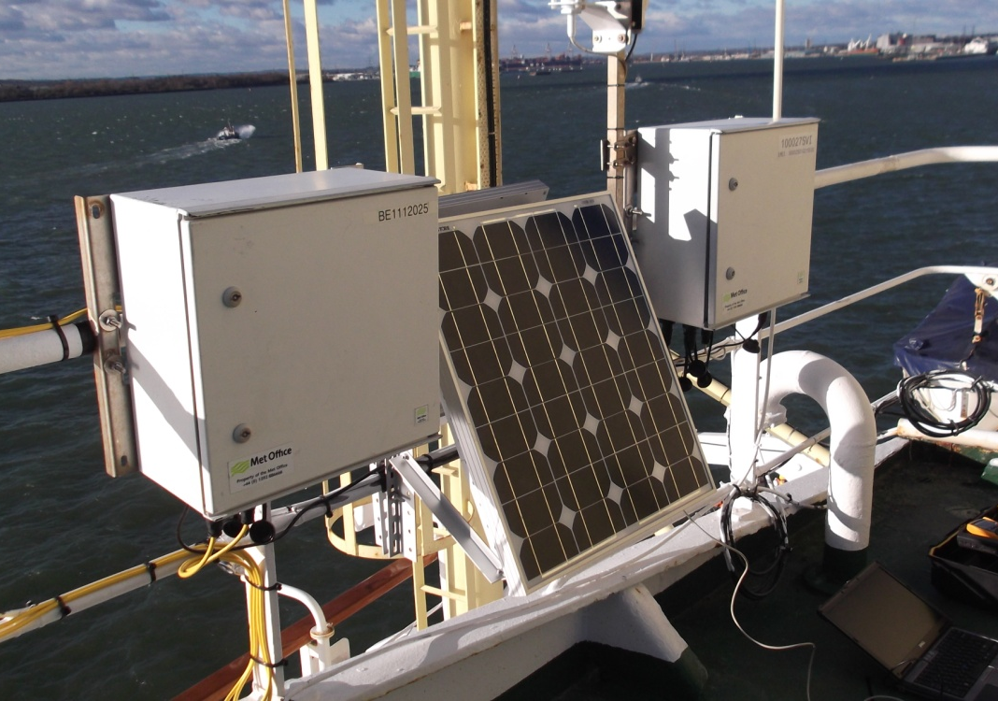

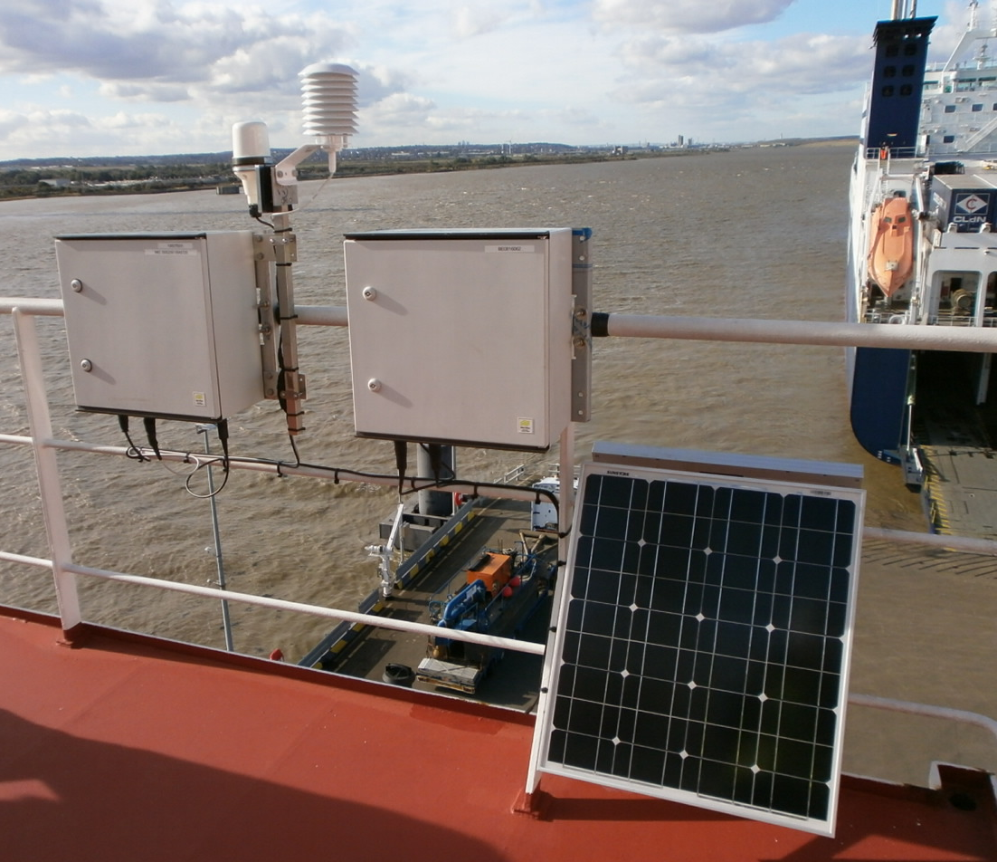

Screenshot of AMOS Google Maps home page showing AMOS fleet

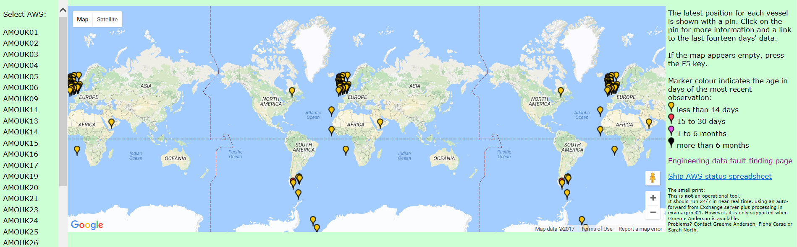

Screenshot of ‘latest data’ from a single ship

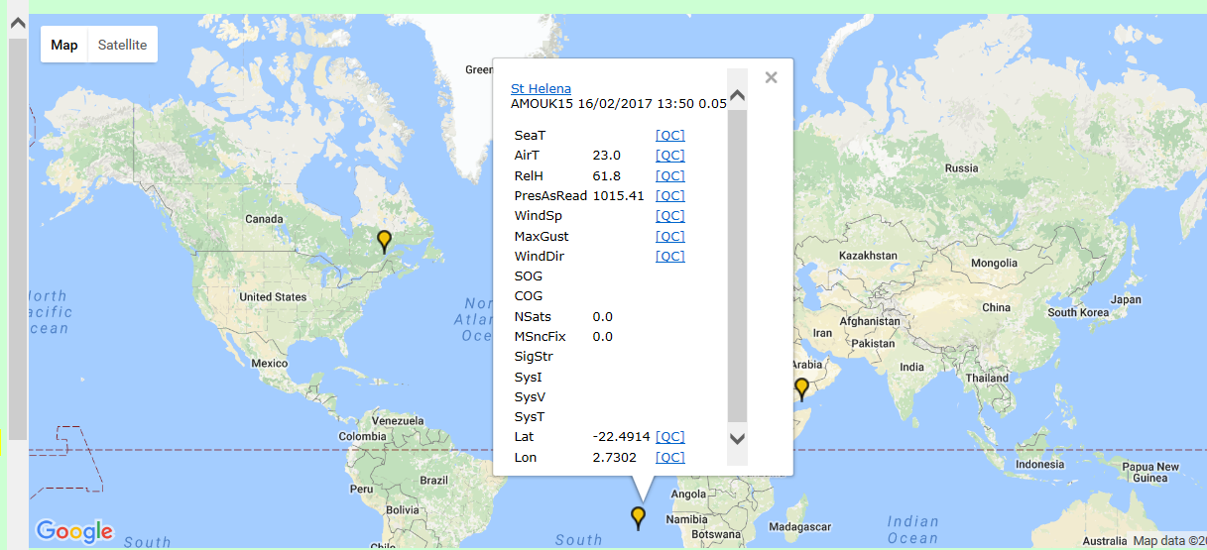

Screenshot showing individual ship track (hourly data points), with associated data and plots

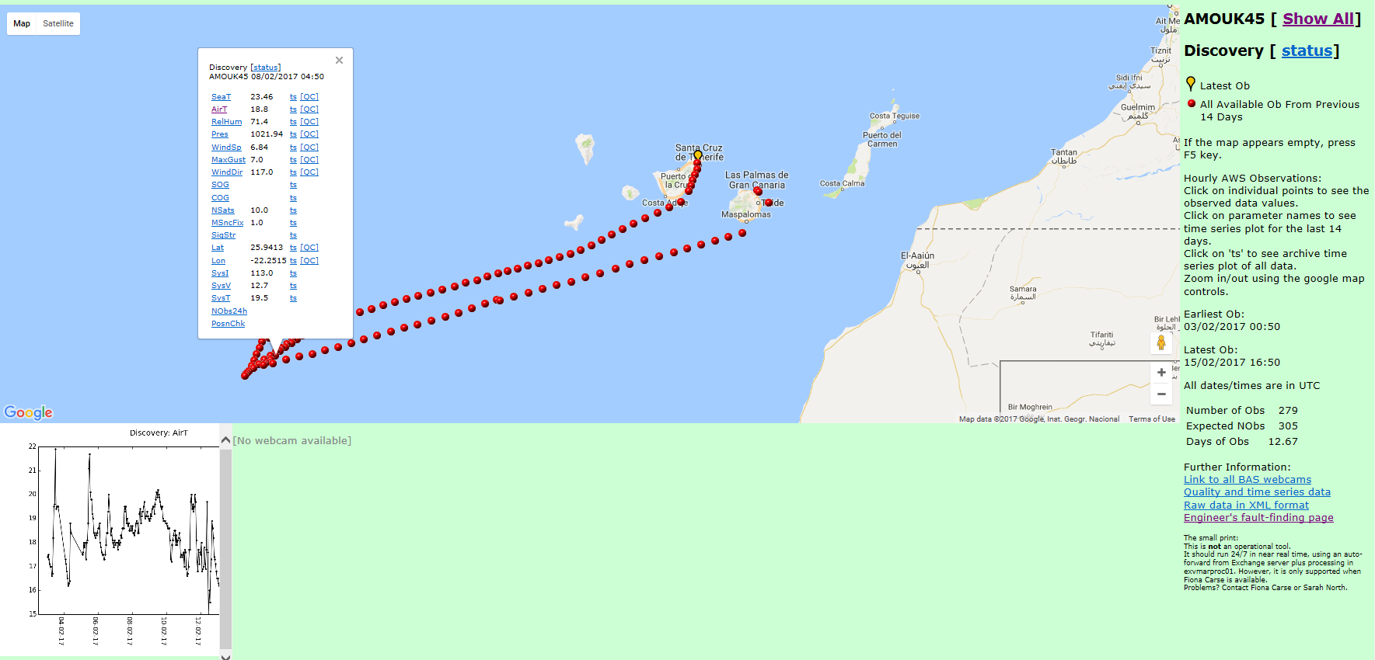

C. BACKGROUND INFORMATION - EUCAWS:

Image showing internal arrangement of the EUCAWS System

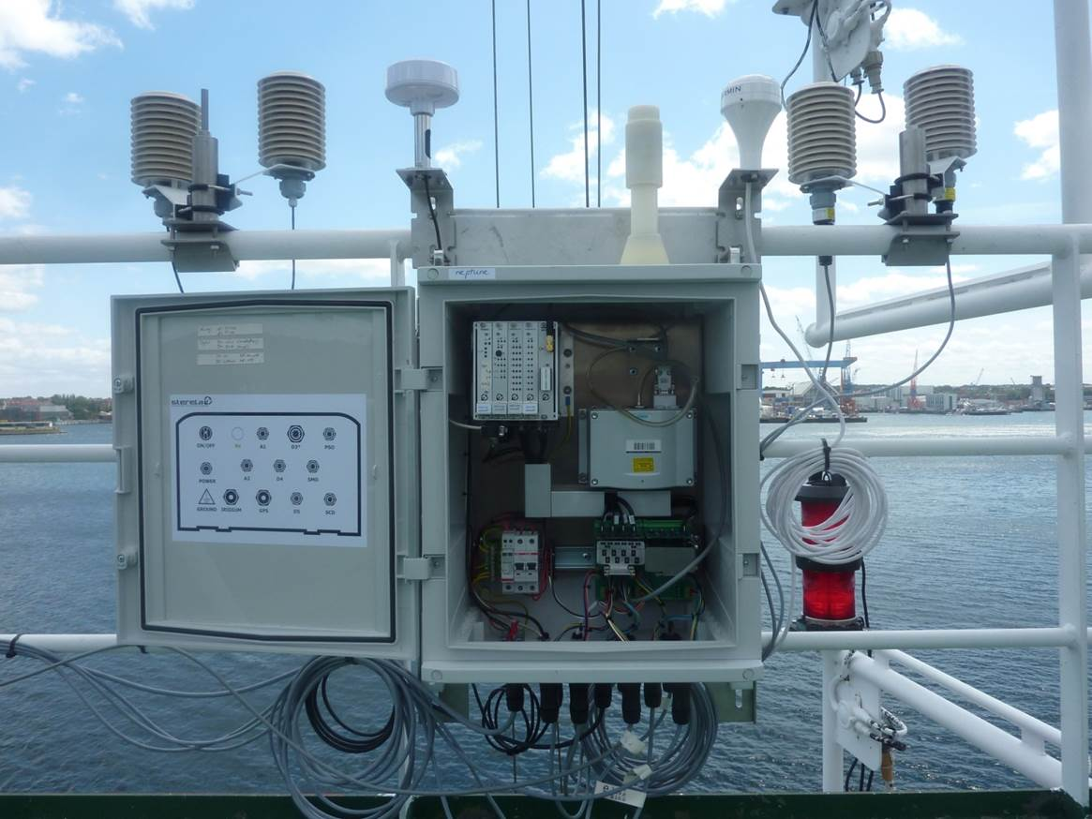

References (if any):
1. [Link to the full report on the website]
2. ...........

ANNEX XX

