World Meteorological Organization &  Intergovernmental Oceanographic Commission (of UNESCO)  JOINT WMO/IOC TECHNICAL COMMISSION FOR OCEANOGRAPHY AND MARINE METEOROLOGY  Ship Observation Team Ninth Session  London, United Kingdom, 27-31 March 2017 | SOT-9/Doc. 10.2.1
Submitted by:
Sarah North, Emma Steventon and Simon Thompson
14.02.2017
DRAFT 1
AGENDA ITEM 10.2: MONITORING AND DATA CENTRE REPORTS
AGENDA ITEM 10.2.1: Monitoring Report from the Regional Specialized Meteorological Centre (RSMC) and Real-Time Monitoring Centre (RTMC) for VOSClim data

SUMMARY
This document provides a report on Monitoring Report from the Regional Specialized Meteorological Centre (RSMC) and Real-Time Monitoring Centre (RTMC) for VOSClim data including recommendations to the panel for approval and actions/decisions required.

A. DECISIONS/ACTIONS REQUIRED:
(a) Adopt draft Decision 10.2.1/1 — Decision title;

- PMOs and VOS Focal Points to contact VOS ships on monthly suspect lists to rectify any problems (action; PMOs; ongoing).

- PMOs to contact VOSClim ships on monthly suspect lists to rectify any problems (action; PMOs; ongoing).

- VOS Focal Points to provide feedback on the value of the RSMC performance ranking lists (action; VOS Focal Points; January 2018).

- The Met Office RSMC to advise SOT members and VOS operators when their new automatic monitoring system becomes operational by sending information to the JCOMMOPS SOT mailing list (Action RSMC : July 2017)

(b) Adopt draft Recommendation 10.2.1/1 — Recommendation title;
B. DISCUSSION (Draft text for inclusion in the final report):

10.2.1 - Regional Specialized Meteorological Centre (RSMC) Exeter VOS monitoring report

10.2.1.1 Ms Sarah North and Miss Emma Steventon (United Kingdom) reported on the activities of the Regional Specialized Meteorological Centre (RSMC) Exeter, acting as CBS Lead Centre for monitoring the quality of surface marine observations. It routinely produces monthly quality reports and provides feedback to VOS operators regarding the quality of the data delivered by VOS ships. The planned move to automation of observation monitoring in light of personnel changes at the Met Office was brought to the group’s attention.

10.2.1.2 The Met Office (RSMC Exeter) continues to compile lists of ships that have produced ‘suspect’ observations each month (e.g. see Appendix A) which are available via the Met Office web site¹ and are also sent to the WMO Secretariat.

10.2.1.3 The Team noted that the Met Office had contacted other monitoring centres regarding the new monitoring criteria for labelling ships as ‘suspect’ and obtained agreement on implementing them in monthly monitoring reports

10.2.1.4 The new monitoring criteria (shown in Appendix B) started to be used from January 2015 in monthly monitoring reports. These criteria are substantially tighter for ships that report with automatic observing systems, because these systems are seen to be more reliable and less prone to errors than manual observing systems. Some of the criteria for ships with manual observing systems were also tightened slightly. Consequently, there are now more ships on the suspect lists than in previous months and years.

10.2.1.5 The Team noted that the RSMC now also produce separate tables for suspect manual and automatic ships on the Met Office marine monitoring website

10.2.1.6 The Met Office also produces monthly lists of monitoring statistics for all VOS, which are sent to the VOS focal points and are also available from the Met Office website. To maintain up to date lists of ships, the Met Office advised that it continues to use the latest data downloaded from the online E-SURFMAR metadata database, rather than from the WMO Pub47 database. In addition, the Met Office uses the masked call sign data available from the JCOMMOPS FTP site.

10.2.1.7 It was noted that the ‘SHIP’ masking scheme implemented by JMA in 2007 continues to prevent the Met Office from monitoring data from individual Japanese and some US and Canadian ships. There has been a slight increase in the number of these reports over the last two years, with 27199 reports of pressure received in January 2015 from VOS with call-sign “SHIP”, compared to 23457 reports in January 2013 (automatic reports account for 85% of these). It is hoped that use of the proposed new SOT ID system will help to reduce the number of SHIP reports in future

10.2.1.8 Timeliness information for VOS reports received at the Met Office is also made available from the observation monitoring web site² (see Appendices C, D and E). This information shows that the majority of ship reports continue to be received promptly, with more than 86% received within 60 minutes of the observation time. Action 107 (SOT-7) on the RSMC to separate timeliness information for automatic and manual ships has been completed with stats issued monthly.

10.2.1.9 The Met Office continues to make monthly VOS ranking scheme results available on their website for all VOS and for the national VOS fleets. Separate monthly lists of scores are produced for automatic and manual ships. An example from the January 2017 monthly scores and national fleet rankings are shown in Appendix F for manned and automatic ships. It was suggested that VOS operators may wish to consider the use of these performance rankings for their national ship award schemes. The RSMC invited VOS Focal Points to provide feedback on their value

10.2.1.10 The Team also decided on the following action items:

- PMOs and VOS Focal Points to contact ships on monthly suspect lists to rectify any problems (action; PMOs; ongoing).

(ii) VOS Focal Points to provide feedback on the value of the RSMC performance ranking lists (action; VOS Focal Points; January 2018).

10.2.1 Real-Time Monitoring Centre (RTMC) for the VOSClim data monitoring report

10.2.1.11 Ms Sarah North and Miss Emma Steventon reported on the activities of the Real-Time Monitoring Centre (RTMC) for the VOS Climate (VOSClim) data, which is operated by the Met Office, United Kingdom. The RTMC produces monthly suspect lists and monitoring statistics for all VOS Climate ships, using the active VOSClim ship list which is now maintained on the E-SURFMAR ftp site (previously on the VOSClim website). It was noted that when the E-SURFMAR database is migrated to JCOMMOPS the RTMC would in future need to extract the VOSClim ship list from the JCOMMOPS database. An example of the suspect lists for manned and automatic VOSClim ships for January 2017 can be seen in Appendix G.

10.2.1.12. Following agreement at the last session, the suspect criteria for VOSClim ships were tightened in January 2015 to the new values for manual and automated ships shown in Appendix H.

10.2.1.13. The Team noted that the Met Office continues to send the VOSClim suspect lists and the lists of statistics to the JCOMMOPS mailing lists (PMO and VOS).

10.2.1.14 The Team noted that there were 16 ships on the VOSClim suspect list in January 2017, which is 1.8% of the 335 VOSClim ships reporting pressure. Moreover the KPI for less than 3% of VOSClim class ships to be flagged on the suspect list for air pressure has been met in each month over the last 3 years, as shown in Appendix I

10.2.1.15. In February 2017 there were 335 VOSClim ships out of a total of 1526 VOS ships reporting at least 5 pressure values during the month in real time (within about 6 hours of 00, 06, 12 or 18 UTC). As a consequence 22% of VOS ships are reporting to VOSClim standards by this measure. This is therefore within the KPI for 25% of the global active VOS to be upgraded to VOSClim and similar to the value 2 years ago; although it was noted that delayed-mode reports are not included in this percentage. (However it was pointed out that the number of active VOSClim ships listed on the E-SURFMAR database in February 2017 was 491, compared to 3073 active VOS, i.e. just 16.0% of VOS ships are VOSClim by this measure.)

10.2.1.16. In January 2017, 97.1% of VOSClim reports were received within 120 minutes, which exceeded the KPI for at least 95% to be received within 120 minutes.

10.2.1.17. The Team also noted that the Met Office continues to send all VOSClim ship reports and their co-located model field values to the Data Assembly Centre (DAC) and puts a backup copy of the daily BUFR data onto their FTP server, so that it is available for the DAC to access in case of problems with the GTS data. The BUFR data was upgraded in May 2014 to include some extra variables (e.g. wave height) and the BUFR version was upgraded from 3 to version 4.

10.2.1.18. The Team decided on the following action items:

(i) PMOs to contact VOSClim ships on monthly suspect lists to rectify any problems (action; PMOs; ongoing).

10.2.1.19 In considering the RSMC and RTMC reports the Team noted in 2016 the Met Office had decided that the marine observation monitoring system that had been used to generate monitoring statistics had reached ‘end-of-life’ and would be replaced by a new automatic system. This was coincident with the retirement of Mr Colin Parrett, who had administered the system for many years and who had manually collected and sorted statistics for SOT members for many years. The Team thanked Mr Parrett for his long standing contribution to ensuring the quality of VOS observations
10.2.1.20 It was noted that the new automatic system is being developed from the ‘ground up’. As it currently stands (as of February 2017), the new system is being trialled and results are being compared to the existing system to ensure consistency and future continuity for the international marine community. In the meantime, on the timescale of the next 4-6 months, the existing system will continue to operate in a ‘frozen’ state with no further development planned.

10.2.1.21 It is envisaged that the new automatic monitoring system will deliver marine statistics in a simple but more flexible way such that, for example, monthly statistics may be fetched via a simple Ftp retrieval, and individual ship statistics may be queried via a web interface. Further news and accompanying examples of the new system (e.g. graphs, screenshots and sample files) will be published in due course.

10.2.1.22 The Team requested the Met Office RSMC to advise SOT members and VOS operators when their new automatic monitoring system will become operational by sending information to the JCOMMOPS SOT mailing list (Action RSMC : July 2017)

APPENDIX A
MET OFFICE ON-LINE MONTHLY VOS SUSPECT LIST FOR JANUARY 2017 (extract)
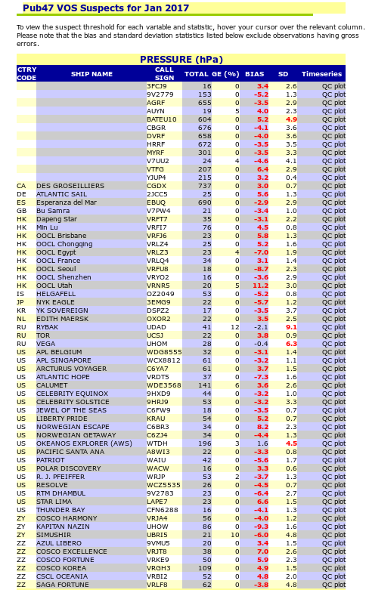
APPENDIX B

CRITERIA FOR MONTHLY MONITORING OF MARINE SURFACE OBSERVATIONS

Monitoring procedures
Period : One calendar month.

Data monitored : Reports from each unique identifier for ships,
fixed buoys and platforms, split into manual and
automatic observing systems.
Standard of comparison : Background field from Exeter global model.
Observation times : All hours
Elements monitored : Mean sea level pressure (hPa).
: Wind speed (ms-1).
: Wind direction (degrees).
: Air temperature (oC).
: Relative Humidity (%).
: Sea surface temperature (oC).
Parameters monitored
NOBS : Number of observations received, excluding
duplicates.
%GE : Percentage of observations with gross errors.
%REJ : Percentage of observations flagged, excluding
those with gross errors.
SD : Standard deviation of difference of observation
from background values, excluding those with gross
errors.
BIAS : Mean difference of observations from background
values, excluding those with gross errors
(N.B. a positive bias indicates the wind
observation is veered to the background).
RMS : Root Mean Square difference of observations from
background values, excluding those with gross
errors.
Gross Error Limits : 15 hPa (pressure)
25 ms-1 (vector wind)
15 oC (air temperature)
50% (relative humidity)
10 oC (sea surface temperature)

Selection Criteria (split into manual/automatic from January/February 2015)
Manual (Automatic) : NOBS >= [20] 15 (50), + one or more of the following:
[Previous]
1. Bias >= [4] 3 (2) hPa (pressure)
>= [5] 4 (4) ms-1 (wind speed)
>= [30] 30 (25) degrees (direction)
>= [4] 3 (2.5) oC (air temperature)
>= [15] 15 (12) % (relative humidity)
>= [3] 2.5 (2) oC (SST)
2. SD >= [6] 5 (4) hPa (pressure)
>= [80] 70 (50) degrees (direction)
>= [6] 5 (4) oC (air temperature)
>= [25] 25 (20) % (relative humidity)
>= [5] 4 (3) oC (SST)
3. PGE >= [25] 25 (15) %

N.B. Observations of wind direction are only included in the wind direction statistics if the observed or background wind speed is greater than 5 ms-1

APPENDIX C

TIMELINESS OF VOS OBSERVATIONS RECEIVED AT THE MET OFFICE, JAN 2017
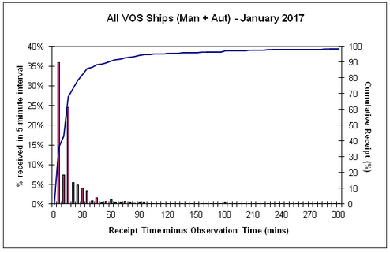
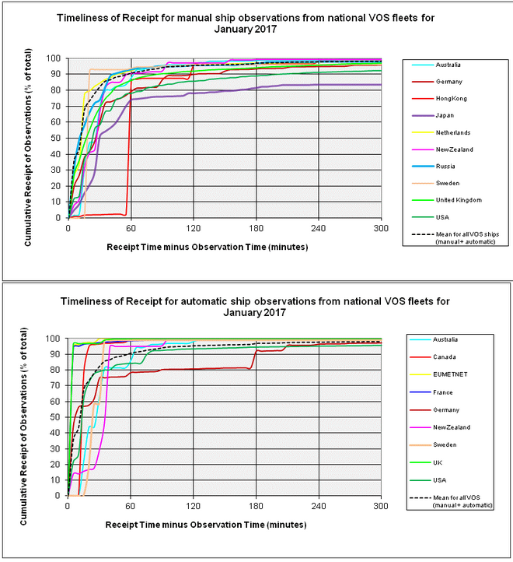

APPENDIX D

MET OFFICE TIME OF RECEIPT STATISTICS FOR INDIVIDUAL SHIPS, JAN 2017 (extract)

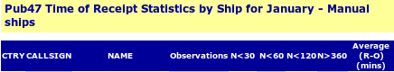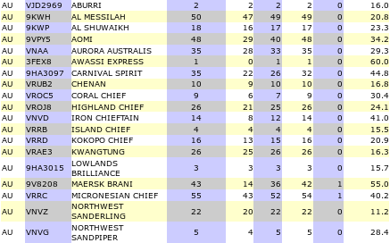
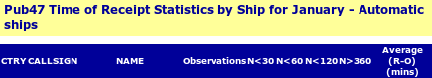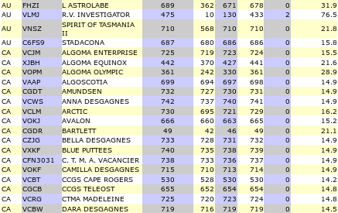

APPENDIX E

MET OFFICE TIME OF RECEIPT STATISTICS FOR NATIONAL FLEETS, JAN 2017

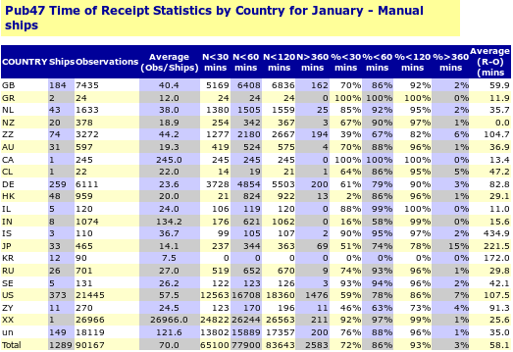

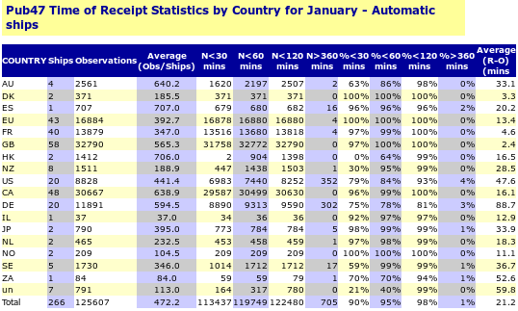

APPENDIX F

MONTHLY VOS NATIONAL FLEET RANKINGS FOR JAN 2017 – MANUAL SHIPS
(extract)
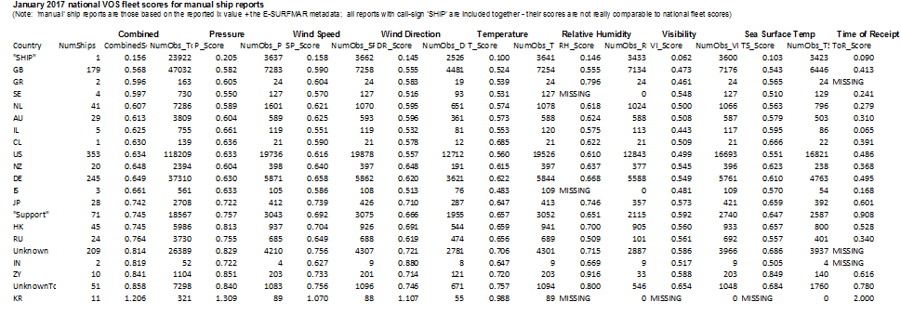

APPENDIX F - ctd

MONTHLY VOS RANKINGS FOR JAN 2017 – AUTOMATIC REPORTS (extract of best ships)

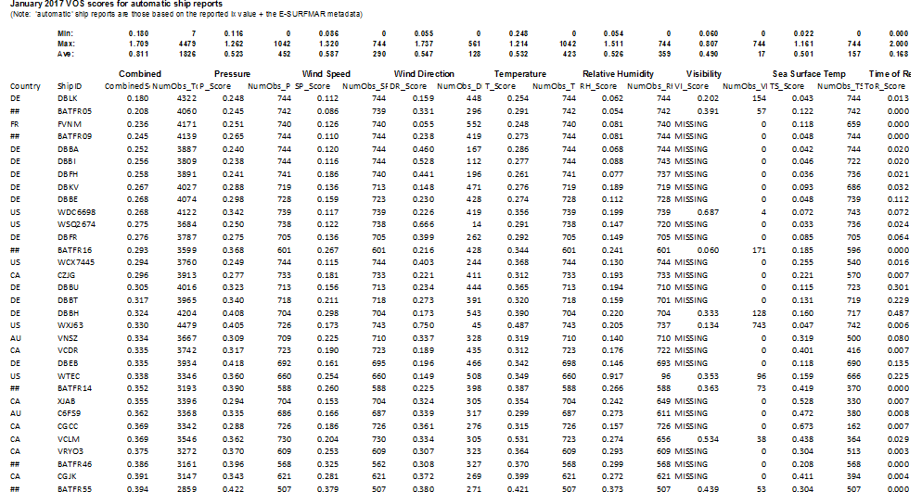

APPENDIX G

VOSClim suspect ships in January 2017 (extracts)

Manual Ships
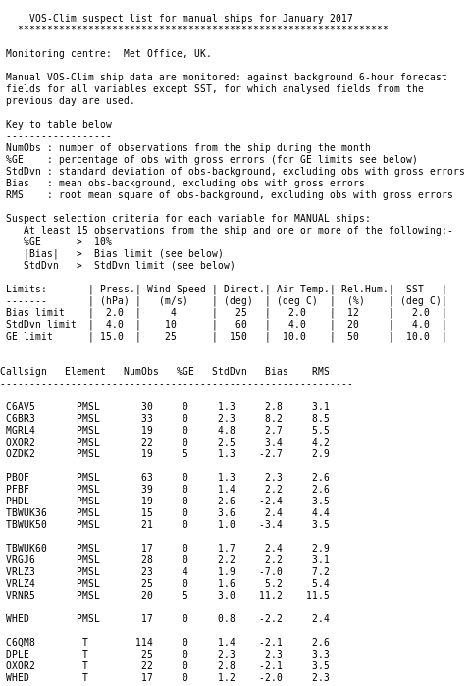

Automatic ships
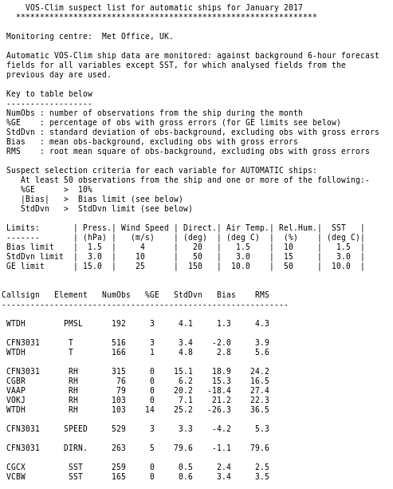

APPENDIX H

MONITORING CRITERIA FOR VOSCLIM SUSPECT SHIPS

- For each ship and each variable there should be at least 15 reports for manual ships and 50 reports for automatic ships during the period (if there are fewer reports the statistics may be unreliable and no action is needed).

- Then, either:

a) The number of gross errors should exceed 10% of the number of observation reports (where the observation-background (o-b) limits for individual gross errors are shown in column 4 of the following table); or,

b) One of the limits shown in columns 2 and 3 in the following tables should be exceeded for either:

- the mean value of o-b over the period (absolute value), or
the standard deviation of o-b over the period

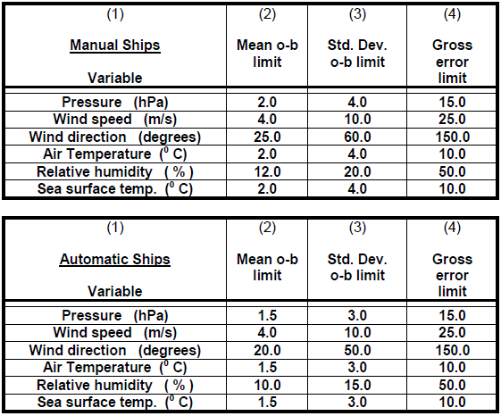

- If either of the limits on o-b statistics in columns 2 and 3 are exceeded the project ship's observations will be considered 'suspect' and corrective action will need to be taken (e.g. by the Port Met Officers). Column 4 contains the o-b limits for each ship observation beyond which the observation will be considered to be a 'gross error'.

C. BACKGROUND INFORMATION - RSMC (not to be included in the session report):

Summary of the Current System (now ‘frozen’ as of 2016)

All appendices in this document are snapshots from the existing ‘un-changed’ system that was built by Colin Parrett (now retired) and described at SOT-8. It was last updated at the end of 2015 to include the separation of manual and automatic ships. The existing system has had no updates since that point and hence looks and behaves exactly the same (now ‘frozen’). The system as it is now is simply maintained ‘as is’ on a best endeavours basis.
The information below describes this ‘frozen’ system.

Monitoring the quality and timeliness of VOS observations

- The Met Office (RSMC Exeter), has for many years been the WMO-designated lead centre for monitoring the quality of surface marine meteorological data (observations from ships, buoys and other in situ marine platforms), comparing observations from individual platforms with the Met Office’s global model background 6-hour forecast fields for each variable. Platforms for which the observed values differ from the background by a significant amount are flagged as suspect.

2. Monthly lists of suspect marine platforms are sent to the WMO Secretariat and also exchanged among other monitoring centres (including JMA, NCEP, Meteo France and ECMWF) for comparison. Generally there is considerable agreement between the different centres, both in terms of suspect platforms (using the same criteria) and mean and standard deviation of differences from the background fields. The Met Office monthly suspect lists are available via the Met Office web site at http://research.metoffice.gov.uk/research/nwp/observations/monitoring/index.html
A recent example of our on-line VOS suspect list for January 2017 is shown in Appendix A. Monthly QC plots are also available from the website for each ship that is listed as suspect.

3. Originally only mean sea level pressure was monitored, but wind speed, wind direction, sea surface temperature, air temperature and relative humidity have been added to the information being exchanged on a monthly basis. The new monthly monitoring criteria for the 6 variables that were agreed at SOT-7 are shown in Appendix B, together with the previous selection criteria. The selection criteria for modelling ships as ‘suspect’ had previously remained unchanged for about 25 years (for pressure), during which time there have been large improvements in data assimilation, numerical modelling and data coverage, resulting in more accurate short-range background forecasts and smaller observation-background (o-b) differences overall. Consequently, some of the monitoring criteria for manual observations have been tightened slightly.

4. Also, over recent years there has been a large increase in the number of ships that send in reports from automatic weather stations, which are generally more accurate and less prone to errors than manual reports. Therefore the monitoring of ‘automatic ships’ has been separated from the monitoring of ‘manual ships’ and tighter limits imposed for automatic ships, as shown in Appendix B (numbers in brackets). The splitting of the ships into manual and automatic reports is helped if “iX” is set correctly in all reports; although the Met Office also uses lists of manual and automatic ships compiled using “atm” from the ship metadata, but these are only updated monthly.

5. Due to the stricter monitoring criteria, there are more ‘suspect’ ships than previously. The old criteria will be used to produce ‘parallel’ suspect lists that will be compared with the new lists by the Met Office and the changes in criteria will be noted in the RSMC’s Biannual Report, with a report on any changes in the time-series of suspects.

6. The Met Office also produces monthly lists of monitoring statistics for the VOS fleets recruited by certain countries. To maintain up to date lists of the VOS fleets for each country concerned, the Met Office uses the meta-data available from the E-SURFMAR web-site.

7. Masked call sign data available from the JCOMMOPS Mask vs Real database is also taken into account when preparing the lists of VOS monitoring statistics.

8. National focal points are notified when the latest VOS monthly monitoring reports and suspect lists become available on the Met Office website by means of an email sent by the Met Office to the SOT, VOS and PMO mailing lists, which are maintained by JCOMMOPS. It is important therefore that focal points wishing to receive this monitoring information check that their mailing list information is kept up to date. However, national monthly monitoring statistics continue to be emailed directly to major VOS operating countries, and as mentioned in reports to previous SOT meetings, any other national focal points who may wish to receive directly emailed copies of the monthly monitoring lists or ‘suspect’ ship lists should advise the Met Office of their email address.

9. Every 6 months more detailed monitoring reports, for all platforms, are produced and made available to the WMO Secretariat via the Met Office web site. The statistics relating to suspect VOS operated by specific members are extracted from the report and distributed by the Secretariat to national focal points for the members concerned, under a covering letter requesting that remedial action be taken to correct the problems.

10. Timeliness statistics for VOS reports received at the Met Office are available on our web site at http://research.metoffice.gov.uk/research/nwp/observations/monitoring/marine/TOR/index.html
where monthly timeliness data for individual VOS is available as well as tables and graphs showing the relative timeliness of national VOS fleets. A graphical example for January 2017 data is shown in Appendix C, where it can be seen from the upper graph that the majority of ship reports were received promptly, with about 70% received within 15 minutes and more than 90% received within 60 minutes of the observation time. The cut-off time for operational NWP global data assimilation is typically 90-150 minutes after the analysis times of 00, 06, 12 and 18 UTC, so that about 95% of global VOS data are being received in time to be assimilated. Examples of timeliness information for January 2017 for individual call-signs and for national fleets are shown in Appendices D and E, respectively. The overall timeliness continues to improve due to increased automation. There are now two sets of timeliness statistics for national automatic and manual VOS fleets.

11. For the last 7 years the Met Office has been producing annual lists of all VOS ships, ranked in order of importance to the numerical weather prediction (NWP) system, available from the Met Office web-site at http://research.metoffice.gov.uk/research/nwp/observations/monitoring/marine/VOSranking/index.html (2016 scores are yet to be published- the Met Office apologises).

The ships are ranked in terms of their quantity, quality and timeliness of reports, largely to assist in presenting awards to the best performing ships (initially in the UK VOS fleet). This system was extended about 5 years ago to produce monthly scores and ranking lists, separately for automatic and manual ships and for national VOS fleets, and these monthly lists are also available from the above link. Extracts of the monthly results for January 2017 are shown in Appendices F and G.

12. As mentioned at previous SOT meetings, the Met Office’s role as CBS Lead Centre for monitoring marine data is incomplete, with Japanese ships not being monitored individually, due to JMA’s adoption of the ‘SHIP’ masking scheme. The Met Office continues to collect the original data from JMA’s FTP server, but this data is not routed into our meteorological database due to issues concerning its security. Consequently, to ensure that the VOS can continue to be monitored efficiently, the Met Office (RSMC Exeter) would prefer that all countries adopt a masking method with a unique masked identifier for each ship, until a new ENCODE masking scheme is rolled out, or until such time as the proposed new SOT ID system ins introduced .

Future Considerations

In early 2016 a collective decision was reached between the Marine Observations and Data Assimilation departments at the Met Office, that the existing marine observation monitoring system had reached ‘end-of-life’. This was coincident with the retirement of long-standing respected colleague, Colin Parrett, who had administered the system for many years and who had manually collected and sorted statistics for a number of internal and external customers. In the place of the existing system that continues to publish statistics to http://research.metoffice.gov.uk/research/nwp/observations/monitoring/index.html a new automatic system is being developed from the ‘ground up’.

As it currently stands (as of February 2017), the new system is being trialled and results are being compared to the existing system to ensure consistency and future continuity of publication for internal customers and the international community. In the meantime, on the timescale of the next 4-6 months, the current system will continue to operate in a ‘frozen’ state with no further development planned. It is envisaged that the new automatic system will deliver statistics in a simple but more flexible way such that, for example, monthly statistics may be fetched via a simple Ftp retrieval, and individual ship statistics may be queried via a web interface. We appreciate your patience whilst this is in progress and further news and accompanying examples of the new system (in the way of graphs, screenshots and sample files) will be published in due course.

1 : http://research.metoffice.gov.uk/research/nwp/observations/monitoring/index.html
2 : http://research.metoffice.gov.uk/research/nwp/observations/monitoring/marine/TOR/index.html

A Decision is an item directly related to SOT and on which SOT can decide directly. Rational for the decision should be included in the Draft Decision.
A Recommendation involves proposed action(s)on another body outside of SOT (e.g. DBCP, JCOMM, WMO, IOC, CBS etc.). Rational for the Recommendation should be included in the Draft Recommendation.

