European Centre for Medium-Range Weather Forecasts

SUMMARY REPORT ON THE MONITORING OF ASAP SHIP DATA

January-December 2016
1. Summary

In 2016, the number of ASAP reports received at ECMWF have increased compared to 2015 period. There was also a slight increase in the number of reporting platforms.
We noticed a lack of ASAP observations in the Indian Ocean in 2016. ECMWF started assimilating BUFR encoded ASAPs in November 2015. In cases where the BUFR encoded reports are assimilated, the TAC counterparts are no longer assimilated. The percentage of ascents reaching the 100 hPa level have been comparable to 2015 levels.

The problem of wrongly located reports has been reduced to only few cases in 2016 involving ASFR4 and DBLK platforms. Some problematic BUFR encoded ASAP identifiers (ASFR*) that were not assimilated before have improved their BUFR reports and hence have been assimilated in BUFR format in the second half of 2016. The quality of the data in general has continued to be good and highly valuable.

2. Data reception

Figures 1 to 3 show time series from January 1994 to December 2016 with monthly counts of ASAP reports for the 4 main synoptic hours (00, 06, 12 and 18 UTC) at different levels. In general, monthly totals have increased slightly compared to previous years. In previous years we have assessed the percentage of launches reaching the lower stratosphere (100 hPa). In 2016, the percentage of reports reaching 100hPa have been comparable to levels in the previous year (Figure 4). Table 1 and Table 2 show annual counts for each ship as well as their encoding and assimilation status. It is worth noting that number of reports has increased slightly compared to last year'
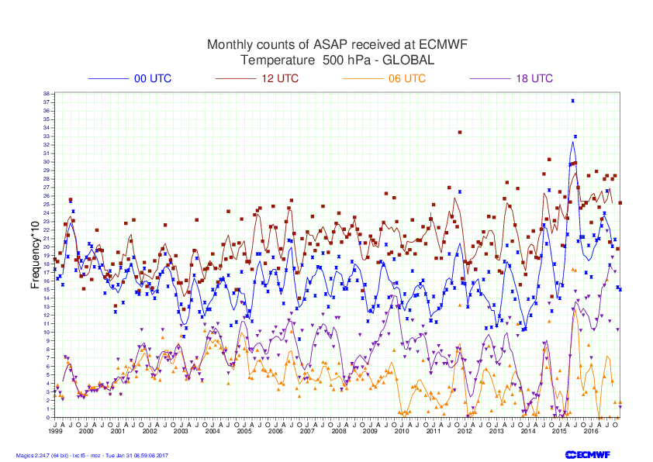

Figure 1: ASAP temperature data received at ECMWF 500 hPa (Jan 1994 to December 2016). Symbols show monthly totals and lines show moving averages.

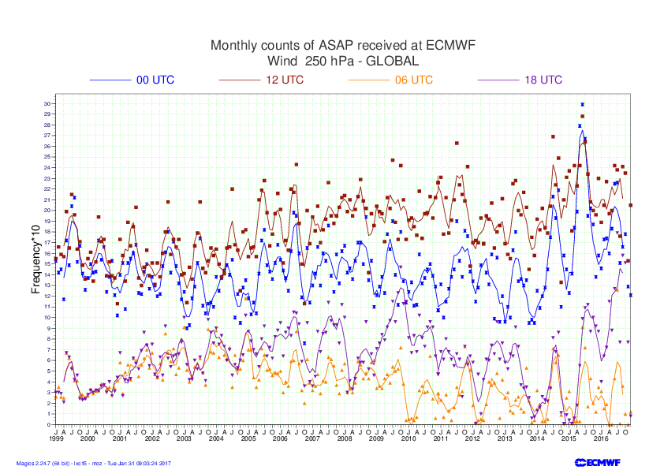
Figure 2: ASAP wind data received at ECMWF 250 hPa (Jan 1994 to December 2016).
Symbols show monthly totals and lines show moving averages.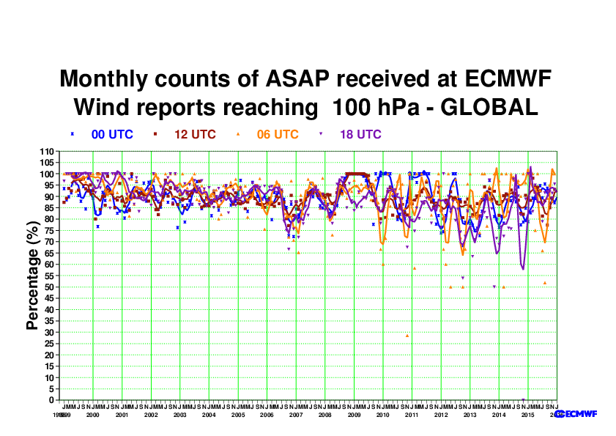

Figure 3: ASAP wind data received at ECMWF 100 hPa (Jan 1994 to December 2016).
Symbols show monthly totals and lines show moving averages.
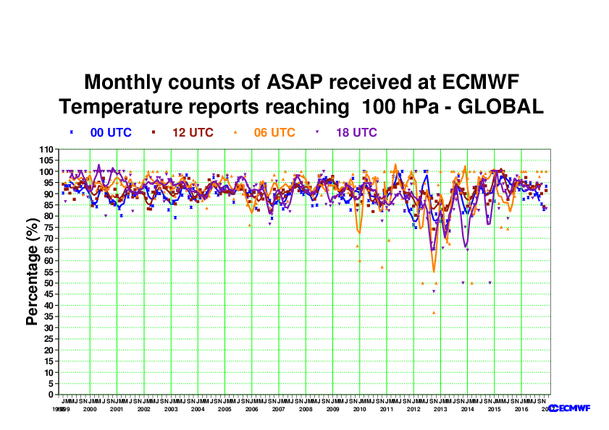

Figure 4: Percentage of ASAP reports reaching the 100 hPa level (Jan 1994 to December 2016)
Symbols show monthly values and lines show moving averages.
TABLE 1: Number of ASAP reports received at ECMWF between March 2015 - Feb 2016 at 500 hPa

RECEPTION OF TEMP/TEMPSHIP/PILOT/PILOTSHIP DATA AT ECMWF
FOR March 2015-Feb 2016
500 HPA LEVEL

STATIONS REPORTING AT OTHER LEVELS ARE NOT INCLUDED. ASSIMILATED FORMAT SHOWN IN GREEN

GEOPOTENTIAL WIND

ID 00 06 12 18 Total 00 06 12 18 UTC Total Encoding Assimilated
ASDE01 136 1 137 98 372 124 1 129 69 323 BUFR (B)
ASDE02 111 7 85 23 226 107 4 80 19 210 BUFR (B)
ASDE03 150 0 125 86 361 138 0 120 67 325 BUFR (B)
ASDE04 73 0 77 68 218 63 0 72 47 182 BUFR (B)
ASDE09 0 15 41 1 57 0 7 37 1 45 BUFR (B)
ASDK01 48 0 38 35 121 47 0 38 27 112 BUFR (B)
ASDK02 150 0 127 77 354 133 0 121 58 312 BUFR (B)
ASDK03 58 0 51 43 152 52 0 48 38 138 BUFR (B)
ASDK1* 69 0 63 39 171 68 0 63 39 170 TAC N/A
ASDK2* 147 0 127 71 345 146 0 127 71 344 TAC N/A
ASDK3* 90 0 77 60 227 89 0 77 60 226 TAC N/A
ASES01 0 2 187 2 191 0 1 179 1 181 BUFR (B)
ASEU01 64 0 155 6 225 62 0 142 4 208 BUFR (B)
ASEU02 77 0 75 59 211 69 0 70 43 182 BUFR (B)
ASEU03 117 0 118 58 293 111 0 111 48 270 BUFR (B)
ASEU04 79 0 78 2 159 70 0 64 1 135 BUFR (B)
ASEU05 43 0 41 28 112 40 0 40 15 95 BUFR (B)
ASEU06 95 5 105 74 279 88 3 97 55 243 BUFR (B)
ASFR1 156 0 145 0 301 149 0 145 0 294 BUFR and TAC (T)
ASFR2 116 0 131 0 247 114 0 131 0 245 BUFR and TAC (T)
ASFR3 133 0 132 0 265 130 0 129 0 259 BUFR and TAC (T)
ASFR4 119 0 127 1 247 116 0 125 1 242 BUFR and TAC (T)
DBLK 13 270 336 39 658 11 132 212 21 376 BUFR and TAC (B)
DFCG 17 13 15 16 61 13 11 13 13 50 TAC (T)
JGQH 79 0 79 0 158 79 0 79 0 158 BUFR and TAC (T)
JNSR 122 112 126 105 465 74 59 73 56 262 BUFR and TAC (T)
------------------------------------------------------------------------------------
2262 425 2798 991 6476 2093 218 2522 754 5587

TOTAL NUMBER OF STATION IDENTIFIERS 26 (23 without duplicate ids)

* denotes duplicate ids(TAC) with a BUFR counterpart

TABLE 2: Number of ASAP reports received at ECMWF between January 2016 - December 2016 at 500 hPa

RECEPTION OF TEMP/TEMPSHIP/PILOT/PILOTSHIP DATA AT ECMWF
FOR Jan 2016 to Dec 2016
500 hPa level

STATIONS REPORTING AT OTHER LEVELS ARE NOT INCLUDED. ASSIMILATED FORMAT SHOWN IN GREEN

TEMPERATURE WIND
----------- ----
ID 00 06 12 18 Total 00 06 12 18 Total Encoding Assimilated
--------------------------------------------------------------------------------------------------
ASDE01 82 5 74 64 225 70 3 68 41 182 BUFR (B)
ASDE02 133 4 101 3 241 99 2 88 2 191 BUFR (B)
ASDE03 104 1 114 102 321 91 1 99 72 263 BUFR (B)
ASDE04 80 2 75 88 245 67 1 66 64 198 BUFR (B)
ASDE09 0 4 40 1 45 0 2 34 1 37 BUFR (B)
ASDK01 132 0 148 128 408 98 0 116 92 306 BUFR (B)
ASDK02 158 0 155 114 427 137 0 136 91 364 BUFR (B)
ASDK03 94 0 96 71 261 72 0 77 57 206 BUFR (B)
ASDK1 * 109 0 123 99 331 99 0 114 91 304 TAC (T)
ASDK2 * 139 0 128 84 351 124 0 122 78 324 TAC (T)
ASDK3 * 79 0 76 57 212 73 0 72 52 197 TAC (T)
ASES01 0 0 182 0 182 0 0 166 0 166 BUFR (B)
ASEU01 46 0 103 63 212 34 0 87 45 166 BUFR (B)
ASEU02 103 0 105 106 314 92 0 88 79 259 BUFR (B)
ASEU03 118 2 108 96 324 108 1 104 81 294 BUFR (B)
ASEU04 77 3 83 0 163 67 1 70 0 138 BUFR (B)
ASEU05 12 0 16 3 31 10 0 11 2 23 BUFR (B)
ASEU06 107 3 108 98 316 95 2 99 79 275 BUFR (B)
ASFR1 148 2 140 41 331 136 2 135 31 304 BUFR/TAC (B)
ASFR2 73 0 72 14 159 67 0 64 13 144 BUFR/TAC (B)
ASFR3 143 1 134 33 311 131 1 127 28 287 BUFR/TAC (B)
ASFR4 131 2 122 27 282 118 1 114 26 259 BUFR/TAC (B)
ASUK2 9 40 19 17 85 9 38 14 17 78 TAC (T)
ASUK3 0 0 33 0 33 0 0 33 0 33 TAC (T)
DBLK 42 122 360 23 547 28 61 202 14 305 BUFR (B)
JGQH 77 0 71 0 148 77 0 71 0 148 BUFR/TAC (T)
JNSR 59 42 73 43 217 54 37 63 36 190 BUFR/TAC (T)
WTEC 44 42 48 46 180 21 20 23 24 88 TAC (T)
--------------------------------------------------------------------------------------------------
2299 275 2907 1421 6902 1977 173 2463 1116 5729

TOTAL NUMBER OF STATION IDENTIFIERS 28 (25 without duplicate ids)

- denotes duplicate ids (TAC) with a BUFR counterpart
As in previous years most of the ASAP units were operating in the North Atlantic and some in the South Atlantic, East Siberian Sea. Lack of observations in the Indian Ocean is noticeable in 2016. Some observations from WTEC in Pacific Ocean were made only in TAC format. We can also see in Figure 5 and Figure 6 the Japanese ASAP operating close to Japan. Although JGQH and JNSR platforms report in BUFR their reports are not high resolution hence are assimilated in TAC format

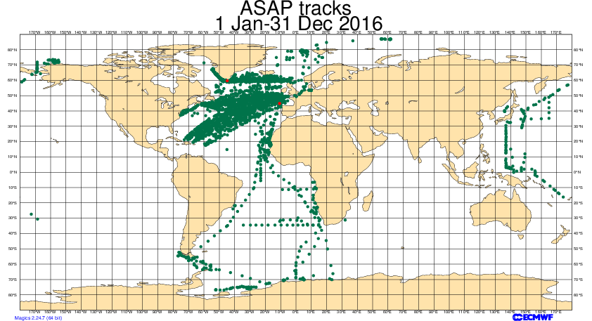

Figure 5: BUFR ASAP tracks for January 2016 to December 2016 period

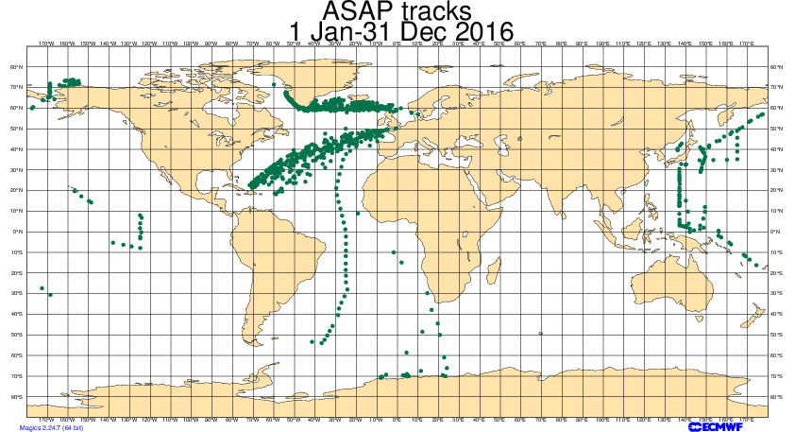

Figure 6: TAC ASAP tracks for January 2016 to December 2016 period
Quality Control.

We run, on a monthly basis, vertical statistics for all units. The results are included in the ECMWF Monthly Monitoring Report, which is freely available at the ECMWF web site.

For the assimilated reports, compared to 2015, in 2016 we see a similar standard deviation and bias curve for temperature and winds for most levels (Figures 7 and 8). The high rejection numbers seen in the plots are misleading and unrepresentative of other levels not shown which are not rejected. The ECMWF model assimilation system applies thinning for the hi-res data and rejects many of the levels which happen to be sampled to prepare these plots. The large bias and standard deviation seen at upper levels in Figure 7 and Figure 8 was due to bad reports from ASEU05 in July 2016 and from ASEU06 platform in March, October 2016, respectively.

We had seen noise issues with individual profiles from BUFR encoded observation identifiers starting with ASFR in the previous reporting period. This is now fixed and we have been using BUFR encoded observations from identifiers starting with ASFR since July 2016.

Decrease in number of reports from ASDK* platforms in their BUFR formatted reports at upper levels (>70hPa) in the beginning of 2016 have been addressed swiftly by the data provider.

Particular problems related to wrong positions are detected in the Daily Monitoring carried out by the Met Analyst on duty.

The quality of the ASAP data continues to be good and is highly valuable over the oceans where data with high quality and high vertical resolution are needed.

The profiles as seen in Figures 7 and 8 show high quality standards fully comparable to land-based radiosondes as in previous years.

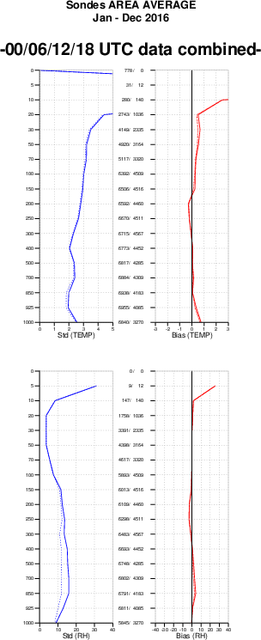
Figure 7: Vertical statistics for ASAPs’ temperature and relative humidity January 2016 to December 2016
Solid lines : Obs-First guess (background)
Dashed lines : Obs-Analysis
Middle scale : Number of reports for each level/Number of rejected reports for each level
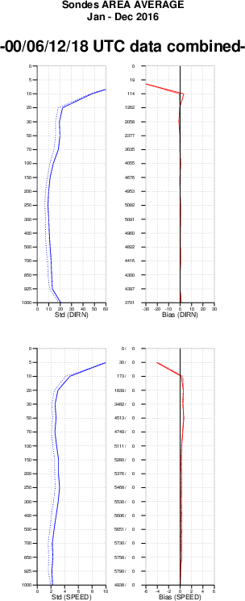

Figure 8: Vertical statistics for ASAPs’ wind direction and speed January 2016 to December 2016
Solid lines : Obs-First guess (background)
Dashed lines : Obs-Analysis
Middle scale : Number of reports for each level/Number of rejected reports for each level

