JCOMM SHIP-OF-OPPORTUNITY PROGRAMME IMPLEMENTATION PANEL
THIRD SESSION

La Jolla, CA, USA, 28-31 March 2000

SOOP STATUS REPORTS
SOOP SCIENTIFIC AND TECHNICAL DEVELOPMENTS
April 2000

WMO/TD-No. 1005

JCOMM Technical Report No. 3
WORLD METEOROLOGICAL ORGANIZATION  _____________ |  | INTERGOVERNMENTAL OCEANOGRAPHIC COMMISSION (OF UNESCO)  ___________

JCOMM SHIP-OF-OPPORTUNITY PROGRAMME IMPLEMENTATION PANEL
THIRD SESSION

La Jolla, CA, USA, 28-31 March 2000

SOOP STATUS REPORTS
SOOP SCIENTIFIC AND TECHNICAL DEVELOPMENTS
April 2000

WMO/TD-No. 1005

JCOMM Technical Report No. 3

N O T E

The designations employed and the presentation of material in this publication do not imply the expression of any opinion whatsoever on the part of the Secretariats of the Intergovernmental Oceanographic Commission (of UNESCO), and the World Meteorological Organization concerning the legal status of any country, territory, city or area, or of its authorities, or concerning the delimitation of its frontiers or boundaries.
C O N T E N T S

SOOP STATUS REPORTS

Australian Ship-of-Opportunity Programme, 1999-2000 Status Report 1

National SOOP Report: Canada 11

Draft of the Project Plan on China Ship of Opportunity Programme 18

National SOOP Report IRD Brest 1999 20

IRD Noumea Report Activities, July 1998 - December 1999 25

Status of Ship-of- Opportunity Activities in Germany, 1999 50

Indian National SOOP Report 65

National Report from Italy 69

National SOOP Report of Japan 83

Towards Establishing a Russian National Ship-of-Opportunity Network 90

UK Hydrographic Office 91

National Report for the United States of America – 1999 94

SOOP SCIENTIFIC AND TECHNICAL DEVELOPMENTS

Report on the Status of the Argo Project – D. Roemmich 107

GTSPP Report – R. Keeley 108

XCTD Testing by TSK 111

Shipboard Data Acquisition and Transmission System Including Meteorological
and SST Sensors – R. Weller 112

The Role of XBT Sampling in the Ocean Thermal Network – D.E. Harrison et. al 130

MK-21 Evaluation – S. Cook 152

Examination of XBT Data from ’97 Probes – V. Philbrick 155

Quasi-continuous Nutrient Measurements with Automatic Pump Photometers at MARNET
Stations – B. Brügge et. al 166

SOOP STATUS REPORTS

AUSTRALIAN SHIP-OF-OPPORTUNITY PROGRAMME

1999-2000 STATUS REPORT

By Rick Bailey
CSIRO/BMRC Joint Australian Facility for Ocean Observing Systems (JAFOOS)

NATIONAL PROGRAMME INFORMATION

National and International Objectives

The low-density (including frequently repeated) XBT program was initially begun by CSIRO in Australia in 1983, with some of the required routine ship-greeting support being provided by the Australian Bureau of Meteorology and the Royal Australian Navy (RAN). The RAN has also provided significant in-kind support in the form of XBTs since the programme’s inception, and the Bureau data satellite transmission costs. The high-density XBT sampling program was begun by CSIRO in the Tasman Sea and Coral Sea region in 1991 (Tasman Box Experiment). High-density sampling was also used to augment the extended frequently repeated sampling across the Indonesian Throughflow region between Fremantle and Singapore (IX-1) in 1995, and has been undertaken regularly in the Southern Ocean in the austral summers from 1992-93 onwards (SURVOSTRAL Programme). All the above-mentioned XBT networks contributed significantly to the Tropical Ocean Global Atmosphere (TOGA) Programme and the World Ocean Circulation Experiment (WOCE) during the periods 1985-1995 and 1990-1997 respectively. They now contribute to the CLImate VARiability (CLIVAR) Programme and the Global Ocean Observing System (GOOS). Since 1983, a total of around 45,000 XBTs have been successfully deployed nationally from merchant shipping, with around 4,000 XBTs being deployed per year at present.

In January 1998 the low-density XBT network was transferred by CSIRO to the Australian Bureau of Meteorology to be run operationally in support of the Bureau’s climate forecasting and analysis systems. CSIRO continues to operate the high-density XBT network and multidisciplinary sampling from SOO in support of its ongoing climate and oceanographic research (see section 2e). The CSIRO/Bureau of Meteorology Research Centre (BMRC) Joint Australian Facility for Ocean Observing Systems presently provides scientific oversight to the national programme. Implementation of the national programme is coordinated through the National SOOP Coordination Panel (NSCP).

The RAN collects around a further 2,000 XBTs per year from its own ships using broad-scale sampling. Like the merchant ships, the naval ships provide the data in both real-time (RT – low resolution satellite/radio transmitted data) and delayed mode (DM – high resolution post voyage submitted data). In addition to the significant in-kind contribution of XBTs to the national SOOP (along with other international agencies – see section 2c), this represents a valuable contribution to the upper-ocean thermal database for both research and operational applications. The number of XBTs deployed from naval vessels is to be increased by approximately 2,000 with the installation of XBT systems on navy patrol boats operating in coastal waters. This would take the total national deployment of XBTs to around 8,000 XBTs per year.

The specific research and operational goals of the Australian SOOP (with related national and international programmes indicated in brackets) are to:

- Provide routine, high quality upper-ocean thermal data for operational analysis and intialisation of climate forecast models, both nationally and internationally, including the development of regional Climatologies (GOOS, JCOMM).
- Document ocean temperature in the heat pool north of Australia and across the Indian Ocean, and to evaluate the relative importance of surface fluxes, advection, and mixing processes to the thermodynamics of the region. As part of this goal it is necessary to document the variability of the major geostrophic currents in the tropical Indian Ocean on seasonal and inter-annual time scales, and to evaluate their role in changing sea surface temperature (TOGA/CLIVAR).
- Measure the transport of mass, heat and salt in the surface layers by the major geostrophic currents in the eastern tropical Indian Ocean, south west Pacific Ocean and Southern Ocean, and to determine the role of these currents in climate change and climate variability (WOCE, CLIVAR).
- Initialise and validate data assimilation models under development for the Indian Ocean and Australian EEZ (GODAE/ACOM).
- Provide tactical environmental information for defence related purposes.
- Develop multi-disciplinary (biological, geo-chemical, and physical) sampling capabilities from ships-of-opportunity (Cooperative Ocean Observing Experiment (COOE), GCOS/JGOFS).
- Form a basis for the design and development of a Regional Ocean Observing Network (ROONet) for the Australian Ocean Observing System (AOOS) as a contribution to the proposed Global Ocean Observing System (GOOS).

b) Collaborating Agencies

CSIRO Marine Research, Australian Bureau of Meteorology, and the RAN are the national contributors to SOOP. The low-density and frequently repeated XBT network is also run in collaboration with the NOAA Global Ocean Observing System (GOOS) Centre in the U.S.. The high-density XBT network in the Tasman Sea is run in collaboration with Scripps Institution of Oceanography (SIO) of the U.S., and the National Institute of Water and Atmospheric (NIWA) Research in New Zealand. The high-density XBT line between Tasmania and Antarctica (IX-28) is run in collaboration with SIO and the Centre National D’Etudes Spatiales (CNES) and the Institut Français pour la Recherche et la Technologie Polaires (IFRTP) in France.

c) Funding Support and Status

The management and operation of the low-density and frequently repeated XBT network is now supported operationally by the Bureau on an ongoing basis. The CSIRO high-density XBT network is still predominantly supported by appropriation funds and funding from the National Greenhouse Research Programme (NGRP). The NGRP funding for the next triennium (ending 2003) is in the process of being renewed. Although a decrease in funding is expected in real-terms, it is hoped that this will not greatly affect the sampling programme in the short-term. This is due to the possibility of other savings and the recent additional collaboration from NIWA, which helps to further share the costs.

The continuation of the low-density, frequently repeated, and high-density XBT networks, however, depends to some extent on the continuing in-kind supply of XBTs from the RAN, SIO, and NOAA. The RAN provides 2,500 XBTs per year to all three networks (support reviewed annually), whilst SIO provide 500 XBTs per year in support of the high-density XBT network (the total number of XBTs supported is currently being reviewed due to the increase in XBT costs). NOAA provides a further 700 XBTs per year in support of the low-density network (ongoing in-kind support at present). The total in-kind XBT support represents about one-third of the total budget. The advantage to contributors such as the navy and NOAA is the multiplier effect, whereby considerable more resources are deployed in return for those contributed. This enables far wider data coverage than possible using each agency's resources alone, and includes the benefit of access to significant regional scientific and technical expertise. This is particularly important in data sparse areas, such as the Indian and Southern oceans. The result is very effective and useful collaboration for all concerned.

Maintaining the CSIRO multi-disciplinary sampling from SOO is somewhat dependent upon the securing of additional funds to continue the Cooperative Ocean Observing System Experiment (COOE). This initiative is presently funded until June 2001 through special once off seed funding, provided by the CSIRO Executive. New funding sources are being actively pursued.

The CSIRO/BMRC JAFOOS is funded by CSIRO and the Bureau until at least 2001 to undertake the scientific design and oversight of these and other ocean observing networks, along with the assembly and scientific quality control of upper ocean data in the Indian Ocean and surrounding regions. This activity is expected to continue beyond 2001.

DATA COLLECTION

a) XBT Lines operated

Table 1 shows a summary of the lines operated and data collected during 1999. The CSIRO high-density XBT network is managed and operated by JAFOOS, and the low-density XBT network is managed and operated by the Bureau’s Marine Observations Unit. High-density sampling nominally consists of an XBT being deployed every 15-50 km, depending on whether the vessel is sampling open ocean or boundary current conditions. Low-density sampling involves an XBT being deployed approximately every 100-150 km depending on whether the vessel is sampling zonally or meridionally. The RAN data are not included in the table, as they do not generally follow designated SOOP lines. The RAN also has different sampling requirements, and therefore the data are considered more as collected in broadcast mode.

Volunteer observers kindly deploy the low-density XBTs, whilst oceanographic observers are generally placed onboard the recruited vessels to collect the more frequently spaced, eddy-resolving, high-density XBTs. Due to cabin space limitations for observers on the MVWellington Express, the officers and crew have very kindly undertaken the high-density sampling for us. We very much appreciate the efforts of all the officers and crews on the participating vessels, without whose support the programme would not be possible.

During 1999 considerable problems were encountered in maintaining regular ships on several of the Australian operated XBT lines. The lines affected were IX-1, IX-12, PX-32, and PX-30/31. This appears to be a worldwide phenomenon, resulting from increased economic rationalisation in the shipping industry. Although every effort was made to find replacement shipping to maintain data continuity, some gaps in the time-series were sometimes unfortunately unavoidable on some of these lines. For now the situation seems to have stabilised.

b) Other Sources of National Data

As mentioned above, the Royal Australian Navy collects around 2,000 XBTs in broad-scale sampling mode in regional waters, with the data being made freely available in both real-time and delayed mode. XBT and CTD data are also collected from the national research and polar supply vessels. Although this data are freely transmitted to the international archives in delayed mode, efforts are being made to transmit this relatively small amount of data in real-time as well.

c) Instrumentation

Both CSIRO and the Bureau use MS-DOS based data collection software specifically developed by CSIRO for the volunteer observer environment. This software drives both the Sippican MK9 (as used by the Bureau) and MK12 (as used by CSIRO) data recorders. The RAN currently uses Sippican MK12 systems, driven by Sippican standard software. CSIRO and the Bureau are currently collaborating with the RAN to develop a new generation, user friendly, modular, software to drive MK12 systems using the NT Windows environment. A prototype is due for completion in June 2000.

The Scripps auto-launcher, which has been mechanically modified by CSIRO, is used on the high-density XBT lines when sufficient space is available to install the system. The launch mechanism deploys up to 6 XBTs automatically at set locations, using GPS positioning. It uses the Sippican MK12 recorder to collect the data. The autolauncher is a valuable tool for the oceanographic observers who are placed onboard the merchant vessels to undertake the high-density XBT sampling around-the-clock.

The systems used in the low-density XBT network are interfaced to Argos transmitters for real-time data transmission onto the Global Telecommunications Systems (GTS). The naval ships use ship-to-shore military communications systems, and the Bureau inserts the data on the GTS once received onshore. As internationally agreed, the data from the high-density XBT network are sub-sampled at low-density sampling resolution and inserted on the GTS immediately after the end of the voyage. In general this provides sufficient resolution for most operational applications, whilst also protecting the intellectual property rights of the principal investigators.

Sippican Deep Blue XBTs are the predominant type of probe used, although sometimes Sippican T-4 and T-10 XBTs are deployed in shallow waters (e.g. continental shelf and shelf-break). A small number (12) of Sippican XCTDs, which were supplied by SIO, were deployed on the high density XBT line IX28 during the 1998/99 austral summer. The relatively expensive price of XCTDs presently excludes any further sampling.

d) Instrument Evaluations

During March/April 1999, XBT/XCTD calibrations and evaluations against a CTD were carried out onboard CSIRO’s R.V. Franklin in the Coral Sea. Sippican T-7, Deep Blue, and T-5 XBTs were evaluated, along with TSK XCTDs.

e) Other Shipboard Instrumentation and Data Collection Activities

Sea-bird thermosalinographs (TSGs) are installed on two ships to collect surface temperature and surface salinity whilst the vessels are underway. These ships operate on lines IX-28 (ORSTOM/IRD software) and IX-1/IX-33/PX-2 (CSIRO software). The data are presently not transmitted in real-time, but this is being investigated. A fluorometer and PAR sensor have been included on the vessel covering IX-1, PX-2 and IX-33 (i.e. circumnavigating Australia and crossing the Indonesian Throughflow) as part of the biological sampling associated with COOE. It is also proposed to add this instrumentation to the route between Tasmania and Antarctica (IX-28).

A revolutionary, compact, and more reliable underway pCO₂ system for use on merchant vessels is being jointly developed by CSIRO Atmospheric Research and CSIRO Marine Research (with significant seed funding from the Bureau). This system should be ready for preliminary trials in late 2000, and eventually installed on IX-28. The original land based system is already undergoing trials.

TSGs and CTD systems are installed on two research vessels (RV Franklin and R.V. Southern Surveyor) vessels and the Australian polar supply and research vessel (P.S.V. Aurora Australis). An Acoustic Doppler Current Profiler (ADCP) is also installed on the R.V. Franklin, but the data are not relayed in real-time due to the extensive shore-based data processing required.

In addition to subsurface measurements taken as part of SOOP, the Bureau’s Marine Observations Unit manages and operates Australia’s surface marine observations programme from Volunteer Observing Ships (VOS). The Australian Voluntary Observing Fleet (AVOF) is a network of approximately 90 ships operating mainly in the Australian region. Ships are recruited to take, record and transmit routine weather observations whilst at sea, including sea state and swell conditions. The AVOF forms part of the World Meteorological Organization’s fleet of approximately 7000 Voluntary Observing Ships worldwide, and consist of Australian and foreign owned merchant, research, passenger and private vessels. The Bureau supplies the necessary meteorological equipment and stationery to the recruited vessels and provides the crew with any additional training that may be necessary. Most observations from ships of the AVOF are transmitted using the Inmarsat satellite communication system. Automatic Weather Stations (pressure, wind speed, temperature, humidity) are being installed on selected vessels.

3. DATA MANAGEMENT

a) Data Flow Monitoring Activities

The Bureau’s National Meteorological Operations Centre (NMOC) monitors the Melbourne hub of the Global Telecommunications System (GTS) for the monthly JJYY tracking project of SOOPIP.

b) QC Procedures (RT and DM)

CSIRO and the Bureau use the QUEST (QUality Evaluation of Subsurface Temperature) software to quality control the full-resolution XBT data in delayed mode. QUEST was designed and developed by CSIRO and BMRC. It applies the standard international procedures for the quality control of upper ocean thermal data, as outlined in Bailey et al. 1995 (data flagged rather than edited; use of an extensive malfunction and real ocean features flagging system; 0-5 overall quality classification system; history records; every profile examined by experienced operator). QUEST is freely available to any user. Delayed mode QC occurs immediately upon retrieval of the data from the participating Australian-selected ships as they return to local ports. This is so as to identify and correct equipment malfunctions before the ships leave local waters for their next sampling assignments.

JAFOOS also operates the WOCE Upper Ocean Thermal Data Assembly Centre (UOT/DAC) for the Indian Ocean (and correspondingly a Science Centre for the Global Temperature Salinity Profile Programme – GTSPP). All data collected in the Indian Ocean during the WOCE period (1990-97 inclusive) are being scientifically quality controlled using QUEST. The years 1990-95 are complete, and 1996 is currently being processed. There is usually a 2-3 year delay before sufficient delayed mode data has been received from other regional operators at the global archives (i.e. 75% replacement of the RT data by its corresponding DM data are required). This could be shortened once full-resolution data are transmitted in real-time. The present RT data are not suitable for scientific QC due to the low-resolution.

Real-time data for the Indian, Pacific and global oceans are quality controlled by NMOC and BMRC using an objective mapping analysis scheme. NMOC collect the data directly from the local-hub of the GTS. BMRC accesses the real-time data, which has been assembled from several centres around the world and quality controlled monthly by Canada’s Marine Environmental Data Service (MEDS) as part of GTSPP.

More sophisticated, semi-automated, statistical quality control procedures, which are iterative and climatologically based, are being developed by CSIRO to assist in the quality control of the upper ocean thermal data in the historical Indian Ocean archives. The work is being coordinated with the Atlantic Ocean UOT/DAC at AOML in an effort to clean up the global archives (i.e. including the Atlantic and Pacific Oceans). One of the aims of the CSIRO project is to revise the Climatology for the Indian Ocean. Unfortunately, and despite the best intentions with available resources by previous parties, the automated QC procedures and mapping procedures presently used to clean up the historical archives still allow significant amounts of corrupted data into the working database. Although the proposed semi-automated procedures don’t satisfy the definitions of true scientific quality control, they represent the next best level of QC. Due to the large number of profiles in the archives, it is unfortunately not possible to individually QC every profile. The semi-automated procedures will ideally reduce the number of profiles needing operator intervention to a practical level. They will only be used on the historical data, and will not be used to replace the scientific or technical quality control on the full-resolution data as retrieved from the Australian-recruited ships.

Although initially supplied with and trained in use of QUEST by CSIRO, the Australian Oceanographic Data Centre (AODC) no longer supports the Silicon Graphics platforms required to operate QUEST, and therefore have developed their own system to quality control and edit the RAN data in delayed mode. The AODC are currently looking at further developing their system to utilise semi-automatic checking for the QC of the navy profile data before submission to the international archives.

c) Delayed Mode Data Submission Status

After rigorous scientific quality control, all CSIRO and Bureau XBT data are forwarded to the various national and international archives on an annual basis. This usually occurs within the first 4-6 months of each calendar year, by which time all ships have returned to Australian shores to enable the data to be collected for delayed mode processing. All 1998 data was submitted in 1999 to NODC, and the 1999 will soon be submitted after processing is completed. Once processed, all navy data are also forwarded to the international archives.

d) Data Analysis

Real-time upper ocean thermal analyses (heat storage, temperature at depth, SST, etc) are prepared each month by NMOC and the Bureau of Meteorology Research Centre (BMRC) for the Indian Ocean, Pacific Ocean and global oceans. The analyses include sampling density maps, which are proposed to be used by SOOPIP as an operational tool to monitor sampling adequacy. Similar, but delayed mode products and analysed fields are available through JAFOOS for the delayed mode UOT data in the Indian Ocean during the WOCE period. Also available are climatological analyses along selected XBT lines in the Indian and SW Pacific oceans. All analyses are available via the JAFOOS web site.

4. FUTURE PLANS

Plans are underway to adopt the recommendations of the international workshop to review the Global Upper Ocean Thermal Network, which was held at JAFOOS in Melbourne during August 1999. As line sampling is already the predominant mode of sampling in the Indian Ocean, and given the Indian Ocean is the main area of operation of the Australian SOOP, it is planned to increase the low-density sampling to the recommended frequently repeated sampling wherever possible (and subject to available resources). The high-density XBT lines will also be maintained according to the recommendations.

The desirability of installing additional thermosalinographs on merchant vessels operating in the Australian networks, in order to extend surface salinity monitoring capabilities, is being examined by CSIRO in support of its climate research.

Preliminary investigations have made concerning the possible installation of rain gauges (optical or bucket) on merchant ships to provide open ocean rainfall calibration data for NASA’s Tropical Rainfall Monitoring Mission. (TRMM).

5. FURTHER INFORMATION

Under COOE, a pilot profiling float programme has been launched off the NW Shelf of Australia in the Indonesian Throughflow region. The data, float positions, etc, is available in near real-time on the COOE web page accessible via the JAFOOS web site. This data are soon to be also inserted on the GTS, and compliments the XBT data collected on IX-1.

6. RELATED NATIONAL WEB SITE LINKS

http://www.marine.csiro.au/JAFOOS
http://www.bom.gov.au/marine/marine_obs.shtml
http://www.aodc.gov.au

7. RELEVANT REFERENCES AND PUBLICATIONS

Smith, N. R., D. E. Harrison, R. J. Bailey, O. Alves, T. Delcroix, K. Hanawa, R. Keeley, G. Meyers, R. Molinari, and D. Roemmich (1999): The role of XBT sampling in the ocean thermal network; Proceedings of the Ocean Observing System for Climate Conference, St. Raphael, France, 18-22 October, 1999; Volume 1.

Bailey, R. J., N. Smith, S. Thomas (1999): Scientific evaluation of the global upper ocean thermal network; Proceedings of the Ocean Observing System for Climate Conference, St. Raphael, France, 18-22 October, 1999; Volume 2.

Bailey, R. J., N. Smith, G. Meyers, L. Cowen, and A. Gronell (1999): Ocean observing system research and development at the Joint Australian Facility for Ocean Observing Systems (JAFOOS); Proceedings of the Ocean Observing System for Climate Conference, St. Raphael, France, 18-22 October, 1999; Volume 2.

Rintoul, S, S. Sokolov, A. Gronell, R. J. Bailey, R. Morrow, and D. Roemmich (1999): Monitoring the transport and heat content of the Antarctic circumpolar current south of Australia; Proceedings of the Ocean Observing System for Climate Conference, St. Raphael, France, 18-22 October, 1999; Volume 2.

Ridgway, K R., R. J. Bailey, and R. C. Coleman (1999): Monitoring a western boundary current using satellite and in situ data; Proceedings of the Ocean Observing System for Climate Conference, St. Raphael, France, 18-22 October, 1999; Volume 2.

Warren, G., and N. Smith (1999): The use of ocean observations in Bureau of Meteorology operational products; Proceedings of the Ocean Observing System for Climate Conference, St. Raphael, France, 18-22 October, 1999; Volume 2.

Bailey, R. J., N. Smith, S. Thomas and L. Cowen (2000); Review of the Global Upper Ocean Thermal Network; BMRC Technical Report Series (in preparation).

Cowen, L., R. J. Bailey, and K. R. Ridgway (2000): Evaluation of the TSK XCTD; BMRC Technical Report Series (in preparation).

Ridgway, K., R. J. Bailey, R. C. Coleman, and D. Roemmich (2000): Mean flow and temporal variability of the East Australian Current from an 8-year time-series of high-density XBT sections (in preparation).

Coleman, R.C., K. R. Ridgway, R. J. Bailey, and D. M. Mickler (2000): Comparing sea surface topography observed from TOPEX/POSEIDON altimetry and XBT transects at a western boundary (in preparation).

Bailey, R. J. (1999) CSIRO/BMRC Joint Australian Facility for Ocean Observing Systems (JAFOOS) 1998-1999 Annual Report; BMRC Technical Report Series (in preparation)

Table 1

Australian XBT Line Summary Report

January - December 1999

Line Number | Call Sign | Sections | Total  XBTs | Good  XBTs¹ | Messages Transmitted | Sampling² | Other Obs | Operator
IX-1 | S6FK | 11 | 232 | 219 | 223 | LD | - | CSIRO
 | VNVT | 9 | 269 | 214 | 228 | LD | - | Bureau
 | PHKG | 3 | 80 | 74 | 69 | LD | TSG+F  /PAR | Bureau  /CSIRO
 | Sub-total | 23 | 581 | 507 | 520
IX-12 | V2AP6 | 1 | 52 | 0 | 4 | LD | - | Bureau
 | PDHU | 3 | 101 | 91 | 86 | LD | - | Bureau
 | ELJP4 | 1 | 51 | 46 | 40 | LD | - | Bureau
 | PDHY | 3 | 122 | 98 | 117 | LD | - | Bureau
 | Sub-total | 8 | 326 | 235 | 247
IX22/PX11 | VJDK | 6 | 293 | 264 | 258 | LD | - | Bureau
 | VJDI | 1 | 46 | 46 | 40 | LD | - | Bureau
 | VNVR | 3 | 94 | 88 | 50 | LD | - | Bureau
 | Sub-total | 10 | 433 | 398 | 348
IX-28 | FHZI | 6 | 496 | 441 | 42 | HD | TSG | CSIRO
 | Sub-total | 6 | 496 | 441 | 42
PX-2 | VNVT | 4 | 84 | 81 | 60 | LD | - | Bureau
 | C6LY4 | 7 | 99 | 94 | 94 | LD | - | Bureau
 | PHKG | 3 | 40 | 36 | 34 | LD | TSG+F  /PAR | Bureau  /CSIRO
 | Sub-total | 14 | 223 | 211 | 188
PX-30/31 | A3CA | 2 | 226 | 210 | 32 | HD | - | CSIRO
 | VJJF | 1 | 152 | 143 | 0 | HD | - | CSIRO
 | A3CG3 | 0.5 | 38 | 37 | 0 | HD | - | CSIRO
 | VROB | 0.5 | 72 | 66 | 0 | HD | - | CSIRO
 | Sub-total | 4 | 488 | 456 | 32
PX-34 | MWSD3 | 4 | 227 | 216 | 25 | HD | - | CSIRO
 | Sub-total | 4 | 227 | 216 | 25
 | TOTAL |  | 2774 | 2464 | 1402

¹ A good XBT is a successful profile reaching at least 100m.

² LD = 6 XBTs/day ≈ 1 XBT/100-130 km; HD = 1 XBT/15-50 km.

Key to Call Signs:

P&O Nedlloyd Otago ELJP4 IX12 + PX32
P&O Nedlloyd Fremantle V2AP6 IX12 + PX32
P&O Nedlloyd Jakarta PDHU IX12 + PX32
P&O Nedlloyd Sydney PDHY IX12 + PX32
P&O Nedlloyd Brisbane PHKG IX01 + PX02
Australian Enterprise VNVT IX01 + PX02
P&O Nedlloyd Lyttelton MZEP7 PX02
L’Astrolabe FHZI IX-28

Iron Kembla VJDK IX22+PX11
Iron Yandi VNVR IX22 + PX11

Fua Kavenga A3CA PX-30/31

RV Franklin VJJF PX-30/31

Southern Moana II A3CG3 PX-30/31

Forum Tonga VROB PX-30/31

Wellington Express MWSD3 PX-34
NATIONAL SOOP REPORT: CANADA

1. NATIONAL PROGRAMME INFORMATION

a) National and International Objectives

Canadian researchers are engaged in oceanographic research in Canadian waters to understand and relate the physical environment to climate, and fisheries issues. As new programme has started on our East Coast, called the Zonal Monitoring Programme (ZMP), to provide a greater degree of data integration and management. To this end, researchers are being encouraged to increase the flow of real-time T, S oxygen and fluorescence profile data. Other variables are nutrients and chlorophyll measurements although cannot be exchanged as quickly. Canada has established a series of standard sections and stations to monitor these variables (figure 1). The programme also includes measurements of sea level at 8 stations, fish survey data, ice reports, remote sensing and climate indices of various kinds. Data and analyses are being made available through a public web site (www.meds-sdmm.dfo-mpo.gc.ca follow links to national programmes, ZMP). The update schedule has still to be decided, but is expected to be anywhere from weekly to monthly.

Internationally, Canada expects to contribute approximately 150 P-ALACE floats to the ARGO programme. As of the date of writing, no money has officially been allocated, but it is expected to be decided shortly. Plans are being formulated now about where we would like to deploy the floats and how many would be offered for general distribution as required by the ARGO programme. Plans are also under development for scientific studies including modeling to determine the optimum depths, profiling timings, and deployment locations. It is hoped that these studies will get underway by mid 2000. Discussions are also underway on how the Canadian data flow will be managed. Plans are developing with cooperation between researchers from both east and west coasts and MEDS.

MEDS contributes resources in support of GTSPP, which is a contributor to SOOP. The objectives of the GTSPP are well known; they are to improve the timeliness and quality of ocean profile data. Canada has benefited from this participation through closer ties to international programmes that are responsible for collecting data in waters of interest to us, in exchanging data and information on data collection, and in analysis practices and concerns with scientists internationally.

b) Collaborating Agencies

Bedford Institute of Oceanography, Institut Maurice Lamontagne, Northwest Atlantic Fisheries Centre, Institute of Ocean Sciences: Contribute data from research vessels, drifting buoys and profiling floats as well as other kinds of data (to ZMP).

Figure 1: Map of station and sections sampled as part of the ZMP.

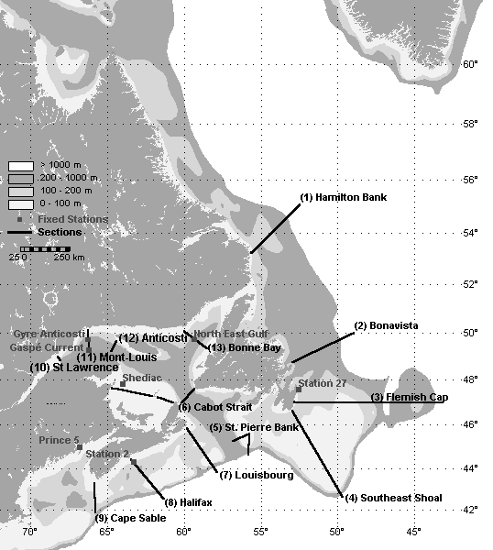
The Canadian navy contributes real-time BATHYs to the GTS and delayed mode XBT profiles to MEDS.

MEDS contributes data processing and management resources for the real-time and delayed mode data from Canada and real-time data from the world.

c) Funding Support and Status

Funding for oceanographic and fisheries research programmes come from operating budgets for the various institutes in the Department of Fisheries and Oceans. Funding of MEDS activities come from government provided operating budgets. These budgets are continuing at least at present levels. Funding of the ZMP is from a special allocation, which is expected to continue for at least another 3 years.

2. DATA COLLECTION

a) XBT Lines operated

Canada operates no XBT lines.

b) Other Sources of National Data

Both oceanographic and fisheries research cruises collect data of interest to SOOP. Over the past eight years, approximately 80% of the CTD data collected on research cruises have been distributed on the GTS as TESAC messages. The graphs in figures 2a and 2b illustrate the data receipts and distribution since the last SOOP meeting. Most of the BATHY data are contributed from Canadian Navy vessels and TESACs from research vessels. We can that a significant fraction of the BATHY reports have already been matched to XBT data received. Additionally, though, there is a lot of XBT data collected that are not reported in real-time. For CTDs, the overall matching to TESACs is not as good although in some months it is quite good. Also, it is evident that there are still CTD not received at MEDS from which TESACs were generated.

Canada is also archiving in real-time, data collected from oxygen and fluorescence probes deployed with CTDs. The value and reliability of these are being tested within the ZMP before more general availability is contemplated.

c) Instrumentation

Not applicable
Figure 2a: Matched and unmatched BATHY reports to XBTs received.
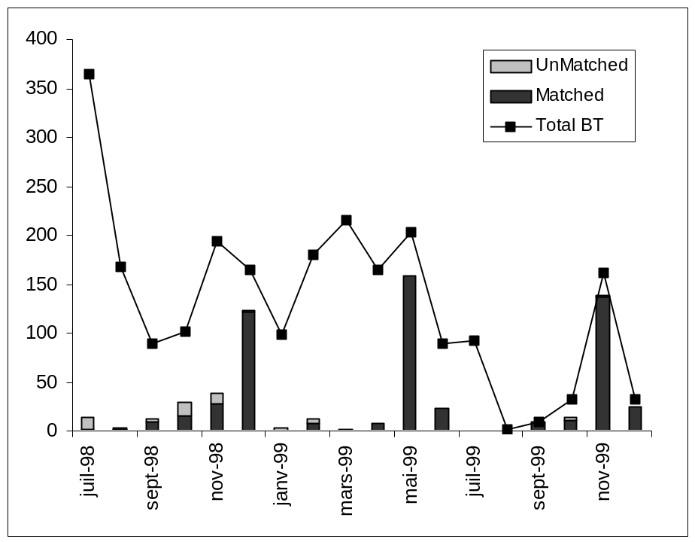

Figure 2b: Matched and unmatched TESAC reports to CTDs received.
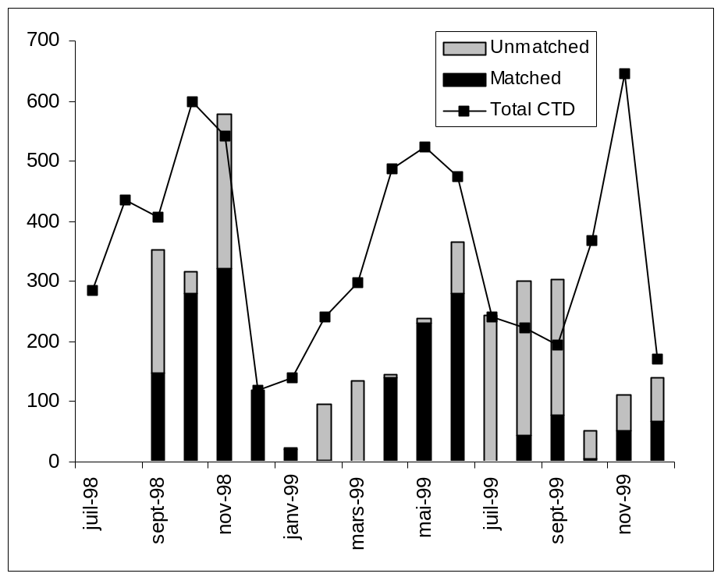
d) Instrument Evaluations

BIO has been collaborating with a private company in the moving vessel profiler. Some information on this was presented at the previous meeting and will again be available.

e) Other Shipboard Instrumentation and Data Collection Activities

As described above, the ZMP programme is starting to exchange oxygen and fluorescence data from continuously sampling probes attached to a CTD. Both of these suffer from some calibration problems, but the relative values reported are reasonably reliable. Further work will be done to evaluate the utility of such observations and, hopefully, improve the reliability of the observations.

On the West Coast, pCO₂, chlorophyll, and associated physical variables are collected on Line P and at OWS Papa. These data come to MEDS after some delay.

3. DATA MANAGEMENT

Data management activities in Canada are a shared responsibility between MEDS and facilities in the research institutes (depending on the type of data). The data flow monitoring with regard to SOOP activities falls largely to MEDS. Each month MEDS provides a collection of reports either to SOOP or other international activities or agencies. A brief summary is given below.

- A report listing the real-time data received from each of Canada, US, Japan and Germany. This report lists numbers and types of reports and information about how they were sent on the GTS.
- A report summarizing data quality problems noted in the previous month in the real-time data stream. This report is sent to ship operators. It also includes a map showing where data were collected.
- A report of the progress in converting GTS reporting from the older JJXX code form to the current JJYY. This reporting will be extended to include the JJVV and KKYY code forms to be introduced in May of this year.
- Maintains a file of the history for each platform reporting in real-time each month. This records the number and types of real-time reports and if problems were sufficiently serious for the operator to be notified that month. Information from this file is included in the report described in ii.

MEDS also provides information about real-time data collected from the GTS on a series of web pages (www.meds-sdmm.dfo-mpo.gc.ca). Here can be found the following information.

- Maps showing the positions of all BATHY and TESAC reports from previous months. (link to international programmes, SOOPIP)
- Maps showing the number of months in which there is at least one profile in each 2x5 degree square in the previous month and over the previous 12 month period (link to international programmes, SOOPIP)
- Explanations of the current and new BATHY, TESAC and TRACKOB code forms including all relevant tables (link to international programmes, SOOPIP, J-COMM)
- Maps showing the locations of TRACKOB data reported in previous months (link to data and products, thermosalinograph)
- A new Monthly Monitor report showing the locations of various kinds of ocean data collected in the waters around Canada (link to data and products, ocean profiles, monthly monitor)
- A document that describes MEDS processing and quality control procedures including the full text of the QC Manual (updates of IOC Manuals and Guides #22) as well as QC manuals from CSIRO and AOML.(link to international programmes, GTSPP, quality control)

MEDS has also been archiving TRACKOB data collected globally. We carry out very little quality control on these data but we do provide maps by month of where the data have been collected. These maps also distinguish between those reports with surface salinities and those without. These maps can be found on MEDS web site by following the links to Data and Products, Thermosalinograph.

b) QC Procedures (RT and DM)

MEDS employs the procedures described in IOC Manuals and Guides #22 including some updates. The complete description of the procedures that are used is found on MEDS' web site as described above.

c) Delayed Mode Data Submission status

Data are received continuously from our research institutes and updated as rapidly as possible. The figure in section B.b above shows the numbers of XBT and CTD data received as of February 2000, since July of 1998. As part of the ZMP initiative, we are working to accelerate delayed mode data delivery to MEDS from our East Coast so that all data of interest to ZMP will be in MEDS archives within one year of collection. Data collected by our West Coast institute are placed on their computer and to which MEDS has access. We periodically, (roughly every 4 months) examine their disks for newly arrived data and then capture these and place them in our archives. MEDS is approximately 1 year behind the date of collection in updating archives with data from our West Coast.

MEDS has recently instituted a bimonthly exchange with NODC to improve our data handling. This process is just getting underway with MEDS delivering data in GTSPP format and NODC delivering data in P3 format. We have recently completed our P3 translation software and are starting into production. MEDS sends all delayed mode data updated to its archives in the last 2 months to NODC and NODC sends all non-Canadian data updated in the last 2 months and collected from the Canadian area of interest.

4. FUTURE PLANS

The ZMP is the programme that is the first entry into a truly multidisciplinary sampling and monitoring programme. We are working to refine the various data collection, exchange, archiving and distribution practices in this context. It is expected that the experience will be carried over into other programmes (such as related to climate) that are in planning.

One of the developments of ZMP is the trial construction of a database system that will manage multidisciplinary data in a single system. Most of the development activity has taken place at the Bedford Institute. Other participants of ZMP, including MEDS, have cooperated in the design. As this work matures this year, MEDS will adopt the same system as an archive scheme for the multidisciplinary data it now holds from the Canadian JGOFS programme. This is a major development and will take some time to mature.

As noted above, Canada is expecting to play a significant role in ARGO. The data management functions are expected to reside at MEDS with a special part of the present web site devoted to information about the profiling floats deployed by Canada. At the same time, since much of these data are coming through the present GTS we expect to include information about the other floats that have been deployed. These plans are under development and are contingent on funding being approved.

5. FURTHER INFORMATION

6. RELATED NATIONAL WEB SITE LINKS

Through MEDS site (www.meds-sdmm.dfo-mpo.gc.ca) and following the links to national programmes, ZMP and links, you gain access to the research institutes web sites on Canada's East Coast. The major West Coast institute, IOS, can be reached at www.pac.dfo-mpo.gc.ca/sci.

_____________

Draft of the Project Plan on China Ship of Opportunity Programme

- Background
In China, The State Oceanic Administration (SOA) is responsible for the implementation of marine hydrological and meteorological observing by ships. Up to half decade ago, about 40 Chinese ships had taken part in the VOS project. But in recent years, because of the limited financial budget, fulfilling of this project is not very smooth. Fortunately, SOA now begin to implement a marine environment monitoring system construction project. SOOP is one part of this project.

- Development plan
(1). Number of vessels

About 90 ships will be gradually developed into this project within 5 years.

(2). Routes

Among them, 40 ships navigate at overseas sea route, including China-America, China-Canada, China-Europe, China-Australia, China-Japan, and so on. The other 50 ships navigate at domestic sea route.

(3). Data and Communication

The real-time observing data will be transmitted by INMARSAT-C or short wave, while the non-real-time data will be retained by ship until it arrives at designated harbour.

(4). Observing Parameters

Wind speed, Wind direction, Air pressure, Air temperature, Sea surface temperature

(5). Instrumentation

Ships taking part in the project will have the following instrumentation and facilities:

- Sensors of wind speed, wind direction, air pressure, air temperature and sea surface temperature.
- Data acquiring, processing and controlling unit
- GPS receiver and antenna
- INMARSAT-C MES and antenna, or short-wave MES
- Thermometer screen

- Problem
The biggest problem we are facing is that the communication cost of INMARSAT-C is too high to afford by us. We know that there is an agreement between WMO and IMO (International Maritime Organization) or ITU (International Telecommunication Union), upon which the opportunity ship can transmit observing data free of charge with the beginning of “BBXX”. We don’t know whether there is a same kind of agreement between WMO and the owner of IMMARSAT. We do hope this agreement is already or will be available soon.

National SOOP Report IRD Brest 1999

- National Programme information

a) National and International objectives

IRD Brest SOOP network covers primarily the Atlantic Ocean and in second priority the Indian Ocean. Pacific Ocean coverage is under the responsibility of IRD Noumea.

This programme is maintained under the general framework of the scientific objectives of the CLIVAR programme. The French contribution to CLIVAR in the tropical Atlantic is called ECLAT. It is intended to improve our understanding of the role of the tropical ocean variability in the global climate variability with special focus on the regional impacts in Western Africa and Eastern South America.

The other aspect is the maintenance of an operational network of subsurface observations aimed at providing a continuous flow of data dedicated to an assimilation process in coupled Ocean/Atmosphere GCM. More specifically the in situ observations combined with those of the PIRATA network are part of the french CORIOLIS programme and should be maintained as long as an ad hoc network of subsurface profiling floats (ARGO) is not in place. Observations are combined with altimetric satellite observations in an assimilation scheme developed for the French MERCATOR programme, which is considered as the French contribution to GODDAE and should be operational in 2002/2003.

b) collaborating agencies

IFREMER in the domain of data management mostly.
Meteo-France for hosting harbour facilities.

c) funding support and status

The funding has two major parts:
- maintenance, development and manpower is funded by IRD under the framework of its scientific programmes. It is provided on an annual basis, the scientific plan of action being approved for a period of 4 years. Next scientific plan should be approved in July 2000.
- Expendables (probes) are nearly exclusively provided by NOAA, therefore dependant on NOAA's budget and fiscal years. Manpower excluded, this represents the major cost of the programme.

2. DATA COLLECTION

a) XBT lines operated

4 lines were operated in the Atlantic Ocean in 1999

AX 11
One vessel (Cap Verde) made a very even sampling on this line (8 cruises). Sampling reduced to on transect per cruise (see action items review). Major issue: this vessel changed her line by the end of 1999. Investigation are under way, with the help of A. Sy from Germany, to select an other vessl on this line (equipped with TSG too).

AX15:
two South African vessels are currently operating on this line (Winterberg and Sederberg). Typical sampling rate: 4/day. Issues: require sometimes visits in Rotterdam or Bremerhaven (no call in Le Havre).
One french vessel (Autan) made 4 cruises in 1999 rouding the Cape of Good Hope to the Persian gulf. Issue: sold for scrap by the end of 1999.

AX20
one vessel (Toucan) performed a very good sampling on this line in 1999 (10 cruises). Sampling on both ways.

AX05
One vessel (Carrymar) made one cruise on this line in 1999.
Contacts are under way to equip one or two vessels operating on this line . These vessels (banana ships) are embarking Meteo France observers who could take part in the observations.

Indian Ocean

IX07
one vessel made 4 cruises in 1999 (see above). No vessel was found to ensure her replacement in 2000.

Summary of the XBT data collected in 1999 by IRD Brest

vessel | call sign | line | number of transects | total real-time data | total delayed mode data
Autan | FNXK | AX 15/IX 07 | 4 | 190 | 259
Cap Verde | ELV03 | AX 11 | 8 | 100 | 177
Carrymar | J8JA4 | AX 05 | 1 | 19 | 27
Sederberg | ZTSG | AX 15 | 6 | 69 | 124
Toucan | FNAV | AX 20 | 10 | 14 | 379
Winterberg | ZSPP | AX15 | 6 | 95 | 275
Total | 6 |  | 35 | 487 | 1241

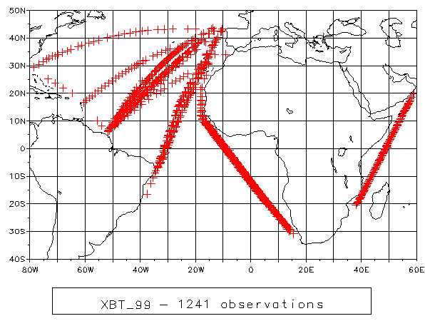

- other sources of national data

navy: no transmission. The Hydrographic Office is investigating the possibility of transmitting real time data from his vessels within the framework of Coriolis (responsible Eric Duporte)
ifremer: the complete collection of data collected by the RV Atalante (167 XBT) in 1999 (Atlantic and Pacific) was transferred in the SISMER data base in Brest. For the other vessels the transfer is planned for the first half of 2000.
notice that the position of these oceanographic vessels can be displayed on real time through the ifremer web server at http://www.ifremer.fr/posnav/

c)instrumentation

For IRD all the acquisition systems are PROTECNO/Argos models ( BATHY code 21 and 22). The probes used are T7 (BATHY code 042). Notice that Ifremer is using MK12 systems on his research vessels.

d)instrument evaluations
no specific activity

e)other shipboard Instrumentation

Thermosalinographs.

line AX 15
one vessel equipped (Waterberg). One vessel, still observing with surface bucket samples, should be equipped in 2000 with a TSG

line AX 11
the Cap Verde made 12 sections in 1999. (see above)

line AX 20
One vessel (Toucan) made 24 sections. A second one (Colibri) was instrumented end of 1999.

Comment: given the frequent sources of errors and malfunction of the TSG on these vessels our long term strategy is to equip at least two vessels per line to be sure to get at least one good transect per month.

Biogeochemistry

in year 1999 the first cruise undertaken under the GEP&CO programme mentioned last year was performed in November. This programme is planned for 3 years with a 4 cruises/year sampling. Complexity of the equipment requires a technician on board. Numerous parameters are measured (pigments, nutrients, CO2, alkalinity, reflectivity, atmospheric ΔC₁₃ . Line crosses the Atlantic and Pacific Ocean (Le Havre, New-York, Norfolk, Panama, Noumea). The vessel is the Contship London.
Data and results still in the scientific domain will be used too for cal/val activities of sea colour satellites.

3. Data management

a) data flow monitoring activities

XBT and salinity data collected and status of the network is available in a continuously updated web server at IRD Brest (http://www.brest.ird.fr/xbt/xbt_ors2.html).

- QC procedures
For XBT, QC as usual described in the documentation of the acquisition system and TOGA/WOCE Center manual. For salinities the QC is performed by the scientist in charge, no automatic procedure is used; it will require some documentation in the next version of DBMS.

- Data submission status

All the XBT data were transmitted
- in real time on the GTS by Meteo-France. Performance of the ARGOS system on the Atlantic network is rather low (see table) for unknown reasons.
- in delayed mode to the TOGA/WOCE Center (SISMER) in Brest who assembles both collections and transmits to the WDC.

Salinity data are managed directly at the Brest IRD Centre in a simple file management system. Plan for 2000 is to use a system similar and compatible with the Noumea data base, through developments with SISMER, who is in charge of managing the TSG of Ifremer oceanographic fleet.

biochemistry data in hands of the p.i.

4. Future plans

- XBT : maintain the system "as it", as long as required (evolution towards the ARGO system and definition of new sampling strategies by scientific Committees of different national and international bodies).

- For TSG the integration of Inmarsat transmission in the "thermo" software developed by IRD is under way. Plans are to equip the vessels instrumented with the automatic meteo station BATOS developed by Meteo France. The two vessels concerned are the Antea (IRD oceanographic vessel) and the Toucan operating on line AX 20. Trackob messages should be put on the GTS by Meteo France.

5. Further information, web sites and relevant references

More detailed information about the IRD SOOP networks may be found on the following site (which hosts the SOOPIP information server) too, under the "Ocean and Climate" pages:
http://www.brest.ird.fr/

_____________________________

STATUS OF SHIP-OF-OPPORTUNITY ACTIVITIES IN GERMANY 1999

Alexander Sy, Jürgen Ulrich and Martin Stolley

Bundesamt für Seeschiffahrt und Hydrographie
Bernhard-Nocht-Str. 78
D-20359 Hamburg,
Germany

www.bsh.de/3175.htm
sy@bsh.d400.de

1. Overview

As in the past the German ship-of-opportunity programmes (SOOP) are focussed on the Atlantic Ocean, and North and Baltic Seas. They haven’t been changed substantially from those reported at the last meeting of the IGOSS Ship-of-Opportunity Programme Implementation Panel (IOC, 1998). Technical and organizational status of the operational lines and other operational data collection activities are summarized in the attached Tables. Plans exist in "Bundesamt für Seeschiffahrt und Hydrographie", Hamburg (BSH) to introduce these commercial vessel-based programmes (in particular TWI line AX-3) as part of the German contribution to GOOS (BSH, 1999). In addition, in 1999 research vessels "Polarstern" and "Walther Herwig III", carried out XBT measurements along some TWI sections while en route. Within the framework of BSH’s SOOP, research and merchant vessels equipped with thermosalinographs or contact thermometers measure near-surface temperature and salinity.

Many of these SOOP activities are PI-driven, and thus are research-based rather than being an application-based official German contribution to the global SOOP network. In all research programmes XBT funding suffers from budget cuts due to the unification related tightened financial situation in Germany. All German real-time SOOP data are inserted as BATHY, TESAC or TRACKOB bulletins onto GTS by BSH with a delay of about 3 days to 1 week. Real-time data from various ocean areas have been contributed by the German Navy which accounts for 20 % of a total of more than 8000 German BATHY data circulating on the GTS in 1999. Further BATHY data are contributed by BSH's stationary "Marine Environmental Monitoring Network in the North and Baltic Seas" (MARNET).

2. XBT network

A regional overview of XBT measurements carried out in 1999 and distributed in real-time via GTS by both German SOOPs and German Navy is given in Fig. 1.

2.1 Line AX-1

XBT measurements in the sub-polar North Atlantic and Norwegean Sea have been continued to be carried out in spring (Norwegean Sea) and fall (AX-1) 1999 by R.V. "Walther Herwig III" (DBFR) operated by "Bundesforschungsanstalt für Fischerei", Hamburg (BFAFi). These contributions are based on cruises in the framework of her fishstock surveys for the North Atlantic Fisheries Organisation (NAFO). The programme probably will be continued in 2000. Real-time and delayed mode data are processed by BSH. However, it appeared in the Deep Blue XBT profiles of the last cruise that the data quality was extremely affected by wire related probe failures.

2.2 Line AX-3

Line AX-3 from the English Channel to Halifax/New York has been operated by BSH as a high density line without serious problems since 1988. The WOCE related programme was funded by the German Ministry of Education, Science, Research and Technology (BMBF) until the end of 1997. Funding from different sources, however, probably will allow to continue these measurements as part of BSH's contribution to the GOOS climate module (see section 3).

From the start of the programme in 1988, measurements have been carried out regularly until now by the German container vessel "Köln Express" (9VBL) and have been supplemented occasionally by several research vessels. A Sippican MK-12 unit and NOAA's SEAS IV software is used for data acquisition and transmission. Most transsects have a resolution of better than 40 nautical miles (Fig. 2). "Fast Deep" probes are used as a standard because these modified T-5 probes are capable of covering the upper 1200 m at a ship's speed of 20 knots.

So far, the line has been kept operational almost without interruptions. However, data quality problems appeared in late 1998 which impeded the programme seriously due to an increased probe failure rate exceeding 30 %. Fast Deep probe failures were wire related and showed up by wire stretching, constant signals and premature wire breaks. After probe replacements took place in October 1999 the probe failure rate again dropped down to the previous level of about 5 %.

2.3 Line AX-11

The Europe-Brazil line was established in 1981 by former DHI (now BSH) as the first German contribution to the IGOSS SOOP line system, and has been kept operational until today without major interruptions. The introduction of SEAS equipment in 1990 allowed an improved sampling strategy. Since summer 1996 the measurements were carried out by the German container vessel "Cap Finisterre" (DACF) on her way due north (Fig. 3). Both data acquisition system and data management are the same as for line AX-3 except that Deep Blue XBTs are used as the standard probe type. Since October 1999 the operation of this line is seriously affected by the same probe wire related quality problems as described above. Due to the tremendous failure rate increase from less than 5 % to up to 50 % and more the programme has to be interrupted until replacement probes take place.

2.4 Southern Ocean

Efforts have been continued to collect data from the Southern Ocean by R.V. "Polarstern" (DBKL) from "Alfred-Wegener-Institut", Bremerhaven (AWI). During the Antarctic summer season 1998/99, however, only 45 XBT measurements were carried out by AWI scientists in the Weddell Sea and on the way from Cape Town to Antarctica which were inserted into GTS by BSH. Delayed mode XBT data from "Polarstern" cruises since 1984 are archived in the AWI data base and are available on request (http://www.awi-bremerhaven.de/OZE/index.html).

BSH contribution to GOOS in the North Atlantic Ocean

As a contribution to CLIVAR and GOOS BSH is going to combine the AX-3 XBT programme with occasional XCTD measurements and with repeats of research vessel-based hydrographic sections every 3-5 years (Fig. 4). The scientific rationale of this BSH funded programme is to monitor ocean climate variability in a key region of large impact on European climate (BSH, 1999). Because autonomous profiling float technology provides a new and very effective tool in the sampling of upper ocean climate variability, in particular in combination with an appropriate XBT/XCTD SOOP network, an ARGO proposal has been drafted by BSH and submitted for funding to the German Ministry of Education, Science, Research and Technology (BMBF).

Various observations show pronounced surface and subsurface temperature variability of a multiyear time-scale in the western mid-latitude North Atlantic (e.g. Hansen and Bezdek, 1996; Sutton and Allen, 1997; Molinari et al., 1997). Our time series from both lines AX-3 and AX-11 show similar results for the entire main thermocline (Fig. 5).

Furthermore, observations from WOCE reveal surprisingly large and rapid changes in the water mass distribution of the intermediate and upper layers of the North Atlantic. It was found that the Labrador Sea Water dominating the intermediate depth level, which had been assumed to have a nearly constant temperature and salinity, presently is undergoing major changes. It is the most important oceanic occurrence of the 90s in the North Atlantic, characterized by marked cooling proceeding at annual intervals (cascades). This signal is spreading from its source area to the European shelf with a speed that is three times higher than had been assumed (Sy et al., 1997). In the Sub-polar Mode Water layer above significant changes in the baroclinic structure along the eastern margin of the sub-polar gyre were observed in the mid 90s coinciding with the strong decrease of the North Atlantic Oscillation (NAO) Index (Bersch et al., 1999).

Besides substantial changes in the formation of North Atlantic Deep Water these events affect the thermohaline circulation or vice versa. Results from data of the last 40 years indicate that the Meridional Overturning Circulation (MOC) is subject to strong and natural variability on time scales of 10 to 30 years which are correlated with the NAO (Koltermann et al., 1999). Because the space-time variability of its heat transport has an obvious impact on European climate corresponding long-term observations in selected regions are necessary for European climate prediction efforts.

4. XCTD Measurements

Measurements of temperature profiles alone do not satisfactorily meet the requirements for the investigation of heat flux or other important processes. Although XCTD probes were available to close this gap BSH reduced its XCTD programme meanwhile due to unsatisfying costs versus benefit relationship. Using probes and acquisition system designed by Tsurumi-Seiki Co. (TSK), Yokohama, Japan, however, one North-Atlantic transect has been carried out with good success in January 2000 (Fig. 6). Although at-sea tests showed TSK’s system close to providing the performance required by the oceanographic community for the upper ocean thermal and salinity investigations (Sy, 1998) further independent side by side tests with controlled and accurate CTD references are necessary to evaluate the depth fall rate formula and to monitor quality and reliability.

5. Further activities

On research cruises we are going to continue to convert the CTD bottle readings into TESAC coded messages for transmission from ship to BSH by e-mail in order to comply with the IGOSS request for more TESAC data.

Additionally, temperature data from selected stations of the BSH's stationary "Marine Environmental Monitoring Network in the North and Baltic Seas" (MARNET, Fig. 7) as listed below are inserted onto GTS as BATHY coded messages in 1999. This network is under development. Sea water parameters measured in 2 – 5 depth levels are at present temperature, salinity, oxygen, radioactivity and nutrients.

MARNET Station Name WMO-ID Position Remarks
"TW Ems" 10004 54° 10.0' N, 6° 20.8' E
"Elbe" 10005 54° 00.0' N, 8° 06.5' E capsized Dec 1999
"Deutsche Bucht" 10007 54° 10.0' N, 7° 26.0' E
"LT Kiel" 10044 54° 30.0' N, 10°16.0' E
"Nordseeboje II" 62086 55° 00.0' N, 6° 20.0' E
“Darsser Schwelle” 62089 54° 41.8’N, 12° 42.4’E new station
“Oder Bank” 66022 54° 04.6’N, 14° 09.6’E new station

The SST programme of BSH, which was established in 1987 has been started in 1996 to be supplemented by SSS measurements. Data are collected by both governmental and commercial vessels using Pt100 hull contact thermometers or SEABIRD thermosalinographs. All SST and SSS data received at BSH are inserted onto GTS as TRACKOB coded reports (Fig. 8). This programme is restricted to the North and Baltic Seas and does not follow the TWI line system.

Since 1972 BSH has participated actively in IGOSS and acts as the German input and output GTS hub for real-time oceanographic bulletins. All German BATHY, TESAC and TRACKOB bulletins circulating on the GTS have been submitted by BSH. We hope to contribute in the same way in the future. Trackplots of the output for BATHY messages in 1999 are given in Fig. 9. Fig. 10 shows that data acquisition along lines AX-3 and AX-11 and total real-time data flow has been relatively continuous during this period of time. Quality control of real-time data prior to insertion onto GTS is carried out by BSH personnel for most SOOP data but not for Navy data. Delayed mode data if processed and quality controlled by BSH have been submitted on a yearly basis to the responsible data centres (i.e. WOCE Global UOT Data Centre in Brest, France and NOAA/NODC in Silver Springs, USA).

Finally, based on various at-sea test data obtained in the North Atlantic between 1991 and 1997 we are going to evaluate T-5 and Fast Deep depth fall rate formulas using the procedures described by Hanawa et al. (1994). However, first results show relatively large variances of depth-time characteristics between different data sets. This investigation will be continued. Possibly additional at-sea tests have to be carried out in order to improve the data base.

6. References

Bersch, M., J. Meincke and A. Sy (1999): Interannual thermohaline changes in the northern North Atlantic 1991-1996. Deep-Sea Res., Part II, 46, 55-75.

BSH (1999): German programme contribution to the Global Ocean Observing System (GOOS). Berichte des BSH, 19, 74 pp.

IOC (1999): Second session of the Joint IOC-WMO IGOSS Ship-of-Opportunity Programme Implementation Panel (SOOPIP), Noumea, New Caledonia, 26-30 October 1998, Final Report.

Hanawa, K., P. Rual, R. Bailay, A. Sy and M. Szabados (1994): Calculation of new depth equations for expendable bathythermographs using a temperature-error-free method. UNESCO Tech. Pap. Mar. Science, 67, 46 pp.

Hansen, D.V. and H.F. Bezdek (1996): On the nature of decadal anomalies in North Atlantic sea surface temperature. J. Geophys. Res., 101, 8749-8758.

Koltermann, K.P., A.V. Sokov, V.B. Tereschenkov, S.A. Dobroliubov, K. Lorbacher and A. Sy (1999): Decadal changes in the thermohaline circulation of the North Atlantic. Deep-Sea Res., Part II, 46, 109-138.

Molinari, R. et al. (1997): Multiyear variability in the near-surface temperature structure of the midlatitude western North Atlatic Ocean. J. Geophys. Res., 102, 3267-3278.

Sutton, R.T. and M.R. Allen (1997): Decadal predictability of North Atlantic sea surface temperature and climate. Nature, 388, 563-567.

Sy, A., Rhein, M., Lazier, J.R.N., Koltermann, K.P., Meincke, J., Putzka, A. and Bersch. M. (1997): Surprisingly rapid spreading of newly formed intermediate waters across the North Atlantic Ocean. Nature, 386, 675-679.

Sy, A. (1998): At-sea test of a new XCTD system. Intern. WOCE Newsl., 31 45-47.
Table 1: Status of existing SOO lines operated by German agencies (1999)
TWI # | AX-1 | AX-3 | AX-11
Start of Operation | Nov-89 | May-88 | 1981
Finish | open | open | open
Ship Name | Walther Herwig III | Köln Express | Cap Finisterre
Callsign | DBFR | 9VBL | DACF
Fequency | 2/year | 8/year | 7/year
Density | 6/day | 12/day | 6/day
Probe Type | Sippican Deep Blue | Sippican Fast Deep | Sippican Deep Blue
Equipment | SEAS IV, MK-12 | SEAS IV, MK-12 | SEAS IV, MK-12
Data Transmission | METEOSAT | METEOSAT | METEOSAT
Agency | BFAFi, Hamburg | BSH, Hamburg | BSH, Hamburg
PI | M. Stein | A. Sy | A. Sy
Programme | Fisheries | GOOS/CLIVAR | GOOS
Sections 1999 | 1 | 8 | 7
Profiles 1999 | 30 | 310 | 395
GTS Input 1999 | 30 | 261 | 380
Sect. planned 2000? | 2 | 8 | 7
Activity 2001? | ? | yes | yes
Problems 1999 | probe quality | probe quality | probe quality
Remarks |  | occasionally XCTD
Table 2: Status of operational real-time data distribution (1999)
Ship/Callsign | BATHY | TESAC | TRACKOB
W. Herwig, DBFR | 60 |  | 59
Köln Express, 9VBL | 261
Cap Finisterre, DACF | 380 |  | 28
Polarstern, DBLK | 45
Alkor, DBND |  | 12
A. v. Humboldt, Y3CW |  | 24 | 20
Penck, Y3CH |  |  | 22
Ebro, CSEP |  |  | 240
Coral Essberger, CSAP |  |  | 203
Gauss, DBBK |  |  | 171
Meteor, DBBH |  |  | 21
Atair, DBBI |  |  | 33
Wega, DBBC |  |  | 32
Deneb, DBBA |  |  | 35
Meerkatze, DBFM |  |  | 30
Seefalke, DBFO |  |  | 208
Neuwerk, DBJM |  |  | 20
Barbara, DJOK |  |  | 188
German Navy | 1600
MARNET | 5665
T o t a l | 8011 | 36 | 1310

Figure Captions

Fig. 1: a) XBT measurements carried out 1999 by BSH operated ships of opportunity
b) XBT real-time data contribution 1999 from German Navy.

Fig. 2: Example of a high density Fast Deep XBT section across the North Atlantic (AX-3) carried out by CMS "Köln Express" in January 2000

Fig. 3: Example of a regular Deep Blue XBT section from Brazil to Europe (AX-11) carried out by CMS "Cap Finisterre" in August 1999.

Fig. 4: BSH’s proposed contribution to GOOS/CLIVAR: Ship-of-Opportunity measurements (hatched area) with bimonthly eddy resolving XBT sections, TSG and supplemented by occasional XCTDs and research vessel-based full depth repeat hydrographic sections along the northern and southern boundary of the SOOP area.

Fig. 5: Normalized monthly heat content anomalies of the upper 750 m
a) Line AX-3 between 1988 and 1999.
b) Line AX-11 between 1991 and 1999

Fig. 6: XCTD section carried out by CMS “Koeln Express” in January 2000

Fig. 7: Two new stations of the automated "Marine Environmental Monitoring Network in the North and Baltic Seas" (MARNET) of BSH.
- Mast station “Darsser Schwelle”
- Buoy station “Oder Bank”

Fig. 8: Trackplot of TRACKOB messages of the BSH SST/SSS programme in 1999

Fig. 9: Trackplot of BATHY messages received at BSH in 1999

Fig. 10: a) Number of XBT profiles obtained along AX-3 and AX-11 from 1988 until 1999. The decrease for AX-3 in 1999 is caused by wire related probe failures.
- Time series of yearly BATHY, TESAC and TRACKOB input by BSH since 1972.
INDIAN NATIONAL SOOP REPORT

Submitted by: V.V. Gopala krishna,
Physical Oceanography Division,
National Institute of Oceanography,
Dona Paula, Goa - 403004, INDIA
E-mail: gopal@csnio.ren.nic.in
gopal@darya.nio.org

- NATIONAL PROGRAM INFORMATION

- National and International Objectives

Under the Indian TOGA program, National Institute of Oceanography, Goa, has initiated XBT observations onboard ships of opportunity along a few selected shipping lanes (listed below) in the seas around India. This program was supported by the Department of Science & Technology, Government of India till 1998 and now it is funded by the Department of Ocean Development under its Ocean Observing Systems program. Along all these routes XBT surveys are planned to repeat at bi-monthly intervals subjected to the availability of Merchant ships and scientific observers have been carrying out the observations. Ongoing XBT lines are:

- Madras - Andamans - Calcutta in the Bay of Bengal (IX14). Sampling started in this route during mid 1990

- Madras - Singapore in the Bay of Bnegal (IX14). Observations along this line commenced during early 1995.

- Bombay - Mauritius in the western Indian Ocean (IX08). First XBT survey took place during February 1992.

Following are the major National Objectives:

- To document and understand the variability of near-surface thermal structure along the shipping lanes on seasonal and inter-annual time scales.
- To examine the relationship between near-surface thermal structure and TOPEX sea level data.
- To explore the potential relationship between near-surface thermal structure and monsoons and cyclogenesis.
- To generate sea truth data for validation of satellite derived parameters.

- Collaborating Agencies

Dr.Rokkam R Rao, Naval Physical and Oceanographic Laboratory, Cochin, India.

Dr.M.M.Ali, Space Application Centre, Ahmedabad, India.

- Funding Support and Status

The Department of Ocean Development, Government of India, New Delhi is supporting this project under their Ocean Observing Systems Program. The funding is committed till 2002..

- DATA COLLECTION

(a) XBT Lines operated

Under the Indian XBT Program we have been carrying out XBT surveys along the following three routes at near bi-monthly intervals.

- Madras - Andamans - Calcutta in the Bay of Bengal (IX14)

- Madras - Singapore In the Bay of Bengal (IX14)

- Bombay - Mauritius in the western Indian Ocean (IX08)

XBTs are operated at every one degree (110Km) spatial intervals all along the XBT section in the open ocean and at half degree (about 50km) spatial intervals close to the coastal regions. The data is collected by the scientific observers (post graduates in marine sciences). Apart from operating XBTs we also collect routing surface marine meteorological data at three hourly intervals throughout ship sailing.

There is no problem for the availability of merchant ships in the Bay of Bengal, but along Bombay - Mauritius (IX08) frequency is relatively less. However we are still managing four to five XBT voyages minimum per year. We never experienced of equipment malfunctioning problem since we take utmost care. The biggest problem we face is frequent changing of Merchant ships. We do not have a fixed ship for a fixed route. Whatever ship is available or whichever shipping agency provides berth onboard their merchant ships, we board the vessel to carry out measurements.

- Other sources of National data

Our Institute conducts regular multidisciplinary cruises in both the seas. In addition, the National Institute of Ocean Technology (NIOT), Madras , obtains time series data under their National data Buoy Program.

- Instrumentation

We use PC based M/S.Sippican Inc make Mark12 XBT data acquisition System and T7 (0-760m) Sippican XBT probes. Also used are M/S.Casella, UK make Portable wind wane, Cup Anemometer, Whyrling Psychrometer and German Make Out Board Bucket Thermometer, At present we do not have satellite transmission system because we have the problem of frequent changing Merchant Ships. However, shortly we are going to begin real time XBT data transmission using Inmarsat-C.

- Instrument Evaluation

We have not under taken any instrument evaluation.

- Other Shipboard Instrumentation and Data Collection Activities:

Apart from sub-surface temperature and surface marine meteorological data at present we are not collecting any other type of data. We have plans to introduce surface salinity data collection and chlorophyll data.

- DATA MANAGEMENT

- Data Flow Monitoring Activities

- QC Procedures (RT and DM)

At the end of each XBT survey, we process the XBT data in our Institute using known QC procedures (Bailey et al 1994, CSIRO, Hobort). Individual temperate profiles are carefully examined to find any spikes, unacceptable inversions etc.

- Delayed Mode Data Submission Status

Till recently, Non - EEZ XBT data is supplied to the International User community in delayed mode (once a year). However, since Dec 1999, we are submitting the Non - EEZ Data within 30 days of its collection. We sent the recent data to Dr.Dug Hamilton (NODC Washing ton) and Dr.Keeley (MEDS, canada).

- FUTURE PLANS

We have plans to introduce collection of multidisciplinary parameters such as sea surface salinity, chlorophyll and nutrients along these XBT lines.

- FURTHER INFORMATION

- RELATED NATIONAL WE SITE LINKS

- RELEVANT REFERENCES AND PUBLICATIONS

- Seasonal variability of upper-layer geostrophic transport in the tropical Indian Ocean during 1992-1996 along TOGA-I XBT tracklines

V.S.N.Murty, M.S.S.Sarma, B.P.Lambata, V.V.Gopalakrishna, S.M.Pednekar, A.Suryachandra Rao, A.J.Luis, A.R.Kaka and L.V.G.Rao

Next Issue of Deep Sea Reserach.

- T-S variability and volume transport in the central Bay of Bengal during south west monsoon.

V.V.Gopalakrishna, S.M.Pednekar and V.S.N.Murty

Indian Journal of Marine Sciences, 1996, Vol.25, 50-55

- The value of Ce for the Arabian Sea during summer monsoon

A.Suryachandra Rao, Y.Sadhuram and V.V.Gopalakrishna

Proceedings of the Indian Academy of Sciences,1995, Vol.104 (4), 607-611

- Observed year to year variability in the thermal structure along Madras - Andamans XBT trackline in the Bay of Bengal.

V.V.Gopalakrishna, A.Suryachandra Rao, M.S.S.Sarma, S.M.Pednekar, B.P.La,bata, L.V.G.Rao and R.R.Rao

Proceedings of TOGA-95 International Scientific Conference, 1995, WCRP-91 WMO/TD no. 717, pp 166-170.

- Response of Ocean upper layers to the storm forcing in the Bay of Bengal

V.V.Gopalakrishna, V.S.N.Murty, M.S.S.Sarma and J.S.Sastry

Indian Journal of Marine Sciences, 1995, Vol.44, 234-240.

- Detection of Bay of Bengal Eddies from TOPEX and In-situ observations.

A.K.S.Gopalan, V.V.Gopalakrishna, M.M.Ali and Rashmi Sharma

Journal of Marine Sciences (communicated the revised version)

Ph.Ds

- Rossby waves in the Bay of Bengal: Observations and Simulations

By: A.Suryachandra Rao, 1999, Andhra University, Visakhapatnam, India

- Some studies on the thermal fields in the central Bay of Bengal

By: V.V.Gopalakrishna, Andhra University, Visakhapatnam, India

M.Phil Thesis

- Variability of upper ocean thermal structure and circulation in the tropical Indian Ocean from TOGA-I XBT data

By: Balajee Prasad Lambata, Berhampur University, Orissa, India, 1994

- A study on distribution of surface marine meteorological fields in the central bay of Bengal during 1990-1995 Indian TOGA XBT Program

By: Kulbeer Singh Raina, Kurukshetra University, India, March 1997

- A study on Dynamic fields and moisture budget of the marine troposphere over the central Arabian Sea during Monsoon - 77

By: A.Suryachandra Rao, Andhra University, Visakhapatnam, India, March 1993.

NATIONAL REPORT FROM ITALY

VOS Data Collection and management in the
Mediterranean Forecasting System project
within the EU RTD Framework Programme

MFSPP-VOS Group

Abstract. The Mediterranean Forecasting System has the overall aim to explore, model and quantify the potential predictability of the marine ecosystem variability at the level of primary producers. Among the tools for achieving such aim there is the development and implementation of a monitoring system based on ships of opportunity. New strategies for data decimation and transmission have been developed as well data management strategies for the dissemination of the 'Near Real Time' data. A particular care was put on the implementation and application of quality assurance concepts including the fieldwork and the data quality control. The monitoring started on September 1999 on 7 tracks crossing the Mediterranean from east to west and from north to south. A training period was done up to November during which the ships' trips were once per month. From December the monitoring was more frequent (15 days' sampling interval) in order to capture the synoptic scale. The spatial sampling scale is 10-12 nautical miles. The data transmission in Real Time started on October 1999. All the decimated data are freely available in the web, The paper provide the information on the data transmission strategy development, on data quality control and dissemination in Near Real Time.

- Introduction.

The Mediterranean Forecasting System, in the framework of the GOOS initiative, aims at the prediction of the marine ecosystem variability up to the primary producers and from the time scales of days to months. Such a predictive capability is required to sustain a healthy marine and coastal environment and its management (Pinardi et al, 1997).

Some data management aspects which are under development as part of an EU MAST project called Mediterranean Forecasting System Pilot Project (MFSPP), started on September 1998, are herewith presented. The project is representing the application of some important scientific, modelling and data collection efforts in the Mediterranean area.

For the particular case of the data management aspects, the Mediterranean area is representing a laboratory where new concepts on data quality checks are being developed. The physical conditions of the sea changes from season to season, from year to year and also from area to area. Vertically homogeneous profiles are usually found in particular ares of dense water formation (e.g. the northwestern Mediterranean, in the Adriatic, in the Aegean and portion of the Levantine basin). These aspects necessitate the development of particular software for data decimation and quality control. In the case of MFSPP, there is the necessity to provide with a short time delay data collected with a high temporal and spatial sampling rate.

Strengths and weaknesses of the VOS MFSPP system are here presented, providing also some examples of the results obtained up to now.

- The Mediterranean Forecasting System

MFSPP is a pilot project having the aim to develop a forecast system for the Mediterranean Sea ecosystem, up to the primary producers, from time scales of days to months. The entire Mediterranean Forecasting System plan is for a ten year science and technology implementation programme divided in three phases:

- First phase (1997 – 2000) – Short term forecast of the physics of entire Mediterranean Sea. This is also including the validation of ecological simulation of seasonal nutrient cycles and primary production
- Second phase (2000 – 2003) – Regional and medium range forecasts, including a fully coupled ocean-atmosphere model and pilot forecast experiments of the ecosystem model
- Third phase (2003 – 2008) – Pre-operational. The entire observational and modelling systems will be released to the National and International marine operational agencies.

The MFS group is now developing, among other tasks, the monitoring system and the real-time forecast experiments.

The reasons for the setting up of a Mediterranean Forecasting System are:

- the increased availability of high quality and good coverage data sets
- the development of accurate schemes of numerical modelling and data assimilation
- the advancement in understanding key circulation processes

The rationale of MFSPP is including the development of services for the Mediterranean community and the trans-national co-operation within the basin countries. The data management plan is including a novel approach on data dissemination, i.e. the wide, free distribution of the (near)real-time data collected within the project to the international community.

- The monitoring system during the first phase of MFS

To focus the design of the observing system, 3 main sub-goals were identified:

- deploy elements of a VOS monitoring system for the upper ocean. The focus here is on collection of XBT data along 7 transects. XBT real-time data are collected and transmitted via ARGOS to the Global Telecommunication System;
- develop methods and techniques to analyse (near)real-time data. The data allow the analysis of spatial and temporal variability of the upper layer of the Mediterranean Sea. They constitute benchmarks against which temporal variability will be evaluated;
- improve (near) real-time data exchange capabilities and networking. Near-real-time dissemination is an important part of the project, as well as the production of high level analysis to be distributed to a wider user community.

The ‘Volunteer Observing Ships’ programme set up for the Mediterranean Sea has some strong requirements:

- data must be collected to resolve the mesoscale (10-12 nm) at a synoptic time scale (15 days)
- data must be available in ‘near-real-time’, which means that all collected data must be available within two days
- open access of the ‘near-real-time’ data must be given to the international scientific community
- all data must be quality controlled before the dissemination .

The monitoring design has been defined on the base of the most advanced knowledge of the Mediterranean circulation. Transects have been designed in order to:

- follow the spreading of the Atlantic water into the basin,
- sample the main gyres,
- detect the variability of the dense water formation areas.

In this first pilot phase, the spatial coverage is not yet optimal, but the main circulation features are captured by the monitoring system. The Institutions involved in data collection are belonging to various Mediterranean Countries and have a proved experience on oceanographic studies. The Countries involved are: Spain (CSIC CEAB), France (LOB), Italy (CNR IOF, OGS, ENEA), Greece (NCMR), Cyprus (FDMR LPO), UK (SAHFOS).

The quality of data is assured by the application of quality criteria concerning the various phases of the project, from the monitoring design to the use of the data. The development of fieldwork guidelines guarantee the harmonisation of the working procedures among the different participants. Furthermore, the data values are controlled three times: on board the ships of opportunity applying an automatic gross range check, in the VOS NRT DCA (ENEA La Spezia, Italy) and in the Project data centre (IFREMER Brest, France). A particular care has been devoted to the automation of the data control, by developing specific softwares.

In summary, four main criteria are at the base of the management practice of the MFSPP VOS project:

- quality assurance of the measurement programme strategy
- quality assurance of field work
- quality assurance of collected data
- quality assurance of the use of the data

A particular attention is devoted to the quality assurance of fieldwork. A report was elaborated with the following objectives:

- to provide documentation on methods and q.a.
- to ensure the quality of the data
- to plan data production

It is thought also as a tool for those person that will operate on board the VOS (students, technicians, ship personnel, …), which will found all the necessary information on instruments and procedures to follow for data collection (MFSPP - VOS, 1999). The quality of products and services depends on the resources that are set aside. The expertise and qualification of the personnel are decisive for the quality of the results supplied. The quality assurance system therefore includes guidelines and procedures which, at all times, aims to ensure the best possible and most relevant expertise relative to requirements.

The formal education is now adequate to the collection of XBT data and decisions to be taken in case of failures of the acquisition/transmission system. The field workers have the relevant information on the environment they are exploring, such as the temperature profiles expected during the ship trip.

4. Ship track design

The ship track design has been adapted accordingly to the availability of commercial ships. This is the final design:

Institution | Ship name | Track number | Initial and last port
SAHFOS | City of Dublin | 1.1 | Palermo- Gibraltar
SAHFOS | City of Dublin | 1.2 | Haifa - Messina
CSIC CEAB | Isabella | 2.1 | Barcelona- Arzew
CSIC CEAB | Isabella | 2.2 | Barcelona-Skikda
LOB | Cap Canaille | 3.1 | Sete - S.Antioco
LOB | Cap Canaille | 3.2 | Tunis - S. Antioco
IOF/ENEA | Majestic/Splendid | 4.0 | Genova - Palermo
OGS | Lipa | 5.0 | Ploze - Malta
NCMR | Sariska | 6.0 | Thessaloniki- Alexandria
FDMR LPO | Princesa Victoria | 7.0 | Limassol - P. Said

During the period September - November 1999 the tracks were done once per month. From December 1999 the data are collected twice per month, with the exception of the long route 1, which is continuing with a once per month trip.
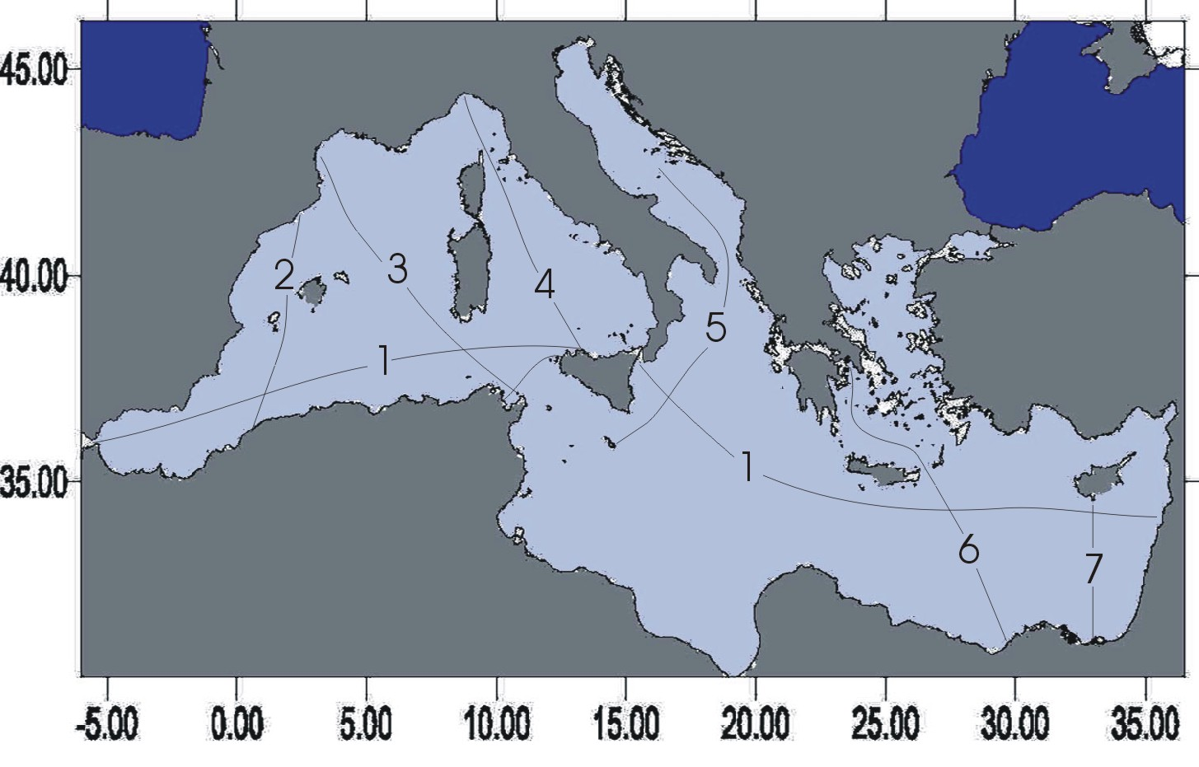

Fig.1a The MFSPP VOS design from September to December 1999

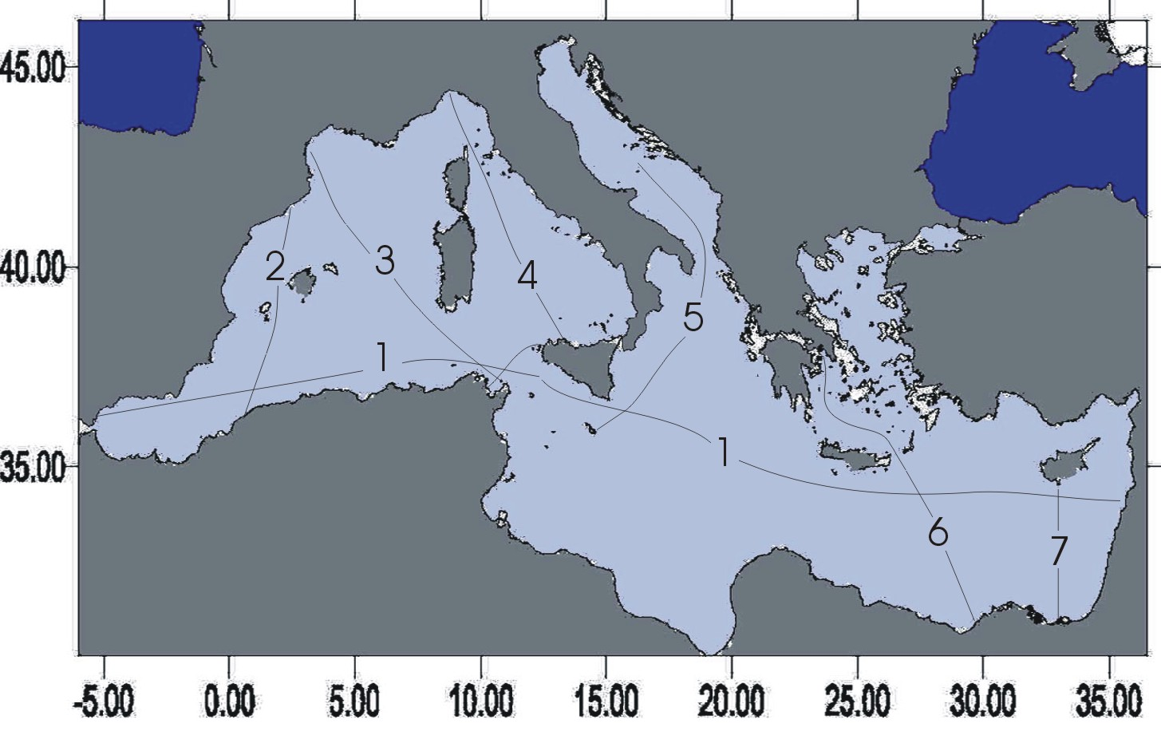
Fig. 1b The MFSPP VOS design from January 2000

5. Software and hardware check

The hardware and software related to the collection system, acquired by all partners, is composed by Sippican hand launcher LM 3A, MK12 board and application software version 3.03. It was checked that all the participants have the same software version, in order to avoid any problem with data decimation and quality control.

The Argos data decimation and transmission software has been changed accordingly to MFSPP requirements.

1. No test from 0 to 10 m
2. Maximum depth | 460 m
3. Minimum temperature | 2°C
4. Maximum temperature | 34.0°C
5. Maximum temperature inversion (0 – 200 m) | 4.5°C
6. Maximum temperature inversion (> 200 m) | 1.5°C
7. Maximum temperature gradient | 3°C/m

The data transmission software was initially based on the old version used for the oceanic Ships of Opportunity programs. After some experiences, many significant changes were operated on the automatic quality control, messages content and accuracy of data, in collaboration with ARGOS.

The following table show the differences of the accuracy of the old and new version.

ARGOS transmission | Old software | New software
Depth accuracy (0 -200 m) | 2 m | 1 m
Depth accuracy (below 200 m) | 2 m | 2 m
Time | 2min 48 sec | 2 min
Sea Surface Temperature | 0.1333°C | 0.1 °C
Temperature | 0.1333°C | 0.1°C

Concerning the data decimation and transmission, the following changes have been operated, in addition to the gross check defined above:

- whatever could be the XBT probe used, the data to be transmitted must be comprised between the surface and 460 m depth
- whatever could be the temperature profile, 15 significant points must always be transmitted
- end of profile check – the profile is thought at is end when there is an artificial increase of temperature due to the wire stretching, as consequence of the elongation occurring when the probe reaches the bottom. However this check is dangerous because of the existence in the Mediterranean of relatively warm Levantine intermediate water. This check was deleted in the MFSPP VOS version
- accepted profiles – in the oceans the XBT profiles are accepted if the temperature gradient between the upper and lower layer is greater than 2°C. Due to existence of vertically homogenous water in the Mediterranean, this check was modified and set in order to receive also vertically homogeneous profiles
- rounding error – the new software and transmission protocols were constructed in order to achieve a higher accuracy in data decimation and transmission. However rounding errors were possible. For this reason the encoding and decoding software is firstly applied in the computer on board, then the data are transmitted. The results of this modification is very promising.

Problem are still existing in the decimation software are analysed by the MFSPP VOS group. In order to check the effects of some parameters in the data decimation and transmission, a ‘virtual ship (acquisition/transmission system)’ was created in the ENEA Centre. It is constituted by a PC having the Sippican and ARGOS softwares installed, an electric circuit simulating the XBT probes and the sea water, the Argos transmitter. By simulating the fieldwork it is possible to send instructions to the partners and reply to any practical question posed by them.

The software for the quality check of the delayed mode data has been developed following the criteria defined by MEDATLAS, another EU funded project.

6. Data Management

The data management system has been developed using the experience of the most important international programmes (IGOSS, SOOPIP) and the experience gathered as part of the EU projects (MEDATLAS).

The data flow follows the steps:

- data are acquired by means of the Sippican system, stored in the pc hard disk in both rdf and edf formats.
- The edf files are quality controlled by the Argos software
- Decimated profiles are generated and sent to the transmitter were a local logger can store up to 12 profiles
- Data are transmitted to Toulouse and from Toulouse to the ENEA centre
- After a final control the data are transferred in the web site

7. Establishment of the WWW server and ftp site

The MFSPP VOS web site has been established in ENEA Marine Environment Research Centre. It gives the information on the project and gives also a user friendly interface to the ftp site for data extraction. The web site is providing links with the most important Ships of Opportunity programmes.

The most important work done in the MFSPP VOS web was the possibility to download near-real time data with a short delay. The experience acquired up to now demonstrate that quality data can be included in the web with a delay of 1 – 3 days. We are confident that a delay of one day can be easily achieved, instead of the 2 days defined in the technical annex of the EU contract.

The downloading system is easy, since the user only need to define the days, month and years of data to be downloaded. A zip file is created automatically and the user can save it in his own computer.

The web offers also the access to a free software developed by AWI in Germany as part of the EU funded MODB (1996) project, which allow the processing of the data (vertical sections, scatter plots, horizontal maps). In order to facilitate the use of the ODV software, the project has developed a tool which allow to download from the WP1 web ODV zipped files. The user must only extract the data which are in ODV format.

8. Results of the MFSPP VOS program

8.1 The delayed mode data analysis

The monitoring system has been successful up to now and delayed mode data are now constituting a unique data set for the exploration of the Mediterranean sea dynamics.

Depending on the track length and ship speed, the data collection system is managed by one – three persons. In fact the ship speeds vary from 15 kn to 22 kn and the launch interval consequently vary from about one hour to half hour.

The major difficulties come mainly from the meteorological conditions, especially in particular areas under the domain of the strong winds such as the Mistral, Tramontana and Ethesian. Although some of these winds blow all year long, conditions can be especially severe in winter, even for cargo ships sailing downwind. Therefore, changes in the route can occur.

The track design was done in order to capture the most important features of the Mediterranean Sea Circulation, which are schematically presented in figure 2.

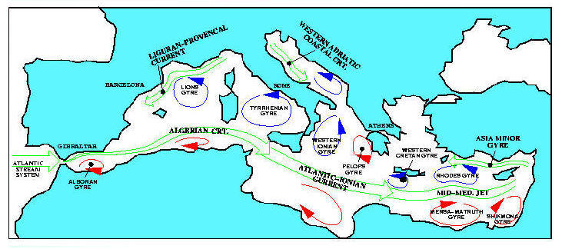Fig. 2 The Mediterranean general circulation scheme.

In the surface layer of Modified Atlantic Water (MAW), the tracks 2 and 3 crosses, from north to south, the Northern Current, the zone where Winter Intermediate Water (WIW) and Western Mediterranean Deep Water (WMDW) are formed, the North-Balearic front, eventually some mesoscale Algerian eddies and, finally, the Algerian Current. At intermediate depths, and still from north to south, the routes crosses the Levantine Intermediate Water (LIW) vein flowing (i) westward along the French and Spanish continental slope (it is relatively old here), (ii) northward along the western slope off Sardinia, (iii) westward along the southern slope off Sardinia (it is relatively young here), and finally, (iv) the various intermediate waters flowing eastward along the Algerian and Tunisian slopes, from the Algerian Basin into the Tyrrhenian Sea (among which the very old LIW could be recognized with salinity data). At intermediate depths too, the distribution of WIW will be described over the whole study area. Below, the route will also allow monitoring the WMDW formation in the Gulf of Lions and its spreading along both the Algerian and Tunisian slopes.

The thermocline was very strong at the beginning of the measurement period and absent during the winter trips. The progressive homogenisation of the water column in the northern part of the sections, caused by the winter cooling, leaded tp an increase of the density that favoured the deep water formation.

Track 4 provide information on MAW and LIW entering the Ligurian Sea. In the Tyrrhenian Sea the route crosses the area in front of Bonifacio Strait dominated by an Ekman pumping and then the wider southern gyre.

From data of tracks 2, 3 and 4 it appears that the LIW vein displays a marked variability in both space and time around Sardinia. The entrance of intermediate and relatively deep waters from the Algerian Basin into the Tyrrhenian Sea appears to be much more variable than expected.

Track 5 crosses the southern Adriatic gyre and the western Ionian gyre. It has been divided into several transects which cover different geographical sub-areas distinct from the oceanographic point of view. In the southern Adriatic pit dense water is formed through an open-ocean deep convenction in the centre of a cyclonic gyre. The observation period represents a transition phase from the highly stratified summer season and a pre-conditioning period to a winter deep convection phase.

Track 6 crosses the South Aegean Sea and the Levantine basin of the Eastern Mediterranean (figure 1). Thus, we expect to cross and identify mesoscale features in these areas. Based on bibliographic information, we expect that the transects will be able to cross the Mersah-Matruh anticyclone in the southern Levantine, and possibly the Rhodes cyclonic gyre in the northern Levantine (Robinson and Colnaraghi, 1994). We see that the signature of the Mersah-Matruh anticyclone is very strong (located between 600 to 850 km from Piraeus) and remains a dominant feature from October until the end of December of 1999 (the January 2000 transect was interrupted by the unscheduled change of route of the MSC SARISKA to Beirut). Furthermore, among the “permanent” features in the Levantine, we note a westward current south of Crete (400 to 600 km from Piraeus), probably extension of the Asia Minor Current, and the eastward current along the northern coast of Africa. In the Cretan Sea we observe some small mesoscale features that have a transient nature. Also, of interest are the hydrological characteristics. Note the progressive shallowing of the 15⁰ C isothermal along the transect from north to south, as well as the cooling of the surface layer throughout fall.

Track 7. More eastward, south of Cyprus the analysis of the XBTs transects shown a very well stratified water column with an increase of the upper homogenised layer from 40 m down to 150-200 m, respectively from September 1999 to February 2000. The temperature of the surface water layer from 27-28 °C in September 1999 was decreased to 17-18 °C in February 2000. Moreover, in the centre of the transect, in the area Southeast of the Eratoshenes seamount, a permanent temperature depression exits throughout the entire period of the observations. This temperature depression may associated with the westward extension of the permanent Cyprus anticyclonic eddy found during the CYBO-Cyprus Basin Oceanography project between 1996-1999 as well during late 80s (Zodiatis et al, 1998),. Moreover, during February 2000, at the epicentre of this depression, the homogenisation of the upper surface water layer exist the 200 m depth .

Track 1 is following the entire stream of the Modified Atlantic water both in the Western and Eastern Mediterranean. The data also make possible an intercomparison with the other tracks’ data, in the crossing points.

The analysis of specific XBT sections (such as track 3) will be done in relation with current meters time series and satellite data sets.

8.2 The NRT data analysis

More different is the data availability in near real time. Figure 3 gives the situation from October 1999. The data are mainly used for assimilation into a numerical model for the ten day forecast of the Mediterranean Sea circulation. They also provide a quick view of the temperature changes occurring in the Mediterranean.

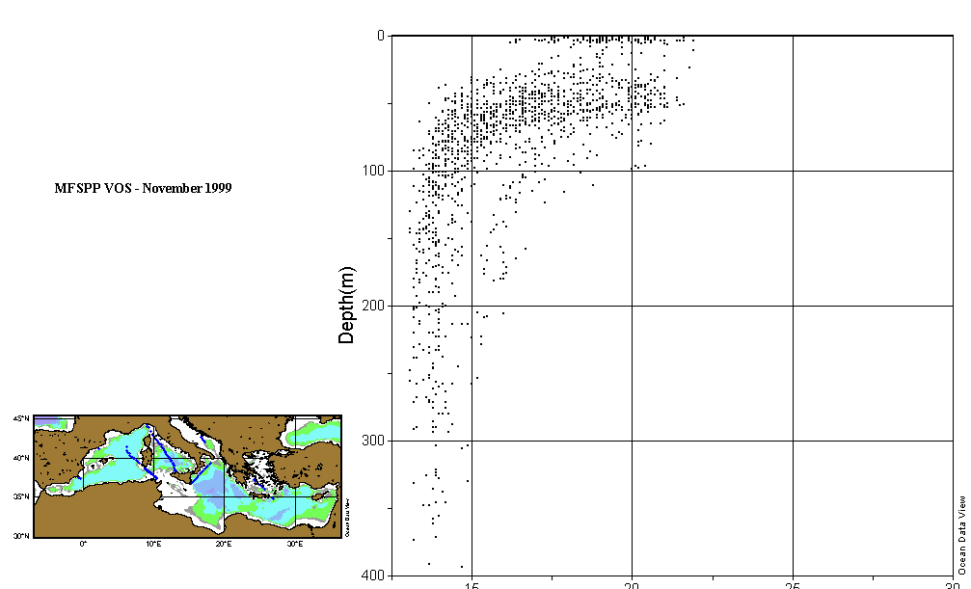
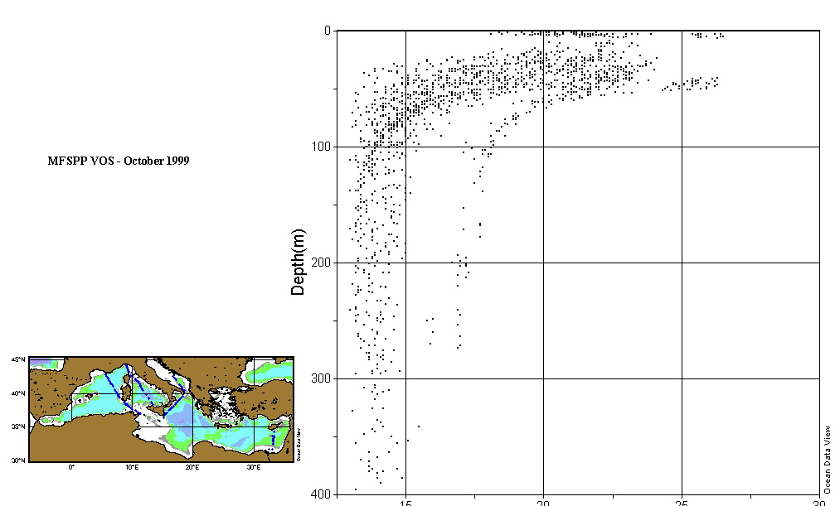
Fig. 3a NRT data in October 1999 Fig. 3b NRT data in November 1999

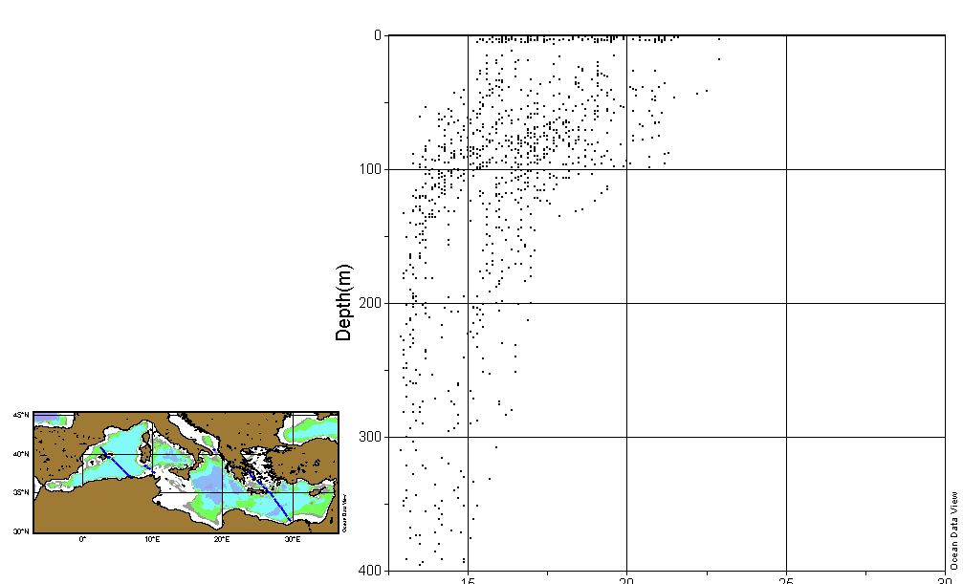
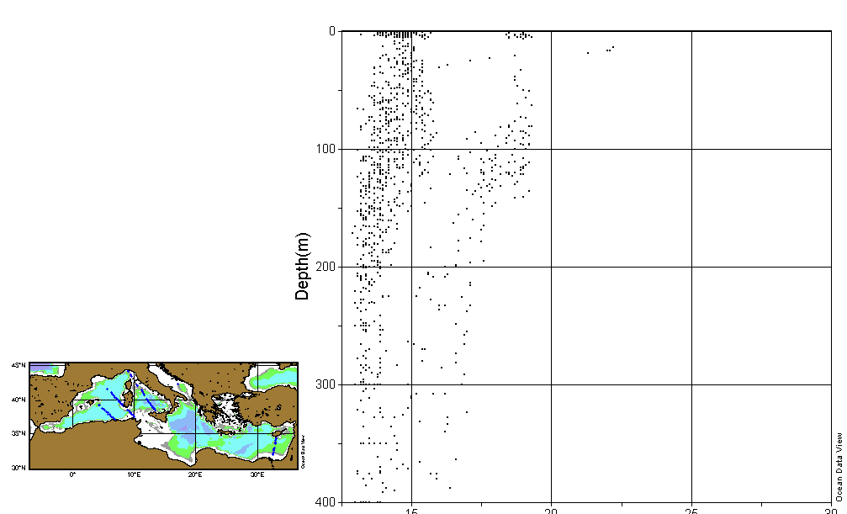

Fig. 3c NRT data in December 1999 Fig. 3d NRT data in 1-15 January 2000

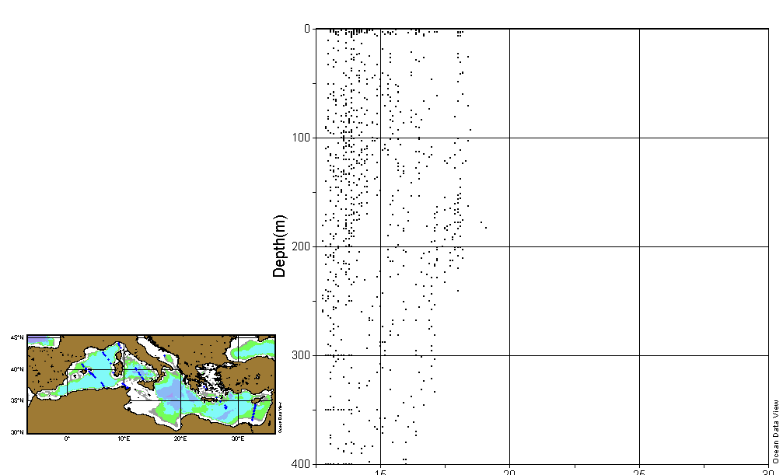
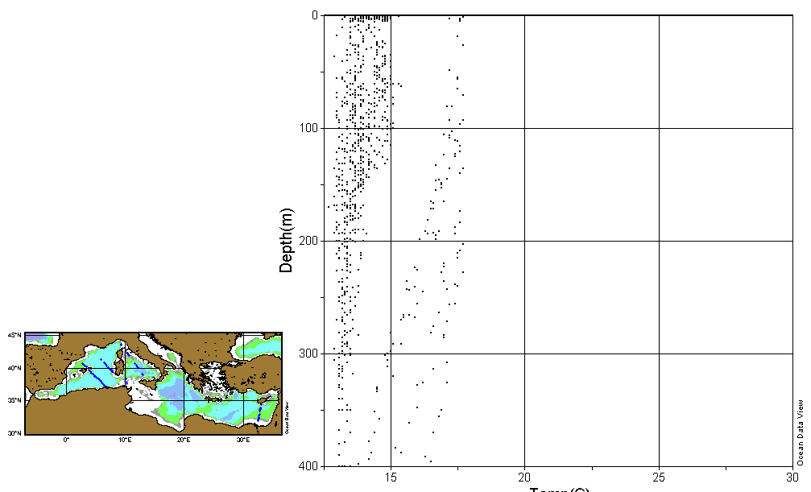

Fig. 3e NRT data in 16-31 January 2000 Fig. 3f NRT data in 1-15 February

9. Data Assimilation

Before the assimilation of the data into the model is necessary to do:

- Data extraction. It is carried out once a week (Wednesday afternoon) and it consists of downloading from the WP1 web site all the decimated XBT data transmitted by ARGOS. The weekly downloading is done for consistency with the management of all the other data that have to be assimilated (ECMWF analysis and forecast data, SLA and SST data).
- Raw data quality check:
Every XBT profile is quality checked before the assimilation. The check is carried out for the position (inside the Mediterranean basin, and on the sea), and for the temperature profile (search for strong gradients, and extreme maximum and minimum values).

Due to ARGOS system malfunctions the number of the decimated profiles transmitted (and available on the web site) is much less than the real number of the measurement done by the WP1 partner. It was decided to try to assimilate into the model also the profiles that were not transmitted and that were made available by each institute after the survey as full resolution profiles. The large amount of work that requires the quality check of these data avoid a quick pre-assimilation procedure.

The model used for the forecast is the GFDL-MOM(Geophysical Fluid Dynamics Laboratory-Modular Ocean Model) three-dimensional primitive equation ocean general circulation model. The version of the model used in this project is the MOM1.1 version implemented in the Mediterranean at 1/8 X 1/8 degrees of resolution and 31 levels in vertical. The topography has been manually designed to parametrise Strait passages with the given resolution. The Strait of Gibraltar is assumed to be composed of 3 latitudinal grid points, 4 longitudinal grid points and the Atlantic box is 0,5 X 0,375 degrees extended. The topography of the Strait is variable.

The data files consist of monthly mean model fields of horizontal velocity (u,v), temperature and salinity. They are obtained from a 7 years perpetual run with monthly mean surface forcing, computed on the base of ECMWF data. The surface salinity is relaxed to monthly mean climatological data (MED 5). The model simulations are initialised with climatological temperature and salinity and zero velocity components.

Results from data assimilation are shown in figure 4, were a comparison is provided with model results without assimilation. It appears that the circulation features are more clearly evidenced when the data are incorporated into the model.
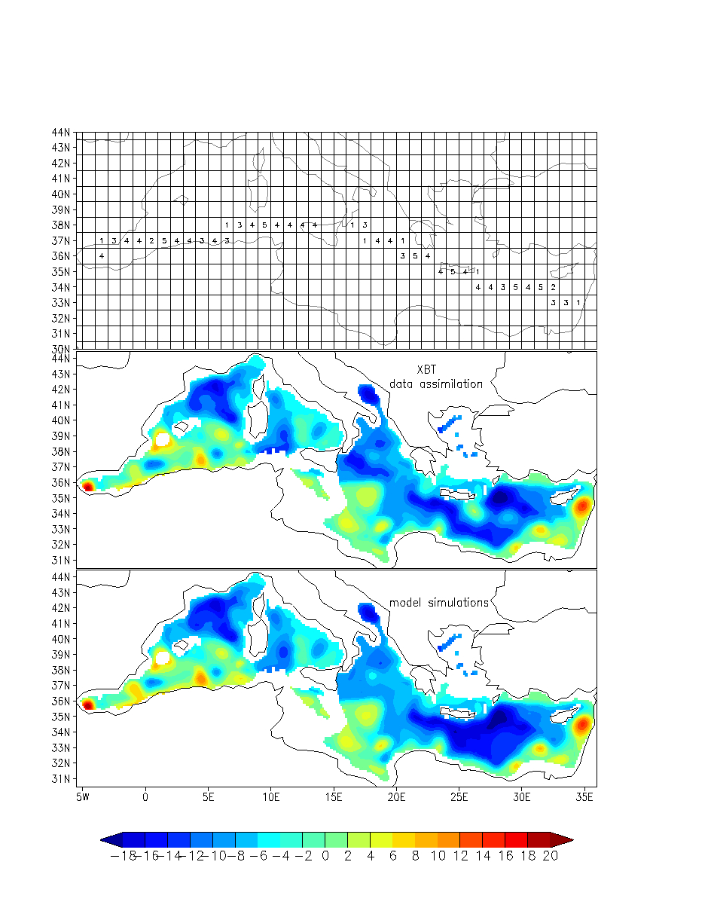

10. Conclusion and discussion

Starting with he MFSPP VOS project, our initial idea was to use the experience gained in the World Ocean. However many difficulties arisen soon, due to the necessity to transmit data with a high spatial and temporal resolution. Furthermore the temperature characteristics are different from the oceans and we discovered that the existing decimation/transmission softwares were considering the Mediterranean waters as a ‘noise’. This obliged to request many significant changes in the transmission system, changes which are not yet satisfying the needs for a Mediterranean operational monitoring system.

Although some faults, the monitoring system is providing a data set of paramount importance for the study of spatial and temporal temperature variability in the Mediterranean. The data set is not yet exploited but the information content is of scientific importance.

Also the use of the data for circulation forecast can be considered a success of the project. The Forecasting system in all the MFS modules are providing for the first time a pre-operational system for the entire Mediterranean Sea.

However, a most cost-effective system is necessary for the development of an operational system. For this reason we are trying to develop a system based on multiple launchers.

Another important aspect which is necessary to deal with is the development of environmental safe monitoring system, avoiding the launch of thousands expendables probes in a relatively smll basin such as the Mediterranean.

All these aspects are part of projects which are under development in the MFS community.

Acknowledgements. The authors are grateful to ship owners and the crew members of City of Dublin - UK, LIPA – Losinjinska Plovidba Croatia, TGT Annabella and TGT Isabella - Chemikalien Seetransport GMBH Hamburg, Cap Canaille – DELOM France, Excelsior - Grimaldi Italy, MSC Mariska – Mediterranean Shipping Company Greece, Princesa Victoria - Louis Cruises Cyprus,

Bibliography

Fuda J.-L., C. Millot, I. Taupier-Letage, U. Send and J.M. Bocognano. XBT monitoring of a meridian section across the Western Mediterranean Sea. Deep-Sea Res, in press.

Millot C., 1999. Circulation in the Western Mediterranean sea. J. Mar. Systems, 20, 1-4, 423-442.

MFSPP VOS, 1999. Guidelines for quality assurance of fieldwork. Doc.1, MAS3-CT98-0171 (DG12 – EHKN), 27 pp.

MODB Group, 1996 . Climatological Atlas of the Mediterranean Sea: Scientific Report of the MAST-MODB initiative for ocean data and information management, University of Liège, 253 pp.

Pinardi N., De Mey P., Manzella G., Ruiz de Elvira A., EuroGOOS MTCSSG, 1997. The EuroGOOS Mediterranean Test Case: science and implementation plan, in Operational Oceanography. The challenge for European Co-operation, J.H. Stel, H.W.A. Behrens, J.C. Borst, L.J. Droppert, J.v.d.Meulen editors, Elsevier, Amsterdam, 549-557.

Zodiatis G, Theodorou A., Demetropoulos A, 1998. Hydrography and circulation in the area south of Cyprus in late summer 1995 and in spring 1996. Oceanologica Acta, 21, 3, 447-458.

NATIONAL SOOP REPORT OF JAPAN

- National Programme Information

1.1 SAGE
“Subarctic Gyre Experiment in the North Pacific (SAGE)” is a scientific research project promoted and funded by the Science and Technology Agency (STA) of Japan with participation of more than 10 Japanese organizations/institutions. SAGE is a 5-year project from FY1997 to FY2001. Under the SAGE, the Japan Meteorological Agency (JMA) carries out XBT sampling by ships-of-opportunity (SOOs) in the TRANSPAC region (PX26) in cooperation with NOAA. As of February 2000, 4 SOOs are operated under the cooperative sampling programme.

1.2 Cooperative research programme by FORSGC/JMA and FORSGC/ NRIFSF
Frontier Observational Research Systems for Global Change (FORSGC), which is sponsored by STA, has been newly established in August 1999. FORSGC is going to make cooperative SOO sampling with JMA and National Research Institute of Far Seas Fisheries (NRIFSF) of the Fisheries Agency of Japan, respectively.

FORSGC and JMA are to start XBT/XCTD low density sampling in the western Pacific (PX05, PX49 and PX51) and in the Indian Ocean (IX09 and IX10), which was succeeded the long-lasted sampling by two SOOs under the former STA project “Japanese Experiment on the Asian Monsoon (JEXAM)”, which terminated in 1999. The JMA/FORSGC cooperative sampling will start in mid-2000.

FORSGC and NRIFSF started XBT/XCTD high density sampling by a SOO in the Indian Ocean (IX06) in February 2000.

1.3 JAHMP
“JApan Hawaii Monitoring Programme (JAHMP)” is a scientific research programme operated by Tohoku University (Prof. Kimio HANAWA’s group). Under the JAHMP, a fisheries training ship is operated to make high density XBT sampling on her way back from Hawaii to Japan (PX40) 3 times a year.

1.4 137E and 165E sections by JMA
JMA has been making routine oceanographic observation along 137E (PX45) since 1967. JMA has also been making observations along 165E (PX46) since 1996. The routine/operational observations are periodically performed by two research vessels of JMA 4 times a year along 137E and twice along 165E, respectively.

2. Data Collection

2.1 SOOP lines
The numbers of “good” drops and BATHY messages on SOOP lines in 1998 and 1999 are summarized in Tables 1 and 2, respectively. Information on sampling density, operator, programme, instrument and transmission is also summarized in Table 3. Totals of 1,612 and 1,383 BATHY messages on 80 and 65 sections were reported by Japanese ships during 1998 and 1999, respectively.

LINE | SHIP NAME | CALL SIGN | #GOOD | #BATHY | #SECTION
PX05 Japan - New Zealand | Wellington Maru | JITV | 268 | 256 | 7+1p
PX40 Japan - Hawaii | Miyagi Maru | JGBL | 110 | 110 | 1
PX45 137E section by CTD | Ryofu Maru | JGQH | 66 | 66 | 2
PX45 137E section by CTD | Keifu Maru | JBOA | 66 | 66 | 2
PX46 165E section by CTD | Ryofu Maru | JGQH | 73 | 73 | 2
PX49 Taiwan - Malacca Str. | Kashimasan Maru | JFPQ | 145 | 144 | 15
PX51 Hong Kong -New Zealand | Wellington Maru | JITV | 313 | 308 | 8
PX26 TRANSPAC | Sealand Express | KGJD | ? | 81 | 8
PX26 TRANSPAC | Sealand Developer | KHRH | ? | 60 | 6
IX06 Malacca Strait -  Mauritius/La Reunion | Planet Ace | 3EYF9 | 77 | 77 | 1
IX09 Fremantle - Persian Gulf  (northern portion) | Kashimasan Maru | JFPQ | 225 | 219 | 14
IX10 Malacca Str. - Red Sea  (eastern portion) | Kashimasan Maru | JFPQ | 154 | 152 | 14
TOTAL |  |  | (1,497) | 1,612 | 80+1p

Table 1. Japanese SOOP line sampling activities in 1998

LINE | SHIP NAME | CALL SIGN | #GOOD | #BATHY | #SECTION
PX05 Japan - New Zealand | Wellington Maru | JITV | 275 | 244 | 7
PX40 Japan - Hawaii | Miyagi Maru | JGBL | 215 | 215 | 2
PX45 137E section by CTD | Ryofu Maru | JGQH | 66 | 66 | 2
PX45 137E section by CTD | Keifu Maru | JBOA | 66 | 66 | 2
PX46 165E section by CTD | Ryofu Maru | JGQH | 64 | 64 | 2
PX49 Taiwan - Malacca Str. | Kashimasan Maru | JFPQ | 116 | 113 | 11
PX51 Hong Kong -New Zealand | Wellington Maru | JITV | 275 | 274 | 7+1p
PX26 TRANSPAC | Sealand Express | KGJD | ? | 5 | 1
PX26 TRANSPAC | Sealand Developer | KHRH | ? | 20 | 4
PX26 TRANSPAC | Westwood Belinda | C6CE7 | ? | 81 | 4+1p
IX06 Malacca Strait -  Mauritius/La Reunion | Planet Ace | 3EYF9 | 79 | 0 | 1
IX09 Fremantle - Persian Gulf  (northern portion) | Kashimasan Maru | JFPQ | 156 | 153 | 11
IX10 Malacca Str. - Red Sea  (eastern portion) | Kashimasan Maru | JFPQ | 83 | 82 | 11
TOTAL |  |  | (1,375) | 1,383 | 65+2p

Table 2. Japanese SOOP line sampling activities in 1999

LINE | SHIP NAME | CALL  SIGN | DENSITY | OPERATOR/  progamme | INSTRUMENT |  | TRANSMISSION
 |  |  |  |  | RECORDER | PROBE | TRANSMISSION
PX05 | Wellington Maru | JITV | 4 obs/day | JMA/JEXAM | JMA ASTOS | TSK/T7 | via GMS
PX40 | Miyagi Maru | JGBL | every 0.5 deg  in longitude | Tohoku Univ./  JAHMP | Murayama Denki  Z-60-16 III | TSK/T7 | Delayed BATHY from JMA
PX45  (137E) | Ryufu Maru | JGQH | every 1 deg  in latitude | JMA/operational | ICTD/FSI | (CTD) | via GMS
PX45  (137E) | Keifu Maru | JBOA | every 1 deg  in latitude | JMA/operational | Neil Brown MK-IIIB | (CTD) | via GMS
PX46  (165E) | Ryofu Maru | JGQH | every 1 deg  in latitude | JMA/operational | ICTD/FSI | (CTD) | via GMS
PX49 | Kashimasan Maru | JFPQ | 4 obs/day | JMA/JEXAM | JMA ASTOS | TSK/T6 | via GMS
PX51 | Wellington Maru | JITV | 4 obs/day | JMA/JEXAM | JMA ASTOS | TSK/T7 | via GMS
PX26 | Sealand Express | KGJD | 2 obs/day | JMA/NOAA/  SAGE | SEAS | TSK/T7 | SEAS
PX26 | Sealand Developer | KHRH
PX26 | Westwood Belinda | C6CE7
IX06 | Planet Ace | 3EYF6 | 4 obs/day | NRIFSF/JEXAM | TSK MK-30 | TSK/T7 | Delayed BATHY from JMA
IX09  (north) | Kashimasan Maru | JFPQ | 4 obs/day | JMA/JEXAM | JMA ASTOS | TSK/T6 | via GMS
IX10  (east) | Kashimasan Maru | JFPQ | 4 obs/day | JMA/JEXAM | JMA ASTOS | TSK/T6 | via GMS

Table 3. Summaries of Japanese SOOP as of the end of 1999

GMS: Geostationary Meteorological Satellite
ASTOS: Automated Subsurface Temperature Observation/Transmission System

2.2 Other sources
Besides the sampling on the SOOP lines, many Japanese research vessels have been making XBT/XCTD/CTD observations. Many of them, unfortunately not all, are reporting their observations by BATHY messages. Table 4 shows the numbers of all the inserted BATHY messages onto GTS by Japanese ships in the recent 3 years including those on SOOP lines. Figure 1 is a geographical distribution of the BATHY messages in 1999. A total of 5,322 BATHY messages were reported by Japanese ships during 1999. Many research vessels of Japanese organizations, such as JMA, the Fisheries Agency, universities and the Japan Marine Science and Technology Center (JAMSTEC), report their observations in the form of BATHY messages not only from the seas around Japan but also from the wide region in the Pacific.

SHIP NAME | CALL SIGN | AGENCY | 1997 | 1998 | 1999 | LINES
Ryofu Maru | JGQH | JMA | 249 | 354 | 374 | including PX45 (137E) and PX46 (165E)
Keifu Maru | JBOA | JMA | 283 | 304 | 260 | including PX45 (137E)
Kofu Maru | JDWX | JMA | 426 | 372 | 399
Shumpu Maru | JFDG | JMA | 364 | 400 | 419
Chofu Maru | JCCX | JMA | 364 | 398 | 381
Seifu Maru | JIVB | JMA | 485 | 387 | 395
Wellington Maru | JITV | JMA | 616 | 571 | 518 | PX05, PX51
Kashimasan Maru | JFPQ | JMA | 537 | 505 | 397 | IX09 (north), IX10 (east), PX49
Sealand Express | KGJD | JMA/NOAA | 0 | 60 | 5 | PX26
Sealand Developer | KHRH | JMA/NOAA | 0 | 80 | 21 | PX26
Westwood Belinda | C6CE7 | JMA/NOAA | 0 | 0 | 76 | PX26
Takuyo | 7JWN | MSA | 9 | 8 | 62
Shoyo | JCOD | MSA | 136 | 3 | 0
Kaiyo Maru | JNZL | Fisheries Agency | 186 | 354 | 199
Shoyo Maru | JDRD | Fisheries Agency | 146 | 61 | 283
Wakataka Maru | JQIX | Fisheries Agency | 55 | 163 | 27
Soyo Maru | JGKL | Fisheries Agency | 49 | 197 | 51
Shunyo Maru | 8JIF | Fisheries Agency | 79 | 4 | 17
Hokko Maru | 8LRY | Fisheries Agency | 0 | 131 | 142
Wakatake Maru | JLOV | Fisheries Agency | 0 | 88 | 149
Yoko Maru | 7KDD | Fisheries Agency | 0 | 0 | 3
Mizuho Maru | JJEB | Fisheries Agency | 210 | 181 | 84
Tanshu Maru | JMRV | Fisheries Agency | 101 | 0 | 0
Toshi Maru No. 11 | JNOL | Fisheries Agency | 0 | 105 | 0
Fukui Maru | JIVN | Fisheries Agency | 0 | 41 | 54
Torishima | JROY | Fisheries Agency | 0 | 0 | 72
Planet Ace | 3EYF | Fisheries Agency | 0 | 77 | 0 | IX06
Shirase | JSVY | Defense Agency | 14 | 13 | 5
Umitaka Maru | JGBB | Tokyo Univ. of Fish. | 8 | 32 | 0
Keiten Maru | JGDW | Kagoshima Univ. | 182 | 209 | 124
Miyagi Maru | JGBL | Tohoku Univ. | 0 | 110 | 216 | PX40
Hakuho Maru | JDSS | Univ. of Tokyo | 0 | 0 | 112
Kaiyo | JRPG | JAMSTEC | 45 | 80 | 160
Mirai | JNSR | JAMSTEC | 43 | 272 | 238
Ogasawara Maru | JHLO | JAMSTEC/  Tohoku Univ. | 20 | 18 | 79
TOTAL |  |  | 4,607 | 5,578 | 5,322

Table 4. Numbers of BATHY messages inserted onto GTS by Japan

JMA : Japan Meteorological Agency
MSA : Maritime Safety Agency
JAMSTEC : Japan Marine Science and Technology Center
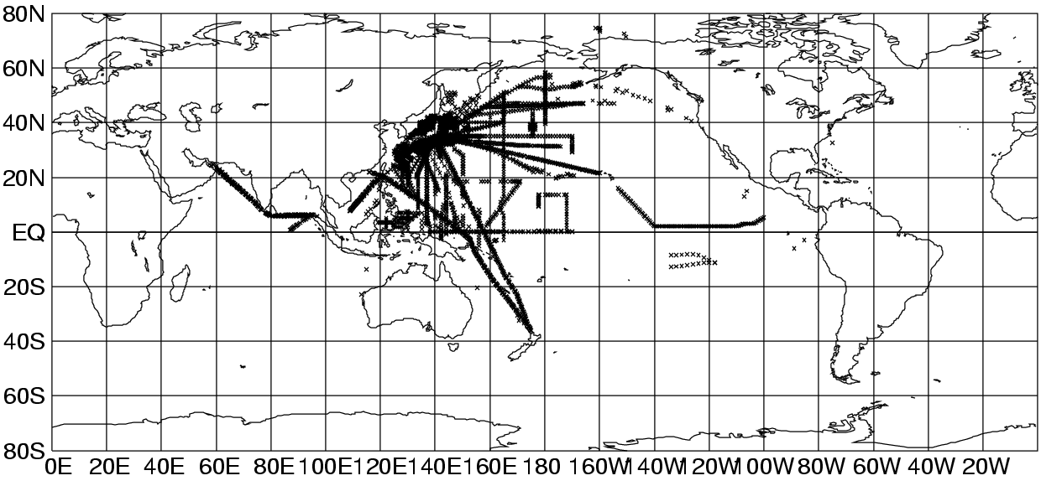

Figure 1. Distribution of BATHY messages reported by Japan during 1999

  - Other shipboard instrument

2.3.1 ADCP
The ongoing Japanese ADCP sampling programmes are summarized in Table 5. In each programme, shipboard ADCP apparatus is installed on each SOO and ADCP sampling is regularly performed along the shipping route.

Program | TOLEX-ADCP Monitoring | WESTPAC ADCP Program | Monitoring of Tsushima Current
Main operator | Tohoku Univ. and JAMSTEC | Hiroshima Univ. | Kyushu Univ.
Name of ship (call sign) | Ogasawara Maru (JHLO) | First Jupiter (3FXG6) | Camellia
ADCP manufacturer | Furuno Electric Co. | RD Instruments (VM-BB150) | RD Instruments (VM-BBADCP)
Line | Tokyo – Chichijima (27N, 142E) | Japan – Port Hedland/Dampier (PX22/PX51) | Fukuoka – Pusan  (Tsushima Strait)
Number of transects | 116/year | 10/year | 312/year
Horizontal interval | 3.3 km | 10 km | 1.16 km (1/96 degree)
Depth interval | 10 m | 10 m | 8 m
Maximum depth | 350 m | 220 m | to the bottom (max 240 m)
Start date | February 1991 | January 1997 | February 1997
Contact | Yasushi Yoshikawa (JAMSTEC)  yoshikaway@jamstec.go.jp | http://www.ocean.hiroshima-u.ac.jp | Jong-Hwan Yoon  yoon@riam.kyushu-u.ac.jp

Table 5. ADCP sampling programmes by ship-of-opportunity in Japan

    - pCO2
National Institute for Environmental Studies of Environment Agency of Japan has been carried out the observation of pCO2 both in the surface water and the overlying atmosphere since 1995 by a SOO, Skaugran (LADB2) in the North Pacific (TRANSPAC). Foundation for Promoting Personal Mobility and Ecological Transportation has started another SOO pCO2 observing programme under the technical support of JMA in 1999 recruiting a SOO, Alligator Liberty (JFUG) in the TRANSPAC region.

3. Data Management

3.1 Realtime data management
The two SOOs operated under JEXAM, namely Wellington Maru and Kashimasan Maru, are equipped with Automated Subsurface Temperature Observation/Transmission System (ASTOS), which was developed by JMA. The system automatically transmits BATHY messages via Geostationary Meteorological Satellite (GMS) to JMA and the messages are inserted onto GTS at JMA. JMA’s research vessels also transmit WMO code messages via GMS. Under the new FORSGC/JMA cooperative programme, they are now developing a new automated system which uses INMARSAT.

The SOOs under the JMA/NOAA cooperative sampling are equipped with NOAA’s SEAS system. As the SOOs carring out high density sampling, namely Miyagi Maru, Planet Ace and Delmas Blosseville, are not equipped automated transmssion system, BATHY messages are encoded and inserted onto GTS at JMA as soon as possible after they call a port in Japan.

3.2 Delayed mode data management
All of the detailed XBT profile data are submitted to the Japan Oceanographic Data Center (JODC) within a year. JMA also sends the data to the WOCE UOT Data Assembly Centre/IFREMER, Brest.

4. Future Plans
The plans of Japanese SOOP activities are summarized in Table 6. Under the JMA-NOAA cooperative sampling, additional two or more SOOs are under examination at present. The cooperative research programme by FORSGC/JMA and FORSGC/NRIFSF is expected to continue at least 5 years, though it is not fixed at present.

LINE | SHIP NAME | CALL SIGN | SECTION/  DENSITY | OPERATOR | REMARK
PX05 | Wellington Maru | JITV | 8/LD (XBT/XCTD) | JMA/FORSGC | start in mid-2000
PX40 | Miyagi Maru | JGBL | 3/HD | Tohoku Univ. | as long as possible
PX45 (137E) | Ryofu Maru | JGQH | 4/LD (CTD) | JMA | operational CTD section
PX45 (137E) | Keifu Maru | JBOA | 4/LD (CTD) | JMA | operational CTD section
PX46 (165E ) | Ryofu Maru | JGQH | 2/LD (CTD) | JMA | operational CTD section
PX46 (165E ) | Keifu Maru | JBOA | 2/LD (CTD) | JMA | operational CTD section
PX49 | Katori | 3FRY5 | 14/LD (XBT/XCTD) | JMA/FORSGC | start in mid-2000
PX51 | Wellington Maru | JITV | 8/LD (XBT/XCTD) | JMA/FORSGC | start in mid-2000
PX26 | Sealand Express | KGJD | 10/LD | JMA/NOAA | -2001 (project SAGE)
PX26 | Sealand Developer | KHRH | 10/LD | JMA/NOAA | -2001 (project SAGE)
PX26 | Westwood Belinda | C6CE7 | 10/LD | JMA/NOAA | -2001 (project SAGE)
PX26 | Skauboard | LACF5 | 10/LD | JMA/NOAA | -2001 (project SAGE)
IX06 | Delmas Blosseville | 3FIK5 | 3/HD (XBT/XCTD) | FA/FORSGC | start in February 2000
IX09 (north) | Katori | 3FRY5 | 14/LD (XBT/XCTD) | JMA/FORSGC | start in mid-2000
IX10 (east) | Katori | 3FRY5 | 14/LD (XBT/XCTD) | JMA/FORSGC | start in mid-2000

Table 6. Japanese SOOP Plans

JMA: Japan Meteorological Agency
FORSGC: Frontier Observational Research System for Global Change
FA: Fisheries Agency of Japan SAGE: Subarctic Gyre Experiment

5. Further Information

5.1 TESAC messages from JMA research vessels
JMA is planning to start reporting the CTD and ADCP observations (temperature, salinity and current profiles) by 6 research vessels in the form of TESAC message in January 2001.

5.2 Manual on BATHY, TESAC and TRACKOB
JMA has published a Japanese manual on BATHY, TESAC and TRACKOB messages corresponding to the amendment of the BATHY and TESAC messages effective May 2000. The manual briefly explains how to report the above WMO codes on board. JMA distributed the manual to Japanese domestic oceanographic organizations/institutes in March 2000.

5.3 Subsurface floats
A total of 26 subsurface floats, including both PALACE and APEX, have allocated WMO buoy ID numbers. JMA collects the profile data from the float operators and inserts the data onto GTS in the form of BUOY message. A total of 529 profile data were reported in 1999.

6. Related National WEB Site Links
None

7. Relevant References and Publications
None

TOWARDS ESTABLISHING A RUSSIAN NATIONAL SHIP-OF-OPPORTUNITY NETWORK

Alexander Postnov
Roshydromet State Oceanographic Institute,
3, Kropotkinskiy Lane, 119838, MOSCOW, Russia

Since 1996, the Roshydromet marine research organisations (State Oceanographic Institute in Moscow, Far Eastern Research Hydrometeorological Institute in Vladivostok, Arctic and Antarctic Research Institute in St. Petersburg) have been involved in a programme which aim is to establish a national ship-of-opportunity network. There are a number of agencies in Russian Federation which possess or operate the ocean-going ships carrying out various activities in the World Ocean. These are the Department of Sea Transportation, the State Committee for Fisheries, the Russian Navy, the Ministry of Natural Resources (geological surveys), the Russian Academy of Sciences (oceanic studies) and the Russian Federal Service for Hydrometeorology and Environment Monitoring - Roshydromet (composite monitoring of seas and oceans).

The routes of ships belonging to each agency are specific as to regions (lines) and frequency of operations, etc. Many of these ships can carry a relevant instrumentation (XBT probes, towed sensors, automated meteorological stations, etc.) and make on-route oceanological and meteorological observations. .At present, however, such observations are not being made on a routine basis though some of the Roshydromet institutes possess a vast experience in using XBT in oceanographic research. The greatest constraint is lack of available funding and a difficulty in encouraging the ship owners to participate in a ship-of- opportunity programme in market environment. At this stage we are being collecting and evaluating the international experience in maintaining the SOO-based oceanographic observations including instrumentation and procedures for observations and their quality control. At the nearest future, we plan to:

- complete a draft programme for low-density oceanographic observations from the Russian ships-of-opportunity which will include description of the required equipment, measurement procedures, data quality control and data exchange both on national and international scales;
- develop a legal basis for encouraging participation of various national agencies in the SOO-based oceanographic data collection;
- develop a draft plan for participation of the ships of various agencies in the SOO-based oceanographic data collection including the ship names, regions (lines) of operation and frequency of observations;
- evaluate the required resources, outlining the number of XBT probes, shipboard equipment and their costs as quoted by various foreign and national manufacturers;
- develop proposals for the Rosgydromet application to the national funding bodies for support of the Russia's participation in the IOC/WMO SOO Programme.

We also attach importance to international co-operation on regional scale especially promoted by regional IOC committees (like the Black Sea GOOS Project promoted by the IOC Regional Committee on the Black Sea) or the regional GOOS bodies (like NEAR GOOS for the Japan Sea). For instance, within the framework of the Black Sea GOOS Project, plans are being developed to equip ferries operating between Odessa and Varna with automatic meteorological stations and XBT systems

UK HYDROGRAPHIC OFFICE

Please note that whilst others in the UK have been asked to submit information for this report only SAHFOS have responded (see Para 5). However, there has been a good response to the request for information to be released from research cruises (see Para4). The release of processed data from the Hydrographic Office to NODC will be addressed later this year.

- NATIONAL PROGRAMME INFORMATION

- UK National and International Objectives

To obtain data for the Hydrographic Office Oceanographic Database (HOOD) in order to support Royal Navy needs in operational areas and to help support UK oceanographic research.

- Collaborating Agencies

As listed in e-mail to Etienne Charpentier recently. (SOC, MARLAB, BAS and PML). Also listed were the call signs of UK SOOP vessels.

- Funding Support and Status

Probes are provided by the Director of Naval Surveying, Oceanography and Meteorology (DNSOM). The future of this is not known.

- DATA COLLECTION

- XBT Lines Operated

SAHFOS, MV City of Dublin, East – West Mediterranean project. A nine month project with about 175 probes deployed each five week period. Coordinated from Bologne, Italy. Data received regularly in the UKHO. It is also understood they are signalled real time, via ARGOS. The project runs to May 2000. Work leader Giuseppe Manzella is attending the San Diego meeting.

PML, Atlantic Meridian Transect, about 150 XBTs per leg.

- Other Sources of National Data

SOC RRS Discovery Iceland study of deep water outflow
RRS Charles Darwin North Atlantic seismic survey
? Geophysical cruise, New Zealand
RRS Discovery Scotland/Iceland cruise

MARLAB FRV Scotia Faroe/Shetland Channel

BAS RRS James Clark Ross South Georgia

PML RRS Discovery Northern North Sea
RRS Challenger Rockall Channel
RV Hesperides Azores

UKRN Various Historical data planned for release during year 2000

- Instrumentation : Various systems, probes and transmissions.

- Instrument Evaluations : None in the period

- Other Activities : Attempts to set up supply of probes to the Nuke Arctica so far unsuccessful.

SAHFOS also collect biological data in the Mediterranean.

3. DATA MANAGEMENT

- Data Flow Monitoring Activities

The UK Met Office do not monitor the amount of SOOP data received in real time.
This data reaches the UKHO in very slow time as the result of a supply agreement with the Met. Office.

- QC Procedures

Full database QC procedures are applied at the UKHO to both real time data and delayed mode data received direct from the ships.

- Delayed Mode Data Submission Status

The UKHO monitor the amount of delayed mode data received but there has been no recent programme to release this data to the wider community. Most data is received promptly. Data from RRS James Clark Ross to January 1999 has not been received nor has data yet from more recent scientific cruises. Details of all data received in 1999 were supplied to Etienne Charpentier by e-mail dated 28 January 2000 (979 observations).

FUTURE PLANS

Little known especially with uncertainty of funding as a result of the ARGO project. However, UK scientists strongly feel that SOOP should compliment ARGO, not be replaced by it.

Etienne has asked UKHO to supply all 1999 (and possibly earlier historical) SOOP XBT data in about May 2000; this we will aim to do. Permission to release recent data has been received from Bill Turrel of MARLAB, Doug Masson of SOC, Christine Peirce of Durham University, Mark Brandon of BAS, Nathalie Lefevre at CCMS, John Huthnance at NERC (OMEX project) and Adrian New at SOC. Stuart cunningham at SOC would prefer his data from Discovery Cruise 242 not to be released until 2001.

- FURTHER INFORMATION

From my knowledge the best UK organisation for co-operating with SOOP is likely to be SAHFOS, POC Anthoney Walne (ANWA@wpo.nerc.ac.uk). The reason for this is that SAHFOS are interested in collecting long lines of biological data.

The UK Met. Office are taking the Uk lead with ARGO. John Turton is the POC there. John Gould at SOC and Leslie Rickards at BODC are also involved.

- RELATED NATIONAL WEB SITE LINKS

None to my knowledge but there may be references on university and NERC sites.

- RELEVANT REFERENCES AND PUBLICATIONS

None to my knowledge.

- UKHO Contacts : Mr David Kelf
Mrs Anji Hussey

D L Kelf
UKHO, Physical Oceanography, x3225
dkelf@ocean.hydro.uk

SOOP SCIENTIFIC AND TECHNICAL DEVELOPMENTS

REPORT ON THE STATUS OF THE ARGO PROJECT
Submitted by Dean Roemmich, Chairman, Argo Science Team

The second meeting of the international Argo Science Team (AST-2) was held in Southampton U.K. on March 7-9, 2000. The meeting report will soon be posted on the web at www-argo.ucsd.edu. Objectives of the meeting were to:

• Review national plans, priorities and commitments - to measure progress toward achieving resource requirements for Argo and to continue formulation of a strategy for global coverage. Deployment of Argo floats is expected to ramp up steeply during 2000-2002, attaining a rate greater than 700 floats per year. It is expected that by 2003, more than half of the 3000-float global array will be in place, with full deployment in 2005. Based on national priorities of the float-providing nations, the most challenging region for achieving the Argo objective of 3º average spacing in latitude and longitude will be the Southern Ocean. Detailed planning will move forward through a series of Basin Implementation meetings, with the first being a Pacific and eastern Indian Ocean meeting to be held in Tokyo on April 13-14, and then an Atlantic meeting in France on July 10-11.

• Examine and compare data management prototypes of those countries having begun to design and implement an Argo Data System. The intention is to ensure that the data system is in place to enable data throughput from floats to be deployed in the near future. It must meet the requirements of users for dual real-time (operational quality) and delayed mode (scientific quality) T,S data streams. It must be country-to-country compatible to facilitate easy exchange and maximum usefulness.

• Review the technical issues relevant to Argo, including salinity stability, float lifetime, communications and depth capability. Are the evolving technical capabilities of floats able to satisfy user requirements? What are the performance standards needed to ensure the value of the Argo array composed of intermingled floats from multiple float providers?

• Initiate a forum for discussion of scientific results relevant to Argo.

In two years since its creation, the Argo project has attained a high international profile and strong resource commitments from a number of nations including Australia, Canada, France, Germany, Japan, Korea, the U.K., and the U.S.A., plus a European Union contribution. Additional broad international participation is actively sought, including float procurement, assistance with deployment and utilization of Argo data. An International Coordinator and Argo Information Centre will be located in Toulouse France. The Argo project is now entering its implementation phase.

There is every reason to believe that Argo will effectively replace the broad-scale XBT network with a better-sampled global network including salinity, as anticipated at the 1999 Upper Ocean Thermal Review. However, following the recommendations of that Review, caution requires that XBT sampling should not be reorganized until the Argo array is in place.

GTSPP REPORT

Introduction

The GTSPP continues to be an important participant in the evolving ocean observing system. Since the last IODE meeting, there have been a number of developments that are summarized below. Generally, GTSPP has established itself as a strong programme of IGOSS (now J-COMM) and IODE. It has developed linkages to science programmes, and established ocean observing systems and supports these by its activities. It has demonstrated how close international collaboration between data centres and science programmes can help the collection, processing, quality, distribution and utility of data.

GTSPP Practices

There have been changes in participants due to changing priorities in home countries. However, other groups have joined with the result of no loss of functions. As for any programme, an evolution takes place as changes come about in participating countries and in changing observation programmes.

The core functions and ideas of GTSPP are unchanged. MEDS and NODC continue to handle the real-time data flows and continuously managed database respectively. Data exchanges occur regularly three times each week. Both MEDS and NODC have clients that receive regular dispatches of data on each update (these will be discussed later). Once a year, all data collected two years previously are divided into three oceans and forwarded for scientific QC in the US, AOML and Scripps, and Australia, (CSIRO/BMRC Joint Australian Facility for Ocean Observing Systems (JAFOOS)). The results are returned to NODC and update the archives.

There is still the commitment to transfer of technology and expertise among participants. Both MEDS and NODC benefit from the close working relationships with science centres. At present AOML and CSIRO are collaborating in the development of more sophisticated semi-automated QC procedures that are expected to be incorporated in data centre operations in due course. The participating data centres have also benefited from the scientific expertise provided by science centres. On the other hand, the data centres believe that science centres have benefited by exposure to the data management issues and practices used at data centres and that this has improved the dialogue and understanding of our respective roles.

There have been changes in the way data are handled by GTSPP. Through discussions with the OAR office in the U.S. (they handle the SEAS programme) changes have been made to streamline operations between MEDS and them to remove some of the duplications. Through agreements between MEDS and JMA, instead of a monthly transfer of GTS data, MEDS now receives and processes daily files from JMA in the same manner as it handles data from the US. At the same time, the monthly files received from BSH is so prompt, there is no longer a need to issue monthly reports from both North America and Internationally. MEDS has ceased production of the North American report.

The data volumes in the continuously managed data base are slightly less than 1 million stations from 1990 to 1999. The table below shows the sampling by instrument type and ocean. Clearly the majority of data are still as real-time reports. Increasing the timeliness of flow of delayed mode data to the archives is still an important function that needs attention. It is also evident that the SOOP is a mainstay of the data availability (since they are responsible for the large majority of real-time reports from ships). Both SOOP and WOCE IPO have been very helpful in getting full resolution XBT data to the archives. Typically, the SEAS data arrive about a month after collection. In addition, the number of BATHY reports listed below includes all of the profiles from the moored buoys. This constitutes about 200,000 profiles. GTSPP continues to have difficulty in acquiring research vessel data in a consistent and timely way.

WOCE IPO has been very helpful in getting WOCE full resolution data in to NODC. Also full resolution XBT data from the NOAA SEAS programme arrive at NODC routinely in the month following data collection. Full resolution XBT data collected jointly by CSIRO and the Bureau of Meteorology of Australia, has ben forwarded to NODC on a timely, annual basis for many years. So, there are some real improvements in that area. Also the number of BATHY reports includes all of the moored buoy reports (nearly 200,000), so the difference between the number of BATHYs and the number of XBTs is not so large as it appears at first.

Type \ Ocean Atlantic Indian Pacific Total
BATHY 132055 39211 400952 572218
TESAC 38315 679 19693 58687
CTD 11239 544 14346 26129
Profiling floats 1502 0 678 2180
Bottles 1344 7 4316 5667
XBTs 70345 42727 139174 252246

GTSPP has developed a number of users of the data. MEDS has about 6 users that receive data three times a week. Each user can define their area of interest, and the data are either sent by FTP, email, or placed on MEDS anonymous FTP server for pickup. The NODC has more than a dozen users receiving data either weekly or monthly. These include NASA (using the data to compare XBT to altimeter data), ECMWF (for seasonal forecasting), Tokyo University (studying Ekman heat transport), NOAA offices, Universities, and meteorological services. The GTSPP web site hosted by NODC has regular visitors with 341 page accesses in a 7 day period in December. A quick analysis of the web logs shows that about 30% are from companies, 10% from educational organizations in the US, and 20% from foreign government institutions.

Linkages

A very important development has been the active participation of GTSPP in scientific programmes. GTSPP continues to play an integral part of the WOCE Upper Ocean Thermal programme. In 1998, the first WOCE CDs of data collected were issued and GTSPP data centres were responsible for the production of the master CD for UOT. This will be repeated in mid 2000 with a second issue of all data, acquired from 1990 to 1999. All data from 1990-1996 on the CD will have passed through scientific quality control. A limited number of these CDs are available from the WOCE IPO, NODC or MEDS.

GTSPP is also directly linked to the Ship Of Opportunity Programme (SOOP) and takes part in the Implementation Panel discussions and planning. GTSPP makes available data sampling information on a monthly basis (this can be found at www.meds-sdmm.dfo-mpo.gc.ca and follow the real-time data, SOOPIP and WOCE links). The data quality statistics are posted here each month. Also shown are maps of the sampling both in the past month and over the past twelve months.

By participation in WOCE and SOOP, GTSPP has developed a number of tools that are used to monitor the volume, distribution and quality of data reported. Late in 1993, GTSPP started monitoring the quality of data being reported in real-time. When the IGOSS coordinator position at IOC ceased, GTSPP took over the job of notifying ships operator's on a monthly basis of problems noted. This service has benefited greatly by the close cooperation of SOOP and the OAR offices in Washington.

As the GOOS develops, it is certain that GTSPP will play an important role. Already GTSPP is cooperating with NEAR-GOOS in the exchange of data from this programme. Representatives of GTSPP took part in discussions in Sydney in early 1998 to try to define the major players and their contributions to GOOS. In August, 1999, GTSPP participated in discussions on a redefinition of the upper ocean monitoring network held in Melbourne. Results of this were presented at the Ocean Observation Conference held in St. Raphael in October. At the same time, because of participation in WOCE, experience gained from GTSPP contributed to a paper for the same conference discussing ocean data systems and data management.

Profiling floats represent an important addition to the ocean observing programme. The GODAE programme has spawned an ocean observing programme called ARGO that intends to place 3000 profiling floats in the oceans by 2003. Already there are about 270 operating and sending about 700 TESACS each month. Typically, these report every 10 days and profiles deeper than 1000-1500m. The ARGO intention is to report to 2000m and high resolution (on the order of m rather than inflection points) on the roughly 10 day duty cycle for a float. GTSPP is already handling the data from these floats as part of its normal operations. Discussion between the GODAE and ARGO participants and representatives of GTSPP have taken place to define the contribution from GTSPP. It is clear that this mode of data sampling, in conjunction with high spatial resolution and line sampling using SOOP will be the mode of ocean observation in the future. GTSPP will need to adjust to the requirements to meet this volume of data and the timeliness needs of programmes like GODAE.

GTSPP also assist organizations in special monitoring. It has participated twice in special monitoring of BATHY and TESACs by the WMO. It also provides a monthly report to the Argentine Data centre of data they place on the GTS and that they should be receiving from the GTS from their area of interest. In a similar vein, because moored buoys report profiles (such as from the TAO, PIRATA and TRITON arrays) GTSPP has been reporting on a weekly basis to OAR, Washington, what it receives from the these platforms, to help ensure an uninterrupted service.

Future Work

A second version of the GTSPP Project Plan has been published. This updates the original version with goals achieved and work still to carry out. These include

1. The development of new scientific (CLIVAR) and operational oceanography (GOOS and GODAE) programmes will have a requirement for services of data management as done by the GTSPP. GTSPP needs to be well connected to these programmes so that no needless duplication of effort occurs and so that the work to sustain these programmes can be shared among a wider group of data centres and science groups. The stated requirements for more and diverse data in more immediate time frames will require adjustments not just by GTSPP but by all members of IODE (and J-COMM). This constitutes a major challenge to IODE.

2. Increased cooperation is required between not just international science programmes, but especially with national ones. The GODAR project identified substantial volumes of data collected but never exchanged within the IODE system. These data were collected primarily by national programmes. Each country of IODE can make a strong and positive contribution by developing the data exchange mechanisms with research and monitoring groups in their own countries to increase the volume, type and timeliness of this exchange. IODE can make a positive contribution by ensuring that timely and efficient exchange mechanisms exist between countries.

3. A number of products (both of participants and external users) are based on data flowing through the GTSPP. This aspect has not been well documented nor is it well known. Likewise, the distribution of data, although an improvement on past practices, still needs improvements. Operational programmes such as GOOS and GODAE state that they require immediate access to data in an easier fashion. GTSPP needs to adjust to these needs, and to document the uses to which the data it handles are put

4. Increased data volumes and more immediate needs for the data will require adjustments to how data are handled in GTSPP. Improvements in many areas will be needed including more standardization of data formats, more automated quality assessment procedures, more efficient and reliable real-time data transmission systems, and better data monitoring (volumes, quality, types). This reflects the shift in oceanography from research requirements to operational programmes. GTSPP is in the vanguard of this process, but it is clear that IODE must also make adjustments in data management practices.
XCTD TESTING BY TSK

1. Salinity Bias

- +(plus) Bias

At the SOOPIP II meeting held on October 1998 in Noumea, Dr. Mizuno (an ex-member of the Fisheries Agency, presently at JAMSTEC) and others have presented the TSK XCTD salinity data that showed a tendency to go towards +(plus) bias (0.03 – 0.05mS/cm). The error source and countermeasure are:

- We simulated a condition when an XCTD probe was launched into sea using a test tank (15m deep) in which an XCTD probe was slowly descended and ascended while monitoring output. Conductivity data shifted towards +(plus) by 0.03 – 0.04mS/cm at depths of 2 – 3m, but the output was stable in the deeper depths. When the probe was being ascended to the zero (0) meter deep, the same shift shown at the depths of 2 – 3m appeared again and the +(plus) bias was eliminated.
- Then, we immersed a portion of the conductivity sensor of the XCTD probe in a clear pressure case filled with seawater where an end of a U shaped tubing was in the bottom. Another end of the U tubing had a container filled with seawater. We repeated to pressurize and decompress pressures of 0 - 5m deep by moving up and down the container and visually observed conditions. Through this test, we found that a microbubble (2 – 3mm dia.) came in and out the bottom of norse piece where there was a gap (0.1mm) between the outside wall of the pyrex glass (equipped to keep the stability of the cell constant against the pressure and temperature changes) located in the center of the inductive cell and the inside wall of the cell itself.
- We concluded that process caused the +(plus) bias in the salinity data. The C data calibration (zero (0) m deep) at the factory was done including air (source of the microbubble) in the gap in some cases. When the XCTD probe was launched into sea, the microbubble went into the gap deeply in depths greater than 2 – 3m deep, which caused the +(plus) bias.
- The countermeasure of this is: The XCTD probe head was immersed in a container filled with seawater and was vacuumed to remove the air from the gap before calibrating it at the factory and took the calibration data.

(b) Slow start up after launching

The slow start up after launching from the VOS was pointed out by SCRIPPS Institution of Oceanography. JAMSTEC will prepare XCTD data compared with CTD data to be taken using his research vessel, MIRAI around March 22, 2000. The data are to be presented at the meeting.

2. Drop rate equation

The following is added to the material submitted at the previous SOOPIP meeting. In December 1999, under the cruise number of KY9909, Mr. Kashino, a member of Ocean Research Department at JAMSTEC has consecutively launched the XCTD probes (10 XCTD probes were launched every 10 minutes interval) using KAIYO, a research vessel of JAMSTEC. He assured the adequacy of the XCTD drop rate equation comparing with the CTD data. The results will be presented at the meeting.

_____________
SHIPBOARD DATA ACQUISITION AND TRANSMISSION SYSTEM - INCLUDING METEOROLOGICAL AND SST SENSORS

Dr. Robert A. Weller - Woods Hole Oceanographic Institution

Background.

The ocean is critical to inter-decadal climate variability because of its ability to store and transport heat and fresh water and release them to the atmosphere through sensible and latent heat fluxes. Knowledge of various properties at the sea surface is essential to monitoring, understanding, and developing the ability to predict climate change. Vertical exchange across the air-sea interface of horizontal momentum and of buoyancy couples the ocean and atmosphere. The sea surface is the interface through which heat, fresh water, momentum, gases, and other quantities are exchanged. It is the bottom boundary of the atmosphere over approximately 70% of the earth’s surface and the top surface of the very large oceanic reservoirs of heat and other properties. Observing this coupling is a fundamental need if we are to both understand ocean variability and its interrelation to climate. This requires the observation of surface wind velocity, humidity, air temperature, sea temperature, barometric pressure, incoming shortwave radiation, incoming longwave radiation and precipitation.

Historically there have been two separate paths for collection of meteorological data from ships. The first is the near real time data collected by VOS (Volunteer Observing Ships) and transmission via radio or satellite to weather forecast and safety of life at sea facilities. The second is the collection of data for climate research on various research experiments from which a better understanding of the processes and improved modeling have evolved. These now need to be merged so that both near time weather forecasting and seasonal or decadel climate forecasting can be done using the higher quality data required. A series of programs that provide the technology for this new requirement include the "Improved METeorology from Ship and Buoys" (IMET) project funded by NSF within the WOCE (World Ocean Circulation Experiment), the "Observations of Air-Sea fluxes and the Surface of the Ocean" project funded by NOAA-OGP under CORC (Climate and Ocean Research Consortium), and the "Improved VOS Measurements as Part of GCOS/GOOS" project funded by NOAA-OGP. NOAA-OGP is soliciting a SBIR proposal to transition the results of these programs into a commercially available system. A primary goal of this SBIR is that the data quality and reliability of the lower cost commercial system will not be degraded from the research system that has been developed.

IMET (Improved METeorology from Ships and Buoys)

In planning for WOCE (World Ocean Circulation Experiment) it was recognized that moored buoys and ships would provide especially attractive platforms from which to make accurate in-situ measurements of the basic surface meteorological observable parameters required to investigate the air-sea fluxes of momentum, heat, and mass. Accuracy's of 10 Watts per meter squared were sought in estimates of the mean values (averaged over monthly and longer time scales) of each of the four components of the total heat flux (sensible, latent, shortwave, and longwave). Accuracy's of approximately 1 mm per day were sought in evaporation and precipitation.

WHOI (Woods Hole Oceanographic Institution) was funded to evaluate and choose sensors capable of meeting the WOCE goals and to develop the IMET system as a flexible data collection system. Each sensor was incorporated into a module with built-in intelligence that responds to polled commands from the central computer and data recording unit. Each module interfaces to an ADDB (addressable digital data bus) consisting of +12vdc power and RS485 serial ports. A key component of IMET accuracy is that the calibration constants are stored in the module so that the serial digital output is in calibrated units. The calibration constants from each unit are polled and stored on the data file with the data from a specific time period. Modules having non-linear algorithms will output both calibrated and raw data to permit later corrections.

IMET systems are now in use on eight UNOLS ships, six WHOI buoys, one USF (University of Southern Florida) buoy, one NOAA ship and the Rutgers University Field Station. These systems have proven themselves over the last eight years and now provide the baseline for climate quality data.

Data Accuracy

Traditionally, the bulk of surface marine observations have come from merchant ships. There have been numerous attempts to make use of these observations to map the air-sea fluxes and understand the ocean's role in climate. However, these shipboard observations have significant errors associated with the sensors, sensor placement, and flow disturbance. Furthermore, few ships are equipped to measure the shortwave and longwave
radiative fluxes. Bunker, in his atlas of surface observations for the Atlantic, concluded that the error in the net heat flux developed using bulk formulae and merchant ship observations was in excess of 100 W m^-2 (Figure 1).

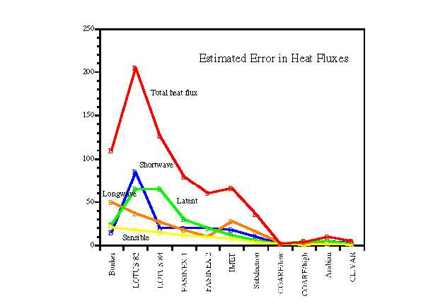

Figure 1- Estimated Error in Heat Fluxes

National agencies and researchers have turned to surface moorings in order to obtain time series of surface meteorology at fixed locations and to work toward observations that were both more complete and more accurate than those obtained on merchant ships. In the late 1970's and early 1980's, research oceanographers in the United States began to deploy surface buoys to investigate air-sea interaction. Error analysis of the sensor performance in the Long Term Upper Ocean Study (LOTUS)(Figure 1), which was conducted at 34 deg N, 70 deg W, was discouraging, as the measurement error in the net heat flux was found to be larger than the uncertainty Bunker assigned to his atlas data.

Work to improve buoy measurements continued in association with the ONR-supported Frontal Air-Sea Interaction Experiment (FASINEX), andsignificant, focussed support by the NSF as part of the World Ocean Circulation Experiment (WOCE) led to extensive sensor testing and development and to the design of the Improved Meteorological system (IMET). This work brought continued improvement. During the ONR-funded Subduction experiment, error in net heat flux was reduced to approximately 40 W m^-2 in monthly means. A major, international collaboration on flux sensors and algorithms and a specific focus on in-situ intercomparisons of methods and sensors during the TOGA Coupled Ocean-Atmosphere Response Experiment (COARE) led to another significant increase in accuracy. In part, the accuracy shown in Figure 1 for COARE results from the benefit of these dedicated in-situ intercomparisons. Further work continued in support of the ONR Arabian Sea experiment, and gains were made in reducing error due to radiative heating of sensors. Work on aspiration, on humidity sensors, on anemometer performance, and on radiation sensors continues; and these gains help make possible an accuracy approaching that achieved in COARE even though in-situ intercomparisons are not being conducted.

The Applications of Accurate Surface Meteorology and Fluxes.

The time series of accurate surface meteorology and air-sea fluxes acquired by the buoys deployed in these experiments are now providing the means to examine the performance of atmospheric models, the accuracy of climatological data sets, the calibrations and performance of satellite sensors, and methods used to improve the data on Volunteer Observing Ships (VOS). For example, Taylor and Josey at the Southampton Oceanography Centre in the UK have worked to correct biases and errors in the data from the VOS; and comparisons between the buoy data and the ship-based SOC climatology verify that they have made significant improvement (Fig 2a).

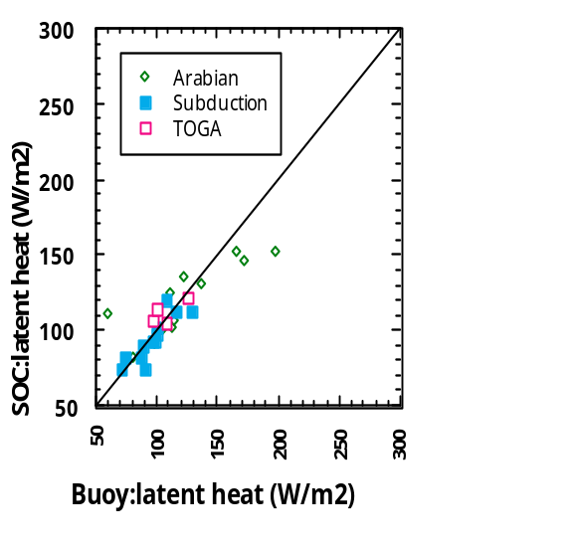

Figure 2a - Buoy vs SOC Climatology

In contrast, comparisons between the buoy data and numerical weather prediction and climate models (here, the Hadley Centre model ) reveals problems with the surface meteorology and fluxes from the models (Figure 2b).

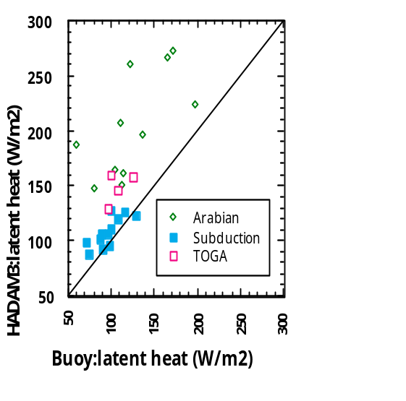

Figure 2b - Buoy vs HADAM3 Climatology

These problems may not be apparent in the net heat flux, as the heat flux components from the models can have biases that cancel. Figure 3 shows that the latent and shortwave fluxes from the Hadley Centre model have biases of opposite sign.

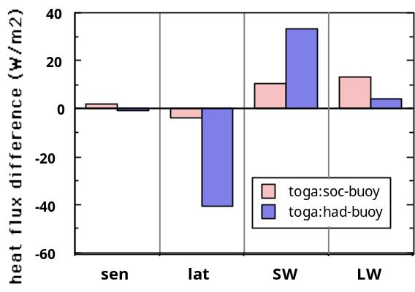

Figure 3 - TOGA-COARE SOC vs Hadley Centre

High quality in-situ data is essential to validating models, remote sensing, and climatologies. Figure 4a uses one year of buoy data from the Arabian Sea and contemperaneous, co-located model data to show how far off the net heat fluxes from the ECMWF, NCEP, and Hadley Centre models were. The model error approaches 100 W m^-2; during the Southwest Monsoon the NCEP model had the wrong sign of the net heat flux.

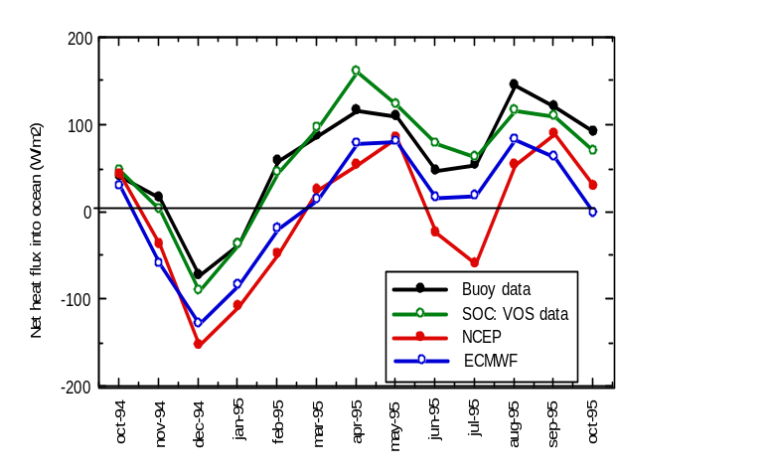

Figure 4a - Buoy / SOC / NCEP / ECMWF / Hadley Centre

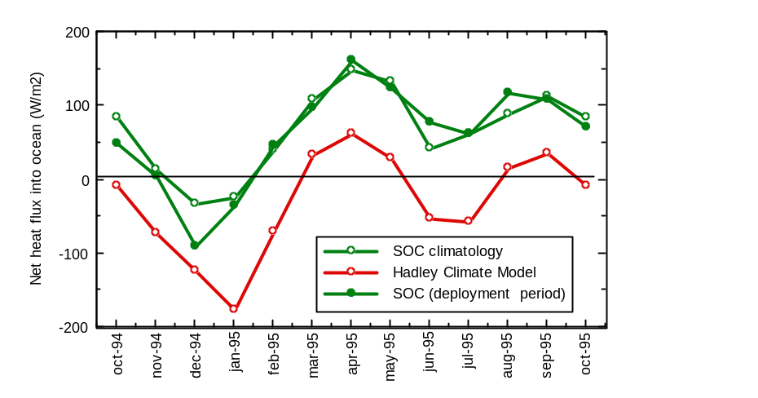
Figure 4b - SOC / Hadley Centre

Figurte 4b compares the 1994-1995 SOC data with the SOC climatology and the Hadley Centre climatology. This comparison suggests that the Hadley Centre climate model has errors similar to the NWP models.

Figure 4(a&b) , however, also presents a very encouraging result. The SOC developed VOS-based flux data at the buoy site and for the same time period agrees very well with the buoy data. Further such SOC and buoy comparisons indicate the need to make regional choices of the parameterizations used in the bulk formulae. There is both temporal and spatial variability in the fluxes due to things such as atmospheric aerosols that make high quality in-situ observations essential. Taylor's work has documented the benefits of a modest investment in understanding and improving the sensors in VOS, in understanding the air flow around the ships, and in regional choices of bulk formulae. Thus, a strategy for moving toward greatly improved global surface meteorology and air-sea fluxes is to deploy surface moorings as flux reference sites and to field improved VOS systems to fill in the regions around the reference sites. The flux reference sites provide the regional tie points, and the VOS calibrated by these sites provide the mapping capability.

Lessons Learned (Ongoing Improvements based on Field Experience)

The IMET program and the many field programs that used IMET modules have had many lessons learned. Some of these include:

[] Ease of installation essential to make short in-port availability.
[] Addressable Digital Data Bus - intelligent digital modules are addressable.
[] Calibration constants are stored in the module digital electronics.
[] Lower power circuitry makes possible battery operation.
[] RS485 communications are rugged but require careful system design.
[] Sensors have required additional modifications for use on buoys and ships.
[] r.f. interference has required careful system design and metal housings.
[] Module housings made of titanium for ruggedness and low maintenance.
[] Easy mounting brackets are required for fast ship installation.
[] Use of hardwired power and data connections incurs high cost and logistics
problems.
[] r.f. and acoustic modems relieve the need for hardwired data links.
[] Use of low power electronics with batteries relieves the need for hardwired
power connections.
[] Provision of data access to ship's crew of great value.
[] Both high and low temperature environments require testing.
[] New sensors such as longwave radiation require development.
[] Component and module redundancy are required for long deployments.
[] Reliability requires extensive system "burn-in" and testing.
[] Accuracy requires regular pre- and post-deployment calibration.
[] Manufacturer's changes to sensors must be evaluated prior to deployment.

The successful operation now of these modules required improvements based on the many "lessons learned". Any system requires extensive field use to be proven units.

VOS Climate Data Acquisition

Recently, the IMET technology has evolved into new modules designed for use on VOS ships. These new VOS-IMET are self-powered, self recording, stand alone units that also are able to communicate on the IMET Addressable-Digital-Data-Bus (ADDB). These units are being tested on VOS in cooperation with the SIO-VOS Group as part of a NOAA - OGP program. Currently installed sensor modules include the full flux suite including: Wind Speed and Direction, Relative Humidity and Air Temperature, Barometric Pressure, Precipitation, Shortwave Radiation, Longwave Radiation, and Sea Surface Temperature. These modules are housed in Grade 2 titanium, which provides low maintenance, corrosion-free, rugged units. Mounting is accomplished by fiberglass channel and stainless steel latches that provides easy installation in a wide variety of ship configurations. The following figures shows the target platform for these systems - large commercial ships that make voluntary observations.

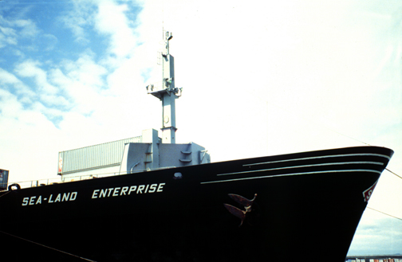

Figure 5 - Bow view of the SeaLand Enterprise. Bow mast with sensors is 70 feet above the deck.

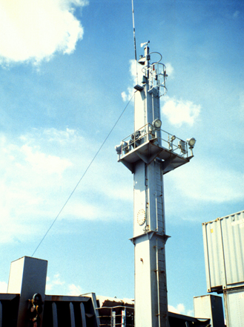

Figure 6 - Bow mast with IMET instruments at top.

It is expected that the prototype climate observing system currently being tested on VOS will be available from commercial sources as an operational system. This new commercial system will provide the same data quality and data time resolution as modules used previously to establish better understanding of climate processes. This system or components from this system can provide the same performance from buoys and smaller ships. The following figure shows a block diagram of an IMET system for VOS real time use. On research ships with installed cables, the wireless devices (r.f. modem and acoustic modem) and battery packs may not be needed.

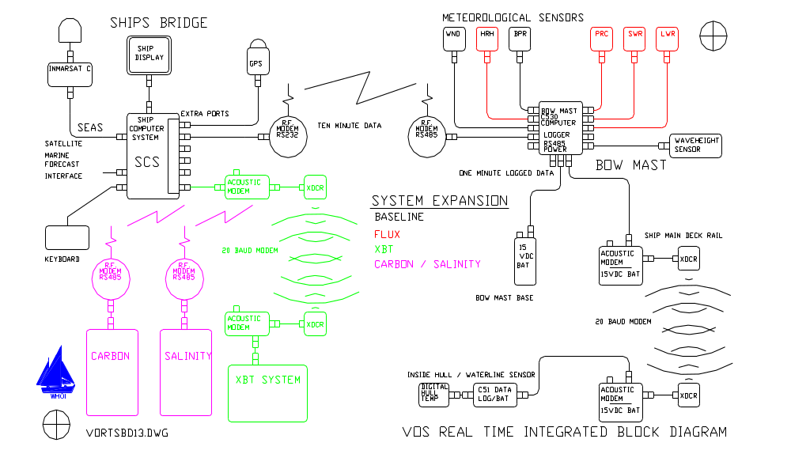

Figure 7 - Overall Block Diagram for an Automated / Integrated / VOS System

Commercial Availability.

The next phase for obtaining automated VOS meteorological systems is to have a pilot project that would put twenty systems on ships. The existing research programs have developed the technology to field rugged, low power, stand-alone instruments that measure the full flux suite of variables needed for climate research and prediction. These programs were funded by:

[] NSF sponsored IMET (Improved METeorology from Ships and Buoys) program
$3,000k starting 1988.
[] NOAA OGP has a 2 year program in place via CILER (Univ of Michigan) for a
total of $400k to Improve climate quality measurements from VOS.
[] NOAA OGP has had a multi year program in place via JIMO (Scripps
Institution of Oceanography) to determine the feasibility of flux measurements
from VOS for a total of $350k.

These programs resulted in research quality instruments that were initially manufactured at WHOI and have now transitioned to being manufactured at a commercial company, Star Engineering Inc. under subcontract to WHOI. Another critical part of a suitable VOS system is an Acoustic Modem Unit that was developed by WHOI and Harris Acoustic Products Inc and is now available commercially from Harris. Harris Acoustic Products is a sister company to SeaBeam Instruments Inc that manufactures the SeaBeam precision bathymetery system used on many Navy and research ships.

WHOI has supplied research quality IMET instruments to:

[] Seven UNOLS ships that have IMET systems.
[] Expanded WHOI programs in Upper Ocean Processes.
[] NDBC for initial test.
[] South Florida University for research buoys.
[] The Rutgers shore laboratory LEO-15.
[] The NOAA ship RON BROWN.
[] Mitsubishi Heavy Industries for the JAMSTEC Triton buoys that are being deployed in the western Pacific. Each buoy requires three modules (wind speed and direction, relative humidity and air temperature, and shortwave radiation). A total of 8 sets of instruments (24 modules) were purchased in 1997, 16 sets (48 modules) in 1998, and 10 sets (30 modules) in 1999. It is expected that a total of 60 buoys will be deployed that will require 180 modules plus spare parts. The IMET modules were selected for the JAMSTEC buoys based on the data quality obtained by IMET instrument on WHOI buoys during the TOGA COARE and ARABIAN SEA experiments.

This program can now transition to Harris Acoustic Products for systems integration, test, and installation with IMET modules being manufactured by Star Engineering. WHOI would provide engineering support for both systems and modules. Standard packages such as GPS and the R.F. modems would be purchased from other commercial sources. The software for the bridge computer would be obtained from the NOAA SEAS office and supported by NOAA OMAO (Office of Marine and Aviation Operations) who currently support NOAA VOS systems. The technical approach would build on the existing research quality instrumentation to obtain a system that maintains high quality at a lower cost.

The NOAA SCS (Shipboard Computer System) is an PC NT based software package used on NOAA ships and currently interfaces to scientific instrumentation on the ship including the IMET modules provided by WHOI. It provides on board real-time graphical display of local conditions as measured by the automated sensors. The SCS is currently being modified to automatically interface to Inmarsat-C for sending SEAS satellite messages to the National Weather Service (NWS). In the near future, the SCS will be modified to interface to the XBT system. In an operational environment, support of the software for the SCS would need to be funded directly to the NOAA OMAO office. The NOAA SCS is the system of choice and is already developed and operational. The system integrator would purchase the bridge computer and associated hardware to meet the current NOAA OMAO requirements and interface with that office for software installation and support.

The Acoustic Modem has been developed based on a proprietary product called the "Hull Phone". The Hull Phone Unit consists of a set of hull mounted transducers, a transceiver electronics package , and a self contained power supply. The device operates as an acoustic modem transferring data back and forth between two ultrasonic transducers using the ships hull structure as the communications medium. The system interfaces with the VOS-IMET SST data module. This "Hull Phone" was modified under subcontract from WHOI to provide the transducers and transmit / receive electronics. The controller interface and packaging was designed by WHOI. This new instrument has been tested on the WHOI ship OCEANUS, at sea, and will soon be working on the NOAA ship RON BROWN as well as two other VOS.

It is proposed that the sensor and interface electronics be kept the same while the system architecture be changed for reduced cost. Alternate packaging would be investigated that would maintain system convenience but reduce costs. Components like connectors and cables that were designed for long term exposure on ships and buoys have been working well and would be kept the same.

The following pages show the individual modules including the acoustic modem unit.

ASIMET ACOUSTIC MODEM UNIT

One feature of the US VOS is that they are sold and change routes on a very regular basis. This has severe implications in that it is not feasible to run cables for system installations and it is normally not possible to obtain useable electrical power close to sensor mounting locations. One special problem is getting sea-surface temperature data from inside the hull of the ship at the waterline up to the rest of the modules. An acoustic modem has just been developed that uses the ships steel hull at the acoustic path for 20-baud data.

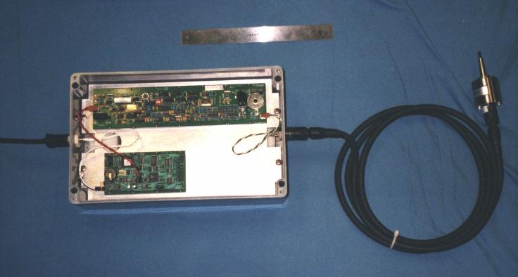

Acoustic Modem Unit. The transducer is at the far right of the picture and is installed in the steel frame of a ship at both the local and remote locations. The open enclosure has the long transmit/receive PC board and the smaller controller PC board. The input is at 9600 baud and the acoustic unit modulates the 42khz carrier at 20 baud.

ASIMET BAROMETRIC PRESSURE

An AIR (Atmospheric Instrumentation Research Inc.) model S2B sensor was selected for barometric pressure measurement. The sensor provides output of calibrated engineering units in ASCII (parallel) for direct input to the processor board. A sample is collected from the ARI sensor every several seconds. Each sample is calibrated in the ARI barometer and is internally averaged from 10 samples taken over the previous second. A Gill static pressure port is used to minimize errors due to the wind blowing over the exposed sensor port.

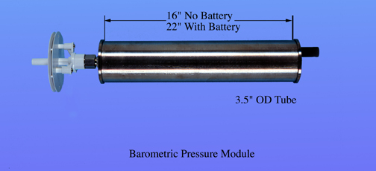

ASIMET RELATIVE HUMIDITY / AIR TEMPERATURE

Relative humidity measurements are made with a Rotronic MP-101A sensor. To meet the environmental needs of buoys and ships, the sensor is packaged in a custom housing which is more rugged than the standard housing and with high pressure water seals. The sensor electronics is conformal coated and the sensor housing is packed with a desicant. The humidity-temperature probe provides analog outputs of 0 to 1.0 volts DC for humidity ( 0 to 100% rh): and 0 to 1.0 volts DC for temperature (- 40 to +60 deg C). These signals are amplified and converted to digital in the module. One set of measurements are made every minute and calibrated via a fourth order polynomial for RH% and degrees C. This set of measurements is returned when polled. This probe is placed inside a modified R.M. Young multi-plate radiation shield for standard use. This modified shield has wider plate spacing and a hydrophobic coating on the plates to provide a more accurate measurement.

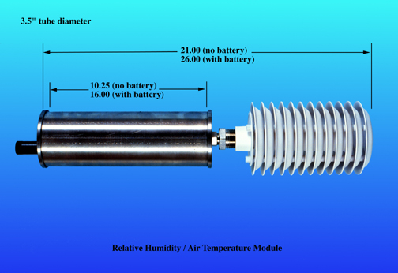

ASIMET PRECIPITATION

Rainfall is measured by an R.M. Young model 050201 self-syphoning rain gauge. This sensor uses a capacitive measurement technique to measure the volume of rain water deposited inside a collection chamber. It automatically empties in about 20 seconds when the chamber is full. The output of the sensor is 0 to 5 Vdc which represents 0 to 50 mm of rainfall in the gauge. The sensor is sampled once each minute and the level output. Rain rate is calculated based on average of the last 5 (one minute) samples. The total rainfall for the last hour is also calculated.

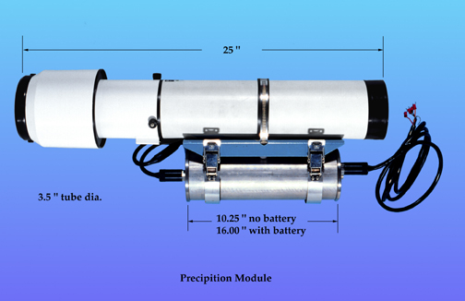

ASIMET - HASSE SHIP RAIN GAUGE

An unique precipitation gauge was developed by Dr. Lutz Hasse of IFM (Institute fur Meerskunde) in Kiel Germany. The SRG measures both vertical (from the top) and horizontal (from the side) water accumulation and uses an algorithm to determine rain rate based on wind speed. The transition takes place between 9 and 11 meters/sec in a linear manner. This unit is currently in use on the NOAA ship RON BROWN. The accuracy of the data from this instrument is significantly better than standard rain gauges when used on ships.

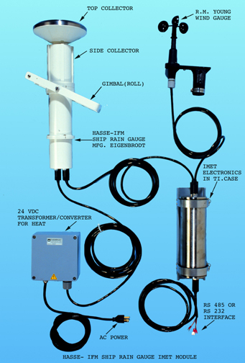

ASIMET SHORTWAVE RADIATION

Shortwave radiation is measured with a modified Eppley Precision Spectral Pyranometer (PSP) mounted on an aluminum base which provides a reference mass for the PSP. The aluminum base is mounted to a PVC endcap for thermal isolation from the module housing. The sensor uses a temperature compensated thermopile. It provides an output voltage proportional to incident short wave solar radiation (0.3 to 5.0 micro meters). Sensitivity is approximately 9 microvolts per watt, per meter squared, and has a temperature dependence of +/- 1% over the range of -20 to +40 degrees C. A set of sample is collected, calibrated via a fourth order polynominal, and averaged for the return measurement.

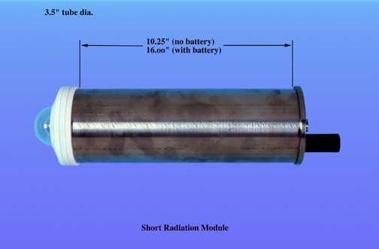

ASIMET SEA SURFACE TEMPERATURE

A platinum resistance thermometer (PRT) was chosen for sea surface temperature measurement. PRTs have a positive temperature coefficient, are highly stable over long periods of time, and have a very low hysteresis. The electronics consists of an analog front end and an ultra low-power micro processor unit for conversion to a digital signal. The analog front-end uses an Anderson circuit that provides a low noise interface to the PRT that uses a constant current source through the series combination of the PRT and two precision resistors. The resistors are set at the -10 deg C and + 20 deg C values of the PRT. Since the measurements are always made relative to the reference resistors, electronic drift is compensated for and an accuracy of 5 milli degrees C with a resolution of one milli-degree C is achieved over a range of -10 to +45 deg C. The sensor is mounted in a PVC housing that is attached inside the ship hull at the water line. This conforms to the configuration that has provided excellent results from the U.K. Meteorological Office sensors used on VOS ships.

Note that this system can also be used for air temperature with a PRT mounted in a standard 6” probe. For very accurate air temperature measurements, an aspirated shield (R.M. Young) is recommended since the R.M. Young static shield introduces errors in direct sun and with low wind speeds independent of the sensor used. The aspirator uses about 0.5 amps at 12 vdc and is only suitable on a buoy with solar panels or for limited time.

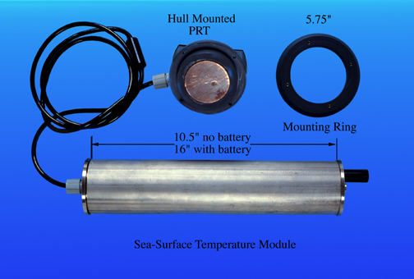

ASIMET WIND

Wind speed and direction are measured with a modified R.M. Young model 05103 wind monitor. This sensor was selected because of its proven record. It uses a propeller to measure wind speed. The standard vane potentiometer is removed and the vane shaft extended down and coupled with an absolute angle encoder for a full 360 degrees of measurement. A magnetometer compass is used to provide the north reference for use on buoys. This is can be disabled for use on ships (ships gyro and external GPS are then used to compute true wind speed in the data recorder). The propeller generates 3 pulses per revolution which has a calibration of 0.297 meters of wind per revolution. The pulses are amplified and counted over a 5 second period providing scalar wind speed. The vane position is measured once per second and the compass measured once each 5 seconds. This provides a scalar wind speed and direction every 5 seconds that is then vector averaged over the normal one minute sample period. The maximum and minimum wind speeds during the one minute time are also reported for wind gust information.

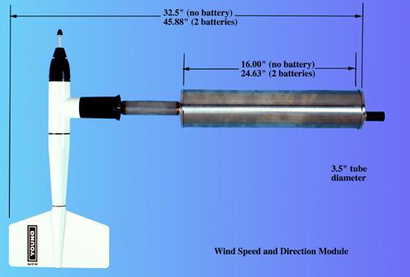

THE ROLE OF XBT SAMPLING IN THE OCEAN THERMAL NETWORK

Neville R. SMITH ¹, D.E. HARRISON ², Rick BAILEY ³, Oscar ALVES ⁴, Thierry DELCROIX ⁵, Kimio HANAWA ⁶, Bob KEELEY ⁷, Gary MEYERS ⁸, Bob MOLINARI ⁹ and Dean ROEMMICH¹⁰

¹ BMRC, Box 1289K, Melbourne Vic. 3001, AUSTRALIA
² NOAA/PMEL, 7600 Sand Point Way, Seattle, WA 98115, USA
³ JAFOOS, BMRC, Box 1289K, Melbourne Vic. 3001, AUSTRALIA
⁴ UKMO, London Rd, Bracknell RG12 2SY, UK
⁵ IRD, BP A5, 98848 Noumea, NEW CALEDONIA
⁶ Tohoku Univ., Aoba-ku, Sendai 980-8578, JAPAN
⁷ MEDS, 1202-200 Kent Street, Ottawa, Ontario K1A 0E6, CANADA
⁸ CSIRO Marine Research, Castray Esplanade, Hobart Tas. 3001, AUSTRALIA
⁹ NOAA/AOML, 4301 Rickenbacker Causeway, Miami, FL 33149, USA
¹⁰ Scripps Institution of Oceanography, La Jolla CA 92093-0230, USA

ABSTRACT - This paper evaluates the present role of the XBT program and proposes a strategy for the future under the assumption that there are other direct and indirect contributions to sampling the temperature and salinity of the ocean. Since the focus is on XBT sampling the paper restricts its scope to the upper ocean, mostly above 1000 m. The conclusions of the paper are based on a study and workshop that were convened specifically to look at the design of the ship-of-opportunity network and to look at options for its implementation in the future under the assumption that Argo happens. The paper also addresses issues related to data distribution and management. The primary conclusion is that the network of the future should place greatest emphasis on line sampling, at intermediate to high densities, and assume that a proposed profiling float array, Argo will largely take over the role formerly occupied by area (broadcast) sampling. It is argued that line sampling exclusively addresses several needs of the ocean observing system that cannot easily be addressed by other forms of sampling. Further it is argued that such a mode complements other in situ components such as moorings and floats as well as remotely sensed surface topography. A new network is outlined with a strategy for implementation that ensures continuity between existing and planned networks. We conclude the data management system that was established around the SOOP program requires substantial renovation if it is to adequately address the needs of the data gatherers and suppliers, and the data users (modellers, scientists, operational applications).

Background.
While we have been collecting thermal samples of the ocean for much of this century (Figure 1), it is only in the last quarter of the century that oceanography has been able to take advantage of cheaper, more cost effective expendable and autonomous instrumentation. Many of these advances are addressed in other papers of this Conference. The eXpendable BathyThermograph (XBT) was introduced around 30 years ago and opened up the possibility of gathering inexpensive measurements from ships-of-opportunity and thereby avoiding the costly overheads associated with research vessels. Such a strategy has been employed for the collection of marine data since the middle of the last century and continues to be an important component of the World Weather Watch. The ship-of-opportunity program (SOOP) was initiated to develop this capability for upper ocean observations. The first significant networks were established in the North Pacific and North Atlantic Oceans and led to improved understanding of the upper ocean in those regions.
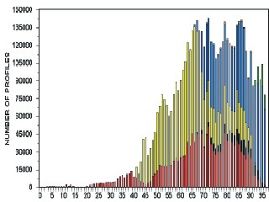
Figure 1. Profile count for the World Ocean Database 1998 (Levitus et al 1998). Bottle casts are in red/brown. CTD casts are shown in black. The yellow are mechanical bathythermographs while XBTs are shown as steel blue. TAO data are shown in green.
The major impetus for a more extensive network came from the Tropical Oceans-Global Atmosphere Experiment (TOGA) and the World Ocean Circulation Experiment (WOCE). The TOGA and WOCE programs used ships-of-opportunity to deploy XBTs along selected routes. The networks were first extended into the tropical oceans to capture variability associated with El Niño and later to other mid-to high-latitude regions, providing data for observing network design and for fundamental studies of ocean variability and predictability. The tropical network was critical for developing models of ENSO and continues to be an important contribution to the initialization of prediction models. SOOP thermal data also constitute a significant fraction of the recent global upper ocean thermal data base (Fig. 1) and so to a large extent represent our "knowledge" of the seasonal cycle and interannual variability.
The Tropical Atmosphere-Ocean array (TAO; McPhaden 1995; Hayes et al 1991) was an initiative of TOGA and presently constitutes the core of the (operational) ENSO observing system. Till this point it has been argued that TAO and SOOP are complementary and that any redundancy that does exist could not be removed without significant effort and loss of capability (see also Anderson et al, this Conference). While this may be true, it is timely for the ocean community to look at this issue afresh and re-articulate the justification for a major tropical ocean SOOP and, where uncertainty exists, encourage appropriate studies.
In the early 1990's the US and France launched the Topex/Poseidon altimeter. This instrument delivered, and continues to deliver, estimates of surface topography changes to an accuracy of around 2 cm (Mitchum et al, this Conference). This capability, plus the development of skilful model and data assimilation systems, has changed the perceived role of SOOP data. With such information available it does not make sense to design and evaluate networks such as SOOP in isolation. Networks must be considered as a contribution to a larger, integrated in situ and remote system, with consequences for sampling and design.
There are now also firm plans for a global array of profiling floats (Argo; Argo ST 1998 and Roemmich et al, this Conference). In theory Argo will deliver an upper ocean profile (around 1500-2000m) of T and S every 10 days or so from around 3000 floats. This will revolutionize the upper ocean observing network.
The last concerted examination of the SOOP network was undertaken just prior to the establishment of the Climate Variability and Predictability Programme (CLIVAR) (TWXXPPC 1993). This paper and the associated workshop and study represent a logical progression from that point taking into account innovations over the last 6 years. For the purposes of this study, the rationale for the observing network is provided by OOSDP (1995) and the CLIVAR Implementation Plan (WCRP 1998), plus the action plan for ocean observing system for climate (IOC/WMO 1998) The Workshop also examined some issues associated with salinity. These are not pursued here (see Lagerloef and Delcroix, this Conference).

A Study of the Upper Ocean Thermal Network
The GCOS/GOOS/WCRP Ocean Observations Panel for Climate (OOPC), CLIVAR Upper Ocean Panel (UOP) and the Ship-of-Opportunity Program of the IOC/WMO Integrated Global Ocean Services System (IGOSS SOOP) agreed to convene a study of the upper ocean network with the support of NOAA and the Bureau of Meteorology. The aims of the study were
- To compile a consolidated account of the existing upper ocean thermal (UOT) data base, using whatever data bases that are available;
- Produce consolidated "maps" of information level/content based on the dominant scales of climate signals;
- Document the existing practices for assembling, quality control and distribution of upper ocean data;
- Document to the extent possible the "value adding" of thermal data process chains, be they automated assimilation, quick-look/semi-automated quality control or higher-level scientific quality control and assembly.
- Provide quantitative assessment of all SOOP lines including an assessment of relevance/impact against scientific objectives
- Provide a renovated SOOP plan taking account of, as far as is practical
- The existence (or potential) of other direct sampling networks (e.g., TAO, Argo);
- The indirect information available from remote sensing, particular altimetry; and
- The indirect information available from models, e.g. wind-forced equatorial.
The study and associated workshop report (An Ocean Thermal Network Review, in preparation) provide the substantial input for this paper. Some of the details will be provided in a separate paper (Bailey et al, this Conference). The plan here is to first discuss some of the scientific and historical background to the present SOOP network (Section 3), including the rationale for the three most prominent modes of sampling (i) low density broadcast (areal) mode, (ii) frequently-repeated lines, and (iii) high-density sampling. We will then extend this discussion by introducing the main scientific goals for the network (Section 4), most of which are not exclusive to SOOP. They do however provide a suitable framework from which to develop a picture of why XBT sampling has utility. Sections 5 and 6 describe what the XBT program can and should contribute and introduce a new strategy for XBT sampling given certain assumptions about other elements of the system. Section 7 discusses various aspects of data assembly, management and processing and concludes that a major rethink of the approach might be warranted. Specific suggestions are put forward. Section 8 concludes the paper by recapitulating some of the major conclusions and suggests a prioritized timetable for the implementation of the recommendations. Some discussion of cost is also included.

Scientific Background
In this section we outline the scientific rationale behind the sampling strategies that have been developed for the ship-of-opportunity network to this point in time. While we do emphasize the importance and, in some cases, the fundamental contributions from the SOOP network, there is also the implicit acknowledgment that the observational environment has changed and continues to change and that it is therefore timely to re-evaluate the deployment of SOOP resources. We also note that although we are here focussing the discussion around three modes of sampling, in practice the division between these modes is blurred. A fourth mode has provided much of the historical XBT data. This latter mode consists of data collected during basic research experiments and military applications. Typically, data are taken from research vessels in limited areas but with intense sampling. Much of the early North Atlantic sampling in the Gulf Stream region is of this type. Figure 2 shows an example of the annual distribution of data during this period.
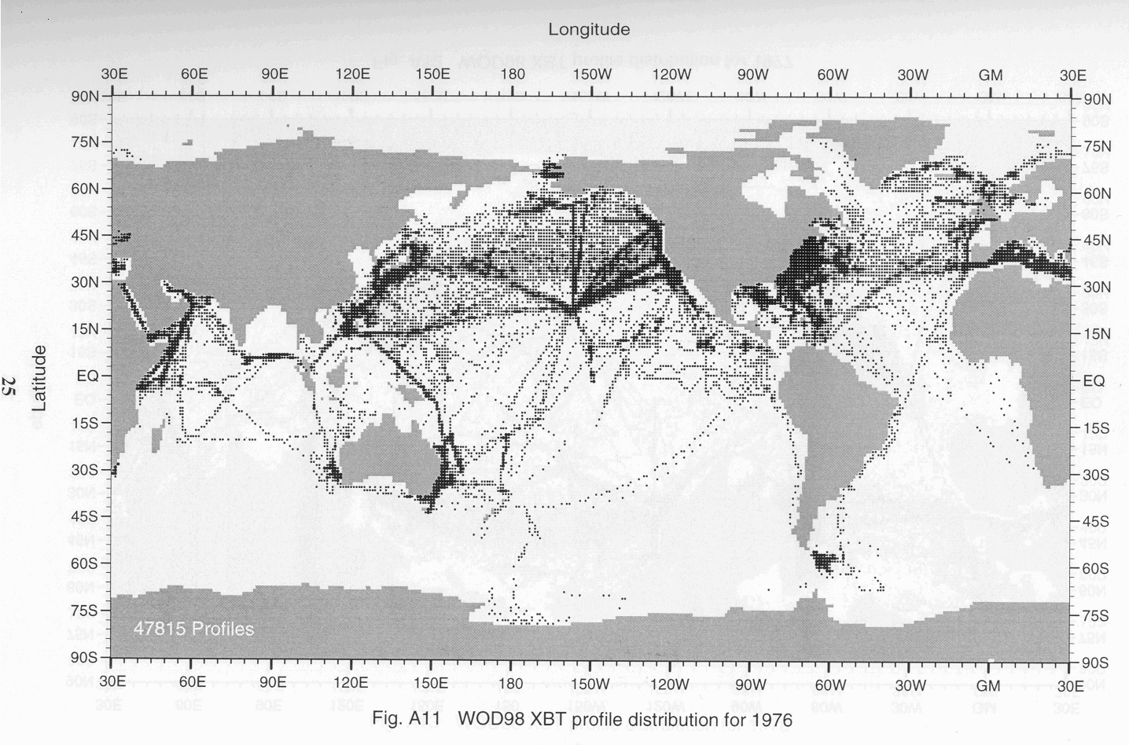
Figure 2. Distribution of XBT profiles for 1976 (from Levitus et al. 1998).

Low resolution sampling
Low-resolution sampling (sometimes referred to as broadcast or areal sampling) was the dominant mode in the early days of the ship-of-opportunity network. The original rationale was that it targeted the large-scale, low-frequency modes of climate variability and made no attempt to resolve the energetic, mesoscale eddies that are prevalent in much of the ocean. The early studies used sampling rates that, within the resources available, would provide over-sampling of the relevant modes of variability. It was then possible, on the basis of simple estimation theory (e.g., Gandin 1963) to calculate the relevant scales of spatial variability. The results of such studies formed the basis of the network design adopted for TOGA. Molinari et al (1992) discuss several of these studies and note the variation in temporal and spatial scales.
The current low resolution network is comprised of data from 1) VOS XBT lines along which sampling ideally has been monthly and 4 drops per day (as established during WOCE and TOGA) and 2) basic research and operational experiments in which XBT's are dropped in grid-like patterns to study various oceanographic phenomena (the early high-resolution sampling noted above). The low-resolution lines are maintained through an international consortium with oversight by the SOOP Implementation Panel and data are frequently available in real-time for operational climate forecasts and analyses. The experimental data are available in a delayed mode when (ideally, but not always in reality) investigators provide their data to a national data bank.
The present SOOP network is shown in Figure 3. It is evident that while the coverage is extensive, it is not global and that there are large gaps in the network. The availability of data is adequate for studies of low frequency variability (Festa and Molinari, 1992; TWXXPPC 1993). Extensive use of such data has been made in the tropical Pacific (e.g., Meyers et al 1991; TWXXPPC 1993; Taft and Kessler 1991) and in studies of global modes of variability (e.g., White 1995). There have also been extensive studies of decadal variability in the North Pacific (Hanawa and Suga 1995). Hanawa and Yoritaka (1999) and Yasuda and Hanawa (1999) argue that XBT data are particularly useful for North Pacific Subtropical Mode Water studies. The scales of variability of mode water and the distribution and circulation of associated water properties can be readily captured by broadscale sampling. The unique niche of the low resolution mode among global ocean observations is in the 30 plus years worth of data along some lines and regionally in the North Atlantic and North Pacific.
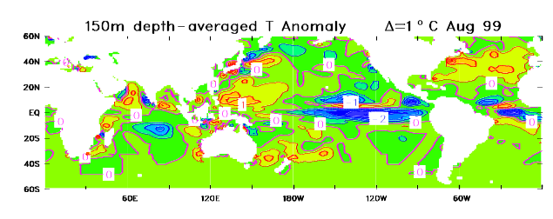
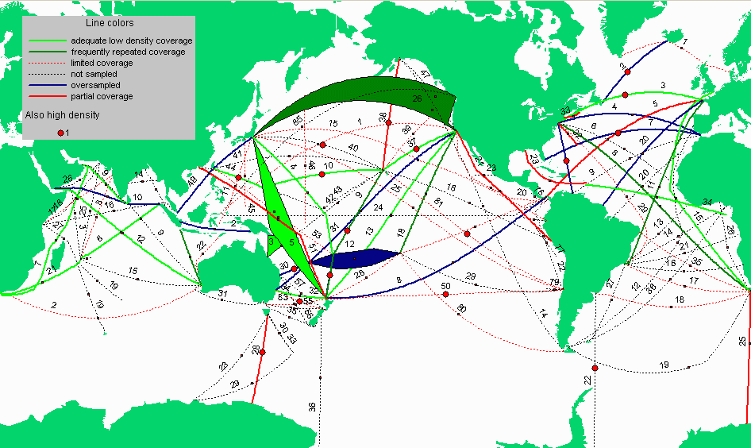
Figure 3. (Top) Typical data distribution (August 1999) for the present network comprising SOOP, TAO and some profiling floats. The majority of the SOOP lines are maintained in low-density mode. (Bottom) The SOOP network design show low-density line of adequate coverage (light green), frequently-repeated lines (dark green), limited coverage (dashed red), not sampled (dashed blue), oversampled (dark solid blue) and partial coverage (solid red). Lines that are also high density (see Fig. 5) are marked with red dots.

Low resolution data are also used routinely in ocean analysis and climate model initialisation. For El Niño prediction, XBT data complement that from TAO (Smith and Meyers 1996; Anderson et al this Conference) though it is difficult to precisely quantify their contribution in the presence of altimetry and good models. XBT data also are a staple input for several global ocean analysis systems (e.g., Clancy et al 1997). In the latter cases, there are tight constraints on timeliness.
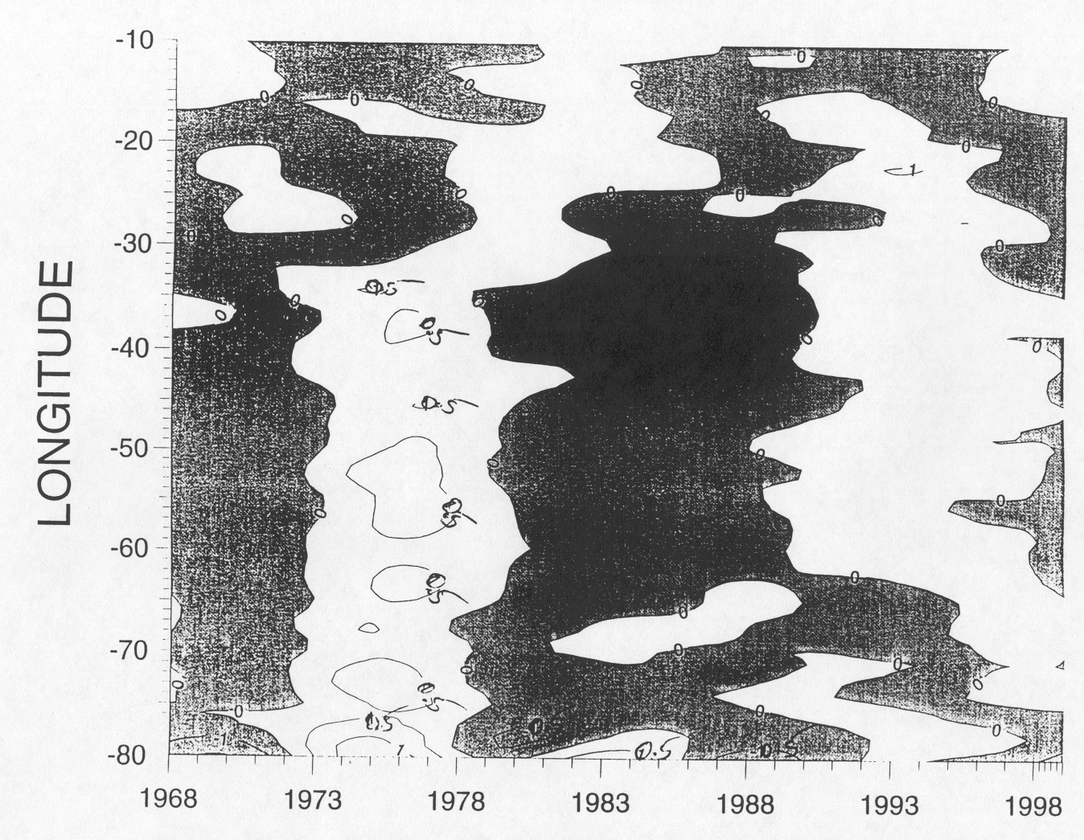
Figure 4. Reconstruction of the low-frequency temperature variability along AX7 using the first 4 harmonics (Molinari and Snowden, personal comm.)
The use of XBT data to measure the seasonal and interannual fluctuations in the upper layer heat storage and to serve as constraints on estimates of air-sea fluxes in areas where the balance is primarily one-dimensional constitutes one of the (formerly) unique roles of SOOP. XBT data also play a key role in the determination of regional patterns of upper layer temperature structure in well sampled areas. Figure 4 shows such an analysis of decadal temperature changes in the North Atlantic. There are also many other examples where low-resolution data play a significant role (e.g., Deser et al 1999).
Lines that cross intense boundary currents and have been occupied continuously for more than 10 years provide a unique source of information on the variability at time scales greater than interannual and in some cases decadal. It is unlikely that other data can provide similar information because of the high advective speeds in these currents. In some cases the sampling rate exceeds that normally associated with broadcast mode. Furthermore, lines that have been occupied for more than 20 years constitute an important component of our historical thermal data archive.

Frequently repeated sampling

What are frequently repeated lines?
Frequently repeated XBT (FRX) lines are mostly located in tropical regions to monitor strong seasonal to inter-annual thermal variability in the presence of intra-seasonal oscillations and other small scale geophysical noise. The lines typically run almost north/south, and cross the equator or intersect the low latitude eastern boundary. They are intended to capture the large scale thermal response to changes in equatorial and extra-equatorial winds. Sampling is ideally on an exactly repeating track to allow separation of temporal and spatial variability, although some spread is possible. The lines are (ideally) covered 18 times per year with an XBT drop every 100 to 150 km. An extra XBT is dropped at the 200m depth contour when crossed if possible. Volunteer observers on merchant ships do the sampling.
FRX sampling tries to draw a balance between undersampling and greatly increasing the risk of aliasing, and more expensive high-density sampling. Its niche is in regions where temporal variability is strong (and resolvable with order 20 day sampling) and spatial variability is not dominated by scales at the Rossby radius. The oldest FRX lines have been monitored for 20 years, allowing accurate documentation of seasonal and inter-annual variations of thermal structure and very accurate documentation of differences between decades.

Where are FRX lines most valuable?
Lines in the FRX network were selected to satisfy the following general criteria:
- Meridional lines crossing the equator or intersecting the low latitude eastern boundary in the tropical western, central and eastern parts of the Pacific, Atlantic and Indian Oceans (Fig. 5).
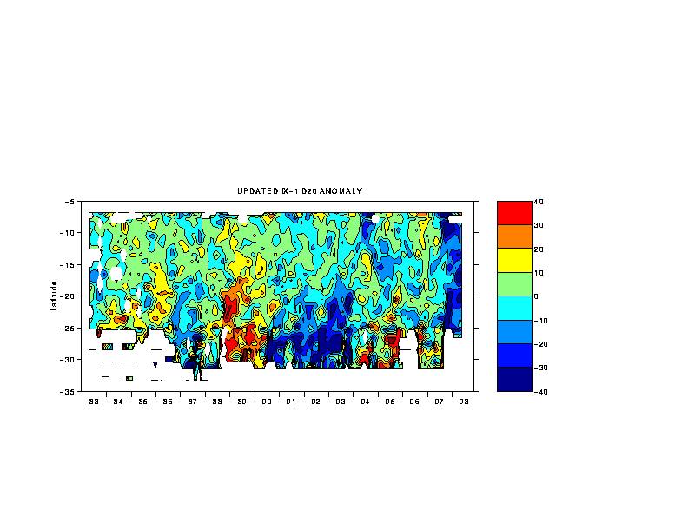
Figure 5. The evolution of the anomaly in the depth of the 20ºC isotherm along line IX1. Note the significant events in 19889, 1991-93 and 1998. [G. Meyers, pers. Comm.]
- Lines across important regional features of the climate system, such as Indonesian throughflow, North Equatorial Countercurrent (NECC) in response to Intertropical Convergence Zone (ITCZ), Western Pacific Heat Pool, Somalia upwelling zone, etc.
- Isolated lines in the poorly sampled parts of the tropical oceans, where widely dispersed low density sampling is not possible due to ship-routing patterns.
The future of all modes of XBT sampling should take into account the availablility of global altimetric data, offering the potential for synthetic XBT's in regions where the T/S relationship is not too variable, as well as the planned development of global thermal measurements by the Argo Program. With only a few exceptions, the FRX lines have not been managed with enough tenacity to ensure the sampling occurs on a narrow, repeating track-line. This is relatively easy for XBT operators to fix, but it requires extra time and attention to detail to select and change ships when required.
Whether or not FRX lines have any particular value for initialisation of seasonal climate predictions and/or ocean estimation using a dynamical model has not been clearly demonstrated. In principal, models should be able to exploit the long zonal scales to export information well beyond the line of measurement. In practice, it seems, model and/or wind errors contrive to diminish this potential value.

High-density XBT (HDX) sampling

What are high resolution lines?
High resolution XBT (HRX) lines are those whose sampling criteria require boundary-to-boundary profiling, with closely spaced XBTs to resolve the spatial structure of mesoscale eddies, fronts and boundary currents. The present set of regularly sampled HRX lines are shown in Figure 6, with probe spacing (typically 10-50 km) displayed from a single realization along each transect. Time-series of HRX lines are as long as 13 years in the case of PX6 (Auckland-Suva). The repetition frequency is about four times per year. In most cases, a technician or scientist on board the ship makes measurements.
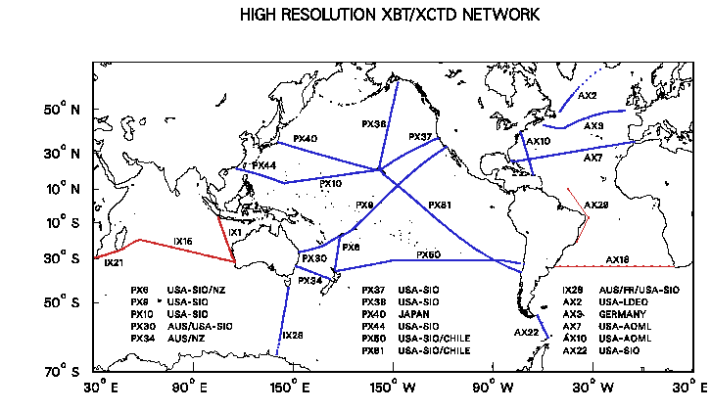
Figure 6. Map of the HRX lines. Presently sampled routes are shown in blue, with symbols at station locations from a single cruise. High-priority additions (see Section 6) are shown in red.
The unique niche of the HRX mode among global ocean observations is in spanning spatial scales from that of eddies and boundary currents to basin-width, and time scales from seasonal to (potentially) decadal. The closest analog to HRX sampling, but usually in regional scale observations, is repeat hydrography. HRX sampling is substantially more labor-intensive than broad-scale or high frequency lines. It returns higher quality datasets through use of (i) a stern-mounted automatic launcher (ii) redrops of questionable profiles (iii) horizontally coherent sampling. The characteristics and objectives of HRX lines dictate careful selection of a limited set of routes for this sampling mode.

Scientific objectives addressed by HRX sampling.
HRX transects are an important means for addressing the following objectives.
- Measure the interannual fluctuations in the transport of mass, heat, and freshwater across ocean-spanning transects (e.g. at tropical/ subtropical boundaries, Figure 7) or through the perimeter of large ocean areas (e.g. Tasman Box PX6/30/34, Western Atlantic AX7/10 etc.);
- Characterize the structure of baroclinic eddies (Fig 8) and estimate their significance in the transports of heat and water masses;
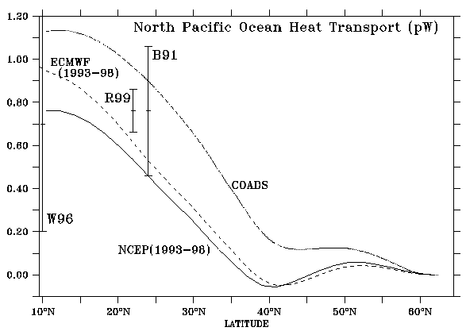

- Figure 7. Meridional heat transport (pW) in the North Pacific Ocean. B91 (Bryden et al 1991) and W96 (Wijffels et al, 1996) are from the one-time hydrographic transects. R99 (Roemmich et al 1999) is based on geostrophic and Ekman transport calculations from 25 HRX transects along P37/10/44 (average latitude 22ºN) from November 1992 to January 1999, with simultaneous wind measurements. The other estimates are from climatological data or operational products as indicated. Accurate estimates of ocean heat transport can be used to test or constrain modeled air-sea fluxes.

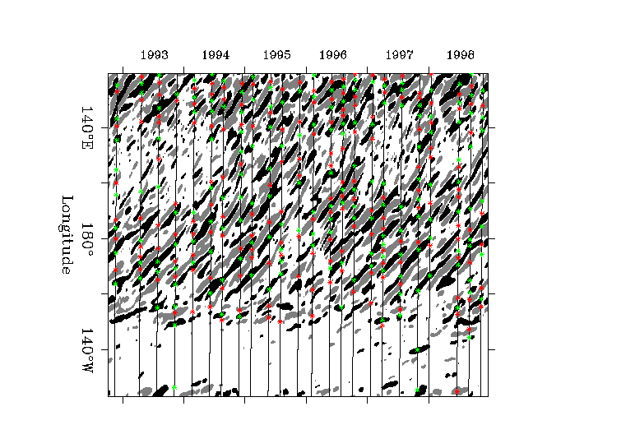

Figure 8. Complementary information in TOPEX altimetry and HRX dynamic height. Eddy locations are shown from the T/P altimetry and HRX data along P37/10/44 as a function of longitude and time. Warm (cold) eddies with sea surface height maxima (minima) are shown as red (green) symbols for XBT data and gray (black) for T/P data. Note how individual eddies can be identified 1999.)and tracked for a year or longer, propagating westward at 10 cm/s. (From Roemmich and Gilson, 1999)

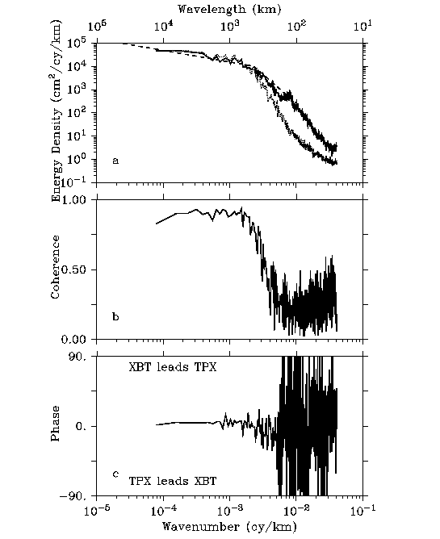

Figure 9. Horizontal wavenumber spectra and coherence of dynamic height (solid) and altimetric
Height, along PX37/10/44. Note the high coherence (> 0.9) at low wavenumbers
(> 500km). (From Gilson et al., 1999)

- Determine the spatial statistics of variability of the temperature and geostrophic velocity fields (Fig 9);

- Identify persistent or permanent small-scale features;

- Determine the scale-dependent correlation of sub-surface temperature and dynamic height with altimetric height (Fig 9). What are the minimal requirements for in situ data?
- Facilitate additional measurements from a small set of highly instrumented Volunteer Observing Ship (VOS) platforms (XCTD, SSS, improved SST and meteorological observations, float deployment etc.); and
- Determine the long-term mean, annual cycle and interannual fluctuations of temperature and large-scale geostrophic velocity and circulation in the top 800 m of the ocean (Fig 10).

Where are HRX lines most valuable?
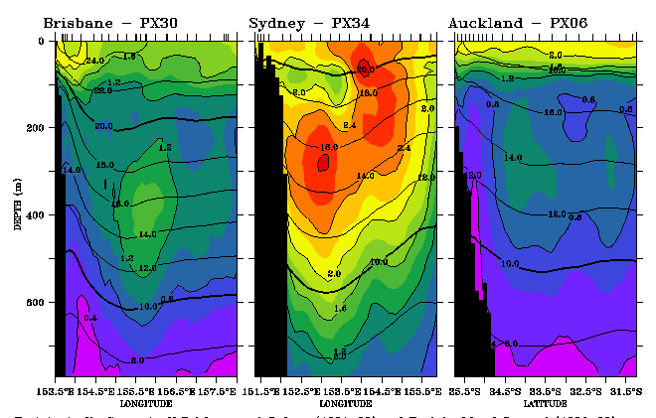
Figure 10. Long-term sampling of western boundary currents in the southwestern Pacific. The East Australian Current (EAC) is sampled by 2 transects, PX30 off Brisbane , and PX34 off Sydney, each with about 30 transects from 1991 to the present. The EAC separates from the coast north of Sydney, but overshoots and then re-curves northwestward across PX34. Part of the current reattaches to the northern New Zealand coast as the Auckland Current, sampled by over 50 transects since 1986 along PX06. The figure shows the mean and standard deviation of temperature for the three western boundary current crossings. Note the offshore maximum in variability at all three locations. Tick marks at the top are single-cruise XBT station positions. [Roemmich, personal comm. and Sprintall et al 1995]
Lines in the HRX network were selected to satisfy several general criteria subject to specific shipping availability and basin geometries. These are:
- Zonal ocean-spanning transects across the subtropical gyres, where meridional ocean heat transport is large, and at other special locations.
- Meridional lines (with maximum extent in latitude) crossing the equator in the western, central and eastern Pacific
- Choke point transects.
- Selected "boxes" in eastern or western boundaries.
Given these criteria, the most significant shortcomings of the present HRX network (Fig. 6) are the lack of:
- Zonal transects across the subtropical S. Indian (where one was discontinued in 1995) and S. Atlantic.
- A meridional line crossing the western equatorial Pacific
- Choke point transects from S. Africa to Antarctica and across the Indonesian throughflow (presently a frequently repeated line; Rintoul et al 1997).
Experience shows that the most valuable HRX lines are those that are maintained along exactly repeating routes for periods of 5 years or longer. There is little reason to initiate HRX lines if they cannot be maintained, and higher priority is attached to maintaining long time-series lines than to initiating new ones.
There is a very complementary relationship between HRX lines and frequently repeated lines. The latter provide important context consisting of long-term climatologies and improved temporal resolution that balance the high spatial resolution of the HRX mode. Because of this, existing frequently repeated lines are the best candidates for new HRX sampling.

The operational and scientific framework for the future
For the immediate future, it is the practical applications associated with the Global Ocean Observing System and the scientific objectives of CLIVAR that provide the main rationale for maintaining an upper ocean thermal network. This paper does not address the overall design of this observing system but instead focuses on those elements that are impacted by the SOOP. However it is not possible to do this without first considering the broad objectives for the upper ocean thermal network, be they practical or scientific. We do this by re-expressing the relevant scientific objectives of the CLIVAR Implementation Plan (WCRP 1998) and of GOOS (OOSDP 1995; IOC/WMO 1998) as a small set of goals. There is a level of arbitrariness in this choice but this cannot be avoided. We argue that, in order to re-design the SOOP network and assign priorities, we must have a clear set of reasons out front; Why do we want an upper ocean network? These reasons are in general not exclusive to SOOP and do not even encompass all the reasons for using XBTs but there is be little to gained by making them greatly more complex. Rather, we will use these objectives as a means for ordering the discussion and the evaluation of the individual contributions (lines).
The Study (see Bailey et al, this Conference) use the following scientific objectives as the basis for its evaluation of the SOOP contributions in the past. As we will indicate in subsequent sections, the future system is likely to be targetted at more specific aspects.

The scientific objectives
- Seasonal-to-interannual prediction (ENSO)
- There are many centres that now run routine / operational ENSO prediction systems (see Anderson et al, this Conference). There are many more that have experimental systems. The dependence on ocean data varies but there is clear evidence from both hindcasts (e.g. Ji et al 1998; Kleeman et al 1995) and applications in practice (WCRP 1999) that subsurface data are important.
- Understanding tropical ocean variability, predictability
- In parallel with practical applications are research efforts attempting to understand tropical ocean variability and the predictability of the coupled climate system. Many of these issues are addressed in the CLIVAR Implementation Plan and are addressed in other papers from this Conference (Garzoli et al; Meyers et al; McPhaden et al).
- Mid- and high-latitude ocean variability (intra-seasonal to interannual)
There is significant ocean variability in the extra-tropics and higher-latitudes on scales ranging from weeks (boundary current meanders, eddies) to seasons and years (e.g., the ACW). What strategy should be employed for the UOT network? For the SOOP network? How do we exploit complementarity between altimetry and the UOT network? What role should SOOP play in an Argo world?
- Global and regional heat storage
On interannual and longer time scales there are significant regional and global variations in heat storage and water mass formation with important implications for the climate system. Several papers at this Conference discuss longer time scale modes and the implications that might be drawn in terms of required observations. The challenge is to design a UOT network, with contributions from SOOP, Argo and other in situ and remote systems, that can give useful estimates of the rate of storage and release. Global coverage is essential but temporal and spatial resolution requirements might be less demanding. Issues of quality, however, are likely to be more demanding.
- Heat and mass transport / circulation
Geostrophic transport of heat (and freshwater) is thought to be a key element of the climate system at interannual and longer time scales. The western and eastern boundary currents are known to be important and, as discussed in Section 3.3 and shown in Figs 7 and 8, transport by baroclinic eddies is also likely to be critical. What is the role of the SOOP network in delineating time and space scales of variability and in monitoring transports? As was suggested in Section 3, it is likely SOOP can play a singularly important role in this area.
- Ocean state estimation / short-range ocean forecasting
The Global Ocean Data Assimilation Experiment (GODAE; see Le Traon et al, this Conference)) is one manifestation of renewed interest in ocean state estimation, but with the time scales of interest now ranging from a few days to annual and longer. To a large extent the goals introduced above cover the longer time scale aspects though, it should be noted, for at least some areas models will play a less prominent role than envisaged for GODAE. Many centres already operate routine ocean analysis and short-range ocean prediction systems. The utility of ocean data is beyond question, the remaining question here being whether the broad range of practical applications envisaged for GODAE influence the preferred design for the SOOP network. Certainly the need for regular ocean circulation estimates and short-range ocean prediction places a premium on rapid data delivery. On these time scales, it is the constraint of internal ocean variability that is important and it is hard to see SOOP being at the forefront.
- Climatologies and climate change
Knowledge of the mean state of the ocean, including the seasonal cycle, is fundamental to most of the objectives introduced above. We cannot escape the fact that we have a short record relative to the time scales of several of the dominant modes of ocean variability. However we have a responsibility to ensure future generations are better placed than we are today. This means we should identify weaknesses/gaps in our knowledge of the mean state of the ocean (i.e., climatologies and their first moments), and pay attention to quality and data assembly in order to get data sets useful for monitoring climate change.

The quantitative assessment
Just as there are many different ways of composing the goals, there are also many different ways of assessing the contributions against these goals. Bailey et al (this Conference) list the criteria that were used as the basis for evaluating contributions, line-by-line. The Workshop Report (to be published) gives a detailed assessment of the existing XBT database against these criteria for each of the objectives listed above. Largely independent of the specific goals, ratings were assigned for each line, with an explicit recognition that such assessments were subjective and liable to be uncertain. However they provided a powerful method for quantifying the historical records. Each criterion was then assigned a weighting under a particular goal with the weighted sum for each line giving a measure of the importance of a line. Refer to Bailey et al (this Conference) for some further details.

What can the SOOP XBTs Contribute?

Some assumptions
At this point we need to be more explicit with regard to some of the assumptions we must make. It is not possible to look forward for the SOOP network without some such working assumptions.
- Tropical moorings
We will assume that an array similar to the present Tropical Atmosphere-Ocean array (TAO) is sustained in the equatorial Pacific (McPhaden et al, this Conference); that an array derived from PIRATA will be maintained in the tropical Atlantic (Garzoli et al, this Conference); and that some limited deployment of moorings in the Indian Ocean will occur on an experimental basis (Meyers et al, this Conference).
- Global float array
We will assume an array of profiling floats (Argo) is sustained at coarse resolution (250-300 km) giving around 3000 profiles every 10-14 days (Roemmich et al, this Conference). These profiles will be to mid-depth (2000 m) and will be mostly T and S.
- Altimetry
Assume a continuing altimetry program with both high-precision, low-resolution sampling (i.e., T/P and Jason series) and low-precision, high-resolution samplng (e.g., ERS) (Mitchum et al, this Conference).
- Time-series stations
Assume that a limited set of time-series stations is established and maintained.
- Acoustic thermometry
Assume that emerging technologies such as acoustic thermometry are deployed, at least regionally.
There is no certainty with any of these assumptions but is is sensible to acknowledge arrangements that are likely. These assumptions are not intended to exclude SOOP participation in particular areas if it is concluded that SOOP can provide a cost- and science-effective solution. In most cases however it is the complementarity which will be emphasised.

The SOOP contributions
Here we wish to discuss the specific role of XBTs and state just what the SOOP can do. The order of the goals is modified a little to allow a somewhat better ordered introduction of the different proposed contributions.

ENSO forecasting
As is noted by Anderson et al (this Conference), the TAO array remains the key contribution to initialization of practical ENSO forecasts models, both for its contributions to determining the surface wind and for its sampling of the subsurface equatorial ocean thermal field. These data lie at the heart of the initial conditions used by coupled forecast models. The fact that the equatorial ocean adjusts rapidly, with elongated zonal scales (order 1500 km) and narrow meridional scales (order 200 km) means that the TAO design is well-suited to this problem.
Given the sampling from TAO, one then might ask what role the SOOP could play. Smith and Meyers (1996) argued that the extra-equatorial data from SOOP came into play at longer lead times where the important information is being fashioned by the more slowly moving Rossby waves and conditions beyond the TAO array. Intuitively this seems reasonable. However in the presence of altimetry and Argo the importance of this contribution is negated, at least in the low- to intermediate density mode. The one aspect that is not adequately sampled is the meridional structure, particularly in the central-to-eastern Pacific. The importance one might attach to this has grown in recent times with several studies suggesting important links from the extra-tropics into the equatorial region via the sub-tropical meridional cell. However there is no evidence at this point that such data would have a positive impact on forecast models.
One should look forward with the expectation that models will improve and that the systems will likely to be sensitive to detail that is ignored today. At one extreme lie the intraseasonal effects and the hypothesis that predictability is intimately related to westerly wind bursts. At the other extreme is the hypothesis equatorial-extratropical exchanges introduce decadal modulations of ENSO, perhaps similar to the early 1990's. The former hypothesis draws down the temporal resolution, a demand that can probably be met by TAO. The latter requires systematic transects from the tropics into the extra-tropics and resolution of the meridional cells.
At the moment there is no firm evidence that ocean temperature data outside the tropical Pacific is other than of secondary importance. This however may simply be a reflection of the inadequacy of the models and the way they are initialized. Meyers et al (this issue) certainly put forward a persuasive case for Indian Ocean data, both XBTs and moorings. We conclude then that, in the presence of Argo and altimetry, there is no longer a strong case for low density SOOP sampling for ENSO forecasting. However sampling with frequent transects and intermediate spatial density appears justified along some north-south lines running through the central and eastern Pacific and in the Indian Ocean. Such data sets are not at the highest level of priority for this goal but would form a useful, complementary data set.

Tropical ocean variability and predictabilty
One view of this goal is that it is the research extension of the practical focus in the first goal. Yet as Garzoli et al (this Conference) and Meyers et al (this Conference) show, there is much tropical ocean variability beyond the Pacific that has interest in its own right and that might in the future lead to practical applications. Even in the tropical Pacific, there are modes of variability such as tropical instability waves and adjustments due to westerly wind bursts that are for the moment not attributed high importance for model initialization.
We have already noted the importance of extra-tropical links, perhaps via the sub-tropical cells, and are thus giving strong support to a selection of intermediate-to-high density meridional transects with a repeat of around 20 days. Because of the sharp meridional gradients it is preferable that the sampling be at what we term "eddy detection" scales; that is around 75 km compared with 20-25 km of high density sampling. The central and eastern Pacific are the preferred locations.
In the tropical Atlantic and Indian Oceans a similar set of transects is favoured. In the absence of mature mooring arrays such sampling takes on increased importance. We take the posture that such data, collected regularly, could be extremely effective at initializing the slower modes of adjustment and, with the aid of a good model and good winds, also the faster adjusting (Kelvin) modes. The model is used to fill out some of the spatial gaps and the wind, perhaps combined with altimetry, helps interpolate between transects. Frequently repeated sampling has proven extremely effective in the eastern Indian Ocean (e.g., Fig. 5) and there is every likelihood this will remain so in the future. One notes that at 120-150 km sampling density and a repeat of 20 days, the space-time sampling along these lines would be similar to Argo.

Global and regional heat storage
To first order the sampling requirements are those of the low-density mode. That is, broad coverage is needed to map the gyre- to basin-scale changes in heat storage and that, because of the characteristic large-scale and low-frequency, the sampling density need only be modest in both space and time. Yasuda and Hanawa (1999), Deser et al (1999), Levitus et al (1994) and Molinari et al (1997) provide some examples of how such data have been exploited. The issue to be addressed here is: What is the role of XBT sampling given the presence of Argo and altimetry? While there is some need to ensure gaps are not opened up in key areas, the sampling of Argo seems more than capable of resolving the signals formerly addressed by LDX with the possible exception of areas where the circulation may prevent an even sampling by Argo (e.g., at some high-latitude locations). Argo will be global, will go deeper, will have salinity, and will have a nominal sampling density several times that of low density.
Because Argo will be phased in, the phasing out of areal sampling by SOOP should be done in such a way as to maximise global coverage and encourage at least some over-lapping period for cross-calibration.

Heat and mass transport
As has been noted in Section 3.3, it is in this area that XBT sampling retains a unique role, a role that is unlikely to be usurped by any of the other proposed or speculated strategies. This arises from the fact that calculations of heat and mass transport, say across a mid-latitude gyre, require fine spatial sampling in order to avoid aliasing of eddy and other fine horizontal variability into the signal. The requirements are severe: XBT drops need to be every 20-25 km and the transects have to be from boundary-to-boundary. They should be repeated around every 3 months. Any gap in the transect, or weakening of the sampling rate, can introduce uncertainties of the same order as the signal being sought. It is also important the transects follow lines; that is, any cross-track spreading can compromise the utility of a line.
The conclusion then is that high-density sampling for heat and mass transport calculations remains an important, unique application of the SOOP. It should be noted that supporting altimetric data and, wherever possible, surface marine data, are extremely important. The altimetric data provide an immediate spatial context for transects as well as a direct estimate of dynamic height changes which can be calibrated against occasional XCTD profiles. The marine data permit a direct estimate of the wind-forced surface drift and thus some estimate of the contribution of the surface Ekman drift to meridional heat transport.

Mid- to high-latitude variability.
There are many different aspects to this goal.
First in regions of boundary currents (e.g., the Kuroshio or Gulf Stream) or strong directional flow (e.g., the Antarctic Circumpolar Current; White and Peterson, 1996) XBT transects help resolve temporal variability and variations orthogonal to the flow. Figure 10 shows the variability measured in transects through the East Australian Current. Similar studies have been undertaken in the North Atlantic using AX7 and AX10. Knowledge of this variability and its impact on mean transports is clearly important. For the Southern Ocean such data clearly have high general significance (see Rintoul et al, this Conference) and high-density transects warrant sustained support. The boundary current transects provide information on variability that is not readily obtainable from other systems such as Argo. We therefore attach high priority to these lines.
The second important aspect is the characterization of baroclinic eddies and quantification of their significance in the transport of heat and water masses. There remain many unanswered questions about the way heat is transported from the tropics to high latitudes and about the way different water masses are circulated through the ocean. Clearly one set of information that is needed is measures of baroclinic eddies, at a resolution that avoids aliasing, with sufficient repetition and length of record to build a stable statistical picture of the interaction. Clearly, high-density lines are one of the few methods that are amenable to this issue. One might argue that this has the character of a process study rather than a sustained contribution, and so one would not wish to support transects/lines purely on the basis of this contribution. However, in the process of gathering data for measurements of heat transport, these statistics are readily derived, so it is useful to explicitly recognize this additional purpose.
Third there is the need to identify and characterize persistent or permanent small-scale features (eg, the Great Whirl in the western Indian Ocean). These features may well have some long-term climatic significance and thus warrant sustained measurements if at all possible. Sampling may not need to be at high-density but will usually be above the intermediate sampling of frequently repeated lines.
Finally, and perhaps most importantly, we need improved knowledge of such variability to test and develop models and as part of data assimilation parameterizations. As was pointed out at the start of this section, we are moving toward an era where Argo and altimetry provide the keys to understanding and monitoring ocean variability. Ocean models being developed for GODAE are likely to be eddy resolving. The issue then is how do we blend and integrate these different sources of information. "Assimilation" is usually the answer, but this glosses over the real problem. In the absence of adequate knowledge on mesoscale variability, it will be difficult to know how the coarse samples of Argo should be projected onto the eddy resolving fields of the model. In assimilation this is done through various parameterizations and assumptions about the ability of the model. These parameterisations and assumptions lie at the heart of data assimilation. A select number of high-density transects would not only help determine the spatial statistics of temperature and geostrophic velocity, but would also provide a means for "knitting" the various components of the observing system (particularly Argo and altimetry) together.

Ocean state estimation
The requirements for seasonal-to-interannual forecasts and longer time scales are mostly covered above. It should be noted that ocean state estimates for longer time scales (Stammer et al, this Conference) do not, at this time, resolve mesoscale features and are thus unable to fully exploit high-density transects. However the coherency of line sampling is a powerful constraint, as is the fact that the data can be assimilated safe in the knowledge that all relevant scales have been resolved in the original data.
At shorter time scales, GODAE does not have requirements that call for a unique contribution from SOOP other than the very important requirement related to data assimilation and parameterization (see the previous sub-section). Indeed, the aspects mentioned under 5.2.5 are perhaps as an appropriate characterisation of the requirements as we need. The focus on assimilation and estimation serves to highlight the need for SOOP lines that will assist in the blending and merging of different data sources.
GODAE does perhaps have a greater focus on the upper ocean and near-surface circulation. For mixed-layer depth, a mix of high-resolution transects (primarily there for other purposes) and Argo would seem an ideal mix.
The need for rapid dissemination of data is perhaps the unique twist that GODAE provides. In some cases, the cut-off is less than 24 hours which means the flow from instrument to users must be direct and automated. This does have some implications for quality - it comes after quantity in terms of priority.

Climatologies and climate change
It is clear our knowledge of the mean and seasonal cycle of upper ocean temperature is not uniform through the world's oceans. In some places we a good picture; in others our knowledge is scant. These gaps are mostly in places where our research vessels and SOOP do not go. There is no real expectation that this renovation of the SOOP can adequately redress this deficiency.
Implementation of Argo is likely to have a first order impact on our climatological data base. Around 100,000 extra temperature profiles per year, hopefully evenly spread through the world's oceans. The modern data base is not, however, simply about extracting the monthly means. It should contain reasonable estimates of the error, both in terms of the accuracy of the estimated signal and in terms of the "noise" about this mean (this tells a user how to interpret a single profile). It should also say something about the spatial coherence of the signal and about the spatial coherence of the noise. These are essential information for data assimilation. XBT transects are particularly useful for the spatial coherence estimates.
Section 7 discusses some of the data and information management issues. These have considerable bearing on the development of climatologies and a coherent, integrated database. For climate change, the emphasis has to be on high quality data sets. Argo seems to adequately address the issue of holes in our global sampling. The high-density east-west transects will address issues associated with trends in meridional exchange of heat.

Towards a new SOOP
The overarching guideline is that:
We should begin a phased reduction in areal sampling and an enhanced effort in line (transect) mode. The phased reduction in areal sampling will be determined by the schedule of implementation for Argo and the need for sufficient overlap to ensure that there are no systematic differences between XBT and float sampling. The line sampling will be built from the existing frequently-repeated and high-density modes of sampling. Where high density is recommended the sampling density will be sufficient to resolve the Rossby radius and of around 3 month frequency. For frequently repeated sampling the sampling will be Rossby radius "detecting" [75-90 km] and repeated around every 3 weeks.
The key objectives of this new network will be
- To measure intraseasonal to interannual variability in the tropical oceans with a particular emphasis on the fine meridional structure and zonally-oriented currents. A secondary consideration is the provision of ocean data for the initialization of the next generation of seasonal-to-interannual prediction models.
Mode: FRX
- To measure the seasonal and interannual fluctuations in the transport of mass, heat and freshwater across ocean-spanning transects.

Mode: HDX
- To determine the spatial statistics of variability of the temperature and geostrophic velocity fields including the scale-dependent correlation of sub-surface temperature with surface topography variations (as measured by altimetry).

Mode: HDX
- To measure the temporal variability in boundary current regions and in the Antarctic Circumpolar Current through regular cross-current transects.

Mode: FRX, HDX
- To assist in the characterization of baroclinic eddies and other fine structure and thus estimate their significance for transport calculations and contribute to the determination of appropriate parameterizations for models and data assimilation.

Mode: FRX, HDX
- To the extent possible, and building on regional interests, contribute to studies of persistent small-scale features and to regional (large ocean area) measures of transport variability.

Mode: FRX, HDX
These goals are not intended to be unique to XBT sampling. For example, hydrographic sections contribute to the determination of transports and water masses. In such cases, the SOOP lines will assist determining the representation of the less-frequently repeated, but comprehensively sampled, sections.
We have resisted the temptation to write down "model testing" as a specific goal. All ocean data have a role in model testing. For the revised design, SOOP will provide data largely devoid of uncertainties due to inadequate sampling of the mesoscale and it is this attribute that will be most useful.
We have however emphasized the importance of these data in developing appropriate parameterizations for data assimilation.
The shift toward more intensive, line sampling does have implications for the way sampling must be done. Most high-density lines are sampled with the assistance of a scientist on board. This does have an advantage in that it can ensure a high-quality data return and facilitate additional measurements. It is this latter aspect that may be extremely important.
The revised frequently-repeated lines are shown in Figure 11 while the recommended high-density lines are shown in Figure 12. Highest priority lines are solid; second level priority dashed. More details on these particular lines can be seen in Bailey et al (this Conference).
It can be seen that the majority of the frequently repeated lines intersect the tropical regions. The high-density lines are mostly for the determination of meridional heat transport and do are thus east-west. The exceptions are in the Southern Ocean, the Indonesian Throughflow and two lines in the Pacific which have a long history and provide some estimate of partitioning between the east and west. The frequently-repeated lines annually would require order 40% more probes for the same length of transect if the suggested spatial sampling is adopted.
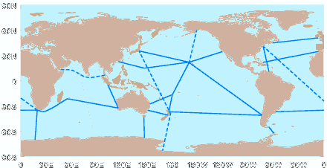
Figure 12. Proposed location of the density lines. Note that this schematic is only a first draft and has not been discussed by all the relevant participants. Highest priority lines are shown solid.

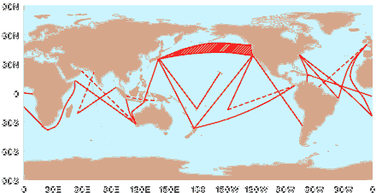
Figure 11. Proposed location of the frequently repeated lines. Note that this schematic is only a first draft and has not been discussed by all the relevant participants. Higher priority lines are drawn solid.

A detailed costing has yet to be undertaken. The average cost of an XBT profile in low-density mode is variously estimated at between US$120 to US$170 per day. The cost per profile in HDX mode tends to smaller because reduced labor costs - US$100-120 is a guide. FRX mode is somewhere in-between. No new lines have been added though several lines have been only irregularly sampled in the past (details are provided in the Workshop Report). In some cases HDX lines are also being occupied in FRX mode. The potential savings from moving toward less costly modes of sampling will be counterbalanced by the increase in the number of FRX and HDX lines and the increasing price of probes. The initial estimate is that a substantial fraction, if not all, of the new plan could be achieved with redeployment of existing resources. This may be difficult however as the resources are tied to nations and there is unlikely to be a zero-sum game for all nations.

Data Assembly and management issues
This is an aspect that is not strictly within the remit of this paper, though it was included in the terms of reference of the study. Many of the details will be delayed until the Report of that study which includes a detailed analysis by Bob Keeley. However there are some issues that directly impact the effectiveness of the upper ocean network and that, moreover, could adversely impact the proposed new network if not addressed.

Data delivery
Several of the applications and objectives discussed above place an extremely high premium on rapid delivery of data. Even in cases where delays can be tolerated there is wide agreement that rapid distribution is highly desirable. The accepted rule is
All upper ocean thermal data are to be distributed as soon as is practical after measurement (preferably 12 hours). The strong preference is to keep intervention to a minimum; perhaps just automated processes. There should be a well-supported second stream which allowed for improved quality control and scientific evaluation of the data sets.
These principles are effectively the same as those adopted by Argo. The fact that data are intended principally for a research goal does not mean that less attention should be given to rapid dissemination. The second stream is all about value-adding and quality control.

Bandwidth and communications
At this point we remain constrained by available bandwidth from platform to shore. Many XBT data arrive in inflexion point form which precludes any high level of quality control (about 20% of such data are never replaced). A significant fraction of data transmitted over the GTS gets "lost" (order 5%). Furthermore, there are limitations on the depth and resolution. The move to line mode and the refocused scientific rationale places a high premium on the coherency of data sets and our ability to keep the original data intact. The present system does not appear well-suited to these tasks. Improved telecommunications and the possibility of two-way communications may alleviate some of these issues. However we must emphasizes they still represent a significant constraint.

Tracking data, auditing and accreditation
At the present time, we do not have a definitive ocean thermal data base. Indeed, for the various data sets that do exist it is difficult to ascertain the true commonality and genuine differences. One of the main reasons for this is our inability to track data - to provide a definitive audit trail by which any interested individual can track his copy of a profile back to its origins. The GTSPP format provides part of this facility through its History Record structure but it has not been adopted widely enough to have an impact. In general, it is simply impossible to tell whether two similar data did in fact originate from a single profile.
This problem is exacerbated by the lack of order in the value-adding chain. If a user is in possession of two records that she is sure originated from the same profile, but which have undergone two separate modes of quality control, which version does she retain and which does she discard? At present there is no guide for this decision. It is a situation that is compounded by the fact that we are still a little way off agreeing on quality control standards and nomenclature, despite the much fine work done in WOCE.
This is not simply an issue of metadata. It is mainly an issue of introducing some order and routine into the way we manage our valuable data.
Recommendation 1. A system of data "tagging" should be instituted immediately. Every original piece of data would be issued a unique identifier, much as an email message receives a unique tag depending upon where it originated and when and where it entered the internet. This tag would never be separated from the data, no more than you would separate data from its location and/or time. Any data without a tag would be classed as non-data. Any subsequent processor would add further identifying information but would leave the original tag in place.
Recommendation 2. A system of quality accreditation would be introduced in order to better identify and credit value adding. Scientific quality control would be at the high-end of this accreditation and would, by definition, involve scientific involvement in the evaluation of quality. One would expect WOCE DACs to be in this category. There may be 3 or 4 other levels down to rapid, automated QC and no QC. Each processor would be obliged to note the level (of accreditation) on data that re-entered circulation.
With these pieces of information it would be possible for users to first identify without confusion duplicates, and to choose a level of QC that was appropriate to his application.
In keeping with distribution guideline, it may be useful to develop the concept of a continuous circuit of data with individuals and groups adding, copying and replacing data on the circuit. The user then could, in principle, copy off the highest quality thermal data for a particular region.

Toward a definitive ocean thermal data base
Without the actions noted in 7.3, the notion of a definitive data base is probably no more than that - notional. It is impossible to totally eliminate replications and errors in the present data sets, this in spite of the dedication of many to these tasks. This is an embarrassment for our community, the fact that we cannot point to a data base that all would agree was an up-to-date representation of our gathered knowledge.
We suggest this be addressed by first putting in place the auditing and accreditation system noted above. At the highest level (high in terms of data set quality) we would designate and/or invite a centre to assume responsibility for the assembly of a definitive data set, in cooperation with those other centres dedicated to improved data sets. The basic premise is that scientific quality control does add considerable value to data sets and that, as a consequence, we should do all we can to ensure this value-adding is not subsequently lost or degraded. The definitive data set would be constructed according to the accreditation system and would be global. At present, the closest we have to this is the research team led by S. Levitus.

Conclusions
This paper describes the past experience with XBT sampling from the ship of opportunity program. It notes that, till this point of time, sampling had been in three modes: low density, frequently repeated and high density. The SOOP has been extremely cost-effective for science and, latterly, for operational applications. However it is reasoned that it is timely to consider a change of direction and a new focus.
This paper is proposing a major revision of the ship-of-opportunity program. The program would gradually withdraw from areal sampling as Argo was implemented, and would at the same time ramp up its effort in line (transect) sampling. The line sampling would include both intermediate resolution, frequently repeated lines and high density, quarterly repeat lines. We argue that this change in approach enhances complementarity with existing elements, particularly TAO and altimetry, and seeks optimum complementarity for the system envisaged for the future.
The new design will address several important scientific goals, both for GOOS and CLIVAR. It will make unique contributions in terms of in situ eddy-resolving data sets and in terms of the repeated lines.
It is estimated that this new design will not have significant resource implications. We note that this new mode of operating does open up further opportunities for observations from SOOP though this has to be balanced against the good-will being offered by the ships.
Several recommendations are also made with respect to data management. It is argues that present arrangements proscribe against efficient and effective use of the data.

References
[Argo 98] Argo Science Team. On the design and Implementation of Argo. An initial plan for a Global array of Profiling Floats. ICPO Report No. 21, GODAE Report No.5, Bureau of Meteorology, Melbourne, Australia, 1998.
[Clan 97] Clancy, R.M. and P.F. Moersdorf : “An overview of operational modeling at Fleet Numerical Meteorology and Oceanography Center”. Monitoring the oceans in the 2000s : an integrated approach, International Symposium, Biarritz, October 15-17. 1997.
[Dese 99] Deser, C., M.A. Alexander and M.S. Timlin. Evidence for a wind-driven intensification of the Kuroshio Current Extension from the 1970s to the 1980s. J. Clim., 12, 1697-1706, 1999.
[Fest 92] Festa, J. F. and R. L. Molinari. 1992. An evaluation of the WOCE volunteer observing ship XBT network in the Atlantic. J. Atmos. Oceanic. Technol., 9: 305-317.
[Gand 63] Gandin, L.S. Objective Analysis Of Meteorological Fields. Gidrometeorol Izdat, Leningrad (translation by Israel Program for Scientific Translations, Jerusalem, 1966), 242 pp.
[Gcos 97] GCOS. Ocean Climate Time-Series Workshop. Report of Ocean Climate Time-Series Workshop: Baltimore, Md., 18-20 March 1997 Joint GCOS GOOS WCRP Ocean Observations Panel for Climate. Co-sponsored by GCOS, GOOS, SCOR/JGOFS, WCRP . - Paris: UNESCO, 1997, 120 pp) (Joint Scientific and Technical Committee for Global Climate Observing System: GCOS report 41.) 1997.
[Gils 98] Gilson, J., D. Roemmich, B. Cornuelle and L.-L. Fu. The relationship of TOPEX/Poseidon altimetric height to the steric height of the sea surface. J. Geophys. Res., 103, , 27947-27965, 1998.
[Hana 95] Hanawa, K. And H. Suga. A review on the subtropical mode water in the North Pacific (NPSTMW). In Biogeochemical Processes and Ocean Fluxes in the Western Pacific, edited by H. Sakai and Y. Nozaki, Terra Science, Tokyo.
[Hana 99] Hanawa, K. And H. Yoritaka. The North Pacific subtropical mode water observed along XBT cross sections along the 32.5º line. J. Geophys. Res., submitted.
[Haye 91] Hayes, S.P., L.J. Mangum, J. Picaut, A. Sumi, and K. Takeuchi, TAO: A moored array for real-time measurements in the tropical Pacific Ocean, Bull. Am. Met. Soc., 72, 339-347, 1991.
[IocW 98] IOC/WMO 1999. Global Physical Observations for GOOS/GCOS: an Action Plan for ExistingBodies and Mechanisms. GOOS Report No. 66; GCOS Report No. 51.
[Ji 98] Ji, M., D. W. Behringer, and A. Leetmaa : “An Improved Coupled Model for ENSO Prediction and Implications for Ocean Initialization. Part II: The coupled model”. Mon. Wea. Rev., 126, 1022-1034. 1998.
[Klee 95] Kleeman, R., A.M. Moore and N.R. Smith. Assimilation of subsurface thermal data into a simple ocean model for the initialisation of an intermediate tropical coupled ocean-atmosphere forecast model. Mon. Wea. Rev., 123, 3103-3113, 1995.
[Levi 94] Levitus, S., J.I. Antonov and T.P. Boyer. Interannual variability of temperature at a depth of 125 meters in the North Atlantic Ocean. Science, 266, 96-99, 1994.
[Levi 98] Levitus, S., T.P. Boyer, M.E. Conkright, T. O’Brien, J. Antonov, C. Stephens, L. Stathopolis, D. Johnson, and R. Gelfeld. World Ocean Database Volume 1: Introduction. NOAA Atlas NESDIS 18, U.S. Government Printing Office, Wash., D.C., 346 pp, 1998.
[McPh 95] McPhaden, M.J., The Tropical Atmosphere-Ocean array is completed, Bull. Am. Meteorol. Soc., 76,739-741, 1995.
[Meye 91] Meyers, G., H. Phillips, Smith, N.R., and J. Sprintall. Space and time scales for optimum interpolation of temperature - Tropical Pacific Ocean. Progr. Oceanography., 28, 189-218, 1991.
[Moli 92] Molinari, R., M. McPhaden, and R. Weller. Space and time scales of the upper ocean. Working Document for the Panel on Near-Term Development of Operational Ocean Observations of the NRC Ocean Studies Board, 1992.
[Moli 97] Molinari, R.L., D.A. Mayer, J.F. Festa, and H.F. Bezdek. Multiyear variability in the near-surface temperature structure of the mid-latitude western North Atlantic Ocean. J. Geophys. Res., 102, 3267-3278.
[Oosd 95] OOSDP (Ocean Observing System Development Panel): "The Scientific Design for the Common Module of the Global Climate Observing System and the Global Ocean Observing System", Report of the Ocean Observing System Development Panel, publ. U.S. WOCE Office, Texas A&M University, College Station, Texas, 285 pp, 1995.
[Rint 97] Rintoul, S.R., J.R. Donguy, and D.H. Roemmich. Seasonal evolution of upper ocean thermal structure between Tasmania and Antarctica. Deep-Sea Research I, 44(7), pp. 1185-1202, 1997.
[Roem 99] Roemmich, D. And J. Gilson. Eddy transport of heat and thermocline waters in the North Pacific: A key to interannual/decadal climate variability. J. Phys. Oceanogr., submitted.
[Roem 99] Roemmich, D., J. Gilson, B. Cornuelle and R. Weller. The mean and time-varying meridional heat transport at the tropical/subtropical boundary of the North Pacific Ocean. J. Geophys. Res., submitted.
[Smit 96] Smith, N.R., and G. Meyers. An evaluation of XBT and TAO data for monitoring tropical ocean variability. J. Geophys. Res., 101, 28,489-28,502, 1996.
[Spri 95] Sprintall, J., D. Roemmich, B, Stanton, and R. Bailey. Regional climate variability and ocean heat transport in the southwest Pacific Ocean. Journal of Geophysical Research, 100, pp. 15865-15871, 1995.
[Taft 91] Taft, B.A. and W.S. Kessler. Variations of zonal currents in the central tropical Pacific during 1970 to 1987: Sea level and dynamic height measurements. J. Geophys. Res., 96, 12599-12618, 1991.
[Twxx 93] TOGA/WOCE XBT/XCTD Programme Planning Committee. Workshop on the use of sub-surface thermal data for climate studies. Brest, France, 13-16 September 1993, International TOGA Project Office Report No. 9/WOCE Report No. 110/93, 64 pp, 1993.
[Wcrp 98] WCRP. CLIVAR Initial Implementation Plan. WMO/TD No 869, 1998.
[Wcrp 99] World Climate Research Program. Report of the 3rd meeting of the CLIVAR Numerical Experimentation Group, Nov 9-12, LDEO, Palisades, in print.
[Whit 95] White, W. Design of a global observing system for gyre-scale upper ocean temperature variability. Progr. Oceanogr., 36, 169-217, 1995.
[Whit 96] White, W.B., and R. Peterson. An Antarctic Circumpolar Wave in surface pressure, wind, temperature, and sea ice extent. Nature , 380, pp. 699-702, 1996.
[Yasu 99] Yasuda, T. and K. Hanawa. Composite analysis of the North Pacific Subtropical Mode Water properties with respect to the strength of the wintertime east Asian monsoon. J. Oceanogr., 55, 531-541, 1999.

The MFSPP-VOS Group is formed by: A. Cruzado, E. Demirov, M. Gacic, C. Galli, G.P. Gasparini, T. Gervais, V. Kovacevic, G.M.R. Manzella, C. Millot, N. Pinardi, G. Spaggiari, M. Tonani, C. Tziavos, Z. Velasquez, A. Walne, V. Zervakis, G. Zodiatis, E. Bassano

