AUTOMATED SHIPBOARD
AEROLOGICAL PROGRAMME (ASAP)

ANNUAL REPORT FOR 2002

WMO/TD-No. 1169

JCOMM Technical Report No. 19
WORLD METEOROLOGICAL ORGANIZATION  _____________ |  | INTERGOVERNMENTAL OCEANOGRAPHIC COMMISSION (OF UNESCO)  ___________

AUTOMATED SHIPBOARD AEROLOGICAL PROGRAMME (ASAP)

ANNUAL REPORT FOR 2002

WMO/TD-No. 1169

JCOMM Technical Report No. 19

N O T E

The designations employed and the presentation of material in this publication do not imply the expression of any opinion whatsoever on the part of the Secretariats of the Intergovernmental Oceanographic Commission (of UNESCO), and the World Meteorological Organization concerning the legal status of any country, territory, city or area, or of its authorities, or concerning the delimitation of its frontiers or boundaries.

Editorial note: This publication is for the greater part an offset reproduction of typescripts submitted by the authors and has been produced without additional revision by the WMO Secretariat.

FOREWORD

I have the pleasure to introduce the Annual Report on ASAP operations for 2002. This document is a compilation of national reports submitted by each ASAP operator under the framework of the World Meteorological Organization. A total of 22 ASAP units were operated over different seas, mainly the North Atlantic.

As in previous years, every national report is displayed in a standard format in the annexes. Moreover, monitoring Reports provided by ECMWF (European Centre for Medium-range Weather Forecasts), EUMETSAT and Meteo France are also included in this document.

Most countries are planning to keep approximately the same level of radiosoundings for the next years. However many changes in routes and shipboard ASAP operators are planified mainly under recommendations of EUMETNET (The European Meteorological Organization). The ASAP Panel’s aim is to continue to encourage and assist the Member States to enhance upper-air soundings, especially over ocean areas, where only sparse meteorological data are available.

Thus, I am very pleased to report that the Worldwide Recurring ASAP Project (WRAP), and that the two new ASAP lines implemented through EUMETNET last year, have now archieved successful operational status.

This document could not have been prepared without the contributions of each ASAP Panel Member. I therefore have to thank them as well as Mr Peter Dexter and the WMO Secretariat for their major help.

Jean-Louis GAUMET
ASAP Panel Chairman

C O N T E N T S

page

FOREWORD i

CONTENTS iii

1. Annual Report 2002 1
2. Table 1 2
3. Table 2 3
4. Figure 1 4
5. Figure 2 5
6. Figure 3 6

ANNEXES

I National Reports 2002
Denmark 7
France 9
Germany 11
Iceland/Sweden 13
Japan 15
Spain 18
United Kingdom 20
EUMETNET Countries 22
WRAP 24

II Monitoring Reports
Report of ECMWF 26
Report of EUMETSAT 38
Report of France 51

III EUMETSAT ASAP - Co-Operation with NOAA/OGP 2001 60

ANNUAL REPORT 2002

The operational statistics of radiosoundings performed in 2002 within the framework of the Automated Shipboard Aerological Programme (ASAP) are summarized in Tables 1 and 2. The total amount of radiosoundings is 5158, significantly lesser than 2001’s one: 5424. This overall decrease (–5%) is mainly due to INMARSAT transmission problems encountered by Spain, and also to slight decreases of the radiosoundings performed by France and the United Kingdom. However the number is still higher than those of 2000. Unfortunately, two important countries (Russia and USA) have, temporarily at least, stopped their ASAP activities. The ASAP Panel encourages these countries to implement new ASAP ships specially on routes where upper-air data are sparse.

The total number of ASAP units operated in 2002 was 22; the operators were: Denmark (3 units), EUMETNET (2 units), France (4 units), Germany (2 units), Japan (6 units), Spain (1 unit), Sweden-Iceland (2 units), United Kingdom (1 unit) and WRAP (1 unit). This document includes the individual national reports and the monitoring reports provided by ECMWF, EUMETSAT and Meteo-France.

The performance of ASAP radiosoundings is stable with respect to the terminal height. However, we can note a decrease of 1 km in average terminal sounding height. The communication efficiency of Germany has been improved probably due to the transmission change from EUMETSAT to INMARSAT.

The ASAP Panel (ASAPP) consists of a group of national operators along with ECMWF, EUMETSAT and eventually with invited manufacturers. The last meeting, ASAP XIII was held in Goa, India, as a component of the first session of the joint WMO/IOC Technical Commission for Oceanography and Marine Meteorology (JCOMM) Ship Observations Team, 25 February-2 March 2002. The session was attended by ASAP operators from Australia, France, Germany, Japan, Russia, United Kingdom, and United States. EUMETSAT participated in the meeting as well as the WRAP project leader. The meeting was also attended by representatives of manufacturers (Vaisala) and external projects (SeaKeepers).

The geographical distribution of ASAP soundings in 2002 corresponds approximately to those of 2001. Figure 2, provided by Meteo France, shows the location of all the TEMP-SHIP messages received in Toulouse (France) during 2002. As in previous years, one can see that most soundings continued to be located over the North Atlantic Ocean.

EUMETNET has started an ASAP programme, called E-ASAP. In a first instance, two routes have been implemented, one within the Mediterranean and the second between the English Channel and the south-eastern seaboard of the US. A third EUMETNET ASAP will be procured for operations in the Mediterranean. Starting 2003, all European ASAP activities are to be progressively integrated with E-ASAP.

Moreover since the beginning of 2002, France has transfered radiosounding operations from Met. personnel ship’s crew and ceased ASAP activities with 2 units along the Caribbean route. It has been decided to implement by the beginning of 2003, a new line with 2 units towards Canada.

The main goal of the ASAP is to encourage and assist the implementation of ASAP units over sparse ocean areas but also to keep continuously improving the radiosounding performances over seas.

Finally, the ongoing objective of the ASAPP in 2003, will be to continue to increase the amount of ASAP data over the oceans especially the North Atlantic Ocean and the Southern Hemisphere (WRAP project to be supported).

Annual evolution of ASAP since 1995
 |  |  |  | TABLE 1
 | 1995 | 1996 | 1997 | 1998 | 1999 | 2000 | 2001 | 2002 | Average
Denmark | 772 | 772 | 954 | 701 | 752 | 768 | 648 | 659 | 753
EUMETNET |  |  |  |  |  | 27 | 464 | 598 | 363
France | 1336 | 1249 | 1383 | 1364 | 1421 | 1360 | 1385 | 1309 | 1351
Germany | 2147 | 2061 | 1439 | 1139 | 1210 | 956 | 1309 | 1037 | 1412
Japan | 630 | 707 | 747 | 956 | 1098 | 871 | 1073 | 1069 | 894
Russia |  | 109 | 84 | 209 | 138 | 69 | 0 | 0 | 87
Spain | 174 | 130 | 175 | 0 | 0 | 3 | 107 | 0 | 73
Sweden-Iceland | 35 | 259 | 331 | 265 | 174 | 117 | 129 | 176 | 185
United Kingdom | 110 | 145 | 53 | 0 | 151 | 220 | 276 | 246 | 150
United States | 366 | 277 | 418 | 167 | 752 | 25 | 0 | 0 | 250
WRAP |  |  |  |  |  |  | 33 | 64 | 48
TOTAL | 5570 | 5709 | 5584 | 4801 | 5696 | 4416 | 5424 | 5158 | 5566
Change to previous year | 11% | 2% | -2% | -14% | 19% | -22% | 23% | -5%

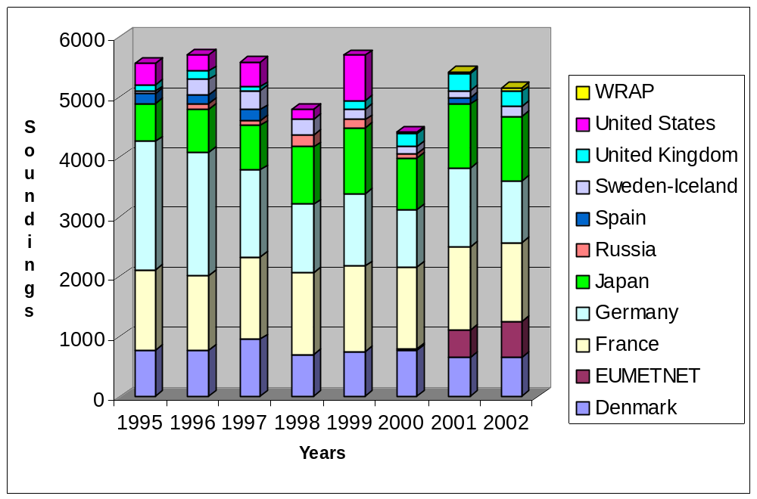

Table 2. Statistics on ASAP units operated during 2002

Operator | ASAP  Units | Number of soundings | Average terminal sounding height (km) | Percentage of data on % the GTS
Denmark | 3 | 659 | 19.8 | -
EUMETNET | 2 | 598 | 20.9 | 92.2
France | 4 | 1309 | 21.5 | 95.7
Germany | 2 | 1037 | 20 | 78.2
Japan | 6 | 1069 | 24.2 | 91.9
Russia | 0 | 0 | - | -
Spain | 1 | 0 | - | -
Sweden-Iceland | 2 | 176 | 20 | 73
United Kingdom | 1 | 246 | 23.6 | 93.8
United States | 0 | 0 | - | -
WRAP | 1 | 64 | 24.9 | 74
Total or average | 22 | 5158 | 21.5 | 77.6

Figure 1. (see.pdf)
Figure 2 (see .pdf)
Figure 3 (see .pdf)

Annual National ASAP Report
COUNTRY: DENMARK NAME OF AGENCY: DMI YEAR: 2002
2 ASAP units operated during the year on 3 ships
Type of ship¹⁾ | Name | Call sign | Comm. method²⁾ | Windfind method/  Sonde type ³⁾ | Launch  Method4) | Launch height⁵⁾ | Area of operations⁶⁾ | ASAP Unit ID No.
Merchant ship | Nuka Arctica | OXYH2 | Inmarsat-C | RS90-AL, RS90-AG | Container (man.) | 18 | North Atlantic
Merchant ship | Irena Arctica | OXTS2 | Inmarsat-C | RS90-AL, RS90-AG | Container (man.) | 12 | North Atlantic
Merchant ship | Arina Arctica | OVYA2 | Inmarsat-C | RS90-AL, RS90-AG | Container (man.) | 14 | North Atlantic
1) Merchant ship, research ship, supply ship, etc.

2) Using IDCS, Inmarsat-C, or others

3) E.G. GPS/Vaisala RS80-G, Loran/Vaisala RS80-L, VIZ GPS Mark II Microsonde, etc.

4) Launch method e.g.: deck launcher (portable); deck launcher (fixed); container (manual); container (semi-automatic); other.

5) The height above sea level from where the sonde and balloon is released

- Ocean area, e.g. North Pacific, North Atlantic, Indian Ocean, variable

Summary of performance of ASAP units during the year
Call sign | Total No. of sondes launched | No. of messages transmitted | No. of relaunches | Average terminal sounding height (km) | Balloon Size (gm) | Percentage on GTS¹⁾
OXYH2 | 225 | 221 | <4 | 20.430 | 200
OXTS2 | 156 | 152 | <4 | 19.558 | 200
OVYA2 | 278 | 273 | <5 | 19.429 | 200
Total or average | 659 | 646 | 13 | 19.806
1) Based upon reports received at a data centre or GTS insertion point, name: .........................
Ratio of reports received against reports transmitted

COMMENTS:

The number of discarded radiosondes does not appear from the scheme.

Of the total number of launched radiosondes only about 50 are GPS-sondes. Normally there is good Loran coverage and the Loran-sondes are about 30 % cheaper compared to GPS-sondes.

ESTIMATES FOR FOLLOWING YEAR:

700 sondes

Annual National ASAP Report
COUNTRY : FRANCE NAME OF AGENCY: METEO-FRANCE YEAR: 2002

.....ASAP units operated during the year on 4 ships
Type of ship¹⁾ | Name | Call sign | Comm  method²⁾ | Windfind  Method³⁾ | Lauch height | Area of operations⁵⁾ | ASAP Unit Serial No
Merchant | Douce France | FNRS | IDCS | GPS | 27 | North Atlantic | FASAP 3
Merchant | Fort Desaix | FNPH | IDCS | GPS | 27 | North Atlantic | FASAP 4
Merchant | Fort Fleur  d’Epée | FNOU | IDCS | GPS | 13 | North Atlantic | FASAP 2
Merchant | Fort Royal | FNOR | IDCS | GPS | 13 | North Atlantic | FASAP 1
1) Merchant ship, research ship, supply ship, etc
2) Using IDCS, Inmarsat-C, or others
3) Loran-C, GPS, Loran/GPS, RTH
4) The height above sea level from where the sonde and balloon is released
5) Ocean aera, e.g. North Pacific, North Atlantic, Indian Ocean, variable

Summary of performance of ASAP units during the year
Call sign | Total No. of sondes launched | No. of messages transmitted | No. of relaunches | Average terminal sounding height (km) | Percentage on GTS¹⁾
FNRS | 372 | 340 | 28 | 21.7 | 99.1
FNPH | 294 | 266 | 28 | 20.3 | 95.5
FNOU | 294 | 279 | 15 | 22.5 | 96.2
FNOR | 349 | 316 | 33 | 21.4 | 91.8
Total or average | 1309 | 1201 | 104 | 21.5 | 95.7
1) Based upon reports at a data center or GTS insertion point, name BDM Toulouse
Ratio of reports received against reports transmitted

COMMENTS ON PERFORMANCE:

Year 2002 saw the progressive use of MODEM GPS 3-D sounding system aboard the ships of our ASAP line, as the replacement of our previous Vaisala GPS 2-D systems. Our main goal was to solve the numerous wind data holes, a frequent feature since we have been using Vaisala GPS 2D radiosondes.

On this very point, the operation turned out to be a bright success, since we had no longer any windless sounding, and since the data holes were sparse and their spread was clearly contained. We are satisfied too that the amount of rejected sondes and relaunches remained low along the year. However we had to cope with setting-off problems, and this had resulted into a lower average maximum altitude reached on sounding-end.

Year 2002 was the last for Meteo France staff to do soundings at sea themselves. This work has indeed been subcontracted to ship line crew since the 01/01/2003.

DCP transmission troubles encountered during the year 2001 went on during the year 2002. Since 2001, we can receive as well Meteosat as American Satellite – passing through messages on the French COTEL receiver. In a lot of cases, we noticed that when the signal was crippled by transmitting through Meteosat, it was not with the American Satellite. We doubt about the good working of Meteosat for DCP transmissions.

Therefore, in 2002, we fitted our ship stations with Inmarsat C transmitter sets. Although unexpected reliability problems encountered, the operational results are quite satisfying, and we decided to retain this transmission system for the shipcrew-subcontracted radiosounding messages.

ESTIMATES FOR FOLLOWING YEAR

First, we have to solve the last troubles about the use of MODEM sondes for radiosoundings at sea together with the manufacturer. By this way we can reach back the previous performance level about sounding-end altitude. Thus, we have to pay attention whether the expected performance level of the messages passing through Inmarsat C is finally achieved.

At last, as soundings at sea have been subcontracted to ship crew since the beginning of 2003, we got a new charge, namely remote checking of the work progress. This is required to keep an efficient maintenance and performance level, worthy of the one formerly achieved on the soundings done by Meteo-France staff.

Annual National ASAP Report
COUNTRY: Germany NAME OF AGENCY: Deutscher Wetterdienst YEAR: 2002
2 ASAP units operated during the year on 2 ships
Type of ship¹⁾ | Name | Call sign | Comm. method²⁾ | Windfind method/  Sonde type ³⁾ | Launch  Method4) | Launch height⁵⁾ | Area of operations⁶⁾ | ASAP Unit ID No.
Research Ship | Meteor | DBBH | Inmarsat-C | GPS/Vaisala RS80 -15G | container semi-automat | 6 m | worldwide | 2
Merchant Ship | Hornbay | ELML7 | Inmarsat C | GPS/Vaisala RS80- 15G | container semi-automat | 10 m | North Atlantic | 5
1) Merchant ship, research ship, supply ship, etc.

2) Using IDCS, Inmarsat-C, or others

3) E.G. GPS/Vaisala RS80-G, Loran/Vaisala RS80-L, VIZ GPS Mark II Microsonde, etc.

4) Launch method e.g.: deck launcher (portable); deck launcher (fixed); container (manual); container (semi-automatic); other.

5) The height above sea level from where the sonde and balloon is released

- Ocean area, e.g. North Pacific, North Atlantic, Indian Ocean, variable

Summary of performance of ASAP units during the year
Call sign | Total No. of sondes launched | No. of messages transmitted | No. of relaunches | Average terminal sounding height (km) | Balloon Size (gm) | Percentage on GTS¹⁾
DBBH | 412 | 412 | 2 | 20 | 200 | 80
ELML7 | 625 | 625 | 34 | 20 | 200 | 77
Total or average
1) Based upon reports received at a data centre or GTS insertion point, name: EGGR
Ratio of reports received against reports transmitted

COMMENTS:

In switching from Meteosat to Inmarsat transmission (Hornbay in Feb 2002, Meteor in Mai 2002) it was expected to have a better ratio of GTS available temps. The station logs report 100% successful transmissions to Goonhilly.

ESTIMATES FOR FOLLOWING YEAR:

3 ASAPS under EUCOS (E-ASAP).

Annual National ASAP Report
COUNTRY: Iceland - Sweden NAME OF AGENCY: Icelandic Met office YEAR: 2002
1 ASAP units operated during the year on 2 ships
Type of ship¹⁾ | Name | Call sign | Comm. method²⁾ | Windfind method/  Sonde type ³⁾ | Launch  Method4) | Launch height⁵⁾ | Area of operations⁶⁾ | ASAP Unit ID No.
Merchant ship | Lagar-foss | V2XO | INMSAT-C | LORAN/Vaisala RS80-L | Container (Manual) | 13 m | North Atlantic | IS-1
Merchant ship | Skoga-foss | V2XM | INMSAT-C | LORAN/Vaisala RS80-L | Container (Manual) | 13 m | North Atlantic | IS-1
1) Merchant ship, research ship, supply ship, etc.

2) Using IDCS, Inmarsat-C, or others

3) E.G. GPS/Vaisala RS80-G, Loran/Vaisala RS80-L, VIZ GPS Mark II Microsonde, etc.

4) Launch method e.g.: deck launcher (portable); deck launcher (fixed); container (manual); container (semi-automatic); other.

5) The height above sea level from where the sonde and balloon is released

- Ocean area, e.g. North Pacific, North Atlantic, Indian Ocean, variable

Summary of performance of ASAP units during the year
Call sign | Total No. of sondes launched | No. of messages transmitted | No. of relaunches | Average terminal sounding height (km) | Balloon Size (gm) | Percentage on GTS¹⁾
V2XO | 122 | 111 | 2 | 19.3 | 300 | 70%
V2XM | 54 | 47 | 0 | 21.7 | 300 | 80
Total or average | 176 | 158 | 2 | 20,0 | 300 | 73%
1) Based upon reports received at a data centre or GTS insertion point, name: BIRK
Ratio of reports received against reports transmitted 81%

COMMENTS: During the year 2002 m/v Lagarfoss was on the route until August 19th when the ship was sold. The equipment was moved over to another ship serving the route, m/v Skogafoss, starting on September 6th. All the equipment is installed in a container and there was only a gap of 3 weeks during the changeover. However problems due to failure in the equipment reduced the efficiency. Antennas and the release door mechanism caused most of the trouble. Bad weather conditions on the route also make the operation quite vulnerable. We were able to do some extra soundings during the SOP period in April and May.

ESTIMATES FOR FOLLOWING YEAR: Same programme as last year. But gradually the management of the ASAP will be moved over to EUCOS/ E-ASAP.

- ASAP (Japan):

  - Catalogue of ASAP vessels in 2002 (see Appendix 6):

  - ASAP performance in 2002 (see Appendix 7):

  - Data management (monitoring / archival / quality control / exchange):

Aerological observation data from JMA research vessels, Ryofu Maru, Keifu Maru, Kofu Maru, Seifu Maru, and Chofu Maru, are published in a CD-ROM of “DATA REPORT OF OCEANOGRAPHIC AND MARINE METEOROLOGICAL OBSERVATIONS” which are composed and distributed by JMA every year.

  - Coordination and collaboration (national / international):

i. Special observation of Baiu front over East China Sea and Kyushu in 2002 (X-BAIU-02) promoted by Meteorological Research Institute (MRI) of JMA

JMA research vessels, Chofu Maru and Seifu Maru participated in this project and made aerological observations in the East China Sea in June 2002

- Winter Mesoscale Convective Systems Observations over the Japan Sea-2002 ( WMO-02) promoted by MRI of JMA

JMA research vessels, Chofu Maru, Seifu Maru and Kofu Maru, made aerological observations in the Japan Sea in Jan.-Feb. 2002 under this project.

  - Research and development:

  - Instrument testing and comparison facilities:

  - Other comments:

Appendix 6. Catalogue of ships participating in ASAP in 2002.

6 ASAP units operated during the year on 6 ships

Type of ship  (1) | Ship name | Callsign | Comms method  (2) | Windfind method / sonde type  (3) | Launch method  (4) | Launch height  (5) | Area of operation  (6) | ASAP unit ID No.
Research ship | Ryofu Maru | JGQH | Others  (DCP via the GMS) | GPS/Vaisala RS80-G | Container  (semi automatic) | 8m | North Pacific | 708514
Research ship | Kofu Maru | JDWX | Others  (DCP via the GMS) | GPS/Vaisala RS80-G | Container  (semi automatic) | 6m | Seas adjacent to Japan | 191678
Research ship | Seifu Maru | JIVB | Others  (DCP via the GMS) | GPS/Vaisala RS80-G | Container  (semi automatic) | 6m | Seas adjacent to Japan | 458533
Research ship | Chofu Maru | JCCX | Others  (DCP via the GMS) | GPS/Vaisala RS80-G | Container  (semi automatic) | 6m | Seas adjacent to Japan | 126155
Research ship | Keifu Maru | JPBN | Others  (DCP via the GMS) | GPS/Vaisala RS80-G | Deck launcher (portable) | 8m | North Pacific | -
Research ship | Mirai | JNSR | Inmarsat-C | GPS/Vaisala RS80-G | Container  (semi automatic) | 16m | Variable | -
(1) Type of ship: Merchant, research, supply
(2) Comms method: Inmarsat C or others
(3) Windfind method / sonde type: eg. GPS/Vaisala RS80-G, Loran/Vaisala RS80-L, VIZ GPS Mark II Microsonde, etc
(4) Launch method: deck launcher (portable), deck launcher (fixed), container (manual), container (semi automatic), other
(5) Launch height: height above sea level from where the sonde is released
(6) Ocean area: North Pacific, North Atlantic, Indian Ocean, variable

Appendix 7. ASAP performance in 2002.

Callsign | Total number of sondes launched | Number of TEMP SHIP transmitted | Number of relaunches | Average terminal sounding height (km) | Balloon size (gm) | Percentage on GTS  (see note)
JGQH | 178 * | 177 | 6 | 26.9 | 350 | 99.4
JDWX | 159 * | 159 | 7 | 24.1 | 350 | 100
JIVB | 186 * | 186 | 13 | 24.9 | 350 | 100
JCCX | 166 * | 166 | 12 | 24.5 | 350 | 100
JPBN | 19 * | 13 | 7 | 20.3 | 350 | 68.4
JNSR | 361 * | 354 | 6 | 22.7 | 350 | 78.2
Percentage on the GTS is the ratio of reports received against reports transmitted, and is based upon reports received at a data centre or GTS insertion point (name: JMA)

* The number of successful observation.

Annual National ASAP Report
COUNTRY: SPAIN NAME OF AGENCY: INM YEAR: 2002
1 ASAP units operated during the year on 1 ships
Type of ship¹⁾ | Name | Call sign | Comm. method²⁾ | Windfind method/  Sonde type ³⁾ | Launch  Method4) | Launch height⁵⁾ | Area of operations⁶⁾ | ASAP Unit ID No.
Supply | Esperanza del Mar | EBUQ | Inmarsat-C | GPS/Vaisala RS80-G | Container (semi-automatic) | 11,7m | North Atlantic (western African coast, between Cannary islands and Mauritania) | 1
1) Merchant ship, research ship, supply ship, etc.

2) Using IDCS, Inmarsat-C, or others

3) E.G. GPS/Vaisala RS80-G, Loran/Vaisala RS80-L, VIZ GPS Mark II Microsonde, etc.

4) Launch method e.g.: deck launcher (portable); deck launcher (fixed); container (manual); container (semi-automatic); other.

5) The height above sea level from where the sonde and balloon is released

- Ocean area, e.g. North Pacific, North Atlantic, Indian Ocean, variable

Summary of performance of ASAP units during the year
Call sign | Total No. of sondes launched | No. of messages transmitted | No. of relaunches | Average terminal sounding height (km) | Balloon Size (gm) | Percentage on GTS¹⁾
Total or average
1) Based upon reports received at a data centre or GTS insertion point, name: .........................
Ratio of reports received against reports transmitted

COMMENTS:

On middle November 2001, a new ship (call sign EBUQ), with the same name as the former (call sign EHOA) “Esperanza del Mar” was put in operation. A sounding ASAP container, equipped with an Inmarsat-C unit, was installed on board. Unfortunately, there was a lot of problems related to the contract procedures for the Inmarsat service, and because of it, there weren’t any sounding throughout the year 2002. Until February 2003 those problems weren’t resolved and since that date, meteorological sounding are regularly carrying out. They are transmitted to Goonhilly land station and inserted to the GTS by the Met Office.

ESTIMATES FOR FOLLOWING YEAR:

23 soundings are estimated each month of year 2003.

Annual National ASAP Report

COUNTRY: .GREAT BRITAIN . . . . NAME OF AGENCY: MET OFFICE . . . . . . YEAR: .2002 . . .
...1... ASAP unit operated during the year on ...1... ship
Type of ship¹⁾ | Name | Call sign | Comm. method²⁾ | Windfind method/  Sonde type ³⁾ | Launch  Method⁴⁾ | Launch  Height⁵⁾ | Area of operations⁶⁾ | ASAP Unit ID No.
Merchant | CanMar Pride | ZCBP6 | Inmarsat-C | GPS  RS80-15GH | Container  (semi-automatic) | 22 metres | North Atlantic | GB/ASAP1
1) Merchant ship, research ship, supply ship, etc.

2) Using IDCS, Inmarsat-C, or others

3) E.G. GPS/Vaisala RS80-G, Loran/Vaisala RS80-L, VIZ GPS Mark II Microsonde, etc.

4) Launch method e.g.: deck launcher (portable); deck launcher (fixed); container (manual); container (semi-automatic); other.

5) The height above sea level from where the sonde and balloon is released

6) Ocean area, e.g. North Pacific, North Atlantic, Indian Ocean, variable

Summary of performance of ASAP units during the year
Call sign | Total number of sondes launched | Number of messages transmitted | Number of relaunches | Average terminal sounding height (km) | Balloon size (gm) | Percentage on GTS¹⁾
ZCBP6 | 246 | 182 | 0 | 23.6 | 350 | 93.8%
Total or average
1) Based upon reports received at a data centre or GTS insertion point, name: _EGRR_________
Ratio of reports received against reports transmitted

COMMENTS:

Figures in the preceding table are based upon 18 voyages of the containership CanMar Pride during 2002.

The figure in the 'messages transmitted' column are for successful soundings only, i.e. ascents producing data to ≥200hPa. The figure in the "percentage on GTS" column is therefore a little misleading in that the total of 194 ascents received in MIDAS includes some ascents which did not reach 200hPa.

Launches were not attempted on 9 occasions due to adverse weather conditions.

UK Met Office staff were also actively involved in the supply of consumables and technical expertise for the Worldwide Recurring ASAP Project (WRAP) which was installed on the UK observing ship Palliser Bay until the ship was withdrawn from service at the end of May 2002.

ESTIMATES FOR FOLLOWING YEAR:

The United Kingdom will continue to operate the one unit, GB/ASAP1, for the year 2003.

Annual National ASAP Report
EUMETNET (18 countries) NAME OF AGENCY: E-ASAP YEAR: 2002
2 ASAP units operated during the year on 2 ships
Type of ship¹⁾ | Name | Call sign | Comm. method²⁾ | Windfind method/  Sonde type ³⁾ | Launch  Method4) | Launch height⁵⁾ | Area of operations⁶⁾ | ASAP Unit ID No.
Container Vessel | PELJASPER | SWJS | Inmarsat-C | Loran-C/Vaisala RS90-AL | Container | 16 m | Mediterranean | E-ASAP/1
Container Vessel | SEALAND ACHIEVER | WPKD | Inmarsat-C | Loran-C or GPS/Vaisala RS90-AL or RS90-AG | Container | 30 m | North Atlantic and Gulf of Mexico | E-ASAP/2
1) Merchant ship, research ship, supply ship, etc.

2) Using IDCS, Inmarsat-C, or others

3) E.G. GPS/Vaisala RS80-G, Loran/Vaisala RS80-L, VIZ GPS Mark II Microsonde, etc.

4) Launch method e.g.: deck launcher (portable); deck launcher (fixed); container (manual); container (semi-automatic); other.

5) The height above sea level from where the sonde and balloon is released

- Ocean area, e.g. North Pacific, North Atlantic, Indian Ocean, variable

Summary of performance of ASAP units during the year
Call sign | Total No. of sondes launched | No. of messages transmitted | No. of relaunches | Average terminal sounding height (km) | Balloon Size (gm) | Percentage on GTS¹⁾
SWJS | 167 | 161 |  | 21,1 | 350 | 95,7%
WPKD | 431 | 372 |  | 20,9 | 350 | 90,9%
Total or average
1) Based upon reports received at a data centre or GTS insertion point, name: Offenbach
Ratio of reports received against reports transmitted

COMMENTS:

The SWJS was out of ASAP operations September-December because of docking and equipment failures paired with logistical problems.

ESTIMATES FOR FOLLOWING YEAR:

A 3rd EUMETNET ASAP will be procured for operations in the Mediterranean. Three national units will be integrated into E-ASAP.

Annual National ASAP Report
COUNTRY : WRAP. NAME OF AGENCY: ASAPP YEAR: 2001/2002
one ASAP unit operated during the year on one ship
Type of ship¹⁾ | Name | Call sign | Comm. method²⁾ | Windfind method/  Sonde type ³⁾ | Launch  Method⁴⁾ | Launch height⁵⁾ | Area of operations⁶⁾ | ASAP Unit ID No.
M/ship | Palliser  Bay | GWAN | Inm C | Vaisala  RS80G | Deck Portable | 31M | Indian Ocean,  Gt Aust. Bight,  S.Pacific Ocean to C.Horn | WRAP 1
1) Merchant ship, research ship, supply ship, etc.

2) Using IDCS, Inmarsat-C, or others

3) E.G. GPS/Vaisala RS80-G, Loran/Vaisala RS80-L, VIZ GPS Mark II Microsonde, etc.

4) Launch method e.g.: deck launcher (portable); deck launcher (fixed); container (manual); container (semi-automatic); other.

5) The height above sea level from where the sonde and balloon is released

- Ocean area, e.g. North Pacific, North Atlantic, Indian Ocean, variable

Summary of performance of ASAP units during the year
Call sign | Total No. of sondes launched | No. of messages transmitted | No. of relaunches | Average terminal sounding height (km) | Balloon Size (gm) | Percentage on GTS¹⁾
GWAN | 64 | 46 | 9 | 24.9 | 350 | 74
Total or average
1) Based upon reports received at a data centre or GTS insertion point, name: Melbourne
Ratio of reports received against reports transmitted

COMMENTS:

A total of 19 soundings failed prematurely – either due to faulty sonde (or sounding system) preventing release, electronics failure (including loss of GPS signal) soon after launch, or balloon train colliding with ship or sea.

The total number of sondes launched does not include sondes which failed the ground check.

Included in the foregoing are four soundings made on the 30.12.01 to 31.12.01.

ESTIMATES FOR FOLLOWING YEAR:

Unable to compile until replacement WRAP vessel for Palliser Bay is recruited.

European Centre for Medium-Range Weather Forecasts

SUMMARY REPORT ON THE MONITORING OF ASAP SHIP DATA

1. DATA AVAILABILITY

The number of ASAP reports received at ECMWF during 2002 is similar to those received during 2001. Having a look to the enclosed figure 1 which displays a time series from January 1996 to March 2003 with the number of temperature reports received at 500 hPa (00/12 UTC) one could think that the numbers show a sharp negative trend since July 2002. Figure 2 shows a similar information but for the 06/18 cycles, the increase in the numbers for these two cycles compensates the decrease at 00/12 UTC.

A nice and positive trend is shown in figure 3. The number of information received at 20 hPa shows a significant increase since mid 2000. Figures 5 and 6 show reception time series in terms of the average percentage of observations reaching 100 and 20 hPa. For 100 hPa the numbers are around 90 % in the last years but for 20 hPa again a positive trend can be seen since mid 2000 particularly at 12 UTC.

The geographical distribution of the operating ASAP is similar to 2001. Most of the units operate on the North Atlantic area and then we see the Japanese units on the West Pacific. The ASAP SWJS is being operating in the Mediterranean, GWAN covering the route between South Africa and Australia, DBLK sent reports from the South Atlantic from January to May when the vessel was back to Germany and then operated on the North Atlantic until coming back to the South Atlantic in November 2002. Another German unit DBBH sent reports from the Tropical Atlantic although in July crossed to the Pacific through Panama reporting from the Tropical Pacific in July and coming back through the same route to Atlantic in August 2002. Figures 7 and 8 show plots displaying ASAP tracking for March and November 2002.

2. TROUBLE SHOOTING

The number of corrupted call-signs received is still large. As an example the call-sign ELML7 was received during 2002 as E/ML7, EDML7, ELM/7 and ELML. More details can be found in Table 1 with all the call-signs received at ECMWF in 2002. The corrupted call-signs can be distinguished easily from the genuine ones,

The number of bad positions in the ASAP reports was not large in 2002. Only two cases were detected (WPKD in several occasions in January 2002 and ELML7 in February 2002). In most of the cases the wrong positions are due to a latitude and/or longitude reversed sign.

3. DATA QUALITY

The quality of the data has continued to be good. Most the ASAP units were reporting as using Vaisala RS80 equipment (RS90 the Danish ASAP). Figures 9 to 13 show statistics of the observations vs. the ECMWF deterministic model T511 background fields with comparisons for temperature, wind and humidity.

In figures 9 and 10 density plots comparing wind speed and temperature statistics for ASAP and land-based stations using Vaisala equipment can be found.

Figure 9 shows wind speed statistics of observation vs. the model background field at the layer 100/400 hPa for the period 1st November 2002 to 31st December 2002 together with the mean fit to the diagonal. The percentage of ASAP used data was as high as 97% compared to the 92% in the case of land-based stations.

Figure 10 shows temperature statistics for the same time period and stations as before. In this case all levels are included in the computation and the display shows the departures from the model background field as a function of the observed temperature together with the mean fit to the horizontal. The percentage of used data is pretty similar in ASAP and land-based stations (94% vs. 95%).

Figures 10 and 11 show vertical statistics for temperature, wind direction and speed and relative humidity (only used data) for the same time period. In this occasion the statistics have been computed for the COSNA area. These vertical profiles show that the quality of the ASAP data is fully comparable to the data from land-based stations.

Finally in Figure 13 composite statistics for ASAP in the COSNA area can be found. The vertical statistics show average statistics from 1st January 2002 to 31st December 2002 at 00 and 12 UTC cycles (temperature and wind direction and speed) and time series for temperature (bias and standard deviation) of observation departures from the model background field at 50, 100 and 500 hPa.

4. CONCLUSIONS

- The reception rates are similar to the previous year. A positive trend in the number of reports reaching 20 hPa can be detected in the time series since mid 2000.
- The problem of the corrupted call-signs is still there and in numbers similar to the previous year.
- Only a few cases of bad positions were detected due to a change of the sign in the latitude and/or longitude.
- The data quality continues to be good and is fully comparable to land-based stations.

TABLE 1
Reports received at ECMWF January - December 2002
Temperature at 500 hPa

SGN 00 06 12 18 UTC
-------------------------------------
ALML7 0 0 1 0
ANOU 0 0 0 0
BNOR 0 0 0 0
D/LK 0 0 0 0
DASAP 16 0 53 1
DBBH 85 28 174 47
DBDK 0 0 1 0
DBDO 0 0 0 0
DBFM 0 0 0 0
DBL/ 0 0 0 0
DBLI 0 0 0 0
DBLK 2 4 165 1
DBMK 0 0 0 0
DBNK 0 0 1 0
DBOK 0 0 0 0
DJLK 0 0 0 0
DL/L7 0 0 0 0
DLML7 0 0 0 0
E/ML7 0 0 0 0
EDML7 0 0 0 0
ELM/7 0 0 0 0
ELML 1 0 1 0
ELML7 209 0 218 1
F/OR 0 0 0 0
F/OU 0 0 0 0
F/RS 0 0 0 0
F0713 0 0 0 0
FBLK 0 0 0 0
FFOR 1 0 0 0
FJOR 1 0 0 0
FJPH 0 0 0 0
FLOU 0 0 1 0
FN// 0 0 0 0
FN/S 1 0 0 0
FN/T 1 0 0 0
FN/U 0 0 0 0
FNIU 1 0 0 0
FNO/ 1 0 1 0
FNO5 0 0 0 0
FNOP 0 0 0 0

TABLE 1 (continued)
SGN 00 06 12 18 UTC
-------------------------------------
FNOQ 0 0 0 0
FNOR 135 0 137 0
FNOU 102 0 108 0
FNOV 0 0 0 0
FNOW 0 0 0 0
FNPH 122 0 109 1
FNPL 0 0 0 0
FNR/ 0 0 0 0
FNRQ 0 0 0 0
FNRS 141 0 130 2
FNSS 0 0 0 0
FNVS 0 0 0 0
FNWU 0 0 0 0
FNXH 1 0 0 0
FVMT 0 0 1 0
FXXX 0 1 0 0
GDLS 0 7 2 8
GNOR 0 0 0 0
GNPH 0 0 0 0
GNRS 0 0 0 0
GWAN 25 0 19 1
HADM 0 0 0 0
JCCX 50 25 41 25
JDWX 52 16 54 12
JGQH 93 0 86 0
JIVB 52 26 58 24
JNSR 52 43 44 39
JPBN 4 3 3 3
LDWR 361 349 346 345
LML7 0 0 0 0
NNOU 1 0 0 0
NNRS 0 0 0 0
OVYA2 36 81 48 93
OXTS2 33 35 35 44
OXYH2 46 62 54 56
RQTOR 0 0 0 0
RQTUQ 0 0 0 0
RQUYI 0 0 0 0
SHIP 0 0 1 0
SWJS 33 40 32 45
V2XM 9 0 8 0
V2XO 52 0 54 2
VNOR 0 0 0 0
VNOU 0 0 0 0
VNRS 1 0 0 0
WPKD 85 66 84 65
YNSR 0 0 0 0
ZCBP6 81 0 94 1

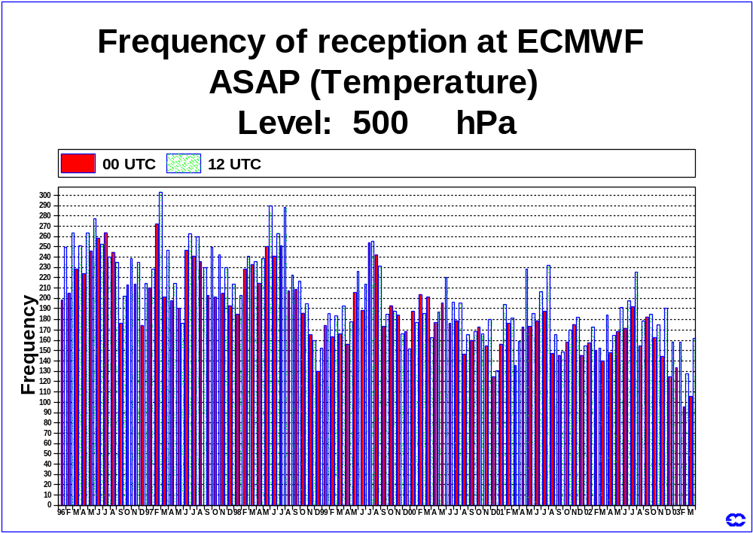
Figure 1

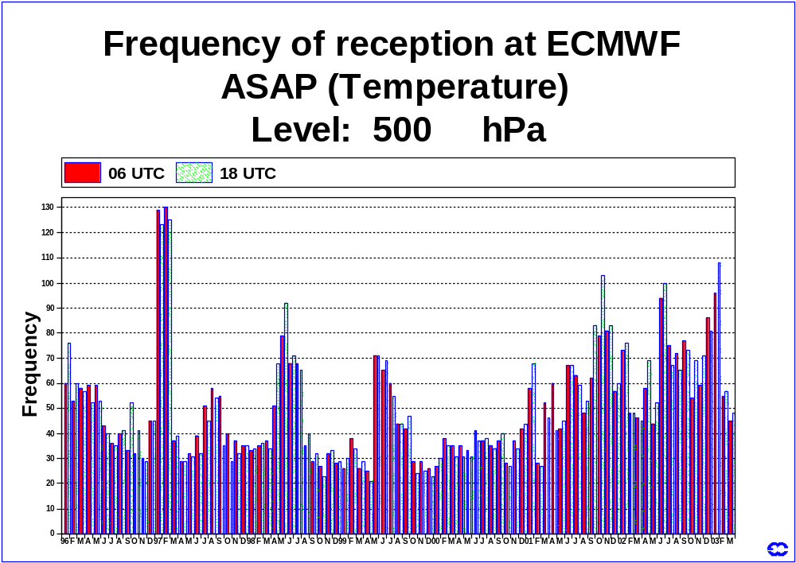
Figure 2
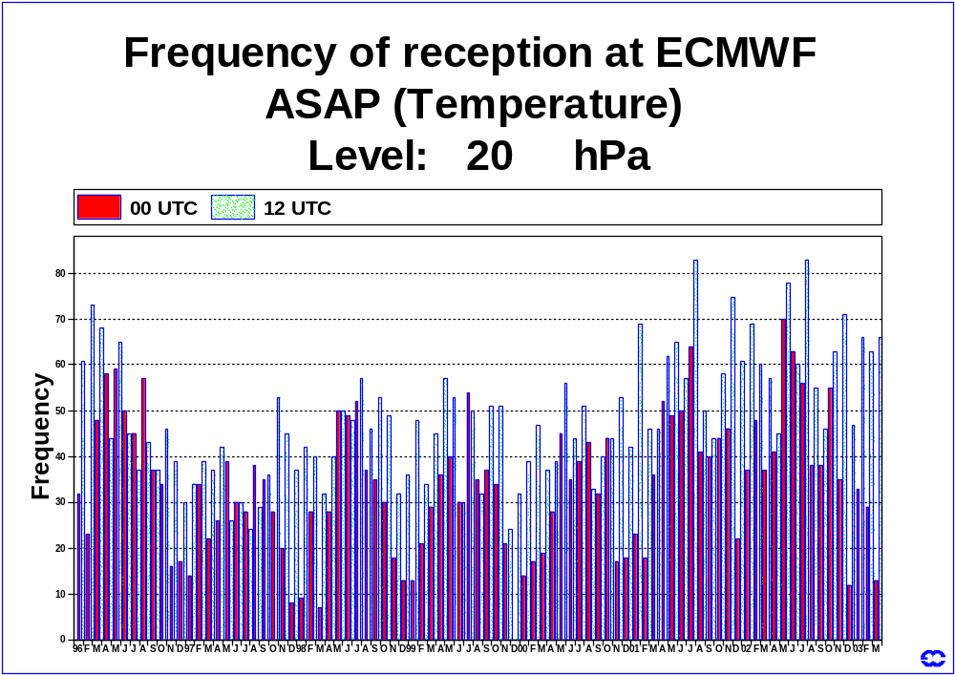
Figure 3
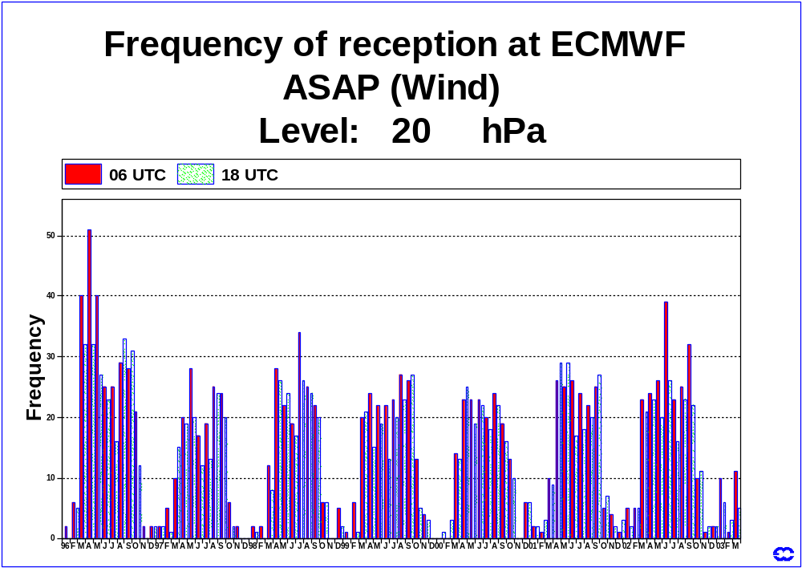
Figure 4
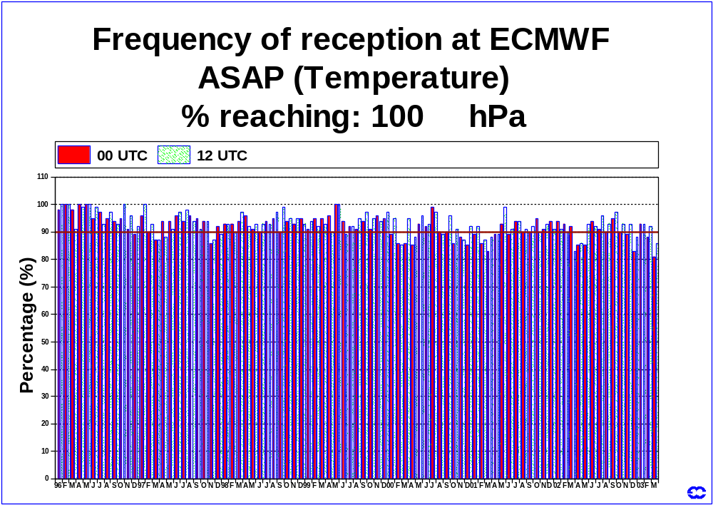
Figure 5
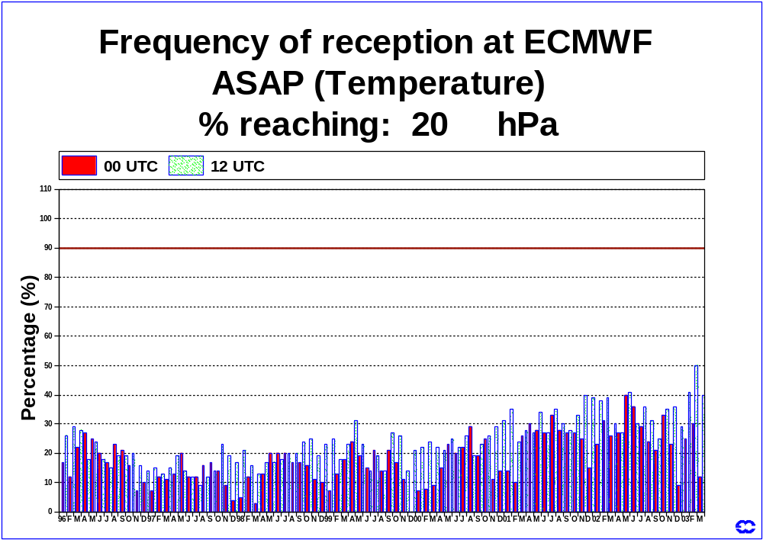
Figure 6
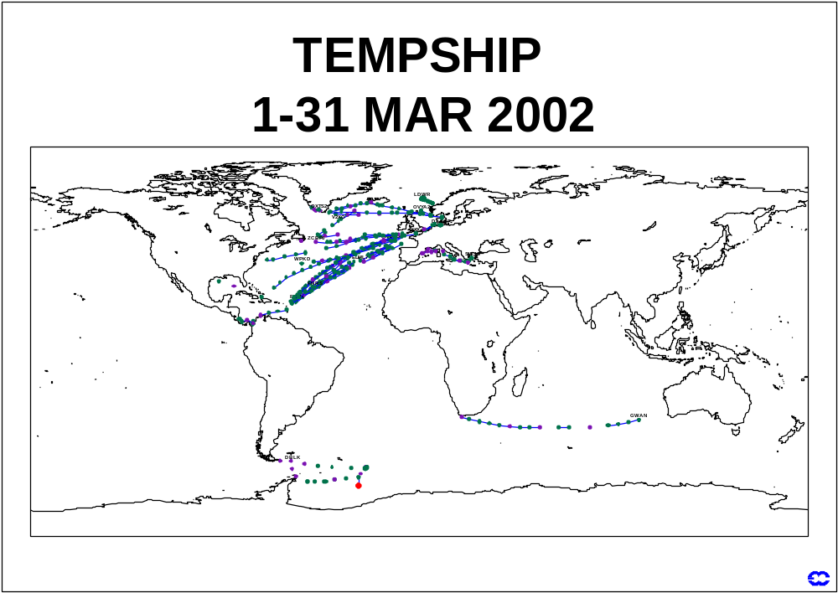
Figure 7
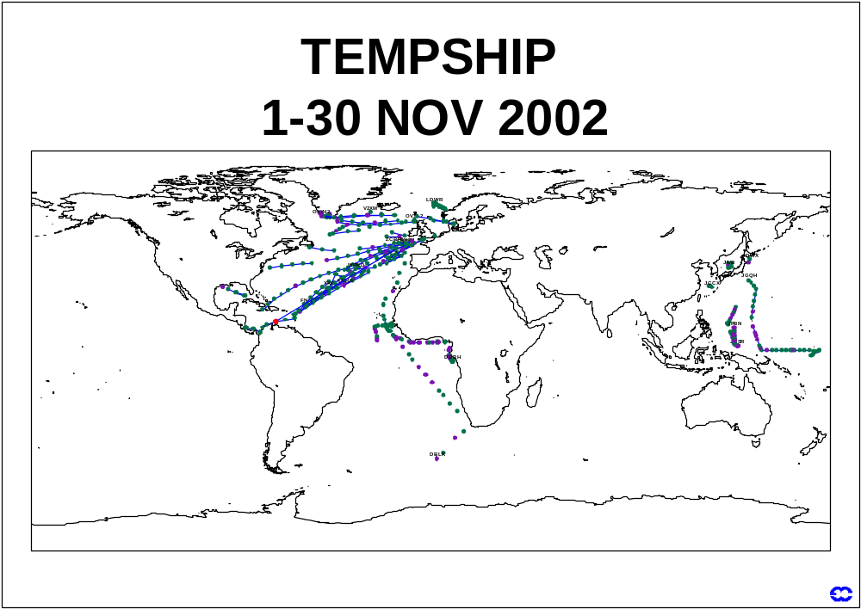
Figure 8

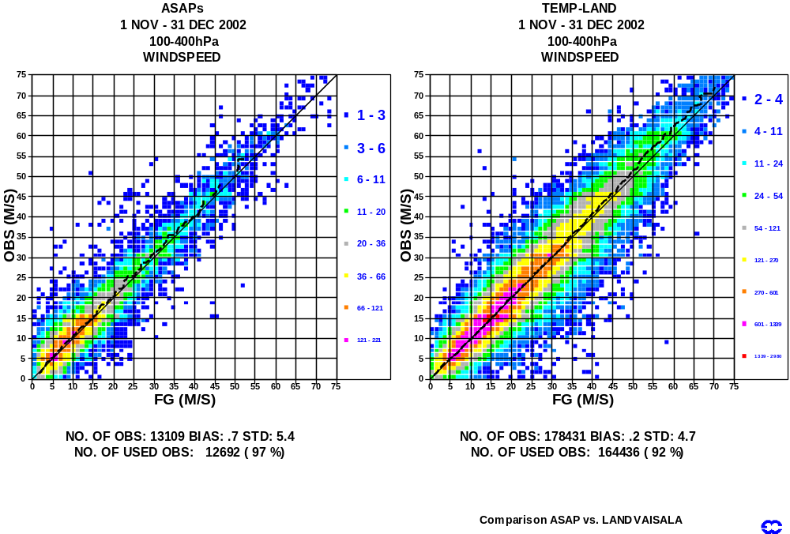
Figure 9
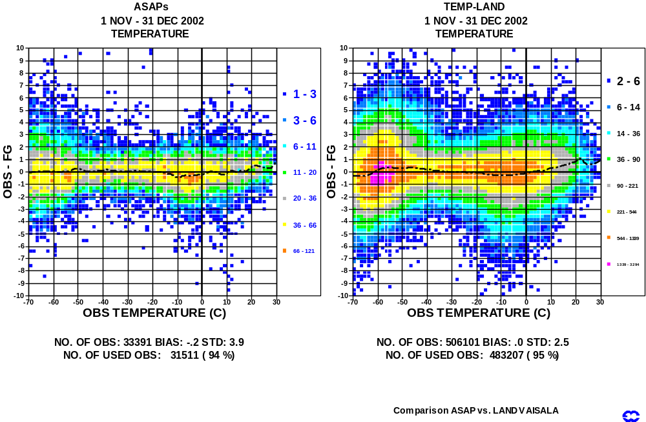
Figure 10

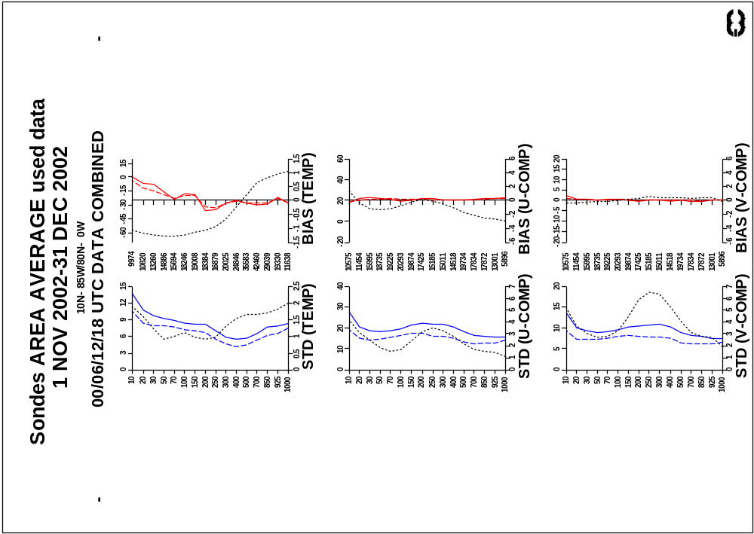
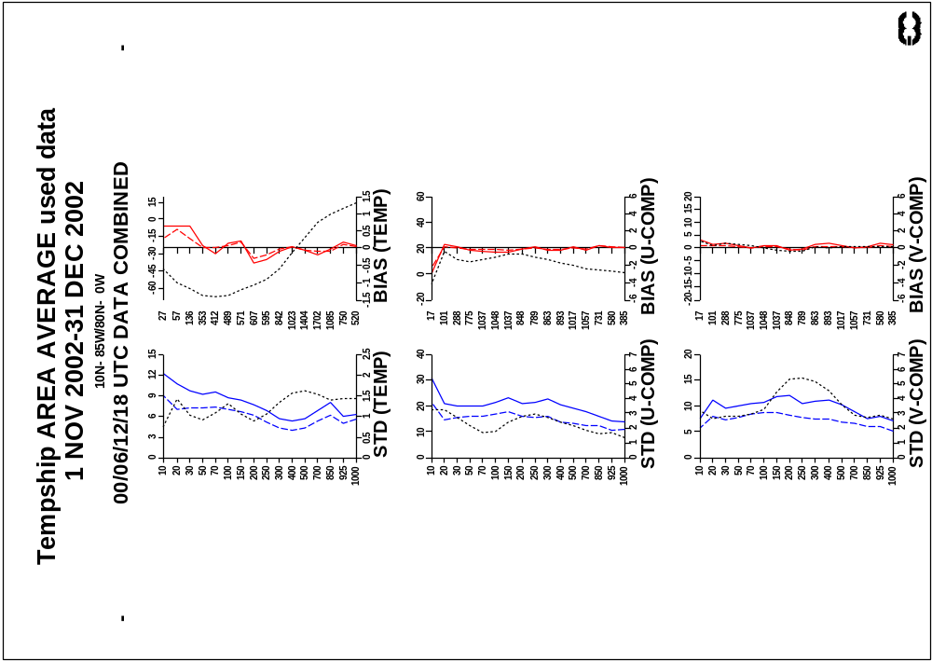
Figure 11
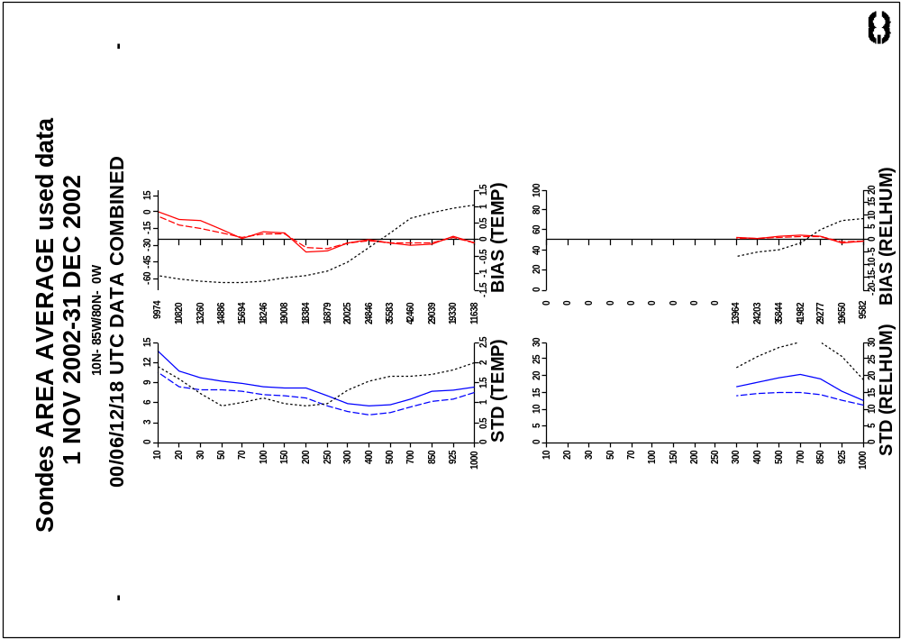
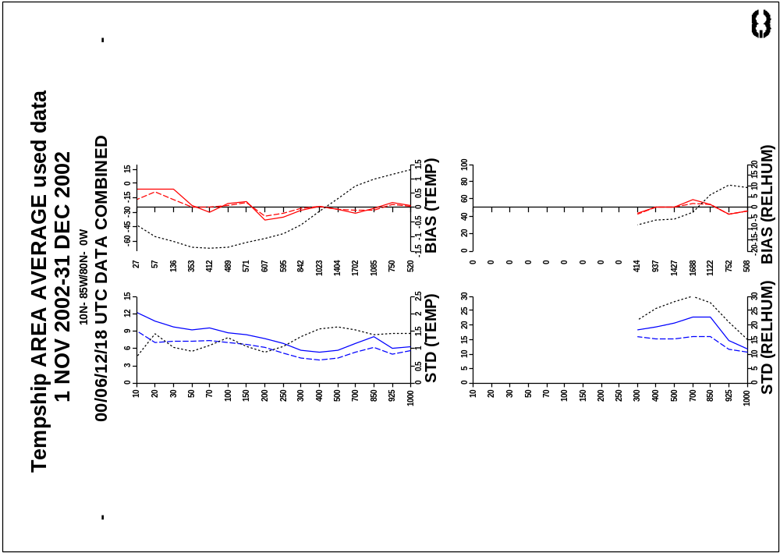
Figure 12
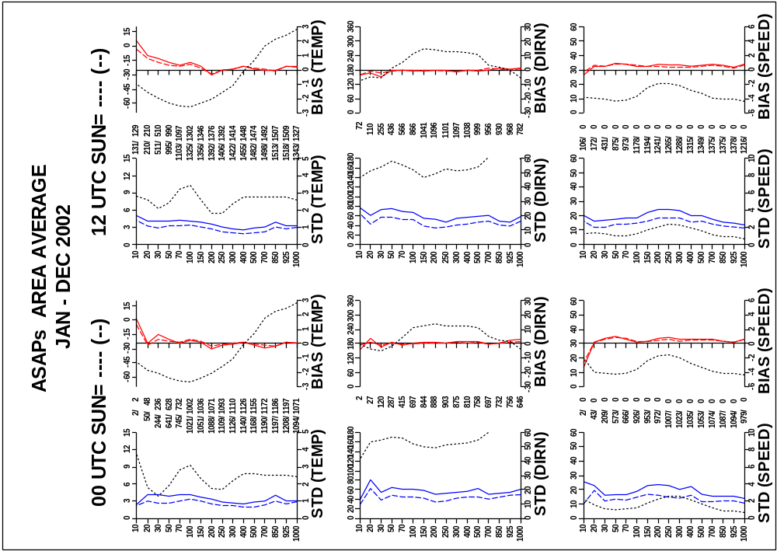
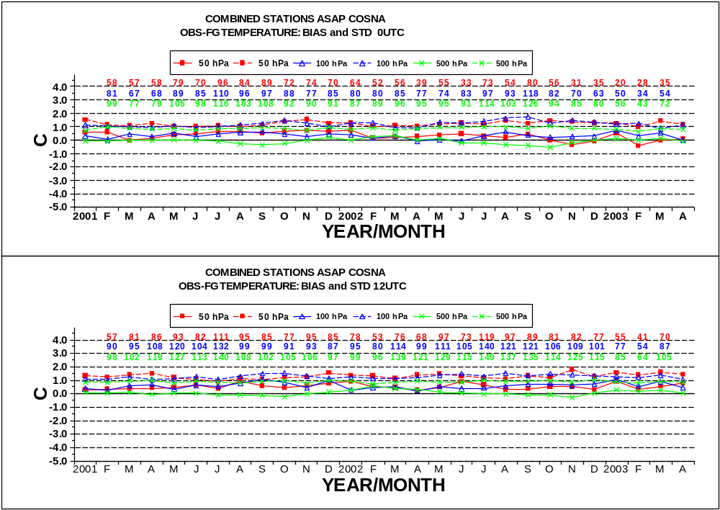
Figure 13
EUMETSAT Status Report
Subject : | EUMETSAT Status Report for the 2nd Session of SOT

This paper summarises the status of Meteosat operations in the period Jan 2002 – Dec 2002 for the following areas:

1 MTP Spacecraft Status 39
1.1 Meteosat-5 39
1.2 Meteosat-6 39
1.3 Meteosat-7 40
2 MSG Spacecraft Status 41
2.1 MSG-1 Launch and Commissioning 41
3 Data Collection System Performance - ASAP 42
3.1 DCPs on the Internet 42
3.2 ASAP DCP Transmissions 42
3.3 ASAP IDCS Allocations 44
4 Future programs status 45
4.1 EUMETSAT Polar System 45
4.1.1 Spacecraft 45
4.1.2 Ground segment 45
4.1.3 Satellite Application Facilities 45
5 Update on MTP/MSG Parallel Operations 46
5.1 Assumptions 46
5.2 Operational Considerations 47
5.3 MTP and MSG Operational Services 47
5.3.1 Image Data Acquisition and Dissemination (HRI and WEFAX / HRIT and LRIT) 47
5.3.2 Data Collection Service (DCS) 48
5.3.3 Meteorological Data Dissemination (MDD) 48
5.3.4 MPEF Product Generation and Distribution 48
5.3.5 User Help-desk, Archive and Retrieval and Training 49
5.4 Scenario For The Transition To Parallel Operations 49
5.4.1 Introduction 49
5.4.2 Transition Scenario 49

1 MTP SPACECRAFT STATUS

1.1 Meteosat-5

Meteosat-5 has been used in support of the Indian Ocean Data Coverage service since the formal start of EUMETSAT support to the INDOEX experiment on 1 July 1998. No DCP or MDD services have been provided via Meteosat-5.

The orbital inclination of the satellite at the end of this reporting period was 5.60° and increasing. The remaining hydrazine fuel on board is estimated to be 5.07 kg, of which a 4kg reserve will be required to de-orbit the spacecraft at the end of its useful life. The on-board fuel reserve limit of Meteosat-5 will be re-evaluated towards the end of 2004.

Orbit |  |  | Attitude
Inclination | Longitude | E/W Drift | Right Ascension | Declination
5.5953° | 62.8552° | -0.0097° | 342.0130° | 84.6650°

Meteosat-5 Orbital Parameters for 27th January 2003

The spacecraft configuration status has remained stable since the failure of Power Amplifier 3 in July 1998.

1.2 Meteosat-6

Meteosat-6 has been used in support of Rapid Scanning Service, since the formal start on the 18th of September 2001. Meteorological products from Meteosat-6 Rapid Scan data have been operational since July 2002.

The inclination of the satellite at the end of this reporting period was 2.64° and increasing.
The remaining hydrazine fuel on board is estimated to be 7.14 kg, of which a 4kg reserve will be required to de-orbit the spacecraft at the end of its useful life. The on-board fuel reserve limit of Meteosat-6 will be re-assessed during 2005.

Orbit |  |  | Attitude
Inclination | Longitude | E/W Drift | Right Ascension | Declination
2.6402 ° | 9.3794° | 0.0143° | 358.236° | 87.196°

Meteosat-6 Orbital Parameters for 27th January 2003

The spacecraft configuration status remains stable.

1.3 Meteosat-7

During the reporting period, Meteosat-7 has been used to provide the nominal 0° operational service.

The autumn eclipse season for Meteosat-7 started on the 30th of August, and finished on the 16th of October. There was a moon eclipse on the 2nd of January. The routine reception of
DCP messages was transferred to Meteosat-6 during Meteosat-7 eclipses when Power
Amplifier 2 was de-configured. This was due to the depth of the eclipse and the available battery capacity.

The inclination of the satellite at the end of this reporting period was 0.18° and decreasing. The remaining hydrazine fuel on board is estimated to be 16.09 kg, of which a 4kg reserve will be needed to re-orbit the spacecraft at the end of its useful life. It is estimated that the fuel available is enough to allow nominal orbit and attitude control until the year 2005.

Orbit |  |  | Attitude
Inclination | Longitude | E/W Drift | Right Ascension | Declination
0.1839° | 0.0536° | 0.0137° | 123.266° | 89.6720°

Meteosat-7 Orbital Parameters for 27th January 2003

The spacecraft configuration status remains stable.

The EUMETSAT Council has agreed provision of the MTP service until at least the end of 2003. This end date will be reviewed in summer 2002; operations are feasible until at least 2005.
2 MSG SPACECRAFT STATUS

2.1 MSG-1 Launch and Commissioning

MSG-1 was launched successfully by an Ariane-5 on August 28th at 22h45 UTC. Commissioning started on 25 September at 10.5°W longitude with the platform and RF aspects. Commissioning was suspended on 17 Oct 2002 due to a Solid State Power Amplifier (SSPA) failure. This SSPA failure will most likely prevent dissemination (HRIT / LRIT) via MSG-1. An alternative dissemination scheme is being put in place using Digital Video Broadcasting (DVB) technology via a telecommunication satellite. The failure of this amplifier also means that the Data Collection mission cannot be supported by MSG-1.

Reactivation of the MSG1 payloads was performed on 26 Nov 2002 with a new satellite configuration to minimise risks of further SSPA failure.

The first SEVIRI Image was obtained on 28 Nov 2002. The GERB instrument was activated on 9 Dec 2002 and first images taken on 12 Dec 2002.

SEVIRI performance testing will continue with the initial Image Processing System until end of commissioning phase A (end May 2003). Commissioning phase B with final Image Processing System will start in June 2003 after a dry run phase in April and May and continue until the entry into the operational service foreseen by end of 2003.

The following is an overview of the planned dissemination trials with the Alternate Dissemination Mechanism (ADM), the replacement of the broadcast via MSG-1.
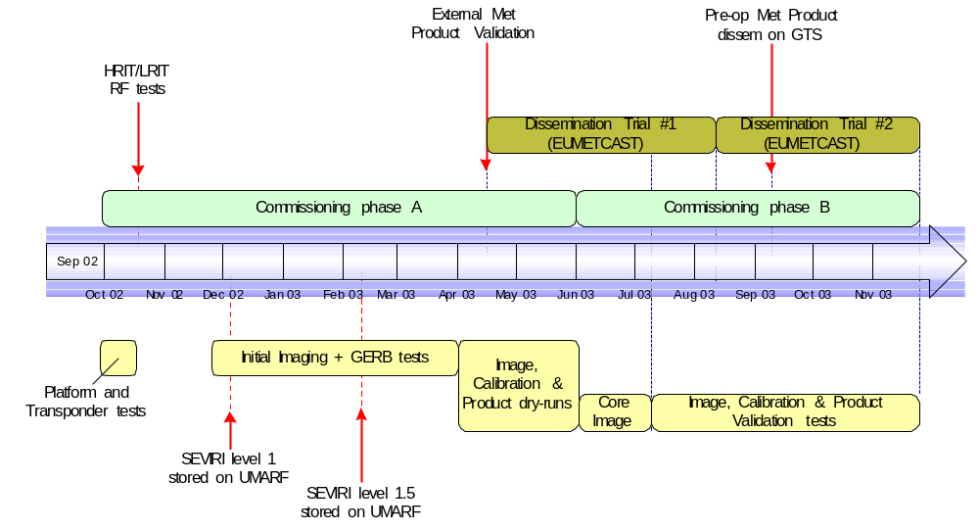

3 DATA COLLECTION SYSTEM PERFORMANCE - ASAP

3.1 DCPs on the Internet

EUMETSAT has an on-line DCP service available for DCP operators. This password-protected service allows the operators of DCPs to download their DCP messages from the EUMETSAT web site. In addition the DCP web pages also give monthly DCP reception statistics. This includes the number of transmissions and the maximum and minimum power levels of received DCP messages. A web based system for co-ordinating the IDCS channels was introduced at the end of 1998.

3.2 ASAP DCP Transmissions

Table 1 shows the ASAP DCP transmissions through the Meteosat satellite from January to December 2002. Figures 1 and 2 show this graphically, for the reporting countries.

DCP Address | DCP Name | Jan | Feb | Mar | Apr | May | June | July | Aug | Sep | Oct | Nov | Dec
112007C8 | D/ASAP 1 | 188 | 225 | 92 | 232 | 403 | 370 | 377 | 354 | 414 | 334 | 348 | 382
112044C2 | D/ASAP 2 | 0 | 0 | 80 | 178 | 259 | 270 | 213 | 271 | 0 | 0 | 0 | 0
112057B4 | D/ASAP 3 | 492 | 112 | 123 | 432 | 205 | 158 | 186 | 111 | 431 | 7 | 16 | 31
160037D2 | D/ASAP 4 | 88 | 115 | 173 | 59 | 146 | 262 | 221 | 47 | 0 | 0 | 1 | 0
1180F11A | F/ASAP 1 | 105 | 51 | 76 | 28 | 46 | 18 | 168 | 182 | 204 | 169 | 122 | 204
11810364 | F/ASAP 2 | 153 | 170 | 180 | 192 | 179 | 179 | 166 | 205 | 213 | 170 | 171 | 190
11819606 | F/ASAP 3 | 168 | 147 | 196 | 195 | 210 | 197 | 192 | 172 | 199 | 230 | 173 | 153
1181A39C | F/ASAP 4 | 141 | 128 | 41 | 24 | 0 | 4 | 0 | 51 | 77 | 0 | 0 | 1
1183207C | F/ASAP 5 | 107 | 97 | 148 | 190 | 193 | 143 | 65 | 122 | 116 | 11 | 0 | 0
11836376 | SPAIN/ASAP 1 | 10 | 2 | 6 | 49 | 14 | 48 | 34 | 58 | 60 | 17 | 0 | 0

Table 1: ASAP DCP transmissions

Figure 1: D/ASAP transmissions
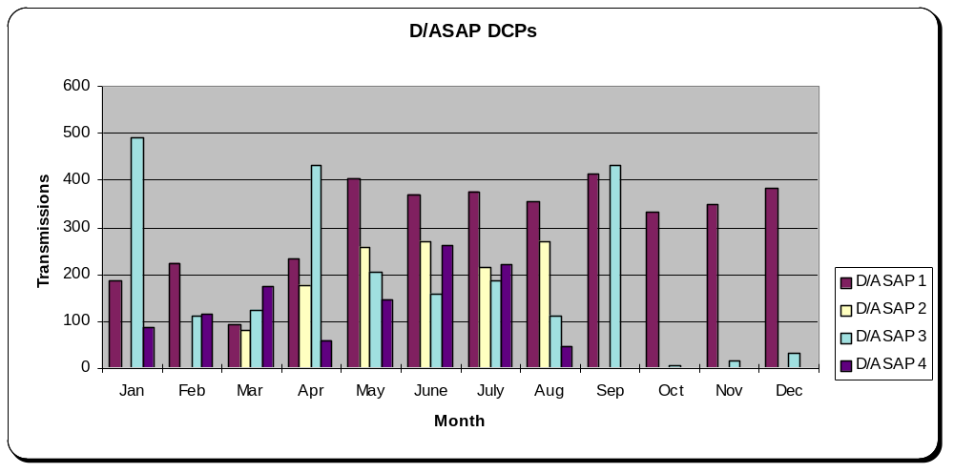

Figure 2: F/ASAP transmissions
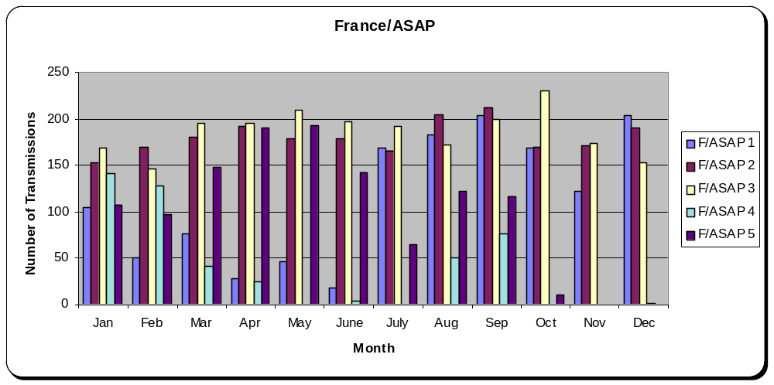
3.3 ASAP IDCS Allocations

The following tables give the present allocations for the ASAP DCPs on I12 and I10.

ASAP Communications Schedule For Operation On IDCS Channel 12 And 10

Transmission timeslots on International Channel 12 for ASAP use 90-second timeslots composed of a 30-second guard band and 59 seconds of data.

The following are the allocations for the primary first transmission timeslot at 0000 and 1200UTC. The second transmission is 30 minutes later. The backup timeslot is 1 hour after the primary timeslot:

Operator | DCP name | DCP address | Primary Transmission Time  For 0000 UTC  First Transmission Second Transmission  00.30.00 - 01.00 00 01.00.00 - 01.30.00
Spain | SPAIN/ASAP 1 | 11836376 | 01.00.00 - 01.01.30 | 01.00.00 - 01.01.30
NOAA | CANADA/ASAP 1 | A040056E | 01.01.30 - 01.03.00 | 01.01.30 - 01.03.00
Reserved for future ASAP use | N/A | N/A | 00.33.00 - 00.34.30 | 01.03.00 - 01.04.30
NOAA | CANADA/ASAP 2 | A0401618 | 01.04.30 - 01.06.00 | 01.04.30 - 01.06.00
Germany | D/ASAP 1 | 112007C8 | 00.36.00 - 00.37.30 | 01.06.00 - 01.07.30
Germany | D/ASAP 2 | 112044C2 | 00.37.30 - 00.39.00 | 01.07.30 - 01.09.00
Germany | D/ASAP 3 | 112057B4 | 00.39.00 - 00.40.30 | 01.09.00 - 01.10.30
Germany | D/ASAP 4 | 160037D2 | 00.40.30 - 00.42.00 | 01.10.30 - 01.12.00
NOAA | CANADA/ASAP 3 | A0402382 | 01.13.30 - 01.15.00 | 01.13.30 - 01.15.00
Reserved for future ASAP use | N/A | N/A | 00.45.00 - 00.46.30 | 01.15.00 - 01.16.30
NOAA | CANADA/ASAP 4 | A04030F4 | 01.16.30 - 01.18.00 | 01.16.30 - 01.18.00
France | F/ASAP 1 | 1180F11A | 00.51.00 - 00.52.30 | 01.21.00 - 01.22.30
NOAA | CANADA/ASAP 5 | A0404664 | 01.19.30 - 01.21.00 | 01.19.30 - 01.21.00
France | F/ASAP 2 | 11810364 | 00.52.30 - 00.54.00 | 01.22.30 - 01.24.00
France | F/ASAP 3 | 11819606 | 00.54.00 - 00.55.30 | 01.24.00 - 01.25.30
France | F/ASAP 4 | 1181A39C | 00.57.00 - 00.58.30 | 01.27.00 - 01.28.30
Reserved for future ASAP use | N/A | N/A | 00.55.30 - 00.57.00 | 01.25.30 - 01.27.00
France | F/ASAP 5 | 1183207C | 00.48.00 - 00.51.30 | 01.18.00 - 01.19.30
Reserved for future ASAP use | N/A | N/A | 00.58.30 - 01.00.00 | 01.28.30 - 01.30.00

Operator | DCP name | DCP address | Backup Transmission Time  For 0000 UTC  First Transmission Second Transmission  01.30.00 - 01.30 00 02.00.00 - 02.30.00
Spain | SPAIN/ASAP 1 | 11836376 | 02.15.00 - 02.16.30 | 02.25.30 - 02.27.00
NOAA | CANADA/ASAP 1 | A040056E | 02.01.30 - 02.03.00 | 02.01.30 - 02.03.00
Reserved for future ASAP use | N/A | N/A | 01.33.00 - 01.34.30 | 02.03.00 - 02.04.30
NOAA | CANADA/ASAP 2 | A0401618 | 02.04.30 - 02.06.00 | 02.04.30 - 02.06.00
Germany | D/ASAP 1 | 112007C8 | 01.36.00 - 01.37.30 | 02.06.00 - 02.07.30
Germany | D/ASAP 2 | 112044C2 | 01.37.30 - 01.39.00 | 02.07.30 - 02.09.00
Germany | D/ASAP 3 | 112057B4 | 01.39.00 - 01.40.30 | 02.09.00 - 02.10.30
Germany | D/ASAP 4 | 160037D2 | 01.40.30 - 01.42.00 | 02.10.30 - 02.12.00
NOAA | CANADA/ASAP 3 | A0402382 | 02.13.30 - 02.15.00 | 02.13.30 - 02.15.00
Reserved for future ASAP use | N/A | N/A | 01.45.00 - 01.46.30 | 02.15.00 - 02.16.30
NOAA | CANADA/ASAP 4 | A04030F4 | 02.16.30 - 02.18.00 | 02.16.30 - 02.18.00
France | F/ASAP 1 | 1180F11A | 01.51.00 - 01.52.30 | 02.21.00 - 02.22.30
NOAA | CANADA/ASAP 5 | A0404664 | 02.19.30 - 02.21.00 | 02.19.30 - 02.21.00
France | F/ASAP 2 | 11810364 | 01.52.30 - 01.54.00 | 02.22.30 - 02.24.00
France | F/ASAP 3 | 11819606 | 01.54.00 - 01.55.30 | 02.24.00 - 02.25.30
France | F/ASAP 4 | 1181A39C | 01.57.00 - 01.58.30 | 02.27.00 - 02.28.30
Reserved for future ASAP use | N/A | N/A | 01.55.30 - 01.57.00 | 02.25.30 - 02.27.00
France | F/ASAP 5 | 1183207C | 01.48.00 - 01.49.30 | 02.18.00 - 02.19.30
Reserved for future ASAP use | N/A | N/A | 01.58.30 - 02.00.00 | 02.28.30 - 02.30.00
4 FUTURE PROGRAMS STATUS

4.1 EUMETSAT Polar System

4.1.1 Spacecraft
Industrial activities are progressing. The METOP-1 launch planned for July 2005

4.1.2 Ground segment
All Ground Segment elements are in the procurement phase, critical design reviews have been held. Operations preparation activities are underway with the first SSVT planned for the end of 2003.

4.1.3 Satellite Application Facilities
4 SAFs have been kicked off:
- NWP (UK, ECMWF, NL, F)
- Climate (D, B, SF, NL, S)
- GRAS (DK as host)
- Land Applications (P as host)
5 UPDATE ON MTP/MSG PARALLEL OPERATIONS

It is currently planned that, following completion of the commissioning activities, MSG-1 will commence routine operations in the fourth quarter of 2003. In order to ensure that there is an overlap between the MTP and the MSG operational systems, MTP operations have been extended to the end of 2005.

The purpose of this section is to provide information about the services that will be offered by both MTP and MSG, for the period of MTP/MSG Parallel Operations, starting in the fourth quarter of 2003.

5.1 Assumptions

a) It is assumed that during the period under consideration Meteosat-6 and Meteosat-7 will continue to be available with their current operational functionality.

It should be noted that, because of fuel considerations, the Meteosat-6 orbital inclination is no longer controlled. Currently, the Meteosat-6 inclination is 2.7° and increasing at approximately 0.9° per year. During the Transition Phase, the Meteosat-6 inclination will be approximately 3°.

b) It is assumed that the MSG operational system will provide the full set of planned Day 1 Meteorological Products from the start of MSG routine operations, unless otherwise indicated.

- It is assumed that MSG-1 will be commissioned at 10° west and, once successfully commissioned, could be drifted to a different orbital longitude for the start of MSG-1 routine operations.

e) It is assumed that Meteosat-7 will remain at the current position at 0°E, to avoid re-pointing of the existing PDUS/SDUS antennas. This is made possible by the fact that no direct dissemination will be performed from MSG-1.

f) It is assumed that it will be possible, when required, to conduct MTP backup operations with Meteosat-6 at 10° east on a non-interference basis (in a similar manner to IODC at 63° East).
5.2 Operational Considerations

5.3 MTP and MSG Operational Services

The operational services currently offered by MTP are:

- Image Data Acquisition and Dissemination (HRI and WEFAX);
- Data Collection Service (DCS);
- Meteorological Data Dissemination (MDD);
- MPEF product generation and distribution;
- User Help-desk;
- Archive and Retrieval;
- Training.

The operational services expected to be offered by MSG at the end of MSG-1 commissioning are:

- Image Data Acquisition and Dissemination (HRIT and LRIT using the EUMETCast Alternative Dissemination scheme);
- Data Collection System (DCS) – The proposed role of MSG-1 is as a DCS acquisition back-up – initially to Met-7, then MSG-2. DCP messages and Bulletins derived from MTP will be disseminated using EUMETCast);
- Meteorological Data Dissemination (MDD using EUMETCast);
- MPEF product generation and distribution;
- User Help-desk;
- Archive and Retrieval;
- Training.
5.3.1 Image Data Acquisition and Dissemination (HRI and WEFAX / HRIT and LRIT)

For Raw Data downlink radio frequency interference reasons it is not possible to operate both the MSG and MTP image data acquisition services when the spacecraft are located close together. This closeness is a function of both spacecraft transmission and ground station antenna characteristics. In the case of operating both MTP and MSG Raw Data downlinks, the minimum orbital separation is of the order of 3° of longitude.

The nominal location assigned to EUMETSAT for operations is 0°, with reduced operations possible at both 10° West and 10° East.
However, with EUMETCast being used for MSG-1 data dissemination, dissemination downlink radio frequency interference is no longer a constraint to be taken into account.
It is now possible to locate MSG-1 closer to 0°, and leave Meteosat-7 at 0°. This is proposed to be the baseline, as this dramatically reduces the impact of the transition phase on existing PDUS/SDUSs and avoids any frequency co-ordination issues at 10°W regarding dissemination. The advantage of locating MSG-1 closer to 0° is concerned both with coverage and image processing. Locating MSG-1 either east or west of 0°allows to optimise the coverage of the images, and still to rectify to 0° if required.
So far, investigations have revealed that a gap exists between 2.5° and 4° W in which MSG-1 could be operated. No similar gap exists between 1° and 6°E where spacecraft are located every degree of longitude. Therefore, for Parallel Operations, MSG-1 is proposed to be operated at 3.3°W +/- 0.5° on a non-interference basis.

5.3.2 Data Collection Service (DCS)

It should be noted that the current MSG-1 MCP operational configuration does not support the acquisition of Data Collection Platform messages.

However care will have to be taken in developing the operational approach to the MSG DCS in view of the questions raised by the SSPA Inquiry Board with respect to the design of the SSPAs, and the overriding necessity not to endanger the redundancy situation for the Raw Data downlink.

Bearing this in mind, it is proposed that MSG-1 be considered as a backup to, initially, Met-7, and later, MSG-2.

Meteosat-7 will provide DCP messages and bulletins via EUMETCast. In addition DCP messages will continue to be available using the MTP DCP Retransmission Service and using the Internet.

5.3.3 Meteorological Data Dissemination (MDD)

It is proposed that the current MTP MDD service would be continued throughout the period of parallel operations from the three uplink stations at Bracknell, Toulouse and Rome.

For the MSG MDD service, it is planned that the MTP MDD uplink site operators will route the MDD data to the MCC where the data will be added to the LRIT stream and disseminated to the Users via EUMETCast. The data will be routed to Darmstadt using the GTS via the RTH at Offenbach.

5.3.4 MPEF Product Generation and Distribution

It should be noted that the suite of products generated by MSG MPEF is broadly a superset of that generated by MTP MPEF. Bearing in mind that, for dissemination via the GTS, no questions seem to surround the end-users' ability to receive the products, it is proposed that there is a limited overlap period between the start of MSG routine operations and the termination of the MTP MPEF product generation and distribution service.

The precise length of this overlap period (currently proposed to be about one year) would be dependent on the feedback received from delegations regarding the continued usefulness of the MTP products.

This proposal is made in recognition of the request by delegations to have parallel dissemination of products, when introducing a new operational system, and the long time scales associated with the validation of new products.

5.3.5 User Help-desk, Archive and Retrieval and Training

The continuation of the User Help-desk, Archive and Retrieval and Training services presents no real technical problems, but needs to be planned well in advance to ensure that there are adequate resources available. It is expected that the efforts expended on MTP Training during this period would be minimal; with most of the training effort being directed towards MSG and EPS.

5.4 Scenario For The Transition To Parallel Operations

5.4.1 Introduction

As dissemination via EUMETCast is now the baseline for MSG-1, a new transition scenario has been developed, to minimise the effect of the transition into MSG operations on the existing MTP PDUS/SDUS systems.

5.4.2 Transition Scenario

This transition is based on the relocation of Meteosat-6 to 9.5°E prior to the launch of MSG-1. This was performed in September/October 2002. The final position of Meteosat-7 is maintained at 0°W and the final position of MSG-1 is 3.3°W.

Spacecraft | Start longitude | End longitude
MTP Standby + RSS (Met-6) | 9.5°E | 9.5°E
MTP Operations (Met-7) | 0° | 0°
MSG Operations (MSG-1) | 10°W | 3.3°W

The principle steps involved in the transition scenario are as follows:

Step | Planned Date | Description
Step 1 | Sept – Oct 2002 | Meteosat-6 relocation to 10°E prior to MSG-1 launch (done)
Step 2 | Nov 2003 | End of MSG-1 commissioning, readiness for start of Transition Phase
Step 3 | Nov 2003 | Start MSG-1 drift to 3.3°W (nominal drift rate 0.5°/day, spacecraft in imaging configuration)
Step 4 | Dec 2003 | Stop MSG-1 at final location. Start MSG Operational Services.
Step 5 | Jan 2004 | End of Transition Phase

It should be noted that no MTP User Station antenna re-pointings are required, and that MSG-2 can be commissioned at 10°W independent of the selected launch date for MSG-2.
ASAP MONITORING Paris february 2003

ASAP MONITORING
REPORT YEAR 2002 PRESENTED BY FRANCE

- INTRODUCTION .

This report describes the end-to-end monitoring of the ASAP data dissemination performance by Meteo-France.

This end-to-end monitoring has been applied to every TEMP-SHIP message received at LFPW (Toulouse) from EGRR (Bracknell) and EDZW (Offenbach). As in previous years, part A of messages was analysed from the syntactic point of view. When the original data were available, digit-to-digit comparison has been made. Only messages with obviously erroneous ship’s call sign were excluded.

- CONTROLLED MESSAGES

From all processed messages, we have a total of call signs which have been accepted for analysis. This is summarised in Table 1 with the country of the ship, if possible.

Some spurious call sign have been taken in account with a correspondence table used in LFPW enables to link a spurious call sign to a well know one. The corresponding message is then studied, and gives a supplementary information on telecommunications system reliability. It is clear that the telecommunication system may corrupt indifferently the call sign and the message.

Country | Call sign | Accepted messages number | Country | Call sign | Accepted messages number
Germany | DASAP1  DASAP2  DASAP3  DASAPX  DASAP5  DBBH  DBLK  DDWW  ELML7 | 23  9  20  48  5  635  218  6  784 | Great Britain | ZCBP6  GDLS | 183  17
Germany |  | 23  9  20  48  5  635  218  6  784 | USA | WPKD | 313
Denwark | OVYA2  OXTS2  OXYH2 | 247  154  209 | Eumetnet | SWJS | 96
France | FNOR  FNOU  FNPH  FNRS | 614  652  466  785 | Iceland | V2XO  V2XM | 115  13
France | FNOR  FNOU  FNPH  FNRS | 614  652  466  785 | Norway | LDWR | 1320
Japan | JCCX  JDWX.  JGQH  JIVB | 146  161  180  174 | Unidentified | GWAN | 48

Table 1 : Ship’s call sign received in LFPW from January 2002 to December 2002

- THE MONITORING

  - Origin of messages

For the statistic presented here, we used the messages from the 30 ships with call signs registered as OK in Table 1 . From January 2002 till December 2002, this corresponds to 7281 messages , 47.80 % of them coming from EGRR and 52.20 % from EDZW. Duplication of origins is mainly due to ships operated by France.

Country | EGRR | EDZW
D | X | X
F | X | X
JP | X
DK | X | X
GB | X
US | X
N |  | X
ICELAND | X

Table 2 : Origin of messages, according to ship’s Country
(D = Germany, F = France, JP = Japan, DK = Denmark, N=Norway, GB=Great Britain ,US=United States)

3.2 Global system performance

The Table 3 describes the global results of the syntactic check for the messages with agreed call signs, the headers of columns having the following meaning :

A number of message received from EGRR and EDZW ;
N number of messages NIL ;
B number of message compared with original (B=C+D)
C number of message different from original
D number of message identical to original ;
B2 number of message syntactically checked if original non available (B2=C2+D2) ;
C2 number of message syntactically rejected ;
D2 number of message syntactically good ;
T number of good message including duplicates ;
T% percentage of good reception (T%=100*T/A) ;
U number of good and non-duplicated messages.

MONTH | ORIGIN | A | N | B | C | D | B2 | C2 | D2 | T | T% | U
Janu-02 | egrr | 422 | 0 | 225 | 9 | 216 | 197 | 3 | 194 | 410 | 97 | 307
 | edzw | 558 | 174 | 189 | 98 | 91 | 195 | 11 | 184 | 275 | 49 | 239
 | total | 980 | 174 | 414 | 107 | 307 | 392 | 14 | 378 | 685 | 70 | 546
Febr-02 | egrr | 302 | 0 | 172 | 9 | 163 | 130 | 3 | 127 | 290 | 96 | 216
 | edzw | 412 | 86 | 147 | 58 | 89 | 179 | 14 | 165 | 254 | 62 | 219
 | total | 714 | 86 | 319 | 67 | 252 | 309 | 17 | 292 | 544 | 76 | 435
Mar-02 | egrr | 249 | 0 | 122 | 4 | 118 | 127 | 0 | 127 | 245 | 98 | 191
 | edzw | 338 | 0 | 123 | 57 | 66 | 215 | 11 | 204 | 270 | 80 | 242
 | total | 587 | 0 | 245 | 61 | 184 | 342 | 11 | 331 | 515 | 88 | 433
Apr-02 | egrr | 267 | 0 | 99 | 5 | 94 | 168 | 2 | 166 | 260 | 97 | 213
 | edzw | 329 | 0 | 103 | 53 | 50 | 226 | 13 | 213 | 263 | 80 | 249
 | total | 596 | 0 | 202 | 58 | 144 | 394 | 15 | 379 | 523 | 88 | 462
May-02 | egrr | 287 | 0 | 78 | 3 | 75 | 209 | 0 | 209 | 284 | 99 | 248
 | edzw | 262 | 0 | 74 | 30 | 44 | 188 | 4 | 184 | 228 | 87 | 212
 | total | 549 | 0 | 152 | 33 | 119 | 397 | 4 | 393 | 512 | 93 | 460
June-02 | egrr | 414 | 0 | 150 | 20 | 130 | 264 | 0 | 264 | 394 | 95 | 341
 | edzw | 324 | 0 | 117 | 37 | 80 | 207 | 4 | 203 | 283 | 87 | 249
 | total | 738 | 0 | 267 | 57 | 210 | 471 | 4 | 467 | 677 | 92 | 590
July-02 | egrr | 377 | 0 | 147 | 22 | 125 | 230 | 0 | 230 | 355 | 94 | 305
 | edzw | 341 | 0 | 101 | 35 | 66 | 240 | 10 | 230 | 296 | 87 | 271
 | total | 718 | 0 | 248 | 57 | 191 | 470 | 10 | 460 | 651 | 91 | 576
Aug-02 | egrr | 255 | 0 | 96 | 21 | 75 | 159 | 1 | 158 | 233 | 91 | 191
 | edzw | 363 | 0 | 83 | 26 | 57 | 280 | 19 | 261 | 318 | 88 | 280
 | total | 618 | 0 | 179 | 47 | 132 | 439 | 20 | 419 | 551 | 89 | 471
Sept-02 | egrr | 369 | 0 | 147 | 24 | 123 | 222 | 0 | 222 | 345 | 93 | 303
 | edzw | 265 | 0 | 95 | 41 | 54 | 170 | 6 | 164 | 218 | 92 | 199
 | total | 634 | 0 | 242 | 65 | 177 | 392 | 6 | 386 | 563 | 89 | 502
Octo-02 | egrr | 289 | 0 | 81 | 19 | 62 | 208 | 3 | 205 | 267 | 92 | 247
 | edzw | 294 | 16 | 112 | 56 | 56 | 166 | 7 | 159 | 215 | 73 | 192
 | total | 583 | 16 | 193 | 75 | 118 | 374 | 10 | 364 | 482 | 83 | 439
Nove-02 | egrr | 193 | 0 | 7 | 2 | 5 | 186 | 0 | 186 | 191 | 99 | 189
 | edzw | 209 | 0 | 46 | 26 | 20 | 163 | 3 | 160 | 180 | 86 | 171
 | total | 402 | 0 | 53 | 28 | 25 | 349 | 3 | 346 | 371 | 92 | 360
Dec-02 | egrr | 56 | 0 | 20 | 7 | 13 | 36 | 0 | 36 | 49 | 88 | 49
 | edzw | 106 | 0 | 27 | 16 | 11 | 79 | 3 | 76 | 87 | 82 | 83
 | total | 162 | 0 | 47 | 23 | 24 | 115 | 3 | 112 | 136 | 84 | 132
Total | egrr | 3480 | 0 | 1344 | 145 | 1199 | 2136 | 12 | 2124 | 3323 | 95,48 | 2800
 | edzw | 3801 | 276 | 1217 | 533 | 684 | 2308 | 105 | 2203 | 2887 | 75,95 | 2606
 | total | 7281 | 276 | 2561 | 678 | 1883 | 4444 | 117 | 4327 | 6210 | 85,29 | 5355
Average | egrr | 290 | 0 | 112 | 12,08 | 99,92 | 178 | 1 | 177 | 276,92 | 95,49 | 233,42
 | edzw | 316,75 | 23 | 101,42 | 44,42 | 57 | 192,33 | 8,75 | 183,58 | 240,58 | 68,56 | 217,17
 | total | 606,25 | 23 | 213,42 | 56,5 | 156,92 | 370,33 | 9,75 | 343,92 | 517,5 | 450,5 | 85,36

Table 3. Bracknell and Offenbach statistics from January 2002 to December 2002 .

Call Sign | A | N | B | C | D | B2 | C2 | D2 | T | T% | U | P
DASAP1 | 23 | 0 | 0 | . | . | 23 | 0 | 23 | 23 | 100 | 21 | ?
DASAP2 | 9 | 0 | 0 | . | . | 9 | 0 | 9 | 9 | 100 | 9 | ?
DASAP3 | 20 | 0 | 0 | . | . | 20 | 0 | 20 | 20 | 100 | 18 | ?
DASAPX | 48 | 0 | 0 | . | . | 48 | 0 | 48 | 48 | 100 | 39 | ?
DASAP5 | 5 | 0 | 0 | . | . | 5 | 3 | 2 | 2 | 40 | 2 | ?
DBBH | 635 | 276 | 15 | 5 | 10 | 344 | 0 | 344 | 354 | 55 | 307 | 47
DBLK | 218 | 0 | 0 | . | . | 218 | 77 | 141 | 141 | 64 | 139 | ?
DDWW | 6 | 0 | 0 | . | . | 6 | 0 | 6 | 6 | 100 | 6 | ?
ELML7 | 784 | 0 | 605 | 223 | 382 | 179 | 2 | 177 | 559 | 71 | 319 | 416
OVYA2 | 247 | 0 | 0 | . | . | 247 | 2 | 245 | 245 | 99 | 245 | ?
OXTS2 | 154 | 0 | 0 | . | . | 154 | 0 | 154 | 154 | 100 | 153 | ?
OXYH2 | 209 | 0 | 0 | . | . | 209 | 0 | 209 | 209 | 100 | 209 | ?
FNOR | 614 | 0 | 579 | 151 | 428 | 35 | 8 | 27 | 455 | 74 | 231 | 302
FNOU | 652 | 0 | 554 | 168 | 386 | 98 | 21 | 77 | 463 | 71 | 205 | 252
FNPH | 466 | 0 | 455 | 56 | 399 | 11 | 6 | 5 | 404 | 86 | 237 | 264
FNRS | 875 | 0 | 868 | 167 | 701 | 7 | 1 | 6 | 707 | 80 | 272 | 323
JCCX | 146 | 0 | 0 | . | . | 146 | 0 | 146 | 100 | 68 | 146 | ?
JDWX | 161 | 0 | 0 | . | . | 161 | 2 | 159 | 159 | 98 | 158 | ?
JGQH | 180 | 0 | 0 | . | . | 180 | 1 | 179 | 179 | 99 | 178 | ?
JIVB | 174 | 0 | 0 | . | . | 174 | 3 | 171 | 171 | 98 | 170 | ?
JNSR | 132 | 0 | 0 | . | . | 132 | 0 | 132 | 132 | 100 | 131 | ?
JPBN | 13 | 0 | 0 | . | . | 13 | 0 | 13 | 13 | 100 | 13 | ?
ZCBP6 | 183 | 0 | 0 | . | . | 183 | 0 | 183 | 183 | 100 | 182 | ?
GDLS | 17 | 0 | 0 | . | . | 17 | 0 | 17 | 17 | 100 | 17 | ?
WPKD | 313 | 0 | 0 | . | . | 313 | 0 | 313 | 313 | 100 | 305 | ?
SWJS | 156 | 0 | 0 | . | . | 156 | 0 | 156 | 156 | 100 | 153 | ?
V2XO | 115 | 0 | 0 | . | . | 115 | 0 | 115 | 115 | 100 | 114 | ?
V2XM | 13 | 0 | 0 | . | . | 13 | 0 | 13 | 13 | 100 | 13 | ?
LDWR | 1320 | 0 | 0 | . | . | 1320 | 0 | 1320 | 1320 | 100 | 1318 | ?
GWAN | 48 | 0 | 0 | . | . | 48 | 0 | 48 | 48 | 100 | 45 | ?
 | 7936 | 276 | 3076 | 770 | 2306 | 4584 | 126 | 4458 | 6764 | 79 | 5355 | 1604

Table 4 . Global Statistics for each accepted call sign from January 2002 to December 2002

During those 12 months, LFPW received a total (T) of 6210 usable messages, i.e. 85% of the income. Nevertheless, if we put aside the duplicates, we only get 5355 truly used messages (U), i.e. 74 % of the income.

The evolution of the percentage of correct messages for the period is illustrated in the figure below :
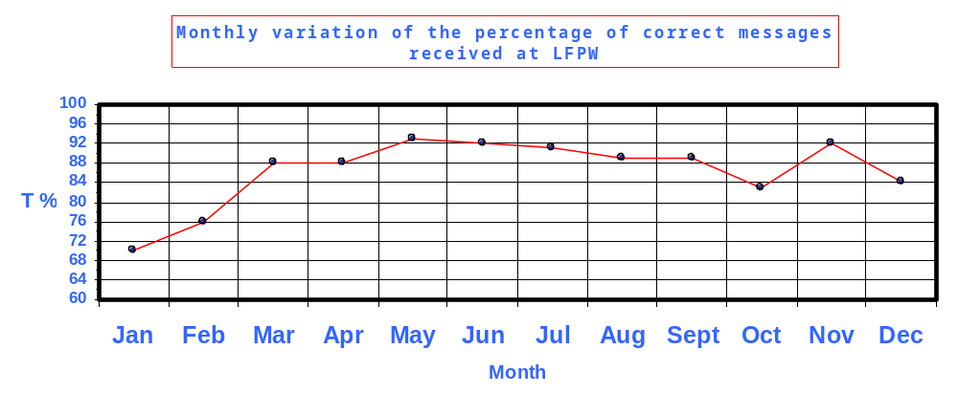Figure 1 : monthly variation of the percentage of correct messages(T%) received at LFPW

On this graph ,we can see that the percentage of good reception T% fluctuates about the average value 86%. In regard of last year 2001, T% is increased of 19% (relative error) ;

The global population of messages can be divided into two populations :

- 2561 messages having been compared to an original, 26.5% of them being corrupted during the transmission ;

- 4444 messages subject to syntactic check only 2.6% of them found as incorrect.

We notice that there is a great difference between these two rates, in that, the telecommunication system may change characters in the messages in without changing the general syntax.
On a monthly average, LFPW has received a total of 450 non corrupted and non duplicated messages i.e. approximately to 15 messages for each of the 30 call signs.

  - Ships with available originals

We studied separately the sample of messages for which the ship’s observation programme was available. This sample includes 4026 messages which global analysis is given in Tables 5 and 6 where column headers are completed as follows, as compared to Table 3:

P Ship’s programme ;
U/P This is the final « system-efficiency index », giving the TEMP ratio of all TEMP messages arrived to LFPW uncorrupted and non-duplicated TEMP produced by SHIPS. If this index is low, the system generates losses.

U/A This ratio can be regarded as a measure of the power of the telecommunication system to generate non corrupted duplicates of original messages. Values close to 100% indicate non duplications and a high quality transmission. Values less than 50% highlight an important duplication rate.

C/B Percentage of messages rejected during the analysis

Call Sign | A | N | B | C | D | B2 | C2 | D2 | T | T% | U
FNOR | 614 | 0 | 579 | 151 | 428 | 35 | 8 | 27 | 455 | 74 | 231
FNOU | 652 | 0 | 554 | 168 | 386 | 98 | 21 | 77 | 463 | 71 | 205
FNPH | 466 | 0 | 455 | 56 | 399 | 11 | 6 | 5 | 404 | 86 | 237
FNRS | 875 | 0 | 868 | 167 | 701 | 7 | 1 | 6 | 707 | 80 | 272
ELML7 | 784 | 0 | 605 | 223 | 382 | 179 | 2 | 177 | 559 | 71 | 319
DBBH | 635 | 276 | 15 | 5 | 10 | 344 | 0 | 344 | 354 | 55 | 307
 | 4026 | 276 | 3076 | 770 | 2306 | 674 | 38 | 636 | 2942 | 73 | 1571

Table 5 : Global statistics from January 2002 to December 2002 for ships with available programme.

Call Sign | U | P | U/P (%) | U/A (%) | %EGRR | %EDZW | C/B (%) | C2/B2 (%)
FNOR | 231 | 302 | 76 | 38 | 37.6 | 22.5 | 26.1 | 22.9
FNOU | 205 | 252 | 81 | 31 | 47.7 | 47.5 | 30.3 | 21.4
FNPH | 237 | 264 | 89 | 57 | 22.7 | 30.2 | 12.3 | 54.5
FNRS | 272 | 323 | 84 | 31 | 42.9 | 52.9 | 19.2 | 14.2
ELML7 | 319 | 416 | 76 | 41 | 61.6 | 16.3 | 36.8 | 1.1
DBBH | 307 | 47 | . | 48 | 49.1 | 43.5 | 33.3 | 56.40
 | 1571 | 1604 | 81 | 39 | 45.2 | 38.8 | 25 | 5.6

Table 6 : System effiency for ships with available programme

All the ships except FNPH have an important duplication .rate
Out of these 4026 messages,76.4% (B/A) have been compared to originals. From them ,
75 % (D/B) are identical to one original. The rather good reception for these ships is 71% rising to 86 % if we exclude the ship DDBH.

The global system efficiency (U/P) is good with 81 % of original messages able to be used at LFPW. Also we note that the high degree of duplication coming from the five ships except FNPH leads to a low telecommunication efficiency (U/A) of 39 % of usable messages as compared to the input to LFPW.
We notice that the scores T% (73%) , C2/B2 (5.6%) are better than those of year 2001 The score U/P (81%). is lower than those of year 2001

3.4 Ships without available originals

Out of all the messages received at LFPW, we also studied the 3910 for which we had no originals (table7). From this syntactic point of view the score (U/A) is 81 % rising .to 100% if we exclude the ship DASAP5

This result is higher to the one of the comparison with the original (average U/P=81%) which is far more stringent than the syntactic comparison .

If we exclude the ship DASAP5 , U/A is 81% rising to 100% , so the duplicates are unsignificant for this population of messages.

Call Sign | % U/A | % egrr | % edzw
DASAP1 | 91.3 | 100 | 0
DASAP2 | 100 | 100 | 0
DASAP3 | 90 | 100 | 0
DASAPX | 81.2 | 95.8 | 0
DASAP5 | 40 | 100 | 0
DBLK | 63.8 | 0 | 100
DDWW | 100 | 0 | 0
OVYA2 | 99.2 | 24.7 | 70.3
OXTS2 | 99.3 | 0 | 100
OXYH2 | 100 | 0 | 100
JCCX | 100 | 100 | 0
JDWX | 98.1 | 100 | 0
JGQH | 98.9 | 100 | 0
JIVB | 97.7 | 100 | 100
JNSR | 99.2 | 100 | 0
JPBN | 100 | 100 | 100
ZCBP6 | 99.4 | 100 | 0
GDLS | 100 | 100 | 100
WPKD | 97.4 | 100 | 0
SWJS | 98 | 2 | 96.8
V2XO | 99 | 100 | 0
V2XM | 100 | 100 | 0
LDWR | 99.8 | 0 | 100
GWAN | 94 | 100 | 100

Table 7 Statistics from January 2002 to December 2002
for ships without available programme .

4. CONCLUSION

- In regard of last year 2001, the total received messages A from each ship has undergone a decrease.

- The best scores are achieved by ships inserting their data in the GTS through only one RTH.
However , there is probably no direct link between the corruption of data and duplication .
It may be only a workload for data processing centres, which has to be avoided , but may also be considered as a back-up.
Main sources of data corruption are thought to found else where. For this reason it is very important to perform the exercise with all original data available.

- The scores 100*T/A, 100*C/B and 100*C2/B2 averaged over the five ships with available programme are better than those of year 2001 but the averaged score 100*U/P is worse than those of year 2001.

EUMETNET ASAP
Co-Operation with NOAA/OGP 2001-2003

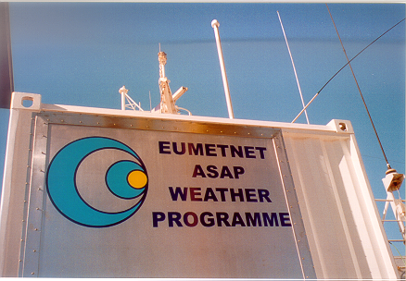
The E-ASAP launcher, here installed on the Mediterranean E-ASAP on the PELJASPER. The logo and text is in the upper 3rd part of the stainless steel door with the launcher mounted on the inside.

Responsible Member: Deutscher Wetterdienst - Programme Manager: Klaus HEDEGAARD
Mail: Klaus.Hedegaard@dwd.de - Web: www.eumetnet.eu.org
P.O. Box 30 11 90 - D-20304 Hamburg – Tel (direct): +49 40 3190 8550 - Fax: +49 40 6690 1496

NOAA_OGP_01-03_E-ASAP_REP_048, Final, 7 April 2003
Table of contents

1. Objectives 62
2. The E-ASAP equipment 62
3. The ships hosting the E-ASAP equipment 63
4. Operations of the Atlantic E-ASAP 65
5. Future of E-ASAP 66

1. Objectives

Vertical profiles of wind, temperature and humidity from radiosondes are essential for the analysis of the state of the atmosphere because of their all-weather capability to measure sharp gradients which the space based soundings are not expected to emulate for years to come. At present, soundings from commercial vessels (ASAP) are the only source for profiles over the ocean areas of interest for short-range General Numerical Weather Prediction (GNWP) over Europe. Satellite data also benefit from the in-situ data as they are used for calibration of the satellite data.

EUMETNET is a network of 18 European national meteorological services. The EUMETNET ASAP Programme (E-ASAP) started in 1999, and procured and operated 2 ASAP systems 2000-2002. From 2003 it is a EUMETNET core programme, i.e. with all 18 Members contributing, and according to GNP. EUCOS is the EUMETNET Composite Observing System. The agreed EUCOS objective is to reach by 2006 a total of 18 systems producing 6.300 soundings annually.
The decision on the pilot programme 1999-2002 was to procure and operate 2 ASAPs, one in the Mediterranean and another one in the Atlantic. In 2000 a Greek ship, the PELJASPER, was identified and equipped as an E-ASAP, operated by the Sarlis shipping company, and it has operated since December 2000. Call sign is SWJS, and she takes about 25 TEMP profiles every month within the Mediterranean area. For the Atlantic ASAP an arrangement has been made with an American flagged and crewed ship, the SEALAND ACHIEVER, from the Maersk-Sealand company, cf. Fig. 1. The ship is about 900 feet long and holds 4800 TEUs (twenty foot equivalent units). NOAA/Office of Global Programs have supported the SEALAND ACHIEVER to take soundings in the Gulf of Mexico.

2. The E-ASAP equipment

The E-ASAP container-launcher is based on a 10-foot container with the doors replaced by a tiltable door with the launcher per se mounted on its inside, cf. the photo on the front page. The launcher is a stainless steel cylinder 1350 mm in diameter mounted on a bottom with helium filling nozzle and a transvector to blow out the balloon. This size makes it possible to launch 350 g balloons, and being slightly overfilled to secure a higher ascent rate in order to get free of the superstructure of the ship before the sonde has unwound itself completely from the unwinder. Typically the 350 g balloons reach about 25 km. Smaller balloons may also be used, but for manual release as they will not reach the sides of the launcher. The container-launcher has its own compressor as well as air-conditioner. With the antennas mounted on the roof the system is self contained, and need only to be hooked up to the ships power, and have an inlet for helium, which is stored somewhere else on the ship.

The container-launcher is equipped with a 600x600 mm rack with a total of 5 shelves to place and secure the radiosounding and communication equipment. For storing sondes and balloons there is a storage cabinet with 3 shelves and a total capacity of 0.9 m³.

The sounding unit is a Vaisala DigiCORA III. Wind finding is primarily done by using Loran-C, but it is also equipped with a GPS-processor board, and for different reasons the windfinding in the Gulf of Mexico is done by GPS. The GPS-facility also makes it possible to have an automated position setting such that the operator only has to accept the given position. Inmarsat-C communications with Thrane&Thrane equipment is used. The communication is automated such that no operator intervention is needed under normal operating conditions. This also means that the TEMP SHIP bulletins are communicated as soon they are ready, i.e. the parts A and B are transmitted soon after the sonde has passed the 100 hPa level, and the transmission does not await the burst of the balloon and the processing of parts C and D. The communication is based on use of the so called Code 41, meaning that the meteorological service in the country where the LES is situated is charged for the communication from the ship to the LES and the landline to the GTS insertion point.

3. The ships hosting the E-ASAP equipment

The SEALAND ACHIEVER is a container vessel making regular traffic between Bremerhaven and Houston, and vice versa, and also calls at different European and American ports. The rotation time is 5 weeks.

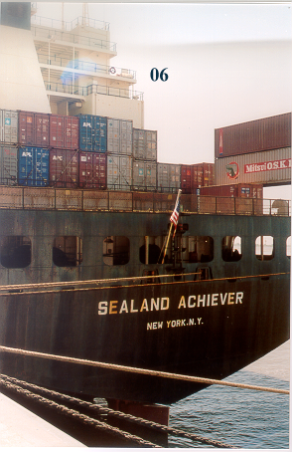
Figure 1. The SEALAND ACHIEVER seen from the stern before the E-ASAP container-launcher was put on the ship. It is placed on level 06 about 2 m to the starboard side from the funnel. The height above MSL of level 06 is 30 m at normal draught.
The container-launcher is placed on level 06, cf. Fig. 1, and the picture in Fig. 2 showing a radiosonde launch from the SEALAND ACHIEVER. The height of the 06 level is 30 m above normal draught.

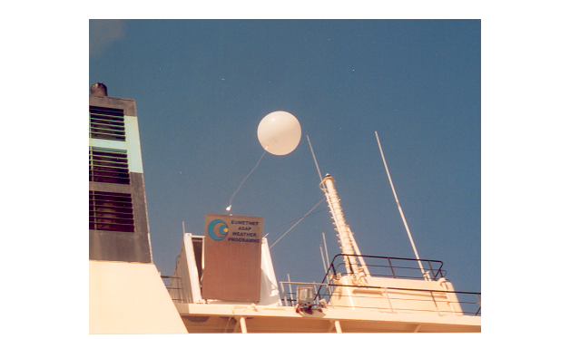
Figure 2. Radiosonde-launch from the E-ASAP container-launcher aboard the SEALAND ACHIEVER (WPKD). The container is situated at 30 m above sea level at normal draught. Note that the sonde has just left the launcher. The antennas are mounted on the roof of the launcher, but are here hidden behind the launcher door.

The soundings are taken by the deck officers, mainly the Chief and 2nd Mate. New officers are trained by those knowing how to operate the equipment. The launcher placed on level 06 is right below the bridge level, and the helium is stored right next to the launcher, cf. Fig. 1. It is thus easily accessible for operations.

The operational programme of the Atlantic E-ASAP, with call sign WPKD, is soundings at 00 and 12 UTC when being between 8° W and 50° W, and soundings at 06 and 18 UTC when west of 50° W and north of 35° N. The American land based sounding stations generally take soundings at 00 and 12 UTC only, and it is considered an advantage to have ASAPs take soundings at 06 and 18 UTC when being close to areas with 00 and 12 UTC soundings only. The radiosondes used on the SEALAND ACHIEVER are either Vaisala RS90-AL (Loran) or RS90-AG (GPS sonde).

NOAA/Office of Global Programs have for each fiscal 2001/2002 and 2002/2003 transferred to E-ASAP 10.000 $US to have soundings taken on the route of the SEALAND ACHIEVER between the Keys and Houston, and vice versa. This amount is to cover approximately the expenses to these soundings for about one year, and based on using GPS-sondes.

4. Operations of the Atlantic E-ASAP

From the Atlantic E-ASAP on the SEALAND ACHIEVER were received a total of 338 TEMP SHIP bulletins on the GTS with a 90,9% communication efficiency. This number of soundings was less than the target of 350 soundings/year to the GTS. This was mainly due to communcation problems in July and August.

In Table 1 is given statistics on data received on the GTS from the Atlantic E-ASAP during 2002. This is the number of TEMP SHIP bulletins available at the NMSs and other forecasting centers, e.g. ECMWF. The loss rate at 14% is high, only slightly less than in 2001 with 16%. The loss rate used in budgeting is 15%, so the fairly high rate does not have economical consequences, but any decrease would be welcome. The communication efficiency is generally high, but was hampered by equipment failures in July and August. On each 5-week rotation the SEALAND ACHIEVER spends about 6 days en route from the Keys to Houston and vice versa, and she takes about 12 soundings per rotation, or about 60 upper-air soundings from the Gulf of Mexico on an annual basis. The actual number of soundings taken in the Gulf of Mexico was 68 in 2002.

Table 1. | Operational statistics for the Atlantic E-ASAP (WPKD)
during 2002. In the Gulf of Mexico were taken 68 soundings.
WPKD | Total number | Failed | Successful | Received | Communi-
2002 | launches | launches | Soundings | on GTS | cation eff.
JAN | 17 | 2 | 15 | 15 | 100,0%
FEB | 19 | 3 | 16 | 16 | 100,0%
MAR | 30 | 6 | 24 | 24 | 100,0%
APR | 30 | 1 | 29 | 29 | 100,0%
MAY | 35 | 2 | 33 | 33 | 100,0%
JUN | 41 | 3 | 38 | 38 | 100,0%
JUL | 30 | 1 | 29 | 15 | 51,7%
AUG | 28 | 1 | 27 | 10 | 37,0%
SEP | 56 | 1 | 55 | 55 | 100,0%
OCT | 69 | 23 | 46 | 45 | 97,8%
NOV | 42 | 11 | 31 | 29 | 93,5%
DEC | 34 | 5 | 29 | 29 | 100,0%
TOT | 431 | 59 | 372 | 338 | 90,9%
Average loss rate: |  | 14%

The losses are mainly caused by unfavourable wind conditions causing the balloon to hit elements of the ships superstructure. Generally with the ship making 16 to 18 knots, and the launcher pointing towards the stern, and with no obstructions in that direction, the likelihood of unfavourable launching conditions should be fairly small. Nonetheless, the loss rates are fairly high. Not unexpectedly the losses mainly occur during the stormy periods in autumn and winter, with October and November being especially difficult in 2002 for the ship based soundings with 33% and 26% losses respectively.

Figure 2 showed a launch, where the sonde had just left the launcher. Due to downdrafts the balloon may in certain conditions follow a nearly horizontal path before reaching normal ascent rate (about 5 m/s) when out of the downdraft from the ship. This makes it important to use a detainer to slow down the unwinding of the sonde, which otherwise would unwind directly into the sea.

LES’s used for the Atlantic E-ASAP are: 1st Goonhilly (United Kingdom), 2nd Aussaguel (France), both through the satellite Atlantic Ocean Region East (AORE) and then for 3rd priority again Goonhilly, but using the satellite Atlantic Ocean Region West (AORW).

After it became clear that the USA would not close down the North American Loran-C stations with year 2000 it was tested whether Loran-C could be used by E-ASAP as windfinding on the North Atlantic. It had been proven by the Swedish-Icelandic ASAP that it could be used on the route from Iceland to Northeastern USA, but it had not been tested across the Atlantic around 40° to 50° N. Use of Loran-C has great economical advantages as the price of a GPS-sonde is about 60% higher than that of a Loran-sonde.

Loran-C is being used for windfinding over most of Europe, and for certain North European ASAPs, and now including the SEALAND ACHIEVER in major parts of the North Atlantic. It is so that already out at 10° W the signals from the Canadian East Coast stations are picked up. The signals from the European chains used (Ejde and Lessay) are picked up out to a little less than 40° W. With only stations from the Canadian East Coast and Northeast US available, the geometry is poor when the ship is at about 50° N, and east of Newfoundland. This means that GPS-sondes have to be used when the SEALAND ACHIEVER is within 40° W and 50° W. Between 50° W and 80° W Loran-C is usually used for windfinding. For different reasons GPS-windfinding is used in the Gulf of Mexico. Some voyages have shown that Loran-C may be used for windfinding also on more southerly routes than the great circle between the Channel and Charleston, e.g. on a route passing close by the Azores. Generally the experience shows that Loran sondes may be used at least 80% of the time, meaning a substantial saving for the E-ASAP on the SEALAND ACHIEVER.

5. Future of E-ASAP

In 2003-2006 E-ASAP will procure 3 new units and at end of 2006 there will be a total of 18 units, which comprise of 13 units presently run by national European operators and 5 units procured by E-ASAP. The coverage of European ASAPs in February 2003 is shown in Fig. 3.

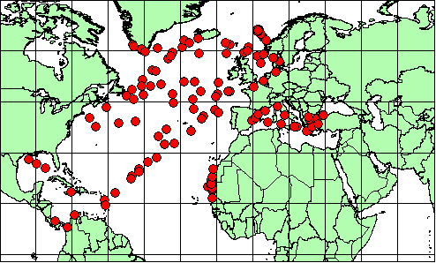
Fig. 3. Upper-air data from the North Atlantic and the Mediterranean in
February 2003. Reproduced from the EUCOS information page.

In 2003 two more ships on the route Bremerhaven to Houston will be equipped as ASAPs. Yet antother unit is expected on the route in 2005. The southerly Atlantic route from the Mediterranean to the US eastern seaboard will also be utilized for ASAPs. All in all this will mean a substantial better coverage of ASAPs over the Atlantic, and also a much improved potential for soundings in the Gulf of Mexico.

