WORLD METEOROLOGICAL ORGANIZATION  _____________ |  | INTERGOVERNMENTAL OCEANOGRAPHIC COMMISSION (OF UNESCO)  ___________

JCOMM SHIP OBSERVATIONS TEAM
FIRST SESSION

Goa, India, 25 February - 2 March 2002

NATIONAL REPORTS

OCA website only:
http://www.wmo.ch/web/aom/marprog/publications_technical.html

WMO/TD-No. 1121

2002

JCOMM Technical Report No. 17
C O N T E N T S

Note: To go directly to a particular national report, click on the report in the "Contents". To return to "Contents", click on the return arrow ← in Word.

The Voluntary Observing Ship Programme in Argentina 1

National Report on Australia's Ship Observation Programmes 6

National SOT Report: Canada 15

VOSP - Report by France - 2001 22

SOOP activities: France National Report 2000/2001 24

Annual National ASAP Report (France) 41

National Report Germany, VOS 43

Ship-Of-Opportunity Activities in Germany 2000/2001 (separate file - 48 MB) 48

National Report Germany, ASAP 64

National Report of Greece 68

National Report of Iceland 69

National Report of India: VOS activities 71

Israel National Report for SOT-I 72

Italian Report on the Mediterranean Ships of Opportunity Program 73

National Report of Japan 76

Kenya: Western Indian Ocean VOS/SOOP/ASAP Project (WIO-VOSA) Project Proposal 94

Voluntary Observing Ships Program in Malaysia 100

Status of Ship-based Observations in Russia 104

National Report, United Kingdom 107

United States SOT-1 Report 113

N O T E

The designations employed and the presentation of material in this publication do not imply the expression of any opinion whatsoever on the part of the Secretariats of the Intergovernmental Oceanographic Commission (of UNESCO), and the World Meteorological Organization concerning the legal status of any country, territory, city or area, or of its authorities, or concerning the delimitation of its frontiers or boundaries.
SERVICIO METEOROLOGICO NACIONAL –F.A.A.-

The Voluntary Observing Ship Programme in Argentina

The Servicio Meteorológico Nacional (SMN) of Argentina has recruited Selected ships under the Voluntary Observing Ship Programme of the World Meteorological Organization (WMO) since the mid 20 th Century. The meteorological data in WMO SHIP code thus obtained represent the main source of real time information for weather analysis, forecasts and warnings for the harbours, coastal waters and open seas under the responsibility of the SMN and provide important inputs to the regional numerical weather prediction model produced by our Organization for some decades now.

STATUS

During the 1990´s the number of recruited ships by Argentina amounted, in average, to 15 (fifteen) units. Unfortunately, this figure dropped dramatically in the last few years, participating at present only 4 (four) vessels in the WMO VOS Programme. The following table provides an overview of the significant decrease in terms of ships recruited and meteorological observations received in WMO SHIP code at the SMN.

Year | 1998 | 1999 | 2000 | 2001
Number of ships  recruited | 6 | 5 | 5 | 4
Total number of meteorological observations in SHIP code | 1368 | 1290 | 2213 | 644

Note: an updating of the International List of Selected, Supplementary and Auxiliary Ships – WMO N° 47 - including this new status is in process and will be submitted to the WMO Secretariat in the short term.

The figures above are far from satisfying the SMN expectations for an efficient meteorological coverage of the South-West Atlantic area. This lack of basic data is attributed to the following facts:

- The number of merchant ships has steadily and remarkably decreased during the last years due to the closure of merchant companies;
- Successive changes in the ships ownership and widespread use of flag of convenience;
- Privatization of the Governmental maritime companies;
- Reduction in the number of crew members. This fact forces the crews to put the strength on navigational tasks rather than any other activities such as the meteorological observation on board, which is only done during the short spare time they have, or may even be omitted;
- Conversely, the number of foreign fishery vessels has increased during the same period; however, economic as well as legal reasons induce their owners not to provide any meteorological information that could reveal their geographical position to the local authorities;
- Ship companies claim not to be able to take up meteorological tasks due to budgetary constrains;
- Ships navigating in our area do not follow a fixed schedule of operations;
- There are no regular routes Westward-Eastward or viceversa;
- The routes of the recruited vessels are, mostly, parallel to the coast.

In view of this dramatic situation, the SMN of Argentina enforced some years ago, and encompassed with the first signals of the decline, a promotional program among the national maritime agencies oriented to revert this unfortunate situation. The program consists in the preparation and issuing of promotional newsletters to all the ship companies registered in our country oriented to encourage their involvement in the WMO SHIP Program.

It is worth adding that the SMN of Argentina has, since the 1960´s, an annual award scheme for the VOS through which our Organization rewards the collaboration and contribution of ship companies, ship Masters and crews to the meteorological science.

Port Meteorological Officers

The SMN is well aware of the essential work of the national PMO (Port Meteorological Officer) services. In this sense and in order to strengthen its capabilities at the national level, the SMN includes in the Meteorological Inspector Course syllabus (delivered at the WMO Regional Meteorological Training Center (RMTC) Buenos Aires – component SMN-), practical and theoretical subjects for the PMOs training. The lectures delivered to the future Meteorological Inspectors include information on international regulations (SOLAS), WMO marine Programs (VOS, GMDSS), maritime telecommunications, instrumentation for ships, etc. .

However, and due to severe budgetary constrains, our Institution has been forced to transfer this trained personnel to other bases such us land synoptic stations, reducing to a minimum the number of PMOs in active duty. Nevertheless, the present staff of PMOs widely satisfies the requirements of services of the recruited ships.

Observations / Instruments

When visiting recruited vessels PMOs provide training in weather observing and in the use of meteorological instruments and WMO codes. Unfortunately, the only meteorological supplies provided to the recruited vessels at present are Ship Observations Logbooks.

No software packages are in use for the coding of VOS reports at present; however, it is in the interest of the SMN to develop a project oriented to adapt the softwares currently in use in some WMO member countries to the needs of our region.

The meteorological instruments on board ships are in all cases property of the ships´owners. The SMN repairs, contrasts and provide maintenance services to all the meteorological instruments used on board the recruited ships at the WMO Regional Instruments Center (RIC) – Buenos Aires -.

Telecommunications

The reports in SHIP code are transmitted in real time, from the recruited VOS to the SMN via Inmarsat-C (at the expense of the ship´s owners) and in Ship Observations Logs in delayed time mode.

At the moment the SMN is working on a technological development to input the SHIP reports received via Inmarsat-C into its operational data base and into the WMO Global Telecommunication System (GTS).

On the other hand, VOS reports received via the GTS at the WMO Regional Telecommunication Hub (RTH) Buenos Aires are automatically plotted, in real time, in the weather synoptic charts and storaged in the SMN data bases.

Quality control

At present, quality controls are not applied to the SHIP reports received from the recruited vessels and no digitizing or analysis of the marine meteorological data currently stored in paper logbooks has been performed until the present time. However, a joint program between the SMN and the SMARA (Servicio Meteorológico de la Armada Argentina) is under study for the implementation of these tasks in the future.

Marine Services provided by the SMN

The marine meteorological services produced and broadcasted by the Servicio Meteorológico Nacional of Argentina, provide the necessary meteorological support to all the maritime activities taking place within the METAREA VI, in accordance with the responsibilities taken on by Argentina as a Member of the World Meteorological Organization (WMO) and as a signatory of the Convention for the Safety of Life at Sea (SOLAS).

With the same intention the SMN provides meteorological support to marine activities taking place in the Antarctic Ocean within the area limited by 60º South and the Antarctic coasts and 20º and 90º West, through its VCOM. MARAMBIO ANTARCTIC METEOROLOGICAL CENTER (CMAVM) - Base Marambio - Antarctic Penninsula-.

Each Center issues two Weather Bulletins for Shipping per day, in Spanish and English. The broadcasting of such information is done according to the schedules published in WMO publication Nº 9, VOLUME D “WEATHER REPORTING INFORMATION FOR SHIPPING”. The marine meteorological services are broadcasted by an integrated system composed by the SMN, the Argentine Coast Guard (PNA) and the governmental radio station -Radio Nacional- .

The means of transmission of the Weather Bulletins for Shipping are the NAVTEX system (518 kHz); Internet through the SMN web sites at http://www.meteonet.com.ar and http://www.meteofa.mil.ar, a system that additionally enables marine users to have access to satellite weather images, weather maps and meteorological radar images and information. Marine users also have round the clock access to forecasts and warnings via telephone and facsimile.

On October 1, 1992, the SMN started the transmissions of the English version of the Weather Bulletins for Shipping issued by the RSMC Buenos Aires via Safetynet-INMARSAT; two years later the Bulletins issued in English by the CMAVM were included in these satellite transmissions. To achieve this aim, the Bulletins issued by each Center are concentrated at the Regional Telecommunication Hub (RTH) Buenos Aires and transmitted via the WMO Global Telecommunication System (GTS) to the World Meteorological Center (WMC) Washington, which in turn retransmits the mentioned Bulletins to the Coastal Earth Station Southbury (U.S.A.) for AOR W.

The message headers are WWSTO2 SABM and WWAAO2 SAWB for the Bulletins issued by the RSMC Buenos Aires and by the CMAVM, respectively.

The first pair of products is broadcasted at 02:30 UTC and the second at 17:30 UTC as stated in the transmission Schedule for Full Global Maritime Distress and Safety System (GMDSS) Service.

The Bulletins issued by the RSMC Buenos Aires and the CMAVM follow the structure below:

- Heading in “C” Code:
1:31:06:01:00
SECURITE

- Contents of the Bulletins:
PART ONE: GALE WARNING
PART TWO: SYNOPTIC SITUATION
PART THREE FORECAST FOR
a) COASTAL AREAS
b) OCEANIC AREAS

- Both Centers issue their products twice a day according to the following schedule:

PARTS OF THE BULLETINS MORNING EVENING

- GALE WARNING 09:00 UTC 21:00 UTC
- SYNOPTIC SITUATION 09:00 UTC 21:00 UTC
- FORECASTING TIME 12:00 UTC TO 06: UTC 00:00 UTC TO 18:00 UTC
PERIOD OF 18 HOURS

Users´ feedback

In response to national biannual surveys, the maritime companies have reported the effectiveness in quality and timing of our marine meteorological services, a fact that encourages our Organization to continue promoting the WMO VOS Programme for the benefit and safety of the human life and property at sea.

METAREA VI
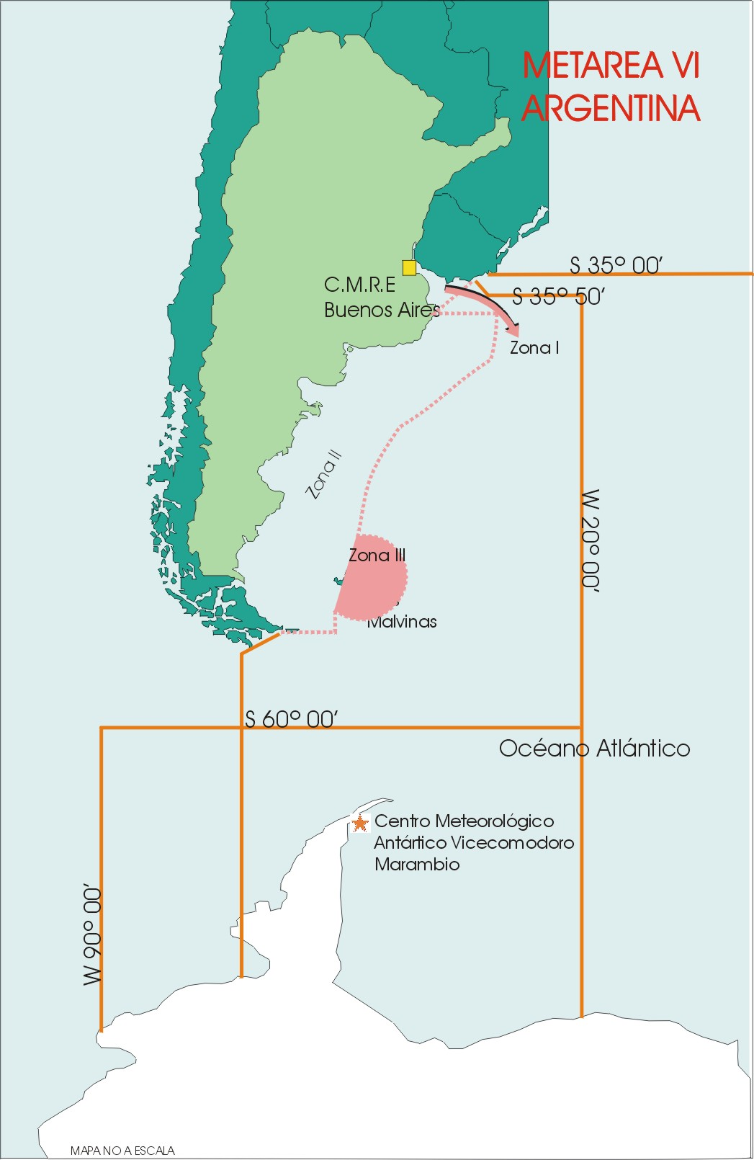

National Report on

Australia’s Ship Observation Programmes

By Graeme Ball and David Evans (Bureau of Meteorology), and
Rick Bailey (CSIRO Marine Research)

National Objectives and Partners

- The principal objective of the Australian ship observations programmes is to provide timely and quality marine meteorological and oceanographic data to support operational and research applications including:

  - marine and climate forecasting;
  - baseline monitoring;
  - defence;
  - safety at sea;
  - fisheries;
  - climate and oceanographic research.

- The programme involves the BoM, CSIRO and RAN.

Collaboration

- Australia collaborates with the following international agencies to operate or implement its ships observation programmes: SIO; NIWA; AOML; NOAA; IFRTP; IRD; CNES; NIO; NIES; UKMO; MSNZ; SAWS; Universite Pierre et Marie Curie; Météo France.

Voluntary Observing Ship Programme (VOSP)

- The AVOF consists of 89 Australian and foreign owned merchant, passenger and fishing vessels (at 31 January 2002), comprising 85 Selected vessels, 2 Supplementary vessels and 2 Auxiliary vessels.

- The national goal is to maintain an AVOF of 100 vessels performing on average 2 marine meteorological observations per day.

- The AVOF does not include RAN vessels, however the BoM liaises closely with the RAN and provides support to their meteorological observations programme.

- Australian research vessels, previously members of the AVOF, were decommissioned in 2001 due to a poor history of reporting.

- Selected and Supplementary AVOF vessels are equipped with certified meteorological equipment:

- Marine temperature screen,
- Two Mercury-in-glass thermometers,
- Digital Aneroid barometer,
- Seven-day barograph.

- With the exception of vessels equipped with a ShipAWS (see para. 10), all vessels are encouraged to report true wind derived from the state of sea. Wind observations performed in this way are not adjusted for height.

- Automatic Weather Stations are installed on eight vessels of the AVOF.

  - The ShipAWS is the BoM’s second-generation shipboard AWS system. Based on a Vaisala Milos 500 AWS, it includes sensors for air pressure, air temperature, humidity, and wind speed and wind direction. Connections are provided to a GPS and the ship's compass to enable the true wind to be derived from the apparent wind, which remains uncorrected for height. A laptop computer displays the current and averaged weather details, and also provides the facility for the manual entry of the visual parameters to complete the BBXX. Transmission of the BBXX is by a dedicated Inmarsat C terminal. The ShipAWS is installed on 6 ships of the AVOF with 2 more in the advanced planning stage. The goal is to expand the network by up to 3 units per year.

  - The AMDCP was the BoM’s first-generation shipboard AWS, and was based on proven buoy technology and the Argos system. A small handheld device is provided for the manual entry of the visual parameters to complete the BBXX, and complement the remotely sensed air pressure and air temperature data. The fleet of AMDCP equipped vessels has decreased over the past few years as the AMDCPs have gradually been upgraded to the more economical ShipAWS.

- The TurboWin software developed by KNMI is progressively being installed throughout the AVOF. It is currently installed on 16 vessels, with the older Turbo1 used on 7 vessels. The BoM has developed installation and operating instructions for TurboWin that are distributed on CD with the software.

- Australia is committed to VOSClim, and aims to have 12 vessels recruited by December 2002. There are 6 TurboWin equipped vessels currently participating in VOSClim, and it is expected that ShipAWS equipped vessels will be considered for VOSClim once the ShipAWS can generate IMMT-2 messages in addition to BBXX. The BoM has provided further support towards the establishment of VOSClim by developing the paper and electronic VOSClim recruitment forms.

- The BoM operates a PMO network using contracted part-time personnel to service the AVOF and other VOS vessels at the major ports in Sydney, Melbourne and Fremantle. At the major ports in the other states, full-time Bureau personnel from the Regional Offices provide a limited PMO service upon the request of the Master. A limited PMO service is also provided at some provincial ports by full-time staff from the nearby Meteorological Offices.

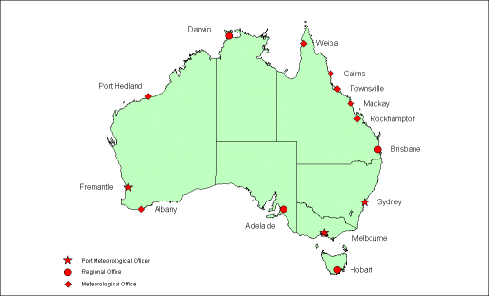
Figure 1. Australian PMO network.

Ship-of-Opportunity Programme (SOOP)

- The Australian SOOP activities involve the CSIRO, RAN, BoM and JAFOOS. The latter is a joint CSIRO/BoM initiative, and has a coordination, data assembly, data analysis and scientific network design function.

- Coordination of the national activities internally and externally occurs on three fronts:
- Bureau – CSIRO/BMRC JAFOOS Upper Ocean Thermal Coordination Group (Monthly)
- National SOOP Coordination Panel (Annual)
- International JCOMM Ship Observations Team (Biennual)

- The BoM operates the low density and frequently repeated, upper ocean thermal sampling lines using merchant vessels, and relies on the ships’ crews to voluntarily launch the approx 2000 XBTs/yr according to specified sampling programmes. Ship greetings are provided by the PMOs.

- The volatile nature of the shipping industry contributes to a high turnover of SOOP vessels, and the sometimes subsequent and unavoidable loss of XBT data. Imminent changes to the BoM’s XBT SOOP network involve the decommissioning of the Montreal Senator (3 March 2002) due to its inability to maintain schedule, and the temporary use of the P&ONL Adelaide on IX01 until a suitable replacement for the Montreal Senator is identified and recruited.

- CSIRO operates the high-density upper ocean thermal (XBT) lines in collaboration with other agencies (e.g. SIO, NIWA, CNES). A scientists/technician is usually placed on the vessels to meet the increased sampling requirements. Approx. 1200-1500 XBTs are launched each year. Ship greeting is performed by technicians and/or the ship-riders.

- The Australian XBT SOOP lines are as follows:

IX01 Fremantle to Sunda Strait (freq) (BoM)
IX12 Fremantle to Red Sea (low) (BoM)
IX22/PX11 Japan/Korea to Fremantle (low) (BoM)
IX28 Hobart to Dumont D’Urville (high) (CSIRO)
PX02 Flores Sea to Torres Strait (low) (BoM)
PX30 Brisbane to Fiji (high) (CSIRO)
PX32 Sydney to Auckland (low) (BoM)
PX34 Wellington to Sydney (high) (CSIRO)

- At the time of SOT-1, the Australian XBT SOOP comprised the following vessels:

Iron Kembla VJDK IX22/PX11
Iron Yandi VNVR IX22/PX11
Montreal Senator 9MCN6 IX01
P&ONL Adelaide C6RJ6 PX02
P&ONL Salerno ELYE9 IX12 and PX32
Contship Ambition P3GU7 IX12 and PX32
Contship Action DLHV IX12 and PX32
Forum Samoa 5WDC PX30
Fua Kavenga A3CA PX30
Wellington Express MWSD3 PX34
Franklin VJJF PX30 and PX34
L’Astrolabe FHZI IX28

- The RAN launches around 2000 XBTs/year in regional waters surrounding Australia in broadcast mode for its operational/tactical requirements, and also contributes 2500 XBT probes to the BoM and CSIRO programmes. The RAN XBT data are unclassified and distributed in real-time on the GTS.

- The XBT systems used to record the data by the agencies are as follows:

Agency | Data Recorder | XBT Probe | XBT Software
BoM | Sippican MK9 | Sippican  Deep Blue | MS-DOS, adapted from CSIRO
CSIRO | Sippican MK12 | Sippican Deep Blue | MS-DOS, In-house development
RAN | Sippican MK12 | Sippican T4,T7,T10 | Windows NT, based on Sippican MK12

- CSIRO uses the Seabird thermosalinographs on its research vessels to measure sea- surface temperatures and salinities, and on a polar supply vessel operating on line IX-28 (IX-1 also planned).

Automated Shipboard Aerological Programme (ASAP)

- WRAP was designed to provide routine upper air soundings en-route from Europe - Cape of Good Hope - Australia - New Zealand - Cape Horn - Brazil – Europe as shown in Fig. 2. A voyage lasts around 85 days, of which approximately 55 days are spent in the Southern Hemisphere.

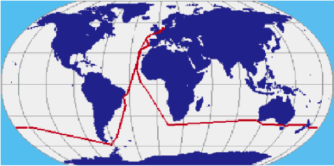
Figure 2. WRAP route

- WRAP commenced in the first half of 2001 with the M.V. Palliser Bay operating out of the UK with international support funding. The BoM sponsors 2 soundings per day between 60E to 160E, and also provides first-in maintenance at Australian ports.

- There have been 4 completed WRAP voyages, however the immediate future of WRAP is uncertain due to the scrapping of the M.V. Palliser Bay (together with its 5 sister ships by Oct 2002). A suitable replacement vessel has not yet been found.

- Impact analyses indicate the WRAP data have had a consistently greater impact on the models than all Australian stations, with the exception of Macquarie Island (54S 159E).

New Programs

- CSIRO is developing and implementing multidisciplinary (biogeochemical) observing capabilities from merchant vessels on a number of shipping lines.

  - A pilot underway bio-geophysical (T, S, Fluorescence, light, pigment) sampling project on a vessel circumnavigating Australia for calibrating and developing remotely sensed ocean colour algorithms is to be implemented routinely in 2002 on a vessel operating between Australia and Singapore on line IX-1.

  - CSIRO is collaborating with NIES of Japan on measuring atmospheric pCO₂ between the east coast of Australia and Japan on line PX-5.

  - CSIRO plans to collaborate with the Universite Pierre et Marie Curie of France on measuring atmospheric pCO₂ between the Australia and Antarctica on line IX-28.

- CSIRO and the Bureau, under the guidance of JAFOOS and the Australian Argo Science Plan, will deploy profiling floats in the Indian Ocean later in 2002 to expand on the CSIRO pilot array off the NW of Australia and in support of the International Argo Program. The deployment of these floats is designed to complement the unique capabilities of the XBT upper ocean thermal sampling network, which in itself is being redesigned to complement the broadcast sampling capability of the floats.

Data Management

- Almost 50000 real-time SHIP messages were distributed on the GTS from the AVOF during 2001 (fig. 3), and include fully automatic, fully manual and combined automatic/manual messages. The BoM applies minimal quality control to messages received on the GTS before archival.

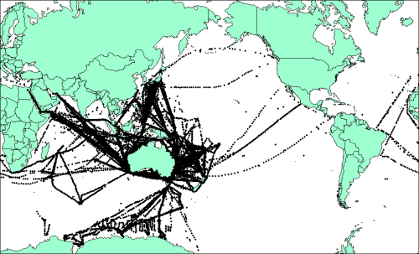
Figure 3. Distribution of SHIP reports from the AVOF in 2001.

- The Australian SOOP collected over 3000 XBT profiles in 2001. A summary is given in Attachment 1, whilst Fig. 4 shows the distribution of the profiles.

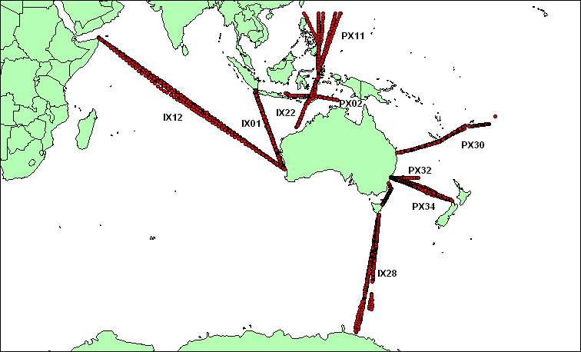
Figure 4. Distribution of XBT profiles from the Australia’s SOOP in 2001.

- The delayed-mode data from CSIRO SOOP vessels are scientifically quality controlled and archived by CSIRO. Real-time data is placed on the GTS at the end of the voyage by SIO in the US.

- Quality control is performed using QUEST software, jointly developed by CSIRO Marine Research (CMR) and the Bureau of Meteorology’s Research Centre (BMRC). This software can graph individual XBT profiles, adjacent profiles, archived profiles and climatology, and allows a statistical analysis of all available data to identify real oceanographic features and erroneous data. The original profile plus any quality flags identifying real or erroneous features are coded into the data set and stored in MEDS-ASCII format. Data are routinely and timely distributed to national and international archives.

- CSIRO/BMRC JAFOOS operates the Indian Ocean Science Centre for the JCOMM/IODE Global Temperature and Salinity Profile Programme (GTSPP) and provides quality control on the entire Indian Ocean Upper Ocean Thermal data set. Figure 5 shows a typical annual distribution of upper ocean thermal data in Indian Ocean.

- Delayed-mode data biogeochemical data from CSIRO are quality controlled and archived by CSIRO.

- Real-time BATHY messages from the BoM’s SOOP are transmitted to shore via Service Argos and inserted on the GTS by Météo France after initial processing by Service Argos in Toulouse. The delayed-mode full-resolution data are collected by ship greeters and forwarded to the Bureau’s Marine Observations Unit, where system level quality control is performed as soon as practicable after completion of the transect using QUEST.

- The Marine Observations Unit also identifies test drops and duplicate BATHY messages which might be released on the GTS. This information is provided to MEDS and the SOOPIP Technical Coordinator on a quarterly basis.

- On the basis of the system level quality control, technical staff attend to shipboard XBT equipment problems at the next opportunity, and the ship greeters are briefed to provide feedback to the ship’s XBT operators.

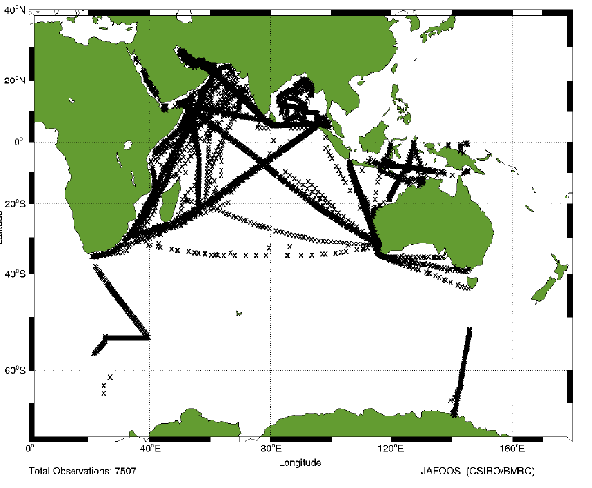
Figure 5. The 1996 Indian Ocean Upper Ocean Thermal data set.

- Once the full-resolution data have undergone system level quality control, the data are passed to JAFOOS for scientific quality control and archiving, and routinely sent to the national and international data centres.

- Real-time BATHY messages are received from the RAN and distributed on the GTS by the BoM in Melbourne. The delayed-mode data from RAN ships are quality controlled and archived by AODC.

- Australia participates extensively in a number of related international marine and oceanographic data management programmes and projects, such as the International Oceanographic Data Exchange (IODE),
Instrument Development and Evaluation

- The CSIRO and the Bureau are currently involved in the development of a new shipboard, windows based XBT software system, capable of interfacing the latest PCs to the older Sippican MK9 data recorders, and an as yet to be completed purpose in-house designed USB data recorder. The system will include satellite-based communications to satisfy the international requirements to distribute the data in real-time on the GTS. Initially it is expected that only the low-resolution data will be available in real-time on the GTS, although it is anticipated that the full-resolution dataset will eventually be distributed in this manner.

- In parallel with the development of the new shipboard XBT system is a review of alternative satellite communication systems including: FedSAT, Inmarsat and Iridium.

- CSIRO is progressing with the development of the CSIRO Lo-Flo Co₂ Analyser used on land for atmospheric pCO₂ measurements for observing ocean pCO₂ from vessels whilst underway. The system has been designed to be more compact and require smaller calibration samples than existing units, making it more ideal for shipboard installation. The prototype will be tested from a research vessel in April 2002 and later in the year deployed on a polar supply vessel operating on line IX-28 between Australia and Antarctica.

- The BoM’s Regional Instrument Centre (RIC) provides calibration and testing facilities for meteorological instruments and electronic sensors. The RIC also houses the regional pressure standard.

- CSIRO provides the opportunity and undertakes regular sea trials to test marine instruments and systems using its research vessels. This includes extensive scientific analysis and evaluation of XBT recorder and sensor systems in collaboration with other members of the international SOOP.

Research and Applications

- Research and development associated with the marine observing systems is undertaken by the CSIRO/BMRC JAFOOS. Projects include:

  - Observing network design and review (e.g. Global Upper Ocean Thermal Network)
  - Design of an integrated in situ (XBT, float) and remotely sensed (altimeter) observing system
  - Design an implementation of an Australian Argo profiling float array
  - Regional climatologies of upper ocean thermal and salinity properties
  - Model and analysis system development
  - Data management and processing systems

- Scientific analysis of the data is undertaken by CSIRO Marine Research and the Bureau of Meteorology Research Centre (BMRC).

- The real-time data is utilised in operational analysis and forecasting systems for weather and climate by the National Meteorology and Oceanographic Centre (NMOC) at the Bureau of Meteorology.

- The real-time data are utilised in routine environmental analyses for fleet operations by the METOC Services at the RAN and for input into onboard, tactical response systems.

Capacity Building

- The BoM conducts biennial training workshops for personnel involved in providing PMO services. At the international level, the BoM organised the Second WMO PMO Training Workshop (RAs II and V, 1999, Melbourne), and provided a lecturer for the Third WMO PMO Training Workshop (RA I, 2000, Cape Town).

For Further Information

http://www.marine.csiro.au/JAFOOS

http://www.bom.gov.au/marine/marine_obs.shtml

http://www.aodc.gov.au

http://www.marine.csiro.au
http://marine.csiro.au
http://www.bom.gov.au

 |  |  |  |  | Attachment 1
XBT Summary Report - Australia
January - December 2001
Line Number | Callsign | Sections | Total Drops | Good Drops | Messages Sent
IX1 | 9MCN6 | 11 | 316 | N/A | 286
 | C6RJ6 | 8 | 186 | N/A | 162
 | Sub Total: | 19 | 502 |  | 448
IX12 | DLHV | 3 | 176 | N/A | 164
 | ELYE9 | 5 | 329 | N/A | 283
 | P3GU7 | 3 | 188 | N/A | 166
 | Sub Total: | 11 | 693 |  | 613
IX22/PX11 | VJDK | 6 | 290 | N/A | 253
 | VNVR | 4 | 194 | N/A | 168
 | Sub Total: | 10 | 484 |  | 421
IX28 | FHZI | 6 | 400 | 377 | 377
 | Sub Total: | 6 | 400 | 377 | 377
PX2 | C6RJ6 | 13 | 190 | N/A | 168
 | Sub Total: | 13 | 190 |  | 168
PX30 | A3CA | 1 | 105 | 100 | 100
 | VJJF | 1 | 154 | 150 | 150
 | 5WDC | 1 | 102 | 98 | 98
 | Sub Total | 3 | 361 | 348 | 348
PX32 | DLHV | 4 | 46 | N/A | 34
 | ELYE9 | 6 | 74 | N/A | 63
 | P3GU7 | 4 | 54 | N/A | 46
 | Sub Total: | 14 | 174 |  | 143
PX34 | MWSD3 | 4 | 269 | 261 | 261
 | VJJF | 1 | 70 | 69 | 69
 | Sub Total: | 5 | 339 | 330 | 330
 | Grand Totals: | 81 | 3243 |  | 3038
Key to XBT Vessels
9MCN6 Montreal Senator | ELYE9 PONL Salerno |  | VJDK Iron Kembla VJJF Franklin
C6RJ6 PONL Adelaide | P3GU7 Contship Ambition |  | VNVR Iron Yandi FHZI L’Astrolabe
DLHV Contship Action | MWSD3 Wellington Express |  | A3CA Fua Kavenga 5WDC Forum Samoa

Feb. 2002

NATIONAL SOT REPORT: CANADA

1. NATIONAL PROGRAMME INFORMATION

a) National and International Objectives

Canadian researchers are engaged in atmospheric and oceanographic research in Canadian waters to understand and relate the physical environment to climate, and fisheries issues. The Atlantic Zonal Monitoring Programme (AZMP), described in the last SOOP report has begun. Its goal is to provide a greater degree of oceanographic and some meteorological data integration and management. To this end, researchers have increased the flow of real-time T, S, oxygen and fluorescence profile data. Other variables including nutrients and chlorophyll measurements cannot be exchanged as quickly because of the time required to carry out the analysis. The AZMP has established a series of standard sections and stations to monitor these variables (figure 1). The programme also includes measurements of sea level at 8 stations, fish survey data, ice reports, remote sensing and climate indices of various kinds. Data and analyses are being made available through a public web site (www.meds-sdmm.dfo-mpo.gc.ca follow links to national programmes, ZMP). The site is updated every 2 weeks.

Canada expects to contribute approximately 150 profiling floats to the Argo programme. At the moment, more than 30 floats are operating, most on Canada's west coast, a few from the east coast and one was deployed in the Indian Ocean in collaboration with Indian colleagues. These data are inserted onto the GTS with upwards of 90% going to the GTS within 24 hours of the float surfacing. Data and information about the Canadian program, and some information about the international program are available from
http://www.meds-sdmm.dfo-mpo.gc.ca/meds/Prog_Int/argo/ArgoHome_e.html

MEDS assists researchers in the Department of Fisheries and Oceans in providing data in real-time. In most cases, the data are sent to MEDS and we carry out initial quality control, reformatting to JJVV or KKYY code forms and upload the data to the GTS.

MEDS provides resources to support the GTSPP, which is a contributor to SOOP. The objectives of the GTSPP are well known; they are to improve the timeliness and quality of ocean profile data. Canada has benefited from this participation through closer ties to international programmes that are responsible for collecting data in waters of interest to us, in exchanging data and information on data collection, and in analysis practices and concerns with scientists internationally.

b) Collaborating Agencies

Bedford Institute of Oceanography, Institut Maurice Lamontagne, Northwest Atlantic Fisheries Centre, Institute of Ocean Sciences: Contribute oceanographic data from research vessels, drifting buoys and profiling floats as well as other kinds of data (to AZMP).

Figure 1: Map of station and sections sampled as part of the AZMP.

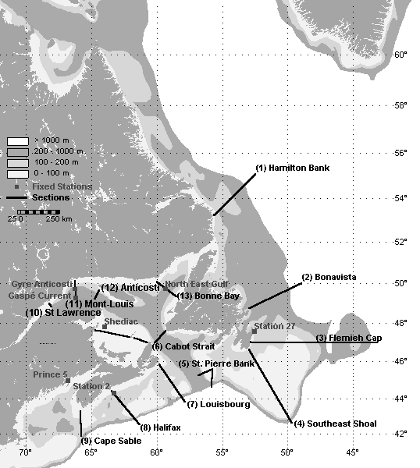
The Canadian navy contributes real-time BATHYs to the GTS and delayed mode XBT profiles to MEDS.

MEDS contributes data processing and management resources for the real-time and delayed mode data from Canada and real-time data from the world.

c) Funding Support and Status

Funding for oceanographic and fisheries research programmes come from operating budgets for the various Institutes in the Department of Fisheries and Oceans. Funding of MEDS activities come from government provided operating budgets. These budgets are continuing at least at present levels. Funding of the AZMP is from a special allocation, which is expected to continue for at least another 2 years. Funding for Argo is also from a special operating budget.

GCOS Panels have stressed the requirement for long term maintenance and selective enhancement of the WMO Voluntary Observing Ship (VOS) program. The Canadian VOS program has, however, suffered from financial reductions imposed in recent years and the number of recruited ships has declined to 275 today with this trend being expected to continue. In the face of this reality, Canada has recently undertaken a major initiative aimed at installing automated observing systems on VOS. Currently 13 systems have been installed with a target of 75 in total. This automated VOS program (AVOS) will result in a dramatic increase in the quality, frequency and number of observations. In particular, all Canadian AVOS vessels will produce data that meet VOS Climate Project (VOSClim) standards with these observations being relayed on the GTS round the clock, at hourly or three-hourly intervals. Furthermore, emphasis is being placed on automating VOS that operate in data sparse areas and a substantial increase will result in observations from high latitude waters such as the Beaufort Sea and Eastern Arctic.

Meteorological observations from Canadian VOS are relayed, in real-time, on the GTS. Unfortunately, however, quality controlled data from these vessels have not been forwarded to the World Data Centre for a number of years. A major effort is currently underway to remedy this deficiency.

B. DATA COLLECTION

a) XBT Lines operated

Canada operates no XBT lines.

b) Other Sources of National Data

Both oceanographic and fisheries research cruises by Canadians collect data of interest to SOOP. The graphs in figures 2a and 2b illustrate the data receipts at MEDS since the last SOOP meeting. The part of the bar labeled "Match" represents those profiles that we received in both real-time (as BATHYs) and in delayed mode. Profiles marked "BATHYs" are ones for which we still only have the real-time data and for which we can (presumably) recover the full resolution profile. Profiles marked "BTs" represent delayed mode data received that we could not match to real-time data and therefore represent data collected but which were not distributed on the GTS.

It is obvious that a large fraction of XBT data collected by Canada does not get distributed on the GTS. This is because many of these data are collected by our navy and though some is contributed to the GTS, most is not.

Figure 2a: Matched and unmatched BATHY reports to XBTs received.
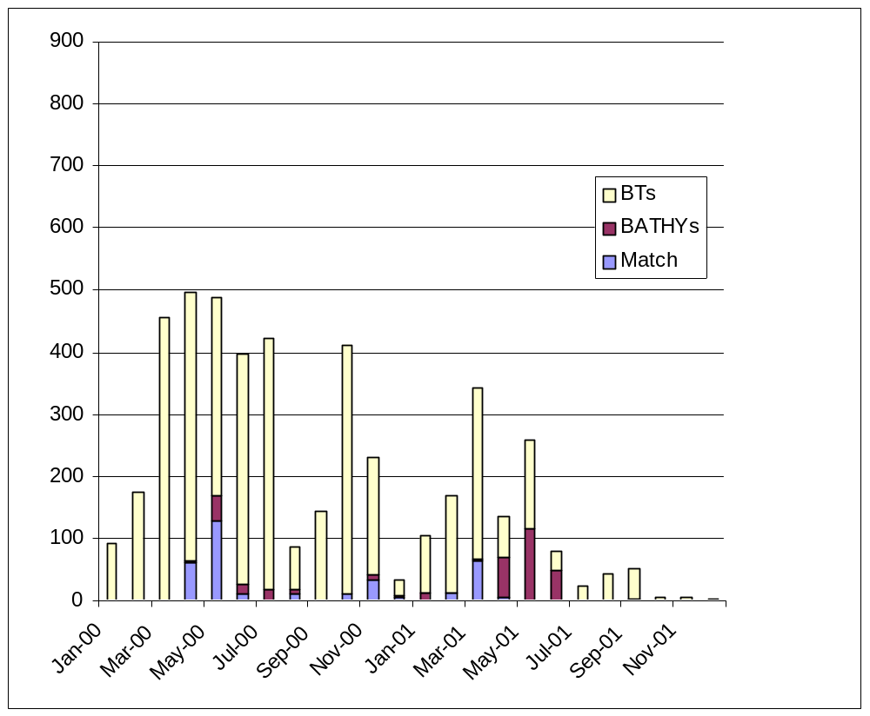

Figure 2b shows a similar display for TESACs. In this case we see a larger fraction of the TESACs distributed have been matched to delayed mode profiles. There are still significant numbers of profiles collected that do not get to the GTS, however. Just as for figure 2a, in more recent months the volume of delayed mode data is low simply because the data have not yet come to MEDS>

Figure 2b: Matched and unmatched TESAC reports to CTDs received.

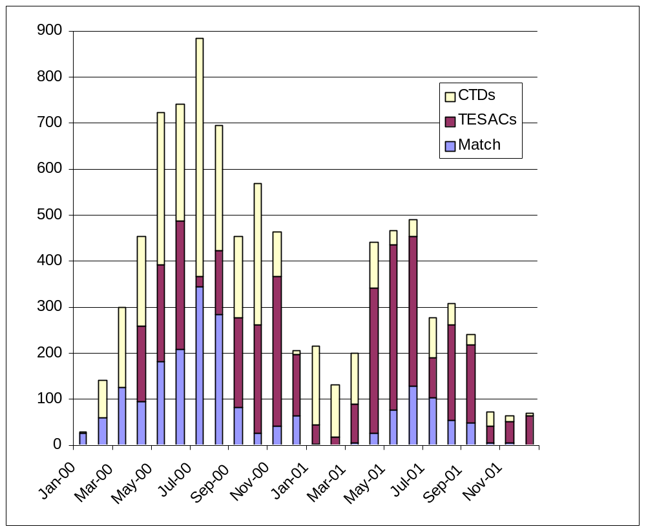
Canada is also archiving in real-time, data collected from oxygen and fluorescence probes deployed with CTDs. The value and reliability of these are being tested within the ZMP before more general availability is contemplated.

c) Instrumentation

Not applicable

d) Instrument Evaluations

BIO has been collaborating with a private company in the moving vessel profiler. Some information on this was presented at previous meetings.

e) Other Shipboard Instrumentation and Data Collection Activities

As described above, the ZMP programme is starting to exchange oxygen and fluorescence data from continuously sampling probes attached to a CTD. Both of these suffer from some calibration problems, but the relative values reported are reasonably reliable. Further work will be done to evaluate the utility of such observations and, hopefully, improve the reliability of the observations.

On Canada's west coast, pCO₂, chlorophyll, and associated physical variables are collected on Line P and at OWS Papa. The physical oceanographic data come to MEDS after some delay. We are presently working with our data management counterparts on the west coast to acquire the pCO₂ data.

3. DATA MANAGEMENT

Data management activities in Canada are a shared responsibility between MEDS and facilities in the research institutes (depending on the type of data). The data flow monitoring with regard to SOOP activities falls largely to MEDS. Each month MEDS provides a collection of reports either to SOOP or other international activities or agencies. A brief summary is given below.

- A report listing the real-time data received from each of Canada, US, Japan and Germany. This report lists numbers and types of reports and information about how they were sent on the GTS.
- A report summarizing data quality problems noted in the previous month in the real-time data stream. This report is sent to ship operators. It also includes a map showing where data were collected.
- A report of the progress in converting GTS reporting from the older JJXX, and JJYY code forms to the current JJVV form.
- Maintains a file of the history for each platform reporting in real-time each month. This records the number and types of real-time reports and if problems were sufficiently serious for the operator to be notified that month. Information from this file is included in the report described in ii.

MEDS also provides information about real-time data collected from the GTS on a series of web pages (www.meds-sdmm.dfo-mpo.gc.ca). Here can be found the following information.

- Maps showing the positions of all BATHY and TESAC reports from previous months. (link to international programmes, SOOPIP)
- Maps showing the number of months in which there is at least one profile in each 2x5 degree square in the previous month and over the previous 12 month period (link to international programmes, SOOPIP)
- Explanations of the current and new BATHY, TESAC and TRACKOB code forms including all relevant tables (link to international programmes, SOOPIP, J-COMM)
- Maps showing the locations of TRACKOB data reported in previous months (link to data and products, thermosalinograph)
- A Monthly Monitor report showing the locations of various kinds of ocean data collected in the waters around Canada (link to data and products, ocean profiles, monthly monitor)
- A document that describes MEDS processing and quality control procedures including the full text of the QC Manual (updates of IOC Manuals and Guides #22) as well as QC manuals from CSIRO and AOML.(link to international programmes, GTSPP, quality control)

MEDS has also been archiving TRACKOB data collected globally. We carry out very little quality control on these data but we do provide maps by month of where the data have been collected. These maps also distinguish between those reports with surface salinities and those without. These maps can be found on MEDS web site by following the links to Data and Products, Thermosalinograph.

a) QC Procedures (RT and DM)

MEDS employs the procedures described in IOC Manuals and Guides #22 including some updates. The complete description of the procedures that are used is found on MEDS' web site as described above.

b) Delayed Mode Data Submission status

Data are received continuously from our research institutes and updated as rapidly as possible. The figures in section B above shows the numbers of XBT and CTD data received from 2000 and 2001. As part of the ZMP initiative, we are working to accelerate delayed mode data delivery to MEDS from our East Coast so that all data of interest to ZMP will be in MEDS archives within one year of collection. Data collected by our West Coast institute are placed on their computer and to which MEDS has access. We periodically, (roughly every month) examine their disks for newly arrived or modified data and then capture these and place them in our archives.

MEDS has instituted a bimonthly exchange with NODC to improve our data handling. MEDS delivers data in GTSPP format to NODC and NODC delivers data in P3 format. MEDS sends all delayed mode data updated to its archives in the last month to NODC and NODC sends all non-Canadian data updated in the last 2 months and collected from the Canadian area of interest. There are still some delays in receiving data from NODC that we are trying to smooth out.

4. FUTURE PLANS

The ZMP is the programme that is the first entry into a truly multidisciplinary sampling and monitoring programme. We are continuing to refine the various data collection, exchange, archiving and distribution practices in this context. It is expected that the experience will be carried over into other programmes (such as related to climate) that are in planning.

As noted above, Canada is playing a significant role in Argo. The Canadian data management functions reside at MEDS with a special part of the present web site devoted to information about the profiling floats deployed by Canada. At the same time, since much of these data are coming through the present GTS we include information about the other floats that have been deployed.

5. FURTHER INFORMATION

6. RELATED NATIONAL WEB SITE LINKS
Through MEDS site (www.meds-sdmm.dfo-mpo.gc.ca) and following the links to national programmes, ZMP and links, you gain access to the research institutes web sites on Canada's East Coast. The major West Coast institute, IOS, can be reached at www.pac.dfo-mpo.gc.ca/sci.

7. RELEVANT REFERENCES AND PUBLICATIONS

VOSP – Report by France - 2001

1. OPERATIONS

Mid 2000, there were 83 vessels selected by Météo-France. At the beginning of 2002, there are 76. It confirms the regular decrease trend in reliable VOS availability. These ships are equipped:
i) 32 with conventional "manual" instruments,
ii) 25 with POMMAR data acquisition system (numerical display on deck),
iii) 19 with the BATOS automated data acqusition and transmission system.
Only BATOS (see below) provides a numerical output of the observations and an automatic emission of the SHIP message, even without any presence of an observer. The 24% of the fleet equipped with BATOS have provided more than 50% of the data acquired in 2001. BATOS has been installed on different kind of vessels: 6 oceanographic vessels, 4 ferries (including an high-speed ship), 1 tanker, 2 cargo ships and 3 trawlers.

DEVELOPMENTS

2.1 BATOS

The BATOS system was developed by Météo-France to equip the vessels selected by Météo-France within the framework of the VOS (Voluntary Observing Ship) programme of WMO.

This system was therefore primarily conceived to allow the vessels to produce automatic SHIP messages (with a programmable time-step from 1 to 6 hours) and full SHIP messages when an observer is available. A BATOS version running under WINDOWS is available since 2000. BATOS can also transmit underwater temperature profiles (using the BATHY code) and surface temperature/salinity records (TRACKOB message) if coupled to the appropriate device.

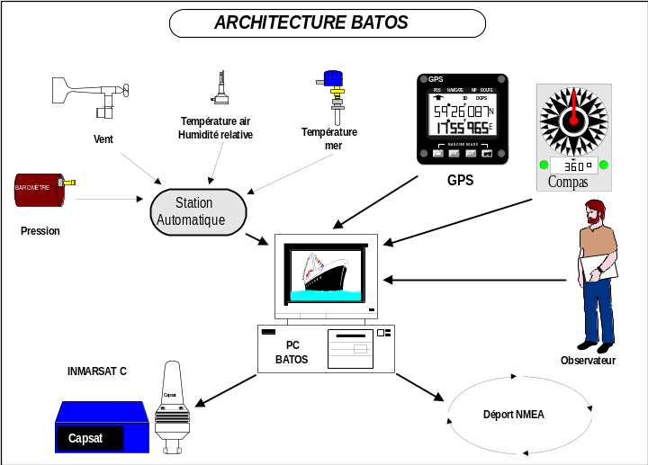

The BATOS system was conceived to satisfy the WMO recommendations with respect to marine observations and continuity with previous manual observations. It is built on a PC and a hub (labeled "station automatique" on the figure), both installed at the bridge. The major constraint is the wiring of all the sensors to the central unit and currently the space required by the system. The overall cost of an installed system is about 12k$.

2.2 MINOS

Considering that the main requirement from NWP is for surface pressure, it has been decided to develop a low-cost ship-independent data acquisition system, based on the experience gained with the drifting buoys. The prototype is shown on the figure below.

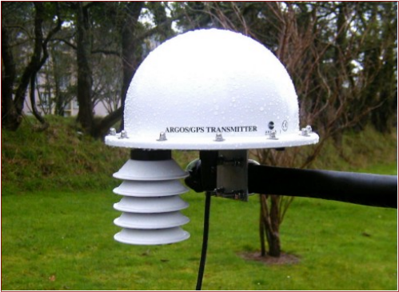

MINOS measures Pressure and air temperature only, and disseminates the data through the Argos system (half sphere in the figure above). It also includes a display on the ship’s deck. Installation takes only a few hours, the only difficulty being to draw cables for energy and display. Comparisons with BATOS demonstrated a good quality for pressure but the need for upgrades on temperature measurement, which are underway. Tests on ships will be performed in 2002.

SOOP activities : France national Report 2000/2001

- National Programme information

a) National and International objectives

Most of the French SOOP activities are achieved by the IRD network operated by the IRD Centres of Brest and Nouméa and covering the tropical part of the three oceans.

This programme is maintained under the general framework of the scientific objectives of the CLIVAR programme. The French contribution to CLIVAR in the tropical oceans is intended to improve our understanding of the role of the tropical ocean variability in the global climate variability with special focus on the regional impacts in Western Africa, Eastern South America and the West Pacific area.

The second aspect is the maintenance of an operational network of subsurface observations aimed at providing a continuous flow of data dedicated to an assimilation process in coupled Ocean/Atmosphere GCM. More specifically the in situ observations combined with those of the PIRATA network are part of the french CORIOLIS programme together with subsurface profiling floats (ARGO). Observations are combined with altimetric satellite observations in an assimilation scheme developed for the French MERCATOR programme, which is now operational since January 2001. Assimilation of subsurface observations will start in 2002.
see : http://www.mercator.com.fr/html/information/presentation/mission_en.html

b) collaborating agencies

- IRD for the management of the SOOP network
- IFREMER in the domain of data management mostly and underway measurements by the oceanographic fleet.
- Meteo-France for hosting harbour facilities, distributing data over the GTS and providing manpower on one line.
- CNRS in operating one line out of the tropical belt and buying a few probes.

c) funding support and status

The funding has two major parts:

- maintenance, development and manpower is funded by IRD under the framework of its scientific programmes. It is provided on an annual basis, the scientific plan of action being approved for a period of 4 years.
- Expendables (probes) are nearly exclusively provided by NOAA, therefore dependant on NOAA's budget and fiscal years. Manpower excluded, this represents the major cost of the programme.

2. Data Collection

Two majors type of data are collected:

  - subsurface temperature profiles using XBT
  - surface salinity using thermosalinograph

one round the world line is equipped for biogeochemistry

XBT lines operated

Atlantic Ocean

4 lines were operated in the Atlantic Ocean in 2000/2001

AX 01
A Danish vessel (Nuka Arctica) joins Denmark to Greenland. 7 cruises performed (responsible Gilles Reverdin). Issue: small number of Bathymessages due to the limitations of the ARGOS software in case of weak temperature gradients.

AX05
Two vessels (Fort Fleur d'Epée, Fort Royal, banana ships) embarking Meteo France observers started sampling on this line in June 2001. Very successful : 13 cruises and 348 probes. Risk of oversampling.

AX 11
The only vessel left on this line (Cap Verde) was sold and replaced by the Pasteur but the company refused the XBT equipment on board. One only cruise ends a 15 years sampling on this line.

AX15
Very good sampling by the two South African vessels operating on this line (Winterberg and Sederberg). Typical sampling rate: 4/day, 400 to 500 launches per year. To avoid oversampling one vessel launches probes during one leg only per cruise.

AX20
one vessel (Toucan) makes 6 cruise per year. Sampling on both ways. typically 250 XBT/year. An other vessel (Colibri) available but not equipped to avoid oversampling

The mean rate of successful drops for this ocean is around 84%

Indian Ocean

With the lying up of the tanker Autan the last line operated by IRD in the Indian Ocean (IX07) disappeared. In 2001 an attempt was done to reequip the Ariana chartered by the French Army on line IX03. It ended in failure due to lack of deck officers to drop probes.

The launches on lines IX01 and IX10 by the three round the world ships operated by Nouméa had to end in 2000, due to the decrease in the probe allocation by NOAA. One vessel only (Cs London) continues to sample on these lines as well as in the Atlantic (line AX03).

Pacific Ocean

IRD operates from its Centre in Nouméa three vessels who make round the world trips. One vessel (CS London) samples underway in the three oceans including lines AX03, IX01 and IX 10, the two others (CS Rome, CS Wahington sample only in the Pacific along lines PX17, PX28, PX30 (see maps). The typical number of cruises is 4 per year.

Two vessels operating in the Western Pacific (Coral Islander and Pacific Islander) sample lines PX05, PX53, PX04, PX12. The typical number of cruises is 5 per year for each vessel. Each of them is using roughly 400 probes per year.

The oceanographic vessel Alis completes this sampling around New Caledonia.

Other sources of national data

Navy: few transmissions. The Hydrographic Office is investigating the possibility of transmitting real time data from his vessels within the framework of Coriolis (responsible Eric Duporte)

Ifremer: All the major oceanographic vessels (Atalante, Thalassa, Suroit of Ifremer are equipped with acquisition systems transmitting in real time full resolution profiles through Inmarsat. Data are then put over the GTS by Meteo-France using the TESAC format. This effort was undertaken within the framework of the CORIOLIS and MERCATOR projects. A stock of XBT was bought by Ifremer for this purpose, and launches are achieved in the Atlantic, according to the needs and requirements of these projects. All these data can be directly accessed and freely retrieved through the CORIOLIS web server data service at http://www.coriolis.eu.org/coriolis/cdc/default.htm. Under way development will include cruise maps.

CNRS : A particular case is a three countries (France, Australia, USA) cooperative programme named SURVOSTRAL on the line IX28 (Hobart Dumont-d'Urville) and managed by CNRS for France. Results will be presented in the Australian report.

Instrumentation

For IRD all the acquisition systems are PROTECNO/Argos models ( BATHY code 21 and 22). The probes used are Deep Blue for IRD and T7 for the Nuka Arctica (BATHY code 042). Ifremer is using MK12 systems on his research vessels.

Thermosalinographs lines.

Atlantic Ocean

line AX 01
15 cruises were achieved by the Nuka Arctica. Real time transmission is done through GOES. Owing to the Bergen Geophysical Institute a hull ADCP was installed on the vessel. The vessel changed her route during winter 2001 and sampled the Bay of Biscay (5 cruises).

line AX03
operated by Noumea on three containers vessels achieving round the world trips at a mean rate of 4 cruises per year each.

line AX 11
the Cap Verde made one section in 200, before being sold. A thermosalinograph was installed on board the Pasteur who made 4 cruises in 2000 and 6 in 2001. An electric shock destroyed the acquisition system in late 2001 (2 cruises lost)

line AX 15
The Waterberg (renamed Maersk Constantia) is operating on this line (12 cruises). Two other vessels (Winterberg and Sederberg) are still collecting surface bucket samples analyzed in Le Havre.

line AX 20
Two vessels (Toucan and Colibri) are operating on this line and made 24 sections.

Comment: given the frequent sources of errors and malfunction of the TSG on these vessels our long term strategy is to equip at least two vessels per line to be sure to get at least one good transect per month.

Indian Ocean

the three Containers operated by Nouméa are sampling on lines IX01 and IX10 at a rate of 4 cruises per year for each vessel.

No other vessel could be equipped on other lines. The polar Institute vessel Marion Dufresne (servicing Kerguelen Islands) is equipped with a thermosalinograph and data are archived at Ifremer.

SURVOSTRAL cruises data will be presented in the Australian report

Pacific Ocean

Besides the three already mentioned containers achieving round the world trips,sampling on lines PX17, PX28, PX05, PX30, there are 4 vessels operating in the Western Pacific on PX05, PX53, PX04, PX12 (see maps).

All these vessels are equipped with real transmitter through the GOES system. Data are managed at AOML and put over the GTS.

one vessel (Lady Geraldine) is sampling between New Caledonia and the Loyalties.

other sources of national data

all the IFREMER vessels are collecting underway surface salinity data. The processing and archiving of these data is under way at SISMER (Brest). All the data are transmitted in real-time by Inmarsat on a daily basis. Meteo-France will insert data over the GTS using the TRACKOB format. the complete management system, including an on line interface similar to the ARGO and XBT systems, should be operational at Ifremer in less than one month.

instrumentation

For IRD operated vessels the acquisition systems are seabird sensors, the acquisition system in fully described in the "Users guide for thermosalinograph installation and maintenance aboard a ship" available on the SOOPIP web server.

The sampling resolution is 15 seconds, a median value being recorded on disk every 5 minutes. The real time transmission, if any, is one median value per hour. The spatial resolution, depending on ships speed, is therefore between one and two miles for delayed mode data

Biogeochemistry

The cruises undertaken in 1999 under the GEP&CO programme continued during 2000 and 2001. with a 4 cruises/year sampling. This programme will end in 2002. Complexity of the equipment requires a technician on board. Numerous parameters are measured (pigments, nutrients, CO2, alkalinity, reflectivity, atmospheric ΔC₁₃ . Line crosses the Atlantic and Pacific Ocean (Le Havre, New-York, Norfolk, Panama, Noumea). The vessel is the Contship London.

Data and results still in the scientific domain will be used too for cal/val activities of sea colour satellites.

All the details about this programme can be found at http://www.lodyc.jussieu.fr/gepco/gepco.html

3. Data management

a) data flow monitoring activities

XBT and salinity data collected and status of the network are available in continuously updated web servers at IRD Brest and IRD Nouméa.

- QC procedures

For XBT, QC as usual described in the documentation of the acquisition system and TOGA/WOCE Center manual. For salinities the QC is performed by the scientist in charge, no automatic procedure is used; it will require some documentation in the next version of DBMS.

- Data submission status

All the XBT data were transmitted

- in real time on the GTS by Meteo-France. Performance of the ARGOS system on the Atlantic network are variable.
- in delayed mode to the TOGA/WOCE Center (SISMER) in Brest who assembles both collections and transmits to the WDC.

Salinity data are managed at the Brest IRD Centre for the Atlantic and at Noumea for the Pacific. Brest adopted this year the same DBMS as Noumea (ORACLE) and all the data previously collected were transferred. This will facilitate future developments related to on line data access together with SISMER, who is in charge of managing the TSG of Ifremer oceanographic fleet. A recent meeting in Brest (USSSDAPP project, report available through the IOC electronic library) should lead to the implementation of a unified system of data management, validation and distribution.

For the Pacific also, a CD-ROM entitled "Three Decades of in situ Sea Surface Salinity Measurements in the Tropical Pacific Ocean" by T. Delcroix, C. Henin, F. Masia and D. Varillon is completed. The CD-ROM is based mainly on SSS data obtained through two IRD SOOP programs during 1969-1999, with additional data from IRD. Yearly data sets can be accessed directly on line at Noumea

biochemistry data are managed at IPSL (Université de Paris 6) and not yet in the public domain.

4. Future plans and developments

- XBT : maintain the system "as it", as long as required (evolution towards the ARGO system and follow new sampling strategies proposed by scientific Committees of different national and international bodies).

- For TSG the integration of Inmarsat transmission in the "thermo" software developed by IRD is under way. Plans are to interface the acquisition system for the vessels instrumented with the automatic meteo station BATOS developed by Meteo France. The two vessels concerned are the Antea (IRD oceanographic vessel) and the Colibri operating on line AX 20. Trackob messages should be put on the GTS by Meteo France.

- Indian Ocean : a scientific proposal is being submitted to a National Programme for funding, to revisit line IX03 (Red Sea, La Réunion) with one vessel equipped with XBT and a thermosalinograph (6 cruises per year). Investigations are under way to find the appropriate vessel.

5. Annexes

Yearly summary and maps of cruises for

- Atlantic Ocean 2000 XBT
- Atlantic Ocean 2001 XBT
- Atlantic Ocean 2000 TSG
- Atlantic Ocean 2001 TSG
- Pacific and Indian Ocean 2000 XBT
- Pacific and Indian Ocean 2001 XBT
- Pacific and Indian Ocean 2000 TSG
- Pacific and Indian Ocean 2001 TSG

Summary of bottle surface sampling and table of probes allocations

IRD Brest XBT data : summary for year 2000

Vessel | Ship Code | Line | Nb of cruises | Launches | Sent in  real time | Good drops | %
Cap Verde | ELVO3 | AX11 | 1 | 27 | 26 | 25 | 92,6
Nuka Arctica | OXYH2 | AX01 | 2 | 54 | 5 | 50 | 92,6
Sederberg | ZTSG | AX15 | 7 | 161 | 129 | 131 | 81,4
Toucan | FNAV | AX20 | 6 | 278 | 221 | 223 | 80,2
Winterberg | ZSPP | AX15 | 7 | 240 | 199 | 209 | 87,1
Total |  |  |  | 760 | 549 | 638 | 84

nb: figures may slightly differ whether the count is made by cruises (above) or strictly per year (below)

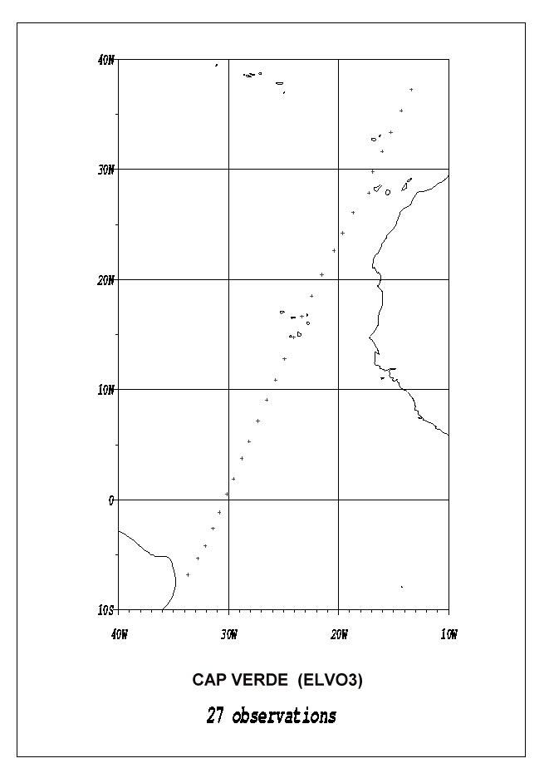 | 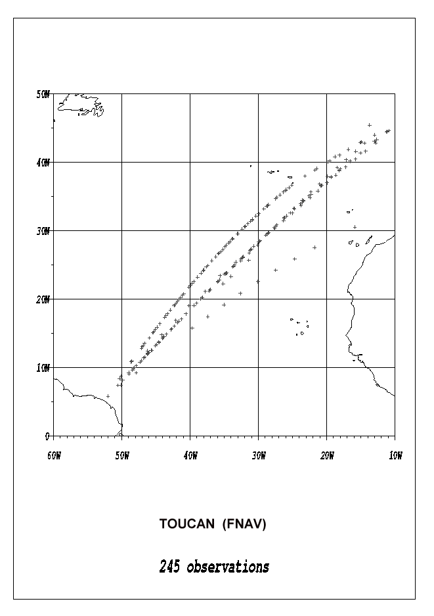 | 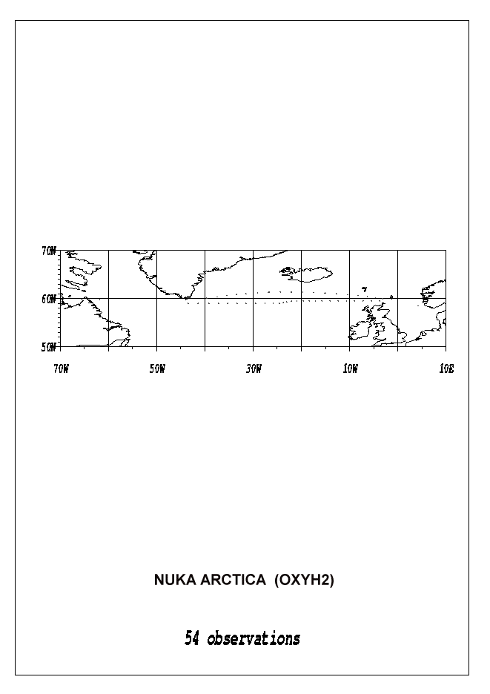
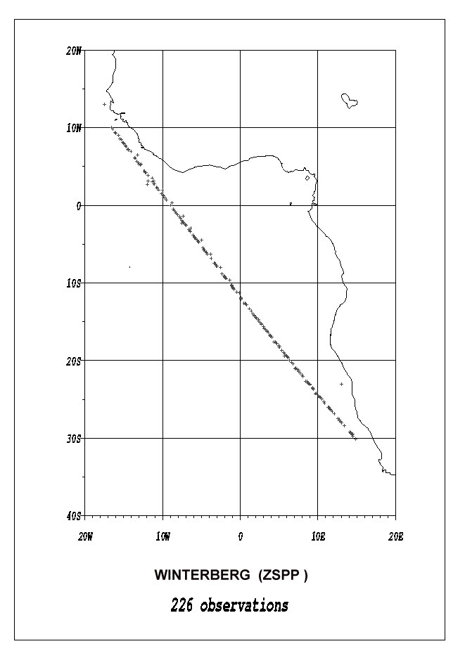 | 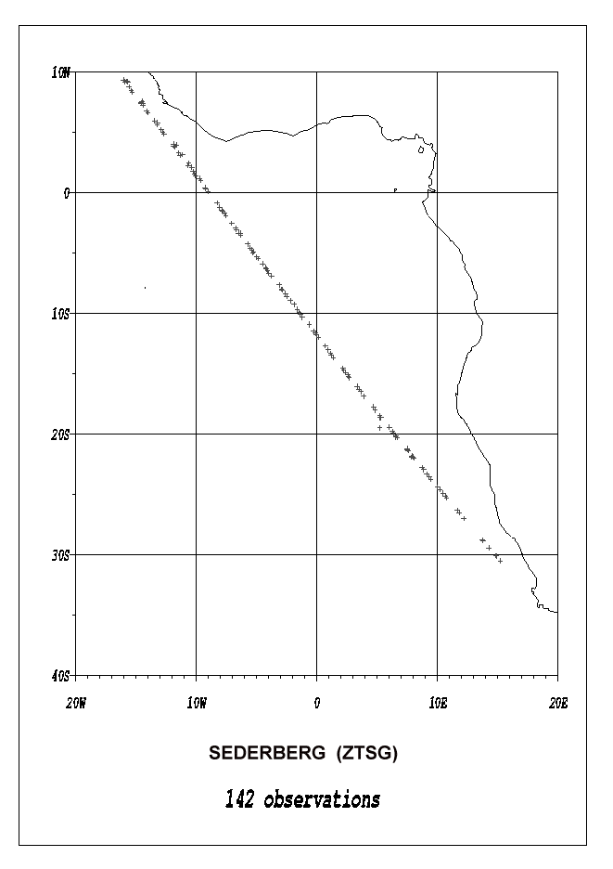 | 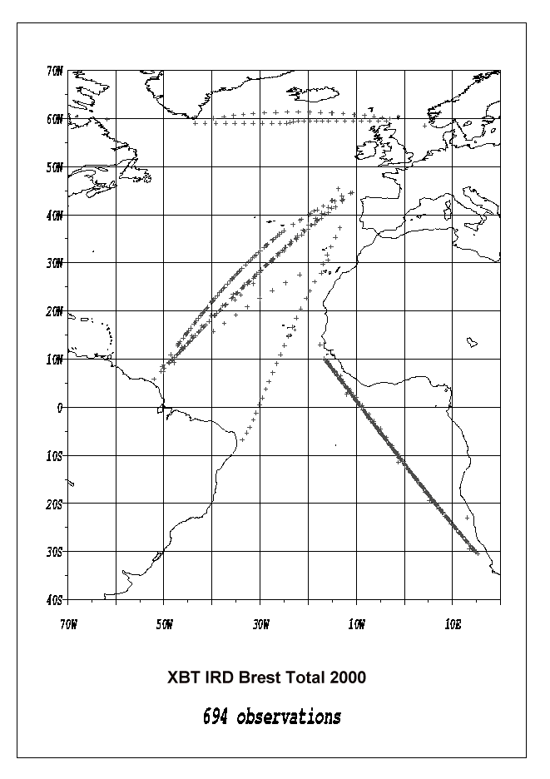

IRD Brest XBT data : summary for year 2001

Vessel | Ship Code | Line | Nb of cruises | Launches | Sent in  real time | Good drops | %
Fort Fleur d'Epée | FNOU | AX05 | 7 | 185 | 176 | 179 | 96,8
Fort Royal | FNOR | AX05 | 7 | 193 | 160 | 162 | 83,9
Nuka Arctica | OXYH2 | AX01 | 5 | 126 | 79 | 102 | 81,0
Sederberg | ZTSG | AX15 | 5 | 218 | 173 | 167 | 76,6
Toucan | FNAV | AX20 | 5 | 239 | 194 | 203 | 84,9
Winterberg | ZSPP | AX15 | 6 | 322 | 284 | 283 | 87,9
 |  |  | Total | 905 | 651 | 755 | 83

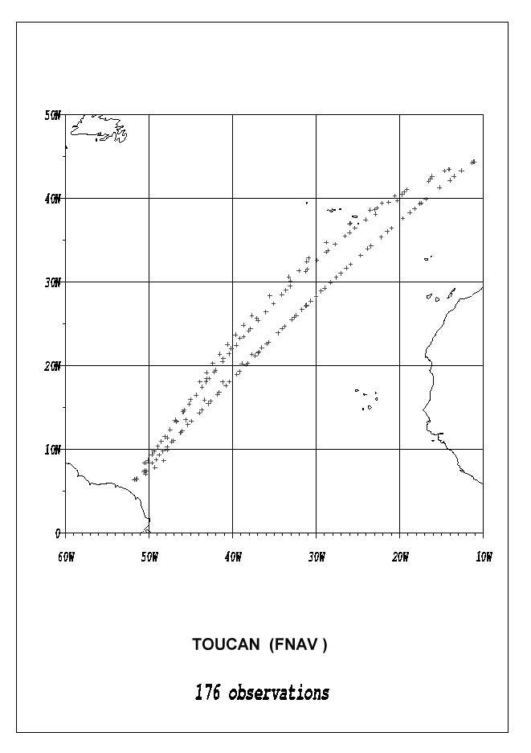 | 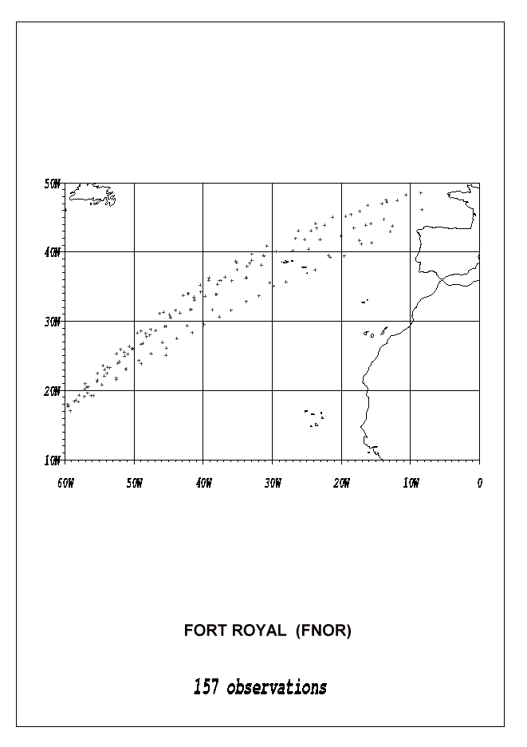 | 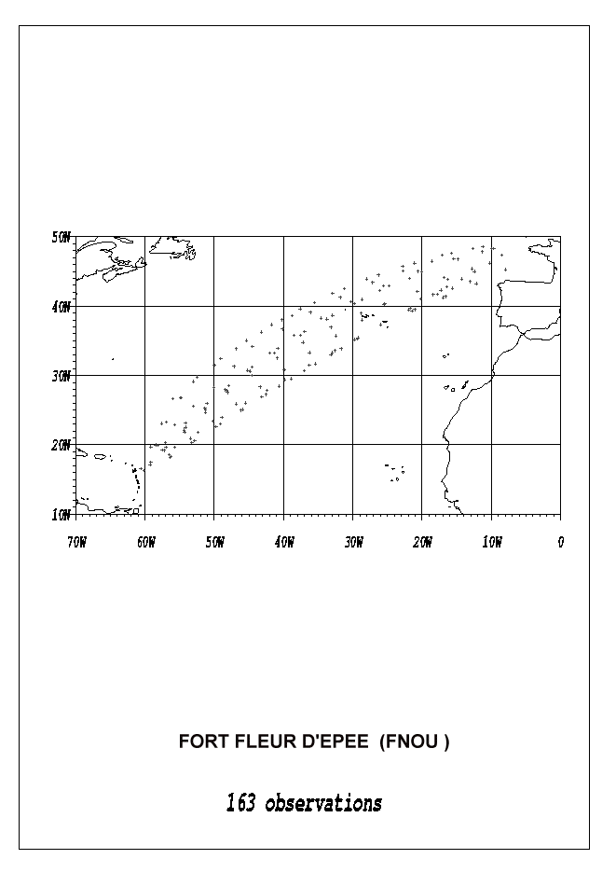
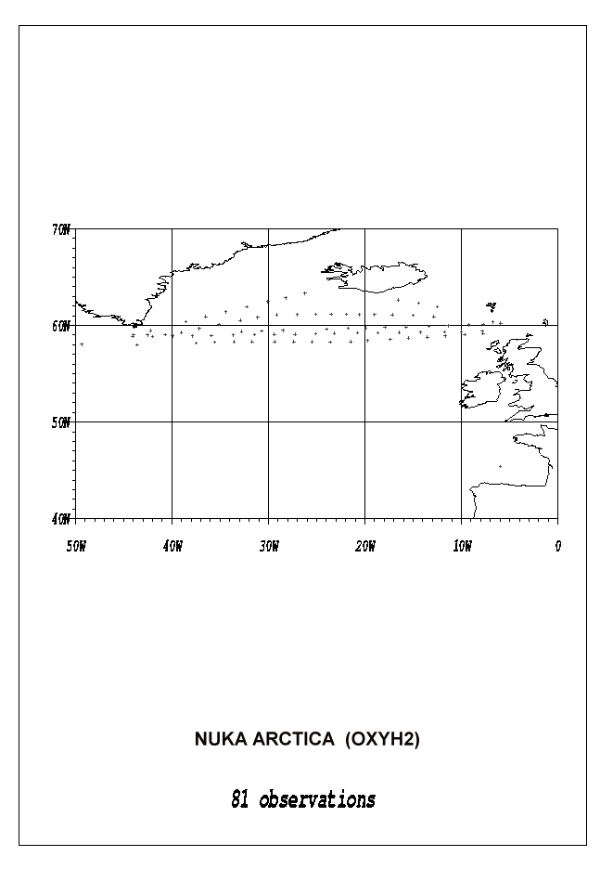 | 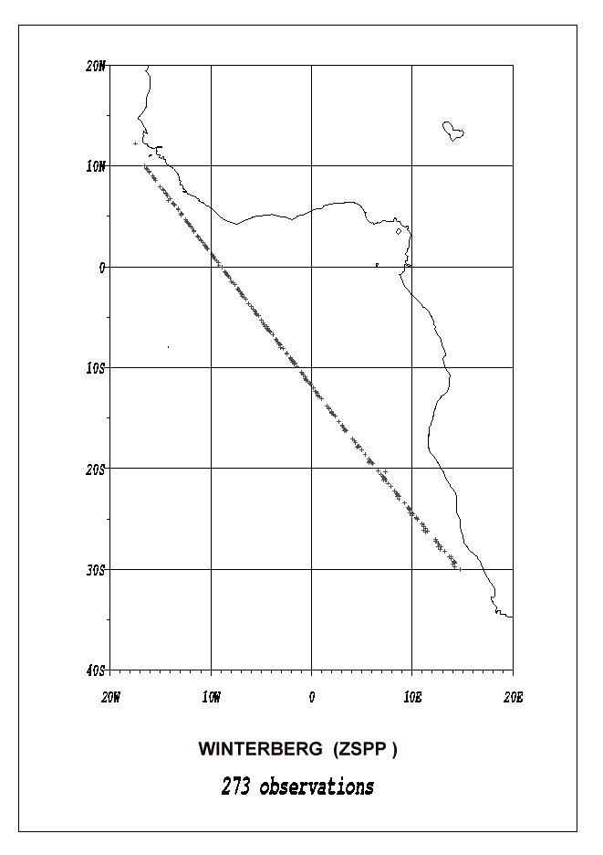 | 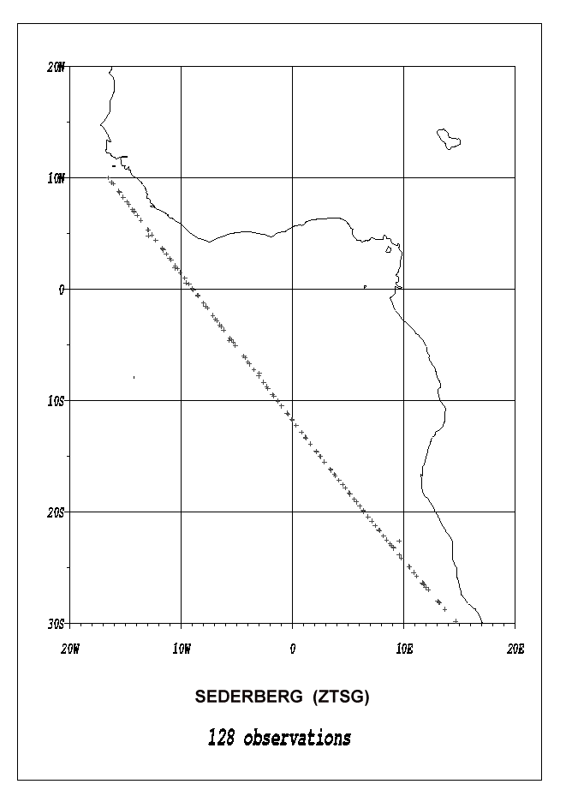

IRD Brest thermosalinograph data : summary for year 2000

Vessel | Ship Code | Line | Number of cruises | Nb Obs. | remarks
Cap Verde | ELVO3 | AX11 | 1 | 0 | Ineffective (valve closed)
Colibri | FNHO | AX20 | 5 | 15816 | 1 cruise ineffective (valve)
Nuka Arctica | OXYH2 | AX01 | 8 | 46467
Pasteur | ELWT7 | AX11 | 4 | 29920 | no GPS position
Toucan | FNAV | AX20 | 6 | 27781 | 1 cruise ineffective (valve)
Waterberg | ZSUY | AX15 | 6 | 40651

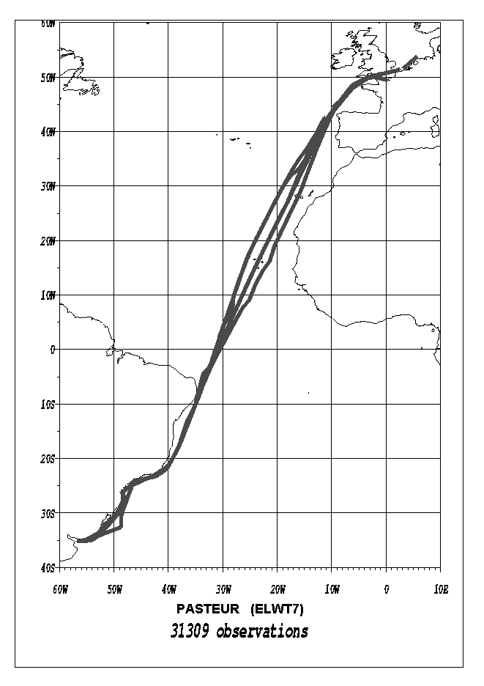 | 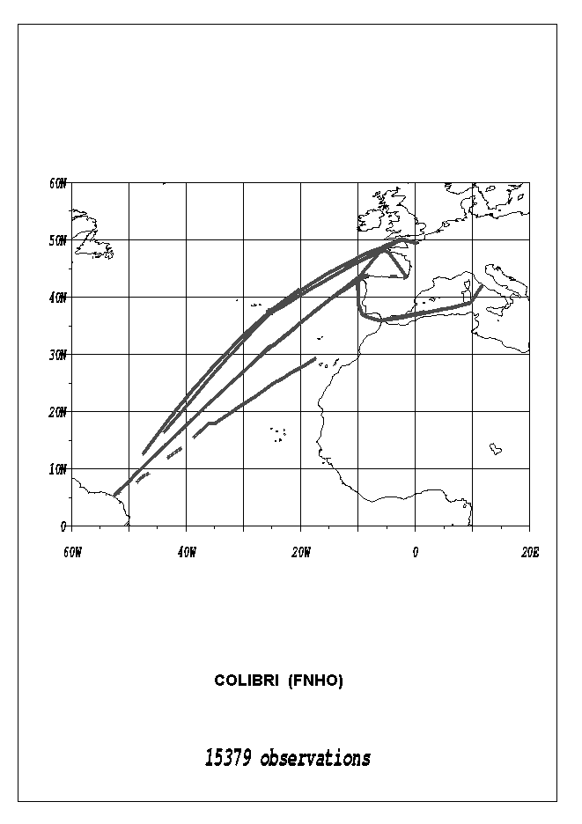 | 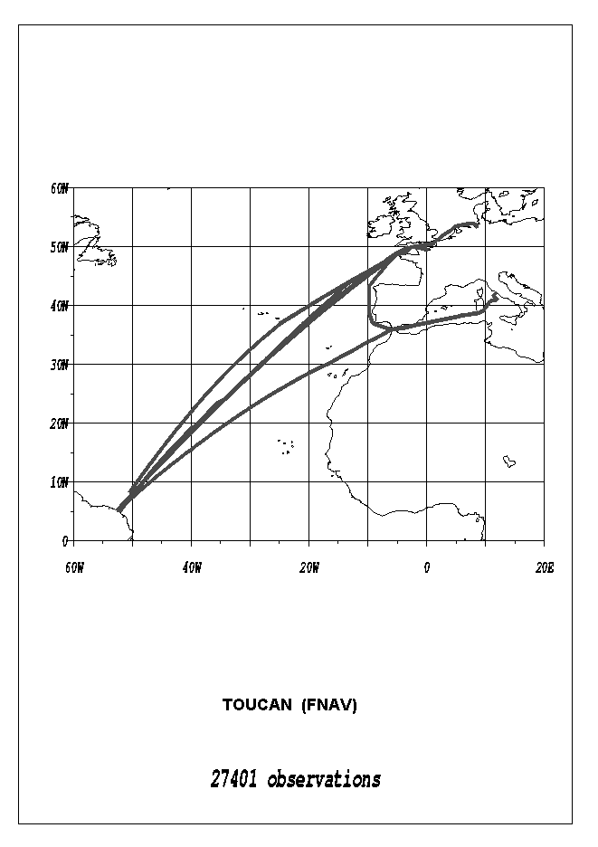
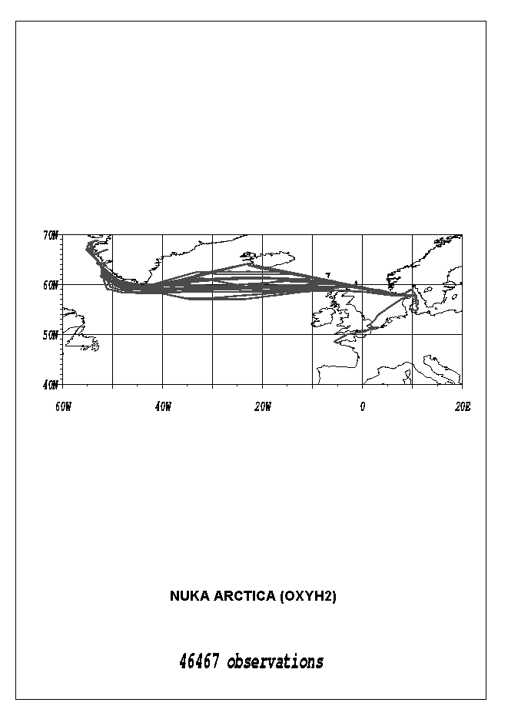 | 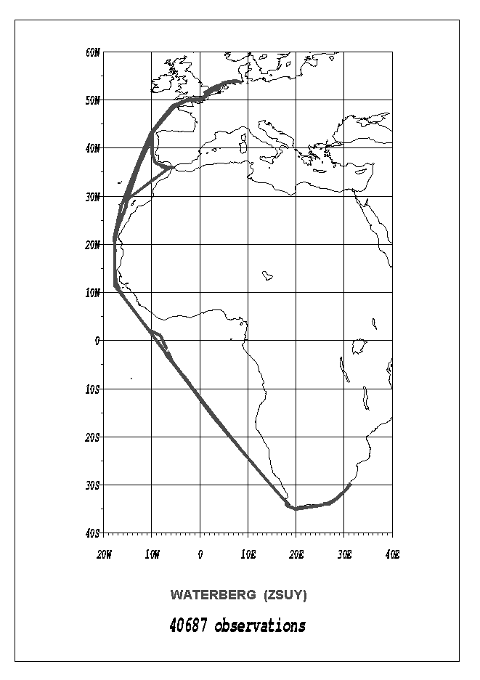 | 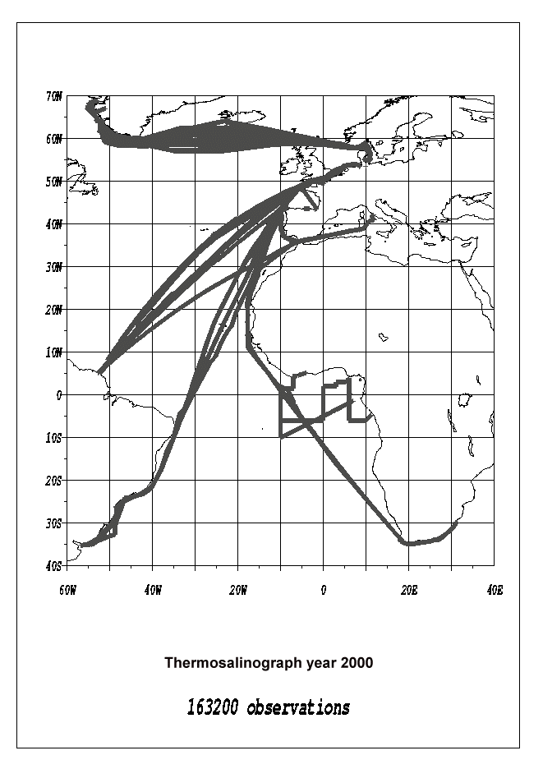

IRD Brest thermosalinograph data: summary for year 2001

Vessel | Ship Code | Line | Number of cruises | Nb Obs. | remarks
Colibri | FNHO | AX20 | 5 | 27064 | some pump problems
Nuka Arctica | OXYH2 | AX01 | 10 | 65179 | + 5 Brest - Algésiras cruises
Pasteur | ELWT7 | AX11 | 6 | 41042 | no GPS
Toucan | FNAV | AX20 | 5 | 26181
Waterberg | ZSUY | AX15 | 8 | 34059 | 2 cruises inefficient (HD or valve)
 |  |  | Total | 193 525

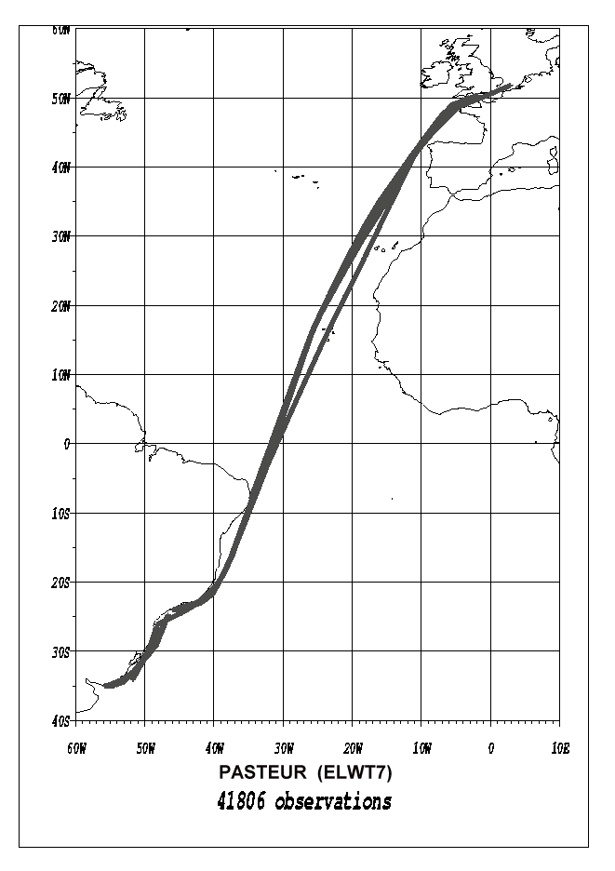 | 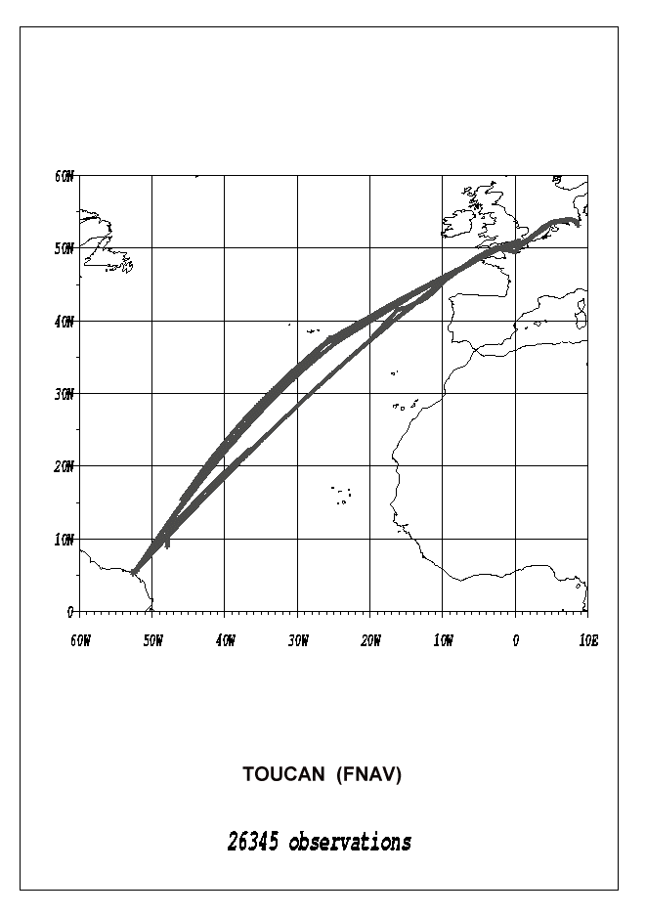 | 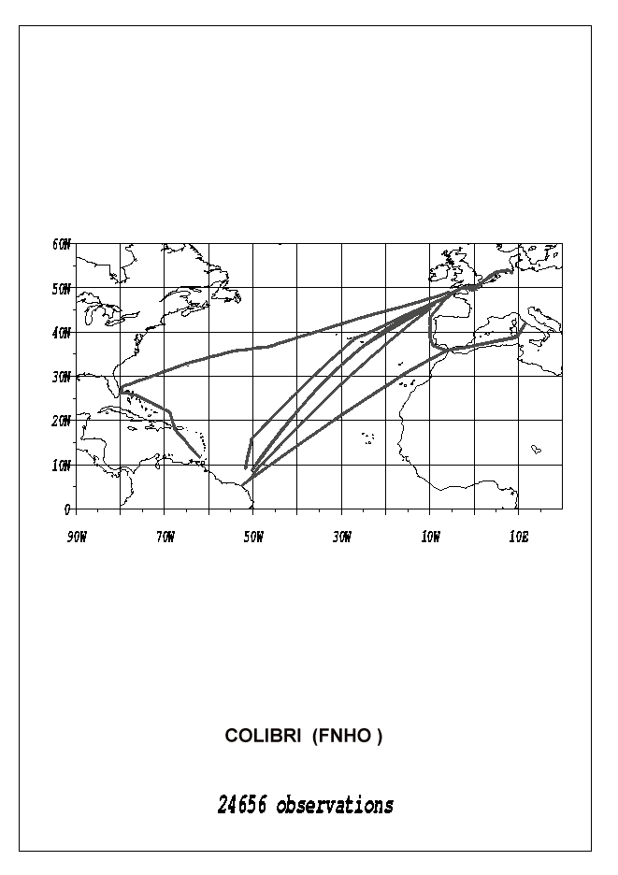
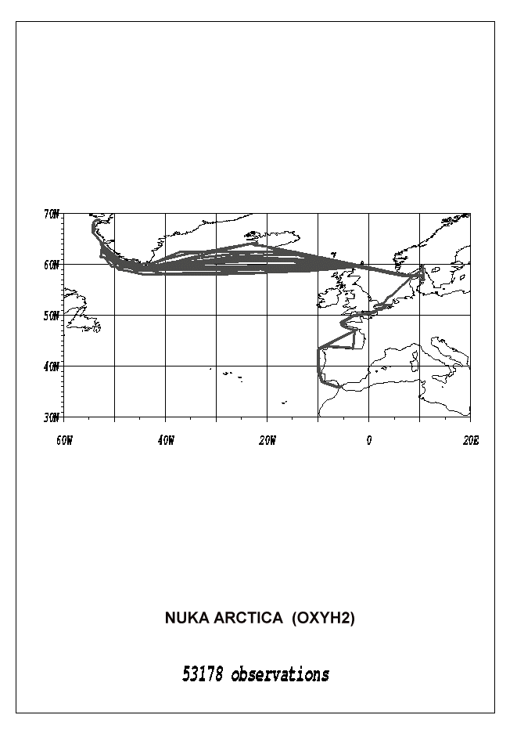 | 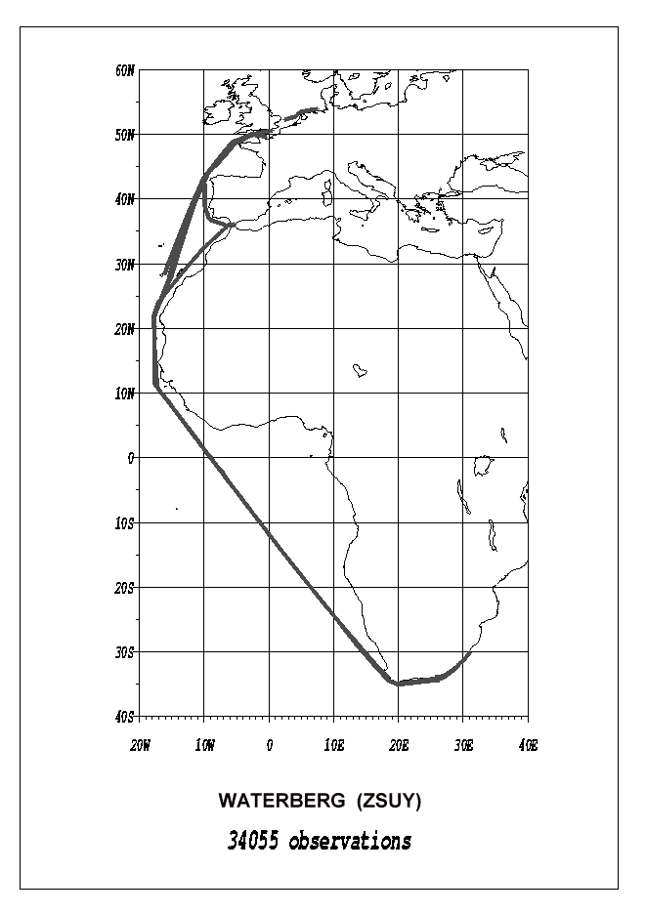 | 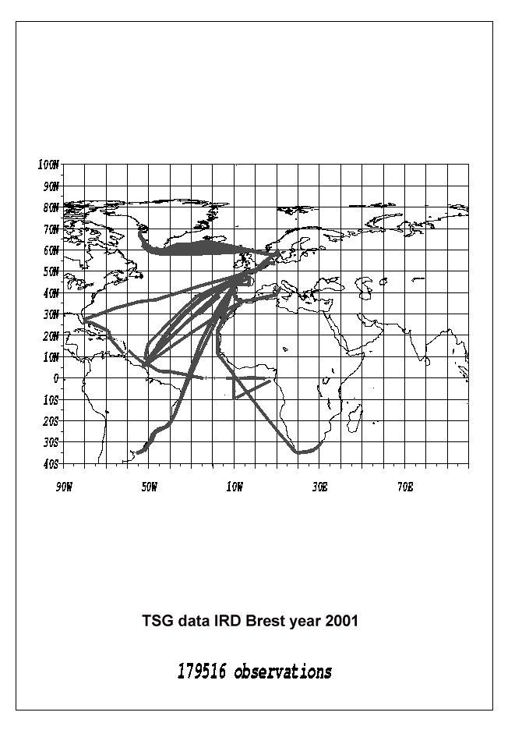

IRD Noumea X.B.T data: summary for year 2000

Vessel | Ship Code | NB of Cruise | NB Probes | Remarks
CORAL_ISLANDER | 3EVS | 5 | 415
CS_LONDON | ELVX4 | 4 | 496
CS_ROME | ELVZ6 | 4 | 285
CS_WASHINGTON | ELVZ5 | 4 | 245
NO_ALIS | FHQB | 3 | 34
PACIFIC_ISLANDER | HPEW | 6 | 451

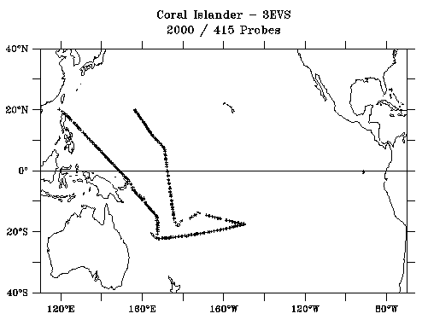 | 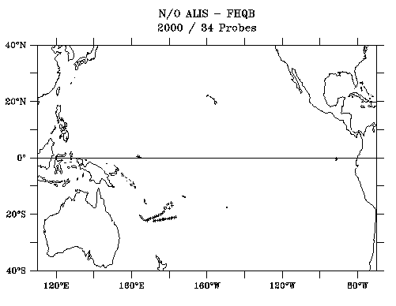
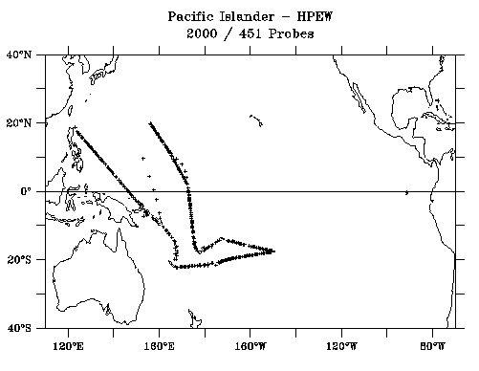 | 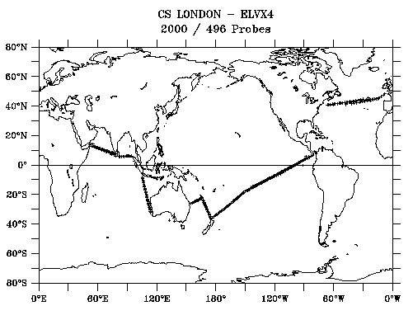
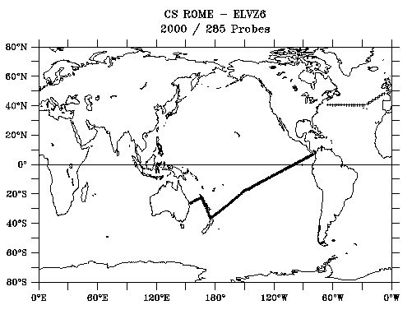 | 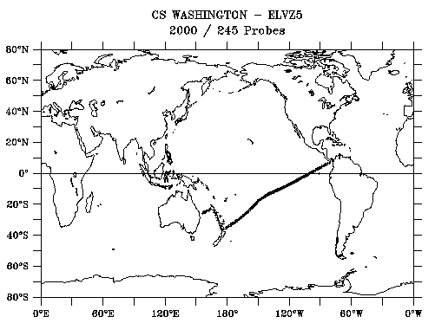
IRD Noumea X.B.T data : summary for year 2001

Vessel | Ship Code | NB Cruises | NB Probes | Remarks
CORAL_ISLANDER | 3EVS | 5 | 456
CS_LONDON | ELVX4 | 3 | 327
CS_ROME | ELVZ6 | 4 | 261
CS_WASHINGTON | ELVZ5 | 4 | 226
NO_ALIS | FHQB | 1 | 7
PACIFIC_ISLANDER | HPEW | 5 | 376

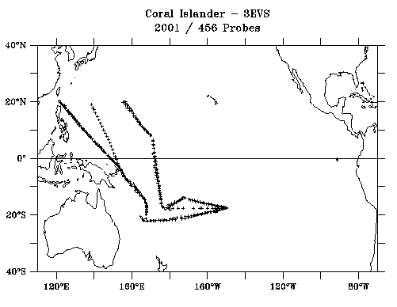 | 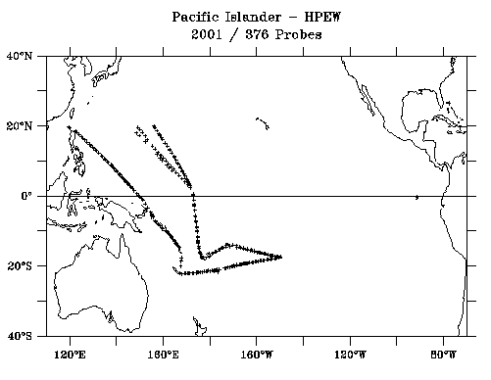
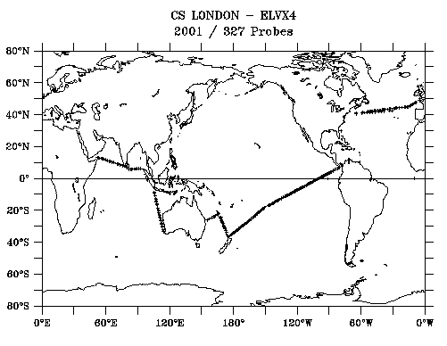 | 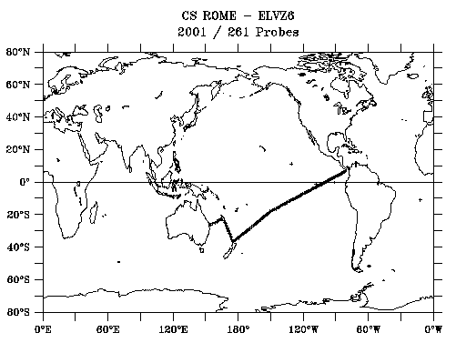
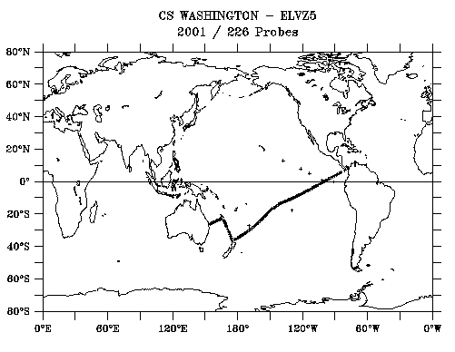
IRD Noumea thermosalinograph data : summary for year 2000

Vessel | Ship Code | Nb of Cruise | NB Obs | Remarks
CS London | ELVX4 | 4 | 54670
CS Rome | ELVZ6 | 4 | 59134
CS Washington | ELVZ5 | 3 | 28362
Coral Islander | 3EVS | 5 | 32718
Kyowa Cattleya | 3FEW5 | 7 | 39433
Kyowa Hibiscus | 3FMF4 | 7 | 71772
Lady Geraldine | LADY | 44 | 14072
NO l'Alis | FHQB | 3 | 14685
Pacific Islander | HPEW | 6 | 59562

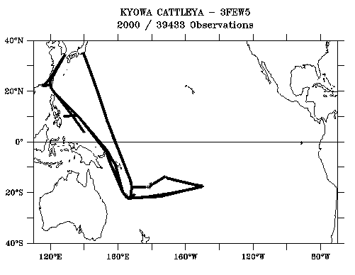 | 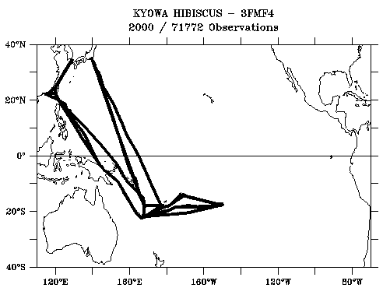
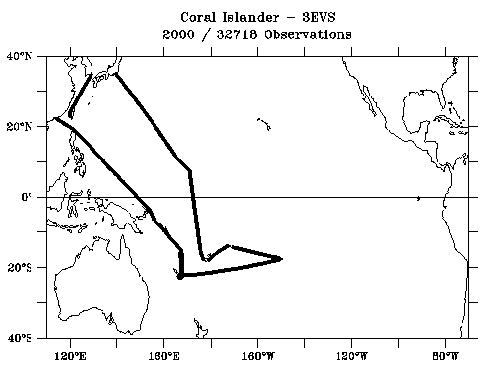 | 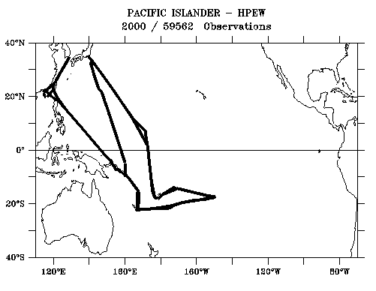
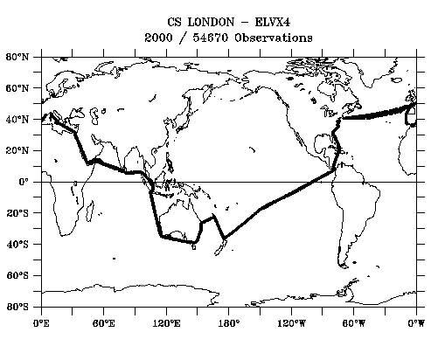 | 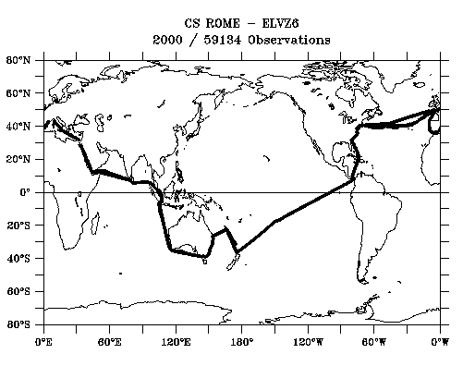

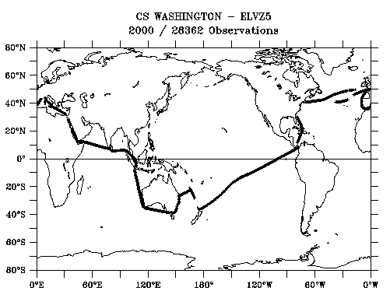 | 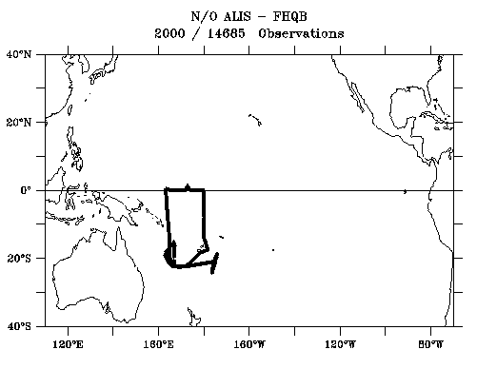
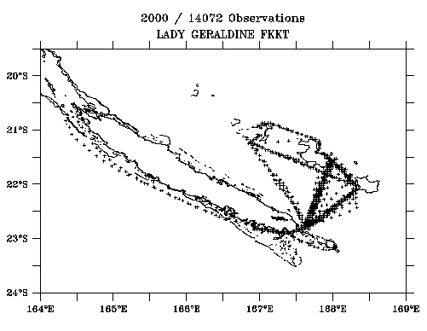

IRD Noumea thermosalinograph data : summary for year 2001

Vessel | Ship Code | NB of Cruise | NB Obs | Remarks
CS London | ELVX4 | 3 | 51441
CS Rome | ELVZ6 | 4 | 57207
CS Washington | ELVZ5 | 4 | 49445
Coral Islander | 3EVS | 5 | 52462
Kyowa Cattleya | 3FEW5 | 5 | 32634
Kyowa Hibiscus | 3FMF4 | 9 | 62934
Lady Geraldine | LADY | 48 | 20911
Pacific Islander | HPEW | 4 | 40420

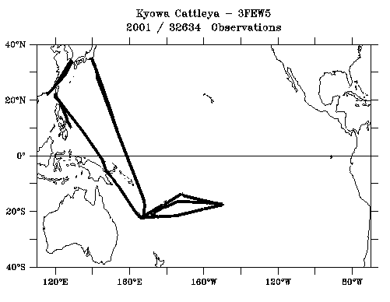 | 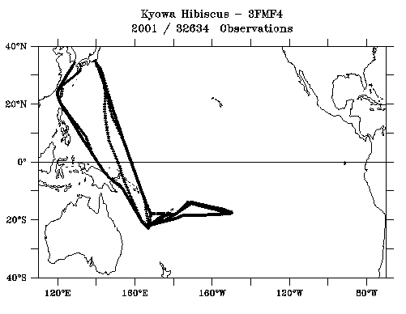
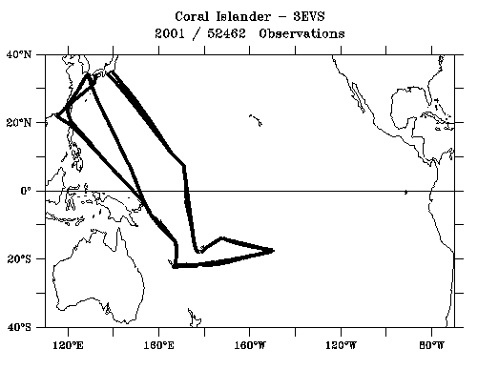 | 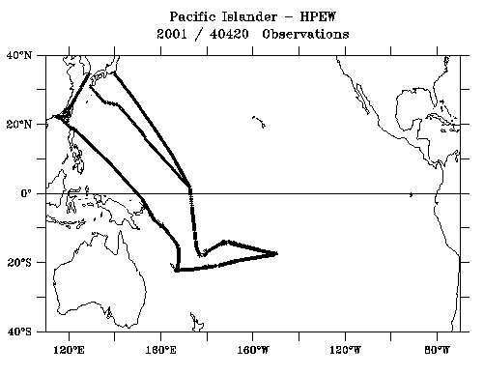
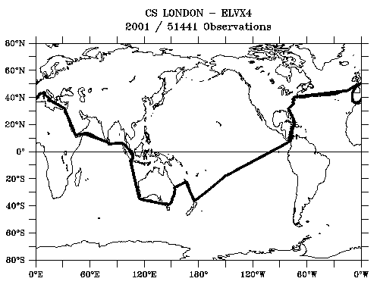 | 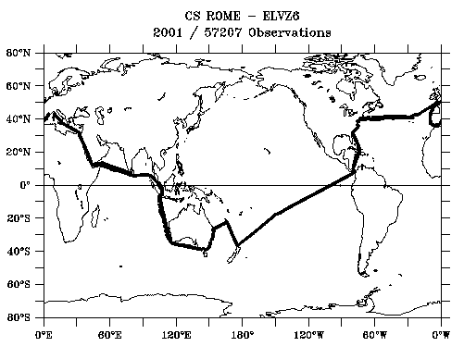

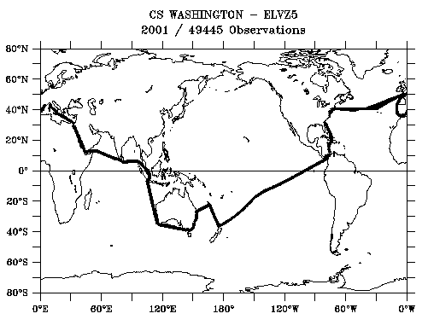 | 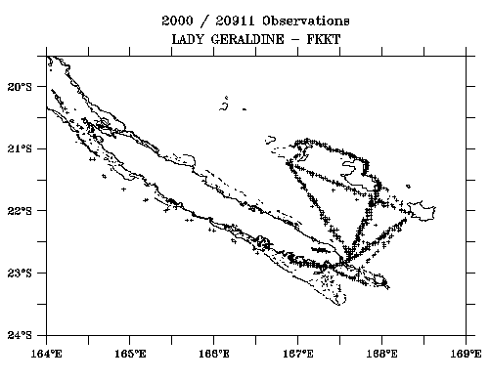

Atlantic Ocean

Summary for salinity bottle samplings - 2000
Vessel | Ship Code | Line | Nb of cruises | Samples | Remarks
Cap Verde | ELVO3 | AX11 | 1 | 4 | + XBT+Thermosal
Helderberg | ZSZW | AX15 | 5 | 210 | Bottle only
Romain Delmas | C6MY6 | AX26 | 1 | 43 | Bottle
Saint-Roch | FNXW | AX26 | 3 | 78 | Bottle
Sederberg | ZTSG | AX15 | 7 | 128 | XBT
Toucan | FNAV | AX20 | 6 | 103 | XBT+Thermosal
Waterberg | ZSUY | AX15 | 5 | 116 | Thermosal
Winterberg | ZSPP | AX15 | 5 | 225 | XBT
Colibri | FNHO | AX20 | 5 | 54 | Thermosal
TOTAL |  |  |  | 961

Summary for salinity bottle samplings - 2001
Vessel |  | Ship Code | Line | Nb of cruises | Samples | Remarks
Colibri |  | FNHO | AX20 | 5 | 102 | + Thermosal
MSC Texas |  | ZSZW | AX3 | 2 | 100 | bottle only
Romain Delmas |  | C6MY6 | AX26 | 2 | 63 | bottle
Sederberg |  | ZTSG | AX15 | 5 | 178 | XBT
Toucan |  | FNAV | AX20 | 5 | 75 | XBT+Thermosal
Waterberg |  | ZSUY | AX15 | 7 | 101 | Thermosal
Winterberg |  | ZSPP | AX15 | 6 | 265 | XBT
TOTAL |  |  |  |  | 884

XBT probe supplies (origin and number)

Year | supplier | IRD Nouméa | IRD Brest | Coriolis
2000 | NOAA |  | 1620
2001 | NOAA | 972
2001 | Ifremer |  |  | ?

Annual National ASAP Report

COUNTRY : FRANCE NAME OF AGENCY: METEO-FRANCE YEAR: 2001

.....ASAP units operated during the year on 4 ships
Type of ship¹⁾ | Name | Call sign | Comm  method²⁾ | Windfind  Method³⁾ | Lauch height | Area of operations⁵⁾ | ASAP Unit Serial No
Merchant | Douce France | FNRS | IDCS | GPS | 27 | North Atlantic | FASAP 3
Merchant | Fort Desaix | FNPH | IDCS | GPS | 27 | North Atlantic | FASAP 4
Merchant | Fort Fleur  d’Epée | FNOU | IDCS | GPS | 13 | North Atlantic | FASAP 2
Merchant | Fort Royal | FNOR | IDCS | GPS | 13 | North Atlantic | FASAP 1
1) Merchant ship, research ship, supply ship, etc
2) Using IDCS, Inmarsat-C, or others
3) Loran-C, GPS, Loran/GPS, RTH
4) The height above sea level from where the sonde and balloon is released
5) Ocean aera, e.g. North Pacific, North Atlantic, Indian Ocean, variable

Summary of performance of ASAP units during the year
Call sign | Total No. of sondes launched | No. of messages transmitted | No. of relaunches | Average terminal sounding height (km) | Percentage on GTS¹⁾
FNRS | 367 | 325 | 42 | 22.3 | 99.4
FNPH | 344 | 318 | 26 | 22.7 | 89.7
FNOU | 358 | 339 | 19 | 22.7 | 99.1
FNOR | 316 | 302 | 14 | 22.1 | 94.6
Total or average | 1385 | 1284 | 101 | 22.5 | 95.8
1) Based upon reports at a data center or GTS insertion point, name BDM Toulouse
Ratio of reports received against reports transmitted

Annual National ASAP Report (Continued)

Year 2001

Comments on performance

A major concern, the same as last year, was the high number of soundings without wind data (12% during 2001 versus 11% during 2000). Except unwinder problems, most of the troubles always occurred the same way: In a first step, an as-usual troubleless ground preparation, the sonde picks up enough satellite signals to allow a correct wind data processing. In a second stage, as soon as launched, these sondes cannot pick up any longer the four satellite broadcasts needed to calculate wind data.

Let us point also a slight increase of the number of sonde ground rejection due to PTU sensor failures.

Then, let us recall the DCP transmission troubles, which have been lasting since the end of the year 2000. Since 2001, Cotel - the French data dissemination system - has been able to receive messages transmitted through Meteosat as well as through the American satellite. In most of cases, when messages sent through Meteosat were corrupted, they were not when sent through the American satellite. We therefore have strong suspicions about Météosat optimal operational state.

Estimates for the following year

External circumstances forced us to delay the installation of Geolink sondes on our ships up to beginning 2002.

Although we expect of this a very good availability of the wind data, we shall only be able to conclude after six month's operational use.

About the transmissions, we are fitting all our ships with Inmarsat (C or mini M). We expect of this upgrade an increase of the number of transmitted messages as well as a better quality of those received in Toulouse (the monitoring centre).

National Report
Germany

1. VOS

Trends in the development of German VOS since 1990
The German VOS fleet comprises primarily merchant vessels as the largest component of the system, but also specialised ships as research vessels and ships for coastal surveys.
The development (Fig. 1) from 1990 shows a steady increase in numbers with the greatest leap in 1991, after reuniting with Eastern Germany (DDR).
The increase of the VOS number correlates to the activities of German Shipping companies in building new ships - although it is the owning of the PMOs to be successful in recruiting them.

The Equipment
The standard equipment comprises: Barometer (Aneroid/Barograph), sling psychrometer, bucket, meteorological journals, electronic notebooks (Turbo1/TurboWin software), detailed regulations for the weather reporting incl. cloud atlas and pictures of the sea state for wind estimates.
Most ships conducting standard observations, 21 ships are presently equipped with automatic weather stations, which allow for manual input of observed parameters.

Number of Observations from German VOS
The absolute number of observations from German ships on the GTS increased steadily from ca. 79.000 in 1990 to more than 245.000 in 2001. Differentiating by automated stations and conventional observations (Fig. 2) there is a steady increase with the automatic observations up to present. The conventional numbers also increase until 1999, but decreased in 2000. The year 2001 stops this trend in the conventional observations, which is ascribed the introduction of notebooks with the TURBO1 software, which provided a big leap in observers motivation. At the same time the availability of observations on GTS from these ships increased by 50 – 100 %. This development has still to be observed further.
The total data income (Fig. 3) considering also the non real time data, only available in journals or diskettes, increased from ca. 226.000 in 1990 to ca. 292. 000 in 200. The proportion of German data on the different links is as follows: 6% GTS only, 66% non-real-time only, 28% both (GTS and non-real-time).
The global proportion for comparison, as derived from the German Archive is 28% GTS only, 42% non real time, 30 % both sources (number from 1982-1994)

The geographical coverage
The geographic distribution (Fig. 4) of weather observations from German ships is more or less world wide, with a predominance on the northern hemisphere, analogue to the world wide trend.

PMO services.
Continuous service is provided since historical times (Deutsche Seewarte in the 19th century) until present. Service is available in all German ports; Focal Points in Hamburg, Bremen, Bremerhaven, Rostock. There is an excellent co-operation with other PMO services world wide.

Award System:
The participation in the weather observing scheme is principally voluntarily. There is no payment for this engagement, but an award system was installed. The entitlement for an award is based on a combination of number of observations and time of participation in the scheme. The personal awards (Fig. 5) cover high quality products ranging from stationary to meteorology/navigation related books and a personal plaque as the top award.
Besides of this a yearly plaque for the ship can be attained if minimum requirements are met.
The scheme works rather satisfactorily. In our experience the attitude of the captains is of utmost importance.

Telecommunication
The automatic weather stations are sending their messages via DCP and METEOSAT to the German Weather Service for input on to the GTS. This is free of charge, as the German Weather Service is financially engaged in the METEOSAT mission.
The typical German standard VOS is sending her message via Inmarsat and Code 41 to an Inmarsat earth based Station (CES).
Up to the end of 2001 the number of Observations through the German Telecommunication link (Raisting) CES was ca. 120 Obs per day or about 44.000 observations per year from ships of every flag choosing Raisting as their earth station.

Problem: In 2002 the ownership of this station changed from a German to a French provider, thus conveying all these observations through the French channel with all consequences for the French Meteorological Service.
As the CESs are in private hands, national commitments with costs can be over-ruled by private business and short term decisions.
This may lead to an overburdening of individual National Services in the framework of the marine data flow and a restriction of acceptance for receiving and handling meteorological data. First signals are already visible.

Many ships request for providing their observations by email. This is principally possible, although providing a problem in allocation of the costs to the Met Service. Some email providers offer features for adequate addressing and charging.

Future Plans:
- Participation in the VOSClim Project.
- Germany tries to equip as many ships as possible with notebooks and the data acquisition software within the budgetary limits. The experience is encouraging. First problems with „playing down“ notebooks, viruses on the laptop etc. are decreasing. The minimum quality control tool on the PC is helpful and rises the overall quality of the data. The motivation for weather observing is increasing significantly.
- The strategy of recruiting those ships who are willing to observe weather is followed up. The number of provided observations is a minor criterion.
- Further equipment with automated stations is limited as the equipment is expensive and the risk of losses due to sudden ship sales and a loss of the stations can not be accepted. It is even difficult to get back the standard equipment in such cases. So the number of automatic stations on German VOS will be limited.

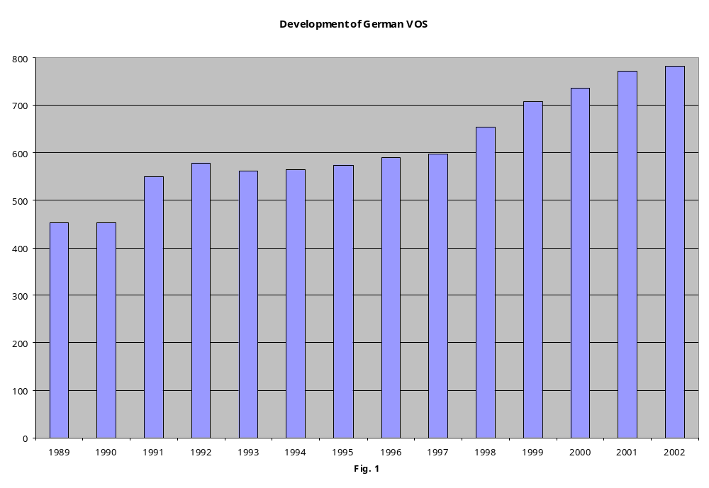

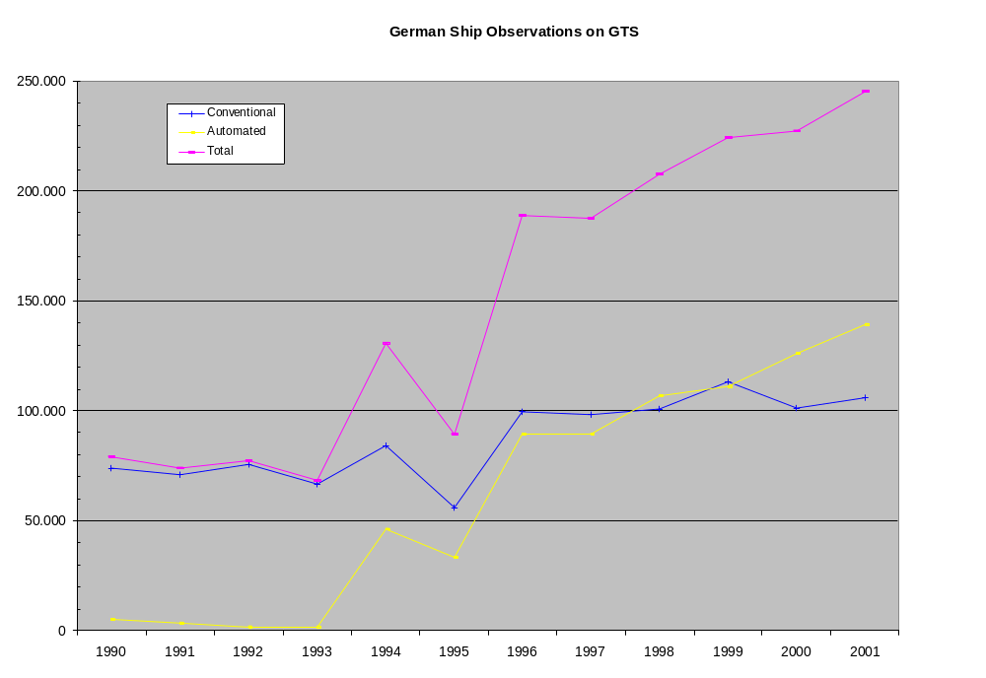
Fig. 2

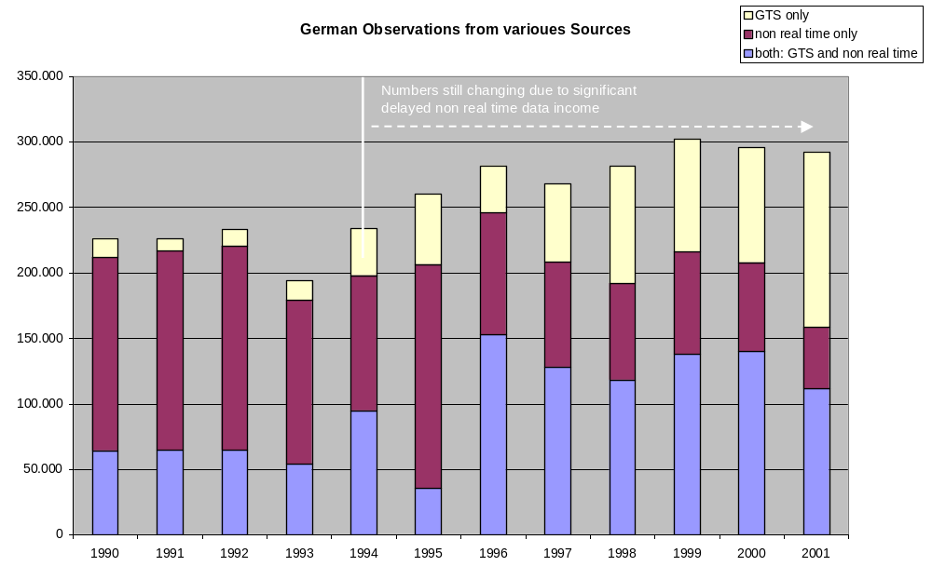Fig. 3

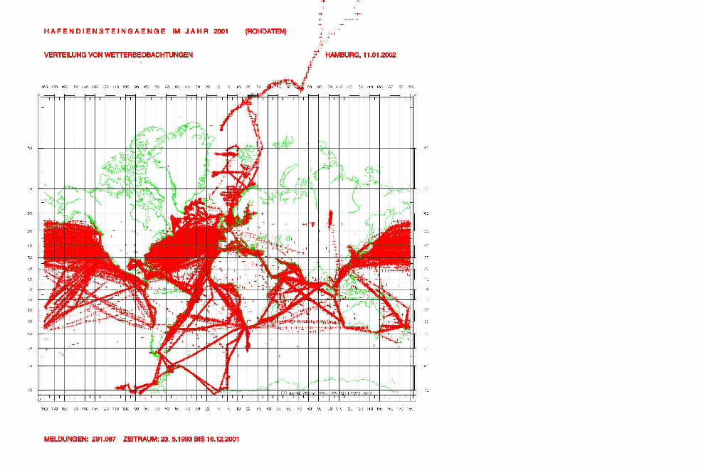
Fig. 4: Geographical Coverage of German VOS (1993 – 2001)
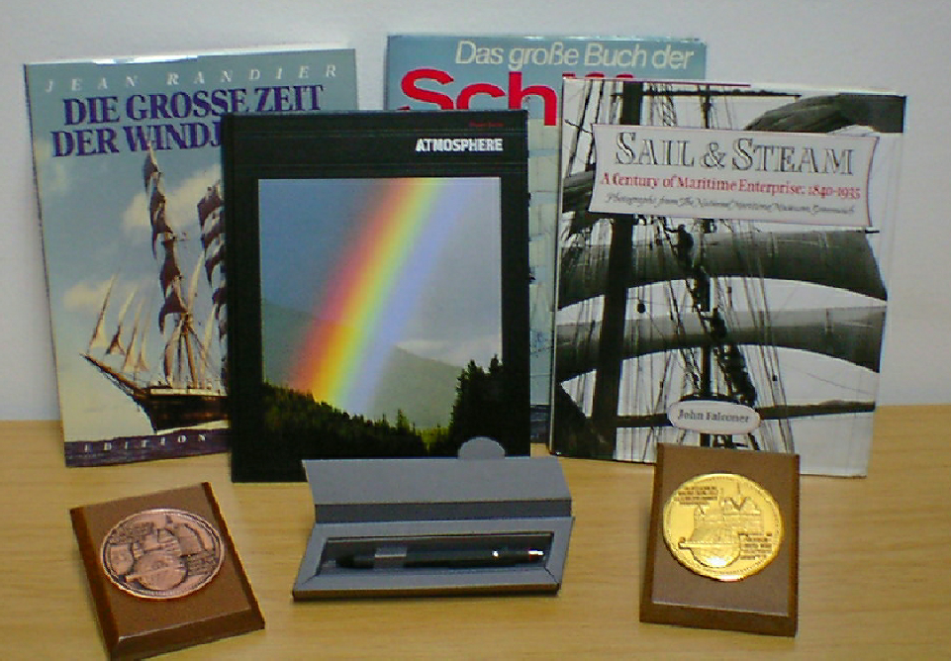

Fig. 5: Awards

SHIP-OF-OPPORTUNITY ACTIVITIES

IN GERMANY 2000/2001

This report (pp. 48-63) is in a separate file.

National Report Germany
ASAP

Introduction
Germany started its ASAP project with 1 unit in 1987 up to its full size of 5 units in 1990. The conception based on a containerised solution, where the total equipment was installed in a 20 ft. full air conditioned container. Four units were planned to be permanent operational, one for back up, which was also in operation sometimes, e.g. for local coast near research campaigns.
Due to lack of resources the engagement had to be reduced from 1997 stepwise down to 2 containers in 1998/99.
In 2001 the activities could be re-intensified again with the goal of 4 upgraded operational systems.
This included a total re-construction of the container hulls, the interiors as: all cabling and connections, all mechanical components as launching system, air pressure generation, air conditioning, etc.
All components of the sounding system were upgraded by the latest product series of Vaisala. The data transmission switched from DCP-transmission to Inmarsat services (Fig. 1).

The routes of the German ASAPs cover the North Atlantic up to Spitzbergen and the South Atlantic down to the Weddell Sea. Some few voyages are in the Arabian Sea and South China Sea.

Performance of the System
The number of ascents (Fig. 2) is nearly parallel to the number of operational units and shows clearly the implementation phase1988-1990 with a small gap in 1991and the decrease beginning in 1997.
The standard level of 300 HPa was reached in ca. 95 % of all cases, the mean max height was almost between 18 and 20 km (Fig. 3). The number of early failures was about 3 %.
There were several reasons for the end of theTemp (Fig. 4). The regular end is normally marked by the blow out of the balloon with 80-90 % of all cases. In 1999 this decreased to ca. 70 % and the reason of no data signals increased to 20-25 %. The reason for this is not exactly known, but could point to a transmission or sonde problem.
In October 1997 the Omega Positioning System was announced to stop and Germany changed to GPS sondes, which provided for more than one year severe problems in wind finding. This problem has been settled meanwhile, by several system modifications although soundings with wind failing are sometimes experienced.
Nevertheless the overall quality could be regarded as good.

GTS Availability
The availability of Temps from German ASAPs on the GTS steadily decreased from 80-90% in 1995/96 to 66-68 % in 2000/2001. The reasons for missing Temps on GTS are hardly to be traced back, as there are too many potential sinks, e.g.:
- Temp not received by satellite (ship board problems with software, properly procurement of Temp for transmission, Antenna problems, problems with time slot, etc.)
- No correct TEMP receipt in Darmstadt, the earth based station for METEOSAT transmissions (GOES-East less problems).
- Data losses between Darmstadt and DWD (German Weather Service)
- Erroneous Temp header and thus no insertion into GTS
Discrepancies with the numbers of other monitoring centres resulted e.g. from obscured call signs on the GTS.
The latest problem was no reception when ship was eastward of 000 Longitude.

In consequence of all this it was decided to use the Inmarsat transmission links in future with the upgraded Containers, although it has to be noted, that not all Inmarsat ground stations accept Temps with Code 41.

Conclusion
The German ASAP System will be fully upgraded and back to full operation presumably at the end of 2002. Potential problems may arise from the fact, that ships, suitable to carry a 20 ft. Container at a position where it does not need to be removed when loading, are rare, especially on the North Atlantic routes.

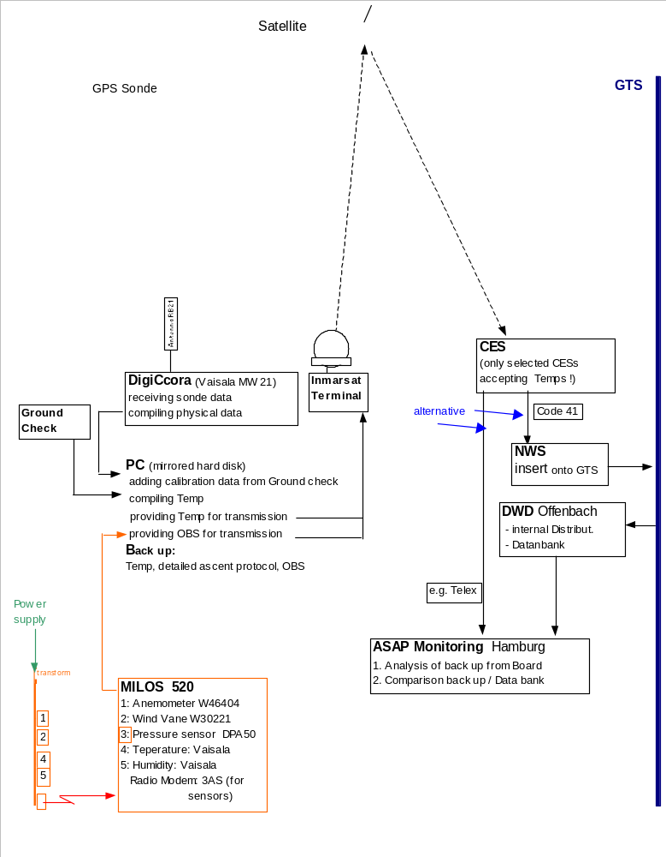ASAP Equipment and Data Flow

Fig. 1

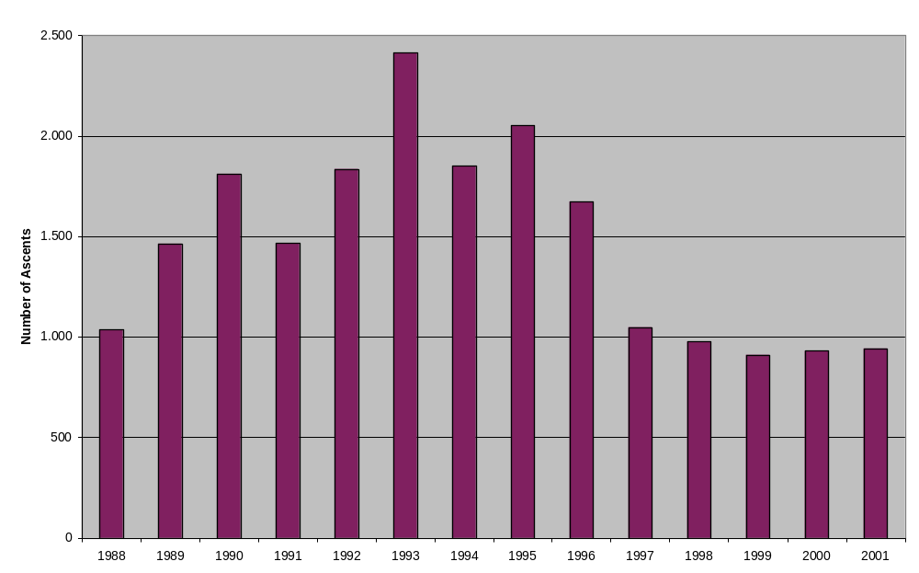Number of Ascents from German ASAP Units

Fig. 2

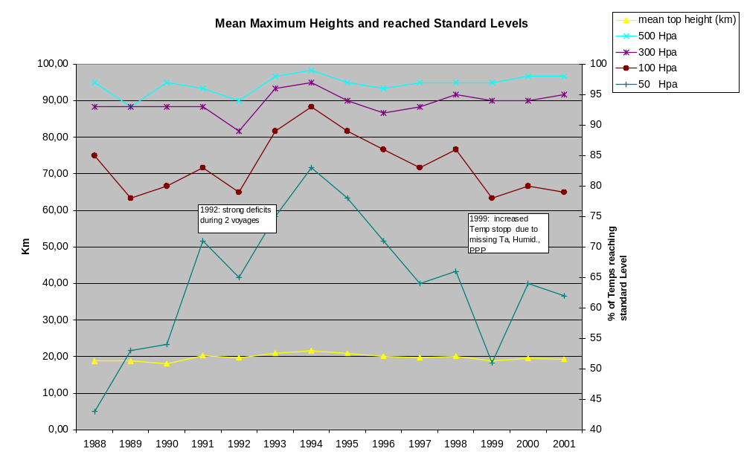

Fig. 3

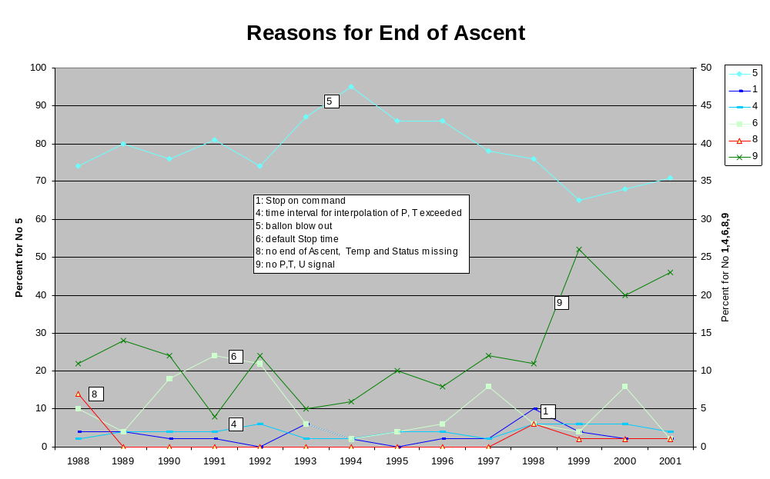

Fig. 4

NATIONAL REPORT OF GREECE

1. Status of implementation of VOS from the HNMS

The last decades, the Hellenic National Meteorological Service (HNMS) operates a number of about 35 VOS, almost all ply in the Mediterranean Sea. Today 12 of those are Selected VOS and 23 are Auxiliary VOS. From time to time some VOS change owner and flag, but we try to substitute the lost ships by new ones VOS.

The last years we have faced a reduction of the number of VOS and the number of observations. Some VOS make 4 observations per day, some VOS make 1-2 observations per day and some VOS make very few per month or nothing. This is due to:

a. The cessation of radio officers, which means that deck officers have not only to make observations but also to transmit the observations.

b. Some deck officers are not enough familiar to all functions of INMARSAT-C transceivers.

c. Today many ships of new technology are very fast, up to 30 Knots, and their masters refuse to permit their deck officers to make observations, leaving their post in order to make and transmit observations.

In order to attract the mariners to make observations and of course in order to give to them a moral satisfaction for their offer to us, the HNMS has established a ceremony day every year which takes place in its headquarters, and awards the best (first, second and third) Selected and Auxiliary VOS. This offer, in addition to amoral satisfaction to mariners, creates a kind of competition among them.

2. Status of imlementation of ASAP

The HNMS had never installed by itself any ASAP before. Into the framework of EUMETNET and the European ASAP programme, the HNMS has assumed some responsibilities and under the supervision of the project manager Dr. Klaus Hedegaard (Denmark), the first E-ASAP has been installed on a Greek ship (container) which ply on a regular basis, in the whole Mediterranean Sea. So, a number of radiosoundings have been made in areas of the Mediterranean Sea, which are inserted on to GTS.

National Report of Iceland

Annual National ASAP Report
COUNTRY: ICELAND/Sweden
NAME OF AGENCY: Icelandic Meteorological Office /SMHI YEAR: 2001
1 ASAP units operated during the year on 1 ships
Type of ship¹⁾ | Name | Call sign | Comm. method²⁾ | Windfind method/  Sonde type ³⁾ | Launch  Method⁴) | Launch height⁵⁾ | Area of operations⁶⁾ | ASAP Unit ID No.
Merchant ship | Lagarfoss | V2XO | Inmarsat-C | Loran/Vaisala RS80-L | Container (manual) | 13 m | North Atlantic | IS-1
1) Merchant ship, research ship, supply ship, etc.

2) Using IDCS, Inmarsat-C, or others

3) E.G. GPS/Vaisala RS80-G, Loran/Vaisala RS80-L, VIZ GPS Mark II Microsonde, etc.

4) Launch method e.g.: deck launcher (portable); deck launcher (fixed); container (manual); container (semi-automatic); other.

5) The height above sea level from where the sonde and balloon is released

- Ocean area, e.g. North Pacific, North Atlantic, Indian Ocean, variable

Summary of performance of ASAP units during the year 2001
Call sign | Total No. of sondes launched | No. of messages transmitted | No. of relaunches | Average terminal sounding height (km) | Balloon Size (gm) | Percentage on GTS¹⁾
V2XO | 129 | 103 | 7 | 18.3 km | 300 gr | 78%
Total or average
1) Based upon reports received at a data centre or GTS insertion point, name: BIRK
Ratio of reports received against reports transmitted 78%

COMMENTS: Year 2001. M/v Lagarfoss started on the route Reykjavik-Argentia-Norfolk–Argentia-Reykjavik in beginning of June. But the installation of the equipment was delayed one trip, until 28 June. On the trip 26 July – 23 August we had failure on the MARWIN system and no soundings were from that period. So for the whole year we only had 5.5 effective trips. During the SOP period, Sep-Oct, we were able to do some extra soundings. In November the soundings had lot of “early balloon burst” and the average height only 9 km. For December we had failure in the INMARSAT-C antenna and therefore few soundings on GTS. We used the first half of the year for maintenance work on the container and to modernize the observation system. We installed our own INMARSAT-C transmitter with GPS-receiver and also moved all antennas to the container. We also installed digital thermometer and hygrometer on the container so now all but the Helium batteries are installed in the container. In the future it should be much cheaper and easier to move from one boat to another. The TEMP messages are now sent automatically by E-mail to the Icelandic Met. Office and there automatically inserted on GTS.

ESTIMATES FOR FOLLOWING YEAR:

Same programme as last year.

VOS PROGRAMME

In Iceland there are 16 ships in the VOS fleet, sending 7984 synoptic messages during 2001. These are made up of 9 merchant ships, 4 research vessels and 3 trawlers.

National Report of India: VOS activities

The India Meteorological Department has got a vast coastline with six Port Meteorological Offices. Three Port Meteorological Offices viz., Mumbai, Goa and Kochi are located along its west coast towards Arabian Sea and the other three viz. Chennai, Vishakhapatnam and Kolkata are located along its east coast towards Bay of Bengal. The National Focal Point is stationed at Pune, who coordinates with other six PMOs for implementation of WMO Programmes.

The data collected from the ships are scrutinized and archived at Pune.

We have recruited 23 ships for VOSClim Project of which three are being decommissioned. We are in the process of recruiting more ships for the above project. The IMMT - 2 format and quality control check version MQCS - IV have already been implemented in IMD with effect from March 2002.

15 April 2002

Israel National Report for SOT 1

Israel is participating actively in the VOS program for at least 30 years. In the present time, there are about 25 commercial Israeli ships that take part in the program. The ships are taking observations mainly in the northern parts of the Atlantic and Pacific oceans. There are very few ships that sail in the southern hemisphere.
There are about four ships that sail only in the Mediterranean and two ships that sail from the Israeli ports to the Red Sea, the Arabian Sea and the Indian Ocean. The ships that sail west word from Israel through the Mediterranean to the Atlantic, usually do not make meteorological observations as long as they are in the Mediterranean, although they were asked to do so again and again.
Although the number of ships reduced in the last ten years, the number of yearly observations is more or less constant, about 13000 a year. The observations are quality-controlled and sent once a year to the regional centers in England and Germany.
The ships are recruited by the Israel port meteorological officers in Haifa and Ashdod who are visiting the ships regularly.

Mediterranean Forecasting System
Italian Report on the Mediterranean Ships Of Opportunity Program.

Giuseppe M.R. Manzella
ENEA Marine Environmental Research Center
p.o. box 224 – I 19100 La Spezia
manzella@santateresa.enea.it

1. Introduction

The Ship Of Opportunity Program in the Mediterranean is part of the ‘Mediterranean Forecasting System’ (MFS) that was initiated in late 1998 by a wide consortium including European as well as non-European scientific institutions. Information can be found in the web site ‘www.cineca.it/mfspp/’.

MFS is the application in a key region of the Euro-GOOS concepts in the operational oceanography, providing data, information and services. MFS is divided in different phases and components: in situ data are integrated with satellite data (AVHRR and sea surface height anomalies) in a model providing 10 days forecast of the physical state (i.e. Temperature, Salinity, Currents) at basin scale. A coastal component had been recently implemented as a contribution to the Coastal – Global Ocean Observing System.

The Mediterranean Forecasting System is divided in various phases and modules:

- A Pilot Project (1998 – 2000) supported by the European Commission allowed the setting up of the MFS components (observation and forecast systems);
- The coastal component is under development in the Adriatic Sea (2001-2003) supported by the Italian Ministry of Environment;
- Recently the European Commission has approved the implementation of the MFS program ‘Toward Environmental Protection’.

2. The Mediterranean Forecasting System – Pilot Project.

The ships of opportunity program started in September 1999. The institutions involved in data collection from different countries: Spain (CSIC-CEAB), France (CNRS-LOB), Italy (ENEA, CNR-IOF, OGS), Greece (NCMR), Cyprus (DFMR-LPO), UK (SAHFOS).
The monitoring period was divided into three parts:

- the training phase, from September to November 1999; in this period the temporal sampling was one month and allowed to check the protocols developed for data collection and the transmission system;
- the MFSPP VOS targeted phase, from December 1999 to May 2000; in this period the tracks were repeated approximately every 15 days;
- the MFS extension, from June to December 2000; in this period some tracks have been maintained.

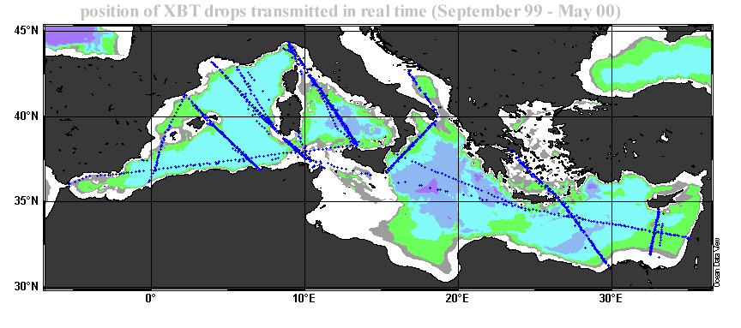

Three different data flows co-existed in MFSPP:

GTS (NRT) mode flow. From the ship the decimated data were transmitted to the CLS centre in Toulose where were decoded, checked and transmitted to the Global Communication System (GTS) of the World Meteorological Organisation. The data sent to the meteorological community via GTS were only a part of those collected. In fact the MFSPP VOS coordinator first checked the quality of the NRT data received by each partners, then decide to authorise the insertion into the GTS.

MFSPP (NRT) mode flow. In a first period the MFSPP mode flow was identical to the GTS one, Subsequently, having noted that the values between 0 and 5 metres were not representative of the surface temperature, it was decided to delete these data. From Toulouse the decimated data arrived to the ENEA centre in La Spezia, where were controlled. All the temperature values at surface (depth less than 5 metres) were deleted and additional data were added in order to provide always 15 data values. These sets of data were generally delivered with a delay of less than 2 days via an ftp site accessed through the MFSPP-VOS WWW

Full resolution data flow. The edf files produced by the Sippican system were checked by each partner and regularly sent to the ENEA data management centre. Due to some problems with ARGOS software, the full resolution data substituted in many cases the NRT data for the assimilation into the forecast model. The full data set from September 1999 to December 2000 was released to Ifremer to be included in the Coriolis system and also be used for the production of a new climatology of the Mediterranean. The complete data set is now available in cd-rom.

During the last months of 2000, a transmission system based on GSM+Internet and TSK multiple launcher was used in one track.

3. ADRICOSM

From 2001 only one track was maintained by OGS, with a varying time interval (from one to three months). This track is still continuing and will be integrated by a second track in the Adriatic, that will be maintained jointly by ENEA and the Institute of Oceanography and Fisheries, Split (Croatia). From October 2002, data will be collected every 15 days.

During 2001 – 2002 new methodologies for Near Real Time data control have been developed. The automated procedure includes:

- Elimination of spikes
- Broad range check
- End of profile check
- Smoothing
- Comparison with the climatology (if the data are within three standard deviations they are considered good)
- Visual check using the Ocean Data View software

In collaboration with Ifremer (Coriolis) all data will be again included in GTS. A new web site allows to download the original edf files or the q.c. files. In the near future also CTD data will be accessed through the ENEA web site.

National Report of Japan

VOLUNTARY OBSERVING SHIP PANEL

1. Japanese VOSs
In Japan, it is an obligation in accordance with the Meteorological Service Law, for ships to be equipped with meteorological instruments (e.g. barometer, thermometer, psychrometer or wet-bulb thermometer and anemometer) by own expense, to make observations and to report them on a real time basis (eight times a day) when they are in the western North Pacific (10N-65N, 115E-170E). Observations and reports are done on a voluntary basis outside of this area. The Japan Meteorological Agency (JMA) supplies the ships with guidebooks on marine meteorological observations/reporting procedure and weather logbooks. These materials are available not only in Japanese but also in English for foreign officers/crews.

Further to installation of the meteorological instruments and reporting of marine meteorological data, in accordance with the Law, Japanese ships are obliged to submit a report on the status of meteorological instruments on board to the JMA, as of 1st January every year. Since January 2002, the JMA has established an internet web site for Japanese VOSs (Figure 1). This web site provides shipping companies and VOSs with information on marine meteorological observations/reporting procedure, and they were made available to submit reports about meteorological instruments to the JMA. Based on these reports, the JMA submits the information on ships which register as Japanese VOSs for WMO Publication No. 47 to the WMO Secretariat. In 2001, the Selected, Supplementary and Auxiliary ships are 385, 37 and 10 in number, respectively.
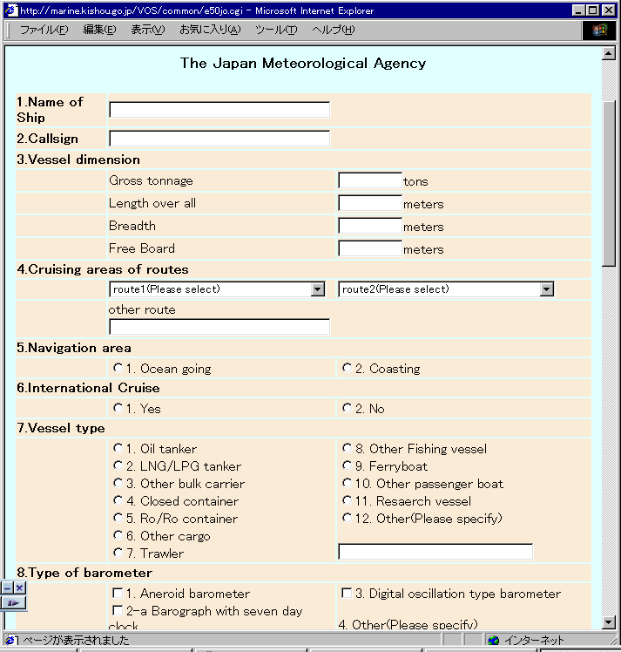
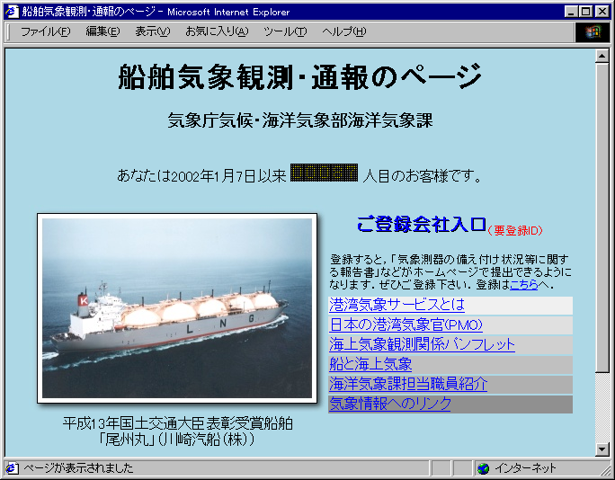
Figure 1. Web site for Japanese VOSs
a) Entrance page

b) Submission entry page for reports of meteorological
instruments on board

2. Weather reports from Japanese VOSs
Figure 2 shows a recent status of weather reports from Japanese VOSs. JMA research vessels are not included in the figure because they are not VOSs and make so many observations even every hour. The numbers of Japanese ships which regularly send weather reports has been decreasing. Ships which sent SHIP messages were 207 in number and those sent logbooks were 135 in 2001. The number of reported logbooks has also been decreasing, e.g. 68,021 in 1997 and 49,558 in 2001, but the number of SHP messages has been increasing, e.g. 46,032 in 1997 and 58,469 in 2001. For many Japanese ships, the number of officers/crews for each ship has been decreasing. This may make weather observations/reporting harder on VOSs.
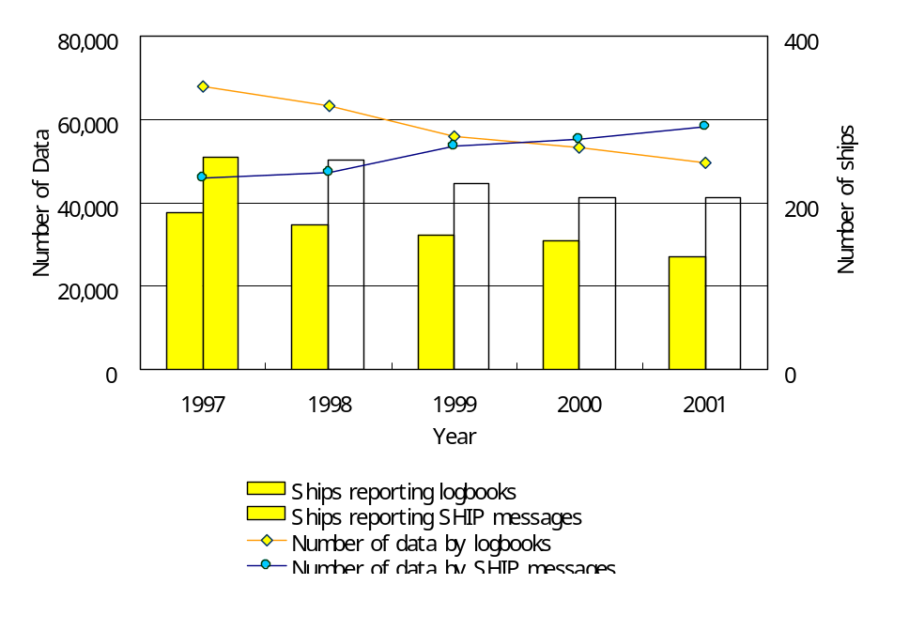
Figure 2. Weather reports by Japanese VOSs
3. Awarding ships for excellence in weather observations/reporting
The Ministry of Land, Infrastructure and Transport (MLIT), to which JMA is affiliated and JMA make annual awards to several ships for excellence in weather observations/reporting for encouragement. In 2001 one ship (BISHU MARU (JGAC)) was awarded by the Minister of MLIT and five ships, namely RAINBOW WING (3FIQ7), GOLDEN GATE BRIDGE (3FWM4), WASHINGTON HIGHWAY (JKHH), NOSHIRO MARU (JJHU) and ONOE MARU (JMMN), by the Director-General of JMA for their contribution to the meteorological observations/reporting.

4. Japanese Port Meteorological Officers (PMOs)
PMO's services are available at six ports in Japan, i.e. Kobe, Nagoya, Yokohama, Hakodate, Nagasaki and Maizuru. In 2001, Japanese PMOs visited a total of 498 ships at the above six ports.

5. OBSJMA
JMA developed OBSJMA in 1997 for easy and accurate compilation of weather reports and marine meteorological logbooks recording by using a personal computer. After trial use by several ships, JMA has distributed OBSJMA and its operating manuals to about 500 ships. However, the current OBSJMA has become to be rather old-fashioned because the software was developed on MS-DOS base. For example, keyboard is the only device for data input (i.e. mouse pointer is not available).

JMA is now upgrading the OBSJMA to Windows edition. The main screen of the software is designed to be similar to the "Sheet for Marine Weather Observations" traditionally distributed to VOSs by JMA. Observers on board can easily enter weather data on the screen using the mouse pointer referring appropriate help screens. Figure 3 shows examples of screens of the new OBSJMA.

In connection with the near future use of the Table Driven Codes CREX/BUFR, JMA is considering to add a function to migrate the SHIP messages to CREX/BUFR in the future OBSJMA without any modification of data entry procedure by officers/crews.

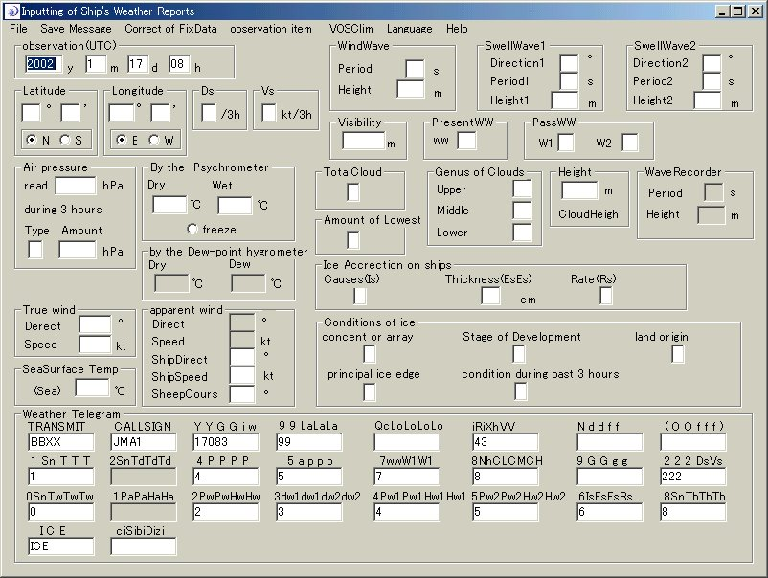
Figure 3. Screens of the new OBSJMA

a) Data entry screen
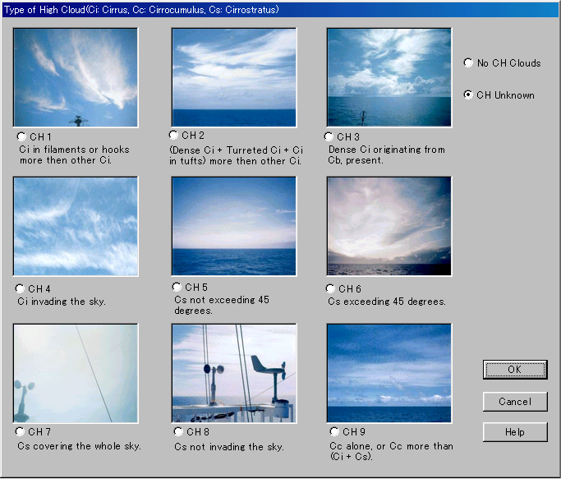
b) Help screen
for cloud type
6. Telecommunication Facilities
JMA accepts SHIP messages with Code "41" through Yamaguchi Coast Earth Station (CES) via INMARSAT Pacific Ocean Region (POR) satellite for INMARSAT-A, B and C and via Indian Ocean Region (IOR) satellite for INMARSAT-C. JMA inserts the messages onto the Global Telecommunication System (GTS).

7. Data management
Besides the real time SHIP messages, JMA received ships' weather reports either hand written in JMA's logbooks or on floppy disks recorded by OBSJMA on a delayed mode basis. The Agency operationally digitizes the reports on the logbooks and sends them together with data collected by floppy disks to the Global Collecting Centres (GCCs) after the Minimum Quality Control procedure of the Marine Climatological Summaries Scheme (MCSS) (Figure 4).

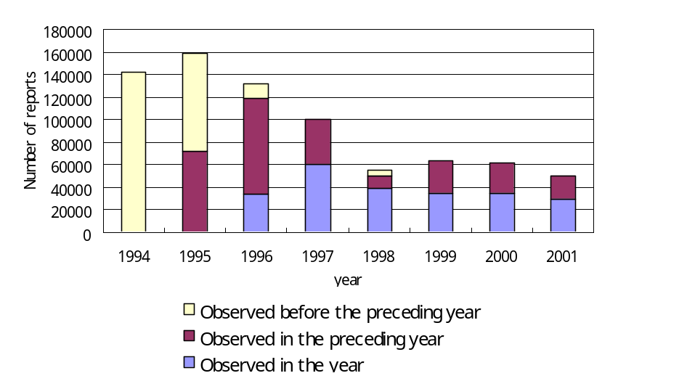
Figure 4. Number of weather reports submitted to GCCs by JMA

8. VOSClim ship recruitment in Japan
Firstly five research vessels of the JMA will join the project. They routinely make oceanographic and marine meteorological observation in western North Pacific (Figure 5). Secondly other governmental/university research/training vessels which navigate high seas are considered to have a potential to participate in the VOSClim project. Then, the JMA could examine a possibility to recruit merchant ships as a future target.

Figure 5. Typical observation lines of JMA’s research vessels

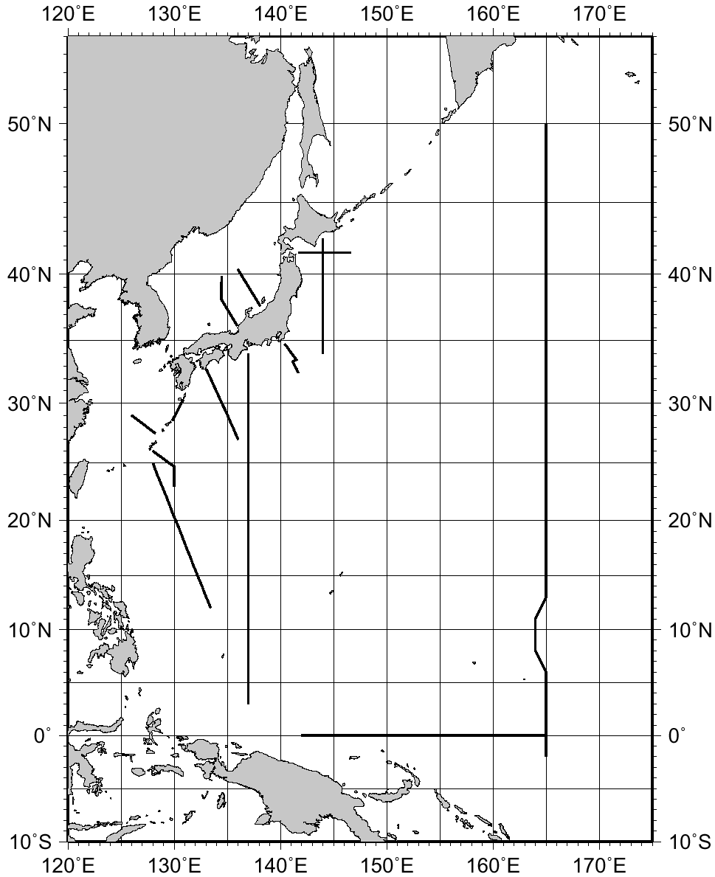
SHIP-OF-OPPORTUNITY PROGRAMME IMPLEMENTATION PANEL

1. National Programme Information
1.1 SAGE
“Subarctic Gyre Experiment in the North Pacific (SAGE)” is a scientific research project promoted and funded by the Ministry of Education, Culture, Sports, Science and Technology (MEXT) of Japan with participation of more than 10 Japanese organizations/institutions. SAGE is a 5-year project from FY1997 to FY2001. Under SAGE, the Japan Meteorological Agency (JMA) carries out XBT sampling by ships-of-opportunity (SOOs) in the TRANSPAC region (PX26) in cooperation with the National Oceanic and Atmospheric Administration (NOAA). SAGE will be completed in March 2002.

1.2 Cooperative research programme by JMA/JAMSTEC and NRIFSF/JAMSTEC
The Japan Marine Science and Technology Center (JAMSTEC) makes cooperative SOO sampling with JMA and the National Research Institute of Far Seas Fisheries (NRIFSF) of the Fisheries Research Agency (FRA) of Japan Fisheries Agency (JFA), respectively.

JMA and JAMSTEC started XBT/XCTD low density sampling in the western Pacific (PX05, PX49 and PX51) and in the Indian Ocean (IX09 (northern portion) and IX10 (eastern portion)) in September 2000, which was succeeded the long-lasted sampling by two SOOs under the former Science and Technology Agency (STA) project “Japanese Experiment on the Asian Monsoon (JEXAM)” continued until FY1999. As of February 2002, the sampling is carried out on the lines PX05, IX09 and IX10.

NRIFSF and JAMSTEC started XBT/XCTD high density sampling by a SOO in the Indian Ocean (IX06) in February 2000. The ship changed its route from IX06 to another in November 2001, and NRIFSF/JAMSTEC is now searching for another ship on IX06.

1.3 JAHMP
“Japan Hawaii Monitoring Programme (JAHMP)” is a scientific research programme operated by the Tohoku University (Prof. Kimio HANAWA’s group). Under the JAHMP, a fisheries training ship is operated to make high density XBT sampling on her way back from Hawaii to Japan (PX40) three times a year.

1.4 137E and 165E sections by JMA
JMA has been making routine oceanographic observations along 137E (PX45) since 1967. JMA has also been making observations along 165E (PX46) since 1996. Those observations are periodically performed by two research vessels of JMA. The 137E section is sampled four times a year. Two full samplings along 165E are made a year by four cruises of the vessels (e.g. northern/southern part of the section is sampled by one cruise).

2. Data Collection
2.1 SOOP lines
The numbers of “good” drops and BATHY/TESAC messages on SOOP lines in 2000 and 2001 are summarized in Tables 1 and 2, respectively. Information on sampling density, operator, programme, instrument and transmission is also summarized in Table 3. Totals of 1,566 BATHY and 27 TESAC, and 934 BATHY and 557 TESAC messages were reported along 68 and 87 sections by Japanese ships in 2000 and 2001, respectively. JMA research vessels started reporting TESAC messages instead of BATHY from January 2001 for the stations occupied by CTD observations.

LINE | SHIP NAME | CALL SIGN | #GOOD | #BATHY | #TESAC | #SECTION
PX05 Japan - New Zealand | Wellington Maru | JITV | 82 | 27 | 17 | 3
PX40 Japan - Hawaii | Miyagi Maru | JGBL | 379 | 379 | 0 | 3
PX45 137E section by CTD | Ryofu Maru | JGQH | 99 | 99 | 0 | 3
PX45 137E section by CTD | Keifu Maru | JBOA | 33 | 33 | 0 | 1
PX46 165E section by CTD | Ryofu Maru | JGQH | 53 | 53 | 0 | 2
PX49 Taiwan - Malacca Str. | Katori | 3FRY5 | 20 | 0 | 0 | 1
PX51 Hong Kong -New Zealand | Wellington Maru | JITV | 30 | 24 | 10 | 2+1p
PX26 TRANSPAC | Westwood Belinda | C6CE7 | ? | 126 | 0 | 11
PX26 TRANSPAC | Sealand Defender | KGJB | ? | 66 | 0 | 4
PX26 TRANSPAC | Sealand Express | KGJD | ? | 126 | 0 | 6
PX26 TRANSPAC | Sealand Developer | KHRH | ? | 167 | 0 | 7
PX26 TRANSPAC | Skauboard | LACF5 | ? | 90 | 0 | 5
PX26 TRANSPAC | Skaugran | LADB2 | ? | 27 | 0 | 3
PX26 TRANSPAC | Skaubryn | LAJV4 | ? | 191 | 0 | 8
IX06 Malacca Strait - Mauritius | Delmas Blosseville | 3FIK5 | 158 | 158 | 0 | 2
IX09 Fremantle – Persian Gulf  (northern portion) | Katori | 3FRY5 | 56 | 0 | 0 | 4
IX10 Malacca Str. – Red Sea  (eastern portion) | Katori | 3FRY5 | 24 | 0 | 0 | 3
TOTAL |  |  | (934) | 1,566 | 27 | 68+1p

Table 1. Japanese SOOP line sampling activities in 2000

LINE | SHIP NAME | CALL SIGN | #GOOD | #BATHY | #TESAC | #SECTION
PX05 Japan - New Zealand | Mol Wellington | JITV | 241 | 120 | 90 | 8
PX40 Japan – Hawaii | Miyagi Maru | JGBL | 327 | 327 | 0 | 3
PX45 137E section by CTD | Ryofu Maru | JGQH | 33 | 0 | 33 | 1
PX45 137E section by CTD | Keifu Maru | JPBN | 117 | 0 | 117 | 3
PX46 165E section by CTD | Ryofu Maru | JGQH | 65 | 0 | 65 | 3
PX46 165E section by CTD | Keifu Maru | JPBN | 24 | 0 | 24 | 1
PX49 Taiwan – Malacca Str. | Katori | 3FRY5 | 24 | 4 | 11 | 4
PX51 Hong Kong –New Zealand | Mol Wellington | JITV | 92 | 0 | 41 | 3
PX26 TRANSPAC | Westwood Belinda | C6CE7 | ? | 78 | 0 | 4
PX26 TRANSPAC | Sealand Defender | KGJB | ? | 216 | 0 | 14
PX26 TRANSPAC | Sealand Express | KGJD | ? | 0 | 0 | 0
PX26 TRANSPAC | Sealand Developer | KHRH | ? | 0 | 0 | 0
PX26 TRANSPAC | Skauboard | LACF5 | ? | 19 | 0 | 2
PX26 TRANSPAC | Skaugran | LADB2 | ? | 39 | 0 | 5
PX26 TRANSPAC | Skaubryn | LAJV4 | ? | 80 | 0 | 7
IX06 Malacca Strait – Mauritius | Harbour Bridge | 3FRU9 | ? | 10 | 1 | 3
IX09 Fremantle – Persian Gulf  (northern portion) | Katori | 3FRY5 | 165 | 24 | 99 | 13
IX10 Malacca Str. – Red Sea  (eastern portion) | Katori | 3FRY5 | 124 | 17 | 76 | 13
TOTAL |  |  | (1,212) | 934 | 557 | 87

Table 2. Japanese SOOP line sampling activities in 2001

LINE | SHIP NAME | CALL  SIGN | DENSITY | OPERATOR/  progamme | INSTRUMENT |  | TRANSMISSION
 |  |  |  |  | RECORDER | PROBE | TRANSMISSION
PX05 | Mol Wellington | JITV | 4 obs/day | JMA/JAMSTEC | TSK MK-130 | TSK/T7, XCTD | via INMARSAT
PX40 | Miyagi Maru | JGBL | every 0.5 deg  in longitude | Tohoku Univ./  JAHMP | Murayama Denki  Z-60-16 III | TSK/T7 | Delayed BATHY  from JMA
PX45  (137E) | Ryofu Maru | JGQH | every 1 deg  in latitude | JMA/operational | ICTD/FSI | (CTD) | via GMS
PX45  (137E) | Keifu Maru | JPBN | every 1 deg  in latitude | JMA/operational | SBE 9-11Plus | (CTD) | via GMS
PX46  (165E) | Ryofu Maru | JGQH | every 1 deg  in latitude | JMA/operational | ICTD/FSI | (CTD) | via GMS
PX46  (165E) | Keifu Maru | JPBN | every 1 deg  in latitude | JMA/operational | SBE 9-11Plus | (CTD) | via GMS
PX46  (165E) | Ryofu Maru | JGQH | every 1 deg  in latitude | JMA/operational | ICTD/FSI | (CTD) | via GMS
PX49 | Katori | 3FRY5 | 4 obs/day | JMA/JAMSTEC | TSK MK-130 | TSK/T7, XCTD | via INMARSAT
PX51 | Mol Wellington | JITV | 4 obs/day | JMA/JAMSTEC | TSK MK-130 | TSK/T7, XCTD | via INMARSAT
PX26 | Westwood Belinda | C6CE7 | 2 obs/day | JMA/NOAA/  SAGE | MK-9, MK-12 | TSK/T7 | SEAS
PX26 | Sealand Defender | KGJB
PX26 | Sealand Express | KGJD
PX26 | Sealand Developer | KHRH
PX26 | Skauboard | LACF5
PX26 | Skaugran | LADB2
PX26 | Skaubryn | LAJV4
IX06 | Harbour Bridge | 3FRU9 | 12 obs/day | NRIFSF/  JAMSTEC | TSK MK-130 | TSK/T7, XCTD | via INMARSAT
IX09  (north) | Katori | 3FRY5 | 4 obs/day | JMA/JAMSTEC | TSK MK-130 | TSK/T7, XCTD | via INMARSAT
IX10  (east) | Katori | 3FRY5 | 4 obs/day | JMA/JAMSTEC | TSK MK-130 | TSK/T7, XCTD | Via INMARSAT

Table 3. Summaries of Japanese SOOP as of the end of 2001

2.2 Other sources
Besides the sampling on the SOOP lines, many Japanese research vessels have been making XBT/XCTD/CTD observations. Many of them, but not all, are reporting their observations by BATHY/TESAC messages. Table 4 shows the numbers of all the inserted BATHY/TESAC messages onto GTS by Japanese ships in the recent three years including those on the SOOP lines. Figures 1 to 4 are geographical distributions of the BATHY/TESAC messages in 2000 and 2001, respectively. A total of 3,495 BATHY and 2,333 TESAC messages were reported by Japanese ships in 2001.

JMA distributed an operational manual on BATHY/TESAC messages to domestic organizations and institutions in April 2000. JMA started reporting the CTD and Acoustic Doppler Current Profiler (ADCP) observations (temperature, salinity and current profiles) by five research vessels in the form of TESAC message in January 2001. In addition to JMA vessels, several research vessels have been reporting TESAC messages.

SHIP NAME | CALL SIGN | AGENCY | 1999 |  | 2000 |  | 2001 |  | LINES
SHIP NAME | CALL SIGN | AGENCY | BATHY | TESAC | BATHY | TESAC | BATHY | TESAC | LINES
Ryofu Maru | JGQH | JMA | 374 | 0 | 399 | 0 | 4 | 381 | including PX45  (137E) and  PX46 (165E)
Keifu Maru  (until Aug. 2000) | JBOA | JMA | 260 | 0 | 78 | 0 | 0 | 0 | Including PX45  (137E)
Keifu Maru  (since Sep. 2000) | JPBN | JMA | 0 | 0 | 32 | 0 | 0 | 348 | Including PX45  (137E) and  PX46 (165E)
Kofu Maru | JDWX | JMA | 399 | 0 | 389 | 0 | 0 | 448
Shumpu Maru | JFDG | JMA | 419 | 0 | 347 | 0 | 9 | 0
Chofu Maru | JCCX | JMA | 381 | 0 | 426 | 0 | 0 | 378
Seifu Maru | JIVB | JMA | 395 | 0 | 418 | 0 | 0 | 386
Wellington Maru  (Mol Wellington  since Aug. 2001) | JITV | JMA | 518 | 0 | 51 | 28 | 121 | 131 | PX05, PX51
Kashimasan Maru | JFPQ | JMA/JAMSTEC | 397 | 0 | 0 | 0 | 0 | 0 | IX09 (north),  IX10 (east),  PX49
Katori | 3FRY5 | JMA/JAMSTEC | 0 | 0 | 0 | 0 | 45 | 186 | IX09 (north),  IX10 (east),  PX49
Sealand Express | KGJD | JMA/NOAA | 5 | 0 | 126 | 0 | 0 | 0 | PX26
Sealand Developer | KHRH | JMA/NOAA | 21 | 0 | 167 | 0 | 0 | 0 | PX26
Sealand Defender | KGJB | JMA/NOAA | 0 | 0 | 66 | 0 | 216 | 0 | PX26
Westwood Belinda | C6CE7 | JMA/NOAA | 76 | 0 | 126 | 0 | 78 | 0 | PX26
Skauboard | LACF5 | JMA/NOAA | 0 | 0 | 90 | 0 | 19 | 0 | PX26
Skaugran | LADB2 | JMA/NOAA | 0 | 0 | 27 | 0 | 39 | 0 | PX26
Skaubryn | LAJV4 | JMA/NOAA | 0 | 0 | 191 | 0 | 80 | 0 | PX26
Takuyo | 7JWN | JCG | 62 | 0 | 0 | 0 | 0 | 0
Shoyo | JLPT | JCG | 0 | 0 | 12 | 0 | 0 | 0
Kaiyo Maru | JNZL | JFA | 199 | 0 | 40 | 0 | 32 | 0
Shoyo Maru | JLOJ | JFA | 283 | 0 | 87 | 0 | 173 | 0
Hokko Maru | 8LRY | JFA | 142 | 0 | 32 | 0 | 161 | 16
Wakataka Maru | JQIX | JFA | 27 | 0 | 88 | 0 | 191 | 0
Soyo Maru | JGKL | JFA | 51 | 0 | 114 | 0 | 292 | 0
Shunyo Maru | 8JIF | JFA | 17 | 0 | 39 | 0 | 0 | 0
Yoko Maru | 7KDD | JFA | 3 | 0 | 43 | 0 | 50 | 0
Mizuho Maru | JJEB | JFA | 84 | 0 | 108 | 0 | 192 | 0
Wakatake Maru | JLOV | JFA | 149 | 0 | 125 | 0 | 153 | 0
Kaiun Maru | JRFC | JFA | 0 | 0 | 92 | 0 | 62 | 0
Fukui Maru | JIVN | JFA | 54 | 0 | 97 | 0 | 46 | 0
Wakatori Maru | 7JJX | JFA | 0 | 0 | 60 | 0 | 60 | 0
Shonan Maru No.3 | 7MGA | JFA | 0 | 0 | 1 | 23 | 0 | 14
Torishima | JROY | JFA | 72 | 0 | 242 | 0 | 121 | 0
Kaiyo Maru No.5 | JRUJ | JFA | 0 | 0 | 122 | 0 | 0 | 0
Delmas Blosseville | 3FIK5 | JFA/JAMSTEC | 0 | 0 | 158 | 0 | 0 | 0 | IX06
Harbour Bridge | 3FRU9 | JFA/JAMSTEC | 0 | 0 | 0 | 0 | 13 | 1 | IX06
Shirase | JSVY | Defense Agency | 5 | 0 | 0 | 0 | 2 | 0
Oshoro Maru | JDVA | Hokkaido Univ. | 0 | 0 | 61 | 0 | 0 | 0
Miyagi Maru | JGBL | Tohoku Univ. | 216 | 0 | 379 | 0 | 327 | 0 | PX40
Hakuho Maru | JDSS | Univ. of Tokyo | 112 | 0 | 170 | 0 | 47 | 29
Tansei Maru | JIQY | Univ. of Tokyo | 0 | 0 | 0 | 0 | 0 | 15
Keiten Maru | JGDW | Kagoshima Univ. | 124 | 0 | 183 | 0 | 129 | 0
Kaiyo | JRPG | JAMSTEC | 160 | 0 | 85 | 0 | 114 | 0
Mirai | JNSR | JAMSTEC | 238 | 0 | 598 | 0 | 567 | 0
Ogasawara Maru | JHLO | JAMSTEC/  Tohoku Univ. | 79 | 0 | 142 | 0 | 152 | 0
TOTAL |  |  | 5,322 | 0 | 6,011 | 51 | 3,495 | 2,333

Table 4. Numbers of BATHY messages inserted onto GTS by Japan

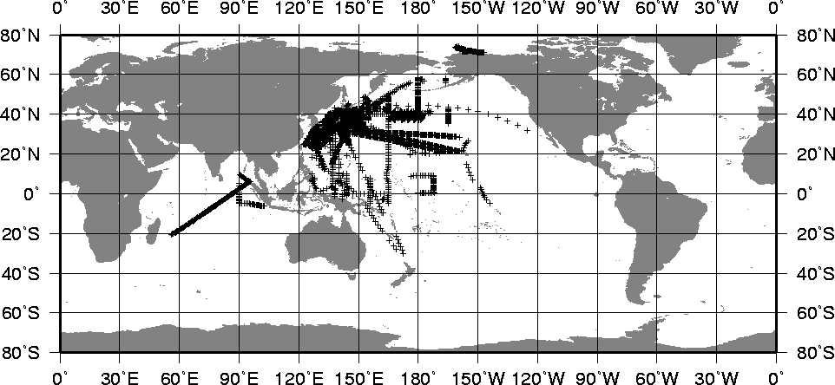

Figure 1. Distribution of BATHY messages reported by Japan during 2000

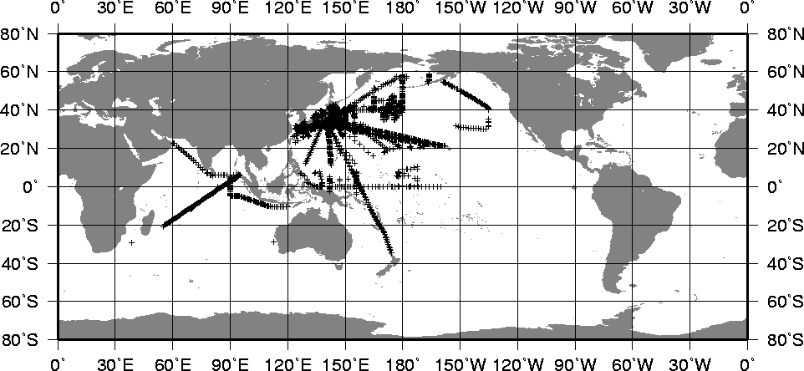

Figure 2. Distribution of BATHY messages reported by Japan during 2001

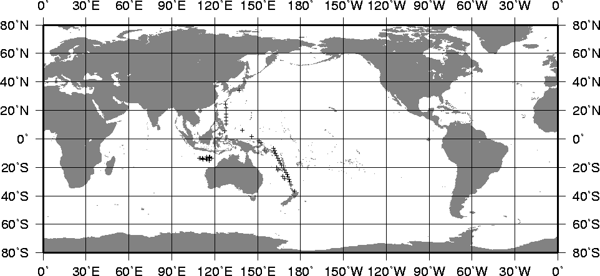

Figure 3. Distribution of TESAC messages reported by Japan during 2000

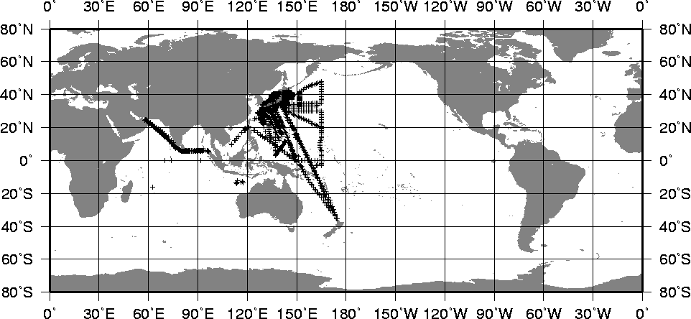

Figure 4. Distribution of TESAC messages reported by Japan during 2001

3. Data Management
3.1 Realtime data management
The two SOOs under the cooperative programme by JMA/JAMSTEC, Mol Wellington and Katori, are equipped with automated XBT/XCTD sampling and data transmission system, which has been newly developed (see 5). The system automatically transmits BATHY/TESAC messages via INMARSAT to JMA.

JMA research vessels also transmit BATHY/TESAC messages via the Geostationary Meteorological Satellite (GMS) to JMA. These messages are inserted onto GTS at JMA.

The SOOs under the JMA/NOAA cooperative sampling are equipped with SEAS system. Regarding Miyagi Maru on PX40, BATHY messages are encoded and inserted onto GTS at JMA as soon as possible after the ship calls a port in Japan.

3.2 Delayed mode data management
All of the detailed XBT profile data are submitted to the Japan Oceanographic Data Center (JODC). JMA also sends the data to the WOCE UOT Data Assembly Centre/IFREMER, Brest in France.

4. Future Plans
The plans of Japanese SOOP activities are summarized in Table 5. The cooperative research programmes by JMA/JAMSTEC and NRIFSF/JAMSTEC are expected to continue at least five years, though it is not fixed at present. The present project for the high density sampling on PX40 will be completed in March 2003, but the Tohoku University plans to continue the sampling after that. The JMA/NOAA cooperative sampling on PX26 are stopped on March 2002 due to a termination of the project SAGE. A plan of resumption of the PX26 sampling is expected to be examined in a new MEXT project. Anyway no project will be carried out at least in FY2002 regarding PX26 by Japan.

LINE | SHIP NAME | CALL SIGN | SECTION/  DENSITY | OPERATOR | REMARK
PX05 | Mol Wellington | H9TO | 8/LD (XBT/XCTD) | JMA/JAMSTEC | as long as possible  (The call sign changed from JITV on 16 Jan. 2002.)
PX40 | Miyagi Maru | JGBL | 3/HD | Tohoku Univ. | as long as possible
PX45 (137E) | Ryofu Maru | JGQH | 4/LD (CTD) | JMA | operational CTD section
PX45 (137E) | Keifu Maru | JPBN | 4/LD (CTD) | JMA | operational CTD section
PX46 (165E) | Ryofu Maru | JGQH | 4/LD (CTD) | JMA | operational CTD section
PX46 (165E) | Keifu Maru | JPBN | 4/LD (CTD) | JMA | operational CTD section
IX09 (north) | Katori | 3FRY5 | 14/LD (XBT/XCTD) | JMA/JAMSTEC | as long as possible
IX10 (east) | Katori | 3FRY5 | 14/LD (XBT/XCTD) | JMA/JAMSTEC | as long as possible

Table 5. Japanese SOOP Plans

5. Further Information
Automated XBT/XCTD sampling and data transmission system
JMA and JAMSTEC have developed an automated XBT/XCTD sampling and data transmission system and equipped two SOOs with the system under their cooperative programme. The system consists of an automated XBT/XCTD launcher and a launcher controller (Photos 1, 2 and Figure 5). The system is connected to the ship's INMARSAT-C computer. The system automatically launches XBT/XCTD probes at a preset time interval and makes BATHY/TESAC messages to transmit them to JMA for the insertion onto the GTS.

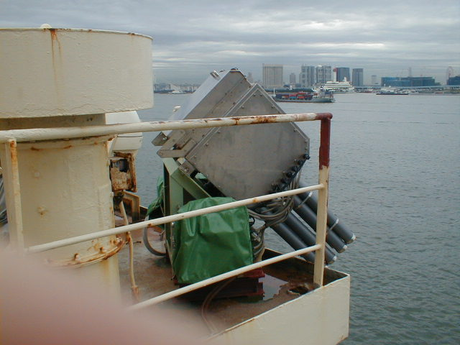
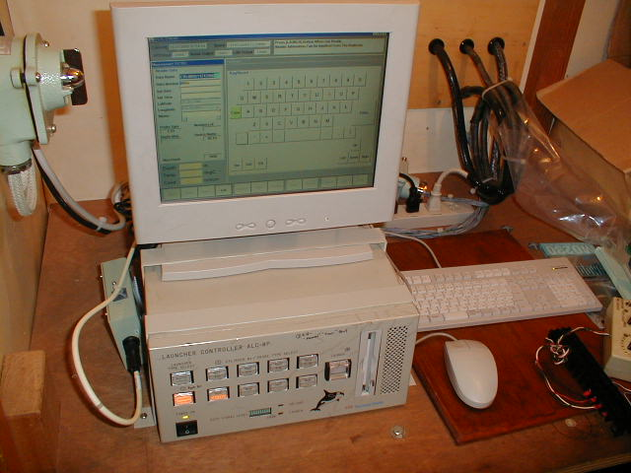
Photo 1. Automated XBT/XCTD launcher
Photo 2. Launcher controller

automated XBT/XCTD launcher
XBT/XCTD converter
GPS receiver

launcher controller
INMARSAT-C computer
observational data
location data
command
XBT/XCTD probe
BATHY/TESAC
message
JMA ⇒ GTS

Figure 5. Automated XBT/XCTD sampling and data transmission system

AUTOMATED SHIPBOARD AEROLOGICAL PROGRAMME PANEL

COUNTRY JAPAN NAME OF AGENCY: Japan Meteorological Agency YEAR: 2001
6 ASAP units operated during the year on 6 ships
Type of ship¹⁾ | Name | Call sign | Comm. method²⁾ | Windfind method / Sonde type³⁾ | Launch Method⁴⁾ | Launch height⁵⁾ | Area of operations⁶⁾ | ASAP Unit ID No.
research ship | Ryofu  Maru | JGQH | others  (DCP via the GMS) | GPS/Vaisala  RS80-G | container  (semi-automatic) | 8 m | North Pacific | 708514
research ship | Kofu  Maru | JDWX | others  (DCP via the GMS) | GPS/Vaisala  RS80-G | container  (semi-automatic) | 6 m | Seas adjacent to Japan | 191678
research ship | Seifu  Maru | JIVB | others  (DCP via the GMS) | GPS/Vaisala  RS80-G | container  (semi-automatic) | 6 m | Seas adjacent to Japan | 458533
research ship | Chofu  Maru | JCCX | others  (DCP via the GMS) | GPS/Vaisala  RS80-G | container  (semi-automatic) | 6 m | Seas adjacent to Japan | 126138
research ship | Keifu  Maru | JPBN | others  (DCP via the GMS) | GPS/Vaisala  RS80-G | deck-launcher  (portable) | 8 m | North Pacific | -
research ship | Mirai | JNSR | Inmarsat -C | GPS/Vaisala  RS80-G | container  (semi-automatic) | 16 m | variable | -
research ship | Hakuho  Maru | JDSS | Inmarsat -C | GPS/Vaisala  RS80-G | deck-launcher  (portable) | - | variable | -
1) Merchant ship, research ship, supply ship, etc.
2) Using IDCS, Inmarsat-C, or others
3) E.G. GPS/Vaisala RS80-G, Loran/Vaisala RS80-L, VIZ GPS Mark II Microsonde, etc.
4) Launch method e.g.: deck launcher (portable); deck launcher (fixed); container (manual); container (semi-automatic); other.
5) The height above sea level from where the sonde and balloon is released
6) Ocean area, e.g. North Pacific, North Atlantic, Indian Ocean, variable

Summary of performance of ASAP units during the year 2001
Call sign | Total No. of sondes launched | No. of messages transmitted | No. of relaunches | Average terminal sounding height (km) | Balloon Size (gm) | Percentage on GTS¹⁾
JGQH | 177 | 169 | 8 | 25.2 | 350 | 100
JDWX | 189 | 180 | 9 | 24.1 | 350 | 100
JIVB | 216 | 190 | 26 | 23.5 | 350 | 100
JCCX | 193 | 177 | 16 | 22.4 | 350 | 88.7
JPBN | 29 | 25 | 4 | 19.6 | 350 | 100
JNSR | 269 | 267 | 2 | 22.3 | 350 | 42.6
JDSS | 81 | 35 | 2 | - | 350 | 25.7
Total or average | 1073 | 1043 | 67 | - | 350 | 80.8
1) Based upon reports received at a data centre or GTS insertion point, name: Tokyo (RJTD)
Ratio of reports received against reports transmitted

COMMENTS:

During the year of 2001 in Japan upper-air observations over the oceans are made by seven oceanographic research vessels listed in the above table. R/V Mirai (JNSR) is operated by the Japan Marine Science and Technology Center (JAMSTEC), R/V Hakuho Maru (JDSS) is operated by the Ocean Research Institution of the University of Tokyo, and the others are operated by the Japan Meteorological Agency (JMA).

JMA makes upper-air observations in the western North Pacific and the seas adjacent to Japan on a regular basis (twice a day) on board four vessels (JGQH, JDWX, JIVB and JCCX) among five research vessels operated by JMA. R/V Keifu Maru (JPBN) does not make upper-air observation on a regular basis.

In July 2001, three research vessels (JGQH, JCCX and JPBN) of JMA performed enhanced upper-air observations (four times per day) in order to monitor and investigate typhoons in the western subtropical North Pacific. R/V Keifu Maru (JPBN) joined this enhanced observations using a portable deck-launcher.

In December 2001, R/V Hakuho Maru (JDSS) operated by the Ocean Research Institution of the University of Tokyo performed research based observations using a portable deck-launcher in the central Pacific.

ESTIMATES FOR FOLLOWING YEAR:

JMA will carry out upper-air observations in the similar regions in 2002 almost as many times as in 2001.

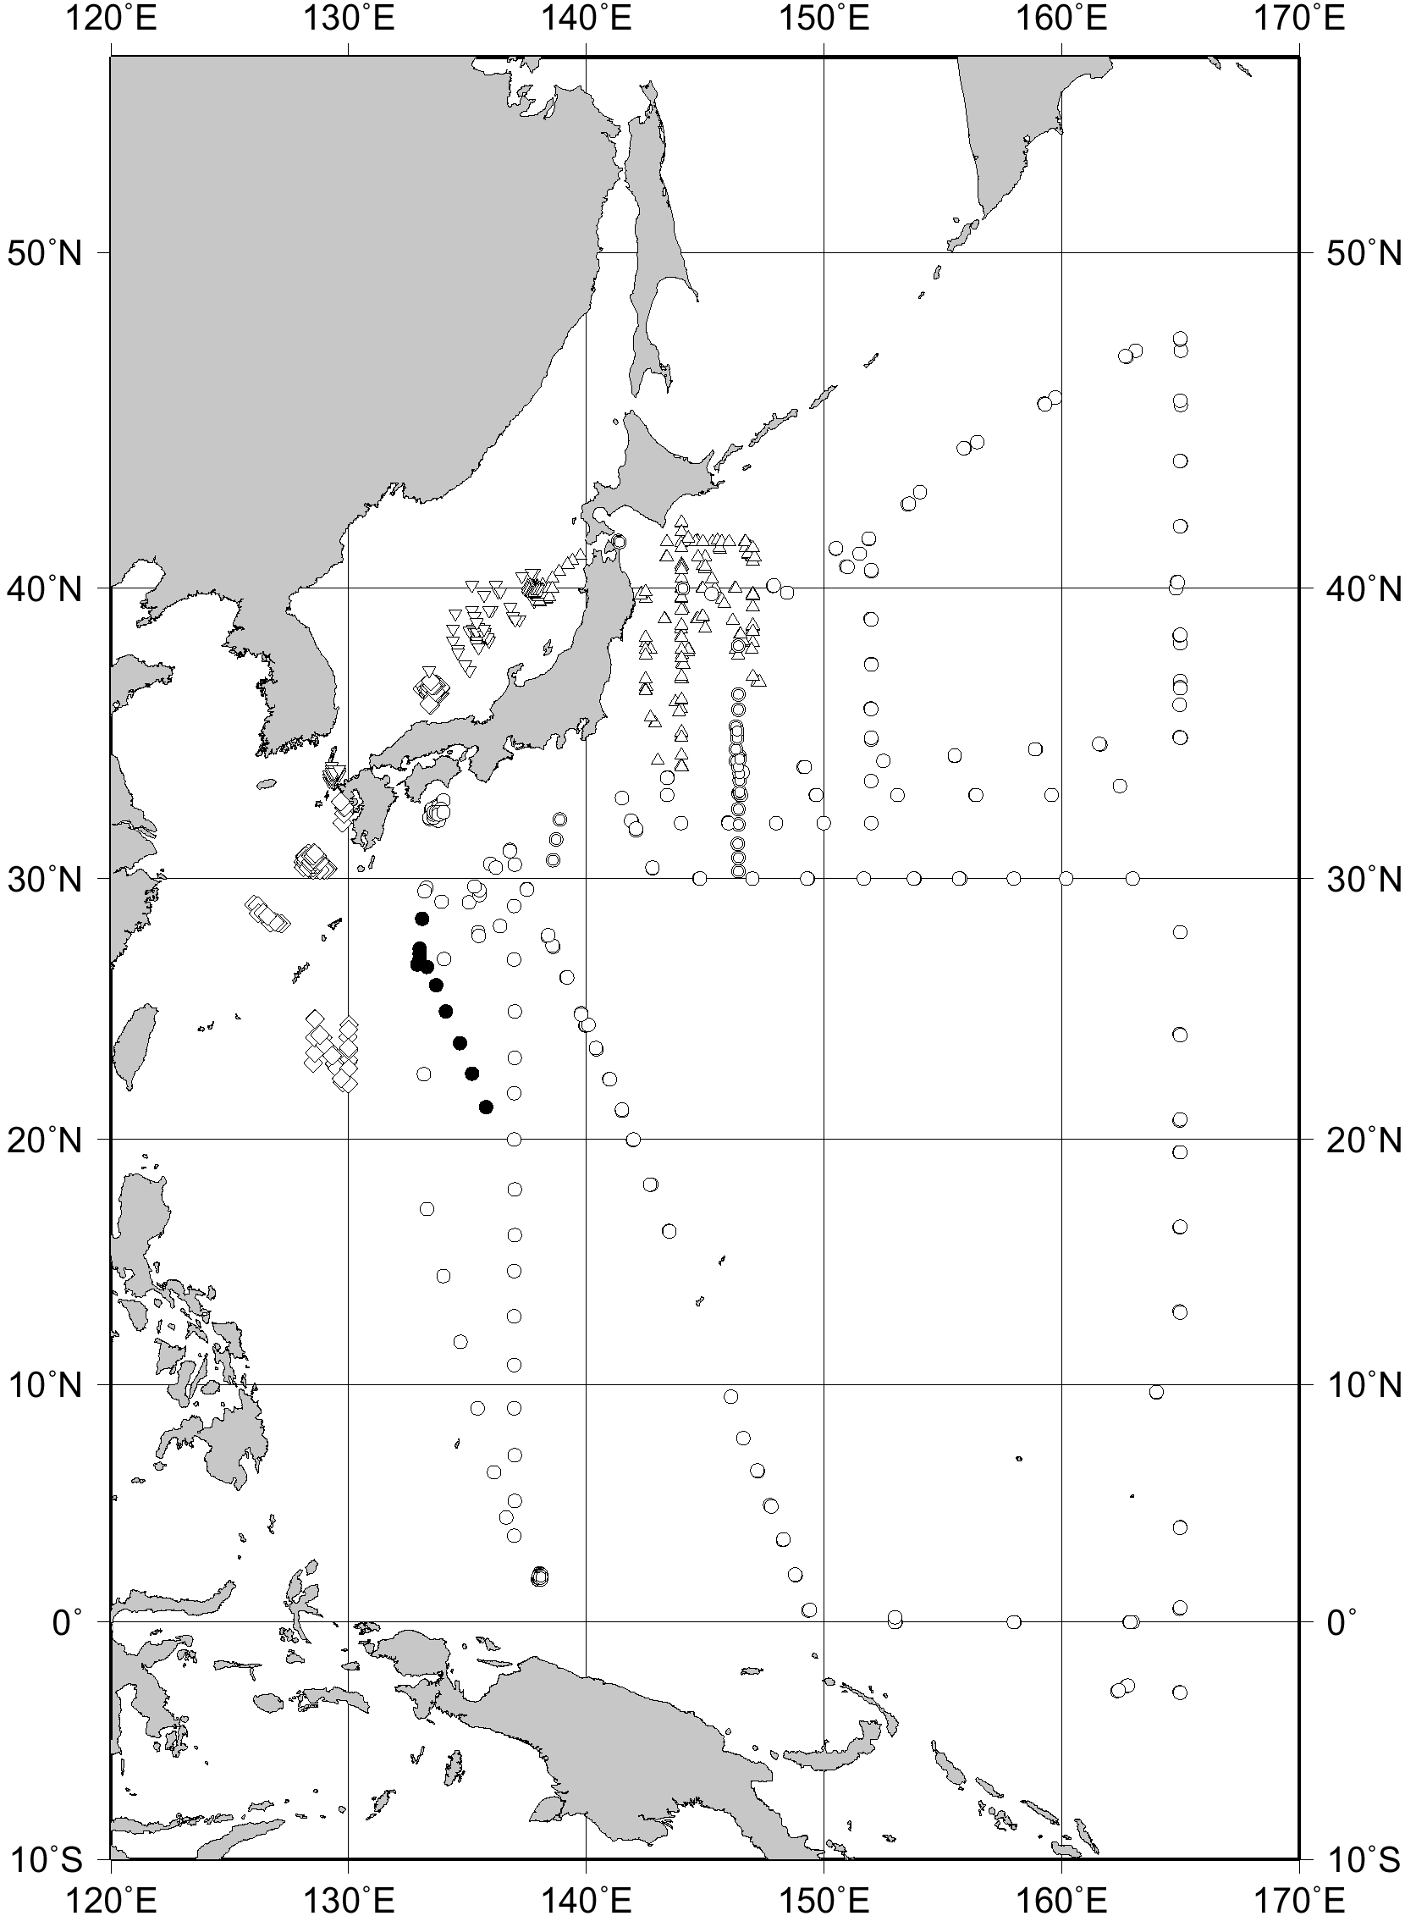
Upper-air observations by Japan in 2001 for the western North Pacific
including equatorial regions. (JGQH, JDWX, JIVB, JCCX, JPBN, JNSR)
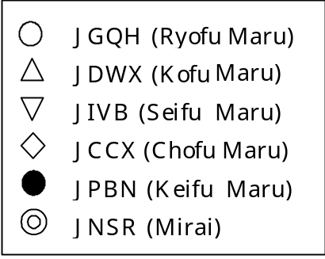

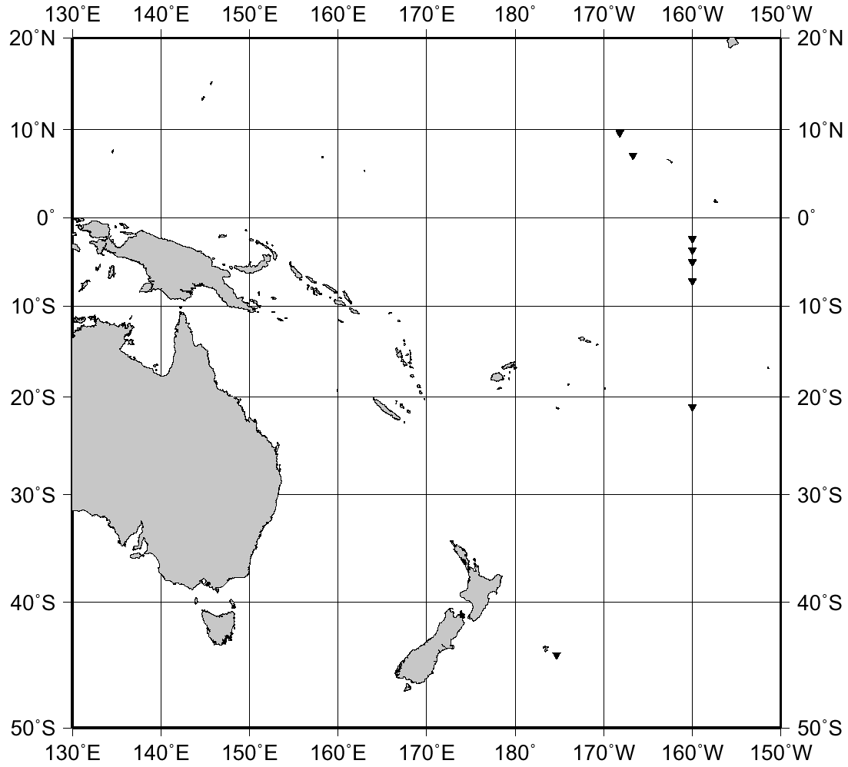
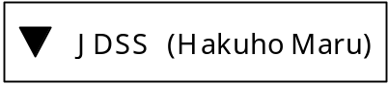
Upper-air observations by Japan in 2001 (JDSS)

WESTERN INDIAN OCEAN VOS/SOOP/ASAP PROJECT (WIO-VOSA)

PROJECT PROPOSAL DOCUMENT

Submitted by Kenya

- INTRODUCTION.

The Western Indian Ocean region is constituted by the Island states of Comoros, Madagascar, Mauritius, Seychelles and La Reunion (France) as well as mainland states of Kenya, Uganda, Mozambique, Somalia and Tanzania.
This region forms one of the least monitored areas in terms of sourcing real-time meteorological and oceanographic data and information. While it may be covered adequately by satellite there isn’t enough activity in terms of Voluntary Observing Ship, Ship of Opportunity and Automated Shipboard Aero logical programmes as well as data buoy deployment to monitor the oceans for Global Climate change.
The project proposal is in line with the terms of reference of the Ship Observing Team, SOOP Implementation Panel, ASAP Panel and VOS Panel of the Observation Coordination Group of the Observation Programme Area of JCOMM.
The relevant terms of reference are:

1.1 Ship Observation Team
- Review and analyse requirements for ship – based observational data expressed by the WWW, WCP, WCRP, GOOS, GCOS and in support of marine services, and coordinate actions to implement and maintain the networks to satisfy thes requirements.
- Review marine telecommunication facilities and procedures for observational data collection, as well as technology and techniques for data processing and transmission, and propose actions as necessary for improvements and enhanced application.
- Coordinate PMO/Ship greeting operations globally, propose actions to enhance PMO standards and operations, and contribute as required to PMO training.

1.2 SOOP Implementation Panel.

- Review, recommend on and, as necessary, coordinate the implementation of specialized shipboard instrumentation and observing practices.

1.3 ASAP Panel.

- As may be required by some members, arrange for and use funds and contributions in kind needed for the procurement, implementation and operation of ASAP systems and for the promotion and expansion of the programme
- VOS Panel.
- Develop and implement activities to enhance ship recruitment, including promotional brochures, training videos, etc.

The project is also in support of the observations made by the Chairman of the Working Group on Marine Observing Systems at the at the first session of JCOMM, Akureyri, Iceland, 19 – 29 June 2002, which state inter alia:
- To maintain and expand marine meteorological reports from VOS should be a high priority within the observations programme area of JCOMM. In particular, to improve the quality and quantity of ship reports, consideration should be given to the following:
  - Enhancement of training of crews for observation and reporting by using various materials and opportunities, including preparation of video – tapes/CD-ROMS and further improvement of software to assist the work of the crews.
  - Support for PMO through training events and materials and strengthening of the global PMO network, including enhanced communication among PMOs’.
  - Encouragement of ship owners and crews to participate in the VOS, including through schemes such as the awarding of prizes to high – performing VOS and the issuing of news letters to mariners to individual Members.
- Ship – based observations, including the VOS for surface meteorological observation, the SOOP for sub-surface salinity and temperature, and the ASAP for upper - air observations, should be developed in an integrated manner.

RETIONALE FOR VOS/SOOP ENHANCEMENT IN WESTERN INDIAN OCEAN OF RA 1.

The project to enhance the VOS/SOOP/ASAP activities in the region is necessary because:
- It will act as co-operative venture to enhance the provision of marine meteorological and oceanographic data in support of a diversity of national, regional and global programmes.
- During the 1982-84 lanina episode the Indian Ocean gave a strong signal as compared to the Pacific Ocean, which is informative that a thorough study of the ocean’s physical processes in the region can help a better understanding of the global climate change.
- Currents within the WIO region do not give any indication of how they are distributed with depth due to limited data sets. This information is crucial to understanding how heat and other properties are transported in the ocean. The Indonesian through flow, which originate from west Pacific and flows westwards into the Indian Ocean, affects the ocean’s heat budget and is thought to be significant in predicting El Nino and Lanina episodes.
- Fresh water inputs in an ocean region can modify the surface heat budget whose interannual variations are of primary interest to the ocean observing system for climate. However no attempt has yet been made to understand the pattern of fresh water transports in the region due to limited data sets.

- CURRENT PROBLEMS TO BE ADDRESSED BY THE PROJECT.

The problems expected to be addressed by the implementation of the WIO-VOSA
Project in the region are.
- Lack of equipment for the recruitment of ships into the VOS, SOOP and ASAP programs
- Lack of well developed capacity for making data quality control monitoring of the VOS, SOOP and ASAP data sets
- Lack of coordination of VOS, SOOP and ASAP activities within the region.
- Lack of technical know-how of the PMOs in the region.

Latest records show the status of VOS in the countries of the region as shown on the table below: -

COUNTRY | VOS STATUS
COUNTRY | NUMBER 1997 | PMO’S
COMOROS | NIL | NIL
FRANCE (LA REUNION) | - | 1
KENYA | NIL | 1
MADAGASCAR | NIL | -
MAURITIUS | 2(AUXILLARY) | 1
MOZAMBIQUE | NIL | -
SYCHELLES | NIL | NIL
SOUTH AFRICA | 27(SELECTED) 20(AUXILLARY) | 2
TANZANIA | NIL | 1
UGANDA | - | -

But most of the recruited ships shown in the countries do not ply within the ocean of the region. At least they have not yet been monitored at the Port of Mombasa.
4.0 POTENTIAL FOR VOS AND SOOP IN THE REGION.
The potential for VOS, SOOP and ASAP in the region exists. There is a strong shipping circuit, which has developed within the Indian Ocean linking the various Indian Ocean RIM countries in Africa, the Middle East, the Indian sub-continent and the Indian Ocean islands. There are a number of unrecruited ships monitored at the Port Meteorological office operating within the RIM and beyond. However due to the countries’ shrinking budget we cannot recruit them into the observing scheme despite their willingness.

5.0 STRATEGY.

The WIO- VOSA is to be developed as a Pilot Project monitoring 10 ships plying within the region. These ships will be picked in consultation with PMO’s in the region

5.1 SELECTION OF SHIPS

Below is a selected list of unrecruited ships, which have shown willingness to join the VOS, SOOP and ASAP fleet in the region.
The criteria for their selection is,
- Their willingness to be recruited.
- Their regularity at the Port of Mombasa
- Their appreciation for the meteorological services offered to them in the region
- Their duration of operation within the region.

‘MV’CONTI ROSE
‘MV’ VINBI
‘MV’ MSC AUGUSTA
‘MV’ KOSI
‘MV’ CONCORDE DAISEN
‘MV’ SEA BARON
‘MV’ ATTICA
‘MV’ ROVU
‘MV’ OSCAR SATURN
‘MV’ PHOINEX ACT
‘MV’ KOTA ABADI
‘MV’ ASIAN STAR
‘MV’ VALERIA
‘MV’ MARIANAD
‘MV’ KOTA ALAN
‘MV’ SEA CRYSTAL
‘MV’ STELLA TINGAS
‘MV’ INDIAN EXPRESS
‘MV’ LEOPARD 1
‘MV’ SEA COUNTESS
‘MV’ STORM WIND
‘MV’ SEA WIND
‘MV’ ADALINA
‘MV’ APJ ANJIL
‘MV’ KENYA STAR
‘MV’ ANNAMARA
‘MV’ SWEET LADY
‘MV’ EAST WOOD
‘MV’ AL-WALLI YU
‘MV’ SEA HORSE
‘MV’ CMBT PANGANI
‘MV’ CAPE BRYON
‘MV’ NEDLOYD MOMBASA

5.2 EQUIPMENTS AND STATIONERY FOR TEN SHIPS

The logbooks will have a regional outlook that can be exchanged at any country within the region.
All equipments and stationery necessary for VOS and SOOP operations in a ship.
The equipments to loan to ships will include:
- Precision aneroid barometers.
- Barographs
- Sheathed thermometers (air and wet bulb)
- Screens
- Sea thermometers
- Rubber buckets.
- XBT’S.
- Radiosonde
- Upper air balloons
- Hydrogen gas supply,

6.0 PROJECT MANAGEMENT.

The project will require the involvement of all the national meteorological and oceanographic Services of the countries of this region. In particular the active participation at least of Kenya in the East Africa mainland, Mauritius in the Island states. It will however be necessary that the management team comprises of representatives from all participating countries preferably PMO’s.
The Management group will require the involvement/support of the WMO secretariat in implementing its objectives. This group will be responsible for all aspects of the project implementation. The project leader will be the chairman of the management group and will be the focal point for the project.

7.0 ACTIVITIES.

7.1 Meeting of all PMO’s in the region with WMO secretariat and IOC regional project leader.
Implementer-WMO/IOC
Host -KMD Kenya
Time frame –immediately

7.2 Provision of meteorological and oceanographic equipment to loan to the ships and printing of logbooks with regional outlook.
Implementer. Friendly countries through WMO’s VCP Programme (UK, USA, NETHERLANDS etc).

7.3 Wide area networking of all PMO’s within the region with the IOC project office in Kenya and connected to a more developed PMO service like UK by the provision of computers for PMO’s and networking of these offices.
Implementer -Government, WMO.
Time frame- on going within the project duration.

7.4 TRAINING.

- All PMO’s in the region on data quality control monitoring.
- Trainers for ships crews on board ships or at maritime colleges in respective countries in basic knowledge on interpretation of met products to ships.
- On public relations management.
- Data and information transmission techniques through INMARSAT.
- Latest software on electronics logbooks etc.

SUMMARY

 | ACTIVITY | RESPONSIBILITY | TIMING | OUTPUT
1 | Meeting of Management group,  (PMO’s)/WMO/IOC | WMO/IOC and hoist country | Immediately | - Getting chairperson  - Confirming country focal points  - Drawing a timetable and a budget
2 | Networking of focal points | WMO/IOC and  Member countries | 3 months after first meeting | Quick communication links between focal points
3 | Identification of ships and provision of equipments to focal points | WMO/IOC, Friendly countries, focal points | 6 months after activity 2
4 | Ship recruitment and notification to other focal points. | Member countries. | Ongoing after activity 3
5 | Data monitoring and training. | WMO/IOC, Friendly countries, member countries. | Ongoing

Voluntary Observing Ships Program in Malaysia

ALUI BIN BAHARI
MALAYSIAN METEOROLOGICAL SERVICE

The Division of Marine Meteorology and Oceanography (DMMO) was established in the Malaysian Meteorological Service (MMS) in 1975. MMS has participated actively in the Voluntary Observing Ships (VOS) program, ever since 1974 in an effort to build up an adequate marine meteorological database. Ships are recruited and categorized into three different groups i.e. Selected Ships, Supplementary Ships & Auxiliary Ships according to WMO guidelines, circular No. W/MA/MS dated 28 February 1991.

Ship Category | Selected | Supplementary | Auxiliary | TOTAL
Number of ships | 33 | 39 | 31 | 103

Table 1: Number of Malaysian recruited ships under VOS Program.

Currently, a total of 101 Malaysian ships are maintained and visited by PMOs of MMS at three seaports namely Port Klang (1976), Port Bintulu (1984) and Port Kota Kinabalu (1988). Port Meteorological Officers (PMOs) normally visit each Malaysian recruited vessel once in three months for briefing and calibration of the meteorological equipment onboard. The number of VOS ships visited by the PMOs from 1997 to 2000 is shown in Table 2.

Year | Number of visit | Ship Category
Year | Number of visit | Selected | Supplementary | Auxiliary
1996 | 113 | 62 | 25 | 26
1997 | 105 | 65 | 28 | 12
1998 | 89 | 53 | 25 | 11
1999 | 92 | 61 | 19 | 12
2000 | 79 | 55 | 13 | 11
Total | 478 | 296 | 110 | 72

Table 2: Number of ship visit by PMOs from 1996 to 2000.

During a ship visit, completed meteorological logbooks from VOS ships are also collected. These logbooks are quality checked at DMMO office before archiving, and dispatched to the TOGA Marine Climatology Data Centre in United Kingdom, every quarterly.

The number of data received from Malaysian VOS vessels through meteorological logbooks from year 1974 to 2000 is depicted in Fig 1. From 1997 onward, data from the VOS program is observed reducing sharply.
Figure 2 shows the monthly performance of the Malaysian VOS program for a region bounded by latitude 5 °S – 20 °N and longitude 95 °E – 130 °E.

MMS has taken steps to encourage VOS ships to maintain a high number of observations by issuing appreciation letters monthly to ships reporting more than 20 observations per month. Besides this, MMS also presents excellence awards yearly to the three best reporting ships for their contributions to the VOS program. This selection is based on the quantity, regularity and quality of weather observation data. MMS will continue with these awards to show its appreciation and encouragement to the ship personnel involved in this programme. Efforts are also constantly taken by MMS to improve and upgrade the efficiency of port meteorological offices in serving the VOS program.

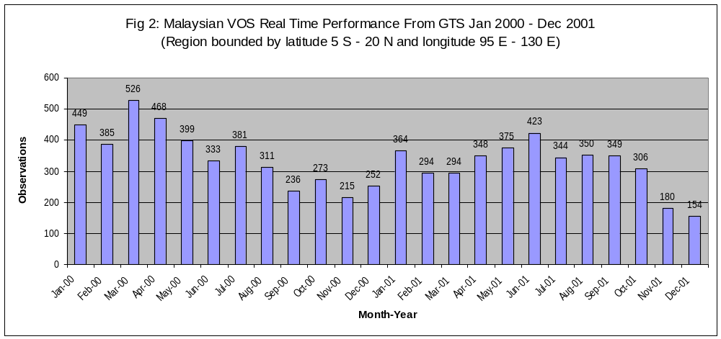
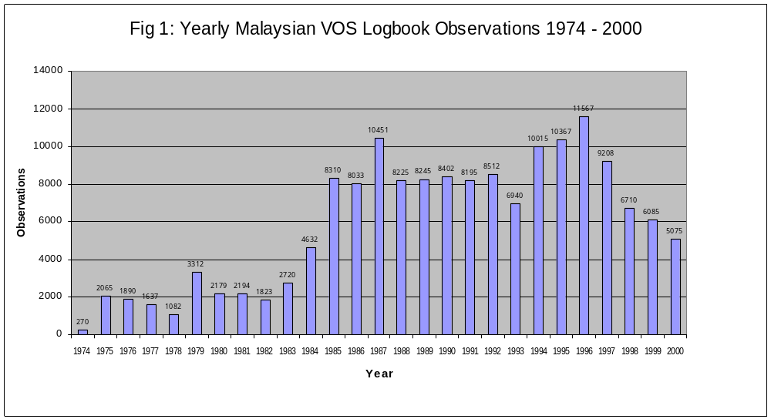
Status of ship-based observations in Russia

Ravil Fakhrutdinov
Federal Service of Russia for Hydrometeorology and Environmental Monitoring (Rushydromet), Moscow, Russia
Alexander Postnov

State Oceanographic Institute, Moscow, Russia

SUMMARY
The report describes status of the voluntary observation ships and oceanographic observations using XBT and XCTD probes in Russia, the new developments in support of the national ship-based observations including data collection, quality control and dissemination. Problems facing the PMOs and oceanographers and plans for improvements in the ship-based observations in Russia are outlined.

VOS activities in Russia

At present, the VOS programme in Russia involves 304 ships, including 35 research vessels and 12 special ships operated by various agencies. The voluntary observations are performed by 167 commercial and 90 fishery ships. The observations are supervised by 13 PMOs whose offices are located in the sea regions. The VOS make only meteorological observations four times a day according to SHIP code. Oceanographic and aerological observations are made by research and special ships in accordance with special programmes.

All the ships involved in the observations are equipped with a standard set of instruments, mainly of national origin. Only some 20 ships carry automatic ship stations MIDAS, MILOS. By now, the instruments and equipment have worn out or outdated. In some cases, the observers are short of barographs, thermometers and wind-measuring equipment.

As for aerological observations, they are made on 15-20 research vessels either on the long routes or during special expeditions. Some 15 ships carry automatic balloon launching and tracking equipment. The SHIP-coded reports are transmitted to the shore both by radio and via INMARSAT-C system. Almost all ships use the satellite communication systems.

Prior to being put on GST, the ship reports pass through the quality control procedures. The regional telecommunication center “Moscow” routes the observational data to users for operational purposes and to World Data Centre Moscow for archiving.

The VOS in Russia are being coordinated by a constant communication between the focal point in Rushydromet and PMOs in the regions with a due reference to the recommendations by WMO and the NHMS leadership. The VOS activities are well-coordinated with the Russian Federal Task Programme “World Ocean” which involves several agencies. On the other hand, contacts are being established between the VOS programmes in Russia and in other CIS countries.

Oceanographic XBT and XCTD observations

As in the past, the usage of XBT and XCTD probes in Russia are confined to research purposes. The Roshydromet Far East Hydrometeorological Research Institute (based in Vladivostok) launched a total of 119 XBTs and 72 XCTDs in the Okhots Sea during the expeditions in June 2000 and September 2001. The expedition was a join venture with the Institute for Low Temperatures of the Hokkaido University (Japan). The data was forwarded to the National Oceanographic Center in Obninsk with a temporal ban for further distribution in accordance with the agreement conditions.

The Rushydromet Arctic and Antarctic Research Institute (St. Petersburg) used 44 XBTs in the Kara and Laptev Seas during the “Arctic –2000” Expedition in August – September 2000. The data were forwarded to NODC for further international exchange.

The Russian research vessel operators welcome the idea of widening the XBT and XCTD usage practice during the expeditions in the far eastern seas and in the Arctic. However, it is largely hindered by high operational costs. The usage of XBT and XCTD data is more common. Presently, these kind of data is used almost entirely for ocean climate estimations in research projects.

Before 1990, the marginal seas around the Soviet Union were routinely sampled temperature, salinity, dissolved oxygen, nutrients, contaminants along the so cold long – term sections using standard bathometric equipment. The observational data were used mainly for climate summaries and identification of long-term climate change. Now, the routine observations are continued only at the Black Sea by the Southern Branch of the Shirshov Institute of Oceanology, Russian Academy of Sciences which operates a small research vessel.

The R/V «Akvanavt» is of 270 tons displacement, its crew consists of 12 members, scientific personnel includes 10 members. The vessel is equipped with a winch for lowering oceanographic probes to a depth of up to 2500 m. The oceanographic measurements along the standard sections (coast – sea center) are repeated regularly, every 2 or 3 months. In the period from November 1997 till April 2000 20 series of observations were carried out within the Russian sector of the Black Sea, their durations being from 3 to 7 days. These operations are sponsored mainly by the Russian Ministry for Industry and Science.

All sections are normal to the coast, the stations located 2-3 miles apart on the shelf, 5 miles apart in 20-mile coastal zone and 10-12 miles apart in the deep basin. In the coastal area, observations are made within a 500-m upper layer, lowering down to the bottom (∼2000 m) at the sea interior. A hydrophysical probe «Sea Bird» with a holder for twelve 5-litre bathometers is used for oceanographic measurings and water sampling. The following parameters are determined: hydrophisical, i.e. pressure (depth), temperature, salinity, density and water transparency; hydrochemical, i.e. dissolved oxygen, hydrogen sulphide, dissolved manganese, biogenous elements (phosphate - phosphorus, siliceous acid, ammonia - nitrogen, nitrate - nitrogen and nitrite - nitrogen).

New developments in support of the national ship-based observations

To assist the ship-based observation programmes, a progress has been made both in the field of the VOS scientific support and in developing procedures for automatic observations, data coding and decoding, data management and archiving. The latter include the computer-assistant systems “Navigator –meteorologist” and “Meteorologist – Actinometerist”, an automatic system for VOS data quality control, processing and archiving.

In the field of measuring systems, new instruments have been developed including a mercury-free digital barometer (which can be also used for on-board instrument checking) and similar units for air temperature, relative humidity, wind velocity, visibility and cloud height.

In the field of communication, the new developments are meant to improve collection, exchange and dissemination of all kinds of hydrometeorological and environmental data (including those coming from satellites). The communication and data transmission means and systems are or have been updated.

Problems in the ship-based observations

The PMOs face the following problems in the VOS activities

- Problems with ship recruiting, since many ship masters demand payment for observations;
- Problems with weather report transmission via coastal radiocentres which also require payment for radio traffic;
- The principle of voluntary observations does not work well;
- Lack of useful and portable reference materials for observers (posters and booklets with cloudness, sea state and code tables);

Plans for furthering national VOS activities
The plans include

- raising status of the PMOs and their involvement in the marine meteorological services;
- raising number of the VOS;
- encouragement of national VOS activities in the Black, Azov, Caspian and Arctic Seas and collaboration with the VOS from the CIS countries to achieve more data collection and better weather forecasting in the regions;
- fitting of VOS with automatic meteorological, oceanographic and aerological systems;
- application of the technical systems development in the Rushydromet institutions at the ships and PMO offices.

Plans for establishment of the routine XBT observations

Presently, regional GOOS activities are unfolded worldwide. Russia is a member of NEAR GOOS and a newly established Black Sea GOOS. An improvement in the ship-based routine observations, both meteorological and oceanographic, is a high priority in the GOOS activities. The Strategic Plan for the Black Sea GOOS which brings together the 6 Black Sea countries and is promoted by the IOC Black Sea Regional Committee and IOC GOOS Office provides for an establishment of 2 to 3 XBT lines between the Ukrainian and Russian ports on the one hand and the Bulgarian and Turkish ports on the other. The small ship observations in the coastal zone are also strongly encouraged. It is most likely that under present financial constraints, the Russian oceanographic and hydrometeorological organizations will tend to confine their ship – based observational efforts to the marginal seas rather than the vast ocean extensions.
National Report : United Kingdom

Annual National VOS Report

1 — Voluntary Observing Fleet
At the close of 2001 the numbers of voluntary observing ships and rigs recruited by the UK and reporting in the Ship’s International Meteorological Code (FM-13-XI SHIP Code) was as follows:

- 445 ‘Selected’ ships which transmit weather messages using the full SHIP code and are equipped with complete sets of meteorological instruments and stationery. These vessels are currently operating in all ocean regions;
- 24 ‘Auxiliary’ ships which are requested to transmit limited observations. Such ships are normally equipped with their own instruments and generally operate in areas where observation data are in short supply;
- 40 Offshore units comprising 16 fixed and 22 mobile installations, and 2 FPSO's. These units report in the SHIP Code and operate in the North Sea oil fields as well as other areas of exploration on the UK continental shelf;
- 34 ‘MARID’ ships which transmit information on sea-water temperature together with non-instrumental weather observations, and which operate in UK coastal or near continental areas.

2 — Ships

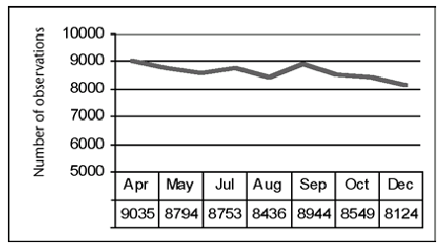
Observations received from the UK fleet of ‘Selected’ observing ships currently amount to between 8,000 and 9,000 observations each month. Figure 1 (Right) shows that the number of observations received from selected ships between April and December 2001 declined slightly.

Figure 1

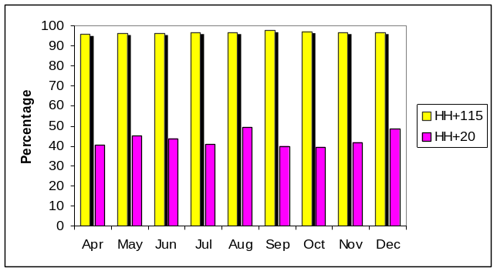The timeliness of observations received from selected ships during this period is indicated in Figure 2 (Right). On average, for all ocean areas, 96.7 per cent of observations were received within the mesoscale model cut-off time of 115 minutes, whilst 43 per cent were received within 20 minutes of the observation.

Figure 2

Ships recruited to work in the Selected category carry a precision aneroid barometer, a marine barograph and a marine screen containing dry- and wet-bulb thermometers. For recording sea-water temperature they also carry a sea-water bucket with thermometer, or are fitted with distant reading equipment. ‘MARID’ ships are equipped with the necessary tested thermometers and contribute to the prediction of fog and, in appropriate meteorological conditions, icing.

Anemometers are not normally used for observations made by the UK voluntary fleet, the surface wind speed and direction being estimated from the sea state.

In the course of the year 28 Selected ships were recruited and 30 withdrawn; 1 ‘MARID’ ship was recruited and 7 withdrawn; and 3 ‘Auxiliary’ ships recruited and 3 withdrawn.

3 — PMO Network
UK voluntary observing ships are currently serviced by a team of six Port Meteorological Officers (PMOs) and one Port Met. Assistant based at principal ports around the country. UK offshore units are co-ordinated by an Offshore Adviser, based in Aberdeen.

A number of changes have been made to the UK PMO structure during the last year with the closure of the Port Met. Office for Scotland and Northern Ireland (based in Greenock) and the closure o the Port Met Office for NE England (based in Middlesbrough).

In total, during the year, the Port Met. Officers performed 657 UK VOS ship inspections.

4 — TurboWin
The number of UK Selected ships equipped with ‘notebook’ computers loaded with the Royal Dutch Meteorological Institute’s (KNMI) TurboWin program rose to 51 at the end of 2001, whilst a further 26 ships had access to TurboWin, or the earlier Turbo1 version of this software, through their own ship computers. This rise has been largely due to recruitment of ships to the VOS Climate Project

5— Logbooks
The number of ship’s meteorological logbooks received during 2000 was 504 compared to last year’s total of 573, a continued reduction owed, in part, to the increased use of TurboWin computer programs for coding ship observations.

6 — MOSS
In view of the increased use and reliability of ships observations transmitted via Inmarsat Sat–C, it was decided in 2001 to discontinue the use of the Meteorological Observing System for Ships (MOSS) which relied on transmissions via Meteosat. Most existing systems on board UK observing ships have now been removed and any remaining units will be removed during 2002.

7 — Automatic Weather Stations
An Automatic Weather Station - the ‘Automet’ system - was installed on the UK voluntary observing ship OOCL Belgium in November 2000 for testing. Although the system is only capable of measuring atmospheric pressure and air temperature at present, preliminary results show that the system may have potential for use on certain ship routes.

8 — Inmarsat Sat–C
Five dedicated Inmarsat Sat-C systems have been fitted on the UK observing ships Baltic Tern, European Seafarer, European Envoy, the Tor Baltica and the UK ASAP ship CanMar Pride

The system, which is linked to a dedicated notebook computer, provides one of the solutions to the problem of transmitting observations from ships that are not required by GMDSS, owing to their coastal service areas, to be fitted with their own Inmarsat terminals.

9 — VOS Climate Project
Recruitment of UK observing ships for participation in the VOSClim project began in August 2001 and, by the close of the year, 20 UK ships had agreed to be recruited.
In order to promote the project a detailed article describing its aims and scope was published in the April 2001 issue of our publication The Marine Observer,

10 — Drifting buoy deployments
UK Voluntary observing ships are increasingly being used for deploying drifting buoys. In the North Atlantic a drifter was recently deployed from the UK observing ship CanMar Pride. A number of buoys have also been deployed for the United States in the mid Atlantic and in the Southern Ocean

At the end of the 2001 the Met Office had 25 fully operational and 5 partially operational drifting buoys in the North Atlantic

11 — Marine publications

A range of marine publications continue to be placed on board recruited UK voluntary observing ships to assist observing officers with coding their observations and to encourage their continued participation in the WMO Voluntary Observing Ship Scheme. In particular copies of our publications entitled The Marine Observer's Handbook and Meteorology for Mariners are placed on board all UK recruited ships
Copies of our journal The Marine Observer continue to be published quarterly and are also placed on board all our observing ships. Copies are also sent to shore based shipping company representatives and other interested organisations.

A new durable Ship's Code Card was published during the year and copies placed on board all UK selected ships.

12 — Awards
The UK continues to operate a reward scheme for participating observers. Each year a small number of long serving shipmasters is selected to receive a presentation barograph. This award is determined according to the quality of observations received and the number of years service accumulated.
For observers with shorter observing careers, it is current practice to present book awards to those observers who have submitted meteorological logbooks during the previous year, the contents of which have been assessed as being of sufficiently high quality.

A review of our awards scheme is currently being undertaken with a view to increasing the emphasis given to rewarding the timeliness and quality of real time observations.
oooOOOooo

Annual National ASAP Report

COUNTRY: .GREAT BRITAIN . . . . NAME OF AGENCY: MET OFFICE . . . . . . YEAR: .2001 . . .
...2... ASAP units operated during the year on ...2... ships
Type of ship¹⁾ | Name | Call sign | Comm. method²⁾ | Windfind method/  Sonde type ³⁾ | Launch  Method⁴⁾ | Launch  Height⁵⁾ | Area of operations⁶⁾ | ASAP Unit ID No.
Merchant | CanMar Pride | ZCBP6 | Inmarsat-C | GPS  RS80-15GH | Container  (semi-automatic) | 22 metres | North Atlantic | GB/ASAP1
Research | RRS Charles Darwin | GDLS | Inmarsat-C | GPS  RS80-15GH | Deck launcher  (portable) | 8 metres | Indian Ocean | N/A
1) Merchant ship, research ship, supply ship, etc.

2) Using IDCS, Inmarsat-C, or others

3) E.G. GPS/Vaisala RS80-G, Loran/Vaisala RS80-L, VIZ GPS Mark II Microsonde, etc.

4) Launch method e.g.: deck launcher (portable); deck launcher (fixed); container (manual); container (semi-automatic); other.

5) The height above sea level from where the sonde and balloon is released

6) Ocean area, e.g. North Pacific, North Atlantic, Indian Ocean, variable

Summary of performance of ASAP units during the year
Call sign | Total No. of sondes launched | No. of messages transmitted | No. of relaunches | Average terminal sounding height (km) | Balloon  Size  (gm) | Percentage on GTS¹⁾
ZCBP6 | 256 | 174 | Nil | 24.684 | 350 | 100%
GDLS | 20 | 16 | Nil | Not Available | 200 | 84%
Total or average | 276 | 190 | Nil | N/A |  | 92%
1) Based upon reports received at a data centre or GTS insertion point, name: _EGRR_________
Ratio of reports received against reports transmitted

COMMENTS:

Figures in the preceding tables are based on 18 ASAP operational voyages of the containership CanMar Pride and on 1 voyage of the NERC research ship RRS Charles Darwin for the year 2001.

Figures in the 'messages transmitted' column are for successful soundings only, i.e. ascents producing data to  200 mb. Although the average terminal sounding heights for the RRS Charles Darwin are not presently available, 80% of the sondes launched achieved a height of 50 mb and above.

Launches from CanMar Pride were not attempted on 13 occasions due to exceptionally strong winds and extreme weather conditions. On 6 occasions no coded TEMP message was generated due to technical problems.

Trials were undertaken during the course of the year using a portable deck launcher located on the starboard side of the funnel deck on the CanMar Pride i.e. in addition to the container launcher on the port side. Although it had been hoped that the use of this portable launcher would avoid some of the problems being experienced when launching balloons under adverse wind conditions, this was not the case. The portable launcher was therefore removed in January 2002.

On RRS Charles Darwin, overall the system worked well and no problems were experienced in performing the manual launches although the wind speeds for the period were low. However a problem did occur with the Vaisala DigiCORA MW15 Receiver Unit, which resulted in 3 out of the 20 flights terminating prematurely when generating the first level TEMP message at approx. 850 mb. Due to the limited number of Radiosonde available these flights were not repeated.

UK Met Office staff were also actively involved in the installation of the ASAP system used in connection with the Worldwide Recurring ASAP Project (WRAP) which was installed on the UK observing ship Palliser Bay in March 2001

ESTIMATES FOR FOLLOWING YEAR:

The United Kingdom will continue to operate the one unit, GB/ASAP1, for the year 2002.
The British Antarctic Survey may make soundings later in the year from their research ship James Clark Ross.

oooOOOooo
Annual National SOOP Report

The UK Hydrographic Office (UKHO) co-ordinates the supply of XBT Probes and launching systems to vessels operating under the UK SOOP programme.

Probes and launchers are funded, by UK Ministry of Defence, on the understanding that all data collected is supplied to the UKHO for inclusion in its databases. On supply of the probes UKHO obtains the cruise operator’s permission for data to be released for use by the Oceanographic community.

Over the past two years probes have been supplied to 10-15 vessels, mostly engaged on research cruises but some merchant vessels have also been involved. The data is not usually transmitted in real-time via GTS.

The data is quality checked, databased and, from time to time, released to various data centres. UKHO plan to release approximately 7,000 observations, collected from 1995 to 2000, in early summer 2002. Observations are currently being received in the UKHO at a rate of approximately 1,000 per year.

UK Port Met Officers remain available to assist SOOP ships that may visit or operate from UK ports.

Vessels Supported

For 00/01

Ernest Shackleton Antarctic
James Clark Ross UK to Falklands, Drake Passage and Antarctic
Discovery Iceland, Shetlands
Charles Darwin W Scotland, SW Approaches to UK, E Africa, S Indian Ocean
Celtic Voyager W Ireland
FRV Scotia Faeroe, Shetland, N Sea
FRS Clupea N Sea
Nuka Arctica Greenland, Denmark

Planned/in hand

Charles Darwin S Indian Ocean
James Clark Ross Falklands, Antarctic
FRS Clupea E and NW Scotland
Nuka Arctica Greenland, Denmark

Other Vessels supplied in last 3 years

RV Pelagia, RV Hesperides, RV Aegea, Tangaroa, Challenger

oooOOOooo
_____________

United States SOT-1 Report

National SOOP Report 2000 - 2001: United States

In 2000 and 2001 the United States Global Ocean Observing System (GOOS) Center – Ship of Opportunity Program collected the following number of Expendable Bathythermograph observations along the indicated routes:

SOOP National Report for the United States of America - 2000/2001
Routes | Location | Requirements |  |  | 2000 |  | 2001
 |  | LD | HD | FS | Obs. | Trans. | Obs. | Trans.
AX-02 | Newfoundland to Iceland | 200 |  |  | 130 | 5 | 197 | 9
AX-04 | New York to Gibraltar | 440 |  |  | 476 | 12 | 926 | 25
AX-07 | G. of M. to Gibraltar | 520 | 980 |  | 344 | 7 | 1019 | 9
AX-08 | New York to C. of Good Hope | 960 | 770 | 980 | 840 | 12 | 500 | 6
AX-10 | New York to Puerto Rico | 200 |  |  | 164 | 10 | 660 | 11
AX-18 | Buenos Aires to Cape Town |  | 1046
AX-29 | New York to Brazil | 360 |  |  | 15 | 1 | 337 | 10
AX-32 | New York to Bermuda | 120 |  |  | 97 | 5 | 232 | 10
IX-06 | Malacca Strait to Mauritius | 340 |  |  | 152 | 7 | 158 | 6
IX-07 | C. of Good Hope to Persian Gulf | 480 |  |  | 116 | 3 | 70 | 3
IX-21 | C. of Good Hope to Mauritius | 300 |  |  | 87 | 6 | 73 | 5
PX-01 | Seattle to Indonesia | 860 |  |  | 336 | 7 | 204 | 3
PX-08 | Auckland to Panama | 700 |  |  | 794 | 12 | 933 | 12
PX-09 | Hawaii to Auckland | 440 |  |  | 130 | 5 | 138 | 4
PX-10 | Hawaii to Japan | 440 |  |  | 403 | 12 | 348 | 11
PX-13 | New Zealand to California | 770 |  |  | 619 | 9 | 906 | 9
PX-18 | Tahiti to California | 440 |  | 900 | 904 | 24 | 870 | 25
PX-25 | Chile to Japan | 1320 |  |  | 522 | 5 | 714 | 4
PX-26 | TRANSPAC | 5500 |  | 650 | 2014 | 50 | 1328 | 29
PX-37 | Hawaii to California | 250 |  |  | 199 | 9 | 219 | 12
PX-38 | Hawaii to Alaska | 320 |  |  | 306 | 8 | 141 | 7
PX-40 | Hawaii to Japan | 450 |  |  | 218 | 6 | 174 | 6
PX-44 | Taiwan to Guam | 160 |  |  | 212 | 8 | 165 | 10
PX-81 | Honolulu to Chile | 800 |  |  | 372 | 5 | 273 | 8
Total |  |  |  |  | 9450 |  | 10585

The Expendable Bathythermograph observations in 2001 were collected by route as follows:

2001 SEAS XBT COUNTS BY ROUTE

AS OF 10 FEB 2002

AX02 - 197 drops in 9 transects
Ship | Jan | Feb | Mar | Apr | May | Jun | Jul | Aug | Sep | Oct | Nov | Dec | Tot
V2XM | 32 | 7 | 13 | 17 | 10 | 32 | 1 | 30 | 10 | 0 | 8 | 37 | 197

AX04 - 926 drops in 25 transects
Ship | Jan | Feb | Mar | Apr | May | Jun | Jul | Aug | Sep | Oct | Nov | Dec | Tot
WAUW | 43 | 13 | 28 | 28 | 43 | 30 | 17 | 9 | 11 | 10 | 18 | 10 | 260
WAUY | 12 | 40 | 32 | 30 | 46 | 49 | 19 | 24 | 30 | 19 | 13 | 12 | 326
WMLG | 22 | 23 | 34 | 28 | 35 | 41 | 27 | 19 | 23 | 28 | 22 | 38 | 340
Total | 77 | 76 | 94 | 86 | 124 | 120 | 63 | 52 | 64 | 57 | 53 | 60 | 926

AX07 - 1019 drops in 9 transects
Ship | Jan | Feb | Mar | Apr | May | Jun | Jul | Aug | Sep | Oct | Nov | Dec | Tot
3FPA9 |  |  |  |  |  |  |  | 30 | 41 | 49 | 22 | 10 | 152
3FRY9 |  |  |  |  |  |  |  | 231 | 3 | 43 | 11 | 202 | 490
V2PC4 |  | 153 | 94 | 0 | 130 |  |  |  |  |  |  |  | 377
Total | 0 | 153 | 94 | 0 | 130 | 0 | 0 | 261 | 44 | 95 | 33 | 212 | 1019

AX08 - 500 drops in 6 transects
Ship | Jan | Feb | Mar | Apr | May | Jun | Jul | Aug | Sep | Oct | Nov | Dec | Tot
MQLN7 | 41 |  |  |  |  |  |  |  |  |  |  |  | 41
V7CW2 |  | 1 | 95 | 49 | 55 | 48 | 77 | 71 | 63 |  |  |  | 459
Total | 41 | 1 | 95 | 49 | 55 | 48 | 77 | 71 | 63 | 0 | 0 | 0 | 500

AX10 - 660 drops in 11 transects
Ship | Jan | Feb | Mar | Apr | May | Jun | Jul | Aug | Sep | Oct | Nov | Dec | Tot
KIRF | 7 | 13 | 111 | 28 | 114 | 30 | 31 | 28 | 126 | 18 | 126 | 28 | 660

AX29 - 337 drops in 10 transects
Ship | Jan | Feb | Mar | Apr | May | Jun | Jul | Aug | Sep | Oct | Nov | Dec | Tot
PPXI | 36 | 29 | 40 | 33 | 37 | 44 | 33 | 26 | 40 | 19 |  |  | 337

AX32 - 232 drops in 10 transects
Ship | Jan | Feb | Mar | Apr | May | Jun | Jul | Aug | Sep | Oct | Nov | Dec | Tot
PJJU | 33 | 6 | 24 | 23 | 28 | 0 | 1 | 23 | 31 | 20 | 18 | 25 | 232

IX06 - 158 drops in 6 transects
Ship | Jan | Feb | Mar | Apr | May | Jun | Jul | Aug | Sep | Oct | Nov | Dec | Tot
PGDL | 4 | 22 |  |  |  |  |  |  |  |  |  |  | 26
ZSDS | 17 | 22 | 21 | 15 | 16 | 20 | 20 | 0 | 1 |  |  |  | 132
Total | 21 | 44 | 21 | 15 | 16 | 20 | 20 | 0 | 1 | 0 | 0 | 0 | 158

IX07 - 70 drops in 3 transects
Ship | Jan | Feb | Mar | Apr | May | Jun | Jul | Aug | Sep | Oct | Nov | Dec | Tot
9KKF |  | 37 | 0 | 0 | 11 | 9 |  |  |  |  |  |  | 57
PGDL |  |  | 13 |  |  |  |  |  |  |  |  |  | 13
Total | 0 | 37 | 13 | 0 | 11 | 9 | 0 | 0 | 0 | 0 | 0 | 0 | 70

IX21 - 73 drops in 5 transects
Ship | Jan | Feb | Mar | Apr | May | Jun | Jul | Aug | Sep | Oct | Nov | Dec | Tot
PGDL |  | 16 |  |  |  |  |  |  |  |  |  |  | 16
ZSDS | 22 | 0 | 11 | 3 | 5 | 7 | 5 | 4 |  |  |  |  | 57
Total | 22 | 16 | 11 | 3 | 5 | 7 | 5 | 4 | 0 | 0 | 0 | 0 | 73

PX01 - 204 drops in 3 transects
Ship | Jan | Feb | Mar | Apr | May | Jun | Jul | Aug | Sep | Oct | Nov | Dec | Tot
9VND |  | 3 | 5 |  |  |  |  |  |  |  |  |  | 8
KRGB |  | 15 | 0 | 0 | 0 | 0 | 0 | 11 | 12 |  |  |  | 38
S6ID | 23 | 0 | 0 | 14 | 47 | 13 | 5 | 42 | 0 | 0 | 0 | 3 | 147
WPGK |  | 11 |  |  |  |  |  |  |  |  |  |  | 11
Total | 23 | 29 | 5 | 14 | 47 | 13 | 5 | 53 | 12 | 0 | 0 | 3 | 204

PX08 - 933 drops in 12 transects
Ship | Jan | Feb | Mar | Apr | May | Jun | Jul | Aug | Sep | Oct | Nov | Dec | Tot
C6JY6 |  |  |  |  |  |  |  | 11 | 8 |  |  |  | 19
GOVL |  | 65 | 0 | 11 | 50 | 0 | 61 | 0 | 16 | 50 | 0 | 50 | 303
GZKA | 43 | 0 | 53 | 0 | 0 | 0 | 0 | 58 | 0 | 25 | 24 |  | 203
MZBM7 | 34 | 22 | 40 | 29 | 55 | 36 | 38 | 31 | 31 | 33 | 50 | 9 | 408
Total | 77 | 87 | 93 | 40 | 105 | 36 | 99 | 100 | 55 | 108 | 74 | 59 | 933

PX09 - 138 drops in 4 transects
Ship | Jan | Feb | Mar | Apr | May | Jun | Jul | Aug | Sep | Oct | Nov | Dec | Tot
DDFG |  | 23 | 0 | 22 | 0 | 24 | 0 | 44 |  |  |  |  | 113
ELTZ3 |  |  |  |  |  |  |  |  | 22 | 3 |  |  | 25
Total | 0 | 23 | 0 | 22 | 0 | 24 | 0 | 44 | 22 | 3 | 0 | 0 | 138

PX10 - 348 drops in 11 transects
Ship | Jan | Feb | Mar | Apr | May | Jun | Jul | Aug | Sep | Oct | Nov | Dec | Tot
KRGB |  | 18 | 22 | 21 | 17 | 7 | 24 | 6 | 13 | 20 | 0 | 30 | 178
WPGK | 14 | 25 | 12 | 7 | 7 | 22 | 27 | 11 | 14 | 12 | 9 | 10 | 170
Total | 14 | 43 | 34 | 28 | 24 | 29 | 51 | 17 | 27 | 32 | 9 | 40 | 348

PX13 - 906 drops in 9 transects
Ship | Jan | Feb | Mar | Apr | May | Jun | Jul | Aug | Sep | Oct | Nov | Dec | Tot
DDFG | 57 | 0 | 48 | 0 | 55 | 15 | 42 |  |  |  |  |  | 217
DDGY |  |  |  | 52 | 5 | 50 | 0 | 52 | 0 | 51 | 8 | 39 | 257
ELTZ3 |  |  |  |  |  |  |  | 15 | 16 | 60 |  |  | 91
ELTY5 | 10 | 32 | 48 | 1 | 49 | 0 | 35 | 0 | 39 | 0 | 22 | 2 | 238
J8FI6 |  |  | 45 | 0 | 3 | 55 |  |  |  |  |  |  | 103
Total | 67 | 32 | 141 | 53 | 112 | 120 | 77 | 67 | 55 | 111 | 30 | 41 | 906

PX18 - 870 drops in 25 transects
Ship | Jan | Feb | Mar | Apr | May | Jun | Jul | Aug | Sep | Oct | Nov | Dec | Tot
DDFG | 34 |  |  |  |  |  |  |  |  |  |  |  | 34
V2CA2 | 37 | 34 | 32 | 37 | 33 | 36 | 30 | 34 | 31 | 36 | 31 | 34 | 405
V2FA2 |  |  | 36 | 28 | 38 | 31 | 55 | 33 | 30 | 45 | 30 | 36 | 362
V2KS | 35 | 34 |  |  |  |  |  |  |  |  |  |  | 69
Total | 35 | 34 | 68 | 65 | 71 | 67 | 85 | 67 | 61 | 81 | 61 | 70 | 870

PX25 - 714 drops in 4 transects
Ship | Jan | Feb | Mar | Apr | May | Jun | Jul | Aug | Sep | Oct | Nov | Dec | Tot
3EZI6 |  |  | 49 | 40 | 69 | 15 | 160 | 151 | 8 | 222 |  |  | 714

PX26 - 1328 drops in 29 transects
Ship | Jan | Feb | Mar | Apr | May | Jun | Jul | Aug | Sep | Oct | Nov | Dec | Tot
9VND |  |  |  |  | 12 | 24 |  |  |  |  |  |  | 36
BOAB | 15 | 23 | 22 | 29 | 15 | 19 | 36 | 24 | 19 | 15 | 32 | 3 | 252
C6CE7 | 0 | 0 | 22 | 37 | 27 | 24 | 31 | 16 | 27 | 38 | 19 | 42 | 283
KGJB | 38 | 41 | 47 | 13 | 15 | 33 | 15 | 28 | 10 | 22 | 20 | 17 | 299
KRGB | 8 | 0 | 25 | 14 | 15 | 22 | 18 | 19 | 23 | 0 | 0 | 0 | 144
LACF5 | 0 | 0 | 25 | 15 | 3 | 0 | 0 | 00 | 0 | 0 | 0 | 0 | 43
LADB2 | 8 | 1 | 2 | 0 | 1 | 0 | 5 | 9 | 0 | 11 | 2 | 8 | 47
LAJV4 | 11 | 21 | 15 | 9 | 9 | 9 | 23 | 6 | 13 | 6 | 12 | 0 | 134
NRUO | 0 |  | 0 | 0 | 0 | 0 | 4 | 16 | 0 | 0 | 0 | 0 | 20
S6ID | 0 |  | 0 | 0 | 0 | 0 | 50 | 0 | 0 | 0 | 0 | 11 | 61
WPGK | 0 |  | 0 | 7 | 0 | 2 | 0 | 0 | 0 | 0 | 0 |  | 9
Total | 80 | 86 | 158 | 124 | 97 | 133 | 182 | 118 | 92 | 92 | 85 | 81 | 1328

PX37 - 219 drops in 12 transects
Ship | Jan | Feb | Mar | Apr | May | Jun | Jul | Aug | Sep | Oct | Nov | Dec | Tot
9VND |  |  | 6 |  |  |  |  |  |  |  |  |  | 6
DDFG |  | 17 | 0 | 19 | 0 | 0 | 0 | 23 |  |  |  |  | 59
DDGY |  |  | 10 | 20 |  |  |  | 0 |  |  |  |  | 30
ELTZ3 |  |  | 0 | 0 |  |  |  | 0 |  | 21 | 13 | 13 | 47
KRGB |  |  | 14 | 0 | 0 | 17 | 5 | 0 | 15 | 3 | 0 | 19 | 73
WPGK |  |  | 0 | 0 | 4 |  |  | 0 |  |  |  |  | 4
Total | 0 | 17 | 30 | 39 | 4 | 17 | 5 | 23 | 15 | 24 | 13 | 32 | 219

PX38 - 141 drops in 7 transects
Ship | Jan | Feb | Mar | Apr | May | Jun | Jul | Aug | Sep | Oct | Nov | Dec | Tot
WXBR | 8 | 0 | 17 | 18 | 0 | 28 | 0 | 34 | 18 | 18 |  |  | 141

PX40 - 174 drops in 6 transects
Ship | Jan | Feb | Mar | Apr | May | Jun | Jul | Aug | Sep | Oct | Nov | Dec | Tot
3EZI6 | 33 | 35 | 0 | 0 | 0 | 0 | 32 | 0 | 21 | 0 | 19 | 34 | 174

PX44 - 165 drops in 10 transects
Ship | Jan | Feb | Mar | Apr | May | Jun | Jul | Aug | Sep | Oct | Nov | Dec | Tot
KRGB |  | 7 | 14 | 8 | 3 | 0 | 0 | 11 | 13 | 17 | 0 | 11 | 84
WPGK | 10 | 3 | 8 | 7 | 2 | 0 | 13 | 4 | 15 | 3 | 9 | 7 | 81
Total | 10 | 10 | 22 | 15 | 5 | 0 | 13 | 15 | 28 | 20 | 9 | 18 | 165

PX81 - 273 drops in 8 transects
Ship | Jan | Feb | Mar | Apr | May | Jun | Jul | Aug | Sep | Oct | Nov | Dec | Tot
3EZI6 | 16 | 35 | 18 | 0 | 0 | 28 | 7 | 26 | 40 | 0 | 65 | 38 | 273

Key to call signs:

3EZI6 NACRE
3FPA9 NUEVO LEON
3FRY9 LYKES COMMANDER
9KKF AL SAMIDOON

9VND RUBY INDAH
BOAB TAI HE
C6CE7 WESTWOOD BELINDA
C6JY6 MELBOURNE STAR
DDFG COLUMBUS FLORIDA
DDGY COLUMBUS-COROMANDEL
ELTZ3 COLUMBUS FLORIDA
ELXD6 LYDIA OLDENDORFF
ELYT5 DIRECT FALCON
FDAM NEDLLOYD COLUMBO
GOVL MELBOURNE STAR
GZKA AMERICA STAR
J8FI6 ROSSELCURRENT
KIRF CSX HAWAII
KGJB SEA LAND DEFENDER
KRGB CSX ENTERPRISE
LACF5 SKAUBOARD
LADB2 SKAUGRAN
LAJV4 SKAUBRYN
MQLN7 NOLIZWE
MZBM7 QUEENSLAND STAR
NRUO POLAR SEA
PGDL NEDLLOYD COLUMBO
PJJU OLEANDER
PPXI COPACABANA
S6ID EMERALD INDAH
V2CA2 POLYNESIA
V2FA2 TAUSALA SAMOA
V2KS TAUSALA SAMOA
V2PC4 VERACRUZ
V2XM SKOGAFOSS
V7CW2 NOLIZWE
WAUW ENDEAVOR
WAUY ENTERPRISE
WMLG DELAWARE BAY
WPGK CSX NAVIGATOR
WTEJ MCARTHUR
WXBR CHEVRON MISSISSIPPI
ZSDS S A VAAL
Transmitted Observations by SEAS in 2000:

Summary - 2000 | # Messages | # Bytes | % Messages | % Bytes | % Total
Coast Guard Inmarsat-A | 7.00 | 889.00 | 0.00 | 0.00
Coast Guard Message Channel Code 41 | 818.00 | 162109.00 | 0.30 | 0.60
Coast Guard Message Channel ASCII | 149.00 | 33256.00 | 0.05 | 0.12
Coast Guard Message Channel Binary | 13993.00 | 1115701.00 | 5.13 | 4.13 | 5.48
Met Inmarsat A Code 41 Telex | 15853.00 | 2082419.00 | 5.81 | 7.72
Met Inmarsat C Code 41 Telex | 126612.00 | 16904838.00 | 46.38 | 62.64
Met Inmarsat C Message Channel ASCII | 364.00 | 41279.00 | 0.13 | 0.15
Met Inmarsat C Message Channel Binary | 90164.00 | 3984098.00 | 33.03 | 14.76 | 85.35
Bathy Inmarsat C Message Channel Binary | 9553.00 | 592946.00 | 3.50 | 2.20
Bathy/TESAC Inmarsat C Message Channel ASCII | 11.00 | 1895.00 | 0.00 | 0.01
Bathy/TESAC Inmarsat C Message Channel Binary | 382.00 | 36392.00 | 0.14 | 0.13 | 3.64
Upper Air Code 41 | 22.00 | 17669.00 | 0.01 | 0.07
Upper Air Message Channel Binary | 35.00 | 45701.00 | 0.01 | 0.17
UUBB Code 41 Telex | 6.00 | 3930.00 | 0.00 | 0.01 | 0.02
Junk Messages | 15044.00 | 1965369.00 | 5.51 | 7.28 | 5.52
Totals | 273013.00 | 26988491.00 | 100.00 | 100.00 | 100.01

Transmitted Observations by SEAS in 2001:

Coast Guard Inmarsat-A | 11 | 1460 | 0.00 | 0.01
Coast Guard Message Channel Code 41 | 750 | 154870 | 0.28 | 0.60
Coast Guard Message Channel ASCII | 107 | 21864 | 0.04 | 0.08
Coast Guard Message Channel Binary | 13298 | 1218271 | 5.04 | 4.69 | 5.37
Met Inmarsat A Code 41 Telex | 10645 | 1500366 | 4.03 | 5.78
Met Inmarsat C Code 41 Telex | 122343 | 16457256 | 46.36 | 63.40
Met Inmarsat C Message Channel ASCII | 116 | 15470 | 0.04 | 0.06
Met Inmarsat C Message Channel Binary | 91342 | 4306270 | 34.61 | 16.59 | 85.04
Bathy Inmarsat C Message Channel Binary | 9020 | 563160 | 3.42 | 2.17
Bathy/TESAC Inmarsat C Message Channel ASCII | 22 | 3742 | 0.01 | 0.01
Bathy/TESAC Inmarsat C Message Channel Binary | 437 | 43674 | 0.17 | 0.17 | 3.59
Upper Air Code 41 | 25 | 24573 | 0.01 | 0.09
Upper Air Message Channel Binary | 151 | 170817 | 0.06 | 0.66
UUBB Code 41 Telex | 0 | 0 | 0.00 | 0.00 | 0.07
Junk Messages | 15654 | 1476225 | 5.93 | 5.69 | 5.93
Totals | 263921 | 25958018 | 100.00 | 100.00 | 100.00

GTS XBT Observations monitored by the GOOS Center:

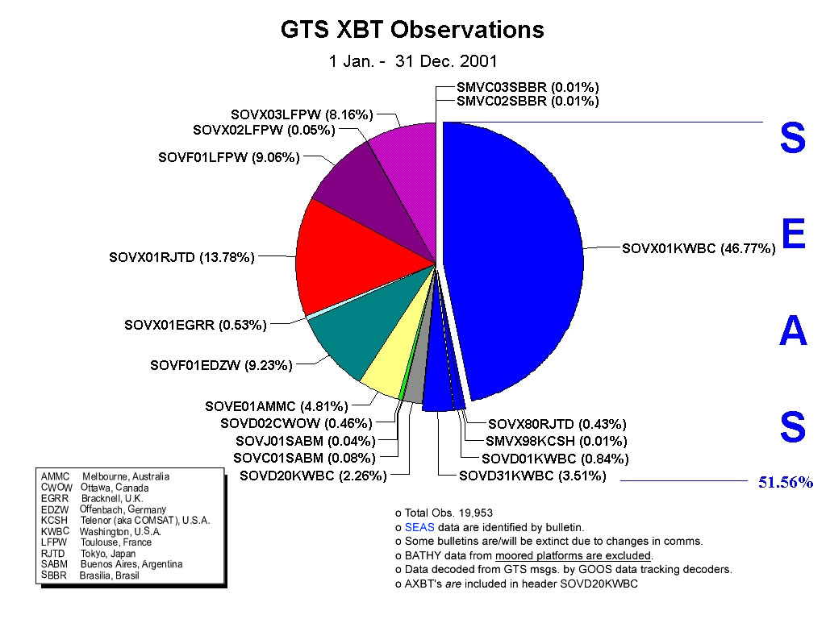

Proposed Activities:

- Maintain the present XBT network.
- Modify AX-8 to HD between 20N and 20S and FS for the remainder.
- Initiate HD AX-18 with Argentina and South Africa.
- Implement SEAS 2000 Phase II and III.
- Implement Automated Weather System units when practical.
- Increase the use of VOS for the deployment of Drifters and Argo Floats.
- Coordinate sampling with the SOOPIP, DBCP and COSC communities.
- Migrate Float auto QC procedures to the real-time XBT data stream.
- Begin evaluation of Iridium technology for real-time data transmission.
- Begin development of integrated pCO2 and TSG sampling system for VOS applications.

Pertinent Web Sites:

http://www.aoml.noaa.gov/goos/

http://www.aoml.noaa.gov/phod/dac/dac.html

http://seas.nos.noaa.gov/seas

http://nos.noaa.gov/dbcp

http://www-hrx.ucsd.edu/

VOS Activities – 2001

NOAA’s National Weather Service VOS Program was reorganized in 2001 and placed under the management of the National Data Buoy Center. A review of the master ship list of participating vessels reduced the actual list of participating vessels to about 700 ships. Those vessels accounted for approximately 230,000 meteorological observations. However, we know that part of that number represents duplicate observations. We are presently investigating methods to eliminate the counting of duplicate records.

ASAP Activities – 2001

NOAA presently does not operate an ASAP. NOAA’s participation in ASAP activities is mostly an opportunistic and as such has provided the following:

- Provide electronics package and launcher for the WRAP effort.
- Supported the E-ASAP effort by purchasing radiosondes launched near the United States.
- Willing to contribute to setting up another WRAP vessel.
New JCOMM series replaces discontinued MMROA series

JOINT WMO/IOC TECHNICAL COMMISSION
FOR OCEANOGRAPHY AND MARINE METEOROLOGY
TECHNICAL REPORT SERIES

No. | Title | WMO/TD-No. | Issued
17 | JCOMM Ship Observations Team, First Session - National Reports (Goa, India, 25 February - 2 March 2002) - Website only | WMO/TD-No. 1121 | 2002
16 | Scientific and Technical Workshop of the JCOMM Ship Observations Team - Presentations at the first session of the Ship Observations Team (Goa, India, 26 February 2002) - CD ROM only | WMO/TD-No. 1118 | 2002
15 | Automated Shipboard Aerological Programme (ASAP) - Annual Report for 2001 | WMO/TD-No. 1112 | 2002
14 | Operational Oceanography - Scientific Lectures at JCOMM-I (Akureyri, Iceland, June 2001) | WMO/TD-No. 1086 | 2001
13 | Advances in the Applications of Marine Climatology - The Dynamic Part of the WMO Guide to the Applications of Marine Climatology | WMO/TD-No. 1081 | 2001
12 | Automated Shipboard Aerological Programme (ASAP) – Annual Report for 2000 | WMO/TD-No. 1069 | 2001
11 | JCOMM Capacity Building Strategy | WMO/TD-No. 1063 | 2001
10 | Proceedings of CLIMAR 99 | WMO/TD-No. 1062 | 2001
9 | Estimation of Extreme Wind Wave Heights | WMO/TD-No. 1041 | 2000
8 | Oceanographic and Marine Meteorological Observations in the Polar Regions - A Report to the Joint WMO/IOC Technical Commission on Oceanography and Marine Meteorology | WMO/TD-No. 1032 | 2000
7 | Proceedings of a Workshop on Mapping and Archiving of Sea Ice Data – The Expanding Role of Radar, Ottawa, Canada, 2-4 May 2000 | WMO/TD-No. 1027 | 2000
6 | Automated Shipboard Aerological Programme (ASAP) – Annual Report for 1999 | WMO/TD-No. 1011 | 2000
5 | Voluntary Observing Ships (VOS Climate Subset Project (VOSCLIM) – Project Document - Revision 2  Revision 1 (WMO/TD-No. 1042 - 2001)  First Printing (WMO/TD-No. 1010 - 2000) | WMO/TD-No. 1122 | 2002
4 | The Voluntary Observing Ships Scheme – A Framework Document | WMO/TD-No. 1009 | 2000
3* | JCOMM Ship-of-opportunity Programme Implementation Panel, Third Session, La Jolla, CA, USA, 28-31 March 2000 – SOOP Status Reports – SOOP Scientific and Technical Developments | WMO/TD-No. 1005 | 2000
2 | Meeting of Experts on a JCOMM/GOOS Polar Region Strategy, Geneva, Switzerland, 6-8 December 1999 - Status Reports from Existing Polar Region Observing Systems | - | 2000
1* | First Transition Planning Meeting - St Petersburg, Russian Federation, 19-23 July 1999 – Status Reports from JCOMM Component Bodies and Activities | - | 1999

MARINE METEOROLOGY AND RELATED OCEANOGRAPHIC ACTIVITIES
REPORT SERIES

No. | Title | WMO/TD-No. | Issued
44 | Marpolser 98 - Metocean Services for Marine Pollution emergency Response Operations, Townsville, Australia, 13-17 July 1998 – Proceedings - Volume 2 - Review and Information Papers | WMO/TD-No. 960 | 1999
 | Marpolser 98 - Metocean Services for Marine Pollution emergency Response Operations, Townsville, Australia, 13-17 July 1998 – Proceedings - Volume 1 - Research Papers | WMO/TD-No. 959 | 1999
43 | Proceedings of the International Workshop on Digitization and Preparation of Historical Marine Data and Metadata, Toledo, Spain, 15-17 September 1997 | WMO/TD-No. 957 | 1999
- | Automated Shipboard Aerological Programme (ASAP) - Annual Report for 1998 | WMO/TD-No. 951 | 1999
42 | Provision and Engineering  Operational Application of Ocean Wave Data - in French only | WMO/TD-No. 938 | 1998
41 | The Climate of the Baltic Sea Basin | WMO/TD-No. 933 | 1998
40 | Automatisation de l'observation en mer  Automation of Observations at Sea | WMO/TD-No. 928 | 1998
- | Automated Shipboard Aerological Programme (ASAP) - Annual Report for 1997 | WMO/TD-No. 900 | 1998
39 | Proceedings of the Commission for Marine Meteorology Technical Conference on Marine Pollution | WMO/TD-No. 890 | 1998
38 | Evaluation of the Highest Wave in a Storm (A.V. Boukhanovsky, L.J. Lopatoukhin, V.E. Ryabinin) | WMO/TD-No. 858 | 1998
37 | Tropical Coastal Winds (W.L. Chang) | WMO/TD-No. 840 | 1997
36 | Handbook of Offshore Forecasting Services (Offshore Weather Panel) | WMO/TD-No. 850 | 1997
- | Automated Shipboard Aerological Programme (ASAP) - Annual Report for 1996 | WMO/TD-No. 819 | 1997
35 | Ice Navigation Conditions in the Southern Ocean (A.A. Romanov) | WMO/TD-No. 783 | 1996
- | Automated Shipboard Aerological Programme (ASAP) - Annual Report for 1995 | WMO/TD-No. 767 | 1996
34 | Polar Orbiting Satellites and Applications to Marine Meteorology and Oceanography – Report of the CMM-IGOSS-IODE Sub-group on Ocean Satellites and Remote Sensing | WMO/TD-No. 763 | 1996
33 | Storm Surges (Vladimir E. Ryabinin, Oleg I. Zilberstein and W. Seifert) | WMO/TD-No. 779 | 1996
32* | Proceedings of the WMO/IOC Workshop on Operational Ocean Monitoring Using Surface Based Radars, Geneva, 6-9 March, 1995 | WMO/TD-No. 694 | 1995
- | Proceedings of the WMO/IOC Technical Conference on Space-based Ocean Observations, September 1993, Bergen, Norway (US $15.00) | WMO/TD-No. 649 | 1994
31* | Proceedings of the International Workshop on Marine Meteorology | WMO/TD-No. 621 | 1994
30 | Proceedings of the International Seminar for Port Meteorological Officers | WMO/TD-No. 584 | 1993
29 | Meteorological Requirements for Wave Modelling (Luigi Cavaleri) | WMO/TD-No. 583 | 1993
28* | Proceedings of the Commission for Marine Meteorology Technical Conference on Ocean Remote Sensing | WMO/TD-No. 604 | 1993
27 | A Survey on Multidisciplinary Ocean Modelling and Forecasting (Johannes Guddal) | WMO/TD-No. 516 | 1992
26* | The Accuracy of Ship’s Meteorological Observations - Results of the VSOP-NA |  | 1991
25 | Ships Observing Marine Climate - A Catalogue of the Voluntary Observing Ships Participating in the VSOP-NA | WMO/TD-No. 456 | 1991
24 | Proceedings of the Commission for Marine Meteorology Technical Conference on Ocean Waves | WMO/TD-No. 350 | 1990
23 | Summary Report on National Sea-ice Forecasting Techniques | WMO/TD-No. 329 | 1989
22 | Wind Measurements Reduction to a Standard Level (R.J. Shearman and A.A. Zelenko) | WMO/TD-No. 311 | 1989
21 | Coastal Winds (E.P. Veselov) | WMO/TD-No. 275 | 1988
20* | La Prévision du Brouillard en Mer (M. Trémant)  Forecasting of Fog at Sea - in French only | WMO/TD-No. 211 | 1987
19 | A Global Survey on the Need for and Application of Directional Wave Information (S. Barstow and J. Guddal) | WMO/TD-No. 209 | 1987
18 | Baltic Multilingual List of Sea-ice Terms (Jan Malicki, Alex N. Turchin, Hans H. Valeur) | WMO/TD-No. 160 | 1987
17 | Processing of Marine Data (G.D. Hamilton) | WMO/TD-No. 150 | 1986
16* | Field Workshop on Intercalibration of Conventional and Remote-sensed Sea Surface Temperature Data (A.E. Strong and E.P. McClain) |  | 1985
15* | Forecast Techniques for Ice Accretion on Different Types of Marine Structures, Including Ships, Platforms and Coastal Facilities | WMO/TD-No. 70 | 1985
14 | Scientific Lectures at CMM-IX | WMO/TD-No. 41 | 1985
13 | User's Guide to the Data and Summaries of the Historical Sea Surface Temperature Data Project | WMO/TD-No. 36 | 1985
12 | WMO Wave Programme: National Reports for 1984 on Wave Measuring Techniques, Numerical Wave Models and Intercomparisons | WMO/TD-No. 35 | 1985
* | Supplement No. 4 - Reports for 1991 to 1994 on Wave Measuring Techniques, Numerical Wave Models and Intercomparisons | WMO/TD-No. 35 | 1994
 | Supplement No. 3 - Reports for 1989 to 1990 on Wave Measuring Techniques, Numerical Wave Models and Intercomparisons | WMO/TD-No. 35 | 1990
 | Supplement No. 2 - Reports for 1986 to 1988 on Wave Measuring Techniques, Numerical Wave Models and Intercomparisons | WMO/TD-No. 35 | 1989
 | Supplement No. 1 - Reports for 1985 on Wave Measuring Techniques, Numerical Wave Models and Intercomparisons | WMO/TD-No. 35 | 1986
11 | Drifting Buoys in Support of Marine Meteorological Services (Glenn D. Hamilton) | - | 1983
10* | Guide to Data Collection and Services Using Service Argos (revised version) | - | 1989
9 | Intercalibrations of Directly-measured and Remotely Sensed Marine Observations (Alan E. Strong) | - | 1983
8 | Summary WMO Technical Conference on Automation of Marine Observations and Data Collection | - | 1981
7* | Proceedings of the WMO Technical Conference on the Automation of Marine Observations and Data Collection | - | 1981
6 | Report on the Results of An Enquiry on Marine Meteorological Services Products | - | 1981
5 | The Automation of Observational Methods on Board Ship (M. Yasui) | - | 1981
4 | Intercalibration of Surface-based and Remotely Sensed Data (except Sea Surface Temperature Data) to Be Used in Marine Applications (E.P. McClain) | - | 1981
3 | Review of Reference Height for and Averaging Time of Surface Wind Measurements at Sea (F.W. Dobson) | - | 1981
2 | Investigation of Contemporary Methods of Measuring Sea Surface and Surface-layer Temperatures (F.S. Terziev) | - | 1981
1* | Precipitation Measurement at Sea (G. Olbrück) | - | 1981

Bureau of Meteorology
Commonwealth Scientific and Industrial Research Organisation
Royal Australian Navy
Scripps Institution of Oceanography, USA
National Institute of Water and Atmospheric Research, NZ
Atlantic Oceanographic Marine Laboratory, United States
National Oceanic Atmospheric Administration, United States
Institut Français pour la Recherche et la Technologie Polaires, France
Institut de Recherche pour le Development, New Caledonia
Centre National d'Etudes Spaciales, France
National Institute of Oceanography, India
National Institute for Environmental Studies, Japan
United Kingdom Meteorological Office
Meteorological Service of New Zealand
South African Weather Service
Australian Voluntary Observing Fleet
Royal Dutch Meteorological Institute
VOS Climate Project
Port Meteorological Officer - known as Port Meteorological Agent (PMA) in Australia
CSIRO/BMRC Joint Australian Facility for Ocean Observing Systems
Worldwide Recurring ASAP Project
QUality Evaluation of Subsurface Temperatures
Marine Environmental Data Services, Canada
Australian Oceanographic Data Centre
¹On the other hand, there is a very successful VOS-based CO2 flux research program operated by DFO in the north Pacific. MEDS is working with IOS to acquire these data.

