ARGOS SYSTEM, APPLICATIONS & ENHANCEMENTS

February 2002
Christian Ortega
CLS
Collecte Localisation Satellites, 8 – 10 rue Hermès,
Parc Technologique du Canal, 31526 Ramonville, France
tel: +33 561 39 47 20 / fax: +33 561 39 47 97 / email: ortega@cls.fr

Argos SYSTEM OVERVIEW
The Argos data collection and location system was established in 1978 by the National Oceanic and Atmospheric Administration (NOAA, USA), the National Aeronautics and Space Administration (NASA, USA), and the French space agency (CNES, France). Argos, was developed specifically for scientists to study the environment.

Argos can locate any platform carrying a suitable transmitter, anywhere in the world, and collect data from sensors connected to the transmitter.

The Argos system is operated and managed by:
- CLS, a CNES subsidiary in Toulouse, France
- Service Argos, Inc. (SAI), a CLS subsidiary in Largo, MD, near Washington, DC, USA
- worldwide subsidiaries

Over the last 20 years, Argos has evolved continually to keep pace with the needs of scientific research and applications dedicated to observing, monitoring and protecting planet Earth.



Figure 1: Argos is flown onboard the NOAA polar orbiting satellites (5 satellites as of today), and will also fly on NASDA and EUMETSAT polarorbiting satellites.

ARGOS APPLICATIONS
Half of the Argos system capacity is used for ocean, climate research applications. Many of these data are also used as input for operational meteorology and, as progress is made towards an observing system for the oceans, for operational oceanography. Argos applications also include animal tracking , oil spill tracking, monitoring equipment at sea, hydrology, fish stock management and hazardous cargo monitoring.

OCEAN applications
In the last six years, 5,000 drifting buoys, 1,500 deep floats, and 300 moored buoys and fixed stations, fitted with Argos transmitters, have measured the ocean currents and sent millions of measurements of atmospheric pressure, wind speed and direction, sea temperature and more. They have been important components of the operational WWW and WCRP programs, through TOGA, WOCE and now GOOS/GCOS, CLIVAR and GODAE programs and experiments.

Argos on SOOP AND VOS
Argos have been used on ships since 1987 to collect SHIP and XBT observations.
Today some 20 ships equipped by French IRD and Australian BOM-CSIRO are fitted with Argos systems, of which 10 to 12 relay profiles every month. Temperature profiles data are validated by the shipboard software, inflexion points are calculated and coded in an Argos message. Messages are processed, quality controlled by the Argos GTS sub-system and sent to MeteoFrance for GTS insertion. In December 2001, 322 XBTs were inserted onto GTS.

Similarly, 4 PAB units from the BOM are sending SHIP observations. These units combine automatic measurements of atmospheric pressure, air and sea temperature, and manually-input observations. These data are validated in Argos centers, coded in SHIP and relayed to the GTS.
MeteoFrance has developed a basic weather station for VOS called Minos, which collects atmospheric pressure and air temperature. As a major advantage, this low-cost station can be installed in a couple of hours.

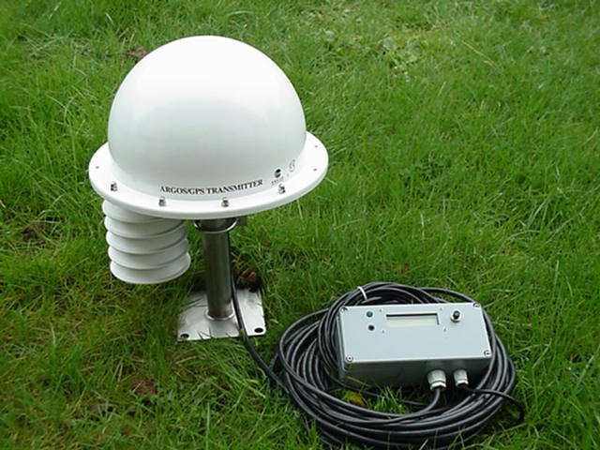

Figure 2: Minos : self-contained Argos telemetry station with atmospheric pressure, air temperature sensors, GPS, and data display unit for crew members.

Argos ENHANCEMENTS
Most fundamental changes are in the satellite segment and are planned years in advance. Two important decisions have been taken regarding the future of the Argos space segment:
- CNES has given the go-ahead for development of a third-generation Argos instrument to enter service in 2005. This instrument will offer significant enhancements, including better sensitivity, faster data transmission, and increased data collection capacity.
- CNES and NOAA are consolidating the Argos system’s global reach by extending their partnership agreement to include two new major partners: Japan, represented by its national space agency NASDA, and Europe, represented by EUMETSAT. Partnership agreement with the Brazilian space agency, INPE, is on its way too.

The current launch schedule for the satellites carrying the Argos instruments is:

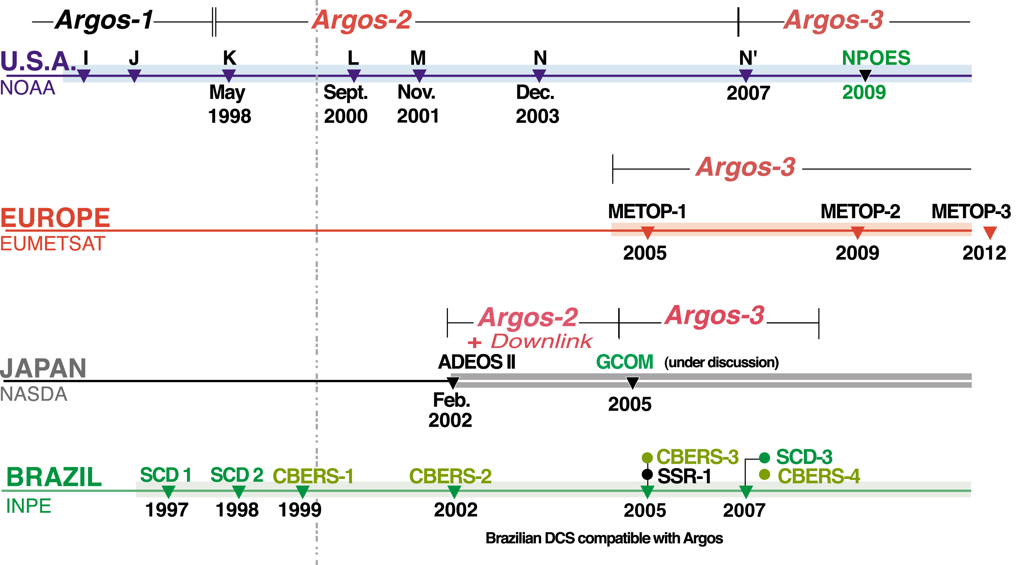

Figure 3: New satellites launches for the Argos system are already planned until 2012.

Two-way communication
Two-way communication with Argos transmitters, also known as downlink messaging, will start with the ADEOS-II satellite, from late 2002.

Typical applications will be switching a transmitter on or off, or modifying a sensor sampling rate.

Users will connect to Argos servers via the web, and program the information they want their platforms to receive. The downlink will also provide uplink message acknowledgement.

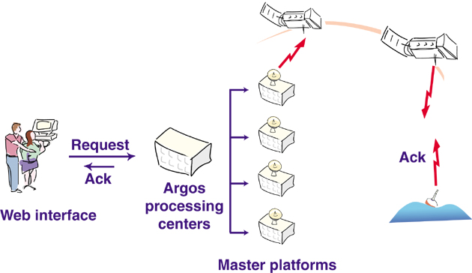
Figure 4: Argos users will send command to their platforms through a web interface and the satellite link.

increasing data bandwidth
The Argos-2 generation, now flying on NOAA-15 & 16, can receive greater than three times more platform messages simultaneously than previous satellites. The improvement is due to a doubling of the number of Data Recovery Units on board the satellite and a tripling of the Argos frequency bandwidth.

The Argos system in use today includes redundant transmissions to increase the probability of error-free data receipt by the satellite. The two-way communication capability outlined above will enable the number of repetitive messages to be reduced by a factor 2 by including an “Acknowledgement” signal which will indicate when the data has been successfully received by the satellite.

The Argos-3 generation will feature a 4800 bps high data rate channel, ten times more data transfer than the current channel. This will, for example, match the ARGO float data relay requirements in a single satellite pass.

New user interface, more processing capacity
New data processing and management systems for the Argos processing centers are being phased in. These will provide:
- a more open system that lets users access and modify platform processing, program characteristics and access to results, on line
- easier access to results via an improved user interface.

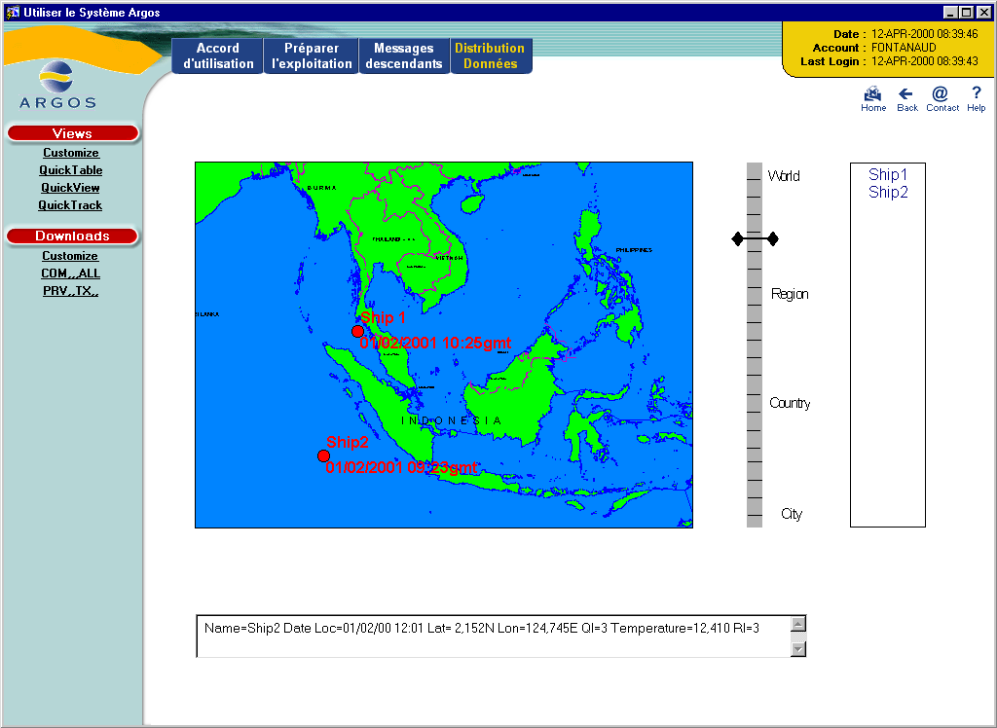

Figure 9: By mid-2002, Argos users will easily access their results on customized charts through a web browser, to see the most recent position or tracks along a number of days. Users can also download their results in spreadsheet.

Realtime coverage
Argos onboard equipment provides both global coverage of the earth through the store-and-forward mode and real time regional capability through a “bent-pipe” direct readout mode. CLS and SAI are shortening throughput time for operational needs, by installing regional stations worldwide. In January 2002, there were 28 S-band stations relaying Argos data in real-time.

The mission continues
Argos has been serving users for more than 20 years, in a spirit of worldwide cooperation. The best example of this is the way the system continues to evolve as a partnership between its users and operators. The enhancements described above will enable the Argos user community to satisfy increasingly difficult data relay needs with a proven, reliable and robust data collection system as Argos continues its Earth observation and monitoring mission into the next century.

WEB SITES
Argos system description:
http://www.cls.fr/
http://www.argosinc.com/

