An Automated Ocean and Weather Monitoring System for Use on Volunteer Observing Ships (VOS)

Tom Houston, Geoffrey K. Morrison, Cynthia Moore and Rod G. Zika
The International SeaKeepers Society
4600 Rickenbacker Causeway
Miami FL 33149
www.seakeepers.com

The International SeaKeepers Society has designed an autonomous oceanographic and meteorological monitoring system which can be deployed on a wide variety of platforms to collect data for marine weather forecasting and oceanographic research. The compact modular system has been deployed on yachts, cruise ships, commercial vessels, research ships and piers. Low energy-demand systems are being developed for use in buoys, in partnership with the National Data Buoy Center of the National Oceanographic and Atmospheric Administration (NOAA). These are expanding the VOS network with reliable, timely and accurate reports every three hours by INMARSAT Standard C telemetry, and collecting data on oceanographic conditions, stored every minute. The system carries a standard suite of sensors, and can accommodate specialized sensors for focused research problems. The society has invited instrument manufacturers, academic faculty , government agencies and other organizations to design sensors and experiments utilizing the SeaKeepers capabilities for low-cost world-wide environmental research..

The monitoring system, shown in Figure 1, is housed two NEMA-4 stainless steel enclosures to facilitate installation in a variety of configurations. The smaller module contains the computer, the INMARSAT transceiver and the power supplies. The second module has the pump, a distribution manifold, and mounting brackets for up to five instrument packages. The modules are each 16 inches wide, 10 inches deep and 18 inches/30 inches high.

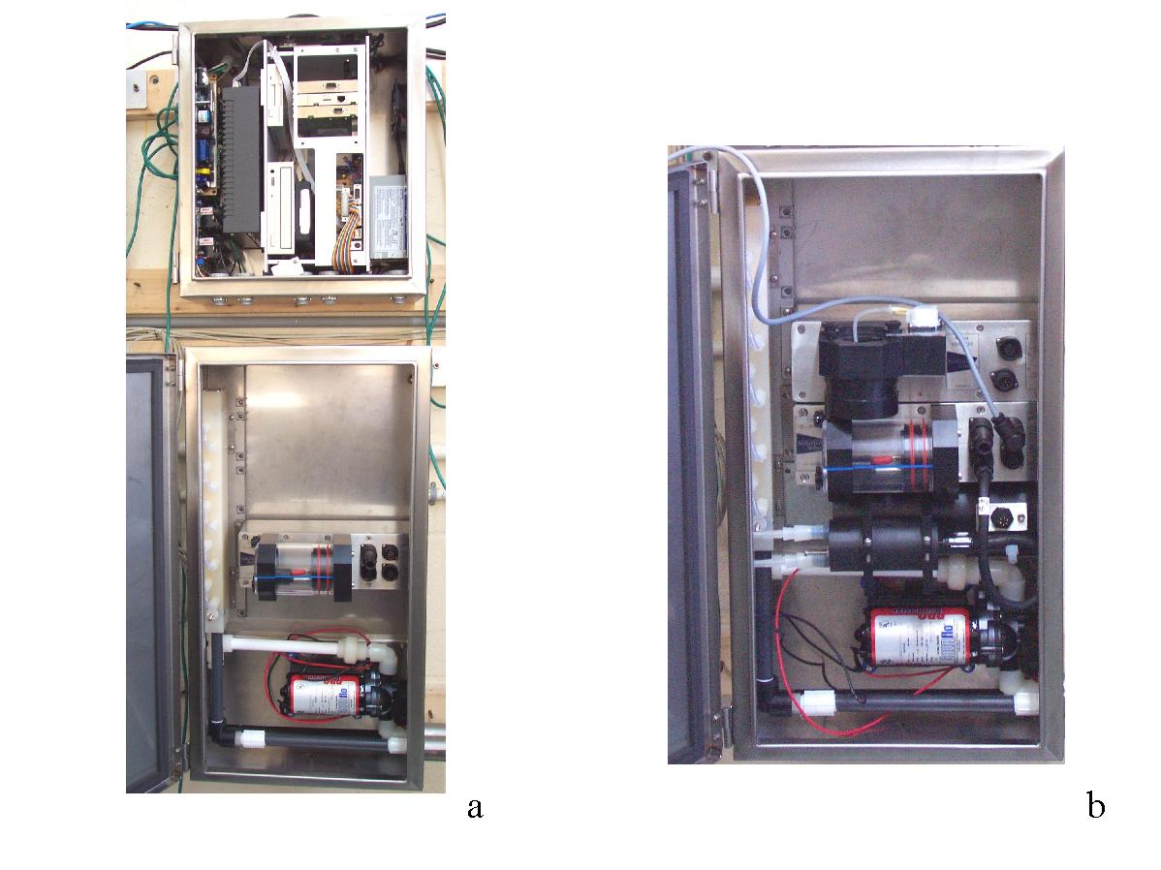
Figure 1. The Ocean and Weather Monitoring System. The standard system is shown in figure a, and the instrument module with an expanded suite of sensors in b.
The meteorological station illustrated below (figure 2) comprises components manufactured by R M Young Inc. In most applications all of the sensors are mounted on a single mast.

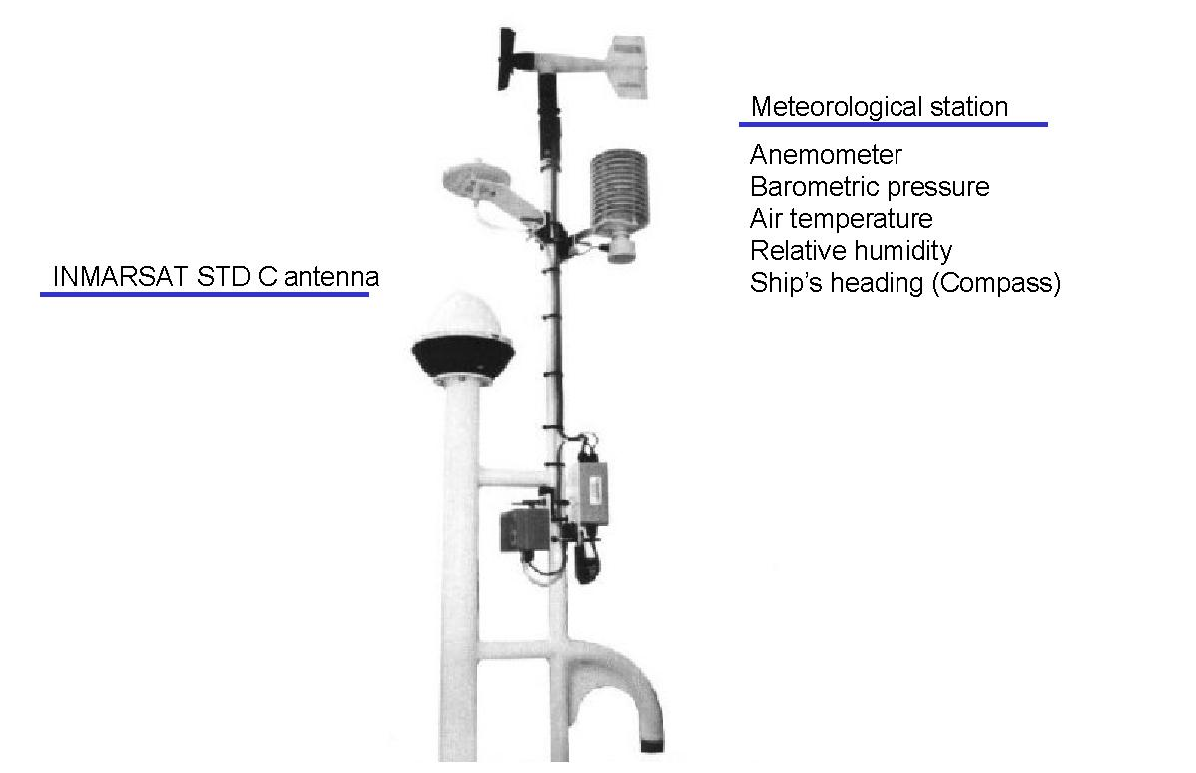

Figure 2. The meteorological sensor suite comprises wind speed and direction, a fluxgate compass, barometric pressure, air temperature and relative humidity.

The standard SeaKeepers installation has a multi-parameter sensor for oceanographic measurements which includes temperature, conductivity, dissolved Oxygen, pH and Eh. A platinum resistance thermometer mounted outside the hull at the water intake measures sea surface temperature (SST). Solid-state optical sensors have been developed for Chlorophyll-a and dissolved organic material (DOM) fluorescence and Turbidity. A new sensor suite is under development by SeaPoint Sensors, Inc. that will incorporate Turbidity, Chlorophyll and CDOM in one package. Toxic metal sensors are being developed by Idronaut Srl Italy to fit into this system. A nutrient sampling package has been developed by WS Envirotech in the UK and will shortly be undergoing sea trials.

A phase II NSF Tech. Transfer grant has been awarded to General Oceanics Inc. in conjunction with The University of Miami and NOAA AOML scientists to assist in the development of a miniaturized pCO₂ monitoring system that will be suitable for SeaKeepers use and later unattended buoy operation. Details of this system are reported in a paper: Kearns, E. et al., “Report on the development of CO₂ monitoring systems to be included in an autonomous data gathering system.” also presented at the JCOMMs meeting in Goa, India.

The modular design of the SeaKeepers Ocean monitoring system makes it possible to deploy many sensors, if they are designed to fit the required footprint. Submodules for mounting electronics and components can be supplied by the society.

One of the advantages of utilizing yachts as one component of the VOS network is the opportunity to sample less frequented ocean regions. Figure 3 illustrate the cruise tracks of 30 SeaKeepers member vessels for 2001. The number of vessels equipped with the Ocean Monitoring system continues to grow.
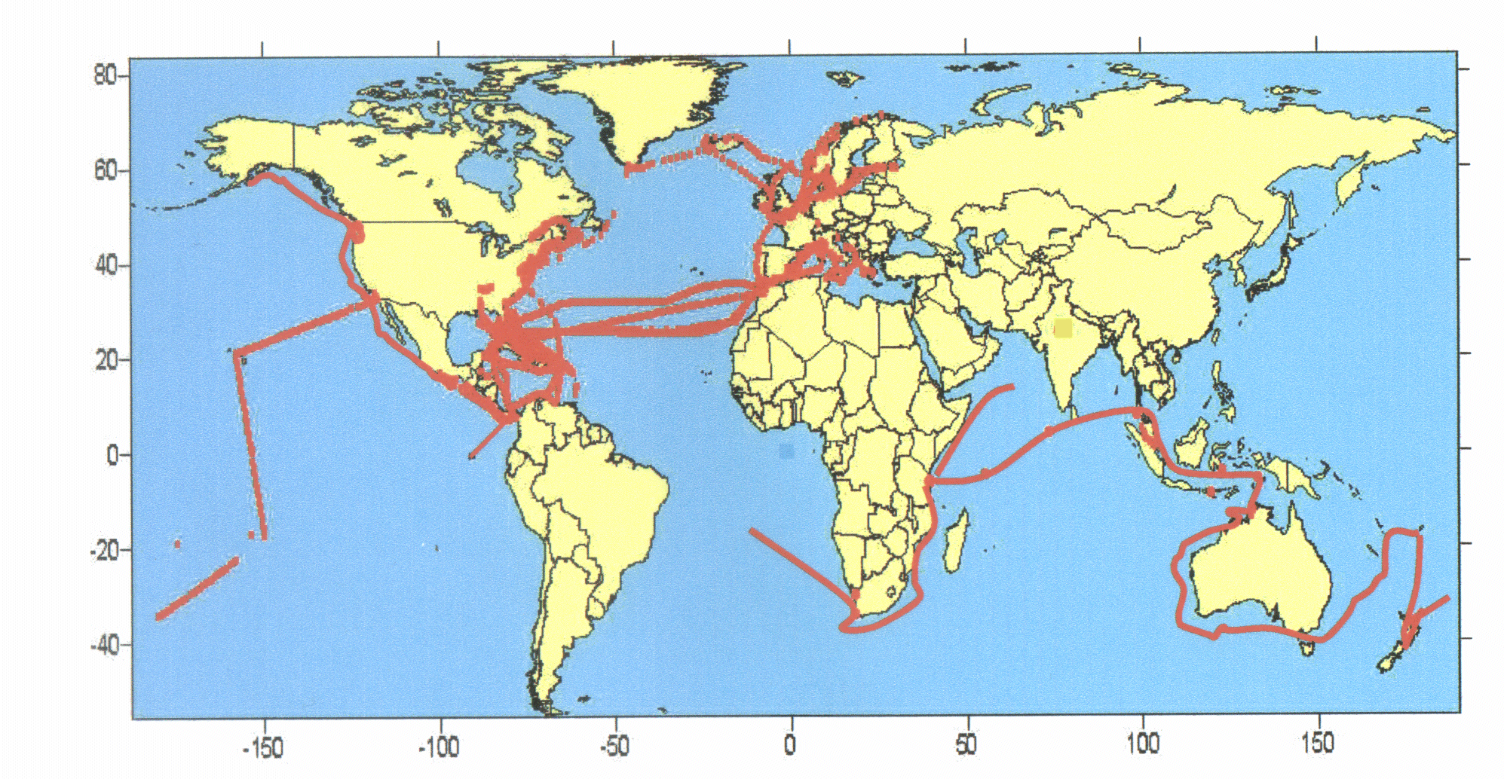

Figure 3. Cruise tracks year 2001

Figure 4 illustrates in a cartoon how the data is transferred and handled at the University of Miami prior to distribution to the US National Weather Service via GTS. As the data volume increases we anticipate requiring a full time group of data managers in this area.

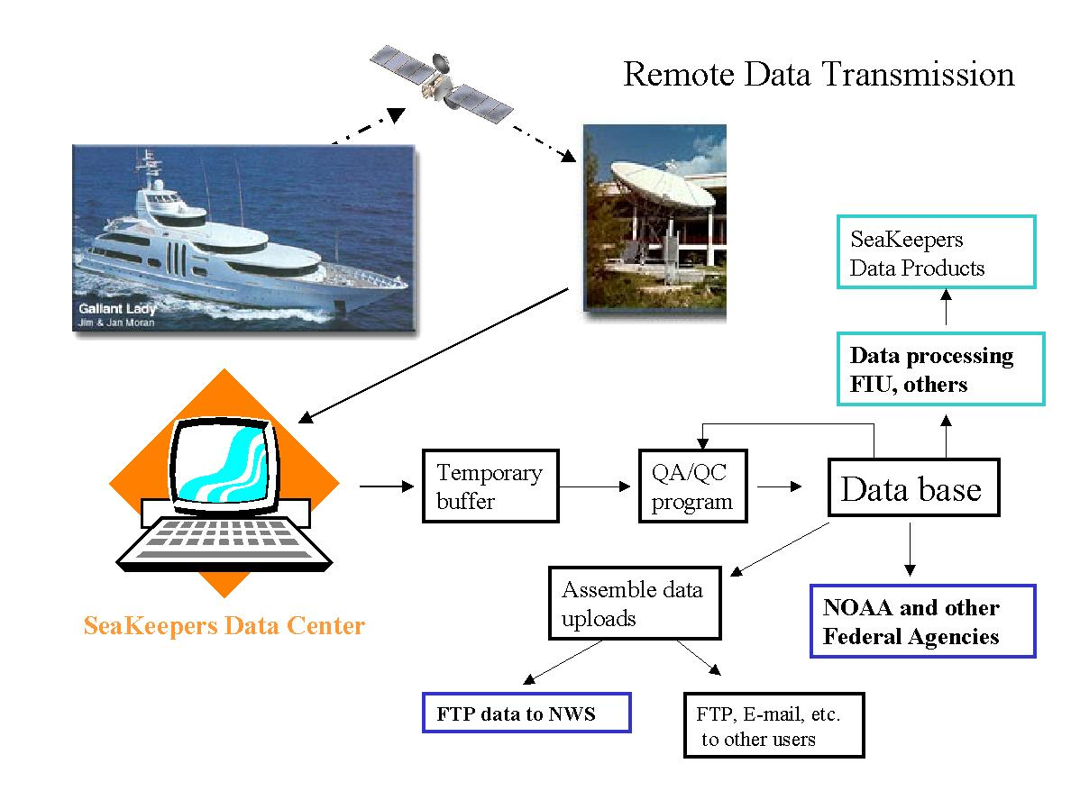
Figure 4. Data handling
A spin off from the above system is the creation of an automated weather station that can be readily installed upon any vessel and will fulfill and exceed the VOS ship requirements while logging a high resolution data set for later use. In an effort to develop another source of funding for the Society, the Society is now offering an Automated VOS station which is described in the attached brochure. As well as providing 8 3 hourly observations per day this system will telemeter observation times and positions, while providing an elegant display on the vessels networked computers.

This project represents as unique collaboration between:

The International SeaKeepers Society, a not-for=profit organization
The National Oceanographic and Atmospheric Administration, US government
The University of Miami, Rosenstiel School of Marine and Atmospheric Science
General Oceanics Inc., a US corporation
Idronaut Srl, an Italian manufacturer
SeaPoint Sensors Inc, a US corporation
WS Envirotech, a UK manufacturer

The International SeaKeepers Society has proved that a small determined group of people can make a significant impact on the volume and frequency of marine observations.


The International SeaKeepers Society Automated Volunteer Observing Ship (VOS) Meteorological Station.

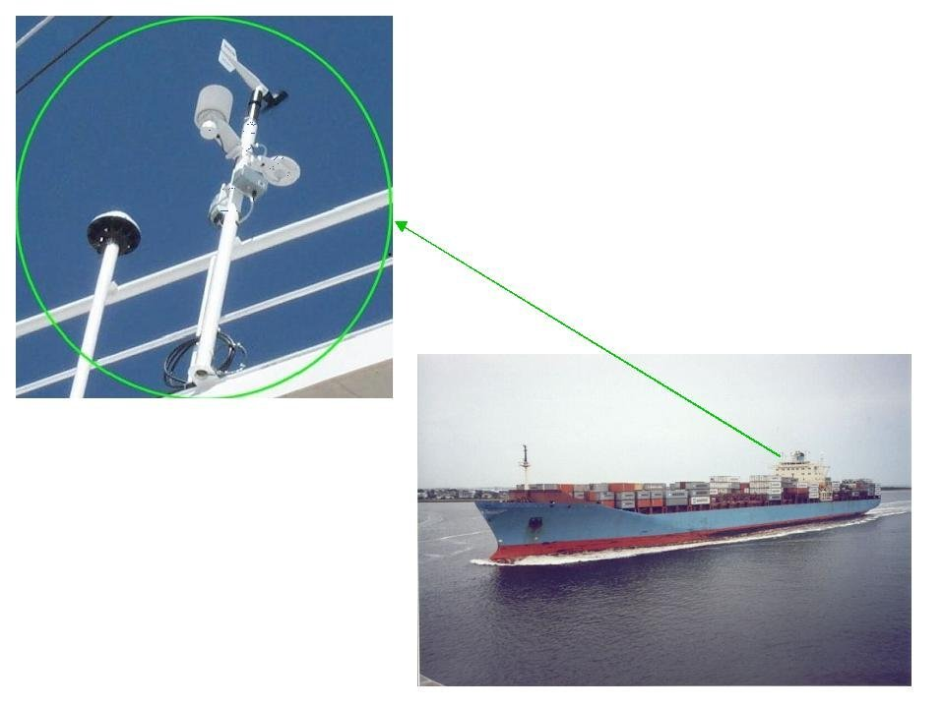

Avoid time-consuming manual data collection and transmission

Eliminate transcription errors

Improve marine weather forecasting

Generate a permanent record of weather conditions on all voyages
Met sensors and INMARSAT C antenna

Collect data to the quality required by the National Weather Service World Meteorological Organization, and Global Ocean Observing System

Data Transmissions will always be made automatically without involvement by the ship’s crew
Data transmissions include vessel position and course over the ground, which may be utilized to facilitate better fleet planning. The automated VOS meteorological station which is based upon the International SeaKeepers Society’s Ocean monitoring module has been extensively field tested for the last three years; providing data of exceptional quality.

The package includes the weather station, a NEMA4 enclosed computer, INMARSAT C transceiver and a sea surface temperature probe. Simple installation requires running a coaxial cable to the antenna, and 0.25 inch diameter cables to sensor locations both on the mast and to the sea surface temperature probe on the hull. An additional cable is required to connect the system the vessel’s computer.

As an option, system can also provide bi-directional email capability (INMARSAT C) for the crew with true global coverage.
Utilizing the vessels computer network any connected computer can access user-friendly data displays.
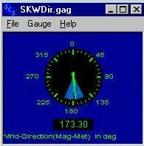
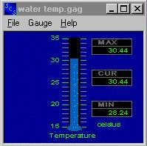
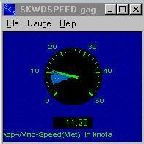
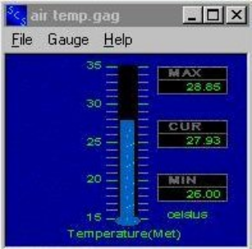The system further provides a continuous history of weather conditions during the voyage that can be displayed on the ship or sent to headquarters

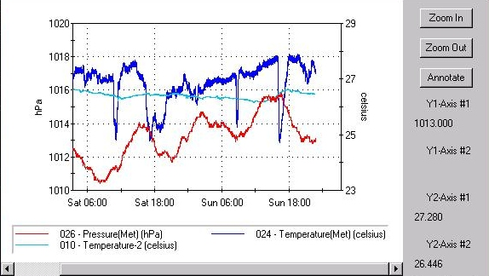

A plot of barometric pressure, air temperature and water temperature from Saturday at 0300 until Sunday at midnight

Sensor specifications

Variable | Units | Range | Accuracy | Resolution
Sea surface temperature | ° Celsius | -3 to 50 °C | ± 0.01 °C | 0.001 °C
Air temperature | ° Celsius | -50 to +50 °C | ± 0.3 °C | 0.1 °C
Relative humidity | % | 0 to 100 % | ± 3 % | 0.1 %
Wind speed | Knots | 0 to 120 Knots | ± 1 Knot | 0.1 Knots
Wind direction | Degrees | 0 to 355 Degrees | ± 3 Degrees | 0.1 degree
Barometric pressure | h Pascals | 800 to 1100 hPa | ± 2 hPa | 0.1 hPa
Course over ground | Degrees | 0 to 359 Degree | ± 3 degrees | 1.0 degree
Speed over ground | Knots | 0 to 100 knots | ±0.5 knot | 0.1 Knot
Latitude | Degrees | -90 to +90 | <±0.001min | 0.0001min
Longitude | Degrees | -180 to +180 | <±0.001min | 0.0001min
UTC time | HH:MM:SS | 0 to 24 hours | ±0.013 sec | 0.001 sec

