Operational Oceanography

Scientific Lectures at JCOMM-I
(Akureyri, Iceland, June 2001)

WMO/TD-No. 1086

2001

JCOMM Technical Report No. 14
WORLD METEOROLOGICAL ORGANIZATION  _____________ |  | INTERGOVERNMENTAL OCEANOGRAPHIC COMMISSION (OF UNESCO)  ___________

Operational Oceanography

Scientific Lectures at JCOMM-I
(Akureyri, Iceland, June 2001)

WMO/TD-No. 1086

2001

JCOMM Technical Report No. 14

N O T E

The designations employed and the presentation of material in this publication do not imply the expression of any opinion whatsoever on the part of the Secretariats of the Intergovernmental Oceanographic Commission (of UNESCO), and the World Meteorological Organization concerning the legal status of any country, territory, city or area, or of its authorities, or concerning the delimitation of its frontiers or boundaries.
FOREWORD

The Joint WMO/IOC Technical Commission for Oceanography and Marine Meteorology (JCOMM) was formally established in 1999, by WMO Congress and the IOC Assembly, through a merger of the former WMO Commission for Marine Meteorology (CMM) and the Joint IOC/WMO Committee for the Integrated Global Ocean Services System (IGOSS). One of the primary initial priorities for JCOMM is the development and implementation of operational oceanography, on the basis of designs and requirements expressed by the Global Ocean Observing System (GOOS) and the Global Climate Observing System (GCOS), including, in particular, an operational ocean observing system for climate.

Traditionally, CMM had arranged for the presentation of scientific lectures, on specific themes, as an integral part of its formal sessions, with the full texts of these lectures subsequently published by WMO and distributed to all Commission members. This has proven to be a very effective means of informing these members of the latest developments and status in scientific and technical fields within the terms of reference of the Commission. The interim Management Committee for JCOMM, therefore, agreed that this tradition should be continued under the new Commission, and that the theme for the scientific lectures to be given at JCOMM-I (Akureyri, Iceland, June 2001) should be “Operational Oceanography”.

The scientific lectures were subsequently presented to JCOMM-I during a single half-day session, and the Commission later agreed that the full texts should be published as a formal JCOMM Technical Report, so that they might also be of benefit to those unable to attend the session. This present publication is the result. It should prove of interest and benefit to all those with an interest in the implementation of operational oceanography and in the rapid development of JCOMM as the appropriate technical instrument of WMO and IOC to coordinate operational oceanography at the intergovernmental level. The considerable thanks of WMO and IOC are due to all the expert lecturers for their time and effort in preparing and presenting these lectures.

(P. Bernal)  Assistant Director-General of UNESCO |  | (M. Jarraud)  Deputy Secretary-General of WMO

C O N T E N T S

FOREWORD

Contents i

Operational Ocean Modelling, Forecasting and Applications
Masaro Saiki, Japan Meteorological Agency 1

Launching the Argo Armada
Stan Wilson, National Oceanic and Atmospheric Administration 19

The Path to JCOMM
Neville Smith, Bureau of Meteorology Research Centre 24

Operational Ocean Modelling Forecasting and Applications
Stephan Dick, Federal Maritime and Hydrographic Agency 32
Operational Ocean Modelling, Forecasting and Applications

Masaro SAIKI

Japan Meteorological Agency

- Introduction

It has been a dream for many years for oceanographers to monitor the global ocean conditions including water temperature, salinity and ocean currents on a real time basis. Meteorologists already came to produce not only surface synoptic charts but also upper-air charts on a global basis 50 years ago, owing to routine upper-air observations with radiosonde balloons every 12 hours made at about 900 aerological stations covering the world. Surface synoptic and upper-air data were made available for providing initial and boundary conditions for numerical weather prediction models.

With regard to the ocean, the Argo programme, now implemented under the international cooperation, will deploy a global array of 3,000 profiling floats to observe the temperature and salinity of the ocean’s upper layer in real time (e.g. Argo Science Team, 1998). The Argo array will initiate the oceanic equivalent of today’s operational observing system for the global atmosphere.

In recent years, products of ocean data assimilation and forecasting by ocean models are becoming important bases for climate monitoring and seasonal prediction as well as indispensable information for fisheries, shipping and other marine activities. Operational meteorological and oceanographic agencies are making efforts to upgrade their ocean data assimilation and forecasting skills to meet increasing needs for oceanographic products. The author will present an overview of the ocean data assimilation systems and El Niño forecast model operated by the Japan Meteorological Agency (JMA) as examples of operational ocean modelling.

- Ocean data assimilation system in the mid-/high-latitudes of the North Pacific

It is well known that the Kuroshio Current, the western boundary current in the North Pacific Ocean, significantly affects the climate of the East Asia and socio-economic activities such as fisheries and shipping. The monitoring and forecast of oceanic conditions including the Kuroshio in the North Pacific have been required in this context.

JMA developed and operates a high resolution ocean data assimilation system, which is named the Marine Analysis system of North Pacific Ocean (MAP), for physically consistent analyses of the ocean structure such as the Kuroshio in the mid-/high-latitudes of the North Pacific. The MAP consists of an objective analysis system and an assimilative ocean model. TOPEX/POSEIDON altimeter data, and in situ observations by ships and buoys are assimilated in the system.

The objective analysis system of the MAP deals with sea surface temperature (SST), in-situ subsurface ocean data, and sea surface height (SSH) remotely observed by satellites (Fig.1). Major data sources of the in-situ data are the BATHY, TESAC, BUOY messages through the Global Telecommunication System (GTS), and other reports gathered through facsimile, postal mail and the Internet which are stored in the NEAR-GOOS (North-East Asian Regional GOOS) Regional Real Time Database (RRTDB) (http://goos.kishou.go.jp). JMA operationally analyzes these in-situ subsurface temperatures, in addition to daily SST data with 1/4 degrees horizontal resolution by NOAA-AVHRR. Fig.2 shows the system for objective analysis of SSH measured by TOPEX/POSEIDON. The SSH data are compiled with an optimum interpolation (OI) method in a horizontal space and time domain each 5 days. Subsurface temperature and salinity fields shallower than 1000m are estimated with correlation scheme of a statistical vertical projection method (Mellor and Ezer, 1991) from objectively analyzed SSH anomalies. Fig.3 shows a geographical distribution of the vertical correlation coefficients by calculating the correlation and regression coefficient (Kuragano and Kamachi, 1997) based on ship observations by the World Ocean Atlas (Levitus and Boyer, 1994; Levitus et al., 1994). Fig.3 (a) indicates the correlation of SSH versus subsurface temperature and salinity. Fig.3 (b) indicates that of SST versus subsurface temperature and salinity. The correlation coefficients of SSH have the maximum values at about 400m depth, and have larger values shallower than 800m depth. On the other hand, SST correlation has a shallower influence depth (about 100m). All of these observed and estimated SST and subsurface temperature and salinity data are combined to prepare grid point values which corresponds to the ocean model in every 5-days intervals, 73 data sets per year, which are restoring reference of real-time data assimilation.

The ocean model part of the MAP is COMPASS-K (Comprehensive Ocean Modeling, Prediction, analysis and Synthesis System in the Kuroshio region: Kamachi et al., 1998) which realizes both of the high resolution around Japan and less computational burden in use of variable horizontal grids. The target of the COMPASS-K is the North Pacific Ocean between 13°N and 55°N from 120°E to 110°W with 1/4°horizontal resolution around Japan between 23°N and 45°N west of 180°as shown in Fig.4. At the northern and southern artificial boundaries of the basin, temperature and salinity are restored to climatology (Levitus, 1982) with free-slip condition for zonal currents. Vertical grids are horizontally uniformly located at 10, 35, 70, 115, 170, 235, 310, 400, 500, 600, 700, 800, 925, 1100, 1350, 1750, 2250, 2750, 3250, 3750, 4500m below the rigid lid surface.

Long time simulation from the rest state to statistically spun-up state forced by monthly climatological wind stress (Hellerman and Rosenstein, 1983) and sea surface temperature and salinity (Levitus et al., 1994) were completed as shown in Fig.5. Variability of the Kuroshio path separation off Boso Peninsula (eastern part of Japan) and activity of meso-scale eddies around Japan were already examined (Kamachi et al., 2001). Operational test-run restarted after the spun-up state, with additional assimilation method of a nudging scheme with the e-folding restoring time of 2-days for first 3-days of every 5-days intervals, and free for rest 2-days without restoring force as shown in Fig.6. For surface condition during the assimilation, surface momentum flux is added by monthly climatological wind, and surface heat and water flux are added as the restoring.

Fig.7 shows distribution of the assimilated temperature at the depth of 100m in waters adjacent to Japan, Feb 16, 2000. The Kuroshio flowed NE-ward along south of Kyushu, Shikoku and Kii Peninsula, then turned SE-ward and meandered off Tokai, after that, it turned NE-ward and flowed near Boso Peninsula to the Kuroshio Extension east of Japan.

JMA initiated the operation of the MAP on January 2001 and has been providing some new products including subsurface temperature and current charts. Products of the data assimilation are available by publications and at Web pages of the NEAR-GOOS RRTDB. Grid Point Value (GPV) data will be particularly useful to have more flexible applications and will make user communities wider. The system will give a firm foundation for regional forecast of ocean structures in the western North Pacific. Oceanographic data, in particular, temperature and salinity data of the upper ocean from the Argo programme will greatly contribute to the improvement of the outputs of the MAP as well as SSH data from Jason-1 to be planned as the successor to TOPEX/POSEIDON satellite.

- El Niño forecast model

JMA has been operating a global ocean data assimilation system (ODAS:Ocean Data Assimilation System) (Kimoto et al., 1997) and an El Niño forecast model (a coupled ocean-atmosphere model) for monitoring and forecasting of El Niño and La Niña events since 1995 and 1998, respectively. Products of the ODAS and the forecast model are provided in the El Niño Monitoring Report which is a monthly publication in Japanese, as well as through the WMO Distributed Database operated by JMA (http://ddb.kishou.go.jp), which can be reached from the “Access to Climate System Monitoring products” page of the WMO Internet Web site. In addition, products of the ODAS are available in the Monthly Report on Climate System and the Monthly Ocean Report.

The ocean general circulation model (OGCM) of the ODAS has the basic horizontal resolution of 2.0°latitude and 2.5°longitude. Near the equator, the meridional grid spacing is reduced to a minimum, 0.5°, as shown in Fig.8. The OGCM has 20 levels in the vertical, and most of them are placed in the upper 500 meters in order to resolve the surface mixed layer and thermocline properly. The model includes Mellor-Yamada’s turbulent closure scheme of level 2.5 for vertical diffusion, a nonlinear horizontal diffusion scheme, and a convective adjustment scheme as Rosati and Miyakoda (1988). No sea ice is explicitly treated in the model.

The upper ocean temperatures are analyzed every 5 days based on ship-based and buoy-based ocean data mainly available on the GTS. A two-dimension optimal interpolation scheme is used for the analysis. The analyzed temperatures are introduced in the OGCM using a nudging technique. Fig.9 shows longitude-depth cross sections of temperature and anomalies along the equator obtained by the ODAS. They indicate typical thermal structure during El Niño and La Niña events.

JMA is going to introduce a three dimensional variational scheme into the analysis system within a few months in order to improve the quality of obtained oceanic field. In addition, JMA is developing a system to assimilate salinity observations as well as TOPEX/POSEIDON altimeter data.

The ODAS and the JMA operational four dimensional atmospheric analysis system provide the El Niño forecast model with initial conditions. The El Niño forecast model is named “Kookai” which means sky and sea in Japanese. The model consists of an atmospheric general circulation model (AGCM) and an ocean model which is identical to that used in the ODAS. The AGCM is a lower resolution version of the previous JMA global atmospheric model for operational numerical weather prediction. Its horizontal resolution is T42, and it has 21 levels in the vertical. The following physical parameterization schemes are adopted in the AGCM; Kuo’s cumulus convection scheme, Mellor-Yamada’s level 2.0 turbulence closure scheme, Lacis-Hansen shortwave radiation, 4-band longwave radiation, relative-humidity-based interactive clouds (Saito and Baba, 1988).

In the coupled model, heat and momentum fluxes from the atmosphere to the ocean are updated once a day, and drive the OGCM. On the other hand, the OGCM provides the AGCM with the sea surface temperature. Flux correction is applied to both the heat and momentum fluxes in order to suppress climate drift.

The model predicted the onset and evolution of 97/98 El Niño event reasonably well with one and two season lead time. The upper left panel of Fig.10 shows the observed three month mean SST anomalies for autumn (September - November) 1997, when the 97/98 El Niño event was in its mature phase. The other panels show predicted SST anomalies.

The forecast skill was evaluated with root mean square errors (RMSE) and root mean square skill scores (RMSSS) for the NINO.3 (4°N-4°S, 150°W-90°W) SST anomaly. Fig.11 indicates the RMSE and RMSSS which are calculated using 169 runs from 1986 to 1999. RMSE(M), RMSE(C) and RMSE(P) are the RMSEs of the model predictions, climatology forecasts and persistence forecasts, respectively. With regard to RMSSS, RMSSS(C) is defined as 100×(1-RMSE(M)/ RMSE(C)), and RMSSS(P) defined as 100×(1-RMSE(M)/ RMSE(P)). If RMSSS has a positive value, the forecast skill of prediction by the model is better than that by the climatology forecast or persistence forecast. It is judged from Fig.11 that the model prediction is better than the other two forecast methods.

Fig.12 shows outlook of NINO.3 SST deviation from the 1961-1990 mean. The thick lines with closed circles are observed SST deviations and the boxes are predictions for the following six months. Each box denotes the range where the SST deviation will be included with probability of 70%. The predictions were obtained by applying a statistical method (Model Output Statistics) to the six-member output of the El Niño forecast model which is run twice a month.

The ENSO outlook is consulted when making seasonal forecasts for the Japan area, because Japanese climate is closely connected with ENSO. JMA is planning to run an atmospheric general circulation model for seasonal prediction using SST anomalies predicted by the El Niño forecast model as lower boundary conditions. The other plans for the near future are to update the AGCM to a low resolution version of the latest JMA operational model with an Arakawa - Schubert scheme, and to make the resolution of both the AGCM and OGCM higher than that of the present coupled model.

- Future view

The ocean monitoring and forecasting have been essentially based on global marine meteorological and oceanographic observing systems and data telecommunications systems. The former CMM and IGOSS had significantly contributed to oceanic services in this regard. Recently dynamical ocean models have been becoming widespread use in ocean monitoring and forecasting. Further development in physical oceanography and computer science as well as improvement of computer resources will make it possible to introduce higher resolution numerical models and more advanced data assimilation schemes into operational systems in the near future. Like weather analyses and forecasts, however, ocean analyses and forecasts crucially depend on global marine meteorological and oceanographic observational data which are exchanged worldwide on a real time basis. In this context, JCOMM is expected to play a key role in further development of global observing networks and reliable supporting communications facilities. Experiences and knowledges which will be gained from the GODAE will make it sure that the oceanic services will enter a new era where ocean models are indispensable tools for preparing oceanic products beneficial to a wide variety of users.

References

Argo Science Team (1998): On the design and implementation of Argo: An initial plan for a global array of profiling floats. International CLIVAR Project Office Report 21, GODAE Report 5. GODAE International Project Office, Melbourne Australia, 32pp.
Hellerman, S. and M. Rosenstein (1983): Normal monthly wind stress over the world ocean with error estimates. J. Phys. Oceanogr., 13, 1093-1104.
Kamachi, M., T. Kuragano, T. Yoshida, F. Uboldi and N. Yoshioka (1998): Development of mid- to high- latitude Ocean Data assimilation System. Weather Service Bulletin, JMA, 65, S1-S19 (in Japanese).
Kamachi, M., T. Kuragano, N. Yoshioka, Z. Jiang and F. Uboldi (2001): Assimilation of Satellite Altimetry into a Western North Pacific Operation Model. Submitted to Advances in Atmospheric Physics.
Kimoto, M., I. Yoshikawa and M. Ishii (1997): An ocean data assimilation system for climate monitoring. J. Meteor. Soc. Japan, 75, 471-487.
Kuragano, T. and M. Kamachi (1997): Investigation of temperature and salinity fields statistically derived from TOPEX/POSEIDON altimeter data. Proceedings of the Symposium Monitoring the Oceans in the 2000s: An integrated approach., Biarritz, France, 4-29.
Kuragano, T., N. Yoshioka, M. Kamachi and A. Shibata (2000): Ocean Monitoring with TOPEX/POSEIDON. Weather Service Bulletin, JMA, 67, S27-S49 (in Japanese).
Levitus, S. (1982) : Climatological atlas of the world ocean. NOAA Prof. Paper 13, 174pp.
Levitus, S. and T.P. Boyer (1994) : World Ocean Atlas 1994, vol.4: Temperature, NOAA Atlas NESDIS 4, 117pp.
Levitus, S., R. Gurgett and T.P. Boyer (1994) : World Ocean Atlas 1994, vol.3: Salinity, NOAA Atlas NESDIS 3, 99pp.
Rosati, R.K. and K. Miyakoda (1988): A general circulation model for upper ocean simulation. J. Phys. Oceanogr., 18, 1601-1626.
Saito, K. and A. Baba (1988): A statistical relation between relative humidity and the GMS observed cloud amount. J. Meteor. Soc. Japan, 66, 187-192.

Captions of Figures

Fig.1 Composition and data flow in the objective analysis system.

Fig.2 Objective analysis system of SSH measured by TOPEX/POSEIDON.

Fig.3 Geographical distribution of the vertical correlation. (a): Altimetry versus temperature (solid line) and salinity (broken line). (b): SST versus temperature (solid line) and salinity (broken line).

Fig.4 Integration region and horizontal grid spacing for the ocean model of the MAP.

Fig.5 Model basin and boundary conditions for spin-up of the ocean model.

Fig.6 Nudging scheme of the assimilation.

Fig.7 Assimilated temperature at the depth of 100m in waters adjacent to Japan, 16 February 2000.

Fig.8 Topography and grid points (a), vertical levels (b) of the Ocean General Circulation Model.

Fig.9 Vertical cross sections of temperature and anomalies along the equator obtained by the ODAS.

Fig.10 Prediction of the 97/98 El Niño event. Observed three month mean SST anomalies for September to November 1997. The other panels indicate predicted SST anomalies by the lead times of one, two and three seasons, respectively.

Fig.11 RMSE and RMSSS for NINO.3 SST anomaly prediction. RMSE(M), RMSE(C) and RMSE(P) are the RMSEs of the model predictions, climatology forecasts and persistence forecasts, respectively. RMSSS(C) is defined as 100×(1-RMSE(M)/ RMSE(C)), and RMSSS(P) defined as 100×(1-RMSE(M)/ RMSE(P)).

Fig.12 The outlook of SST deviation from the 1961-1990 mean for NINO.3 during half a year from June 2001. The thick lines with closed circles are observed SST deviation from the 1961-1990 mean. The boxes are predictions for the following six months. Each box denotes the range where the SST deviation will be included with probability of 70%.

Objective analysis system
Assimilative ocean model
M A P
Assimilated
grid point values
SST
subsurface T
TOPEX/POSEIDON
NOAA-AVHRR
SSH
SST
GTS Internet
Ships
Objective analysis system
Assimilative ocean model
Sun Ultra SPARC-2 450MHz workstations

Figure 1
Subsurface
T and S
Initial guess
Subsurface T

Ships and buoys
NOAA/AVHRR
SST
Subsurface T
Correlation between SST and subsurface T
Adjacent to Japan only
Uppermost 100m only

3D-OI
Merge
For T

For S

Objective analysis
Estimated
subsurface T and S
All over the model basin
OI of TOPEX/POSEIDON

5-days interval
restoring reference

Figure 2

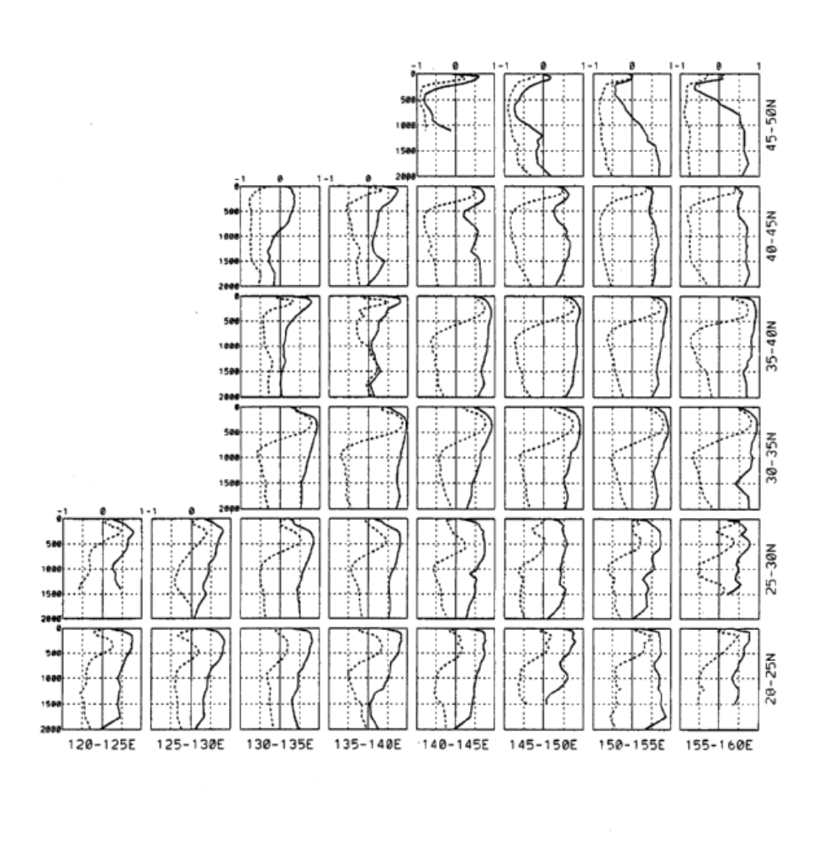Figure 3(a)

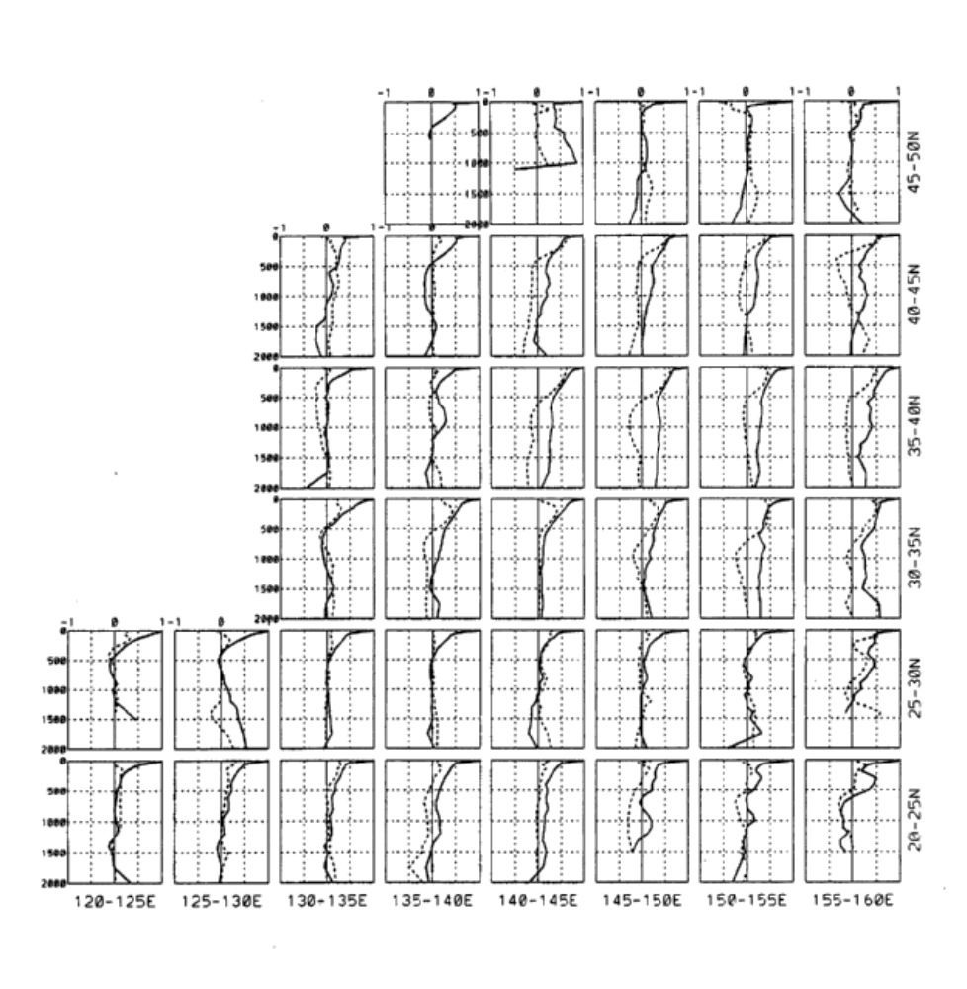Figure 3(b)
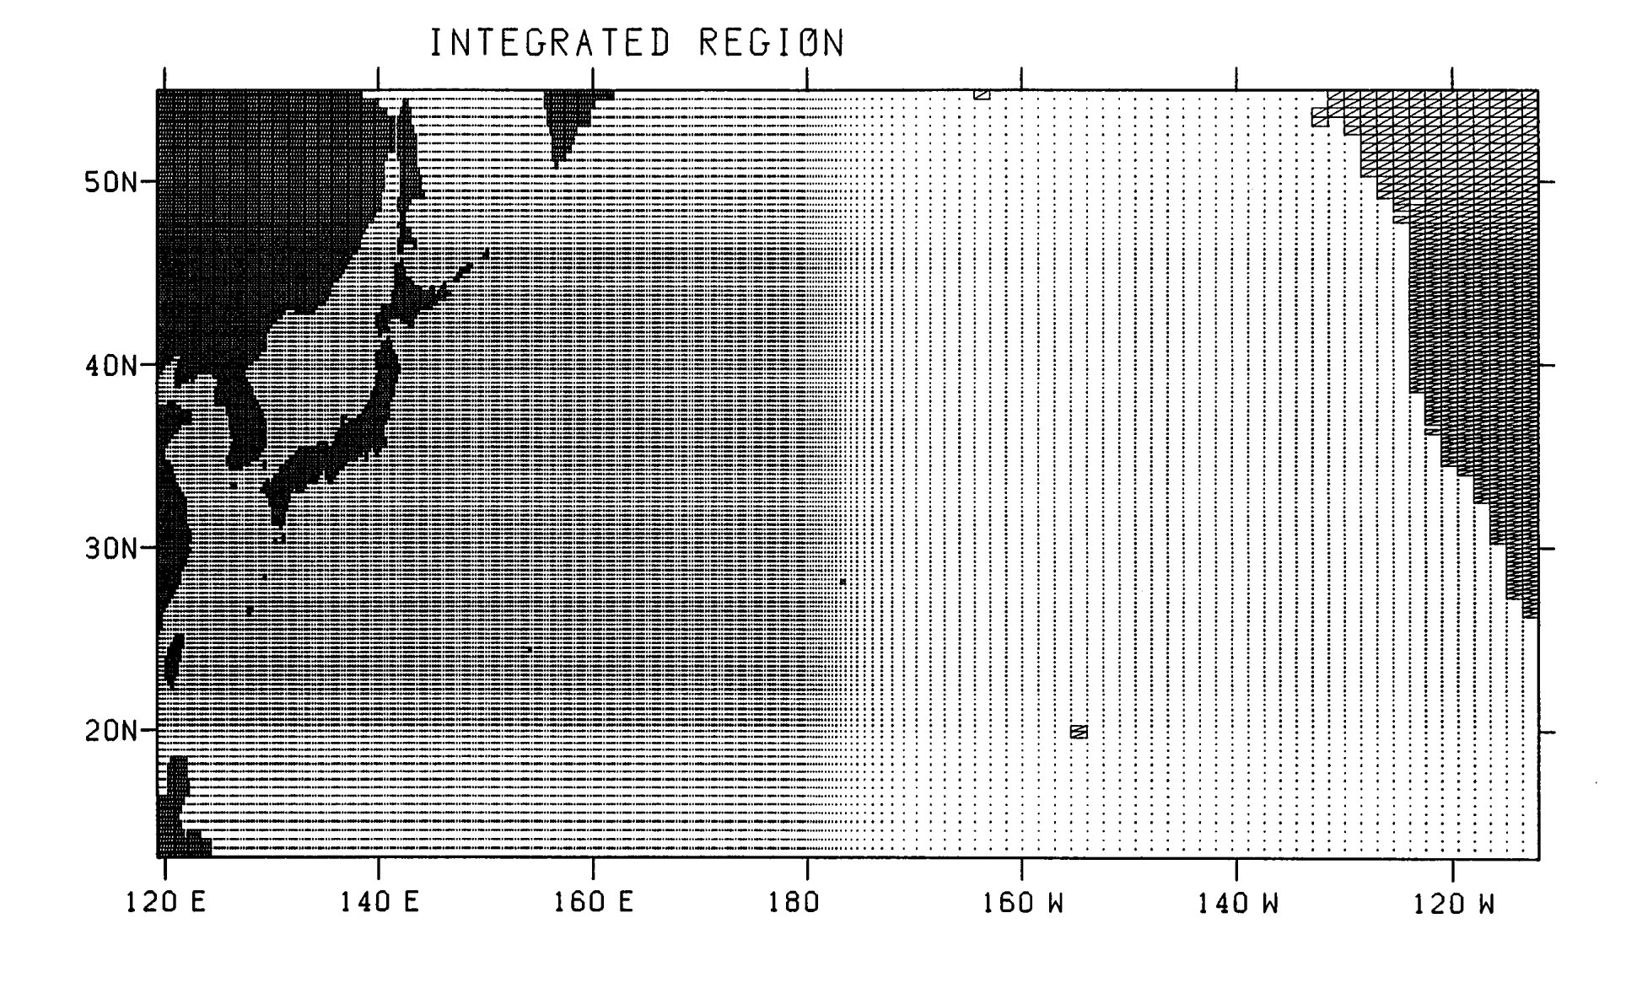
- 10 -

Figure 4

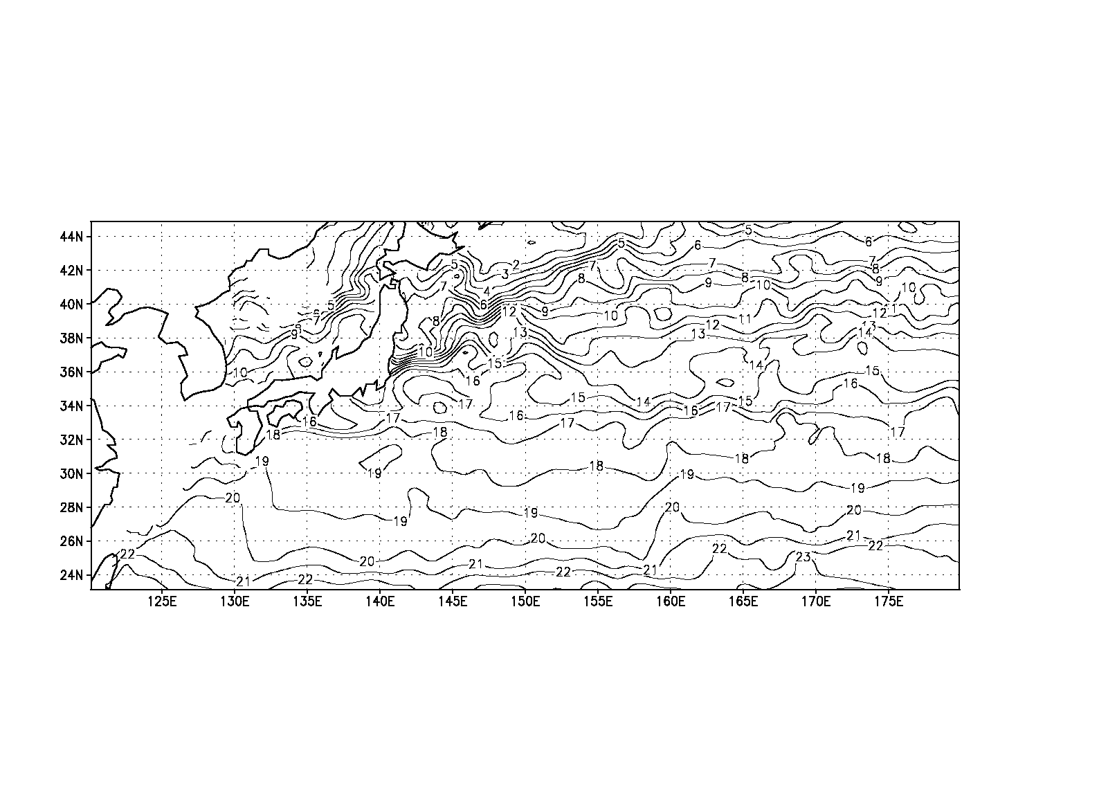
55N

120E

110W
13N
Artificial boundary
T&S : Levitus climatology
Zonal Current : free slip

23N
45N
Wind stress : Hellerman and Rosenstein

180

0m
4750m

Adjacent to Japan
1/4×1/4 degrees

Figure 5

5days
3days
2days
Center of 3D-OI
Model-obs.
1/e
Nudging
Free
2days
Time

Figure 6

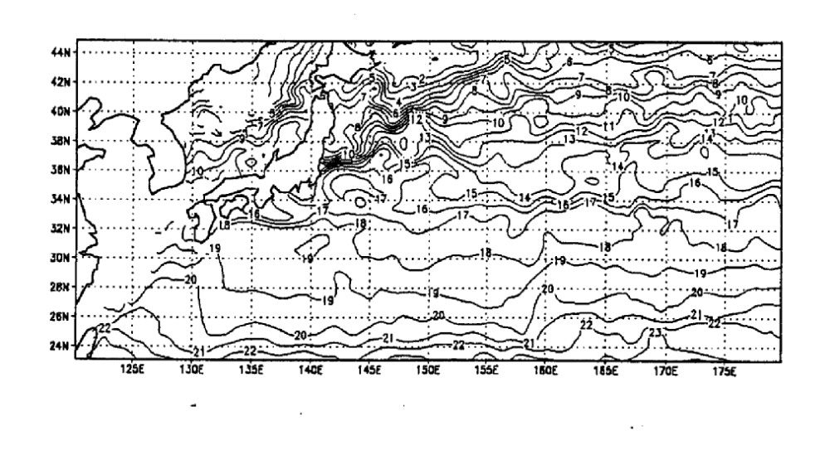Figure 7

Figures 8-12 in separate file.

Launching the Argo Armada:
an array of profiling floats
to observe the global oceans
...in real time

Dr. Stan Wilson

We have made great progress in our capability to observe the global oceans. The Century of Undersampling in oceanography extended from the Challenger Expedition in the 1870s to ~1970, during which time it was not possible to distinguish between temporal and spatial variability in observations taken across ocean basins.

Then the last three decades has seen a Transition to Large Programs. Investigators from multiple institutions using multiple platforms organized large programs—like the World Ocean Circulation Experiment (WOCE) and the Tropical Ocean Global Atmosphere (TOGA) programs—began addressing how to separate spatial and temporal variability, especially as they moved to cover broad areas.

During this period satellites emerged as an observational tool which could provide synoptic coverage of the sea surface globally. And modeling was accepted as a complement to observing systems, to provide a means to fill in between observations both in space and time. Finally, El Niño has been recognized as a global issue, spanning the Equatorial Pacific, but having a global impact.

We are now entering a new era in ocean observations—an era of global and operational programs. We have the World Climate Research Program’s Climate Variability and Predictability Program (CLIVAR)—a global research program, the Global Ocean Data Assimilation Experiment (GODAE)—a global operational demonstration, and Argo—the subject of this talk. We have the Global Climate Observing System (GCOS) and Global Ocean Observing System (GOOS), with their operational sea level, data buoy, and ship of opportunity observational programs.

There is recognition of the need to provide an institutional focus for operational observations, both at the intergovernmental level with JCOMM, and at the national level, where in our country the Ocean.US Office is being established under our National Oceanographic Partnership Program.

We have a satellite capability to observe the sea surface—both globally and synoptically; but we do not have a corresponding capability to observe beneath the surface of the ocean. WOCE collected ~20,000 hydrographic stations globally—but over a nine-year period.

The closest we have to a global, synoptic network to collect subsurface observations is shown in Figure 1. Here we see 6,316 temperature and temperature/salinity profiles collected in real time during December, 2000 by the Marine Environmental Data Service of Canada; vast areas of the globe are unsampled.

Argo will cover the global oceans with 3,000 profiling floats—with a ~300-km horizontal spacing. (See Figure 2.) For a meteorologist, an Argo float can be thought of as an oceanographic radiosonde. For an oceanographer, it is a robotic CTD. (See Figure 3.) An Argo float can be deployed off a vessel of opportunity where it will freely drift with the currents. It dives by decreasing its volume, pumping fluid from an external rubber bladder to the inside of the pressure housing. It descends to as deep as 2,000 meters where it drifts with the currents. (See Figure 4.)

After a typical period of 10 days, it slowly rises to the surface measuring temperature and salinity profiles as it goes. At the surface, it relays these observations to, and has its position fixed by, the Argos Data Collection and Positioning System aboard the NOAA polar-orbiting satellites. It then sinks to begin another cycle. It continues sampling in this manner for its lifetime, a period of four or more years.

Argo will supply the following properties globally, in real-time, and without restriction. First are temperature and salinity profiles. Steve Riser reports an accuracy of 0.01 PSU or better over at least 3 years from SeaBird sensors, based on the analysis of 76 float-years of data collected since 1997, including the results of three floats which were retrieved and returned to their manufacturer for recalibration.

And second, Argo will supply velocity estimates, computed from its drift between successive positions as determined by satellite.

With sufficient coverage by floats, the time-varying, broad-scale ocean circulation can be determined from the resulting profiles and velocity estimates. In effect, Argo will be a Real-Time Upper-Ocean WOCE.

Improved seasonal/interannual climate forecasts are one of Argo’s many applications. Most of us are familiar with the ENSO Observing System spanning the Tropical Pacific. (See Figure 5.) This system, a legacy of TOGA, has provided the capability—along with satellites—to observe and understand ENSO events, and ultimately enabling forecasts of their impacts six months in advance. This resulted in these forecasts over the U.S. of temperature and precipitation anomalies at the top which compare favorably with the observed conditions at the bottom. (See Figure 6.)

But we have solid evidence of two other basin-scale oceanic phenomena with global impacts: the Pacific Decadal Oscillation and the North Atlantic Oscillation.

And we have strong suggestions of an Antarctic Circumpolar Wave and an Indian Ocean Dipole. These are not without controversy. The first is correlated with anomalous precipitation over parts of Australia, and the latter is correlated with anomalous precipitation over parts of Africa.

That controversy exists only makes the case that we are limited by our capability to collect systematic, global observations of the oceans. To what extent are these basin-scale oceanic phenomena real, are they linked, or are they separate and distinct? How do they redistribute heat, and how does that redistribution in turn influence the atmosphere? Answering these questions will help predict these phenomena and their effects, thus contributing to improved climate forecasts.

Another of Argo’s applications is understanding the influence of the ocean on hurricanes. While forecasting the path of a hurricane is challenging, forecasting hurricane growth is even more so, at least for the U.S. The latter is limited by our understanding of the processes involved, which in turn is limited by our ability to collect appropriate marine observations as a hurricane develops.

Figure 7 an example of a fortuitous situation, when one of Steve Riser’s floats happened to lie in the path of Hurricane Dennis and collected observations both before and after its passage. You can see a 3.5-degree C drop in mixed layer temperature and a 0.5 PSU rise in surface salinity. Our ability to sort out the extent to which these changes are due to evaporation, some combination of lateral and vertical mixing, or other factors is limited by our present capability to collect complementary observations.

As Argo is systematically deployed covering the hurricane belt in the Atlantic, there are two interesting prospects. First, NASA’s QuikSCAT, launched two years ago, provides global coverage of the surface vector winds on a daily basis. QuikSCAT, together with NASA’s SeaWinds scatterometer on the Japanese ADEOS-II (to be launched in a year), will provide global coverage of the surface vector wind field every 12 hours.

Second, the Japanese/U.S. TRMM mission carries a Microwave Imager (TMI) that is able to provide sea surface temperatures (SST), albeit at a much coarser spatial resolution that the AVHRR, the infrared imager on the NOAA polar-orbiting satellites. Unlike AVHRR, the TMI is able to observe SST through clouds. Argo, together with satellite-derived surface temperature and surface vector winds, will contribute to advancing our ability to forecast hurricanes.

The final application of Argo data is understanding climate change in the oceans. Syd Levitus estimates that the upper 300 meters of the oceans have warmed by approximately 0.2 degrees C over the past 50 years, but the data on which these results are based are concentrated in the Northern Hemisphere, especially along shipping lanes.

When can we achieve the 3,000-float array? Argo was initiated in 1999 and, expressed in numbers of floats, has grown from 55 that first year, to 255 in 2000 and 535 in the current year. 703 are proposed for funding in 2002.

Assuming 90% of the floats live four years (assume the other 10% fail early), it will be necessary to provide floats at a sustained rate of 825 per year, in order to achieve a 3,000-float array. We could achieve that goal by then end of 2005—if the proposed funding were realized at a level of 825 per year.

13 countries (Australia, Canada, China, Denmark, France, Germany, India, Japan, New Zealand, Republic of Korea, Spain, United Kingdom and the U.S.A.) plus the European Commission are contributing floats.

What does Argo cost? Each float costs approximately U.S. $25,000 over its 4-yr life—including hardware, deployment & data management costs. The cost per profile is ~$25K / (36 profiles/yr x 4 yrs) ~ $170. This is similar to the XBT cost per profile ~ $100. The estimated cost of the 3,000-float array is approximately $20,000,000, an amount to be shared by the international partners.

The WMO & IOC have endorsed/accepted Argo as an important component of the operational observing system of GOOS and GCOS, as a major contribution to CLIVAR and other research programs—assuming that the data and derived products from Argo floats are…“freely available in real-time and delayed mode”. There will be no period of exclusive use.

The Resolution passed by the IOC Assembly states that “as with existing surface drifting buoys some…[floats] ...may drift into waters under national jurisdiction” [ie, an EEZ]. Further, “…concerned coastal states must be informed in advance... of all deployments of...floats which might drift into [their] waters…” The IOC Resolution was silent concerning the issue of deployment of floats within EEZs.

How will we coordinate deployments? The Argo Information Centre has been established under JCOMM, with Mathieu Belbéoch hired as full-time Technical Coordinator to provide services for Argo, just as they are for DBCP & SOOP. In addition, the AIC is to provide notification for, and assist with, float deployments.

We have had three Implementation Planning Meetings for Argo:

- Pacific Ocean -- Tokyo, April 13-14, 2000
- Atlantic Ocean -- Paris, July 10-11, 2000
- Indian Ocean -- Hyderabad, July 26-27, 2001

In these meetings we discuss which countries are interested in providing how many floats for coverage of the basin in question and according to what schedule, what opportunities are available for assistance in deployment, what EEZs issues may be specific to the region, and how might countries in the region benefit from possible improvements in forecasts which Argo data might enable.

In the Pacific meeting, we realized that adequate coverage of the western tropical Pacific—a priority area—will of necessity involve float deployment within the EEZs of Pacific Island Nations, if there is to be adequate coverage of the region. For example, Figure 8 shows the deployment plans for 2001 compared with EEZ coverage in the western Pacific.

Consequently, we have approached these Nations via South Pacific Applied Geoscience Commission (SOPAC) and, working through its Council, have developed the following consensus approach:

The Float-Providing Countries will:

- Provide advance notice of plans for ships & aircraft coming into the collective EEZ of the Pacific Island Region for float deployment.
- Provide assistance identifying and linking with operational forecast centers which will generate forecasts using Argo data.

The Pacific Island Nations will:

- Concur with plans for ships & aircraft coming into the collective EEZ of the Pacific Island Region for float deployment.

When you see the next monthly status of Argo float deployments, you will start to see floats deployed within this region according to this consensus plan. Overall, as of the first of June, 2001, there were 135 Argo-funded floats in the water reporting on real-time data on the GTS. Figure 9 shows the plans for deployments in 2001 and 2001.

Floats can be deployed over the side of ships of opportunity, even when underway at 20 knots; they can also be deployed from C-130 aircraft.

Finally, how we get the data back. Figure 10 is a schematic from the Canadian Marine Environmental Data Service (MEDS) showing how Service Argos’ Data Collection and Positioning System aboard the NOAA polar-orbiting satellites is used to relay the profile data, as well as fix the position of the floats when they surface. The goals for access to Argo data are: real-time data onto the GTS within 24 hours, and scientifically quality-controlled data via Internet within 3 months. Exactly how the data system will organized is the focus of an Argo data management workshop which MEDS is hosting this fall.

In closing, Argo, together with Jason, its satellite companion to be launched this September, are both elements of the broader concept—GODAE, the Global Ocean Data Assimilation Experiment.

In addition to existing systems like surface drifting buoys, ships of opportunity, and sea level stations, we will need complementary in-situ observations from fixed Time-Series Observatories. Some of these exist—like the moored arrays (TAO and PIRATA) in the Pacific and Atlantic, and the air-sea flux site off northern Chile. But many do not. This activity—being organized by Bob Weller at Woods Hole and Uwe Send at Kiel—will accompany Argo and Jason in contributing to GODAE.

Where are we headed? With GODAE, we look forward to the time when real-time observations can be collected and assimilated into models to deliver better forecasts in order to demonstrate the operational utility of the observing systems. To the extent that we can achieve this, we will be make progress toward achieving our long-term goal, namely, implementing a comprehensive operational system for observing the global oceans.

Acknowledgments: Many people and institutions have contributed to this presentation. They include: Howard Freeland, Dean Roemmich, Muriel Cole, Russ Davis, Mike Johnson, Kuh Kim, Syd Levitus, Tim Liu, Breck Owens, Steve Piotrowicz, Steve Riser, Alf Simpson, Uwe Send, Detlef Stammer, Jon Turton, Frank Wentz, and the International Argo Science Team; also the Institut Français de Recherche pour l’Exploitation de la Mer, Jet Propulsion Laboratory, Marine Environmental Data Service, National Geographic Magazine, Naval Research Laboratory, NOAA Climate Prediction Center, Scripps Institution of Oceanography, Webb Research, and Woods Hole Oceanographic Institution. For more information, see: www.argo.ucsd.edu.

Figure 1. Location of the 6,316 real-time BATHY and TESAC reports collected by the Canadian Marine Environmental Data Service during the month of December 2000.

Figure 2. Typical coverage of the global oceans by 3,000 Argo floats.

Figure 3. One of several varieties of Argo floats.

Figure 4. An Argo float will continue this cycle for four or more years.

Figure 5. The ENSO Observing System consists of moored buoys (red), ship of opportunity lines (blue), sea level stations (yellow), and surface drifting buoys (orange).

Figure 6. Forecast for Dec/Jan/Feb 1997/98 made six months in advance; forecast (above) compared with observations (below) for both temperature (left) and precipitation (right) anomalies.

Figure 7. Response of temperature and salinity profiles to the passage of Hurricane Dennis between August 24 and September 5, 1999.

Figure 8. Proposed deployment of Argo floats in the western Pacific compared with the coverage of the Exclusive Economic Zones of the Pacific Island Nations.

Figure 9. Proposed deployment plans for Argo floats in 2001 (black) and 2002 (red).

Figure 10. Schematic of the Argo data system.
The Path to JCOMM

Neville Smith

Bureau of Meteorology Research Centre

Abstract: The path to the First Session of JCOMM has required much planning and more than a little vision. In this Lecture, we will focus on one element of this process, scientific planning and design, and examine some of the significant components of the design, as it exists today. Advances in scientific knowledge and in technology have provided the keys for rapid advances in operational oceanography over recent years but there have also been significant, evolutionary changes in marine forecasting and weather prediction that have impacted the approach to observation. Perhaps more importantly, there has been a big change in the perceived societal relevance of operational oceanography, from monitoring and prediction of El Niño to advanced applications for ocean prediction. Concern for the consequences of climate change has also heightened interest. Remote sensing has, in part, provided the ability to be global, an ability that has been central to all planning. Planning and design have also placed a high premium on integration and broad effectiveness. This paper presents a picture of a well-planned, integrated design, with an appropriate balance between short-term and long-term needs. An effective JCOMM is central to the design. For the future, the major challenge will be to work with JCOMM to ensure that the benefits of this observing system are available to all who wish to use it, using methods that are both efficient and effective. A few of the major issues will be discussed.

1 - INTRODUCTION AND HISTORICAL BACKGROUND

The Joint Technical Commission for Oceanography and Marine Meteorology owes its existence to the hard work of many and to the current perception that the time of “operational oceanography” has finally arrived. The focus of this paper is the path we have taken to reach this point, with most attention being given to physical oceanography and the development of an observing system. Though the theme is operational oceanography, we do not forget that the interests of the Commission include marine meteorology and that there is a rich and important contribution to the partnership that is also coming from that community.

M.F. Maury, superintendent of the Depot of Charts and Instruments at Washington, D.C. in the middle part of the nineteenth century, realised that scientific study and systematic observations of the sea could improve safety and decrease voyage times. Maury began to collect and collate information on surface currents and weather conditions leading to the publication of The Physical Geography of the Sea (Maury 1859), making it one of the first practical applications of ocean science and observations. This international system of voluntary observation remains in place today, nearly 150 years later, and provides the ultimate foundation for the work of JCOMM.

It is probably not an exaggeration to say that operational oceanography evolved little for nearly a century after Maury, despite some of the pioneering work being done in the name of oceanography. World War II marked the start of an era that was characterised by significant technological advances, such as the bathythermograph for continuously recording temperature as a function of depth, and by highly organised, intensive oceanographic surveys which sought quasi-synoptic sampling of large regions. This era also marked the introduction of non-ship based instrumentation such as drifting and moored buoys. One of the more imaginative innovations of this period was the neutrally buoyant float (Swallow 1955). The principles of this technology provide the basis for modern autonomous float instrumentation.

Through the fifties and sixties rudimentary systems for wave forecasting and some other ocean services were put in place but it was not until the late 1970’s and early 1980’s that the first real steps toward operational systems were made. The development of the Expendable Bathythermograph (XBT) in the 1970’s and the development of the drifting buoy for the First GARP Global Experiment (FGGE) buoy were two key advances. At this time people began to ponder whether oceanography could develop an equivalent of the World Weather Watch – Dr Jim Baker coined the term World Ocean Watch. Though this name was not taken further, it is probably only now that we appreciate a key weakness of such a term. The word “Weather” in World Weather Watch brings focus onto the service, onto the impact, whereas “ocean” focuses on the medium. This is perhaps also a failing of the term Global Ocean Observing System (GOOS) since it too fails to identify with the associated services and impacts of the system. Oceanography has not come up with a collective term for those direct effects of the ocean that impact our operations at sea, the marine environment, and society in general. The term “ocean weather and climate” seems inadequate and we should perhaps explore the languages and dialects of the members of the Commission for such a word!

This period also introduced planning for two significant research efforts, the Tropical Oceans-Global Atmosphere Experiment, TOGA, and the World Ocean Circulation Experiment, WOCE (Smith, 2001). These experiments were vital for the development of several elements of JCOMM including the ship-of-opportunity program (SOOP), the global sea level network (GLOSS), the Pacific tropical moored buoy array (TAO and TRITON), the surface drifter program and, more recently, Argo. These research programs were also influential in the development of prototype ocean products and services and in the development of data management practices and standards. Both Experiments, but perhaps more so TOGA, were influential in embracing the interests of developing countries and bringing them in as both providers of information (e.g., within the GLOSS network) and developers and users of services.

It is useful to cast our attention back a mere ten years. In 1990, there was no TOPEX/PSEIDON satellite; there were only around 6 tropical moorings; IGOSS was young; and we had had the first signs of a “successful” El Nino forecast. WOCE was just embarking on its observational program. The computers being used for ocean and climate applications were about as powerful as a laptop PC today. The Internet was available but the World Wide Web was yet to make its big impact. Oceanographic services were few. Yet, at this time, people were already convinced of the value of systematic observations.

Through this period, several people also started to ponder the design of an ocean observing system, a task that was explicitly recognized in the goals of WOCE. The Ocean Observing System Development Panel was established in 1989 to provide a conceptual plan for a permanent ocean observing system, an effort that ultimately resulted in a scientific design for an ocean observing system for climate (OOSDP, 1995).

Today, we have in place many elements of what we desire for an operational ocean observing system, and through the remainder of this paper we will discuss these elements in turn. For El Niño prediction, the accompanying paper by scientists from the Japan Meteorological Agency provides ample evidence of the progress in recent years. For operational ocean forecasting, the paper by Stephan Dick also discusses many related areas of progress. The paper by Stan Wilson provides detail on Argo, perhaps one of the most exciting developments of recent years. With these separate contributions this paper is left with an altogether more manageable task and it will emphasise, yet again, the strength we believe comes from integration, cooperation and a multi-faceted user base.

2 - KNOWLEDGE AND A SYSTEMATIC APPROACH

Through the First Session of the Commission we focused on the technical elements, those aspects that in the end constitute an operating, working, robust system. Yet there is a fundamental aspect that is more important than all these components. It was referred to in the opening remarks by the Secretary General for the WMO, by the Executive Secretary of IOC, and by the Iceland Minister for the Environment. Knowledge of the oceans is fundamental to all we do and aspire to do. It determines why we measure, how we measure, and how effective our measurements are. It underpins both the way we exploit information, be it a climate forecast or a wind wave forecast – the building blocks of every model comprise knowledge of processes and knowledge of the ocean, among other things. Such considerations lie at the heart of our vision for JCOMM: the development of knowledge and capacity for future generations, from all societies. With knowledge we can turn uncertainty into certainty, the impossible into the possible, the needed into the available.

Advances in scientific knowledge and in technology have provided the keys for rapid advances in operational oceanography over recent years but there have also been significant, evolutionary changes in marine forecasting and weather prediction that have impacted the approach to observation. Perhaps more importantly, there has been a big change in the perceived societal relevance of operational oceanography, from monitoring and prediction of El Niño to advanced applications for ocean prediction. Concern for the consequences of climate change has also heightened interest.

For many, operational oceanography does not have a defined place in the knowledge/skill domain. Whereas society and science is generally familiar with, and appreciative of, our skills in weather prediction, they are mostly ignorant of our potential contributions in operational oceanography. At least in part, drawing on our advanced knowledge base, we should see one of our tasks as putting oceanography on “the map” and acknowledge the importance of a strong and constructive relationship with science.

Having built the knowledge base, or at least established to our own satisfaction that we have access to the requisite knowledge and understanding, we should immediately turn our attention to the other end, the user end, and ensure we have the correct approach to taking account of user requirements.

The first point is that we must build our system with the whole user community in mind, not just one narrow sector. We may choose to sell (promote) some particular element against a particular use, but we should design and operate with the broad community in mind. We should make the content of the observing system (see Fig. 1) a principle focus, making sure the different parts (read JCOMM Programme Areas) are scientifically and technically best-practice, that they take full account of the user push and pull, and that they are structured in such a way that new technology can be incorporated as appropriate.

The Ocean Observations Panel for Climate (OOPC) has attempted to implement this approach in practice. The scientific guidance of the Panel attempts to address the full range of objectives, ranging from climate change down to marine and numerical weather prediction. It attempts to represent these different drivers collectively in the priority it attaches to different observational elements, both existing and emerging, of the system. There is no simple formula for doing this, and it cannot be done with tables and databases. It requires scientific knowledge of the objectives; it requires technical knowledge of the potential solutions; it demands both a scientific and socio-economic representation of the utility (the purpose to which we put the system) and technical and logistical knowledge of the availability (what can we accomplish within the bounds of our present capability, taking due account of the logistical and resource limitations).

True effectiveness, for a given investment, is achieved through integration at both the user end (multi-use outputs) and provider source (combining several different approaches and elements to meet the requirement). The attached schematic attempts to illustrate this point (Fig. 1). JCOMM, together with GOOS, works to develop the content of the system including observational networks, data distribution procedures, models (production) and products. There is then an interface to the broad user community with various groups providing value-added services for these particular groups.
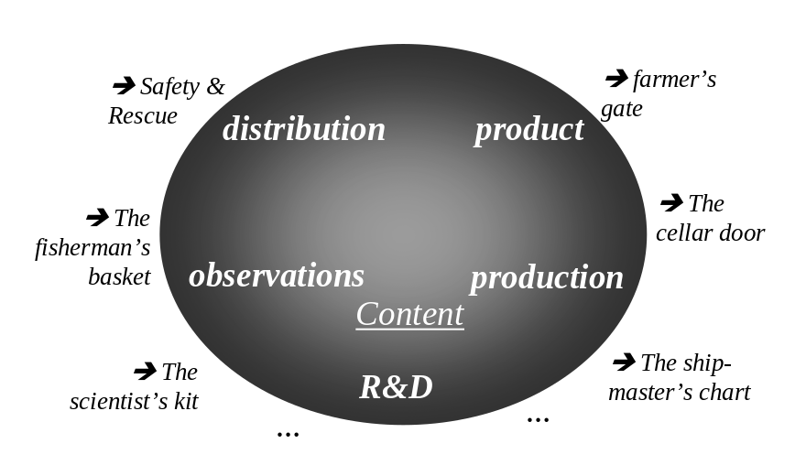

Figure 1. Schematic of the relationship between JCOMM and its ultimate user communities.

Nowlin et al (2001) note the importance of a systematic approach to the evolution of an operational (sustained) ocean observing system. Many of the issues discussed in that paper are relevant to the evolution of JCOMM. In particular, they note the importance of a phased approach to the introduction of new technology and the importance of building community and user acceptance to different approaches.

3 - THE OBSERVATIONAL NETWORKS

Smith and Koblinsky (2001) provide a synopsis of the current plans for the ocean observing system. We will not repeat that detail here but instead concentrate on giving a synopsis of the key features.

3.1 - Commitments to long-term satellites

Remote sensing is a key component of the observing system. As was pointed out several times at the First meeting of the Commission, one of our most important challenges has been, and continues to be, advocacy for sustained (continuing) satellite missions. The Ocean Theme of the Integrated Global Observing Strategy (IGOS; Ocean Theme Team, 2000), supported by consensus from the OceanObs Conference (Smith and Koblinsky, 2001), has set down the rationale and provided priorities. The work now is to see these plans implemented or, failing that, to see that the most important contributions are put in place. The key elements include:

- Polar orbiting and geostationary satellites for sea surface temperature;
- Accurate and high-resolution altimetry (at least one mission of the class of TOPEX/Poseidon and one similar to ERS/ENVISAT);
- High-resolution surface winds from scatterometers (preferably two) or equivalent devices; and
- Accurate images of sea-ice extent and coverage.

The path to the point we are at today has required significant levels of investment and great technical innovation. The in situ and remote sensing communities have not always worked closely together but today there is considerable consensus on the need for an integrated approach. All of the required remote sensing capabilities are within reach now though we have yet to secure long-term commitments in several important areas (e.g., altimetry). Commitment and continuity are two of the main challenges identified by the Ocean Theme Team (2000) though the very fact that that report was published is an indication of the intent and determination of the ocean remote sensing community to deliver the needed capability.

It is important to note that we do not see any one element of the observing system as standing alone. The power of the integrated system derives from all its parts, not just from one element or from one application. The SST system requires both in situ and satellite. The same for sea surface topography and sea level.

We have the technology to observe what we want, with the possible exception of salinity. We know the sampling that is demanded from an integrated multi-purpose system. We have assigned our priorities. We have communicated requirements to the agencies and have set in place a continuing process of constructive dialogue, recognizing the limits of the agencies and the value we can return. All are agreed on the importance.

3.2 - The in situ elements

The OceanObs Conference (Smith and Koblinsky, 2001) established a consensus on the primary elements of the ocean observing system and on needed enhancements. The Conference emphasized the need for effective integration and for considering the system as a multi-faceted, multi-purpose system with a staged approach. Smith and Koblinsky (2001) provide the schedule for full implementation of the system. For the in situ component, the key networks include

- The tropical moored buoy networks (TAO, TRITON and PIRATA);
- The ship-of-opportunity and Voluntary Observing Ship Programs;
- The Argo global array of profiling floats;
- The surface drifter network;
- Time-series stations and surface reference sites; and
- Hydrography and carbon measurements in support of carbon cycle studies and climate change monitoring.

Direct measurements of the ocean are critical and will continue to be important, no matter how skilful satellites become at directly or indirectly inferring ocean properties. Two aspects that received less attention at the First meeting of the Commission are fixed-point (time-series) stations and deep sections. Fixed-point measurements have an illustrious place in our historical record, principally due to the contributions from ocean weather ships. Advances in technology are re-enabling this approach, as is the heightened interest in multi-disciplinary sampling. We are only now starting to consider how best to exploit the legacy of WOCE with respect to deep measurements. By JCOMM II, we might anticipate a robust plan of deep measurements, mostly driven by interest in climate change and the carbon cycle.

4 - APPLICATIONS

Climate change continues to occupy the attention of many nations and is a key factor in all considerations of the observing system. There is nothing that the JCOMM will do that we can assume is not important for climate change. We mostly think in terms of observations, and that is certainly important, but we should give equal attention to, if not greater, the way we process information (data management) and the way we allow less capable nations to access important information.

El Niño prediction is perhaps the most topical application at present but, as this is covered in another paper, we will not discuss it here. Similarly, the general area of marine and regional prediction is covered elsewhere.

In general terms, the “game” we are playing in is one of exploitation of data for broader socio-economic benefit (Fig 2). As indicated previously, the ocean observing system is in fact a multi-faceted, interconnected system of networks, each focused on different aspects of the ocean and/or climate. However, to the user, these facets are of secondary importance. The output of the system and its ability to meet specific needs are the primary focus. The principle behind the Global Ocean Data Assimilation Experiment (GODAE; IGST, 2000) is that models and data assimilation can be used to provide a general framework for exploiting and delivering the value from the observing system. The data is turned into initial conditions or constraints for a model that in turn uses knowledge of physics and dynamics to produce products that may take the form of a forecast (e.g., a forecast for the location of the Kuroshio current at a lead time of three weeks) or the form of an analysis for fields that are not directly observed. Climate predictions and boundary currents for regional predictions are two other applications that might be “fed” by such a system (Fig. 3).
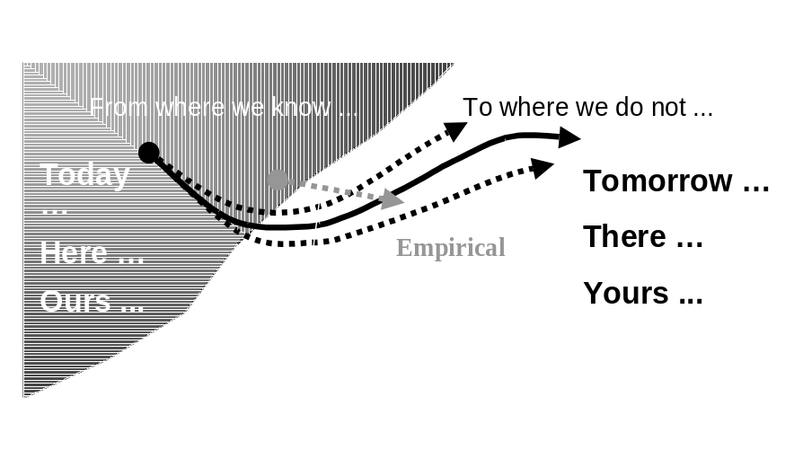

Figure 2. Schematic of the processes used to exploit data. In some cases we use linear, perhaps empirical relationships to relate the current state to, say, a likely future state. In other cases forecasts are produced based on current data (“today”), perhaps at a specific location (“here”), and perhaps for a subset of the total variable space (“ours”), in order to forecast the state in the future (“tomorrow”), at some remote location (“there”) or for some variables that are not part of the observables (“yours”). The process involves extrapolation (e.g., a forecast), interpolation (e.g., discrete points to a grid) and interpretation (e.g., inferring winds from sea surface topography).

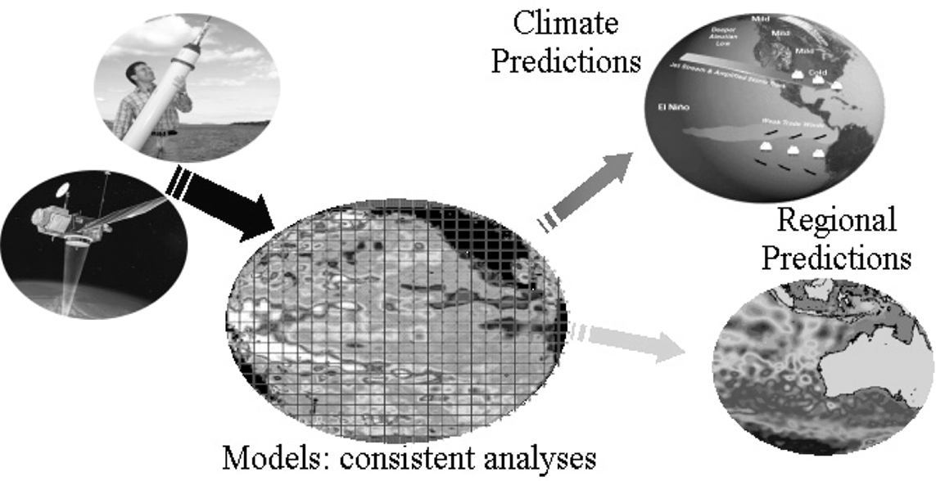

Figure 3. Illustration of the process for taking in situ and remotely sensed data (left) through a model-based assimilation system to produce a self-consistent analysis, which is then used to produce products such as a climate or regional/coastal forecast.
The concept we have described is of course well known to meteorologists but only gradually emerging in oceanography. We assemble the various sets of information, whether it is from satellites or in situ platforms, and ingest (assimilate) the information into computer models of the ocean. The models allow us to do in practice (Fig. 3) what we illustrated in concept (Fig. 2). The equations of motion, and the knowledge encoded in the parameterisations, allow us to exploit the observations in a unique way. The “knowledge” introduces certainty and reproducibility, though we are far from finding a way to measure that skill.

The model “scientific” product only gets us halfway. The critical step is taking this information forward into value adding applications, perhaps a climate forecast and associated interpretation for South America, or perhaps an ocean prediction for the eastern Indian Ocean. This is the interface introduced with Fig. 1. The sources of uncertainty and error are numerous - Nature has a wonderful way of confounding theory.

GODAE is ambitious but was initiated in the belief that the objectives are doable and worth doing. The anticipated outcomes include (IGST, 2000):

- Improved predictability of coastal and regional subsystems through the provision of suitable oceanic boundary conditions,
- Better initial conditions for climate predictions,
- Improved open ocean nowcasts and forecasts,
- Integrated analyses or reanalyses for research programs
- Description of the ocean circulation and physics upon which more specialized systems can be developed and tested,
- A foundation for hypothesis testing, process studies, etc.
- Improved availability and utility of ocean data,
- A methodology for systematic handling, quality control and consistent scientific interpretation (analysis) of special data sets,
- Assessments of the observing system and of the utility of new ocean data sets,
- Model testing and improvement through data assimilation,
- A viable, long-term observing system for GOOS; and
- Development of an enhanced user base and suite of applications.

5 - THE FUTURE

While we can look back and be proud of the achievements, there is clearly much to be done. For the Indian Ocean, we have some very good ideas on what is required but, at present, lack the consensus and resources to implement those ideas. In the ice-covered regions, we need to make further progress on sustaining those observations that are known to be effective while at the same time developing support for innovative new systems (e.g., tomography). In the South Atlantic we have only the broadest notions of what is required and why, so the community needs to forge some consensus on the best approach. In the Southern Ocean, remoteness and logistical constraints make the challenge difficult but, again, there is a clear willingness to work together to find a sustainable approach.

Kyoto and recent discussions on the importance of the carbon cycle suggest we need to give particular attention to carbon measurements. However, just how we go about this in a JCOMM world and with the recognition that such measurements are, and probably will forever remain, very specialised is not yet clear.

One aspect that the community does seem to be agreeing on is data management. Within JCOMM, data management is being accorded a prominence that has been lacking in the scientific community. Several groups have concluded that we need fundamental changes in attitude and in technology if we are to bring the riches of the ocean observing system to the benefit of all who would choose to use it. If there is a grand challenge for the future, then perhaps this is it: To create an efficient and effective data and information management system for the ocean and marine environment, based on leading-edge [ocean] information technology, and serving the oceanographic community and beyond.

6 - CONCLUSION

The path to JCOMM has been long but a rich capability has been revealed and is now being exploited through JCOMM and other mechanisms. We recognize that we are only part the way there and that there is a long way yet to go. There are significant challenges in terms of continuity and sustained support for observing networks, in terms of the development of appropriate processing (model and assimilation) systems, and in the area of data and information management.

For JCOMM, all parts are vital, all elements of all Program Areas (observations, data management, services and capacity building). As a community, we must be prepared to debate and resolve key issues and to set priorities. If we do not, the decisions will be made for us. Barriers to integration and cooperation must be taken down if we are to realize an integrated, multi-purpose, coordinated and multi-national system. JCOMM is vital for this process.

The outlook appears to be bright and we seem to have the technology and methods to do much of what we wish to. Strong work now will have big dividends and clear and precise planning will make JCOMM efficient and effective.

References

International GODAE Steering Team, 2000: GODAE Strategic Plan, N. Smith (ed.), publ. GODAE Project Office, 2000.
Maury, M.F., 1859: The Physical Geography of the Sea. Harper and Bros, New York.
Nowlin, W. D. Jr., M. Briscoe, N. Smith, M. J. McPhaden, Dean Roemmich, P. Chapman, and J. F. Grassle, 2001: Evolution of a Sustained Ocean Observing System. Bull. Amer. Meteor. Soc., 82(7), 1369–1376.
Ocean Observing System Development Panel,1995: The Scientific Design for the Common Module of the Global Ocean Observing System and the Global Climate Observing System: An Ocean Observing System for Climate. Report of the OOSDP, publ U.S. WOCE Office, Texas A&M University, College Station Texas, 285 pp.
Ocean Theme Team, 2000: An ocean theme for the IGOS partnership. Final Report of the ocean Theme Team, 38 pp. [Available online at http://ioc.unesco.org/igospartners/IGOS-Oceans-Final-0101.pdf.]
Smith, N.R., 2001: Ocean and Climate Prediction – the WOCE Legacy, Chapter 7.4 of “Ocean Circulation and Climate” (Eds. G Siedler, J A Church and J. Gould) , Academic Press, pp 585-602.
Smith, N. and C. Koblinsky, 2001: The Ocean Observing System for the 21st Century. In Ocean Observations for the 21st Century, published by the GODAE Office/BoM, accepted.
Swallow, J.C., 1955: A neutral-buoyancy float for measuring deep currents. Deep-Sea Res., 3, 74-81.

First Session of JCOMM, Akureyri, Iceland, 19 – 29 June 2001

Operational Ocean Modelling

Forecasting and Applications

Stephan Dick
Federal Maritime and Hydrographic Agency, Germany

Introduction

In many countries, operational ocean models are used to predict water levels, currents, sea state, water temperatures, salinity or the dispersion of substances. This presentation will focus on short-term forecasts and on forecasting systems for shallow sea areas like the north European shelf seas.

In the north European shelf area, nearly every country has an operational system for the generation of numerical ocean forecasts. An overview of operational systems used for real-time prediction of tides, surges, currents and waves in north and west European countries is given by Flather (2000). Almost all of the operational models are run at national institutions, often by the national weather forecasting agencies. Funding for their development and implementation has been primarily national, and their focus is on national applications.

One important application is the support of the water level prediction and storm surge warning services. Also maritime shipping is supplied with water levels and information about currents. Computed currents and waves are used in different ship guidance and information systems and for ship routing. In future, it shall be possible to integrate current information in electronic chart displays (ECDIS). Model forecasts are also needed in combating marine pollution and to support search and rescue operations. Other important customers are the oil and gas industry, military, coastal engineering and fisheries as well as the leisure industry.

To fulfil the various tasks, an operational model system has been established at the Federal Maritime and Hygrographic Agency (Bundesamt für Seeschifffahrt und Hydrographie, BSH) which consists of different circulation and dispersion models. Results of the BSH's Model System for the German parts of the North Sea and Baltic Sea will be presented as examples of different marine applications.

The Operational Model System of the BSH

The operational model system of the BSH has been in use for more than 15 years now (Dick, 1997). In daily routine runs, predictions for up to 72 hours are computed on the basis of meteorological and wave forecasts supplied by the German Weather Service (Deutscher Wetterdienst, DWD) and based on tide predictions.

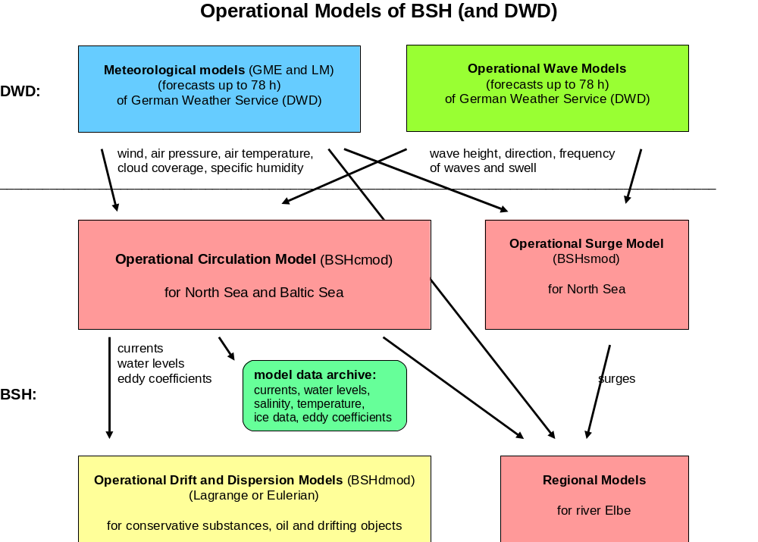

Fig. 1: The Operational Model System of the BSH

The main constituents of the model system are a hydrodynamical model to compute currents, water levels and temperatures, salinities and ice cover in the North Sea and Baltic (circulation model), programmes to compute the drift and dispersion of substances (dispersion models), a surge model for the North Sea and Regional models for German estuaries (Fig. 1).

  - The Circulation Model

The Circulation Model (Dick et al., in prep.) predicts currents, water levels, water temperatures, salinity, and ice cover in the North Sea and Baltic Sea in nightly routine runs on two nested and interactively coupled grids. Grid spacing in the German Bight and western Baltic Sea is 1 nautical mile and 6 n.m. in the other North and Baltic Sea areas (Fig. 2). The model also simulates the falling dry and flooding of tidal flats, allowing complex processes in the highly structured coastal waters (tidal flats, sandbanks, tidal channels, barrier islands) and water exchange with the open sea to be simulated realistically (Dick and Schönfeld, 1996).

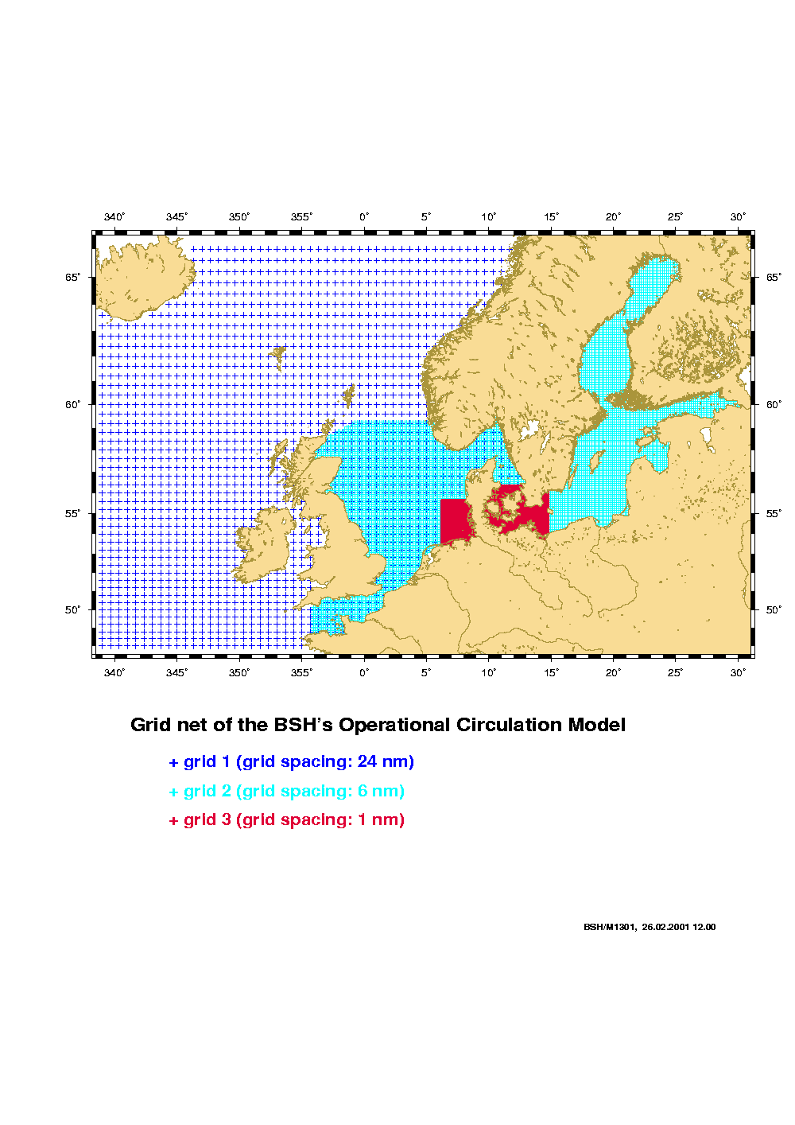
Fig. 2 Grid nets of the BSH's circulation model

The model is three-dimensional and takes into account meteorological conditions in the North Sea and Baltic Sea area, tides and external surges entering the North Sea from the Atlantic as well as river runoff from the major rivers. The meteorological data are computed by the German Weather Service (DWD) using an atmospheric model and are transmitted daily to the BSH. To compute the heat fluxes between air and water, the BSH model uses air temperature, cloud cover and specific humidity data above the sea. The tidal predictions at the model’s open boundaries are calculated using the harmonic constants of 14 tidal constituents. External surges entering the North Sea are computed by a model of the Northeast Atlantic. This two-dimensional model has a grid spacing of about 24 n.m. and is also forced by meteorological data provided by the DWD (Fig.2).

The circulation model simulates density driven (baroclinic) currents which depend on the prevailing temperature and salinity distributions. Especially in the Baltic Sea, baroclinic currents play an important role. As hydrodynamics is also influenced by ice conditions in the North Sea and Baltic, there is an ice model integrated to simulate formation, melting and drift of sea ice (Kleine and Sklyar, 1995).

  - The Surge Model

The BSH's Surge Model (Jansen, 1996) was developed especially for the water level prediction and storm surge warning service. The model covers the North Sea with 6 n.m. grid spacing and is two-dimensional. The model is run twice a day with tidal and wind forcing. An additional run is carried out with pure tidal forcing. For the main German stations surge values are evaluated by subtracting 'tide' from 'tide+surge' results. The main advantage of the surge model in comparison to the complex three-dimensional circulation model is its short running time. In spite of the longer forecast interval (84 hours) new surge model predictions are available soon after meteorological predictions have been transferred.

- Validation

The operational model results are used by different BSH services. Models are validated on a regular basis but also within the framework of projects (Müller-Navarra and Ladwig, 1997, Klein and Dick, 1999). This paper will focus on validation of the parameters water levels, temperature and sea ice.

Water levels

Model forecasts are important tools in the BSH’s water level prediction service and, therefore, their accuracy is checked daily by comparing measured and computed water levels. Furthermore, predicted high and low water levels for German Baltic and North Sea stations are evaluated yearly on a routine basis. Figure 3 shows the frequency distribution of differences between measured and modelled high water surges at the station Cuxhaven in 2000. Cuxhaven is located in the inner German Bight at the mouth at the river Elbe and is the basic station for German water level forecasts in the North Sea. Similar values for bias and standard deviation of differences have been computed for other German North Sea stations.

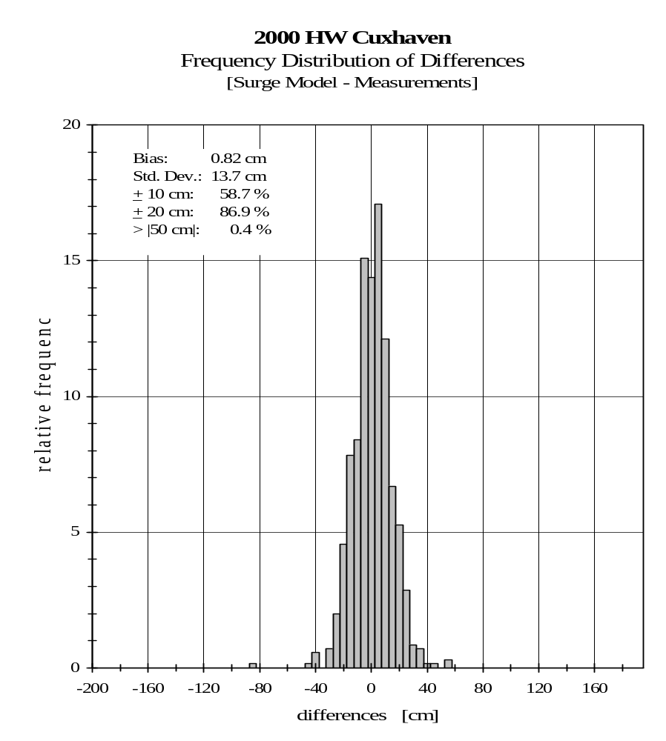
Fig. 3: Frequency distribution of high water level differences at Cuxhaven station for the year 1999 (results of the Operational Surge Model)

In the Baltic, water level changes are influenced only to a slight extent by tides but much more by wind effects and seiches. Figure 4 shows a time series of measured and predicted water levels in the winter of 1999/2000 at the German Baltic Sea station 'Warnemünde'. It clearly reflects the typically strong water level variations during the winter season. In the first half of December, water levels varied between 170 and +80 cm. The results of the circulation model agree quite well with the measurements. In 2000, the standard deviation of differences between measurements and model prediction at German Baltic Sea stations was between 7 and 10 cm, while the bias was in the range of 20 cm. The reason for the bias is a different reference level of the water level stations and the model in the Baltic Sea area. In the daily water level prediction service, the shift of reference levels can be easily corrected by adding a constant value.

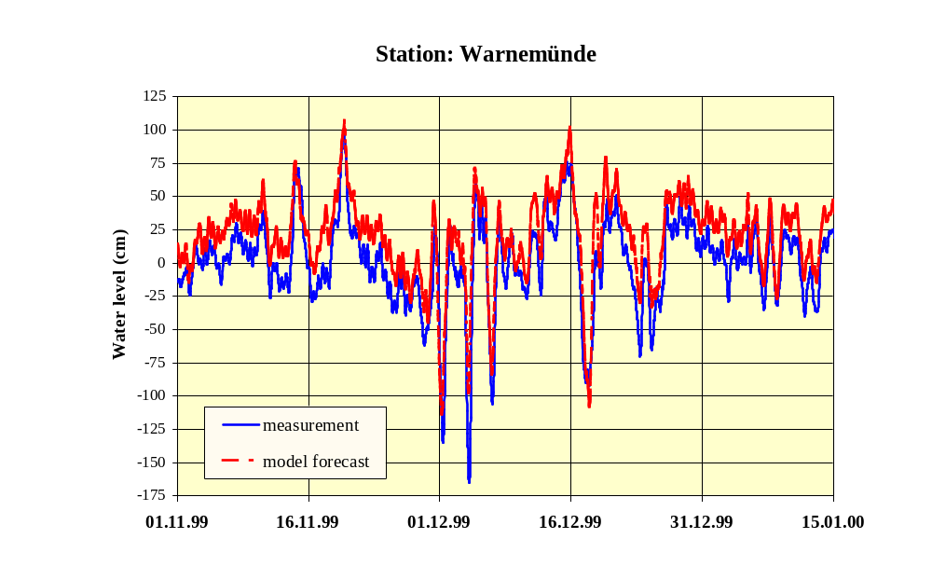
Fig. 4 Measured and predicted water levels in winter 1999/2000 at the station Warnemünde in the western Baltic Sea
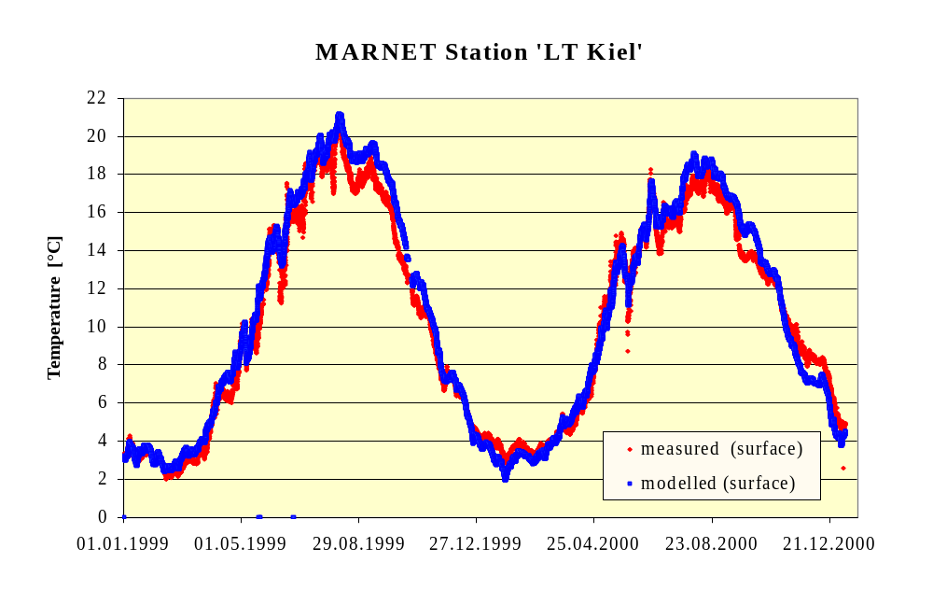
Fig. 5: Measured and predicted surface water temperatures at station 'LT Kiel'
3.2 Water temperature

Another possibility of validating the operational circulation model on a routine basis is provided by the data of the German Operational Coastal Monitoring Network (MARNET) which is also operated by the BSH (Knauth et al., 1996). It presently consists of 4 stations in the German Bight and 4 stations in the western Baltic Sea. All automated stations carry sensors for different physical or chemical parameters. Figure 5 shows a comparison of measured and predicted water temperatures at the Baltic Sea station 'LT Kiel'. The bias of predicted surface temperatures during a two year period (1999/2000) was -0.31°C with a standard deviation of differences of 0.79°C. Similar or even better agreements between modelled and measured surface water temperatures were found at other German stations.

3.3 Sea ice

Ice modelling is very closely linked to the simulation of water temperatures. The support of the BSHs ice service with model predictions is getting more important with increasing forecast length. Of special interest for the service is the temporal development of the computed ice distribution and thickness. Comparisons of ice charts with model results allow the model predictions to be checked on a routine basis. Fig. 6 shows a comparison of measured (Strübing, pers. comm.) and computed ice distribution and thickness in the Baltic Sea on 26.03.2001. In general, the ice extension and distribution in nature and in the model are quite similar. Both model and ice chart show the thickest ice (30 – 50 cm) in the northern Gulf of Bothnia and eastern Gulf of Finland while the location of the thickest ice differs in detail. As a rule, large-scale performance is acceptable while small scale features are not yet sufficiently reproduced.

4. Special Applications

4.1 Storm Surge Warnings

Shelf sea coastal areas are very much exposed to danger by storm surges. In the past some severe storm surges in the southern North Sea caused death of many people and substantial damage.

Therefore, in many countries storm surge models have been developed for the prediction of such events. At the BSH, the circulation and storm surge models are important tools – among other methods - of the storm surge warning service. As an example, the results for the most recent very high storm surge will be presented.

In the evening of 3 December 1999, a north-westerly storm caused a very high storm surge in the German Bight, especially in Danish waters. At Cuxhaven, surge values of 3.3 metres were measured during high tide. Model forecasts like the predicted surge distribution for 3 Dec. 1999, 17:00 h (Fig. 7), made it possible to issue proper warnings in time.
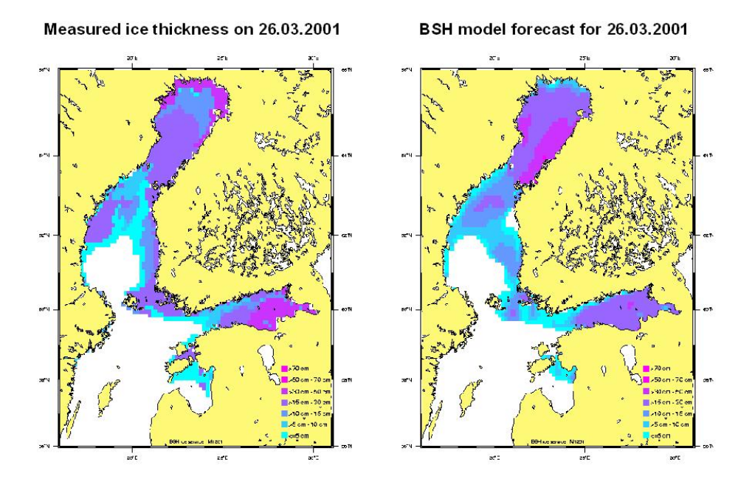
Fig. 6: Comparison of measured and predicted ice thickness in the Baltic Sea on 26 March 2001
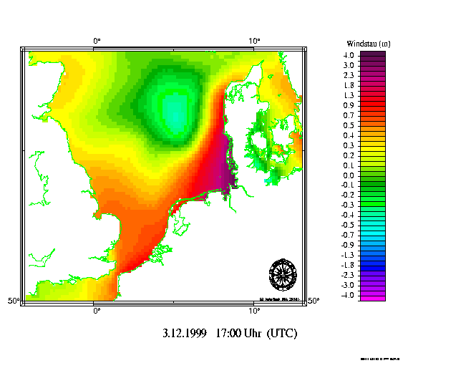

Fig. 7: Computed distribution of surge values on 3 December 1999 17:00.

Results of the BSH's Surge Model.

4.2 Ship Guidance and Information Systems

Forecasts of water levels, waves, currents and ice are of special interest to maritime shipping. In ship traffic management, a wrong operational decision concerning, for example, port admittance would involve high financial loss and safety risks. In this important application, there is a need for the continuous provision of forecast data.

Another important application is ship routing where meteorological and oceanographic information is needed to operate a vessel in a certain sea area. The information is transmitted directly to the ship and supports the ship’s master in his decision-making. One example is the Baltic Ferry Information System (BAFIS), where ferries in the Baltic Sea are provided with forecasts of winds, waves, currents and sea ice on a regular basis. Fig. 9 shows, as an example, the representation of currents in the system 'FERRY' which has been developed by the German Weather Service.

In future, it is planned to include time varying marine information also in electronic charts (ECDIS). In a tidal sea like the North Sea there is a special need for water level and current information not only for commercial shipping but also for sports and leisure activities. On the internet pages of the BSH (www.bsh.de) detailed maps of surface currents are presented showing forecasts for selected areas of the North Sea and Baltic.

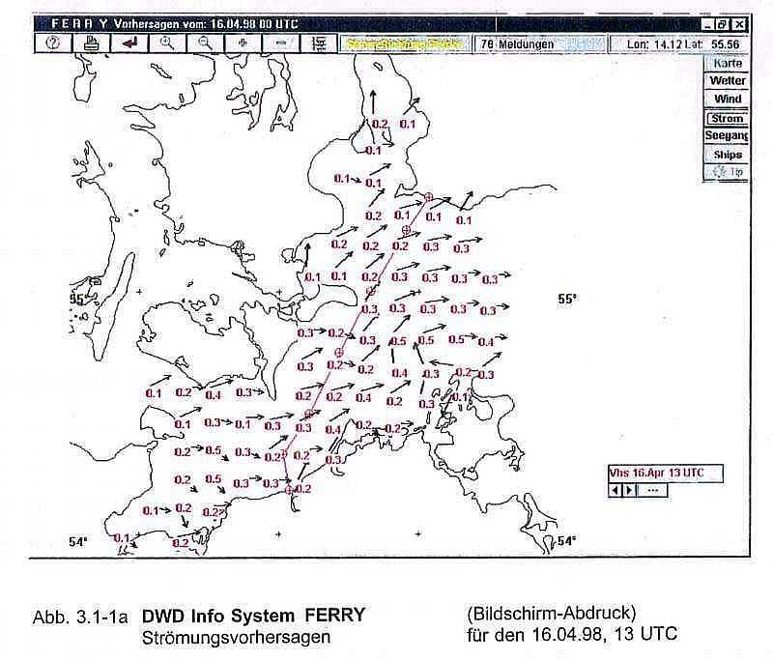
Fig. 8 Example for representation of currents in the Baltic Ferry Information System (BAFIS, Cooperation of DWD and BSH)
4.3 Oil spill prediction

The simulation of dispersion processes at sea has been gaining in importance during the past few years. Applications include modelling of the dispersion of pollutants and computations of the drift paths of shipwrecked persons. The BSH operates two models serving different purposes.

Studies of the dispersion of water soluble substances and of the quality of North and Baltic Sea water are mostly performed using an Eulerian dispersion model (Müller-Navarra et al., 1999). This model is suited particularly to compute the distribution of substance concentrations. For example, it may help to answer the question how harmful substances from rivers are transported and dispersed in the sea.

The Lagrangian Model (Dick and Soetje, 1990) is used primarily to support search and rescue operations and to assist the coast guard in cases of marine environmental pollution. Among its applications are drift forecasts for shipwrecked persons and floating objects (boats, lost cargo etc), as well as drift and dispersion computations for oil and water-soluble chemicals. The model is frequently used to trace back harmful substances and is thus a valuable tool in identifying environmental polluters.

To simulate the drift and dispersion of a substance in the Lagrangian Model, the particular substance is represented by a particle cloud drifting with the current. Aditionally, turbulence is taken into account. Sub-scale motion is simulated by a Monte Carlo method. Substances floating on the surface are additionally driven by a certain percentage of wind velocity. In simulations of oil dispersion, the physical behaviour of different oil types on the water surface and in the water column is taken into account as well. The BSHs oil drift model simulates wind and current-induced drift, spreading, horizontal and vertical dispersion, evaporation, emulsification, sinking, beaching as well as the deposition of oil on the sea bed.

On 29 March 2001, the Baltic Sea was polluted by the worst oil accident in 20 years when the tanker 'Baltic Carrier' collided with another vessel and lost 2700 tonnes of heavy fuel oil. Within three days, 2000 of about 10.000 sea birds in the area had died.

Shortly after the BSH had been alarmed by the National Reporting Centre of the German oil accident committee (SBM), model forecasts for the drift and dispersion of the oil were sent to the Abatement Unit (Fig. 9). The model predicted a stranding of oil in a small Danish bight for the evening of the same day. Later, the time and position were confirmed by the Danish authorities. Also in this case, it was proved that model prognoses are an important decision-making tool in combatting oil or other marine pollutants.

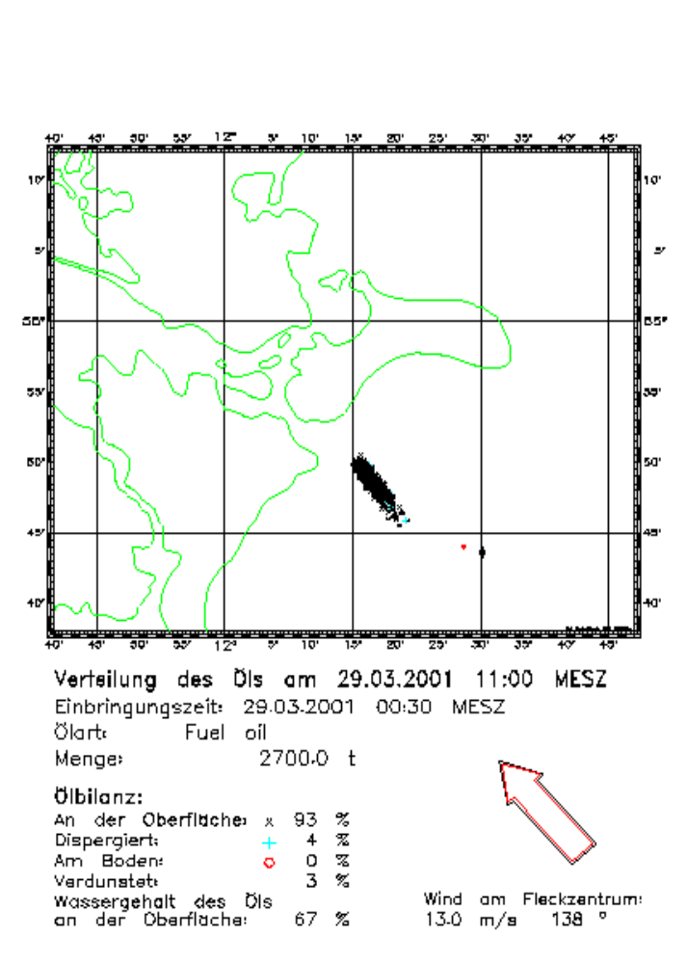
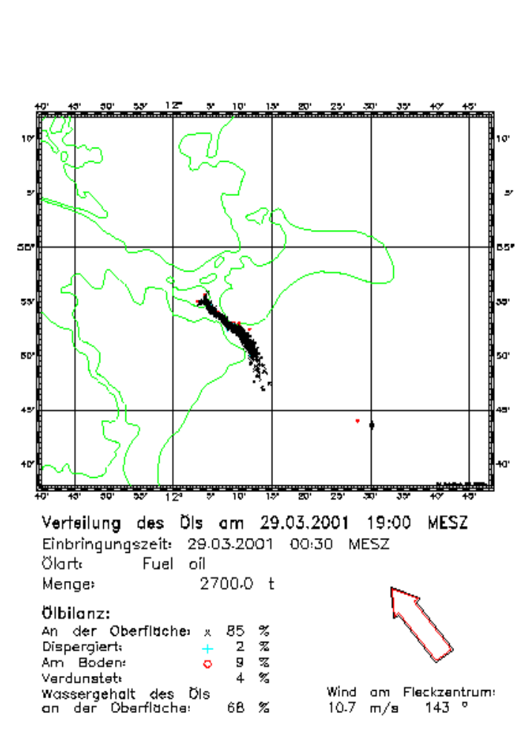
Fig. 9 Predicted distributions of oil released after the accident of the 'Baltic Carrier' in the western Baltic Sea.

5. International cooperation

As all operational ocean models need meteorological, oceanographic and hydrological information there is a close link to JCOMM. JCOMM will play an important role in the development of a system for the distribution of marine information. The information is needed for forcing, assimilation and validation of the models. Close interactions also exist in the field of wave, storm surge or sea ice forecasting as JCOMM assists the members in their forecasting work.

Operational ocean forecasting systems are important elements of the Global Ocean Observing System (GOOS). In the frame of the Coastal Component of GOOS (C-GOOS) co-operation between different ocean forecasting centres in the North Sea and Baltic Sea area has been established. Examples are the HIROMB (High Resolution Operational Model for the Baltic Sea) project between Baltic Sea countries and the ESODAE project for the North West European Shelf area.

5.1 HIROMB

The HIROMB project is an activity under the umbrella of BOOS (Baltic Operational Oceanographic System). HIROMB's main objective is to develop a High Resolution Operational Model for the Baltic Sea, based on the latest scientific knowledge. Agencies in Sweden (SMHI), Germany (BSH), Poland (IMGW), Denmark (RDANH) and Finland (FEI) have signed an agreement of co-operation to foster international co-operation and jointly develop a model system for daily prediction of all hydro-dynamical parameters. In the Baltic, baroclinic features are of special importance, such as thermo-haline stratification, stagnation and sea ice.

For about a year now, a circulation model with 1 nautical mile grid spacing in the whole Baltic Sea has been run operationally at the Swedish Meteorological and Hydrological Institute (SMHI). The model code has grown out of BSH's circulation model but had to be customised for a massively parallel computing machine (T3E). Complementary elements of the model system were provided by other HIROMB partners. All HIROMB partners may use the model output for their own purposes such as drift and dispersion modelling in local areas. HIROMB is a good example of how international co-operation can also stimulate scientific discussion. In the project model results and source code are exchanged free of charge.

5.2 ESODAE

ESODAE-1 is a EU Concerted Action for planning an European Shelf seas Ocean Data Assimilation and forecast Experiment. The main phase of ESODAE will be linked to the Global Ocean Data Assimilation Experiment (GODAE). Like GODAE, the plan for ESODAE concentrates on physical oceanography, in this case that of the North West European Shelf. It is aimed at the day to day analysis and prediction of water levels, temperature, salinity and currents. Surface waves are considered only to the extent that they have to be included for mixing processes or forcing.

The overall goals of ESODAE are to:

- carry out an experiment to provide a practical demonstration of the overall capabilities of ocean analysis and forecasting models for the NW European Shelf Seas
- implement the techniques for, and assess the usefulness of, data assimilation in shelf models
- exchange model products between the various participants and, with a range of users, to jointly assess performance and utility
- encourage the practical use of the output from such modelling systems by a range of users to their benefit

As a result of co-operation in ESODAE phase 1, an exchange of water level predictions between North Sea Agencies running storm surge models has been established. The UK Meteorological Office, MUMM (Belgium), DMI (Denmark), BSH (Germany), DNMI (Norway) and KNMI (Netherlands) are routinely exchanging sea level forecasts. A typical time series of HW/LW surge forecasts together with measurements is presented in Fig. 10.

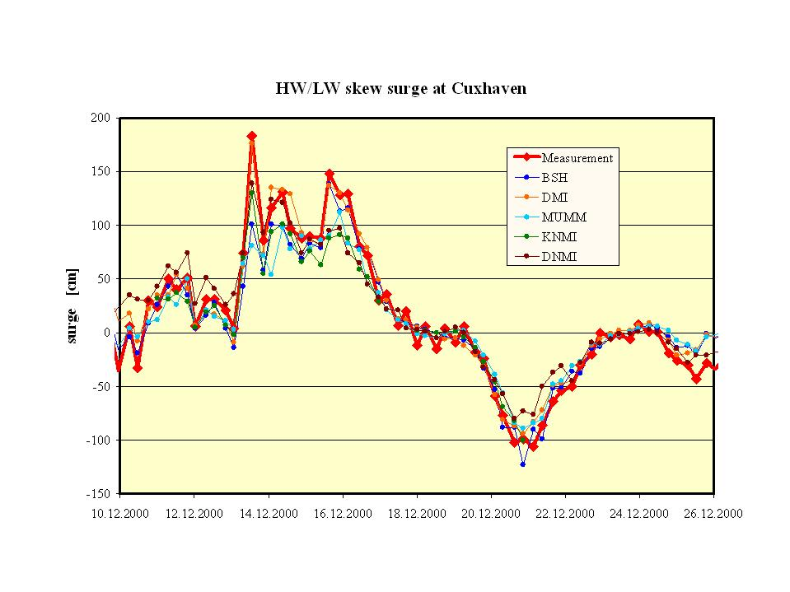
Fig. 10 Comparison of measured HW/LW skew surges at Cuxhaven with forecasts of different surge models in Norway (DNMI), Netherlands (KNMI), Belgium (MUMM), Denmark (DMI) and Germany (BSH)

6. Future development

Further international co-operation is a crucial requirement for future development. Prandle (2000) and Flather (2000) also state that improved communication and (international) collaboration is a key to future developments. Efforts will have to be made in several fields of model development. In circulation models, for example, turbulence schemes will have to be improved in order to obtain a better representation of fronts, eddies and stratification. Modelling of sea ice will also be a subject of further research.

In the future, progress is to be expected in the field of coupling atmospheric, wave and circulation models. Also data assimilation will play a more important role in operational shelf modelling. However, for some parameters (like salinity) there is a need for more real-time measurements.
Also drift and dispersion models have to be further elaborated. Research is necessary to include additional chemicals and to improve suspended matter and ecosystem models. At the moment, operational ecosystem modelling is still a future challenge.

Last but not least, another important future requirement will be to improve and further establish products and services to meet the needs of different environmental and maritime user groups. In this context, the Internet is a very useful instrument which will be growing in importance.

References

Dick, S., K. C. Soetje, 1990: Ein operationelles Ölausbreitungsmodell für die Deutsche Bucht., Dt. hydrogr. Z., Erg. H. Reihe A, Nr. 16, 43 S.
Dick, S., W. Schönfeld, 1996: Water Transport and Mixing in the North Frisian Wadden Sea - Results of Numerical Investigations. Dt. Hydrogr. Z., Vol 48 No. 1, 27-48
Dick, S., E. Kleine, S. Müller-Navarra (in prep.) The BSH's Operational Circulation Model. Berichte des BSH
Flather, R. A., 2000: Existing operational oceanography. Coastal Engineering 41, 13-40.
Janssen, F., 1996: Auswirkungen unterschiedlicher Windschubspannungsansätze auf die Qualität von Wasserstandsvorhersagen mit einem numerischen Nordseemodell. Diplomarbeit im Fach Ozeanographie, Universität Hamburg, 165 S.
Klein, H., S. Dick, 1999: Currents at the German Bight lightship: A comparision between ADCP measurements and the BSH forecast model. Dt. hydrogr. Z., Vol. 51, No. 4, 465-475
Kleine, E., S. Sklyar, 1995: Mathematical features of Hibler's Model of Large-Scale Sea-Ice Dynamics. Dt. Hydrogr. Z., Vol 47 No. 3, 179-230.
Knauth H., F. Schroeder, D. Kohnke, 1996: Coastal monitoring network. Sea Technol. 37, No. 12, 33- 42.
Müller-Navarra, S. H., N. Ladwig, 1997: Über Wassertemperaturen an deutschen Küsten. Die Küste, H. 59, 1 – 26.
Müller-Navarra, S. H., K. Huber, H. Komo, 1999: Model Simulations of the Transport of Odra Flood Water through the Szczecin lagoon into the Pomerian Bight in July/August 1997. Acta hydrochim. hydrobiol. 27 (5) , 364-373.
Prandle, D., 2000: Operational oceanography - a view ahead.Coastal Engineering 41, 353-359.

Contact
Stephan Dick
Bundesamt für Seeschifffahrt und Hydrographie
Bernhard-Nocht-Str. 78
D-22111 Hamburg
Germany
Tel.: +49-40 - 3190 3131, Fax: +49-40 - 3190 5032
Email: dick@bsh.d400.de

A presentation to the Joint Technical Commission on Oceanography and Marine Meteorology, June 25, 2001.
Director, International Ocean Programs, NOAA/OAR, HCHB Room 5224, Washington, DC 20230, U.S.A. <stan.wilson@noaa.gov>

