ENSO SIGNALS IN RELATION TO ASPECTS OF OCEAN CHARACTERISTICS ALONG THE GULF OF GUINEA COAST

BY

*Folorunsho R. A, **Ojo S. O and *Awosika L. F.
*Nigerian Institute for Oceanography and Marine Research. PMB 12729, V8ictoria Island , Lagos.
** Climatology Lab., University of Lagos, Akoka-Yaba

ABSTRACT: This paper discusses the characteristics of ENSO signals/teleconnections in relation to aspects of ocean dynamics in the Atlantic with particular emphasis on the characteristics and consequences of the ocean dynamics along the Gulf of Guinea (GG) coast. The paper first discusses the ENSO signals in relation to the distribution patterns of some elements of ocean-climate, especially in the GG coast with special reference to the ENSO events of 1982–1983, 1991-1995 using the available information in the region. The paper then examines in detail, the variability of the climatic elements during the ENSO periods of 1991 – 1995. The climatic elements examined include SST, wind speed and sea level pressure patterns. The paper then relates the variability in the characteristics of ocean dynamics to aspect of ocean–atmosphere systems for example, with regards to rainfall, storm surge and upwelling which are significant aspects of ocean-climate systems in the GG.
The results show that variabilities in the characteristics of the ocean dynamics along the GG are to a large extent related to ENSO signals along the east Pacific coast. In particular, for the most parts of the 1991–1995 ENSO periods, the patterns of distribution of the climatic elements along the Gulf of Guinea show the reverse of the patterns along the east coast of the Pacific Ocean.

1. INTRODUCTION

The Gulf of Guinea coast (GGC)(figure 1) is one of the most important socio-economic nerve centers of Africa. With an average population growth rate of 3% per annum (World Bank 1995), and a population density of between 1000-1500pp/sq.km especially in the coastal cities, the GG has one of the fastest population growth rates in sub-Saharan Africa.

Figure 1: The Gulf of Guinea Coast

Climatic characteristics are considerable influenced by the ocean - atmosphere interactions in and outside the GG. In this regards, the Inter-Tropical Convergence Zone (ITCZ) also known as the Inter-Tropical Discontinuity (ITD), plays a major controlling factor. The migration of ITD northwards between approximately March and August and southwards between September and November over West Africa influence weather and climate over the GG.

Mean monthly maximum temperatures range between about 29⁰C to about 33⁰C, while mean monthly minimum temperatures range between about 25⁰C - 28⁰C. Mean Wind speeds vary between about 0.5m/sec. to 9m/sec daily.

The dominant climatic type is equatorial tropical, characterised by wet and dry seasons. Annual rainfall range from less than 800mm along the Accra coast in Ghana, to about 3500mm in the east of Nigeria.

In-situ Sea Surface Temperatures (SST) in Lagos and Abidjan fluctuate between about 21⁰C along the western zone (e.g. Abidjan to Takoradi) to about 26⁰C (e.g. Cotonou and Lagos) along the eastern zone. In April and October/November, mean maximum SSTs of 29⁰C – 31⁰C are generally recorded.

Analysis of the Pacific ENSO signals on the GG coast was conducted in two phases: The warm ENSO phase and the cold La Nina phase. There are however, some disagreements among various authors as to which years are actually El-Nino or La-Nina years and what their impacts in West Africa have been. Most investigators recognize strong events, but there are some differences in their lists of episodes. However, in this write-up, the years shown in (Table 1.) will be considered for the purpose of this analysis and discussions.

TABLE 1. El-Nino and La-Nina events included in this study.

El-Nino Years | 1982, 1986, 1991 & 1994
La-Nina Years | 1985, 1988 and 1995

2. THE EL-NINO SOUTHERN OSCILLATION (ENSO) AND ITS
TELECONNECTION IN THE GULF OF GUINEA.

The El-Nino Southern Oscillation (ENSO) is an ocean-atmosphere coupling system that produces changes in the atmosphere and the ocean. These changes are manifestations of the joint atmospheric and oceanic interactions between the ocean and its overlying atmosphere in the tropical Pacific.
ENSO has been a subject of several reviews (Philander 1990: Diaz and Markgraf 1992; Neelin et. al. 1994). It consists of a warm phase (El Nino) and a cold phase (La Nina) usually characterised by reversed climatic conditions. The occurrence of these different phases causes different climatic conditions in various parts of the world. In West Africa for example, the warm phase of ENSO has been associated with the 1982-83 drought episodes and the negative anomalies associated with the 1994-1995 rainfall. Some of these El Nino/La Nina events have had major impacts on the global climate system, disrupting "normal" weather and climate characteristics and generating extremely adverse meteorological events such as droughts and floods etc. These facts are especially true of West Africa in general and GG in particular. Thus for the present study, an analysis is carried out on the possible teleconnections between ENSO and aspects of ocean-atmosphere interactions along the GG.

3. DATA AND METHODS OF STUDY

For this study, Satellite precipitation data used was derived from the Global Precipitation Climatology Project (GPCP) described by Janowiak and Akin (1991). The period of record analyzed consists of pentads from January 1990 through December 1995. This data provided a good understanding of the global precipitation variability associated with ENSO on a global scale. In addition, rainfall observations along the coast of Ivory Coast, Ghana, Togo, Benin and Nigeria covering 1982-1995 are especially used for the present study. The rainfall data was obtained from the Department of Meteorological Services in the various countries.
Satellite SSTs and wind speed maps used, were also derived from IGOSS nmc climatology and Goodberlet Algorithm respectively. Other sources of data included relevant maps and data from published works in literature.

Monthly rainfall and insitu SST records analysed for different locations in the GG coast were expressed as "standardized deviation" - calculated by taking the average anomaly of each available station after dividing the anomaly by the long-term standard deviation. Thus a value of "0.00 Std. Devs." would indicate average conditions with respect to the number of years climatology. Conversely, negative values indicate below average rainfall over the area as a whole.

4.DISCUSSIONS

The following discussions give some further details on GG coast as regards (a) SST teleconnection with ENSO on the east Pacific coast, and the characteristics of (b) winds (c) rainfall (d) sea level pressure and (e) upwelling.

A. SEA SURFACE TEMPERATURE TELECONNECTION TO ENSO

Analysis of the SST structure in the initial stage of warm ENSO events in (Reynolds and Smith 1995) in Kousky, V. E., Bell G. D. et. al. (1993) in the Pacific coast (not shown), revealed a positive SST anomaly of about 3⁰C to 3.5⁰C protruding from longitude 80⁰W through 100⁰W in the east Pacific coast from August to December. During these periods, normal to negative SST anomaly of about 0⁰C to –2⁰C teleconnection were observed on the GG coast (figure 2). Further analysis of SST departure time series in Lagos (Nigeria) and Abidjan (Ivory coast) from 1980 to 1994 (figure 3 and 4) suggest an SST variability characterised by both positive and negative anomaly of about 1.0⁰C to 1.5⁰C from January to June. During the 1982-83, warm ENSO event of the Pacific, SST observations in Lagos, the GG coast, revealed a rather continuos negative anomaly of about -1.8⁰C to -2.4⁰C. In 1994 for example, SST in Lagos was between –0.4⁰C to 0⁰C.

On the other hand, the 1988 La Nina year of the east Pacific coast was characterised in the GG by a general positive SST anomaly of between 1.8⁰C from January to June, while from July to December, SST's were in the negative region of about -0.8⁰C to -1.5⁰C. The persistent positive SST in the GG coast has been reviewed by several authors who have attributed the phenomenon to an ENSO-related North

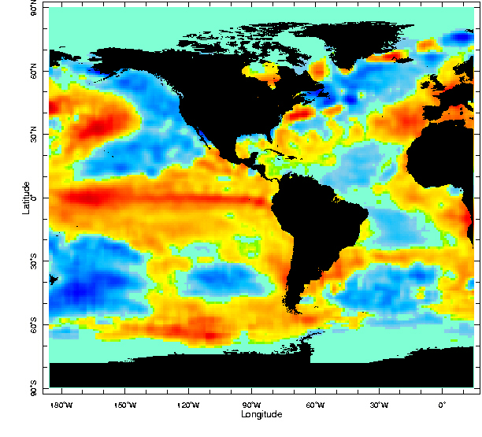
December 1994 SST Anomaly

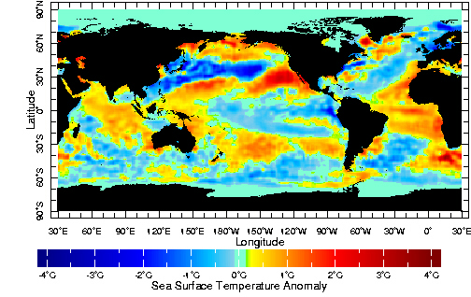

February 1996 SST Anomaly

Figure 2: Global Sea Surface Temperature Anomalies .

Source: IGOSS nmc monthly SSTA .1994 .

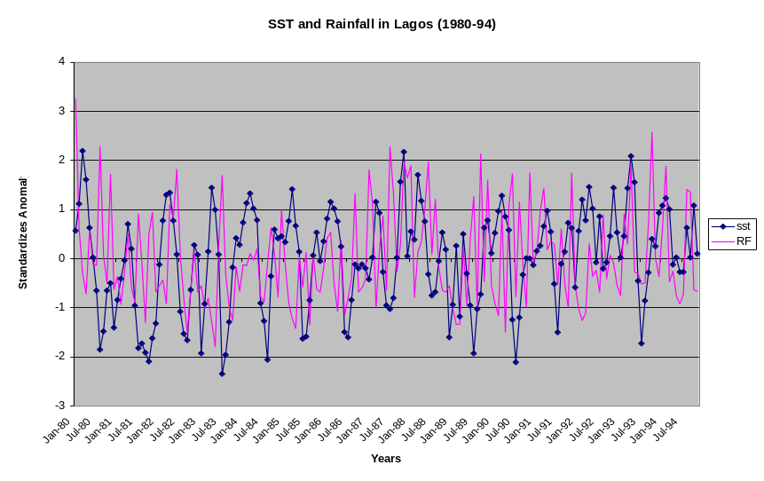
Figure 3: Time Series of Sea Surface Temperature and Rainfall in Lagos

Atlantic warming lags of the Pacific by about 3 - 5 months (Enfield et. al 1993).

B. WIND SPEEDS

Historical records of the Pacific strong ENSO events indicate weak surface ocean winds and the relaxation of the easterlies along the Equator (Legler et. al. 1993).
While El-Niño episodes feature large-scale changes in the atmospheric winds across the tropical Pacific, the GG coast was under a strong easterly winds during ENSO years. Analysis of wind speeds off Ivory Coast and Benin for example, indicates the presence of strong wind speeds of more than 12 knots in 1995 (July to October) and more than 6 knots from 1994, 95, 96 to 98.

C. RAINFALL

Relationships between ENSO and precipitation in various regions have been investigated for many years, see for example, Skula and Paolino (1983), Ropelewski and Halpert (1987). Janicot et al.(1996) also studied the relationship of Pacific SST with West Africa rainfall, and expressed a high correlation between the different regions in West Africa and Pacific ENSO.
During warm El-Nino phase, heavy rainfall and thunderstorm activity develops across regions in the eastern equatorial Pacific regions where abnormally warm ocean temperatures reach approximately 28°C or greater. During La-Niña years on the other hand, rainfall over the central equatorial Pacific, becomes confined to other parts of the world.
Studies on West African precipitation associated with El-Nino Southern Oscillation, has been well treated (see for
example, Nicholson et. al. 1993, Ward 1992 and Rowell et. al. 1995. Analysis of time series rainfall departures in Lagos(Figure 3) shows a generally negative rainfall anomaly during El-Nino years along the coast, with significant positive rainfall anomalies characterising La Nina years of 1985 and 1988.

Standardized rainfall anomaly time series in the GG coast, (June-September 1950-97) (Figure 4) generally showed

Figure 4: Time series of Rainfall Deviation in the
Gulf of Guinea

negative deviation from 1980 to 1989, and part of 1990 to 1994. Rainfall anomalies of between -0.04⁰C to —0.08⁰C characterised these years in the GG coast. Further analysis of rainfall time series deviations in Lagos during the ENSO warm events of 1982-83, 1987 and 1992 also showed negative rainfall anomalies.

D. SEA LEVEL PRESSURE
A comparative analysis of the annual sea level pressure anomaly map, showed a positive sea level pressure anomaly in the GG as compared to negative anomalies in the east Pacific coast between 1991 to 1994 (Figure 5).
Figure5: Annual Sea Level Pressure Anomaly for 1991, 1992, 1993 and 1994

Further analysis of coastal sea level pressure for Lome in Togo and Cotonou, Benin revealed a cyclic high mean sea level pressure of about 1014mb around July to September every year (Figure 6 & 7).

Figure 6: Sea Level Pressure Lome (Togo)

Figure 7: Sea Level Pressure Benin

Relatively higher values of about 1012 – 1016mb were also observed in 1996 and 1997 approximately between July and September.

E. STORM SURGE

The presence of varying pressure systems and high wind speeds of more than 12 knots in 1995 between July and October, could be responsible for the high waves climates experienced in the months of August to September in the GG coast. Records of Storm surge occurrence in Lagos over the past few years for example has showed an increased storm surge occurrences on the coast. This increase could be remotely connected with warm El-Nino years.

- UP-WELLING

The increase in small palegic catches like Sardinella and anchovy in Ghana and Ivory Coast during the major up-welling season of July to September and minor up-welling season of January to March are indications of an up-welling phenomena along the GG coast. The mechanisms causing the up-welling are not well understood, however, remote connections between ENSO events of the Pacific ocean and the Atlantic ocean have been cited as possible signals to the malfunction of the phenomenon in the GG Bakun (1993).
In the Pacific, the 1983 ENSO (El-Nino) was followed by a Strong La-Nina in 1984 with corresponding strong positive sea surface temperature anomalies in the GG. This SST anomaly caused changes in sardinella and anchovy catches in Ghana and Ivory Coast.

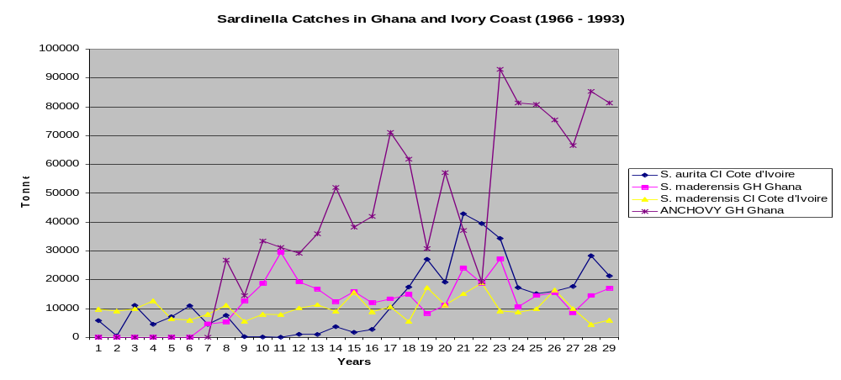

Figure 8: Sardinella Catches in the Gulf of
Guinea

Analysis of sardinella catches in the region showed a drastic reduction in the La-Nina year of 1984 and 1988. During El-Nino years of 1983 and 1986 for example, sardinella catches were very high (Figure 8).

5. CONCLUSION

The occurrence of El Nino in the eastern Tropical Pacific Ocean generally results in positive SST values and low wind speeds in the GG. The reverse cold La-Nina on the east Pacific ocean also leads to an inverse relationship in SST and wind speeds patterns in the GG, thus creating a seesaw pattern of ocean dynamic signals/teleconnections between the Pacific coast and the GG coast. All these patterns indicate an ocean – atmosphere teleconnections between the two areas. The warm superficial layer of SST anomalies in the GG following the occurrence of El-Nino, could be referred to as the “Guinea Nino”.
While the ENSO phenomenon along the coast of Peru has been well investigated, the Gulf of Guinea still remains only partially investigated. There is therefore need to carry out more research or investigations in the region to enable a better understanding of teleconnections between ENSO and the characteristics of ocean-atmosphere dynamics in the GG region.

6. References.

- Arkin, P. A., and Janowiak, J. E., 1991: Analyses of the global distribution of precipitation. Dyn. At. Oceans, 16, 5-16.

- Bakun, A. 1993: Global climate variations and potential impacts on the Gulf of Guinea sadinella fishery. Dynamics and use of sardinella resources from upwelling off Ghana and Ivory Coast.Ed. Francous Xavier Bard and Kwame Koranteng.

- Barnston, A. G.,1995: Our improving capability in ENSO forecasting . Weather, 50, 419-430.

- Diaz, H. F., and Markgraf, Ede., 1992: El Nino Historical and Paleoclimatic Aspects of the Southern Oscillation . Cambridge University Press, 476 PP

- Enfield, D. B.,and Mayer, D. A., 1993: Tropical Atlantic SST Variability and its relations to Pacific SST and Western Hemisphere rainfall. Proc. International Scientific Conference on the Tropical Ocean Global Atmosphere (TOGA).WMO/TD No. 717.

- FAO Paper, 1998: FAO paper related to climate change.

- Janicot S., Harzallah, B. F., and Moron, V. 1998: West Africa monsoon dynamics and eastern equatorial Atlantic and Pacific SST anomalies. Int. J. Climatol.,11,No. 8 1970-1988.

- Kousky, V. E., Bell G. D. and Ropelewski C. F.1993: Interannual variability in the tropics during 1985-1994. Proc. International Scientific Conference on the Tropical Ocean Global Atmosphere (TOGA).WMO/TD No. 717.

- Legler, D. M., and O’Brien, J. J. 1993: Pacific wind variability during TOGA: A view from ships and Satellites. Proc. International Scientific Conference on the Tropical Ocean Global Atmosphere (TOGA).WMO/TD No. 717.

- Neelin, J. D., 1990: A hybrid coupled general circulation model for El Nino studies, J. Atmosphere Sci. 47, 674-93.

- Nicholson, S. E.,and Kim, J.1993: The ENSO signal in the tropical Atlantic and western Indian Oceans. Proc. International Scientific Conference on the Tropical Ocean Global Atmosphere (TOGA).WMO/TD No. 717.

- Philander, S.G. H., 1990: El Nino, La Nina, and the Southern Oscillation. Academic .

- Ropelewski, C. F., and Halpert, M. S., 1987: Global and regional scale precipitation patterns associated with the El-Nino/Southern oscillation. Mon. Wea. Rev., 115, 1606-1626.

- Skula, J. and Paolino, D. A.,1983: The Sourthern Oscillation and long range forecasting of the summer monsoon rainfall over India. Mon. Wea. Rev., 111, 1830-1837.

- Trenberth K. E, and Shear, D. J.1987 ; On the evolution of the southern oscillation. Mon. Wea. Rev.115, 3078-3096.

- World Bank, 1995: African region, Taking action for poverty reduction in Sub-Saharan Africa. Report of an African Task Force, Washington D.C.

- Wright, P. B., 1989: Homogenized long-period southern oscillation indices. Int. J. Climatol., 9, 33-54.

- Wright, P. B.,1984 : Relationship between indices of the southern oscillation. Mon. wea. Rev. 112 1913-1919.

